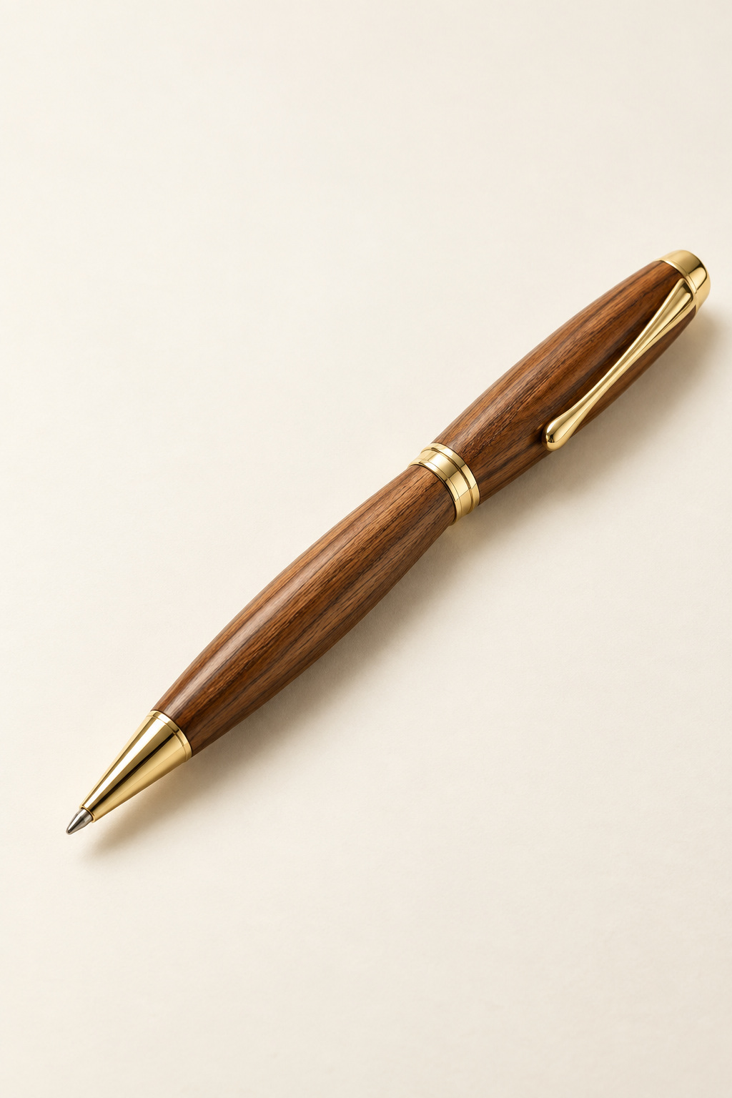
Timber Pen
STAGE 5 INDUSTRIAL TECHNOLOGY · TIMBER
Student workbook · Edition 1.0

Name: _______________________ Class: __________
Teacher: _____________________ Year: __________

Your route through the project
Work through the ten topics in the order your teacher sets. Each topic contains three readings and a check and apply page. The topics support the practical project; their numbers do not represent weeks.
Topic | Focus | Pages
1 | Brief, sources and safety | 3–6
2 | Timber, grain and responsible planning | 7–10
3 | References, tubes and drilling | 11–14
4 | Mandrel and pre start checks | 15–18
5 | Controlled turning and profile | 19–22
6 | Surface, abrasives and finish | 23–26
7 | Kit and controlled assembly | 27–30
8 | Design, standards and production | 31–34
9 | WMS, flowchart and impacts | 35–38
10 | Evidence, PMI and transfer | 39–42
Folio | Process reference and project records | 43–50

Read · discuss · record
Read the section, examine the figure and explain the worked decision. Complete the response while the thinking is fresh. Record practical evidence only at a safe, teacher approved pause. Keep this book together with your own photos and approved kit information.

The updated Pen Making guide supplies the current process. Your actual kit instructions, teacher demonstration and school SOP control practical details. The website retains some older names; this book identifies the differences where they matter. Never measure from an image.
Pen course: stevencowell.github.io/Yr-9-Pen/
Keep your work and follow the teacher’s current submission instructions. The website and this workbook do not submit evidence automatically. Printing: A4, double sided, flip on the long edge; 50 pages use 25 sheets.

A small object. A complete project.
Your timber pen and project report tell the same story: how a considered idea became a carefully made, functioning product.
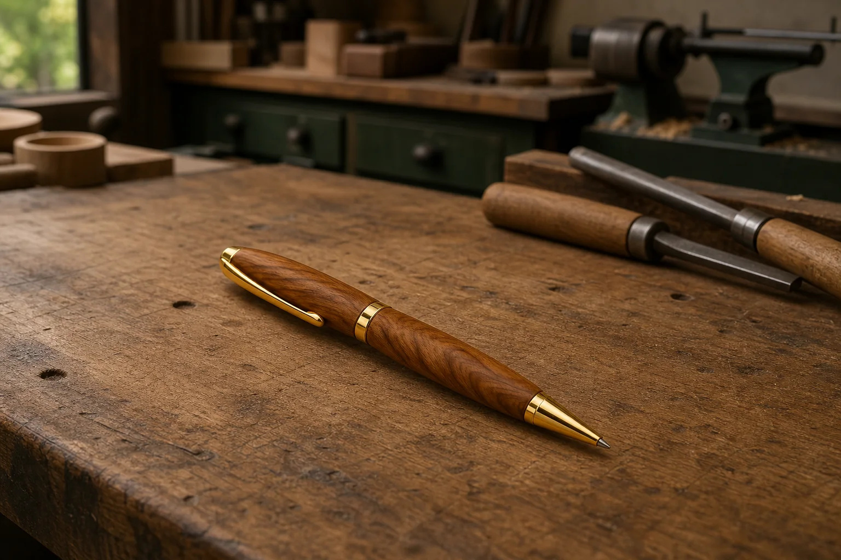
Figure 1. Illustrative course photograph: the finished pen is one outcome; your records explain how you achieved it.

A successful pen combines controlled manufacture, a suitable surface, aligned parts and reliable function. “It looks good” is too broad to test. Turn that judgement into observable criteria: the timber feels evenly finished, the joins appear flush, the two barrels look related and the mechanism works as the supplied kit requires. Check these features against your teacher approved brief.
The report makes your thinking visible. Freehand sketches communicate alternatives, the cutting list organises verified material information, and the Work Method Statement connects each construction stage with its hazards and controls.

Your production flowchart explains the inputs, processes and outputs, including waste. Keep a record of real checks and decisions as they happen. A clear photo with a specific caption is more useful than a collection of uncaptained images taken at the end.
Finish with a PMI evaluation: Plus for evidenced strengths, Minus for limitations and their effects, Interesting for discoveries or questions worth pursuing. Compare the result with the brief and propose a practical improvement. Honest explanations of problems show judgement when they identify the cause, response and outcome.

Write one product criterion and one piece of process evidence that would help you judge it.

Read the guide as a sequence
The current Pen Making – Updated Student Guide explains a connected process: prepare, drill, turn and assemble. Read the complete guide before beginning. Early decisions prepare later stages: the witness line preserves grain order, tube preparation supports bonding, and square ends help components meet cleanly. Copying a photograph without understanding that relationship can carry an error into the next stage.
Use each source for the question it controls. The current guide supplies the project sequence and stated facts. The actual kit instructions identify its components and fit requirements. Product information controls the approved adhesive and finish. Teacher demonstration and the school standard operating procedure (SOP) govern local equipment, controls and authorisation. Another kit’s video cannot replace these sources.
The updated guide specifies a sound blank at least 110 × 20 × 20 mm; older website text says greater than 110 mm long × 20 × 20 mm. Record this wording difference and confirm starting stock with the teacher. Neither statement supplies the finished barrel length. Never measure a resized picture to obtain a missing dimension.
Terminology also needs checking. The current guide uses bushes and brass nut for the mandrel arrangement, and clip, cap, nib and twist mechanism for assembly. Older pages use collets, brass thumb screw, clip/button and nib shroud. Compare names with the actual kit rather than silently treating every term as interchangeable.
Worked example · hypothetical
A photograph seems to show a longer barrel than your kit requires. The written kit requirement controls the decision; screen proportions may have changed through resizing. Record the uncertain detail and verify it before making a cut.

Name one decision controlled by the guide and one controlled by the actual kit or local workshop procedure. Explain why a photograph alone cannot settle both.

Control the risk before rotation
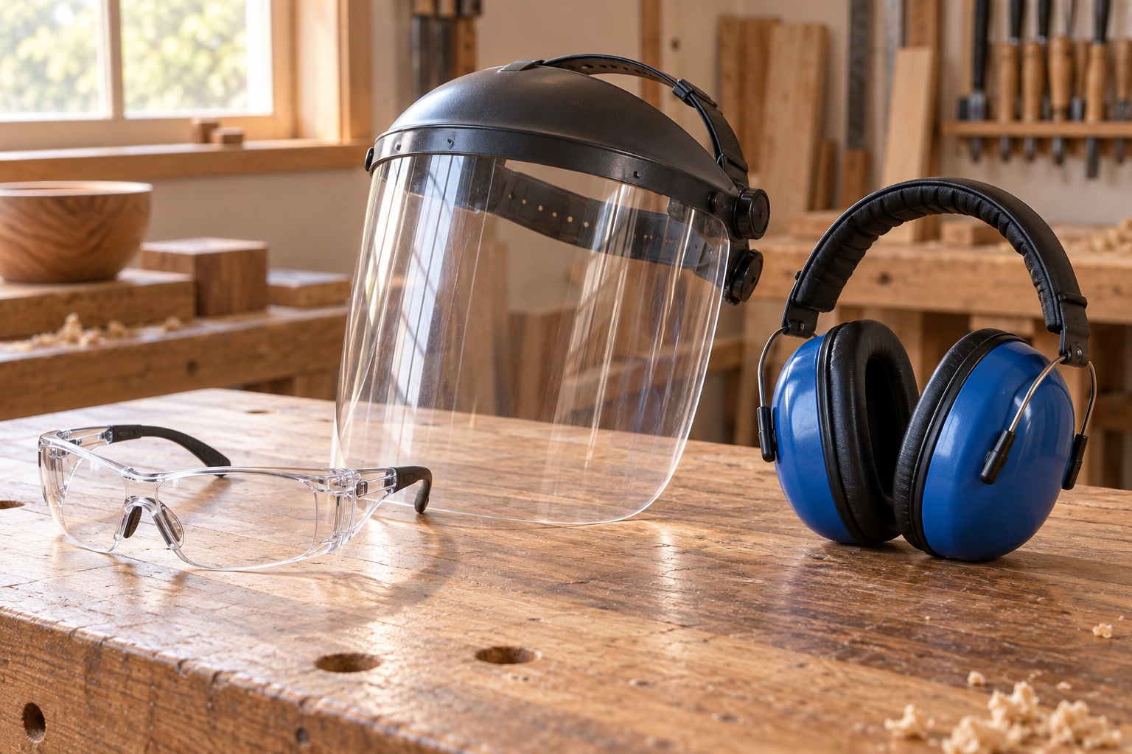
Figure 2. Protective equipment supports the approved workholding, procedures and supervision; it cannot replace them. Illustrative scene.
A hazard has the potential to cause harm. Risk considers how likely that harm is and how serious its consequence could be. Rotation makes a lathe different from a stationary bench: loose hair, clothing, jewellery or other items may become caught, while poorly secured work can move unexpectedly. Sharp tools, dust and finishing products add hazards at different stages.
The hierarchy of controls prioritises removing, substituting or isolating hazards and using engineering measures before depending on instructions and personal protective equipment (PPE). Approved workholding and guards control physical conditions. A Work Method Statement, demonstration and authorisation are administrative controls. Eye protection and other directed PPE support these measures; they cannot correct loose workholding or an unsuitable setup.
Recognise different turning arrangements. Between centres turning supports work between the headstock and tailstock. Chuck turning holds suitable work in a chuck; faceplate turning secures suitable work to a faceplate. Their clearances and mounting requirements differ. These are recognition examples: only the teacher selected setup and current school procedure authorise this pen’s practical process.
Inspect timber and mounting before operation. Cracks, loose defects or questionable laminated bonds need teacher judgement. Secure personal items, organise the area and obtain the required pre start approval. Report abnormal movement, vibration or equipment condition immediately. Stopping for uncertainty prevents a doubtful condition becoming a larger problem; a photograph of a setup cannot itself prove that the controls were applied.
Worked example · hypothetical
A student has eye protection but notices a loose mounting part. PPE does not prevent that part moving during rotation. The correct decision is to stop and obtain a setup check before authorisation to run.

Explain the difference between a hazard and a risk using one pen making example. Name a control that addresses it.

Topic 1 · Check and apply
Choose one answer for each question. Use the readings to justify your choice. These questions retain the website wording and option order.
1 What is the strongest next action when applying "Understanding the Pen project brief and success criteria"?
○ A. Act before checking the approved source.
○ B. Before each project stage, check the approved instructions, identify the intended quality outcome and record evidence of my decision or result.
○ C. Wait until the final lesson to inspect the result.
○ D. Copy another student without checking the approved resource.

2 Which evidence would best demonstrate this learning in the Pen folio?
○ A. An unrelated internet image with no caption.
○ B. A final photo that hides the relevant detail.
○ C. A copied definition with no Pen example.
○ D. Record the marked timber, paired grain alignment, identified kit parts and completed checks as progressive Pen project evidence.

3 Which statement best captures the main idea in "Managing wood-lathe hazards, risks and teacher approval"?
○ A. Effective safety on the lathe comes from identifying hazards and applying the strongest practical controls before relying on PPE.
○ B. Wearing PPE alone makes lathe work safe without proper setup, approval and control of hazards.
○ C. Appearance is the only evidence that matters.
○ D. Guessing is acceptable when the result looks close.

A student has a polished pen but no record of preparation or safety checks. Explain what is missing and what evidence should be collected during the next project.

Choose sound timber first
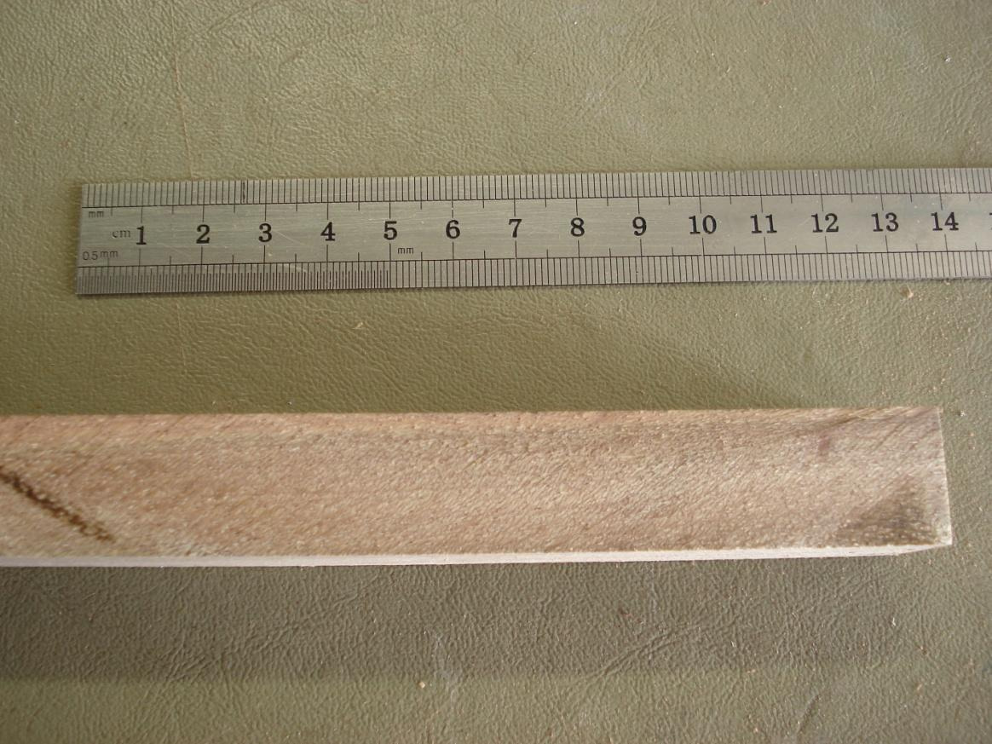
Figure 3. Inspect the actual blank’s grain, faces and ends before treating appearance as a design advantage. Original guide photograph, page 2.
A pen blank is the starting piece of timber from which the two bodies are prepared. The current guide specifies sound, straight grained stock at least 110 × 20 × 20 mm. Older website wording requires length greater than 110 mm. Confirm the starting piece with the teacher before marking; the stated stock size is not a finished barrel size or permission to guess later dimensions.
Soundness means suitability for the planned preparation and turning. Look along the blank for distortion and examine its faces and ends for splits, cracks, knots, loose areas, damaged corners or short grain. Record what is visible, then seek teacher judgement where a feature is uncertain. A striking pattern does not make a defective piece suitable for rotation.
Grain describes the direction of the fibres; figure is the visible pattern produced by their arrangement and natural variation. Straight grain can make reference marking clearer and help the material behave more predictably. Attractive figure contributes to appearance, but its value comes after suitability. Material removal may reveal defects that were previously hidden, so initial acceptance does not replace later checks.
Good selection also reduces waste. Rejecting sound stock for no clear reason wastes material, while using unsuitable stock can cause failure and greater loss later. Explain the evidence behind the decision, keep usable offcuts through the approved system, and link the initial inspection to what happens during drilling, turning and final evaluation.
Worked example · hypothetical
Appealing figure does not cancel a visible end split. Record the defect and ask whether the stock is suitable; do not invent a shorter starting blank.

A blank looks attractive but has an uncertain dark line near one end. Explain what you can claim now and what needs checking.

Keep the grain relationship visible
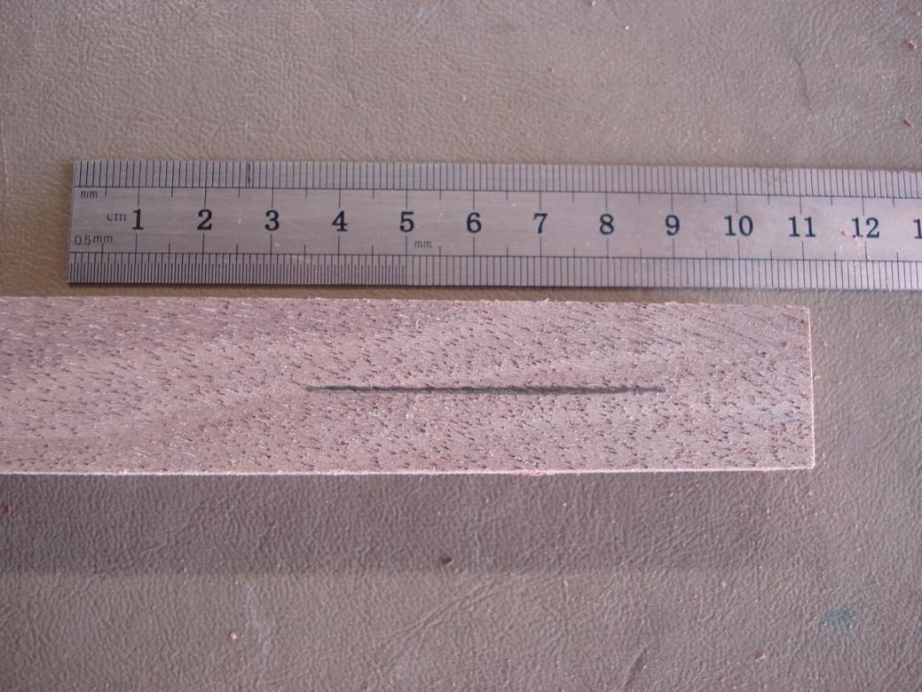
Figure 4. A continuous witness line records the relationship that must survive cutting, mounting and assembly. Original guide photograph, page 3.
The two timber bodies began as one blank. Keeping them in their original relationship allows parts of the figure to appear connected across the finished pen. Grain is the direction of the fibres; figure is the visible pattern of lines, colour and variation. Both influence the appearance, but visual continuity depends on how the paired pieces are handled after separation.
The current guide places one continuous witness line along the blank, then marks the centre before cutting it into two barrel pieces. The lengthwise line carries orientation information; the centre mark serves a different marking purpose. Do not read the witness line as an extra dimension, a final profile or a new cutting schedule.
Keep the halves together and in the same grain order. A piece can lose its relationship by being reversed end for end, rotated around its length or mixed with another pen’s parts. Similar colour is insufficient proof of a match. The approved marking and identification system lets you check the relationship instead of relying on memory.
When the pieces are mounted and later assembled, compare the witness reference and visible figure. The guide requires the grain to align across the centre. Rounded surfaces may reveal the pattern differently from the original flat faces, so a clear earlier record helps explain the change. Photograph the original reference, the paired arrangement and the finished result at approved safe points; captions should connect the marking decision with the final appearance.
Worked example · hypothetical
Two pieces have similar colour, but their reference marks no longer correspond. Preserve the pair and check its recorded order before progressing, rather than selecting an arrangement from memory.

Explain how reversing one barrel piece could affect appearance even if it still fits the kit.

Plan the material, reduce the waste
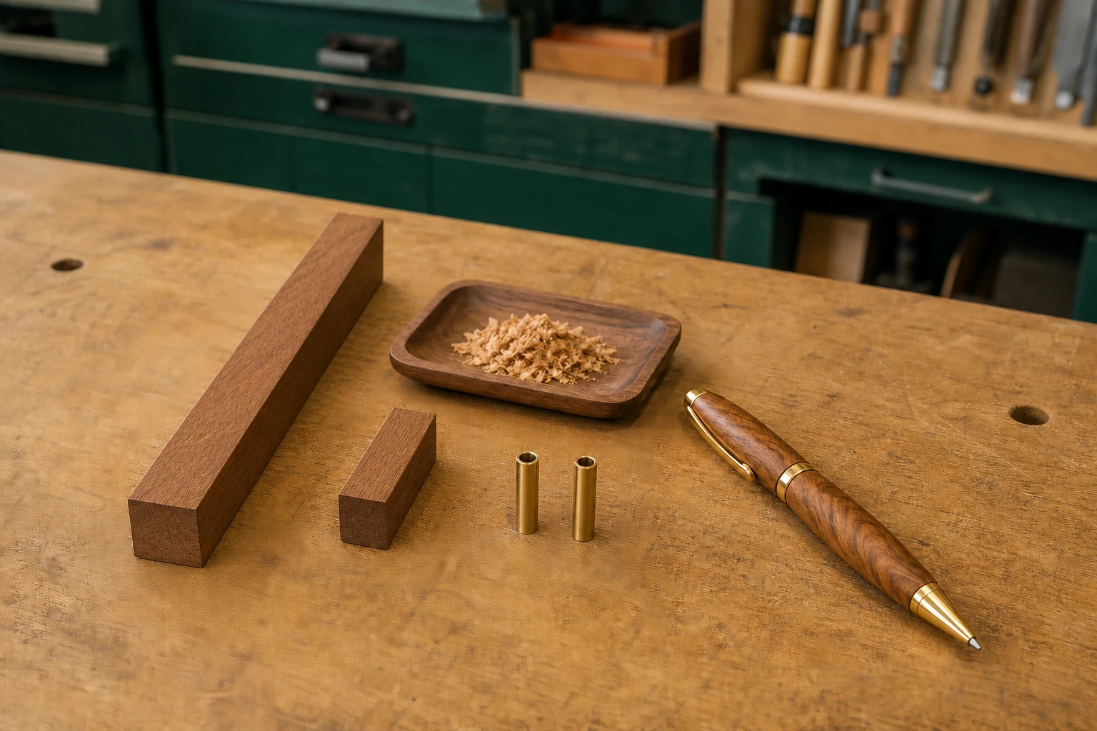
Figure 5. Illustrative course photograph: starting stock, useful offcuts and true waste deserve different decisions.

A cutting list records components, quantities and verified dimensions. It is a preparation tool: a guessed value can become a wrong cut, a failed part and unnecessary replacement stock. Separate what the current guide states from what your actual kit and teacher still need to confirm. Record units and the source of each value.
The updated guide starts with sound timber at least 110 mm × 20 mm × 20 mm. That is a starting blank requirement, not a finished pen size. Dividing 110 by two does not establish barrel cutting lengths: the approved preparation and kit details must determine those.

Efficient planning preserves the paired grain relationship and avoids repeated trimming. Set aside useful clean offcuts only through the workshop’s approved system; some may serve as teacher approved finish or technique samples. Do not assume that every leftover piece is suitable for reuse.
A durable, functioning pen may extend useful material life. This is a reason to control quality as well as waste, although you cannot prove an environmental advantage from appearance alone. Your flowchart should account for the finished product, records, chips, dust and packaging, then link one decision to its likely effect.

Worked decision
A proposed list says “two 55 mm barrels” because the blank is 110 mm long. The arithmetic is correct; the manufacturing assumption is unsupported. Keep the starting stock fact, mark barrel lengths “Teacher to confirm”, then check the supplied kit before cutting.

Record one value that is known, one value needing confirmation, and one sensible way to manage an offcut.

Topic 2 · Check and apply
Choose one answer for each question. Use the readings to justify your choice. These questions retain the website wording and option order.
1 What is the strongest next action when applying "Selecting and inspecting timber for the Pen blank"?
○ A. Act before checking the approved source.
○ B. Inspect the starting timber carefully, record what you observe and confirm suitability with the teacher before use.
○ C. Wait until the final lesson to inspect the result.
○ D. Copy another student without checking the approved resource.

2 Which evidence would best demonstrate this learning in the Pen folio?
○ A. An unrelated internet image with no caption.
○ B. A final photo that hides the relevant detail.
○ C. A copied definition with no Pen example.
○ D. Show the original orientation mark, the corresponding lines on the paired parts and the final grain-continuity judgement.

3 What is the strongest next action when applying "Planning responsible material use and the Pen cutting list"?
○ A. Act before checking the approved source.
○ B. Record only approved values, confirm uncertainties with the teacher and plan how the timber will be used efficiently.
○ C. Wait until the final lesson to inspect the result.
○ D. Copy another student without checking the approved resource.

Two barrels came from one blank, but the grain looks disconnected. Give two possible causes and explain how you would investigate without guessing.

Make references you can trust
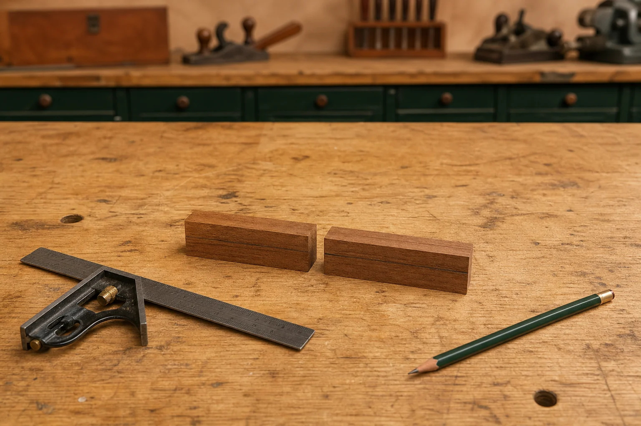
Figure 6. Paired pieces retain information from the original blank; the approved marks keep that relationship traceable.
A billet is a piece of stock prepared for further work. Marking the pen billet records information that later stages must preserve. The current guide asks for a continuous witness line along the blank, a centre mark, and two barrel pieces kept in the same grain order after cutting. The lengthwise line is a reference for orientation; it is not a substitute for the kit’s written dimensions.
Keep different marks understandable. A reference mark communicates a relationship, while a measured mark communicates a verified position or size. Extra unlabelled lines can create ambiguity. Use the teacher approved marking method and compare it with the guide before cutting. The original stock requirement does not, by itself, define a final barrel length.
References can become faint through handling, abrasion or later preparation. Check them before the next stage instead of assuming they remain readable. If a mark has become uncertain, preserve the parts and consult the record and teacher. Reconstructing an orientation from memory can create cumulative error: one small unsupported assumption carries into the next decision.
Keep the prepared bodies identified as one matched pair. A simple, approved label can support the witness line, but should not invent component positions or an assembly sequence. Record the billet before separation and show how its references are used later on the mandrel. A useful caption explains which relationship the mark preserves and why losing it would affect the finished pen.
Worked example · hypothetical
Several pencil lines are present, but the maker cannot explain which records grain order. More marks have reduced clarity. Check the guide and original record with the teacher before using a line.

Distinguish a witness line from a dimensional mark. State what you would do if the witness line became unclear.

Prepare the brass tubes for bonding
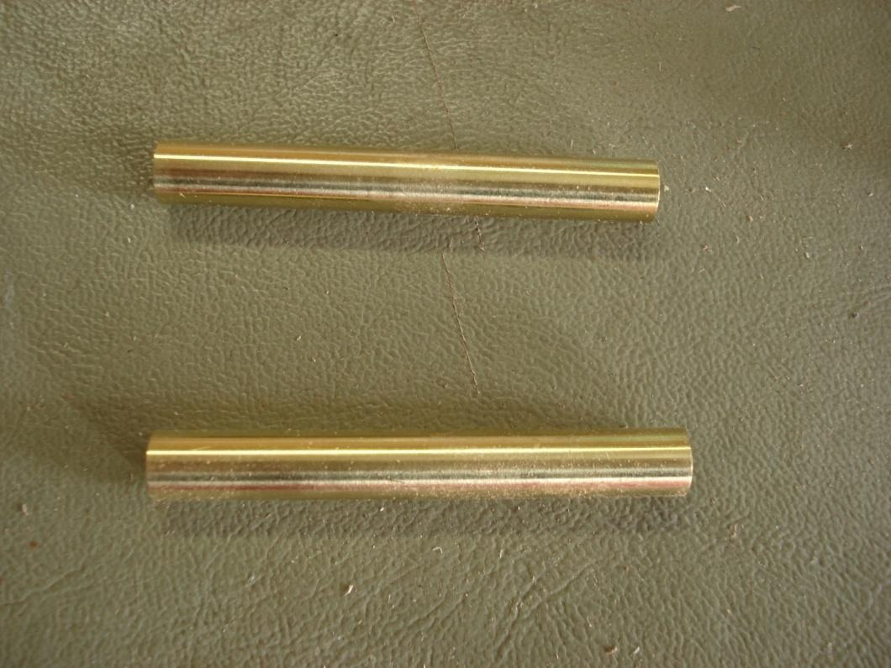
Figure 7. Original guide material: prepare both tubes consistently while protecting their bore, shape and ends.
The kit contains two brass tubes, also called sleeves in the website theory. They belong to the same matched kit as the timber bodies. Identify them from the actual kit instructions and keep the kit label with the parts. Similar diameter or colour does not prove that a loose tube from another kit is the correct component.
The updated guide directs light abrasion of the outside only, followed by removal of dust and grease. This prepares the surface for the approved adhesive rather than changing the tube’s shape. A roughened outer surface supports bonding; contamination can interfere with that contact. Keep the prepared surfaces clean using the approved method and protect the ends from damage or distortion.
The next guide stage applies the approved adhesive evenly and rotates each tube as it enters to distribute the glue. The tube is centred inside the blank and left to cure fully. Keep adhesive out of the bore, the hollow space inside the tube. The actual product label, Safety Data Sheet, demonstration and school procedure control the method and handling conditions; do not invent an adhesive or curing time.
Inspect both prepared tubes before bonding. Look for consistent preparation, unwanted residue and damaged ends, using the teacher’s accepted example. Too little preparation or excessive material removal can both weaken control. A photograph becomes useful evidence when its caption identifies the matched tubes, explains why the outside was prepared and records the checkpoint before the next stage.
Worked example · hypothetical
A prepared tube is returned to dusty offcuts. Earlier preparation does not guarantee readiness for bonding. The maker stops for the approved cleanliness check before applying adhesive.

Explain why the outside is prepared for bonding while the bore and tube ends must remain protected.

Drill through the end grain
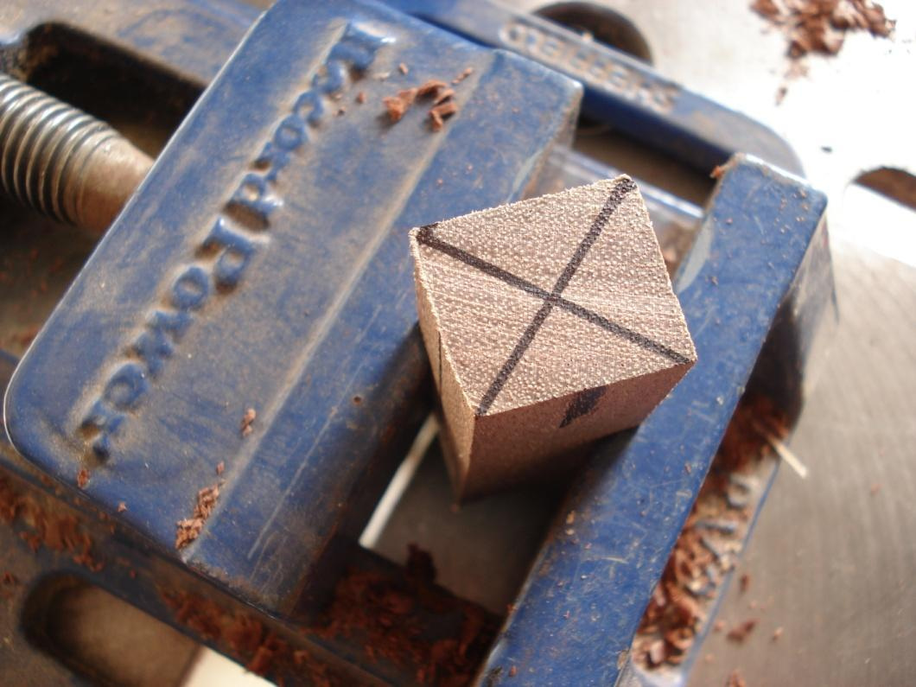
Figure 8. Original guide, page 4: a clamped blank is drilled through its end grain using the approved setup.
Drilling creates the internal holes for the brass tubes, so its accuracy affects later bonding and alignment. The current guide specifies drilling from the centre of the end grain, never through the side. Clamp each blank securely and keep it square to the drill using the teacher approved setup. The teacher checkpoint confirms the drilling arrangement, bit size and depth; these details cannot be taken from another kit.
Swarf is the loose material produced as the bit cuts, including chips, shavings or fine particles. The guide requires regular withdrawal of the bit to clear swarf and reduce heat. This is a planned part of the demonstrated process, not merely cleaning up after a hole is finished. The local method controls how it is done; no interval or feed rate is prescribed here.
Trapped swarf can obstruct clearance and increase friction. Friction creates heat, which may affect the timber and drilling result. Report unexpected resistance, movement, sound, smell or equipment behaviour rather than forcing progress. Stop and have the condition checked before the work continues.
After drilling, inspect the holes against the approved criteria before bonding. Damage, obstruction or poor direction can interfere with tube seating and later alignment. Do not enlarge or repair a hole by guesswork. A strong record identifies the workholding check, the regular swarf clearance process and the accepted hole condition. These details explain how early drilling control supports a clean assembly much later.
Worked example · hypothetical
A student notices increased resistance and assumes the timber is simply harder. Resistance is an observation; its cause is uncertain. The appropriate response is a controlled stop and teacher check, not extra force.

Explain one safety reason and one quality reason for secure workholding during end grain drilling.

Topic 3 · Check and apply
Choose one answer for each question. Use the readings to justify your choice. These questions retain the website wording and option order.
1 What is the strongest next action when applying "Marking the Pen billet and preserving reliable references"?
○ A. Act before checking the approved source.
○ B. Apply and protect the centre/grain line, keep paired parts identified and confirm markings with the approved source and teacher.
○ C. Wait until the final lesson to inspect the result.
○ D. Copy another student without checking the approved resource.

2 Which evidence would best demonstrate this learning in the Pen folio?
○ A. An unrelated internet image with no caption.
○ B. A final photo that hides the relevant detail.
○ C. A copied definition with no Pen example.
○ D. Show both prepared sleeves and explain the identification, surface-quality and teacher checks completed before bonding.

3 What is the strongest next action when applying "Drilling clean Pen blank holes and clearing swarf"?
○ A. Act before checking the approved source.
○ B. Use the teacher-approved setup, clear swarf as demonstrated and stop for approval whenever the process appears abnormal.
○ C. Wait until the final lesson to inspect the result.
○ D. Copy another student without checking the approved resource.

Match each check to the problem it helps prevent: protect the witness line; prepare tube exteriors; clear swarf by the approved method. Explain one link in detail.

Understand the mandrel system
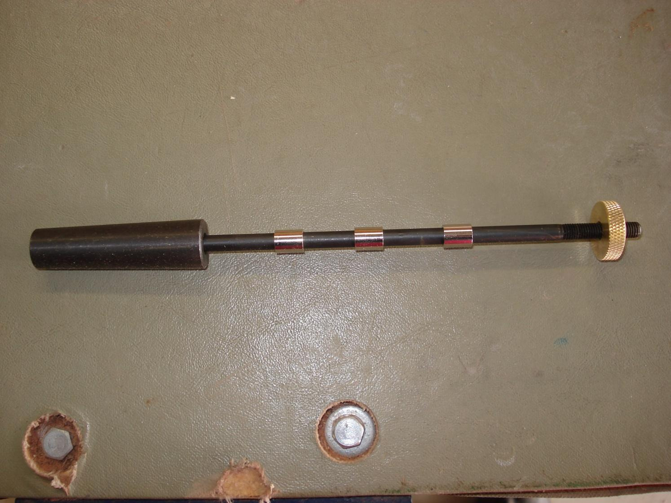
Figure 9. Original guide photograph, page 8: the mandrel, three spacers and brass end fastener. Confirm the supplied kit’s terms and arrangement.

A mandrel carries the prepared pen barrels along a common turning axis. The relationship between the shaft, tubes, spacers and end fastener helps hold the assembly in its intended position. This is different from choosing an arbitrary workholding method because it looks convenient. Use the teacher selected equipment for the actual kit.
Between centres turning supports work between headstock and tailstock. Chuck turning grips an approved component in a suitable chuck; faceplate turning secures it to a faceplate. These setup families have different clearances and holding requirements. Understanding the names does not authorise changing the Pen setup.

The older website calls the three spacers “collets” and the end fastener a “brass thumb screw”. The updated guide uses “bushes” and “brass nut”. Compare the photographed parts with your kit and teacher demonstration; do not assume that every component sold under these names is interchangeable.
Before mounting, inspect the mandrel for straightness and cleanliness and report damage or uncertain fit. An arrangement may contain all the expected parts and still be wrong. The teacher confirms component order, support and secure workholding before the pre start routine. Never copy an operating speed, torque or spacing from a photograph.

Explain why identifying every component is necessary but does not prove that a mandrel assembly is ready to run.

Mount the pair in grain order
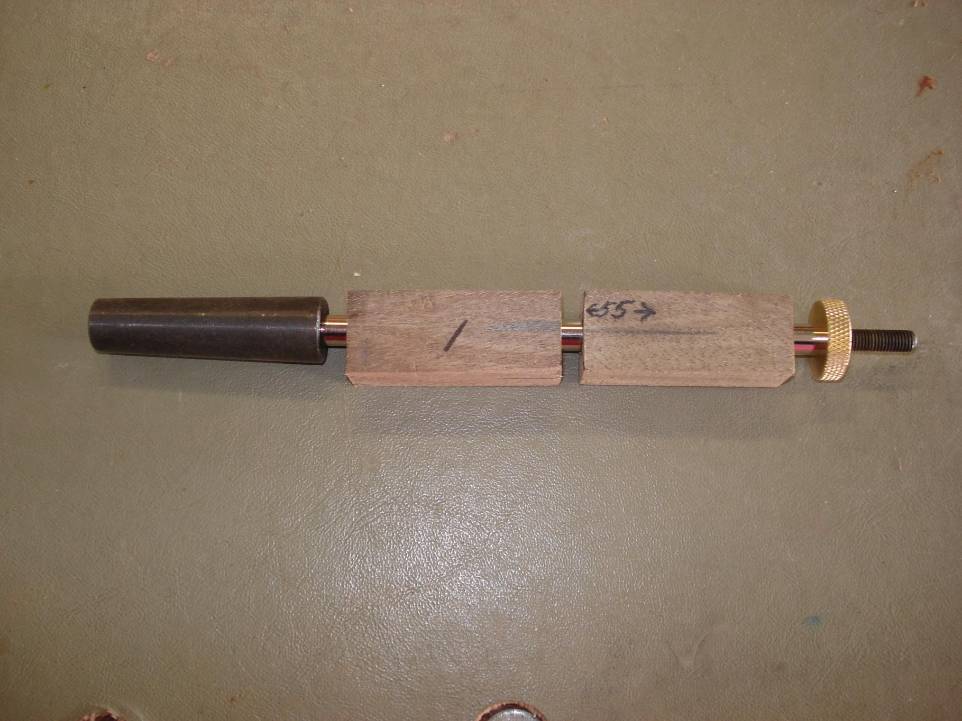
Figure 10. Original guide arrangement: preserve the paired grain while checking the actual bush order and secure mounting.
A pen mandrel supports the prepared bodies around the intended turning axis. Before assembly, compare its components with the supplied kit and current guide, and check that the mandrel is straight and clean. Keep the mounting parts together in a clean area. A missing, damaged or uncertain component needs identification before it is placed into the arrangement.
The older website calls the three spacers collets and the fastener a brass thumb screw. The updated guide calls them bushes and a brass nut. Use the current guide and actual kit to confirm the names and order rather than assuming every mandrel uses the same components. Counting three spacers in the supplied example does not establish a universal schedule.
The updated guide says to fit the bushes in the correct kit order, then mount the first blank, centre bush and second blank with the witness line matched. That restores the grain relationship recorded before cutting. Check that the pieces have not been reversed, rotated out of relationship or mixed with another pair. Grain alignment is a visual quality check; it does not replace secure mounting.
Tighten only enough to prevent slipping, as the guide directs, and do not overtighten the brass nut. The teacher checks bush order and secure mounting before operation. No torque, spacing or machine setting is supplied by this page. Record the identified components, corresponding grain references and actual teacher checkpoint to show that the arrangement was checked, not merely assembled.
Worked example · hypothetical
All expected spacers are present, but a barrel’s witness line is reversed. The inventory checks only one condition. Resolve the grain arrangement before requesting the complete mounting check.

Explain why counting the mounting parts is insufficient evidence that the setup is ready to start.

Make the pre start check deliberate
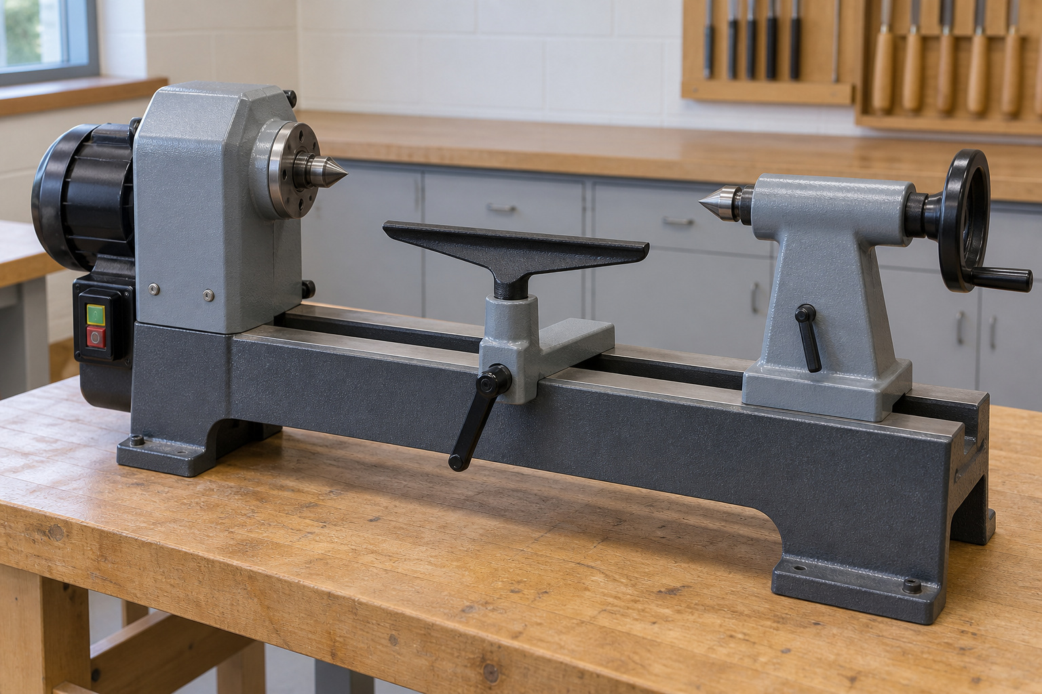
Figure 11. A machine overview helps identify areas to check; the school procedure controls their actual setup and use. Illustrative scene.
A pre start check confirms that the machine, workholding, area and operator are ready for the authorised task. Previous use does not guarantee current readiness: equipment may have moved and parts may be incorrectly assembled. Begin inspection and adjustment with isolation as required by the school procedure. Stationary means not moving; it does not prove the machine cannot start.
Compare the approved mounting with the kit and demonstration. Check for visible looseness, damage, uncertain gaps and the required grain relationship. Verify guards, tool rest condition and clearance. The guide calls for the rest close to the work and a manual rotation check before starting; perform that check only while isolated and permitted by the local procedure. Stop if anything contacts, binds or appears abnormal.
Remove keys and loose items, secure hair and clothing, and manage jewellery and personal items under the SOP. Keep the area organised and wear the directed protection. Use only the teacher directed speed. Teacher approval confirms the complete setup; a photograph records a condition but cannot authorise it.
Task changes require new checks. Stop before measuring, adjusting the work or moving the rest. Where sanding is the approved next lathe process, stop and isolate before the required tool rest removal; the rest must not create a contact or trapping hazard. Follow the local sanding and dust control procedure. Record any concern, the decision to stop and the teacher directed outcome so the checkpoint is traceable.
Worked example · hypothetical
The work is stationary, but isolation has not been confirmed. A student should not begin adjusting the rest on that evidence alone. The safe next step is to follow the isolation procedure and obtain the required check.

Explain why “the lathe has stopped” and “the lathe is isolated for adjustment” are different statements.

Topic 4 · Check and apply
Choose one answer for each question. Use the readings to justify your choice. These questions retain the website wording and option order.
1 What is the strongest next action when applying "Understanding between-centres turning and the approved Pen mandrel"?
○ A. Act before checking the approved source.
○ B. Follow the approved Pen mandrel process, align the grain reference and obtain teacher approval before and during turning.
○ C. Wait until the final lesson to inspect the result.
○ D. Copy another student without checking the approved resource.

2 Which evidence would best demonstrate this learning in the Pen folio?
○ A. An unrelated internet image with no caption.
○ B. A final photo that hides the relevant detail.
○ C. A copied definition with no Pen example.
○ D. Photograph the clean staged components, the three collets and brass thumb screw, aligned timber parts and completed teacher checkpoint.

3 What is the strongest next action when applying "Lathe pre-start checks and secure approved workholding"?
○ A. Act before checking the approved source.
○ B. Isolate, inspect all required controls, confirm workholding and obtain teacher approval before starting.
○ C. Wait until the final lesson to inspect the result.
○ D. Copy another student without checking the approved resource.

At pre start you notice an unexplained gap and a grain line that no longer matches. Record your decision, who must check it and what would count as evidence of a resolved problem.

Move from square to cylinder
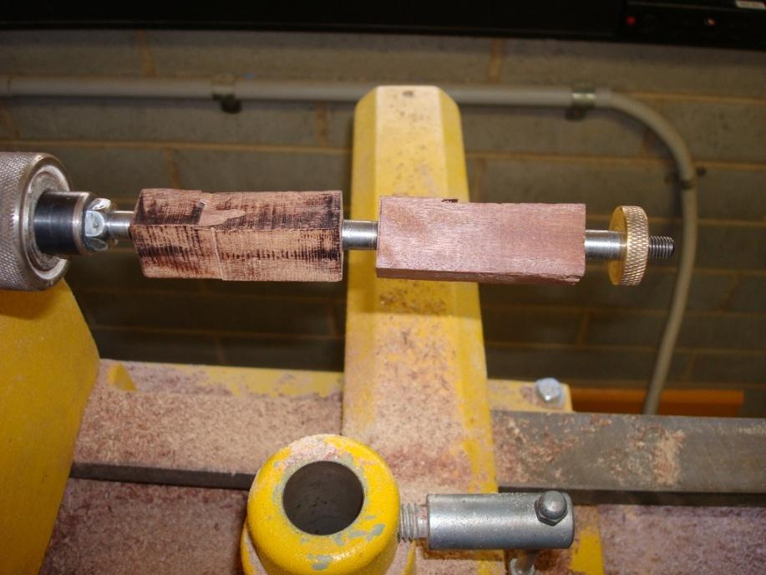
Figure 12. Progressive forms show the concept of controlled removal; the approved method governs the actual turning. Original guide photograph, page 10.
The square blank begins with flat faces and projecting corners. Turning gradually removes material around the central axis until the surface becomes cylindrical. The aim is an even, controlled form, not the fastest removal. The guide calls for roughing the square pieces to cylinders before refining the barrels, with the teacher demonstration controlling each practical action.
The corners do not disappear simultaneously. At an early approved checkpoint, remaining flats or corners show that the form is still developing; later, the outline becomes more continuous. Judge progress from the actual form and teacher directed checks rather than time spent on the machine. Gradual removal creates opportunities to detect uneven areas before too much timber is lost.
Symmetry means balance around the intended axis. Compare the two bodies as related parts of one pen, while retaining the grain relationship. Their visible figure may change as flat faces become rounded and different fibres appear at the surface. This natural change is worth recording; it is not a reason to lose track of the marked pair or guess a final profile.
Use a check–decide–act cycle at approved stops. Describe the current form, compare it with the guide and decide the next permitted action with the teacher. Stop for uneven form, uncertain alignment or abnormal movement, sound or surface condition. Record square, intermediate and cylindrical stages at safe checkpoints, explaining what changed and why the next decision followed.
Worked example · hypothetical
One body is rounded while a flat remains on the other. Record the difference and seek the next controlled step. Removing extra timber from the first merely to keep working could damage the balance.

Explain why the disappearance of corners is better evidence of progress than the number of minutes spent turning.

Notice how the tool action changes the surface
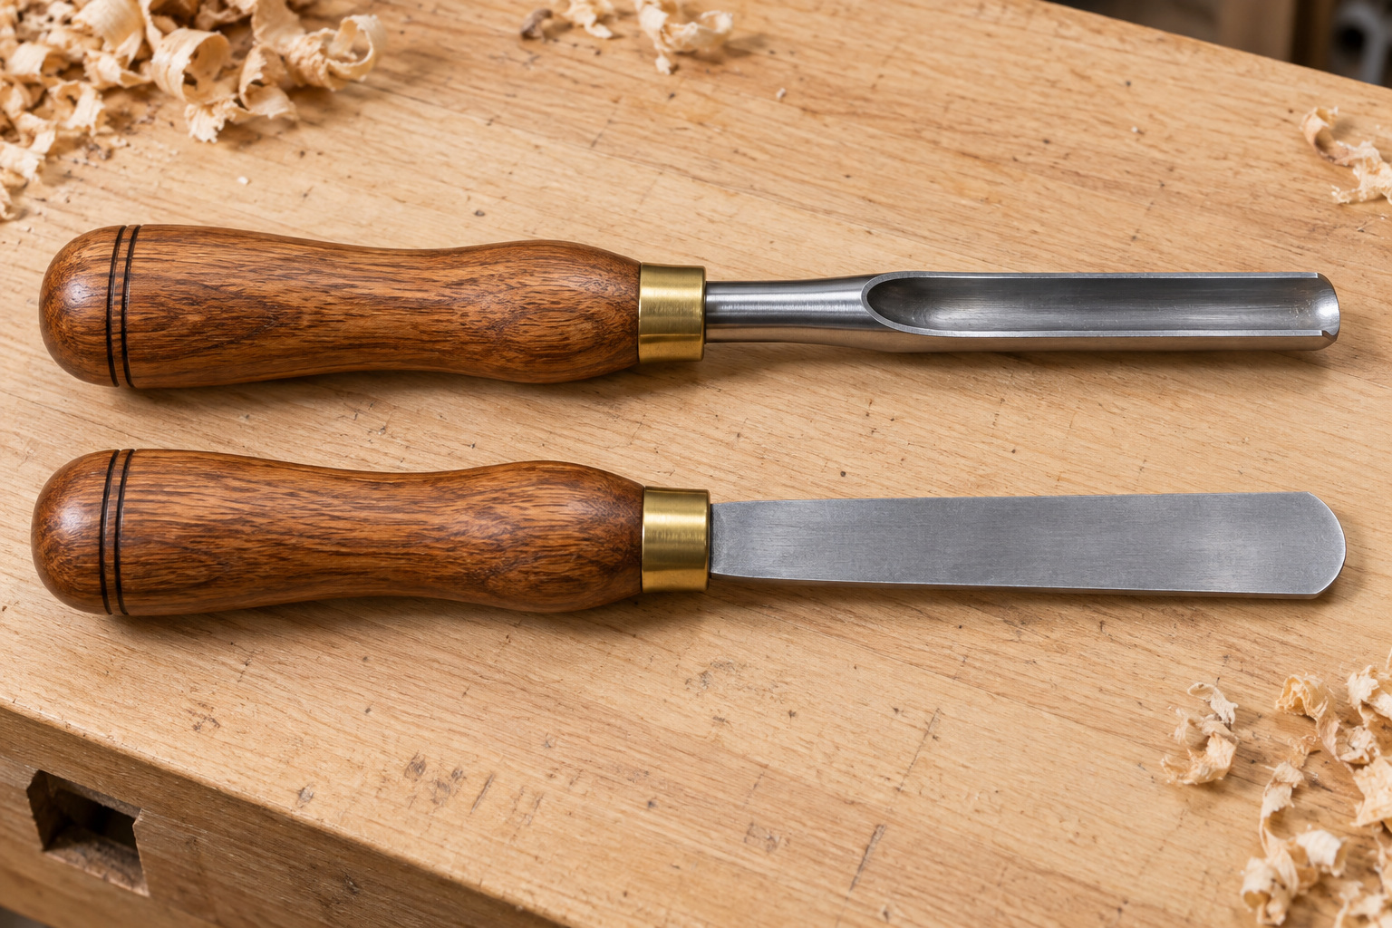
Figure 13. Tool forms support discussion of different actions; the teacher demonstrates the tool and presentation for this task. Illustrative scene.
Cutting and scraping both remove timber, but the actions contact and separate fibres differently. A controlled cutting action can leave a cleaner, more continuous surface when the approved presentation and timber response are suitable. Scraping uses a different contact action and may remove small amounts for refinement where the teacher permits it. Neither action is automatically best for every stage or piece of timber.
Tool presentation is how the tool meets the rotating work. Small changes can affect engagement, material removal and surface condition. The demonstration and school procedure determine the tool, support, presentation and body position. A printed explanation or photograph does not supply a safe angle, grip, speed or feed to copy.
Observe the developing form and the timber’s response. Torn fibres, raised grain, ridges or an uneven area provide information about the result, but do not prove the cause by themselves. Report unexpected behaviour and stop for teacher inspection before changing the method. Continuing because a familiar action worked earlier can repeat a fault under different conditions.
Each permitted pass should have a defined purpose, such as continuing the move towards a cylinder or refining an identified area. Avoid repeatedly chasing a mark without a diagnosis: extra removal may flatten a region or unbalance the paired bodies. Folio evidence should describe the authorised action, observed surface, checkpoint and decision, showing the reasoning behind the result.
Worked example · hypothetical
A surface becomes rougher after an action that previously gave a clean result. The maker describes the changed surface and stops. “Scraping is always better” would be an unsupported conclusion; the cause and next method need checking.

Why is “cutting is always better than scraping” an unreliable rule for this project?

Check the profile before removing more
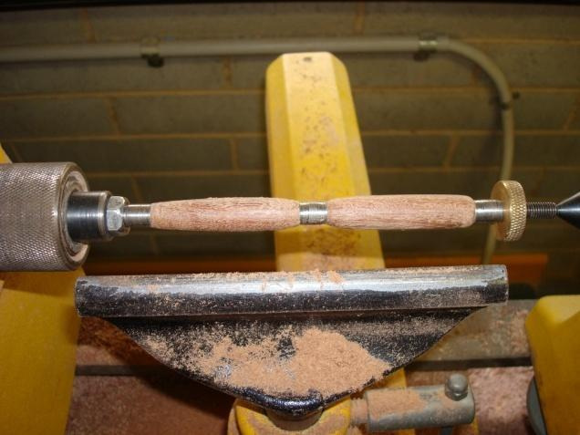
Figure 14. Original source bodies provide a profile reference; use the actual kit and approved checks for the final dimensions.
Profile is the outline of the developing timber body. It includes fullness, changes in form and the transitions into the kit components. The updated guide calls for both barrels to be refined evenly, checked from several angles and finished to the bush diameters. The actual kit determines those diameters; the guide’s words do not authorise estimating them from a photograph.
Check balance across the pair rather than inspecting only the most attractive side. The guide warns against a fat centre or thin ends. An uneven area, remaining flat or abrupt transition should prompt comparison with the agreed design and the kit reference. More material removal is useful only when it addresses an identified need within those constraints.
Alignment carries the earlier reference work forward. The two bodies should retain the intended grain relationship as their form changes. If their order or orientation becomes uncertain, stop before further removal makes the relationship harder to recover. A smooth surface can still belong to a poorly matched pair, so appearance, alignment and profile require distinct checks.
Timber removed cannot be restored. Use check–decide–act: inspect at an approved stop, decide what needs to change against the reference, then undertake only the authorised response. Record the observation and decision in the folio, including an honest stop for uncertainty. Several modest, justified decisions provide stronger evidence of control than one uninterrupted account that says only “I finished turning”.
Worked example · hypothetical
A barrel looks smooth, but one end appears over reduced beside its kit transition. Smoothness does not repair size. Report the observation rather than sanding or turning the other body to match the fault.

Name two separate checks needed when a barrel surface looks smooth. Explain what each check reveals.

Topic 5 · Check and apply
Choose one answer for each question. Use the readings to justify your choice. These questions retain the website wording and option order.
1 What is the strongest next action when applying "From square blank to controlled cylindrical form"?
○ A. Act before checking the approved source.
○ B. Follow the approved process, pause at checkpoints and compare both Pen bodies before further material is removed.
○ C. Wait until the final lesson to inspect the result.
○ D. Copy another student without checking the approved resource.

2 Which evidence would best demonstrate this learning in the Pen folio?
○ A. An unrelated internet image with no caption.
○ B. A final photo that hides the relevant detail.
○ C. A copied definition with no Pen example.
○ D. Use checkpoint photos and notes to show observed surface changes, teacher checks and decisions made during Pen turning.

3 What is the strongest next action when applying "Monitoring profile, alignment and material removal against approved kit references"?
○ A. Act before checking the approved source.
○ B. Pause regularly to compare the work with approved references and seek teacher approval before further material removal.
○ C. Wait until the final lesson to inspect the result.
○ D. Copy another student without checking the approved resource.

Complete the reasoning chain: I notice an uneven area → I check… → I decide… → I record… . Explain why another unplanned cut could make it worse.

Read the surface before sanding
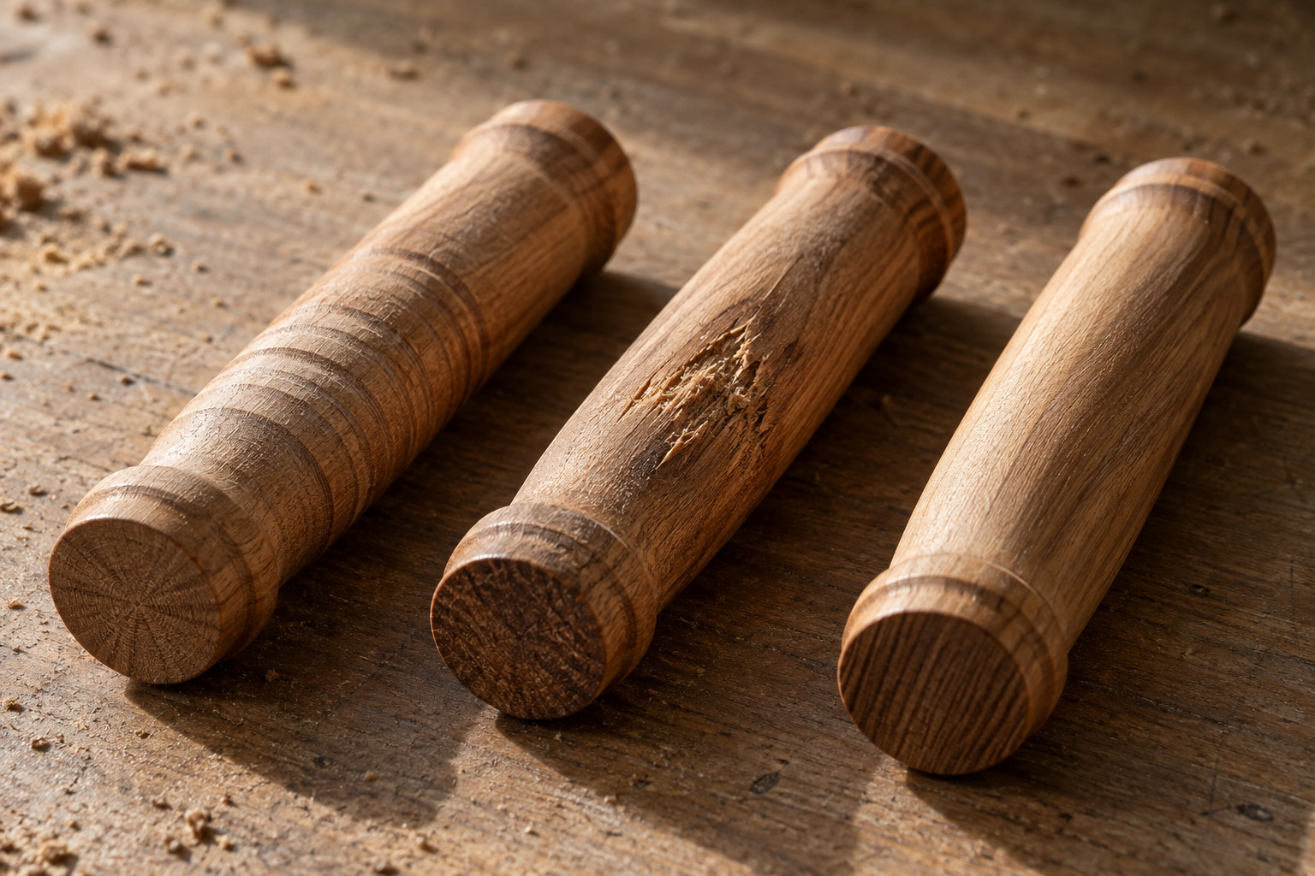
Figure 15. Surface inspection: compare a visible feature with the surrounding form before deciding what it means. Illustrative scene.

Surface inspection is a decision point between turning and sanding. A tool mark is a track left by an earlier cutting action; torn fibres look broken or lifted; a ridge is a raised band beside a lower area. These observations describe what is visible. They do not, by themselves, prove why it happened. Naming a possible cause as a certainty can send the next correction in the wrong direction.
Stop and make the work safe for inspection under the workshop procedure. Examine both bodies in suitable light from several angles. Angled light can reveal shallow ridges through their shadows. Clear dust by the approved method so it does not disguise the surface. Compare the profile, grain relationship and transitions with the agreed design and kit references, rather than judging by colour or shine.

Use stop–check–decide: identify the feature, discuss its likely cause, then agree whether to progress or make a limited correction. Sanding refines a controlled surface; it cannot restore timber already removed. Chasing one mark may flatten the profile or create a mismatch with the other body. A useful folio record shows the original condition, the approved decision and the result of reinspection. If no correction was needed, explain the evidence for that decision.
Worked example · hypothetical
A dark band remains visible when a barrel is viewed from several angles. The maker records “dark band near the centre”, rather than “the tool was blunt”. Teacher inspection then determines the cause and the permitted response.

A narrow scratch remains beside an otherwise even profile. State what you can observe, one uncertain cause, and the next check before removing timber.

Refine in stages
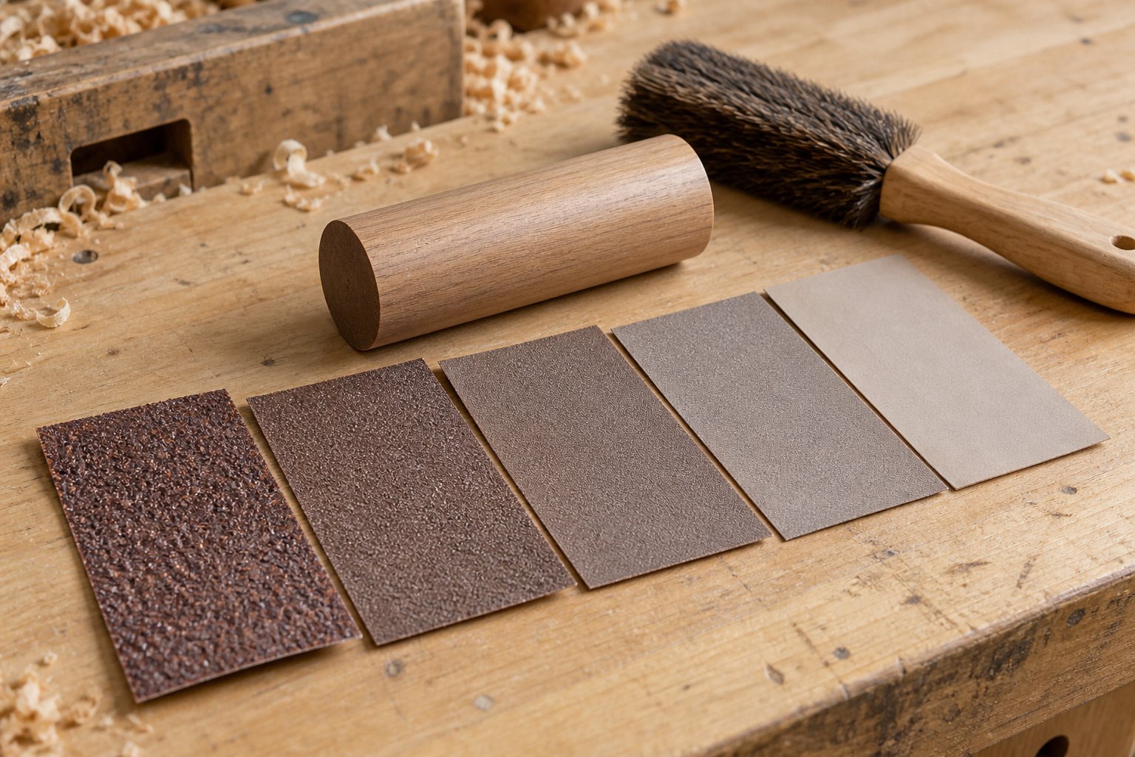
Figure 16. Approved abrasives are a sequence of refinement, with a stopped inspection between stages. Illustrative scene.

An abrasive removes small amounts of material through its cutting particles. A progressive sequence moves through the approved stages so that each refines the marks left by the previous one. Earlier stages address the surface condition that remains after accepted turning; later stages make those marks finer and more consistent. Skipping ahead may leave earlier scratches visible even after lengthy work with a finer abrasive.
The updated guide requires the lathe to be stopped between abrasive grades. Follow the actual sequence and method demonstrated for this pen; the book does not assign grit numbers. Inspect between stages after the approved dust clearing step. Look for remaining lines, uneven areas and consistency across both bodies. A surface that appears smooth at one angle may still show marks under different lighting.

Refinement should preserve the shape already achieved. Keep the end faces crisp and avoid rounding the ends, because the finished components must meet cleanly. Extra sanding can change the diameter, weaken a transition or make paired bodies look uneven. Keep heat low using the approved process and use the required dust controls. Respiratory protection, where specified, is one layer of that system; it does not replace control of dust at its source.
Worked example · hypothetical
One barrel looks uniform; the other still shows earlier lines. Advancing both merely to stay together would preserve the defect. The maker pauses, identifies which stage needs review and seeks the approved response before continuing.

Explain why “use the finest abrasive for twice as long” may fail to remove an earlier scratch and may harm the pen profile.

Choose a finish from evidence
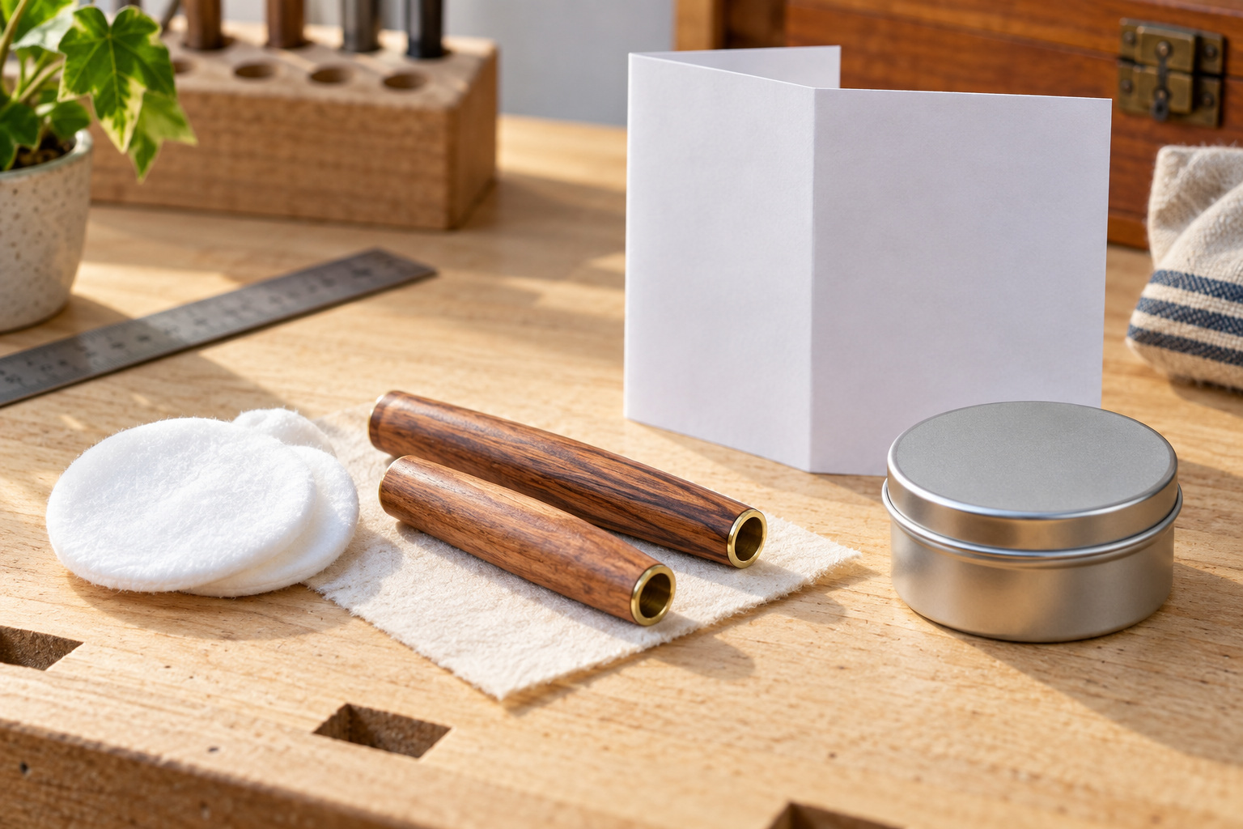
Figure 17. Finishing decisions begin with the actual product information and a prepared, inspected surface. Illustrative scene.

A finish is selected for its suitability to the prepared timber and the intended use of the pen. Compatibility means that the materials work together as expected. Two containers labelled “wood finish” may require different preparation, controls or handling. Similar appearance is therefore insufficient reason to substitute or mix products. Use the actual product approved for the project.
Read the sources together. The label identifies the product, intended use and application information. The Safety Data Sheet (SDS) explains hazards and protective measures. The school standard operating procedure (SOP) gives local requirements, while the demonstration shows their practical application. Unclear or conflicting information needs a teacher decision before use. Quantities, coats, timings and application methods come from these verified sources.

Check surface readiness first: remaining scratches, torn fibres, dust or contamination may become more obvious after finishing. Then protect the prepared bodies from dust and contact during the approved process. Curing is the product reaching its required condition; a glossy or apparently dry surface may not yet be ready to handle. Record the permitted handling checkpoint and judge evenness, clean appearance and intended protection. Do not treat shine as proof that the finish is fully cured or durable.
Worked example · hypothetical
A sample looks glossy, but a handling check has not been completed. “Looks ready” is a visual observation. Permission to assemble depends on the product information and the teacher directed curing and handling check.

Identify two sources you would consult before using the finish. Explain the different question each source answers.

Surface and finish check
Surface diagnosis
1 What is the strongest next action when applying "Diagnosing tool marks and surface defects before sanding"?
○ A. Act before checking the approved source.
○ B. Stop, inspect under suitable lighting, describe the defect and seek teacher approval before any correction or sanding.
○ C. Wait until the final lesson to inspect the result.
○ D. Copy another student without checking the approved resource.

Progressive abrasives
2 What is the strongest next action when applying "Using a progressive approved abrasive sequence"?
○ A. Act before checking the approved source.
○ B. Follow the approved sequence, inspect between stages and stop when the intended surface condition is achieved with teacher approval.
○ C. Wait until the final lesson to inspect the result.
○ D. Copy another student without checking the approved resource.

Approved finishing
3 Which evidence would best demonstrate this learning in the Pen folio?
○ A. An unrelated internet image with no caption.
○ B. A final photo that hides the relevant detail.
○ C. A copied definition with no Pen example.
○ D. Provide before-and-after photos with notes on product identification, surface checks, teacher approval and final appearance and protection.

Sequence repair: a student writes “finish → inspect → jump to finest abrasive → assemble”. Rewrite this as four sensible stages, including a condition that must be met before assembly.

Keep one complete kit together
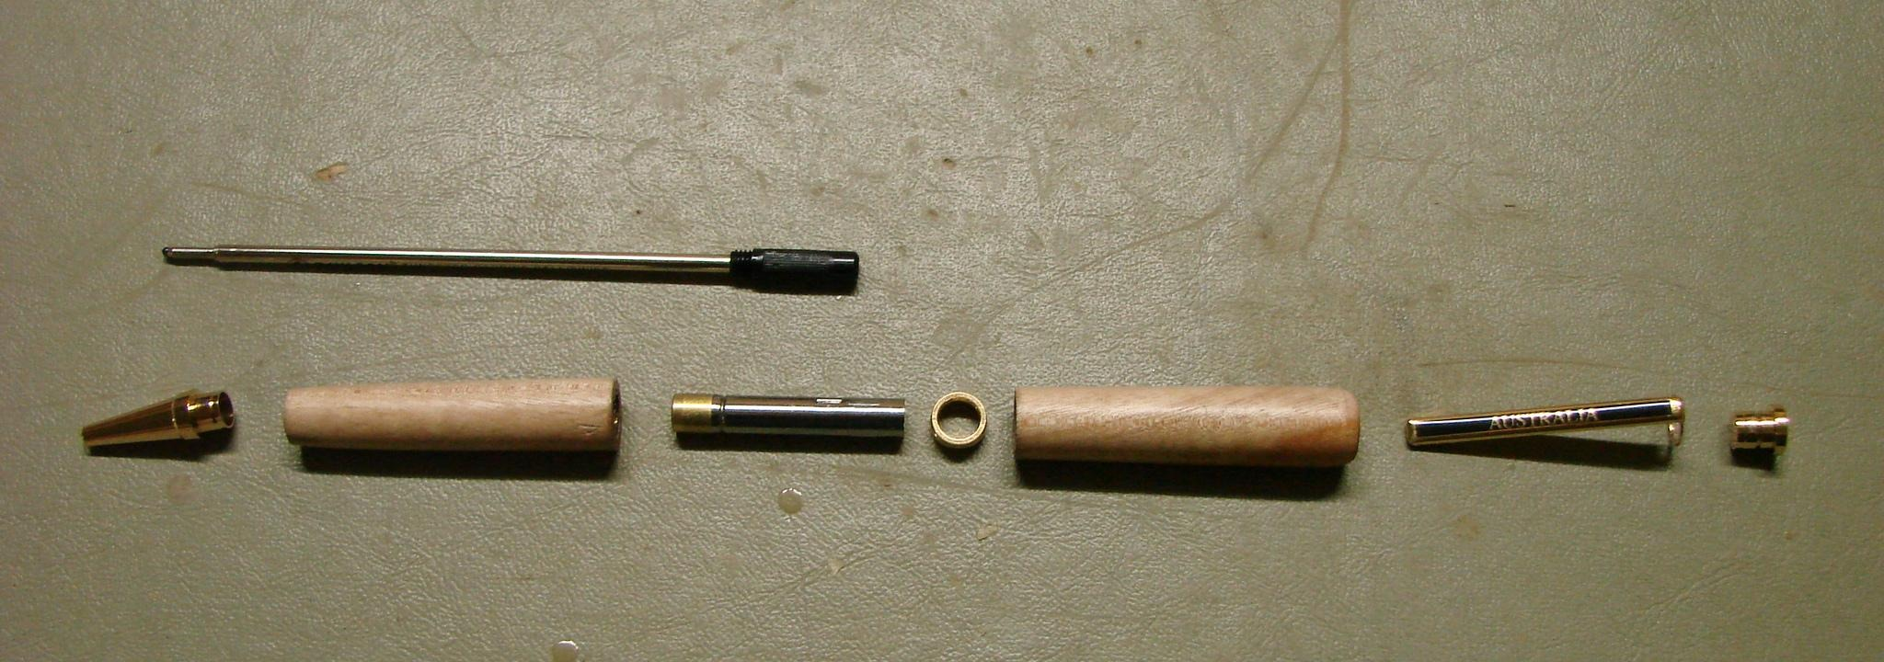
Figure 18. Original source photograph: identify the pictured components against the current guide and your supplied kit.
Assembly preparation starts with an inventory: identify the actual parts, their condition and their relationship to one matched kit. Counting pieces is only the beginning. A similar looking component from another kit may have a different fit or purpose. Keep the kit identification with its components and preserve the two timber bodies as a pair.
The updated guide names the clip, cap, nib and twist mechanism. Older website sections use clip/button and nib shroud. These labels should prompt a comparison with the supplied kit instructions; do not assume that different names prove interchangeable parts. Lay out every component in the order required by the current guide and kit. Confirm the upper and lower barrels against their witness line before using the pen press.
A clean staging area makes that check visible. Remove unrelated parts, dust and unnecessary tools. Protect the finished timber from scratches and inspect it in suitable light. Check for a missing, damaged, bent or uncertain component before any joining begins. Preserve the arrangement and report a problem instead of swapping or modifying the part. Pressed components can be difficult to reverse, so preparation prevents damage that later inspection may be unable to fix.
Record the inventory with a clear overall view and a caption explaining what you checked. A photograph of loose pieces becomes evidence when it identifies the matched kit, the paired bodies, the orientation check and any uncertainty resolved before assembly.
Two visually similar metal parts are found in the staging area, but one has lost its kit label. Explain how you would resolve the uncertainty before assembly.

Press squarely and protect the timber
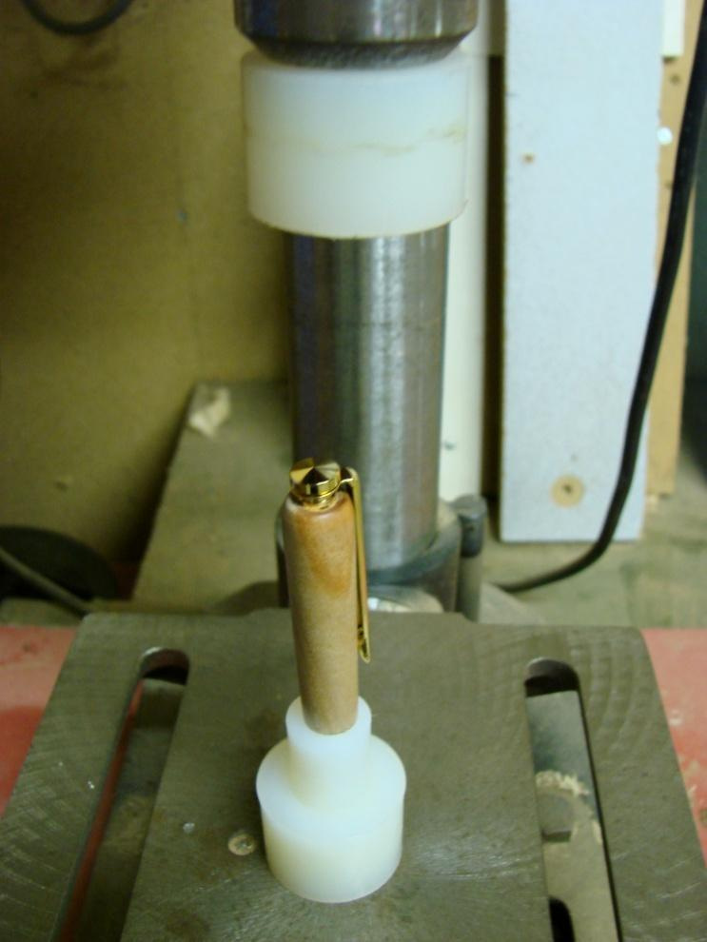
Figure 19. Original guide, page 14: the clip and cap stage. The current kit instructions control local setup.
Mating parts are components designed to meet in a particular relationship. Before pressing, identify those parts and confirm their orientation using the current kit instructions. The component and barrel must share their intended centre line. A part that begins at an angle can load one side first, damage the contact area or leave a visible gap.
The updated guide shows the cap passing through the clip, then the combined assembly being pressed squarely into the upper barrel. It says to stop as soon as the shoulder seats. The shoulder is the part’s locating edge that meets the barrel at the joint. For the lower barrel, the guide places the nib assembly squarely in the press and brings its shoulder firmly against the timber. Support the barrel through the approved arrangement to protect the finish.
This sequence explains the supplied guide; your kit and teacher demonstration control the actual setup. The older website calls this the clip/button and nib shroud stage. Verify those names against the components in front of you. Do not improvise a support, pressing force or reversal method from the photograph.
Watch alignment throughout controlled progress. If a body shifts, a component tilts or resistance changes unexpectedly, stop for inspection. More force may enlarge the damage while hiding its cause. Compare the seated joint with the approved reference for straightness, gaps and surface marks, and record the result. An attached component is acceptable only when its fit and condition meet the required check.
A cap begins to enter at an angle and resistance rises. Name the observation and explain why applying extra pressure is the wrong response.

Test as the mechanism advances
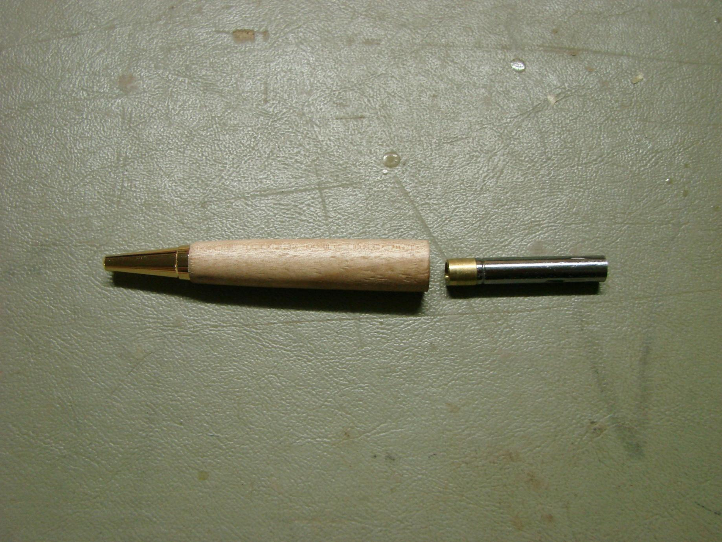
Figure 20. Original guide, page 16: fit the mechanism incrementally and check the refill extension as instructed.
Preventing damage depends on more than a straight initial setup. Contact surfaces must remain clean, the matched barrels must retain their intended grain relationship, and the supports must protect the finish. Axial alignment means the parts meet along their intended centre line. A slight tilt, trapped residue or shifted support can change how the parts seat.
The updated guide makes controlled progression especially clear when fitting the twist mechanism. Press it into the lower barrel in small increments, check the refill extension as you go, and stop at the kit’s correct depth. The depth comes from the kit; the book supplies no substitute measurement. Each test creates an opportunity to stop before an irreversible overpress.
The guide then joins the barrels with the centre band and aligned grain, fits the refill and tests the twist action. Check smooth operation, even tight joins and the absence of gaps or scratches against the approved example. Visual inspection and functional testing answer different questions: a pen may look aligned yet still have incorrect refill extension.
If the mechanism resists unexpectedly or the test result is wrong, stop and describe the symptom before proposing a cause. Misalignment, contamination, incorrect identification or damage are possibilities, not automatic diagnoses. Keep an honest checkpoint record showing what was observed and the teacher directed decision. A controlled stop is evidence of judgement, even when the assembly cannot be completed immediately.
Explain why a smooth looking joint cannot replace the refill extension check while the twist mechanism is being fitted.

Assembly decisions
Matched kit inventory
1 What is the strongest next action when applying "Identifying and staging the Pen kit components for assembly"?
○ A. Act before checking the approved source.
○ B. Compare the staged timber bodies, clip/button and nib shroud with the approved resource and stop for any uncertainty.
○ C. Wait until the final lesson to inspect the result.
○ D. Copy another student without checking the approved resource.

Clip, cap and nib assembly
2 What is the strongest next action when applying "Assembling the clip/button and nib shroud in the approved sequence"?
○ A. Act before checking the approved source.
○ B. Follow the kit resource and teacher demonstration, support the finished bodies and stop whenever alignment or resistance is uncertain.
○ C. Wait until the final lesson to inspect the result.
○ D. Copy another student without checking the approved resource.

Preventing assembly damage
3 Which evidence would best demonstrate this learning in the Pen folio?
○ A. An unrelated internet image with no caption.
○ B. A final photo that hides the relevant detail.
○ C. A copied definition with no Pen example.
○ D. Record clean staging, alignment checks, teacher approvals and any stop-and-report decisions that prevented damage.

Decision note: after a small mechanism adjustment, the refill test is still uncertain. Write a two sentence workshop note stating the observation and the next authorised decision.

Design for the hand and the eye
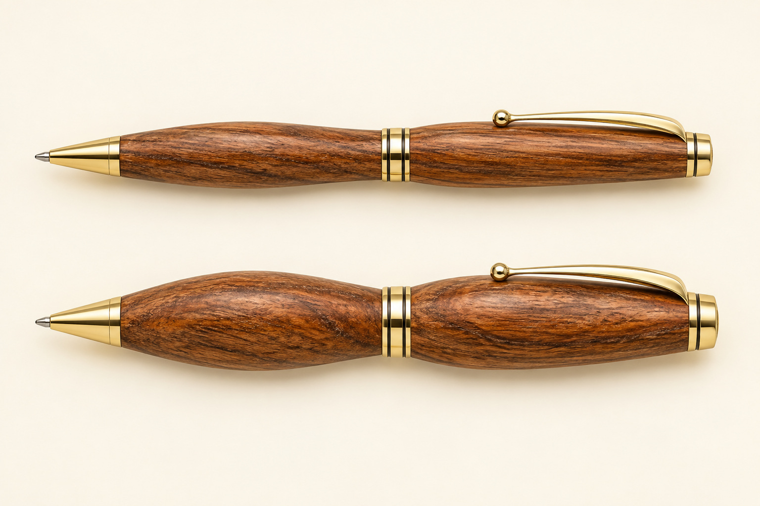
Figure 21. Concept profiles invite comparison of balance and transitions; the kit sets the construction limits.
A pen profile is the outline of its timber bodies, including changes in fullness and the transitions into the kit components. Its success depends on function, appearance and the fixed requirements of the kit. A dramatic shape can be visually interesting yet awkward to hold or poorly connected to its components. Explore possibilities in sketches while changes are still reversible.
Ergonomics considers the relationship between a product and its user. For a pen, grip, control and comfort matter. Hand sizes and writing habits vary, so one person’s favourable comment does not prove universal comfort. A useful user observation names the person’s experience and the part of the profile involved, such as a transition that feels abrupt.
Visual proportion concerns how the apparent weight and size of one area relate to another. Compare both barrels together and with the kit. A centre that looks too heavy, thin looking ends or an uneven transition may weaken the overall design. Also consider grain continuity: the paired bodies were marked and kept in order so their figure can read as a connected material.
Select a feasible profile with teacher guidance, then compare the developing form with that intention at approved checkpoints. Removed timber cannot be put back. Record both design reasoning and the final user response; the evaluation should explain where the intended comfort, balance and grain relationship were achieved and where a limitation remains.
Worked example · hypothetical
A maker prefers a fuller grip in a sketch but checks the kit transitions and asks for a handling judgement after completion. “One user found the grip easy to control” is a defensible conclusion; “comfortable for everyone” is not.

Choose one profile feature you would compare before turning. Explain how you would judge its appearance and its effect on use.

Build quality into the process

Figure 22. Production equipment illustrates a wider manufacturing context; verified setup and quality checks still matter.
A standard is a reference used to judge whether work is acceptable. Here, project criteria come from the guide, supplied kit, product information, teacher demonstration and workshop procedure. These school project expectations are not automatically a named Australian Standard or an industrial certification. Do not claim compliance with an external standard that has not been identified and verified.
Quality control means planned checks against those references. It starts with sound timber, clear grain marks and secure, approved preparation. Later checkpoints check clean brass tube preparation, aligned mounting, controlled profile development, surface readiness, finishing and component assembly. The appropriate cutting or scraping action depends on the demonstrated process, stage and material response; it is not selected merely because it is familiar.
Consistency means applying the same criterion to both bodies and at each relevant stage. Traceability means another person can follow the record: stage, criterion, observation, decision, checkpoint and evidence reference. “Looked fine” is weak because it hides the criterion. “Both grain references corresponded before mounting; the teacher checked the arrangement” is more useful when supported by an actual record.
Final inspection remains necessary, but it cannot replace timber removed too early or restore a lost grain reference. Repeated check–decide–act cycles help prevent faults from passing into later work. The same principle matters in larger production systems: repeatability depends on verified setup and continuing quality checks, even when machines make the process appear highly consistent.
Improve the quality record “I checked it and it was good” by naming a pen stage, a criterion and an observation that could be recorded.

Compare ways of making
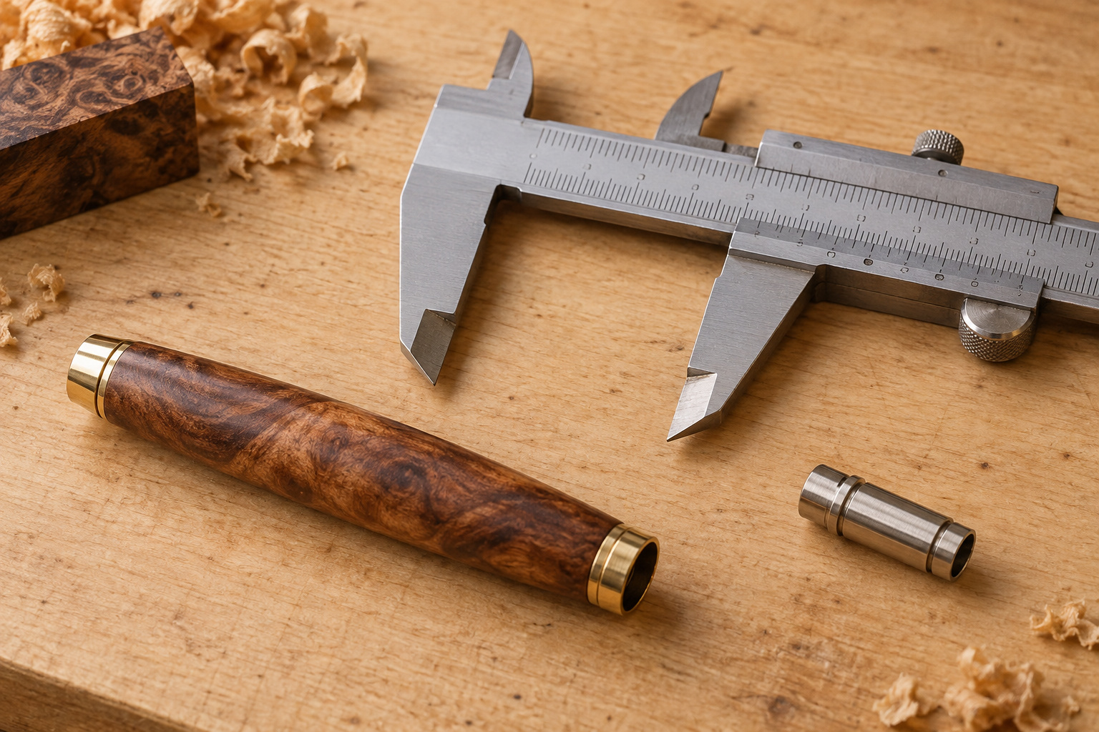
Figure 23. Inspection connects different production methods: a repeated process still needs a verified result. Illustrative scene.
Skilled handcraft places many decisions with the maker. In this project, the student responds to the timber’s grain, checks the evolving profile and makes controlled decisions under supervision. This flexibility helps when natural material varies. It also means that inconsistent judgement can produce variation between parts.
Jigs and workholding support repeatable conditions. A jig generally helps guide a process; a fixture or workholding device locates or secures the work. The approved mandrel supports and positions the pen bodies for turning. Its purpose is to assist control, not to replace correct setup, observation or teacher checkpoints. A support used incorrectly can repeat the same fault.
Larger scale repeat production may use standardised inputs, specialised fixtures, programmed operations or monitoring to reduce variation across many items. These are comparison examples, not extra school workshop procedures. The initial setup must be accurate, and people remain responsible for supervising results and responding when material or conditions change.
Compare approaches using the same criteria: control, consistency, adaptability and responsibility. Handcraft is responsive to individual material but depends heavily on judgement. Workholding stabilises selected conditions but still needs checking. Repeat production can be consistent at scale, yet a poor initial setup can reproduce errors. None removes the need for inspection. Record a real example from your project and keep industrial comparisons clearly identified as conceptual.
Worked example · hypothetical
A mandrel helps keep a pair supported in a repeatable arrangement. The maker must still check grain order and the developing form. The support controls part of the process; it does not decide whether the design is resolved.

Name one condition controlled by approved workholding and one decision that still belongs to the maker and teacher.

Design and production check
Profile design
1 What is the strongest next action when applying "Designing a comfortable and visually resolved Pen profile within kit constraints"?
○ A. Act before checking the approved source.
○ B. Compare profile sketches, check feasibility with the teacher and monitor the developing form against the selected design.
○ C. Wait until the final lesson to inspect the result.
○ D. Copy another student without checking the approved resource.

Quality checkpoints
2 What is the strongest next action when applying "Standards, quality control and production techniques in Pen manufacture"?
○ A. Act before checking the approved source.
○ B. Use a check–decide–act cycle at each Pen stage and obtain teacher approval whenever the result is uncertain.
○ C. Wait until the final lesson to inspect the result.
○ D. Copy another student without checking the approved resource.

Production methods
3 Which evidence would best demonstrate this learning in the Pen folio?
○ A. An unrelated internet image with no caption.
○ B. A final photo that hides the relevant detail.
○ C. A copied definition with no Pen example.
○ D. Create a comparison table showing handcraft, jigs and repeat production in terms of control, consistency, adaptability and responsibility, supported by examples from the Pen project.

Comparison in three lines: explain how handcraft, approved workholding and repeat production each support consistency, then identify one responsibility shared by all three.

Write a WMS that guides work
A Work Method Statement (WMS) connects the real project sequence with its hazards, controls and checkpoints. “Make the pen safely” is too broad to guide a decision. A useful row identifies a particular stage, such as preparing the drilling setup or checking work before the lathe starts. It follows the guide and current school procedure without adding guessed machine settings.
Use hazard–event–consequence thinking. The hazard is the source of possible harm; the event is what might happen; the consequence is the resulting injury, damage or exposure. This cause and effect chain helps choose a control that addresses the actual event. Writing “lathe: dangerous” names a machine but explains neither the event nor its prevention.
The hierarchy of controls asks whether the hazard can be eliminated, substituted, isolated or controlled through engineering before depending on administrative measures and personal protective equipment. The school’s approved equipment, workholding and isolation requirements supply the applicable measures. The WMS, instructions and supervision are administrative controls; PPE provides another layer. Exact local controls must be verified for the task.
Residual risk is what remains after the controls are applied. A checklist does not make that risk disappear or authorise work by itself. Record the teacher hold point and review the WMS when equipment, material, product or conditions change. The final evidence should show which listed controls were actually used, what changed and how the plan was updated.
Worked example · hypothetical
For a pre start check, rotating equipment is the hazard; a loose item becoming caught is the event; injury is the possible consequence. The response combines the approved pre start routine, secured hair and clothing, supervision and required protective measures. It is more specific than “be careful”.

For one pen stage, write a hazard, possible event and consequence. Name one relevant control and the source that must confirm it.

Map inputs, processes and outputs
A production flowchart explains how resources become results. Inputs include more than timber and the kit: approved information, student skill, teacher supervision, equipment and energy also enable the process. Identify only equipment and materials that apply to your project. A guessed input makes the production story less reliable.
Processes are the actions that transform those inputs. Use short action labels in the guide’s sequence: inspect and mark the blank; prepare the paired pieces and tubes; mount in grain order; turn; inspect and refine the surface; finish; stage and assemble the kit. A detailed chart can expand these stages, but should preserve the current guide’s order and its checks.
Outputs include the completed pen and evidence, as well as relevant offcuts, dust, swarf, packaging or other by products. Show where outputs arise rather than placing all waste in an unexplained final box. This helps connect an improvement, such as careful marking, with its possible effect on material loss.
A decision point turns a list into a useful control system. Ask whether the current criterion is met. A yes branch advances to the next approved stage; a no branch leads to inspection, consultation or a permitted correction and another check. Label both branches. A feedback loop must not send the student directly into an improvised repair. Verify the chart against the guide and explain one loop in your own words.
Worked example · hypothetical
Input: the turned bodies plus the approved abrasive information. Process: inspect and refine through the required stages. Outputs: an accepted prepared surface and generated dust. Decision: ready for finishing? No returns to teacher directed inspection; yes advances after the readiness checkpoint.

Choose one stage and identify a material or information input, its process, and two outputs: the intended result and one other output.

Explain benefits and trade offs
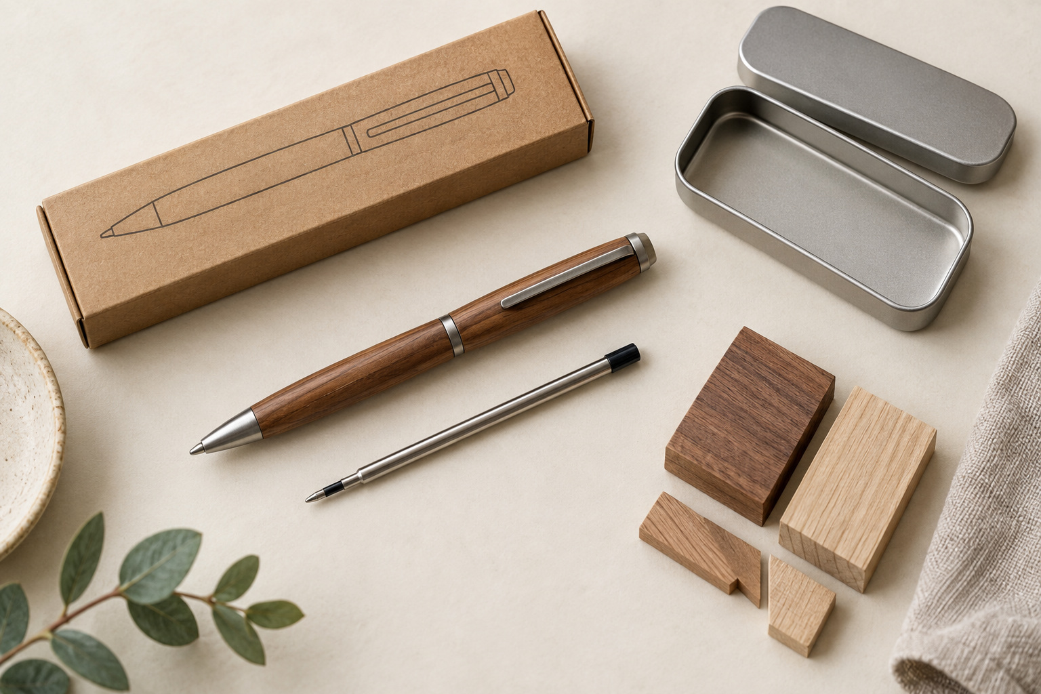
Figure 24. A small product still connects timber, kit components, finish, useful life and waste decisions. Illustrative scene.
An impact is an effect on people, resources or the environment. A timber pen is not automatically sustainable because it is small or handmade. Timber supply can involve land use, harvesting, processing and transport; the kit and finish have their own material and manufacturing histories. The actual source, species, composition and certification must be verified before making specific claims.
Some useful decisions are within the maker’s control. Careful selection and marking can reduce avoidable waste. A usable offcut is different from dust or contaminated waste, and recycling depends on what the school’s system accepts. Do not assume that all mixed timber, metal, plastic and finish can enter the same recovery stream.
Finishing creates a trade off. Correct use can support the intended appearance and protection, but the product also uses resources and may generate emissions or controlled waste. Use label and SDS information before making claims such as “non toxic” or “environmentally friendly”. Controlled application can reduce unnecessary product use without proving that its overall impact is low.
Social benefits may include writing usefulness, gift value and the skills developed through making. These sit alongside demands on supervision, shared equipment, time and resources. A longer useful life may reduce early replacement, but a lifespan cannot be claimed without evidence. Explain a benefit, its limitation and one realistic improvement rather than declaring the product entirely good or bad.
Worked example · hypothetical
“I kept a usable offcut” is a project observation. “Therefore this pen has no environmental impact” goes beyond it. A stronger judgement links that small saving to reduced avoidable waste while acknowledging unverified sourcing and other materials.

Write one project specific environmental claim you could support, then add the evidence and a limitation that keeps the claim accurate.

Plan and impact check
The Work Method Statement
1 Which evidence would best demonstrate this learning in the Pen folio?
○ A. An unrelated internet image with no caption.
○ B. A final photo that hides the relevant detail.
○ C. A copied definition with no Pen example.
○ D. Submit the completed WMS with dated checkpoints and records showing that the stated controls were actually used and reviewed.

Inputs, processes and outputs
2 What is the strongest next action when applying "Creating the Pen production flowchart: inputs, processes and outputs"?
○ A. Act before checking the approved source.
○ B. Map each approved Pen stage with its inputs, process, output, checkpoint and relevant impact, then verify the sequence with the teacher.
○ C. Wait until the final lesson to inspect the result.
○ D. Copy another student without checking the approved resource.

Social and environmental impacts
3 What is the strongest next action when applying "Explaining social and environmental impacts of Pen production and use"?
○ A. Act before checking the approved source.
○ B. Use the flowchart and project records to identify one social benefit, one environmental impact, one uncertainty and one realistic improvement.
○ C. Wait until the final lesson to inspect the result.
○ D. Copy another student without checking the approved resource.

Flowchart repair: “surface inspected → finish applied” has no decision. Add a yes/no readiness check and explain where the no branch should lead.

Photograph a decision, not just a result
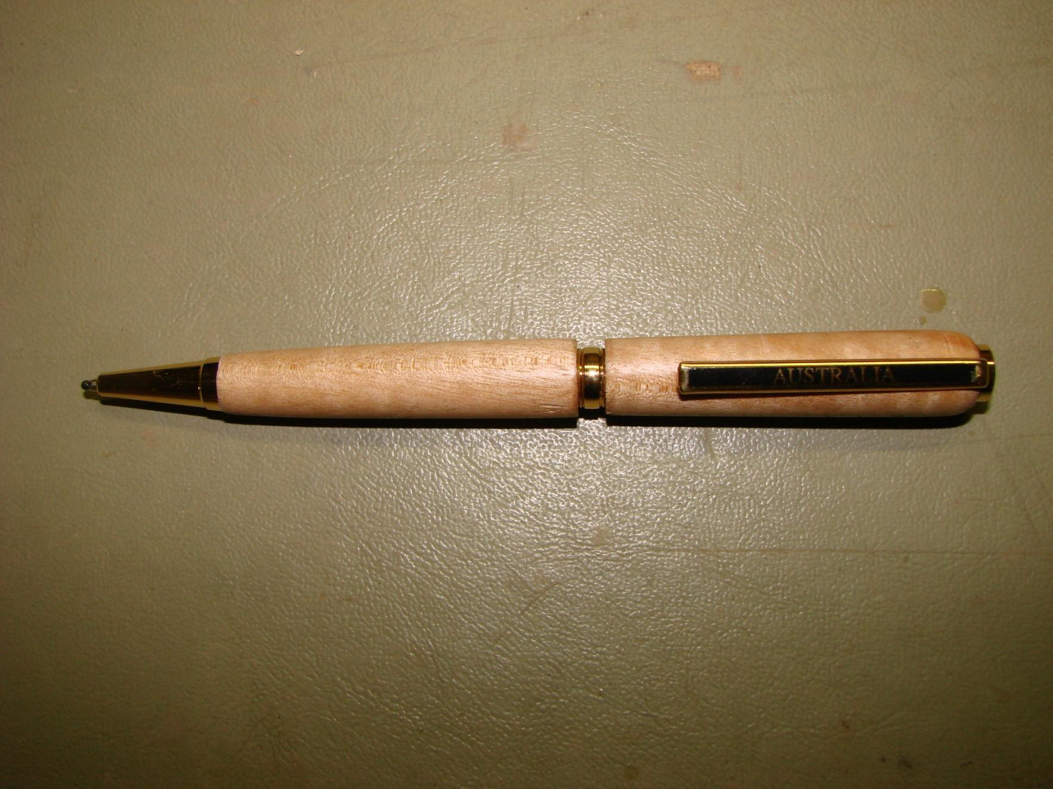
Figure 25. Original guide, page 18: a completed pen provides a final reference view, not evidence of your own process.
An attractive final photograph shows appearance at one moment. It cannot prove how the timber was selected, how a fault was diagnosed or why a process stopped. Collect evidence progressively at meaningful stages so the reader can follow the manufacture and the decisions behind it. Each image should have a clear purpose.
Photograph only at a teacher approved safe point, with equipment stopped and the work in the condition required by the school procedure. Do not hold a phone while operating machinery or handling a hazardous product. Follow privacy and device rules and keep unrelated people, personal information and other students’ work out of the frame unless authorised.
Combine views thoughtfully. An overall image identifies the stage; a context view links it to the setup or checkpoint; a close view shows the relevant grain mark, surface defect or joint. Labels and consistent file names help place them in order. A close up that hides the surrounding relationship may be less useful than a slightly wider view.
A caption should connect observation, decision, action and result. Before and after evidence must show a real condition and its actual response, not a fault recreated later. State what the teacher checked, not merely “teacher approved”. If the problem remained, explain that honestly. A stopped or imperfect stage can demonstrate strong judgement when the reasoning and limits are clear.
Worked example · hypothetical
A useful caption might read: “The close view showed a ridge. I paused for teacher inspection; the agreed correction was completed, then the new view was checked for consistency.” Each statement needs the corresponding real record.

Name a stage you would photograph before completion. Specify the view and the decision that its caption should explain.

Evaluate with Plus, Minus and Interesting

Figure 26. Useful evaluation draws on distinct observations, inspection records and truthful photographs. Illustrative scene.
PMI means Plus, Minus and Interesting. It helps organise a balanced judgement of the finished pen and the process that produced it. A Plus identifies a success and why it matters; a Minus identifies a limitation and its effect; Interesting records a discovery, question or possibility worth investigating. Evidence makes each category useful.
Evaluate against the brief and the design intention: writing function, comfort for an identified user, balanced profile, grain relationship, clean transitions, surface quality and sound assembly. A successful twist test supports a functional claim; it does not automatically prove comfort or long term durability. Use different evidence for different criteria.
Process and folio quality belong in the PMI as well. Consider whether checkpoints were timely, controls were followed and the production sequence can be traced. A missing photograph does not prove a stage was unsafe, but it may limit what the report can demonstrate. Acknowledge that distinction. Small imperfections are worth explaining without presenting the entire project as a failure.
Turn the evaluation into action through criterion → evidence → judgement → possible cause → next step. The next step should name a change you could check, not simply promise to try harder. Social and environmental observations can sit within Interesting, provided unknown sources, product impacts and future lifespan remain qualified.
Worked example · hypothetical
Minus: a transition looks less even than the chosen sketch. Evidence: a labelled final detail. Possible cause: the comparison checkpoint was too late. Next step: compare the developing profile with the sketch at an earlier approved stop and record the decision.

Write a possible Interesting finding about the pen, then state what evidence would help investigate it. Keep proposed evidence separate from evidence you already have.

Check the story and transfer a skill
The final reflection asks whether the claims in the folio match what actually happened. Read the report as a connected production story: selection, orientation marks, drilling, tube preparation, mounting, turning, surface work, finishing and assembly. Check that evidence appears in the right sequence and that captions explain purpose and decisions.
Repair the evidence, not the history. Relabel a misplaced photograph, replace an unreadable image where a genuine clearer one exists, or qualify an unsupported claim. Do not invent a missing checkpoint or recreate a process and present it as the original. Confirm that files open, important details survive PDF export and the local submission method has actually been completed.
Use specific examples to connect learning with the course outcomes. Materials, tools and equipment choices support INT5-USE-01; approved industrial processes and practical work support INT5-INP-01 and INT5-PRO-01. A design decision or skill adapted to a new context connects with INT5-DES-01, while supported judgements of functional, economic, aesthetic and environmental qualities connect with INT5-EVL-01. A code by itself proves nothing: identify the decision and its evidence.
Transfer means using a learned principle in another context. Clear reference marks, controlled checking, protected finished surfaces and honest records can support later timber projects. Identify where the skill appeared in this pen and how you would adapt it. A future project still needs its own approved instructions; transferring judgement does not authorise copying this kit’s settings or construction details.
Worked example · hypothetical
“My paired grain marks kept the barrel order traceable. In a future frame project, I would use the approved matching marks to preserve the intended relationships between parts.” This transfers a reference habit while leaving the new project’s method to its own instructions.

Name one pen skill you can evidence and one future use. Add a check that would show whether the transfer worked.

Evidence and reflection check
Purposeful photographs
1 What is the strongest next action when applying "Photographing Pen stages and explaining problem solving"?
○ A. Act before checking the approved source.
○ B. Photograph approved stop points and explain each important image using observation, decision, action and result.
○ C. Wait until the final lesson to inspect the result.
○ D. Copy another student without checking the approved resource.

PMI evaluation
2 Which evidence would best demonstrate this learning in the Pen folio?
○ A. An unrelated internet image with no caption.
○ B. A final photo that hides the relevant detail.
○ C. A copied definition with no Pen example.
○ D. Use final inspection notes, staged photographs, user judgement, teacher checkpoints, WMS records and impact observations to support the PMI.

Reflection and skill transfer
3 What is the strongest next action when applying "Final reflection, evidence review and skill transfer"?
○ A. Act before checking the approved source.
○ B. Audit your folio, fix gaps, link evidence to outcomes and write one concise improvement and transfer statement.
○ C. Wait until the final lesson to inspect the result.
○ D. Copy another student without checking the approved resource.

Caption repair: replace “It was perfect and I learnt heaps” with two sentences naming a criterion, evidence and one realistic next step. Use your own result, or label your response hypothetical.

Keep the process in view
A reading aid to the updated Pen Making guide. Follow the complete guide, supplied kit, school SOP and teacher demonstration at the bench. Teacher approval is required at practical checkpoints.
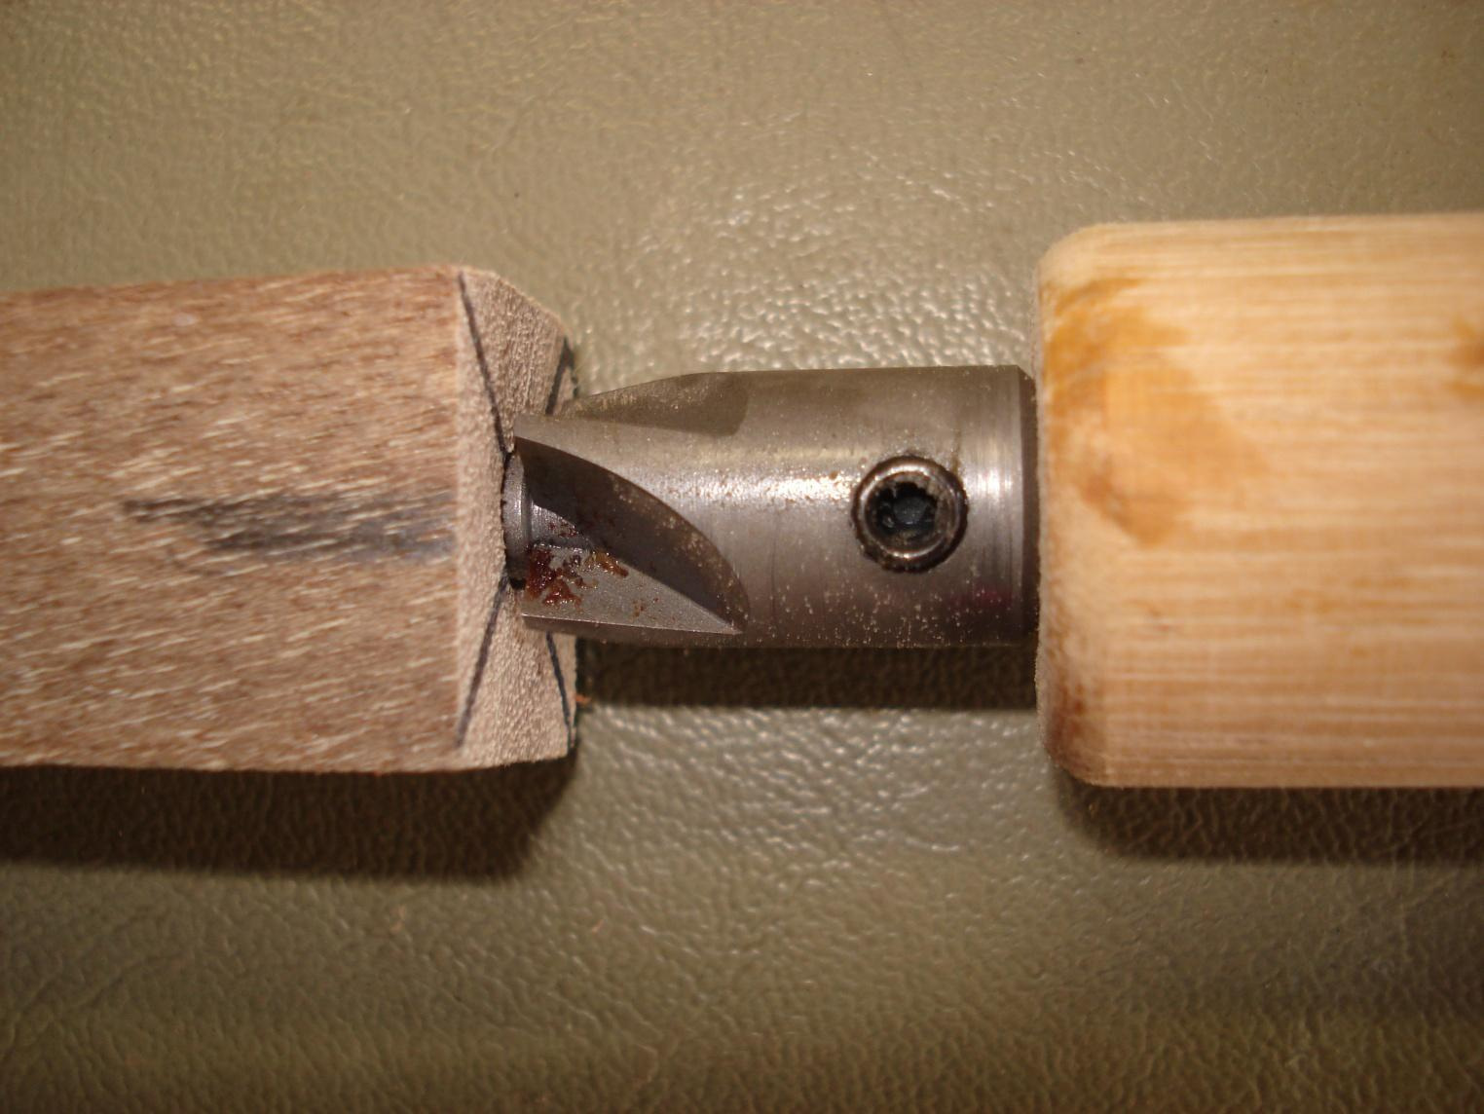
Figure 27. Original guide photograph, page 7: barrel trimming squares the wood ends to the brass tubes. The teacher approves the setup; stop before cutting the tube.

Prepare and verify
1. Inspect sound, straight grained starting stock: at least 110 × 20 × 20 mm in the updated guide.
2. Establish the continuous witness line across the centre; mark and cut the paired barrel pieces as approved.
3. Clamp securely and drill through the centre of the end grain. Clear swarf regularly using the demonstrated method.
4. Identify two tubes; lightly abrade only their outside surfaces and clean as approved.
5. Apply the approved adhesive evenly, rotate tubes into place, keep bores clear and allow full cure.
6. Square the wood ends flush to the tubes using the approved trimming setup.

Shape, finish and assemble
7. Check clean straight mandrel, correct bushes, paired orientation and suitable fastening. Obtain the pre start check.
8. Follow demonstrated turning to develop balanced cylinders and the approved profile. Stop for measurements and adjustments.
9. Inspect, use the approved abrasive sequence and finish system; protect crisp ends.
10. Lay out the actual kit in order. Press cap and clip into the upper barrel and nib into the lower barrel squarely.
11. Fit the mechanism in small checked increments to the kit’s required depth.
12. Align grain, join barrels with the centre band, fit the refill and check operation.

Open the complete 18-page Pen Making guide
Teacher to confirm: stock allowance and barrel cutting lengths, bit and depth, mandrel/bush arrangement, machine settings, tool methods, abrasive grades, adhesive/finish controls and mechanism depth.

Folio · My kit and cutting information
Use the actual kit and approved written information. Record “Teacher to confirm” where a fact is missing. This becomes your cutting and preparation record only after the teacher has checked the required values.
Kit name / supplier reference / instruction version and the teacher confirmed source of my cutting information:

Component / material | Quantity | Approved size / allowance and source
Starting timber blank | 1 | Guide: at least 110 × 20 × 20 mm. Actual stock / approval:
Prepared timber barrel pieces | 2 | Teacher confirmed lengths:
Brass tubes | 2 | Actual kit identification:
Other supplied kit components |  | Confirmed inventory / source:

Explain one kit constraint that affected your plan, and one material use decision you made.

Teacher check: __________________ Date: __________ Required corrections: __________

Folio · Compare two design ideas
Sketch two possible profiles for your supplied kit. Label the grain relationship, grip area and transitions into metal fittings. Use written kit information for constraints; these are ideas for teacher review, not cutting plans.
Idea A · annotated freehand sketch

Idea B · annotated freehand sketch

Choose an idea. Explain one comfort advantage, one manufacturing challenge and the information you need before approval.

Teacher design discussion / approved next action: __________________________

Folio · Work Method Statement
Write the real sequence before practical work. Link each hazard to what could happen and the possible harm, then specify the strongest practical school approved control and the teacher hold point. Add another sheet if your process needs more rows.
Complete the table for your actual project. Use stage specific controls and identify the relevant school SOP.

Stage / SOP | Hazard → event → harm | Approved controls / teacher hold point
Preparation / drilling
Mounting / turning
Surface / finishing
Assembly / checking

Which hazard needs the strongest control in your plan, and why?

Teacher review / changes required: _____________________ Date: __________

Folio · The production system
Show inputs, processes and outputs. Use arrows to show direction, rectangles for operations and a decision shape for a quality checkpoint. A failed check must lead to a teacher directed correction and recheck. Include finished product, evidence and waste outputs.
A useful feedback loop
Inspect surface → Ready for the approved next stage? → Yes: proceed after the required check. No: stop, diagnose with the teacher, complete the authorised correction, then inspect again. The “No” route never jumps over the checkpoint.

Draw your Pen flowchart. Include information, materials, equipment and skill inputs, the actual stages, outputs and at least one feedback loop.

Explain one social effect and one environmental effect of a decision in your flowchart. State what evidence would support each claim.

Folio · My production evidence
Record decisions while the project progresses. Photos must show your own work at a safe, permitted pause. Attach or reference the image rather than copying an example from this book.
Complete the record with four significant stages. Continue on an attached page when required.

Date / stage | Observation / decision / outcome | Evidence ID / teacher check

Choose one evidence item. Write a caption explaining what you checked, what changed and what happened next.

Name one problem you investigated rather than guessed at.

Folio · Evaluate and transfer
Compare the completed Pen with the approved brief: function, comfort, grain relationship, surface and assembly. Tie each judgement to an observable result or evidence item. Include the effect of your process decisions.
Complete Plus, Minus and Interesting with evidence and a reason.

PMI | Judgement, evidence and explanation
Plus
Minus
Interesting

Propose one practical improvement. Explain how it addresses a cause you identified.

What skill will you transfer to another timber project? Explain how the new context might change the procedure.

Folio · Final evidence check
Use this list to locate your evidence. A tick means the record is present and explains your own work. It does not replace teacher assessment or approval.
Add a page, photo or file reference for each evidence area. Resolve any missing item with your teacher.

Evidence area | Page / photo / file reference
1. Brief and success criteria
2. Approved resource and kit constraints
3. WHS, WMS and lathe controls
4. Timber inspection and grain orientation
5. Tubes, drilling and swarf
6. Mandrel and pre start check
7. Controlled turning and profile
8. Surface diagnosis and abrasives
9. Approved finish and quality
10. Kit and controlled assembly
11. Photos, flowchart and problem solving
12. PMI, impacts and skill transfer

Sources and image notes
Aligned with the Pen course snapshot checked 12 September 2026 and its linked Pen Making – Updated Student Guide. The full website readings, online question bank and folio cards remain available through the course link on page 2. The complete making guide is linked on page 43. Follow current teacher instructions if local requirements change.
Original workshop photographs are reproduced from the teacher’s Pen Making guide. Selected illustrative photographs come from the Pen course assets; additional studio and concept images were generated for this edition. Captions distinguish original evidence from illustration. Illustrations are learning aids, not dimensioned plans, machine authorisation or evidence of your work.
Submission location / method confirmed by teacher: _________________________

