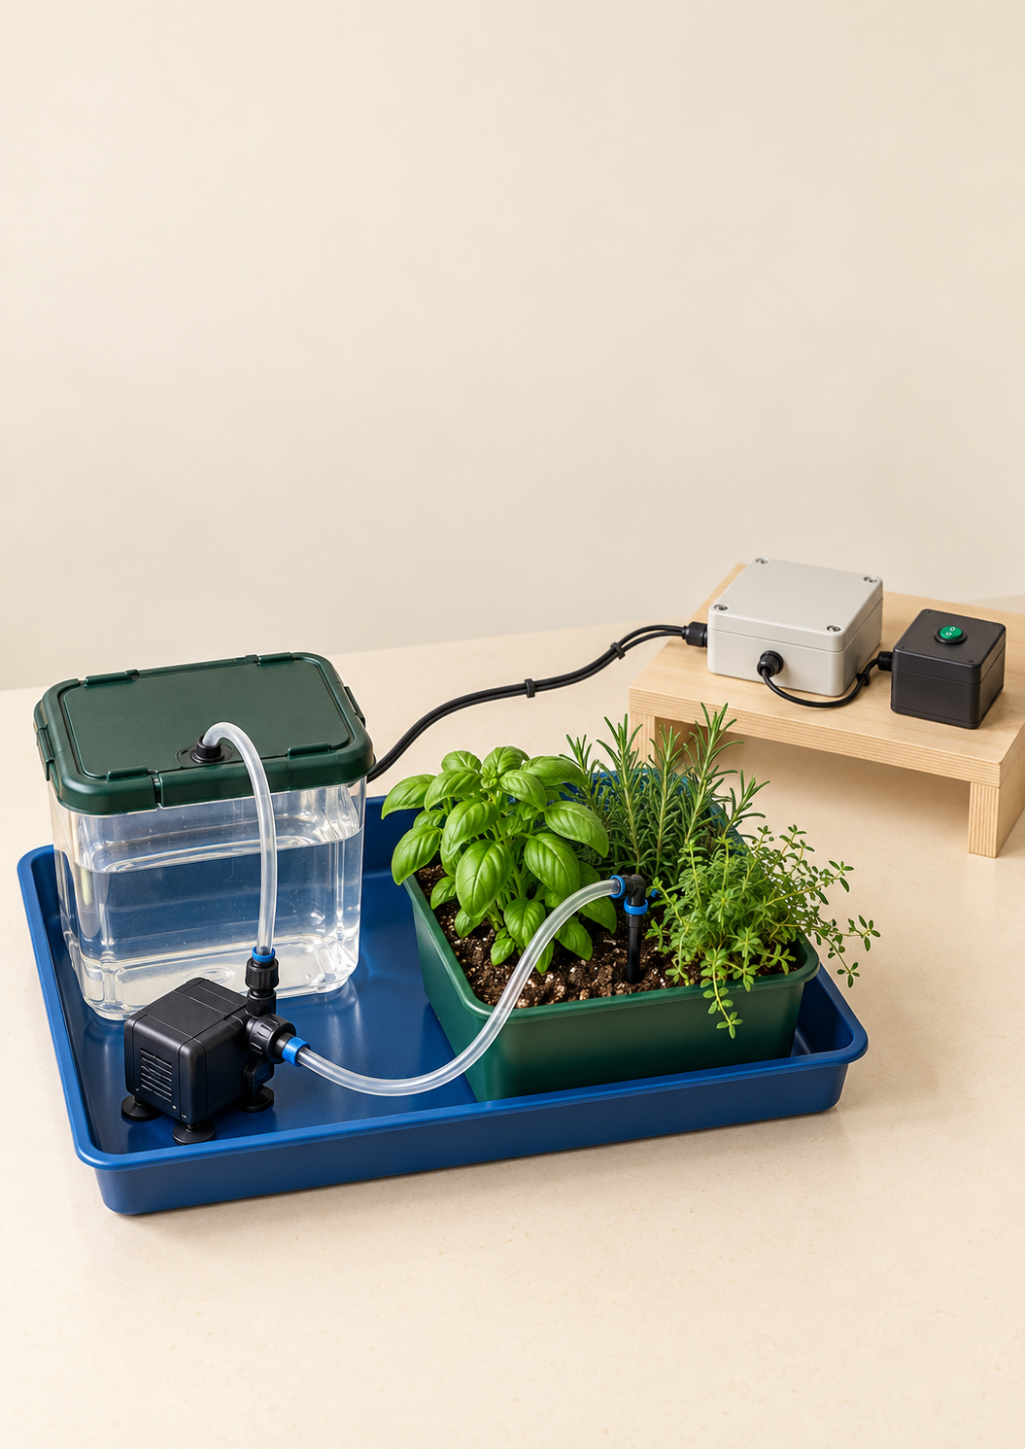
YEAR 10 ENGINEERING

Garden Watering
System
Student workbook and guided project folio

Illustrative concept only. Use the teacher-approved components, circuit and safe setup for your own prototype.
Name | Class

Year 10 Semester 1 | 50 A4 pages | Print double-sided on the long edge
START HERE

Use the workbook through the project
This book helps you explain, plan and record a Garden Watering System. Read the theory, try the checks, then develop your own evidence. The practical work is teacher-supervised. An illustration or completed workbook page does not approve a circuit, component, tool or powered test.
Learning route | Pages
The brief and research | 3 to 5
Safety and risk controls | 6 to 11
Control systems and logic | 12 to 22
Design and planning | 23 to 31
Build and test evidence | 32 to 43
Evaluation and completed folio | 44 to 50

Build the evidence as you go
The guided website portfolio has twelve sections, from Project Brief to Final Evaluation. This paper book follows those evidence purposes. Record dates, conditions and observations while they are fresh. Leave an honest gap if a test has not happened; a planned result is not an observed result.
Before practical work
Your teacher confirms the components, power source, circuit, machine access, test limits and assessment instructions. The current student build guide is a placeholder, so this book does not supply a fixed construction recipe.

Use the blank fields for handwriting or type into the native Word version. Insert your own drawings and photos with captions if working digitally. The teacher guide contains model answers and examples; use it after making your own attempt.
My evidence organisation Where will I keep my own sketches, photos and test records?
PROJECT BRIEF

Turn a watering need into a brief
A garden watering system is an engineering response to a need. The need is not simply to make a pump turn. Water must reach the intended plant area at an appropriate time, remain contained and stop under the intended conditions. A design brief connects that function to a user and a setting.
Describe the actual problem before selecting parts. A user may forget to water a small plant tray, or watering may continue when the soil is already wet. These are different problems. The first might be helped by timing; the second needs information about the soil or a person making that judgement.
Make the criteria testable
A criterion is useful when you can gather evidence for it. “Works well” gives no test method. “Starts under the approved dry-soil condition, directs water into the tray, and stops at the approved stop condition” gives actions to observe. Decide with your teacher how a successful cycle will be judged before testing.
Weak statement | More useful criterion
It saves water | Measure delivered water and visible losses under stated conditions
It is reliable | Repeat the same cycle and record starts, stops and faults
It is safe | Show separated zones, stable components and teacher check records

Choose a workable scope
Available parts, low-voltage power, safe water handling, workshop space and class time constrain the solution. A simpler system that can be explained and tested may be a stronger choice than an elaborate system you cannot finish.

Write one success criterion and the evidence that would show whether it was met.
BRIEF FOLIO

Record your project brief
Use your actual user and constraints. These three prompts preserve the current guided portfolio questions. Develop each response with a specific detail and a reason.
What problem is the watering system meant to solve?

Who is the user and what does the system need to do for them?

What limits affected your design?

Agreed criterion | Test or evidence | Teacher feedback
RESEARCH FOLIO

Make research change a design choice
Existing systems research is useful when a feature changes a design decision. Compare a hand-watered planter, a timed irrigation system or a sensor-controlled system. Record what the system senses, how it moves water and how it stops. Do not copy a product specification into your prototype without checking that the school components support it.
Look for transferable ideas: a stable reservoir, supported tubing, an accessible refill point, an outlet that waters the intended area, or feedback that avoids watering already-wet soil. Also record a feature you would avoid, such as inaccessible wiring or a sensor location that is difficult to test.
Source note Record the real product or demonstration title, creator or organisation, and URL or other source identity.

What existing irrigation or automatic watering idea helped your group?

Which feature did you adapt or avoid?

How did the research change your design?
SAFE SYSTEMS

Separate the wet and dry functions
Water, electronics and tools create interacting hazards. A spill can damage a controller, change a sensor reading, wet a switch or make the floor slippery. Loose leads can pull a tube or reservoir out of place. Low voltage reduces some electrical risks; it does not make water damage, overheating, moving parts or tools harmless.
Design the zones before connecting parts
The wet zone includes the reservoir, plant tray, tubing, outlet and catch area. The dry electronics zone includes the controller, exposed joins, power pack and accessible controls. Place the dry area away from the water path and protect it from foreseeable drips or movement. Keep the refill route away from electronics.
The tool zone is used for drilling, cutting, trimming and assembly. Keep loose leads, tubing and offcuts away from blades and bits. Use the demonstrated clamping, tool and PPE arrangements, and obtain permission before using a tool. This book does not set machine speeds or authorise machine use.
A check has a target
The teacher check occurs before a new powered test, before adding water near a circuit, and after relevant wiring, pump or tube-route changes. It is an experienced check of the real setup, not a box you can approve for yourself.

What hazards were present during testing?

How did your group control the water/electricity risk?
SAFETY REASONING

Choose a control that changes the hazard
Risk is the possibility of harm from a hazard. The hierarchy of control helps you choose changes that reduce the risk before relying on a person remembering a rule. Stronger controls often remove a hazard, replace it with a lower-risk option or physically prevent exposure.
Control level | Project example
Eliminate | Test switch or code behaviour without water first
Substitute | Use the teacher-approved low-voltage option rather than mains
Engineering | Contain the water path in a tray and secure tubes
Administrative | Use a planned test sequence and teacher checkpoints
PPE | Use the workshop PPE required for the task

Worked scenario
A group notices that the reservoir refill opening is above the controller. Wearing glasses will not keep refill water out of the circuit. Moving the refill route into the wet zone and relocating/protecting the controller changes the exposure. A reminder to “be careful” can support that change but does not replace it.
Choose two controls for a tube that could detach and splash water. Explain how each reduces the risk.

What teacher check or safe setup mattered most?
SAFE SETUP FOLIO

Draw the safe testing area
Show the actual planned setup. Mark the wet zone, dry electronics zone, power source, water path, spill control, teacher checkpoint and approved stop method. Show safe access to switches without reaching across water.
Safe test setup Add labels and notes showing containment, component fixing, refill access and lead or tube routes.

Highest risk Identify the highest-risk part of this setup and explain your strongest control.

Teacher feedback or checkpoint | Date and evidence reference
RISK CONTROL FOLIO

Build a risk table for the real system
Include at least five hazards covering water/electronics, tools, pump or tubing, moving parts and trip or snag risks. Describe the possible harm, the control and how you will show it was used. Update the table when the design changes.
Hazard and possible harm | Control before work | Evidence and review

A design change What changed, what new risk did it create, and how did the controls change?

Attach the OnGuard or other WHS evidence your teacher requires. Reference its date and title rather than copying personal details from another student.
SAFETY SELF CHECK

Check the safety reasoning
Answer in your own words before checking the teacher guide. Connect each control to the risk it reduces.
Why must the wet zone and dry electronics zone be physically separated during testing?

Give two higher-level controls that are stronger than simply wearing PPE.

What should you check before the first powered test of a pump, relay or controller?

Why should powered water tests be short at first?
SAFETY SELF CHECK

Check the safety evidence
Use the actual safe-testing sequence and evidence requirements to answer these source questions.
What evidence should appear in your folio for Toolkit 1?

If water reaches the dry electronics zone, what should happen next?

How can a design change create a new WHS risk?

Why is teacher sign-off part of the safety system, not just a classroom rule?
CONTROL SYSTEMS

Explain information decision and action
A control system receives information, makes a decision and produces an action. The input may be a person pressing a switch or a sensor detecting a condition. The process applies a rule. The output may move water, show a state or give a warning. Feedback supplies information about the changing result.
Part of the system | Question to ask | Example
Input | What information arrives? | Soil reading or a start command
Process | What decision is made? | Compare reading with start and stop rules
Output | What action follows? | Switch pump or valve; show indicator
Feedback | What result is returned? | Changed soil reading changes the next action

Follow a causal chain, not just a list of parts. A controller cannot decide from a sensor that was never read, and a pump that turns on has not necessarily delivered water to the plant. Your diagram should show how information influences action and how the water travels.
Sketch your IPO chain and label at least one possible feedback path. Annotate which parts are manual, semi-automatic or automatic.
CONTROL COMPARISON

Compare levels of automation
Manual control leaves the start and stop decision with a person. Semi-automatic control divides the work: a person starts the action and a timer or rule controls part of it. Automatic control uses sensed information to decide what happens. These descriptions concern behaviour, not how impressive the circuit looks.
Control type | Watering behaviour | Trade-off
Manual | Person switches pump on and off | Simple to inspect; depends on attention
Semi-automatic | Person starts a timed output | Duration is controlled; soil need is not measured
Automatic | Sensor condition controls the response | Responds to condition; needs calibration and reliable sensing

Choose the level that suits the brief and available time. A manual mode can be useful for an approved subsystem test or override. It does not satisfy an automatic behaviour claim by itself. A timed system may be reliable in delivering a set duration while still watering unnecessarily when the soil is already wet.
1. A student presses start and the pump stops when a timer ends. Which description fits best?
A. Manual throughout
B. Semi-automatic
C. Closed-loop soil feedback
D. No control system

2. Which evidence best supports an automatic watering claim?
A. A complicated circuit photo
B. A pump moving water once
C. Tests showing sensed conditions cause the intended start and stop
D. The brand of controller

Choose a level of automation for your brief and explain one benefit and one limitation.
CONTROL SYSTEMS

Choose the input for the decision
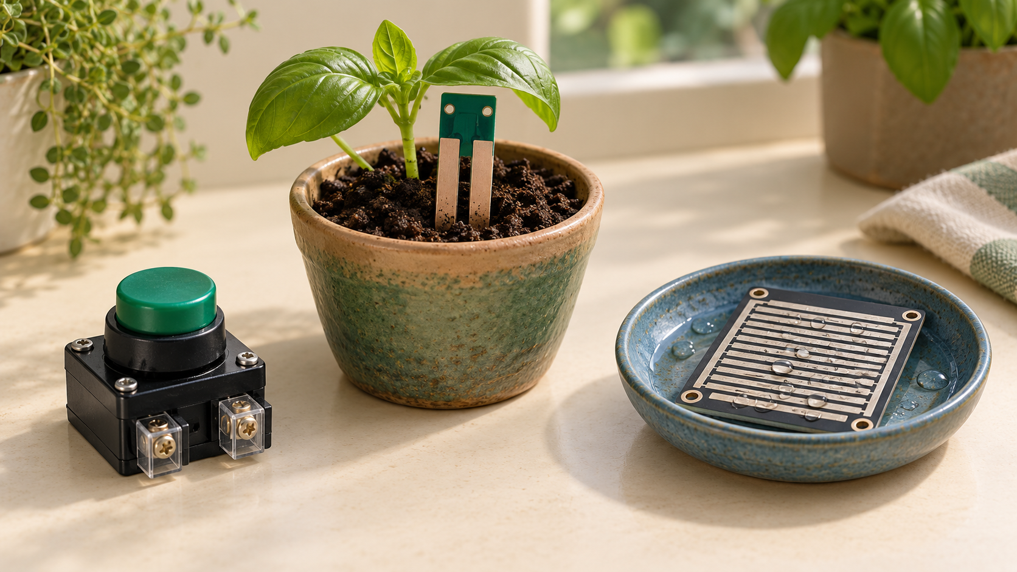
Illustrative input options at rest: manual button, soil probe and rain sensing plate. These are not the confirmed classroom parts.

A command or a measurement
A switch gives the controller a command from a person. A sensor gives information about a condition. These roles differ: a button can start a test, but it cannot tell whether the soil is already wet. Choose an input because its information helps the watering decision.
A moisture probe samples the soil near its position. That sample may not represent every part of a plant tray. A rain sensor detects water at its own sensing surface. Testing the placement is therefore part of testing the whole system.

Readings need interpretation
A digital signal has distinct states, often on or off. An analogue signal varies across a range. A sensor module may supply one or both kinds of signal, so check the teacher-approved interface rather than judging by its appearance.
Calibration connects a reading to known conditions. Compare a controlled dry sample and wet sample, record the readings, then choose a threshold that separates them. Do not assume that a larger number always means wetter soil; the particular sensor and circuit determine the direction.

Which input would give evidence that the soil needs water, and what limitation would you test?

Identify whether each input is manual, digital or analogue.
COMPONENT CHOICES

Match the output and switching device
An actuator changes the physical system. A pump moves water; a solenoid valve opens or closes a water path. The valve needs a suitable water supply or pressure arrangement; it is not a pump. An LED or buzzer communicates a state, so it can help you see what the controller is trying to do during a dry test.
A controller output pin supplies a limited control signal. Pumps and valves often need more current than that pin can safely supply. A relay, transistor or motor driver may switch the output load under control of the signal. The school circuit and component specifications determine the safe arrangement.
Ratings must match the real parts
Use the actual teacher-approved circuit and specifications. This conceptual page does not give connections or ratings. Get the real circuit checked before power.

Chosen part | Role and reason | Limit or failure risk
Input
Controller or process
Pump or valve
Switching device if needed
Indicator if used

What input does the system read?

What decision does the controller make?

What output happens, and how does feedback stop or change it?
CONTROL SYSTEMS

Read the feedback path
A control system is open-loop when it acts without checking the result. It is closed-loop when information about the result returns to the controller and changes the next action. The presence of a sensor alone is not enough: explain how its reading affects the output.
Two kinds of path in a closed loop
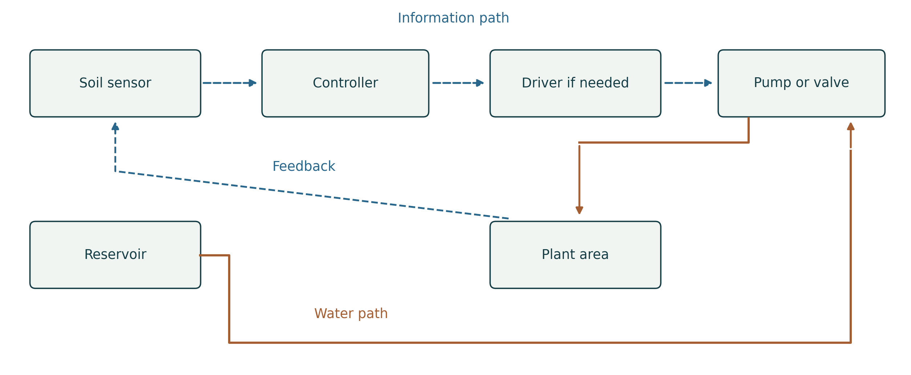
Conceptual paths only. Dashed arrows carry information; solid arrows show water movement. The soil condition returns to the sensor as feedback. This is not a wiring plan.
An open-loop timed output has no returned soil-condition information. A closed loop uses the changed reading to adjust the output; the water and information travel along different paths.
Follow the loop
Water delivery changes the soil condition. The sensor measures the changed condition and sends information back to the controller. That returned information is feedback. The information path and the water path are different.

Feedback can reduce unnecessary watering, but a sensor far from the outlet may react slowly. A poorly placed sensor can also report one wet spot while the rest of the tray remains dry. Check the response rather than assuming that automatic means reliable.
Describe the feedback path in a sensor-controlled watering system. Explain one way it could still fail.
SENSOR CALIBRATION

Use a threshold without guessing the scale
A threshold marks a decision point. It is not automatically a percentage of soil moisture. A raw sensor number may be a circuit reading in device-specific units. First record what dry and wet test samples produce, then choose and test a rule that separates the conditions.
Worked example with invented readings
Controlled sample | Trial 1 | Trial 2 | Trial 3
Dry | 270 | 280 | 275
Wet | 690 | 705 | 700

For this example only, larger readings mean wetter soil. A threshold of 500 separates the recorded groups. That does not make 500 a universal value. A different sensor may use the opposite direction, a different range or a digital on/off output.
Observe the boundary
Read the condition, apply the rule, then observe the response. If readings near the decision point make the output switch repeatedly, record the behaviour and ask the teacher to review calibration, placement and control logic. Do not hide unstable trials.

Your controlled condition | Reading or state | Expected decision
Dry sample
Wet sample
Rain or no rain if used
Low or normal tank if used

For the invented data, explain why the chosen threshold is testable and what it does not prove.
CONTROL LOGIC

Write start stop and fault decisions
An algorithm is an ordered description of behaviour. A useful watering algorithm says when the system may start, what happens during watering, when it stops and what it does when a condition is unsafe. The diagram or pseudocode must match the intended physical system.
Conceptual rule to examine
A rule with permission and inhibition
Read the soil condition, rain condition and tank condition. If the soil is dry AND the tank has water AND rain is not detected, allow watering. Otherwise keep watering off. During watering, recheck the stop and safety conditions. Stop when the approved wet condition, low tank, rain or stop command is present.

AND means every listed permission must be true. An OR stop rule means any one listed stop condition can inhibit watering. Do not leave a pump running because one permission stayed true while a safety condition changed. Exact timing, thresholds, reset and invalid-signal behaviour need the teacher-approved control option.
Soil | Tank | Rain | Expected output
Dry | Okay | Not detected
Wet | Okay | Not detected
Dry | Low | Not detected
Dry | Okay | Detected

Rewrite “Turn the pump on” so that it has a start condition, stop condition and safe response to a fault.
ALGORITHM FOLIO

Draw and explain your control algorithm
Use a flowchart or pseudocode for your approved design. Include soil dry/wet, rain detected/not detected and tank low/okay as decisions to consider. Mark conditions that are actually sensed and conditions tested through a teacher-approved simulation or manual check.
Algorithm Show start, read input, decision, output, stop or reset, repeat and warning where relevant.

What is the trigger condition for watering?

What happens when the soil is dry?

What stops the pump from running forever?
CONTROL SELF CHECK

Check the control system relationships
Explain the relationships using the theory pages, then compare your answer with the model reasoning.
What is the difference between an input and feedback?

Why is a moisture sensor better than a simple timer?

Is a switch a sensor?

What makes an algorithm strong enough for this project?
CONTROL SELF CHECK

Check the control system decisions
Use an example and identify what evidence would show the intended behaviour.
What is the difference between open-loop and closed-loop control?

Why do outputs like pumps sometimes need relays or drivers?

What should you test before claiming your system works?

How do you write a good control systems evaluation?
TEST PLANNING

Plan conditions before measuring results
An expected result is a prediction from the algorithm. An actual result is an observation from a test. Write the prediction before testing so that an unexpected response remains visible. Decide what stays constant, what changes and what counts as success.
Check dry and wet soil, rain and no rain, low and normal tank conditions where those inputs are part of the intended rule. If the build has no rain or tank sensor, plan an approved simulated/manual check rather than claiming that the system detects them automatically. Keep the condition and test method clear.
Condition or combination | Expected output and stop | Method and what stays constant
Dry soil
Wet soil
Rain detected
No rain
Low tank
Normal tank

Choose one test. What result would make you revise the design, and which evidence would you collect?
DESIGN PLANNING

Plan two paths and a safe layout
The water path and control path solve different problems. The water path runs from reservoir to pump or valve, through tubing to the target area. The control path carries power and information between input, controller, switching device and output. A clear design shows both without confusing water flow with signal flow.
Place the reservoir where it is stable, visible and refillable. Support tubing, avoid kinks and mark joins that need leak checks. Aim the outlet at the target plant area and contain expected drips. Show how the parts stay in position so the arrangement you test is the arrangement you designed.
Keep the battery/controller and exposed joins in the dry area. Show where hands access the stop control or reset. Consider maintenance: can you see the water level, inspect a blocked tube or replace a component without dismantling everything? A difficult-to-service prototype can be hard to test fairly.
Drawing | Information it communicates
Irrigation layout | Reservoir, pump/valve, tubing, outlets, target area and catch tray
Circuit or wiring plan | Actual approved power, input, process, output and switching arrangement
IPO or block diagram | Functional information and action relationships
Algorithm | Decisions, start/stop and relevant fault responses

What design feature would you change between two concepts, and what difference would you expect?
DESIGN FOLIO

Develop the first layout option
Change a meaningful design feature, such as sensor position, reservoir placement or tube route. Draw a concept, not a finished construction plan. Keep the wet zone and dry electronics zone visible.
Concept A Label the reservoir, tubing, outlet, plant area, sensor or input, controller, power source and wet and dry zones.

What were two possible design ideas?

Annotations that explain
Place a short note beside a feature explaining its intended effect. A useful annotation links position or routing to safety, response, water delivery or access.
CONCEPT COMPARISON

Compare and choose between the layouts
Concept B Show a meaningful change from Concept A and label its intended effect.

Which idea was more practical and why?

What trade-off did you accept?
FINAL DESIGN FOLIO

Communicate the final physical layout
Draw the selected layout after teacher feedback. Add useful dimensions measured or agreed for your own build. No measurement in a generic illustration is a project specification.
Final irrigation layout Show reservoir, pump or valve, tubing, outlet, plant area, sensors or inputs, dry electronics and fixing points.

Where are the sensor, pump, plant area and electronics?

How is the water moved and controlled?

How does the layout protect the electronics?
TECHNICAL PLAN FOLIO

Record the approved circuit and connections
Copy or attach the teacher-approved circuit for the actual class hardware. Keep the original source identity. Show power, input, process/controller, switching device if needed and output. A conceptual block diagram cannot replace terminal-level wiring guidance.
Circuit or wiring plan Label actual parts and connection identities from the approved source. Add a separate legend for wire or signal meanings.

Circuit source and version | Teacher feedback or check | Date or evidence reference

Before first power, check polarity, loose connections, exposed joins, the water route and approved stop method with the teacher. Disconnect power before changing wiring.
RESOURCES FOLIO

Select and account for components
A component list records what is needed, why it is needed and how it fits the system. Use the actual school parts and specifications. A pump or valve must suit the approved power and switching circuit; a sensor must provide information the controller can interpret. Appearance is not proof of compatibility.
Material choices affect durability and maintenance. A mounting platform needs stable fixing; tubing needs a route that can be secured and inspected. Consider what can be reused or repaired. Record quantities and costs from real information so the evaluation can discuss resource use without guessing.
Part or material | Qty | Purpose and compatibility check | Cost or source

Choose one component. Why is it suitable, and what alternative or limitation did you consider?
BUILD PLANNING

Plan the build and the checkpoints
A planned sequence keeps the water path, input/control subsystem and output tests manageable. Complete the design package first, then have the teacher confirm components, circuit, tools and limits. The practical sequence adapts to the actual approved hardware.
Assemble and check the contained water path with power disconnected. Build and check electronics dry. Obtain the required teacher check before power or a wet test. Test one subsystem at a time before integrating the system. Power off before changes and document what changed.
Stage | Tools or components | Check and evidence
Final plan and approval
Water path and unpowered leak check
Dry input or control check
Approved output test
Integration and repeated trials
Improvement and retest

Before construction What will you show the teacher, and what remains to be confirmed?
DESIGN SELF CHECK

Check the design reasoning
Answer these source planning questions. Use the drawings and algorithm rather than a list of component names.
Why should the wet zone and dry zone be shown on the design plan?

What makes a concept sketch useful for this project?

Why is a flowchart or pseudocode needed before building?

Which change creates a genuinely different concept?
A. Change only the heading colour
B. Copy the same layout twice
C. Move the sensor and explain how response may change
D. Use a larger name label

PLANNING AUDIT

Check the complete design package
Use evidence from your final design and the current source checklist.
What should be included in the final design package?

How do you justify the strongest design option?

Planning evidence | Page or file reference | Ready or teacher feedback needed
Two concepts and reasoned choice
Water layout and circuit plan
Algorithm and component list
Risks, sequence and planned tests

Which planning omission would most affect testing, and how will you correct it?
PRACTICAL BUILD

Build in inspectable stages
Construction should make faults visible, not hide them. Secure the reservoir so it cannot tip, support tubing with smooth bends and contain outlets. Where the teacher-approved arrangement allows it, check water movement by gravity or hand testing with power disconnected before adding electronic control.
Assemble electronics in the dry zone. Label input, process and output connections. Use the approved fixing and strain relief so a pulled lead does not detach a tube or connection. Never use a realistic illustration as terminal-level wiring guidance. Ask the teacher to check the real circuit before powering or wet testing.
Make a change traceable
If a part does not fit or a tube kinks, record the issue, the change and the reason. Update the relevant plan. A change to routing, wiring or component position can create new hazards, so review controls and obtain the relevant check before retesting.
Evidence during construction | What the caption should explain
Photo of water path | Reservoir fixing, tube support, outlet target and leak check
Photo or drawing of dry circuit | Input/process/output and protected connections
Change note | What changed, why, and what was checked next
Teacher checkpoint record | What was actually checked and when

Before the next practical stage, what must be visible and inspectable in your prototype?
BUILD LOG FOLIO

Keep a dated prototype build log
Record actual work in order. A photo needs a caption explaining what it shows and why it matters. Describe shared group work accurately and identify your own contribution.
What did you build first, next and last?

What practical issue came up?

What change made the prototype work better?

Date and stage | Photo or evidence reference | Change and teacher checkpoint
SUBSYSTEM TESTING

Isolate a fault with subsystem tests
Testing the whole prototype first can mix several causes. Water may fail to arrive because the output never switched, the pump lacked a suitable supply, the tube kinked or the inlet was blocked. A subsystem test narrows the question and reduces uncontrolled interactions.
Subsystem | Question to test | Useful evidence
Water delivery or output | Can the approved pump/valve deliver and stop? | Timed volume, leak/kink observations and stop behaviour
Input or threshold | Does the signal change as expected? | Dry/wet readings or switch states and response delay
Control logic | Does the stated rule command the output? | Condition, expected command and actual response
Whole system | Do the parts work together repeatedly? | Cycle data, photos, faults and correct stop

Keep tests short at first and within teacher-approved limits. A low-tank check must not damage a pump by running it dry. An input test can use an approved dry/simulated arrangement before introducing water. State the method clearly so the evidence proves only what was actually tested.
Keep the comparison honest
Expected behaviour comes from the design rule. Actual behaviour comes from observation. If they disagree, preserve both and identify the next safe check. Do not revise the prediction afterwards to make the trial appear successful.

A pump runs but no water reaches the outlet. Which subsystem would you investigate first, and what would you check safely?
SUBSYSTEM DATA FOLIO

Prepare and record subsystem trials
Use separate rows for the output, input and control tests. State conditions and units. Record actual behaviour, including a failure or incomplete test. Repeat a method that can answer the intended question.
Subsystem and method | Expected response | Measured or observed result | Decision and evidence

Which subsystem did you test?

What reading, behaviour or result did you observe?
TEST INTERPRETATION FOLIO

Explain what the subsystem result proves
An isolated test can support or rule out a cause, but only within its conditions. An LED responding to a switch can show a command path is working. It does not prove that the pump delivers water or that the automatic soil rule works.
What did this prove or rule out?

Evidence panel Attach or sketch the relevant subsystem setup and annotate the observation.

What is the next safe test, and why does it follow from this result?
FULL SYSTEM DATA FOLIO

Repeat the full system under stated conditions
Run at least three approved full cycles under the same conditions. Define success before testing: intended trigger, target delivery, intended stop and no unacceptable leak or fault. Then change one condition and record its effect. Never copy invented example data into this table.
Cycle and condition | Response time in s | Delivered water in mL | Stop behaviour and fault
1
2
3
Changed condition

What were the test conditions?

What happened in each trial?
WORKED TEST EXAMPLE

Calculate from the test evidence
Reliability describes whether the system performs the intended function repeatedly under stated conditions. A successful cycle must meet the same criterion each time. Counting only pump starts would hide a system that starts correctly but fails to stop.
Worked example with invented data
Cycle | Water in 10 s | Outcome
1 | 80 mL | Starts and stops correctly
2 | 78 mL | Starts and stops correctly
3 | 25 mL | Kinked tube limits delivery
4 | 82 mL | Starts and stops correctly
5 | 80 mL | Starts and stops correctly

Work through the reasoning
Four successful cycles out of five gives 4 ÷ 5 × 100 = 80% observed success. The result describes these five trials under the stated conditions; it does not prove an 80% success rate in every garden. The failed cycle stays in the record.

For a successful 80 mL delivery in 10 s, average delivery rate is 80 ÷ 10 = 8 mL/s. Delivery rate is useful for comparison, but high flow alone does not prove water efficiency. Record whether water reached the intended area or was lost through leaks or overspray.
Try a separate example: six of eight cycles meet the agreed criteria. Calculate observed success and explain why the failed cycles matter.
RELIABILITY FOLIO

Compare variability and judge the response
Similar conditions should produce a consistent response, but measurements can vary. Keep that variation visible. A small sample supports a limited claim about the tested setup; it cannot establish performance in every soil, weather or garden.
Plot your own repeated trials Label cycle number on the horizontal axis and water volume or response time with units on the vertical axis.

Was the response reliable enough?

What pattern do you notice, and what limit prevents a stronger conclusion?
FAULT FINDING FOLIO

Turn a fault into a testable explanation
A fault is an observed behaviour that differs from the intended behaviour. A likely cause is an explanation to investigate. A fix is a change made to address it. A retest checks whether the change improved the same condition. Keep these four ideas separate.
Worked example with invented evidence
The output command was on, but only 25 mL reached the plant tray in the timed trial. An unpowered inspection found a sharp bend in the outlet tube. After the teacher-approved route was adjusted and secured, three comparable trials delivered 79, 81 and 80 mL without visible leaks. This supports the tube-route explanation for these trials; it is not proof that every possible fault is fixed.
Observed fault | Likely cause and evidence | One fix and safe check | Retest result

What fault did you find?

What was the most likely cause?

What fix did you apply, and what happened after retesting?
CONTROLLED IMPROVEMENT

Improve one variable and retest fairly
Changing several features at once may improve the prototype, but it makes the cause difficult to explain. Name one problem from the data, predict how a specific change should affect it, then repeat the method under comparable conditions.
Problem and evidence | One proposed change | Predicted effect | Teacher feedback

Before condition and result | After comparable condition and result | What stayed constant

What improved, what did not, and what evidence supports your conclusion?

What should be tested next before making a stronger claim?
BUILD AND TEST SELF CHECK

Check the testing process
Use the test method and evidence concepts to answer these exact source questions.
Why should you test subsystems before testing the whole garden watering system?

What data should be collected during a full-system test?

How does a fault log improve the final evaluation?

Why is repeatability more useful than one successful test?
BUILD AND TEST SELF CHECK

Check the evaluation evidence
Connect each judgement to a recorded observation or test result.
What makes a strong final evaluation paragraph?

How can the prototype be evaluated for sustainability?

Why should improvements be tested one at a time?

What evidence should be included in the build log?
SUSTAINABILITY

Evaluate water energy and maintenance
Water efficiency means useful delivery with reduced waste, not simply a high pump flow rate. Record whether water reaches the intended area and whether leaks, overspray or continued dripping waste it. A timed output or a calibrated threshold may reduce unnecessary watering, but the claim needs a comparison.
Automation uses energy and components as well as water. Consider the approved output duration, unnecessary operation, batteries or power source, material waste, repairability and reuse. A system that can be inspected, repaired and retested can avoid replacing the entire prototype after a minor fault.
Do not claim that an automated system is always sustainable. A poorly calibrated sensor can cause waste, while a simple well-managed system may perform the small task effectively. Compare the real benefit with energy use, cost, complexity and maintenance.
Aspect | Evidence from your prototype | Limitation or improvement
Water reaching the target
Leaks or unwanted output
Energy or unnecessary operation
Material reuse and repairability

Which sustainability improvement is most realistic for a second version, and why?
EVALUATION WRITING

Write an evidence based engineering judgement
A final evaluation returns to the brief and criteria. Begin with a judgement, support it with the strongest evidence, explain what the evidence means and name a realistic next improvement. A photograph shows construction; a repeated-test table shows behaviour. Use the kind of evidence needed for the claim.
Worked paragraph using invented results
Claim evidence reason next step
The prototype met the delivery and stop criteria in four of five comparable cycles. The unsuccessful cycle delivered 25 mL because the outlet tube kinked, while the other cycles delivered 78 to 82 mL in the timed test. After the tube route was secured, three new trials delivered 79 to 81 mL with no visible leaks. This supports improved repeatability under the tested conditions. I would next test sensor placement because the current soil response was checked in only one position.

Notice the limits. The paragraph does not say the prototype is perfect or that it will work in every garden. It names the failed trial and distinguishes the original trials from the retest. It links a specific improvement to a specific remaining uncertainty.
Claim you might make | Evidence you would need
The sensor stops watering when the soil is wet
The improved tube route reduces lost water
The system is easy to maintain

Rewrite a vague claim from your draft evaluation so it includes evidence and a limit.
FINAL EVALUATION FOLIO

Complete the final evaluation
Use your own trial data and success criteria. Answer these current guided portfolio questions with developed paragraphs. Include function, reliability, water efficiency, safety, cost, sustainability, construction quality and remaining limitations where relevant.
How well did the system meet the success criteria?

What is your strongest evidence?

What would you improve if you had one more lesson?
FOLIO COMPLETION

Audit the complete engineering folio
A complete folio connects problem, design, build, test and improvement. Check whether another reader can follow the decisions. Reference where the evidence is stored and what remains missing; do not replace missing evidence with an unsupported claim.
Folio section | Page or file reference | Gap or final check
Project Brief
Existing Systems Research
Inputs, Process and Outputs
Safe Test Setup
Concept Sketches
Final Design Plan
Algorithm or Flowchart
Prototype Build Log
Subsystem Testing
Full-System Test Data
Fault Log and Improvements
Final Evaluation

Which claim still needs better evidence before submission?
TRANSFER THE LEARNING

Apply the language to a new situation
Use the control terms to explain cause and effect. An input provides information or a command; a threshold is a decision point; an actuator produces physical action; feedback returns information about the result. Reliability concerns repeated intended behaviour under stated conditions.
Apply the rule
An imagined class display should water only when the sample is dry, the reservoir is okay and no rain signal is present. A student substitutes OR for AND between these permissions. Treat this as a paper logic problem; it is not code to run on a pump.
Explain one unsafe or wasteful result of the OR version, and rewrite the permission rule.

Which statement distinguishes observation from a likely cause?
A. “The controller is bad” is a measured result
B. “The pump ran but delivered 0 mL” is observed; a blockage is a cause to investigate
C. A guessed cause belongs in the measured-volume column
D. One successful trial proves every condition

Explain input, process, output and feedback using a different everyday system. State one limit of the analogy.
TUTORIAL SELF CHECK

Check the tutorial and your practical readiness
These source tutorial questions help you connect design and testing. Answer them before the relevant teacher-supervised stage. Student self-checks never replace teacher checks.
What should I test first?

Why separate wet and dry zones?

What counts as useful evidence?

What if the prototype fails?
SAVE AND SUBMIT

Save and hand over your own evidence
The current guided website portfolio autosaves in that browser. Download Session JSON is the continuity backup, and Upload Saved Session restores it later. Export Folio Text produces writing to copy into a final Google Doc. Print or Save PDF produces a reviewable print copy. Keep your own photos and drawings alongside the writing.
For this workbook, save the editable Word copy and a review PDF when asked. Follow the teacher-confirmed submission destination, format, date and rules. This workbook supports learning and evidence preparation; it does not issue a formal assessment notification or approve powered practical work.
Source learning routes
Current Garden Watering System unit
Guided twelve section project portfolio
Printable source information sheets
Teaching basis: the four current toolkits, Design and Test Tutorial, Testing Checklist, guided portfolio, information sheets and linked 20-week Water Control System scope and lesson documents. Sources were checked on 4 October 2026, Sydney. Garden Watering System is the student unit title; Water Control System is its document name.
New explanatory passages, formative tasks and generated at-rest pictures are supplementary teaching. Example data is explicitly invented. The source setup infographics contain inconsistent voltage/timing details, so their illustrated numbers are not used as circuit specifications here.
My final handover check Where is the saved copy, what evidence is attached, and what teacher instruction still needs confirming?

