
YEAR 9 ENGINEERING

Geared Lolly
Dispenser
Design build and test a repeatable mechanism

Illustrative dispenser concept. Final dimensions, materials, food-contact suitability and safety features must be approved by your teacher.
Name | Class

Use with the current course and teacher-approved project instructions.
START HERE

Your learning route
Read, reason, design, make, test and improve. Keep this book beside the course website and your teacher’s demonstrations. Use the paper tasks to make your thinking visible, then collect your own digital drawings, photographs and data for the project folio.
Learning route | Pages
Purpose and approved task | 3–4
Gear systems and mechanisms | 5–23
Dispenser design and CAD | 24–41
Manufacture, assembly and tuning | 42–57
Reliability, evaluation and showcase | 58–81

How to recognise the work
Source question preserves the website’s exact question wording. Source activity is transparently adapted for paper, with the same evidence purpose. Practice is newly authored formative learning. Worked examples are hypothetical; their figures are not your measurements or a manufacturing plan.
Evidence belongs to you
Separate predictions from observations. Record actual values, units, dates and file revisions. A teacher demonstration can inform your work but must be labelled as a demonstration. Write “not measured” or “not yet confirmed” when that is true.
Write one mechanism question you want this project to help you answer.

Current Geared Lolly Dispenser course
PROJECT PURPOSE

Turn the brief into evidence
The source project brief asks you to design and build a geared dispenser that releases one lolly per defined handle cycle. Reliability, smooth mesh, safe operation and justified improvement matter together. Agree the actual item, cycle definition and approved test conditions before you freeze your design.
Brief requirement | What would demonstrate it?
One item per defined cycle | Cycle-by-cycle success/failure record; no doubles
Justified gear train | Teeth counts, shaft connections and predicted turns
Safe, stable mechanism | Approved hazard controls, retained shafts, suitable guards
Repeatable operation | Source expects 50–100+ recorded cycles; final approved count confirmed
Engineering communication | CAD pack, build photos, tables/graphs and evaluation

Identify a requirement and a constraint for your own design. Explain how you will find out whether each is met.

Practical boundary
Teacher to confirm: permitted materials, dimensions/capacity, acceptable test pieces, test count and target, machine procedures, food-contact/hygiene controls, and exact submission requirements. Use inert non-food pieces for trials if food suitability is unconfirmed.
ASSESSMENT ORIENTATION

Know the current assessment
The currently linked draft notification describes Task 2, Projects & Reports 2, as a summative, marked task weighted 40%, with complete folio submission in Week 6 of Term 4. It says teacher approval is required before issue. Your current teacher-issued approved notification controls the actual task; this workbook does not issue a new assessment or create marks.
Confirm before submission
The source course’s guide places final submissions in Weeks 9–10, while the linked draft notification says Week 6. Ask your teacher for the confirmed issue date, calendar due date/time, submission method, component marks and whether the final folio must include earlier projects. Do not select a deadline from the website guide yourself.

The linked draft lists safe workshop conduct; construction quality and accuracy; clear CAD/design communication; a thorough folio; and evidence-based evaluation as criteria. The full source document contains its outcomes and feedback sheet. Your teacher confirms the current outcomes and formal criteria. Practising in this book does not change assessment requirements or student records.
Record the teacher-confirmed task title, due date/time, submission destination and folio scope. If not confirmed, say so and write the question you need answered.

View the linked draft assessment notification
For absence, extensions and late submission, use the current school-issued assessment policy and ask your teacher. This orientation does not restate draft penalty wording.
MECHANISMS and PURPOSE

One cycle one result

A system not just a set of gears
A dispenser must do more than turn smoothly. It must separate one item, move it to the release point, let it leave and return ready for the next cycle. The handle provides an input. Gears transmit rotary motion; a cam can move a gate; a ratchet can block reverse rotation. The hopper and guides feed items into that controlled sequence.
These jobs interact. Changing the gear ratio alters how much handle rotation is needed for the same output movement. A cam mounted on a different shaft may then open the gate at a different phase. A ratchet stops back-rotation, but does not by itself prevent two items passing through an oversized opening.

Define what success means
Agree with your teacher what counts as one complete handle cycle. A cycle might mean a specified movement from one home position back to it; it is not automatically one full handle revolution. Record the actual definition before calculating turns per dispense or counting successes.
Success means exactly one item is released during that defined cycle with the intended safe operation. A jam, double or incomplete release needs its own record. The useful question is not “Did it work once?” but “How consistently did it work under stated conditions?”

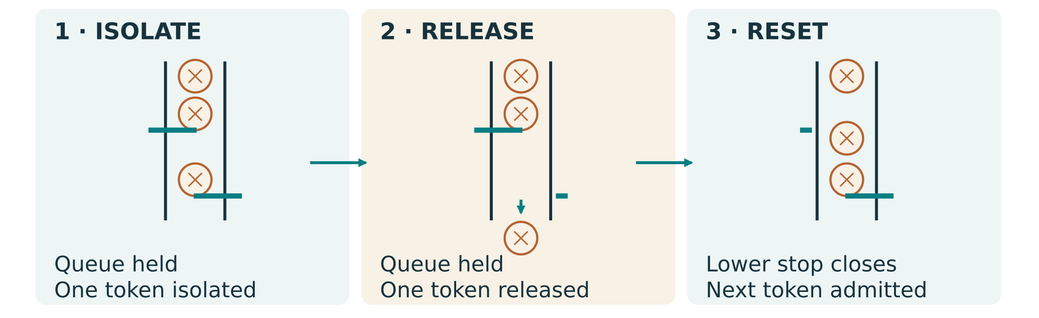
Figure 1. Inspect the feed, separation and release path. A ratchet and the gate solve different problems.
Explain one interaction that could make a freely turning dispenser release two items.
GEAR RELATIONSHIPS

Simple pairs speed and torque
For this book, gear ratio g = driven teeth ÷ driver teeth. The driver receives input rotation; the driven gear supplies the output. With a 20-tooth driver and 60-tooth driven gear, g = 60 ÷ 20 = 3. The output makes one revolution for three input revolutions, and an external meshing pair reverses direction.
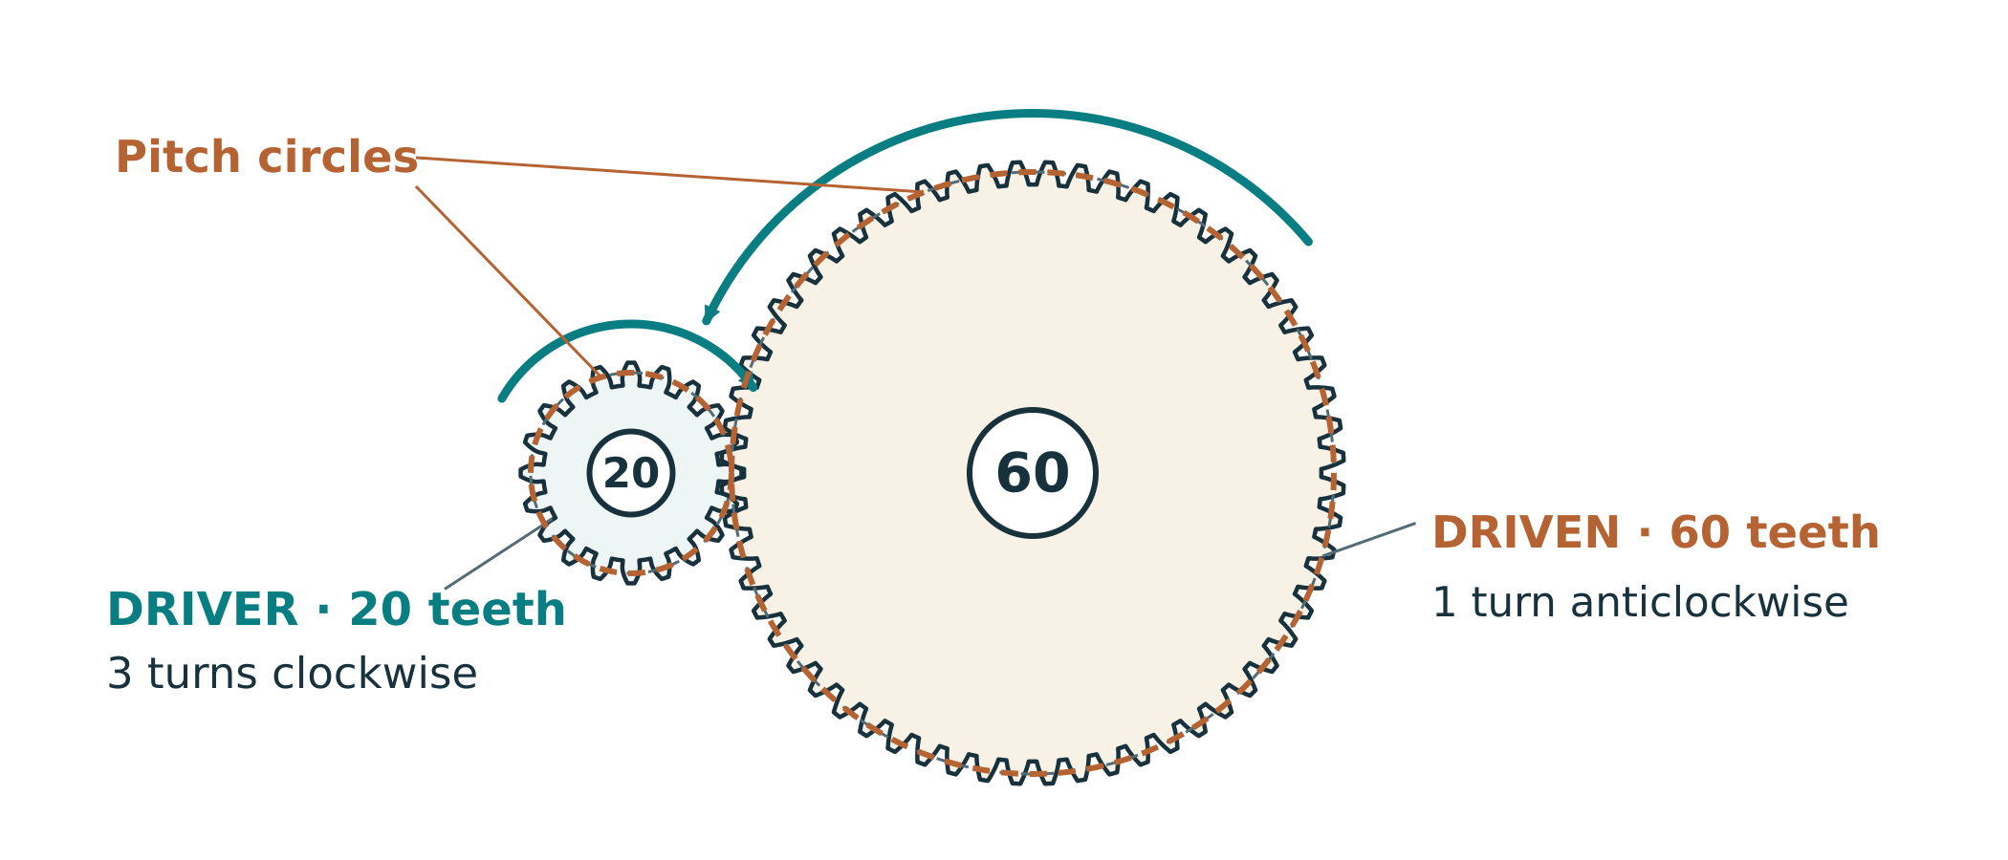
Figure 2. Illustrative 20-tooth driver and 60-tooth driven gear: compare pitch circles and rotation arrows, not the outer tooth-tip circles.

Speed changes
Output speed = input speed ÷ g. An illustrative input of 60 rpm gives 60 ÷ 3 = 20 rpm at the output. rpm means revolutions per minute. Use the same time unit throughout a calculation.

Torque changes
Ignoring losses, output torque = input torque × g. Real friction reduces available output torque. Torque is a turning effect; handle force also depends on the distance from the shaft to where the user pushes. A torque ratio is not automatically a force ratio.

Geometry matters
Pitch circles describe the ideal rolling relationship. Compatible tooth geometry and approved centre distances are required. Tooth-tip gaps are not a universal setting; never force a binding handle.

A 30-tooth driver turns a 90-tooth gear. Predict output rpm when input is 45 rpm, and state the direction relative to input. Show working.
GEAR GEOMETRY and FIT

Mesh begins with geometry
A gear’s pitch circle is an imaginary circle used to describe its ideal meshing relationship. The tooth tips lie outside it; the roots lie inside it. Two external spur gears with compatible tooth geometry roll at their pitch circles. Their shafts must also be aligned and parallel so the teeth engage across the intended face width.
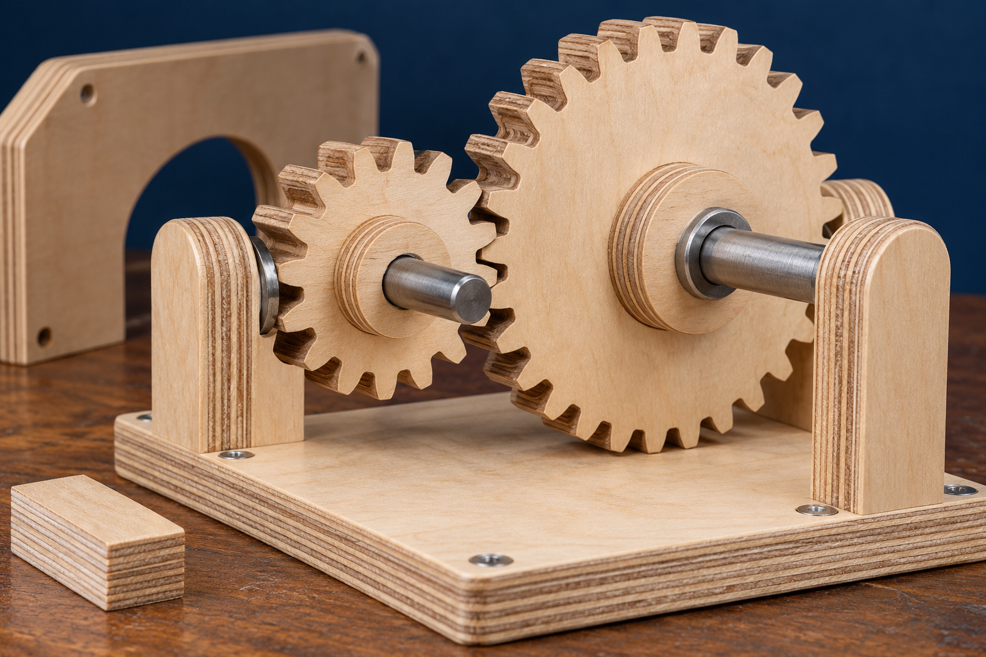
Figure 3. Inspect tooth engagement, shafts and supports. Use Figure 2 on the previous page for ideal pitch-circle spacing. Illustrative at-rest inspection; no operation with guards removed.
Correct the source shortcut
For an ordinary external spur pair, nominal centre distance = (driver pitch diameter + driven pitch diameter) ÷ 2. It is not one pitch diameter plus an arbitrary clearance. Approved gear design data may specify corrections; use the teacher-approved geometry. The website’s generic tooth-clearance numbers are not machine or assembly settings.

Explain the difference between centre distance, tooth-tip clearance and backlash. What would you inspect if a handle binds?
GEAR ARRANGEMENTS

Idlers and compound trains
A simple train has one gear on each shaft. In the chain 20 → 10 → 40, the middle gear is an idler. The ratio is (10 ÷ 20) × (40 ÷ 10) = 2. Its tooth count cancels from the overall ratio; it changes layout and adds a direction reversal. Two external meshes make the final output rotate in the same direction as the input.
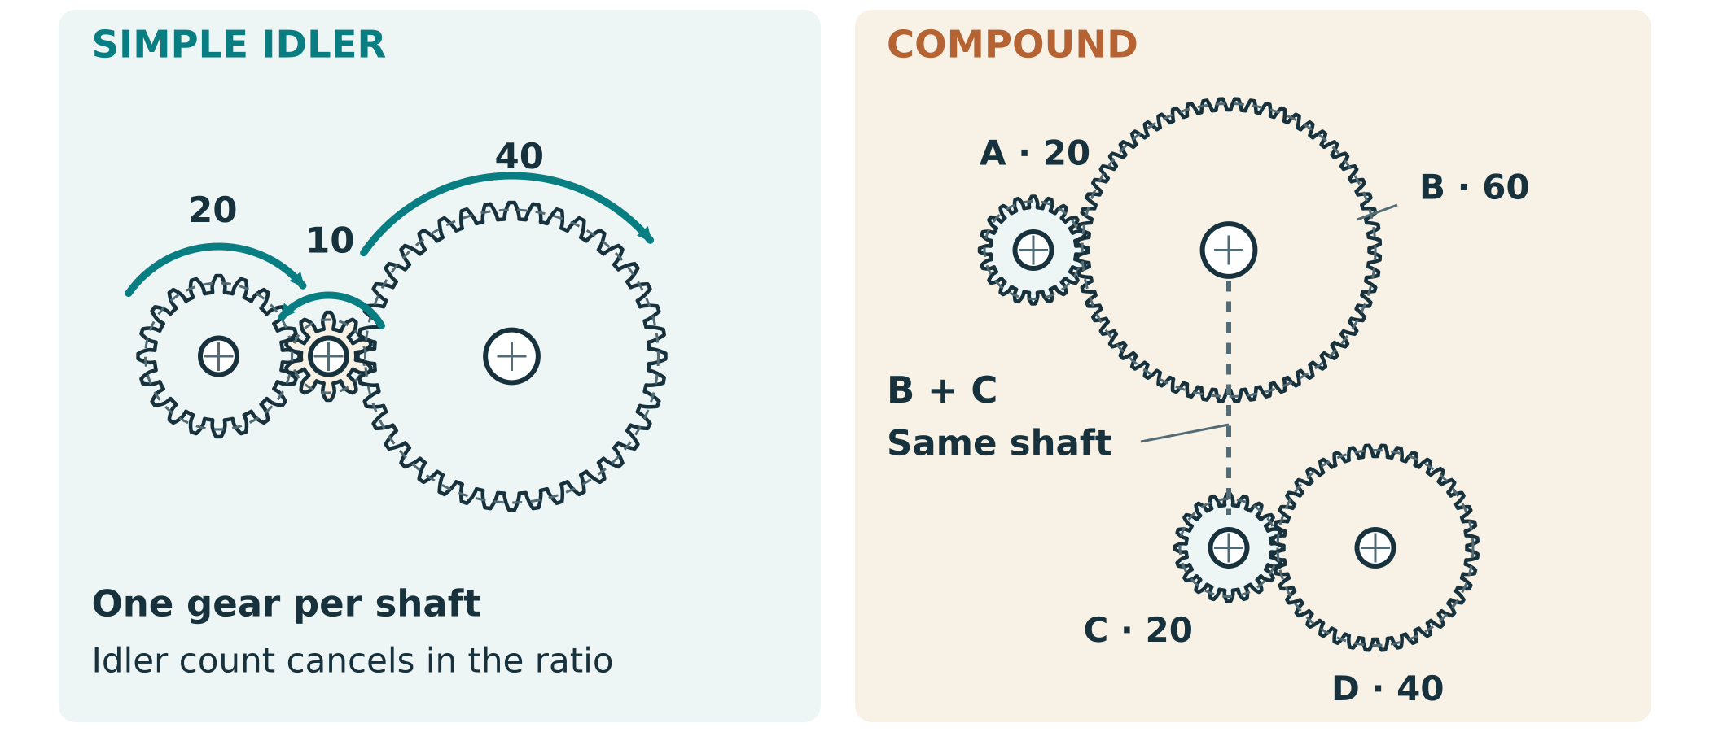
Figure 4. A simple idler chain and a true compound train are different: inspect the shared intermediate shaft.
In a true compound train, two different gears are fixed to the same intermediate shaft. The driven gear of the first stage and the driver of the next turn together. Multiply the driven/driver ratio of each actual stage. Two 2:1 stages give 4:1; adding ratios would give the wrong prediction.
An illustrative train uses 10 → 30, then 15 → 45, with 30 and 15 fixed together. Calculate total ratio and describe output direction.
PREDICT and COMPARE

Worked example four input turns
Illustrative design requirement: four input revolutions for one output revolution. The required ratio is g = 4. This is a teaching example, not a required carousel layout or class specification.
Option | Working | Meaning
One pair: 20 → 80 | 80 ÷ 20 = 4 | One external mesh; output reverses
Simple chain: 20 → 10 → 80 | (10 ÷ 20) × (80 ÷ 10) = 4 | The middle gear is an idler; output matches input direction
True compound: 20 → 40, then 20 → 40 | (40 ÷ 20) × (40 ÷ 20) = 4 | Two middle gears share a shaft; output matches input direction

A source correction
The website labels its three-gear chain “compound”. Its overall arithmetic is useful, but the chain is a simple train with an idler. A true compound arrangement uses two intermediate gears fixed to the same shaft. Check the actual shaft connections before multiplying stages.

The compound option can distribute reduction across smaller gears, but adds shafts, supports and alignment work. Tooth counts alone do not establish which layout fits the frame. Compare approved compatible gear geometry, space and assembly before selecting a design.
Create a different true compound 4:1 option. Name both intermediate gears as sharing one shaft, calculate each stage and total ratio, and explain one comparison with a single pair.
GEAR RATIO PRACTICE

Calculate predict compare
Source activity, adapted for paper: calculate at least three simple pairs. For each show ratio, speed relationship and ideal torque relationship. Use the illustrative pairs below, or teacher-approved alternatives. Ideal predictions ignore losses; they do not establish actual handle effort.
Driver → driven | Ratio: show working | Output at 60 rpm input | Ideal output torque ÷ input
10 → 40
20 → 60
40 → 20

Compare the first and third pair. Which would require more input rotation for the same output movement? Explain the torque trade-off.

Design two different illustrative gear arrangements giving four input turns per output turn. Show connections and working.
CAM MOTION

Cams give rotation a pattern

Follow the profile
A cam rotates while its follower moves according to the profile and the follower’s constraint. An eccentric circular cam has an offset axis, so the distance to a radial follower changes through the turn. A centred circular cam gives no rise for that arrangement. A shaped cam can provide a deliberate lift, holding period and return.
The follower can be a sliding contact or a roller. Sliding contact is simpler but can have more rubbing; a roller can reduce sliding at the contact but adds parts and alignment work. The actual mechanism must keep contact safely through its intended motion.

Rise dwell and fall
Rise means increasing follower displacement; fall means decreasing it. Dwell means displacement stays constant over a range of cam angle. For a suitably constrained radial follower, a constant-radius cam region can produce dwell. The following physical-example page shows the cam and follower relationships. A flat line on a displacement-versus-angle graph shows dwell; it does not mean the physical cam edge must be straight.
A longer angular dwell lasts longer only at the same rotation speed. Timing also depends on the cam shaft’s relation to the handle, the feed path and whether the gate isolates one item. A steep transition may create abrupt movement and higher drive effort for the same lift and load.

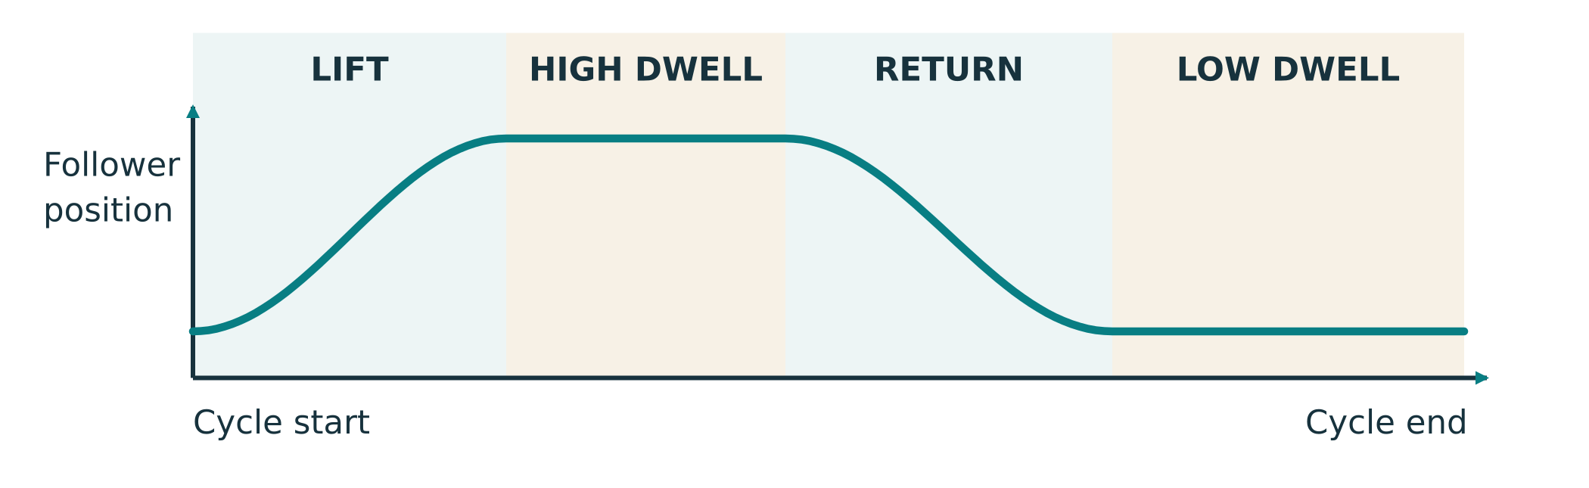
Figure 5. Follower displacement plotted against cam angle. A flat graph segment means constant displacement; this graph is not a picture of the physical cam profile. Compare it with the following physical-example page.
Why is the cam’s shaft connection as important as its shape when planning a dispensing gate?
PHYSICAL CAM EXAMPLES

Cam profiles and follower contact
A physical cam profile is the boundary that contacts the follower. Its shape, rotation axis and follower constraint determine movement together. Locate the shaft axis before judging the profile. An eccentric circle has an axis offset from its geometric centre; the illustrated shaped cam instead has deliberate motion regions about its rotation axis.
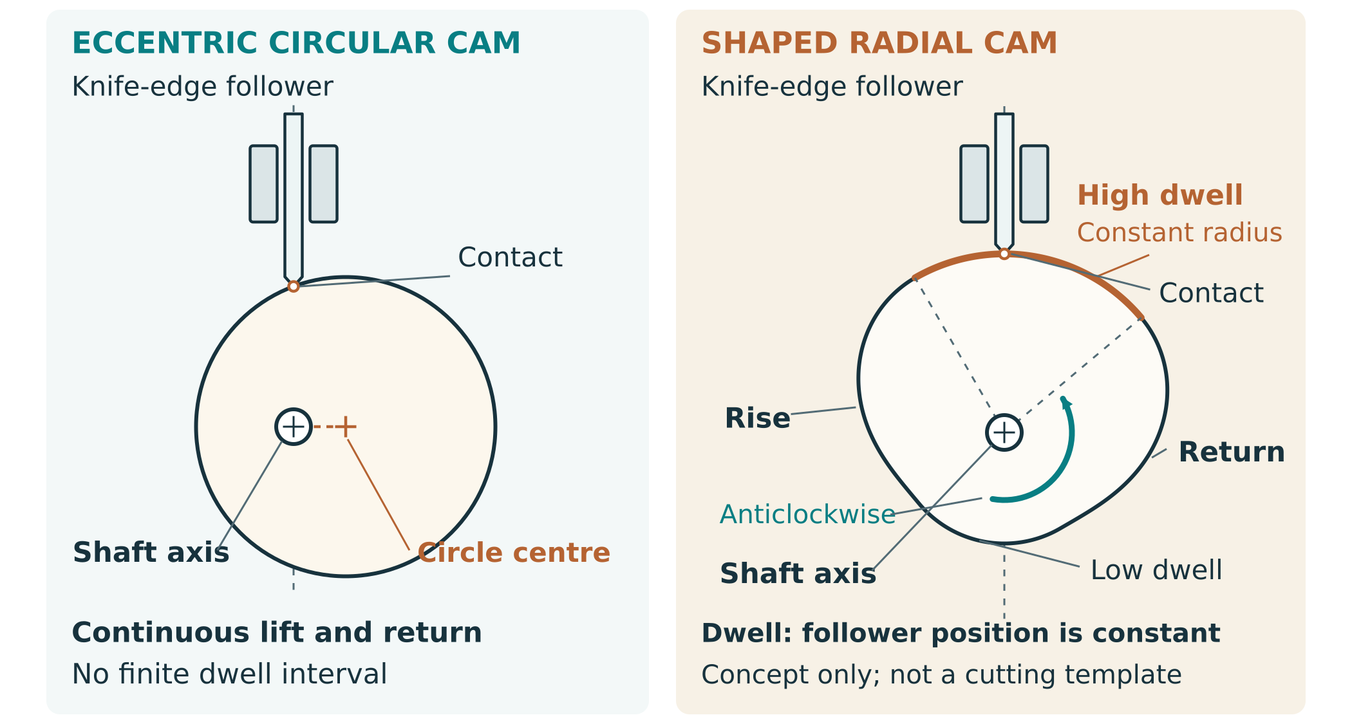
Figure 6. Physical concepts with simplified knife-edge radial followers: offset-axis eccentric circle and shaped rise–dwell–return cam. The shaped cam’s shown rotation is anticlockwise. Inspect shaft axes and contact. These explain mechanisms, not cutting templates or recommended follower constructions.

Eccentric circle
As the offset circle turns, its contact relationship changes and the follower rises and falls smoothly in this conceptual arrangement. It has no finite true dwell region. Reaching a highest or lowest position for an instant is not the same as holding constant displacement over a range of cam angle.

Shaped rise dwell and return
A deliberate profile can raise the constrained follower, hold its displacement and then return it. For this radial concept, a constant-radius arc measured from the rotation axis provides dwell. The follower must remain in the intended contact throughout the cycle; a teacher-approved return/contact arrangement is part of any actual mechanism. The simplified drawing does not specify that construction.

Read the graph and the object differently
The preceding displacement graph describes follower movement, not the cam’s outline. Its horizontal dwell segment means no displacement change. Use the physical axis, profile and follower arrangement to explain that graph. Teacher-approved geometry, travel, return and guards control any actual design; no dimensions or spring settings are supplied here.
CAM DESIGN EVIDENCE

Compare two cam profiles
Source activity, adapted for paper: sketch at least two cam profiles and their intended follower motions. Use an eccentric profile and a shaped rise–dwell–fall profile, or approved alternatives. A centred circle has no rise for a radial follower: label “no rise/fall” rather than invent those phases.
Two profile sketches: show axes, follower contact, rotation direction and matching rise/dwell/fall motion

For each profile explain opening, holding and closing motion. Which would you investigate for your gate, and what is the effort/timing trade-off?
ONE WAY MECHANISMS

Ratchets allow one direction
A ratchet wheel and pawl work together. During intended forward movement, the pawl lifts over a tooth and returns into engagement. Reverse movement brings a locking tooth face against the pawl. The pawl’s pivot, contact angle and return force must allow consistent engagement without dragging excessively or blocking forward motion.
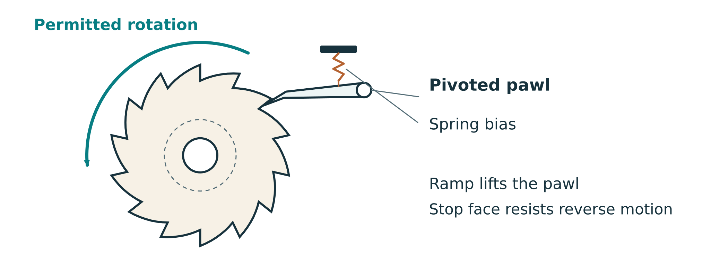
Figure 7. Observe the pawl’s pivot and contact face. Direction control is different from one-item separation.

Useful with limits
Ratchets occur in socket tools and winches because they permit selected movement and resist the opposite direction. In a dispenser they can discourage accidental back-rotation. They do not decide how many items pass through an open gate; that still depends on separation and timing.

Compare alternatives
A one-way bearing or clutch can also allow rotation in one direction. It may be compact and smooth but needs compatible shafts, mounting and suitable components. A visible low-speed pawl is easier to explain and inspect, but adds wear/contact points. Choose using approved parts and the actual task.

Predict two problems caused by a pawl that returns too weakly, and one caused by excessive contact resistance.
RATCHET INVESTIGATION

Research and draw a one way device
Source activity, adapted for paper: research an approved real example such as a socket wrench or winch. Record the source, then draw how pawl and wheel engage. Compare with a one-way bearing or clutch. Do not operate or dismantle unfamiliar equipment without teacher approval.
Real example: labelled wheel, pawl, pivot, forward movement and reverse stop

Comparison | Ratchet and pawl | One-way bearing or clutch
Mounting/parts
Inspection, wear and fit
Suitability for my dispenser

Source title/URL or teacher demonstration, and what you learned from it:
MECHANISM INTEGRATION

Make the sequence visible
A motion-flow diagram tells you what drives what. A timing sequence tells you when each job occurs. Start with a marked home position. Ask how an item is isolated, when the release path opens, when it closes, and when the mechanism can advance again. Check the actual shafts and phase relationships instead of assuming one cam cycle equals one carousel turn.
Stage of the defined cycle | What must happen? | My timing/check
Ready/home | Item feed and mechanism in repeatable start state
Position/isolate | Only one item reaches release path
Release | Gate motion permits the isolated item to leave
Close/reset | Next item remains contained; mechanism returns ready

If you change the carousel gear ratio but keep the cam on the input shaft, what might change? Explain the checks needed.

Common mistake to avoid
A smooth gear train can still be poorly timed. Look at feed, isolation, release and reset as one system. Correct the interaction before trying to hide a jam by pushing harder.
MECHANISM TRANSFER

Linear motion and handle effort
A rack and pinion changes rotary motion into linear motion. The pinion is a gear; the rack is a straight toothed strip. Compatible teeth let the rack travel as the pinion turns. This is useful in steering and linear positioning. A sliding gate could use this idea, but the actual gate still needs travel limits, safe clearance and controlled timing.
One revolution moves the rack by one pitch-circle circumference: travel = π × pitch diameter for compatible ideal geometry. This is a relationship to investigate, not a supplied gate dimension. Use the teacher-approved pinion data before predicting a real mechanism.
Torque is not force
For a perpendicular handle force, input torque = force × handle radius. The same torque can require different force at different handle radii. Gear ratio predicts the ideal torque relationship; practical force also depends on geometry, friction and load. No force limit is supplied by this example.

Compare a rack-and-pinion gate with a cam follower gate. Name the input/output motion and one design issue for each.

Why is “4:1 gears means four times less hand force” an incomplete claim?
MECHANICAL ADVANTAGE and VELOCITY RATIO

Force motion and efficiency
Mechanical advantage compares corresponding forces: MA = output (load) force ÷ input (effort) force. Velocity ratio compares corresponding movement over the same interval: distance VR = effort-point distance ÷ load-point distance. Use the actual input/output points and their motion along the force directions. For a simple constant-force movement, efficiency = useful output work ÷ input work = MA ÷ VR; multiply by 100 for a percentage.
Paper only teaching example
A hypothetical mechanism needs 10 N input force and delivers 25 N output force. In the same interval, the effort point travels 120 mm and the load point travels 40 mm. These are teaching numbers, not dispenser loads, safe limits, component dimensions or machine settings.

Quantity | Worked calculation | Meaning
Force MA | 25 N ÷ 10 N = 2.5 | Output force is 2.5 times input force
Distance VR | 120 mm ÷ 40 mm = 3 | Effort point moves 3 times as far
Efficiency | (2.5 ÷ 3) × 100 ≈ 83.3% | Useful work is about 83.3% of input work

An ideal machine has MA = VR and 100% efficiency; real losses reduce useful output. Gear reduction g describes shaft rotations and ideal shaft torque ratio. It is not automatically the force MA or linear-distance VR: the actual force points, input/output radii and losses must be known.
Practice, paper only: input force 8 N, output force 32 N, effort movement 150 mm and load movement 30 mm over the same interval. Calculate MA, distance VR and efficiency. Show working.

Why can a dispenser’s 4:1 gear reduction not by itself prove force MA = 4 or efficiency = 100%?
MECHANISM KNOWLEDGE CHECK

Mechanisms check your understanding
Source questions keep the website’s wording. Answer from the preceding learning, then use teacher feedback. This is formative practice, not a new marking scheme.
1. A handle gear with 30 teeth drives a carousel gear with 90 teeth. Calculate the gear ratio and explain its effect on speed and torque.

2. Why use a compound gear train instead of a single gear pair? Give an example.

Practice: what makes a gear train genuinely compound?
○ A. Any three gears meshing in one chain
○ B. Two different gears fixed to a shared intermediate shaft
○ C. Any pair with unequal tooth counts
○ D. A gear with a missing tooth

MECHANISM KNOWLEDGE CHECK

Cams and direction source check
Answer the exact source questions. Use the corrected definition of dwell from the cam learning.
3. How does a cam profile affect gate motion in a lolly dispenser? Explain the trade-offs.

4. What is a ratchet mechanism and why is it needed in a lolly dispenser?

Practice: which statement describes dwell?
○ A. The follower keeps a constant displacement over a range of cam angle
○ B. The follower always returns as fast as possible
○ C. Any straight edge on a physical cam
○ D. The output gear stops whenever the input turns

MECHANISM KNOWLEDGE CHECK

Timing and effort source check
Show the shaft and timing relationships in words or a small labelled sketch within the response lines.
5. How do you synchronize gear train, cam, and ratchet mechanisms in a dispenser?

6. Explain the trade-off between gear ratio and handle effort in a dispenser.
MECHANISM KNOWLEDGE CHECK

Mesh and dwell source check
Use approved geometry and the correct motion meaning of dwell. Generic web clearances are not class settings.
7. What happens if gear teeth don't mesh properly? How can you prevent this?

8. How does a cam dwell period affect dispensing reliability?
MECHANISM CHECKPOINT

Theory evidence and teacher feedback
Before design, organise the source activity evidence: at least three simple-pair calculations; a true compound train with at least two stages; two 4:1 design options; at least two cam profile/motion comparisons; ratchet research; and a system/timing diagram. Use the approved class destination for digital evidence. This paper record does not submit work by itself.
Evidence to locate | Book page/file reference | Feedback or next action
Gear calculations and 4:1 options
Cam comparison and force/timing reasoning
Ratchet research and alternative
Mechanism integration diagram

Teacher-led video, model or demonstration: title/source, two observations and one question about my own design.

What change will I make after feedback, and why?
DESIGN and PLANNING

Analyse your design brief
Source activity, adapted for paper: annotate the approved class brief, then make a design checklist. Turn broad words into evidence you can collect. “Reliable” needs a defined cycle, approved conditions and an agreed success target; “safe” needs identified hazards and verified controls. Leave unconfirmed limits blank rather than guessing.
Requirement / constraint | Confirmed value or description | Evidence/check
Function and cycle definition
Reliability target and test length
Allowed material/stock/equipment
Size/capacity or other constraints
Safety and user needs

Choose a requirement that most affects your mechanism. Explain how the theory informs a design decision.
CONCEPT DESIGN

Compare two dispenser concepts
Develop two genuinely different arrangements before choosing. Show feed/gate route, shafts, gears, cam and one-way control where required. Use the same confirmed brief so your comparison is fair. These are your concepts, not approved plans.
Concept A: label input/output and separation–release sequence

Concept B: a different arrangement or mechanism integration

Choose a concept using two criteria. Name one trade-off and one point needing verification.
MATERIALS and SUSTAINABILITY

Materials follow the job

Compare useful properties
A frame needs stable support for aligned shafts. Plywood’s cross-laminated layers can provide good dimensional stability; solid timber offers grain character but orientation and movement matter. Sheet materials can make repeatable cut profiles, but edge quality and suitable stock must be checked.
A gear blank needs suitable tooth strength and consistent geometry. A guard must resist the expected access/contact conditions without touching moving parts. Acrylic can permit inspection through the guard; it is not automatically the right thickness or material. Shafts and pivots need approved fit, straightness and retention.

Choose with evidence
Compare strength, stability, workability, available cost and sustainability for the actual component. Certified timber information, efficient nesting, durable repairable construction and suitable finishes can support lower-impact choices. A cheap offcut may be useful if it is identified, sound and suitable for the process.
The source lists timber, plywood, MDF and acrylic as possibilities, not an approval for every process or food-contact surface. Teacher-confirmed material identity, machine compatibility, hygiene and finish suitability control selection. Use inert non-food test pieces if food use is not approved.

Material / component | Useful property | Limitation / approval needed
Solid timber
Plywood
MDF
Acrylic

Justify one material choice using function and sustainability.
MATERIALS PLANNING

Parts stock and cost
Source activity, adapted for paper: prepare a bill of materials and cut list. Distinguish finished dimensions from rough stock and manufacturing allowance. Use the approved design and stock measurements; do not copy example sizes. Include gears, shafts, spacers, fasteners, guards and gate/feed parts, not just frame plates.
Part / quantity | Material / thickness | Finished size or CAD ref. | Stock / cost source

How will you calculate material cost and compare designs fairly? Show your method with real available values, or list what is missing.

Which part could be repaired or replaced without discarding the whole dispenser? Explain your design choice.
NESTING and WASTE

Plan the sheet before cutting
Nesting places approved part profiles efficiently within actual usable stock. It must preserve grain/face orientation, safe separation and any teacher-confirmed process allowances. A dense layout is not good if it weakens a part, places a hole in damaged stock or leaves no appropriate holding/support area.
Nesting plan: outline actual usable sheet, label parts/quantities and grain/face direction

Explain two choices that reduce waste without compromising part strength, fit or process safety.
PROJECT FOLIO

Design evidence a motion flow sketch
Source activity, adapted for paper: draw your proposed mechanism as a system. Show the handle/input shaft, each gear and its tooth count, the shared shaft in a compound stage, output, cam/follower, gate, pawl and ratchet where used. Use arrows for motion and label where an item is isolated and released.
My proposed mechanism: components, shaft connections, motion and safe access

Explain how a change in your gear ratio could affect gate timing. Identify what you would check before making parts.
CAD ORGANISATION

Build the CAD assembly in layers

Give the model a structure
Name the document, Part Studios, Assemblies, Drawings and important features so their purpose is visible. Group the frame/base, gear train, cam/gate and guard/lid into useful sub-assemblies. A small mechanism is easier to inspect and correct before you combine it with the whole dispenser.
Use a stable frame reference. Fixed parts should stay fixed; shafts and gears need the intended rotational relationships; a sliding gate needs the intended linear movement. Insert the tested sub-assemblies into a top-level assembly and recheck the complete motion.

Model the real connections
A fastened relationship fixes relative position. A revolute relationship permits rotation about an axis. A slider permits movement along one axis. The chosen mates and limits must match your actual design, not simply make a screen animation look convincing.
Check after each change. Drag the intended movement, inspect interference and confirm a complete cycle. A digital model may reveal collisions and missing constraints; it does not prove physical friction, shaft fit, safe guarding or food suitability. Keep a clear revision record.

Sub-assembly | Main parts | Why group them?
Gear train
Cam/gate
Frame/base or guard/lid

Record the CAD view or file that shows your top-level assembly and at least one sub-assembly. Explain the organisation.
CAD MOTION CHECKS

Diagnose mates before manufacture
Illustrative fault: a gear will not turn in the assembly. One mate already fixes its shaft axis; another has accidentally fixed its rotation. Adding more mates can make the problem harder to diagnose. First identify the intended degree of freedom, then inspect which relationships constrain it.
Symptom | Possible explanation | Safe digital investigation
Gear locked | Fasten mate used where rotation is needed | Inspect mate type and intended axis
Random whole-assembly motion | No stable fixed reference | Check frame/base reference
Mate fails after an edit | Reference was a changed edge | Use stable faces/axes/planes
Gate collides at end of travel | Wrong limits or geometry | Inspect a full cycle, then revise approved design

Source activity: create a short screen recording or motion study showing the gears and cam operating through a complete assembly cycle. Record its file/link reference, what the moving evidence shows, and one finding or next action. Static screenshots can support labels but cannot replace this moving evidence.

Practice: a gear rotates in one sub-assembly but locks after insertion into the top-level model. Name two checks and explain why.
PARAMETRIC DESIGN

Variables and configurations
A variable names a design quantity so related features can use one controlled value. A configuration groups a deliberate set of choices, such as a tested ratio or size. Neither removes the need to inspect fit and motion after a change. “Hole = shaft diameter” may not provide the required fit; any allowance must come from approved design/calibration.
Variable name | Purpose / linked features | Approved value or source

Configuration | What changes? | When useful / what to recheck?

If approved stock thickness changes, which features and outputs could need updating?
ENGINEERING DRAWINGS

Drawings communicate build intent

Choose views that answer questions
Front, top and side views show shape and feature position; an isometric view helps the reader recognise the assembled form. A section view exposes an internal relationship such as a shaft through its support. A detail view enlarges a critical feature. Use views that make the information visible rather than repeating a hidden view.

Dimension from a clear reference
A datum is the reference used to locate dimensions, such as a base edge or centreline. Repeated measurements from consistent datums help avoid accumulated error. Show overall size, critical shaft centres, hole sizes, spacing and clearances from the approved model. Avoid dimension overload or contradictory duplicate dimensions.

A complete title block identifies part/assembly name, scale, units, material, revision, drafter and actual drawing date. Notes explain approved special fits, finish or assembly requirements. Readable dimensions and clear conventions matter more than a crowded page. Drawing scale does not replace stated dimensions.
Builder’s question | Drawing feature that answers it
Where are the shaft axes? | Datum/centreline dimensions and hole detail
How do the plates and shaft fit? | Section/detail view with approved fit notes
Which file is current? | Matching part name and revision
What is being made? | Material/thickness, views, title block

Explain why shaft-centre positions should not be guessed from a printed isometric picture.
DRAWING EVIDENCE

Create a build ready drawing pack
Source activity: produce native CAD drawings, then attach or reference their readable PDF exports. The activity asks for at least one component and one assembly; the workflow names the main frame, base, gear-train sub-assembly and cam/gate drawings. Ask your teacher to confirm the final required set. Include section/detail views where they communicate a real hidden relationship.
Plan a useful part or assembly view: datums, centre marks and critical information

Drawing / revision / file | Views and critical features | Review finding / next action

What did another reader find unclear, and how will you fix it?
FILES and VERSION CONTROL

Exports must match the model
A manufacturing export is a snapshot. Later CAD edits do not automatically update an old DXF or drawing PDF. A gear moved to a new shaft centre in the model can still be cut from the old profile if files are not controlled. Match part names and revisions across the source CAD, drawing and export; archive superseded files clearly without deleting source masters.
Folder / file role | What belongs here? | Verification
SourceCAD | Current model and revision reference | Parts, variables and assembly match
DrawingsPDF | Readable production drawings | Units, title blocks and revision match
LaserExports or CAM exports | Approved 2D profiles | Correct units/scale, closed profiles, no duplicate paths
Readme / cover sheet | File list, material and approved process notes | A reader can identify what to manufacture

A frame was edited after its DXF was exported. Write a safe file workflow before it is cut.

Record two actual files and their matching CAD/drawing revision. Explain how you know they agree.
CAD HANDOVER

Design pack checkpoint
Before construction, present your brief analysis, gear calculations, material plan and actual CAD assembly for teacher review. A complete pack helps another reader manufacture and assemble the intended design. Include the actual short screen recording or motion study of the gears and cam through a complete assembly cycle; labelled static screenshots cannot replace it. Keep exports in the approved class destination; this record is not permission to use machinery.
Pack item | File/page/revision | What was checked?
Brief and approved criteria
Gear/cam/ratchet layout and calculations
Material/cut list and nesting
Top-level assembly, sub-assembly and full-cycle screen recording/motion study
Drawings and manufacturing exports
Readme and remaining confirmation points

Source reflection: if someone else built from your pack, what would be easy and what might still be confusing?
CAD KNOWLEDGE CHECK

Assemblies and drawings source check
Answer the exact source questions using your CAD learning and actual design examples where useful.
1. Why is it good practice to create sub-assemblies (e.g., gear train, cam/gate) instead of putting every part directly into one giant assembly?

2. Give one advantage of using variables and configurations instead of manually editing dimensions every time you want a new size or version.

3. What are two things that must be clear on a build-ready drawing for a frame plate?
CAD KNOWLEDGE CHECK

Exports and mates source check
Answer the exact source questions using your CAD learning and actual design examples where useful.
4. Why is it risky to export DXF/DWG files early and then keep changing the model without updating the exports?

5. A mate in your assembly is over-constraining a gear and causing it to “lock up”. What are two reasonable troubleshooting steps?

6. What is one thing you can do in your CAD pack to make life easier for a technician or teacher who wants to cut your parts on a laser or CNC?
CAD KNOWLEDGE CHECK

Variables and drawing quality source check
Answer the exact source questions using your CAD learning and actual design examples where useful.
7. What are the advantages of using variables instead of hard-coding dimensions in your CAD model?

8. How do you ensure your drawings are build-ready and easy to follow?
CAD KNOWLEDGE CHECK

Versions and motion source check
Answer the exact source questions using your CAD learning and actual design examples where useful.
9. What is version control, and why is it important for CAD files?

10. How can you test that your assembly mates work correctly before building physical parts?
DESIGN CALCULATION TRANSFER

Predict motion before making parts
Optional supplementary practice, re-authored for paper: a true compound mechanism uses 12 → 36, then 18 → 54, with 36 and 18 rigidly sharing a shaft. Input is an illustrative 90 rpm. Identify the actual stages before calculating; these are not specified class gears or an operating speed.
Calculate each stage, total ratio, output rpm and final direction. Show working.

If the output needs a quarter revolution for one release, how many input revolutions are predicted for that release? What else must you know to call it one successful dispense?

Compare that result with a 4:1 train needing a quarter output turn. Explain why ratios cannot be judged without the release movement.
WORKSHOP PLANNING

Ready for supervised manufacture
The design becomes physical only through approved workshop procedures. Your operations plan connects part, process, tool, hazard control and quality check. Complete the school’s SWMS and equipment authorisation as directed before work. This workbook helps you recognise and record controls; it is not a substitute procedure or a machine licence.
Planned operation | Hazard / consequence | Teacher-approved control / check
CAD–CAM cutting
Drilling shaft/fixing holes
Sanding and finishing
Assembly and moving mechanisms
Testing and clearing a fault

Where will you find the current procedures and who confirms readiness? Name a stop condition you will follow.

Materials and food
Confirm stock identity and process compatibility. No unverified material, coating, adhesive or lubricant is approved for food contact by this workbook. Use inert non-food test pieces unless the teacher has confirmed the full food-contact/hygiene arrangement.
CAD CAM PREPARATION

From CAD profile to manufactured part
CAD describes the part. CAM prepares a manufacturing path or process from that geometry. Before cutting, the current profile must be correct in identity, units, scale, orientation and closed boundaries. Duplicate paths or an export from the wrong face can change the job even when the file opens successfully.
Check | Why it matters | My evidence / status
Model, drawing and export revision agree | Prevents cutting superseded geometry
Units and test-import scale verified | Prevents the wrong size
Profiles closed; no duplicate paths | Prevents missing areas or repeated processing
Material identity/thickness and stock plan verified | Keeps process and design compatible
Compensation and holding method teacher-confirmed | Controls fit and process safety

Explain why both a closed profile and a revision match are needed.

Avoid double compensation
The school’s workflow may apply kerf/tool compensation in the export or CAM software. Record where it is handled so it is applied once, with the approved inside/outside direction and calibrated value. Do not add a generic number to every dimension.
CALIBRATION and EVIDENCE

Measure kerf and verify fit
Kerf is material removed along a cut. Its effect depends on the material, tool/process and conditions. An outside profile and an inside opening are affected differently. The source’s generic 0.1–0.2 mm values are not approved settings. Use teacher-directed scrap calibration and the correct CAM compensation method.
Illustrative reasoning not a setting
Suppose a teacher-led calibration determines a cut width k for that approved process. A centreline cut removes material on both sides of the path. The intended finished edge may require an offset of k ÷ 2 in the appropriate direction. Whether the workflow uses this offset, a full-width compensation entry or another convention must be confirmed in its software.

Scrap/test identity | Intended / observed fit | Approved change / recheck

Why could adding the same allowance to both a hole and an outside tab produce the wrong fit?
STOCK and FABRICATION

Fabricate from a verified plan

Preserve the important references
Check stock identity, soundness, surface quality and actual dimensions against the approved material plan. In solid timber, grain direction can affect strength around holes and narrow features. Mark the reference face and orientation so a mirrored or reversed part does not enter the assembly unnoticed.
Follow the approved cut list and nesting plan. Label each made part with its identity and revision; keep matching pieces organised. Check the result before repeating an error across a set. Cutting accuracy matters particularly where parts locate shafts or guide the gate.

Quality before assembly
A hole position can be correct in CAD but wrong in the workshop if the datum, face or alignment is lost. A rough edge in the feed path can snag an item. Early checks reveal these problems while they are easier to correct. Record genuine variations so the final CAD/drawings and test explanation match the built object.
Choose tools and methods only under the current workshop procedures and teacher authorisation. Scrap trials support an approved process; they do not permit experimenting with unsafe stock or unapproved equipment settings.

Part / revision | Quality check performed | Result / next action

Identify a small fabrication error that could become a large mechanism problem. Explain the chain of effects.
DRILLING and MEASUREMENT

Datums keep holes aligned
Use the approved drawing’s reference faces, edges and centre marks to locate shaft and fixing holes. Check the correct face/orientation before marking. Repeated measurements from a consistent datum reduce accumulated error; square aligned supports help the mechanism turn freely. Your teacher determines the tool, restraint, setup and approved hole/fit method.
Annotated drawing or part sketch: identify datums, shaft axes and checks

Critical feature | Approved drawing value / ref. | Observed result / action
Shaft location/alignment
Hole/shaft fit
Matching support/orientation

Why should a shaft fit be checked on approved scrap before committing a finished frame?
SURFACE QUALITY

Edges finish and the release path
Surface preparation has a functional job. Burrs, splinters or rough edges can rub against a moving part, catch an item in the hopper or make handling uncomfortable. Prepare edges and surfaces using the approved process, then recheck the actual fits. Removing material from a critical tooth, guide or contact face without a plan can change geometry and make performance worse.

Timber and sheet edges
End grain and exposed sheet edges can absorb finish differently from faces. Appropriate teacher-approved edge preparation/sealing may improve appearance and durability. Match the method to the actual material and finish; follow product and workshop instructions rather than invent a mixture.

Food contact is a separate decision
A smooth surface is not proof of food-contact suitability. Teacher confirmation is needed for every contact material, adhesive, coating and any lubricant, as well as hygiene and test handling. Keep trial pieces non-food if this is not confirmed. Do not eat workshop-tested items.

Surface / contact area | Observed issue | Approved preparation and recheck
Hopper or gate path
Gear/shaft rubbing area
Handle/guard edges

Explain why “sand until it turns” is poor fault-finding for a binding gear train.
ASSEMBLY and ALIGNMENT

Assemble and inspect each mechanism
Assemble in the approved design sequence and check each sub-system before combining it. Gear alignment includes shaft parallelism, face alignment, centre spacing and retention. Spacers or washers may prevent rubbing where the approved design uses them. A retained shaft should not slide into a new position during repeated operation.
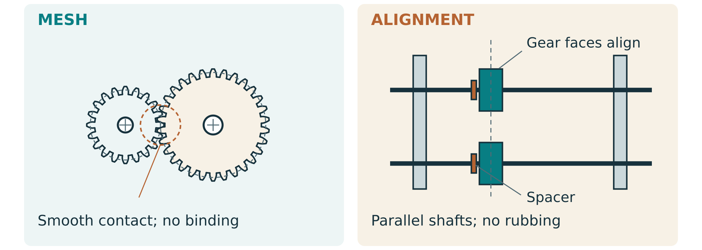
Figure 8. Inspect parallel shafts, support alignment and retention. The illustration explains what to check; it does not specify a fit or clearance.
Assembly check | Observation / evidence | Correction / recheck
Gear mesh and shaft alignment
Spacers, rubbing and shaft retention
Frame/base stability and fixings

What evidence would show your physical gear train matches the predicted ratio?
MECHANISM TUNING

Tune the cam gate and pawl
The cam and follower need consistent contact and the intended phase. The gate needs its approved travel and an unobstructed path. The ratchet needs reliable forward passage and reverse engagement. Inspect these relationships under the teacher-approved unloaded check first; a loaded jam can conceal which interface is responsible.
Figure 9. Follow the item path and gate phase. A correct release needs isolation as well as an opening.
Interface | What I observed | Approved adjustment / evidence
Cam/follower contact and phase
Gate opening, closing and reset
Pawl/ratchet engagement
Full combined cycle

A pawl works alone but blocks the mechanism after the cam is added. What would you investigate?
SAFETY FEATURES

Guard the real hazards
A guard must address the actual access path to moving gears, cams and pinch points. Visibility can help inspection, but it is not the same as protection. Check the entire intended range of motion: a guard must not touch a moving part or expose a new sharp edge. Your teacher confirms guard suitability and testing readiness.
Guarding plan or annotated actual photo: hazards, access path and intended protection

Safety check | Evidence / status | Remaining action
Stable base; shafts retained; fixings secure
Guard protects access without rubbing
Edges/contact surfaces suitable
Approved stop/fault procedure understood

How will you stop and get help if a jam occurs?
MANUFACTURING EVIDENCE

Keep a traceable build log
Source activity: record dated stages with photographs and meaningful notes. Show the approved design reference, what actually happened and any variation. A log explains decisions; a stack of unlabelled photos cannot show why a part changed. Attach additional entries/photos as needed without inventing completed work.
Date / part or stage | Work / check actually done | Photo/file reference | Variation / next step

Explain one build variation and how it could affect later results.
BUILD CHECKPOINT

Quality assurance before testing
Use the source checklist as a preparation aid. Its website progress counter is not a teacher sign-off. Keep evidence for each check and return unresolved issues to the teacher before loaded testing. The approved school procedure controls readiness.
Area | Evidence / finding | Next action / confirmation
SWMS, equipment permission and PPE
Stable surface; retained aligned shafts
Smooth approved gear mesh, no wobble
Cam/follower and pawl/ratchet checks
Feed/gate path and full-cycle reset
Guards, fasteners and edges
CAD/build photos and variations organised

What needs resolving before your first loaded trial?
BUILD and TUNING KNOWLEDGE CHECK

Feed effort and variables source check
Answer the exact source questions. Any numerical test, threshold, gate clearance or hopper angle in an example is illustrative, not an approved setting or pass mark.
1. Your dispenser works well when it is half full, but jams frequently when almost empty. Give one possible reason.

2. Explain how changing the gear ratio could make the dispenser easier to use for a younger child.

3. What does it mean to “change one variable at a time” during testing, and why is it important?

4. Give two examples of data you could collect in a 10-cycle test that would help you judge reliability.
BUILD and TUNING KNOWLEDGE CHECK

Jerky motion and users source check
Answer the exact source questions. Any numerical test, threshold, gate clearance or hopper angle in an example is illustrative, not an approved setting or pass mark.
5. A user reports that the handle feels “jerky” at one point each turn. What are two potential causes you might investigate?

6. Why is user feedback an important part of mechanism testing, even if the mechanism "works" in your own trials?
BUILD and TUNING KNOWLEDGE CHECK

Reliability and data source check
Answer the exact source questions. Any numerical test, threshold, gate clearance or hopper angle in an example is illustrative, not an approved setting or pass mark.
7. How do you calculate reliability, and what does it tell you about your design?

8. What is the difference between qualitative and quantitative data, and why do you need both?
BUILD and TUNING KNOWLEDGE CHECK

Evidence and improvement source check
Answer the exact source questions. Any numerical test, threshold, gate clearance or hopper angle in an example is illustrative, not an approved setting or pass mark.
9. How can you use test data to justify design decisions in your evaluation?

10. What makes a realistic improvement suggestion, and how should you justify it?
SUPPLEMENTARY CAM PRACTICE

Cam motion explain sketch transfer
Optional supplementary practice, re-authored for paper: explain cam motion using the terms rise, dwell and fall. A displacement-versus-angle sketch describes the follower, not the shape of the physical cam. At the same rotation speed, increasing an angular dwell increases its time; changing shaft speed also changes dwell time.
Sketch a follower motion sequence for a proposed gate: label rise, dwell, fall and reset

Compare a sliding and a roller follower. What must both do for reliable gate motion?

Practice: why can a long open dwell still produce unreliable dispensing?
TESTING PROTOCOL

Plan a fair reliability trial
A reliability trial asks how often the dispenser completes the defined job under stated conditions. First use the approved unloaded check to identify binding and count intended input/output travel. Begin loaded trials only after teacher review of safety, test pieces and the stop procedure. The source asks for 50–100+ recorded cycles; confirm your required count and conditions with the teacher.

Figure 10. A controlled trial records the mechanism, input cycle, test pieces and each outcome. Use inert non-food pieces if food-contact approval is unconfirmed.
Control / definition | My approved plan
One complete cycle / home marks
Test-piece type/size and loading method
Number of cycles / target criterion
Turning method and initial fill condition
Stop/fault procedure and recording roles

Define success, jam, double and partial release so two observers would classify the same cycle alike.
CYCLE BY CYCLE EVIDENCE

Reliability log cycles 1 to 25
Record every completed trial cycle. Codes: S = one correct release; J = jam; D = double; P = partial; O = other (explain). Use one primary outcome per cycle and note overlaps. Stop safely for a fault. Do not erase failures. Trial/version/date: __________________
Cycle | Outcome | Fill/condition | Turns (if measured) | Note / fault reference
1
2
3
4
5
6
7
8
9
10
11
12
13
14
15
16
17
18
19
20
21
22
23
24
25
CYCLE BY CYCLE EVIDENCE

Reliability log cycles 26 to 50
Record every completed trial cycle. Codes: S = one correct release; J = jam; D = double; P = partial; O = other (explain). Use one primary outcome per cycle and note overlaps. Stop safely for a fault. Do not erase failures. Trial/version/date: __________________
Cycle | Outcome | Fill/condition | Turns (if measured) | Note / fault reference
26
27
28
29
30
31
32
33
34
35
36
37
38
39
40
41
42
43
44
45
46
47
48
49
50
CYCLE BY CYCLE EVIDENCE

Reliability log cycles 51 to 75
Record every completed trial cycle. Codes: S = one correct release; J = jam; D = double; P = partial; O = other (explain). Use one primary outcome per cycle and note overlaps. Stop safely for a fault. Do not erase failures. Trial/version/date: __________________
Cycle | Outcome | Fill/condition | Turns (if measured) | Note / fault reference
51
52
53
54
55
56
57
58
59
60
61
62
63
64
65
66
67
68
69
70
71
72
73
74
75
CYCLE BY CYCLE EVIDENCE

Reliability log cycles 76 to 100
Record every completed trial cycle. Codes: S = one correct release; J = jam; D = double; P = partial; O = other (explain). Use one primary outcome per cycle and note overlaps. Stop safely for a fault. Do not erase failures. Trial/version/date: __________________
Cycle | Outcome | Fill/condition | Turns (if measured) | Note / fault reference
76
77
78
79
80
81
82
83
84
85
86
87
88
89
90
91
92
93
94
95
96
97
98
99
100
TESTING CALCULATIONS

Reliability calculate and qualify
Reliability percentage = successful cycles ÷ total performed cycles × 100%. The denominator includes failures. Do not divide by the number of good releases alone or omit a jam because it was inconvenient. Report the sample size and conditions alongside the percentage.
Illustrative outcome | Cycles
Success | 42
Jam | 6
Double | 2
Total performed | 50

The worked set gives 42 ÷ 50 × 100 = 84% reliability. Failed cycles total 8, or 16%. This describes the illustrative set only. It does not establish your result or meet a target unless the confirmed target and test conditions support that judgement.
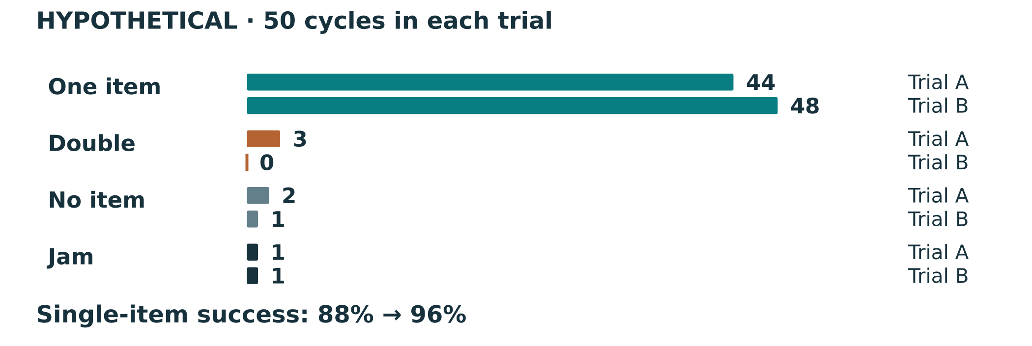
Figure 11. Read success and failure counts with their denominator. A percentage without trial size or conditions hides important evidence.
My actual run / version | Total | Success | Failure | Reliability %

What does your percentage show, and what does it not prove?
TESTING RELATIONSHIPS

Predicted motion and measured dispensing
Keep geometric gear ratio separate from operating results. For intact non-slipping meshed gears, tooth counts and shaft connections determine relative rotation. Friction changes effort and available torque, not that geometric ratio. Skipped teeth, slipping attachments, incorrect counts or inaccurate observation can make measured motion differ from the prediction.
Turns per dispense also depends on the actual output travel and releases per revolution. Failures can increase total handle turns per successful release without changing gear ratio. State whether you counted turns for a defined normal cycle or all turns across a run with failures. Those measurements answer different questions.
Quantity | Prediction / method | Actual result / units
Geometric input/output rotation ratio
Output movement needed for one release
Input turns for a normal defined cycle
Total input turns / successful releases (if used)

Your ratio prediction is 4:1, but a loaded run needs extra turns for some good releases. Explain two possible reasons and how to distinguish them.
DATA PRESENTATION

Make patterns visible in a graph
Choose a graph that answers a question. A bar chart can compare failure categories or before/after reliability; a line or cumulative plot can show changes over a stated sequence. Label axes, units, run/version, sample size and conditions. Counts and percentages must not share an unlabeled scale. A graph is evidence only when its values match the source table.
My graph: title, labelled axes, readable scale and actual test data

Explain the main pattern using two actual values and one limitation.
FAILURE ANALYSIS

Symptoms point to investigations
A symptom is what you observe; a cause is an explanation to investigate. Low-fill jams may indicate feed geometry, while a stiff point every turn may indicate alignment or a repeating cam/gear contact. The same symptom can have several causes. Compare the cycle log, fill/turning conditions and physical observations before selecting an approved change.
Actual symptom / cycles | Possible cause and evidence | One proposed check/change

Why would changing gate clearance and hopper slope together make the results hard to explain?

Do not force a fault
Stop for binding, loose parts, damaged guards or unsafe motion. Use the approved fault procedure and teacher review. An investigation is not permission to bypass guards, reach into moving parts or use an unapproved setting.
IMPROVEMENT EVIDENCE

Iteration record one change at a time
Source activity: document adjustments and retest with the same approved method. At least two specific improvements are expected in the source folio; they may be completed approved changes or clearly justified proposals. Link each to a problem, engineering reason and evidence. More change is not automatically better.
Iteration item | Change 1 | Change 2
Problem and evidence reference
One approved change or proposal
Engineering reason
CAD/drawing/build revision
Comparable before/after run
Result, limitation and next action

Did your test support the proposed explanation? State what the evidence allows you to conclude.
VISUAL EVIDENCE

Before and after show the change
Source activity: annotate at least one actual final dispenser photo with the gear train, cam/gate, handle and safety features. If you made an improvement, show comparable before-and-after views and explain the changed feature. Keep lighting, framing and scale useful; an arrow needs a short claim tied to evidence.
Attach or plan an annotated final photo: label features and the evidence each supports

Image / version | Annotation / what changed | Related test evidence
Before:
After:

Write a useful caption that explains one visible feature and one evidence limitation.
USER FEEDBACK

User trials comfort and predictability
Source activity: under teacher approval, gather feedback from 3–5 different users on ease of use, comfort, effort, predictability and satisfaction. Use participant labels rather than unnecessary personal details. Do not recruit younger children or treat a machine as safe for them from a written scenario. Keep the approved operating method and stop procedure consistent.
User label | Comfort / effort | Predictability / behaviour | Suggested change
A
B
C
D (if used)
E (if used)

Summarise one shared finding and one different experience. What would you investigate next?

If a user tries to turn backwards, what does that reveal about the design or instructions?
EVALUATION REASONING

Evaluate against confirmed criteria
Evaluation makes a judgement, then supports it. Name the confirmed criterion, cite your actual evidence, explain what it means and qualify the limit. A description such as “I tested 100 times” tells what happened but not how well the design performed. A reliability figure does not establish safety, comfort or durability by itself.
Confirmed criterion | Specific evidence / reference | Judgement and limitation
Function/reliability
Safety/guarding
Ergonomics/effort
Durability/retention
Appearance/communication

Write one complete evaluation paragraph using criterion + evidence + judgement + limitation.
EVALUATION and IMPACT

Sustainability and practical trade offs
Environmental evaluation uses your actual choices and evidence. Compare usable stock and offcuts, material provenance where verified, avoided rework, durability and repairability. Do not label a design sustainable only because it uses timber. An honest limitation, such as unverified certification or unmeasured waste, is more useful than an unsupported claim.
Design / process choice | Evidence of impact | Trade-off / improvement
Stock and nesting
Rework / rejected parts
Finish / food-contact boundary
Durability and repairability

Propose one realistic lower-impact change and explain how you would check it still works safely.
PRESENTATION and COMMUNICATION

Showcase your engineering evidence
Your showcase should explain the problem, how the mechanism controls release, the evidence for performance and a justified improvement. Use your actual final photos and a teacher-approved demonstration or video. A polished presentation cannot replace the cycle log or make an unapproved dispenser food-safe.
Showcase section | My evidence / message
Purpose and target user
Gear train, cam/gate and one-way control
Actual trial result and limitation
One improvement and engineering reason
Safety and sustainability evidence

Write a short showcase script a visitor can understand. Include one numerical result with its sample/conditions and one limitation.
PERSONAL REFLECTION

Reflection explain your learning
Source activity: write 1–2 connected paragraphs about mechanisms, materials, CAD, testing and problem-solving. Name one challenge and explain the evidence behind your response. Compare what you could do at the start with what you can do now. Link to current teacher-confirmed outcomes only if asked; do not copy a later syllabus code from an example.
What did I learn, what challenged me, and how did I respond? Use one real event and explain the engineering reasoning.

What skill improved, and what would I do differently next time? Link one realistic improvement to evidence.
FINAL FOLIO ORGANISATION

Make the folio easy to follow
A reader should be able to find the brief, your decisions, the physical build evidence and the data supporting your judgement. Keep clear headings, page numbers, readable photos/captions, current drawings and authentic records. The source draft’s reference to earlier projects needs teacher confirmation; this unit book alone does not decide the wider folio scope.
Folio section | Exact page/file location | Complete / next action
Cover, purpose, brief and confirmed criteria
Mechanism calculations and concepts
Materials, cut list, CAD pack and drawings
SWMS, operations and build/guarding evidence
Cycle logs, analysis, graphs and user feedback
Evaluation, two improvements and reflection
Showcase and approved submission details

Ask a reader: can they understand what you built, why and how it performed? Record one useful revision.
EVALUATION KNOWLEDGE CHECK

Reliability and failure modes source check
Answer the exact source questions. Use confirmed criteria and your own evidence; worked sample targets, force figures, hopper angles and later syllabus codes are not requirements.
1. Why is reliability testing important, and how do you calculate reliability?

2. How do you identify failure modes systematically during testing?
EVALUATION KNOWLEDGE CHECK

Description judgement and effort source check
Answer the exact source questions. Use confirmed criteria and your own evidence; worked sample targets, force figures, hopper angles and later syllabus codes are not requirements.
3. What is the difference between describing your project and evaluating it?

4. Your dispenser is reliable but hard to turn for younger users. Give one realistic improvement and justify it.
EVALUATION KNOWLEDGE CHECK

Photos and honest evaluation source check
Answer the exact source questions. Use confirmed criteria and your own evidence; worked sample targets, force figures, hopper angles and later syllabus codes are not requirements.
5. What makes an annotated photo more useful than an unlabelled one in a folio?

6. Why can honestly identifying weaknesses and future improvements actually strengthen your overall evaluation?
EVALUATION KNOWLEDGE CHECK

Paragraphs and readiness source check
Answer the exact source questions. Use confirmed criteria and your own evidence; worked sample targets, force figures, hopper angles and later syllabus codes are not requirements.
7. How do you structure an evaluation paragraph that links criteria, evidence, and judgement?

8. What makes a folio "marking-ready" and easy to assess?
EVALUATION KNOWLEDGE CHECK

Reflection and evaluation source check
Answer the exact source questions. Use confirmed criteria and your own evidence; worked sample targets, force figures, hopper angles and later syllabus codes are not requirements.
9. How do you write a strong personal reflection that demonstrates learning?

10. What is the difference between describing your project and evaluating it, and why does this matter?
SUBMISSION READINESS

Feedback to final handover
Check the exact teacher-issued submission requirements before handing in. Verify that final CAD/drawings/exports match the built version and that every claim refers to real evidence. Keep source masters and earlier versions safely organised. This checklist supports preparation; only your teacher applies the current assessment requirements.
Final check | Evidence / unresolved action
Approved task, date/time, destination and folio scope confirmed
All required own CAD/drawings/exports readable / current
Build, safety/guarding and variations traceable
Cycle totals, reliability and graphs reconcile
User feedback and criteria-based judgements bounded
Two specific improvements and reflection included
File names, contents and links tested

Record the final feedback you acted on and one outstanding question for the teacher.
REFERENCE and HANDOVER

Terms sources and useful next steps
Term | Meaning in this project
Driver / driven | Input-receiving gear / gear receiving motion from it
Ratio g | Driven teeth ÷ driver teeth for each actual stage
Torque | Turning effect; force × perpendicular lever distance
Pitch circle / centre distance | Ideal meshing circle / shaft-axis spacing
Dwell | Constant follower displacement over a range of cam angle
Backlash / clearance | Play between tooth flanks / separation preventing interference
Reliability | Successful defined cycles ÷ total performed cycles × 100%
Datum / revision | Measurement reference / identified version of a file or design

Optional gear-systems, ratio/RPM and cam workbooks linked from the course support the named concepts. Use teacher-selected sections; this book does not reproduce those scanned resources wholesale. Videos and demonstrations supplement the printed explanation and do not authorise their machinery, dimensions or methods.
Course overview and resource links
Gear systems and mechanisms source
Design and CAD source
Build and manufacture source
Testing and evaluation source
Original teaching and paper adaptations prepared for this workbook from the frozen source course. Generated concept figures are illustrative and cannot replace your own evidence. Keep current teacher-approved specifications, assessment and workshop procedures alongside these resources.

