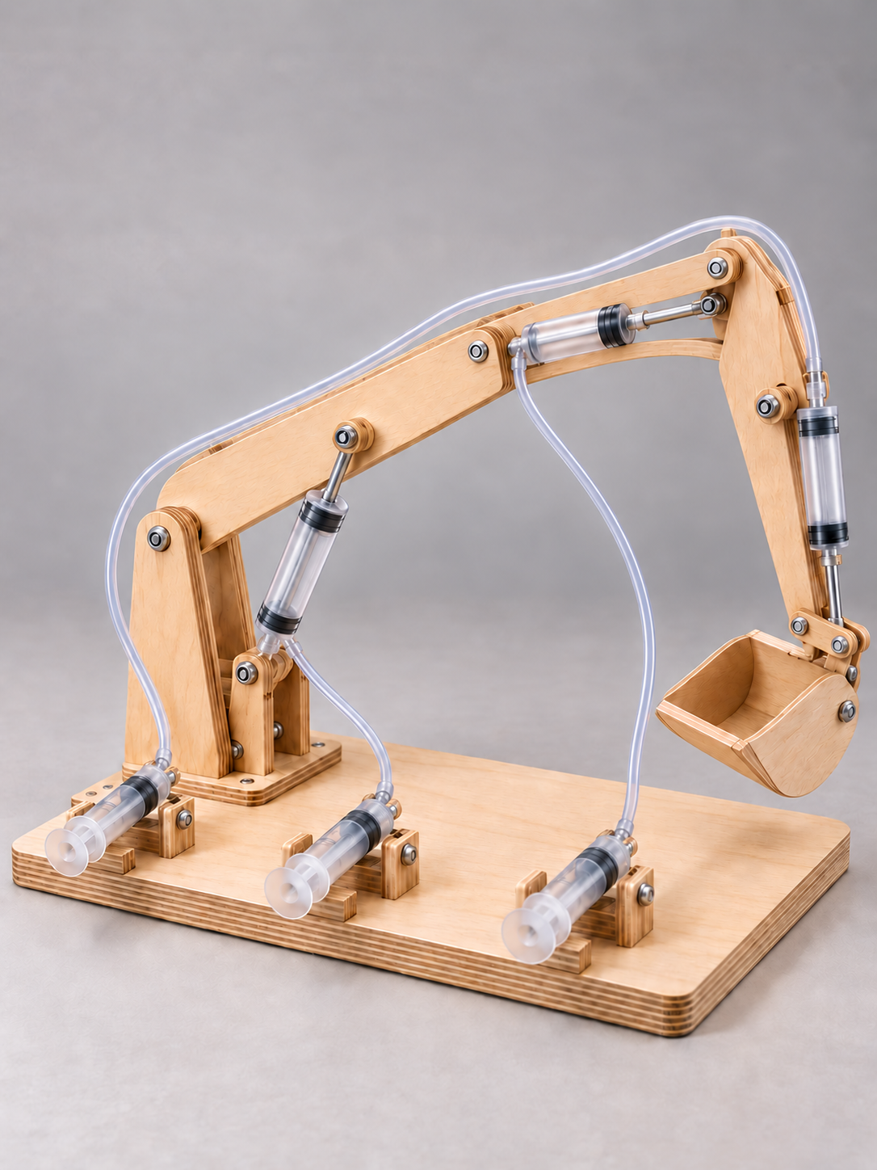
YEAR 9 ENGINEERING

Hydraulic
Digger
Fluid power • Mechanisms • Design • Build • Test and evaluate

Figure 1. A tabletop hydraulic digger: water-filled circuits connect hand controls to the boom, dipper and bucket. Illustrative project view, not an approved construction plan.
Name _____________________________________ Class __________________
Group ____________________________________ Teacher _________________
Predict force and movement. Design the linkages. Build with care. Test fairly. Explain what the evidence shows.
Year 9 Engineering • Term 3 • Student learning and folio companion
START HERE

Your learning and evidence route
Use this workbook with the current Hydraulic Digger course website, your teacher’s class brief, approved practical instructions and current task notification. Read the explanation, try the paper task, and use feedback to improve your own evidence. The teacher confirms how these pages contribute to your submitted folio.
Learning route | Find these pages
Fluid power and mechanisms | 5–28
Design and prediction | 29–45
Construction and setup | 46–51
Testing, analysis and evaluation | 52–61
Drawings, costing, sustainability and pathways | 62–71
Media notes and final handover | 72–81

Evidence that can be followed
Keep predictions separate from observations. Give each circuit, setup, test and image a clear name or number. Put units and measurement points beside results. If something was not measured, write “not measured” and explain why. A neat invented number is not engineering evidence.
“Source question” preserves the website’s question wording. “Source activity” retains or explicitly adapts a website task for paper and safe teacher-led use. “Practice” is newly authored formative learning. Worked examples are hypothetical; they are not your results.
What is one thing you want to understand about a hydraulic digger’s force or movement?
START HERE

The class brief controls the build
The source project is a tabletop digger with three separate hydraulic circuits: boom, dipper and bucket. It asks for smooth, leak-free control, predictions using syringe areas and lever geometry, systematic tests and a folio showing design, making and evaluation. That learning brief does not supply every construction or safety detail.
The website lists reach, lifting and syringe capacities as examples. Record the actual class targets below. A syringe’s mL capacity is its volume marking; it does not prove its piston diameter, area or pressure rating. The source working drawing is undimensioned reference material. Do not measure the printed picture to obtain cutting sizes.
Teacher-confirmed item | Class instruction / source
Reach target and measurement datum
Lifting target and approved load method
Approved materials, tools and dimensions
Safe syringe travel, force and test stop conditions
Due date/time and submission method

Current task status
The linked notification describes a formative learning task that is not graded. It gives end-of-Term-3 submission guidance. Your teacher confirms the current class dates and instructions. This workbook does not create a marking scheme or workshop approval.

Which requirement still needs confirmation before your group starts?
START HERE

From a hand movement to bucket motion
A digger combines systems. The control syringe receives the operator’s input. Water and tubing transmit pressure. The output syringe converts fluid pressure into linear piston motion. A linkage then rotates an arm or bucket about a pivot. The load and the digger’s own moving parts resist that motion.
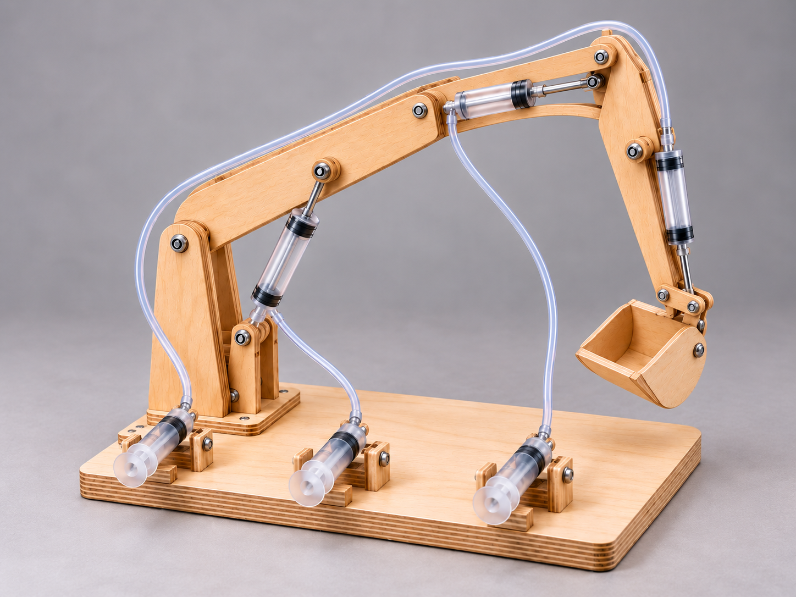
Figure 2. Name the base, boom, dipper, bucket, control syringes and output actuators. This illustrative view is for system identification, not fabrication.
A useful design does more than move once. It should move predictably through a useful range, remain stable, keep water contained and give results that can be repeated. An arm can reach far but need too much force to lift at that position. A large output piston can provide more force but run out of travel. Design is the process of balancing these linked decisions.
Practice: sketch one control-to-bucket motion chain. Label input, fluid path, actuator, fulcrum and load; add arrows for linear and rotating motion.

Explain one reason that “it moves” is not enough evidence of success.
FLUID POWER & MECHANISMS

Water carries the pressure

When you push a syringe plunger, your hand applies a force to the water beneath the piston. In a connected, enclosed water-filled circuit, the pressure change is transmitted through the liquid. The output piston responds to that pressure, so a push at the control can move a different part of the digger. The tubing carries fluid; the linkage directs the resulting motion.
Pressure is force divided by area: P = F/A. It is not the same quantity as force. If the same force acts on a smaller area, the pressure is greater. If the same pressure acts on a larger output piston, the output force is greater. This is Pascal’s principle applied to a simplified hydraulic circuit.

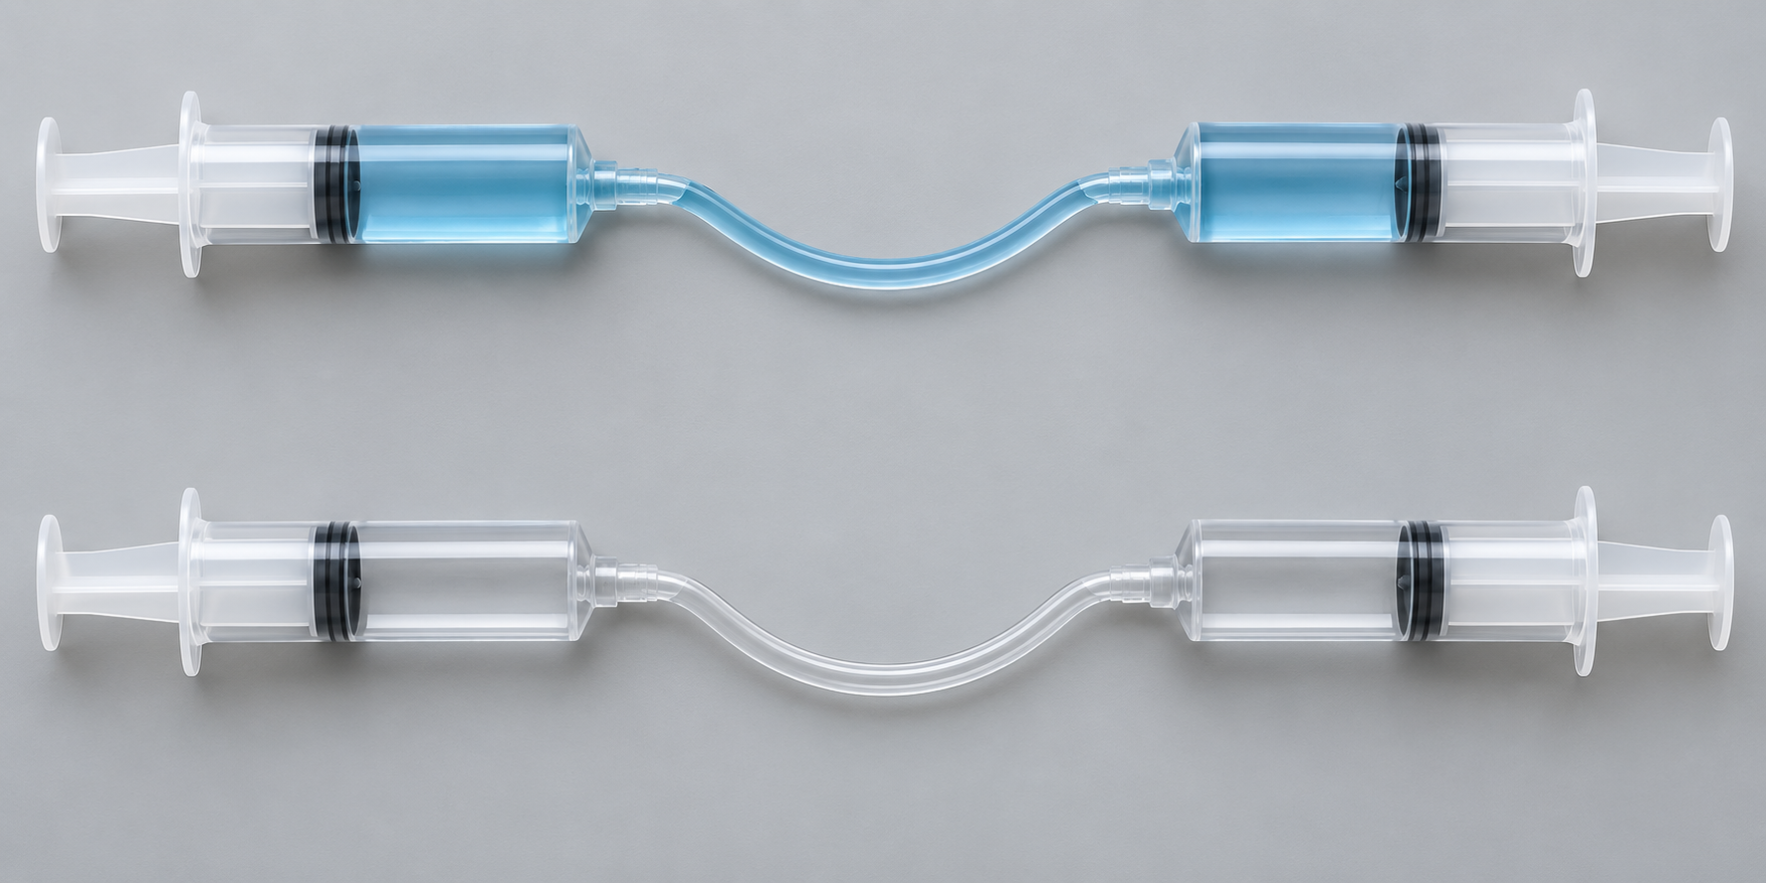
Figure 3. Upper: liquid-filled pair. Lower: air-filled pair. Compare circuit contents; the reading explains their different response. Illustrative comparison, not a pressure rating or filling instruction.

Liquids change volume very little under classroom conditions. Gases compress much more, so an air bubble can absorb input movement before the output moves. That delay feels “spongy”. A leak is different: fluid escapes and the circuit may lose position or become less repeatable. Neither problem is repaired by pushing harder.
Term in context: circuit
A circuit is one connected fluid path between a control syringe and its output actuator. The brief calls for separate boom, dipper and bucket circuits.

Practice: explain why an air bubble and a leak can both make control poor, but require different checks.
FLUID POWER & MECHANISMS

Pressure, force and piston area
Force is a push or pull, measured in newtons (N). Pressure describes how that force is distributed across an area. For a flat piston, P = F/A; rearranging gives F = P × A. Keep the area units consistent on both sides of a ratio. In SI units, 1 pascal (Pa) is 1 N/m².
Hypothetical example: 10 N acts on 100 mm². P = 10/100 = 0.10 N/mm². Because 1 mm² = 0.000001 m², the same pressure is 100,000 Pa, or 100 kPa. At that pressure an ideal 200 mm² output piston gives 20 N. Pressure is the same; force differs because area differs.
Keep the dimensions honest
Use the working piston face or teacher-supplied barrel bore diameter, not the outside barrel diameter. Record whether the dimension was measured or teacher-supplied. Do not infer diameter from an mL label or assume all brands have the same proportions.

Practice: a hypothetical piston has area 80 mm² and experiences 8 N. Calculate pressure in N/mm². At the same ideal pressure, what force acts on 160 mm²?

Explain the mistake in “the large syringe has higher pressure because it produces more force”.
FLUID POWER & MECHANISMS

A larger piston trades travel for force
Hypothetical calculation only. These numbers are not syringe specifications, project dimensions or approved loads. We compare an input piston diameter of 12 mm with an output diameter of 24 mm, with a 5 N input force and 40 mm input travel. Real piston diameters must be measured or supplied by the teacher.
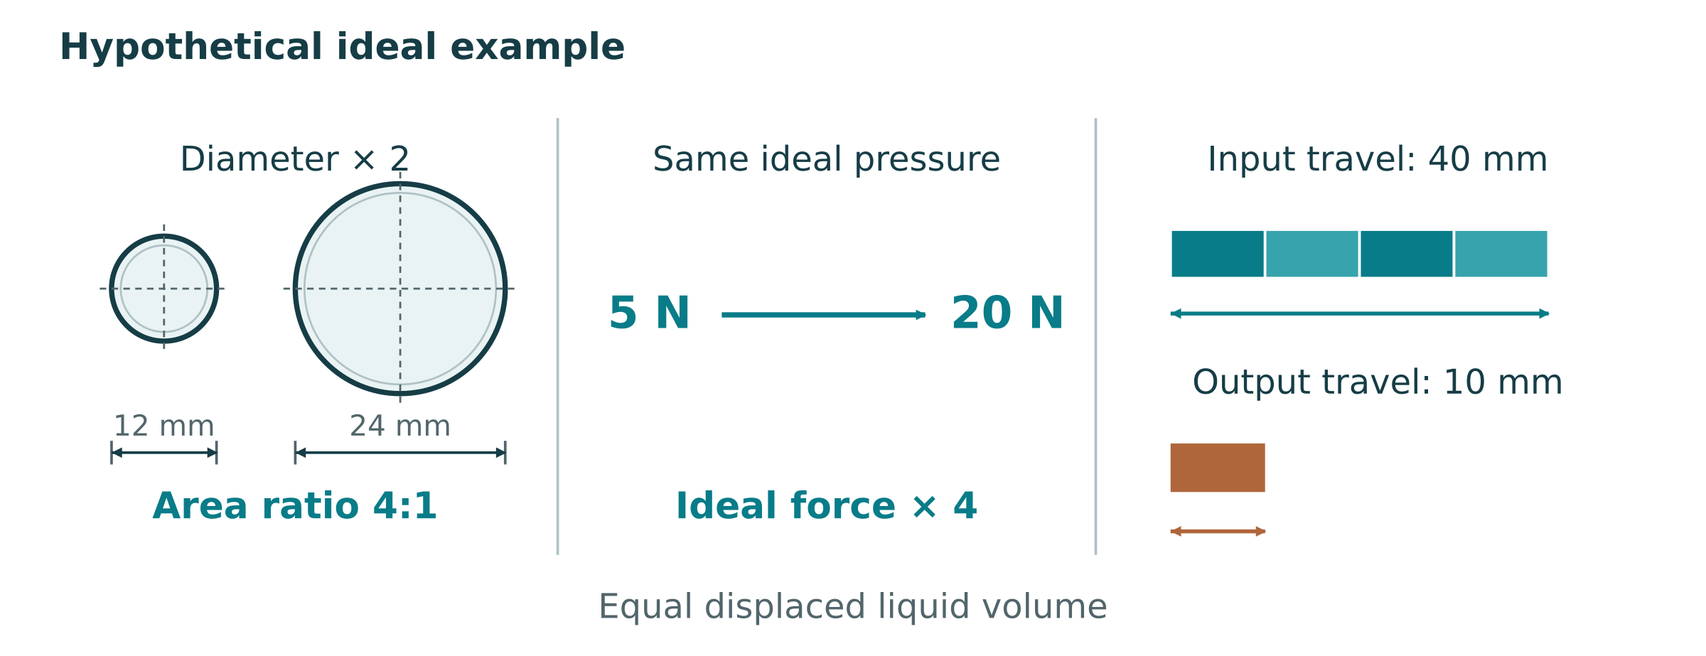
Figure 4. A hypothetical area comparison: doubling diameter gives four times the area. Output travel is shorter because both pistons displace the same volume in an ideal circuit.
Reasoning step | Working
Calculate input area | A₁ = π × 12² / 4 ≈ 113.1 mm²
Calculate output area | A₂ = π × 24² / 4 ≈ 452.4 mm²
Compare areas | A₂/A₁ = 4
Predict output force | F₂ = 5 × 4 = 20 N
Predict output travel | s₂ = 40 / 4 = 10 mm

Check the trade-off: input work is 5 N × 0.040 m = 0.20 J. Ideal output work is 20 N × 0.010 m = 0.20 J. The larger piston does not create energy. A real circuit can need extra effort because friction, deformation and leakage reduce useful output.
Practice: using the same hypothetical area ratio, predict output force and travel for 8 N input and 32 mm input travel. Show units and explain one limitation.
FLUID POWER & MECHANISMS

Lever force depends on the moment arm
A lever rotates about a fulcrum. A force turns it more effectively when its line of action passes further from the fulcrum. The perpendicular distance from the fulcrum to that line is the moment arm. Turning effect, or torque, equals force × perpendicular moment arm. A sloping actuator needs this perpendicular distance, not just the length of the boom.
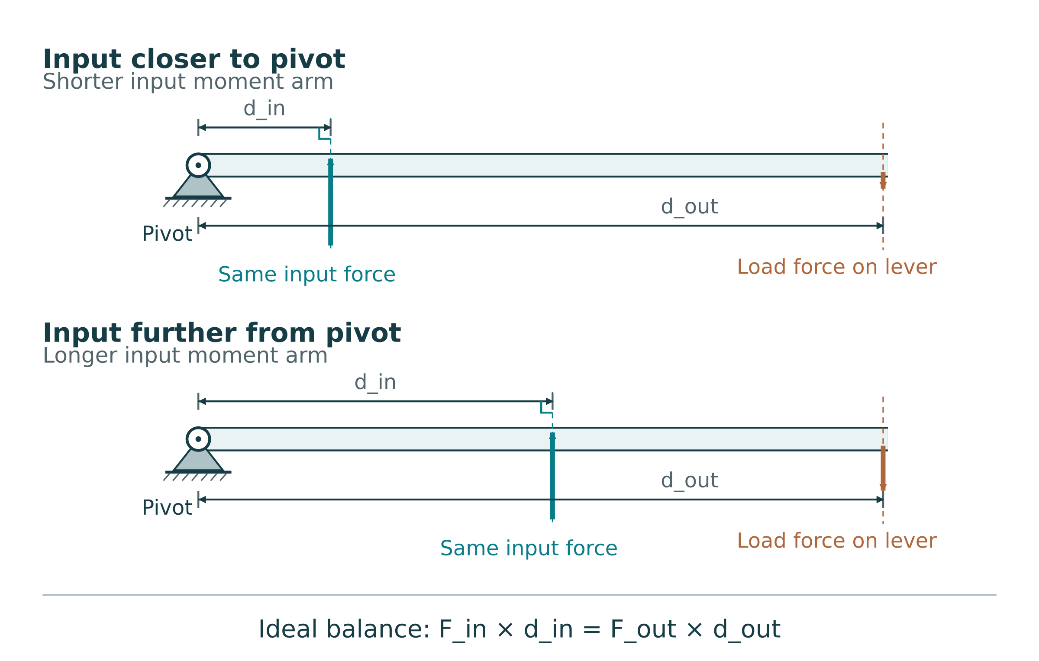
Figure 5. A conceptual lever: compare the actuator’s perpendicular effort arm with the load’s perpendicular arm. The illustration explains force relationships; it supplies no project dimensions.
In a balanced ideal lever, effort force × effort arm = load force × load arm. Therefore ideal force MA = effort arm / load arm. For a fixed actuator force, moving its line of action closer to the fulcrum reduces its moment arm and the available load force. The bucket may travel further for a short actuator movement, but that movement gain costs force.
Check the geometry, not a slogan
Real digger angles change through the stroke. The useful moment arms and mechanical advantage can change with position. A syringe’s output force is not automatically the force available at the bucket.

Practice: an actuator is moved closer to the pivot while the load point stays the same. Explain the likely force–movement trade-off for the same actuator force.
FLUID POWER & MECHANISMS

Three lever classes, one balance rule
Lever class is identified by what sits between the other two features: fulcrum, load or effort. It describes the arrangement, not the strength of the material. Use a labelled diagram rather than guessing from an object’s name.
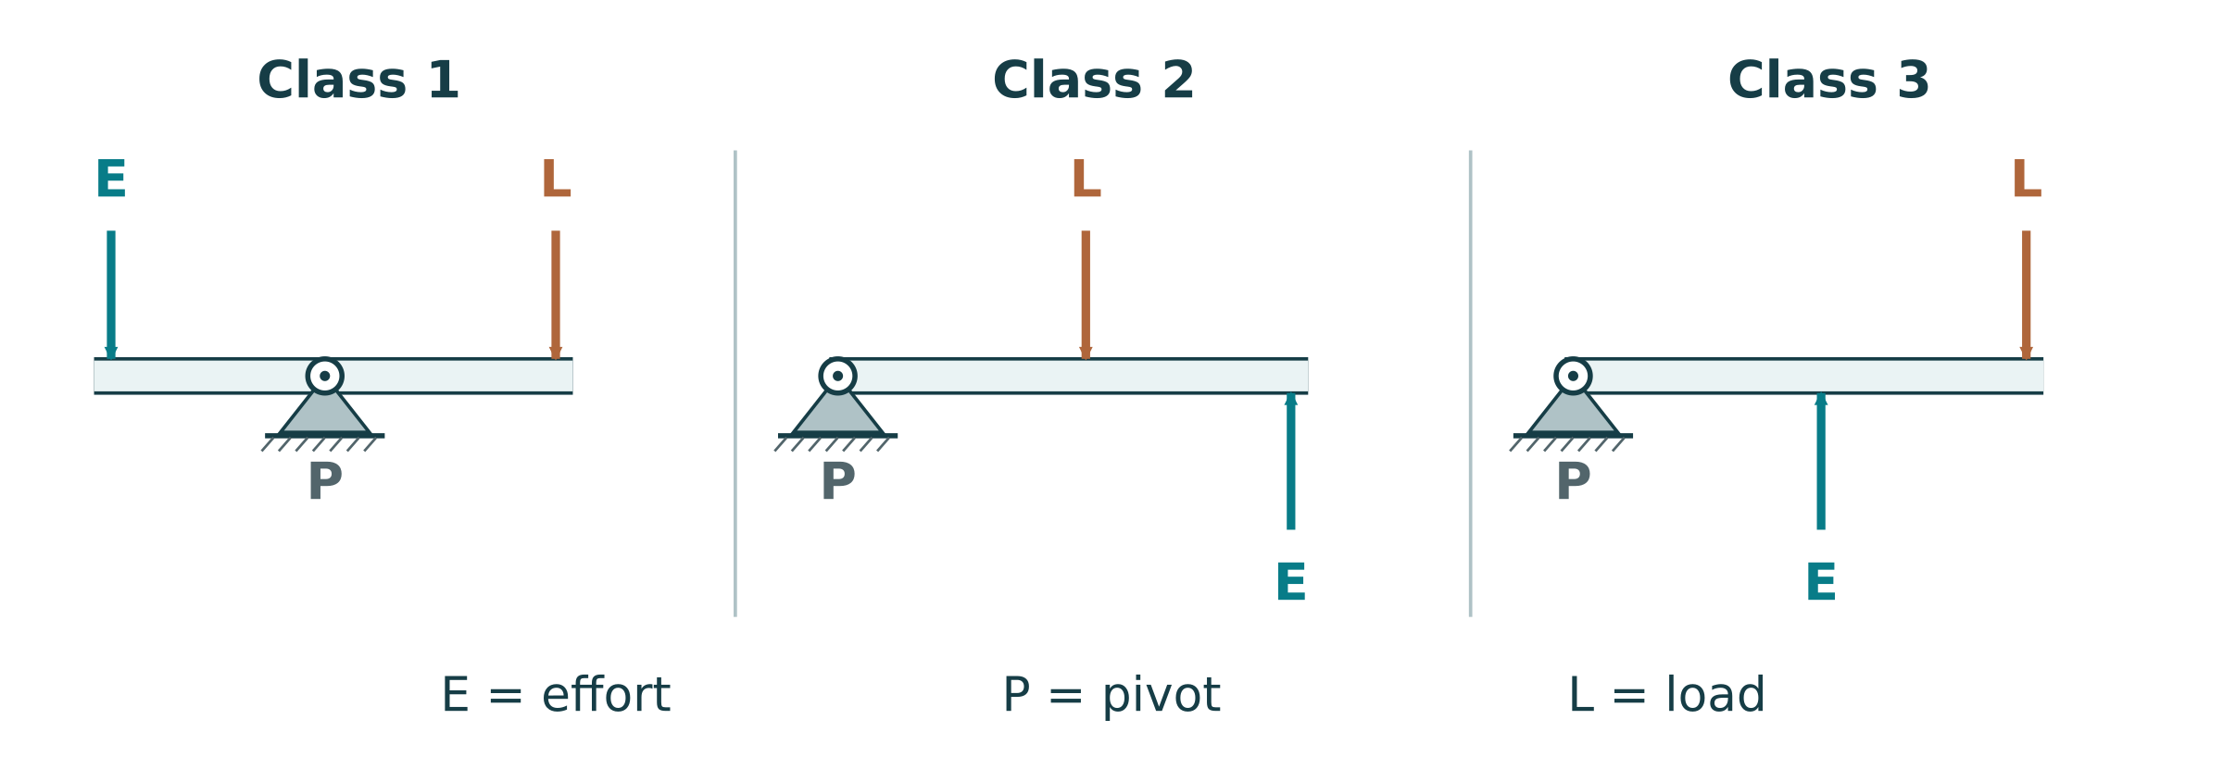
Figure 6. Conventional lever arrangements: class 1 fulcrum between effort and load; class 2 load between; class 3 effort between. Concept diagrams, not project geometry.
Class 1 includes a seesaw-like arrangement and can multiply force or movement, depending on moment arms. In the conventional ideal class 2 arrangement, the effort arm is longer than the load arm, so it multiplies force. In the conventional class 3 arrangement, the effort is between the fulcrum and load; it sacrifices force for movement. The same turning-effect balance applies to all three.
Practice: draw and label an example of each class. Mark the middle feature and the direction of effort and load.

Explain why a conventional class 3 lever needs more effort force than the load force in the ideal model.
FLUID POWER & MECHANISMS

Simple machines make a trade-off
A simple machine changes the size, direction or distance of a force. It does not supply free energy. Mechanical advantage is the output force divided by the input force: MA = Fout/Fin. An MA greater than 1 multiplies force. An MA below 1 gives less output force but can gain motion or speed.
Machine | What to notice
Lever | A rigid member turns about a fulcrum; effort and load positions set the ideal trade-off.
Pulley | A fixed pulley changes pull direction. In an ideal movable pulley, supporting rope segments share the load.
Gear pair | Meshing teeth change rotational speed, torque and direction.
Inclined plane, wedge or screw | A longer input movement can produce a smaller output movement against a larger resisting force.

In a conventional ideal fixed pulley, the distance ratio is 1. An ideal movable pulley supported by two rope segments has distance ratio 2: the input rope moves twice as far as the load. Real pulley bearings and rope bending add losses. For gears, analyse torque and angular motion rather than silently treating shaft torque as a straight-line force.
Practice: compare a fixed pulley and a two-segment movable pulley. Explain the direction and force–distance changes.

Why can a machine make a lifting task feel easier without reducing the ideal work needed?
FLUID POWER & MECHANISMS

Gears trade speed for torque

The driver gear receives the input; the driven gear delivers the output. With two external gears, the gears turn in opposite directions. The driven-to-driver tooth ratio predicts how many input turns are needed for one output turn. Torque is turning effect, measured in N·m, and is distinct from a force in N.
Hypothetical pair: a 10-tooth driver meshes with a 40-tooth driven gear. Gear velocity ratio = 40/10 = 4. If the driver makes four turns, the driven gear makes one. Ideal output torque is four times the input torque. Useful output power is no greater than input power; real meshing and bearing friction reduce the torque gain.
In a compound train, stages share a shaft and stage ratios multiply. An intermediate idler in a simple train can change rotation direction and spacing without changing the overall first-to-last tooth ratio. Identify the actual arrangement before multiplying every gear count.

Practice: a 20-tooth driver turns a 60-tooth driven gear. Find VR, output turns for six input turns, and ideal torque gain.

Practice: sketch the pair and label driver, driven and rotation directions. Add an example engineering use for reduced speed and increased torque.
FLUID POWER & MECHANISMS

Linkages direct the motion
A linkage is a group of connected members and pivots that constrains how parts move. Its geometry can change direction, keep an orientation approximately steady or convert rotation into reciprocating linear motion. The source supplement introduces these types; the digger uses linked rotating arms with linear actuators.
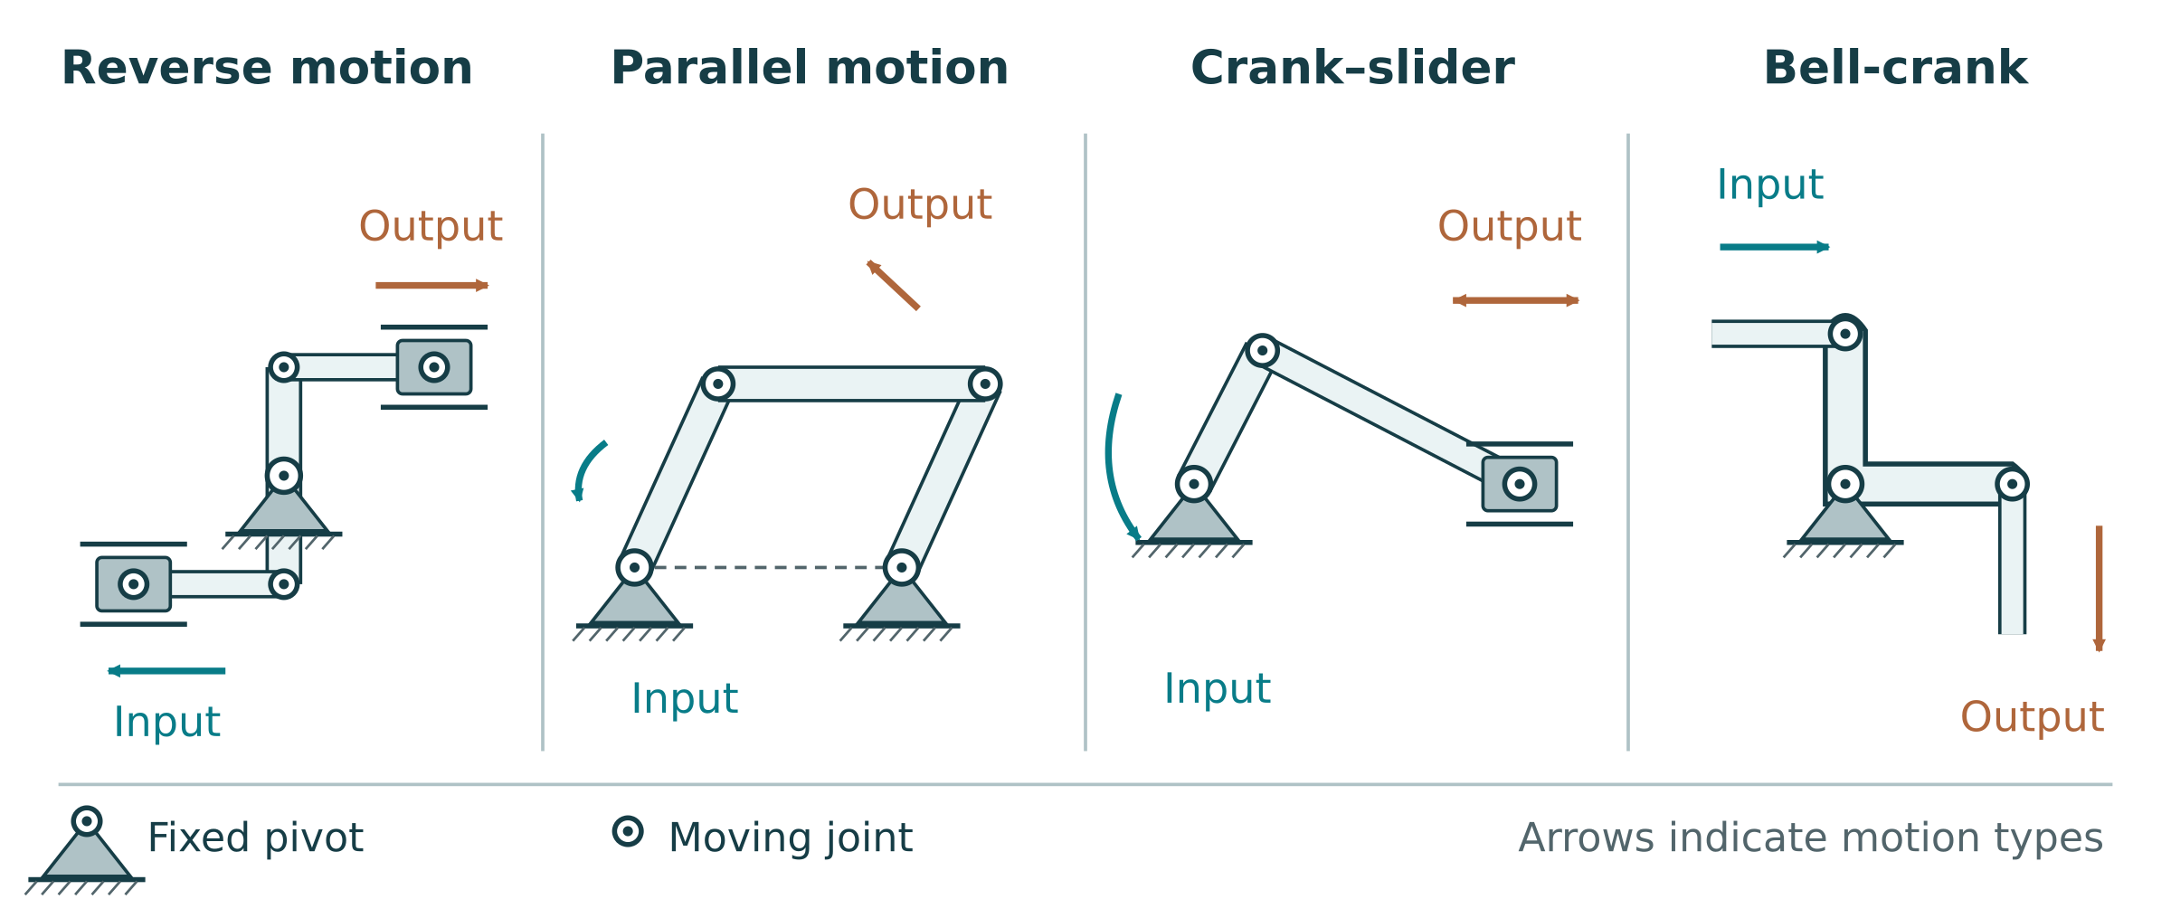
Figure 7. Four conceptual linkage families: reverse motion, parallel motion, crank-and-slider and bell-crank. Compare paths and pivots; the treadle is shown separately. Original explanatory diagrams, not construction plans.
Linkage | Motion to explain
Reverse motion | An input movement can produce an output movement in the opposite sense.
Parallel motion | A suitable parallelogram arrangement maintains member orientation as it moves.
Crank and slider | A rotating crank produces a slider’s back-and-forth movement, or vice versa.
Bell crank | An angled pivoted lever redirects a pull or push.
Treadle | A foot-operated lever/linkage transfers a repeating input to a mechanism.

Practice: choose two linkage types. Explain one motion conversion and one feature you would label in each drawing.
FLUID POWER & MECHANISMS

A treadle turns an input into repeated motion
A treadle is a foot-operated lever connected to another part of a mechanism. In one common arrangement, the pedal rocks while a link drives a crank. A flywheel can help maintain rotation between pushes; the exact motion depends on the linkage. It is an example of motion conversion, not a required hydraulic digger component.
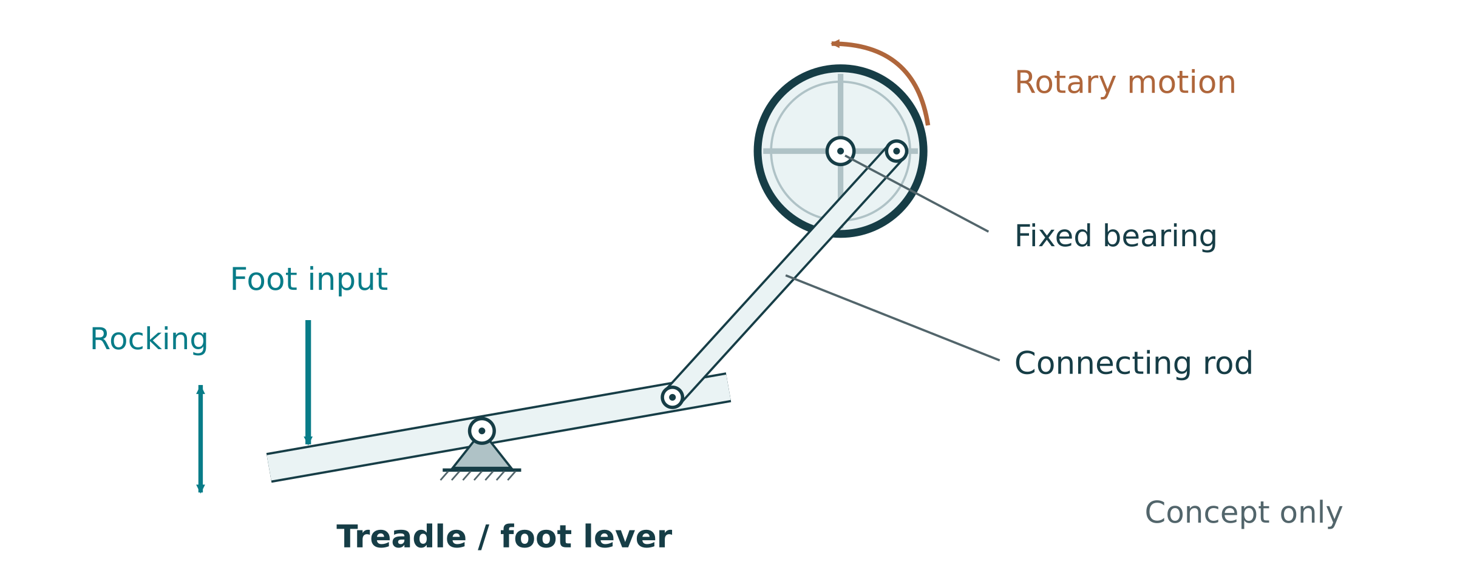
Figure 8. Original conceptual treadle linkage, derived from the motion idea in the linked V. Ryan © 2025 supplement. Notice the foot lever, connecting link and rotating crank; not a construction plan.
The linked third-party supplement asks students to complete and explain a treadle diagram, find four applications, and sketch one application with notes. The following original paper tasks preserve those purposes. Its worksheet marks are not marks for this formative digger project.
Adapted source purpose: draw a simple treadle linkage. Indicate rocking and rotating movement, then label the parts that transfer the input.

Explain how the linkage transfers the foot input to the output.
MECHANISM INVESTIGATIONS

Find and explain treadle applications
Adapted source research task: find four practical treadle applications. Use a teacher-provided reference or current sources and record the source beside each. Look for a real foot-operated linkage, rather than every device with a foot switch. A foot-operated electrical switch is not automatically a mechanical treadle.
Practical application | Source / mechanical evidence
1
2
3
4

Choose one application. Sketch it and add explanatory notes showing the input, linkage and useful output.
FLUID POWER & MECHANISMS

Efficiency measures useful work

For a constant force, useful work is force multiplied by displacement in the force’s direction. An appropriate measured average force can be used over a varying motion only when the teacher’s method supports that comparison. For comparable linear measurements, work in = Fin × sin and work out = Fout × sout. Efficiency = (useful output work/input work) × 100%. With MA = Fout/Fin and VR = sin/sout, the same calculation is efficiency = (MA/VR) × 100%.
Hypothetical test: input 8 N moves 0.060 m; output 12 N moves 0.030 m. Input work = 0.48 J and useful output work = 0.36 J. Actual MA = 12/8 = 1.5; VR = 0.060/0.030 = 2. Efficiency = (1.5/2) × 100% = 75%. Both methods agree because the forces and displacements describe the same test.
Losses include pivot/plunger friction, flexing members, misalignment and fluid leakage. Lifting the digger’s own arm also uses work, so specify whether “useful output” means only the added load. Trapped air can store energy and delay response; this is one reason a changing or spongy system needs careful measurement.

Force comparison is not always energy efficiency
Actual output force/theoretical output force is a force-performance ratio. It equals the work-efficiency expression only when the ideal displacement ratio and other comparison conditions hold. Do not label it measured energy efficiency if travel was not checked.

Practice: input 10 N moves 80 mm; useful output 24 N moves 20 mm. Calculate MA, VR, input/output work and efficiency.
FLUID POWER & MECHANISMS

The energy source sets limits

A mechanism transfers energy supplied from somewhere else. In the hand-operated digger, your muscles provide the input. A battery-driven motor changes electrical energy into movement. A raised mass releases gravitational potential energy as it falls. A stretched spring or rubber band stores elastic energy and releases it as it returns towards its original shape.
Different sources suit different jobs. A motor can provide repeated powered motion while energy is available, but speed and torque depend on the supply and load. Gravity offers a simple drive for a demonstration, but the mass eventually reaches the end of its travel. Spring force changes through the release, so a wind-up device may not run at a steady speed. None operates indefinitely without energy being put back in.

Source | Useful quality | Important limit
Motor/battery | Controllable powered rotation | Finite stored energy; electrical/mechanical controls needed
Raised mass | Simple gravity-driven movement | Limited fall distance; falling-mass hazard
Spring/rubber band | Portable stored energy | Changing force; stored-energy and release hazards

Practice: choose an energy source for a teacher-led slow-motion mechanism demonstration. Justify it against one alternative and name a needed control.
FLUID POWER & MECHANISMS

Learn by dismantling, under supervision
Dismantling can reveal how a mechanism’s parts fit and move. Start by tracing the input and output from outside. A hand drill may contain gears; a toy may combine a motor, reduction gears and a linkage. Taking photographs in sequence lets you reconstruct the assembly instead of relying on memory.
A device that looks harmless can contain sharp edges, compressed springs, electricity or other stored energy. The teacher chooses the device, makes it safe and confirms the procedure. Do not release a spring, remove a guard, disconnect wiring or open a pressurised component on your own. Keep small parts in a labelled tray and use the proper tools.
Source activity: Dismantling Investigation
Under teacher supervision, examine an approved device. Photograph disassembly stages, label components, sketch the motion flow, explain the connections, and record how it is safely reassembled. Follow the approved isolation and stored-energy procedure.

Draw the observed arrangement. Label the input/output, energy source, levers/gears/linkages, joins and safety features.

What did looking inside show that you could not tell from the outside?
FLUID POWER & MECHANISMS

Plan controls before moving parts

Risk management is a process: identify a hazard, assess who could be harmed and how, select controls, then review whether they work. A hazard is a possible source of harm, such as a moving pinch point. The risk depends on the likelihood and consequence in the actual setup.
Prefer controls that remove or separate the hazard before relying only on behaviour or PPE. Guarding and securing the work can reduce access and unexpected movement. Isolation is essential before adjustment. Safety glasses help protect eyes; they do not make it safe to put fingers in a linkage. Water instead of oil may reduce a fluid-handling hazard but does not eliminate stored pressure or moving-arm hazards.
The class Safe Work Method Statement must cover the actual cutting/drilling tools, clamping, water/spills, syringe and hose handling, pinch points and controlled testing. Your teacher determines the approved tools, equipment, limits and procedures. Report damage, leaks or unsafe conditions and stop; repairs and retests need teacher direction.

Hazard in your setup | Control and why it helps | Check / teacher instruction
Moving linkage
Water near equipment
Stored energy / pressure
Cutting or drilling

Choose one control. How will you check that it remains effective as the arm moves?
FLUID POWER & MECHANISMS

Check the relationships
Practice questions below are newly written formative checks. Choose one answer for each, then explain one choice using the reading. These are separate from the exact website question set.
1. Which change increases pressure for the same input force?
A. A smaller input piston area
B. A larger input piston area
C. A longer hose, regardless of losses
D. A larger air bubble

2. The output piston has four times the input area. In an ideal sealed liquid circuit, which pair is correct?
A. Four times the force and four times the travel
B. Four times the force and one-quarter of the travel
C. One-quarter of the force and four times the travel
D. Equal force and equal travel

3. For a fixed actuator force, which description correctly uses lever moment arms?
A. A shorter effort moment arm always increases bucket force
B. The effort arm and load arm are irrelevant
C. A longer effort moment arm relative to the load arm gives greater ideal force MA
D. Moving a pivot removes friction entirely

Build a reason, not a repeated option
Name the relationship you used, say what stays the same, then connect the change to its effect. A strong explanation also identifies where the ideal model may differ from a real measurement.

Explain one answer without simply repeating the option.
MECHANISM INVESTIGATIONS

Identify mechanisms in everyday products
Source activity: Mechanism Identification
Examine teacher-approved everyday devices (for example a door closer, can opener, stapler, hand drill or toy). Identify levers, gears, pulleys, cams or linkages. Sketch the input and output motion, label the type, and document how the motion is transferred or transformed.

Device / evidence ID | Mechanism and input | Output and transformation

Create an annotated sketch of one device. Show the motion path and one point where force or speed changes.
MECHANISM INVESTIGATIONS

Measure lever and gear relationships
Source activity: MA and VR Calculations
Use teacher-approved lever and gear setups. Measure effort/load arms and forces for levers; tooth counts and input/output turns or speeds for gears. Calculate theoretical ratios and measured ratios, then compare. Record the setup, units, observations and any differences.

For levers, use perpendicular moment arms when forces are angled. For gears, record angular motion and torque if measured; do not divide a torque by a force. If a measurement is unavailable, state that limitation rather than claiming an actual MA.
Setup / dimensions | Predicted MA or VR | Measured inputs / outputs | Comparison / notes

Show one complete calculation from your table, including the formula, substituted values and units.
MECHANISM INVESTIGATIONS

Investigate efficiency with a fair comparison
Source activity: Efficiency Experiments
For teacher-approved mechanisms, measure input/output force and distance, calculate VR, actual MA and work efficiency, then identify likely losses. Investigate an approved single change, such as alignment or an approved friction treatment. Compare the before/after results and create an appropriate graph.

Source graph prompts: plot actual MA against VR to compare performance, and work efficiency against mechanism type where comparable data is available. Use an additional graph sheet if both are assigned.
Keep the comparison fair
Use the same measurement points, start position, direction and load. An improvement that also changes several other variables cannot show which change caused the result. Use only teacher-approved lubrication or adjustment procedures.

Test / one change | Input force, travel and work | Output force, travel and work | MA, VR and efficiency
Before:
Repeat:
After:
Repeat:

What does your comparison suggest? Name the largest uncertainty before claiming that the change improved efficiency.
MECHANISM INVESTIGATIONS

Compare energy sources and prototype motion
Source activity: Energy Source Investigation
Use approved rigs driven by a motor, gravity or a spring. Compare speed, torque or lifting behaviour and operating time, using the same mechanism where possible. Document setup and results, then explain advantages, disadvantages and suitable engineering uses.

Approved source/setup | Speed / torque / operating time (units) | Advantage / limitation
Motor
Gravity
Spring

Source activity: Extension: Cam and Linkage Prototype
If assigned by the teacher, prototype a cam or linkage that changes rotary and linear motion. Document design, construction, safe testing and evaluation. Measure comparable input/output quantities where possible and explain MA/VR or varying geometry. This is an extension, not an extra required digger build.

Extension or teacher demonstration: sketch the motion conversion. Label the input, output, pivots or guide, and explain what changes during one cycle.
FLUID POWER & MECHANISMS

Mechanism questions 1
Use the reading and your own evidence to explain your reasoning. Give a clear explanation rather than a list of terms.
What is mechanical advantage, and how do you calculate it?

How does velocity ratio link to gears, and why is it important?
FLUID POWER & MECHANISMS

Mechanism questions 2
Use the reading and your own evidence to explain your reasoning. Give a clear explanation rather than a list of terms.
Why measure efficiency instead of only theoretical MA?

What safety controls limit pinch-point injuries when working with mechanisms?
FLUID POWER & MECHANISMS

Mechanism questions 3
Use the reading and your own evidence to explain your reasoning. Give a clear explanation rather than a list of terms.
How do you identify different lever classes, and what are their characteristics?

What factors affect efficiency, and how can you improve it?
FLUID POWER & MECHANISMS

Mechanism questions 4
Use the reading and your own evidence to explain your reasoning. Give a clear explanation rather than a list of terms.
How do you safely dismantle mechanisms to understand how they work?

How do different energy sources affect mechanism performance?
FLUID POWER & MECHANISMS

Mechanism questions 5
Use the reading and your own evidence to explain your reasoning. Give a clear explanation rather than a list of terms.
Comparison only
The geared dispenser in this source question is a transfer example. It does not add a dispenser build, reliability percentage or cycle-count requirement to the Hydraulic Digger project.

How do these mechanism concepts connect to your hydraulic digger and geared dispenser projects?

What information should you record during mechanism experiments, and how do you present it?
DIGGER DESIGN

Turn the brief into testable criteria
Source activity: Design Brief Analysis
Read and annotate the class brief, highlight requirements and constraints, and create a checklist. Identify limits that affect your design before choosing dimensions or materials.

A criterion states what success will look like; a test explains how you will recognise it. “Good reach” is vague. A teacher-confirmed horizontal distance from a stated datum, measured from a repeatable starting position, can be checked. Record the method alongside the target, so later results answer the same question.
Criterion / confirmed target | How it will be checked | Constraint / source
Boom, dipper and bucket circuits
Horizontal reach
Lifting capacity
Control and repeatability
Containment and stability

Name one pair of criteria that may compete. Explain the design trade-off.
DIGGER DESIGN

Explore two linkage ideas
Source task: sketch 2–3 different digger arm layouts, compare force multiplication, reach and buildability, then select a preferred option. Start with two contrasting ideas here; continue a third on another sheet if it helps. This page is design evidence, not a construction approval.
Label the base, boom, dipper, bucket, pivots and proposed actuator connections. Add arrows for input and output motion. Use teacher-confirmed dimensions only; mark unresolved sizes “Teacher to confirm”.
Concept A: show an arrangement chosen for controlled lifting. Label pivots, load point and actuator line of action.

Concept B: change an attachment or arm arrangement. Annotate what you expect to gain and what you may lose.

Which idea would you develop first, and what evidence would help you choose?
DIGGER DESIGN

Compare concepts before committing
Concept sketches let you compare different solutions while changes are still easy. A useful sketch shows enough of the mechanism to explain the idea, not just an attractive silhouette. Consider force, reach, control, buildability, hose routing and the class limits. Compare the same criteria for each option.
Source activity: Preliminary Sketches
Sketch 2–3 digger arm layouts with different lever arrangements or actuator positions. Compare force multiplication, reach and ease of building. Select a preferred option and justify it.

Optional third concept or refinement: change an engineering feature and annotate the reason. Keep unresolved dimensions clearly marked.

Class criterion | Concept A | Concept B | Preferred / reason
Force/control
Reach/travel
Buildability/safe layout

What must be checked before your preferred concept becomes the build design?
DIGGER DESIGN

Make a drawing someone else can read
Source activity: Detailed Design
Prepare final drawings showing the base, boom, dipper and bucket; annotate lever lengths, pivots and actuator mounts. Show teacher-confirmed dimensions, force/reach predictions, a materials list and a cutting plan. Use the approved plan and class review before construction.

A pictorial view shows the overall form and assembly relationships. Orthographic front, top and side views show sizes and feature locations without perspective distortion. Align the views using the convention your teacher specifies. A written dimension governs a feature; do not obtain dimensions by measuring a resized picture.
Final design or key assembly view: show pivots, actuator lines, load point, motion path and approved dimensions. Add title, date, units and scale/not-to-scale note.

Record feedback from the design review and what you changed.
DIGGER DESIGN

Use the source drawing as a reference
The supplied Hydraulic Digger working drawing has two sheets and is undimensioned. The sheet 1 titleblock says “DO NOT SCALE DRAWING”. Neither sheet supplies manufacturing dimensions; the printed scale labels do not provide cutting sizes or safe working limits. The material, finish and tolerance fields do not supply an approved class specification.
Practice: identify three features or relationships you can read from this reference, then list two practical facts it does not supply.

Which part of your design is informed by these views? Explain one decision that still needs a teacher-approved dimension, material or procedure.

Do not invent a hidden specification
A clear-looking drawing may still omit a critical size, material or connection. Record the gap, ask your teacher, and continue other planning that does not depend on it.

Source working drawing: sheet 1
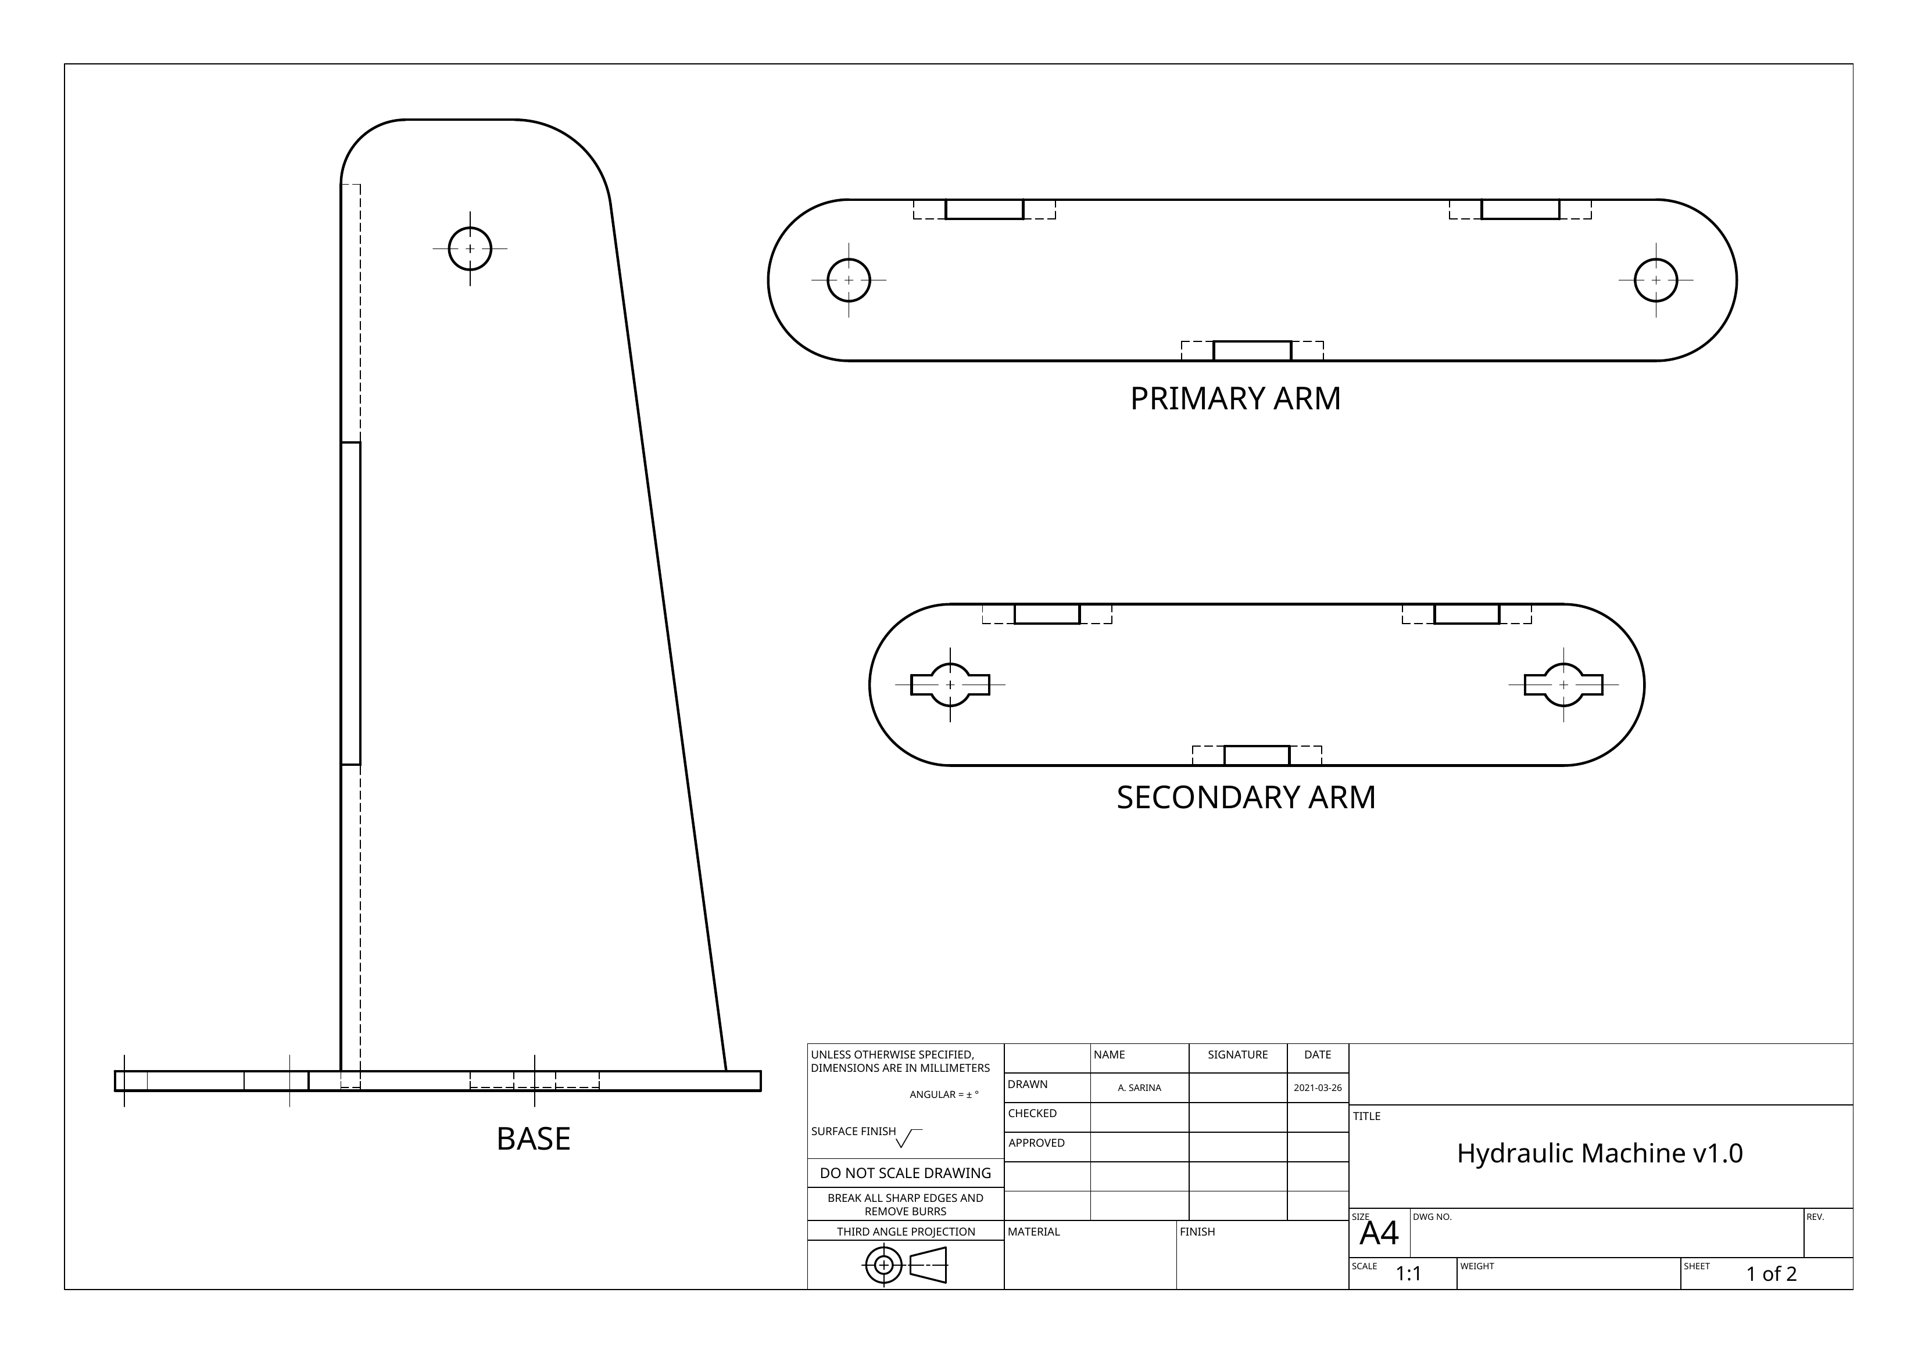
Figure 9. Unchanged undimensioned reference sheet 1. Use teacher-approved dimensions and procedures. Sheet 1 titleblock: DO NOT SCALE DRAWING.
Source working drawing: sheet 2
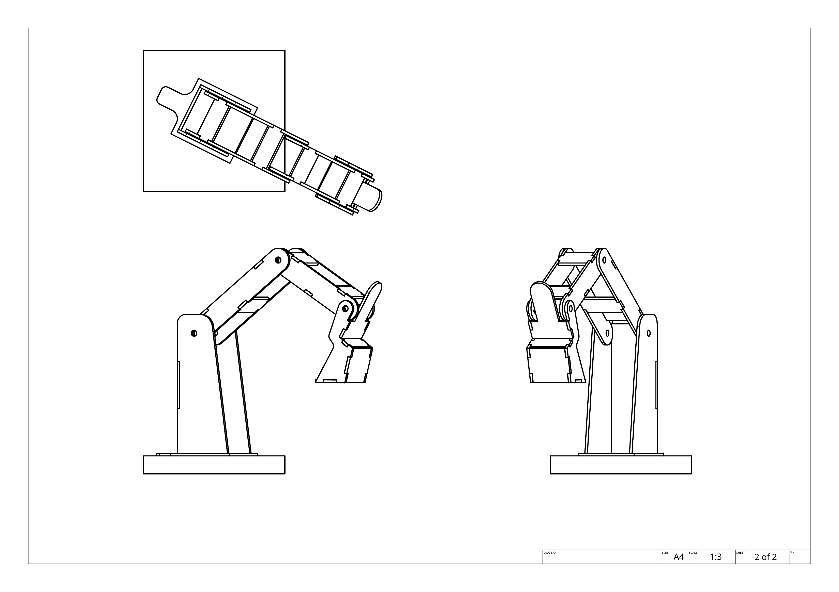
Figure 10. Unchanged undimensioned reference sheet 2. Use teacher-approved dimensions and procedures.

DIGGER DESIGN

Measure and choose the syringe pairing

A syringe’s capacity tells you how much fluid its full stroke can displace; the working piston face or matching barrel bore diameter determines area. Different products can have different diameters or usable strokes. Use a teacher-supplied specification or properly measured working piston face/barrel bore dimension, record the evidence, and calculate A = πd²/4. Do not use the outer barrel diameter.
A larger output area can multiply force, but it moves a shorter distance for the same input volume. Choose each pairing against the function’s force and movement needs. The boom must move the arm assembly as well as any added load. The bucket must curl and dump without binding; force at its syringe is not identical to force at the load point.

Source activity: Hydraulic System Design
Select and justify syringe sizes for each function. Calculate each area ratio, force prediction and movement trade-off. Plan tubing, mounts and an input/output system diagram.

Circuit / piston | Capacity label | Working piston/bore d (mm) | Area (mm²) | Dimension source
Boom input
Boom output
Dipper input
Dipper output
Bucket input
Bucket output

Show one area and area-ratio calculation. Explain why your pairing suits the function.
DIGGER DESIGN

Plan three independent liquid paths
The brief calls for separate boom, dipper and bucket circuits. Trace each control syringe to its own output actuator. A diagram should show both ends of every tube; crossing lines on a drawing are not automatically connections. Label the controls so an operator can identify which part will move before pressing a plunger.
Routing must allow the approved motion range without kinking, snagging, touching sharp edges or pulling a joint apart. Mounts need to hold the syringe securely while allowing any required pivoting. A rigidly misaligned mount can side-load a plunger and cause binding. Discuss the mounting design with your teacher rather than forcing the mechanism through resistance.
Source hydraulic design evidence: draw the three circuits and label inputs/outputs, tubing routes, mounts, pivoting needs and motion arrows.

Choose one hose or mount. Explain how you will check it through the approved range of motion.
DIGGER DESIGN

Predict the complete system
Treat the hydraulic area ratio and the linkage ratio as separate stages. An ideal output syringe force can be predicted from equal pressure. To estimate the load force, apply the lever turning-effect balance at a named arm position. The product of the two ideal ratios is useful only when the assumptions describe that position and direction.
Hypothetical two-stage example
Area ratio 4 gives 20 N actuator force from 5 N input. If the actuator’s perpendicular moment arm is 50 mm and the load moment arm is 200 mm, ideal load force = 20 × 50/200 = 5 N. The lever stage reduces force by a factor of 4; it does not multiply it. These numbers are calculations, not approved project sizes or loads.

Reach is a geometric measurement, not a force ratio. Define its datum and direction. Maximum geometric reach may occur where lifting is difficult or stability is poor. Calculate or sketch the positions, then predict a safe teacher-approved test. Never infer a maximum safe load from the ideal equation alone.
Circuit / named position | Area ratio | Moment-arm ratio | Predicted force/travel | Assumptions
Boom
Dipper
Bucket

Explain two reasons your bucket result may differ from an ideal piston prediction.
DIGGER DESIGN

Write the SWMS for this build
Source activity: Design and Planning
Develop the design calculations and a Safe Work Method Statement for cutting, drilling, assembly, water handling and testing. Apply appropriate hierarchy-of-control choices to actual hazards. Submit the SWMS and calculations for teacher review before practical work.

Record the task, what could go wrong, who may be harmed, the control and how it will be checked. Keep tool-specific instructions with the teacher’s approved procedures. This planning table helps you prepare; it is not a substitute for the school’s current SWMS or permission to operate equipment.
Task / location | Hazard and possible harm | Control | Check / reviewed instruction
Cutting / drilling
Frame / pivot assembly
Filling / connecting circuits
Operating / testing
Adjustment / cleanup

Record what your teacher confirmed and what is still pending before you begin.
DIGGER DESIGN

Plan materials, cutting and checkpoints
A materials list names what is required and where its specification came from. A cutting plan places the teacher-approved parts on available stock to reduce waste. List tools only after the teacher confirms their suitability. Blank specification fields should remain unresolved rather than inheriting a thickness, bolt size or quantity from a decorative image.
Part / quantity | Approved material/size | Source / tool / waste note
Base
Boom / dipper
Bucket / linkages
Pivots / mounts
Syringes / tubes

Attach your cutting-layout or nesting drawing on a separate labelled sheet if it needs more space. Record its evidence ID beside the relevant materials/parts so the layout can be followed. Use only teacher-approved dimensions.
Cutting-layout attachment / evidence ID: __________________________________
Source activity: Build Plan
Show the construction sequence for the base, arms, bucket, pivots and circuits. Include accuracy checks, stiff arms/bracing and tidy hose routing.

Stage | Check before next stage | Evidence / review needed
Design reviewed
Prepare frame and pivots
Dry movement and mounts
Hydraulic setup / de-airing
Final inspection / test permission
DIGGER DESIGN

Hydraulic design questions 1
Use the reading and your own evidence to explain your reasoning. Give a clear explanation rather than a list of terms.
How does Pascal's principle apply to hydraulics?

Why use different syringe diameters, and how do you calculate the force multiplication?
DIGGER DESIGN

Hydraulic design questions 2
Use the reading and your own evidence to explain your reasoning. Give a clear explanation rather than a list of terms.
What reduces efficiency in a hydraulic digger, and how can you improve it?

How do lever ratios affect the digger's performance?
DIGGER DESIGN

Hydraulic design questions 3
Use the reading and your own evidence to explain your reasoning. Give a clear explanation rather than a list of terms.
How should hazards be managed during construction and testing?

Why does the digger feel "spongy" or unresponsive, and how do you fix it?
DIGGER DESIGN

Hydraulic design questions 4
Use the reading and your own evidence to explain your reasoning. Give a clear explanation rather than a list of terms.
How do you calculate efficiency, and what does it tell you about your design?

What information should you record during testing, and how do you present it?
DIGGER DESIGN

Hydraulic design questions 5
Use the reading and your own evidence to explain your reasoning. Give a clear explanation rather than a list of terms.
How does this project connect to real engineering applications?

What should you include in your evaluation to demonstrate engineering thinking?
CONSTRUCTION & SETUP

Build accuracy supports reliable motion
Accurate making keeps the real geometry close to the prediction. Marking from a consistent datum reduces accumulated error. Pivots need alignment so the arms rotate rather than twist. A loose or flexible base changes the measurement position under load; a tight or misaligned pivot uses effort in friction instead of useful movement.
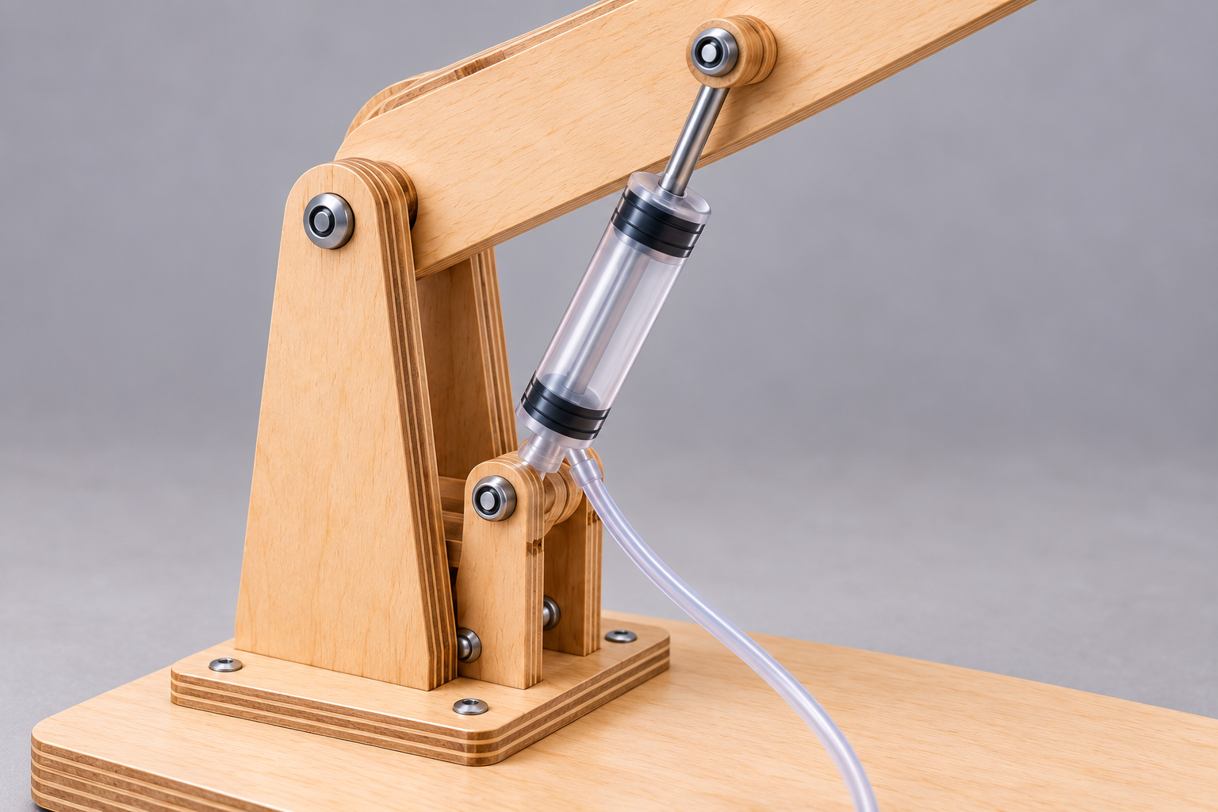
Figure 11. Illustrative details to inspect: aligned pivot, secure actuator mount and free hose path. Follow the approved class hardware and procedures; the image supplies no part specification.
Source activity: Frame Assembly
Follow the approved design to measure, mark, cut, drill and assemble the frame. Use teacher-approved clamping, datum, drilling/alignment and assembly procedures. Check dimensions, pivot alignment and dry movement before continuing.

Dry movement means a teacher-approved check without the hydraulics forcing the arm. It can reveal binding early. Do not “fix” resistance by increasing plunger force. Stop, identify the location and ask for the approved adjustment. Record any geometry change because it affects the later calculation.
Practice: explain how one small making error could change the measured result even if the syringe pairing is correct.
CONSTRUCTION & SETUP

Fill, connect and de-air with care
A good circuit starts with compatible, undamaged teacher-approved syringes and tubing. Water should remain contained, connections secure and the control accessible. Mounting and hose routing must preserve the movement allowed by the design. Syringe travel and acceptable force come from the teacher’s equipment instructions, not a volume label.
Source activity: Hydraulic System Setup
Use the selected and approved syringes, connect the circuits securely, and fill with water using the teacher’s method. Keep the workspace dry, avoid bubbles and arrange each input/output pair according to the reviewed design.

Source activity: Bleeding Air from System
Follow the teacher’s de-airing sequence, observe bubbles and responsiveness, and check each circuit independently within approved travel limits. Record persistent air, leaks or resistance and stop for teacher direction. Do not disconnect a loaded or pressurised circuit to attempt a repair.

Circuit | Observed before | Teacher-led action / evidence | Observed after
Boom
Dipper
Bucket

How did your observations support or weaken the explanation that trapped air caused poor control?
CONSTRUCTION & SETUP

Mount, assemble and inspect
Source activity: Mounting Cylinders
Use the approved brackets/clamps and connection points. Check secure support and the movement needed by the design; verify alignment and independent circuit response before final integration.

Source activity: Final Assembly
Connect boom to base, dipper to boom and bucket to dipper according to the reviewed design. Check free pivots, independent circuits and the approved range of motion. Record and explain design changes.

Source activity: Pre-Test Inspection
Inspect for loose joints, misaligned pivots, kinks, trapped air and leaks. Confirm the test’s load point, method, limits and stop conditions with the teacher. Secure the base, clear the test area and keep electricity away from water.

Inspection item | Observed condition | Action / teacher review
Base and joints
Pivots / clearances
Mounts / syringe travel
Hose routing / containment
Test zone / load method

Which fault would make you stop? Explain the risk and who should resolve it.
CONSTRUCTION & SETUP

Keep a dated construction log
Source activity: Construction Log
Record each build stage with dates and photos. Describe problems, solutions and changes from the design, explaining why changes were made.

Write the entry while the work is fresh. “Finished the boom” is less useful than a dated statement naming the stage, an accuracy check, what was changed and the evidence image. If the teacher demonstrated a repair, record that role honestly. Do not recreate earlier stage photographs and present them as contemporaneous evidence.
Date / stage | What we did and checked | Problem / change / reason | Photo / drawing ID

What is the next authorised stage, and what check must happen first?
CONSTRUCTION & SETUP

Explain a change from the design
Source activity: Build Quality Assessment
Compare construction with the reviewed design. Identify issues that could affect performance and preserve them in the folio so the later analysis can explain the results.

A change needs a reason and an effect. If a pivot moved, the original lever calculation may no longer apply. If a mount changed, the actuator angle and useful moment arm may differ. If a tube was rerouted, control or clearance may improve. Keep the old drawing and annotate the revised design rather than silently overwriting the history.
Before: show the original detail, planned geometry or fault. Add an evidence reference.

After: show the approved change and label what it affects.

Explain why it changed and which prediction or test must be updated.
CONSTRUCTION & SETUP

Photographs need engineering captions
Source activity: Photo Documentation
Capture the frame stages, hydraulic connections, mounts, final assembly and pre-test condition. Use whole-project views and close-ups of important pivots/connections. Label the photos so they support a claim.

A photograph records a visible feature at a moment in time. It does not by itself prove a load was lifted safely or an area calculation is correct. Include the circuit/part, date or stage, what to notice and the claim it supports. If an image is an example supplied by the teacher, label it as an example.
Source photo evidence label | Your image ID / stage | Caption: feature and significance
Base Frame
Boom / Dipper
Bucket Linkage
Problem + Fix

Choose one caption. What does the image show, and what would still need a measurement or other record?
TESTING & EVALUATION

Set up a fair, bounded test
A useful test answers a specific question with comparable measurements. Choose one function and name its start position, direction, input point and output point. Record the piston areas and lever geometry that apply at that position. Secure the digger and use the teacher-approved measuring equipment, loads and method.
Repeat the same procedure so differences are meaningful. If you change the start angle, load point or measuring point between trials, the lever ratio can change too. Zero a force gauge as instructed and read the scale from the correct viewpoint. Measure travel between marked datums, rather than guessing from a video or a diagram.
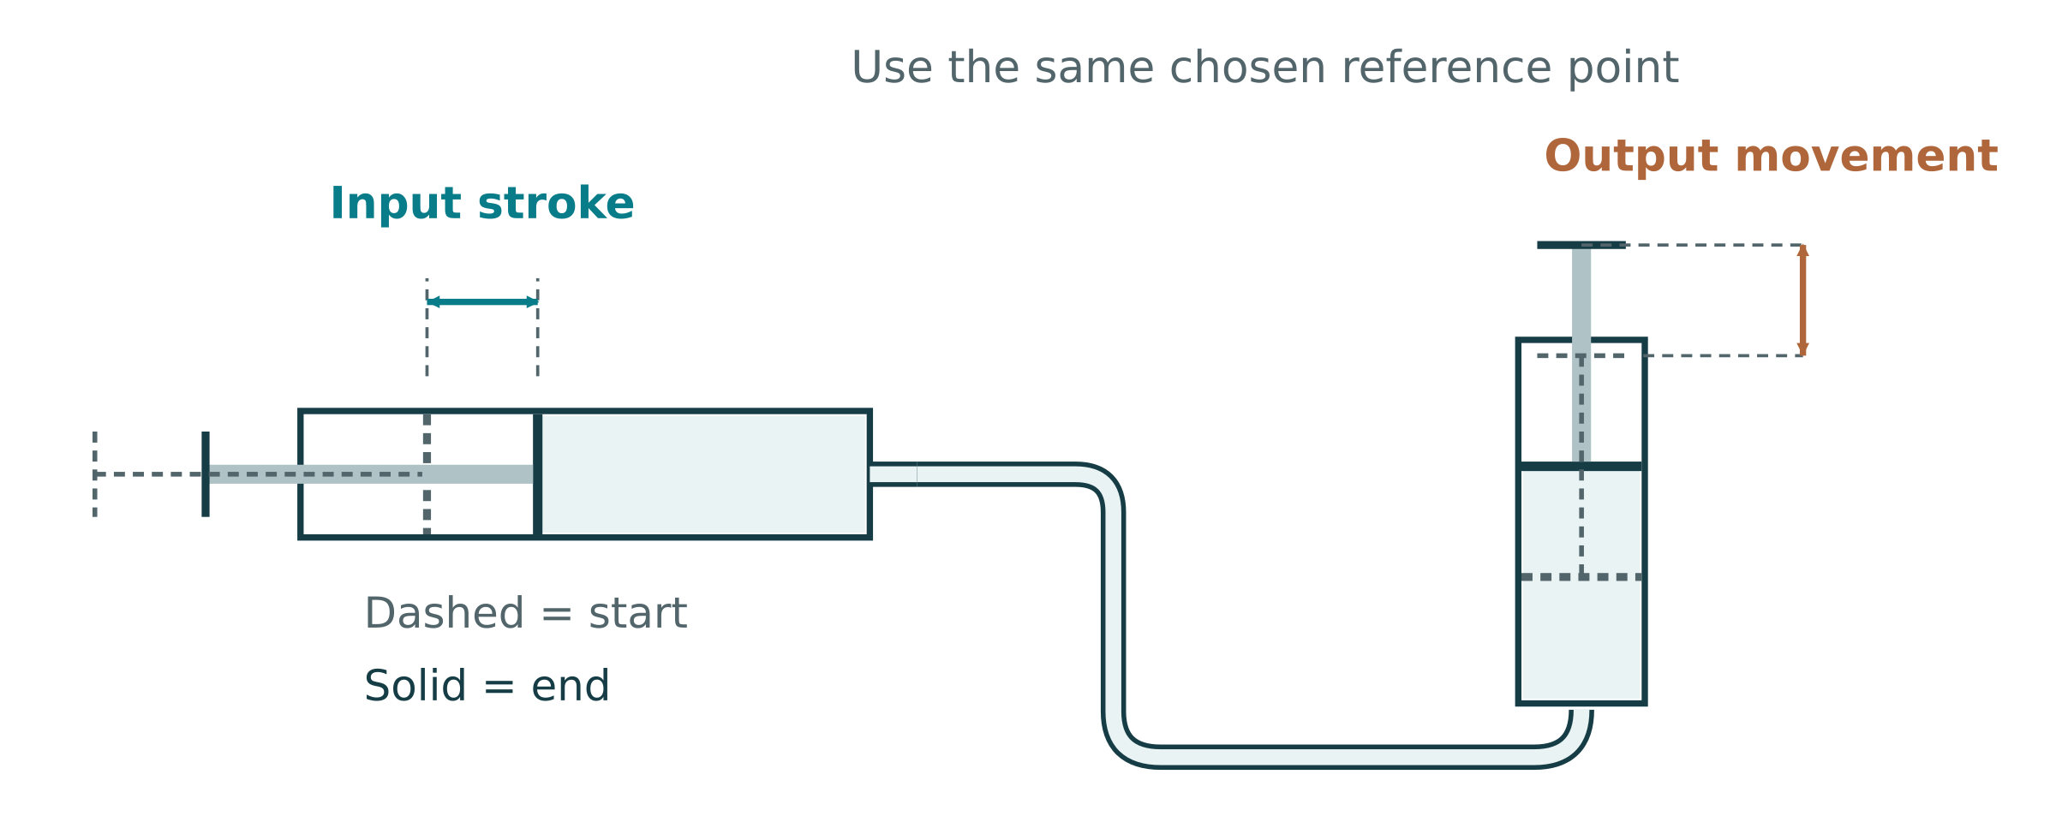
Figure 12. Conceptual input stroke and output reference-point displacement, with start/end positions marked. Measure the actual digger load point for bucket travel; actuator travel is different. Teacher-approved setup and limits control testing.
Source activity: Testing Setup
Prepare teacher-approved force and distance equipment, secure the frame and check controls. Review design predictions and plan the boom, dipper and bucket test order. Write enough detail for another group to understand the method.

Stop at the approved limit
The generic source mentions testing to failure or instability. This workbook does not authorise that. Stop at the teacher’s limit or any leak, binding, damage, movement of the base or other unsafe condition, whichever occurs first.

Practice: explain two variables you must hold constant to compare a before/after improvement fairly.
TESTING & EVALUATION

Record the method before the result
Source activity: Systematic Testing
Use the teacher-approved bounded test sequence to record lifting/reach performance, input/output force and travel, observations and video if assigned. Compare with predictions; stop at approved limits or signs of an unsafe condition. The paper record does not authorise testing to destruction.

Method detail | Your class-approved method
Circuit / function and start position
Input force/travel measurement points
Output load/travel measurement points
Reach datum and direction
Approved load / increments / limits
Stop conditions and safety controls
Repeat trials / equipment resolution

Write the prediction this test will check. Include its assumptions and where the calculation is recorded.
TESTING & EVALUATION

Keep the raw force and load results
Record measurements immediately, before calculating ratios. Mass and force are different quantities: a balance may show grams, while a spring force gauge reads newtons. For a static lifted mass, weight can be estimated from F = m × g, with mass in kilograms and the teacher’s chosen gravitational value. Do not place grams directly into a force ratio beside newtons.
The checklist asks for at least three trials for one joint. Use the class-approved loads and repeated start position. Record the last safe successful trial and the reason the test stopped; this does not establish the machine’s destructive failure load. If force was not measured, label it honestly and do not invent actual MA.
Trial / setup | Input force (N) | Mass (kg) or measured output force (N) | Observation / evidence ID
1
2
3
Extra / repeat

Show one valid mass-to-weight conversion if you used it. Otherwise explain the output-force measurement method.

Why did you stop the test, and what can you conclude from that stopping point?
TESTING & EVALUATION

Measure travel and calculate VR
Travel is the displacement between defined start and end positions. For a comparable linear test, VR = input travel/output travel. Measure both during the same motion and keep units the same. An input piston stroke and a bucket tip path can be very different; identify whether the bucket measure is vertical lift, horizontal reach or path distance.
For a simple ideal hydraulic pair, displaced liquid volume gives Ain × sin = Aout × sout. That area prediction applies to piston travel. The linkage can magnify or reduce the bucket movement. Its ratio varies as angles change, so a measured VR over a finite stroke may differ from an instantaneous moment-arm prediction.
Trial / position | Input travel (mm) | Output travel (mm) | VR and observation
1
2
3
After change

Show one calculation and compare it with the ideal piston-area prediction. Explain a possible difference.
TESTING & EVALUATION

Calculate and compare the performance
Source activity: Data Analysis
Organise test data with headings and units. Calculate actual MA, VR and work efficiency where measurements support them. Compare with predictions, create a graph and identify trends and uncertainties.

Use actual MA = measured output force/measured input force. Use VR = matched input travel/output travel. For the same comparable linear motion, efficiency = (MA/VR) × 100%. If only force predictions and measurements are available, report measured/predicted force percentage and label the missing travel evidence. A ratio alone cannot identify the cause of a loss. Use constant or appropriately averaged forces over the measured motion; a peak force and an unrelated full stroke do not form a valid work calculation.
Trial / evidence | Predicted result | Actual MA | Measured VR | Efficiency / limitation
1
2
3

Show complete working for one trial. State the formula, substituted data, units and rounding.
TESTING & EVALUATION

A graph should answer a question
A graph makes a pattern visible. Choose quantities that answer your test question, such as input force against output force, or efficiency against load where work efficiency was measured. The axes need quantity names, units and a scale suited to the observations. Ratios such as MA and VR are dimensionless.
For a controlled input variable, place that variable on the horizontal axis and the measured response on the vertical axis. Plot measured points accurately and keep predictions visually distinct. A line through points is not proof of causation; check whether setup or geometry changed. If repeats differ, show them or report the spread.
Plot one graph from your actual table. Give it an informative title; label both axes with units, mark a sensible scale and identify measured/predicted values.

Describe one pattern and one limitation. Refer to values from the graph.
TESTING & EVALUATION

Diagnose losses from evidence
Hypothetical observation: a control moves a short distance before the arm responds, visible bubbles remain, and the response improves after teacher-led de-airing. That supports trapped air as one cause of the delay. It does not prove that pivot friction vanished or the digger reached an efficiency target.
A different observation may point elsewhere. A mount shifting under load suggests flex or looseness. A wet tube joint and drift suggest leakage. Resistance at the same arm position can suggest binding or an unfavourable actuator angle. More than one cause can act at once, so name evidence rather than guessing a single explanation.
Observed symptom | Possible cause | Evidence needed to test the explanation
Delay / sponginess | Trapped air or flexible components | Bubbles/expansion and matched before/after response
Position drift / fluid loss | Leak or unstable support | Containment check and measured position change
Resistance at one angle | Binding or changing moment arm | Approved dry-motion/alignment and geometry checks

Practice: your group records lower output than predicted but sees no leak. Propose two other explanations and one safe check for each.
TESTING & EVALUATION

Evaluate against the actual criteria
Source activity: Evaluation and Reflection
Compare the digger with the class brief, explain predicted-versus-measured differences, propose specific practical improvements and connect the reasoning to Pascal’s principle, lever mechanics and losses.

A strong judgement names the criterion and the evidence. “It worked well” does not show reach, lift, control or reliability. State what was measured, the tested conditions and any limit on the claim. If a criterion was not tested, say so. The current task notification asks for at least two specific improvements.
Confirmed criterion | Evidence / result | Judgement and limitation
Reach
Lift
Control / repeatability
Containment / safety
Prediction / efficiency

Explain the most important difference between prediction and measurement using the theory and your evidence.
TESTING & EVALUATION

Plan two improvements and retest one
An improvement is specific enough to try and evaluate. Changing piston area trades force for travel. Changing actuator geometry affects torque and motion range. Reducing binding can improve the useful response without changing the intended ratio. Describe the expected gain, likely cost and evidence needed before choosing.
Specific proposed change | Theory / expected gain | Trade-off / check needed
Improvement 1:
Improvement 2:

Sketch one improvement. Label the altered feature, expected motion/force effect and what stays the same in the comparison.

If authorised, record the retest evidence and conclusion. If not undertaken, state the proposed test and what it would establish.
TESTING & EVALUATION

Your final engineering judgement
Bring the argument together: the class criteria, what you made, the results, the theory that explains them and the changes you would make. Your judgement can include strengths and limits. Honest analysis of a fault is more useful than an unsupported claim that everything was perfect.
Source folio: write your final judgement. Explain what worked best, what first limited performance, the strongest supporting evidence, WHS considerations and at least two justified improvements.

Explain what this project taught you about a real engineering system and how your first learning goal changed.

Operation video, if assigned
The guided folio provides an operation-video slot. A teacher-approved short clip can show a full controlled motion cycle. Record its file name and a caption; it supplements the measured data rather than replacing it.
COMMUNICATION & PROJECT MANAGEMENT

Drawing conventions make information precise
An engineering drawing separates visible shape from hidden features and measurement information. Visible edges are solid. Hidden detail uses dashed lines. Centre lines identify symmetry or feature centres. Dimension and extension lines should be thin and distinct from outlines, with clear arrows and units.
Aligned orthographic views help a reader relate a feature across front, top and side views. Use the projection convention specified by the teacher and show its symbol if required; the view placement depends on that convention. A title block identifies project, author, date, units and scale. Add only teacher-confirmed tolerances where needed, not invented precision.
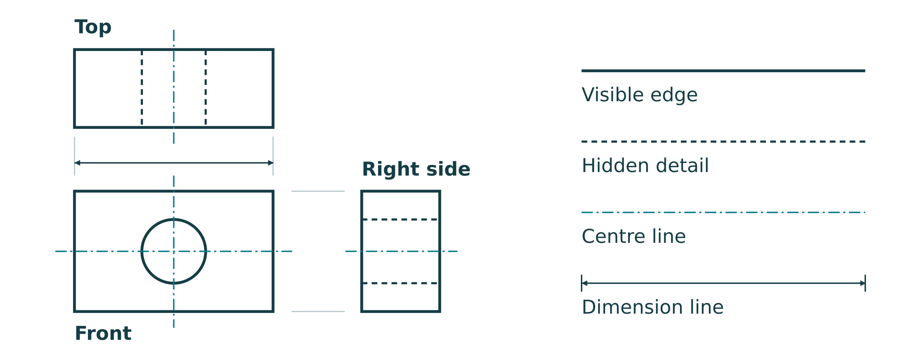
Figure 13. Original conceptual detail showing visible, hidden, centre and dimension lines. Example geometry is for reading conventions, not making a digger part.
Practice: draw a simple teacher-selected part in aligned views. Demonstrate the line types needed and label the title/units/scale. Use approved dimensions only.

Name one way unclear dimensioning could create a making error.
COMMUNICATION & PROJECT MANAGEMENT

Cost quantities, not guesses
A cost estimate starts with quantities and units. Extended cost = quantity × unit price. Multiply 2.4 m by a price per metre, not by a price per sheet. Keep the source and date of a quoted rate. Teacher-provided rates can be used for class comparison; no cost table commits you to buying materials.
Hypothetical estimate: 2.4 m at $5.00/m costs $12.00; 20 fasteners at $0.10 each cost $2.00. Subtotal = $14.00. A hypothetical 15% waste allowance adds $2.10. Subtotal including waste = $16.10. If a 10% contingency is applied to that subtotal, it adds $1.61, making $17.71. The allowance percentages are example assumptions, not class requirements.
Show the assumption
Waste allowance and contingency are different. State the rate and the amount it is applied to. For spreadsheet formulas, use a row quantity × price and a sum of extended costs so changes update totals.

Item / rate source | Quantity / unit | Unit price ($) | Extended cost ($)
Total / stated allowances

Compare two approved material choices using cost and one other factor. Explain your choice.
COMMUNICATION & PROJECT MANAGEMENT

Plan checkpoints, then keep them current
A useful project plan shows dependencies. The reviewed drawing and risk controls come before making. Construction quality affects whether testing is meaningful. Data collection comes before analysis, and analysis gives the evaluation its evidence. A delayed stage may require a revised plan, not rushed unsafe work.
Stage / milestone | Class date or lesson | Needed first | Evidence / status
Research and design
Design / SWMS review
Frame and circuits
Inspection and tests
Analysis / evaluation
Folio handover

Choose one delayed or uncertain stage. Explain how you would revise the plan while keeping the necessary checks.
SUSTAINABILITY & PATHWAYS

Think through the material’s lifecycle
A material decision affects more than the day of construction. Consider strength/stiffness for the job, workability, cost, waste, durability and end-of-life. Embodied energy is the energy used to obtain and process a material. A low-impact label alone is not enough; how much material is used and how long the product lasts also matter.
A cutting layout can reduce offcuts. A repairable design may keep parts in use longer. Reusable syringes, mounts or frame members can serve later teaching where safe and permitted. Mixing materials permanently can make separation harder. Waste water and damaged parts need the school’s disposal procedure; do not assume that every plastic item belongs in the same recycling stream.
Lifecycle decision | Evidence / alternative | Benefit and limitation
Material selection
Cutting / waste reduction
Durability / repair
Reuse / end-of-life

Propose one realistic environmental improvement without undermining the project’s function or safety.
SUSTAINABILITY & PATHWAYS

Connect the project to engineering work
Mechanical engineers work with machines, mechanisms and energy transfer. Civil engineers design infrastructure and use drawings, materials and evidence to make decisions. Mechatronic engineering combines mechanical systems, electronics and control. Industrial engineering studies how processes and resources work together. Real job roles overlap; no single class project represents all of a profession.
The digger develops transferable habits: describe a problem, make a reasoned design choice, communicate geometry, test safely, analyse evidence and improve the result. Trade training, apprenticeships, TAFE and university courses can develop these skills in different ways. Entry requirements and course availability change, so use a current official course or employer source for a pathway detail.
Research field | Evidence / source
Career and a typical responsibility
Relevant project skill and example
Real-world hydraulic/mechanism use
Official course/apprenticeship source and date
Course/apprenticeship duration and likely pathway outcome
Pathway requirement to verify

Explain how one piece of your folio demonstrates a skill used in that career.
COMMUNICATION & EVALUATION

Communication and evaluation questions 1
Use the reading and your own evidence to explain your reasoning. Give a clear explanation rather than a list of terms.
Why use both orthographic and pictorial drawings?

What should a costing spreadsheet include, and how do you structure it?
COMMUNICATION & EVALUATION

Communication and evaluation questions 2
Use the reading and your own evidence to explain your reasoning. Give a clear explanation rather than a list of terms.
How can sustainability be shown in the folio, and what should you include?

Why is reflective writing important, and how do you write a strong evaluation?
COMMUNICATION & EVALUATION

Communication and evaluation questions 3
Use the reading and your own evidence to explain your reasoning. Give a clear explanation rather than a list of terms.
What drawing conventions should you follow, and why are they important?

How do you create effective concept sketches, and what should they show?
COMMUNICATION & EVALUATION

Communication and evaluation questions 4
Use the reading and your own evidence to explain your reasoning. Give a clear explanation rather than a list of terms.
What should a build log include, and how do you maintain it effectively?

How do you present test results effectively in a folio?
COMMUNICATION & EVALUATION

Communication and evaluation questions 5
Use the reading and your own evidence to explain your reasoning. Give a clear explanation rather than a list of terms.
How do you link your project to engineering careers and pathways?

What makes a folio professional and easy to assess?
TEACHER-LED MEDIA

Fluid power and mechanisms media notes
Teacher-led source clips. The website lists these links; current playback/content must be checked by the teacher. Record an observation, compare it with the taught concept and ask about differences. A clip is not permission to use its tools, materials, loads or build procedure. If unavailable, use the equivalent workbook explanation or a teacher demonstration.
Syringe Hydraulics (Hands-on demo)
https://www.youtube.com/watch?v=ioLtieMWRT8
Trace the input syringe, fluid connection and output. Record one observation that supports pressure transfer.

Pascal’s Principle (P = F/A) using syringes
https://www.youtube.com/watch?v=556VUW6edtM
Record how area enters P=F/A and the force/travel trade-off. Compare with the workbook’s hypothetical calculation.

Mechanical Advantage (fast lever refresher)
https://www.youtube.com/watch?v=0gkf10NWWFQ
Locate effort, fulcrum and load. Explain which perpendicular moment-arm ratio determines ideal force gain.

Hydraulic Cylinder: what’s happening inside (3D)
https://www.youtube.com/watch?v=-EiufxtGRao
Identify the piston and cylinder. Compare the industrial mechanism with the classroom syringe model.
TEACHER-LED MEDIA

Digger design media notes
Teacher-led source clips. The website lists these links; current playback/content must be checked by the teacher. Record an observation, compare it with the taught concept and ask about differences. A clip is not permission to use its tools, materials, loads or build procedure. If unavailable, use the equivalent workbook explanation or a teacher demonstration.
How Excavators Work (student-friendly intro)
https://www.youtube.com/watch?v=nBE8JrByOf0
Name boom, dipper and bucket functions. Explain one design question this raises for your model.

Excavator Arm Motion (animated breakdown)
https://www.youtube.com/watch?v=A_Rn-ENv5rM
Trace one actuator’s movement and the joint it turns. Explain why the actuator angle could change force gain.

Hydraulic Excavator (3D visual reference)
https://www.youtube.com/watch?v=Q58iKeHwadw
Compare the visible machine layout with your concept. Identify one useful similarity and one model limitation.
TEACHER-LED MEDIA

Construction media notes
Teacher-led source clips. The website lists these links; current playback/content must be checked by the teacher. Record an observation, compare it with the taught concept and ask about differences. A clip is not permission to use its tools, materials, loads or build procedure. If unavailable, use the equivalent workbook explanation or a teacher demonstration.
Build: Hydraulic Excavator from Syringes
https://www.youtube.com/watch?v=xEfYPQlKAuI
Identify one build-sequence or connection idea. What would need teacher approval before using it?

Build: Syringe Hydraulic Excavator (Cardboard version)
https://www.youtube.com/watch?v=Cj1_dObogV0
Compare the model’s material/layout choices with your class constraints. Explain one trade-off.

Build: Another Syringe Excavator Walkthrough
https://www.youtube.com/watch?v=uaNntHiNSVc
Find a different linkage or actuator placement. Predict one force–movement effect using the correct moment-arm rule.
TEACHER-LED MEDIA

Testing and analysis media notes
Teacher-led source clips. The website lists these links; current playback/content must be checked by the teacher. Record an observation, compare it with the taught concept and ask about differences. A clip is not permission to use its tools, materials, loads or build procedure. If unavailable, use the equivalent workbook explanation or a teacher demonstration.
Testing Mindset: Build + Test + Observe Performance
https://www.youtube.com/watch?v=fDW4v1Tt_5k
Identify what is observed and what is actually measured. Propose one improvement to make the test comparison fairer.

MA + VR + Efficiency (for the folio calculations)
https://www.youtube.com/watch?v=pHmlvB04OZY
Write the MA, VR and efficiency relationships used. State what measurements are needed to use them for your digger.
FOLIO EVIDENCE

Design and assembly evidence register
Retain the guided folio’s named evidence slots. Record your image/file ID and an engineering caption below. Attach the actual images using the teacher’s submission method or on additional sheets. Use your own genuine evidence; illustrative source photo examples are not completed student work.
Named source evidence slot | Your file / page / date | Caption: feature, observation and significance
Linkage Design Photos — Labelled Sketch
Linkage Design Photos — Pivot Layout
Linkage Design Photos — Syringe Mounts
Linkage Design Photos — Bucket Path
Assembly Evidence Photos — Base Frame
Assembly Evidence Photos — Boom / Dipper
Assembly Evidence Photos — Bucket Linkage
Assembly Evidence Photos — Problem + Fix

Which evidence is still missing, and what authorised next step will supply it?
FOLIO EVIDENCE

Hydraulic setup and test-method evidence register
Retain the guided folio’s named evidence slots. Record your image/file ID and an engineering caption below. Attach the actual images using the teacher’s submission method or on additional sheets. Use your own genuine evidence; illustrative source photo examples are not completed student work.
Named source evidence slot | Your file / page / date | Caption: feature, observation and significance
Hydraulic Setup Photos — Filled Syringe
Hydraulic Setup Photos — Hose Routing
Hydraulic Setup Photos — De-airing
Hydraulic Setup Photos — Leak Check
Test Method Photos — Reach Setup
Test Method Photos — Lift Test
Test Method Photos — Travel Measure
Test Method Photos — Safety Zone

Which evidence is still missing, and what authorised next step will supply it?
FOLIO EVIDENCE

Results and redesign evidence register
Retain the guided folio’s named evidence slots. Record your image/file ID and an engineering caption below. Attach the actual images using the teacher’s submission method or on additional sheets. Use your own genuine evidence; illustrative source photo examples are not completed student work.
Named source evidence slot | Your file / page / date | Caption: feature, observation and significance
Results and Data Photos — Data Table
Results and Data Photos — Max Lift
Results and Data Photos — Reach Result
Results and Data Photos — MA / VR Working
Tuning and Redesign Photos — Failure Point
Tuning and Redesign Photos — Adjustment
Tuning and Redesign Photos — Retest
Tuning and Redesign Photos — Improvement Sketch

Which evidence is still missing, and what authorised next step will supply it?
FOLIO EVIDENCE

Check the project, then support every answer
Source project self-checks. Write Yes / Not yet / Not checked and an evidence reference. A positive answer must describe your actual project; it is not a safety or practical approval. Follow the teacher-approved dry-motion, hydraulic and test procedures.
Exact source self-check | Status / evidence
Do you know exactly how your digger will be tested?
Does your sketch show pivots and cylinder mounts?
Have you predicted the force/travel trade-off?
Do the arms move smoothly by hand?
Is motion smooth (not spongy) and leak-free?
Do you have enough evidence to justify your evaluation?
Do you have 3 working circuits (boom, dipper, bucket)?
Are syringes secured and hoses routed safely (no kinks/leaks)?
Have you removed air (smooth, repeatable motion)?
Have you recorded syringe sizes/areas and test data (reach, lift, movement)?

Choose the most important unfinished check. Explain the next step and why it matters.
FOLIO HANDOVER

Assemble a folio the reader can follow
Source activity: Folio Completion
Combine the brief/design, build log, tests, analysis and evaluation. Include the source’s sustainability and career/pathway work. Check structure, terminology, units, captions and evidence. Submit using the teacher-confirmed current class method.

The guided portfolio has twelve named sections. Your paper evidence can be collated from the working pages rather than rewritten into twelve generic journals. Use page/file references to connect drawings, calculations and observations with the relevant section.

Project Brief
Introduce the task and define the criteria your hydraulic digger will be judged against.
WHS and Risk Controls
Explain the hazards, PPE, safe tool use, water control, pinch points, and safe testing procedures.
Fluid Power Basics
Explain Pascal's principle, pressure, force, area, and why trapped liquid matters.
Linkage Design
Document your arm geometry with pivots, syringe mounts, movement path, and expected trade-offs.
Syringe Sizing
Record syringe choices, piston area calculations, predicted force, and travel trade-offs.
Build Plan
Show the planned construction sequence for the base, arms, bucket, pivots, and circuits.
Assembly Evidence
Use build-log evidence to explain assembly decisions, problems, fixes, and quality checks.
Hydraulic Setup
Document filling, plumbing, de-airing, leak checks, hose routing, and syringe mounting.
Test Method
Describe the test setup clearly enough that another group could repeat it safely and fairly.
Results and Data
Report measured results and interpret what they show about reach, lift, movement, MA, VR, and efficiency.
Tuning and Redesign
Analyse what limited performance and propose a specific tuning or redesign improvement.
Final Evaluation
Write a final judgement that links evidence, engineering theory, WHS, and practical improvements.

Operation Video Evidence: the source slot is named “Hydraulic digger operation video”. The source viewer stores it in the ZIP backup rather than the smaller JSON-only file. Video remains optional or teacher-directed under the class instructions; paper cannot embed an operation clip.
For the HTML portfolio, save a session backup and the ZIP containing uploaded media as directed. Paper entries can be typed or photographed only where your teacher specifies. Confirm what must be submitted; browser autosave alone is not a handover.
FOLIO HANDOVER

Final check and handover
Current linked task: formative learning, not graded. Your teacher confirms the submission date, platform, file naming and any checkpoint instructions. This final page records what you hand over and what still needs attention; it does not create a formal mark, grade or practical certification.
Evidence item | Page / file ID | Ready / gap / action
Brief / criteria / approved design
SWMS / safety evidence
Syringe areas / moment-arm predictions
Build sequence / dated log / photos
At least 3 trials / force and travel data
MA / VR / work comparison / graph
Evaluation / at least 2 improvements
Sustainability / career connection

Record your teacher-confirmed submission method, date/time and files/pages included. State one remaining question if needed.

Learning sources: current Year 9 Term 3 Hydraulic Digger overview, Toolkits 1–4, guided folio, testing checklist and task notification. Technical relationships are explained with corrected scientific scope. Illustrative images and examples are not plans or student results.

