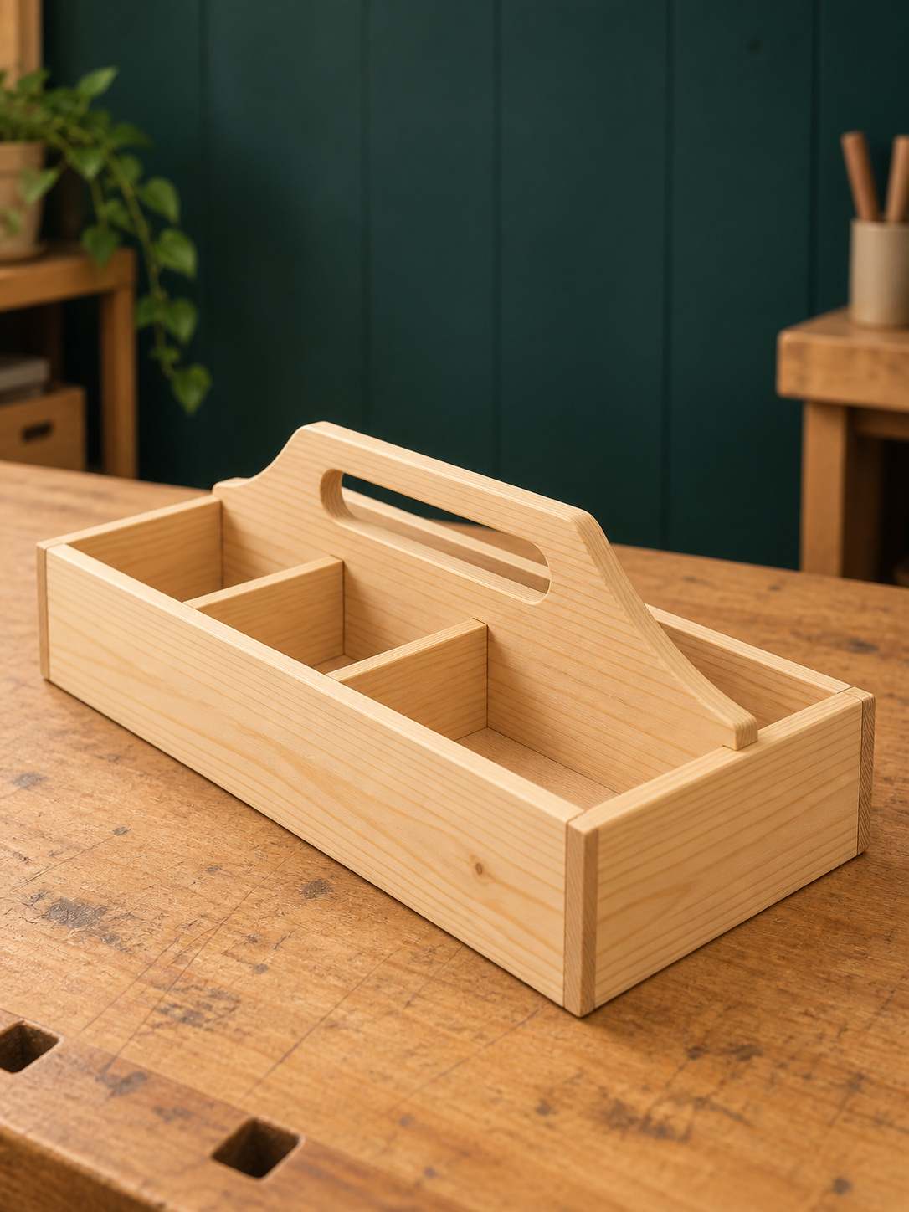
2027 YEAR 9 PATHWAY
BBQ Carry-All
STUDENT WORKBOOK

Practical timber. Thoughtful making.
Built to carry. Made with care.
NAME ____________________________ CLASS __________________
Illustrative cover image | 50 pages · A4 · Duplex long edge | Edition 1.0

PROJECT COMPANION
Your learning route
Read, apply and collect evidence as your project develops.
Learning sequence | Pages
Original working drawing | 3
01 Brief, plans and workshop safety | 4–7
02 Materials, culture and responsible use | 8–11
03 Required construction and comparative joints | 12–15
04 Accurate marking and hand-tool control | 16–19
05 Rebates, housings and dry assembly | 20–23
06 Handle design, drawing and shaping | 24–27
07 Adhesive assembly and workshop care | 28–31
08 Handling, sequencing and surface preparation | 32–35
09 Finish and final workmanship | 36–39
10 Evidence, problem solving and evaluation | 40–43
Project evidence pages | 44–50

Each module pairs connected reading with a worked or technical page and a knowledge check. Use the evidence pages when the matching practical stage occurs, rather than waiting until the final lesson.
Your teacher controls practical methods, approvals and submission instructions. This companion supports the 2027 pathway; the site’s retained 2026 assessment is historical. Current marks and due dates: Teacher to confirm.

MODULE 01 / WEEKS 1–2
The original working drawing
Read written dimensions and their extension lines. Never measure this reproduction to obtain a manufacturing size.
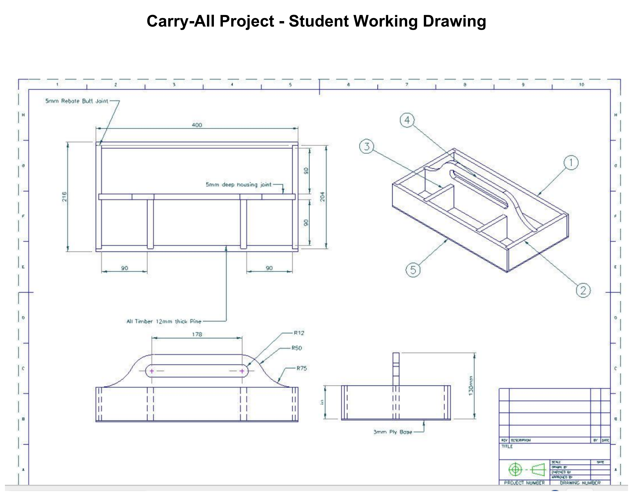
Figure 1. Original working drawing at a larger reading size; surrounding blank page area and page footer omitted. Use written dimensions, never measured print size.

MODULE 01 / WEEKS 1–2
Begin with the brief
Function, workmanship and evidence belong together.
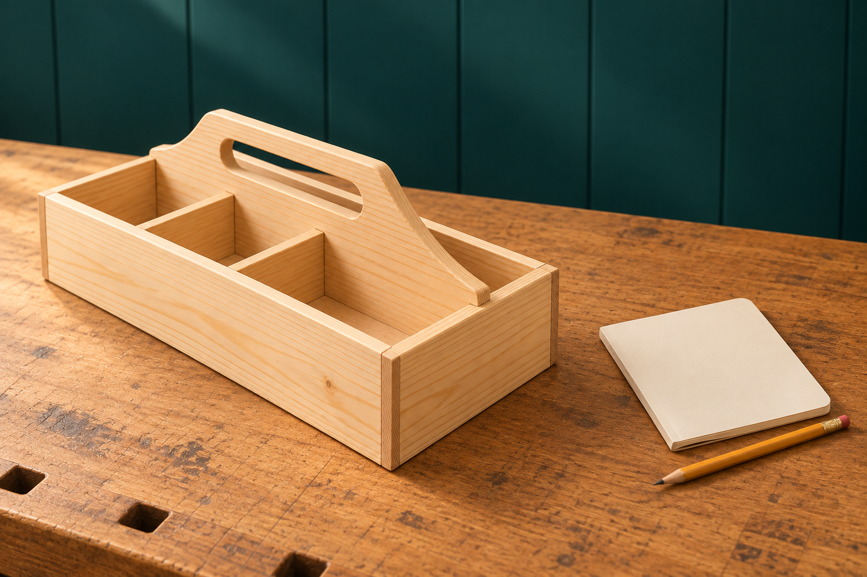
Figure 2. Illustrative project and planning context: connect the object with its purpose, required construction and recorded decisions.

Understanding the Carry-All brief and success criteria
The Barbecue Carry-All is a practical timber tray with a central handle panel and internal dividers. The project brief asks for accurate, safe and useful manufacture, supported by evidence. The working drawing and teacher directions control the parts, materials and construction. A product can look attractive while having a poorly supported base or an uncomfortable handle, so appearance alone cannot demonstrate success.
Useful success criteria name something you can observe or check. “The base sits evenly in the approved rebate arrangement” is more useful than “the base is good”. “The handle has smooth accessible edges” connects workmanship with touch and function. Record the intended criterion, the checking method and the result. Your folio then explains the reasoning behind the finished object.
Reading the Carry-All working drawing without scaling
Orthographic views separate the viewing directions. A top view helps explain the arrangement of the dividers, while another view reveals the handle profile. The pictorial view helps you visualise the assembled object. Cross-check them: an edge in one view may belong to a joint or a hidden feature in another. Read the written information with the relevant leaders and extension lines.
The drawing specifies a 400 mm overall length, 12 mm pine components and a 3 mm plywood base. Its 178 mm handle dimension runs between the centres of the rounded slot ends. Printing and screen zoom change apparent size, so a ruler placed on the picture cannot supply a manufacturing measurement. Where a required detail remains unclear, record the question and obtain teacher clarification before marking the timber.

MODULE 01 / WEEKS 1–2
Make the controls specific
A safe decision explains the hazard, the risk and the control.

Managing Carry-All hazards, risks and the SWMS
A hazard has the potential to cause harm. Risk describes the chance of harm occurring and how serious its consequences could be. A control removes the hazard or reduces that risk. For example, a moving workpiece can create an unsafe cutting situation and an inaccurate joint. Naming the hazard is only the beginning; the workholding method and other controls must be appropriate for the actual task.
The hierarchy of controls encourages stronger protection than a reminder to be careful. Elimination removes a hazard where possible. Substitution uses a safer approved option. Isolation and engineering controls separate people from hazards or control them physically. Administrative controls include training, teacher instructions, supervision and the school’s procedures. Required personal protective equipment supports these controls; it does not replace them.
A Safe Work Method Statement, or SWMS, connects this thinking with the sequence of the Carry-All. Material handling, joint work, adhesive assembly and finishing present different conditions. A useful entry names the stage, hazard, risk, controls and responsibility. It also identifies a hold point: a planned stop for an inspection or teacher decision before an important next step.
Review the relevant entry before each practical stage. A changed condition matters: a loose component, damaged tool or unclear method is a reason to stop and report, even if the lesson has already begun. Your teacher’s demonstration, local standard operating procedure and current product information control the practical method. Strong safety evidence describes what you noticed and what changed because of it; a statement such as “I wore PPE” cannot explain the whole decision.

MODULE 01 / WEEKS 1–2
Follow the dimension
The number is only useful when you identify the feature it measures.
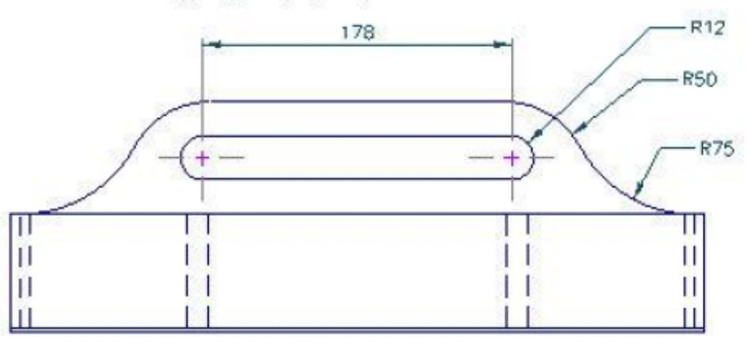
Figure 3. Original handle detail. The 178 mm dimension runs between the centres of the rounded slot ends; follow its extension lines.
Read the ends, not just the number
A dimension line carries the written value. Extension lines connect that dimension to the edges or centres being described. On the original handle view, the 178 mm dimension refers to the centres of the rounded slot ends. Reading it as the total outside opening would describe a different feature.
Drawing-reading routine
Look for | What it tells you
Written value | The stated size of the identified feature.
Extension lines | The exact edges or centres between which it applies.
Another view | The component’s position, orientation or thickness.
Teacher clarification | The resolution of a required missing or unclear detail.

The printed picture looks shorter than 400 mm. Explain why this is not evidence that the overall length has changed.

MODULE 01 / WEEKS 1–2
Start with reliable information
Circle one answer for each question; then connect a control to a practical stage.
1. Which statement is an observable success criterion?
○ A. The Carry-All is perfect.
○ B. The project is nicer than everyone else’s.
○ C. The base sits evenly in its approved support arrangement.
○ D. The work took a long time.

2. A dimension seems different after the page is printed smaller. What controls manufacture?
○ A. The ruler measurement of the new print.
○ B. The written drawing information and teacher clarification.
○ C. The size of a classmate’s project.
○ D. The scale of the website photograph.

3. Which SWMS entry best connects a control with its hazard?
○ A. Work safely at all times.
○ B. Be sensible during the lesson.
○ C. Finish quickly to avoid mistakes.
○ D. Secure the component by the approved method before the joint operation.

Choose material handling, joint work or finishing. Identify one hazard, the possible harm and a relevant control to confirm with your teacher.

MODULE 02 / WEEKS 3–4
Read the material
Sound stock makes accurate work possible.
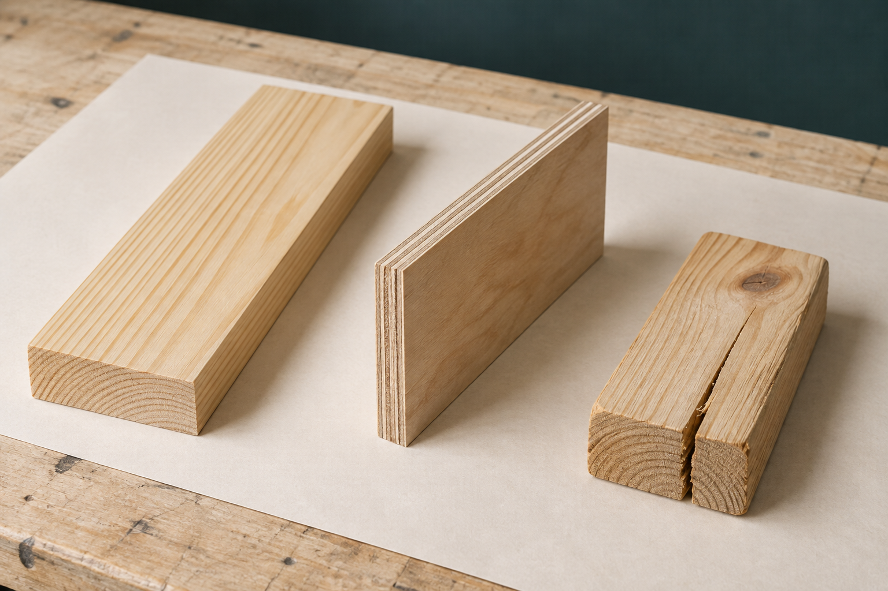
Figure 4. Illustrative material study: solid pine grain, bonded plywood layers and a separate split offcut. Inspect the actual stock before selection.

Selecting pine and plywood for the Carry-All
The working drawing specifies 12 mm pine components and a 3 mm plywood base. These materials have different jobs. Solid pine forms the substantial parts shown in the views; the thin plywood forms the base supported by the surrounding structure. Treating them as interchangeable would change the design. Confirm material identity before deciding where a component belongs.
Pine grain runs mainly along the board. Its direction and condition influence how a component looks, behaves during shaping and responds near a joint. Inspect for bow, cup, twist, splits, loose knots, dents and damaged edges. A striking grain pattern does not make distorted or damaged stock suitable. Compare the whole proposed component with the available sound area, including the places where rebates or housings will be formed.
Plywood is made from bonded thin layers. That construction generally gives useful stability across the sheet, but a 3 mm sheet still needs careful support. Check both faces and the edges for chipped areas, warping, cracks or layers beginning to separate. Rough handling can damage the edge needed for a clean base fit, even when the middle of the sheet appears sound.
Good selection connects the material to its intended position. A teacher may approve a layout that leaves a defect outside the required part; students should not make that judgement alone. Identify the stock and preserve a record of the defect avoided. This gives your final evaluation an observable reason for the choice, instead of the unsupported claim that the timber was “good”.

MODULE 02 / WEEKS 3–4
Materials carry responsibilities
Be precise about both your source and your own choices.
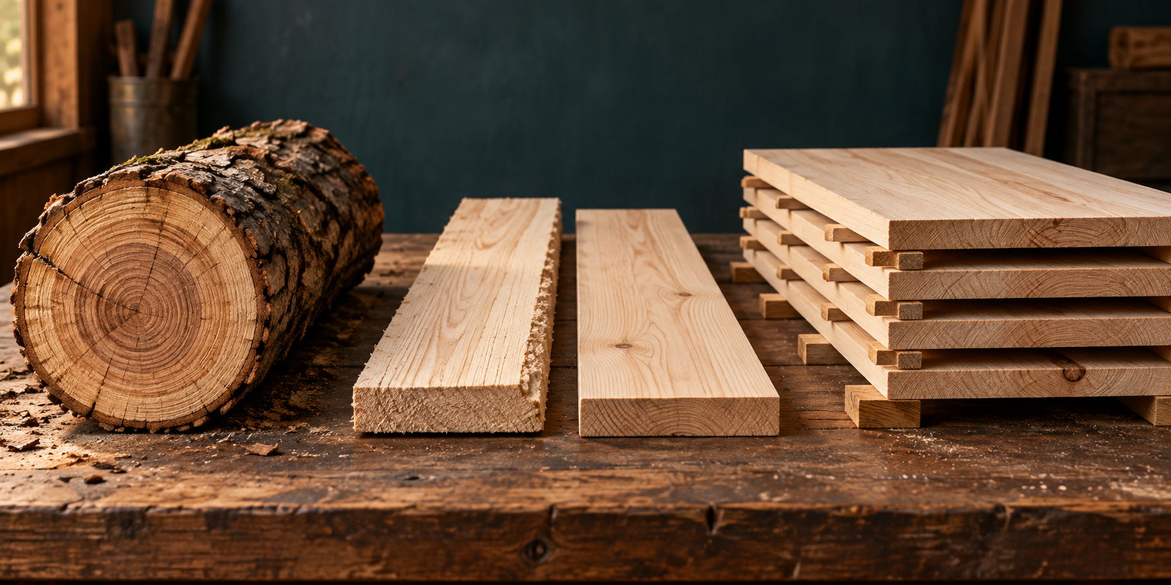
Figure 5. Illustrative timber resource sequence. Appearance cannot verify sourcing, cultural permissions or environmental claims; those require evidence.

Learning respectfully from Aboriginal and Torres Strait Islander timber technologies
First Nations timber technologies belong to many distinct Nations, communities and places. Knowledge about materials can be connected to Country, seasons, purpose and custodianship. One public example cannot represent all Aboriginal and Torres Strait Islander peoples. Respectful learning identifies whose knowledge is being discussed and recognises the authority of the people who hold it.
Indigenous Cultural and Intellectual Property, or ICIP, concerns rights and interests in cultural knowledge and expression. Seeing a design online does not automatically permit copying it. Use teacher-approved, community-authorised sources. The course names the Western Australian Museum’s public account of a Nyoongar kodj: stone cutting edges fixed to a wooden handle with resin. This is one specific example of a timber-working tool, not a universal tradition. Identify the source and its sharing limits; do not copy cultural motifs as decoration.
Using timber responsibly and reducing project waste
Your project can demonstrate responsible material use through specific decisions. Read the complete component requirements before allocating stock. Larger or less flexible parts may need priority. Consider grain, defects, orientation and the joint areas, not just how tightly shapes can be packed. A crowded layout that ignores a split can waste more timber when the component fails.
Keep genuinely useful off-cuts identified and place them in the approved storage area. Sort unsuitable waste by the workshop’s procedure. Wider environmental claims need credible sourcing information; pine’s appearance cannot prove how it was grown or harvested. A useful folio statement connects an action to its result: which defect you avoided, what usable material you retained, or how an earlier check prevented a recut. This is your evidence, not a claim to reproduce another community’s knowledge.

MODULE 02 / WEEKS 3–4
Choose the usable layout
The smallest scrap pile is not the only measure of a sound decision.
Worked example — two proposed stock layouts
In hypothetical Layout A, a long component overlaps a visible split. Layout B places the required component in sound material and leaves a useful short off-cut. B is the stronger proposal because it considers the component’s condition as well as the quantity of waste. The teacher must still approve the actual stock and dimensions.
Decide what each piece needs
Observed material | Decision and reason
Pine with a split through the proposed part
Sound off-cut suited to an approved later purpose
Plywood with layers separating at a required edge

Write one specific piece of evidence that would support the claim “my layout reduced avoidable waste”.

MODULE 02 / WEEKS 3–4
Use evidence for material choices
Circle one answer. Complete the responsible-use sequence below.
1. Why inspect the edges of the plywood as well as its faces?
○ A. An edge may reveal damage or separation between layers.
○ B. The edge colour proves sustainable harvesting.
○ C. All thin plywood is waterproof.
○ D. Plywood grain has no effect on any task.

2. Which statement treats First Nations knowledge respectfully?
○ A. All communities used timber in the same way.
○ B. Anything visible online may be copied.
○ C. This named public source describes one community’s material knowledge.
○ D. A cultural motif can be used without checking its source.

3. What is the strongest basis for a sustainability claim?
○ A. Pale timber colour.
○ B. Credible sourcing information and specific material-use evidence.
○ C. The price of the board alone.
○ D. The absence of a visible knot.

Sequence puzzle: A Store useful off-cuts; B Check requirements; C Inspect stock; D Propose and verify the layout. Write the most sensible order and explain why A comes after D.

MODULE 03 / WEEKS 5–6
Compare the joint geometry
Comparison builds understanding; the project drawing still controls the build.
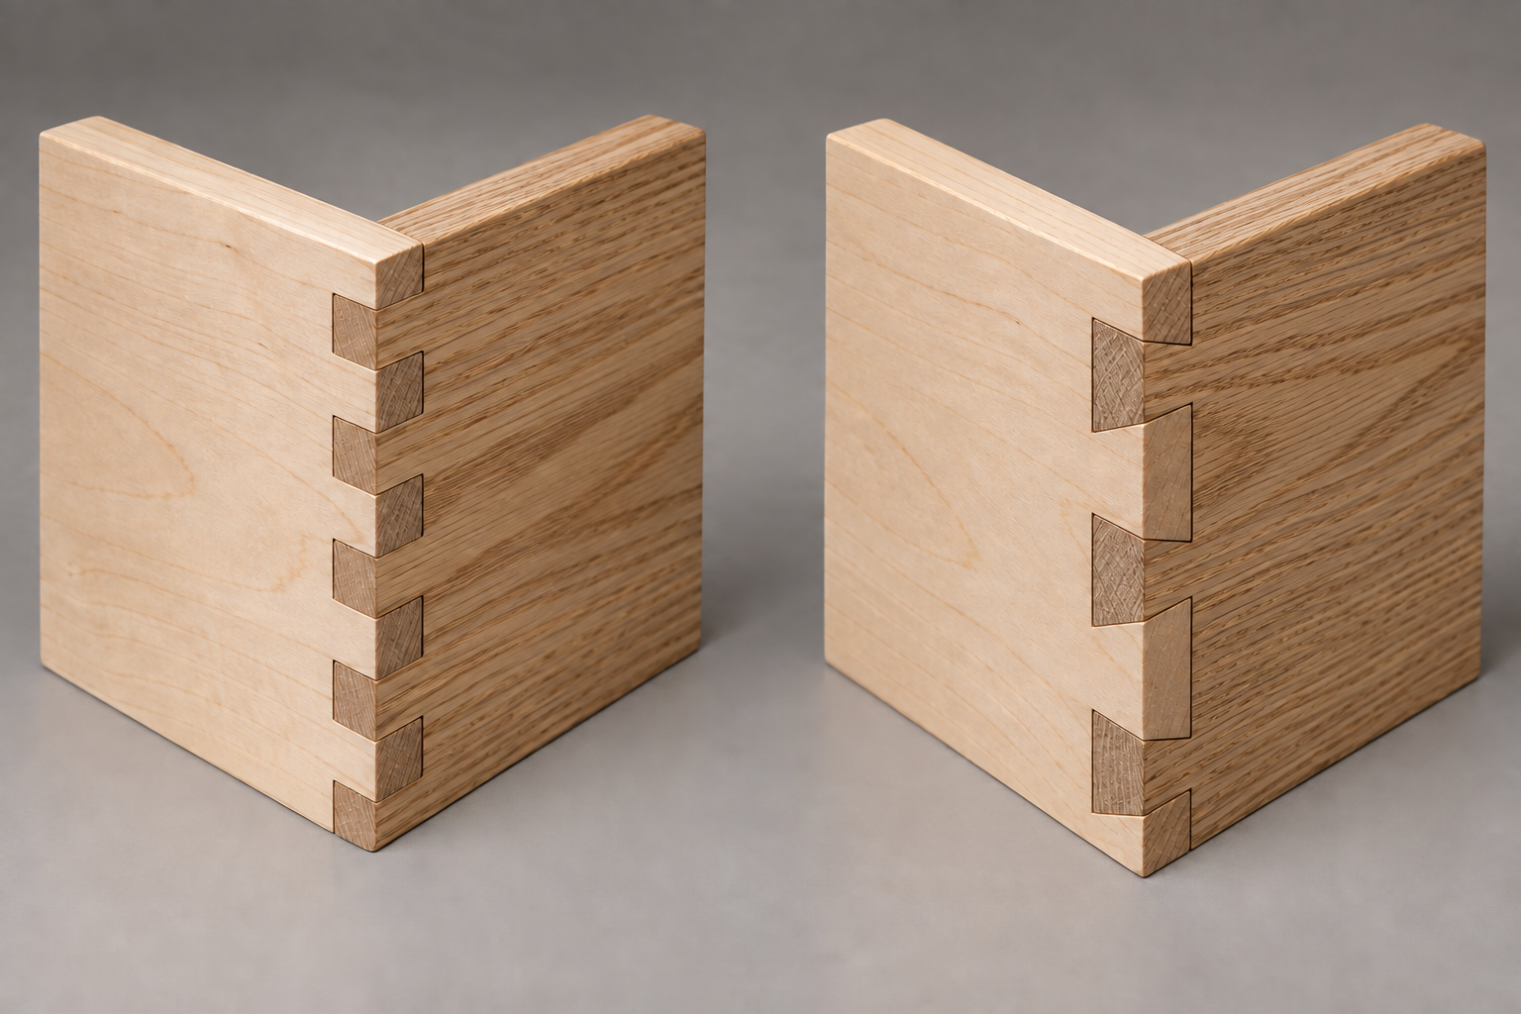
Figure 6. Comparison theory only: rectangular box-pin fingers (left) and sloping dovetail tails and pins (right). The Carry-All uses the rebate-and-housing construction in its original plan.

Comparing box-pin joints as alternative knowledge
A box-pin joint uses alternating rectangular pins and spaces. The pins of one component enter the spaces of its partner, producing an interlocking corner. The repeated pattern makes fit and alignment visible. If marking drifts across the pattern, several small errors can combine into an obvious mismatch. Accurate reference surfaces and progressive checking matter more than the decorative regularity alone.
This joint offers a useful contrast with a stepped rebate-butt corner. Both involve fitted surfaces, alignment and controlled material removal, but their forms differ. Studying a photograph can build vocabulary; it cannot supply a verified pin pattern or authorise a change to Carry-All stock. Label any box-pin sketch as comparison theory and keep it separate from evidence of required construction.
Comparing dovetail joints as alternative knowledge
A dovetail connects sloping tails with matching pins. The interlocking form helps resist separation in one direction. Its geometry and component orientation explain that behaviour. Saying that a dovetail is “strong” without identifying how its parts work gives little useful information. A comparison should name the shapes, their relationship and the accuracy required at the mating surfaces.
The Carry-All does not require dovetails or box-pin corners. Its original drawing specifies rebate-butt corners and housings where shown. Do not estimate alternative joint angles, spacing or quantities from a picture, and do not transfer their geometry to project material. The transferable learning is the need for sound references, correct orientation and checked fit. Understanding several joints makes the authorised decision clearer; it does not turn the current project into a free choice of joint.

MODULE 03 / WEEKS 5–6
Build the specified relationship
Correct form, location and orientation must agree.

Figure 7. Conceptual open-edge rebate and separate mating board. The original Carry-All drawing controls the actual joint and dimensions.

Applying the assessed rebate-and-housing construction
The original Carry-All drawing shows a rebate butt joint at a corner and housings where internal parts are located. The indicated 5 mm notes apply to the features they label. The 12 mm pine and 3 mm plywood specifications also come from that drawing. Read these relationships together rather than treating an isolated number as a rule for every feature.
Before material is removed, identify the component and its partner. Confirm the inside face, reference face, orientation and waste area. A recess may have a consistent depth yet still be unusable if it is on the wrong side. A matching pair of components may look similar while requiring opposite orientations in the assembly. Cross-check the straight-on views and the pictorial arrangement before the teacher checkpoint.
Approved scrap practice allows you to recognise a shoulder, a depth surface and an intended fit before risking the project. The purpose is controlled reference use and checking, not trying an unapproved joint. Follow the demonstrated school process. Preserve the boundary lines and investigate the actual contact when a trial feels tight. A tight fit does not automatically mean the whole recess needs enlarging.
A full dry assembly brings the corner joints, base, dividers and handle panel together without adhesive. Check the complete arrangement: a single neat joint can hide a mismatch elsewhere. When a feature is tight, loose, damaged or unclear, seek the teacher’s diagnosis before altering it. Useful evidence names what was checked, what was found and the approved decision. This shows that the drawing guided the construction from mark-out to assembled form.

MODULE 03 / WEEKS 5–6
What each recess does
Identify the locating surfaces before considering the fit.
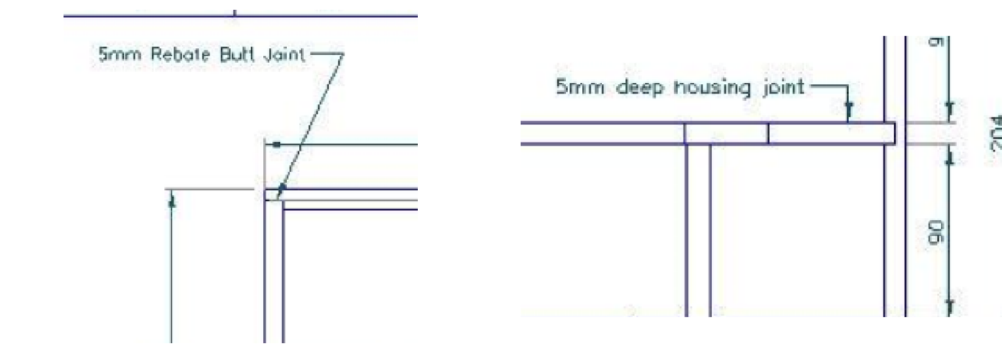
Figure 8. Original drawing details, enlarged: rebate-butt corner (left) and housing at the handle panel (right). Follow each leader to its feature; use the full drawing on page 3 for context.
Two forms, two locating jobs
A rebate is a step at an edge. Its shoulder locates an adjoining edge; its depth surface provides a seat. At the Carry-All corner, the drawing calls for a rebate butt joint. A housing is a recessed channel that locates an internal part such as a divider or the handle panel where shown.
The original drawing labels a 5 mm rebate butt joint and a 5 mm housing at the indicated features. Those notes belong to their leaders and views; they are not permission to assign 5 mm to every recess. Check the receiving part, inserted part, inside face and orientation together.
Notice: a neat recess on the wrong face is still an incorrect component. Geometry, location and orientation must agree.
Explain how a housing helps locate a divider, then name a check that would reveal a housing on the wrong face.

MODULE 03 / WEEKS 5–6
Recognise, compare, follow
Circle one answer in each question. Then explain the construction boundary.
1. Which construction controls this Carry-All project?
○ A. Alternating box-pin fingers at every corner.
○ B. Rebate-butt corners and housings as shown on the drawing.
○ C. Dovetails copied from a reference photograph.
○ D. Whichever joint is most decorative.

2. What distinguishes a dovetail from a box-pin joint?
○ A. A dovetail has no fitted surfaces.
○ B. A box-pin joint uses curved fingers.
○ C. Dovetail tails slope and interlock with matching pins.
○ D. Both names describe exactly the same geometry.

3. A rebate fits neatly but was formed on the wrong face. What follows?
○ A. Fit alone cannot make the component correct.
○ B. More adhesive will correct its orientation.
○ C. The drawing should be changed to suit it.
○ D. The opposite part should immediately be cut to match.

A classmate says, “The dovetail looks stronger, so I will use it on my Carry-All.” Write a reasoned reply.

MODULE 04 / WEEKS 7–8
Keep a reliable reference
Small errors spread when every new mark depends on the last.

Establishing reference faces and marking accurately
A face side is the selected flat surface used as the main reference. A face edge is a straight edge confirmed as square to it. Mark these references clearly and retain them throughout the approved setting-out process. A measurement taken from one edge cannot reliably match a measurement taken from a different, unverified edge. Consistent references help the Carry-All’s mating features meet in the intended positions.
A try square checks or marks a right angle to the reference edge. It must sit against the intended clean surface, rather than a chip, lump or damaged edge. A marking gauge can define a parallel line using an approved setting. The precise tool method comes from the teacher demonstration. Checking the setup before marking prevents a repeated setting error from being copied across several valuable components.
Pencil and knife lines also have width. Understand which boundary represents the required part, and mark the waste clearly. A fine-looking line is not useful if the student cannot identify which material must remain. Carry the relevant lines across the required faces and compare them with the component’s identity, orientation and written drawing information before the first cut.
A common datum is one shared reference from which positions are taken. Chaining each measurement from the last newly marked line can accumulate error. Where the approved layout allows, independent marks from a verified datum reduce that dependence. Matching pieces should be cross-checked while correction is still possible on paper or in the layout. A close photograph of reference marks and waste, with a short explanation, is useful evidence of accuracy beginning before manufacture.

MODULE 04 / WEEKS 7–8
Preserve the line
Control comes from a secure setup and repeated checking.

Controlling approved cuts for
rebate-and-housing features
Accurate cutting begins with the component secured through the approved workholding method. Its identity, orientation, references and waste must already be clear. A stable stance and an unobstructed view support control. A tenon saw may form approved joint features, but naming the tool does not replace your teacher’s instruction, the local standard operating procedure or the stage-specific SWMS.
Work on the approved waste side while preserving the boundary for checking. The line represents material that must remain; crossing it may make the part undersized. Force can make a saw wander, bind or damage fibres. If the path changes unexpectedly, stop and inspect the setup instead of twisting the blade back or pressing harder. Check the result from the relevant faces before progressing.
Refining required rebates and housings
Refinement means removing a small, identified amount of remaining waste or a verified high spot. A chisel may be used through the teacher-approved process to approach the line. Supported timber, clear hand positions and the correct cutting direction are essential. Read the grain because fibres can lift or split beyond the intended boundary, particularly near fragile shoulders and edges.
Use a cycle of inspect, make the approved small adjustment, clear and check again. During gentle dry fitting, examine the contact and whether the parts enter squarely. A tight fit might result from orientation or local damage rather than the whole surface. Removing material cannot repair an already loose housing. The useful folio story records the check and its result, rather than presenting speed or force as evidence of skill.

MODULE 04 / WEEKS 7–8
Find the repeating error
A consistent check is useful only when the reference is correct.
Worked example — a hypothetical setting-out fault
A student checks several marks and finds each one displaced in the same direction. Repeating the measurements from the same incorrect reference will repeat the problem. Before changing any mark, the student checks the component identity, verified datum and tool setting against the drawing.
Match the observation to the check. Use each check once.
Observation | Check: A, B or C
Every repeated line has the same displacement.
The final chained mark is furthest from its intended position.
A correct-looking recess appears on the outside face.

A: Check component orientation and inside/outside marks. B: Recheck the common datum and setting. C: Compare chained marks with independently verified positions.
Why should this check happen before cutting rather than after a dry fit?

MODULE 04 / WEEKS 7–8
Control the cause of accuracy
Circle one answer; explain one practical consequence.
1. What is the chief benefit of a verified common datum?
○ A. It removes the need to check dimensions.
○ B. It makes every tool safe automatically.
○ C. It turns a photograph into a working drawing.
○ D. It reduces dependence on earlier marks when positioning later features.

2. The saw begins binding and leaving its intended path. What is the appropriate response?
○ A. Press harder to finish the cut.
○ B. Stop, inspect the setup and seek teacher guidance.
○ C. Twist the blade towards the line while cutting.
○ D. Ignore it until adhesive assembly.

3. Why remove only small amounts during an approved fitting correction?
○ A. Small adjustments preserve the ability to check and avoid oversizing the recess.
○ B. Small chips can fill any remaining gap.
○ C. The original drawing no longer matters.
○ D. It guarantees that the initial diagnosis is correct.

Explain how a loose housing could result from trying to fix a tight fit without diagnosing its cause.

MODULE 05 / WEEKS 9–10
Give the base a reliable seat
A support detail must work around the whole structure.
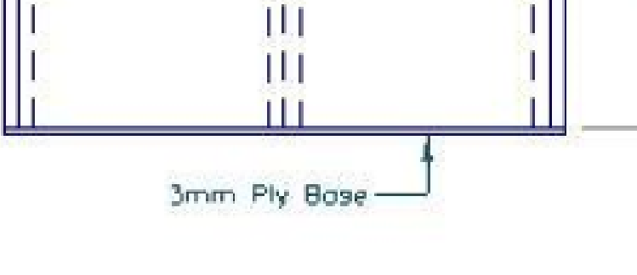
Figure 9. The base line and its 3 mm plywood note, enlarged from the original side view. Use the complete drawing on page 3 for context.

Forming the base rebate accurately
A base rebate is a recessed edge that supports and locates the plywood where the original drawing shows it. Its ledge gives the thin 3 mm base a defined seat within the surrounding pine components. The base is part of an arrangement: its condition and fit must be checked with the sides and corners, rather than treated as a loose sheet added at the end.
Two surfaces help explain the rebate’s job. The shoulder locates the base edge, while the depth surface supports it. An uneven shoulder can change the fit along the component. An uneven seat can leave the base rocking or sitting at an unintended level. The specific sizes and practical method must come from the drawing and teacher directions; a note on one feature does not automatically describe an unlabelled feature.
Adjoining rebates must meet coherently through the corners. A ledge formed on the wrong face or at a mismatched position may prevent a corner closing. Before material is removed, identify the required component, reference face, shoulder, depth and waste. Then make the approved progressive checks. A clean-looking recess can still be incorrect when compared with its neighbouring part.
During dry assembly, the base should rest evenly in the approved arrangement without being bent or forced into place. If it rocks, bows or stops a corner seating, investigate the relationship. The cause may be a support surface, component orientation, joint fit or plywood damage. Do not assume that trimming the sheet will solve it. Capture the rebate before it becomes difficult to see, and explain how its support and continuity were checked.

MODULE 05 / WEEKS 9–10
Check the complete structure
Locating each part is only the beginning of assembly.

Locating dividers and the handle with housing joints
A housing is a recessed channel that locates an inserted component. In the Carry-All it helps position the dividers and central handle panel where shown. The shoulders control lateral position and fit, while the depth surface supports the seated edge. An uneven seat can make a part lean or rock even when the opening appears the correct width.
Matching locations must agree across adjoining parts. Work from the approved references, cross-check the views and confirm the inside faces. An accurately sized housing in the wrong location will not align the structure. The drawing’s 5 mm housing note applies where explicitly indicated. Do not distribute that value to features whose specification has not been established.
Dry fitting the Carry-All structure
Dry fitting brings the complete structure together without adhesive. Confirm the identity and orientation of sides, base, dividers and handle panel. The rebate-butt corners should seat while the base rests in its supports and the internal parts enter their housings. Each relationship affects the others. A trial of only the outer box cannot prove that the complete Carry-All will assemble.
Inspect squareness, alignment and whether the assembly sits evenly on the approved reference surface. Twist means parts do not lie evenly in one plane; it may be missed from a single viewpoint. Parts should not require bending, forcing or heavy pressure to appear correct. When a fault appears, identify it, seek the approved correction and repeat the complete dry fit. The checkpoint belongs before adhesive, when the parts can still be separated and inspected.

MODULE 05 / WEEKS 9–10
A tight fit is a clue
Find the cause before deciding what to change.
Worked example — a hypothetical dry assembly
The sides close when the base is absent. When the base is introduced, one corner remains open. This is a symptom, not proof that the base is too large. The cause might involve base orientation, rebate continuity, a high spot, another joint or damaged plywood.
A useful diagnostic record
Stage | Reasoned action
Observe | Identify the corner and record exactly when the gap appears.
Check | Compare orientation, seating and rebate contact with the original drawing.
Decide | Ask the teacher to confirm the cause and any correction.
Verify | Repeat the complete dry fit; recheck the corners, base and internal parts.

The whole assembly is the test. Improving one contact is insufficient if another corner opens or the handle panel twists.
Why would immediately trimming the plywood be a weak diagnosis? Name one useful check first.

MODULE 05 / WEEKS 9–10
Judge the whole dry fit
Circle one answer and complete the short inspection explanation.
1. What does a rebate’s depth surface primarily do for the base?
○ A. Adds a decorative stripe.
○ B. Replaces the corner joint.
○ C. Provides a supporting seat.
○ D. Makes plywood waterproof.

2. Why must matching housings be checked across the assembly?
○ A. They must align the inserted component in its intended position.
○ B. All housings automatically have identical dimensions.
○ C. A tight clamp will correct every mismatch.
○ D. Their location is decided by the handle photograph.

3. Which observation means a dry assembly needs investigation?
○ A. The component references match the drawing.
○ B. The corners close without force.
○ C. The base rests evenly.
○ D. One side must be bent to seat an internal part.

The corners appear square from above, but the assembly rocks on a flat surface. Explain what another view or check could reveal.

MODULE 06 / WEEKS 11–12
A handle has a job
Comfort and structure belong in the same design judgement.

Designing a practical Carry-All handle
The central handle panel is a working part of the Carry-All. Its opening allows a grip, while the remaining timber and its connections form part of the structure. The original drawing controls shape and position. In that view, the written 178 mm dimension is between the rounded slot-end centres. It must not be relabelled as the total outside opening length or changed to suit a visual guess.
Ergonomics considers comfortable, safe and practical use. A handle should avoid accessible splinters, harsh pressure points and rough internal transitions. Clearance matters, but no single dimension proves that every person will find the grip comfortable. Evaluate the teacher-approved design and verified template rather than independently enlarging the opening or removing structural material.
The handle also belongs to a load path. During a teacher-directed carrying check, force is transferred through the handle panel into its connections and the rest of the structure. A poorly seated panel, damaged narrow area or distorted assembly can affect how the product behaves. Balance depends on the arrangement and sound connections, not simply whether a slot looks centred in a photograph.
Smooth curves should meet surrounding surfaces without unintended flats, dips or abrupt changes. Compare matching parts of a symmetrical profile while preserving the approved boundary. More shaping is not always improvement: excess removal can enlarge the opening or weaken a section. Keep evidence of the template, marked shape and later inspection so the final judgement connects the design information with observed comfort, alignment and workmanship.

MODULE 06 / WEEKS 11–12
Transfer the intended shape
A template is useful only after it has been verified.

Communicating the handle through orthogonal drawing and a template
Orthogonal views show the handle from separate straight-on directions. The front view communicates the profile and opening; another view helps establish thickness and position within the structure. Centre lines make a symmetrical arrangement easier to compare. Dimension and extension lines identify the actual features being described. They are essential to reading the 178 mm centre-to-centre slot dimension correctly.
A full-size template transfers a verified shape. Check it against the written dimensions, stated radii and teacher directions before it touches project stock. A print can be enlarged or reduced by printer settings while still looking convincing. Check its identity, orientation, centre line and reference alignment. A correct template placed backwards or off-centre can still produce an incorrect mark-out.
Shaping and refining the Carry-All handle safely
Shaping develops in controlled stages. Preserve the marked boundary and work on the approved waste side, leaving the intended material available for refinement. Support and secure the panel through the demonstrated process. The teacher decides which tools, method, instruction and supervision are appropriate. A picture of a coping saw, jigsaw or router does not authorise its use.
As the edge approaches the intended profile, inspect corresponding areas on either side of the centre line. Look for uneven curves, flats, lifting grain or unintended narrow sections. Stop if the panel moves, splits or drifts across its boundary. An over-cut cannot be restored by removing extra timber from the opposite side. Record the observation and obtain an approved response rather than chasing visual symmetry into a larger mistake.

MODULE 06 / WEEKS 11–12
Check the template, not the zoom
A convincing print can still transfer the wrong size.
Worked example — checking a printed template
A student prints the handle image using “fit to page”. The shape looks balanced, but that setting may have changed its size. The student returns to the written plan information and teacher-approved template procedure before transferring the outline.
Four checks before transfer
Check | Evidence to record
Identity | The template matches the correct Carry-All handle panel.
Size relationship | The 178 mm value is checked between rounded-end centres.
Orientation | The intended face and centre/reference marks are identified.
Authority | Teacher verification is obtained before marking project timber.

Why is “I measured the entire opening and got 178 mm” not the right verification of this dimension?

A communication sketch can use approximate proportions. A manufacturing template must be verified at the required size before use.

MODULE 06 / WEEKS 11–12
Keep form and function together
Circle one answer; then explain a cautious response to a shape fault.
1. What does the handle view’s 178 mm dimension describe?
○ A. The total outside length of the slot.
○ B. The overall Carry-All length.
○ C. The distance between the rounded slot-end centres.
○ D. The thickness of the handle panel.

2. What is the strongest reason to use centre marks during template transfer?
○ A. They verify alignment and help compare the intended symmetrical form.
○ B. They authorise a different opening.
○ C. They make print scale irrelevant.
○ D. They remove the need to identify the component face.

3. One side of the opening is accidentally over-cut. What should happen next?
○ A. Enlarge every other side until it appears balanced.
○ B. Stop, record the fault and seek a teacher-approved response.
○ C. Hide the edge with more finish.
○ D. Increase the carrying test load.

Explain why a comfortable-looking handle photograph cannot prove that the completed Carry-All is safe and functional.

MODULE 07 / WEEKS 13–14
Let the product information decide
Adhesive supports fitted work; it cannot replace accurate joints.

Choosing and using an adhesive for assembly
Adhesive works across fitted surfaces to help hold the Carry-All together after a successful dry fit. The rebate-butt corners and housings must already locate their components correctly. Excessive gaps, damage or misalignment require an approved diagnosis before adhesive is introduced. A large quantity of glue is not evidence of a stronger or more accurate joint.
Compare at least two teacher-approved candidates using current product information. Consider the specified materials, close-fitting or gap needs, required strength, moisture exposure, working time, curing conditions, shelf life, cost and disposal. A common PVA timber adhesive often suits close-fitting porous timber joints, but it should not be treated as a structural gap filler. Other adhesive families bring different suitability and handling requirements, rather than being automatic upgrades.
The label, technical information and Safety Data Sheet have connected roles. They explain suitability, application requirements, hazards and controls. Use the information for the actual selected product, not a remembered instruction from another project. Your teacher’s approval, local procedures and SWMS determine what students may use and how the stage is managed. No brand, mixing ratio or working time is prescribed by this workbook.
Working time is the product-specific period available to assemble and clamp. Organise parts, clamps, pads and approved clean-up materials before opening the adhesive. Controlled application provides the required coverage without flooding the surfaces. Plan how squeeze-out will be managed according to the selected product and teacher direction. A reasoned folio entry records the comparison, the authorised choice and the check that showed the assembly was ready.

Map the approved tools: name one for each category, its material-specific job and one applicable control.
Category / approved tool | Carry-All job / material suitability | Setup, care or safety control
Marking out
Cutting
Shaping / forming
Machining

MODULE 07 / WEEKS 13–14
Hold the shape, protect the work
Good assembly starts before the first clamp is tightened.

Clamping the Carry-All square and true
Clamps hold correctly fitted components while the approved adhesive develops strength. Plan their positions and the inspection points before applying adhesive. Pads protect soft pine from concentrated pressure; teacher-approved cauls may distribute pressure or help alignment. The arrangement must leave important joints and the overall shape available for checking rather than hide them behind equipment.
Apply pressure progressively through the demonstrated process. Tightening one position fully can pull the structure out of alignment or introduce bow and twist. Check joint seating, base support and internal-part position while the adhesive remains workable. Where appropriate, a comparison of diagonals helps assess a rectangular assembly, but it does not by itself rule out bowed sides, twist or an incorrectly seated part.
Maintaining tools and organising the workspace
Check tools for obvious damage, loose parts, contamination and unusual behaviour. Report a fault and follow teacher direction; do not attempt an unauthorised repair. Protect sharp edges during placement and storage. Keep drawings and reference surfaces clean. A cluttered bench can conceal marks, mix up components and damage work that took considerable care to prepare.
Tool categories describe functions, not permission. Marking-out tools establish references; cutting tools separate material; shaping and detailing tools develop or refine form; machining equipment controls particular operations; finishing tools prepare or apply surfaces; assembly tools locate and hold parts. One tool may serve several roles. Your map should name tools actually approved for this project, explain their function and identify the relevant supervision or local procedure. Maintain clear access and sort off-cuts throughout the lesson.

Complete the tool map. Identification does not authorise operation; confirm unavailable categories with your teacher.
Category / approved tool | Carry-All job / material suitability | Setup, care or safety control
Detailing
Finishing
Assembly

MODULE 07 / WEEKS 13–14
Make the adhesive comparison useful
Compare evidence before making a product choice.
Worked example — a decision with missing information
One candidate is familiar, but its current information has not been checked. Another has a clear technical sheet but may not suit the workshop’s approved process. Neither fact alone decides the choice. The student collects comparable evidence and asks the teacher to confirm suitability before use.
Compare two actual teacher-approved products using current technical information, SDS and dated price evidence. Record missing information for teacher confirmation.
Criterion | Candidate A | Candidate B
Product / evidence source
Material suitability; strength / gap limits
Working / curing time; assembly conditions
Shelf life / storage
Cost / quantity / price date
Hazards / required controls
Clean-up / disposal

Which candidate is better supported for this project, or what evidence is still needed? Explain your decision.

MODULE 07 / WEEKS 13–14
Assemble with a reason
Circle one answer; then explain why a clamp cannot diagnose a fault.
1. What makes an adhesive comparison defensible?
○ A. Choosing the most familiar brand.
○ B. Assuming all timber adhesives share one working time.
○ C. Using more product if the fit is loose.
○ D. Comparing current suitability, working requirements and hazards for approved candidates.

2. What is the purpose of a clamp pad?
○ A. To replace every joint check.
○ B. To protect the timber from concentrated pressure marks.
○ C. To fill a loose housing.
○ D. To make any clamp pressure acceptable.

3. A tool has an obviously loose part. What should the student do?
○ A. Stop using it and report it through the teacher’s procedure.
○ B. Try it once to confirm the fault.
○ C. Repair it without authorisation.
○ D. Hide it under the bench.

A dry-fit corner only closes with heavy clamp pressure. Explain why applying adhesive now would be poor problem-solving.

MODULE 08 / WEEKS 15–16
Prepare the next safe step
Good sequencing protects people, material and time.

Manual handling and workshop housekeeping
Manual handling includes lifting, carrying, lowering and positioning stock or components. Assess the load, route and destination before moving. Size, shape, balance and an awkward grip can matter even when an object is not especially heavy. Long stock can strike someone beyond your immediate field of view. Follow the school procedure and ask for assistance when the path, visibility or handling is uncertain.
A team lift requires an agreed destination and communication, not two people independently grabbing a load. Clear walkways and stable supports must be ready first. Store components so they cannot slide, project into access routes or damage their marked faces and joint surfaces. Housekeeping is an ongoing control; waiting until the end of the lesson allows hazards and damage to accumulate.
Sequencing the Carry-All work in a useful SWMS
The SWMS follows the actual approved sequence and its dependencies. A complete dry fit precedes adhesive; surface readiness precedes finish. Each stage needs its hazards, controls, responsibilities and hold point. A hold point stops an unverified condition from being carried into a later commitment. If the material or approved method changes, revisit the plan with the teacher.
A teacher-authorised collaborative production task should produce or prepare something real: an approved component, template, test piece or repeatable detail. Allocate roles such as interpretation, preparation, authorised operation, checking and recording. At handover, the next person verifies identity, condition and readiness. Record each contribution and the observed result. This is stronger evidence of collaboration than sharing a final photograph or assigning a student an operation outside their instruction.

MODULE 08 / WEEKS 15–16
Prepare what the finish will reveal
A clean surface still needs its edges and shape intact.
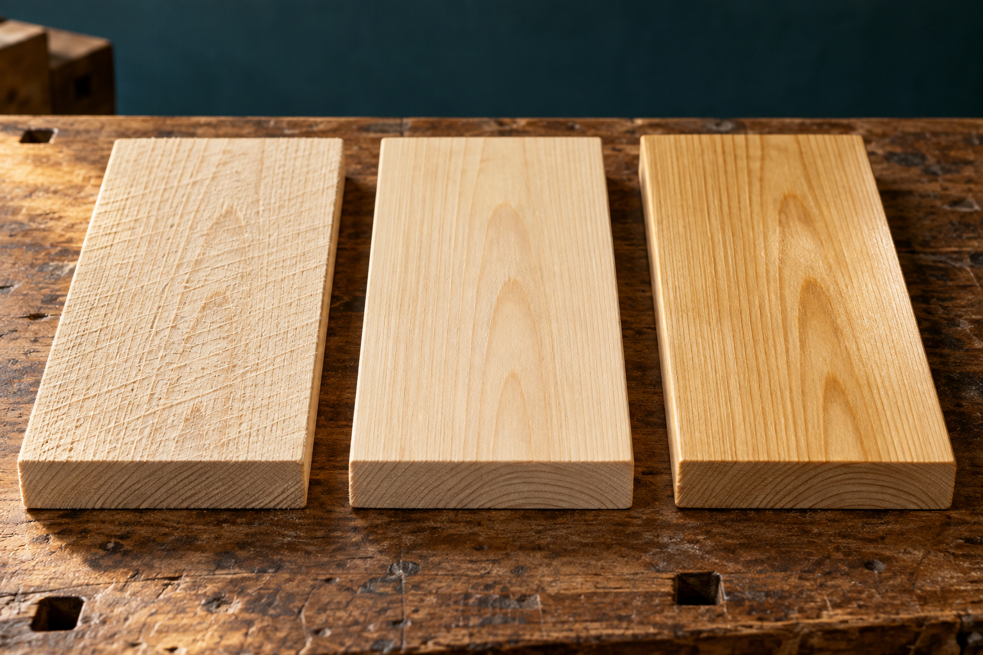
Figure 10. Illustrative surface comparison: coarse scratches, a finely prepared surface and a subtle finished appearance. Judge actual preparation under suitable light.

Preparing Carry-All surfaces for finish
Surface preparation begins with inspection. Look for machining marks, scratches, dents, torn grain, adhesive contamination and uneven areas. Decide which condition needs attention before selecting the teacher-approved process. Sanding the whole project heavily is not a diagnosis. It cannot restore an undersized joint or correct a distorted assembly without risking further changes to the intended form.
Progressive sanding removes the scratches left by the previous approved abrasive stage. Moving to a finer stage too soon may leave deeper marks under a smoother-looking surface. Finishing can make those remaining marks more visible. The abrasive sequence comes from teacher directions and the selected finish system; this workbook does not prescribe universal grit numbers. Check the surface before assuming that the next stage is ready.
Where practical, sanding with the grain makes scratch direction less conspicuous. Inspect changes in grain near joints and shaped edges. Use controlled work that preserves crisp corners, housing relationships and the handle profile. Excessive sanding can round an edge, create an uneven transition or enlarge an opening. Smoothness is useful only when the approved shape and relationships remain intact.
Dried adhesive may prevent finish absorption or bonding and produce a patchy result. Identify it and use the approved correction rather than spreading contamination. Control dust so it does not hide marks or contaminate later work. Inspect the base, internal corners, dividers and handle as well as the outside faces. Record the pre-finish condition under useful light and obtain the teacher checkpoint. The evidence should explain why the surface is ready, not merely that sanding occurred.

MODULE 08 / WEEKS 15–16
A handover is a quality check
Make individual contributions visible within the shared result.
Worked example — a teacher-authorised template task
The teacher approves a small team to prepare and verify a template. One student interprets the controlling information, another prepares and labels the template, and a third checks it. The record identifies what each person did and what was checked before the template was accepted for the next stage. These are example roles, not permission to perform an operation.
Plan your authorised shared task
Role / person | Contribution | Handover check

Sequence puzzle: A apply finish; B approved surface check; C complete dry fit; D adhesive assembly and required waiting. Give the order and explain one dependency.

Teacher to confirm the task, tools, supervision and hold point before production begins. A completed planning page is not practical authorisation.

MODULE 08 / WEEKS 15–16
Protect the sequence
Circle one answer; then link surface quality to your next decision.
1. What should be assessed before moving long stock?
○ A. Only its colour.
○ B. Only whether one student feels strong enough.
○ C. The load, clear route, destination and required assistance.
○ D. How quickly it can be carried.

2. What makes a production handover traceable?
○ A. Everybody writes the same final caption.
○ B. A named contribution and a check of the item’s identity and readiness.
○ C. The next person accepts it without inspection.
○ D. Only the team’s finished photograph is kept.

3. Why inspect between abrasive stages?
○ A. To confirm previous scratches have been removed without losing the intended form.
○ B. To choose grit numbers by appearance alone.
○ C. To hide adhesive residue.
○ D. To make every corner round.

A pale patch remains near an adhesive joint after preparation. What information should guide the next step?

MODULE 09 / WEEKS 17–18
Choose a finish for its purpose
Appearance is one part of a material decision.

Selecting an approved finish for the Carry-All
A finish can improve appearance and resistance to handling, dirt, moisture or normal wear. It does not make a timber product indestructible. Begin with the Carry-All’s intended use and the approved brief: where it will be used, how it will be handled and what durability is required. Do not infer food-contact suitability, outdoor durability or resistance to heat from the word “barbecue”.
Compatibility links the finish to the actual materials and previous work. The project includes pine, thin plywood, adhesive joints and prepared surfaces. A product that worked on a different timber or earlier project may behave differently here. The teacher must approve the product and system. Mixing products, changing stages or improvising an application recipe introduces assumptions that a neat-looking container cannot resolve.
Read the current label, technical information and Safety Data Sheet for the selected finish. These sources provide application requirements, hazards, controls, storage and disposal information. Drying and recoating conditions are product-specific. The school’s facilities, local procedures and teacher directions also matter. Record anything unresolved as Teacher to confirm rather than copying a generic coat count or waiting time into the work plan.
A teacher-approved test piece should represent the material and preparation of the project. It can reveal colour, sheen, grain contrast, surface feel or an unexpected reaction before the full Carry-All is affected. Record the product, source information, preparation and observed result. A useful choice explains why the evidence supports function and compatibility. Liking the colour may contribute to that judgement, but it cannot substitute for suitability or safe use.

MODULE 09 / WEEKS 17–18
Inspect each stage of the finish
A glossy surface is not a complete quality test.

Applying and inspecting the approved finish
Begin only after the required surface checkpoint and preparation of the work area. Follow the actual product’s instructions and school process for application and controls. Some finishes require thin, even coverage, but that direction must come from the selected system. Work methodically so internal corners, dividers, handle and base are not forgotten while the outside faces receive attention.
Dust, adhesive residue, dirty application materials or unwanted contact can change the result. Protect completed work for the specified period and inspect between stages under useful light. Look for missed areas, runs, pooling, roughness and uneven sheen. A fault is a reason to identify its cause and consult the approved response, not automatically to sand, wipe or add another application.
Checking accuracy, function and workmanship
Final inspection returns to the original brief and working drawing. Check the rebate-butt corners and housings for seating, alignment, damage and visible gaps. Confirm that the base and internal parts are secure and correctly located. Inspect stability and evidence of bow or twist. A dimension check must reference the correct edges or centres rather than a scaled picture.
Accessible surfaces should be free of splinters, harsh transitions and rough residue. Judge finish consistency in the internal areas as well as the prominent faces. Any carrying or functional test is teacher-directed with approved conditions; this book specifies no load. Support the judgement with observations, source-linked checks and photographs. Naming one remaining limitation with its effect is more informative than claiming that the whole object is perfect.

MODULE 09 / WEEKS 17–18
Separate a fault from its cause
The right correction depends on evidence.
Worked example — an uneven patch
A hypothetical test piece has a pale patch near an adhesive joint. Possible causes include residue, inconsistent preparation or a product-related issue. The patch alone does not identify which cause is responsible. The student protects the work, checks the preparation record and seeks teacher guidance using the actual product information.
Plan an inspection before changing the surface.
Observed condition | Evidence to check
Pale area near a joint
Roughness after a finishing stage
A visible run on one face

Why would applying more finish to every fault be an unreliable response?

This is a reasoning example. It does not prescribe a finishing product, correction method or recoat interval.

MODULE 09 / WEEKS 17–18
Judge the finish with evidence
Circle one answer; explain how a test piece supports a decision.
1. Where should the actual recoating requirement come from?
○ A. A remembered rule from another product.
○ B. The selected product information and teacher-approved process.
○ C. The number of coats in an unrelated project.
○ D. The colour of the timber.

2. What does a finish test piece help establish?
○ A. That any product is safe for food contact.
○ B. That surface preparation is unnecessary.
○ C. The Carry-All’s allowable carrying load.
○ D. How the approved finish behaves on comparable prepared material.

3. Which final judgement has the strongest evidence?
○ A. The handle edges feel smooth and the inspected joints seat; the checks are recorded.
○ B. The colour is nice, so all requirements are met.
○ C. Nothing went wrong because the student says so.
○ D. The photograph looks expensive.

Describe two things to keep comparable between a finish test piece and the Carry-All, and explain why.

MODULE 10 / WEEKS 19–20
Tell the story with evidence
Another person should be able to follow what you did and why.

Building a traceable Carry-All evidence folio
A traceable folio connects intention, action and result. The brief and drawings show what was planned. Mark-out, process photographs and checks show what happened. The evaluation explains how the outcome compares with the requirements. A collection of attractive final images cannot show an earlier reference decision or prove that a dry-fit problem was checked before adhesive.
Select evidence while important work is still visible. Useful stages include material inspection, reference marks, required joints, the base supports, housings, handle transfer, dry assembly, clamping, surface preparation and finish inspection. The point is not to photograph everything. Choose a view that makes the specific feature understandable and take it only under the school’s device, privacy and workshop rules.
A strong caption names the stage, action, check and result. “Dry fit: I compared the corner seating and base support with the drawing; one corner stayed open, so I stopped for an approved diagnosis” explains more than “my project”. Keep dates, file names or page references clear enough to locate evidence later. Distinguish your actual observations from a supplied model or a hypothetical example.
A genuine fault record can demonstrate judgement. Preserve the observed symptom, the check used to investigate it, the teacher-approved response and the later result. Do not replace the original evidence with a claim that the mistake never happened. For online work, device-local browser storage is a working copy, not official submission. Follow current teacher instructions for saving and submitting, and retain an appropriate backup. The paper companion supports that process without inventing a due date or marking scheme.

MODULE 10 / WEEKS 19–20
Evaluate the decisions as well as the object
Good reflection is specific, fair and useful for the next project.

Diagnosing and correcting Carry-All problems
A symptom tells you something is wrong; it does not prove the cause. A tight joint might involve a high spot, damaged edge, incorrect orientation or angled entry. Inspect before changing anything. Compare the component with its references, the drawing and earlier evidence. Then use the teacher-approved correction and check whether it solved the actual problem.
Removing more material cannot restore a loose joint. Heavy pressure cannot prove an out-of-square assembly is accurate. A finish defect does not automatically require another coat. These examples share one reasoning pattern: observe the symptom, consider causes, make a useful check, obtain the approved response and verify the result. Preserve that chain in your folio rather than recording only the final action.
Using PMI to evaluate the completed Carry-All
PMI means Plus, Minus and Interesting. A Plus names a supported success. A Minus identifies a genuine limitation and its effect. Interesting records a useful insight rather than repeating praise: perhaps a small reference error affected several later fits, or a dry assembly exposed a hidden dependency. Each statement should point to evidence from the product or process.
An industrial comparison can deepen the reflection. Hand production relies on individual control and progressive fitting; industrial production may use jigs, specialised equipment or computer-controlled systems for repeatability. Both still need verified information, safety and quality checks. Finish with one realistic improvement linked to an observed cause, such as an earlier reference check or a clearer handover. Avoid promising perfection. Explain how the change would improve function, workmanship, responsibility or efficiency next time.

MODULE 10 / WEEKS 19–20
Turn a caption into an explanation
A strong account shows the check that changed the decision.
Worked example — improving an evidence caption
Weak caption: “I glued it and it was good.” This gives neither the inspection nor the result. A stronger hypothetical version is: “After the teacher-approved dry fit, I assembled the required joints. I checked corner seating and internal-part alignment before the adhesive set. The parts remained in position under the approved clamp arrangement.”
Find the evidence in the stronger model.
Element | Words or idea that identify it
Stage
Action
Check
Result

Write a caption for one genuine stage of your Carry-All. Include the stage, action, check and observed result.

MODULE 10 / WEEKS 19–20
Make the final judgement useful
Circle one answer and propose an improvement that follows the evidence.
1. Which caption is most traceable?
○ A. My best work.
○ B. It was hard.
○ C. Dry fit: the base rocked; I checked its seating and recorded the teacher’s response.
○ D. Finished!

2. What belongs in the Interesting part of a PMI?
○ A. A useful insight about how a process or relationship worked.
○ B. Only another compliment.
○ C. An invented measurement.
○ D. A copied claim about another student’s project.

3. What remains important in both hand and industrial production?
○ A. Using exactly the same tools.
○ B. Skipping checks when a jig exists.
○ C. Making every component by eye.
○ D. Verified planning, safe methods and quality checking.

A student repeatedly lost track of component orientation. Propose one practical improvement and explain what evidence would show it helped.

MODULE 01 / WEEKS 1–2
Define your success
Connect the brief with checks you can actually make.
Use this page near the start and revisit it during the final inspection. Base construction requirements on the original drawing and current teacher directions. Your own goals can improve care and evidence without changing the approved design.
In your own words, describe the Carry-All’s purpose and the required construction. Name the controlling source.

Set three observable criteria.
Feature or process | Criterion | How I will check

Record one requirement or decision that needs teacher confirmation before work proceeds.

MODULE 02 / WEEKS 3–4
Plan the material before the cut
Use verified information and explain the layout decision.
Enter the components required by the original drawing and current teacher instructions. These blank rows do not imply component quantities. Use additional teacher-approved working space if necessary; do not infer an unlabelled dimension from the reproduction.
Verified cutting-information record
Component / quantity | Material and written size | Source / teacher check

Explain one decision about grain, defects or component placement. How does it protect quality and reduce avoidable waste?

Investigate one First Nations timber-working tool using a teacher-approved, community-attributed public source. Record: source/authority; Nation or community and Country if supplied; tool/material; action and purpose; ICIP sharing limits; and one respectful Carry-All material-use lesson.

MODULE 08 / WEEKS 15–16
Plan the controls and the stop
A working SWMS changes decisions at the relevant stage.
Complete this planning extract with your teacher for three real project stages. It supports the school’s required SWMS and procedures. The teacher confirms practical authority; completing this page does not grant it.
Stage-specific risk and control record
Stage and hazard | Possible harm / risk | Control and hold point

Describe a changed condition that would require you to stop and review this plan. Who needs to be involved?

Teacher record — agreed stage, required check and decision to proceed or revise:

MODULE 06 / WEEKS 11–12
Communicate the handle
Make the relationship clear before the teacher approves transfer.
Use the original drawing on page 3. The written 178 mm dimension is between the centres of the rounded slot ends, not the total outside length of the opening. Trace its extension lines to the centres. Use only the stated radii and teacher-verified template information.
Sketch the handle panel’s front view. Show the centre line, rounded slot ends and the 178 mm
centre-to-centre dimension with extension lines. This is a communication sketch, not a full-size cutting template.

Explain how you would verify and align a full-size template before it reaches the timber.

What will you inspect to judge handle comfort while preserving the approved form?

MODULE 10 / WEEKS 19–20
Capture a check and a handover
Show individual reasoning and the result passed to the next stage.
Evidence reference / stage: identify a real image, sketch or page. State the action, check and result it shows.

One actual correction or diagnostic decision
Symptom and possible cause | Check / approved response | Result after checking again

Teacher-authorised collaborative production handover
My contribution / item | What the next person checked | Teacher observation / next step

Keep source images, student evidence and hypothetical examples clearly identified. Take photographs only within school privacy and workshop rules.

MODULE 09 / WEEKS 17–18
Record the finish decision
Link the product information, test piece and inspected result.
Actual approved system
Record | Your evidence
Product / source information
Material and test-piece preparation
Observed test result / teacher decision
Required controls and next-stage condition

Describe the surface check completed before finish. Include one internal or less visible area.

Name one finishing-stage observation and the information that guided your next decision.

MODULE 10 / WEEKS 19–20
A balanced final evaluation
Use evidence, name a limitation and choose a realistic next step.
PLUS — What meets the brief? Name one feature, why it matters and the evidence that supports the judgement.

MINUS — What limitation remains? Explain its effect and the evidence for the likely cause.

INTERESTING — What did this project reveal about materials, accuracy, collaboration or hand and industrial production?

NEXT TIME — Propose one achievable improvement. Explain which earlier decision would change and how you would check the result.

Source companion: stevencowell.github.io/Yr-9-Carry-All/ — use the matching module and current teacher instructions for saved evidence and submission. Original project dimensions remain on page 3.

