TECHNOLOGY MANDATORY / STAGE 4
Fantastic Food
Student learning and evidence workbook
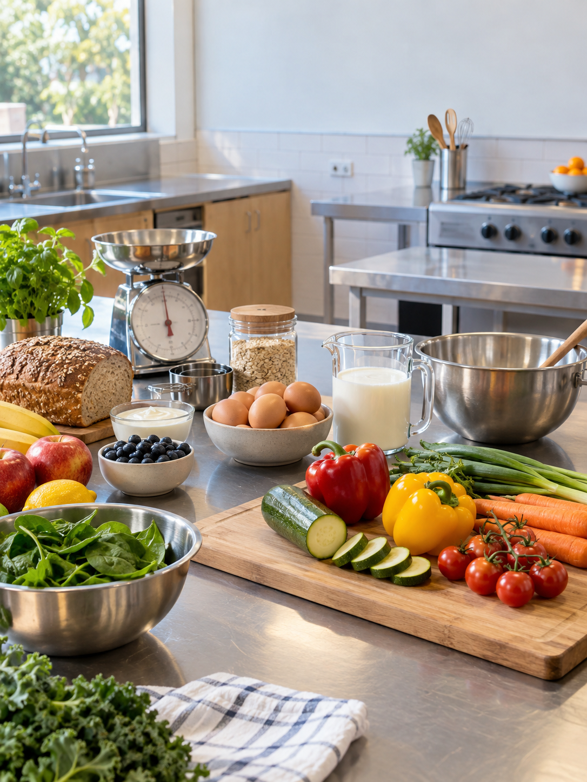
Name ______________________________________________
Class ______________________________________________

MODULE 01 / WORK SAFELY / CONTENTS
Your route through Fantastic Food
Use this book beside the live Fantastic Food course. Your teacher's current recipe masters, demonstrations and assessment notices remain the authority for practical work and submission.
Five modules
Turn to the starting page for each part of the unit.
03 | Ready to work safely | safe decisions, hygiene and hazards
13 | Recipes and nutrition | reading, measuring and nutrients
23 | Workflow and food choices | sequence, variety and modification
33 | Food solutions | lunchbox design, orders and evaluation
43 | Review and communicate | fibre, water, Carbonara and final evidence
This copy belongs to
Name: ______________________________ Class: ______________________________
Keep evidence together
On applied pages, record what you decided, why it matters and what you would check or improve. Add teacher-approved, non-identifying photos or sketches to your folio where useful. The ten online activities and current assessment information remain on the course site.

MODULE 01 / WORK SAFELY / READ AND NOTICE
Ready to Work Safely in Food Technology
Learn how preparation, safety thinking, OnGuard training and careful decisions help you get ready for practical Food Technology lessons.
Practical food work begins before anyone handles ingredients. Readiness means listening to the lesson directions, preparing to follow the local routine and paying attention to the room. It is more than having the right equipment nearby. A ready student understands what the class is about to do, notices when something is unclear and does not begin a step simply because another group has started.  A hazard is something that could cause harm or make a situation unsafe. You can notice a possible hazard without knowing its solution. That distinction matters: recognising a concern is your responsibility, but the response must fit the current lesson and local procedures. If a direction is unclear or a situation changes, pause and ask the teacher rather than inventing a fix. Careful questions support safe work; they are not a sign that you have failed to prepare. | OnGuard training helps build the safety thinking needed before practical work. It can help you recognise why instructions and routines matter, but completing it does not give you permission to choose your own procedure. The teacher's directions and the procedures for the current room still govern what you do. Connect the general ideas from training to what the teacher shows and explains in this lesson.  Safe decisions follow a useful pattern: listen, notice, check and ask when unsure. Rushing can hide uncertainty, while copying a neighbouring group may be misleading if their task is different. Taking a moment to confirm the next action helps you work with purpose. Readiness is shown throughout the lesson by attention, calm judgement and willingness to seek guidance before a guess becomes a problem.
When you are unsure
1. Listen  Hear the instruction | 2. Notice  Look for changes | 3. Pause  Do not guess | 4. Ask  Follow direction
Use the decision pathway when a direction or situation changes: listen, notice, pause and ask before acting.
IN PRACTICE A student hears the teacher describe the next stage but cannot see whether their group has completed the required earlier stage. They stop, check the current directions and ask the teacher before continuing. The useful decision is the pause and check, not a guessed next step.

MODULE 01 / WORK SAFELY / CHECK AND EXPLAIN
Ready to Work Safely in Food Technology
Circle one answer for each question. Explain your thinking in the space below.
1. What does being ready for practical Food Technology work mainly involve?
[ ] A. Preparing to work safely and follow directions
[ ] B. Starting as quickly as possible
[ ] C. Choosing your own procedures
[ ] D. Waiting for another group to begin
2. What is a hazard?
[ ] A. Any task that takes a long time
[ ] B. Something that could cause harm or create an unsafe situation
[ ] C. A direction given by the teacher
[ ] D. A mistake that has already been fixed
3. Why is OnGuard completed before practical work?
[ ] A. To replace teacher directions
[ ] B. To choose what practical work students will do
[ ] C. To prepare students for workshop safety
[ ] D. To let students create their own workshop rules
EXPLAIN
Explain what you should do if you notice a possible hazard or become unsure during a practical Food Technology lesson, and explain why this response is important.
________________________________________________________________________________
________________________________________________________________________________
________________________________________________________________________________
________________________________________________________________________________
________________________________________________________________________________
________________________________________________________________________________

MODULE 01 / WORK SAFELY / READ AND NOTICE
Personal Hygiene for Safe Food Work
Understand how personal hygiene habits help protect food during practical work and how to restore hygiene if it is interrupted.
The person preparing food can affect how hygienically it is handled. Contamination is the unwanted transfer of something to food or to a preparation surface. Hands, hair, clothing and unnecessary touching can create opportunities for that transfer. Personal hygiene is therefore a continuing part of practical work, not a box to tick once at the start. Notice what you touch and how your actions may affect the food and work area.  Before a practical, follow the personal-readiness and handwashing routine taught by your teacher. The exact routine for this room comes from the teacher and local procedures; do not assume that a remembered routine from somewhere else is enough. Hand hygiene matters because hands move between many objects during a lesson. Careful habits after washing are just as important as the initial wash. Think about whether an action has interrupted the hygiene needed for food work. | An interruption might be small, but its effect should not be decided by guesswork. If you think hygiene has been interrupted, pause before returning to food preparation. Identify what happened, then follow the directed routine to restore hygiene. Ask the teacher when you are uncertain about what to do. This response protects the work and makes the routine reliable instead of treating it as a one-off performance.  Good hygiene also involves avoiding unnecessary contact with food, equipment and surfaces. Working automatically can make repeated touching hard to notice, so regularly check your own actions. Hair and clothing should be managed according to the class directions, and the current recipe and teacher instructions still guide the practical. Responsible food work means recognising when your habits need attention and correcting them before continuing.
Hygiene is a cycle
1. Prepare  Follow room routine | 2. Work  Notice what you touch | 3. Notice  Pause at a break | 4. Restore  Follow teacher advice
Hygiene needs attention throughout the practical, including after an interruption.
IN PRACTICE A student completes the directed hygiene routine and then touches something outside the food-preparation task. Before returning to the food, they pause and ask whether hygiene needs to be restored. They follow the teacher's direction rather than assuming the earlier routine still covers this moment.

MODULE 01 / WORK SAFELY / CHECK AND EXPLAIN
Personal Hygiene for Safe Food Work
Circle one answer for each question. Explain your thinking in the space below.
1. Why does personal hygiene matter during food preparation?
[ ] A. It makes every recipe easier to cook
[ ] B. It means teacher directions are no longer needed
[ ] C. Personal actions can affect how hygienically food is prepared
[ ] D. It only matters after practical work is finished
2. What does contamination mean in this section?
[ ] A. A recipe has too many ingredients
[ ] B. A student forgets the name of a utensil
[ ] C. Food takes longer than expected to prepare
[ ] D. Something unwanted is transferred to food or a food-preparation surface
3. Which action best supports hygienic food preparation?
[ ] A. Following the teacher's personal-readiness and hygiene routine
[ ] B. Using a routine remembered from another place
[ ] C. Skipping preparation when you are in a hurry
[ ] D. Waiting until food is finished before thinking about hygiene
EXPLAIN
Choose one personal hygiene habit involving hands, hair, clothing or unnecessary touching. Explain how it helps protect food, then explain what you should do if that hygiene habit is interrupted during practical work.
________________________________________________________________________________
________________________________________________________________________________
________________________________________________________________________________
________________________________________________________________________________
________________________________________________________________________________
________________________________________________________________________________

MODULE 01 / WORK SAFELY / READ AND NOTICE
Kitchen Hygiene, Hazards and Washing Up
Understand how a clean work area, careful hazard awareness and thorough washing up support safe and hygienic practical food work.
A hygienic work area needs attention throughout the practical. A bench that begins clean can become cluttered or less suitable for food work as equipment is used and tasks change. Keep track of the condition of surfaces, equipment and the space around you. Organised actions make it easier to see what needs attention, while leaving mess or unnecessary items in the work area can make the practical harder to manage.  A hazard is something that could cause harm or create an unsafe situation. Unhygienic behaviour is an action that makes hygienic preparation less effective. These ideas can overlap, but they are not identical. It is useful to say exactly what you noticed instead of calling every concern by the same name. Noticing is the first step; choosing a response should be guided by the teacher's directions and local procedures. | When something seems unsafe, unusual or unhygienic, do not guess how to fix it. Stop if you are unsure, report what you noticed and follow the teacher's direction. Another group might appear to use a different response because their situation is different. A clear report gives the teacher useful information and helps you avoid turning one concern into another through an unapproved action.  Washing up is part of the practical, not an optional job after the food is made. Used equipment and work areas need to be returned to the condition required by the local routine. Share the work, check what remains and ask about any item you are unsure how to handle. The practical is complete only when the food work and the directed clean-up are both finished. That full sequence shows care for the shared kitchen and the next class.
A complete practical
1. Set up  Prepare the area | 2. Observe  Notice concerns | 3. Report  Tell the teacher | 4. Clean down  Finish directed routine
A practical includes setup, awareness, reporting concerns and the directed clean-down routine.
IN PRACTICE A group notices an area of the bench is no longer suitable for the next food task. They describe the issue to the teacher and follow the cleaning direction for that room. At the end they check the washing-up requirements instead of assuming that finishing the food means finishing the practical.

MODULE 01 / WORK SAFELY / CHECK AND EXPLAIN
Kitchen Hygiene, Hazards and Washing Up
Circle one answer for each question. Explain your thinking in the space below.
1. What does kitchen hygiene involve during practical food work?
[ ] A. Keeping surfaces, equipment and work patterns clean and organised
[ ] B. Cleaning only after all food preparation is finished
[ ] C. Working as quickly as possible
[ ] D. Following whatever routine another group chooses
2. What is a hazard?
[ ] A. Any mess made during food preparation
[ ] B. Something that could cause harm or create an unsafe situation
[ ] C. Any task that takes extra time
[ ] D. A teacher direction that changes your routine
3. Which example best describes unhygienic behaviour?
[ ] A. Stopping to ask the teacher about a problem
[ ] B. Following the local washing-up routine
[ ] C. Allowing unnecessary mess to build up while working
[ ] D. Reporting something that looks unsafe
EXPLAIN
Imagine you notice a possible hygiene issue or hazard during practical food work. Explain how you should respond, then explain why washing up and leaving an orderly area are still important before the practical is complete.
________________________________________________________________________________
________________________________________________________________________________
________________________________________________________________________________
________________________________________________________________________________
________________________________________________________________________________
________________________________________________________________________________

MODULE 01 / WORK SAFELY / ACTIVITY 1 | APPLY
Safety and hygiene scan
Look at a teacher-approved practical workspace before work begins. Identify what is ready and what needs a safe decision. Do not move, use or fix unfamiliar equipment or hazards without direction.
Notice, then decide
For each observation, explain the possible effect on people or food and the safe next action. Include at least one hygiene point and one hazard point.
Observation 1 | Possible effect | Safe decision
Observation 2 | Possible effect | Safe decision
Observation 3 | Possible effect | Safe decision
A decision worth keeping
Which issue would make you stop and ask the teacher before continuing? Why?
________________________________________________________________________________
________________________________________________________________________________
________________________________________________________________________________
________________________________________________________________________________
________________________________________________________________________________
My next check
What will you check again just before practical work starts?
________________________________________________________________________________
________________________________________________________________________________

MODULE 01 / WORK SAFELY / SAFETY PATHWAY | DRAW AND EXPLAIN
When something changes
A safe routine has a pause point. OnGuard learning supports your thinking, while your teacher's directions and local procedures control what you do in this lesson.
Map a decision pathway
Draw arrows through these four moments: notice a hazard or hygiene problem; pause work; ask or report; follow the teacher's direction. Add one example of uncertainty in a food practical.
Annotated sketch / plan
The important pause
At which point could guessing make the situation worse? Explain how your pathway prevents that.
________________________________________________________________________________
________________________________________________________________________________
________________________________________________________________________________
________________________________________________________________________________
________________________________________________________________________________
Connect to OnGuard
Name one safety idea from your completed training and explain how it helps you notice or question a risk. Do not treat online training as permission to act without teacher direction.
________________________________________________________________________________
________________________________________________________________________________
________________________________________________________________________________
________________________________________________________________________________

MODULE 01 / WORK SAFELY / FOLIO STAGE 1 | KITCHEN-READY ROUTINE
My kitchen-ready routine
Show that you can prepare for practical work and respond appropriately when something becomes unsafe, uncertain or unhygienic.
Before work begins
Describe the routine your teacher requires. Give a reason for each action, not just a list of rules.
My preparation action | What it protects or prevents
My work-area check | What it protects or prevents
My direction or recipe check | What it protects or prevents
An interrupted routine
Describe one realistic point where you would stop and ask. What would you say to the teacher, and what would you wait for before continuing?
________________________________________________________________________________
________________________________________________________________________________
________________________________________________________________________________
________________________________________________________________________________
________________________________________________________________________________
________________________________________________________________________________
Evidence caption
Name a sketch, observation or approved photo and explain what it proves about your readiness. Leave out faces and names.
________________________________________________________________________________
________________________________________________________________________________
________________________________________________________________________________

MODULE 01 / WORK SAFELY / PRACTICAL REFLECTION
Hygiene in action
Hygiene is a repeated decision, not a once-only start. Use one teacher-observed lesson to record what you did before, during and after food work.
Three checkpoints
Record a specific action and explain the contamination or safety issue it addressed.
Before handling food | Action | Why it mattered
During practical work | Action or interruption | How I responded
After practical work | Clean-down action | How I checked completion
When the routine was interrupted
What did you notice, stop or ask about? If nothing interrupted your work, describe a plausible interruption and the response you would use.
________________________________________________________________________________
________________________________________________________________________________
________________________________________________________________________________
________________________________________________________________________________
________________________________________________________________________________
One improvement
Which hygiene or clean-down habit will you make more reliable next time, and how will you check it?
________________________________________________________________________________
________________________________________________________________________________
________________________________________________________________________________
________________________________________________________________________________

MODULE 02 / RECIPES AND NUTRIENTS / READ AND NOTICE
Reading Recipes: Scones and Savoury Twists
Learn how to read and check a teacher-provided recipe so you can organise your work, follow the correct sequence and complete practical food tasks safely.
A recipe is a guide to preparing a particular food product. Start with its title so you know which current teacher-provided recipe is in front of you. Locate the ingredients and the quantities beside them, then look for equipment information if the recipe supplies it. Finally, read the method. These parts answer different questions: what is needed, how much is needed and what happens in what order. Do not fill in a missing detail from memory.  The method has a sequence. Reading the whole sequence before beginning lets you see whether a later action depends on earlier preparation. If you read only the line you are performing, an important earlier requirement may surprise you too late. The Lemonade Scones and Savoury Twists practicals use their current teacher masters; their precise ingredients, amounts, equipment and method must come from those recipes and the teacher, not from this workbook. | Not every recipe presents information in exactly the same format. The Savoury Twists master includes equipment information, while another recipe may arrange its details differently. Scan the page you actually have, rather than assuming each heading will be in the same position. If a word, quantity or step is unclear, ask before acting. Teacher directions and local procedures guide how the written recipe is carried out in the room.  Keep the recipe available while you work. Before moving on, check the next method step and the matching ingredient line. This is especially valuable when a title feels familiar: a previous version or another class's recipe might not match today's master. Careful recipe reading is not a single pre-practical task. It is a repeated check that helps you stay organised, follow the intended sequence and notice questions early.
Practice extract - not the class recipe
TITLE | Sample mix
INGREDIENT | A: ___ mL
EQUIP. IF LISTED | Measure marked mL
METHOD | Check the unit, then measure
Reading relationship: confirm the current master; match mL to a volume measure; check the unit before measuring.
A sample layout to identify a title, amount-and-unit pair, equipment if listed and a method. The blank amount is deliberate.
IN PRACTICE A student recognises the title Savoury Twists but sees an equipment heading on the current recipe that they do not remember. They read that heading and the full method before starting. They follow the current page and ask about any unclear detail instead of relying on the recipe they recall.

MODULE 02 / RECIPES AND NUTRIENTS / CHECK AND EXPLAIN
Reading Recipes: Scones and Savoury Twists
Circle one answer for each question. Explain your thinking in the space below.
1. What should you do first when given a recipe for practical work?
[ ] A. Start from memory
[ ] B. Copy another group's work
[ ] C. Read the recipe before starting
[ ] D. Read only the title
2. What does the ingredient list help you identify?
[ ] A. The order of every method step
[ ] B. The local workshop rules
[ ] C. Which recipe you used last lesson
[ ] D. What ingredients are required
3. Why are quantities important when reading a recipe?
[ ] A. They show how much of each listed ingredient is required
[ ] B. They tell you which method step comes first
[ ] C. They can be ignored if you remember the recipe
[ ] D. They are only useful after cooking is complete
EXPLAIN
Explain why reading the whole method before starting a practical can help you work in the correct sequence, stay organised and make safer decisions.
________________________________________________________________________________
________________________________________________________________________________
________________________________________________________________________________
________________________________________________________________________________
________________________________________________________________________________
________________________________________________________________________________

MODULE 02 / RECIPES AND NUTRIENTS / READ AND NOTICE
Accurate Measuring and Managing a Practical
Learn how accurate measuring, careful checking and good organisation help you follow a recipe consistently and reduce avoidable mistakes and waste.
Accurate measuring begins with reading the quantity and unit on the current recipe. Both matter: a number without its unit is incomplete information. Before handling an ingredient, identify the correct line and ask which provided measuring tool suits it. The teacher's directions control how that tool is used. Guessing an amount because it looks familiar may change the balance of a recipe and use ingredients unnecessarily.  Consistency means that following the same recipe carefully should give results closer to what it was designed to produce. Measuring is only one part of that effort; good organisation also helps. Keep the recipe close, know which step you are on and focus on one measurement at a time. In the Lemonade Scones and Savoury Twists practicals, exact quantities and units come from the current teacher master. This workbook does not substitute a remembered amount or invent a conversion. | A useful check comes before measured ingredients are combined. Compare each measured amount with the relevant recipe line, including the unit. Once ingredients are mixed, a mistake may be difficult to separate or correct. A short pause can reveal that you read the wrong line or selected a tool that does not match the unit. The pause is worthwhile even when you are keen to keep the practical moving.  If the quantity, unit or tool still does not make sense, stop and ask the teacher. Do not add or remove ingredients to correct a suspected error without direction. Managing a practical does not mean pretending mistakes never happen; it means noticing them early and responding carefully. Reading, measuring, checking and asking form an organised cycle that can reduce confusion and avoidable waste while keeping the teacher-provided recipe in control.
Practice example: 100 mL water
1. 100 mL water  Identify volume | 2. mL measure  Match the unit | 3. Measure  Keep it separate | 4. Compare  Ask if unsure
A source-neutral practice example links 100 mL to a volume measure and a check before combining. It is not a class recipe.
IN PRACTICE A practice card says 100 mL of water. The student identifies mL as a volume unit, selects a measure marked in mL, and checks the amount while the water is still separate. A tool marked only in grams would not answer that instruction; the student asks before combining anything. The class recipe itself still comes from the current teacher master.

MODULE 02 / RECIPES AND NUTRIENTS / CHECK AND EXPLAIN
Accurate Measuring and Managing a Practical
Circle one answer for each question. Explain your thinking in the space below.
1. What does accurate measuring mean in a practical lesson?
[ ] A. Using the quantities and units on the current recipe carefully
[ ] B. Using amounts that look about right
[ ] C. Using the quantities you remember from another recipe
[ ] D. Changing quantities when they seem unusual
2. Why can measuring errors be a problem?
[ ] A. They always make food impossible to prepare
[ ] B. They can affect consistency and create unnecessary waste
[ ] C. They only matter after the practical is finished
[ ] D. They mean the recipe must be rewritten
3. What should you consider when choosing a measuring tool?
[ ] A. Which tool is closest to you
[ ] B. Which tool another group is using
[ ] C. The quantity and unit shown on the current recipe
[ ] D. Which tool you used in the previous lesson
EXPLAIN
Explain a useful check-before-mixing routine and how accurate measuring can support a more consistent practical result while reducing unnecessary waste.
________________________________________________________________________________
________________________________________________________________________________
________________________________________________________________________________
________________________________________________________________________________
________________________________________________________________________________
________________________________________________________________________________

MODULE 02 / RECIPES AND NUTRIENTS / READ AND NOTICE
The Six Essential Nutrients
Learn the six essential nutrient groups, understand their broad roles in the body and explain why eating a variety of foods can help meet different body needs.
Nutrients are substances in food that the body uses. The six essential nutrient groups are carbohydrates, protein, fats, vitamins, minerals and water. They contribute to different needs, so a useful question is what a nutrient can do, not whether it belongs on a list of good or bad things. Food is more complex than a single label: one food can contribute more than one nutrient group.  Carbohydrates and fats can provide energy. Protein supports growth and repair. Vitamins and minerals support many body processes, while water supports hydration and other functions. These are broad roles, not a complete description of everything each nutrient does. The body works through connected processes, and a nutrient may have more than one role. Use careful words such as 'can provide' and 'supports' when explaining a food's contribution. | Variety can help an eating pattern include a broader range of nutrients. Different foods may contribute different combinations, so looking across several foods is more informative than deciding that one food must meet every need. This also avoids treating foods or people as morally good or bad. In class, you can discuss possible nutrient groups in a recipe without changing the teacher-provided ingredients or claiming to know another person's individual needs.  When analysing a food idea, first identify the ingredients actually listed in the current recipe. Then consider which nutrient groups those foods may contribute and link each group to its broad role. Notice where your evidence is limited: a food's name alone does not tell you every amount or every nutrient it contains. The purpose is to explain how different nutrients support the body and why variety matters, not to diagnose a diet or make personal health rules for a classmate.
Six nutrients / different body needs
Carbohydrates  Energy | Protein  Growth and repair | Fats  Energy and cells
Vitamins  Body processes | Minerals  Body processes | Water  Hydration and transport
The six nutrient groups play different roles. A varied pattern matters more than one supposedly perfect food.
IN PRACTICE A student studies a teacher-provided recipe and identifies more than one possible nutrient group across its listed ingredients. They explain that the groups may support different body needs, using 'may contribute' where the exact amounts are unknown. They do not claim that the recipe alone meets every need.

MODULE 02 / RECIPES AND NUTRIENTS / CHECK AND EXPLAIN
The Six Essential Nutrients
Circle one answer for each question. Explain your thinking in the space below.
1. Which list contains all six essential nutrient groups?
[ ] A. Carbohydrates, protein, fibre, vitamins, minerals and water
[ ] B. Protein, fats, vitamins, minerals, water and energy
[ ] C. Carbohydrates, protein, fats, vitamins, minerals and water
[ ] D. Carbohydrates, fats, vitamins, minerals, water and hydration
2. Which nutrient groups can supply energy?
[ ] A. Protein and water
[ ] B. Vitamins and minerals
[ ] C. Water and minerals
[ ] D. Carbohydrates and fats
3. What is a broad role of protein?
[ ] A. Supporting growth and repair
[ ] B. Providing hydration
[ ] C. Being the body's only energy source
[ ] D. Replacing vitamins and minerals
EXPLAIN
Explain how several nutrient groups support different body needs and why eating a variety of foods can be useful.
________________________________________________________________________________
________________________________________________________________________________
________________________________________________________________________________
________________________________________________________________________________
________________________________________________________________________________
________________________________________________________________________________

MODULE 02 / RECIPES AND NUTRIENTS / ACTIVITY 2 | PLAN FROM THE CURRENT RECIPE
Lemonade Scones workflow
Use the recipe master supplied by your teacher. Read it all before work starts, then turn its instructions into a sensible sequence. Your teacher confirms the method and practical conditions.
Make the sequence visible
Use the recipe's own wording where a detail matters. Mark any step that depends on an earlier check.
Prepare | What must be ready? | What I will check
Measure | Amount and unit to verify | Before-combining check
Work | Key sequence or dependency | Teacher checkpoint
Finish | Result to observe | Clean-down responsibility
Before anything is combined
What would a wrong amount or unit affect? Describe the check you will make and why it belongs before mixing.
________________________________________________________________________________
________________________________________________________________________________
________________________________________________________________________________
________________________________________________________________________________
________________________________________________________________________________
After the practical
Compare one planned step with what actually happened. What would you retain or change next time?
________________________________________________________________________________
________________________________________________________________________________
________________________________________________________________________________
________________________________________________________________________________

MODULE 02 / RECIPES AND NUTRIENTS / ACTIVITY 3 | FOLIO STAGE 3
Nutrient connections
Different nutrients support different body needs. Foods often provide more than one nutrient, so explain a varied eating pattern rather than calling one food perfect.
The six essential nutrients
Use the unit theory to record one accurate role and a suitable food or drink example for each group.
Carbohydrates | Role | Example
Protein | Role | Example
Fats | Role | Example
Vitamins | Role | Example
Minerals | Role | Example
Water | Role | Example
Connect three different needs
Choose at least three of the nutrient groups above. Explain how variety supports different adolescent body needs, including fibre or water where relevant.
________________________________________________________________________________
________________________________________________________________________________
________________________________________________________________________________
________________________________________________________________________________
________________________________________________________________________________
________________________________________________________________________________
Evidence caption
Which course visual, food label or approved example helped you make one connection? State what it shows.
________________________________________________________________________________
________________________________________________________________________________

MODULE 02 / RECIPES AND NUTRIENTS / PRACTICAL RECORD
What the practical showed
Use a teacher-approved recipe practical you completed. Record observable evidence; do not rewrite the full method or guess at quantities from memory.
Plan beside observation
Focus on one recipe-reading or measuring decision, one workflow check and the finished result.
Planned check | What I observed | Evidence or reason
Workflow checkpoint | What I observed | Evidence or reason
Finished result | What I observed | Evidence or reason
Close the practical
Record what you actually completed or asked the teacher to clarify.
[ ] Work area checked against the teacher's clean-down direction
[ ] Equipment returned or dealt with as directed
[ ] Uncertain result or safety issue reported
One decision for next time
What would you repeat or change to make the sequence more reliable? Link your reason to the evidence above.
________________________________________________________________________________
________________________________________________________________________________
________________________________________________________________________________
________________________________________________________________________________
________________________________________________________________________________

MODULE 02 / RECIPES AND NUTRIENTS / FOLIO STAGE 2 | RECIPE LITERACY
Recipe and measuring check
Show the checking routine you used with the current teacher-provided recipe before ingredients were combined.
A check with a purpose
Refer to the recipe detail by name; copy an amount only from the current approved master if needed.
Recipe information I read first | How it shapes the sequence
Amount and unit I checked | Error this could prevent
Equipment or ingredient I confirmed | Why it matters before mixing
Explain your routine
How will you read, organise and measure from a teacher-provided recipe before combining ingredients? Include the exact point where you pause to check.
________________________________________________________________________________
________________________________________________________________________________
________________________________________________________________________________
________________________________________________________________________________
________________________________________________________________________________
________________________________________________________________________________
Evidence caption
Name an annotated recipe extract, measuring observation or approved image. What does it prove about reliable preparation?
________________________________________________________________________________
________________________________________________________________________________
________________________________________________________________________________

MODULE 03 / PLAN AND ADAPT / READ AND NOTICE
Workflow Planning in the Kitchen
Learn how to organise practical food work by planning the sequence, recognising which tasks depend on others, checking progress and completing both the food product and clean-up efficiently and safely.
Workflow is the order and organisation of tasks from preparation to a finished food product and clean work area. Read the entire current recipe before starting, then look ahead to the result it is meant to produce. Thinking backwards from that result can help you spot what must be ready before a later step can happen. It is a way to understand the method, not permission to rearrange it without guidance.  A dependency is a task that relies on another task being completed first. Find dependencies in the teacher-provided method instead of inventing them. Savoury Twists and Savoury Bread Cases each have their own current recipe and sequence. The Bread Cases master includes bread cases, a roux and listed filling options, but the exact order and practical details must be read from that master and the teacher's directions. A general workflow diagram cannot replace those instructions. | Once the sequence is clear, keep checking progress. Ask which step is complete, which step comes next and whether it depends on anything unfinished. There may be periods of waiting. Use that time only for a task that fits the current recipe and teacher directions, such as checking progress or tending to appropriate organisation and clean-up. Jumping ahead can create problems if a later step is not yet ready.  Workflow includes the finish, not only food production. Monitor the work area as the practical continues and complete the directed washing up before treating the task as done. If progress differs from what you expected, stop, check the recipe and ask before changing the method. A good plan is flexible because you keep noticing what is happening, but controlled because decisions remain tied to the current recipe and local procedures.
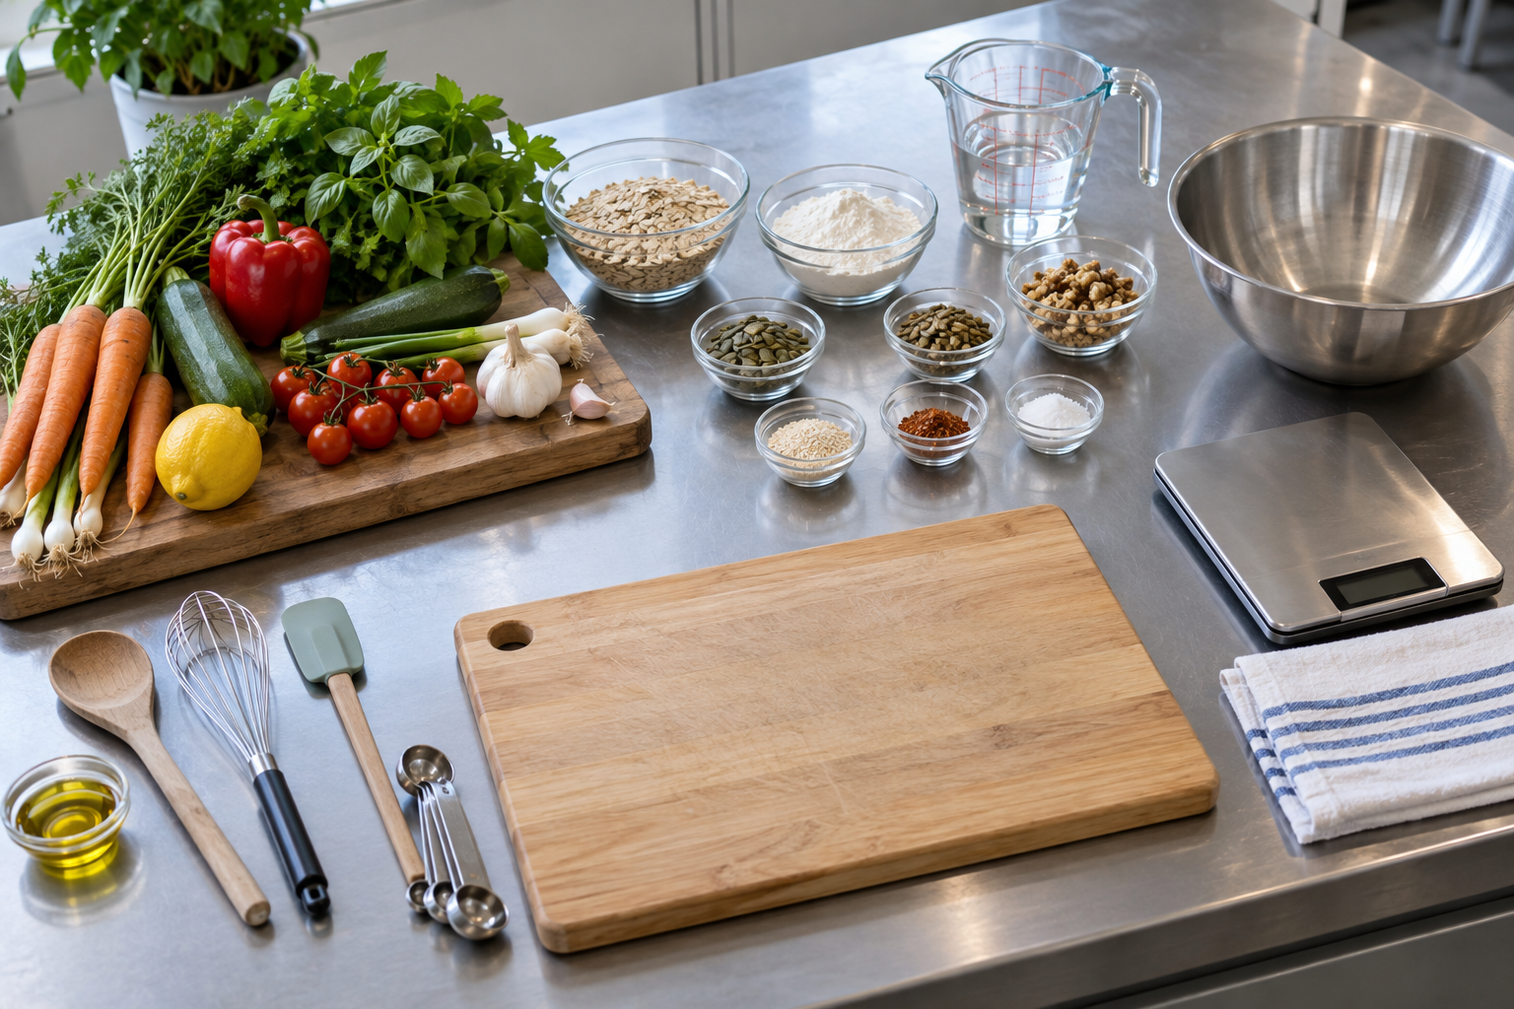
An organised setup can make dependencies visible; use the current teacher plan to decide the actual sequence.
IN PRACTICE A group reaches a waiting point in its current recipe. Rather than starting a later step automatically, they check the method and ask whether an appropriate organisation task can be done now. They later include the directed clean-up in their workflow instead of stopping at the finished food.

MODULE 03 / PLAN AND ADAPT / CHECK AND EXPLAIN
Workflow Planning in the Kitchen
Circle one answer for each question. Explain your thinking in the space below.
1. What is a workflow in practical Food Technology?
[ ] A. An organised plan for moving from preparation to a finished product and clean work area
[ ] B. A list of ingredients without a method
[ ] C. A way to complete every task as fast as possible
[ ] D. A plan that replaces the current recipe
2. Why should you read the complete recipe before starting?
[ ] A. To memorise every detail and put the recipe away
[ ] B. To understand the overall sequence and how tasks connect
[ ] C. To decide which steps you would prefer to skip
[ ] D. To replace teacher directions with your own plan
3. What is a dependency in a workflow?
[ ] A. A task that can always be skipped
[ ] B. A task that must be completed by another group
[ ] C. A task that relies on another task being completed first
[ ] D. A task that has no connection to the recipe
EXPLAIN
Explain how you would organise a simple kitchen workflow so that dependent tasks happen in a logical order, progress is checked and clean-up is included.
________________________________________________________________________________
________________________________________________________________________________
________________________________________________________________________________
________________________________________________________________________________
________________________________________________________________________________
________________________________________________________________________________

MODULE 03 / PLAN AND ADAPT / READ AND NOTICE
The Australian Guide to Healthy Eating and Adolescent Needs
Learn how the Australian Guide to Healthy Eating represents the relative place of the five food groups in an overall eating pattern and why variety can support the changing needs of adolescents.
The Australian Guide to Healthy Eating shows five food groups as parts of an overall eating pattern. They are vegetables and legumes/beans; fruit; grain foods, mostly wholegrain and/or high cereal fibre varieties; lean meats and poultry, fish, eggs, tofu, nuts and seeds, and legumes/beans; and milk, yoghurt, cheese and/or alternatives, mostly reduced fat. Water is shown as the preferred drink. The different spaces in the guide suggest relative contributions across an overall pattern, not identical portions for every food group.  The guide is not a template that every individual meal must copy. One lunchbox or recipe gives only a small view of what a person eats over time. Use it to notice which groups are represented and where variety could be considered, without judging the person who packed or chose the food. Exact individual needs vary, so a classroom discussion should not become a personalised eating prescription. | During adolescence, growth, school, activity and daily life can place different demands on the body. A varied eating pattern can include foods that contribute nutrients involved in energy, growth, repair and normal body processes. Different food groups can offer different combinations of nutrients. Thinking about variety across groups is more useful than calling a food or a person good, bad, clean or guilty.  When studying a food idea, identify the groups you can actually see and explain what the guide helps you notice. Do not assume that every meal must contain all five groups or exactly match the graphic. If you suggest an additional group for a hypothetical lunchbox, frame it as one possible way to increase variety, not a judgement about an individual's health. In practical lessons, the current teacher recipe and local procedures still determine what is prepared.
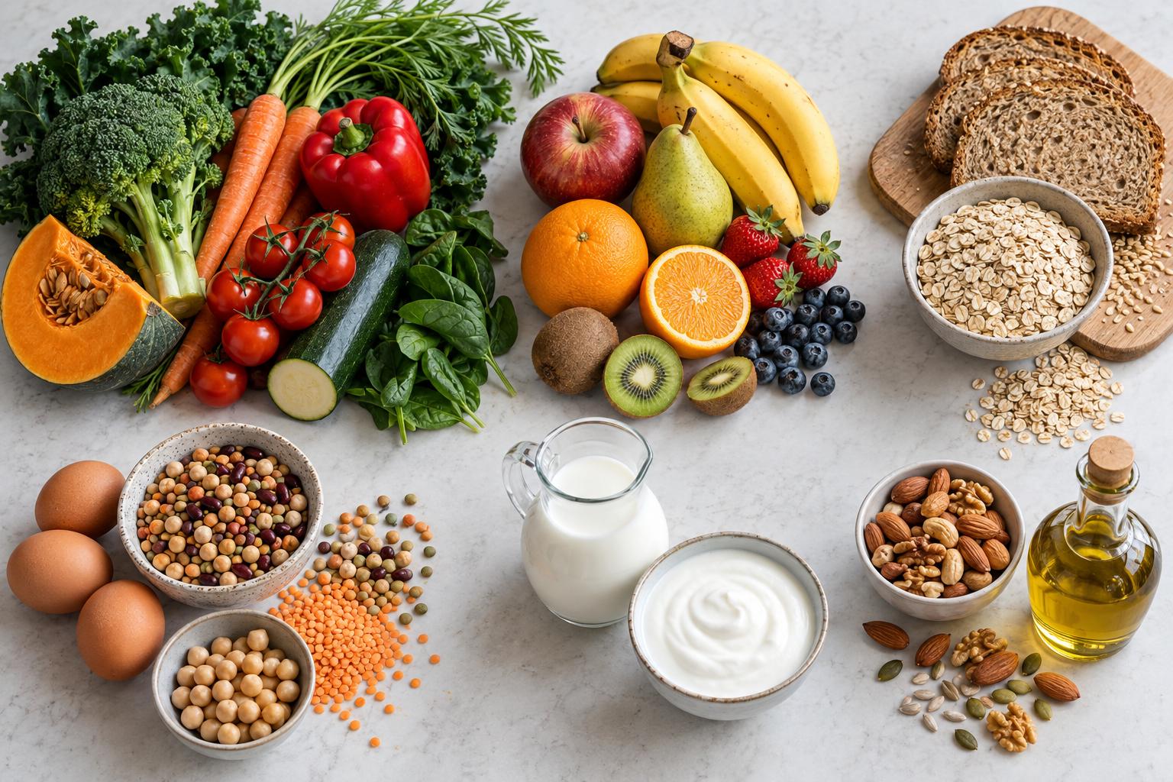
Illustrative food variety. Use the Australian Guide to Healthy Eating and class materials for food-group decisions.
IN PRACTICE A student reviews a hypothetical lunchbox and names the food groups visible in it. They suggest one possible way to add variety across the day, while noting that a single lunchbox cannot show someone's whole eating pattern. They do not prescribe amounts or label the owner of the lunchbox.

MODULE 03 / PLAN AND ADAPT / CHECK AND EXPLAIN
The Australian Guide to Healthy Eating and Adolescent Needs
Circle one answer for each question. Explain your thinking in the space below.
1. What does the Australian Guide to Healthy Eating mainly show?
[ ] A. The exact foods every person must eat at every meal
[ ] B. A ranking of foods from best to worst
[ ] C. The relative place of five food groups across an overall eating pattern
[ ] D. The exact amount of energy every teenager needs
2. Which is one of the five food groups in the guide?
[ ] A. Water and soft drinks
[ ] B. Snacks and desserts
[ ] C. Protein foods
[ ] D. Vegetables and legumes/beans
3. Which wording correctly names the grain food group?
[ ] A. Grain foods, mostly wholegrain and/or high cereal fibre varieties
[ ] B. Only wholegrain foods
[ ] C. Bread and cereal foods only
[ ] D. Carbohydrate foods
EXPLAIN
Explain how variety across the five food groups can support an adolescent's different needs without giving a personalised eating prescription.
________________________________________________________________________________
________________________________________________________________________________
________________________________________________________________________________
________________________________________________________________________________
________________________________________________________________________________
________________________________________________________________________________

MODULE 03 / PLAN AND ADAPT / READ AND NOTICE
Recipe Modification: Bread Cases and Garlic Cheese Flatbread
Learn how to plan a purposeful recipe modification, predict what the change may affect and evaluate whether the final idea meets its original goal.
Recipe modification is a purposeful, teacher-permitted change made for a stated goal. The starting point is always the current teacher recipe, not a version remembered from another lesson. Before proposing anything, name what the change is intended to achieve and who or what the food idea is for. A clear goal gives you a fair way to judge the result later; 'better' on its own is too vague to test.  The Bread Cases master includes listed filling options, while Garlic Cheese Flatbread has its own ingredients and method. You cannot assume a substitution or new step is allowed merely because it sounds appealing. Check the current recipe and ask what kinds of changes the teacher permits. The proposed change should be small and specific enough that you can describe it and consider its possible effects without rewriting the whole practical. | Predict before testing. A change might affect appearance, aroma, flavour or texture, as well as preparation and the food's intended role. A prediction is an informed expectation, not a report of what happened. Use 'may' or 'could' until there is a finished result to examine. Also consider whether improving one quality could create a trade-off elsewhere. That makes the proposal more thoughtful than a claim that every change is automatically an improvement.  After a teacher-permitted version is made, evaluate it against the original goal. Describe what you can actually observe and explain whether that evidence supports your prediction. A result that differs from the prediction is still valuable: it tells you what to question or adjust next. Do not invent ingredients, quantities, method steps or a successful outcome in advance. Good modification links goal, permitted change, prediction, observation and reasoned judgement.
A permitted modification
1. State user  Name the audience | 2. Choose goal  Set a testable goal | 3. Predict effect  Anticipate trade-offs | 4. Evaluate  Use real evidence
A proposed change begins with a user and goal, then needs a prediction and evidence-based evaluation.
IN PRACTICE A student proposes choosing one of the filling options already listed on the current Bread Cases master to pursue a stated sensory goal. Before the practical, they predict how that permitted choice might affect flavour and appearance. After making it under teacher direction, they compare the observed result with that goal instead of claiming success in advance.

MODULE 03 / PLAN AND ADAPT / CHECK AND EXPLAIN
Recipe Modification: Bread Cases and Garlic Cheese Flatbread
Circle one answer for each question. Explain your thinking in the space below.
1. What is the best starting point for a recipe modification?
[ ] A. Identify a clear reason or goal for the change
[ ] B. Change several things at once
[ ] C. Copy a change from another recipe
[ ] D. Decide the result will be better before testing
2. Which is an appropriate reason for proposing a recipe modification?
[ ] A. Because any change automatically improves a recipe
[ ] B. To meet a clearly stated design goal
[ ] C. Because the current recipe can be ignored
[ ] D. Because modifications do not need to be explained
3. What should control which parts of a recipe you are allowed to change?
[ ] A. Whatever another group decides to change
[ ] B. Any recipe you remember from home
[ ] C. Teacher directions and the current recipe
[ ] D. Whatever seems easiest at the time
EXPLAIN
Propose a teacher-permitted type of recipe modification for a stated user or nutritional goal without naming a specific ingredient change. Explain one effect you would predict and one question you would use to evaluate the result.
________________________________________________________________________________
________________________________________________________________________________
________________________________________________________________________________
________________________________________________________________________________
________________________________________________________________________________
________________________________________________________________________________

MODULE 03 / PLAN AND ADAPT / ACTIVITY 4 | SHARED WORKFLOW
Savoury Twists team plan
Use the current teacher recipe and the roles your teacher approves. A team plan needs handovers and checks, not merely two separate task lists.
Who, when and how
Give each stage an owner and identify what must be ready before the next person can act.
Preparation | Owner | Handover or dependency
Recipe work | Owner | Handover or dependency
Progress check | Owner | Teacher checkpoint
Clean-down | Owner | Completion check
A handover that matters
Where could the work stall, become unsafe or become inaccurate if a handover is missed? Explain your planned response.
________________________________________________________________________________
________________________________________________________________________________
________________________________________________________________________________
________________________________________________________________________________
________________________________________________________________________________
Team review
After the practical, describe one thing the team coordinated well and one change that would improve the next workflow.
________________________________________________________________________________
________________________________________________________________________________
________________________________________________________________________________
________________________________________________________________________________

MODULE 03 / PLAN AND ADAPT / ACTIVITY 5 | ANALYSE A FOOD CHOICE
Bread Cases nutrition review
Use your teacher's current Bread Cases recipe and the Australian Guide to Healthy Eating. One recipe contributes to an eating pattern; it does not need to meet every need on its own.
What the recipe contributes
Identify ingredients from the approved recipe, the food-group or nutrient contribution they may make, and a gap you cannot settle without more evidence.
Recipe ingredient or feature | Contribution | Evidence or uncertainty
Recipe ingredient or feature | Contribution | Evidence or uncertainty
Recipe ingredient or feature | Contribution | Evidence or uncertainty
Consider the whole day
How could another food or drink alongside this recipe add variety for an adolescent? Justify the choice without labelling the original food 'bad'.
________________________________________________________________________________
________________________________________________________________________________
________________________________________________________________________________
________________________________________________________________________________
________________________________________________________________________________
A permitted modification
Propose one change only if your teacher allows it. Predict the likely effect on nutrition, taste or practicality and state what you would need to test.
________________________________________________________________________________
________________________________________________________________________________
________________________________________________________________________________
________________________________________________________________________________

MODULE 03 / PLAN AND ADAPT / ACTIVITY 6 | FOLLOW THE APPROVED SEQUENCE
Garlic Flatbread process check
Follow the current teacher-directed recipe. The stages below are checkpoints for observation and planning, not replacement cooking instructions.
Track the stages
At each stage, record what you observed and how you knew it was time to continue under teacher direction.
Mixing | Observation | Check or question
Resting | Observation | Check or question
Shaping | Observation | Check or question
Baking | Observation | Check or question
A dependent step
Which later stage depended on an earlier one being completed? Explain what would have changed if you rushed that dependency.
________________________________________________________________________________
________________________________________________________________________________
________________________________________________________________________________
________________________________________________________________________________
________________________________________________________________________________
Process evidence
Choose a sketch, non-identifying photo or written observation. What does it prove about your sequencing or checking?
________________________________________________________________________________
________________________________________________________________________________
________________________________________________________________________________

MODULE 03 / PLAN AND ADAPT / FOLIO STAGE 4 | PRACTICAL WORKFLOW PLAN
Plan, predict, then evaluate
Choose a practical or teacher-permitted modification from this module. Show how your plan moves from preparation through a checked sequence to a realistic evaluation.
The design decision
A change must have a purpose and a way to test whether it helped.
My goal or problem | Why it matters to the user
Teacher-permitted change or workflow decision | Predicted effect
Evidence I can observe | How it will test the prediction
Workflow with a dependency
Use arrows to show preparation, a step that depends on another, one progress check and clean-down. Mark where teacher confirmation is needed.
Annotated sketch / plan
Evaluate the result
Compare your prediction with one observation. What would you retain or improve, and why?
________________________________________________________________________________
________________________________________________________________________________
________________________________________________________________________________
________________________________________________________________________________

MODULE 04 / DESIGN FOR A USER / READ AND NOTICE
Planning a Balanced Lunchbox
Learn how to plan a lunchbox for a particular person and school day by considering variety across food groups, water, practicality and how the whole lunchbox works together.
A lunchbox is a small design problem: it needs to suit a particular person on a particular school day. Begin by naming the intended user and considering what the day involves. A plan that works for one student may be less practical for another, so copying a model lunchbox is not enough. Think about the whole selection of food and drink, how it will be managed at school and what the teacher has asked you to consider.  The Australian Guide to Healthy Eating offers five useful food-group lenses: vegetables and legumes or beans; fruit; grain foods, mostly wholegrain or high-cereal-fibre varieties; lean meats, poultry, fish, eggs, tofu, nuts, seeds and legumes or beans; and milk, yoghurt, cheese or alternatives, mostly reduced fat. Different foods can contribute different nutrients, so looking for variety across a lunchbox is more useful than judging a single item in isolation. You do not need to force every plan into one identical formula. | Water is the preferred drink and should be considered alongside the food. Practicality matters too: a selection has to make sense for the intended day and the school's directions. If a class activity involves food preparation, the current teacher recipe and local procedures control what is made and how. A drawing of a lunchbox is a proposal, not permission to invent a storage rule, preparation step or substitution.  Review the first plan as a whole. Which groups are represented? Is there a useful spread of choices? Have you considered water and the circumstances of the user? Choose one change only if you can explain the problem it addresses. For example, a plan with little variety could be reconsidered, while another might need a more practical arrangement. Describe the reason without calling a food or a person good or bad.
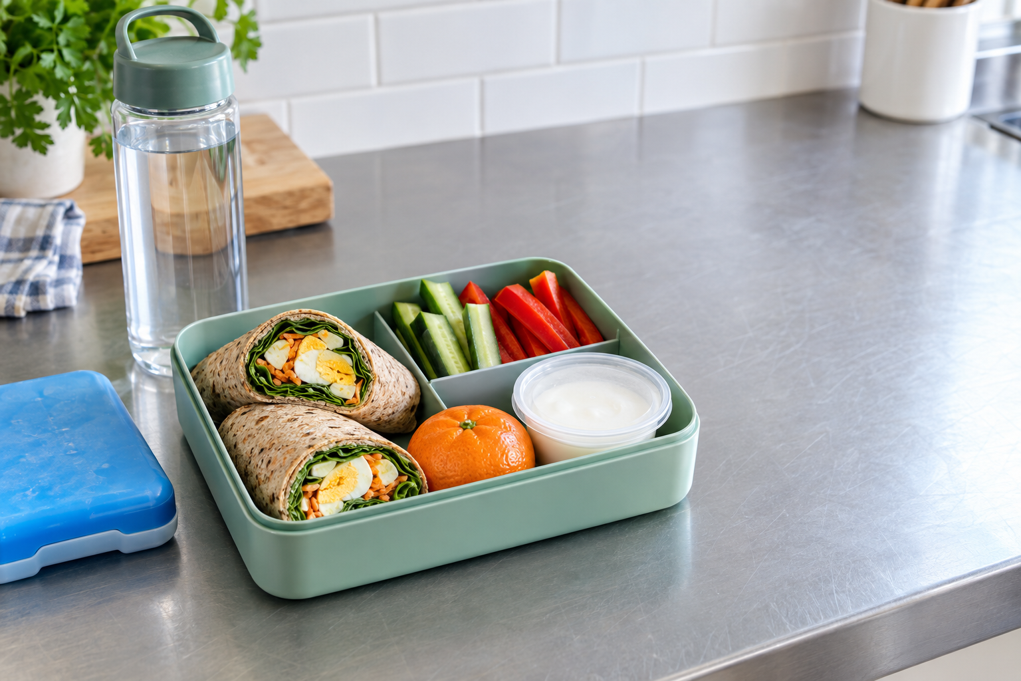
A lunchbox example can be judged for variety, practical use and the needs of its intended student.
IN PRACTICE A student plans a lunchbox for a stated school day and marks which food groups appear across the whole selection. They notice limited variety, then propose one change and explain how it broadens the selection. They keep any practical preparation subject to the teacher's directions.

MODULE 04 / DESIGN FOR A USER / CHECK AND EXPLAIN
Planning a Balanced Lunchbox
Circle one answer for each question. Explain your thinking in the space below.
1. What is a useful first step when planning a lunchbox?
[ ] A. Copy one lunchbox for every person
[ ] B. Choose foods only by appearance
[ ] C. Consider the intended user and school day
[ ] D. Ignore how the lunchbox will be managed
2. What does variety mean when planning a lunchbox?
[ ] A. Making every item the same type of food
[ ] B. Using as many foods as possible regardless of purpose
[ ] C. Making every lunchbox identical
[ ] D. Including a range of foods across different food groups
3. Which is one of the five food groups in the Australian Guide to Healthy Eating?
[ ] A. Fruit
[ ] B. Drinks
[ ] C. Snacks
[ ] D. Desserts
EXPLAIN
Plan a lunchbox for a stated user and school day. Explain how your plan includes variety across food groups, how it is practical for the situation and one improvement you would consider after reviewing the whole lunchbox.
________________________________________________________________________________
________________________________________________________________________________
________________________________________________________________________________
________________________________________________________________________________
________________________________________________________________________________
________________________________________________________________________________

MODULE 04 / DESIGN FOR A USER / READ AND NOTICE
Food Orders and Practical Organisation
Learn how a clear and accurate food order helps communicate what is needed for a practical, supports organised workflow and reduces avoidable waste or confusion.
A food order communicates the items and quantities needed for an approved practical. It is not a new recipe. Start with the current teacher-approved recipe or plan and transfer its information carefully. Each entry should be traceable to that source. Do not rely on remembered quantities. If a name or amount is unclear, ask before recording a guess.  The first draft needs a deliberate check. Compare every item name and quantity with the source, including the unit where one is given. Look for anything missing and for accidental duplicates. A missing entry may leave the group without a required item; a duplicate may request more than the practical calls for. Checking the order before it is submitted is a practical way to reduce confusion and use resources responsibly. Do not add a product simply because it seems typical of the dish. | For each entry, ask where it appears in the approved recipe or plan. This planned-use check is a useful second pass: an entry with no clear connection deserves another look, and an ingredient in the source with no entry may reveal an omission. It does not require you to invent extra method steps. The school may have its own way of recording or processing orders, so follow the teacher's directions and local procedures for the actual form and process.  The completed order supports workflow from preparation through production and clean-up, but it cannot replace reading the method. During the practical, keep using the current recipe, monitor the sequence and manage resources with care. If the teacher changes the approved plan, check the revised information before relying on an earlier order. Good organisation connects accurate planning to what the group actually makes; it does not assume that yesterday's list still applies.
Order from the plan
1. Approved plan  Start with approval | 2. Required items  List each item | 3. Check amounts  Use current amounts | 4. Confirm order  Ask about gaps
The food order comes from an approved plan and must be checked against the current practical.
IN PRACTICE A student compares a draft order with the current approved recipe and finds an item entered twice. They check the source, correct the duplicate and then confirm that each remaining entry has a planned use. They ask the teacher about one unclear quantity instead of filling it in from memory.

MODULE 04 / DESIGN FOR A USER / CHECK AND EXPLAIN
Food Orders and Practical Organisation
Circle one answer for each question. Explain your thinking in the space below.
1. What is the main purpose of a food order in practical Food Technology?
[ ] A. To communicate what is needed for an approved practical plan
[ ] B. To replace the recipe method
[ ] C. To let students add any items they prefer
[ ] D. To record what was used in a previous lesson
2. What should be the main source for items and quantities on a food order?
[ ] A. A student's memory of a similar recipe
[ ] B. The current teacher-approved recipe or plan
[ ] C. Another group's food order
[ ] D. Whatever seems likely to be needed
3. Why should a food order be checked after it is drafted?
[ ] A. To add extra items just in case
[ ] B. To change the practical into a different recipe
[ ] C. To find possible missing, duplicated or inaccurate entries
[ ] D. To make the list longer
EXPLAIN
Explain how you would create and check a food order from an approved practical plan, and describe how the completed order connects to practical workflow and responsible resource use.
________________________________________________________________________________
________________________________________________________________________________
________________________________________________________________________________
________________________________________________________________________________
________________________________________________________________________________
________________________________________________________________________________

MODULE 04 / DESIGN FOR A USER / READ AND NOTICE
Coconut Balls Practical and Healthier Fast-Food Redesign
Learn how to use evidence from a practical activity and apply clear design criteria when proposing and evaluating a healthier fast-food redesign.
The Coconut Balls practical gives you evidence about how a food task was managed. Use the current teacher recipe and local procedures, then notice what actually happens: the sequence followed, when the recipe was checked and whether the work area stayed organised. These are observations, not guesses about how the lesson ought to go. They can help you explain a strength or identify a part of the workflow to improve. Completing a practical alone is not proof that every part went well.  Appearance, aroma, flavour and texture should not be written in advance as though a predicted result has already occurred. Separate observation from judgement. For instance, 'I checked the recipe before moving on' describes an action; 'that helped me stay organised' is your interpretation. Linking the two makes an evaluation more convincing than a bare opinion. | A healthier fast-food redesign is a separate design challenge. Identify its intended user and purpose, then set criteria you can use later to judge the proposal. Consider variety across the overall eating pattern and how practical the idea would be in its intended setting. Avoid treating a single food as simply good or bad. A useful change should answer a stated criterion, not be added at random. Only propose practical changes the teacher permits; the approved plan and local procedures still govern what can be tested.  Before testing, explain what a proposed change may do rather than promising a result. It could affect sensory qualities, organisation or suitability for the user, but that remains a prediction. If the proposal is produced, compare actual observations with your criteria. If it is not produced, evaluate the reasoning and identify what evidence would still be needed. One well-explained improvement, connected to a criterion or observation, is more useful than a list of unsupported claims.
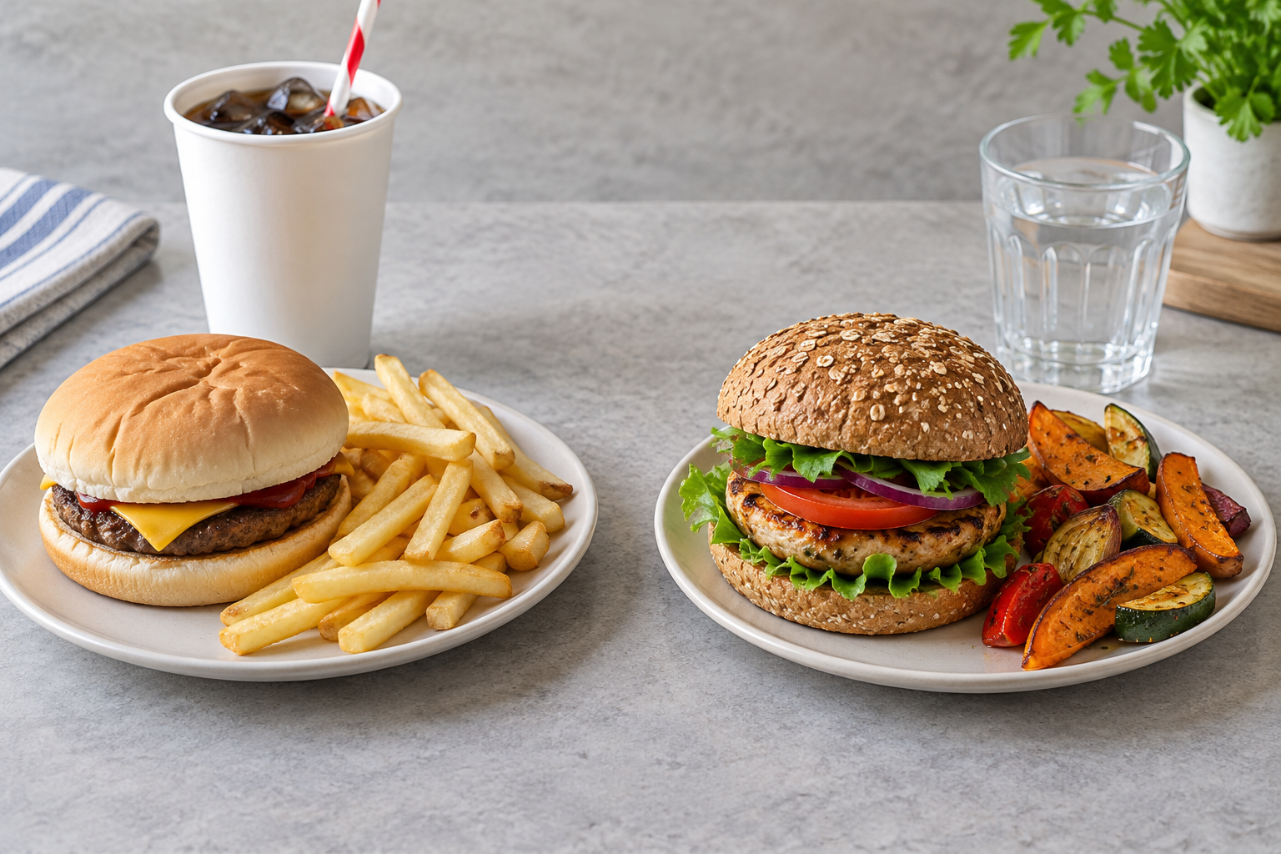
Use criteria and evidence to judge a redesign, not appearance alone.
IN PRACTICE A student wants a fast-food idea to offer more variety for a stated user. They propose a teacher-permitted change and predict that it may affect the finished food's texture. They label this a prediction until a practical test supplies actual evidence, then compare the result with their original criterion.

MODULE 04 / DESIGN FOR A USER / CHECK AND EXPLAIN
Coconut Balls Practical and Healthier Fast-Food Redesign
Circle one answer for each question. Explain your thinking in the space below.
1. What makes an observation from a practical useful evidence?
[ ] A. It describes what you hoped would happen
[ ] B. It copies another group's result
[ ] C. It records what was actually seen or done
[ ] D. It predicts the result before the practical begins
2. Which is the best way to record the finished result of the Coconut Balls practical?
[ ] A. Write the expected sensory result before starting
[ ] B. Assume the result is the same as another group's
[ ] C. Describe the product as successful without giving evidence
[ ] D. Describe the qualities you actually observe after completing the practical
3. What should come first in a fast-food redesign process?
[ ] A. Define the intended user and purpose
[ ] B. Change several parts of the food immediately
[ ] C. Decide the final sensory result before testing
[ ] D. Copy an existing food without reviewing it
EXPLAIN
Explain one criterion you would use when planning a healthier fast-food redesign for a stated user, predict one possible effect of a teacher-permitted change, and explain how you would evaluate whether the proposal met its goal.
________________________________________________________________________________
________________________________________________________________________________
________________________________________________________________________________
________________________________________________________________________________
________________________________________________________________________________
________________________________________________________________________________

MODULE 04 / DESIGN FOR A USER / ACTIVITY 7 | DESIGN FOR A USER
Healthy fast-food redesign
Choose a familiar fast-food idea and redesign it for an adolescent user. Aim for a justified improvement in food variety or practicality while retaining appeal.
Set the design brief
State the original, the intended user and three criteria you can actually test.
Original food idea | Intended user and situation
Criterion 1: food variety | How I could check it
Criterion 2: practicality | How I could check it
Criterion 3: appeal | How I could check it
Before and after
Sketch or annotate the original and redesigned version. Label the changes, not just the appearance.
Annotated sketch / plan
Justify one change
Which change gives the clearest benefit? Explain the evidence or nutrition idea behind it and one possible trade-off.
________________________________________________________________________________
________________________________________________________________________________
________________________________________________________________________________
________________________________________________________________________________

MODULE 04 / DESIGN FOR A USER / ACTIVITY 8 | FOLIO STAGE 5
Adolescent lunchbox plan
Plan for a particular adolescent and school day using the teacher-issued selection list. Consider variety, water, carrying and ease of eating; do not assume one lunchbox fits everyone.
User and purpose
Who is the lunchbox for, and what will their day require? Include a practical constraint that could affect your choices.
________________________________________________________________________________
________________________________________________________________________________
________________________________________________________________________________
Arrange the lunchbox
Sketch the approved food and drink choices. Annotate where variety, water and portability appear in your plan.
Annotated sketch / plan
Three testable criteria
Use criteria to judge a solution, not just to describe it.
Criterion | What would show it is met
Criterion | What would show it is met
Criterion | What would show it is met
Evidence behind one choice
Explain how a course idea or the teacher's selection list influenced one choice.
________________________________________________________________________________
________________________________________________________________________________
________________________________________________________________________________

MODULE 04 / DESIGN FOR A USER / FOLIO STAGE 6 | FOOD ORDER AND TIME PLAN
Order and organise
Use only the current teacher-approved selection, recipe or food-order form. Check every item and amount against its planned use before practical work begins.
Trace each order item
Enter details from the approved source rather than estimating from memory.
Item from approved source | Amount and unit checked | Planned use
Item from approved source | Amount and unit checked | Planned use
Item from approved source | Amount and unit checked | Planned use
Item from approved source | Amount and unit checked | Planned use
Time and dependencies
State what must happen first, what can overlap, when you will check progress and how clean-down fits.
First | Why it must come first
Can overlap | What needs to be ready
Progress check | Who confirms it
Clean-down | How completion is checked
Catch an error early
Which missing, duplicated or unclear item would you raise with your teacher before the practical? Explain the risk it could prevent.
________________________________________________________________________________
________________________________________________________________________________
________________________________________________________________________________

MODULE 04 / DESIGN FOR A USER / FOLIO STAGE 7 | PRACTICAL REFLECTION
Evidence, then judgement
Review a teacher-approved practical result or food solution. A useful evaluation names what was observed, compares it with the plan and justifies a next step.
Compare with the criteria
Use the criteria you wrote on page 40 or another approved plan. Avoid claims that your evidence cannot support.
Criterion or planned step | Evidence observed | Met, partly met or not yet known
Criterion or planned step | Evidence observed | Met, partly met or not yet known
Criterion or planned step | Evidence observed | Met, partly met or not yet known
Evidence caption
Describe a non-identifying photo, sketch or observation: what is visible, when it was recorded and what it proves.
________________________________________________________________________________
________________________________________________________________________________
________________________________________________________________________________
________________________________________________________________________________
A justified improvement
What one change would most improve the result or process next time? Connect your reason to the evidence above.
________________________________________________________________________________
________________________________________________________________________________
________________________________________________________________________________
________________________________________________________________________________
________________________________________________________________________________

MODULE 05 / EVALUATE AND COMMUNICATE / READ AND NOTICE
Fibre and Water for Healthy Bodies
Learn how dietary fibre and water support different body functions and why both are best understood as parts of a varied overall eating pattern.
Dietary fibre includes parts of plant foods that the body does not fully digest. It helps support normal digestive function as food moves through the digestive system. Vegetables, fruit, legumes and wholegrain or other high-fibre grain foods can be fibre sources. Foods within those groups do not all contain identical amounts, so a food-group name is a clue rather than a precise measurement. Looking across varied plant foods is more useful than searching for one special product said to do everything.  Fibre has a different role from the nutrient groups you studied earlier. It can be present alongside other nutrients in the same food, which is another reason to examine the overall pattern rather than label an item as good or bad. When reviewing a lunchbox or recipe, identify possible fibre sources from its actual ingredients. Do not assume that one item supplies all the fibre a person needs or change a practical recipe without teacher approval. | Water supports hydration and normal body functions. Hydration means the body has the water it needs to function normally. The Australian Guide to Healthy Eating identifies water as the preferred drink, a useful broad principle when reviewing food and drink choices. It does not create one exact water target for every person. Individual needs vary, and this workbook is not a personalised health plan.  Water and fibre support different functions; neither substitutes for the other. Consider both within a varied pattern that may include several plant-food groups and water as a drink. Claims that a food or drink will 'detox' the body go beyond what this course establishes. Keep your explanation focused on the supported ideas: fibre helps normal digestive function, water supports hydration, and variety helps bring different contributions together.
Foods and water work together in an overall pattern; avoid judging one pictured item in isolation.
IN PRACTICE A student reviews a planned lunchbox and identifies plant foods that may contribute fibre. They also note whether water has been considered as the drink. Their explanation distinguishes fibre's digestive role from water's role in hydration without setting a personal daily target.

MODULE 05 / EVALUATE AND COMMUNICATE / CHECK AND EXPLAIN
Fibre and Water for Healthy Bodies
Circle one answer for each question. Explain your thinking in the space below.
1. What is dietary fibre?
[ ] A. Parts of plant foods that are not fully digested
[ ] B. A type of water found only in fruit
[ ] C. A nutrient found only in one food group
[ ] D. A product that replaces normal foods
2. What broad body function does dietary fibre support?
[ ] A. Only hydration
[ ] B. Normal digestive function
[ ] C. Every body function by itself
[ ] D. Instant energy for every activity
3. Which group of foods can include fibre sources?
[ ] A. Only one special fibre product
[ ] B. Water and other drinks only
[ ] C. Vegetables, fruit, legumes and wholegrain or high-fibre grain foods
[ ] D. Every food in exactly the same amount
EXPLAIN
Explain how fibre and water support different body functions and describe how both can be considered as part of a varied overall food pattern.
________________________________________________________________________________
________________________________________________________________________________
________________________________________________________________________________
________________________________________________________________________________
________________________________________________________________________________
________________________________________________________________________________

MODULE 05 / EVALUATE AND COMMUNICATE / READ AND NOTICE
Fettuccine Carbonara: Sequencing and Safe Workflow
Apply recipe-reading, workflow, hygiene and evaluation skills to the Fettuccine Carbonara practical by planning an ordered sequence, checking progress and completing the whole practical responsibly.
Fettuccine Carbonara brings several course skills into one practical. Start with the current teacher-master recipe, not a version remembered from home or found elsewhere. Locate its ingredient information, read the whole method and ask about any unclear instruction before acting. The teacher master controls the exact ingredients, quantities and sequence. Keep it available; preparation is not a memory test. Teacher directions and local hygiene and safety procedures control how the practical is carried out in this room.  A dependent step relies on something else being ready or complete first. Find those relationships in the current method so you can understand why the order matters. Arrange your workflow around the recipe's actual sequence, rather than moving to a later task simply because you have a spare moment. Waiting time may support an appropriate organisation task, but only when it fits the method and teacher directions. | During production, check which steps are complete and what must happen next. Accurate measuring, personal hygiene and kitchen hygiene remain part of the workflow throughout. Keep the work area organised enough to notice what is happening. If progress differs from the plan, pause, re-read the recipe and ask the teacher before changing a step. This is responsive work, not a failure of planning: a good sequence is followed while real progress is monitored.  Finishing includes more than reaching the final food step. Observe the result, complete the directed clean-up and leave the workspace as local procedures require. Then evaluate your organisation with specific evidence: where did a recipe check help, and where was the sequence confusing? Suggest one habit that could improve a later practical, such as checking a dependent step earlier. Do not invent an unapproved cooking correction. The full workflow runs from reading and preparation through production, evidence-based reflection and clean-up.
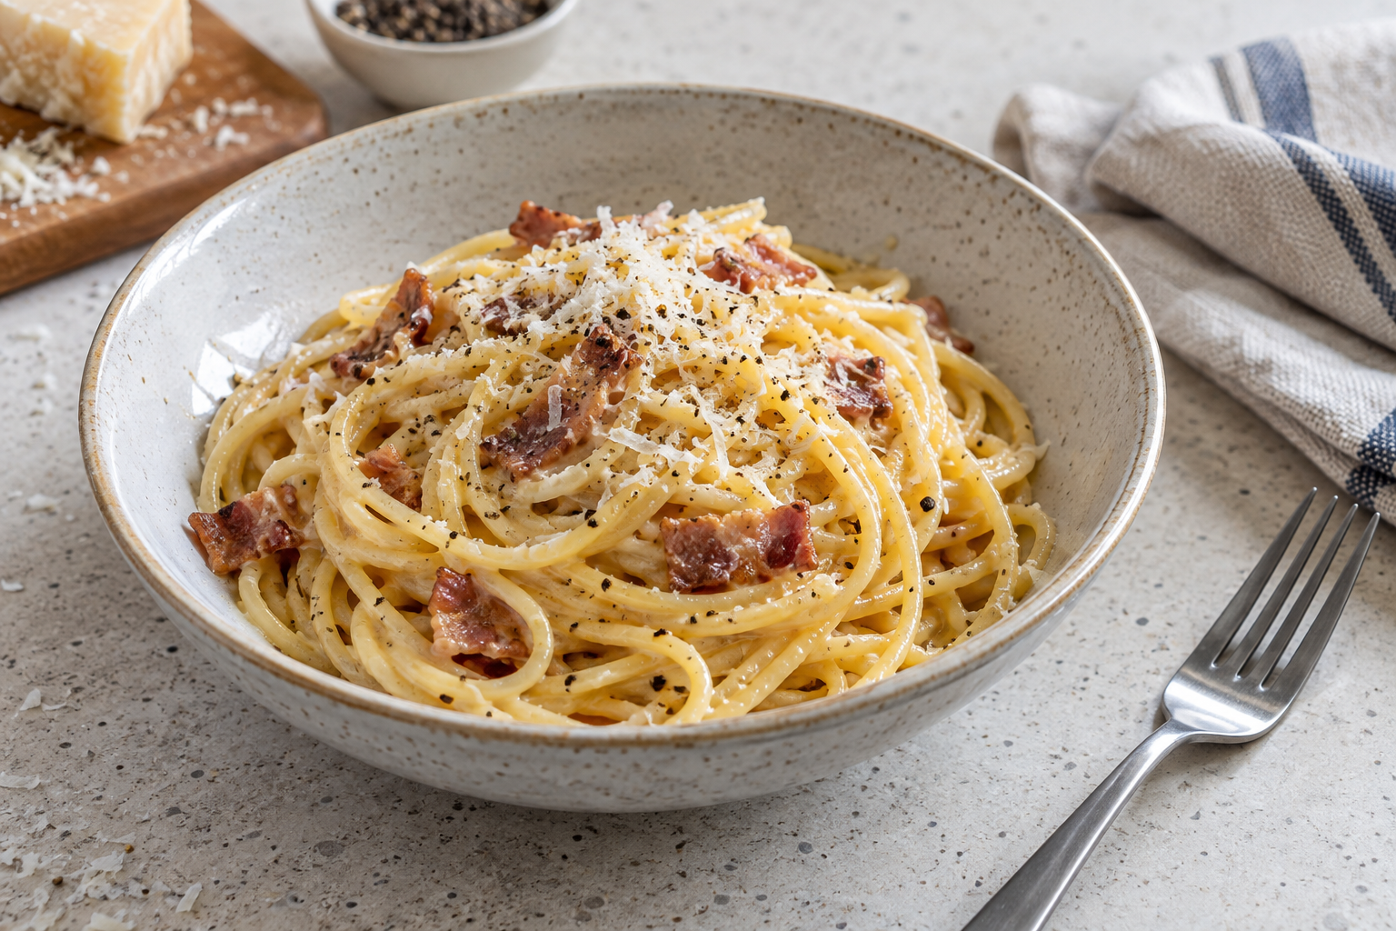
Illustrative carbonara-style result. The current teacher recipe controls ingredients and practical method.
IN PRACTICE A student reaches a point where the next recipe step depends on an earlier task being ready. They check the current method and ask the teacher about the sequence instead of jumping ahead. After the practical, they use that moment as evidence for an organisation improvement and include the directed clean-up in their account.

MODULE 05 / EVALUATE AND COMMUNICATE / CHECK AND EXPLAIN
Fettuccine Carbonara: Sequencing and Safe Workflow
Circle one answer for each question. Explain your thinking in the space below.
1. What should you do before starting the Fettuccine Carbonara practical?
[ ] A. Begin with the first step and read the rest later
[ ] B. Use a Carbonara recipe you already know
[ ] C. Read the complete current teacher-master recipe
[ ] D. Copy another group's plan
2. Why should the complete method be read before practical work begins?
[ ] A. To memorise the recipe and never look at it again
[ ] B. To decide which steps can be skipped
[ ] C. To replace teacher directions
[ ] D. To understand the sequence and identify dependent steps
3. What is a dependent step?
[ ] A. A step that relies on another part of the practical being ready first
[ ] B. A step that can always be completed whenever you like
[ ] C. A step that should be changed from the recipe
[ ] D. A step another group must complete for you
EXPLAIN
Explain how you would organise the Fettuccine Carbonara practical using the current teacher recipe, including dependent steps, progress checks and one evidence-based improvement for future practical work.
________________________________________________________________________________
________________________________________________________________________________
________________________________________________________________________________
________________________________________________________________________________
________________________________________________________________________________
________________________________________________________________________________

MODULE 05 / EVALUATE AND COMMUNICATE / READ AND NOTICE
Evaluating Food Solutions and Course Learning
Learn how to evaluate a food solution and the way it was produced by using clear criteria, specific evidence and a realistic improvement for future practical work.
Evaluation asks how well a solution and the way it was produced met their purpose. Return to the intended user and the criteria set for the task. A criterion is a feature used to judge the result, such as practicality, organisation or a sensory quality relevant to the activity. 'It was good' gives the reader little to assess; naming the criterion and explaining the result shows what your judgement means. Recognise strengths as well as what could improve.  Use evidence from what actually happened. An observation might record that you checked the recipe before a dependent step. Saying that this made the workflow clearer is an interpretation of that observation. Be cautious about cause and effect: a change in organisation may have helped, yet one observation may not prove that it caused every aspect of the final result. Describe sensory qualities only when they were genuinely observed. | Look at production as well as the food. Think back to personal and kitchen hygiene, reading the current recipe, measuring, organising workflow and making food-design decisions. Which actions supported the practical and where did you need more guidance? Compare your actions with the current teacher directions, recipe and local procedures. Choose one realistic improvement linked to a specific difficulty or strength. Evaluation is a tool for better decisions, not a search for faults.  The adolescent communication tool also needs evaluation for its intended audience. Consider whether its home or title page gives a clear purpose; whether its planning, health advice, nutrient information and healthier fast-food redesign are suitable; and whether adolescents can use it easily. Support judgements about appeal, ease of use and content by pointing to features actually present in the tool. A useful final improvement responds to evidence from the tool rather than a vague wish to make it better.
Communicate and evaluate
1. Know user  Adolescent audience | 2. Plan message  Clear useful content | 3. Test use  Observe reader use | 4. Improve  Justify one change
A communication tool is judged by what its intended reader can understand and use.
IN PRACTICE A student points to a feature of their communication tool that helps an adolescent find nutrient information, then explains why it supports ease of use. They also identify a page whose purpose is less clear and propose one specific change. Their judgement is tied to visible evidence rather than a general claim that the tool is good.

MODULE 05 / EVALUATE AND COMMUNICATE / CHECK AND EXPLAIN
Evaluating Food Solutions and Course Learning
Circle one answer for each question. Explain your thinking in the space below.
1. What is the main purpose of evaluating a food solution?
[ ] A. To judge how well it met its purpose and criteria
[ ] B. To decide whether the student is good or bad at cooking
[ ] C. To describe the practical without making any judgement
[ ] D. To change the goal after seeing the result
2. What are criteria used for in an evaluation?
[ ] A. To guarantee a successful result
[ ] B. To provide clear features for judging the result
[ ] C. To replace observations from the practical
[ ] D. To rank students against each other
3. Which statement is an observation rather than an opinion?
[ ] A. My workflow was excellent
[ ] B. The practical was really good
[ ] C. I checked the current recipe before moving to the next stage
[ ] D. I think my organisation was better than everyone else's
EXPLAIN
Evaluate your communication tool for adolescents. Judge its appeal, ease of use and suitable content. Support your judgements with evidence from the tool and suggest one improvement.
________________________________________________________________________________
________________________________________________________________________________
________________________________________________________________________________
________________________________________________________________________________
________________________________________________________________________________
________________________________________________________________________________

MODULE 05 / EVALUATE AND COMMUNICATE / ACTIVITY 9 | COMPARE, DO NOT JUDGE
Fibre and water pattern check
Use a fictional school-day food pattern or a teacher-provided example. Explain how fibre, water and variety play different roles without scoring anyone's eating habits.
Build a varied example
Select suitable food and drink examples from the course ideas. A food may contribute in more than one way.
School-day moment | Food or drink example | Fibre, water or variety contribution
School-day moment | Food or drink example | Fibre, water or variety contribution
School-day moment | Food or drink example | Fibre, water or variety contribution
Two roles, one pattern
How is fibre's role different from water's role? Explain why neither should be considered in isolation from the overall pattern.
________________________________________________________________________________
________________________________________________________________________________
________________________________________________________________________________
________________________________________________________________________________
________________________________________________________________________________
________________________________________________________________________________
A reasoned adjustment
Suggest one realistic change to the fictional pattern and explain which body need it could better support.
________________________________________________________________________________
________________________________________________________________________________
________________________________________________________________________________
________________________________________________________________________________

MODULE 05 / EVALUATE AND COMMUNICATE / ACTIVITY 10 | FOLIO STAGE 8
Carbonara and final evaluation
Use the current teacher Carbonara master and your own practical evidence. Review how well your food solution and communication tool served their intended audience; the teacher's current assessment notice sets any submission conditions.
From plan to evidence
Use a factual observation, not a remembered recipe instruction.
Workflow, hygiene or teamwork plan | What the evidence showed
Product-quality or user criterion | What the evidence showed
The next improvement
Name one change to the food process or result and justify it using the observation above.
________________________________________________________________________________
________________________________________________________________________________
________________________________________________________________________________
Communicate it clearly
Sketch a simple title page and navigation path for an adolescent audience. Label where the food solution, useful evidence and evaluation would appear.
Annotated sketch / plan
Usability judgement
What would you ask a reader to try, and what evidence would tell you the communication tool needs improvement?
________________________________________________________________________________
________________________________________________________________________________
________________________________________________________________________________
Folio evidence audit
Check the eight stages represented in this book; add missing evidence before following the current teacher submission directions.
[ ] 1 Kitchen-ready
[ ] 2 Recipe and measuring
[ ] 3 Nutrition connections
[ ] 4 Practical workflow
[ ] 5 User and criteria
[ ] 6 Organisation and order
[ ] 7 Practical reflection
[ ] 8 Communicate and evaluate

