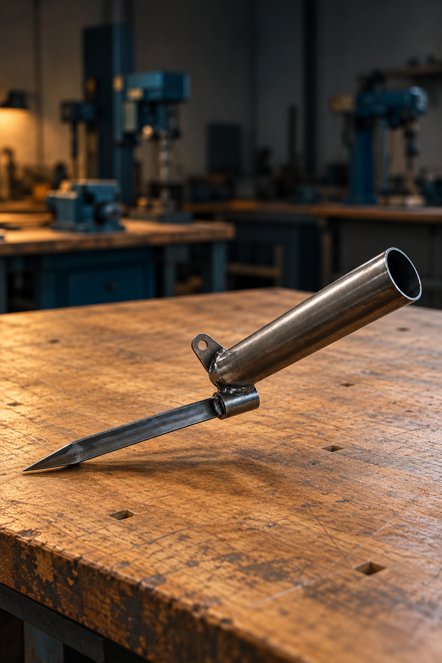
YEAR 9 METALWORK
Fishing Rod
Holder
STUDENT TEXTBOOK + PROJECT FOLIO
DESIGN / MAKE / CHECK / EVALUATE
A source-bound learning guide and space for your project evidence.
INSIDE Five modules connect safe workshop decisions, material selection, plan reading, production and
evaluation.
Student name ____________________ Class / teacher __________________
Illustrative project view. The teacher-issued components drawing controls construction.
50 A4 pages / 25 double-sided sheets
1
PROJECT FOLIO / PAGE 02

Your learning route
Five modules connect design decisions, safe workshop practice and honest project evidence. Use the teacher-issued plan and demonstrations alongside this book.
01 Workshop systems and risk | PAGE 4

02 Brief, materials and drawing | PAGE 9

03 Mark, cut and form | PAGE 23

04 Join, machine and finish | PAGE 31

05 Technology, quality and evaluation | PAGE 40

KEEP CLOSE The original component drawing appears on page 14. Folio pages are distributed beside the learning they support. Source and image credits are on the last page.

PROJECT FOLIO / PAGE 03

How to use this book
Read the explanation before completing the adjacent task. Use the website, presentations and teacher demonstrations when your teacher directs, then record your own thinking and evidence here.
The reproduced drawing is titled FISHING ROD HOLDER: COMPONENTS and is marked NOT TO SCALE. Its printed dimensions and notes, plus current teacher directions, control the project. Never measure a resized image to invent a dimension.
The book supports learning and folio evidence. Your teacher's approved assessment notification controls any formal due date, weighting, submission method and marking criteria.
SOURCE BOUNDARY The 2026 assessment notice still needs teacher approval. A separate 2027 program is for possible early adoption. This student book states neither set of outcomes, marks nor dates as current requirements.

Student name
Class
Teacher-issued plan revision
MODULE 1 / PAGE 04

Risk management is a process, not a poster
Risk management begins before any cutting, forming, drilling or assembly starts. First, identify hazards in the task, work area, material, tools and the behaviour of people nearby. Then consider how likely each hazard is to cause harm and how serious the consequence could be. A low-likelihood hazard with a severe possible injury still needs careful control. Use teacher-issued plans, classroom controls and demonstrations to decide what applies at each project stage.
Controls should follow the hierarchy: eliminate where possible, then substitute, isolate, use engineering controls, apply administrative controls and finally use personal protective equipment. PPE matters, but it is the final layer, not the whole plan. If a guard, material position, floor condition or work zone changes, stop, make the area safe and seek teacher direction before continuing.
HYPOTHETICAL EXAMPLE — A CHANGED SETUP Suppose a student is about to use a teacher-approved workstation and notices that the workpiece is no longer held as demonstrated. The hazard is movement of the stock; the possible consequence could be serious even if movement seems unlikely. The student stops, keeps clear and asks the teacher to restore and verify the approved setup. The student does not treat safety glasses as a replacement for workholding.

Risk management is continuous: identify, assess, control and review.
YOUR TURN
Choose one stage shown in your teacher-issued project instructions. Record (1) the stage and observed hazard, (2) how likely harm is and why, (3) the possible consequence, (4) one stronger control and any directed PPE, and (5) a change that would make you stop and review. Write two sentences explaining why your stronger control matters more than PPE alone.
Approved stage and hazard
Likelihood and reason
Possible consequence
Stronger control and directed PPE
Stop and review trigger
MODULE 1 / PAGE 05

Safe workshop practices
A safe workshop begins with attention and housekeeping. Follow signage, return material to the correct storage area and keep benches and walkways clear of offcuts. Wear the PPE directed for the task, secure loose hair and clothing, and stay aware of others.
Machine permission applies to the trained person, approved machine, demonstrated setup and current task. Do not use a machine when tired, distracted, unsupervised or when the setup differs from the demonstration.
HYPOTHETICAL EXAMPLE — YESTERDAY’S DEMONSTRATION A student watched a demonstration yesterday. Today the available machine has a different setup and the student is unsure whether the same operation is approved. The student clears the work area, leaves the machine unused and asks the teacher for a current demonstration or permission. Yesterday’s observation does not settle today’s setup.

Good housekeeping removes hazards before PPE is needed.
YOUR TURN
Create a two-column “ready / needs teacher check” record for an upcoming approved project stage. List at least three conditions you can check yourself and three that require current teacher confirmation. Explain what you will do if a guard, setup or work area differs from the demonstration.
Ready for work | Teacher check needed
Person and PPE
Stock, tool and area
Stop decision
MODULE 1 / PAGE 06

Incident response and reporting
If an incident or near miss occurs, stop work, make the immediate area safe and alert the teacher. Do not move equipment, material or an injured person unless directed or required to prevent further harm.
Report near misses as well as injuries. A near miss provides evidence that a control may have failed and allows the class to improve the system before someone is hurt.
HYPOTHETICAL EXAMPLE — A NEAR MISS A piece of stock shifts at a workbench but does not strike anyone. The student stops, keeps others clear and tells the teacher what moved and what the setup looked like. “The stock shifted when I began the approved task” is an observation; “the vice is broken” is a possible cause that needs checking. Work resumes only after the teacher reviews the control.

Report the event, the conditions and the control that needs review.
YOUR TURN
Use a teacher-provided scenario or the hypothetical shifted-stock example. Write four brief entries: what you observed; what you did immediately; what you must tell the teacher; and which control needs review. Underline any statement that is only a guess and rewrite it as a question to check.
What was observed
Immediate safe action
Who was told
Control to review
MODULE 1 / PAGE 07

Check your understanding 1
M1-Q01 Why are both likelihood and consequence considered?
□ A To decide how serious the risk is
□ B To choose the fastest tool
□ C To replace the demonstration
□ D To avoid all equipment

M1-Q02 What should happen if conditions change during practical work?
□ A Continue carefully
□ B Stop, make the area safe and seek teacher direction
□ C Rely only on PPE
□ D Ask another student to finish

EXPLAIN
Choose one stage from the teacher-issued project plans. Identify one possible hazard, describe its likelihood and consequence, and explain which hierarchy-of-controls measures should be used before work begins.
PROJECT FOLIO / PAGE 08

Risk control record
FOLIO 03 · WHS AND RISK CONTROLS Record hazards, likelihood, consequence, controls, PPE and permission points.

Teacher to confirm the actual stage and approved controls before practical work.
Project stage and observed hazard
Likelihood and consequence
Stronger controls and directed PPE
What change would make you stop?
MODULE 2 / PAGE 09

Choose metal for the job
Metals are often grouped as ferrous or non-ferrous. Ferrous metals contain iron and are commonly strong and magnetic, but many can rust if left unprotected. Non-ferrous metals may offer lower mass, corrosion resistance or easier forming, depending on the metal. A property is a characteristic such as hardness, strength, ductility or corrosion resistance; performance describes how well the material works in its intended situation.
Choose material by matching properties to function, fabrication processes, corrosion exposure, availability and finish. A metal may perform well but still be unsuitable if it cannot be safely processed using the approved workshop equipment. Use the teacher-issued plan to identify the project-specific metal, then justify why its properties support the Fishing Rod Holder.

Three source-named stock forms shown schematically, not to scale. Compare the printed label with a property and its intended performance.
WORKED REASONING FROM A PRINTED LABEL The drawing labels the STAKE as “Ø12 black bar, 1 off”. A sound explanation begins with that source fact, then asks what the stake must resist and how the school will make and protect it. It would be unsupported to write “this is a particular steel grade” or to substitute aluminium solely because it resists some corrosion.

Link material properties to required performance and available processes.
YOUR TURN
Choose one component on the drawing. In separate columns record its exact printed material/stock label, one relevant property to investigate, how that property could affect performance, and the source or teacher confirmation needed. Finish with a two-sentence material justification that makes no unsupported claim about grade or finish.
Component | Exact stock wording | Property and effect | Confirm from
Chosen part
JUSTIFICATION / Why this material suits the approved function
MODULE 2 / PAGE 10

Properties become performance
A material property describes the metal itself. Performance describes what happens when that material is used in a particular environment and design. A strong metal can still be a poor choice if it corrodes in the intended setting or cannot be made safely with the available equipment.
Compare candidate stock using function, fabrication, corrosion exposure, availability and finish. Do not substitute a different metal for a teacher-specified project part without approval.
Property or constraint | Evidence to look for | Effect on the design
Function
Fabrication
Corrosion
Availability and finish
YOUR TURN
Choose one property and explain how it could change a material decision for an approved project part.
MODULE 2 / PAGE 11

The Fishing Rod Holder brief and production context
The existing program identifies a Fishing Rod Holder, supported by the teacher-issued components drawing. The teacher-issued brief and plan define the exact requirements; this unit does not substitute its own geometry.
Separate requirements from preferences. Record the user, function, environment, approved materials and processes, then identify which evidence will demonstrate that the finished Fishing Rod Holder meets the brief.
HYPOTHETICAL BRIEF-TO-EVIDENCE LINK Suppose a teacher-issued brief required a part to match its approved drawing. The requirement would be “match the drawing”; evidence could be a recorded measurement and a captioned quality photograph. “I like a dark finish” would stay a preference unless the brief or teacher made it a required finish.

Keep the project brief, drawing and production evidence connected.
YOUR TURN
Read the current teacher-issued brief. Copy two actual requirements and one actual constraint into a three-row table. For each, write how it could be checked and what evidence you could save. Add one preference of your own and explain whether it is approved. If the brief is unavailable, mark the relevant cells “Teacher to confirm”.
Brief wording | Type | How checked | Evidence saved
Requirement 1
Requirement 2
Constraint
ONE PREFERENCE / Mark teacher approval status
MODULE 2 / PAGE 12

Design and project planning
Begin with the design brief, research relevant products, generate concept ideas and develop the approved direction. A working drawing communicates the information needed for production; a cutting list records the teacher-specified parts, material and dimensions.
A production plan sequences work, identifies checkpoints and notes demonstrations or permissions required. Review the plan when evidence shows a change is needed rather than improvising during an irreversible process.
HYPOTHETICAL CHECKPOINT — BEFORE CHANGING STOCK A student writes “ROTATION TAB — 25 × 5 flat — 1 off” from the drawing, but is unsure which printed view shows the tab’s hole. Rather than marking by eye, the student traces the label and views, writes the uncertainty in the cutting list and asks the teacher to confirm it. The checkpoint protects both material and evidence.

Plans control production; folio evidence explains decisions.
YOUR TURN
Draw a five-box planning flow from teacher-issued brief to approved practical work. Include the working drawing, cutting list, a quality checkpoint and a teacher permission point. Under each box, state what evidence you would save. Leave the exact operation and machine setting blank until demonstrated and approved.
Stage | Source detail or evidence
Brief
Drawing
Cutting list
Quality check
Teacher permission
MODULE 2 / PAGE 13

Read the Fishing Rod Holder components drawing
Begin by orienting the sheet so the title block and drawing title, “FISHING ROD HOLDER: COMPONENTS”, can be read normally. Scan the whole page before focusing on individual details. Identify the three named parts: ROD HOLDER, STAKE and ROTATION TAB. Then match each name to its related view or views by following the labels, shapes, dimensions and notes shown on the sheet. Because the drawing contains multiple views, do not assume two nearby shapes are separate parts until you have checked their labels and how the views relate.
Read the printed information for each component carefully. The ROD HOLDER is labelled 50 nb. pipe, 1 off; the STAKE is labelled Ø12 black bar, 1 off; and the ROTATION TAB is labelled 25 x 5 flat, 1 off. Check both the material label and the quantity because they help define what belongs in the project. The sheet is marked NOT TO SCALE, so never measure the page to work out a size. Use only the printed dimensions and written notes, and ask the teacher about anything unclear, missing or apparently conflicting.
Before Module 3 marking and production, turn your plan reading into evidence. Save a checked cutting list, an annotated copy of the plan or a clear folio note showing that you identified each component, checked its quantity and material label, and traced the relevant dimensions and notes. Do not begin marking or production from memory or guesswork. The teacher-issued plan, demonstrations and instructions control the exact dimensions, materials, machine settings, construction sequence and permissions, so any uncertainty must be resolved before work continues.
WORKED PLAN READING — ONE PART, TWO VIEWS The ROD HOLDER is shown by a circular end view and a rectangular side view. The label beside it reads “50 nb. PIPE” and “1 OFF”; the side view has a printed length dimension of 100. These are drawing facts. Measuring the circle in a printed workbook, guessing the pipe’s outside diameter, or deciding how to chamfer it without teacher direction would add unsupported instructions.

Read, match, check and record before you mark.
YOUR TURN
Using the unchanged teacher-issued drawing, annotate the title, “NOT TO SCALE” note and the views for each of the three named parts. Complete a register with each printed part name, stock label and quantity. Copy one printed dimension or note for each part exactly as it appears, and write one question for the teacher about any uncertain unit, relationship or practical step. Do not take measurements from the page.
Part | Printed stock + quantity | Exact note / question
Rod holder
Stake
Rotation tab
MODULE 2 / PAGE 14

The original components drawing
This is the complete original teacher-issued drawing. The page has been resized to fit the book; its information has not been redrawn.
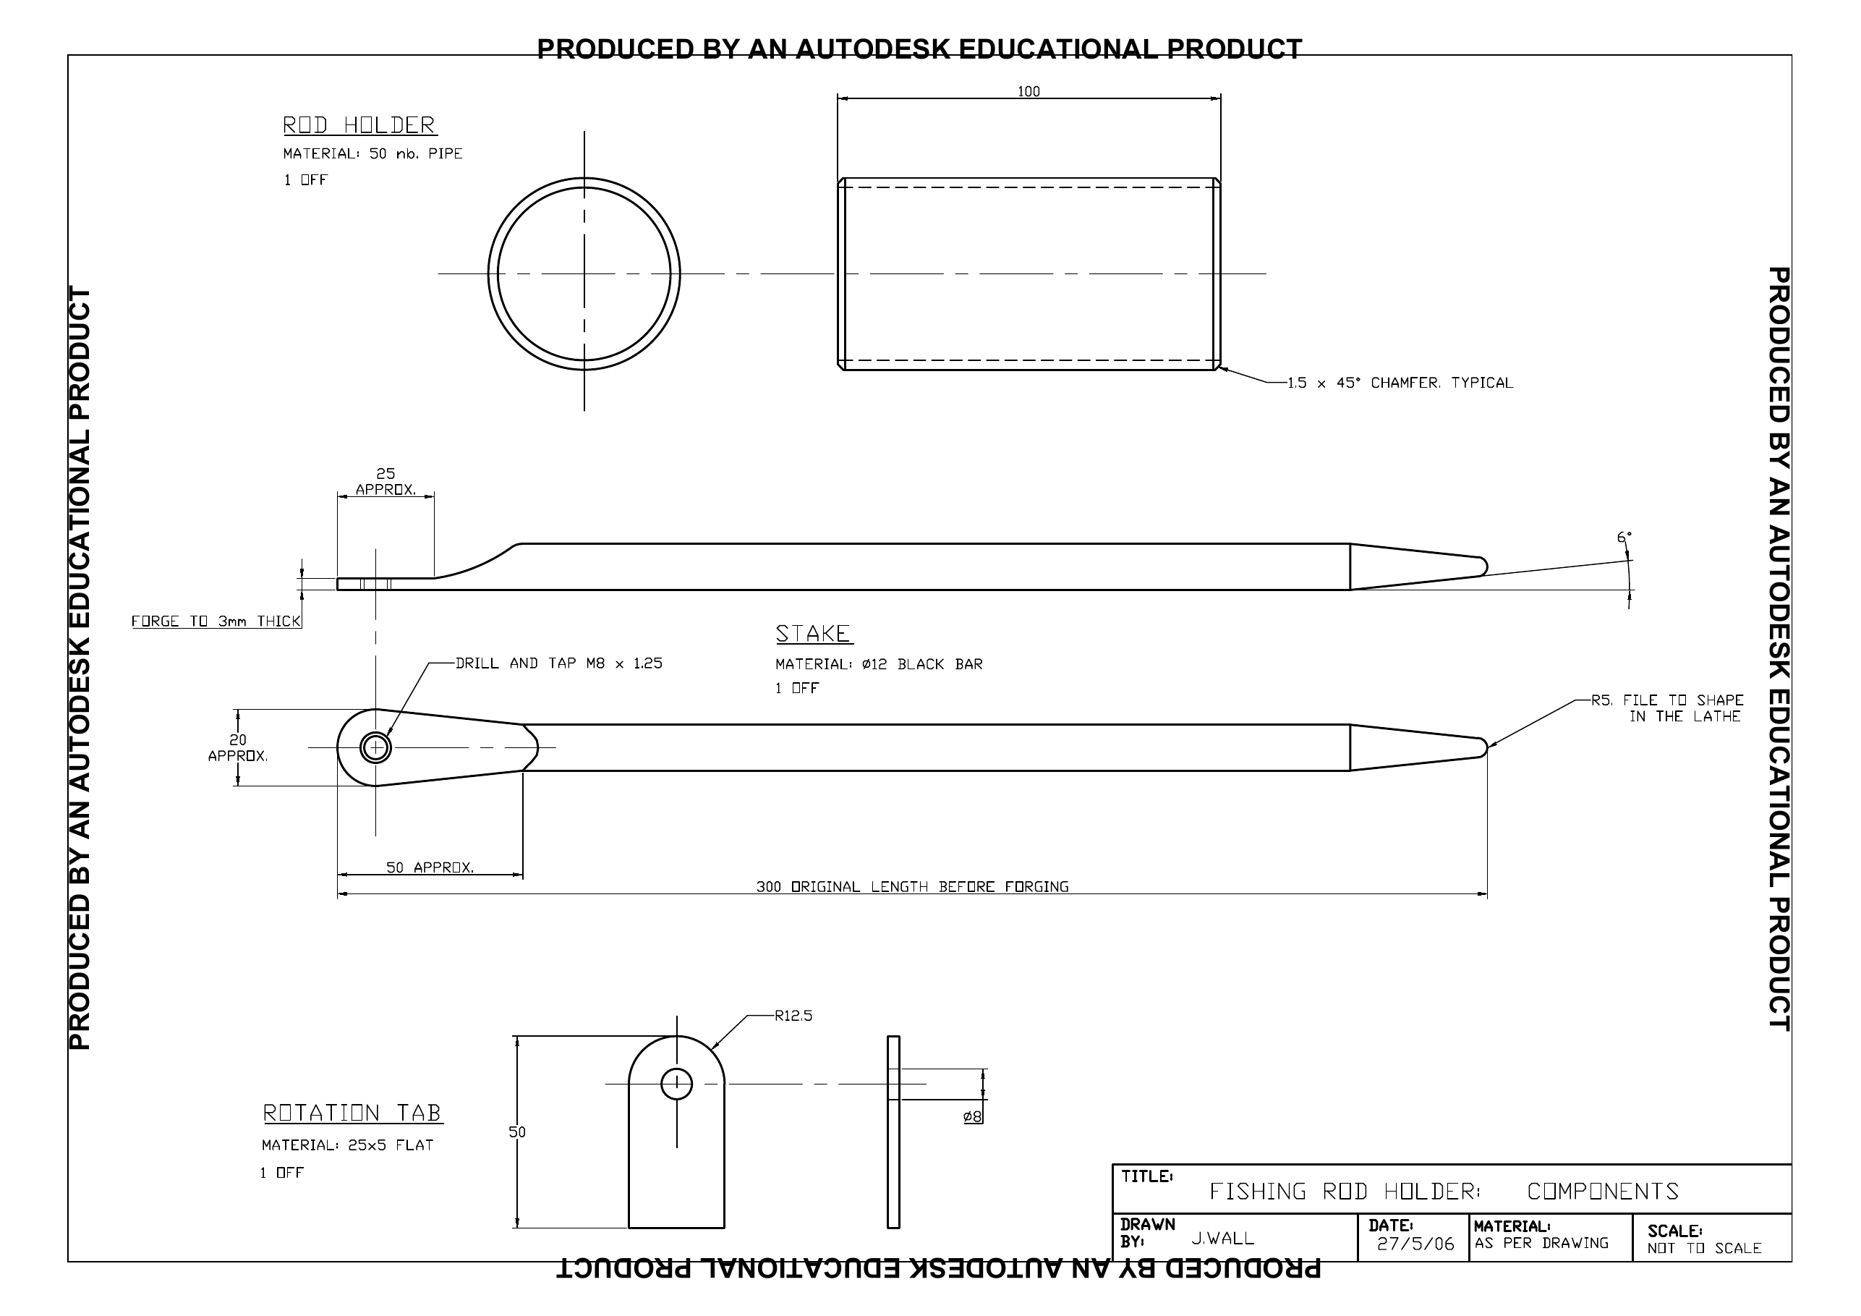
FISHING ROD HOLDER: COMPONENTS. Teacher-issued drawing, reproduced intact. NOT TO SCALE; use the printed dimensions and notes, not a ruler on this page.
READ, DO NOT MEASURE Locate ROD HOLDER, STAKE and ROTATION TAB. Use written dimensions and notes, then check the current teacher instructions. The original source PDF is linked in the course resources.

Rod holder stock + quantity
Printed size or feature note
Why no ruler measurement?
MODULE 2 / PAGE 15

Read the rod holder views
The same part can be shown in more than one view. Match the ROD HOLDER label to its circular end view and the longer side view before interpreting any line or note.
Record what is printed. Trace the visible, hidden, centre and dimension lines. Ask the teacher about unclear notes or units.
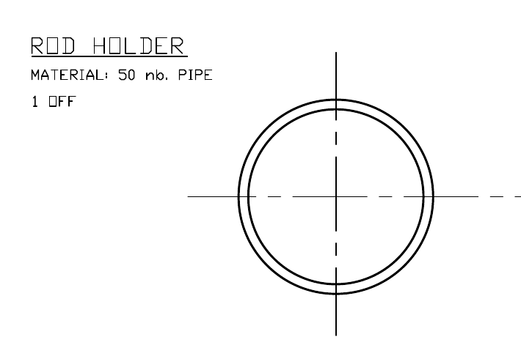
Original drawing extract: rod holder label, stock form, quantity and end view.
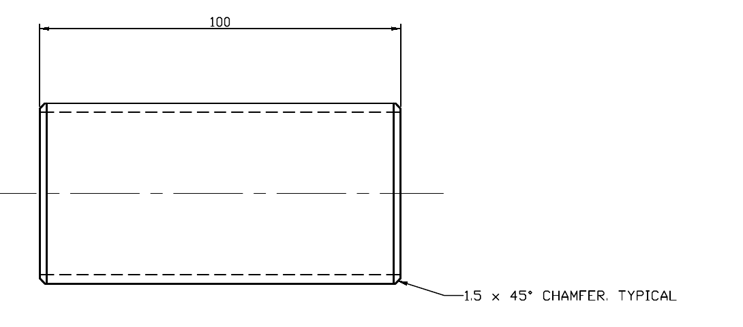
Original drawing extract: matching side view, printed length and chamfer note.
READ FROM THE PRINTED PLAN ROD HOLDER · MATERIAL: 50 nb. PIPE · 1 OFF · 100 · 1.5 × 45° CHAMFER, TYPICAL. Verify any unclear unit or manufacturing step with your teacher.

YOUR TURN
Annotate the ROD HOLDER views here, then complete the plan-reading record on page 13. Identify the printed material, quantity and one feature note. Explain why no size can be taken with a ruler from this page.
Use the three-part plan-reading record on page 13 to write your answer.
MODULE 2 / PAGE 16

Read the stake and rotation tab
Locate the STAKE and ROTATION TAB labels, then connect each label to its views and notes. The source drawing names each as one required component; the written notes distinguish their stock forms.
Some dimensions are explicitly marked approximately. That word matters: it tells you the drawing is not a licence to manufacture to an inferred size. Verify the current plan and teacher direction before adding any value to a cutting list.
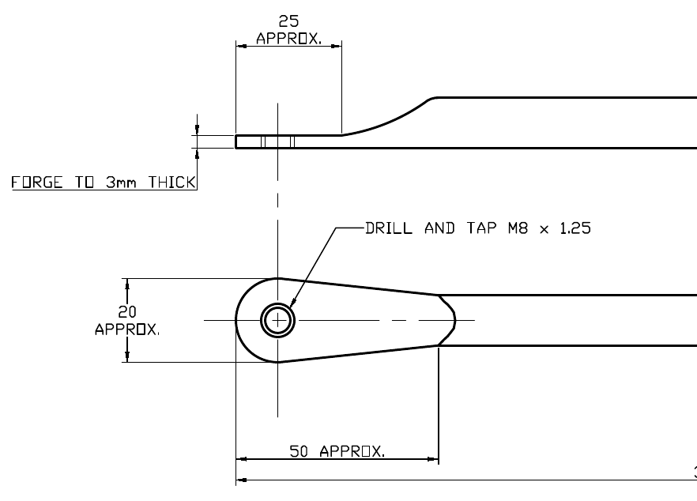
Original drawing extract: stake end, hole note and approximate dimensions.
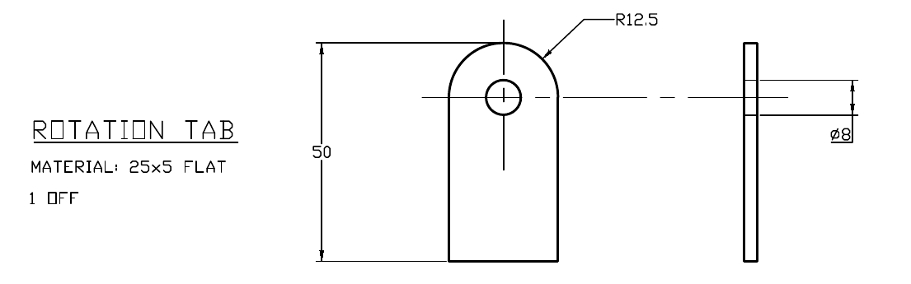
Original drawing extract: rotation tab views, stock form and printed dimensions.
YOUR TURN
Create a two-row component record. For each part, copy its exact material and quantity wording, identify one feature or note, and write one question you would check before making.
Part | Exact stock + quantity | Note to verify
Stake
Rotation tab
MODULE 2 / PAGE 17

Check your understanding 2
M2-Q01 Which statement correctly distinguishes property from performance?
□ A A property is a metal characteristic; performance is how it behaves in use
□ B A property is cost; performance is colour
□ C A property is the product; performance is the plan
□ D They always mean the same thing

M2-Q02 Which is the strongest material-selection justification?
□ A It looks better
□ B It was first available
□ C Its properties suit function, fabrication, corrosion, availability and finish
□ D Ferrous is always best

M2-Q03 What is the title printed on the component drawing?
□ A FISHING ROD HOLDER: COMPONENTS
□ B FISHING ROD HOLDER: ASSEMBLY
□ C ROD HOLDER DEVELOPMENT
□ D FISHING STAKE COMPONENTS

M2-Q04 Which three named parts must be located on the sheet?
□ A Pipe, bracket and handle
□ B Rod holder, stake and rotation tab
□ C Stake, base and pivot
□ D Rod holder, clamp and support

JUSTIFY
Choose two answers and name the exact reading or drawing detail that supports each one.
Question + answer | Source detail and reason
1
2
MODULE 2 / PAGE 18

Read and reason 2.2
M2-Q05 How should a student determine a component’s required size?
□ A Measure the printed view
□ B Estimate from nearby parts
□ C Use the printed dimensions and notes
□ D Copy a similar classroom project

M2-Q06 What does “1 off” indicate beside a component label?
□ A One view is provided
□ B One component is required
□ C One dimension is missing
□ D One material may be substituted

M2-Q07 Which material label belongs to the STAKE?
□ A 25 x 5 flat
□ B 50 nb. pipe
□ C Ø12 black bar
□ D Unlabelled sheet metal

M2-Q08 What should be checked when matching a name to several drawing views?
□ A Labels, shapes, dimensions and notes
□ B The apparent printed size only
□ C The darkest lines on the page
□ D The order in which views appear

JUSTIFY
Choose two answers and name the exact reading or drawing detail that supports each one.
Question + answer | Source detail and reason
1
2
MODULE 2 / PAGE 19

Read and reason 2.3
M2-Q09 Which label belongs to the ROTATION TAB?
□ A Ø12 black bar, 1 off
□ B 50 nb. pipe, 1 off
□ C 25 x 5 flat, 1 off
□ D 25 nb. pipe, 2 off

M2-Q10 What should happen when drawing information appears unclear or conflicting?
□ A Choose the most likely interpretation
□ B Continue and correct it later
□ C Ask another student to decide
□ D Check with the teacher before continuing

M2-Q11 Which item would provide suitable evidence before Module 3?
□ A A memorised list of component names
□ B An unchecked rough sketch
□ C A checked cutting list, annotated plan or folio note
□ D A photograph of unrelated workshop equipment

M2-Q12 Who controls the exact machine settings and construction sequence?
□ A The student’s previous experience
□ B The teacher-issued demonstrations and instructions
□ C The apparent shape of each component
□ D The printed scale of the drawing

EXPLAIN
Using the teacher-issued plans, identify the selected metal for one project part and justify the choice by referring to function, fabrication, corrosion, availability and finish.
PROJECT FOLIO / PAGE 20

Brief and constraints
FOLIO 01 · PROJECT BRIEF Summarise the need, user and function for the teacher-issued Fishing Rod Holder brief.

FOLIO 02 · REQUIREMENTS AND CONSTRAINTS Separate essential requirements, preferences and constraints for the Fishing Rod Holder.

Use the teacher-issued brief; do not invent formal task conditions.
Need, user and function
Essential requirement
Preference
Time, material or workshop constraint
PROJECT FOLIO / PAGE 21

Materials and ideas
FOLIO 04 · MATERIALS INVESTIGATION Compare relevant properties and justify teacher-specified material choices.

FOLIO 05 · RESEARCH AND IDEAS Record useful research, concept evidence and reasons for the approved direction.

Material/property observation
How it affects function or fabrication
Research source or idea
Reason for your approved direction
PROJECT FOLIO / PAGE 22

Working drawing evidence
FOLIO 06 · WORKING DRAWING EVIDENCE Refer to teacher-issued drawings and explain the information used for production.

Use the original drawing and leave the sketch field clear for your annotations.
Drawing title and revision used
View or note consulted
Decision it informed
Teacher question or check
ANNOTATE A VIEW OR SOURCE NOTE
MODULE 3 / PAGE 23

Accuracy before force
Accurate cutting and forming begin with accurate marking-out. A datum or reference edge provides one reliable starting point, so measurements and lines relate to the same known surface. Follow the teacher demonstration and issued plans for project-specific information. Before any cut or form, check that lines are clear, required features are identified and the waste side is marked correctly.
Secure the work using the approved method before cutting, drilling or forming. Do not use extra force to correct a poor line, wrong sequence or moving work. Stop and recheck the datum, waste side, orientation and planned next step. Force cannot repair information that was marked incorrectly at the start.
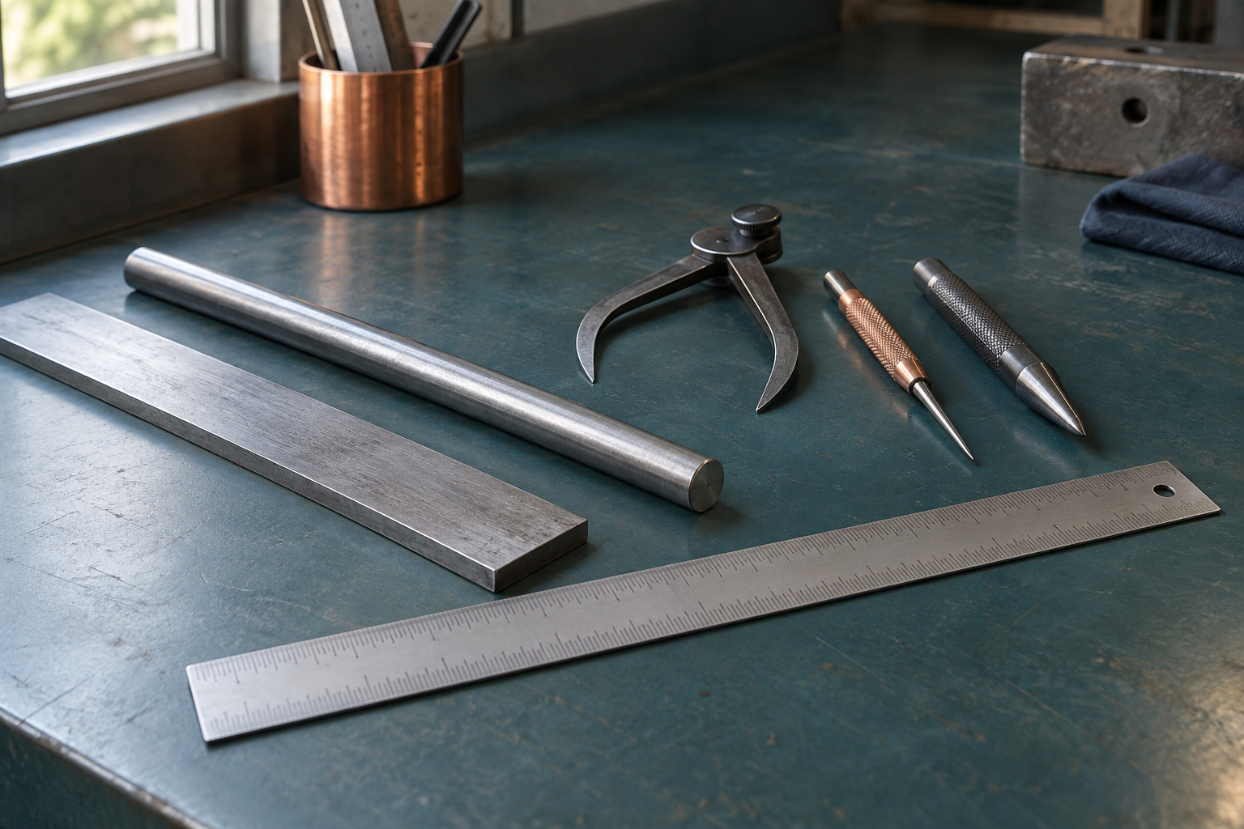
Illustrative still life: check the datum and measure before an irreversible operation.
HYPOTHETICAL FLAT-STOCK LAYOUT For a teacher-approved flat practice piece, a student reads the stated length, marks from the demonstrated reference edge and identifies the waste side. Measuring from a new mark each time could pass an early error along the part. This example does not prescribe a datum edge for the round stake or pipe.

Datum, waste side, sequence and workholding come before force.
YOUR TURN
Choose a teacher-approved component or practice shape. Make a quick concept sketch showing the demonstrated reference, one printed dimension or note, material to keep and waste side where relevant. Add four pre-operation checks and a question for anything unclear. Develop the larger datum example on page 26.
Datum and source check
Waste side and sequence
Workholding / permission
Uncertainty to resolve
SMALL MARKING PLAN — CONCEPT ONLY
MODULE 3 / PAGE 24

Marking and measuring tools
Select the measuring and marking tools demonstrated for the feature: a steel rule or tape for suitable lengths, a square for perpendicular references, a scriber for clear layout lines and a centre punch for an approved hole location.
Measurement accuracy prevents wasted material. Read the issued dimension, work from the approved reference and complete an independent recheck before the material enters a cutting, drilling or forming setup.
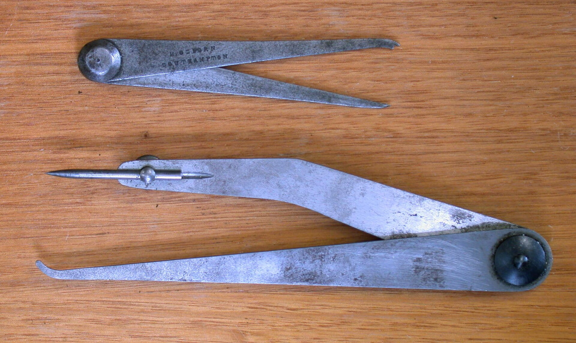
Jenny or odd-leg callipers. Glenn McKechnie / Wikimedia Commons, CC BY-SA 3.0. Identification only; teacher demonstration controls use.
HYPOTHETICAL TOOL CHOICE If an approved flat practice piece needs a line perpendicular to its reference edge, a square helps transfer that relationship while a rule checks the stated length. A scriber makes the demonstrated line. A centre punch would not replace either check; it is used only for an approved hole centre.

The best cutting tool cannot rescue an incorrect line.
YOUR TURN
For four items of teacher-approved drawing information, record the feature, proposed tool, what it checks or marks, and how you will recheck it. Mark any centre-punch or machine-dependent step “Teacher to confirm”. Explain why a tidy line can still be inaccurate.
Feature / operation | Tool, approval and recheck
1
2
3
4
MODULE 3 / PAGE 25

Cutting and forming sequence
Use only the cutting or forming process shown for the material and feature. Support large or awkward material, keep hands outside the demonstrated danger zone and remove burrs using the approved process before passing work to the next stage.
Forming order can affect later dimensions, hole positions and access. Trial or check at the teacher-specified points, and record what changed rather than forcing a part to match.
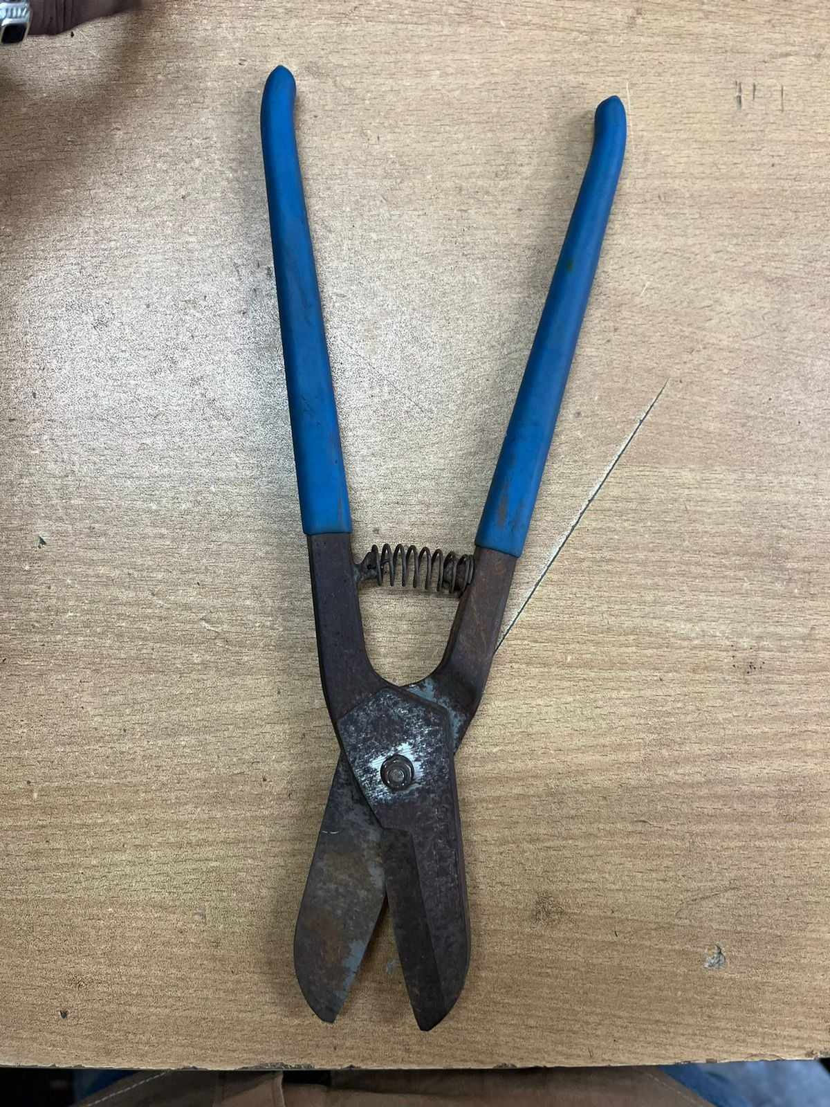
Tin snips. Zkabirkhan / Wikimedia Commons, CC0 1.0. Tool selection and cutting direction remain teacher-controlled.
HYPOTHETICAL SEQUENCING QUESTION A student sees that forming a teacher-approved practice part might make a later feature hard to reach. They do not swap steps independently. They note the access concern on the plan, ask the teacher which stage comes first and record the checkpoint used to confirm the result.

Each irreversible step needs a check before and evidence after.
YOUR TURN
For a teacher-demonstrated operation, record three stages in the table: check before, approved change to stock, check after. Name one evidence item at each stage and one possible problem if the order changed. Mark any unconfirmed exact process or allowance ‘Teacher to confirm’.
Stage | What happens / evidence
1 Check before
2 Approved change
3 Check after
MODULE 3 / PAGE 26

A datum prevents drift
Suppose two features are measured from different rough edges. Small errors in each edge can accumulate, so the features may no longer align. A single approved datum gives both measurements a common starting point.
Before an irreversible step, verify the printed dimension, orientation, waste side and workholding. If the result differs from the drawing or demonstration, stop and seek direction instead of forcing the stock.
MODEL STAGE | EXAMPLE REASONING — IMAGINED OFFCUT
Datum | Choose one straight, approved reference edge.
Mark 1 + mark 2 | Locate both features from that same edge; do not chain from a rough cut.
Waste side | Mark which side of each line is removed before touching a tool.
Pause and check | Compare marks with the current drawing and ask if uncertain.
Conceptual reasoning only — no project size or cutting approval is implied.
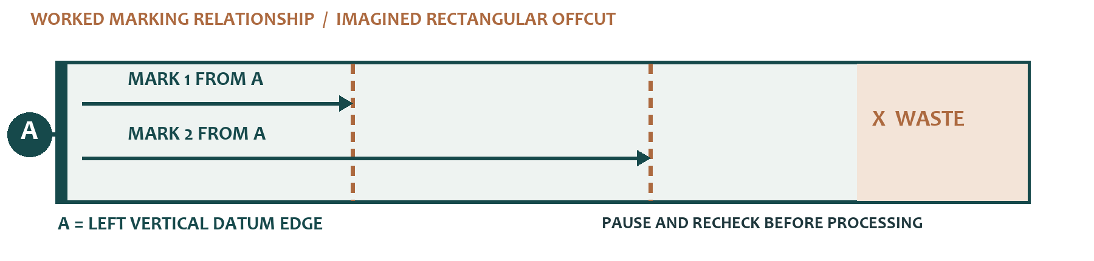
Worked conceptual offcut: both marks reference datum edge A; X identifies the waste side. No project size or process is specified.
YOUR TURN
On an imagined rectangular offcut, mark one datum edge, two measurements from that edge, the waste side and the point where you would recheck. This is a conceptual marking exercise, not a project cutting plan.
YOUR CONCEPTUAL MARKING SKETCH
MODULE 3 / PAGE 27

Check your understanding 3
M3-Q01 What is the main purpose of a datum edge?
□ A Provide one reliable reference for marking
□ B Show where to apply force
□ C Replace the plans
□ D Identify finish colour

M3-Q02 What should happen before cutting or forming?
□ A Secure the work and recheck markings
□ B Remove waste marks
□ C Force material into position
□ D Change sequence without approval

GENERAL COURSE PROMPT The source question refers to a sheet-metal project. Treat it as a hypothetical sequence question; the Fishing Rod Holder plan specifies pipe, bar and flat stock.

EXPLAIN
Explain how a datum edge, waste-side marking, planned sequence and secure workholding can improve the quality of a sheet-metal project.
PROJECT FOLIO / PAGE 28

Cutting list and resources
FOLIO 07 · CUTTING LISTS AND RESOURCES Record teacher-specified parts, materials, tools and consumables without guessing.

Teacher to confirm current dimensions, resources and permissions.
Part | Exact source stock | Quantity / size to verify | Tool or permission
Rod holder
Stake
Rotation tab
SOURCE CHECK
Mark any unstated size or process ‘Teacher to confirm’. Keep the current approved cutting list beside this page.
PROJECT FOLIO / PAGE 29

Production plan and checkpoints
FOLIO 08 · PRODUCTION PLANNING Sequence work, checkpoints, demonstrations and approvals for the Fishing Rod Holder.

Record the sequence actually directed by your teacher.
Stage | Information / permission | Check before next stage
1
2
3
4
STOP POINT
Record the sequence actually directed by your teacher. Add one stop point below.
PROJECT FOLIO / PAGE 30

Production evidence 1
FOLIO 09 · PRODUCTION EVIDENCE Add captions for marking, cutting, forming, joining, machining and finishing stages.

Stage, date and source
Permission or quality check
PHOTO REFERENCE / OBSERVATION SKETCH
EVIDENCE CAPTION
Caption the evidence: what does it actually show, and what still needs checking?
MODULE 4 / PAGE 31

A joint is a design decision
A joining method should suit the job, not simply be familiar. Consider load, whether the connection must be permanent or removable, access to the joint, how heat could affect the metal or coating, and whether the finished joint must be neat or concealed. The plans, demonstrations and teacher permission determine which method is approved for each stage.
Appearance and corrosion also influence the decision. Before permanent joining, complete a trial fit using the demonstrated process. Check that parts meet correctly, edges align, holes or features match, and the assembly remains in position. Stop and seek direction if the fit or approved method is uncertain.
HYPOTHETICAL DESIGN COMPARISON If an approved brief allowed either a removable or permanent connection, the removable option might help disassembly but require access for a fastener. A permanent option might avoid that access but make correction harder. The student compares the stated criteria and asks which method the teacher authorises for the actual holder.

Select the joint, trial the fit, then make it permanent.
YOUR TURN
For one teacher-identified connection, make six rows for load, permanence, access, heat effect, appearance and corrosion. State what each factor asks you to check and which facts remain teacher controlled. Add the teacher-requested trial-fit observations before any permanent joining. Do not nominate an approved method unless one has been issued.
Factor | Effect on decision
Load
Permanence
Access
Heat effect
Appearance
Corrosion
MODULE 4 / PAGE 32

Choose a joining method
A joint must match the required load and the way the product will be used. Permanence, access, heat effects, appearance and corrosion all change which method is suitable. There is no universal best joint.
A trial fit is a decision point. It can reveal gaps, interference or misalignment while the parts can still be corrected using the approved process. The teacher-issued plan and demonstration decide which method is actually permitted.
Decision factor | Question to ask | Evidence before joining
Load
Permanence
Access
Heat, appearance, corrosion
YOUR TURN
Choose two decision factors and explain how each could change a joining decision. Do not nominate an unapproved process as the project method.
MODULE 4 / PAGE 33

Machining is permission-based
Drilling machines, lathes and other workshop machines require training, permission and the exact setup demonstrated by the teacher. The workpiece must be held using the approved device; hands are never a substitute for a vice, clamp, chuck or fixture.
Before starting, identify the stop control, remove setup tools such as chuck keys as directed, secure loose clothing and hair, and check the work zone. Stop immediately if sound, vibration, swarf behaviour or work position changes.
The component drawing includes a drill-and-tap note at the stake and a lathe-related shaping note. These tell a reader what the drawing specifies; they do not train or authorise a student to operate equipment. Drills, lathes and other workshop machines require teacher permission for the person, machine, setup and current task.
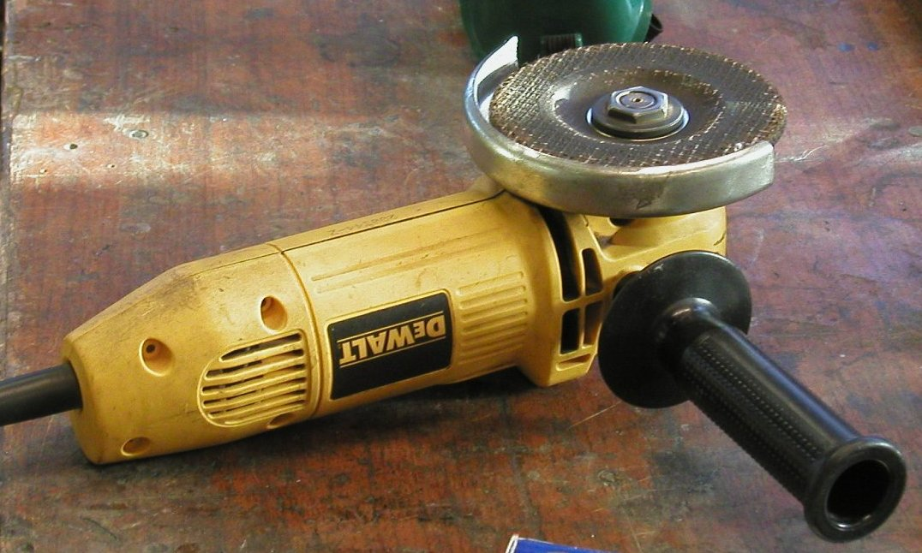
Guarded angle grinder at rest. soulfish / Wikimedia Commons, CC BY-SA 2.0. No image grants machine permission.
WORKED READING OF A PLAN NOTE The stake drawing includes “DRILL AND TAP M8 × 1.25”. A student can copy the note and ask how it applies to the approved plan. The note does not establish drill size, speed, tapping method or permission. The teacher demonstrates and may carry out or supervise the operation.

Permission does not carry across to a different machine, setup or task.
YOUR TURN
Copy one machine-related note exactly from the plan. In two columns list what the drawing tells you and what it does not authorise you to decide. Add a “stop and report” statement for changed sound, vibration or stock position. Ask the teacher for current local confirmation; the paper task is not machine permission.
The drawing tells me | The drawing does not authorise
Fact or permission
MODULE 4 / PAGE 34

Surface preparation and protection
A good finish begins with preparation. Treat burrs, scratches, scale, grease and dust using the approved classroom sequence. Protect prepared surfaces from contamination before the teacher-specified coating or finishing process.
Follow product labels, safety information and teacher direction for ventilation, PPE, application and curing. Record the actual product and process used; do not infer them from another project.

Illustrative comparison of unprotected and prepared/protected steel. It does not specify a coating for this project.
HYPOTHETICAL FINISH COMPARISON Two generic metal coupons receive the same teacher-approved coating. One was cleaned as directed and the other retained dust. If the dusty coupon looks patchy, preparation may explain the difference. This does not claim that a student holder had that defect or specify its coating.

Finish quality and corrosion resistance depend on preparation.
YOUR TURN
For the teacher-approved finish, record the product name from its label, surface condition before preparation, demonstrated preparation, one safety control from the actual product or teacher instruction, and the result after curing. Add a real photo caption or labelled sketch. If no finish is issued, mark product and process “Teacher to confirm” and complete the concept explanation.
Surface condition
Preparation evidence
Approved finish
Quality check
MODULE 4 / PAGE 35

Trial fit before permanence
A sensible trial fit checks contact, alignment and orientation against the authorised drawing. If a hole, edge or part position differs, the student records the difference and asks for the next approved step before making the joint permanent.
The useful evidence is specific: what was checked, what was found and what decision followed. 'It looked fine' cannot show why a join was ready.
REASONING PATTERN Name the observation, identify the evidence, decide what it means, then state the approved next check or question.

YOUR TURN
Write a hypothetical three-line trial-fit record: the feature checked, evidence seen, and the decision or teacher question that follows. Keep it separate from your real production record.
MODULE 4 / PAGE 36

Check your understanding 4
M4-Q01 Which factors should guide a joining method?
□ A Load, permanence, access, heat, appearance and corrosion
□ B Only colour
□ C Whichever is fastest
□ D Another student’s choice

M4-Q02 Why trial fit before permanent joining?
□ A Check fit and alignment before errors are locked in
□ B Avoid the plans
□ C Make metal harder
□ D Replace the approved process

EXPLAIN
Explain how load, permanence, access, heat effect, appearance and corrosion could influence a joining method. Include why a trial fit is needed.
PROJECT FOLIO / PAGE 37

Production evidence 2
FOLIO 09 · PRODUCTION EVIDENCE Add captions for marking, cutting, forming, joining, machining and finishing stages.

Stage, date and source
Permission or quality check
PHOTO REFERENCE / OBSERVATION SKETCH
EVIDENCE CAPTION
Caption the evidence: what does it actually show, and what still needs checking?
PROJECT FOLIO / PAGE 38

Quality checks
FOLIO 10 · QUALITY CHECKS Record measurements, trial fits, alignment checks and teacher-approved criteria.

Use only criteria and tolerances supplied or approved by the teacher.
Feature / criterion | How checked | Actual observation | Decision / feedback
1
2
3
PROJECT FOLIO / PAGE 39

Problem solving and testing
FOLIO 11 · PROBLEM SOLVING AND TESTING Explain a problem, evidence, decision, correction and safe test result.

Problem or unexpected result
Evidence and possible cause
Approved correction or safe test
Result and what you learned
MODULE 5 / PAGE 40

Quality, technology and evaluation
Compare conventional and CNC processes by suitability, not by assuming newer technology is always better. Conventional processes can offer direct control, flexibility and skill development, while CNC can support repeatability and complex shapes when suitable digital information and equipment are available. The best choice depends on accuracy, quantity, material, resources and purpose.
Check quality throughout production using teacher-approved criteria. Evidence might include photographs, annotated sketches, measurements, trial fits and records of problems and corrections. A useful evaluation makes a specific judgement, supports it with evidence and identifies one realistic improvement.
Quality is checked through making, not only at the end. The teacher-approved brief and drawing provide the criteria. Plan reading can prevent a wrong part, layout checks can prevent a wrong mark, a trial fit can reveal alignment before permanent joining, and a finish check can reveal uneven coverage. Each checkpoint leads to a decision: proceed, pause or seek an approved correction.
HYPOTHETICAL QUALITY CLAIM REVISED Weak: “The joint looks good.” Stronger: “The teacher-approved trial fit showed alignment at this checkpoint; the photograph records the position, while a separate measurement record checks size. Next time I would make this check earlier.” This models evidence language, not an actual student result.

Judge technology by suitability and evaluation by evidence.
YOUR TURN
Create three rows for real teacher-approved checkpoints: criterion, evidence, what it proves or cannot prove, and decision. Choose one row and write an evidence-supported judgement plus one realistic improvement. If the stage has not happened, label the result “Awaiting observation”.
Criterion | Actual evidence | Limit | Judgement
1
2
3
MODULE 5 / PAGE 41

Current and emerging manufacturing
Computer numerical control uses programmed information to control machine movement. Depending on the equipment, digital design data can support repeatable parts and complex profiles, but it also requires validated files, correct setup, suitable material and trained supervision.
Laser, plasma, waterjet and CNC machining processes have different capabilities, limitations, costs and safety systems. Compare them using reliable evidence and the needs of the production context rather than promotional claims.
HYPOTHETICAL ONE-OFF AND BATCH COMPARISON One approved generic practice part may suit conventional marking and cutting because digital setup is not justified. Fifty identical practice parts might justify a validated digital process for repeatability. Both choices still depend on material, capacity, cost and trained supervision; neither sets the actual holder process.

Advanced does not automatically mean appropriate.
YOUR TURN
Compare one generic metal practice part with a batch of identical parts. For each, judge conventional and CNC or another emerging process against accuracy, quantity, material, resources/setup and safety authority. Choose a better-supported option for each scenario and name one condition that could change the decision. Keep actual Fishing Rod Holder production teacher controlled.
Criterion | Scenario A | Scenario B
Accuracy
Quantity
Material
Resources
Safety
MODULE 5 / PAGE 42

Conventional and CNC choices
Conventional processes can suit a one-off task when flexibility and direct control are useful. CNC can suit repeatability or complex profiles when suitable digital information, equipment, setup and trained supervision are available.
Neither label proves quality by itself. Compare the same task against accuracy, quantity, material, resources, safety systems and purpose. Any process used for the actual project still needs teacher approval.
Criterion | Conventional process | CNC or emerging process
Accuracy
Quantity
Material
Resources and purpose
YOUR TURN
Choose a hypothetical component and compare two process options against three criteria. Explain your choice as a reasoned example, not an instruction for this project's workshop.
MODULE 5 / PAGE 43

Folio and final evaluation
Organise evidence from the Fishing Rod Holder project so the reader can follow the brief, research, planning, production, quality checks, problem solving and evaluation. Captions should explain what the evidence proves, not merely identify the photograph.
Compare the result with the teacher-approved criteria. Name specific strengths and limitations, cite the evidence, and propose one realistic change to the design, sequence, checking process or skill preparation.
A folio lets the reader follow the Fishing Rod Holder from brief and research through drawing, planning, production, checking, problems and final evaluation. The course folio has twelve headings to organise this chain. Photographs alone are weak if nobody can tell why they were taken. Sequence them and state which decision or criterion each item supports.
HYPOTHETICAL CAPTION IMPROVED Weak: “Finished holder.” Stronger: “This final-view image records the surface appearance after the approved finish. The separate trial-fit and measurement records are needed to judge alignment and size.” This is a model, not a claim about an actual student holder.

A folio shows decisions and learning, not only finished products.
YOUR TURN
Choose three authentic pieces of your own evidence from planning, production and final checking. Caption each with the decision or approved criterion it supports and one limit of that evidence. Then write an evaluation with one evidenced strength, one evidenced limitation and one realistic improvement. Label an incomplete panel “Awaiting evidence”.
Evidence | What it proves / does not prove
Beginning
Making
Evaluation
MODULE 5 / PAGE 44

Check your understanding 5
M5-Q01 How should conventional and CNC processes be compared?
□ A By which looks advanced
□ B By suitability for the task and result
□ C Choose CNC every time
□ D Avoid conventional skills

M5-Q02 Which is the strongest evaluation?
□ A It was good
□ B Everything worked
□ C The trial fit showed misalignment, so I rechecked it; next time I would check earlier
□ D I would make it better

EXPLAIN
Compare one conventional process with one CNC or emerging process by explaining when each would be suitable. Then evaluate one part of your project using specific evidence and identify one realistic improvement.
PROJECT FOLIO / PAGE 45

Final evaluation
FOLIO 12 · FINAL EVALUATION Judge function, accuracy, appearance and construction quality with evidence and one realistic improvement.

Use your teacher-approved criteria and actual results. Write ‘Teacher to confirm’ where the criterion has not been given.
Aspect | Actual evidence | Judgement + reason
Function
Accuracy
Appearance
Construction quality
One realistic improvement
EXTENDED JUDGEMENT
Write a connected evaluation. State the approved criterion, cite your actual evidence, explain the judgement and propose one realistic improvement.
MODULE 5 / PAGE 46

Improve one feature
An improvement is strongest when it responds to evidence. Begin with a specific limitation from your checks, draw a clear possible change, and explain how that change could improve function, accuracy or finish.
This is a proposal for discussion. Do not alter the approved project without teacher permission.
YOUR TURN
Draw an annotated improvement concept. Label the feature, the evidence that prompted the change and one likely trade-off.
LARGE WORKING FIELD
MODULE 5 / PAGE 47

Make your folio tell the story
A useful folio lets another reader trace the need, decisions, source drawing, planning, production, quality checks, problem solving and evaluation. Each photograph or sketch should have a caption explaining what it proves.
Check your twelve folio headings against the evidence you actually have. Identify the strongest example and the gap you must fill truthfully; do not stage a missing practical result.
Folio section | Present | Still needed | Confirm
Project brief | □ | □ | □
Requirements | □ | □ | □
WHS | □ | □ | □
Materials | □ | □ | □
Research | □ | □ | □
Drawing | □ | □ | □
Cutting list | □ | □ | □
Plan | □ | □ | □
Production | □ | □ | □
Quality | □ | □ | □
Problems | □ | □ | □
Evaluation | □ | □ | □
YOUR TURN
For each folio section, mark evidence present, evidence still needed or teacher confirmation. Then write the next two actions that would most improve the clarity of your folio.
MODULE 5 / PAGE 48

Explain a drawing in views
A working drawing communicates a part through complementary views, written dimensions and notes. The teacher-issued drawing shows this relationship for the Fishing Rod Holder components.
Use the large field below to draw a conceptual front, top and side view of a simple classroom object nominated by your teacher. Keep project dimensions out unless they are on the current approved drawing.
YOUR TURN
Label each view, add centre or hidden lines only where needed, and explain which written note would be essential before manufacturing.
LARGE WORKING FIELD
MODULE 5 / PAGE 49

Terms for better decisions
Hazard | Something that could cause harm.
Risk | Likelihood and consequence of harm in a given situation.
Control | A measure that removes or reduces a risk.
Datum | A chosen reference for consistent measurement.
Waste side | The side of a mark that will be removed in an approved operation.
Trial fit | A check of contact, position and alignment before permanent joining.
Property | A characteristic of a material.
Performance | How well a material or product works in use.
CNC | Computer numerical control of machine movement using programmed information.
Evidence | A record that supports a statement about work, quality or learning.
Not to scale | Do not measure the printed image to obtain a required dimension.
MODULE 5 / PAGE 50

Check the evidence, then decide
Before handing in work, compare your explanations with the course readings and your project records with the current teacher-issued plan. Make sure you have named evidence for each claim and a realistic improvement supported by that evidence.
Your teacher will confirm any formal assessment requirements, approved practical methods and final submission route. Keep this book as a working record of what you understood, checked and made.
YOUR TURN
Write one sentence each: a decision you can justify, a quality check that changed your work, and a question to take to your teacher.
SOURCES Year 9 Metal Fishing Rod Holder course and folio; teacher-issued FISHING ROD HOLDER: COMPONENTS drawing. Original plan is NOT TO SCALE. Cover: illustrative project image from the published course. Marking and finish illustrations were created for this edition. Tool photographs: Jenny callipers © Glenn McKechnie CC BY-SA 3.0; tin snips © Zkabirkhan CC0 1.0; angle grinder © soulfish CC BY-SA 2.0, via Wikimedia Commons. Tool photographs identify equipment only.

