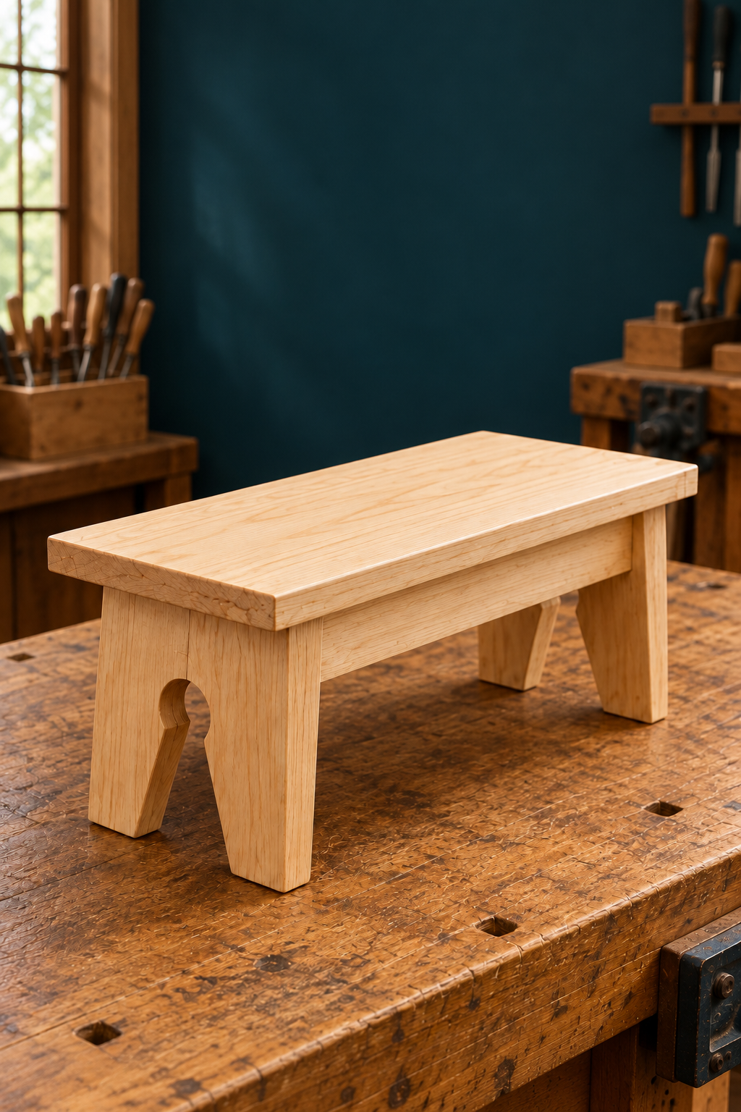
YEAR 8 ELECTIVE / TIMBER
Footstool
STUDENT WORKBOOK
Understand. Design. Make.
Build skill. Show your thinking.
Explore timber, read drawings, develop a personal emblem and record the evidence behind a
well-considered Footstool.
NAME ______________________________ CLASS ___________________
Illustrative project image. Original plan inside. | 50 pages · A4 · Edition 2.0
UNDERSTAND / DESIGN / MAKE
1
GETTING STARTED

Your learning journey
Read, discuss, draw and record as your teacher uses the Footstool website, presentations, videos and demonstrations. This book follows all ten modules; you can complete its activities on paper.
01 Workshop readiness 3–6
02 Tools and accurate references 7–10
03 Timber properties 11–14
04 Engineered wood 15–18
05 Read the original plan 19–22
06 Graphical communication 23–26
07 Personal emblem design 27–30
08 Progress and quality evidence 31–34
09 Function and testing 35–38
10 Aesthetics and final evaluation 39–42

43–44 Original plan / 45–50 Project record
The original two-page Footstool plan controls dimensions and construction. Use written dimensions, not measurements from a picture. Your teacher demonstrates and authorises practical work under current school procedures.
Activities build understanding and folio evidence. Your teacher supplies formal assessment instructions, due dates and submission requirements. Questions and answers for classroom discussion are in the separate teacher guide.
Print A4, double-sided, flip on the long edge: 50 pages use 25 sheets.
Edition 2.0 • 10 September 2026 • Matching course links appear in the footers.
MODULE 1 / WORKSHOP READINESS

A workshop works as a team
Your first contribution to a successful project is making the shared space predictable and safe.
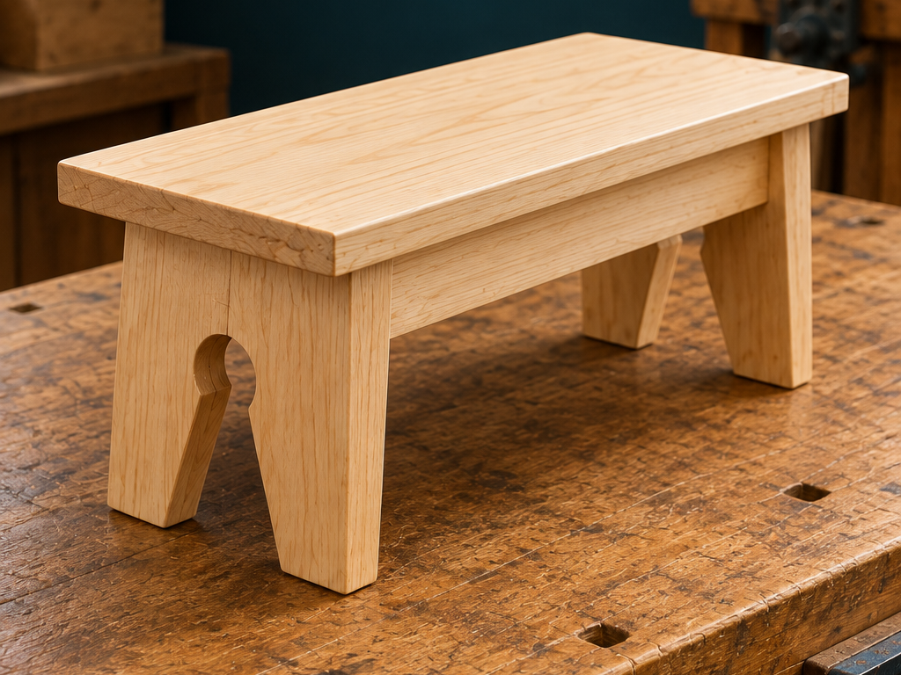
Figure 1. An illustrative view of the Footstool form. Practical work follows the original plan and teacher directions.

Shared workshop conduct
A workshop contains people, materials and equipment whose movements can affect one another. Listen to the complete instruction before starting, follow its order and stay within authorised areas. Teacher permission applies to the equipment and activity being undertaken. Watching a classmate or recognising a tool does not establish permission for your own work.
Walk calmly, look ahead and leave other people enough room. Before placing timber or moving beside a bench, consider whether you could block a route or distract someone. Bags, loose materials and offcuts belong in the locations your teacher identifies. A clear bench and walkway make changing conditions easier to notice.
Report damage, loose parts and unsafe behaviour promptly. Keep the equipment unused while you wait for direction; an unauthorised repair can create another problem. At pack-up, stop when directed, return equipment and leave the bench and nearby floor ready for the next person.

Hazards, risks and controls
A hazard has the potential to cause harm. Risk considers how likely harm is and how serious its consequence could be. A control removes a hazard or reduces its risk. For a loose object in a walkway, the object is the hazard; a possible trip and injury describe the risk. Naming only the object does not explain what might happen.

TRY IT
Point out a clear route in the classroom. Explain how one poorly placed item could change it.
Read the matching course section
MODULE 1 / WORKSHOP READINESS

Choose controls, then check readiness
Recognising a problem matters most when it leads to a suitable action before work begins.
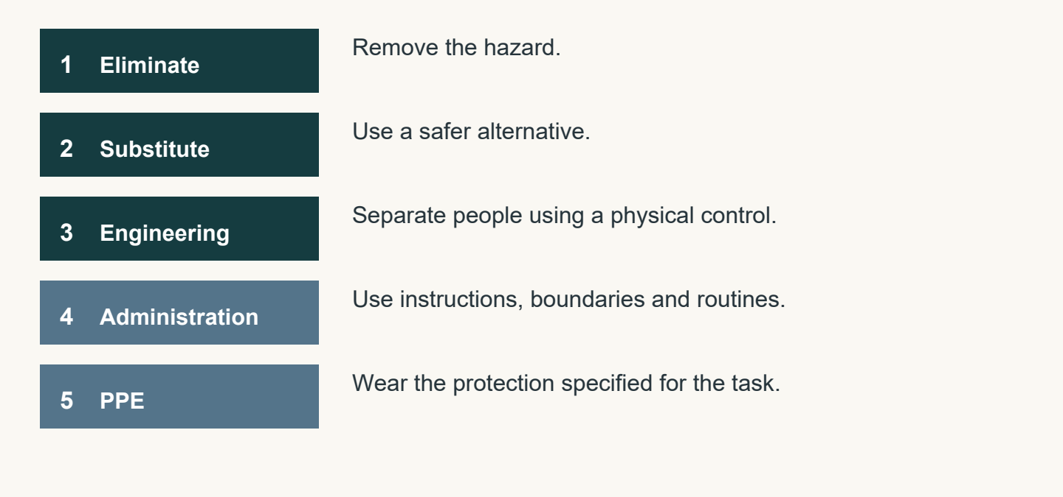
Figure 2. Consider stronger controls first. The right combination depends on the activity and the current school procedure.

Hazards, risks and controls
Consider controls from strongest to weakest. Elimination removes the hazard. Substitution replaces it with a safer option. Engineering controls use a physical feature to separate people from a hazard. Administrative controls include instructions, signs, boundaries and organised routines. Personal protective equipment, or PPE, forms the final personal barrier. Instructions and PPE do not remove the original hazard.
Removing the loose walkway object eliminates that particular hazard. Marking its location may reduce the chance of a trip, but the object remains. A useful explanation connects the control to the problem it changes. Workshop conditions can change during a lesson, so a clear area at the start still needs attention later.

Readiness and asking for help
Readiness combines understanding, a suitable area and teacher permission. Be able to explain the purpose of the activity, its limits and where you must stop. Check that the area is clear, your work will not interfere with someone else, and nothing appears damaged or unsafe.
Turn uncertainty into a precise question: state what you understand, then identify the detail you need confirmed. You might ask whether you are authorised to begin or whether you have the correct work area. Wait for the teacher’s answer before continuing. A classmate’s approval or your own assumption does not complete the check.

REMEMBER
Current school procedures and teacher directions control practical work. A completed workbook activity does not authorise equipment use.
Read the matching course section
MODULE 1 / WORKSHOP READINESS

Choose a safer next step
Choose one answer for each question, then apply the reading to the challenge below.
1. Why should students remain in authorised areas?
A. To avoid returning equipment
B. To reduce unexpected movement and crowding
C. To choose their own activity more easily
D. To keep all students at the same bench

2. Which control is strongest in the hierarchy?
A. PPE
B. Administrative controls
C. Substitution
D. Elimination

3. Which statement best describes readiness before starting workshop activity?
A. Understanding the instruction, checking the area and having permission
B. Having materials nearby and beginning quickly
C. Watching another student complete the activity
D. Knowing where the equipment is stored

Build the control ladder
Write the control level beside each example. Use each level once: elimination, substitution, engineering, administrative, PPE.
Example | Control level
A physical barrier separates people from a hazard.
The loose object is removed from the walkway.
The teacher gives instructions and sets a boundary.
A hazard is replaced with a safer option.
A person wears the protection required for the activity.

Read the matching course section
MODULE 1 / WORKSHOP READINESS

My starting point and workshop readiness
Begin the source-deck activities now, then return to the Learned column as your understanding develops.
Know: an idea I already have | Wonder: a useful question | Learned: return later

Vocabulary confidence studio
For each source-deck term, mark N (new), H (heard it) or E (can explain it). Add an example or a question; uncertainty is useful information.
Term | N / H / E | My example or question
Wood grain
Wood knot
Coniferous
Ergonomic
Durability
Efficient
Isometric
Aesthetics

Set one achievable learning goal. Then name two actions you will take to keep your workshop area safe and explain why.

Read the matching course section
MODULE 2 / TOOLS AND ACCURATE REFERENCES

Know the tool; read the reference
Accurate names and dependable references help people understand what a task actually requires.
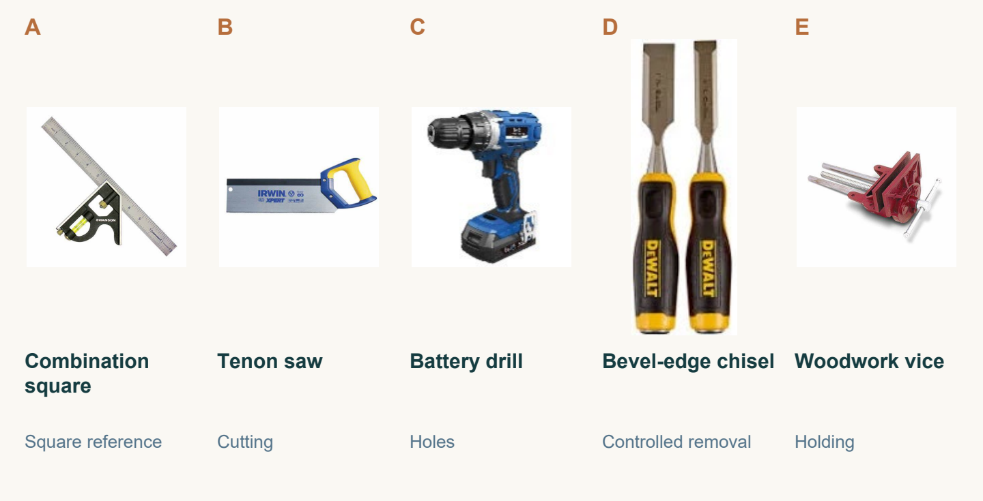
Figure 3. Five tools from the course image library. Recognise each name and broad purpose before discussing a practical task.

Tool recognition and broad purpose
Identify a tool by its approved name using the workshop label, a clear source photograph and teacher guidance. Similar-looking equipment can have different purposes. Shape, colour and size may help you notice a feature, but they are not enough to establish a name or decide that a tool suits the task.
Connect the name with a broad purpose. A disc sander is associated with controlled abrasive material removal; a pedestal drill is associated with producing holes using approved drilling equipment. These descriptions explain a general role. They do not explain how to operate the machine, select a setting or prepare a particular Footstool component.
The tool gallery supports accurate classroom communication. Name what you recognise, identify the information you still need, and ask for confirmation. Being familiar with an item does not establish its suitability or authorise its use.

Measuring and marking references
Begin with written information from the original plan and the teacher’s task directions. Measuring finds or sets a distance with an approved tool. Marking transfers that information to material so the intended position can be seen. A mark needs an agreed reference point; estimating by eye or copying someone else skips that link.

REMEMBER
A screen preview changes with zoom and display size. Read written dimensions from the original plan; never measure the thumbnail.
Read the matching course section
MODULE 2 / TOOLS AND ACCURATE REFERENCES

A clear mark and a sound decision
A mark becomes useful when its information is checked and the next action is authorised.
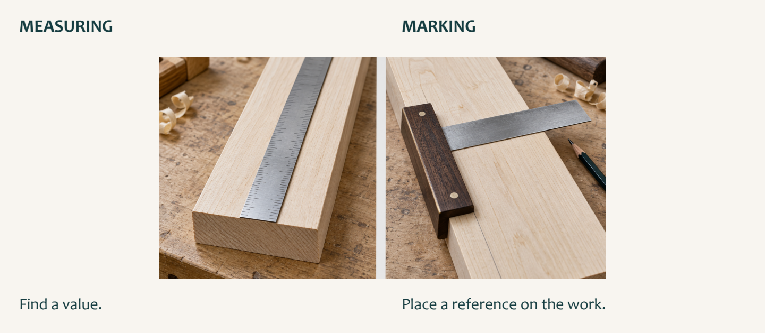
Figure 4. Illustrative measuring and marking views. Find a value, then place a reference. Use the actual tool and teacher demonstration.

Measuring and marking references
Checking compares the mark with the written plan and teacher direction. Ask whether you read the correct dimension, used the approved reference point and made a clear, unambiguous mark. Repeating the same rushed measurement can repeat the same mistake. A check must challenge the result by returning to its reference.
If readings disagree, locate the uncertain feature and ask for clarification. Missing information remains missing until the authoritative plan or teacher guidance resolves it; neat marking cannot make an invented value reliable.

Safe tool decisions
Match the named tool’s broad purpose with the task information before considering its use. Nearby equipment, a familiar shape or a classmate’s choice are poor reasons for selection. Confirm teacher authorisation and the current school procedure that applies to the activity.
Without operating the equipment, notice obvious damage, loose parts, missing guards or unusual wear. Report concerns and wait. Do not test the tool, adjust it or attempt a repair. Also observe the area: your position, movements and materials must not interfere with active work or distract another person.
A decision links purpose, permission, condition and the surrounding space. If any part remains uncertain, stop and ask a precise question, then wait for confirmation. Recognising equipment is the beginning of communication, not the end of a safety check.

TRY IT
Explain the difference between “I recognise that tool” and “I am ready to use it for this task”.
Read the matching course section
MODULE 2 / TOOLS AND ACCURATE REFERENCES

Tools, marks and choices
Choose one answer for each question, then apply the reading to the challenge below.
1. What should a student do when unsure of a tool name?
A. Choose the closest-looking name
B. Use a nickname
C. Pause and ask for the approved name
D. Begin the task and identify it later

2. What is the correct dimensional reference for this project?
A. The written dimensions on the original plan
B. The apparent size of a screen image
C. A measurement copied from another student
D. An estimate based on the finished appearance

3. What must a student check before using a tool?
A. Whether another student approves
B. Whether the activity can be finished quickly
C. Whether the tool is the newest one available
D. Whether teacher authorisation and the current SOP apply

Tools in disguise
Solve these word scrambles from the source deck. The clue describes a broad purpose, not permission to use the item.
Scramble | Source clue | Tool name
ECVI | Similar to a clamp
EOTNN ASW | Used for cutting wood
LIDRL | Makes holes
RAQSEU | Creates a 90-degree reference

Read the matching course section
MODULE 2 / TOOLS AND ACCURATE REFERENCES

My tool communication lab
Use the A–E source photographs on the reading page, or the same approved tools shown by your teacher.
Tool in gallery | Approved name | Broad purpose
A
B
C
D
E

Choose one tool. Sketch a recognisable feature and label it so another student can identify the item.

The tool I selected is… Its broad purpose is… Before using it for a task, I need…

Write a precise question you could ask if the tool, task or measuring reference was unclear.

Read the matching course section
MODULE 3 / TIMBER PROPERTIES

Read the timber, not just its name
Timber vocabulary helps you describe evidence instead of making a guess about quality.
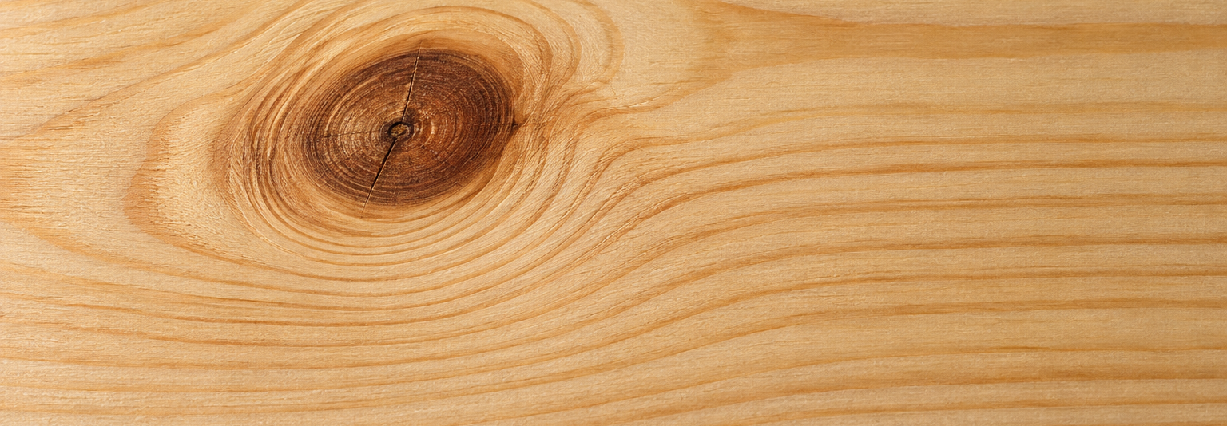
Figure 5. Illustrative timber detail. Follow the changing fibre direction near the knot; the image does not identify your project stock.

Hardwood and softwood language
Hardwood and softwood are botanical groups. Hardwood usually comes from flowering trees; softwood usually comes from cone-bearing trees. The names do not guarantee hardness, mass or strength. Some hardwoods are relatively soft, while some softwoods are firm and durable. A category name is a starting point for classification, not a complete material description.
The course identifies pine for the Footstool project. Pine belongs to the softwood group, but individual pieces can differ in grain, knots, density and condition. One sample cannot represent every piece. Teacher-provided requirements and approved material information guide the stock actually selected and used.
Relevant evidence may include workability, appearance, grain, density and the condition of the piece. Choosing hardwood because the word sounds stronger, or rejecting softwood because it sounds weak, bypasses that evidence. Compare properties with the intended purpose and state what remains uncertain.

Grain, knots and density
Grain is the direction and visible pattern of wood fibres. It may appear straight, wavy, curved or uneven. Inspect more than one face where your teacher permits: the pattern on one surface may not tell the whole story. Describe a direction or change that you can point to, such as fibres running along the length before curving near a knot.

TRY IT
Find two descriptive words that another student could check by looking at the same sample. Avoid “good” or “bad”.
Read the matching course section
MODULE 3 / TIMBER PROPERTIES

Describe what the sample shows
A useful observation states what is visible, how it was checked and the limits of the evidence.
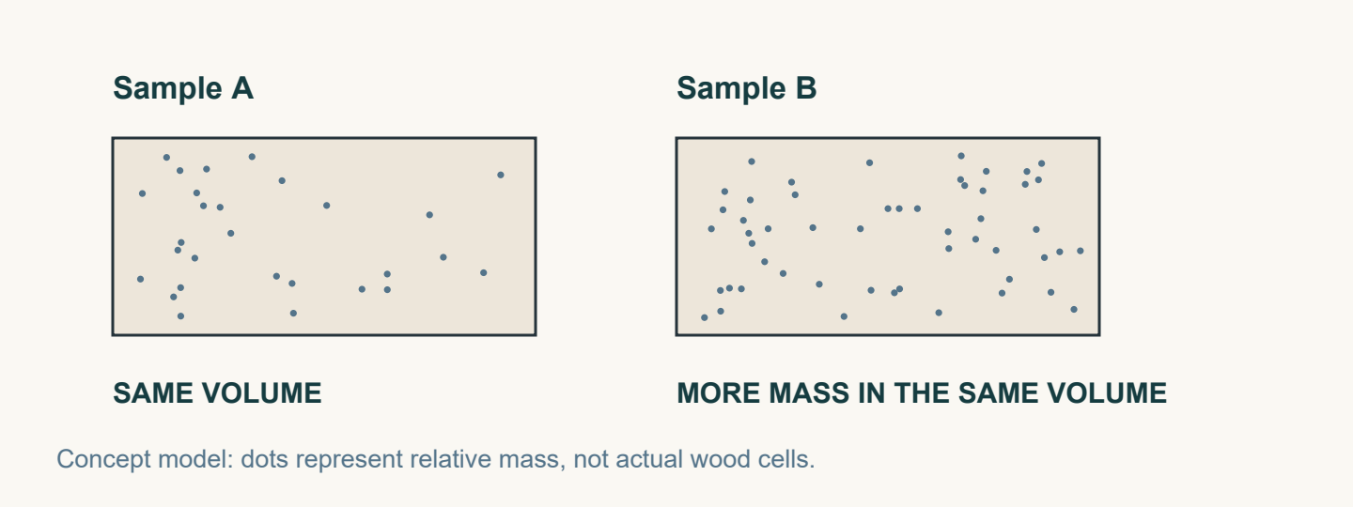
Figure 6. A fair density comparison relates mass to volume. The dots are a concept model, not wood cells.

Grain, knots and density
A knot records where a branch grew. Notice its location, shape, colour and the nearby change in fibre direction. A knot may affect behaviour, but looking at it does not prove that the piece is strong, weak, suitable or unsuitable. Compare the sample with the teacher-provided requirements before reaching a conclusion.
Density means mass in relation to volume. Equal-sized samples can differ in mass. If two samples are different sizes, comparing their mass alone is not a fair density comparison. Use approved information or an approved comparison and describe what is known. Density by itself does not establish overall strength or quality.

Workability and material description
Workability describes how a material responds to approved shaping, joining and finishing processes. Its properties and condition matter, but so do the tool and process. “Softwood is always easy to work” ignores those differences. When a teacher-approved activity reveals variation, record what actually happened instead of assuming a cause.
Build a description from several observations: grain direction, knots, surface texture and any supported density information. Texture concerns how a surface looks or feels, such as smooth, coarse or uneven. A statement about mostly straight grain and a rough area near a visible knot is more useful than simply calling the sample poor.

REMEMBER
Keep observation separate from explanation. You may record a visible change even when its cause or significance still needs teacher confirmation.
Read the matching course section
MODULE 3 / TIMBER PROPERTIES

Make timber language precise
Choose one answer for each question, then apply the reading to the challenge below.
1. Which botanical group does pine belong to?
A. Hardwood
B. Metal
C. Manufactured board
D. Softwood

2. Why might a student observe more than one face of a timber sample?
A. Each face always has a different density
B. One surface may not show the complete grain pattern
C. Knots can only appear on one face
D. The timber category changes between faces

3. Which statement is an unsupported assumption?
A. The material responded evenly during an approved activity
B. The sample has visible knots
C. All softwood is always easy to work
D. The surface appears uneven

Timber property matcher
Match each source-deck definition to one term: hardwood, softwood, knot, straight-grained, dense, workability.
Definition | Term
Timber from a flowering tree.
Timber whose visible grain generally follows a consistent direction.
How readily a material can be shaped or processed for an approved task.
A grain irregularity where a branch or offshoot existed.
Timber from a cone-bearing tree.
Timber that is relatively heavy for its size because its material is closely packed.

Read the matching course section
MODULE 3 / TIMBER PROPERTIES

My timber sample field notes
Observe only a teacher-approved sample. Label your actual evidence instead of inventing a material test.
Sample label / source | Date / approved comparison

Draw the sample. Use arrows to show grain direction and any visible knot or texture change.

Feature | My observation and evidence
Grain direction and pattern
Knot location and nearby grain
Surface texture or condition
Density information: what is known or still needed

Write a supported description using at least three relevant observations. Explain why “pine is a softwood” does not tell you everything about this sample.

Read the matching course section
MODULE 4 / ENGINEERED WOOD

Wood can be reorganised
Looking at the structure of a board reveals more than its colour or its product name.
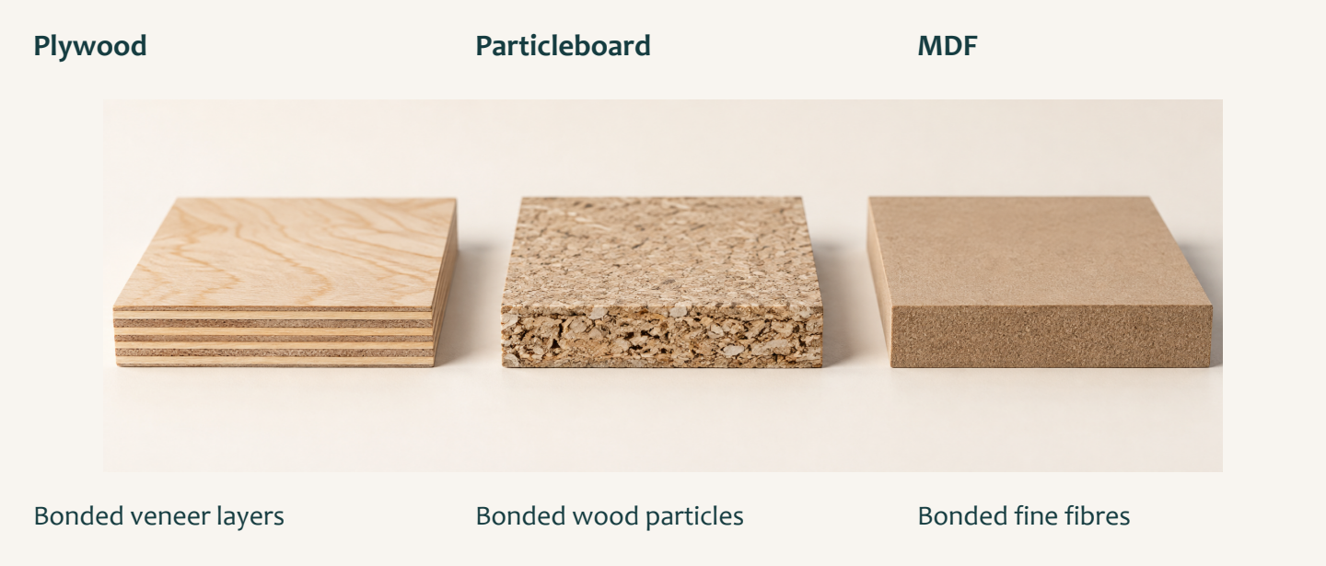
Figure 7. Illustrative board edges distinguish layers, particles and fibres. These do not prescribe a Footstool material.

The engineered-wood idea
Manufactured or engineered wood is made by arranging and bonding wood layers, particles or fibres through controlled manufacturing. It contains real wood, reorganised into a board or structural product instead of remaining one solid piece. The structure affects appearance and behaviour. “Engineered” does not automatically mean better, worse or suitable for a particular task.
Three structures offer a starting point. Plywood uses thin wood layers. Particleboard uses wood particles. Medium-density fibreboard, shortened to MDF, uses fine wood fibres. These are broad product descriptions. Compare the actual face, edge and condition before claiming you have identified a sample.
A smooth surface may be useful in one context; a particular edge or structure may matter in another. Connect those observations with the intended use and the teacher’s project requirements. Learning about a manufactured board does not mean that board has been assigned to the Footstool.

Layers, particles and fibres
The thin sheets in plywood are called veneers. They are bonded together, usually with the grain direction changing between neighbouring layers. A plywood edge often shows repeated thin layers, even when the face resembles other timber. Look for that structural evidence rather than relying on colour alone. Alternating grain is a feature to understand, not a guarantee that every plywood product suits every purpose.

TRY IT
Compare a sample’s face with its edge. Which surface gives you the clearest evidence of how the board is organised?
Read the matching course section
MODULE 4 / ENGINEERED WOOD

Compare boards responsibly
A responsible comparison connects a material feature to a purpose and acknowledges what is still unknown.
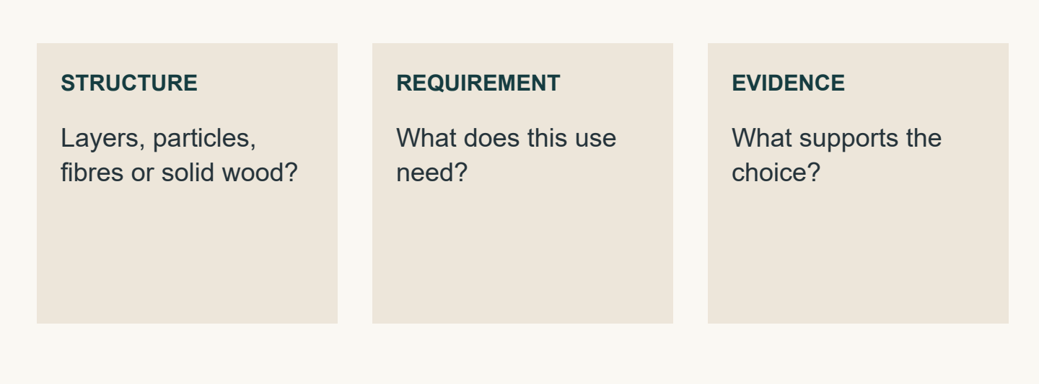
Figure 8. Product structure matters when it is connected to the intended use and supporting evidence.

Layers, particles and fibres
Particleboard contains wood particles bonded into a sheet. Its edge shows separate pieces rather than repeated veneer layers. Describe particle size, distribution and surface without assuming that all particleboard performs identically.
MDF contains fine wood fibres combined with adhesive. Its face and edge generally appear more even and uniform than the visible particles of particleboard, without plywood’s distinct layers. If a sample remains uncertain, compare it with approved examples and ask the teacher. A confident-sounding name is not stronger evidence than an honest uncertainty.

Responsible material comparison
Start with the intended use and the teacher-provided requirements. Consider relevant condition, density, grain structure, surface quality and approved information. Workability concerns the response to approved shaping, joining and finishing; it can change with the sample, tools and process. Explain how a feature may help the intended purpose and identify a limitation, rather than declaring one board always best.
Resource use is also a comparison, not a slogan. Manufactured products may use smaller wood elements, while solid timber comes from larger tree sections. That fact alone cannot settle which option is more sustainable. Sourcing, manufacture, adhesives, transport, useful life, maintenance and waste also affect the comparison. Use reliable information and words such as “may” or “depends” when the evidence has limits.

REMEMBER
An unfamiliar board is for observation until its identity, task suitability and any proposed activity have been confirmed by your teacher.
Read the matching course section
MODULE 4 / ENGINEERED WOOD

Look inside the material claim
Choose one answer for each question, then apply the reading to the challenge below.
1. What makes a wood product manufactured or engineered?
A. Wood elements are combined through controlled manufacturing processes
B. It contains no wood
C. It is always made from one solid board
D. It must look like natural timber

2. Which visible feature most strongly suggests a sample is plywood?
A. A uniform fine-textured edge
B. Separate large wood particles
C. Repeated thin layers along the edge
D. A single natural growth ring

3. Which factor is relevant when comparing material suitability?
A. The classroom wall colour
B. Condition and surface quality
C. The order materials were stored
D. The number of students nearby

Layer detective
Name the product suggested by each edge description. Then repair the unsupported claim in your own words.
Observed edge structure | Likely product
Repeated thin veneer layers.
Separate wood particles bonded together.
Fine, even fibres without distinct veneer layers.

Repair this claim: “This board uses small wood pieces, so it must always be the most sustainable choice.”

Read the matching course section
MODULE 4 / ENGINEERED WOOD

My board investigation
Compare approved samples, then use a teacher-shown source extract or video to investigate beyond what the surface reveals.
Observation | Solid timber sample | Manufactured board sample
Sample name / confirmed source
Visible structure at face and edge
Surface / condition evidence
One uncertainty to investigate

Teacher-led video inquiry
From the deck’s manufactured-wood inquiry, record what the teacher-shown source actually explains. Use “not yet confirmed” where evidence is missing.
Source question | My notes / useful evidence
What types or forms of wood are used in manufactured wood products?
How is laminated veneer lumber made?
How can using and substituting with wood products help address climate change?

Compare one manufactured product with solid timber. Connect a structural feature to a possible use, and state the evidence or teacher confirmation still needed.

Read the matching course section
MODULE 5 / READ THE ORIGINAL PLAN

Read one product through several views
Related views and written information work together to communicate the same Footstool.
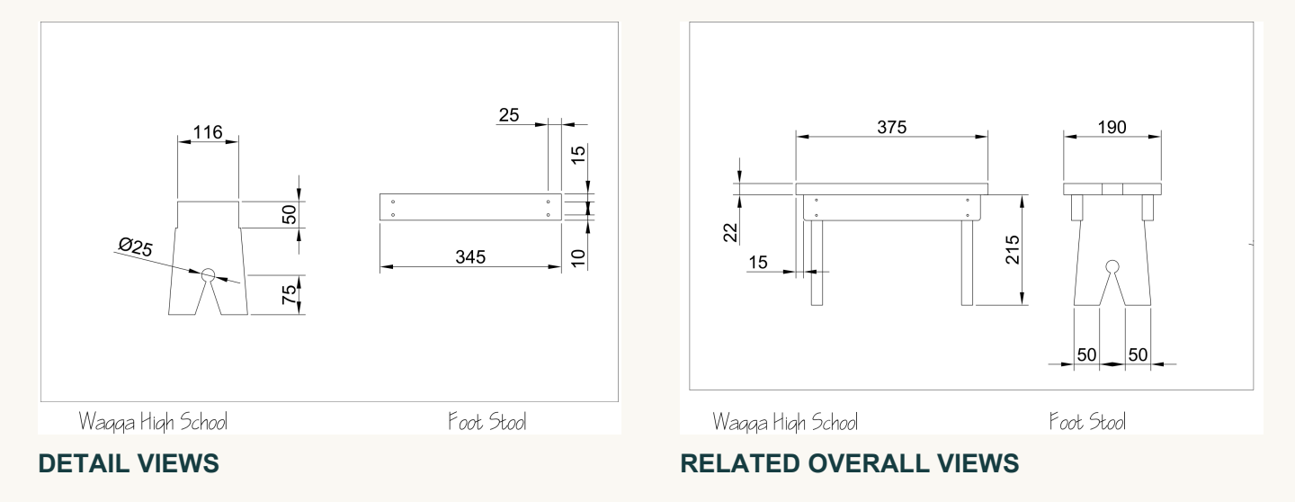
Figure 9. The original plan uses detail views and related overall views. These thumbnails show the layout; use the larger reproductions on pages 43–44 to read dimensions.

Views and drawing information
The unchanged, original two-page Wagga High School Foot Stool drawing is the product’s construction authority. Use the original PDF or its unchanged printed pages, reproduced in this workbook on pages 43–44. A cropped picture, edited copy or small preview may help locate an area but cannot replace the complete reference. Confirm the drawing title and page before searching for a detail.
A plan, or top view, shows the product from directly above. An elevation shows it from an identified side, such as the front. Different views reveal different edges and features. They are connected descriptions of one object, not independent pictures. A feature’s position may be clearer in one view while its form becomes easier to understand in another.
Connect labels, notes and dimensions with the correct view and feature. Find the view that shows your chosen detail clearly, then trace the written information attached to it. Comparing views helps you interpret shape and position without inventing information that is absent.

Dimensions, symbols and scale
Written dimensions control intended size. A line may appear longer after zooming or printing, but its written dimension has not changed. Symbols, line types and notes are communication cues. Read them with the nearby feature and written information; a familiar-looking symbol should not be interpreted in isolation.

REMEMBER
The original Footstool PDF is the sole dimensional and construction authority. Ask about unclear information rather than selecting a convenient value.
Read the matching course section
MODULE 5 / READ THE ORIGINAL PLAN

Check the drawing before the decision
A dependable reading follows the feature, its written information and the related view before accepting a conclusion.
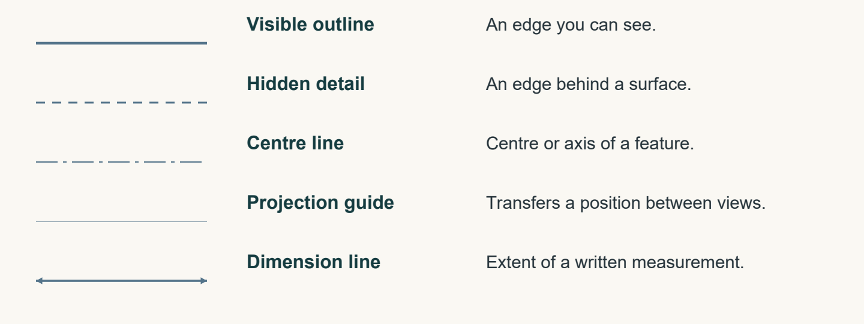
Figure 10. Read each line by its purpose and context. A dimension line indicates the extent; the written value controls intended size.

Dimensions, symbols and scale
Scale is a proportional relationship between a drawing and its intended object. It allows a larger or smaller representation while keeping parts in consistent proportion. It does not make a screen or preview a dependable measuring surface. Zoom, cropping and display settings change apparent size. Written dimensions on the unchanged original drawing still control the actual intended size.
Check how each symbol or note connects to the feature being studied. Use the teacher’s drawing guidance where meaning is uncertain. A value copied neatly is still unreliable if it belongs to the wrong feature or was recalled from memory.

Cross-checking the original plan
Begin with both original plan pages available and clear enough to read. Confirm the title and page, then locate the view showing the required feature. Follow the dimension and extension lines, or nearby cues, to understand exactly what the written information describes. Do not estimate from the apparent length of a line.
Compare the same feature in a related view. Check whether the position and form support the same interpretation. If something seems inconsistent, revisit the page, feature and written information. State the exact uncertainty to the teacher before continuing; neither guesswork nor another student’s interpretation resolves missing authority.

TRY IT
Practise a precise question: “On page…, in the… view, I can read…, but I need to confirm which feature it describes.”
Read the matching course section
MODULE 5 / READ THE ORIGINAL PLAN

Read, connect and cross-check
Choose one answer for each question, then apply the reading to the challenge below.
1. Why should a screen thumbnail not replace the original drawing?
A. It always shows a different product
B. It may not show all information clearly or accurately
C. It contains no visible lines
D. It can only be viewed by teachers

2. What is the broad purpose of symbols on a technical drawing?
A. To decorate the page
B. To show the drawing is complete
C. To replace every written dimension
D. To provide communication cues

3. What should a student open before investigating a plan detail?
A. The unchanged original two-page PDF
B. A cropped screenshot
C. An edited classroom copy
D. A sketch made from memory

Rebuild the reading check
Number the steps 1–5 to make a dependable sequence. You may pause and ask at any point if information is unclear.
Step | Order
A. Compare the same feature in a related view.
B. Confirm the original drawing title and page.
C. State any unresolved uncertainty and ask the teacher.
D. Locate the view showing the required feature.
E. Read the written information linked to that feature.

Read the matching course section
MODULE 5 / READ THE ORIGINAL PLAN

My original-plan reading record
Use the unchanged original plan on pages 43–44 and your teacher’s guidance. Investigate one chosen feature without making a construction assumption.
Reading check | What I located
Original drawing title and page
View and chosen feature
Written dimension, note or symbol linked to it
Related view and what it helps confirm
Uncertainty / teacher clarification

Sketch the relationship between two views of your chosen feature. Label the view names and reference page. This is a reading note, not a replacement construction drawing.

Explain how the written information and related views helped you read the original plan. State what you would do if a detail remained unclear.

Read the matching course section
MODULE 6 / GRAPHICAL COMMUNICATION

One object, related views
Read a drawing as connected information. Follow a feature through the views before deciding what it means.
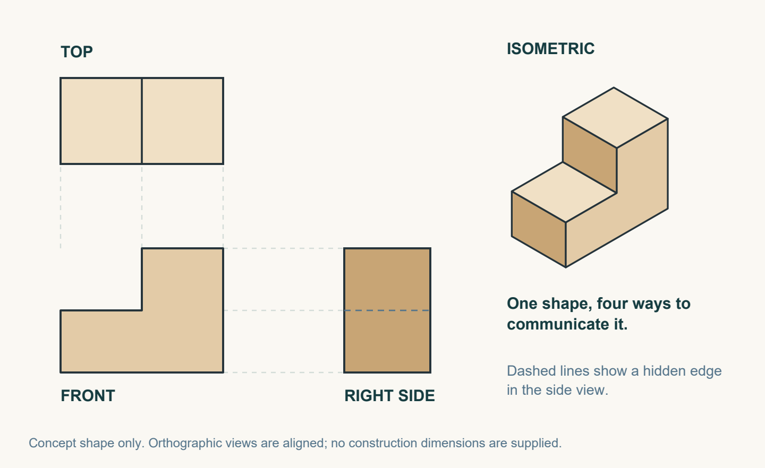
Figure 11. A generic stepped form demonstrates related views. This is a drawing exercise, not a Footstool component.

Compare the directions
Third-angle projection represents an object through related two-dimensional views. The front view shows the object from its selected front. The plan, also called the top view, shows it from directly above. An identified side view adds information from another direction. A single view may not reveal every feature, so read the views together. A feature might appear as a shape in one view and an edge in another. The object has not changed; the viewing direction has. Following the same feature through the views helps you understand both its shape and its position.

Give each line its job
Visible outlines show edges that can be seen from that direction. Short, even dashes commonly represent hidden edges behind a surface. Centre lines identify a centre or axis. Dimension lines connect written measurements to features; the written dimension controls intended size. Light projection or construction lines help transfer positions and maintain alignment. These guides should look lighter than the object itself. If every line looks equally heavy, a guide can be mistaken for an edge. Read its convention and context before interpreting it.

TRY IT
Trace one feature mentally from the front to the plan and side views. Compare its position and line type. If something remains unclear, use the original plan and ask; do not fill the gap with an invented feature. Compare the written notes as well as the linework before reaching a conclusion.
Read the matching course section
MODULE 6 / GRAPHICAL COMMUNICATION

Make the form understandable
Use an isometric view to show the overall form, then cross-check it against the related views.
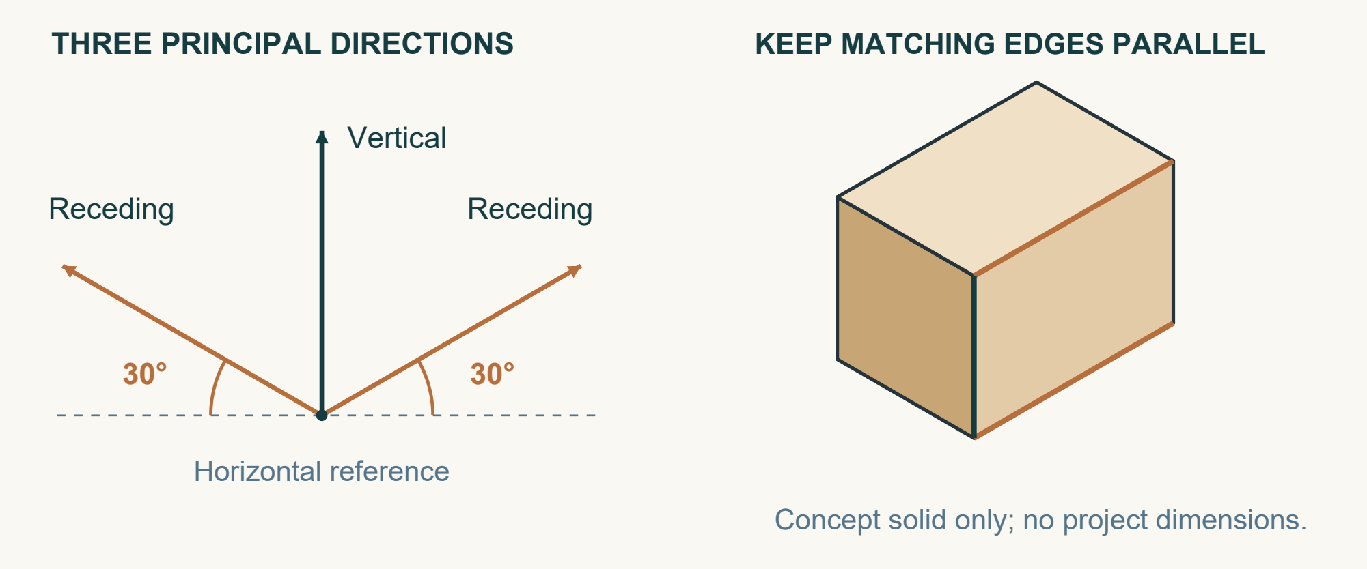
Figure 12. A generic block shows vertical edges and two receding directions at 30° to the horizontal. Edges following the same direction stay parallel.

Three directions organise the drawing
An isometric drawing shows several faces in one three-dimensional-looking view. It helps a reader understand the overall form and how visible surfaces, edges and features relate. Third-angle projection separates the viewing directions; an isometric drawing brings them into one communication image. Neither approach does every job alone. A clear isometric view can make a form easier to recognise, while the related views and written information explain detail that the single image may not reveal.
Begin by recognising the three principal directions. Vertical edges remain vertical. The two receding directions are commonly drawn at about 30 degrees to the horizontal. Edges running in the same direction on the object should remain parallel in the drawing. Keep these directions consistent as you develop the form. Changing lines to imitate artistic perspective can make a technical relationship harder to read, even if the picture initially looks more realistic.

Communicate, compare, confirm
Cross-check a visible feature against the plan and elevation views. Ask where it belongs, which edges describe it and whether the representations agree. Do not use apparent isometric line lengths to estimate size. The unchanged original two-page Footstool plan remains the sole dimensional and construction authority. A communication sketch helps explain that information; it does not replace it or authorise a change.

TRY IT
In your drawing evidence, explain the directions you used, compare the two drawing systems and identify one relationship you checked.
Read the matching course section
MODULE 6 / GRAPHICAL COMMUNICATION

Drawing detective
Circle one answer for each question. Then use line conventions to explain the drawing clues.
1. What is the purpose of comparing aligned features across views?
A. To create a new dimension
B. To choose the largest view
C. To replace written information
D. To identify lines representing the same part

2. Why are projection or construction lines drawn lightly?
A. They represent hidden edges
B. They show written dimensions
C. They are guides and should not look like object outlines
D. They identify every centre point

3. How does an isometric drawing differ from front, plan and side views?
A. It shows only hidden features
B. It combines several visible faces in one view
C. It replaces all written information
D. It shows each direction on a separate page

Match the line to its purpose
Write V (visible outline), H (hidden detail), C (centre line) or D (dimension line) beside each clue.
Drawing clue | Letter
An edge behind a visible surface.
The axis of a circular feature.
The extent of a written measurement.
An edge seen from this viewing direction.

A photocopy makes the drawing larger. Explain what still controls the intended size.

Read the matching course section
MODULE 6 / GRAPHICAL COMMUNICATION

Studio: communicate the Footstool
Use the unchanged original plan. This page records drawing communication, not a revised construction design.
Create an isometric communication sketch from the original plan. Keep the three directions consistent. Label one feature that you can also identify in a related view.

Third-angle drawing communicates… Isometric drawing communicates… Both are useful because…

Identify the related view and the feature you compared. What did the comparison confirm, or leave uncertain?

What did you check in your drawing before treating it as useful evidence?

REMEMBER
Use written information from the original plan. Record an unclear feature as a question for your teacher; do not guess its dimension or construction.
Read the matching course section
MODULE 7 / PERSONAL EMBLEM DESIGN

Give your emblem a meaning
An emblem should communicate something recognisable about you, using a small number of purposeful shapes.

Figure 13. Illustrative concept exploration. Develop your own personal symbols and compare distinct arrangements.

Start with three personal themes
List three different themes that matter to you. Your initials, a place, a hobby, an animal or a significant number could provide a starting point. Explain the personal connection for each theme. Choosing an image only because it looks impressive gives you little reason for later decisions. Three starting themes create a genuine choice and help prevent the first idea from becoming the final design without comparison. The meaning should still be clear when the design becomes simpler.

Notice what makes a reference recognisable
Gather several visual references for each theme. Study outlines, shapes, patterns and symbols. An animal might be recognised by a distinctive curve; a place by an outline; initials by their arrangement. Record where each reference came from and note the useful feature you noticed. This separates your research from your own design response. A reference helps you understand how an idea is communicated. Tracing a completed emblem, or making a tiny change to it, does not demonstrate your own design thinking.

Translate rather than collect
Turn useful reference features into your own simple shapes. Remove details that do not support the main idea. You do not have to include every theme in one emblem. Choose a combination with a clear main message, and consider which shape should attract attention first. Ask whether another viewer can recognise the theme and whether that reading matches your intention. Use a brief note to explain what you kept and what you deliberately removed.

Read the matching course section
MODULE 7 / PERSONAL EMBLEM DESIGN

Compare, choose and refine
Three genuinely different concepts make a reasoned choice possible. Refinement then improves the strongest direction.
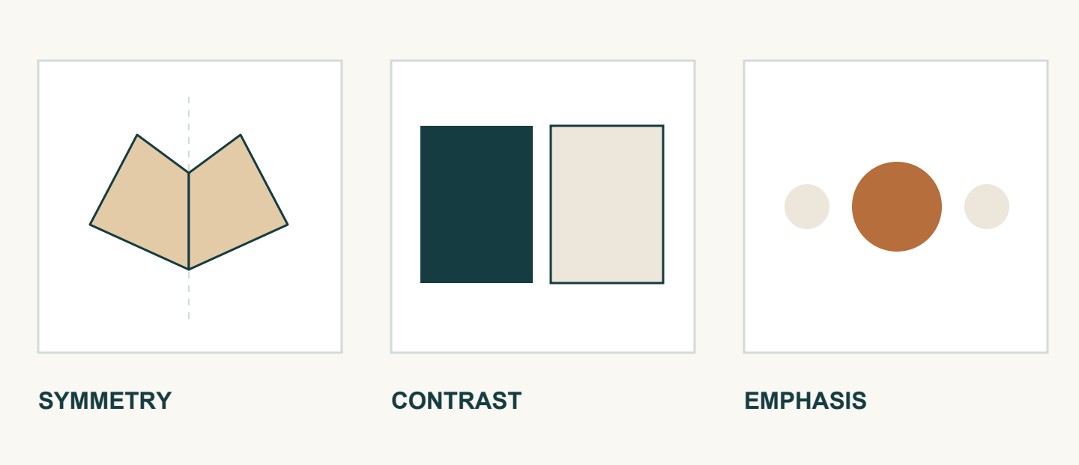
Figure 14. Three visual ideas to investigate in an emblem: symmetry, contrast and emphasis.

Change the idea, not just its size
A thumbnail is a small, quick drawing used to test an arrangement before spending time on detail. Develop three distinct concepts from your research. Change the main symbol, the combination of shapes, their placement or their visual balance. Merely enlarging one symbol or redrawing the same arrangement more neatly gives weak evidence of alternatives. Each concept should offer another possible direction while remaining simple enough to understand quickly. Add notes explaining its theme, arrangement and intended meaning.

Use criteria to make the comparison fair
Clarity concerns whether the design is easy to understand. Recognition asks whether the main theme can be identified. Balance considers the arrangement of visual weight, while contrast helps important shapes stand apart. Personal meaning connects the design to its purpose. Suitability asks whether the idea can work with the teacher-approved decorative process. Record a genuine pro and con for each concept using these criteria. “Good” and “bad” do not explain a decision; “the main symbol is clear, but the surrounding detail is crowded” does.

Keep the meaning; improve the communication
Justify one choice, including a limitation that remains. Refine it by simplifying an outline, strengthening contrast, adjusting balance or removing distracting detail. Explain how the change improves a criterion. The notes should make your reasoning understandable to someone who did not draw the concepts. Any laser cutting or engraving is optional and requires teacher approval. A concept choice supplies no process settings and does not authorise decoration.

Read the matching course section
MODULE 7 / PERSONAL EMBLEM DESIGN

Choose with design evidence
Circle one answer for each question. Then replace vague judgements with useful design language.
1. Which approach best supports an original emblem?
A. Combining and adapting useful reference features
B. Changing only one tiny detail
C. Tracing a completed emblem
D. Copying another student's layout

2. What makes three emblem concepts genuinely distinct?
A. They use the same design with tiny size changes
B. They explore different main ideas or arrangements
C. They contain identical shapes in identical positions
D. They are traced from three finished emblems

3. Which change is an example of refinement?
A. Replacing the idea without explanation
B. Copying a completed emblem
C. Simplifying a distracting outline to improve clarity
D. Adding detail only to fill empty space

Name the criterion
Match clarity, recognition, balance or contrast to these four observations. Use each term once.
Observation | Criterion
The main theme is easy to identify.
The arrangement of visual weight feels even.
Light and dark shapes stand apart.
The design is easy to understand.

Improve this comment: “I chose it because it looks good.” Name one visible strength and one limitation.

Read the matching course section
MODULE 7 / PERSONAL EMBLEM DESIGN

Studio: three ideas, one direction
Develop your own emblem. Use the reading pages for criteria and keep your visual references with this evidence.
Personal theme and meaning | Reference source and useful feature
1.
2.
3.

Draw three distinct thumbnails. Label each concept 1–3 and annotate its arrangement, meaning, one strength and one limitation.

I selected concept… because… A remaining limitation is… The change I will explore is…

Refine the selected concept. Label the change and the criterion it improves.

REMEMBER
The decorative process must be teacher approved. Laser cutting and engraving are optional; these sketches do not authorise either process.
Read the matching course section
MODULE 8 / PROGRESS AND QUALITY EVIDENCE

Record what actually happened
A useful quality log helps another reader understand the work and the evidence behind your judgement.
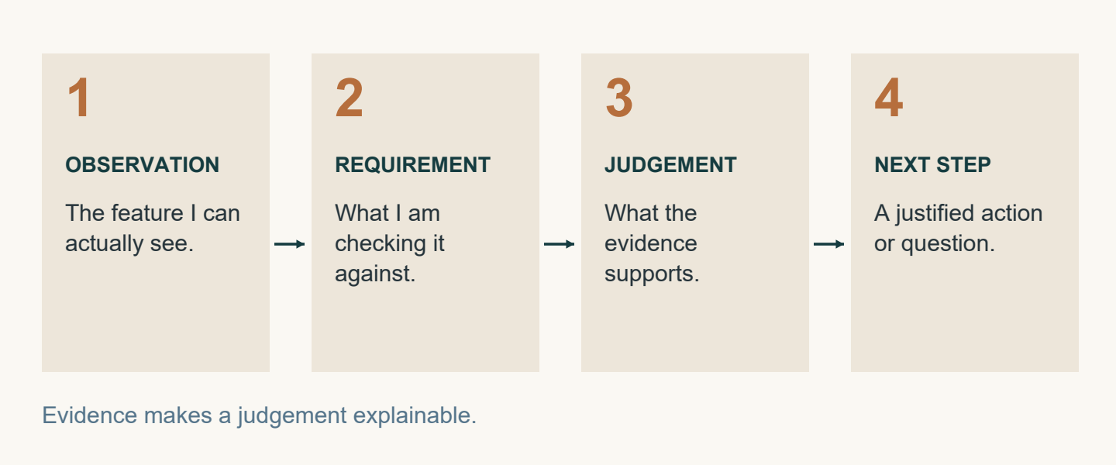
Figure 15. A useful quality record connects an observation with a requirement, a judgement and a next step.

Give the observation a context
Begin an entry with the date or lesson reference when directed. Identify the broad task attempted and its purpose, rather than writing a hidden construction sequence. The reader needs to know which area of work the observation concerns. The unchanged original plan, current school SOPs and teacher directions control actual making. A log records what happened during that authorised lesson; it does not decide a new method or create the next practical step.

Describe the feature, not your mood
An objective observation describes something that could be seen, heard or compared. For example, two marked references might align, an area might appear uneven or a visible gap might remain during a check. These examples are possible observations, not findings about your Footstool. Write what your own evidence shows. “It went well” is too vague because it does not identify a feature or result. “Perfect”, “strong” and “complete” also require evidence; confident wording cannot replace a check.

Explain what was checked
Connect the observation with the information used for the check. This could be the original plan, an approved reference or teacher direction. State what was compared without inventing a dimension or tolerance. If the evidence does not match, describe the difference and record that clarification or further checking is needed. A useful log answers: when, what broad task, what observation and what check? A precise record also shows where your observation ends and an unsupported opinion would begin.

Read the matching course section
MODULE 8 / PROGRESS AND QUALITY EVIDENCE

Turn evidence into a next step
Evidence becomes useful when you explain its meaning, acknowledge its limits and identify what needs confirmation.

Choose evidence that answers a question
An approved photograph should clearly show the feature being discussed. Add a caption explaining what is visible and why it matters. A photograph alone may not prove accuracy, strength or completion. Combine it with an approved check or teacher feedback where appropriate. Record feedback accurately: state the point discussed and what needs further checking. Do not turn a comment into a grade, mark or guarantee of quality. If evidence is incomplete, say what it cannot establish.

Separate the observation from its possible cause
Begin a reflection with a fact: what was seen, heard, measured or confirmed during an approved check? Then explain a possible reason using available evidence. If the cause has not been confirmed, use cautious language. “This may relate to…” signals a possibility; it does not make the cause true. Record an action already taken or propose an action for teacher approval. The action should respond directly to the observation, and a proposal must remain clearly different from an authorised instruction.

Make the question precise
Finish with the next teacher-confirmed step. If confirmation has not happened, write the question that remains. Name what you know and what still needs checking. This helps the teacher respond to the actual uncertainty. A useful question connects the known observation to the particular detail that still needs confirmation. The pattern is observation, reason, action and next step. It turns a general comment into a record of thinking without inventing a construction sequence or assuming approval.

From impression to evidence
Vague impression | A more useful record
It looks good. | The two marked references align in the view I checked.
It must be strong. | This photograph shows appearance; it does not establish strength.

Rewrite “Everything is finished” as a precise question you could check with your teacher.

Read the matching course section
MODULE 8 / PROGRESS AND QUALITY EVIDENCE

Facts, reasons and responsible action
Circle one answer for each question. Then reconstruct a clear reflection from the four statements.
1. Which statement is an objective observation?
A. The work was excellent
B. The activity felt easy
C. The result is definitely strong
D. A visible gap remained during the check

2. Which statement best describes quality evidence?
A. Specific information that can be observed or checked
B. A general opinion that the work looks good
C. A guess about how strong the work may be
D. A claim that the activity is finished

3. What should a proposed action respond to?
A. Another student's project
B. The recorded observation
C. An unrelated future activity
D. A guessed dimension

Put the reflection in order
Write 1–4 beside these statements from a fictional log. Then underline the words that show uncertainty.
Statement | Order
I asked the teacher to help clarify the observation.
A visible gap remained during the approved check.
The teacher confirmed that the observation needed further checking.
The reason may relate to alignment; this is not yet confirmed.

What does the student still need before taking any practical corrective action?

Read the matching course section
MODULE 8 / PROGRESS AND QUALITY EVIDENCE

Studio: build a quality case file
Record one real quality point from your authorised work. Choose evidence that lets another reader understand it.
Lesson/date and broad task | Feature or requirement checked

Objective observation: what could you see, hear, compare or confirm? Identify the reference used for the check.

Attach an approved photograph or draw a labelled observation sketch. Identify the feature; this is evidence, not a new construction plan.

Evidence caption: what does this image show, and what can it not prove by itself?

Possible reason and evidence for it. Identify anything not yet confirmed.

Action already taken OR proposal for approval. Label which it is. Next teacher-confirmed step or question awaiting confirmation:

Read the matching course section
MODULE 9 / FUNCTION AND TESTING

What does “works well” mean?
Function describes performance in the intended situation. Precise words help you decide which evidence matters.
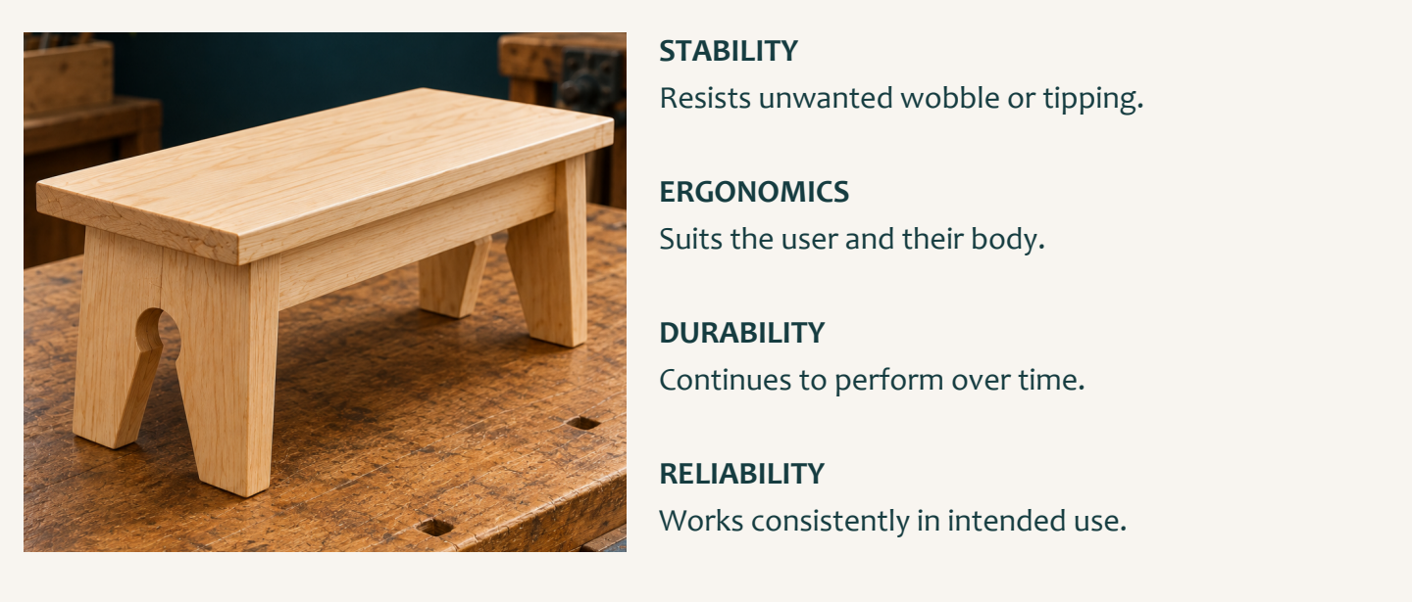
Figure 16. These functional qualities ask different questions about performance. Use a teacher-approved observation or check.

Think about the product and its user
A product’s function is how well it performs its intended purpose. An attractive appearance does not establish that it works effectively. “Stable” means resisting unwanted movement during intended use. “Ergonomic” means designed to support suitable and comfortable human use. Ergonomics therefore directs attention towards the relationship between the product, the person and the intended situation. It cannot be established simply by calling an object neat or attractive. Describe the relevant evidence from an approved observation and leave unexamined claims open.

Separate qualities that sound similar
“Safe” means risks have been controlled for the intended situation. “Durable” concerns withstanding expected use over time. “Reliable” concerns performing consistently when used as intended. These qualities are related but not interchangeable. Evidence about unwanted movement does not automatically establish comfort, long-term durability or every aspect of safety. A single photograph or successful observation also cannot prove everything. Identify the particular quality you are discussing before choosing the evidence that supports it.

Consider resources as well as performance
“Efficient” means achieving the intended result without unnecessary time, effort or resource use. It does not simply mean fastest. “Economical” means reasonable value while considering costs and resources, rather than merely cheapest. Use these words to explain a trade-off, not to attach a favourable label. Keep the quality word connected to its specific meaning throughout your explanation. Functional vocabulary provides criteria for thinking; it does not announce that your Footstool has passed a test. When evidence is missing, state what remains unknown.

Read the matching course section
MODULE 9 / FUNCTION AND TESTING

A fair functional judgement
Begin with one criterion. Match the evidence to it and keep any proposed improvement connected to the observed limitation.
Figure 17. Keep evidence and conclusions connected. A short check cannot prove every future performance claim.

Match the check to the claim
Name the functional quality being investigated, such as stability, ergonomics or reliability. “It works well” is too broad because it does not identify what was considered. Confirm the check or observation with your teacher before actual Footstool testing. Do not invent a load, force, user, dimension, pass level or testing method. The approved check must match the chosen criterion. Observe the relevant behaviour or condition and keep the approved situation consistent enough for the evidence to mean something.

Report the result and its limits
State the criterion, the approved check and what happened. Use objective language rather than “perfect” or “definitely safe”. One check may support one limited conclusion while leaving other qualities untested. An honest judgement explains both the evidence and what it cannot show. If uncertainty could affect safety or quality, stop and ask. Incomplete evidence is a reason to seek clarification, not to fill the record with a confident guess.

Make an improvement answer a real problem
Identify a specific limitation supported by the evidence. Propose a realistic improvement for discussion and explain how it may affect the chosen criterion. Consider whether the idea might create a different problem. A predicted benefit is not a proven result, and missing information should stay visible. The predicted benefit should be linked explicitly to the criterion you originally selected. The reflection does not authorise a change to the original Footstool plan. Seek teacher confirmation before action and record what would still need an approved check.

Read the matching course section
MODULE 9 / FUNCTION AND TESTING

Function words in action
Circle one answer for each question. Then use similar and opposite words to sharpen the meaning of each criterion.
1. Which description best matches ergonomic?
A. Able to last forever
B. Guaranteed to be safe
C. Always inexpensive
D. Designed to support suitable and comfortable human use

2. What can one approved check usually support?
A. A conclusion about every product quality
B. A guaranteed pass result
C. Evidence about the criterion it was designed to examine
D. A new construction requirement

3. How should the predicted effect of an improvement be written?
A. Using cautious language linked to a functional criterion
B. As proof that the product has passed
C. As an authorised plan change
D. As a guaranteed result

Build a vocabulary bridge
Write a useful similar word or phrase and an opposite for each term. Check that your words describe performance.
Term | Similar word or phrase | Opposite
Durable
Reliable
Stable
Ergonomic
Efficient
Economical

Read the matching course section
MODULE 9 / FUNCTION AND TESTING

Studio: investigate one function
Choose one teacher-approved functional criterion. This is a record of an authorised check, not instructions for a new test.
Chosen criterion and meaning | Teacher-approved check or observation

What happened? Record specific observations and identify the evidence or teacher feedback that supports them.

My evidence supports… It does not establish… Which other functional qualities remain unexamined?

Human-use lens: what evidence is available about suitable, comfortable use? If it has not been checked, say so and identify a question for your teacher.

One evidenced limitation and a realistic improvement for discussion. Explain the predicted effect and any uncertainty or possible trade-off.

Teacher-confirmed next step OR precise question awaiting confirmation:

Read the matching course section
MODULE 10 / AESTHETICS AND FINAL EVALUATION

Learn to describe what you see
Aesthetic language makes visual decisions discussable. Identify the feature before explaining its effect.
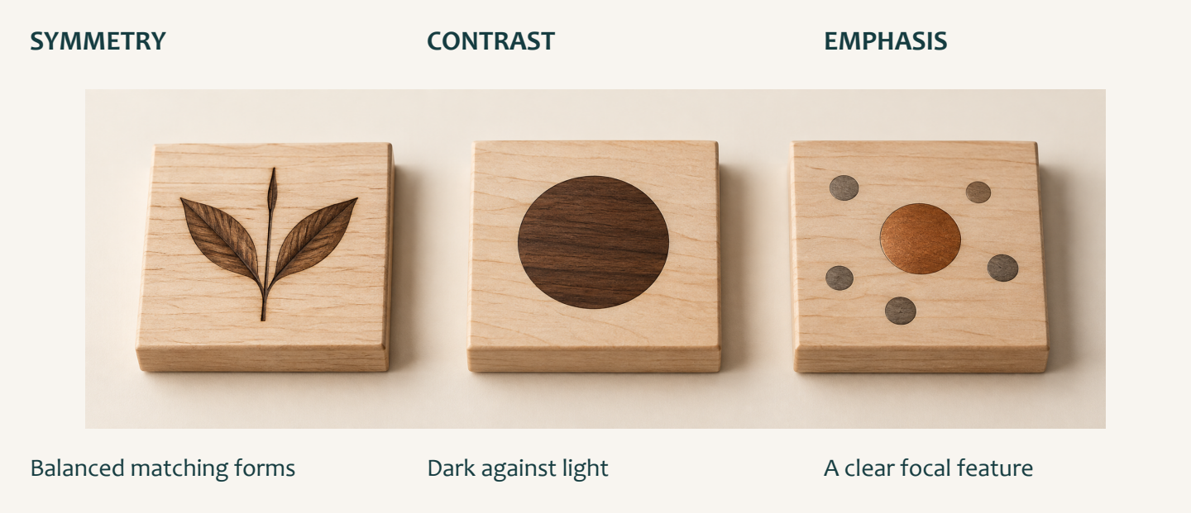
Figure 18. Illustrative design samples: balanced forms, dark–light contrast and a focal feature. Point to what you can see.

Move beyond “nice”
Aesthetics concerns appearance and the visual response a product creates. “Nice”, “ugly” and “cool” give a preference without explaining the visible reason. Texture describes how a surface looks or feels. Pattern is a repeated arrangement of lines, shapes, colours or features. Symmetry occurs when parts appear balanced around a central line or point. Contrast is a noticeable difference, such as light and dark, smooth and rough, or large and small. Name the actual feature you can observe rather than attaching several impressive words to it.

Notice form and arrangement
Layout is how visual elements are arranged and spaced. Style is the overall visual character created by the combined design choices. Geometric forms use regular shapes, straight edges or controlled curves. Organic forms draw on natural, irregular or flowing shapes. A design may use either approach or combine both; one is not automatically better. Describe how the chosen form contributes to the appearance, and base that description on the example in front of you.

Ask what attracts attention first
Visual hierarchy is the order in which a viewer notices elements. Size, position, contrast, spacing and detail can affect that order. Emphasis deliberately makes an important feature stand out. A prominent central emblem may become the main focus, but its effect depends on the evidence available. Describe what you notice first and why. Do not claim to know the designer’s intention when you only know your response.

Read the matching course section
MODULE 10 / AESTHETICS AND FINAL EVALUATION

Evaluate the whole design
A balanced evaluation explains how the product performs, how it appears and what the evidence has taught you.
Figure 19. Appearance is visible in an image; function needs appropriate evidence. Evaluate your own work using both.

Link a feature to an effect
Begin an aesthetic judgement with a visible feature. Connect it to the correct criterion, then explain its possible effect on the viewer. Repeated shapes relate to pattern; noticeable differences relate to contrast; the order of attention relates to hierarchy. Balanced spacing may make a layout appear organised, while a contrasting feature may attract attention first. Use cautious language because viewers can respond differently. “I like it” gives a preference; a useful analysis explains the visual evidence behind that response.

Balance strengths with a limitation
The final evaluation considers function and aesthetics together. Support each claimed strength with approved observations, checks, photographs or teacher feedback. A functional strength may concern stability or reliability. An aesthetic strength may concern clear hierarchy, balanced layout or another observed quality. Do not invent a finish, emblem or performance result. Identify one specific limitation in the product or in the available evidence. Explain why it matters, then propose a realistic improvement that responds to it. Describe the predicted effect without presenting it as proven.

Make the learning visible
Finish by explaining a skill, concept or decision that became clearer. Perhaps you now read related views more confidently or separate observation from opinion. State how this learning could improve future work. The source activity’s self-ratings are reflection prompts, not marks or formal results. Neither a rating nor an evaluation authorises changes to the original plan. Current school SOPs and teacher directions continue to control actual workshop activity.

Read the matching course section
MODULE 10 / AESTHETICS AND FINAL EVALUATION

Read the visual clues
Circle one answer for each question. Then solve the twelve source design clues using the vocabulary from Modules 9 and 10.
1. What is an organic form?
A. A shape that must be symmetrical
B. A layout with equal spacing
C. A feature with the strongest contrast
D. A natural, irregular or flowing shape

2. Which criterion describes the order in which elements attract attention?
A. Symmetry
B. Visual hierarchy
C. Texture
D. Organic form

3. Which learning reflection is most useful?
A. I finished the work
B. The project was fun
C. I learned to separate observations from opinions and can use clearer evidence next time
D. Everything was easy

Twelve design clues
Clue | Term | Clue | Term
Something that works consistently |  | Opposite to safe
Opposite to wasteful |  | A repeated image or arrangement
A strong difference, such as black and white |  | A mirrored or evenly balanced image
Opposite to wobbly |  | Makes something more noticeable or helps it stand out
Lasts a long time |  | Comfortable and suitable for the hand or body
How something works |  | How something looks

Read the matching course section
MODULE 10 / AESTHETICS AND FINAL EVALUATION

Studio: my final evaluation
Use your own evidence. Optional self-ratings prompt reflection; they are not marks. Leave an unexamined quality unrated.
Function | Rating /10 | Appearance | Rating /10
Efficiency |  | Texture
Stability |  | Pattern
Ergonomic |  | Symmetry
Safe |  | Contrast
Durable |  | Layout
Reliable |  | Style

Function: what went well, and what evidence supports it? What could improve, and what would you do differently next time?

Aesthetics: evaluate two visual qualities using specific features and their effect. What could improve, and what would you do differently next time?

Choose one evidenced limitation. Propose a realistic improvement and explain its predicted effect. State what still needs teacher confirmation.

Learning reflection: what can you now explain or judge more accurately? How will this help your next project?

Read the matching course section
MODULE 5 / READ THE ORIGINAL PLAN

Original plan / 1
Wagga High School • Foot Stool. Read the written dimensions; this reproduction is resized to fit the workbook. Do not measure the printed lines.
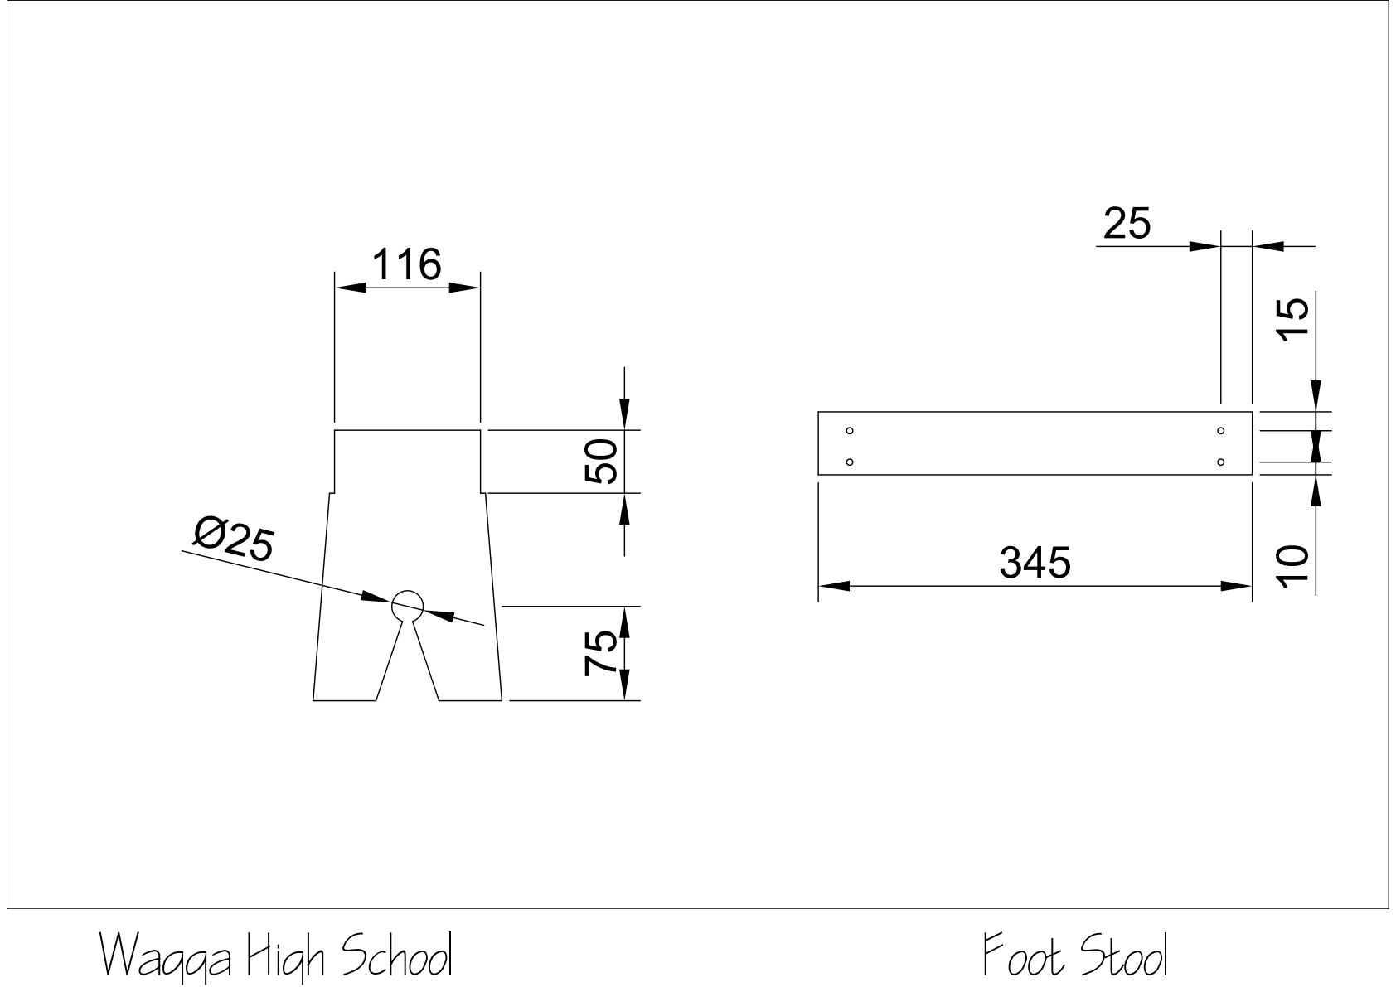
Original plan • Page 1 of 2 • Reproduced from the unchanged course PDF.
Use both original pages together. A detail view shows a particular feature; a related overall view helps you locate that feature in the product. Keep each dimension with the feature it describes.
Identify one dimension and the exact feature it belongs to. Explain how you located it.

Read the matching course section
MODULE 5 / READ THE ORIGINAL PLAN

Original plan / 2
Wagga High School • Foot Stool. Read the written dimensions; this reproduction is resized to fit the workbook. Do not measure the printed lines.
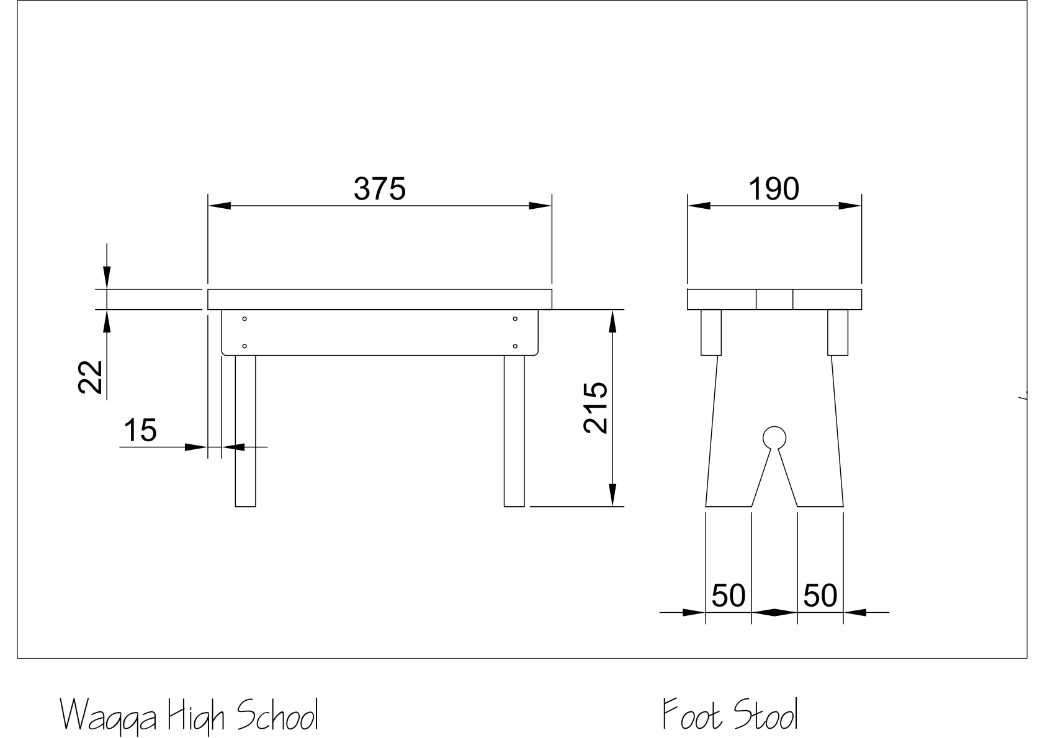
Original plan • Page 2 of 2 • Reproduced from the unchanged course PDF.
Compare the two views before making a judgement about the form. A feature that appears broad in one view may appear narrow in another. The viewing direction changes what you can see.
Name a feature that appears in both views. Describe what each view tells you about it.

Read the matching course section
PROJECT RECORD

My approved workshop record
Complete this with your teacher before recording your own practical work. Use the current plan, local instructions and the materials actually issued.
Project / class instructions / date of teacher briefing

Component or material | Approved information / source | Teacher clarification

Record the next practical task your teacher has authorised and the check required before you begin.

TEACHER CHECK
Confirm this record against the current class instructions. Teacher initials: __________ Date: __________
Read the matching course section
PROJECT RECORD

The making journal
Write while the evidence is fresh. Explain an actual observation and decision, rather than simply listing what you did.

Entry 1 • Date: __________________
Task / current stage and the requirement I checked

What I observed; the action taken and why

Entry 2 • Date: __________________
Task / current stage and the requirement I checked

What I observed; the action taken and why

My next step or the question I need to ask

Read the matching course section
PROJECT RECORD

Show the evidence
Attach a printed photograph or make an observational sketch of your own work. Add arrows and labels so another reader knows exactly what you are discussing.
Evidence image / sketch • Date and stage: _________________________________

Label | What the image shows | What it does not prove
A
B

Compare one labelled feature with an approved requirement. What judgement is supported?

Read the matching course section
PROJECT RECORD

Watch with a purpose
Your teacher can show a course video to the class. Use this page to investigate a material, drawing or design idea without needing your own screen.
Video title / creator / course topic / date

Before viewing: write one question you want the video to answer.

Pause / time | Observation or claim | Explanation / supporting example

Explain one connection between this video and the Footstool learning. State any limit or question still unresolved.

USE EVIDENCE
Distinguish what the video demonstrates from what it only claims. A related project example does not change your approved Footstool plan.
Read the matching course section
PROJECT RECORD

The timber and design lexicon
Use the eight terms once each. First retrieve what you know, then check the matching course reading or workbook page.
WORD BANK
grain • knot • coniferous • ergonomic • durability • efficient • isometric • aesthetics
Clue | Term
Direction and visible pattern of wood fibres
Evidence of where a branch grew
Describes a cone-bearing tree
Suited to the user and their body
Ability to keep performing over time
Achieves a purpose with little waste
Pictorial view showing three directions of a form
Visual qualities and appearance

Use three of these terms in an accurate paragraph about your learning or your own product.

Read the matching course section
PROJECT RECORD

What my Footstool shows
Bring the evidence together. Discuss function and appearance separately, then explain one worthwhile improvement. Refer to a drawing, observation or approved check.
Function: one quality, the evidence and my judgement

Aesthetics: two visual qualities and where they can be seen

Improvement: what I would change, why it would help and what would need checking

Reflection: a skill I developed and the evidence that shows my progress

FINISH THOUGHTFULLY
Check your name, labels, evidence dates and any teacher-required submission details. Keep the workbook as a record of your learning.
Read the matching course section

