
YEAR 12 HSC
Design and
Technology
STUDENT WORKBOOK
Make decisions you can explain
Explore innovation, develop design reasoning and keep evidence of what changes. Use this companion
alongside the course and your teacher’s current instructions.
NAME _____________________________ CLASS ____________________
Illustrative design studio. The prototype is an example, not your prescribed Major Design Project.
A4 | Duplex long edge | Supplementary learning
1

YEAR 12 / COURSE COMPANION

Use the course and the workbook together
Read the named section, inspect its example and answer the original check. Each module ends with one complete applied task or longer response. Use the space for your own reasoning; examples are practice contexts, not prescribed MDP solutions.
01 HSC Course Launch and MDP Boundaries | 3–6
02 Innovation and Emerging Technologies | 7–10
03 Innovation Case Study | 11–14
04 MDP Proposal and Success Criteria | 15–18
05 Research Methods and Ethical Evidence | 19–22
06 Project Management | 23–26
07 Creativity and Concept Development | 27–30
08 Experimentation, Prototyping and Testing | 31–34
09 Production, Resources and Quality | 35–38
10 Communication and Folio Evidence | 39–42
11 Evaluation and Impact | 43–46
12 MDP Handoff and HSC Synthesis | 47–50

Continue the learning online
The book teaches all 36 named sections and selects 36 original MCQs, eight applied tasks and four long responses. Each section link opens its full course reading and remaining practice. The other 324 MCQs, 28 activities and 32 long responses stay online. The 36 media alternatives are learning pathways without video; no playable clips are promised.

Keep the evidence boundary clear
This is supplementary formative practice. Your current school and official instructions control the MDP, assessment, permitted assistance, dates and authentication. Historic Task 1 material is a 2025–26 learning copy, not a newly issued task. Workbook completion does not submit or authenticate work.
The course’s twelve browser-local folio records are optional learning aids. Save and back up work deliberately; they do not automatically submit, authenticate or back up entries.
Open the course
Open the browser-local folio
50 A4 pages, including this front matter. Print double-sided on the long edge as 25 sheets. Use actual size.

01 / HSC COURSE LAUNCH AND MDP BOUNDARIES

Connect the three learning rhythms
The two-year bridge and HSC course map

Carry knowledge forward
Preliminary learning gives you a starting point in research, communication, project management, production and evaluation. Year 12 asks you to select and apply that knowledge with greater independence. The connection between the stages is knowledge and useful habits. A Year 11 project or assessment result does not become part of the HSC assessment program. Use earlier learning to improve a new decision rather than treating an earlier result as current evidence.

Work across the course
Innovation and Emerging Technologies connects with Designing and Producing through the individual Major Design Project. Innovation study explains why designs change, how designers work and what consequences technologies may create. The MDP provides a sustained setting for investigating a need, managing work, developing a response and evaluating it. Theory, MDP development and examination preparation run alongside one another: each gives the others useful concepts, contexts and practice.


Figure 1. Illustrative bridge between earlier learning and new design contexts. The arrows show transfer of thinking, not transfer of assessment results.

Worked observation
Illustrative connection: comparing two sources is a Preliminary research habit. In Year 12, use it to test an innovation claim, justify a project criterion and qualify an examination judgement. The habit transfers; the evidence and task are new.

Move from naming to reasoning
Naming a design stage shows recall; explaining its effect shows reasoning. Connect the situation, the evidence, the decision and the consequence. A useful evaluation record explains what was learnt, which decision changed and why that change better addressed a criterion. In an examination response, the same habit helps you select a relevant example and explain its significance. Ask what this evidence lets you decide or explain before adding it to a record.

CHECK YOUR UNDERSTANDING
Why is it weak to postpone theory until the MDP is finished?
A. Theory can inform project reasoning while project contexts deepen theory.
B. Theory has no connection to design decisions.
C. Every theory topic must be completed before designing begins.
D. Examination preparation replaces theory learning.
Name one earlier design habit and explain one more independent HSC use.

Full reading and remaining practice: Module 01, section 01

01 / HSC COURSE LAUNCH AND MDP BOUNDARIES

Keep individual responsibility visible
Individual MDP, supervision and authentication

Individual work with support
The MDP is an individual design process. Discussion, feedback and demonstrations can support learning, but your decisions, development, evidence and submitted work must remain attributable to you. Independence does not mean isolation. It means being able to explain what you understood and completed. An unclear mixture of other people's ideas, research and making makes that contribution difficult to establish and weakens the evidence of learning.

Build a continuous trail
Teacher supervision and authentication depend on a credible record of development, rather than a story reconstructed at the end. Dated sketches, labelled research, progress photographs, test records and decision annotations can show what was attempted, learnt and changed. Select meaningful evidence instead of collecting every artefact. A polished product does not reveal its whole process, and an unexplained stack of pages does not prove authorship. Keep versions orderly and back up work using arrangements set by your teacher.

Discuss assistance before accepting it
Specialist advice, permitted support and work outside normal classes must remain transparent and within current authority. Discuss what assistance is proposed, which decisions and work remain yours, and how the contribution will be acknowledged. Acknowledgement does not create permission for assistance that is otherwise outside the rules. The teacher and current official advice control the actual conditions. Record the help accurately without implying that another person's work was your own.
Artefact | What was attempted or observed
Reasoning | What the evidence changed
Authorship | What you did and what help occurred
Next action | What needs teacher direction or further evidence

Worked reasoning
Evidence trail: question recorded → research labelled → prototype compared → decision explained → teacher discussion noted. Each connection should reveal thinking. A picture of the final object alone cannot show those links.

CHECK YOUR UNDERSTANDING
Which statement about outside assistance is most accurate?
A. Any assistance is automatically forbidden.
B. Assistance never needs to be recorded if the product is individual.
C. Assistance must be discussed with the teacher, kept within authority and acknowledged accurately.
D. Acknowledgement makes any amount of assistance acceptable.
What would you record after receiving specialist advice?

Full reading and remaining practice: Module 01, section 02

01 / HSC COURSE LAUNCH AND MDP BOUNDARIES

Open the brief before choosing a product
From a need or opportunity to an open design brief

Investigate a need or opportunity
A need describes a difficulty, gap or unmet requirement. An opportunity describes a possible improvement to an experience, system or outcome. Begin with who is affected, where the issue occurs and why it matters. Early observations, conversations or secondary sources can challenge the first assumption as well as support it. Keep the claim provisional until the evidence gives it a defensible boundary.

Describe the situation honestly
A design situation explains the users, setting, current experience and consequences around the need. Separate what is known from what still needs investigation. Different users may have different priorities, and existing responses may already work partly well. A situation should make the issue understandable and researchable; it should not exaggerate a problem to sell a solution chosen in advance.

Write a brief that permits alternatives
An open brief names the intended improvement and relevant users or context without prescribing unverified dimensions, materials, technologies or methods. It connects later research, criteria and concept generation. Several genuinely different responses should be able to answer it. Refine the brief if new evidence changes the understanding of the need, and explain why. The four fictional statements below deliberately close the design too early; use them in the repair activity on page 6.

Fictional statements for page 6
A. I will make a phone app so every visitor can find the right service.
B. I will build a timber organiser because all users need more compartments.
C. I will make a touch screen kiosk because it will remove confusion.
D. I will produce a foldable stool because everyone wants portable seating.

Worked reasoning
A product-first intention such as “make a display stand” can be reopened by investigating what people need to see, where viewing occurs and what currently prevents access. Only then can different display, layout or service responses be compared.

CHECK YOUR UNDERSTANDING
What should happen if research changes the understanding of the need?
A. Hide the new evidence to protect the original idea.
B. Keep the brief unchanged regardless of relevance.
C. Refine the brief and explain the evidence-based reason.
D. Abandon all earlier investigation automatically.
Underline one fixed feature in the statements on this page; note the user evidence it assumes.

Full reading and remaining practice: Module 01, section 03

01 / HSC COURSE LAUNCH AND MDP BOUNDARIES

Solution-first repair studio
Formative practice only
Use the source teaching and the practice material on page 5.
1. Read four fictional solution-first statements.
2. Highlight assumptions, fixed features and missing user or context evidence.
3. Rewrite two as design situations that distinguish known information from questions.
4. Draft an open brief for one situation and list three genuinely different response directions.
Situation 1: statement selected, known information and questions

Situation 2: statement selected, known information and questions

Open brief for one situation

Three genuinely different response directions

A strong rewrite names the intended improvement and context but does not smuggle the final product into the brief.
Full reading and remaining practice: Module 01, section 03

02 / INNOVATION AND EMERGING TECHNOLOGIES

What makes a change innovative?
Innovation, invention and degree of difference

A new idea needs a context
An invention creates a new device, method, system or idea. Innovation develops or applies an idea successfully so that it creates value in a context. Novelty alone does not show that an idea meets a worthwhile need, can be used or can be sustained. An innovation may also recombine existing technologies or change a service without inventing a new component.

Judge the difference
An incremental innovation meaningfully improves an existing design, process or service. A more radical innovation changes important assumptions or creates a substantially different way to meet a need. These sit on a continuum. A technically modest change can have a large social effect; dramatic technology can have little practical effect.
Figure 2 claims
Left: INCREMENTAL IMPROVEMENT
Centre: MORE SUBSTANTIAL CHANGE
Right: GENUINELY DIFFERENT CONCEPT

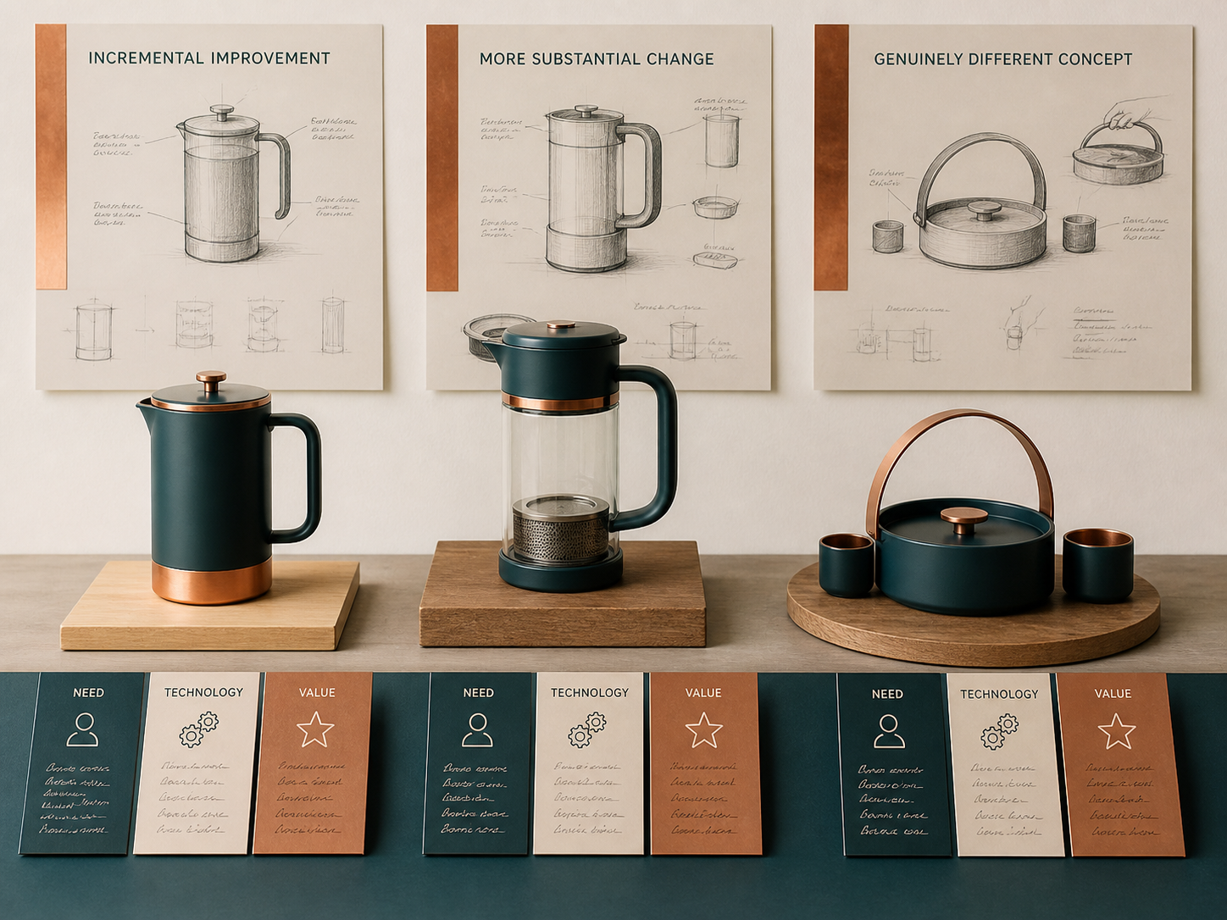
Figure 2. Illustrative concepts show different forms. Their labels are claims to examine: appearance alone does not prove adoption, value or degree of innovation.

Name the comparison
State what existed before, what changed and how the user experience or wider system differs. Value may be social, environmental or experiential, as well as economic. Advertising language is not evidence.

Build a defensible classification
Make a claim, select evidence of the previous situation, change and use, then explain why it supports the classification. A useful added feature may be incremental while a change in who can access a service may have a broader system effect. Limited adoption, costs or unintended impacts can qualify either judgement. Choose the label the evidence supports.

CHECK YOUR UNDERSTANDING
Which statement about radical innovation is most accurate?
A. It is always environmentally beneficial.
B. It always uses a newly invented component.
C. It is whatever advertising describes as revolutionary.
D. It substantially changes assumptions or how a need is met, based on comparison evidence.
Name one piece of evidence you would need before accepting a label in Figure 2.

Full reading and remaining practice: Module 02, section 01

02 / INNOVATION AND EMERGING TECHNOLOGIES

Explain why an innovation succeeds here
Drivers, timing and the success of innovation

Connect the drivers
Technical capability, social expectations, economic conditions, environmental pressure and political decisions can interact to enable or constrain innovation. A list of factors is only a starting point. Explain what one factor allowed another to do. A capability might exist for years before infrastructure, affordability, skills or trust makes adoption practical. Equally, a strong social need may encourage investment that accelerates development.

Treat timing as readiness
Good timing is a relationship between the innovation and its surrounding system. Reliable performance, compatible infrastructure, understandable use and public confidence may all matter. An early launch can expose unresolved limits; a late arrival may face alternatives that already meet the need. Designers can trial, learn, adjust or wait for enabling conditions. Compare the consequences of acting now with the evidence for learning and access, rather than assuming every delay is sensible.

Define the success claim
Success can mean usefulness, adoption, access, reliability, financial viability, cultural fit or environmental effect. State the measure, the stakeholder and the timeframe. A popular service may benefit one group while transferring cost or work to another. Early adoption may not establish long-term value. A balanced judgement explains an achievement and its limit, then identifies what should improve next. Success can change as users, resources and surrounding conditions change.
Driver | What makes a response possible or wanted?
Readiness | What must be available for actual use?
Measure | What outcome shows value for whom?
Limit | What remains uncertain or costly?

Worked reasoning
Fictional case: an accessible booking service attracts more local users after staff assistance is added. Adoption alone does not establish financial or environmental success. The reasoning chain is reduced access barrier → easier first use → more use by that group, subject to evidence about other causes.

CHECK YOUR UNDERSTANDING
Why should a success claim name the stakeholder?
A. All stakeholders always experience the same result.
B. A benefit for one group may accompany a cost or barrier for another.
C. Stakeholder evidence replaces the need for a timeframe.
D. Only designers can define success.
Which additional measure would help judge the fictional service's longer-term success?

Full reading and remaining practice: Module 02, section 02

02 / INNOVATION AND EMERGING TECHNOLOGIES

Turn technology hype into a bounded claim
Emerging technologies and their implications

Identify what is emerging
A technology may be developing in capability, application or adoption. Something established in one field can be newly useful in another. Identify what it enables, the present level of use and the uncertainty that remains. Active research and prototypes show different evidence from sustained use. A possibility demonstrated in a prototype does not establish reliable adoption or a confirmed social outcome.

Map the wider system
Technology interacts with users, organisations, skills, infrastructure, resources and existing practices. A technically capable feature may still be inaccessible or difficult to maintain. Map who gains a choice, who carries costs and which dependencies must work. A digital service also depends on devices, energy and maintenance; using fewer physical materials does not remove every impact.

Calibrate an implication
An implication should connect a capability to a mechanism, an affected stakeholder and a timeframe. Distinguish an observation from an interpretation and a forecast. When an outcome remains uncertain, use language such as “may” and identify the supporting evidence or condition. Weigh potential benefits against limitations and propose something to monitor. Use the fictional statements below for the complete activity on page 10; they are not claims about an actual technology.

Fictional technology statements for page 10
A. In the trial, 8 of 10 people found the next step without help.
B. The larger prompt may have made the next step easier to notice.
C. This system will eliminate every queue.
D. The recorded battery lasted four hours in that trial.
E. Some people may have missed the prompt because glare reduced contrast.
F. Within two years, every service will use this system.

Worked reasoning
Reasoning pattern: a clearer prompt may reduce missed steps for first-time visitors if it remains visible in the actual setting. This identifies a mechanism, a group and a condition; it does not promise that confusion disappears.

CHECK YOUR UNDERSTANDING
Which phrase best signals an uncertain but evidence-supported future implication?
A. It definitely will
B. Everyone knows
C. Evidence suggests it may
D. There can be no doubt
Mark each statement O for observation, I for inference or P for prediction.

Full reading and remaining practice: Module 02, section 03

02 / INNOVATION AND EMERGING TECHNOLOGIES

Hype-to-evidence converter
Formative practice only
Use the source teaching and the practice material on page 9.
1. Label six fictional technology statements as observation, inference or prediction.
2. Rewrite two hype claims using calibrated language.
3. Map a benefit and a limitation through capability, mechanism, stakeholder and timeframe.
4. Add one monitoring question that could test the implication over time.
A | B | C | D | E | F

Rewrite one hype claim using calibrated language

Rewrite the other hype claim

Implication | Capability | Mechanism | Stakeholder and timeframe
Benefit
Limitation

Monitoring question

Do not decide whether the technology is simply good or bad; explain how the consequence could occur and what evidence supports it.
Full reading and remaining practice: Module 02, section 03

03 / INNOVATION CASE STUDY

Follow the designer's decisions
Designer practice, entrepreneurship and evidence

Study practice rather than biography
A case study explains what designers did, why they did it and how the context shaped their choices. Look for decisions about a need, concept selection, expertise, testing and communication. A biography can supply background but does not explain those relationships. Development is often iterative: testing can trigger new research, a simpler offer or a change in users. Where evidence is missing, retain the gap instead of inventing a motive.

Connect entrepreneurship to action
Entrepreneurship organises resources, relationships and action around an opportunity under uncertainty. It may involve a team, expertise, partnerships, a value proposition or a trial of a social need. Its value is not limited to a profit-seeking company. Ask what uncertainty existed, how evidence reduced it and who carried the consequences. Distinguish the designer's contribution from the wider network that made development possible.

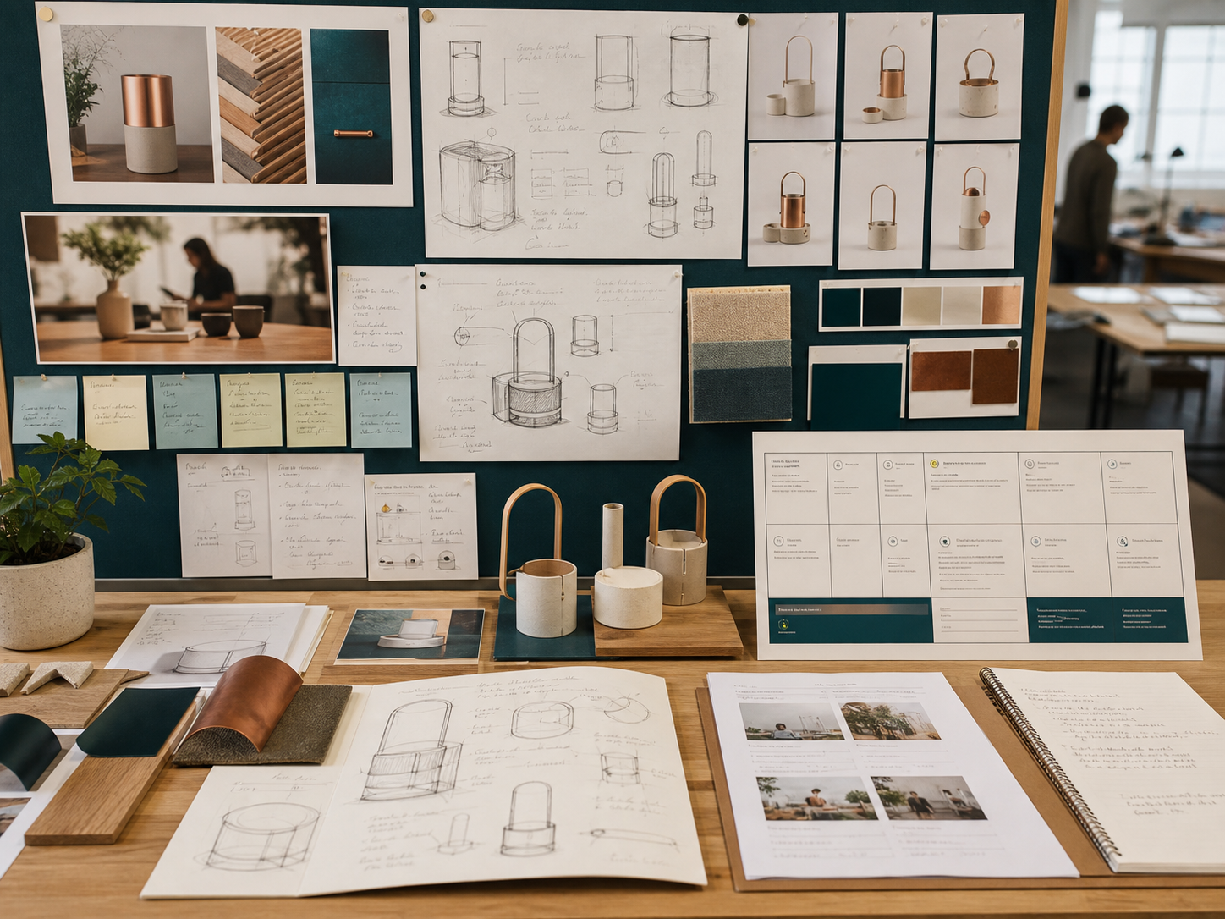
Figure 3. Illustrative design iterations and evidence records. Their variety suggests a process to investigate; it does not prove why a real designer made a decision.

Worked observation
Use a claim → source → corroboration → limitation chain. For “the redesign improved access”, identify what measure supports the claim, whose experience it covers and which other source tests it. Attractive concept photographs alone cannot establish access.

Test the story against evidence
Interviews can reveal stated intentions but may favour the designer's own account. Organisational reports can provide detail while selecting positive measures. Independent research, reporting, user evidence and documented outcomes help test those claims. Acknowledge sources so the reader can trace quotation, paraphrase and your analysis. If sources disagree, explain how that changes confidence rather than choosing only the convenient account.

CHECK YOUR UNDERSTANDING
What is a limitation of a designer interview?
A. It can reveal stated intentions but may present a favourable account.
B. It can never provide relevant evidence.
C. It automatically proves every outcome.
D. It removes the need for source acknowledgement.
What independent evidence could test a designer's claim that a redesign improved access?

Full reading and remaining practice: Module 03, section 01

03 / INNOVATION CASE STUDY

Explain the context around a design
Historical, cultural, political and economic influences

Restore the uncertainty of the time
Historical context includes earlier technologies, established practices, prior attempts and significant events. Explain why a condition mattered to a decision, rather than adding a decorative timeline. Avoid hindsight: an outcome that now seems familiar was not always inevitable. Sources from the period may reveal what designers could know, which alternatives were available and which limits shaped action.

Examine culture and political conditions
Values, practices, identities and expectations can affect how a design is interpreted. Evidence about one community does not justify a fixed stereotype about another. Political priorities, policy, funding and the distribution of power to make decisions can enable action, establish safeguards or affect trust. Ask whose interests are represented and whose are overlooked. Influence can run both ways when an innovation changes community practices or public debate.

Connect economic influences
Capital, labour, skills, infrastructure, supply, price, demand and service models can affect development and access. Economic reasoning should explain a mechanism, not reduce the case to “profit caused it”. Investment may respond to social demand, policy, technical readiness or environmental pressure. Distinguish an enabling condition from a demonstrated cause. Weigh the strongest supported influences and keep alternative explanations visible when evidence is limited.
Historical | What was possible and known then?
Cultural | Whose values and practices matter?
Political | Who sets conditions and decides?
Economic | Which resources enable or constrain action?

Worked reasoning
Fictional causal chain: a dispersed community needs access; local expectations favour supported first use; funding enables assistance; available skills shape delivery. This is a possible interaction to test, not a universal sequence or evidence that one factor caused every outcome.

CHECK YOUR UNDERSTANDING
Which is an economic influence?
A. Availability of investment, skills, supply and affordable access
B. A belief that profit explains every decision
C. A cultural stereotype
D. An unsupported prediction
Choose two influences in the example and explain how they interact.

Full reading and remaining practice: Module 03, section 02

03 / INNOVATION CASE STUDY

Judge impact within an evidence boundary
Ethical, environmental and Australian societal impact

Ask who benefits and who decides
Ethical evaluation links a design decision to stakeholders, a mechanism and a relevant principle such as fairness, access, privacy or accountability. Good intentions do not settle the effect. A convenient service for one group may reduce choice for another. Compare perspectives and decision-making power, rather than treating a generic ethics list as a judgement.

Follow the life cycle
Impacts can occur in extraction, production, distribution, use, maintenance and end-of-life. A benefit at one stage may move a burden elsewhere. Identify the affected resource, emission, waste stream or behaviour and its comparison baseline. A reduced use-phase demand does not prove that production or disposal is harmless. If evidence covers only one stage, limit the conclusion to that stage.

Keep the Australian context specific
An Australian societal claim needs evidence situated in Australia; overseas success cannot simply be assumed to transfer. Geography, access, skills, public systems and community priorities can vary. Regional and metropolitan experiences may differ, as may experiences within either group. Connect ethical and environmental findings to documented outcomes, separating realised effects from future possibilities. The fictional illustration below rehearses these boundaries. Page 14 requires a studied real innovation and traceable Australian evidence; the invented illustration is not its evidence set.
Ethics | Access, choice and support burden
Environment | Repair evidence, incomplete life cycle data
Society | One fictional regional setting, not all Australia

Worked reasoning
Fictional regional Australian tool-library trial: borrowing rose from 40 to 65 loans per month after assisted booking began. Three interviewees without reliable internet still needed staff support. Repair records show four tools returned to use; energy, transport and end-of-life effects were not measured. These invented records support bounded practice, not a real-world impact claim.

CHECK YOUR UNDERSTANDING
Why avoid treating Australian society as one uniform user group?
A. Because access, geography, culture and priorities may vary.
B. Because no Australian evidence is usable.
C. Because only overseas users matter.
D. Because impact can never be evaluated.
Identify one supported trial finding and one environmental claim the data cannot establish.

Full reading and remaining practice: Module 03, section 03

03 / INNOVATION CASE STUDY

Evaluate the innovation’s impact
Formative practice only
Use a real innovation you have studied and traceable Australian evidence. Identify the innovation and sources in your opening lines. The fictional page 13 example is not the evidence for this response.
Evaluate the ethical, environmental and Australian societal impact of an innovation using stakeholder, life-cycle and evidence boundaries.
• Identify affected stakeholders, benefits, risks and decision-making power.
• Trace an environmental effect across relevant life-cycle stages and a baseline.
• Use Australian evidence and recognise variation within society.
• Distinguish realised impact from future possibility before judging.
Your response should
• Applies ethical principles to specific mechanisms and stakeholders.
• Uses a bounded life-cycle comparison rather than a vague sustainability claim.
• Reaches a balanced, Australian-context judgement proportionate to evidence.
Within the documented Australian context, the innovation has ... although ...

Full reading and remaining practice: Module 03, section 03

04 / MDP PROPOSAL AND SUCCESS CRITERIA

Build a proposal around an evidenced need
Need identification, target users and design situation

Test the starting observation
An observation can suggest a need but is not yet proof. Investigate who experiences the issue, when it occurs, its consequences and how existing responses perform. Evidence may narrow or challenge the initial idea; that can prevent a long project aimed at the wrong problem. State the gap or desired improvement without announcing a product, and avoid assuming that every person has the same experience.

Distinguish users and stakeholders
Target users most directly guide the response. Other stakeholders may maintain, purchase, regulate, support or be affected by it. Both groups matter, but their evidence has different roles. Base descriptions on relevant goals, routines, access conditions or abilities rather than stereotypes. Synthesise patterns responsibly, without exposing unnecessary personal information, and follow consent arrangements approved by your teacher for real research.


Figure 4. Illustrative observation, interpretation and design situation records. Use evidence to connect these stages; the depicted notes are not actual user data.

Worked observation
Fictional context for pages 16–18: first-time visitors at a community booking point sometimes cannot identify the next step. Existing staff help works, but demand varies. Investigate visible guidance and continued access to assistance; no particular product or numerical performance target has been approved.

Bound the situation
Connect the need, users, setting and intended improvement into a manageable investigation. These boundaries should guide research, not invent product dimensions or specifications. Recognise what already works and what remains unknown. A strong situation supports several different concept directions while still being specific enough to investigate. The next step is to turn those unknowns into questions that can change decisions.

CHECK YOUR UNDERSTANDING
What protects user research from stereotyping?
A. Basing relevant characteristics on evidence and acknowledging variation
B. Assuming age determines every preference
C. Collecting unnecessary personal details
D. Using one comment as a universal truth
Name a target user and another stakeholder in the fictional context.

Full reading and remaining practice: Module 04, section 01

04 / MDP PROPOSAL AND SUCCESS CRITERIA

Plan research that can change a decision
Areas of investigation and an evidence plan

Turn unknowns into questions
An area of investigation should identify what must be learnt and which decision it can influence. Replace a broad heading such as “users” with a focused question about a priority, an access issue or a comparison. If the answer cannot change or justify a decision, it may be low priority. Questions can develop as early evidence reveals new uncertainty.

Prioritise the important unknowns
Judge importance, uncertainty and timing together. Investigate a high-impact question needed before concept selection ahead of a minor presentational detail. Dependencies matter: one answer may determine which later questions are relevant. This is a living plan, not a long static checklist. Explain why some areas receive deep investigation and others a proportionate scan.

Plan the output as well as the method
Match the question to suitable sources or methods, ethical considerations and an analysis output. A ranked needs summary, comparison or annotated observation is more useful than an unprocessed folder of material. Plan how evidence will be interpreted without writing the hoped-for answer in advance. As findings arrive, record whether they confirm, complicate or change the question. The fictional cards below are for the complete repair task on page 18.

Fictional criterion cards and concepts for page 18
1. Visitors can identify the next booking step without an explanation.
2. It should look good.
3. It must be exactly 200 mm wide.
4. The next booking action is recognisable to visitors.
5. It must be completely sustainable.
6. Staff assistance remains available when required.
Concept A: a clear step sequence with an assistance option, but more information to scan.
Concept B: a minimal display with a striking appearance, but no visible assistance route.

Worked reasoning
For the page 15 situation, a question about finding the next step might use approved observation and visitor explanation. Analyse hesitation and confusion, then use the conclusion to refine an access criterion. More pages of unrelated product information would not answer that question.

CHECK YOUR UNDERSTANDING
Why does more source material not automatically mean better evidence?
A. Evidence quality depends on relevance, credibility and how sources are compared.
B. Only one source should ever be used.
C. Sources never require analysis.
D. Quantity proves a predetermined result.
Which investigation would most directly test the stated access need?

Full reading and remaining practice: Module 04, section 02

04 / MDP PROPOSAL AND SUCCESS CRITERIA

Turn a wish into a usable criterion
Measurable criteria to evaluate success

Start with the need
Criteria translate a design situation into qualities the response should achieve. Derive them from user evidence, context, project purpose and investigation. Include functional, aesthetic, environmental, social or management qualities when they matter; do not fill generic headings for their own sake.

Make the judgement visible
A useful criterion names a quality, its context and evidence of achievement. Measurable does not always mean numerical. Observation, inspection, comparison or documented user judgement may be appropriate. Explain how evidence would distinguish meeting, partly meeting or not yet meeting the criterion.

Worked repair
Fictional context: a visitor needs to locate a booking point without staff directions. “The system should be good” does not identify the quality or its evidence.
Quality | Recognisable next step
Context | A first visit to the booking point
Evidence | Observe whether intended users identify the next step without an explanation
Boundary | Teacher-approved research conditions; the example sets no required sample size or performance threshold

Keep criteria useful throughout
Use criteria to compare concepts, prioritise research and choose tests. A concept may perform better on access but worse on another relevant quality; explain which matters most and why. Refine criteria when evidence changes understanding, and record the reason. Do not quietly reshape them to flatter a finished outcome.

Check the reasoning
The repaired criterion links the need to an observable user action. It does not prescribe a product. At evaluation, relate each criterion to evidence, degree of achievement and an implication. Avoid invented dimensions, standards or thresholds; seek the appropriate authority when a requirement is unknown.

CHECK YOUR UNDERSTANDING
Why is quietly rewriting criteria at the end a problem?
A. It makes them more accurate automatically.
B. It saves too much time.
C. It shapes the reference to flatter the outcome instead of testing it independently.
D. Criteria can never be refined.
Why is the evidence method in the worked repair more useful than “users will like it”?

Full reading and remaining practice: Module 04, section 03

04 / MDP PROPOSAL AND SUCCESS CRITERIA

Criterion repair lab
Formative practice only
Use the fictional context on page 15 and the criteria and concepts on page 16.
1. Diagnose six fictional criteria as relevant, vague, duplicated or unsupported.
2. Rewrite four using quality, context and evidence.
3. Use the revised set to compare two fictional concepts.
4. Record one trade-off and explain which criterion deserves priority.
Card 1 | Card 2 | Card 3 | Card 4 | Card 5 | Card 6

Card | Repaired criterion: quality, context and evidence
___
___
___
___

Your revised criterion | Concept A | Concept B
1.
2.
3.
4.

Trade-off and justified priority

A criterion need not contain a number, but it must make the basis of judgement visible and trace back to the need.
Full reading and remaining practice: Module 04, section 03

05 / RESEARCH METHODS AND ETHICAL EVIDENCE

Choose evidence to suit the question
Primary and secondary research choices

Create relevant firsthand evidence
Primary research is gathered for the current investigation. Interviews, surveys, observations and trials can reveal different things. An observation may show behaviour without explaining motives; an interview may describe an experience without showing what happens in use. The question, setting, participants, ethics and analysis plan determine the value of the method. A convenient small group may inform a local decision without representing every target user.

Evaluate existing knowledge
Secondary research draws on work created by others, such as official information, research, technical sources and documented cases. Consider authority, relevance, currency, method and purpose. A manufacturer may reliably describe a specification while having an interest in a superiority claim. An older source may explain history but not a current condition. Acknowledging a source makes it traceable; evaluating it determines how confidently it can support your claim.

Combine evidence around a decision
The two approaches complement one another. Existing research can frame a question; appropriately authorised firsthand evidence can examine how it applies in a local context. Agreement may strengthen a conclusion, while a difference can reveal an important gap. State the decision, why the method fits, what will be analysed and what the result could change. Do not choose a method simply to add variety to a folio.
Interview | Stated experiences and explanations
Observation | Actions in a specified context
Existing research | Wider knowledge and comparison points
Joint conclusion | What agrees, differs or needs testing?

Worked reasoning
Fictional investigation: published information may explain an established access principle, while an approved observation tests whether a proposed sequence is understandable in the local setting. Together they can inform a criterion. Neither source type automatically overrides the other.

CHECK YOUR UNDERSTANDING
What makes a secondary source useful?
A. It is the first search result.
B. It is long.
C. It agrees with the preferred idea.
D. Its authority, relevance, currency, method and purpose fit the claim.
Give one reason to combine a credible secondary source with local primary evidence.

Full reading and remaining practice: Module 05, section 01

05 / RESEARCH METHODS AND ETHICAL EVIDENCE

Keep evidence credible and ethical
Data quality, bias, consent and source acknowledgement

Match quality to the claim
Relevant evidence addresses the question; credible evidence has a trustworthy method or source; sufficient evidence supports the size of the conclusion. Accurate records preserve what was actually reported or observed. Limits in time, sample or access do not make all research useless. Narrow the claim, compare evidence where useful and record uncertainty. Variation may be a finding rather than an error to remove.

Find the likely bias
Leading wording, a convenient sample, the setting or selective interpretation can distort results. Confirmation bias means favouring evidence that supports a preferred idea. Use neutral questions, appropriate sampling, original records and contrasting evidence to manage it. Explain the likely consequence of bias instead of declaring that it is absent. Removing inconvenient responses can make an apparently tidy summary misleading.

Respect people and sources
Within teacher-approved arrangements, participants should understand the purpose, what participation involves and how information will be used. Participation should be voluntary and data collection proportionate. Collect only necessary information, protect identity and follow directions for sensitive contexts. Acknowledge other people's ideas, words, images and data as evidence is used. Distinguish quotation, paraphrase and your own analysis. A citation does not make a poor source reliable.
Quality | Is the evidence fit for this claim?
Bias | What might distort collection or interpretation?
Ethics | What information and permission are actually needed?

Worked reasoning
Fictional proposal for page 22: a designer asks five friends, “You agree this is the best layout, don't you?”, records their names, discards a negative comment and concludes that all visitors prefer the layout. No purpose, permission or intended use of the data is explained. This is a scenario to critique, not an authorised research method.

CHECK YOUR UNDERSTANDING
What should meaningful consent include?
A. Understanding purpose, participation and use within teacher-approved arrangements
B. A hidden purpose
C. Pressure to participate
D. Collection of every possible personal detail
Identify one bias and the effect it could have on the conclusion.

Full reading and remaining practice: Module 05, section 02

05 / RESEARCH METHODS AND ETHICAL EVIDENCE

Make a finding change the design
Analysing findings and applying conclusions

Organise without erasing variation
Check and organise evidence so patterns can be examined. Quantitative records may be grouped or summarised; qualitative comments may be coded into themes. Keep original records, explain categories and note missing information. A chart is not automatically a conclusion. Its categories and sample must make sense, and inconvenient responses should not disappear simply because they complicate the preferred story.

Interpret before deciding
Look for agreement, variation, unusual cases and conflicts between methods. A majority pattern can be useful while a minority experience exposes an access problem. Repeated co-occurrence alone does not prove causation. Ask whether the method supports the inference and whether another explanation is plausible. Phrases such as “within this sample” help keep conclusions proportional when the evidence has a limited reach.

Make the design implication explicit
State the finding, why the evidence supports it, the limitation and the resulting decision. A conclusion may change a criterion, trigger a focused investigation or alter how concepts are compared. Do not jump from one observation to a complete specification without reasoning. Record evidence → finding → conclusion → decision → next evidence. If a competing criterion prevents following the strongest finding, explain the trade-off rather than hiding it.
Result | Three of five hesitated
Interpretation | Possible clarity issue in this trial
Decision | Compare a clearer sequence
Next check | Observe whether the change helps

Worked reasoning
Fictional observation: three of five first-time visitors hesitate at the same prompt. This suggests a clarity issue under the tested conditions. Compare a clearer sequence before committing to it. The result does not prove that every visitor will hesitate or that one feature caused the difficulty.

CHECK YOUR UNDERSTANDING
Which sequence best traces research into design?
A. Decision, evidence, assumption, decoration
B. Evidence, finding, conclusion, decision, next evidence
C. Opinion, product, research, criterion
D. Chart, page count, final claim
What next evidence would test whether the proposed clearer sequence helps?

Full reading and remaining practice: Module 05, section 03

05 / RESEARCH METHODS AND ETHICAL EVIDENCE

Evaluate the proposed research
Formative practice only
Use the source teaching and the practice material on page 20.
Evaluate the quality and ethics of a proposed research approach, then recommend changes that make its conclusions more credible and proportionate.
• Assess relevance, credibility, sufficiency and record accuracy.
• Identify bias in wording, sampling or interpretation and explain its likely effect.
• Address consent, privacy and minimum necessary data under teacher direction.
• Explain how source acknowledgement and a narrowed claim improve trustworthiness.
Your response should
• Links each weakness to its likely effect on evidence.
• Recommends practical, ethical improvements without inventing local permission.
• Matches the final claim to the evidence's limits.
The proposed evidence is useful for ..., but its credibility is limited by ...

Full reading and remaining practice: Module 05, section 02

06 / PROJECT MANAGEMENT

Make the next action genuinely ready
Action planning and dependency control

Plan outputs rather than vague effort
An action should be specific enough to begin, finish and check. “Do research” hides the question and deliverable; “compare evidence and record a conclusion for concept selection” identifies both. Include investigation, analysis, evaluation, communication and evidence capture as well as authorised production. A plan listing only making steps leaves important decisions without time or evidence.

Control dependencies
An action may depend on information, approval, access or an earlier result. A decision point checks whether those conditions exist before work proceeds. It is a planning device, not a new school checkpoint. Concept selection might wait for user evidence, and final evaluation needs criteria and suitable records. Actual project operations, resources and permissions remain teacher controlled.

Revise the plan transparently
New evidence can add a task or remove one that is no longer relevant. Record the original assumption, the change, its reason and the effect on later work. Prioritise work whose dependencies are satisfied and whose output reduces important uncertainty. Revision shows active control; quietly replacing the old plan removes the management trail. Use the generic cards below in the schedule activity on page 26. Their session ranges are fictional practice estimates, not your timetable.

Generic action cards for page 26
A. Clarify the question: 1–2 sessions.
B. Prepare a comparison after A: 1 session.
C. Collect authorised evidence after B: 2–3 sessions.
D. Interpret the evidence after C: 1 session.
E. Decide and record the next refinement after D: 1 session.

Worked reasoning
A finished concept sketch does not make selection ready if the priority user question remains unanswered. Complete or narrow that investigation first, while progressing genuinely independent documentation work.

CHECK YOUR UNDERSTANDING
Which action is ready next?
A. One whose required approval is unknown
B. One whose dependencies are met and which advances a critical output or reduces uncertainty
C. The easiest action regardless of purpose
D. Any action involving an assumed resource
Link two cards where one output is needed before the next action; explain the dependency.

Full reading and remaining practice: Module 06, section 01

06 / PROJECT MANAGEMENT

Respond to delay without hiding it
Time planning, milestones and variance

Estimate from the action plan
A useful time plan identifies duration, dependencies and sequence. Include design reasoning and evidence work, not only production. Use ranges for unfamiliar work and revise estimates after early evidence. Some actions can overlap, while others must remain sequential. Do not count the same available time twice. A buffer can absorb ordinary variation but cannot repair an unrealistic underlying plan.

Use an evidence milestone
A milestone should reveal an achieved deliverable, decision or authorised condition. “Research conclusions recorded and criteria updated” is more informative than “week finished”. Milestones make a long project reviewable and expose whether the evidence for the next phase exists. Align actual dates and periods with the teacher-confirmed calendar; this practice model supplies no official checkpoint dates.

Analyse variance and its consequences
Variance is a difference between planned and actual progress, duration or sequence. Judge its cause and effect before responding. A small delay may be manageable; a growing delay on a critical dependency may threaten later work. Compare resequencing independent work, narrowing low-value scope, seeking authorised support or improving an estimate. Record the response and revised downstream effect. Never hide delay by removing necessary evidence, quality checks or approval.

Three response options for page 26
1. Delete the remaining evidence collection and keep the original finish claim.
2. Resequence independent record organisation while revising the dependent milestones.
3. Seek teacher direction on a narrower, still valid investigation before revising the plan.

Worked reasoning
Use page 23's cards. Fictional delay: action C takes two sessions longer than estimated. Page 26 asks you to compare the three responses shown here, then justify a revision. The quickest-looking option may weaken the decision evidence.

CHECK YOUR UNDERSTANDING
When does variance most need action?
A. Whenever any estimate differs slightly
B. When it affects a critical dependency or threatens later work
C. Only after the project ends
D. When hiding it is easiest
Which dependency carries the delay into later work?

Full reading and remaining practice: Module 06, section 02

06 / PROJECT MANAGEMENT

Show what changed in the resource plan
Finance planning, resource decisions and revision

Make the estimate transparent
A finance plan records relevant resource categories, quantity assumptions, price sources and uncertainty. A single unexplained total hides which assumption changes. Use a range or pending decision where quantity or cost is not confirmed. Include ancillary costs when they are evidenced and relevant. The learning model does not prescribe suppliers, materials, quantities or a spending limit; those belong to the authorised project context.

Compare value against criteria
The lowest price does not automatically offer the best value. Consider suitability, availability, durability, maintenance, waste and the priority criteria. Compare alternatives on the same basis. A cheaper option may need more replacement; an expensive option may add no useful benefit. Technical suitability and safe use still require authoritative information and teacher direction. Claims about whole-of-use value need evidence rather than a price label.

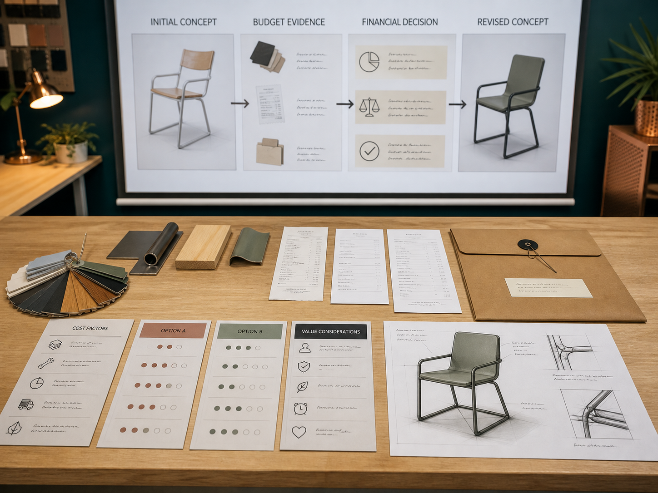
Figure 5. Illustrative estimates and concept revision. Keep the evidence for a cost decision visible; the pictured records provide no actual prices or approved resource list.

Worked observation
Fictional planning example: an estimate assumes two units at $15 each. Later evidence requires three, making the estimate $45 before any other confirmed cost. The quantity assumption changed; calling this only a price increase would hide the cause. No purchase or material choice is authorised by the example.

Track actuals and revise visibly
Replace estimates with actual costs when confirmed and explain variance. It may arise from quantity, availability, scope, source or an earlier estimation error. Compare responses without quietly compromising a critical criterion or using an unapproved substitute. Preserve the original estimate, new evidence, decision and effect on criteria, time and waste. Repeated variance can reveal a weak estimating assumption that should be corrected in future planning.

CHECK YOUR UNDERSTANDING
What should happen before responding to variance?
A. Hide the difference
B. Choose the cheapest substitution immediately
C. Identify the cause and effect on criteria, time and resources
D. Invent a larger budget
What changed in the example, and what should be checked before choosing a response?

Full reading and remaining practice: Module 06, section 03

06 / PROJECT MANAGEMENT

Schedule recovery room
Formative practice only
Use the action cards on page 23 and the delay and response options on page 24.
1. Build a generic timeline from action and duration-range cards.
2. Add evidence milestones and identify the critical dependency chain.
3. Introduce a delay scenario and compare three response options.
4. Record the chosen revision, reason and effect on later work.
Generic timeline: show action IDs, duration ranges, dependencies and evidence milestones
Timeline and milestones

Response option | Effect on evidence and later work
1
2
3

Chosen revision, reason and downstream effect

The fastest-looking option is not automatically best; protect evidence, quality and teacher-controlled requirements.
Full reading and remaining practice: Module 06, section 02

07 / CREATIVITY AND CONCEPT DEVELOPMENT

Widen the field before selecting
Divergent thinking and purposeful idea generation

Generate meaningful alternatives
Divergent thinking deliberately produces different possibilities before choosing a direction. Its purpose is to find better responses to an evidenced need, not to fill a page with unusual shapes. Colour changes alone may leave the same underlying concept. Difference can come from interaction, arrangement, adaptation, production, resource use or experience. Temporarily separating generation from judgement gives unfamiliar ideas enough attention to reveal a useful principle, while the need still provides a boundary.

Change a variable or viewpoint
Ask what could be combined, separated, rearranged, simplified or adapted for another user. Consider a user's, producer's, maintainer's or community's perspective when relevant. These prompts open thinking rather than prescribe answers. Choose a representation that reveals the idea: views for a spatial relationship, a sequence for a service interaction, or a user journey for an interface. Explain what changed and why it could matter.

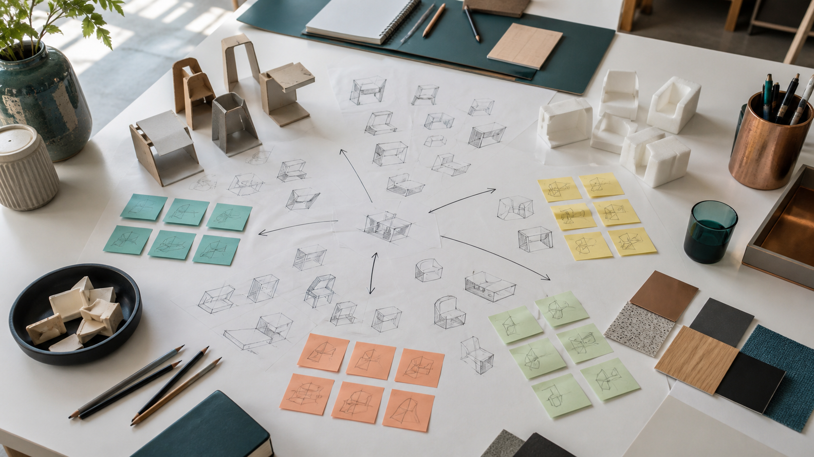
Figure 6. Illustrative concept field using sketches and rough models. The important variation is in relationships and arrangements, not the colour of the notes.

Worked observation
Illustrative variation: moving a cue earlier in a journey changes timing; separating information changes arrangement; adapting the interaction changes how a user responds. These may share a useful clarity principle without being four recoloured copies of one layout.

Record development rather than decoration
A concept record should identify its stimulus, show distinct alternatives and connect features to users, criteria or findings. “Looks good” does not reveal this reasoning. A rejected idea may still contribute a useful feature to another direction. Preserve the early possibility, the observation or feedback, the change and its reason. The four-concept activity on page 30 asks for that evidence trail, not resolved production drawings or a predetermined MDP solution.

CHECK YOUR UNDERSTANDING
Which representation is most useful for exploring a sequence of user interactions?
A. A sequence or user journey showing steps and decisions
B. A colour swatch with no interaction notes
C. A final verdict written before the sequence is mapped
D. A list of unrelated product names
Name one meaningful variable you could change without prescribing the final solution.

Full reading and remaining practice: Module 07, section 01

07 / CREATIVITY AND CONCEPT DEVELOPMENT

Make a trade-off visible
Factors affecting design decisions

Identify factors that matter here
A design decision sits within people, place, purpose and conditions of use or maintenance. Relevant factors might include access, comfort, culture, available information and relationships with other services. A factor earns attention when it can change a decision. Evidence that users miss a control may prompt changes to position, form or feedback; it does not automatically dictate one solution. Avoid copying a generic factor list without explaining its local significance.

Explain interacting qualities
Performance, resources, production, cost, durability and environmental effects often interact. Improving one quality can weaken another. Name the qualities in tension, then use criteria and evidence to explain the chosen balance. Lower initial cost may conflict with maintenance or useful life. Ethical questions concern who benefits and who carries burdens; environmental reasoning considers the life cycle. Social and cultural claims need respectful evidence, not assumptions about a group.

Trace the factor into a change
Show evidence → issue → priority → feature or investigation → expected effect. This makes the decision reviewable and gives later testing a clear job. Different factors may matter at different stages; new evidence can justify revisiting an earlier choice. Keep the earlier reason and later revision visible rather than making the final concept appear inevitable. There is no universal ranking that makes one factor dominate every design situation.
Evidence | Some visitors need an explanation
Priority | Keep access visible
Change | Compare an assistance option
Check | Access benefit and support burden

Worked reasoning
Fictional trade-off: adding an assistance option may improve access but increase staff demand. Investigate both effects, then decide their significance against the established need. Removing assistance solely to make the interface look simpler would leave the access question unanswered.

CHECK YOUR UNDERSTANDING
Which chain makes a factor's influence traceable?
A. Preference to decoration to final claim
B. Evidence to issue to priority to change to expected effect
C. Checklist to copied statement to approval
D. Final feature to unexplained certainty
What evidence would help judge the trade-off in the example?

Full reading and remaining practice: Module 07, section 02

07 / CREATIVITY AND CONCEPT DEVELOPMENT

Choose a direction you can justify
Selecting and justifying a direction

Use a shared comparison basis
Compare alternatives using the same relevant criteria and evidence. Judging one for access and another only for appearance cannot establish which better meets the need. Criteria should come from the situation and investigation, not be invented to favour a preferred sketch. Explain which are essential and which desirable. A score can organise a comparison, but it can also imply precision that the evidence does not support.

Distinguish observation from prediction
User evidence, concept feedback, rough models and credible secondary sources can inform selection. A concept image may suggest how a feature could work; it cannot prove untested performance. Explain what the evidence establishes and where confidence remains limited. A preferred direction can be the strongest current possibility while still needing a specific test. This is more useful than declaring it perfect.

Write a reviewable decision
Name the chosen direction, compare credible alternatives, connect reasons to criteria and explain the trade-off. Record useful elements retained from another idea and the next investigation needed. Later evidence can confirm, refine or challenge the choice. Preserve what was known when the decision was made instead of rewriting the record around the final result. Selection gives development direction while leaving its assumptions open to testing.
Choose | The strongest current direction
Justify | Shared criteria and relevant evidence
Qualify | Trade-off and uncertainty
Investigate | The next decision-relevant question

Worked reasoning
Fictional selection: concept A makes the next action clearer in early feedback, while B uses less display space. Prefer A provisionally because access is the priority, retain B's concise wording and test whether the combined version creates excessive scanning. The prediction remains a question to investigate.

CHECK YOUR UNDERSTANDING
What should a clear selection statement include?
A. Only the name of the chosen concept
B. Chosen direction, comparison, evidence, trade-offs and next investigation
C. A claim that every feature is final
D. A rewritten history in which no alternatives existed
What makes the example a provisional decision rather than an unsupported preference?

Full reading and remaining practice: Module 07, section 03

07 / CREATIVITY AND CONCEPT DEVELOPMENT

Change the variable
Formative practice only
Use the source teaching and the practice material on page 27.
1. State the need without naming a preferred solution.
2. Select four different prompts such as rearrange, adapt for another user, simplify or change the interaction.
3. Create one quick concept response to each prompt using an appropriate representation.
4. Annotate what changed, who could benefit and what still needs evidence.
5. Identify two ideas that share a promising principle and explain a possible combination.
The need I am exploring

Prompt 1 __________________  Show the concept; annotate change, benefit and evidence needed | Prompt 2 __________________  Show the concept; annotate change, benefit and evidence needed
Prompt 3 __________________  Show the concept; annotate change, benefit and evidence needed | Prompt 4 __________________  Show the concept; annotate change, benefit and evidence needed
Two ideas with a promising shared principle and a possible combination

A strong set is not judged by artistic finish. Check whether each response changes a meaningful relationship and whether the annotation explains its possible value.
Learning practice, not a prescribed MDP solution or authenticated assessment record.
Full reading and remaining practice: Module 07, section 01

08 / EXPERIMENTATION AND PROTOTYPING

Make the prototype answer a question
Planning useful experiments and prototypes

Begin with uncertainty
A prototype is a representation built to learn something. Start with a question that could change a decision, rather than “make a model”. Ask what must be learnt about an interaction, arrangement, form or material characteristic. A useful investigation allows evidence to challenge the preferred idea.

Match detail to the question
A rough spatial model can compare arrangement; paper screens can explore information flow. More resolution may be needed for a question about fit, response or finish. Detail that does not help answer the question makes revision harder. One prototype cannot establish every aspect of final performance.

Worked investigation
Hypothetical question: can a user recognise the next step in a booking sequence without extra explanation? Compare two paper-screen arrangements before investing in a working interface.
Change | Location of the next-step control
Keep consistent | Wording, task, screen size and facilitator instruction
Observe | First action, hesitation and explanation needed
Limit | Paper cannot reproduce the final response speed or access conditions

Plan the evidence before testing
Identify the changed factor, the observation and the conditions that should remain reasonably consistent. Plan a record such as labelled notes, a table, sketches, photographs or appropriate measurements. More than one observation can expose an unstable result, but the method must suit the question. Decide in advance what would challenge the current idea.

Check the claim
If the paper sequence supports one arrangement, that informs a navigation decision. It does not prove the finished service works reliably. Record the question, comparison, evidence, limitation and next decision. Actual methods and conditions require teacher authorisation.

CHECK YOUR UNDERSTANDING
Why can repeated observations be useful?
A. They guarantee the preferred conclusion
B. They help reveal whether an apparent result is stable or accidental
C. They remove the need to define what is observed
D. They make every investigation scientifically identical
Which limitation above would need a more resolved prototype to investigate?

Full reading and remaining practice: Module 08, section 01

08 / EXPERIMENTATION, PROTOTYPING AND TESTING

Record enough to judge the result
Recording results and testing against criteria

Make the record understandable
Record the question, alternatives or conditions, observations and relevant limitations. Labels and dates within your process can help reconstruct the sequence without relying on memory. Include unexpected or unfavourable results. A photograph needs a caption that identifies the relevant feature; a user comment needs a task and context. A single comment may reveal an issue without representing all users.

Connect evidence to a criterion
Translate a broad criterion into an observable indicator. Ease of use might involve hesitation, errors or understanding a sequence, depending on the authorised investigation. Present alternatives without steering participants and record them on a comparable basis. Evidence can show achievement, partial achievement or a need for a better test. These are judgements about development evidence, not the person's worth.

Check quality before action
Relevant evidence addresses the actual criterion. Consistent collection makes comparison possible, and sufficient evidence supports the scale of the claim. An exploratory trial may reveal a worthwhile question without proving final performance. Combining observations, explanations and prototype evidence can strengthen reasoning. Disagreement is useful when it identifies an uncertainty to resolve. Separate what happened from what you infer, then identify the next decision. Use the question cards below on page 34.

Question cards for page 34
Q1. How does a choice on the first screen affect what must appear next?
Q2. Can a visitor recognise the next action without an explanation?
Q3. Where can information sit to reduce backtracking?
Q4. Does a proposed form leave space for the intended objects?
Q5. Does the functioning service respond reliably in likely conditions?

Worked reasoning
A record of repeated hesitation can support a focused clarity investigation. It cannot by itself establish the cause. Add the prompt, comparable conditions and the visitor's explanation before deciding what feature to change.

CHECK YOUR UNDERSTANDING
What is a defensible response to ambiguous evidence?
A. Choose the preferred interpretation without noting uncertainty
B. Claim the criterion has been fully met
C. Identify why the evidence is unclear and plan a better test
D. Remove the evidence from the record
Which question card would a paper sequence answer more usefully than a finished appearance render?

Full reading and remaining practice: Module 08, section 02

08 / EXPERIMENTATION, PROTOTYPING AND TESTING

Refine the cause and test the effect
Using conclusions to refine the design

Write a bounded conclusion
A result states what happened; a conclusion explains what that evidence means for a question and criterion. Repeated hesitation may suggest that a sequence is unclear under the tested conditions. It does not prove that all users will always struggle. Where indicators or evidence types conflict, explain what each reveals and which priority matters. Do not average away a conflict simply to produce a tidy answer.

Make a focused change
Name what will change, the evidence behind it and the expected effect. Target a plausible cause instead of polishing an unrelated feature. Altering many variables at once can obscure which change made a difference. Some weaknesses need a small revision; stronger evidence about a critical criterion may require another direction. Match the scale of the response to the significance and reliability of the evidence.

Close the learning loop
Use question → evidence → conclusion → change → re-evaluation. Keep the version before change, the reasoned modification and the later result. Re-evaluation checks both the intended improvement and any new effects. Sometimes evidence supports retaining the original feature because the alternative adds no useful benefit or creates a worse trade-off. Responsive development means justified decisions, not constant alteration. Preserve the learning so the final outcome can be understood as a sequence of tested choices.
Before | Version and uncertainty
Change | Evidence-led modification
After | Observed improvement or new problem
Decision | Retain, refine, reject or investigate

Worked reasoning
Fictional trial: moving a prompt improves recognition but makes another message harder to see. The conclusion should acknowledge both effects. A next comparison could adjust their relationship while keeping other conditions stable; it should not claim that the first change solved the whole interface.

CHECK YOUR UNDERSTANDING
What is the complete refinement loop described in the theory?
A. Preference, decoration, final claim
B. Question, evidence, conclusion, change and re-evaluation
C. Concept, score, submission
D. Problem, many changes, no record
What should the next comparison hold reasonably consistent, and why?

Full reading and remaining practice: Module 08, section 03

08 / EXPERIMENTATION, PROTOTYPING AND TESTING

Prototype with a purpose
Formative practice only
Use the source teaching and the practice material on page 32.
1. Sort question cards into relationship, interaction, arrangement, form or performance categories.
2. Match each question to a possible evidence type and a low-detail prototype or experiment form.
3. Identify the changed factor, observation and consistency needs for one comparison.
4. Write one limitation that prevents an overclaim.
5. Swap plans and check whether the proposed result could actually inform the named decision.
Question | Category | Possible evidence | Prototype or experiment form
Q1
Q2
Q3
Q4
Q5

Selected question | Changed factor | Observation | Keep consistent

Limitation that prevents an overclaim

Peer check: could the result inform the named decision?

There can be several valid investigation forms. Choose the one that can produce relevant evidence with the least unnecessary detail.
Full reading and remaining practice: Module 08, section 01

09 / PRODUCTION, RESOURCES AND QUALITY

Choose resources for their evidence-led role
Resource selection and responsible use

Start with the required job
Resources include materials, information, time, skills, technologies, energy, spaces and authorised support. Ask what a resource must enable, which criteria it affects and which limits it introduces. Familiarity and availability may matter without proving fitness for purpose. Begin with requirements rather than a brand or preferred technique. Relevant evidence can come from approved investigation, reliable sources, comparisons and prototype learning.

Consider the resource life
Responsible use includes obtaining, using, maintaining and dealing with resources later, within the available evidence. Consider waste, durability, repair, replacement, transport and energy where relevant. A longer-lasting option may need more initial input, and a digital service still depends on devices and energy. A single environmental label does not establish responsibility. Explain the benefit, burden and boundary of the comparison.


Figure 7. Illustrative resource samples and a concept object. Texture and form can be observed; suitability, safety and life cycle impact require additional evidence.

Worked observation
Illustrative comparison: two resources may look similar but differ in maintenance, availability or evidence of performance. Record the requirement first, then compare those qualities using credible information. The photograph shows observable samples, not a verified specification or a recommendation to use them.

Keep the decision traceable
State the requirement, alternatives, evidence, trade-off and selected resource or service. Identify what needs monitoring. Replace vague claims such as “best” or “eco-friendly” with a criterion and evidence. Revise when availability or testing changes the case, recording the new information and effect on the plan. Exact materials, equipment, PPE, facilities and practical procedures remain teacher approved. A generic resource discussion cannot authorise their use.

CHECK YOUR UNDERSTANDING
Why might a longer-lasting option still involve a trade-off?
A. It may require greater initial inputs even if replacement is reduced
B. Durability always makes every other factor irrelevant
C. A trade-off proves the option is unsuitable
D. Longer life can never affect resource demand
Name one quality that the photograph alone cannot establish for a resource choice.

Full reading and remaining practice: Module 09, section 01

09 / PRODUCTION, RESOURCES AND QUALITY

Put checks where decisions can still change
Production planning, safe practice and quality control

Plan the linked stages
A production plan identifies stages, dependencies, resources and evidence needs. Place checkpoints before a weak result can affect later work. At each, compare the current state with the relevant criterion, specification or approved plan and record the decision. A check only after completion cannot prevent earlier errors. The generic stage cards below describe planning and evidence, not an authorised practical method.

Keep authority situation-specific
Actual tools, materials, processes, PPE, supervision and risk controls require teacher and faculty approval. Stop before an unauthorised or changed condition and seek direction. Changes in resource, process, location or outside assistance belong at a review point. Off-site work and third-party services must be transparent and permitted. Timetable pressure and money already spent do not justify bypassing an approval or continuing under uncertain conditions.

Manage quality throughout
Quality control checks work against requirements while action remains possible. Quality assurance is the broader set of processes and records supporting consistency. Judge variation by its effect on function, appearance, dependencies and resources. The exact practical response remains authorised by the teacher. Record what was checked, the observed difference, the decision and its effect. These records make quality more than a final claim that the outcome is good.

Generic stage cards for page 38
A. Confirm the current approved requirements.
B. Check required resources, dependencies and authority.
C. Record progress in the authorised stage.
D. Compare current evidence with the relevant requirement.
E. Record the next decision and any approval needed.

Worked reasoning
If a recorded state differs from the approved reference, first identify the affected criterion and the decision requiring authority. Do not turn a general scenario into instructions for unknown equipment or a guessed tolerance.

CHECK YOUR UNDERSTANDING
How should outside assistance be treated?
A. As private and unrecorded help
B. As automatically permitted whenever useful
C. As transparent, authorised and appropriately acknowledged
D. As a replacement for the student's design decisions
Where would you place a quality check before a downstream action?

Full reading and remaining practice: Module 09, section 02

09 / PRODUCTION, RESOURCES AND QUALITY

Transfer a professional principle carefully
Industrial and commercial practice connections

Notice what changes with scale
Larger operations may coordinate repeated outputs, suppliers, logistics, maintenance, support, standards and financial risk. A small inconsistency can matter more when repeated many times. A school project has different purposes, resources and authority; it is not a miniature factory. The useful comparison is about principles such as defining requirements, controlling versions, checking quality and responding to evidence.

Connect the roles and systems
Design, technical development, production, finance, communication, distribution and service can depend on one another. A resource substitution may affect performance, cost, supply and maintenance together. Specifications, version control, reviews and records help people work from current information. A documented process does not guarantee a responsible outcome: evidence, judgement and accountability still matter. Commercial pressure can make trade-offs between time, quality, access and environmental effect visible.

State the limit of the transfer
Describe an observed practice, explain its purpose and effect, then identify a bounded lesson for your project. A version label can prevent use of an outdated decision; a review point can stop an error reaching a dependent stage. Neither proves that a classroom has replicated an industry's regulatory or contractual system. One organisation also does not represent every business. Use the scenario cards below with page 38's complete activity.

Decision scenarios for page 38
S1. Evidence matches the approved plan and all authorised conditions are unchanged.
S2. A record is incomplete, so the criterion cannot yet be checked.
S3. A proposed method or condition differs from what the teacher authorised.

Worked reasoning
A project can adopt the principle of version control by clearly identifying the current plan approved by the teacher. That does not create permission to amend the plan or claim compliance with an industrial quality system.

CHECK YOUR UNDERSTANDING
How can a review gate reduce risk?
A. It checks evidence before an error reaches a costly later stage
B. It guarantees no errors will occur
C. It replaces all professional judgement
D. It allows outdated versions to continue
What is one useful transfer from professional practice, and one limit?

Full reading and remaining practice: Module 09, section 03

09 / PRODUCTION, RESOURCES AND QUALITY

Stop, check or continue
Formative practice only
Use the stage cards on page 36 and the scenarios on page 37.
1. Order a generic set of production-stage cards and mark dependencies.
2. Add two quality checkpoints where evidence can still change the next step.
3. Sort scenario cards into continue under the plan, pause and check, or stop and seek teacher approval.
4. For one variation, record the observed state, affected criterion and decision question.
5. Review whether any answer accidentally prescribes a practical method and replace it with an authority-safe decision step.
Stage order and dependencies

Checkpoint | Evidence that can still change the next step
1
2

Scenario | Continue, pause/check or stop/seek approval | Reason
S1
S2
S3

Variation: observed state, affected criterion and decision question

Authority-safe revision of any accidental practical instruction

Focus on the relationship between evidence and the next decision. Any changed, unclear or unauthorised practical condition belongs at a teacher review point.
Full reading and remaining practice: Module 09, section 02

10 / COMMUNICATION AND FOLIO EVIDENCE

Choose a representation that does a job
Communicating ideas with the right technique

Begin with the reader's decision
Communication should let another person notice, compare or judge something important. A sketch can reveal early possibilities, an annotated drawing can explain a relationship and a model can clarify form or interaction. A comparison table can make reasons for a choice visible. Choose the technique for its evidence job rather than its polish. A representation needs a connected claim, not just a place in the folio.

Fit detail to the audience
An unfamiliar reader may not understand the designer's shorthand. Use readable scale, clear labels, contrast, captions and a logical order. Do not make essential meaning depend on colour, tiny text or an unexplained image. A perspective view can conceal an internal relationship, a table can flatten qualitative differences and a paragraph may not show a physical change. Recognising these limits helps you combine techniques deliberately.


Figure 8. Illustrative sketches, views, models, renders and samples. Each represents a different kind of information; these are not approved construction drawings.

Worked observation
In an illustrative design comparison, a view can show overall form while a separate view reveals relationships. Add a native caption explaining the evidence job. None of the images alone establishes durability, safety or real performance.

Build one coherent evidence unit
Pair a useful visual with a focused annotation and a concise reasoning statement. The caption identifies what is shown; the annotation directs attention; the explanation states why the feature matters. Each element should add information. Remove repeated screenshots and decoration that does not help a reader move from question to evidence to decision. Before keeping a page, test whether someone unfamiliar can identify what to notice and how it affected the project.

CHECK YOUR UNDERSTANDING
An unfamiliar reader cannot interpret abbreviations used throughout a folio page. What is the best response?
A. Keep them because the designer understands them
B. Replace or explain them with clear labels and context
C. Add more abbreviations for consistency
D. Remove every technical term
Choose two representations in the image and explain their different communication jobs.

Full reading and remaining practice: Module 10, section 01

10 / COMMUNICATION AND FOLIO EVIDENCE

Record the decision rather than only the activity
Documenting development, production and decisions

Make the reasoning recoverable
A useful record links question, evidence, decision, change and observed effect. “Worked on the model” names an activity but does not explain what prompted it. Identify the version or stage and select evidence that helps a reader follow the decision. An observation, test, comparison or source finding can be useful when its scope is clear. If evidence is incomplete, state the next question instead of inventing certainty.

Show the benefit and the cost
A decision needs a criterion and reason. Improving one quality may weaken another, add complexity or alter the plan. Record the competing effects rather than presenting only the benefit. Not every change succeeds. Explain what was learnt and whether a version was retained, revised or rejected. An unsuccessful attempt can still provide valid development evidence when its consequence is visible.

Select informative production records
Choose meaningful stages and specific captions, not long runs of similar photographs. Explain the relevant feature, reason for the action and effect on quality or the next step. Use before-and-after records when the change matters. Cross-reference a criterion, investigation or earlier decision when it clarifies continuity. The shuffled fictional cards below support page 42; their small trials do not establish a universal effect or prove a cause.

Shuffled fictional cards for page 42
A. CHANGE: the next-step prompt was moved earlier in the sequence.
B. QUESTION: why do first-time visitors hesitate?
C. EFFECT: a later group had 2 of 5 visitors hesitate; comparison conditions were not fully recorded.
D. EVIDENCE: 3 of 5 visitors hesitated at the original prompt.
E. DECISION: compare an earlier prompt, accepting less space for other information.

Worked reasoning
The reader should be able to reconstruct what changed, which evidence prompted it and what was learnt. A neat chronology without causal links remains an activity diary.

CHECK YOUR UNDERSTANDING
A change improves one quality but reduces another. How should it be documented?
A. Record only the improvement
B. Reject the change automatically
C. Explain both effects and the priority governing the decision
D. Describe the change without evidence
What limitation should accompany a claim that the changed prompt solved confusion?

Full reading and remaining practice: Module 10, section 02

10 / COMMUNICATION AND FOLIO EVIDENCE

Let the reader follow the evidence story
Building a coherent evidence story

Organise around project logic
A folio should let a reader follow why the design developed. Connect proposal and management to development, realisation and evaluation. Research should affect a criterion or decision; a test should lead to a conclusion; evaluation should return to the proposal. A page that cannot be connected to a question or decision may be decoration or duplication. Coherence comes from these relationships, not from a polished story invented after the work.

Cross-reference useful connections
One finding may affect concept selection, testing and production planning. Label the original clearly and refer to it where needed rather than copying it repeatedly. A reference to a named criterion and test conclusion is more useful than “see above”. Captions and short transitions should explain why evidence appears at that point. Separate the raw observation from its interpretation so conclusions do not seem to arrive without support.

Audit before adding more
Check that each major decision has a traceable basis, each claimed change can be found and the final evaluation uses established criteria. Keep labels, versions, plans and conclusions consistent. Remove unsupported superlatives and repeated images while preserving rejected ideas and honest limits that explain later action. A credible evidence story need not look effortless; it should allow the reader to reconstruct the reasoning, including uncertainty and revision.
Research R2 | What was found and its limit
Criterion C3 | What success would mean
Test T1 | Which evidence addresses C3
Evaluation | What that evidence supports

Worked reasoning
A finding labelled R2 informs criterion C3. The concept comparison references R2 and C3; test T1 then investigates C3, and the evaluation references T1. The labels do not replace explanation: each location still states why that link matters.

CHECK YOUR UNDERSTANDING
A finding influences concept selection and production planning. What is the clearest treatment?
A. Copy the full research page twice
B. Mention it only in final evaluation
C. Retain the finding once and cross-reference each decision it informed
D. Remove the finding because it has two uses
Write one useful cross-reference for the example instead of “see above”.

Full reading and remaining practice: Module 10, section 03

10 / COMMUNICATION AND FOLIO EVIDENCE

Rebuild the decision chain
Formative practice only
Use the source teaching and the practice material on page 40.
1. Reorder five cards labelled question, evidence, decision, change and effect.
2. Write a causal link between each adjacent card.
3. Add one trade-off revealed by the decision.
4. Identify whether follow-up evidence is sufficient or inconclusive.
5. Rewrite the sequence as a concise folio entry.
1 | 2 | 3 | 4 | 5

Adjacent cards | Causal link using because or therefore
1 → 2
2 → 3
3 → 4
4 → 5

Trade-off

Is the follow-up evidence sufficient or inconclusive? Why?

Concise folio entry

Look for causal links; each card should answer why the next step occurred.
Full reading and remaining practice: Module 10, section 02

11 / EVALUATION AND IMPACT

Evaluate while the next decision is open
Ongoing evaluation that changes the project

Give evaluation a basis
Ongoing evaluation asks whether current evidence supports retaining, revising or rejecting a direction while change is possible. Connect a question, criterion, evidence, interpretation, action and later check. “The version changed” describes an event; explaining why evidence justified the change is evaluation. The evidence must suit the claim. Appearance cannot establish function, and one response cannot represent every potential user.

Choose a proportionate response
A weak or uncertain result may require a focused check, while repeated evidence about an important criterion may justify a larger revision. Evidence can also support retaining a direction. Record the interpretation, chosen action and expected effect. Check what actually happens next and identify new trade-offs. A confident claim is not a useful substitute for missing evidence; state uncertainty when it remains.

Learn from variance and rejection
Variance compares what was intended with what occurred. Explain its cause, consequence and response. It may reveal better information, an unrealistic assumption or a new constraint. Rejected concepts and unsuccessful trials can strengthen the record if their reasons shape later work. Preserve that reasoning instead of presenting development as a smooth path. The practical evaluation question is what should happen next because of the evidence now available.
Evidence | What happened?
Interpretation | Which criterion does it affect?
Action | What response is proportionate?
Follow-up | Did the expected effect occur?

Worked reasoning
Fictional comparison: one visitor hesitates, but the task instructions were unclear. A proportionate response is to clarify the authorised trial method and gather relevant evidence before abandoning the whole direction. If repeated comparable observations reveal the same access problem, a stronger change may become justified.

CHECK YOUR UNDERSTANDING
Evidence is weak and inconclusive. What is the most proportionate response?
A. Make a major irreversible change
B. State uncertainty and gather a more suitable check
C. Claim the preferred interpretation is proven
D. Ignore the question permanently
Why is a complete redesign premature in the fictional comparison?

Full reading and remaining practice: Module 11, section 01

11 / EVALUATION AND IMPACT

Judge function and aesthetics separately
Functional and aesthetic evaluation against criteria

Turn the criterion into a question
Ask what evidence would show achievement, partial achievement or an unmet criterion. A photograph may reveal form or finish, but not automatically durability or ease of use. A comment describes one experience unless evidence supports a wider claim. Name the criterion, summarise relevant evidence, interpret it and make a qualified judgement. Where results conflict, explain the tension rather than selecting only the favourable finding.

Distinguish the two kinds of success
Function concerns how effectively an outcome performs its intended role for the need and user. Aesthetics concerns sensory and expressive qualities such as form, proportion, surface and visual relationships. These interact without being interchangeable. An attractive design may perform poorly, while a functional design may communicate an unsuitable character. Replace “looks good” and “works well” with a specific quality and supporting evidence.

Weigh significance
A balanced judgement recognises strengths, limitations and their importance to the need. Use the priorities established during development instead of inventing a hierarchy after seeing the result. Explain any tension between function and appearance, then identify the most important improvement or uncertainty. Use the fictional evidence below for the complete response on page 46. It is practice data, not a claim about a real product or user group.
Function | Next action identified without help
Aesthetics | Calm spacing and visual character
Tension | Low contrast may hinder recognition
Limit | One small trial, no long-term evidence

Worked reasoning
Fictional outcome: a booking display has a clear next-action criterion and a calm visual-character criterion. In one recorded trial, 4 of 6 visitors chose the next step without help. Five described the spacing as calm, but two said the low contrast made the prompt hard to notice. No longer-term use was observed.

CHECK YOUR UNDERSTANDING
Why is looks good a weak aesthetic judgement?
A. Aesthetic evaluation is not permitted
B. Only numerical evidence is valid
C. It does not identify the relationship, effect or intention
D. All viewers share the same preference
Which evidence addresses function, and which addresses aesthetic character?

Full reading and remaining practice: Module 11, section 02

11 / EVALUATION AND IMPACT

Trace benefits and burdens beyond handover
Final impact on the individual, society and environment

Use connected impact lenses
Individual impact may concern experience, access, time, cost or independence where evidence exists. Social impact considers inclusion, relationships, work and community practices. Environmental impact concerns resources, production, use, maintenance, transport and end-of-life within the evidence available. These lenses can reinforce or conflict. A benefit for one person may transfer work to another; longer life may require greater initial input.

Follow stakeholders through time
Ask who benefits, who maintains the outcome and who deals with it later. Separate an intended effect from an observed one and a plausible future consequence. A design aim is not proof that the aim was achieved. Consider now, continued use and after useful life. Immediate usefulness may be visible while durability, disposal or long-term access remains uncertain. Identify less visible stakeholders instead of stopping at the intended user.


Figure 9. Illustrative use, production and separated materials. These views prompt life-cycle questions; they do not establish real performance or environmental savings.

Worked observation
A repairable design might reduce replacement if parts, skills and access actually support repair. A separated-parts picture illustrates a possibility; it does not prove recyclability, long service life or a net environmental benefit.

Size the claim to the evidence
Name the affected person or system, direction of effect, supporting evidence and limitation. Avoid universal claims such as “helps everyone” or “has no impact”. Physical and digital outcomes both have resource dependencies. Finish with the strongest supported benefit, an important supported or plausible cost and a reasonable next investigation. The purpose is to explain how a design distributes benefits and responsibilities, not to condemn it simply for having consequences.

CHECK YOUR UNDERSTANDING
Which time frame avoids a presentation-day-only judgement?
A. Now, continued use and after useful life
B. Only the final photograph
C. Only before the project began
D. Only the next lesson
Name one piece of evidence needed before claiming the pictured concept reduces replacement.

Full reading and remaining practice: Module 11, section 03

11 / EVALUATION AND IMPACT

Judge the fictional design outcome
Formative practice only
Use the source teaching and the practice material on page 44.
Evaluate a hypothetical design outcome against one functional and one aesthetic criterion, then reach a balanced overall judgement.
• What evidence question follows from each criterion?
• What does the evidence establish, and what can it not establish?
• How do achievement, limitation and any trade-off affect the overall judgement?
Your response should
• Uses evidence suited separately to functional and aesthetic criteria.
• Reaches a qualified judgement that weighs significance and acknowledges limitations.
Against the functional criterion, the evidence shows ..., while the aesthetic criterion ...

Full reading and remaining practice: Module 11, section 02

12 / MDP HANDOFF AND HSC SYNTHESIS

Check agreement between outcome and evidence
Final product, folio and supporting evidence readiness

Trace the readiness triangle
The realised outcome, folio and supporting evidence should agree. The outcome shows what exists; the folio explains proposal, management, development, realisation and evaluation. Supporting evidence should clarify a genuine gap rather than repeat pages. Trace important claims both ways: locate the criterion, development evidence and resulting feature. If the outcome differs from a plan, explain the variance. Confident wording cannot repair an unsupported claim.

Protect authorship and integrity
Keep your own decisions and work distinct from advice, assistance and sourced material. Acknowledgement makes the contribution visible; it does not weaken genuine authorship or create permission for unauthorised help. Preserve original evidence and version relationships. Correct labels, captions and references honestly, but never manufacture retrospective trials, responses or progress records. Current supervision, authentication and assistance instructions remain controlling.


Figure 10. Illustrative outcome, records and supporting materials. This picture supplies no packaging, submission or authentication requirements; confirm the current instructions.

Worked observation
Readiness question: if an evaluation says a feature improved access, can you locate its criterion, the evidence of the change and the actual feature? If only the final claim exists, add a truthful limitation or locate existing evidence; do not create a trial that never occurred.

Finish with coherence
Check completeness, consistency and readability before adding volume. Important visuals and references should be legible, criteria should remain consistent and conclusions should follow evidence. Remove needless duplication and unsupported claims. Use current official and school instructions for format, final dates and handoff, rather than memory or an older template. Confirm what exists, correct what can honestly be corrected and state remaining limits without inventing evidence.

CHECK YOUR UNDERSTANDING
Why should outside assistance be acknowledged?
A. To distinguish authorship and protect evidence integrity
B. To transfer ownership of the project
C. To make the folio longer
D. To avoid recording student decisions
What is an honest response to a missing trial record at final checking?

Full reading and remaining practice: Module 12, section 01

12 / HANDOFF AND HSC SYNTHESIS

Build the response the question needs
Trial and HSC response strategy

Decode before recall
Identify the command verb, subject and scope before choosing content. Restate the task in plain language and identify what would be irrelevant. A question about the impact of innovation needs more than its definition. A memorised response is risky when its focus does not match the task.
Explain | Connect causes and effects, or explain how and why
Analyse | Examine parts, relationships and significance
Evaluate | Use criteria and evidence to reach a reasoned judgement
Compare | Show meaningful similarities and differences on a shared basis

Give each example a job
Plan a small number of relevant claims. For each, select precise course evidence or an appropriate project insight, explain why it supports the claim and link it back to the task. Naming an example is not analysis. Accurate vocabulary supports reasoning; it cannot replace it.

Review the reasoning
Check that every paragraph answers the same task, performs the command and explains its evidence. A conclusion should weigh the evidence rather than repeat the opening. Qualify broad claims and replace description with an explained cause, consequence or significance.

Use feedback diagnostically
Identify the weakness: misread question, missing evidence, weak link, inaccurate concept or unsupported judgement. Revise that feature in the next practice response. Simply writing the same answer faster preserves its weakness.

CHECK YOUR UNDERSTANDING
Which paragraph sequence is strongest?
A. Claim, relevant evidence, reasoning and link to task
B. Example, unrelated definition, new topic
C. Technical terms, more terms, conclusion
D. Description, description, description
In your next practice paragraph, identify one reasoning weakness and the specific revision you will make.

Practice guidance only. Your current examination notification controls timing, conditions and task requirements.
Full reading and remaining practice: Module 12, section 02

12 / MDP HANDOFF AND HSC SYNTHESIS

Carry a tested principle into the next context
Whole-course synthesis and reflective handoff

Connect the course
Innovation cases and the MDP reveal related decisions about need, timing, people, resources, technology and impact. Synthesis explains these relationships instead of listing topics. A management choice and an innovation case need not be identical to reveal a shared principle. Show how evidence changed a criterion, how a constraint altered a decision or how an ethical issue affected both a case judgement and a project choice.

Turn experience into insight
Move beyond “I enjoyed it” or “it was hard”. Identify a turning point, the evidence available, the reasoning, the consequence and what might transfer. Keep the insight conditional. Early research is useful when its quality is checked and findings change decisions, not simply because it occurred early. Evaluate strategies in thinking, communication and management rather than personal worth. A limitation becomes useful when it suggests a specific alternative approach.

Make the handoff actionable
Select a small number of valuable insights and support them with course or project evidence. State where each could apply, where it might not and the next action that would test it. Connect a course concept, a project example and a future decision. Page 50 provides the complete reflective response. Use your genuine MDP learning record for that response. The illustrative example teaches the reasoning pattern and cannot replace your own project turning point.
Course concept | A principle about design practice
Turning point | Evidence, reasoning and consequence
Transfer | Where the principle may apply
Next action | A specific way to test its value

Worked reasoning
Conditional insight: when concept selection depends on an uncertain access assumption, a focused early investigation can improve the choice. The limit is that irrelevant or biased evidence may mislead. A future action is to define the decision and evidence quality before choosing a method.

CHECK YOUR UNDERSTANDING
What should reflection judge instead of personal worth?
A. Design-thinking, communication and management strategies
B. Whether the student is naturally talented
C. Whether every decision was perfect
D. How work compares with private student evidence
What condition or limit makes the example more useful than “always research more”?

Full reading and remaining practice: Module 12, section 03

12 / MDP HANDOFF AND HSC SYNTHESIS

Write a reflective handoff
Formative practice only
Use your genuine MDP turning point and recorded evidence, connected to a studied innovation concept. The worked example on page 49 models reasoning; it is not your project evidence.
Reflect on one innovation concept and one MDP turning point into a reflective handoff for a future design context.
• What shared principle connects the course concept and project turning point?
• What evidence, reasoning and consequence support the insight?
• Where might it transfer, what is its limit, and what future action will test it?
Your response should
• Explains a meaningful relationship rather than listing course topics.
• Creates a conditional, evidence-based insight with a specific future action.
A transferable principle connecting the course and project is ... because ...

Full reading and remaining practice: Module 12, section 03

