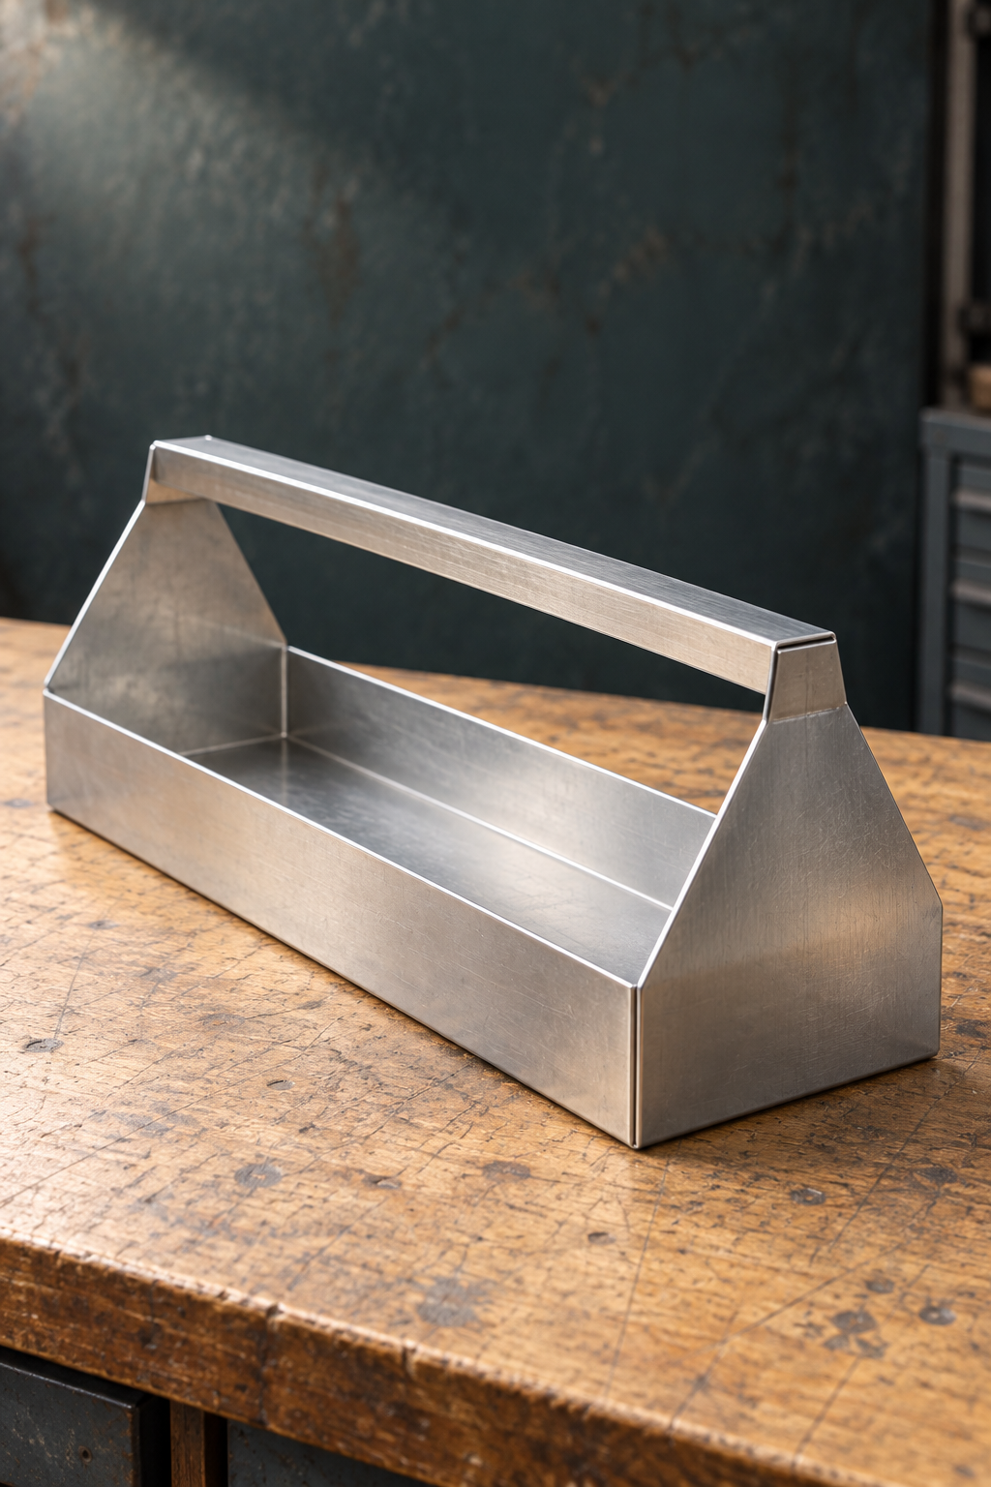
YEAR 9 / INDUSTRIAL TECHNOLOGY METAL

Sheet-metal
Toolbox
STUDENT WORKBOOK

Name __________________________ Class __________
50 pages · A4 · 25 sheets duplex · Edition 1.0 · Course companion
Illustrative cover. Use the teacher-issued Tool Carryall plan for construction.

NAVIGATION

Your route through the project
Read, investigate, make with permission, then explain the evidence.
This book follows the five modules on the Sheet-metal Toolbox site. The learning is sequenced by module so your teacher can set the lesson pace. Practical demonstrations, workshop permissions and the current task notification remain part of the course. Complete the written learning before the relevant practical stage and keep the evidence folio up to date.
Route | Pages | What you will establish
Workshop systems and risk management | 4–8 | Recognise hazards, use controls and respond when conditions change.
Toolbox brief, materials and planning | 9–18 | Interpret the brief and original plan; justify materials.
Mark, cut and form accurately | 19–24 | Use reliable references, tools and checkpoints.
Join, machine and finish with purpose | 25–30 | Connect methods to function, fit and protection.
Technology, quality and evaluation | 31–36 | Compare processes and judge results using evidence.
12-part project folio | 37–48 | Record your own decisions, production and evaluation.
Glossary and sources | 49–50 | Return to key terms and the source learning.

Find the original The unchanged Tool Carryall drawing is reproduced on page 12. Use its written information together with current teacher instructions. The website and drawing use different names for the same project context.
Print and write 50 A4 pages = 25 sheets when printed double-sided on the long edge. Use pencil for sketches and clear annotations. Attach extra approved evidence if your teacher requests it.

READ / OBSERVE / APPLY

Work from the right information
Authority, responsible research and honest evidence
The site calls this project Sheet-metal Toolbox. The original teacher-issued drawing is titled TOOL CARRYALL DEVELOPMENT. That drawing, the current brief and teacher demonstrations control exact geometry, materials, construction sequence, machine settings and practical permission. A textbook image explains an idea; it does not authorise a change to the plan.
Keep sources traceable. When you record a dimension, name the drawing and feature. When a value, fold line or instruction is unclear, write the question and take it to the teacher. An unanswered question is useful evidence of checking. Guessing hides the uncertainty until it becomes a production problem.
Research also carries responsibilities. Indigenous Cultural and Intellectual Property (ICIP) includes rights connected with cultural knowledge, designs, stories and practices. A cultural motif being visible online does not give permission to copy it. Seek the appropriate authority and agreed attribution or conditions before any proposed use. Original ideas and authorised sources are the basis for responsible design.
A student copies a dimension from an attractive online carryall and a cultural motif from a search result. Explain the two checks needed before either is used.

Keep the record honest Label example evidence as hypothetical. Record only demonstrations, confirmations, observations and results that actually occurred. Current assessment requirements come from the teacher-issued task notification.

READ / OBSERVE / APPLY

Risk management is a process
1.1 Risk management is a process, not a poster
A hazard is something with the potential to cause harm. Risk considers how likely that harm is and how serious the consequence could be. An unsecured workpiece, a sharp offcut and a blocked walkway are different hazards, so they need controls that address their actual causes. A hazard does not become acceptable simply because an incident seems unlikely.
Start before cutting, forming, drilling or assembly. Look at the material, tools, work area and people nearby. Consider what could change while the work is happening. Then select controls in order: eliminate the hazard where possible; substitute; isolate; use engineering controls; apply administrative controls; and use personal protective equipment (PPE). Stronger controls act on the hazard or exposure, while PPE adds a final protective layer.
Control level | What it aims to do
Eliminate / substitute | Remove the hazard or replace the source with a safer option where feasible.
Isolate / engineering | Separate people from the hazard or control it through the physical setup.
Administrative / PPE | Direct safe work through procedures, training and permission; add task-directed protection.

Controls need review. If a guard, workpiece, floor condition or work zone changes, the earlier plan may no longer fit the task. Stop, make the area safe and seek teacher direction. Recording the changed condition helps the class improve the system.
Explain why safety glasses alone do not control a workpiece that may move during processing.

READ / OBSERVE / APPLY

Make the whole setup safe
1.2 Safe workshop practices
A safe setup includes the student, the equipment, the workpiece and the surrounding space. Housekeeping reduces exposure before a tool starts: return materials to their storage area, clear offcuts from the bench and walkway, and follow the workshop signs. Secure hair and loose clothing, use task-directed PPE and stay aware of nearby work.
Machine permission belongs to a trained person using an approved machine, demonstrated setup and current task. It does not transfer automatically to another machine or to a different operation. Tiredness, distraction, missing supervision or an unfamiliar setup are reasons to stop and ask for direction.
SafeWork NSW is the workplace health and safety regulator. WHS legislation and regulations establish legal duties and requirements. Standards provide technical benchmarks where relevant, while codes of practice give practical guidance for achieving required standards of health and safety. In this workshop, follow the current teacher-approved school procedures, signs and demonstrations. These roles connect, but knowing a code or answering a safety question does not grant local machine permission.
For a teacher-nominated task, record one check for each: you, equipment, workpiece and surrounding area. Identify what needs teacher confirmation. Explain why the regulator’s role is different from local machine permission.

Changed task, fresh check A previous demonstration helps you understand the process. Current permission and the exact setup still need to match the work you are about to do.

WORKED EXAMPLE

Use an incident to improve the system
1.3 Incident response and reporting
An incident or near miss is evidence that something needs attention. A near miss is an event that could have caused harm even though no injury occurred. Reporting it allows the cause and controls to be reviewed before someone is hurt. “Nobody was injured” is a result, not proof that the setup was safe.
Stop work, make the immediate area safe and alert the teacher. Do not move equipment, material or an injured person unless directed or required to prevent further harm. Follow the current local incident and first-aid procedures; your teacher confirms the steps for this setting.
Hypothetical report During a paused lesson, an offcut was noticed across a walkway. A student nearly stepped on it. The task stopped and the teacher was alerted. The class needs to review where offcuts are placed and when the walkway is checked. This is an invented example, not a record of an actual incident.
Write a clear hypothetical near-miss report. State what happened, the conditions, the immediate response and the control that needs review. Do not name a real student.

Useful reporting Be specific about conditions and actions. The purpose is to make the system safer, not to hide a problem or assign blame.

INVESTIGATE / APPLY

Spot the change, then review the controls
Paper investigation / discuss before any practical action
Read each situation as a paper scenario. You are deciding which information and controls need review, not carrying out an operating procedure. In every case, identify what changed and explain why the earlier setup may no longer be suitable.
For each situation, identify the change and state your immediate response.
Scenario | Changed condition and next action
A classmate places a large sheet beside the marked work zone.
A workpiece shifts in a setup that had been checked earlier.
You are asked to use a different machine because the usual one is busy.

Choose one scenario. Explain a stronger control than simply telling students to “be more careful”, and how its effectiveness could be checked.

Discussion prompt A careful person still needs a safe system. Explain how your proposed control changes the hazard or exposure.

KNOWLEDGE CHECK

Check your safety reasoning
Original course questions / explain the reasons
1. Why are both likelihood and consequence considered?
○ A. To decide how serious the risk is
○ B. To choose the fastest tool
○ C. To replace the demonstration
○ D. To avoid all equipment

2. What should happen if conditions change during practical work?
○ A. Continue carefully
○ B. Stop, make the area safe and seek teacher direction
○ C. Rely only on PPE
○ D. Ask another student to finish

Choose one stage from the teacher-issued project plans. Identify one possible hazard, describe its likelihood and consequence, and explain which hierarchy-of-controls measures should be used before work begins.

READ / OBSERVE / APPLY

Choose metal for the job
2.1 Choose metal for the job
A metal property describes the material. Strength describes its ability to resist an applied load; hardness relates to resistance to indentation or scratching; ductility describes the ability to deform without breaking. Performance asks a different question: how well does this particular material work in this particular product? A strong material can still be an unsuitable choice if the available workshop cannot form it safely.
Ferrous metals contain iron. Many are strong and magnetic, and many can rust without suitable protection. Non-ferrous metals do not have iron as their main constituent. They can offer lower mass, corrosion resistance or useful forming behaviour, depending on the metal. These groups are a starting point for investigation, not a guarantee that every member behaves alike.
For a carryall, connect the selected metal to what the part must do, how it will be fabricated and where it will be used. Availability and finish also matter. A material choice is convincing when each relevant property explains a useful result or a trade-off. The actual metal and stock form come from the teacher-issued brief and instructions.
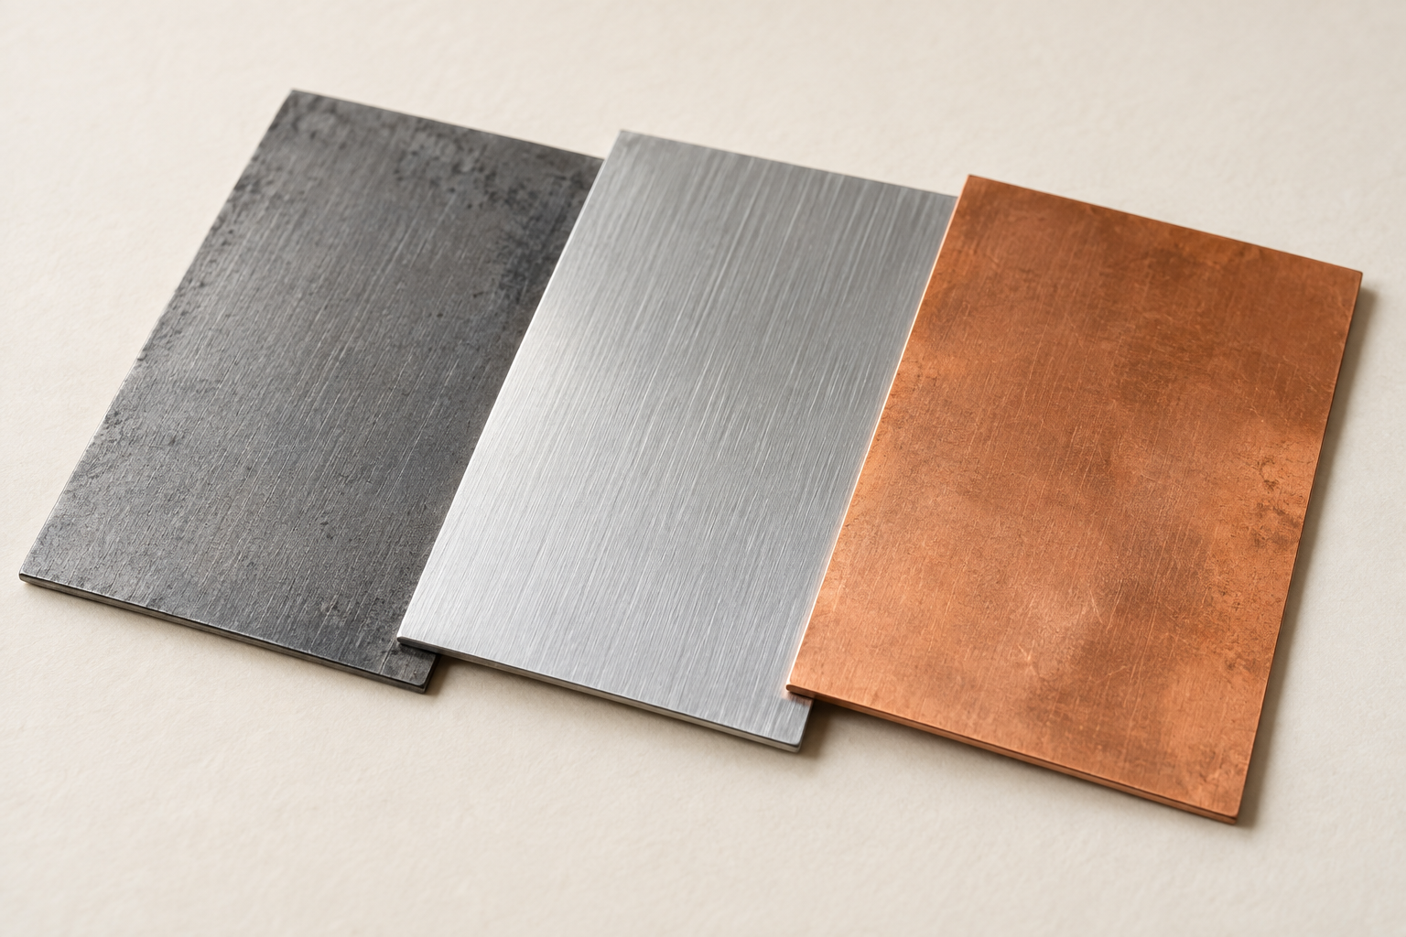
Figure 1. Illustrative metal samples. Compare visible sheet surfaces; appearance alone cannot verify composition, grade, thickness, strength or project suitability.
Choose one property. Explain a useful effect and one further fact you need before selecting a metal for this project.

READ / OBSERVE / APPLY

Turn a brief into requirements
2.2 The Toolbox brief and production context
A brief explains the need, intended user and function. It gives a direction for the project, while the approved drawing and instructions define the exact requirements. Separate a requirement that must be met from a preference that might be desirable. A constraint limits the available choices, such as time, resources, equipment or an approved process.
For this project, connect the carryall’s purpose to evidence you can collect. A useful criterion says what will be checked; it does not simply say “high quality”. Ask the teacher which criteria and checks are authorised. Do not invent a load limit, dimensional tolerance or extra feature because it appears on another Toolbox.
Responsible material sourcing extends beyond the purchase price. Extraction and processing can affect land, water, people and Country. Consider material use, offcuts, service life, repair and recovery at the end of use. Recycled content may help, but a complete claim also needs evidence about suitability and the wider life cycle. Record the evidence you have and the questions that remain.
Use the current teacher-issued brief. Keep unknown details marked “Teacher to confirm”.
Category | One source-based example from your brief
Essential requirement
Preference
Constraint
Evidence to collect

READ / OBSERVE / APPLY

Plan decisions before production
2.3 Design and project planning
Planning begins with the brief, relevant research and possible ideas. Compare alternatives against the same requirements so the approved direction has a clear reason. A sketch can explore a possibility; a working drawing communicates the confirmed information needed for production. Keep exploratory ideas distinct from the drawing that controls the actual part.
A cutting list records the teacher-specified parts, materials and dimensions. A production plan adds order: what happens first, what depends on it and where checking or a demonstration is needed. The Tool Carryall drawing names HANDLE, BODY and SIDE x 2, but the teacher still confirms how the class will turn those parts into the approved assembly.
A checkpoint is useful before an irreversible step. Checking a marked feature is easier than correcting it after cutting; trial fitting can reveal a mismatch before permanent joining. If evidence shows a problem, revise the plan with teacher direction and record the reason. A written plan is a working control, not a promise to ignore new information.
Complete a generic checkpoint plan. The teacher supplies the actual manufacturing sequence.
Planned stage | Before proceeding, check… | Evidence to keep
Read current plan
Prepare marking-out
Before permanent joining

ORIGINAL PLAN

Original teacher-issued drawing
TOOL CARRYALL DEVELOPMENT
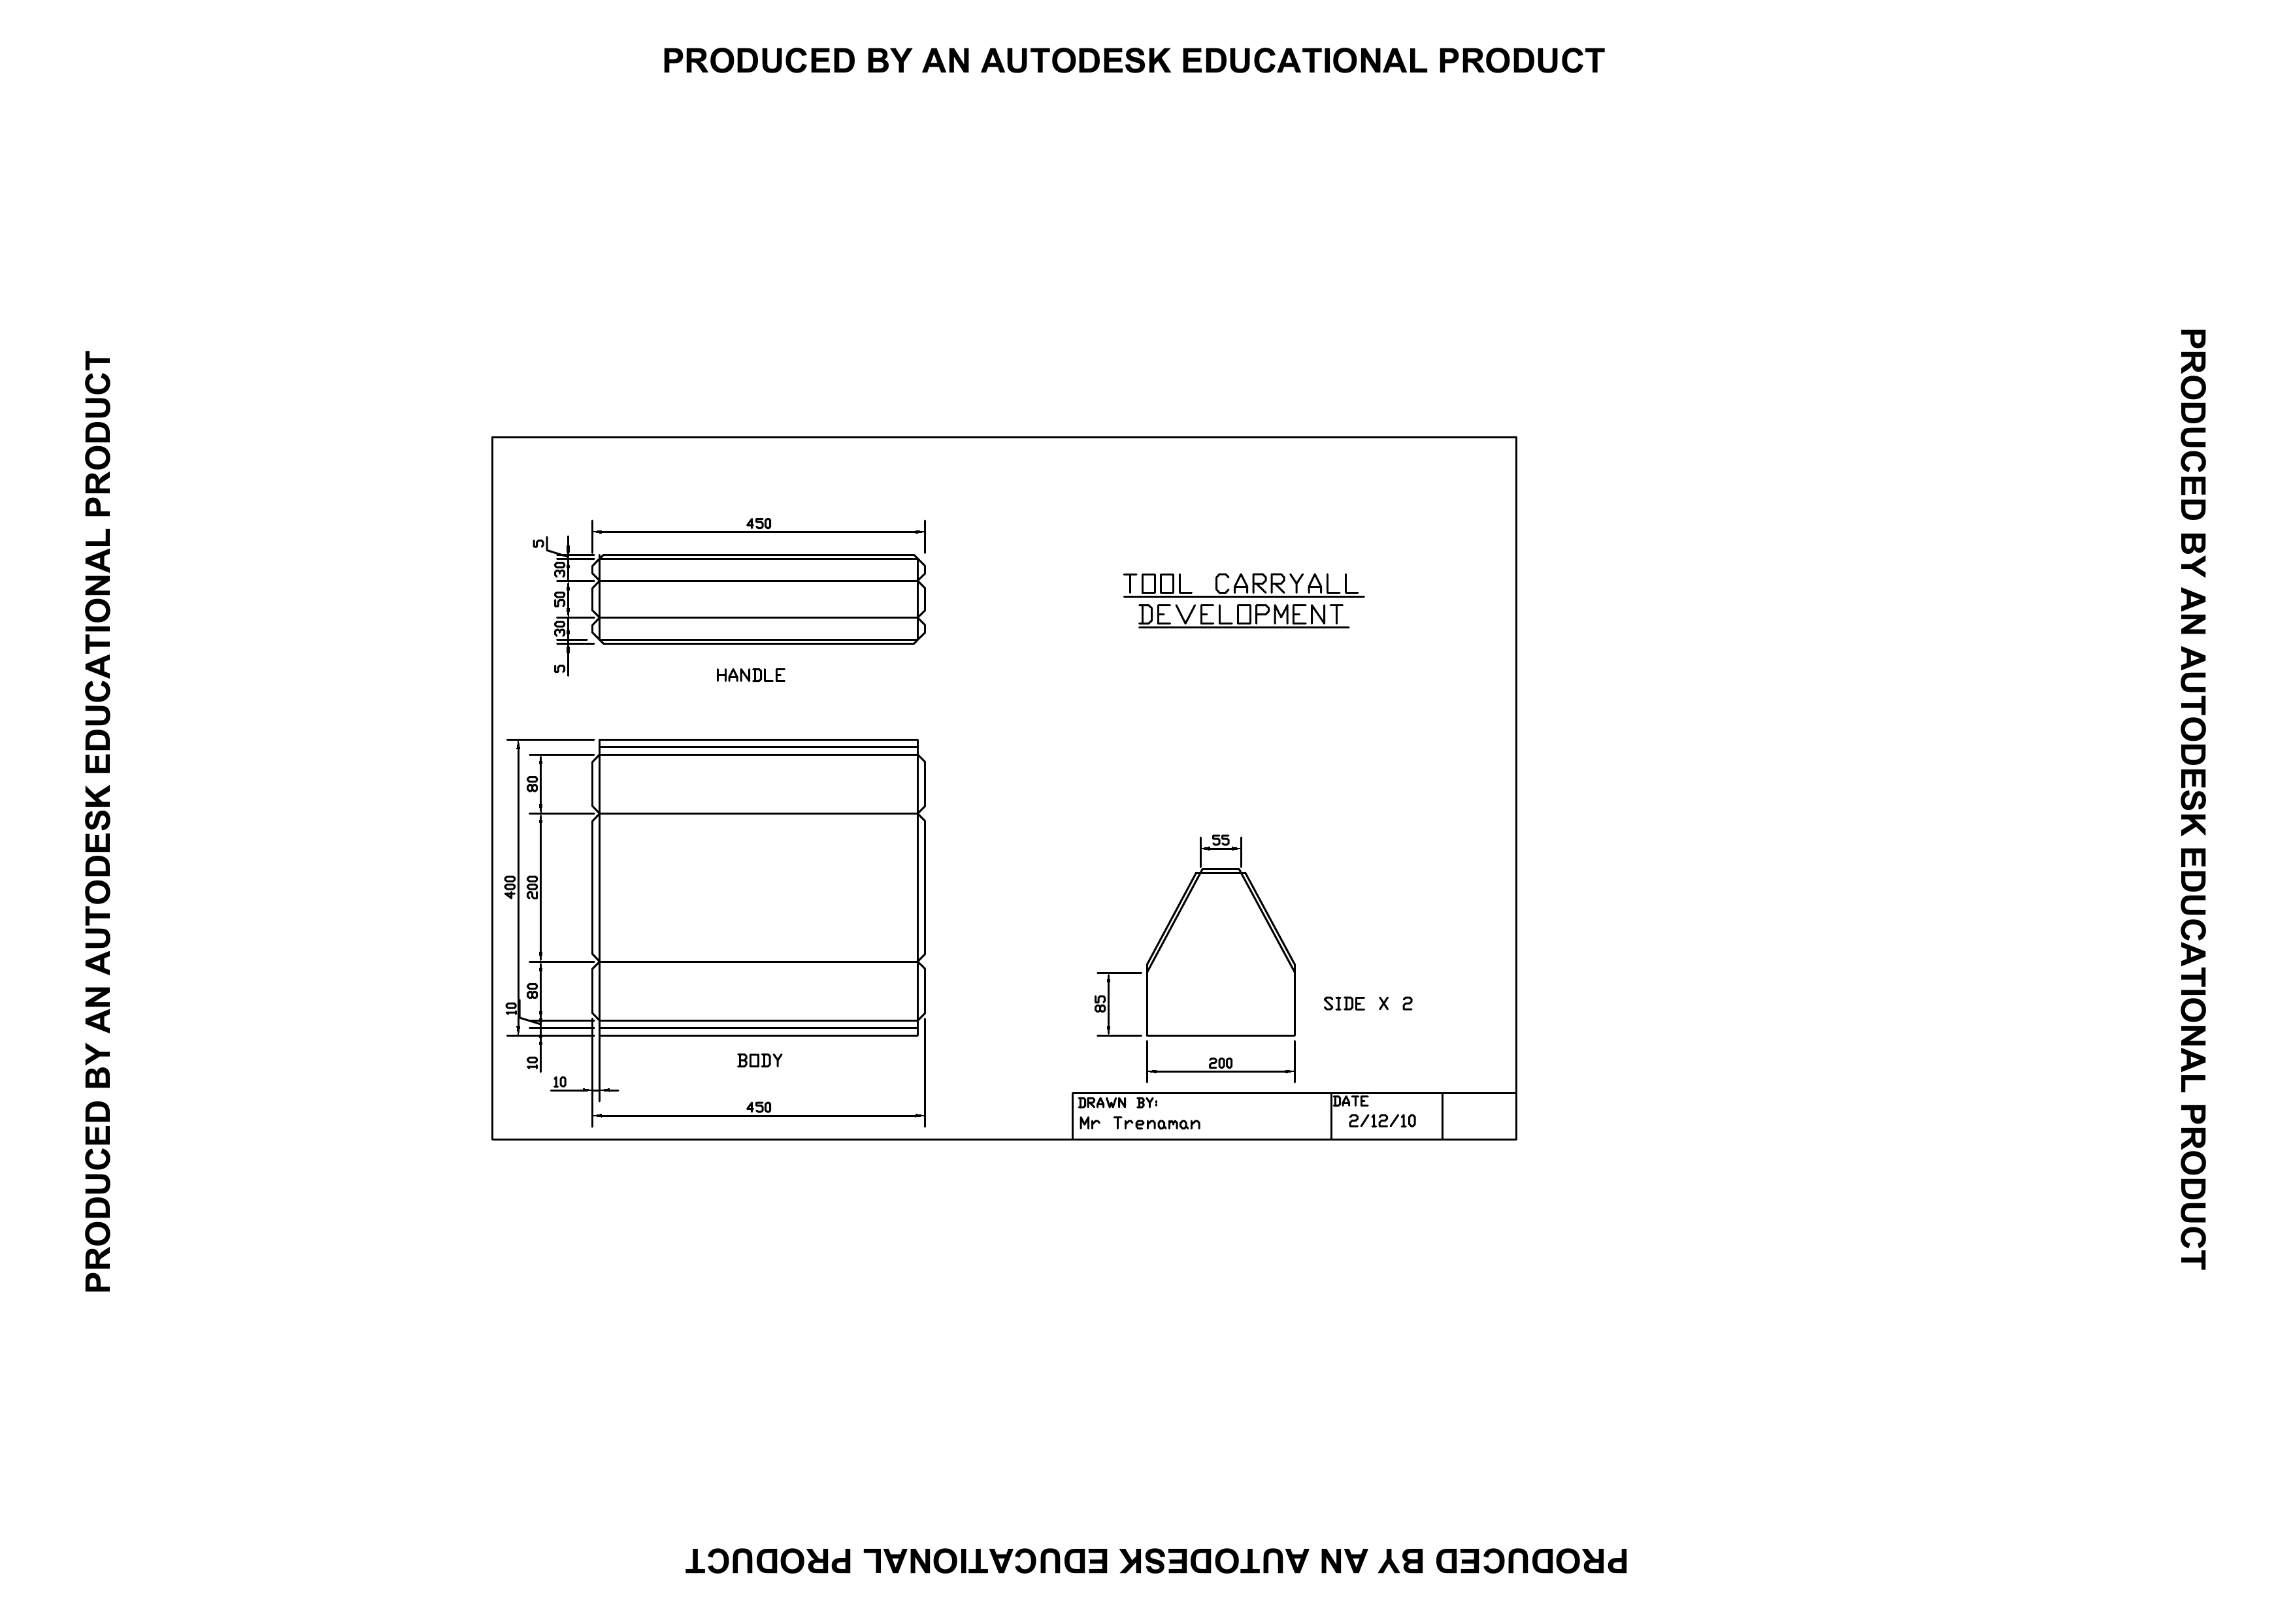
Original sheet overview: unchanged teacher-issued drawing, including its page context.
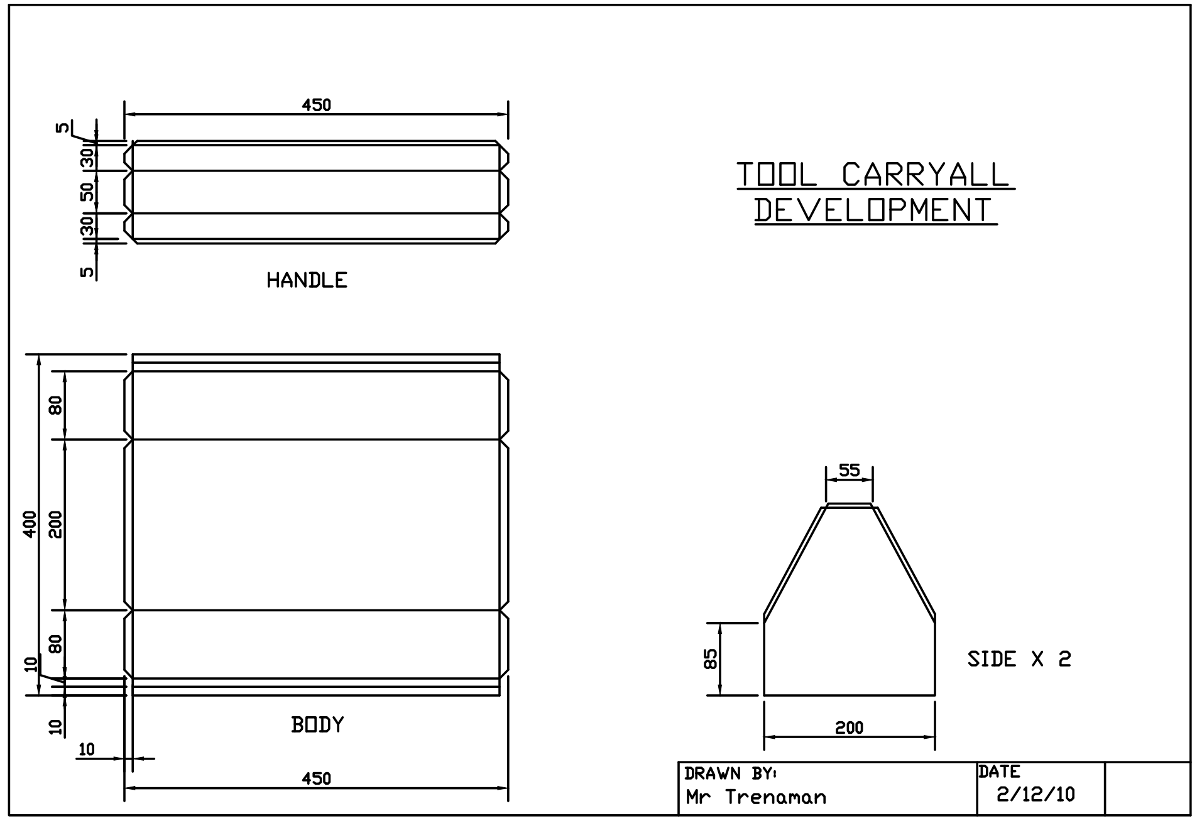
Figure 2. Enlarged original drawing detail. Only surrounding page margins are omitted; the entire drawing and title block remain. Use written dimensions, never the image scale.
Construction authority Use the original drawing with the current teacher instructions. Unclear dimensions, fold lines, orientation or permissions must be checked before marking or cutting.

LOOK CLOSELY

Read the plan before marking out
2.4 Read the Toolbox plan before marking out
Start with the whole drawing. Place it so TOOL CARRYALL DEVELOPMENT reads normally and the views are upright. Locate the labels HANDLE, BODY and SIDE x 2. Use those printed names to connect each component to its view. The largest shape is not automatically the body, and the simplest shape is not automatically the handle.
Trace one part at a time, beginning with the BODY and then checking the HANDLE and two SIDE pieces. Follow each dimension through its arrows and extension lines to the feature it controls. A value printed near a shape does not apply to every nearby feature. Distinguish the outside boundary from fold or edge lines inside the view.
Now relate the information. Identify which dimensions, lines and notes belong together, and record anything that is unclear. Check orientation, repeated parts and the relationship between views with the teacher. Save an annotated copy or a clear folio note showing the information you verified before Module 3 marking out.
Choose one named component on page 12. Make a small explanatory sketch showing a printed label, a dimension relationship and a line you need to interpret. Do not invent or scale dimensions.

Follow the chain Printed value → arrows and extension lines → specific feature. Ask when any part of that chain is unclear.

INVESTIGATE / APPLY

Plan detective
Paper investigation / establish what is known
A careful reader separates a fact on the drawing from an interpretation that still needs checking. Use page 12 to complete this evidence record. Point to the source of each fact so another reader can find it. Keep your questions; they are part of the work, not a sign that the page is unfinished.
Record the actual drawing evidence. Use no estimated measurements.
Find on the original | Evidence or question
Drawing title and upright orientation
HANDLE: label and corresponding view
BODY: one dimension-to-feature relationship
SIDE x 2: repeated-part requirement
One fold/edge line needing explanation

Write the most useful question to take to the teacher before marking out. Explain what mistake the answer could prevent.

KNOWLEDGE CHECK

Check materials and plan identity
Circle one best answer for each original course question.
3. Which statement correctly distinguishes property from performance?
○ A. A property is a metal characteristic; performance is how it behaves in use
○ B. A property is cost; performance is colour
○ C. A property is the product; performance is the plan
○ D. They always mean the same thing

4. Which is the strongest material-selection justification?
○ A. It looks better
○ B. It was first available
○ C. Its properties suit function, fabrication, corrosion, availability and finish
○ D. Ferrous is always best

5. What should a student use first to orient the drawing correctly?
○ A. The largest component view
○ B. The position of the dimensions
○ C. The drawing title and upright views
○ D. The order of workshop tools

6. Which title appears on the teacher-issued drawing?
○ A. TOOL CARRYALL DEVELOPMENT
○ B. Sheet-metal Toolbox Plan
○ C. Year 9 Metal Toolbox
○ D. Toolbox Assembly Drawing

KNOWLEDGE CHECK

Check component and line reading
Original course questions / use the printed information
7. How should the website and drawing names be treated?
○ A. As two unrelated projects
○ B. As interchangeable drawing titles
○ C. As student-selected alternatives
○ D. As different names for the matching project context

8. Which named parts must be located on the drawing?
○ A. Base, lid and bracket
○ B. HANDLE, BODY and SIDE x 2
○ C. Front, back and tray
○ D. Handle, hinge and panel

9. What is the best way to identify which view belongs to a component?
○ A. Choose the simplest shape
○ B. Use the printed component label
○ C. Select the view with most dimensions
○ D. Match it by estimated size

10. How should dimension information be traced?
○ A. From arrows and extension lines to the controlled feature
○ B. From the page edge towards the centre
○ C. From the largest value to the smallest
○ D. From the handle view to every other part

KNOWLEDGE CHECK

Check uncertainty and authority
Original course questions / know when to ask
11. What should be distinguished from the outside shape of a part?
○ A. The drawing title
○ B. The component label
○ C. The page border
○ D. Fold or edge lines

12. What should a student do when drawing information is unclear?
○ A. Estimate from the component shape
○ B. Copy a value from another view
○ C. Record the uncertainty for teacher checking
○ D. Leave the feature unmarked without comment

13. Which information remains controlled by teacher-issued plans, demonstrations and instructions?
○ A. Only the project name
○ B. Only the folio format
○ C. Exact dimensions, materials, settings, sequence and permissions
○ D. Only the number of side pieces

14. What evidence should be saved before Module 3 marking out?
○ A. A checked plan annotation or folio note
○ B. A completed cutting record
○ C. A photograph of finished assembly
○ D. A list of generic workshop rules

WORKED EXAMPLE

Justify the specified material
Connect a property to a useful result and a trade-off.
A material justification is a chain of reasoning. Name the teacher-specified metal and part, identify a relevant property, then explain how that property supports the function or approved process. Extend the explanation to corrosion conditions, availability and finish. Do not fill a missing specification with an educated guess.
Worked reasoning — hypothetical Weak: “This sheet looks strong.” Stronger: “If the specified sheet can be formed by the approved process without cracking, that behaviour supports the required shape. I still need the confirmed metal, thickness, corrosion conditions and finishing instructions before judging the full choice.” This model shows reasoning; it does not specify your material.
Using the teacher-issued plans, identify the selected metal for one project part and justify the choice by referring to function, fabrication, corrosion, availability and finish.

Identify one piece of information or evidence that would strengthen your justification.

LOOK CLOSELY

Accuracy before force
3.1 Accuracy before force
A datum is a reliable reference edge or surface. Measuring related features from the same confirmed datum makes the relationship between marks easier to check. If you keep moving the starting point, an early error can be carried into later marks. The teacher demonstrates which reference to use on the actual part.
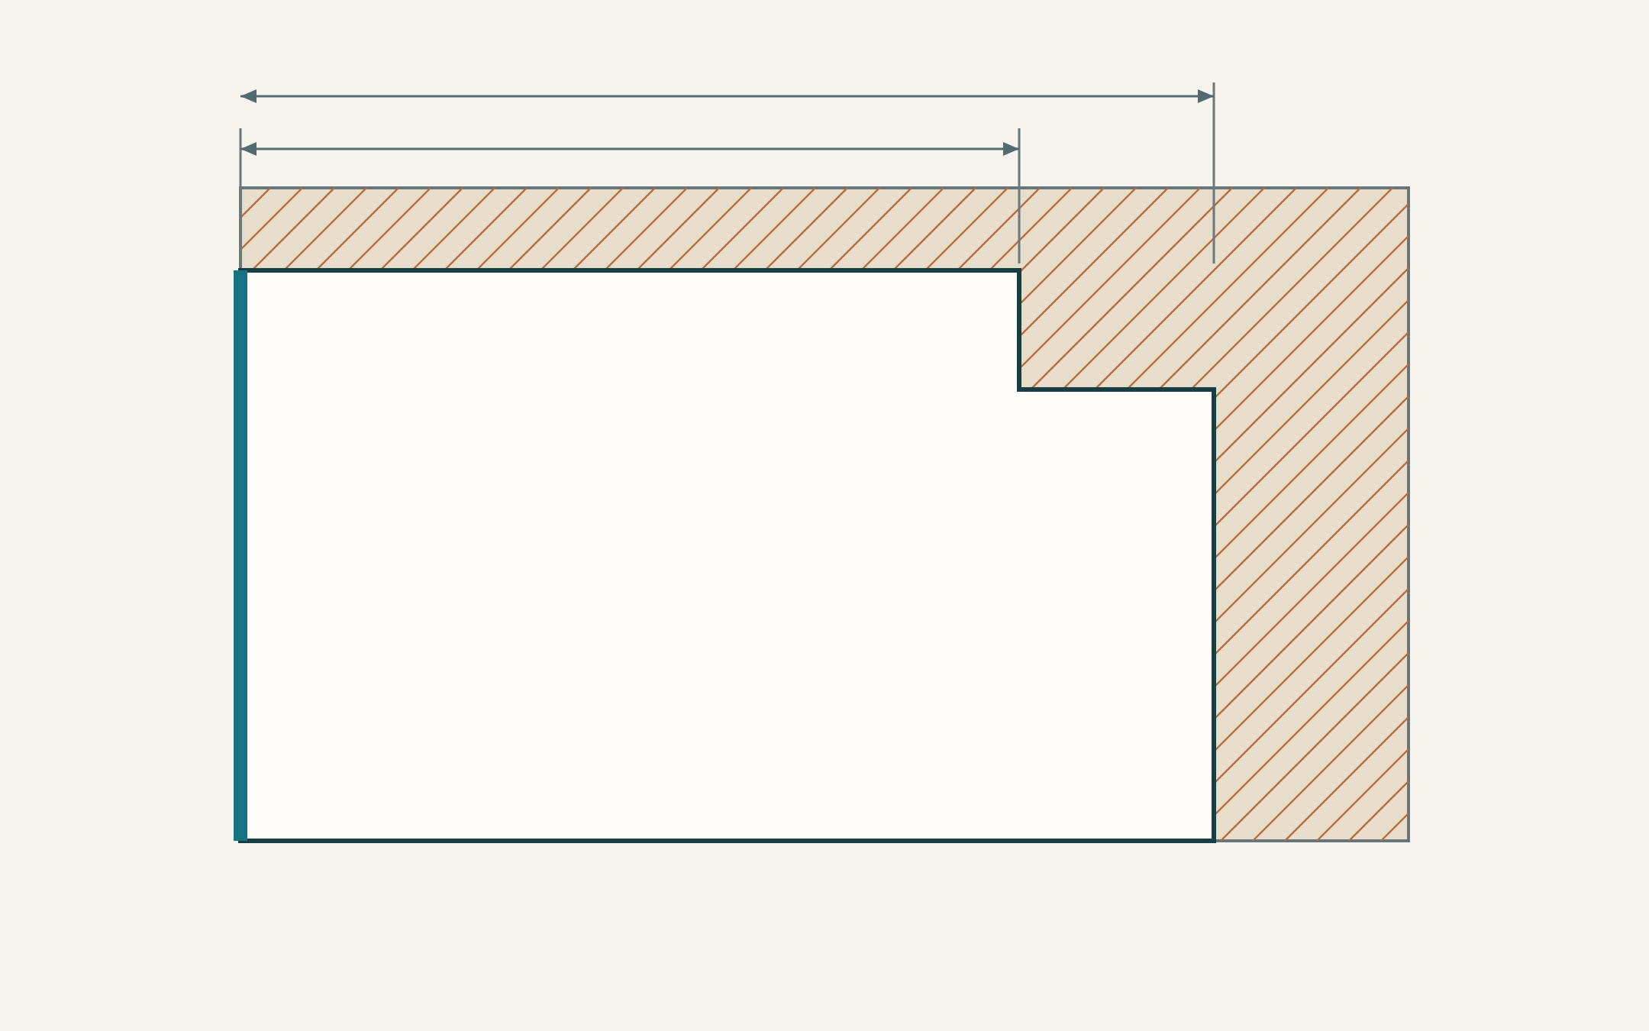
Figure 3. Concept only, not a Toolbox part or cutting instruction. The heavy left edge is the datum; the dark stepped outline is the finished edge; hatching identifies waste. Both arrows begin at the same datum. No dimensions are specified.
The intended finished outline and the waste side carry different information. A clear line shows a boundary; a waste mark helps protect the material that must remain. Check the part orientation and which side of the line is waste before entering the approved cutting setup. Read the written dimensions on the controlling drawing rather than measuring this illustration.
Secure workholding keeps the part in its intended position. Extra force cannot repair an incorrect mark or compensate for a moving workpiece. If the datum, waste side, orientation or next step is uncertain, stop and recheck the information before the irreversible process.
Explain how an error in the reference edge could affect two later features. Name the check you would complete before cutting.

READ / OBSERVE / APPLY

Choose a tool for the feature
3.2 Marking and measuring tools
A tool is selected for the information or feature it must produce. A steel rule or suitable tape measures length; a square establishes a perpendicular reference; a scriber produces a clear layout line; and a centre punch marks an approved hole location. The teacher selects the suitable type and demonstrates its use on the actual material.
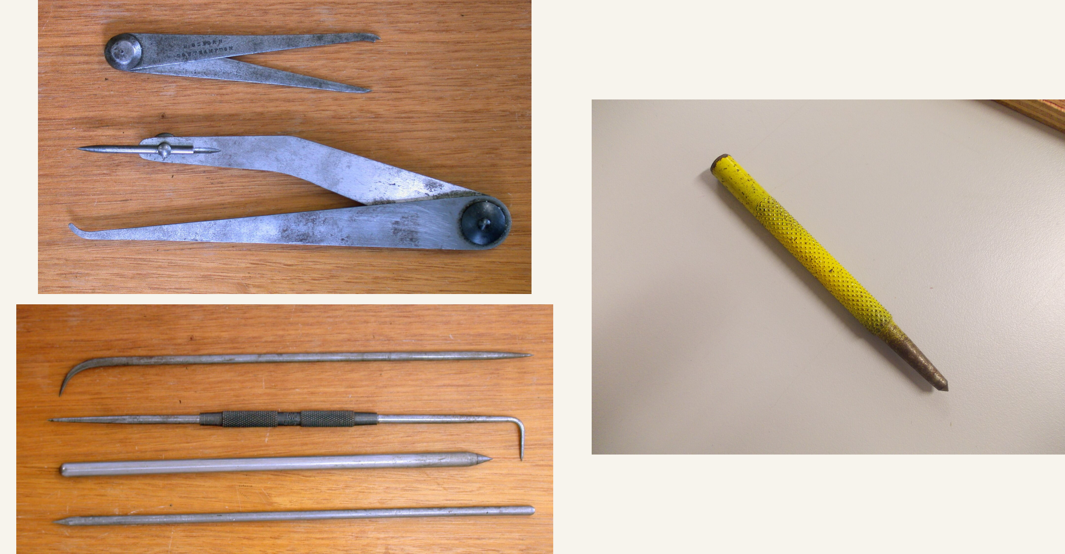
Figure 4. Identification references: Jenny callipers upper left; scribers lower left; centre punch right. The photographs show tool features, not an operating procedure. See page 50 for credits.
Jenny callipers are also called odd-leg callipers. One leg provides an edge reference while the other marks, so the tool is associated with marking a line related to an edge. A scriber has a sharp hardened point. These identifying features help you distinguish tools; technique, safe handling and the approved reference still come from the demonstration.
Read the issued dimension first, locate the reference and make the approved mark. Then recheck independently against the drawing. Repeating the same mistaken starting point is not a useful independent check. Explain what you checked so the record shows more than a tick.
Choose two features from the current plan. Name a teacher-approved measuring or marking tool for each and explain why it suits the feature.

READ / OBSERVE / APPLY

Keep the forming sequence controlled
3.3 Cutting and forming sequence
Cutting separates material; forming changes its shape. A process must suit the specified material and feature. Tin snips and a manual nibbler are examples of sheet-metal cutting tools, but they work differently and are selected for the demonstrated task. A bossing mallet has a rounded head used in forming contexts. Recognition is the beginning of tool learning, not an operating instruction.
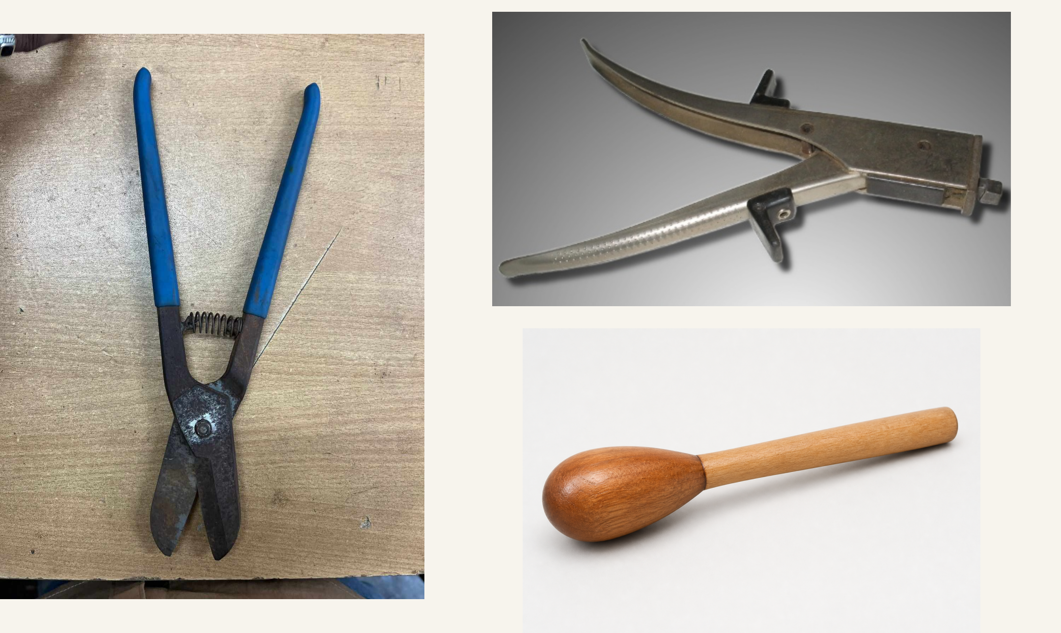
Figure 5. Identification references: tin snips left; manual nibbler upper right; illustrative bossing mallet lower right. The teacher selects and demonstrates the tool for the actual task. See page 50 for credits.
Support large or awkward material as demonstrated and keep hands outside the demonstrated danger zone. Remove burrs through the approved process before passing the work on. A burr is an unwanted sharp edge or projection left by processing; leaving it untreated can affect handling, fit and finish.
Forming order affects later access, dimensions and hole relationships. A fold made too soon may restrict a later operation. Follow the teacher-specified order and trial or check at the nominated points. If the result differs from the plan, record it and ask for direction instead of forcing the part to match.
Explain two reasons why the teacher may place a checkpoint between cutting and forming.

INVESTIGATE / APPLY

Match the tool to its job
Paper investigation / classify before choosing
Different tool families solve different problems. Measuring establishes a value; marking communicates a location; cutting separates material; forming changes shape. Some tools have more than one use, so classify the demonstrated job rather than relying only on the name. Use the vocabulary from pages 20–21.
Complete every row. Describe the visible or functional feature, without writing an operating procedure.
Tool or process | Job: measure, mark, cut or form | Feature that supports your choice
Steel rule
Scriber
Tin snips
Manual nibbler
Bossing mallet

A correctly identified tool is the wrong choice for an unfamiliar material. Explain what still needs checking.

KNOWLEDGE CHECK

Check marking and workholding
Original course questions / quality begins before processing
15. What is the main purpose of a datum edge?
○ A. Provide one reliable reference for marking
○ B. Show where to apply force
○ C. Replace the plans
○ D. Identify finish colour

16. What should happen before cutting or forming?
○ A. Secure the work and recheck markings
○ B. Remove waste marks
○ C. Force material into position
○ D. Change sequence without approval

Explain how a datum edge, waste-side marking, planned sequence and secure workholding can improve the quality of a sheet-metal project.

INVESTIGATE / APPLY

Check before the irreversible step
Transfer the learning to your next approved stage.
An irreversible process changes the material so the original condition cannot simply be restored. A pre-process check should therefore examine the information as well as the physical setup. “I checked it” is weak evidence unless the record shows what was compared and which uncertainty was resolved.
Sketch one planned feature from the approved drawing. Identify the datum, intended boundary, waste side where relevant and the detail requiring a teacher check. Use only confirmed written dimensions.

Describe your independent check, the evidence you compared and the result. Record “Not yet checked” if the practical check has not happened.

Permission point This paper record does not authorise cutting, drilling or forming. Show the actual work and current plan to the teacher as required.

READ / OBSERVE / APPLY

A joint is a design decision
4.1 A joint is a design decision
A joint connects parts so the assembly can serve its purpose. The method must suit the expected load, whether the connection is permanent or removable, access for making it, possible heat effects, appearance and corrosion. These factors interact. A method that is easy to reach may still be unsuitable for the material or intended finish.
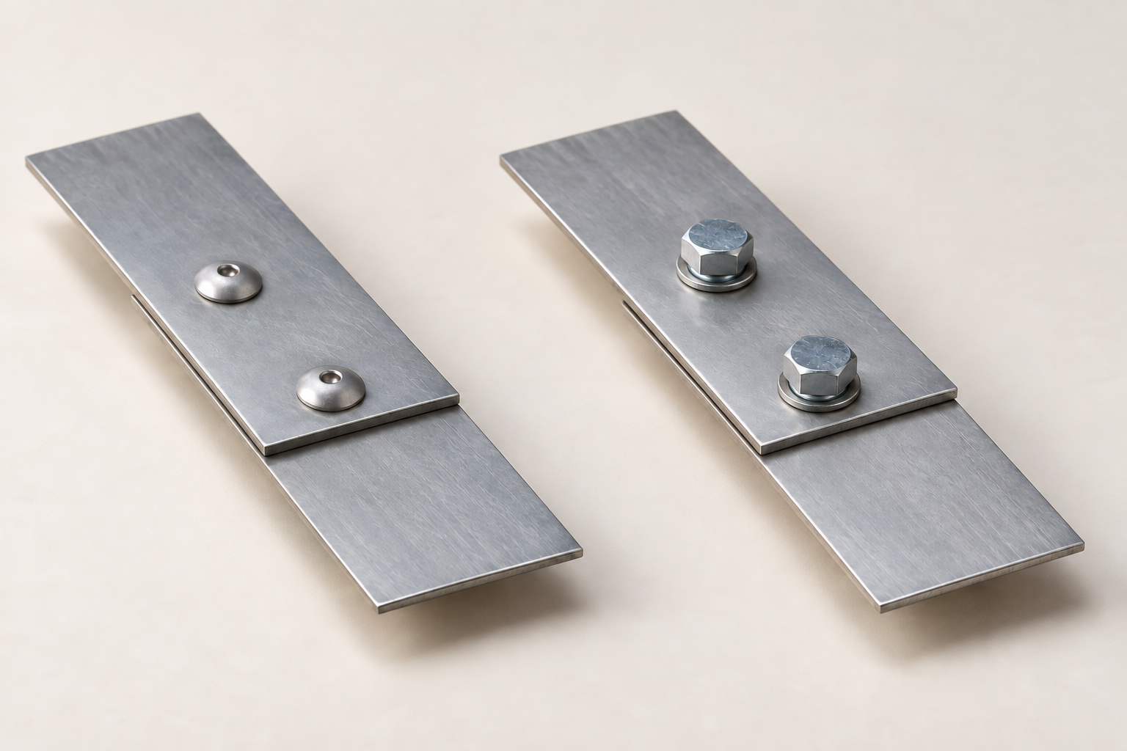
Figure 6. Illustrative joint study. Contact, access and alignment are useful questions for comparison. Only the approved plan and teacher instructions specify the Toolbox joining method.
Think about the whole life of the connection. A removable joint can support access or repair where required. A permanent method may suit another need, but errors can become harder to correct once the joint is complete. Heat can affect the metal or coating; an attractive surface does not establish that the method is compatible with the material.
Before permanent joining, trial fit using the demonstrated process. Check that parts meet correctly, edges align, holes or features match and the assembly stays in its intended position. If fit or method is uncertain, stop. The trial fit is information for a decision; it is not a reason to force the assembly into place.
Choose two joining factors that could conflict. Explain what evidence would help resolve the choice.

READ / OBSERVE / APPLY

Machining is permission-based
4.2 Machining is permission-based
Machining uses controlled equipment to produce a feature or remove material. Drilling machines, lathes and other machines require training, permission and the exact setup demonstrated for the task. The workpiece is held by the approved device. Hands do not replace a vice, clamp, chuck or fixture.
Before starting, know the stop control, check the work zone, secure loose hair and clothing and remove setup tools such as chuck keys as directed. These are parts of a larger demonstrated procedure, not a complete operating checklist. Use the current local instructions and ask when the setup differs.
Sound, vibration, swarf behaviour and work position provide information about changing conditions. Swarf is material removed during machining. An unexpected change is a reason to stop immediately and alert the teacher. Do not reach into a moving setup, continue to “see what happens” or improvise a correction.
Explain the permission or control issue in each situation. Do not describe an operating procedure.
Paper situation | Decision and reason
The usual machine is unavailable; a similar machine is free.
The work moves after the operation begins.
You cannot identify the stop control.

READ / OBSERVE / APPLY

Prepare before you protect
4.3 Surface preparation and protection
A finish depends on the surface beneath it. Burrs, scratches, scale, grease and dust can affect appearance, fit or the performance of a coating. Use the approved classroom preparation sequence and protect the prepared surface from new contamination. Covering a fault does not establish that it has been corrected.
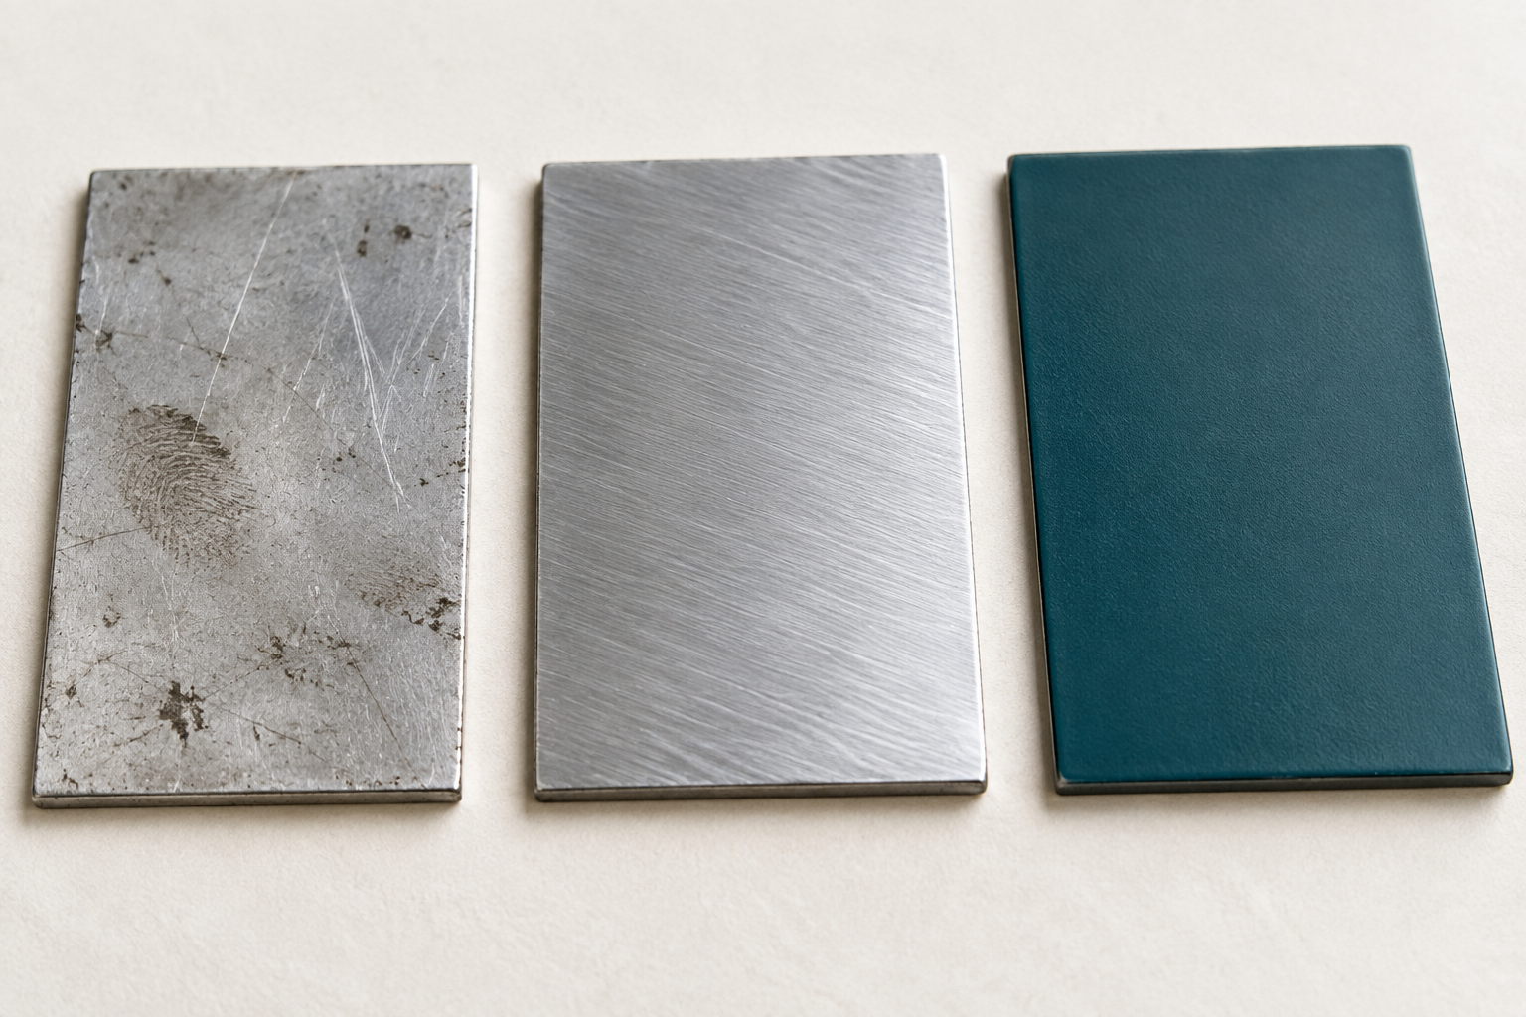
Figure 7. Illustrative surface comparison. Visible texture can reveal questions about preparation; it cannot prove a coating product, curing condition or corrosion performance.
A protective barrier can reduce contact between metal and the conditions that promote corrosion, but protection depends on the actual material, finish and continuity of the barrier. Follow product labels, safety information and teacher direction for ventilation, PPE, application and curing. Record the actual product and process used.
Finishes and lubricants have purposes and trade-offs. A finish may improve protection or appearance; a lubricant may reduce friction in an approved process or moving system. Each can bring preparation, maintenance, cost and environmental consequences. Neither should be added simply because another project used it. The teacher confirms suitability and use.
Explain why selecting a finish or lubricant requires more than choosing an attractive appearance. Include one trade-off and one source to check.

INVESTIGATE / APPLY

Make a reasoned process choice
Paper investigation / compare the same factors
Compare possible processes against the same needs. A fast method may require more setup or create a different waste stream; a finish that lasts longer may need more preparation. In industry, decisions affect workers, users, material use, emissions and cost as well as the product. A responsible choice makes those trade-offs visible.
For an approved joint or finishing stage, record a useful question for each factor.
Factor | What must be known before choosing?
Function and load
Access and permanence
Material, heat and surface
People, waste and environment

Choose the most important unanswered question. Explain how its answer could change a process decision.

KNOWLEDGE CHECK

Check joining decisions
Original course questions / fit before permanence
17. Which factors should guide a joining method?
○ A. Load, permanence, access, heat, appearance and corrosion
○ B. Only colour
○ C. Whichever is fastest
○ D. Another student’s choice

18. Why trial fit before permanent joining?
○ A. Check fit and alignment before errors are locked in
○ B. Avoid the plans
○ C. Make metal harder
○ D. Replace the approved process

Explain how load, permanence, access, heat effect, appearance and corrosion could influence a joining method. Include why a trial fit is needed.

WORKED EXAMPLE

Read a trial fit as evidence
A mismatch is information to investigate.
A trial fit compares the actual parts with their intended relationships before permanent joining. Observe contact, alignment, feature positions and assembly position. A visible mismatch tells you that further checking is needed; it does not automatically tell you which process caused it.
Worked example — hypothetical Two intended edges do not align in a trial fit. The student first records the mismatch and asks for teacher direction. They compare the actual orientation and relevant marks with the approved drawing. This reasoning keeps observation separate from possible causes. It does not prescribe a correction.
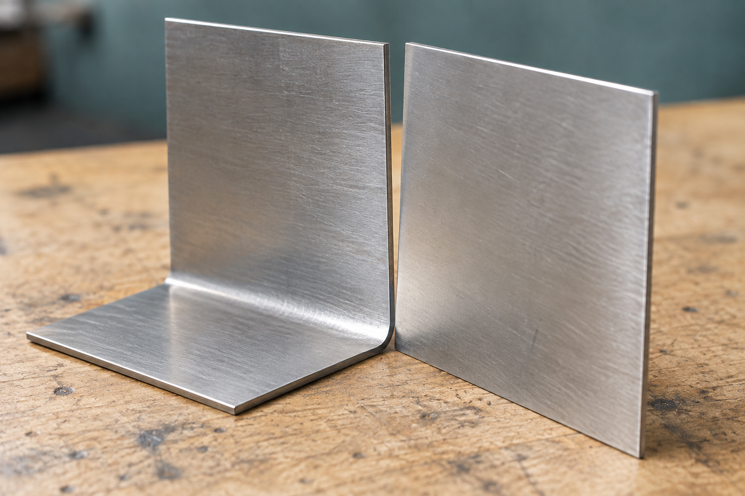
Figure 8. Illustrative alignment study. Compare corresponding edges. A mismatch prompts checking; the illustration does not establish its cause or an approved repair.
For the hypothetical mismatch, write: one observation, two possible causes to investigate, and the evidence that could distinguish them.

Record the next result After a teacher-approved correction, repeat the approved check and record what actually changed. “Corrected” is a claim that needs evidence.

READ / OBSERVE / APPLY

Judge quality throughout production
5.1 Quality, technology and evaluation
Quality is established through a sequence of decisions and checks. A finished product may look satisfactory while a hidden fit, function or protection issue remains. Use the teacher-approved criteria during production so errors can be identified before later work makes them harder to correct.
A measurement, annotated sketch, trial-fit record or photograph can each supply evidence, but they answer different questions. Name the criterion first, then choose an appropriate approved check. A close-up photograph may show an edge relationship; a measurement records a value; a dated sequence of notes can show how a problem was corrected.
Process choice also affects quality. Conventional processes offer direct control, flexibility and opportunities to develop skill. CNC uses programmed information and can support repeatability and complex shapes when appropriate files, equipment and setup are available. Compare the methods by accuracy, quantity, material, resources and purpose rather than assuming the newer option is always better.
Choose a useful evidence type for each question, then state what it cannot prove alone.
Criterion or question | Suitable evidence and its limit
Do the intended edges align?
Was a reported mismatch corrected?
Does the result meet the approved dimension?

READ / OBSERVE / APPLY

Technology must suit the job
5.2 Current and emerging manufacturing

Computer numerical control (CNC) uses programmed information to control machine movement. Digital design can support repeated parts and complex profiles, but the output still depends on a validated file, correct setup, suitable material and trained supervision. A digital mistake can also be repeated, so checking remains essential.
Laser, plasma, waterjet and CNC machining have different capabilities, costs, limitations and safety systems. CAD/CAM, robotics, sensors and digital inspection can change the flow of information as well as production. Compare reliable evidence about the same job: required quality, scale, time, resources, waste and the available skills.

Industrial change also changes work. Some routine tasks may be automated while design, programming, maintenance, inspection and data skills become more important. Material knowledge, communication and judgement remain necessary because someone must interpret whether the output meets the real need.
A reasoned forecast connects a driver to a possible change and a consequence. For example, pressure to reduce material loss may encourage improved nesting software, changing how planners arrange parts and verify output. This is a prediction to investigate, not proof that every workshop will change in the same way.

Write one reasoned forecast about metal manufacturing. Link a technology, social or environmental driver to a possible process change and a skill that people would need. State one uncertainty.

READ / OBSERVE / APPLY

Build a folio that explains decisions
5.3 Folio and final evaluation
A folio is a chain of evidence. It connects the brief, research, material choice, drawing information, planning, production, checks, problems and final evaluation. Arrange the evidence so another reader can understand what you intended, what happened and why you changed direction.
A caption should explain what the evidence proves. “My Toolbox” identifies a subject but says little about learning. “The trial-fit sketch shows the two intended edges before permanent joining” names the stage and the relationship being checked. Add a date or source where it helps the reader trace the claim.
In the final evaluation, compare the actual result with teacher-approved criteria. Explain specific strengths and limitations and identify one realistic improvement. Separate an observed limitation from an untested possibility. If you did not collect evidence for a criterion, say so and identify the approved check that would be needed.
Rewrite the caption “Here is my work”. Refer to a real piece of your evidence, state what it shows and explain what it does not establish.

Choose two folio sections that should link to each other. Explain the connection.

INVESTIGATE / APPLY

Compare a one-off with a batch
Paper investigation / the same tool is not always the best answer
Consider two hypothetical jobs: one teacher-approved practice part and a batch of identical parts in a suitably equipped enterprise. The jobs differ in quantity and resources, so process choice may differ too. Do not assume that either job automatically requires one named machine. Use the comparison to identify evidence for a decision.
Compare a conventional process with a CNC or emerging alternative. State needs or trade-offs, not invented performance figures.
Decision factor | One-off practice part | Batch of identical parts
Setup and information
Accuracy and checking
Time, material and waste
People and skills

Make a conditional recommendation for one job. Include a benefit, a limitation and evidence that could change your decision.

KNOWLEDGE CHECK

Check technology and evaluation
Original course questions / support a judgement with evidence
19. How should conventional and CNC processes be compared?
○ A. By which looks advanced
○ B. By suitability for the task and result
○ C. Choose CNC every time
○ D. Avoid conventional skills

20. Which is the strongest evaluation?
○ A. It was good
○ B. Everything worked
○ C. The trial fit showed misalignment, so I rechecked it; next time I would check earlier
○ D. I would make it better

Compare one conventional process with one CNC or emerging process by explaining when each would be suitable. Then evaluate one part of your project using specific evidence and identify one realistic improvement.

WORKED EXAMPLE

Turn evidence into a judgement
5.3 Folio and final evaluation
An evaluation explains how well the result meets an approved criterion. It needs a judgement, relevant evidence and a realistic improvement. A photograph can show alignment, but it cannot by itself prove an unperformed load test or long-term corrosion resistance. State what your evidence supports and what remains unknown.

Worked example — hypothetical evidence
Criterion → evidence → judgement Criterion: the intended edges align at the trial fit. Evidence: the left edge aligns, but the right edge has a visible mismatch. Judgement: the alignment criterion is only partly met. Next step: stop and ask the teacher to help trace the mismatch before permanent joining.
The example does not invent a tolerance or a cause. The mismatch might relate to marking, cutting, forming or assembly position; the evidence does not yet establish which. A useful improvement is to check the relevant dimensions and orientation earlier, then repeat the approved trial fit. Record any correction only after it actually happens.
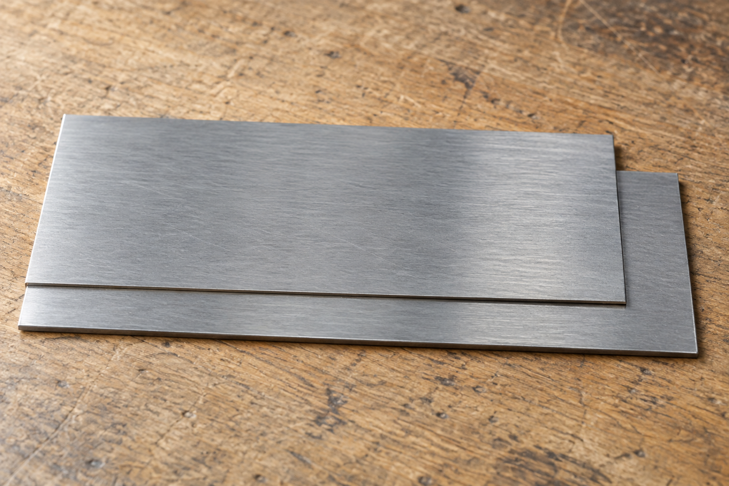
Figure 9. Illustrative comparison: the left ends align, while the right ends do not. The image reveals a mismatch, not its cause or an acceptable tolerance.
Improve this statement: “My Toolbox looks good, so it meets every requirement.” Use one approved criterion and clearly hypothetical evidence. Include a limitation and one realistic improvement.

Transfer to your folio Use actual evidence in the final evaluation on page 48. A proposed improvement is a next step, not proof that the problem has been solved.

PROJECT FOLIO

Project brief
Folio 01 / 12
Use the current teacher-issued brief. Explain the need in your own words and identify who will use the carryall and what it must do. Keep your proposal connected to the authorised project; a research image does not add a new requirement.
Summarise the need, user and function for the teacher-issued Toolbox brief.

Name the source of your brief and one piece of evidence that would show the need has been addressed.

Return to this page Your final evaluation should answer this brief. If the approved brief changes, record what changed and why.

PROJECT FOLIO

Requirements and constraints
Folio 02 / 12
Use requirements to guide decisions and later checks. A preference is desirable; a constraint limits your choices. Keep quantities, dates, costs and approved processes tied to actual teacher information.
Separate essential requirements, preferences and constraints for the Toolbox.
Essential requirements | Preferences | Constraints

Select two confirmed requirements. Explain how each could be checked using teacher-approved evidence.

PROJECT FOLIO

WHS and risk controls
Folio 03 / 12
Choose an actual approved project stage. Review the record when material, equipment, work area or people nearby change. A written risk record supports the live demonstration and permission process.
Record hazards, likelihood, consequence, controls, PPE and permission points.

Organise the record so the relationship between the hazard and each control is clear.
Field | Your actual stage and controls
Project stage / hazard
Likelihood / consequence
Stronger controls / PPE
Demonstration / permission point
Changed condition / review needed

PROJECT FOLIO

Materials investigation
Folio 04 / 12
Compare relevant properties and justify teacher-specified material choices.

Compare teacher-selected or specified material evidence. Label untested claims.
Material / source | Useful property and project implication

Teacher-led properties studio Heat treatment and mechanical or chemical modification can alter metal properties. Changes involve trade-offs. The teacher controls the material, method, equipment, safety procedure and permission for any studio observation or practical activity.
After the teacher-authorised properties activity, record the intended change, what you observed and what the result means. If it has not occurred, write “Not yet observed”.

PROJECT FOLIO

Research and ideas
Folio 05 / 12
Use research to explain a decision, not simply decorate the folio. Credit the source and distinguish an interesting feature from an approved change. Cultural material requires the appropriate authority and permission before any proposed use.
Record useful research, concept evidence and reasons for the approved direction.
RESEARCH / SOURCE | IDEA / REASON

Explain why the approved direction fits the brief. State one research idea that was not adopted and why.

PROJECT FOLIO

Working drawing evidence
Folio 06 / 12
Use the reproduced original on page 12 and the current teacher-issued drawing. An annotation should point to a feature and explain what it controls. Keep unresolved questions visible until the teacher has checked them.
Refer to teacher-issued drawings and explain the information used for production.

Record one plan detail checked with the teacher, the information confirmed and the date. If not checked yet, write “Awaiting teacher confirmation”.

Plan authority Use written dimensions. This workbook reproduction may be resized; do not scale measurements from the page.

PROJECT FOLIO

Cutting lists and resources
Folio 07 / 12
Transcribe confirmed information from the current drawing and instructions. Where a specification is absent or unclear, write “Teacher to confirm”. SIDE x 2 is a repeated part requirement; do not invent the stock, allowance or machining settings.
Record teacher-specified parts, materials, tools and consumables without guessing.
Part / quantity | Material and dimensions — source | Tools / consumables — confirmed
HANDLE
BODY
SIDE x 2
Other confirmed resource

Identify one resource or specification still to be confirmed and explain why it matters before production.

PROJECT FOLIO

Production planning
Folio 08 / 12
Write the actual teacher-approved order, including checks before irreversible stages. The stage names below are blank deliberately: the book does not replace the workshop’s demonstrated sequence. Add a dated change when new evidence requires the plan to be revised.
Sequence work, checkpoints, demonstrations and approvals for the Toolbox.
Stage / order | Checkpoint and evidence | Demonstration / approval needed

Record one approved change to the plan and the evidence that prompted it, or state “No change recorded”.

PROJECT FOLIO

Production evidence
Folio 09 / 12
Use photographs, annotated sketches or clearly identified attachments from your actual work. A useful caption identifies the stage, the feature being checked and what the evidence proves. Record only stages undertaken under teacher direction.
Add captions for marking, cutting, forming, joining, machining and finishing stages.
EVIDENCE 1 / STAGE | EVIDENCE 2 / STAGE

Index additional evidence for the remaining applicable stages.
Other stage / date | Evidence or attachment ID / what it proves

PROJECT FOLIO

Quality checks
Folio 10 / 12
Record what you compared and what you found. Use teacher-approved criteria and actual results. A photograph, measurement or trial fit should answer a stated question; a tick alone does not explain the evidence.
Record measurements, trial fits, alignment checks and teacher-approved criteria.
Criterion / source | Check and actual result | Judgement / next action

Identify one limit in your evidence and the further approved check that would be needed.

PROJECT FOLIO

Problem solving and testing
Folio 11 / 12
Keep observation, possible cause, decision and result separate. Ask for teacher direction before a correction or test. If no issue has occurred yet, use this page later; do not manufacture a problem to complete the record.
Explain a problem, evidence, decision, correction and safe test result.

Add an annotated before-and-after sketch or evidence reference. Show what changed and what remained uncertain.
BEFORE / EVIDENCE | AFTER / EVIDENCE

PROJECT FOLIO

Final evaluation
Folio 12 / 12
Judge function, accuracy, appearance and construction quality with evidence and one realistic improvement.

Make the evidence chain easy for a reader to follow.
Criterion / judgement | Evidence ID or page | Limitation / improvement

Final check Confirm that your evaluation answers the brief on page 37. Label evidence clearly and retain any unresolved questions or checks requested by your teacher.

REFERENCE

Words that make the work precise
Use each term to explain a relationship or decision.
Term | Meaning in this project
Hazard / risk | A possible source of harm / the likelihood and consequence of that harm.
Hierarchy of controls | An ordered approach that prioritises removing or controlling hazards before relying on PPE.
Property / performance | A material characteristic / how effectively it works in the intended context.
Ferrous / non-ferrous | Iron-containing metals / metals without iron as the main constituent.
Ductility | Ability to deform without breaking; relevance depends on the approved forming task.
Datum | A reliable reference edge or surface used to locate related features.
Waste side | The side of a marked boundary identifying material intended for removal.
Development | A drawing of the unfolded shape used to communicate a formed part.
Burr | An unwanted sharp edge or projection left by processing.
Workholding | The approved device and setup that keep the workpiece in its intended position.
Trial fit | A check of how parts meet before permanent joining.
Corrosion | Deterioration of a metal through reaction with its environment.
CNC | Computer numerical control: programmed information controlling machine movement.
Criterion / evidence | The basis for judging a result / the information used to support the judgement.
ICIP | Indigenous Cultural and Intellectual Property: rights connected to cultural knowledge, designs, stories and practices.
Life cycle | The stages from resource sourcing through manufacture, use, repair and end-of-life recovery or disposal.

Use precise language A term becomes useful when you connect it to the actual feature, source or result. Keep “confirmed”, “observed”, “proposed” and “not yet checked” distinct.

REFERENCE

Sources and teacher-led media
Return to the matching source when a detail needs checking.
Core learning: Sheet-metal Toolbox course, five modules, 16 named sections, 20 original multiple-choice questions, five written prompts and the 12-part folio. Source snapshot: Yr-9-Metal repository, 25 September 2026. Course: stevencowell.github.io/Yr-9-Metal/toolbox/
Construction authority: original “TOOL CARRYALL DEVELOPMENT” drawing, reproduced on page 12. The current teacher-issued brief, demonstrations and task notification control practical and assessment details. Supplementary concepts follow the Toolbox teaching program v2.1 and the site’s Syllabus Learning Hub.
M | Teacher-led video | Channel / access
1 | The Hierarchy of Controls | Healthier Workforce Center  youtu.be/XOkPcLD5Soo
2 | Understanding Metals | The Efficient Engineer  youtu.be/PaGJwOPg2kU
3 | Marking Out (Metal) | LHS Technologies  youtu.be/bByYRFZYAIA
3 | Hand Deburring Sheet Metal | Ramsey Laser Press Brake  youtu.be/uHjEuSeo0fc
3 | Sheet Metal Bending Basics | RAPID DIRECT  youtu.be/NAaHh_V3rX0
4 | How to Use POP Rivets | Albany County Fasteners  youtu.be/1G8lGECOe1U
4 | What Is Corrosion and How to Stop It | Cognito  youtu.be/q0CAfXV-YdY
5 | CNC Machining - What It Is and How It Works | Protolabs  youtu.be/lEyNWtM6MW4

Use videos for the source’s nominated observation purpose, with teacher discussion. They do not replace local procedures or permissions. The teacher guide lists watch-for prompts and a paper observation response.
Image credits: Tool Carryall plan by Mr Trenaman, from the course. Jenny callipers and scribers: Glenn McKechnie, CC BY-SA 3.0. Centre punch: Luke Milburn, CC BY 2.0. Tin snips: Zkabirkhan, CC0 1.0. Nibbler: Richard Frantz Jr, public domain; background revision by Hydrargyrum. Photographs are arranged into comparison plates. New editorial images and the course bossing-mallet reference are AI-generated. Illustrations are not construction authority.

