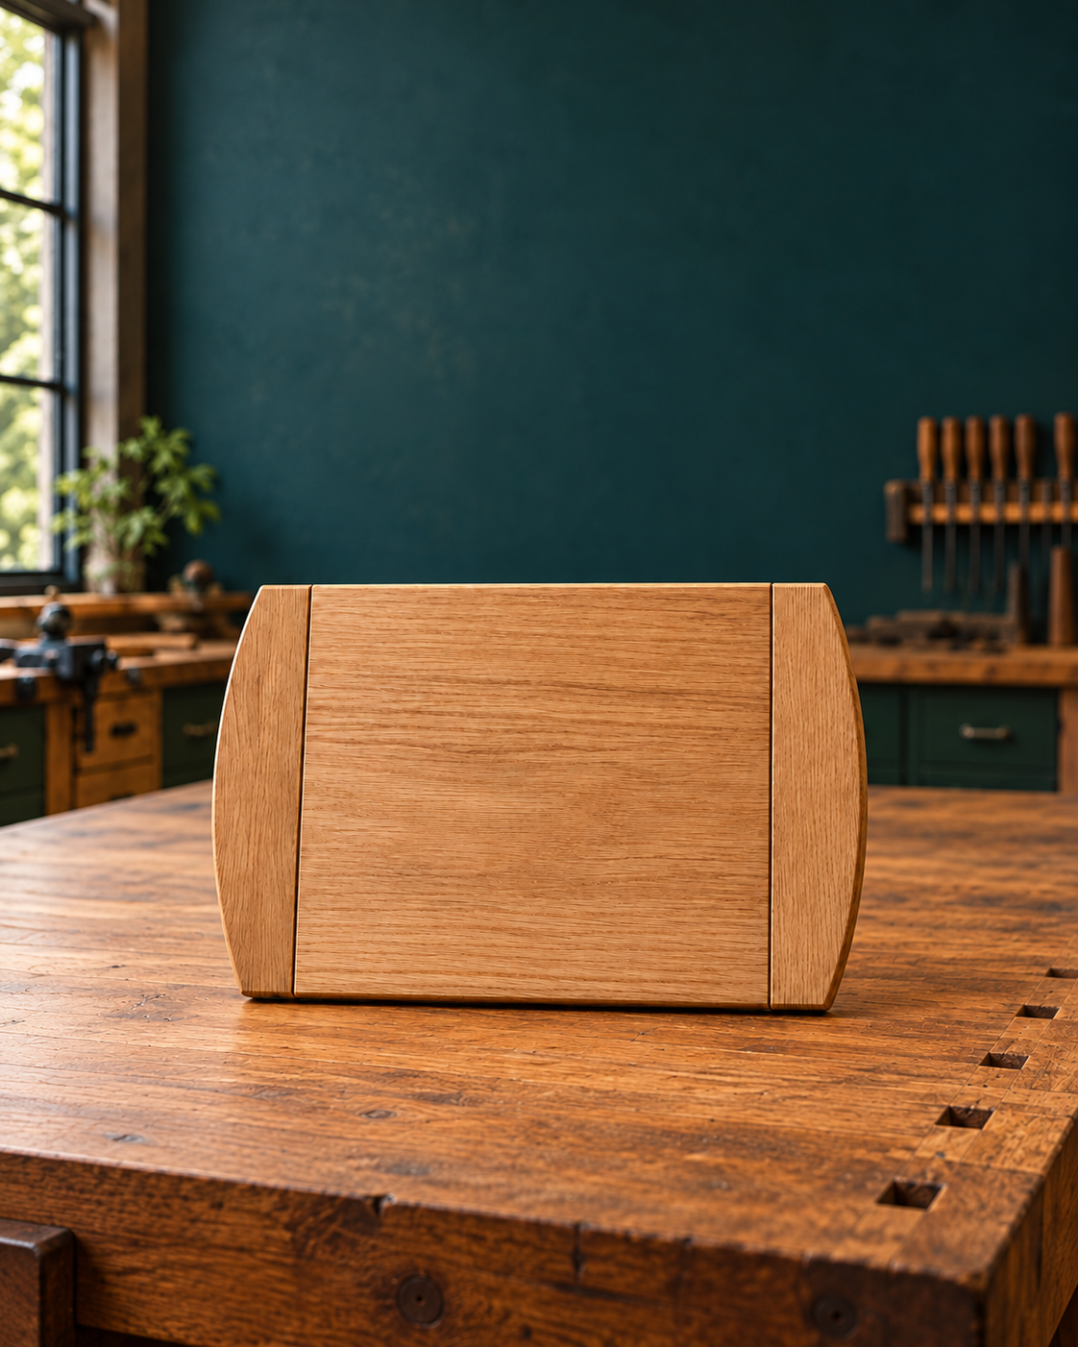
STUDENT WORKBOOK
Breadboard
Understand. Make. Record.
Understand the timber. Make controlled decisions. Show the evidence.

Illustrative course image of the complete breadboard. The original plan controls construction.
A companion to the Bread Board Guided Course. Read, draw, discuss and record practical learning while the teacher uses the course presentations, videos and demonstrations.
STUDENT | CLASS / TEACHER

Breadboard The brief and accurate marking

01 / Read the matching course section 2
STUDENT WORKBOOK

A book for the whole project
Use the readings before the workshop task, and the evidence pages while the decisions are fresh.
START HERE | PAGES
Original supplied plan | 3
1 Workshop readiness and accurate marking | 4–11
2 Grain, joint layout and controlled shaping | 12–19
3 Dry assembly, glue-up and routed profiles | 20–27
4 Consistent sanding and responsible finishing | 28–35
5 Evaluate, document and hand over | 36–43
Project evidence and practical records | 44–50

Read / discuss / apply / record
Readings explain the named course sections. Knowledge checks use the original course questions. Applied activities ask you to diagnose, sequence, compare and justify. Studio pages give room for labelled drawings, written explanations and the twelve folio checkpoints.

Work with the course
The teacher can open the matching module, presentation or video while you work on paper. Keep photographs of your own work for the course folio; attach a print or record its file reference in this book as directed. A labelled sketch supports an explanation but does not silently replace a required photograph.
 Remember
The supplied plan and current teacher instructions control practical work. Confirm materials, equipment, machine settings, finishes and assessment requirements with the teacher. This book does not authorise machine use.

50 pages • 25 double-sided sheets • Edition 1.0
Bring this workbook to theory and practical lessons. Keep the evidence you record specific to your own work.

Breadboard The brief and accurate marking

01 / Read the matching course section 3
ORIGINAL PROJECT PLAN

Read the original plan
Turn the book to read the supplied drawing. Use written dimensions; do not measure this reproduction.
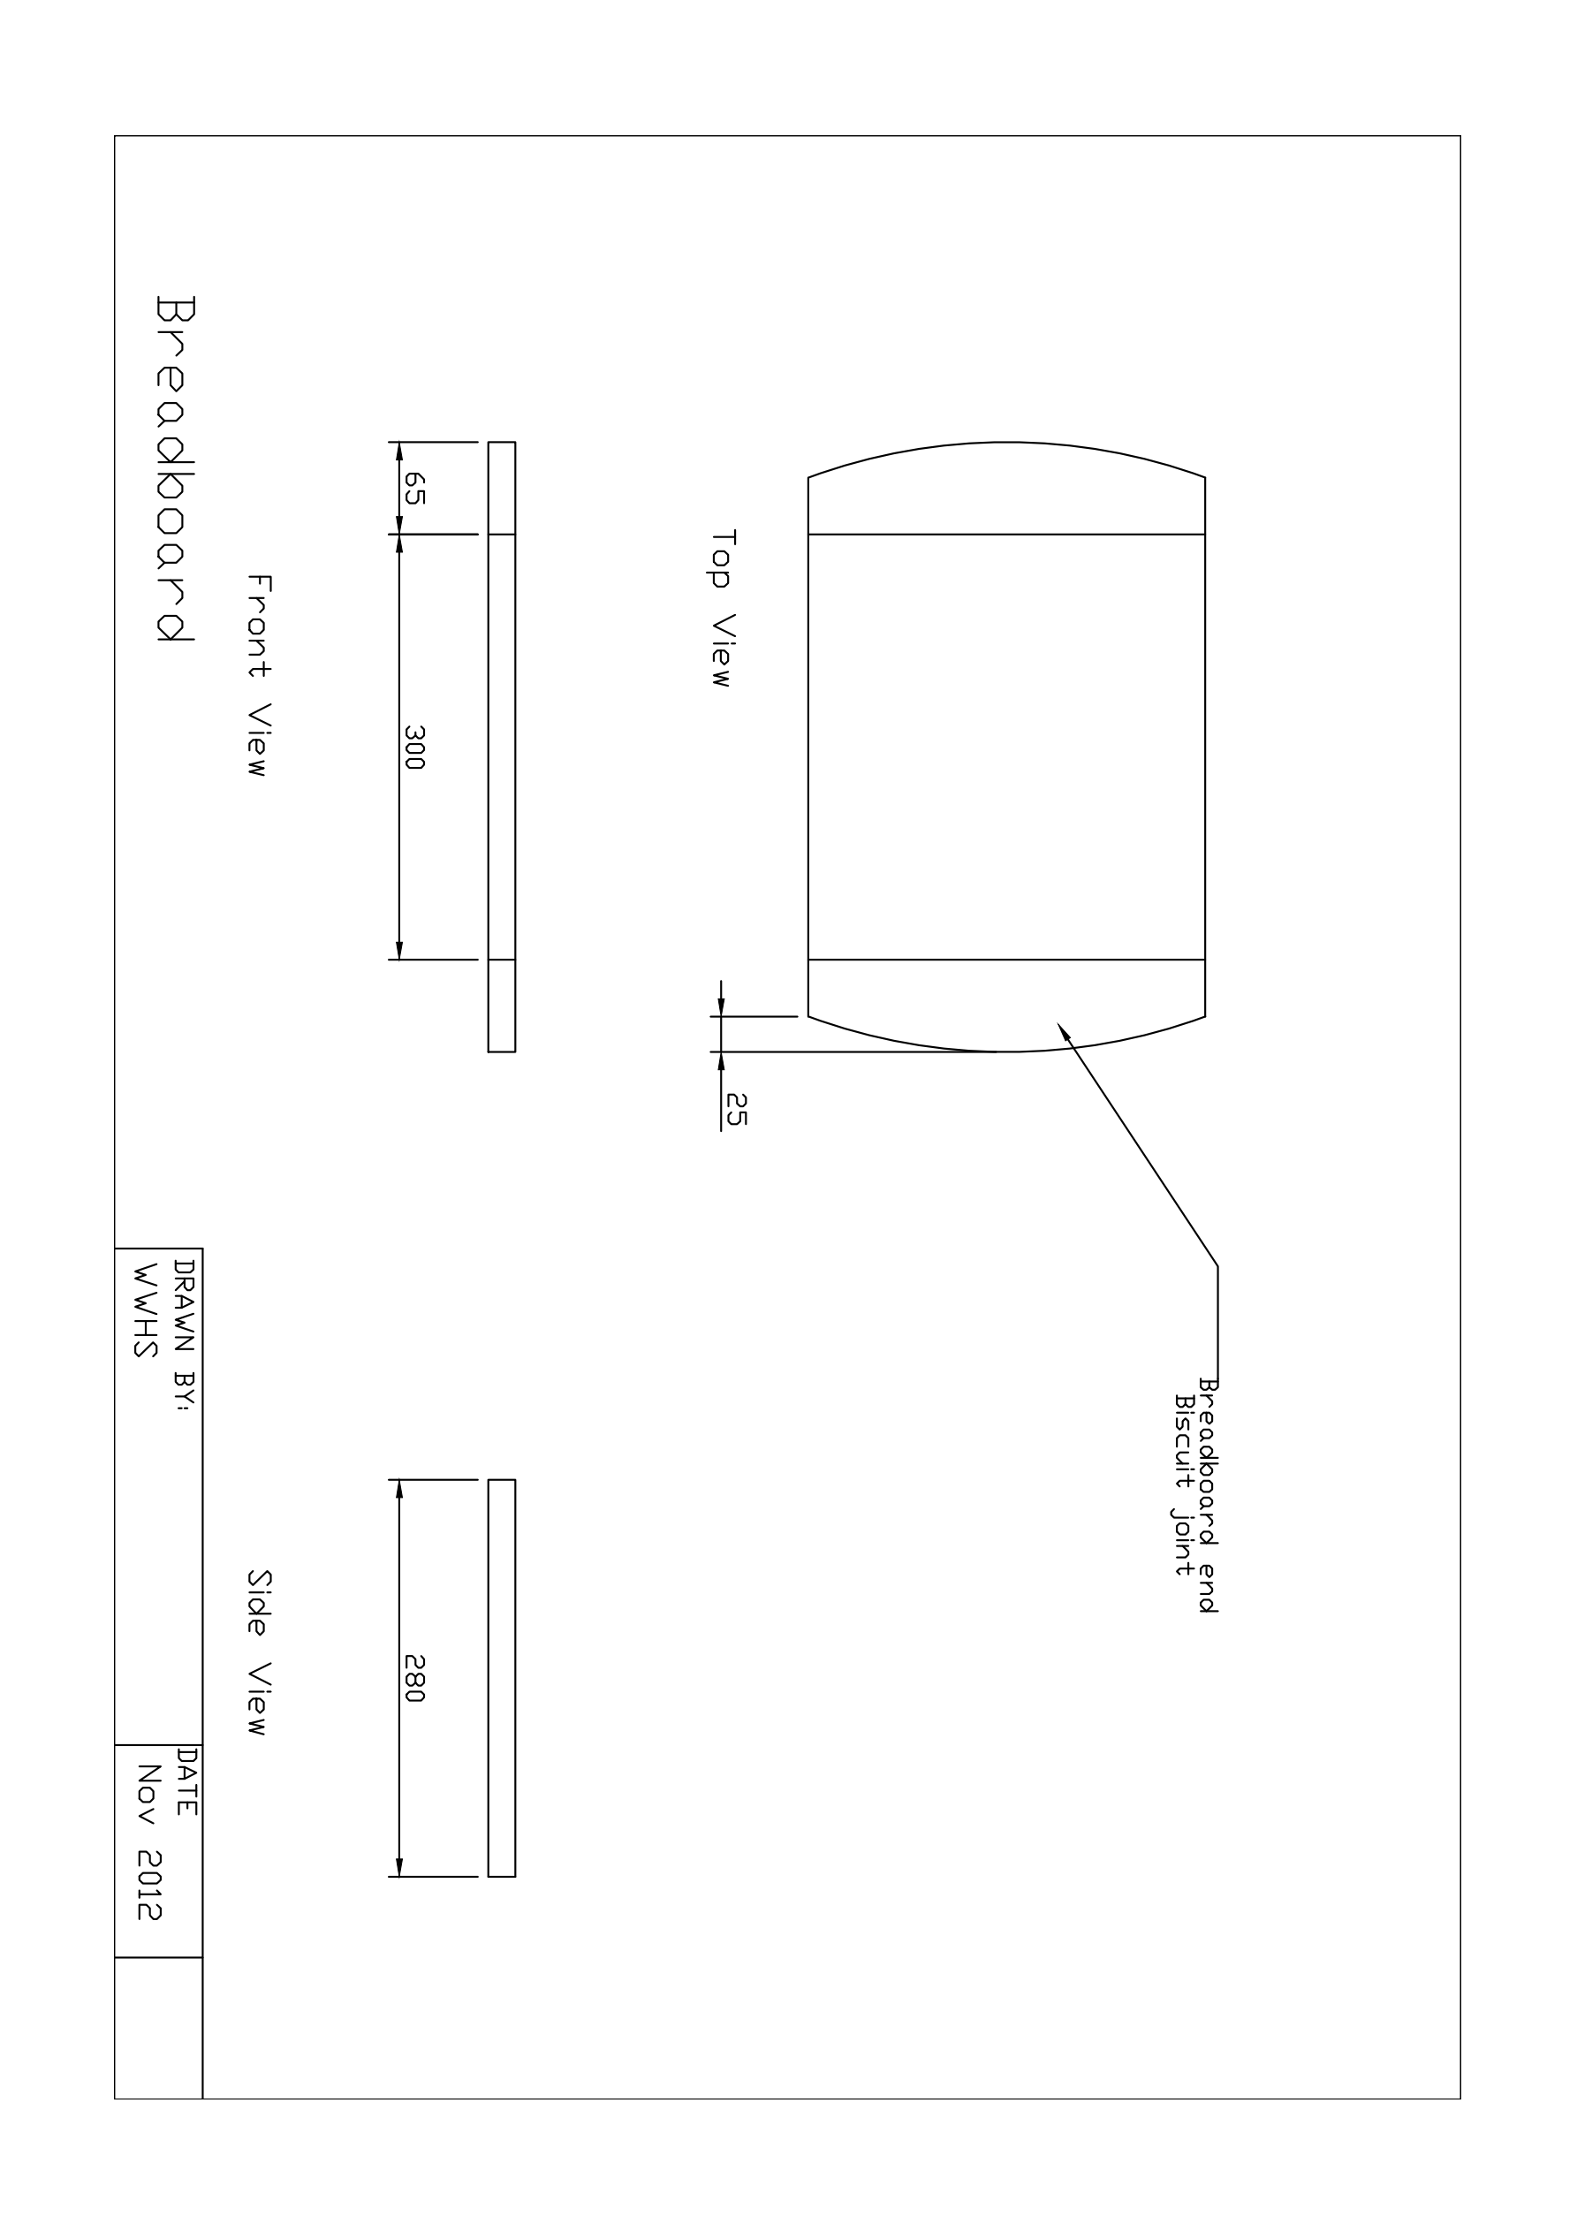
Figure 01. Original supplied Breadboard drawing, WWHS, November 2012. Complete page, rotated for a larger reproduction.
Use the top, front and side views together. Confirm unclear notation and all missing practical details with the teacher before marking or removing timber. Illustrative images do not add construction specifications.

Breadboard The brief and accurate marking

01 / Read the matching course section 4
MODULE 1 / SECTION 1 / READ AND UNDERSTAND
01 | Begin with a clear brief
Good practical work begins with a shared understanding of the required result.

The brief gives decisions a purpose
A project brief explains what the breadboard needs to achieve and the conditions that shape the work. The supplied plan makes the intended form visible. Read them together before choosing a method or making a mark. Separate requirements from personal preferences: an attractive idea is not automatically an authorised change. If a detail is missing, identify the question while the decision is still reversible. Guessing first can waste timber and create avoidable rework.
 Remember
Use the brief and original plan to justify decisions. A photograph helps you notice form; it cannot authorise a construction change.

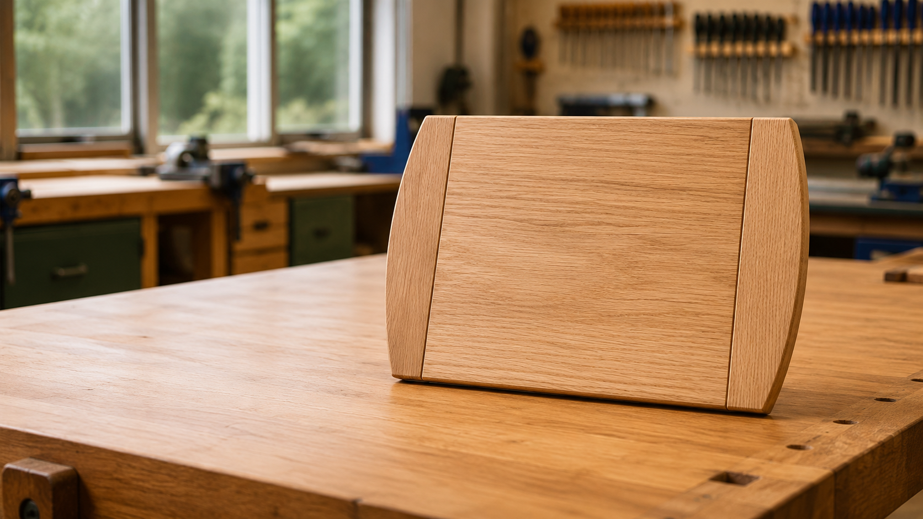
Figure 02. Illustrative course image: the broad centre and curved end pieces give this project its recognisable form.

Readiness is a working habit
Check yourself and the space around you. Secure hair and loose clothing, wear the directed protective equipment and use enclosed footwear as required. Safety glasses help protect eyes, but they cannot make a cluttered bench or uncontrolled action safe. Clear the current work area, keep access routes open and place only the equipment needed for the task within reach. Bags, stools and offcuts can become hazards when people move between benches.
Move calmly and stay aware of nearby students. Rushing and distracting others make a small uncertainty harder to notice. Readiness is not a once-only tick: pause when the task or conditions change. A prepared student can explain the next authorised action, the check that comes before it and the point at which teacher direction is needed.

Breadboard The brief and accurate marking

01 / Read the matching course section 5
MODULE 1 / SECTION 2 / READ AND UNDERSTAND

Notice risk before it grows
A hazard is something that could cause harm; a control changes the situation.
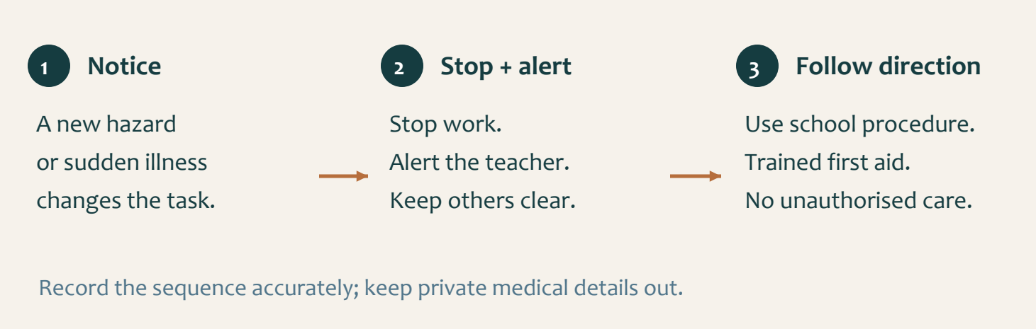
Figure 03. Recognise the change, stop the task and bring the teacher into the response.

Match the control to the problem
Look beyond your own hands. An obstructed walkway, damaged tool or unstable component can affect someone else as well as you. Identify what might happen, then use the
teacher-approved control suited to that hazard. Clear an obstruction when safe and directed, secure the work by the demonstrated method, and keep others away from a reported fault. Simply wearing more protective equipment does not correct every unsafe condition.
SafeWork NSW administers workplace safety requirements and guidance. Laws, regulations, codes and technical standards have different roles. In the school workshop, current signs, teacher directions, safe operating procedures and relevant safety data sheets translate requirements into the controls students must follow.

Know the incident response
If an injury or sudden illness occurs, stop work and alert the teacher immediately. Keep others clear and make the immediate area safe only when that can be done without creating another risk. The school procedure brings a trained first aider to the incident. Do not attempt treatment beyond your training and authority. Follow the teacher, first aider and emergency plan.
An incident record needs an accurate account of the sequence. It does not need classmates’ private medical information in your workbook. Equipment damage is also a stop-and-report matter: do not conceal it or attempt an unauthorised repair. Honest reporting protects the next person who might otherwise use it.

 Remember
A serious incident scene is left undisturbed except to assist an injured person or make the site safe. The school manages formal reporting.

Breadboard The brief and accurate marking

01 / Read the matching course section 6
MODULE 1 / SECTION 3 / READ AND UNDERSTAND

Make every mark traceable
Related measurements need one reliable starting reference.
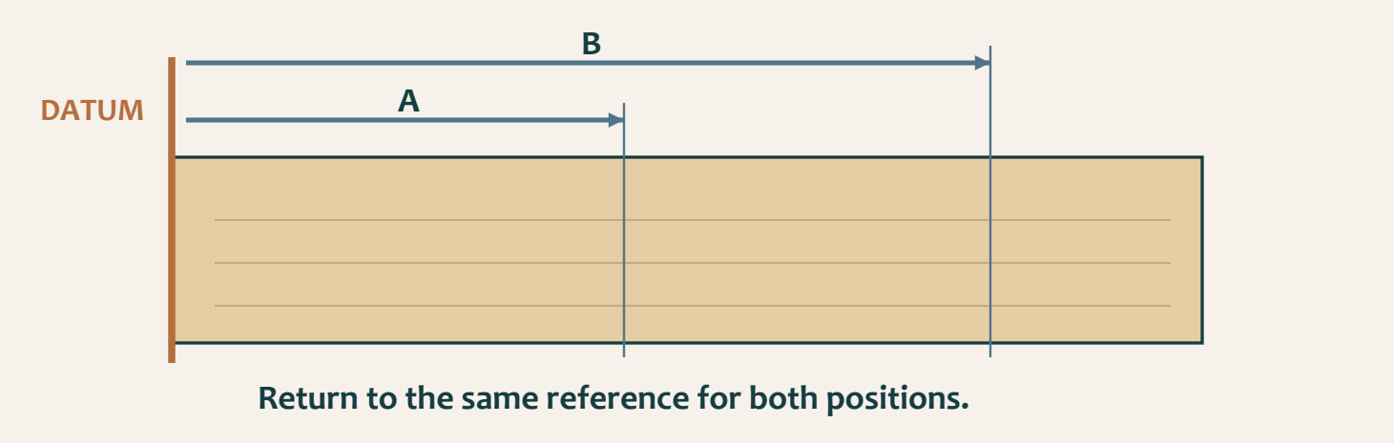
Figure 04. Concept only: both positions are related to one datum. The letters represent positions, not project dimensions.

Read the dimension before the ruler
Locate the required measurement on the plan. Identify exactly where it begins and ends, and which component or view it describes. A line that looks plausible is not evidence that the correct dimension was used. Screen size and print enlargement change the apparent size of a drawing, so use the written information rather than measuring the picture. Check unclear notation with the teacher before transferring it to timber.

Keep one datum through the routine
A datum is the reference face, edge or point from which related measurements are taken. Returning to that reference keeps the marks connected. Measuring the next position from a previous pencil line can carry an earlier error into every later mark. Establish the reference, measure the required position and check it again from the same starting point.

Use a sharp pencil to leave one fine line. Thick bands and several competing lines make the intended boundary uncertain. Cancel an incorrect mark clearly using the workshop’s method, then recheck the replacement. Use the approved straight or square marking aid against the correct reference and check that it has not shifted.
Before material is removed, compare the completed layout with the plan. Preserve the working boundary while approaching the intended form gradually. This final pause matters because a confused line can still be corrected on paper; removed timber cannot simply be put back.

 Remember
Accuracy is a chain: correct plan reading, reliable reference, clear mark and independent check.

Breadboard The brief and accurate marking

01 / Read the matching course section 7
KNOWLEDGE + APPLIED THINKING

Check readiness
Circle one answer for each question. Use the readings to explain a choice you find difficult.
1 | What should guide the first practical decisions in the Bread Board project?  ○ A. A remembered image of another board  ○ B. The supplied brief, plan and teacher directions  ○ C. The fastest available method  ○ D. A classmate's measurements

2 | Which statement best describes a hazard?  ○ A. Something with the potential to cause harm  ○ B. The score given after an accident  ○ C. A piece of PPE  ○ D. A completed risk control

3 | What is the safest response to damaged workshop equipment?  ○ A. Keep using it carefully  ○ B. Repair it without telling anyone  ○ C. Stop, keep others clear and report it to the teacher  ○ D. Return it silently

Hazard or control?
SITUATION | SUITABLE FIRST RESPONSE
Offcut blocks a shared walkway
A tool is visibly damaged
A student suddenly becomes unwell

Breadboard The brief and accurate marking

01 / Read the matching course section 8
KNOWLEDGE + APPLIED THINKING

Check your marks
Circle one answer for each question. Use the readings to explain a choice you find difficult.
4 | Why is one consistent datum used for related measurements?  ○ A. To make pencil lines darker  ○ B. To keep related marks aligned from one reference  ○ C. To avoid reading the plan  ○ D. To remove the need for checking

5 | Which line is most useful for accurate manufacture?  ○ A. Several heavy pencil lines  ○ B. One fine checked line  ○ C. A guessed mark near the edge  ○ D. A line copied from the screen with a ruler

6 | What should happen when a plan or mark is unclear?  ○ A. Remove material and check later  ○ B. Choose the most likely interpretation  ○ C. Stop and ask for teacher direction  ○ D. Copy the nearest student's mark

Order the marking routine
Number the steps 1–5. Treat the last step as a check before material is removed.
[ ] Recheck the position from the same reference.
[ ] Read the written dimension and identify its endpoints.
[ ] Make one fine line and verify the completed layout.
[ ] Establish the agreed datum.
[ ] Measure the required position from that datum.
Which check prevents an unclear mark becoming an irreversible error? Explain why.

Breadboard The brief and accurate marking

01 / Read the matching course section 9
STUDIO / PROJECT EVIDENCE

Explain your decisions
Use complete explanations: name the action, explain the reason and include the check or evidence.

Explain a safe start and incident response
Explain what you will check before beginning practical Bread Board work, why each check matters, and what you would do if an injury or sudden illness occurred.

Explain an accurate marking routine
Explain how you would transfer a required position from the project plan to timber without allowing small errors to build up.

Breadboard The brief and accurate marking

01 / Read the matching course section 10
STUDIO / PROJECT EVIDENCE

Brief and safety evidence
Folio checkpoints 1–2: make the requirements and a meaningful safety check visible.
BRIEF / PLAN REQUIREMENT | HOW I WILL CHECK IT

Draw your ready work area. Label one controlled hazard, the clear movement space and where the current task belongs.


Record the actual safety check, its reason and result. Add the photograph reference for checkpoints 1–2 when available.

Breadboard The brief and accurate marking

01 / Read the matching course section 11
STUDIO / PROJECT EVIDENCE

A datum you can explain
Folio checkpoints 3 and 5: record plan reading, layout and one checked mark.
Draw a component layout for explanation. Label the datum, one required position and the reference used to check it. Copy written values only after confirming them from the original plan.


WHAT I CHECKED | RESULT / CORRECTION
Plan and component orientation
Datum and fine mark

Caption your marking evidence: stage, action, reason and result. Photo reference:

Breadboard Timber, layout and shaping

02 / Read the matching course section 12
MODULE 2 / SECTION 1 / READ AND UNDERSTAND
02 | Read the timber first
Grain, visible defects and component orientation belong in the same layout decision.

Look across faces and edges
Timber is not visually uniform. Grain gives clues about appearance and how the material may behave during shaping. Inspect the faces and edges before arranging the components. Notice grain direction, visible defects and the character of each piece. A feature that seems interesting in a photograph may need teacher advice before it is accepted in a working component. Colour alone is an incomplete basis for selection.

Keep the whole arrangement visible
Place the central board and end pieces in the order and orientation required by the plan. Examine the arrangement as a complete product, not as unrelated pieces. Grain direction can strengthen the visual connection between components, while an accidental rotation may make the relationship look inconsistent or change the working behaviour. The illustration helps you compare directions; the approved plan and teacher determine the actual stock and orientation.
 Remember
Observe first, arrange second, label third, then compare the whole layout with the plan.

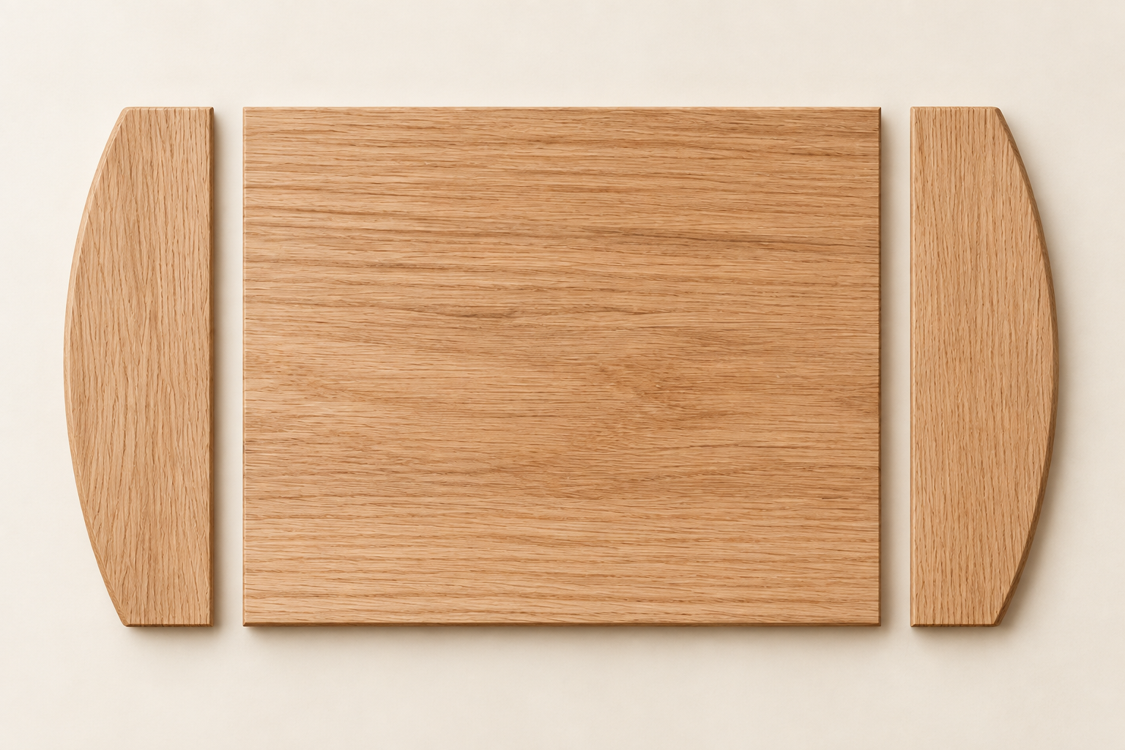
Figure 05. Generated material study: the central grain runs across the image; the two curved end pieces show a different direction. Illustrative, not a cutting plan.
Maintain visible reference faces and edges while you plan. Identify paired pieces so that the chosen arrangement survives marking and later handling. Avoid turning a part merely because it looks similar from the other side. Recheck the plan whenever orientation changes.
Plan efficient use of the available timber while retaining the material needed for accurate preparation. Crowding outlines together can sacrifice the allowance needed for refinement. Before cutting, check the complete outline, spacing, reference marks and component identity. Raise any unresolved defect or stock question before it becomes an irreversible choice.

Breadboard Timber, layout and shaping

02 / Read the matching course section 13
MODULE 2 / SECTION 2 / READ AND UNDERSTAND

Keep biscuit marks matched
The joint only aligns when its two mating parts share a clear reference.
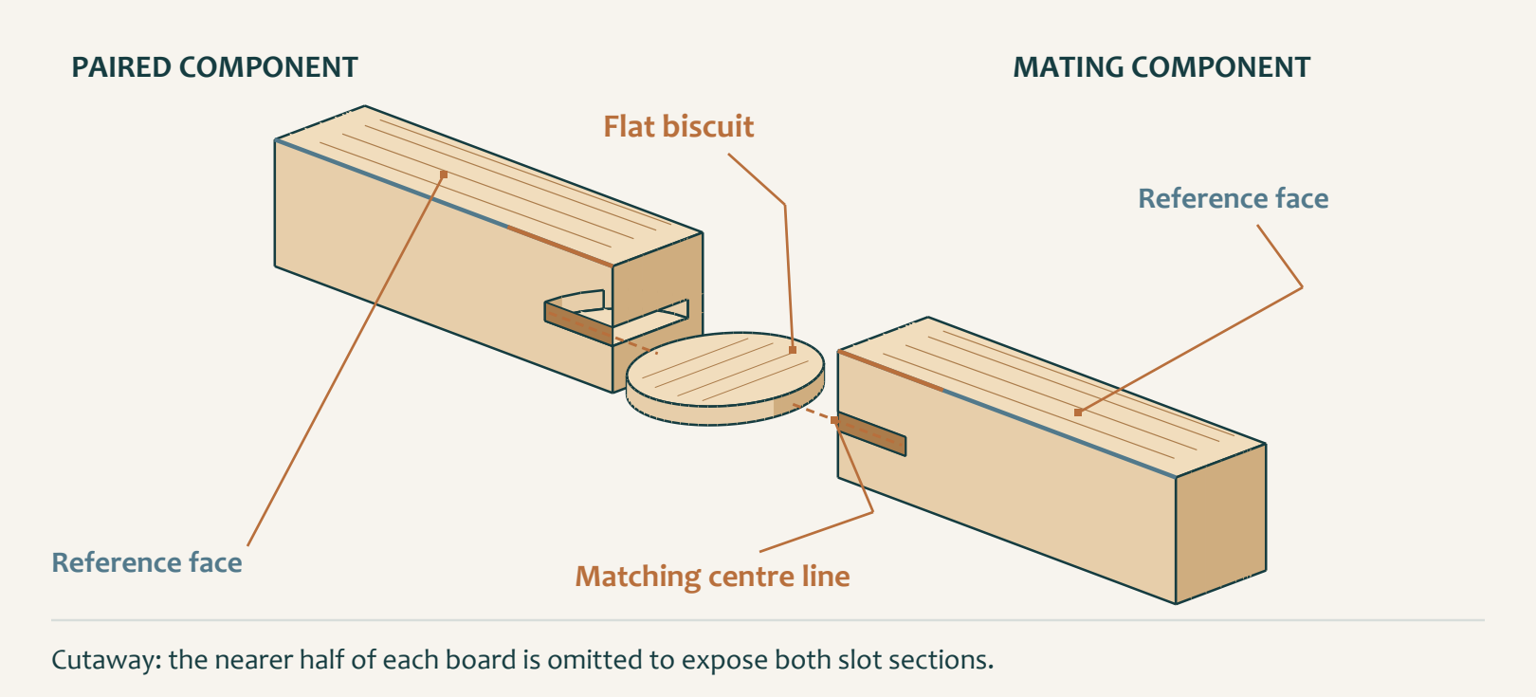
Figure 06. One conceptual mating pair: a shared centre line relates both slots to the same flat biscuit. No construction values are specified.

Pair before you separate
A biscuit joint uses a flat biscuit that fits into corresponding slots in adjoining components. The essential preparation problem is correspondence: a position marked on one piece must match the intended position on the other. Start by identifying the meeting parts in the plan. Place them together in their finished orientation, confirm the reference faces and edges, and keep the inside and outside relationships clear.

Transfer the relationship
Use the workshop’s agreed marking system to identify corresponding parts. Transfer each
joint-position mark across the aligned mating components while their relationship is visible. A sharp pencil makes a clear centre line; repeated or heavy marks leave room for doubt after the pieces are separated. Consistent references also help prevent variations in stock from producing an uneven joint line.

Do not rotate, flip or exchange components after marking without checking the arrangement again. Similar-looking parts are not proof of interchangeability. Before any slot is made, compare the entire layout with the plan: correct parts, intended orientation, matching references and aligned positions.
The number, location and machining details of the joints come from the approved plan and teacher direction. A teaching diagram can explain alignment without supplying those values. Guessing extra slots or copying a different project can leave a component weakened or a joint misplaced. If a line is uncertain, stop while a pencil mark can still be corrected.

 Remember
These diagrams explain matching, not biscuit size, slot settings, number or spacing.

Breadboard Timber, layout and shaping

02 / Read the matching course section 14
MODULE 2 / SECTION 3 / READ AND UNDERSTAND

Shape in controlled stages
Every short removal stage should be followed by a check against the intended boundary.
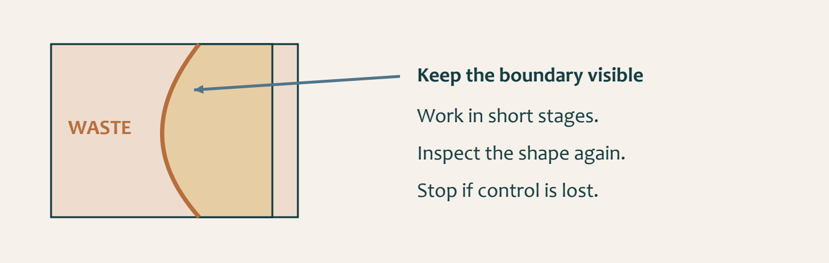
Figure 07. A conceptual profile shows the planned boundary inside the waste area. It is not a template for tracing.

Protect the form you still need
Read the profile on the supplied plan or approved template and confirm its orientation before shaping. Identify the material that belongs to the finished component and the waste outside it. Keep the intended boundary visible while working towards it. Removing the line too soon may mean that the part has already become undersize. A small controlled allowance can be refined; a missing portion of the form is much harder to recover.

Let inspection set the pace
Use only the secure support and process demonstrated by the teacher. A part that rocks or shifts makes both safety and accuracy harder to control. Do not compensate with an awkward reach or by forcing the material. Stop and obtain direction when support, resistance, grain behaviour or the planned profile becomes uncertain.

Work in short, deliberate stages. Between them, clear loose material by the approved method and inspect the shape from more than one angle. Compare both end pieces with the planned form rather than judging each in isolation. Look for high areas, low areas and a change in the intended curve.
A visible fault does not automatically tell you how much to remove. Identify the cause, decide whether correction can preserve the form, and seek teacher advice where needed. Regular comparison turns shaping into a series of informed decisions. Continuous removal without inspection can convert a small discrepancy into an uneven or undersize component.

 Remember
The quality check is part of the shaping process, not something reserved for the end.

Breadboard Timber, layout and shaping

02 / Read the matching course section 15
KNOWLEDGE + APPLIED THINKING

Check the layout
Circle one answer for each question. Use the readings to explain a choice you find difficult.
7 | Why should grain direction be considered before the board components are arranged?  ○ A. It changes the written dimensions  ○ B. It affects appearance, working behaviour and component consistency  ○ C. It removes the need for reference marks  ○ D. It proves every board is defect-free

8 | What is the strongest way to keep matching components correctly oriented?  ○ A. Rely on memory  ○ B. Label reference faces and keep the parts paired  ○ C. Turn each piece until it looks similar  ○ D. Remove all pencil marks early

9 | Why are biscuit-joint positions transferred across aligned matching components?  ○ A. To make the biscuits thicker  ○ B. To keep matching slots on the same centre lines  ○ C. To avoid using the plan  ○ D. To create decorative pencil lines

A swapped component
A matching end piece is flipped after its joint marks are transferred. Explain what must be checked before any slot is made.

Breadboard Timber, layout and shaping

02 / Read the matching course section 16
KNOWLEDGE + APPLIED THINKING

Check controlled shaping
Circle one answer for each question. Use the readings to explain a choice you find difficult.
10 | What should control the number and location of biscuit joints?  ○ A. Whatever looks balanced  ○ B. The approved plan and teacher direction  ○ C. The number used on another project  ○ D. The maximum number that will fit

11 | Why is the finished boundary line kept visible while shaping?  ○ A. It shows that controlled allowance remains for refinement  ○ B. It makes the project darker  ○ C. It proves the machine is correctly set  ○ D. It replaces later inspection

12 | When should shaping stop immediately?  ○ A. When the work begins to feel uncontrolled or the plan is unclear  ○ B. Only after the boundary has disappeared  ○ C. When another student finishes first  ○ D. After forcing the material through

Protect the boundary
One end has a high area; the other already matches the planned curve. A student proposes removing the same amount from both. Explain the problem with that choice.

Breadboard Timber, layout and shaping

02 / Read the matching course section 17
STUDIO / PROJECT EVIDENCE

Explain your decisions
Use complete explanations: name the action, explain the reason and include the check or evidence.

Plan a grain and component layout
Explain how you would arrange and label the Bread Board components before marking joints or removing material.

Explain accurate biscuit-joint preparation
Explain how matching biscuit-joint positions are planned and checked before any slots are made.

Breadboard Timber, layout and shaping

02 / Read the matching course section 18
STUDIO / PROJECT EVIDENCE

Select and arrange the timber
Folio checkpoint 4: connect a material observation to the component’s purpose.

Figure 08. Illustrative grain study. Inspect your own supplied timber before making a selection.
OBSERVATION | WHAT IT MEANS FOR MY LAYOUT
Grain direction and appearance
Visible defect or uncertainty
Reference face / component role

Justify your selected arrangement and note the teacher direction that resolved any uncertainty. Add your evidence photo reference.

Breadboard Timber, layout and shaping

02 / Read the matching course section 19
STUDIO / PROJECT EVIDENCE

Plan the matching relationship
Folio checkpoints 6–7: show controlled preparation and matching biscuit-joint references.
Draw the meeting parts separated slightly. Label paired identities, reference faces and one corresponding centre line. Show a flat biscuit and matching slots conceptually; do not invent construction values.


Explain one controlled preparation step and the boundary or quality check it protected.

What did you check before separating the paired parts? Add the photograph reference for your
joint-preparation evidence.

Breadboard Dry fit and assembly

03 / Read the matching course section 20
MODULE 3 / SECTION 1 / READ AND UNDERSTAND
03 | Use the dry fit to learn
A complete trial assembly reveals problems while the components can still be separated.

Test the relationships together
Dry assembly means fitting the project without adhesive. Place every part in the planned orientation, using the paired identification and reference marks. Compare the whole arrangement with the original plan rather than trusting memory. Check that mating parts meet as intended and that the end pieces have not been reversed or exchanged. A successful fit of one joint does not prove that the whole board is aligned.

Find the cause before correcting
Inspect the top, sides and overall length on the flat support approved by the teacher. Look for gaps, uneven contact, high spots, twist or rocking. Notice where the pieces touch and where they do not. Resistance can indicate incorrect orientation, debris or a local fit issue; force may conceal the cause and damage the components.
 Remember
A gap is an observation. Its cause is a question to investigate, not an excuse to apply more force.

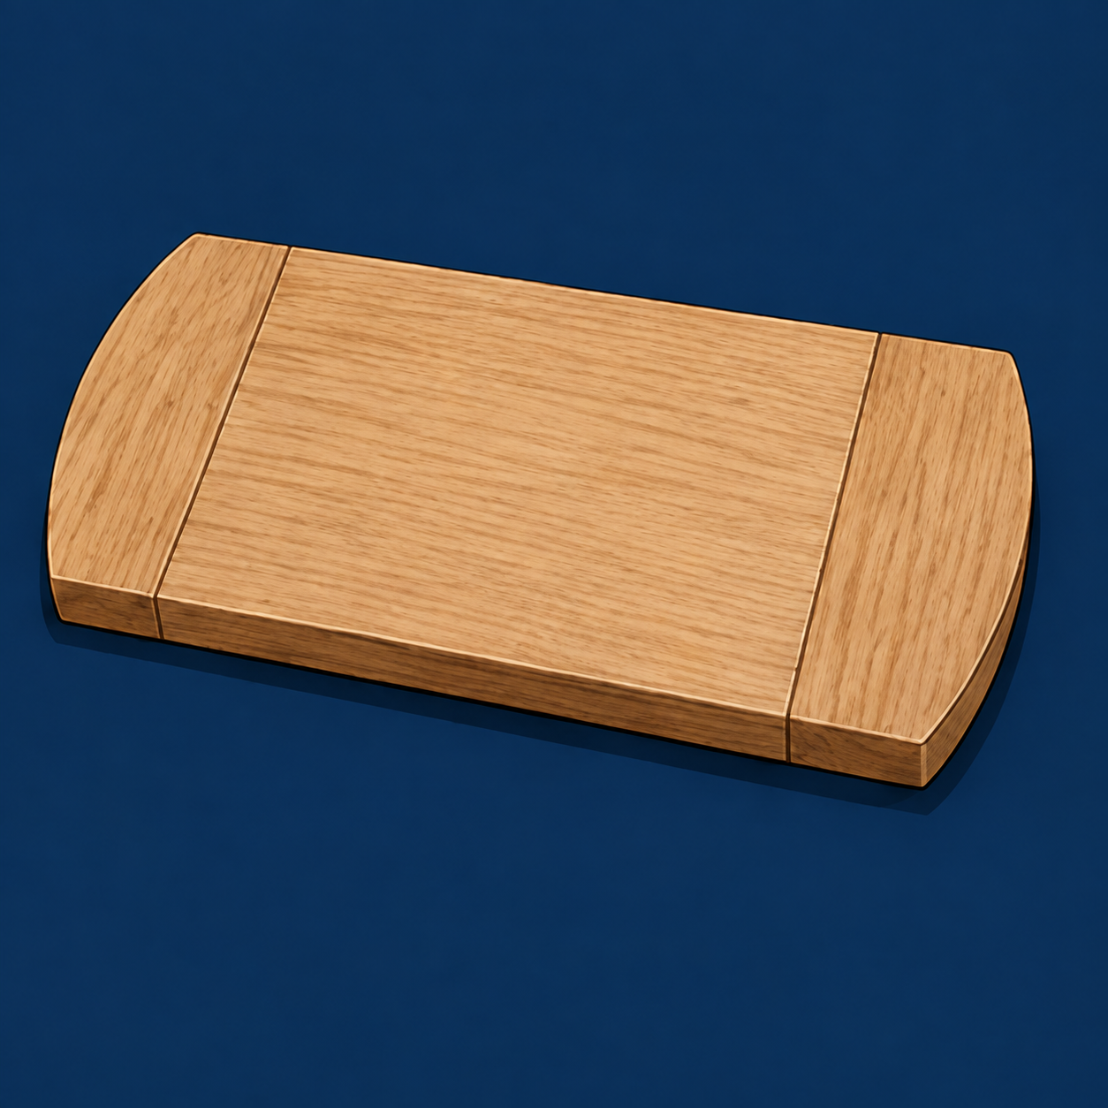
Figure 09. Illustrative assembly adapted from the course image: compare joint contact and surface alignment. A photograph alone cannot prove that a real dry-fit check occurred.
When a fault appears, stop and investigate it. Repositioning a wrongly oriented component may solve the problem without removing any timber. If a verified correction is required, use the
teacher-approved method and make only the controlled change that the evidence supports. Randomly sanding every mating face can turn a tight local problem into a loose joint.
Reassemble the complete project after any correction and inspect again. Record the observation, action and result so the check becomes useful folio evidence. If the cause remains unexplained, obtain teacher advice before adhesive is introduced. Glue-up should begin with an understood assembly, not a hope that pressure will make an uncertain fit disappear.

Breadboard Dry fit and assembly

03 / Read the matching course section 21
MODULE 3 / SECTION 2 / READ AND UNDERSTAND

Prepare before opening adhesive
A planned sequence leaves attention available for the alignment checks that matter.
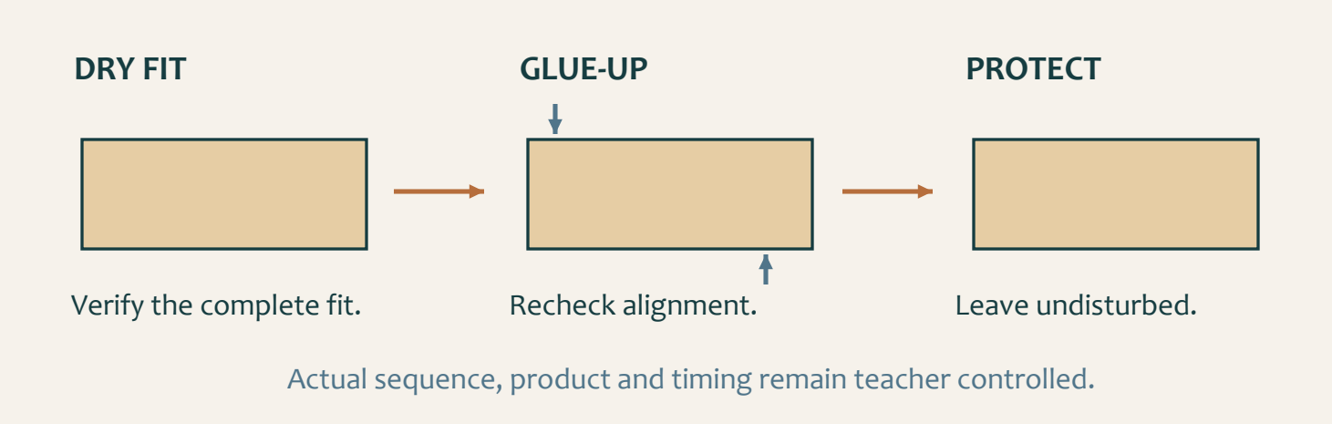
Figure 10. Plan the process before adhesive; inspect alignment as pressure changes; then protect the assembly while it remains undisturbed.

Stage the complete operation
Glue-up makes the verified assembly permanent. Begin only after the dry fit confirms the correct arrangement, fit and alignment. Prepare the components, clear working space, clamps, protective pieces and checking equipment in the demonstrated order. Check that mating surfaces are clean enough for the approved process; a chip trapped between them can interfere with closure. Choose only the teacher-approved adhesive and follow its label and the local instructions.

Watch what pressure changes
Balanced clamping pressure closes the checked joints while preserving the board’s form. It is not a competition to apply the greatest force. As the teacher-directed sequence progresses, check whether components move, twist or become uneven. Protection at contact points helps prevent clamp marks. If the assembly shifts out of alignment, pause and seek direction rather than continuing to tighten it.

Good preparation also reduces rushed movement and unclear communication. Agree who is doing each authorised action when work is shared. Keep the checks in the sequence: they should not disappear simply because adhesive working time is limited. Manage excess adhesive by the approved clean-up method.
Once the assembly is positioned and checked, leave it undisturbed for the period directed by the teacher and product information. Do not invent a curing time, lift it early to inspect underneath or remove clamps because another group has finished. Record the actual sequence and observations without turning an illustrative photograph into a prescribed clamp setup.

 Remember
An earlier dry-fit record and a later alignment check show why the glue-up was ready to proceed.

Breadboard Dry fit and assembly

03 / Read the matching course section 22
MODULE 3 / SECTION 3 / READ AND UNDERSTAND

Prepare for the routed profile
Clear understanding and an authorised setup come before machine use.
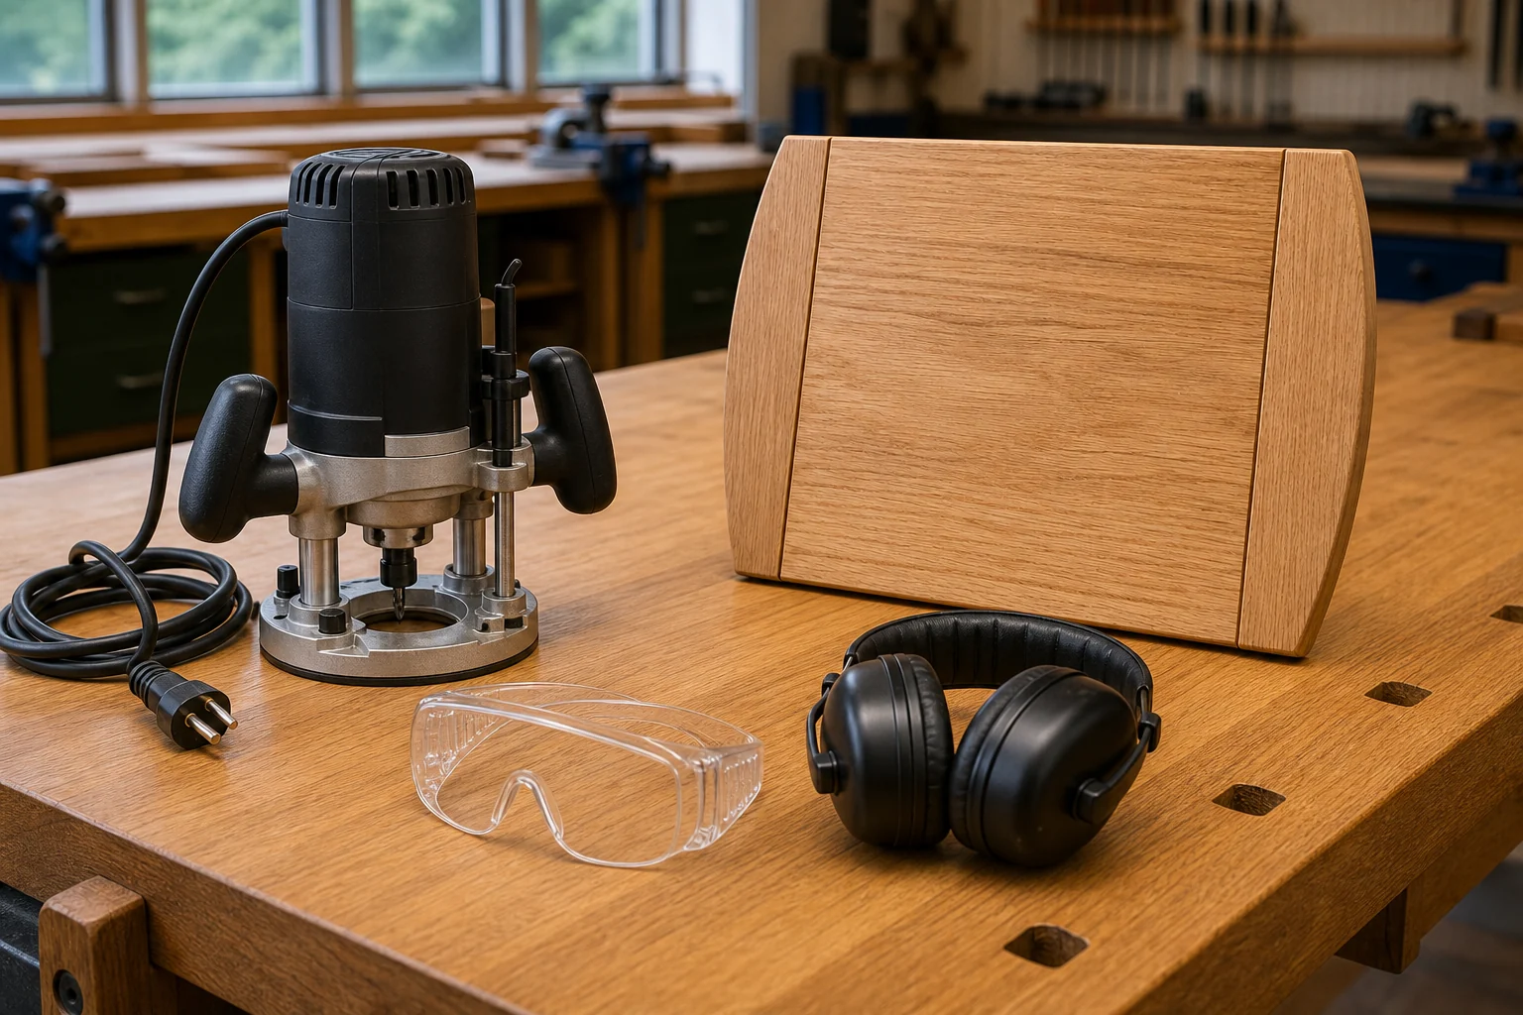
Figure 11. Course pre-start illustration: the router is unplugged. Equipment shown at rest is not an authorised operating setup.

Identify the intended edge
A routed profile belongs in a particular location on a particular component. Read the plan and listen to the teacher demonstration to confirm what the finished edge should be. Do not assume that every edge receives the same treatment. Check the piece, its orientation and any marks or defects that could affect the proposed work. An attractive profile seen elsewhere does not change this project’s requirement.

Keep preparation under control
The source shows an unplugged router prepared for a teacher pre-start check. The school’s demonstrated process controls the actual machine, cutter relationship, guards, extraction, workholding and permission to operate. Clear offcuts and unrelated tools so the component can be supported as demonstrated. It should not rock, slide or shift. Check the directed personal protective equipment and secure hair and loose items before approaching the work.

A video can clarify a relationship; it cannot authorise a setup or an operating method. Follow the approved sequence and technique without changing settings or copying another student’s variation. Stay focused and avoid distractions near the work area.
Stop if the component moves, a profile or mark becomes unclear, protective equipment needs adjustment or any condition differs from the authorised preparation. Continuing more slowly does not resolve the change. Obtain teacher direction before restarting. The workbook records understanding and observation; the teacher controls the practical demonstration and permission.

 Remember
No speed, depth, feed direction or cutter choice is supplied by this workbook. Record the teacher’s instructions in the practical notes.

Breadboard Dry fit and assembly

03 / Read the matching course section 23
KNOWLEDGE + APPLIED THINKING

Check before joining
Circle one answer for each question. Use the readings to explain a choice you find difficult.
13 | What is the main purpose of a complete dry assembly?  ○ A. To make adhesive cure faster  ○ B. To confirm fit, orientation and alignment before permanent joining  ○ C. To hide small gaps  ○ D. To replace the project plan

14 | A joint does not close evenly during the dry fit. What should happen first?  ○ A. Apply more force  ○ B. Remove material from every surface  ○ C. Identify the actual cause and high point  ○ D. Add adhesive to lubricate it

15 | Why is the glue-up sequence planned before adhesive is applied?  ○ A. To reduce rushed decisions while working time is limited  ○ B. To avoid checking alignment  ○ C. To use as much adhesive as possible  ○ D. To change the plan dimensions

Diagnosis before correction
OBSERVATION | CHECK BEFORE A CHANGE
One joint does not close evenly
The board rocks on the approved support

Breadboard Dry fit and assembly

03 / Read the matching course section 24
KNOWLEDGE + APPLIED THINKING

Check the preparation
Circle one answer for each question. Use the readings to explain a choice you find difficult.
16 | What is the best description of balanced clamping pressure?  ○ A. Maximum pressure from one side  ○ B. Enough even pressure to close joints without distorting the assembly  ○ C. No pressure at all  ○ D. Pressure applied before checking orientation

17 | Which condition must be confirmed before a teacher-directed routed profile begins?  ○ A. The component is secure and the process is authorised  ○ B. The student has guessed the profile  ○ C. Loose items remain near the work  ○ D. The line is unclear

18 | What should a student do if the routed-profile setup or condition changes?  ○ A. Continue more slowly  ○ B. Stop and seek teacher direction  ○ C. Hold the component closer to the cutting area  ○ D. Ignore the change

Stop signals
During preparation, the component shifts and the planned edge is now unclear. Write the response and the condition required before restarting.

Breadboard Dry fit and assembly

03 / Read the matching course section 25
STUDIO / PROJECT EVIDENCE

Explain your decisions
Use complete explanations: name the action, explain the reason and include the check or evidence.

Diagnose a dry-assembly fault
A curved end piece does not sit evenly during the dry assembly. Explain how you would investigate the cause without forcing or randomly removing timber.

Plan a controlled glue-up
Explain the sequence and checks you would prepare before adhesive is applied to the Bread Board assembly.

Breadboard Dry fit and assembly

03 / Read the matching course section 26
STUDIO / PROJECT EVIDENCE

Record the complete dry fit
Folio checkpoint 8: describe the evidence before permanent joining.
Attach a print or draw your complete trial assembly. Label the joint contact, orientation and an alignment check. Add the actual photo reference.


OBSERVATION | ACTION / RECHECK RESULT
Joint contact and orientation
Surface alignment and stability
Fault or uncertainty, if any

Explain why this evidence was collected before adhesive.

Breadboard Dry fit and assembly

03 / Read the matching course section 27
STUDIO / PROJECT EVIDENCE

Record the glue-up decisions
Folio checkpoint 9: show sequence, balanced pressure and alignment checks.
BEFORE ADHESIVE | ACTUAL CHECK / TEACHER DIRECTION
Complete dry assembly
Parts, clamps and protective pieces
Approved adhesive and clean-up

Draw or attach your authorised arrangement. Label the alignment check and protective contact points. This records the demonstrated setup; it does not prescribe one for others.


What changed as pressure was added, and what did you check? Add the evidence photo reference and the teacher’s storage instruction.

Breadboard Surface and finish

04 / Read the matching course section 28
MODULE 4 / SECTION 1 / READ AND UNDERSTAND
04 | Prepare the whole surface
One smooth patch does not prove that the complete breadboard is ready for finish.

Begin with evidence of the faults
Inspect the board in good light before sanding. Look across faces, edges and end grain, and feel the surface gently for rough fibres and changes that are hard to see. Notice scratches, dents, glue residue and raised grain. An unexplained mark needs investigation: removing more timber may alter the planned form without solving the original problem. Establish what requires attention before beginning the approved abrasive sequence.

Work evenly and inspect again
Move systematically across the component rather than jumping between random patches. Keep track of completed areas so one region is not repeatedly sanded while another is missed. Work with the grain where appropriate to the demonstrated process. The source presentation emphasises removing the previous scratch pattern before progressing to the next approved stage; it does not prescribe a universal grit list.
 Remember
Use the teacher-approved abrasive stages. The evidence for moving on is the surface condition, not simply time spent sanding.

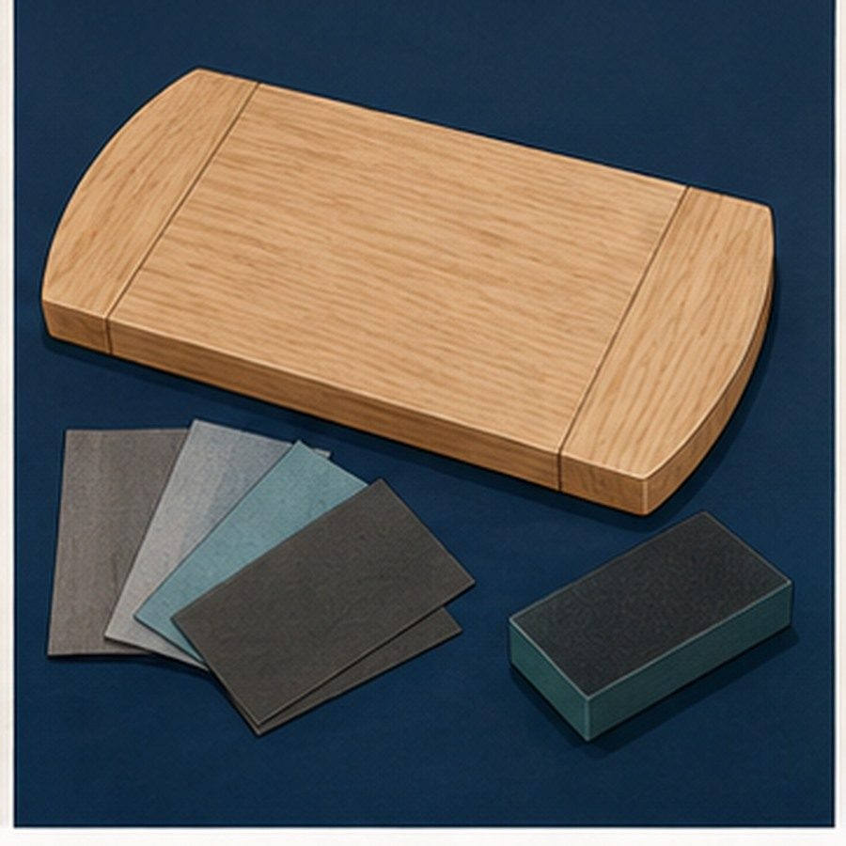
Figure 12. Course surface-preparation illustration. The abrasive samples do not specify a grit sequence; use the approved stages.
Preserve the flatness, curved ends and intended edge profile. Extra pressure at a corner or extended attention to one fault can create rounding or a low spot. Stop regularly, remove loose dust by the approved method, then inspect from different angles and feel for remaining roughness.
Dust control supports both health and surface quality. Particles left on the board can scratch it again or contaminate later finishing. Follow the workshop’s collection, cleaning and
protective-equipment instructions. Do not blow dust across the room or towards classmates. Ask the teacher before a correction that might compromise the intended shape, and complete a whole-surface check before finishing.

Breadboard Surface and finish

04 / Read the matching course section 29
MODULE 4 / SECTION 2 / READ AND UNDERSTAND

Make the finish area ready
A clean, protected surface and an organised workspace are part of the finish.
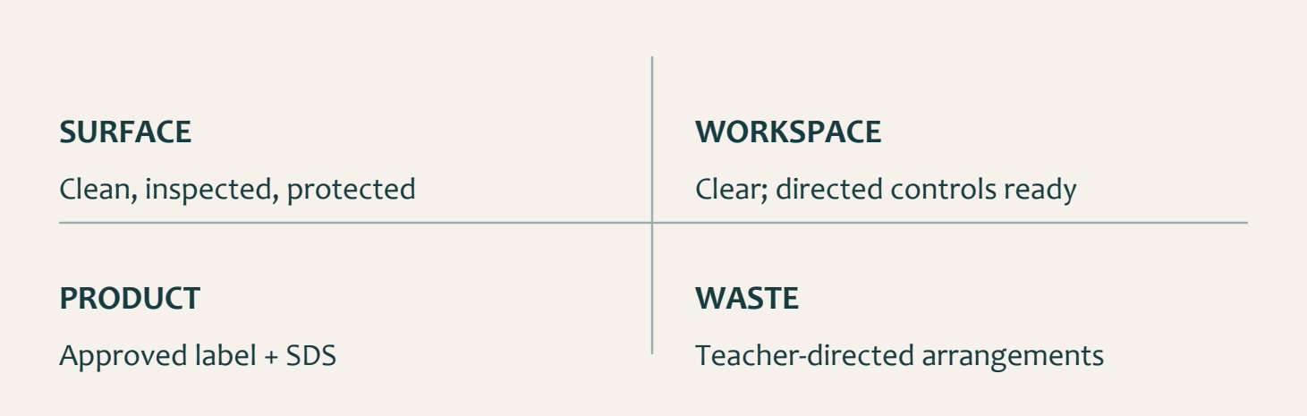
Figure 13. Surface, space, product instructions and waste arrangements must all be ready before application.

Check before collecting materials
Before the oil finish is opened, inspect the prepared timber again. Examine every face, edge and end-grain area in suitable light. Check for dust, glue residue, roughness or marks that sanding may have left behind. Handle the board with clean hands and avoid dragging it across dusty or rough supports. Fingerprints, moisture and loose particles can affect how a finish is absorbed or how the completed surface looks.

Use the product’s own instructions
Confirm the approved product, teacher demonstration, label, safety data sheet and local procedure. These sources control preparation, ventilation, protective equipment, handling and waste. A method from another project may use a different product and must not be substituted. Keep finishing materials protected from contamination and containers secure. Organise the space so that moving between materials and the board does not introduce dust or spills.

Preparation includes knowing where used cloths and contaminated waste will go. Oily materials can create product-dependent hazards, so never invent a storage or disposal method. Use the location and procedure directed by the teacher. An ordinary bin, pocket or unattended bench is not a substitute.
A readiness check can prevent wasted finish as well as a poor surface. If the board is still dusty or an unexplained mark remains, stop before applying the product. Record the issue and seek direction. Finishing should reveal careful preparation, not be used to hide a problem that has not been understood.

 Remember
The source names an approved oil finish but does not assign a product, coat count or drying time.

Breadboard Surface and finish

04 / Read the matching course section 30
MODULE 4 / SECTION 3 / READ AND UNDERSTAND

Use resources responsibly
Material care, controlled quantities and safe waste decisions work together.
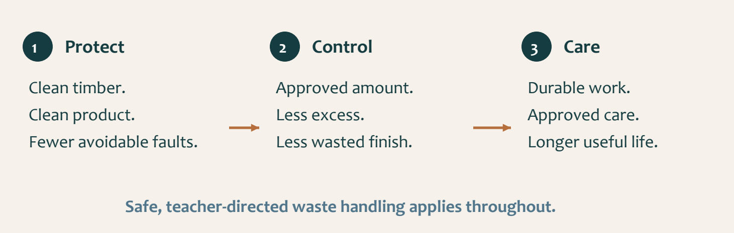
Figure 14. Prevent contamination, control the quantity and support durable use. Safe waste management applies at every stage.

Prevent waste before it happens
Responsible finishing starts before application. Prepare the board and work area first so the approved finish is not opened while essential decisions remain unresolved. Secure containers, avoid spills and keep dust or used material away from clean product. Returning dirty or excess material to a container can contaminate the supply; do so only if the teacher and product instructions permit it. Small actions affect both the immediate result and the resources available for the next task.

Quality supports a longer useful life
Use only the amount needed for the demonstrated stage. Extra finish is not automatically better:
over-application may create uneven areas, extended curing or unnecessary waste. Follow the approved method instead of treating a larger quantity as insurance against an uncertain result. Good surface preparation helps the finish work consistently and reduces avoidable correction.

Manage oily cloths and contaminated waste exactly as directed by the teacher, safety data sheet and workshop procedure. The appropriate response depends on the actual product. Do not place these materials in an ordinary bin, leave them on a bench or take them home without authorisation.
Sustainability also includes how long the object remains useful. Accurate manufacture, a suitable approved finish and correct care can reduce unnecessary replacement. That does not remove the need for future maintenance. An environmental explanation is stronger when it connects an action to its effect: protecting clean finish avoids contamination; preserving the board’s form supports durability; safe waste control protects people and the shared environment.

 Remember
Explain the chain from action to effect. “Use less” alone does not show how quality or safety will be protected.

Breadboard Surface and finish

04 / Read the matching course section 31
KNOWLEDGE + APPLIED THINKING

Check surface quality
Circle one answer for each question. Use the readings to explain a choice you find difficult.
19 | Why should the complete surface be inspected before sanding begins?  ○ A. To identify faults and plan controlled preparation  ○ B. To choose a random starting area  ○ C. To remove the need for later checks  ○ D. To change the planned shape

20 | What can happen if one edge or area is sanded much more than the others?  ○ A. The plan becomes more accurate  ○ B. The intended form may become rounded, uneven or undersize  ○ C. The finish automatically improves  ○ D. The grain direction changes

21 | What should control the finishing process?  ○ A. A product seen online  ○ B. The teacher demonstration, product label, SDS and local procedure  ○ C. The greatest amount of finish available  ○ D. A classmate's method from another project

Inspect more than one patch
The middle feels smooth, but the edge still has a scratch. Explain why more sanding everywhere may be the wrong response.

Breadboard Surface and finish

04 / Read the matching course section 32
KNOWLEDGE + APPLIED THINKING

Check responsible finishing
Circle one answer for each question. Use the readings to explain a choice you find difficult.
22 | Why should prepared timber be protected from dust and fingerprints?  ○ A. Contamination can affect finish consistency  ○ B. It changes the written plan  ○ C. It creates more biscuit joints  ○ D. It makes the board heavier

23 | What should happen to oily rags and finish-contaminated waste?  ○ A. Place them in any bin  ○ B. Take them home  ○ C. Manage them exactly as the teacher, SDS and workshop procedure direct  ○ D. Leave them spread across the bench

24 | How does durability support sustainability?  ○ A. A durable project can remain useful longer and avoid unnecessary replacement  ○ B. It allows unlimited finish use  ○ C. It removes the need for maintenance  ○ D. It makes waste procedures optional

Follow the resource chain
ACTION | HOW IT HELPS
Protect clean finish from dust
Use the demonstrated quantity
Care for the finished board

Breadboard Surface and finish

04 / Read the matching course section 33
STUDIO / PROJECT EVIDENCE

Explain your decisions
Use complete explanations: name the action, explain the reason and include the check or evidence.

Explain a systematic surface-preparation routine
Explain how you would inspect and sand the Bread Board without losing the intended form or contaminating the surface.

Explain responsible oil-finish preparation
Explain how you would prepare for the approved oil finish while protecting quality, safety and sustainability.

Breadboard Surface and finish

04 / Read the matching course section 34
STUDIO / PROJECT EVIDENCE

Map the surface condition
Folio checkpoint 10: make systematic preparation visible.
Draw the board as inspected. Mark any scratch, residue or rough area, then use arrows to show an orderly inspection path. Do not mark directly over a finished surface.


AREA / OBSERVATION | APPROVED ACTION / RESULT

Explain the check that showed the complete surface was ready. Add the evidence photo reference.

Breadboard Surface and finish

04 / Read the matching course section 35
STUDIO / PROJECT EVIDENCE

Prepare finish and waste control
Folio checkpoint 11: record the authorised information before collecting the finish.
CONFIRM WITH THE TEACHER | ACTUAL INSTRUCTION / SOURCE
Approved product and label / SDS
Surface and clean work area
Ventilation and directed PPE
Used cloths / contaminated waste

Explain how you will avoid excess finish and contamination while following the demonstrated process.

After the activity: record what happened, the result and your evidence photo reference.

Breadboard Evaluation and project evidence

05 / Read the matching course section 36
MODULE 5 / SECTION 1 / READ AND UNDERSTAND
05 | Judge the board with evidence
A useful evaluation names what can be observed and explains why it matters.
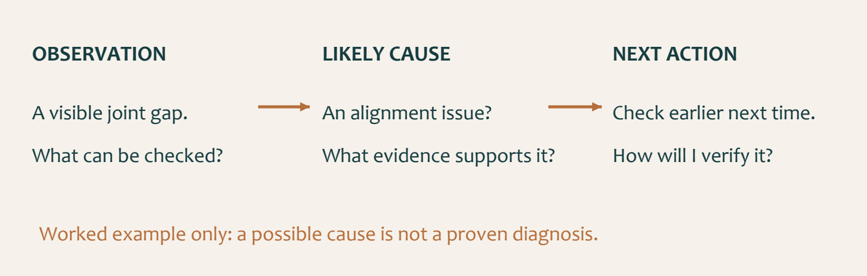
Figure 15. The same board can show a strength and a limitation. An evidence chain explains both.

Compare with the agreed requirements
Return to the brief, original plan and teacher criteria. Check the overall form, the relationship between the central board and curved ends, joint alignment, surface condition and the approved finish. Functional evidence may include safe handling and stability under the teacher’s approved observation or check. Do not invent a load test or claim a result that has not been observed. Visible appearance and functional performance are related, but one does not prove the other.

Separate observation from explanation
A sentence such as “there is a visible gap at the end joint” describes evidence another person could inspect. “It is perfect” gives no comparable detail. Examine the board in suitable light and identify both a strength and a limitation. Look for uneven contact, scratches, glue residue, unplanned rounding or differences in the finish.

Then explain a likely cause carefully. A patch may be associated with preparation or contamination, but the appearance alone may not prove which occurred. Use cautious language and connect the explanation to the records you have. An honest uncertainty is more useful than a confident invented cause.
Finish with an improvement that responds to the evidence. Earlier checks, clearer references or more systematic surface inspection are practical actions when they address the fault identified. Explain how you would check whether the change helped. The aim is to understand your work well enough to make the next attempt more reliable, not to make every judgement sound positive.

 Remember
Criterion / observation / likely cause / realistic action / check. Keep each link tied to your own work.

Breadboard Evaluation and project evidence

05 / Read the matching course section 37
MODULE 5 / SECTION 2 / READ AND UNDERSTAND

Make the folio tell the truth
Each evidence item should explain a meaningful stage, decision or quality check.
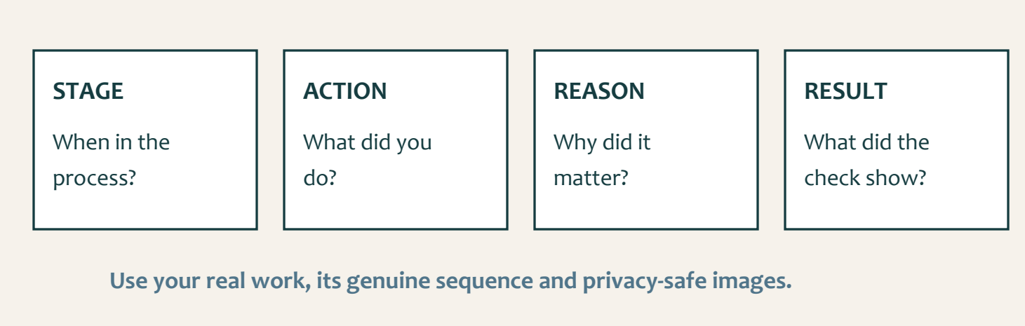
Figure 16. A caption adds stage, action, reason and result to an authentic image; the chronology and privacy check remain visible.

Select instead of collecting everything
Choose clear photographs that show a change in the project or an action worth explaining. A large number of repeated images can make the important evidence harder to find. Blurry pictures, decorative internet images and unrelated workshop scenes do not establish what you did. The source folio asks for photographs of your own work at twelve checkpoints; paper notes and labelled sketches help you plan and explain those records.

Give the image a useful caption
A strong caption identifies the stage, action, reason and result. “Sanding” names an activity but does not explain its purpose. A better caption describes the inspected fault, how the authorised preparation addressed it and what the later check showed. Link the record to a plan requirement, a quality criterion or a safety decision. Do not claim a check merely because the photograph shows the finished board.

Keep the genuine order and available dates. Rearranging images to imply that a check happened before it really did makes the account misleading. Problems and corrections are valuable evidence when the observation, likely cause, action and result are explained honestly. If a stage was not photographed, tell the teacher rather than manufacturing a record.
Before sharing, check for faces, names, class lists and classmates’ unrelated work. Crop or replace images as directed, and include other people only with the required permission. A concise, authentic folio gives the reader enough evidence to understand the work without compromising anyone’s privacy.

 Remember
Illustrations in this workbook teach ideas. They cannot be submitted as photographs of your own practical work.

Breadboard Evaluation and project evidence

05 / Read the matching course section 38
MODULE 5 / SECTION 3 / READ AND UNDERSTAND

Leave a professional handover
The work is complete only when the next person can use the space safely.
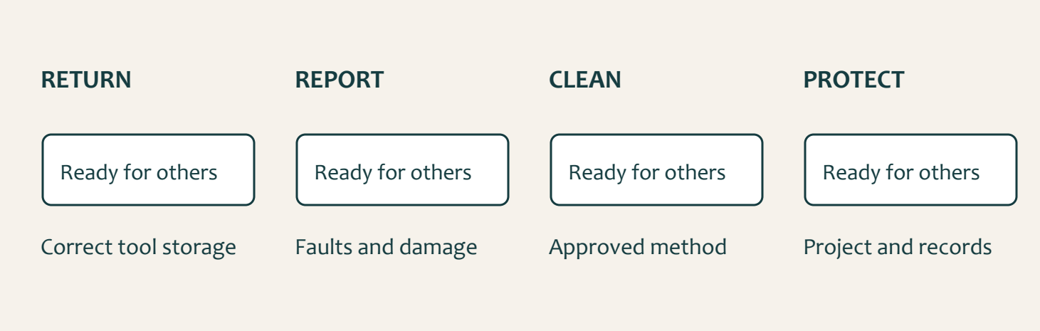
Figure 17. Return, report, clean and protect: each action leaves useful information or a safer space for the next user.

Care for the shared workshop
Return tools and equipment to their correct storage locations using the workshop system. Check that items are complete and ready for their next user. Report damage, looseness or an unexpectedly blunt edge instead of hiding the fault or returning it silently. Students do not carry out repairs without authority. A small reported problem can be addressed before it becomes someone else’s injury or damaged work.

Protect the project and its record
Clean using the teacher-approved method so dust is collected rather than sent into the air. Separate reusable offcuts and waste as directed; different materials may need different handling. Keep the path clear while equipment and projects are being moved. A handover is a shared-space task, not simply a tidy patch in front of your own bench.

Store the board where the teacher directs, protected from damage and contamination. Keep the plan, workbook and evidence record organised so the next lesson begins with the correct information. For the completed board, follow the care guidance approved for its actual finish and intended use. Cleanliness, appropriate drying and protection from impact or extreme conditions support a longer useful life. Do not add a new product or attempt a repair based on a guess.
A concise handover record names what was returned, any fault reported, how materials were managed and where the project is stored. These habits support reliable work beyond the classroom: another person can see what is ready, what needs attention and what must happen before work resumes.

 Remember
Record unresolved issues honestly. A clear handover is more useful than a claim that everything is fine.

Breadboard Evaluation and project evidence

05 / Read the matching course section 39
KNOWLEDGE + APPLIED THINKING

Check the evaluation
Circle one answer for each question. Use the readings to explain a choice you find difficult.
25 | Which statement is the strongest evaluation evidence?  ○ A. It looks perfect  ○ B. There is a visible gap at the end joint and the surfaces are not level  ○ C. I worked hard  ○ D. My friend likes it

26 | What should the completed Bread Board be compared with?  ○ A. A different commercial board  ○ B. The supplied plan, brief and teacher criteria  ○ C. Only the student's memory  ○ D. The quickest project in the class

27 | What makes an improvement suggestion useful?  ○ A. It is vague and positive  ○ B. It connects a fault to a likely cause and a realistic future action  ○ C. It blames the material  ○ D. It says nothing should change

Turn opinion into evidence
Rewrite “My board is perfect” as a useful evaluation sentence about an observable feature. You may describe a hypothetical example, but label it as one.

Breadboard Evaluation and project evidence

05 / Read the matching course section 40
KNOWLEDGE + APPLIED THINKING

Check evidence and care
Circle one answer for each question. Use the readings to explain a choice you find difficult.
28 | Which folio photograph is most useful?  ○ A. A blurry repeated image  ○ B. A clear image showing a meaningful stage or quality check  ○ C. An unrelated workshop photo  ○ D. A decorative internet image

29 | What should a strong folio caption include?  ○ A. Only the word 'sanding'  ○ B. The stage, action, reason and quality or safety result  ○ C. A made-up date  ○ D. Another student's name

30 | What is part of a professional workshop handover?  ○ A. Hide damaged tools  ○ B. Return tools, report faults and leave shared areas ready  ○ C. Leave waste for the next class  ○ D. Attempt unauthorised repairs

Build the caption
Improve the caption “Gluing”. Include the stage, action, reason and result. Use a clearly labelled example if your own glue-up has not occurred.

Breadboard Evaluation and project evidence

05 / Read the matching course section 41
STUDIO / PROJECT EVIDENCE

Feedback that changes work
Use complete explanations: name the action, explain the reason and include the check or evidence.

Record peer feedback and one improvement
With teacher approval, review one observable Bread Board criterion with a classmate. Record your roles, one specific comment you gave, one specific comment you received, and one improvement you made or will make because of the feedback. Finish with a check or evidence item that shows whether the improvement helped. Use initials or roles rather than a classmate's full name.

Show the observable feature discussed with your peer. Label the feedback and the point you checked.


Breadboard Evaluation and project evidence

05 / Read the matching course section 42
STUDIO / PROJECT EVIDENCE

Evaluate your result
Use complete explanations: name the action, explain the reason and include the check or evidence.

Write an evidence-based final evaluation
Evaluate one strength and one area for improvement in your completed Bread Board. Use specific observations, likely causes and a realistic future action.

Show the feature that supports your evaluation. Label a strength and a limitation or area needing another check.


Breadboard Evaluation and project evidence

05 / Read the matching course section 43
STUDIO / PROJECT EVIDENCE

Choose authentic evidence
Use complete explanations: name the action, explain the reason and include the check or evidence.

Select and explain authentic folio evidence
Choose two project evidence items you would include in the folio and explain what each proves. Include privacy and honest sequencing.

Plan your two evidence items here. Label their real order and the action or check that each will prove.


Breadboard Evaluation and project evidence

05 / Read the matching course section 44
STUDIO / PROJECT EVIDENCE

A final evidence panel
Folio checkpoint 12: connect a visible feature to an honest judgement.
Attach a photograph print or draw your completed board. Label one strength and one limitation or area that needs a further check. Record the original image reference.


OBSERVATION | CRITERION / LIKELY CAUSE / NEXT ACTION
Strength
Limitation or fault

Name the evidence that would let another person check your judgement.

Breadboard Evaluation and project evidence

05 / Read the matching course section 45
STUDIO / PROJECT EVIDENCE

Build the evidence index
Use this index to connect every course folio checkpoint to your own records.
CHECKPOINT | WORKBOOK / PHOTO REFERENCE
01 Project brief
02 Safety preparation
03 Plans and layout
04 Timber selection
05 Accurate marking
06 Component preparation
07 Biscuit-joint preparation
08 Dry assembly
09 Glue-up and clamps
10 Surface preparation
11 Finish and waste control
12 Final evaluation

 Remember
Check each item for a clear stage, action, reason and result. Keep the real order. Tell the teacher about a missing record rather than recreating a past event as if it were original.

Breadboard Evaluation and project evidence

05 / Read the matching course section 46
STUDIO / PROJECT EVIDENCE

Notice, act, check again
Use one real practical problem to show how your thinking changed the result.
OBSERVATION | WHY IT MATTERED

Before: show the observed problem. Label the evidence; keep dimensions source-based.


After: show the authorised change and the recheck result. Label any remaining limitation.


Explain what you would change in your next attempt because of this experience.

Breadboard Evaluation and project evidence

05 / Read the matching course section 47
STUDIO / PROJECT EVIDENCE

Learn from the demonstration
Record the idea that a teacher demonstration, slide or selected clip makes clearer.
RESOURCE / SECTION | IDEA I AM WATCHING FOR

Draw the key relationship you observed. Label the reference, contact, support or quality check that matters.


Explain what the visual made easier to understand. Connect it to the next authorised task in your own project.

What still needs teacher clarification before you act?

Breadboard Evaluation and project evidence

05 / Read the matching course section 48
STUDIO / PROJECT EVIDENCE

Keep a useful practical record
A short, precise entry makes the next lesson easier to start.
DATE / STAGE | ACTION, REASON AND RESULT

Next authorised action, and the check required before it:

 Remember
Write while the observation is fresh. A truthful record of an unresolved issue is useful evidence.

Breadboard Evaluation and project evidence

05 / Read the matching course section 49
STUDIO / PROJECT EVIDENCE

Care and handover record
Finish by making the board, the workshop and the evidence ready for their next use.
HANDOVER ITEM | WHAT I DID / WHAT NEEDS ATTENTION
Tools returned; faults reported
Workspace and dust managed
Reusable material / waste
Project and records stored

Write the teacher-approved care instructions for this board and its actual finish. Identify any detail that still needs confirmation.

Explain how one care action can extend the useful life of the board.

Breadboard Evaluation and project evidence

05 / Read the matching course section 50
STUDIO / PROJECT EVIDENCE

Your next piece of work
Use this project to carry one reliable habit into the next workshop challenge.
SKILL OR HABIT | EVIDENCE FROM THIS PROJECT
A safe decision
An accuracy check
A material or waste decision

Which decision made the greatest difference to your result? Explain using an observation from your workbook.

Sketch the one check you want to remember. Add a short instruction to your future self.


