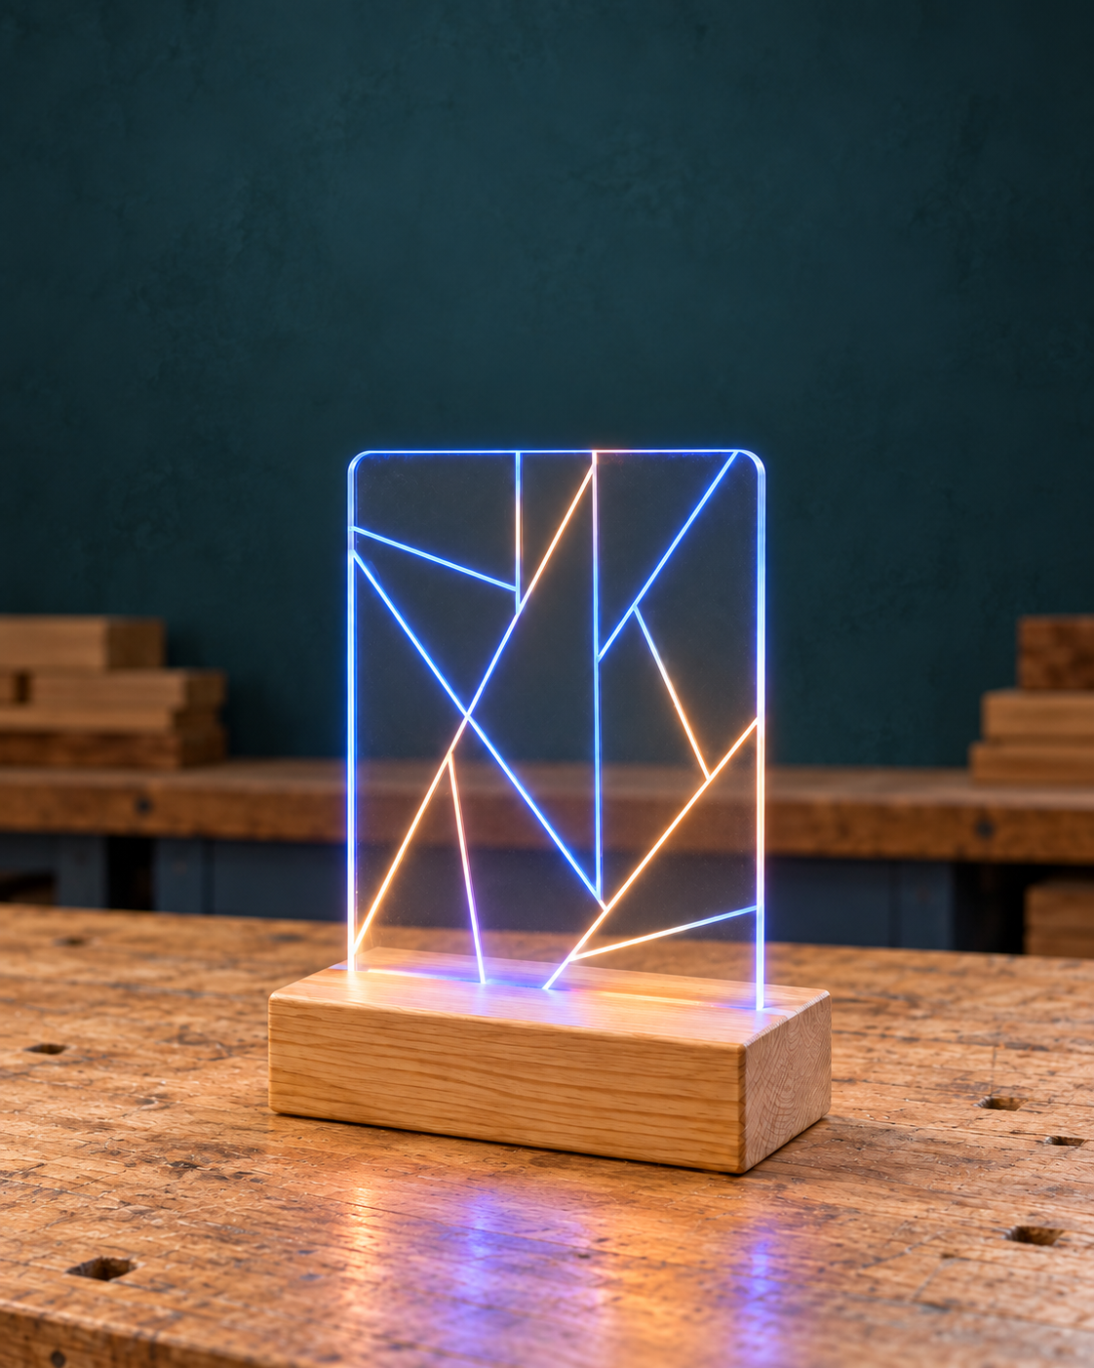
Stage 4 Technology
Programmable Light
Materials, design and digital thinking

Illustrative light concept. Use the original drawing and teacher-approved resources for the project.

Explore how timber, acrylic, electronics and code contribute to a designed product. Read, investigate, sketch and record your own evidence as your teacher leads the practical project.

Student workbook • Stage 4 Technology • Edition 1.0 • 50 A4 pages

Student name | Class

Programmable Light Project foundations

01 / Read the matching course section 2

Your learning journey
Use this book alongside teacher-led website lessons, presentations, videos and demonstrations. The readings support paper activities; the original drawing and teacher instructions guide practical work.
Learning focus | Pages
Brief, safety and drawing information | 3–12
Research, vector design and six ideas | 13–22
Timber, sustainability and planning | 23–29
Coding concepts and system thinking | 30–37
Integration, testing and evaluation | 38–46
Tools, terms and final evidence | 47–50

How to use the book
Read the explanation before attempting each check. Keep examples separate from your own observations. Use pencil for drawings and label each idea. When you revise a response, explain what changed and why.
The folio index on page 50 connects the twelve website evidence records to this book. Your teacher supplies current assessment and submission instructions. Complete workshop safety requirements separately before equipment use.
Print A4, double-sided, flip on the long edge: 50 pages use 25 sheets. Website links are attached to page footers. The separate teacher guide supplies answer guidance and source notes.

Programmable Light Project foundations

01 / Read the matching course section 3
01 | One product, several contributions

What makes it programmable
A programmable lamp combines light, electronics, code and physical design to create an illuminated product whose behaviour can be controlled. It is more than a light attached to a base: its materials, components and programmed system must contribute to one complete solution. In Technology, you will investigate how these parts work together while developing, communicating and evaluating your design ideas.
A successful solution must be considered from several viewpoints. Design concerns the purpose and arrangement of the idea. Function considers whether the solution performs as intended. Construction and build quality concern how accurately and carefully the physical product is made. Electronics and programming concern the controlled lighting system. Aesthetics include the lamp’s shape, size, materials, finish and light effects. The exact success criteria and project constraints will be agreed during class discussion.

Connect the parts to the purpose
The Programmable Lamp project combines a timber base, clear acrylic and electronic components. The identified materials and components include radiata pine, wood screws, 3 mm clear acrylic, an Arduino Uno board, an RGB LED strip, jumper wires and a USB-A to USB 2.0 cable. Named tools and equipment include a tenon saw, tri-square, pencil, steel rule, soldering iron, helping-hands stand, solder and a ULS 4.0/4.6 laser cutter.

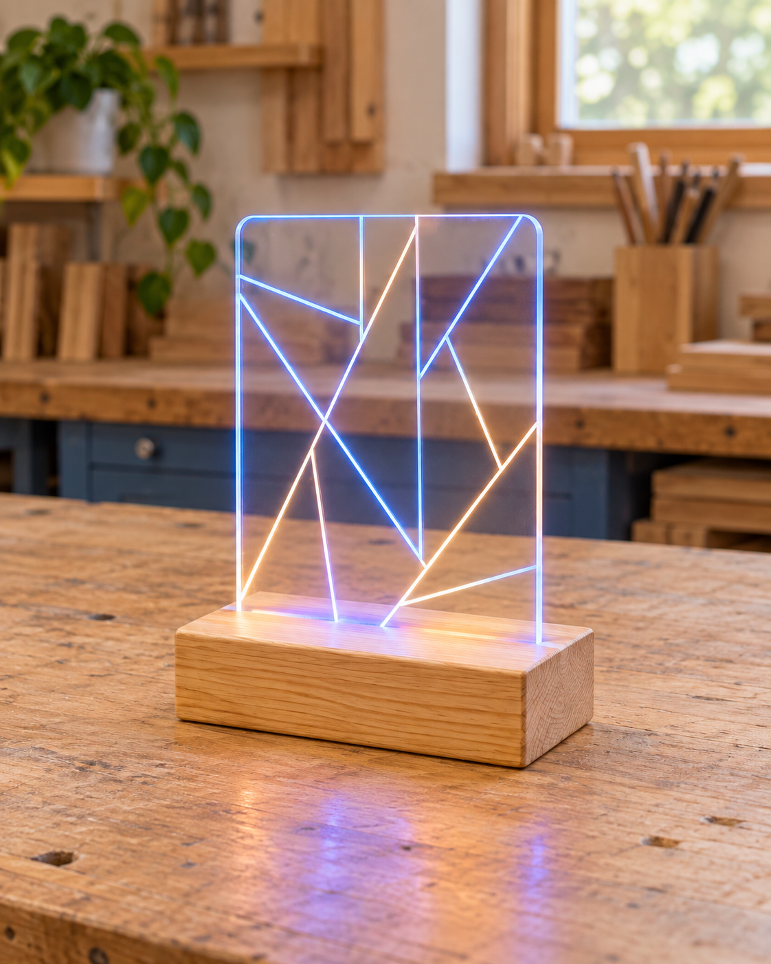
Figure 01. An illustrative lamp concept helps discuss appearance and behaviour. Its form is not the supplied construction plan.
This list tells you what must be recognised and investigated. It does not prove exactly how the components connect, operate or fit together. Each material, system and component should be considered according to what it contributes to the overall solution.
Before practical work, identify the named materials, tools and components and describe their likely project role without guessing unsupported details. Record the class-agreed criteria for design, function, build quality, electronics and programming, and aesthetics. Exact dimensions, circuitry, connections, code, settings, procedures and requirements must come from the supplied drawing, teacher demonstrations and class-agreed criteria.

Programmable Light Project foundations

01 / Read the matching course section 4

A safe workshop starts with decisions
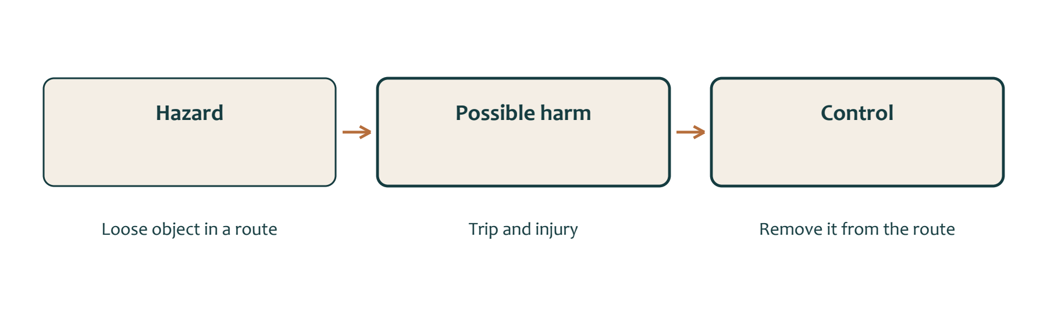
Figure 02. One example links a hazard, possible harm and a control. Your workshop may contain different hazards.

Identify the problem
Workshop safety begins by identifying a hazard, explaining the risk it creates and following controls that reduce the chance of harm. A hazard is something unsafe or capable of causing harm. Risk considers what injury or harm could occur if that hazard is not controlled. For example, poor organisation can create unsafe conditions, while running, messing around or distracting others can place several people at risk.
Safety is a shared responsibility, but each student is responsible for their own choices. Every lesson, students must follow teacher instructions, wear the required personal protective equipment, keep workspaces clean and tidy, and report faulty equipment or unsafe behaviour immediately. Students must never use equipment they have not been trained to use.

Check readiness
The fixed disc sander illustrates why recognising a machine is not enough. The supplied course resource requires demonstration, a passed safety test, teacher permission and observed safe use. Hazards include dust, contact with an abrasive surface, entanglement and flying material. Controls must match the equipment, the workpiece and the current school procedure.
A control acts on a particular risk. Clearing a route removes an obstacle; keeping people outside a machine zone reduces exposure. PPE provides protection for its intended hazard, but it does not make a damaged machine, unsuitable workpiece or unauthorised task acceptable.
Before practical work, identify hazards and explain their possible risks rather than merely listing unsafe objects. Know the rules for behaviour, organisation, reporting and permission. Confirm which PPE is required and locate the first-aid equipment and
emergency-stop controls with the teacher. An SOP supports training but does not replace teacher demonstrations, permission or local procedures, and it may not identify every possible hazard.

Programmable Light Project foundations

01 / Read the matching course section 5

Notice hazards and explain the risk
Folio 03 • Workshop safety and risk control
Walk through the teacher-led workshop discussion. Record five hazards you actually identify or discuss. Explain what could happen and how the proposed control changes the risk.
Hazard or situation | Possible harm | Proposed control

Which of these needs attention before work begins? Explain why.

Programmable Light Project foundations

01 / Read the matching course section 6

Turn safety knowledge into action
Complete the remaining five hazards, then record the local arrangements.
Further hazard or situation | Possible harm | Proposed control

If something becomes unsafe, what will you do and who will you tell?

Teacher-led readiness discussion | Confirmed detail
Required PPE and clothing
First aid and emergency-stop locations
Demonstration, safety test and permission arrangements

Programmable Light Project foundations

01 / Read the matching course section 7

Numbers, units and drawing scale
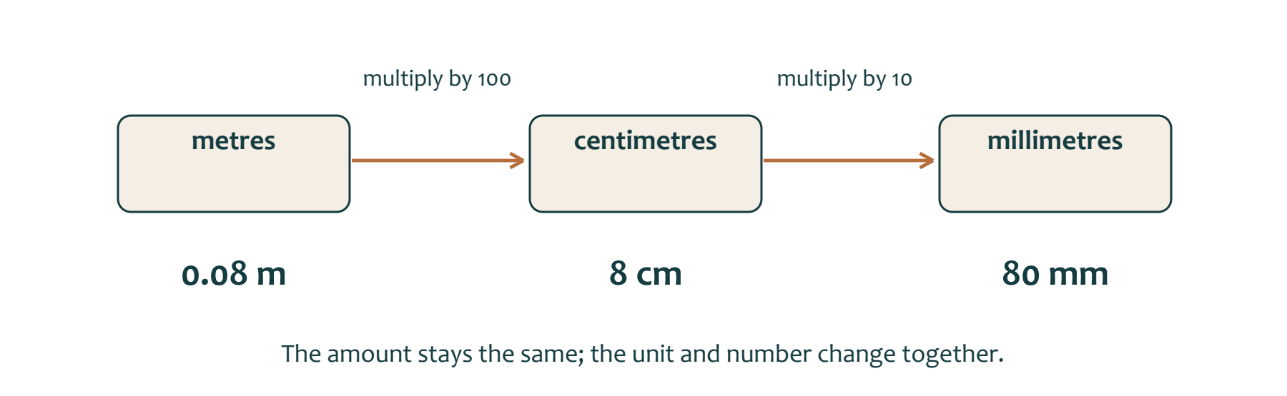
Figure 03. A worked conversion changes the number and unit together. This example is not a lamp dimension.

Read the written size
Accurate measurement begins with using the correct unit and reading the supplied drawing carefully. In this project, measurements may be shown in millimetres, centimetres or metres. The laser cutter uses millimetres for precision, workshop rulers commonly show centimetres and millimetres, and large sheet materials may be listed in millimetres or metres. Useful relationships are 10 mm = 1 cm = 0.01 m, 100 mm = 10 cm = 0.1 m, and 1000 mm = 100 cm = 1 m. Ruler measurements should be recorded in millimetres.
A drawing’s written dimension represents the intended real size. The scale describes how large or small a view is printed compared with the real object. At 1:1, the view is intended to appear full size. At 1:2, the printed view is intended to be half the real size. However, screens, photocopiers and printers can resize a page. You must therefore follow the written dimensions rather than measuring a displayed or printed view.

Use the right view
The authorised Programmable Lamp drawing is titled Programmable Lamp, names Josh McKenzie as author and is dated 24/02/2025. Its title block gives an overall scale of 1:2, while two detail views are labelled SCALE 1:1. The drawing also contains numbered dimensions and the sequence notes “1 - Cut First and Sand”, “2 - Cut Second and Sand” and “3 - Cut Third”.
Each dimension must be associated with the correct view, extension lines, arrows and feature. A number extracted from the file must not be assigned to a feature without checking the visible full-resolution drawing and teacher guidance.
Confirm the title, date, view scale, units and sequence notes. Trace each dimension to its correct feature and convert units when required. Record uncertainty instead of guessing. Exact feature identification and interpretation are Teacher to confirm using the full drawing.

Programmable Light Project foundations

01 / Read the matching course section 8

Read the original drawing
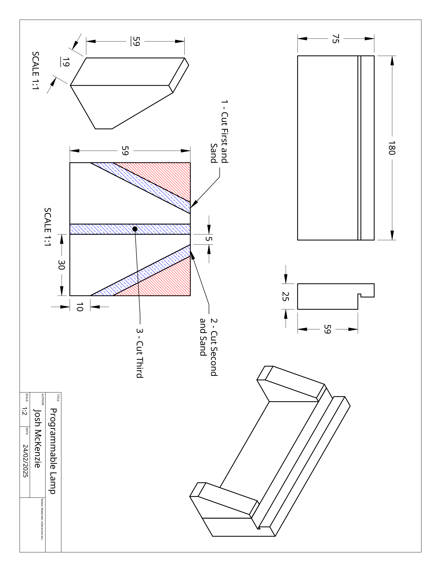
Figure 04. Original Programmable Lamp drawing, Josh McKenzie, 24/02/2025. Rotated and resized for the workbook; written dimensions control intended size. Turn the book sideways to read.
The notes area does not state units, materials or tolerances. Record missing details for teacher confirmation. Open the source PDF from the course for an enlarged view.

Programmable Light Project foundations

01 / Read the matching course section 9

Trace each value to its feature
Folio 04 • Plan interpretation
Title block | Your transcription
Drawing title and author
Date and overall scale
Detail-view scales

Account for all ten displayed dimension labels, including repeated values. Locate the arrowheads and extension lines before describing the feature.
Value | Unit if stated | View and feature indicated

Write one ambiguity you must resolve before marking or cutting.

Programmable Light Project foundations

01 / Read the matching course section 10

Check the project foundations
Circle one answer for each question, then explain your thinking.
1.1 | Which description best explains a programmable lamp?  ○ A. A timber object that must have a painted surface  ○ B. A light, electronic system, code and physical design combined into one solution  ○ C. An acrylic decoration without electronic components  ○ D. A standard lamp that cannot be controlled

1.11 | What is a hazard?  ○ A. The possible seriousness of an injury  ○ B. A source or situation that could cause harm  ○ C. A completed safety record  ○ D. A control used to reduce risk

1.21 | Why does the project commonly use millimetres?  ○ A. Millimetres remove the need for drawings  ○ B. The laser cutter uses millimetres for precision  ○ C. Workshop rulers show metres only  ○ D. Millimetres make every view full size

Convert 8 cm to millimetres and 0.25 m to millimetres. Show the relationships you used.

Programmable Light Project foundations

01 / Read the matching course section 11

Use evidence before action
Circle one answer for each question, then explain your thinking.
1.9 | Which statement is the most useful success criterion?  ○ A. The lamp should be good  ○ B. The design should use every possible material  ○ C. The first idea should be accepted  ○ D. The finished result can be checked against a clearly stated requirement

1.19 | Which statement correctly describes a safe operating procedure (SOP)?  ○ A. It replaces practical training  ○ B. It guarantees that every hazard has been removed  ○ C. It gives permission to improvise with equipment  ○ D. It supports training and other safety controls

1.28 | What is the correct order of the three written sequence notes?  ○ A. Cut first; cut second; sand third  ○ B. Sand first; cut second; cut third  ○ C. Cut first and sand; cut third; cut second and sand  ○ D. Cut first and sand; cut second and sand; cut third

A classmate measures a plan preview with a ruler and wants to cut from that measurement. Explain the problem and a better check.

Programmable Light Research and design development

02 / Read the matching course section 12
02 | Define success before designing
Folio 01 • Purpose, criteria and a personal goal
Explain the purpose of your programmable light and the person or setting it is intended for.

Category | Our confirmed criterion | How we could check it
Design
Function
Construction and build quality
Electronics and programming
Aesthetics

My personal learning goal is… I could show progress by…

Programmable Light Research and design development

02 / Read the matching course section 13

Research that informs a design
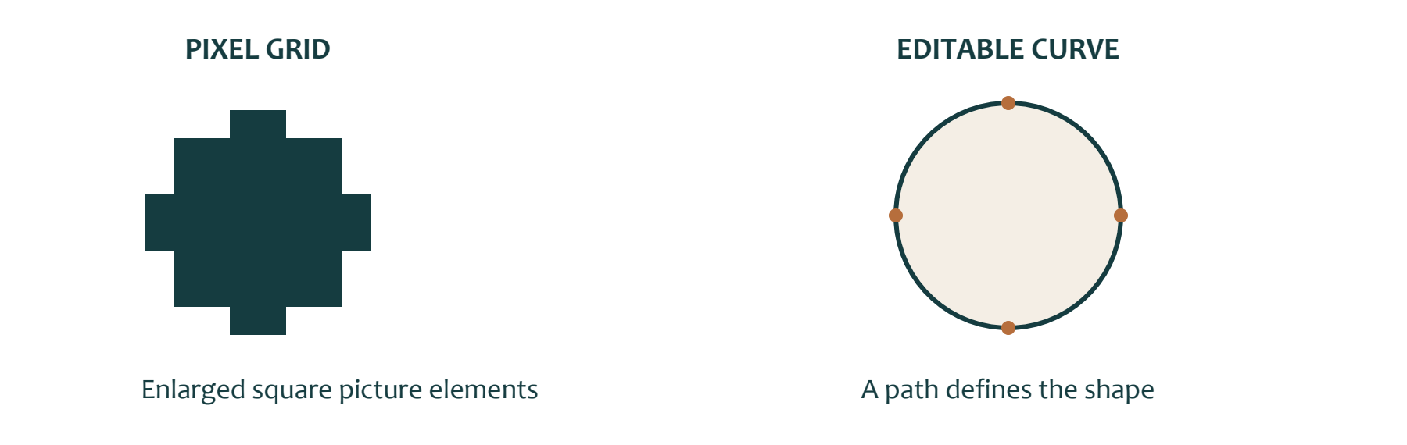
Figure 05. A conceptual enlargement compares a pixel grid with a path. Resolution and editability answer different questions.

Look beyond the first image
Design research helps you collect visual references, compare possibilities and explain why ideas may suit a project. A reference image can show shapes, symbols, layouts, details or visual styles that may influence your thinking. Research should not be treated as choosing the first image that looks interesting. Research records enough information to compare several ideas later.
Resolution describes the pixel dimensions of a digital image, usually recorded as width by height. Pixel dimensions influence how much visible detail an image can show, particularly when it is enlarged. An image may appear sharp when displayed at a small size but become blurred, blocky or unclear when enlarged. Resolution is therefore useful evidence when comparing research images, but it does not automatically prove that an image will suit manufacturing.
For each useful reference, record its source or location, title or subject, resolution and design relevance. Design relevance explains what the image contributes to your thinking, such as a recognisable outline, balanced shape or useful arrangement.

Record evidence for a choice
The authorised image-search activity asks students to locate high-quality logos or images and record both the image and its resolution across 11 prompts. The Lamp Idea Iteration worksheet then provides six design-idea spaces with columns for an object, logo or item, a PNG photo and an explanation. Its Gold Coast Titans idea with blue and yellow lighting is only a student example, not a project requirement.
A research image is an inspiration or reference. It is not automatically a finished design that can be manufactured. A final manufacturable vector design must be developed and checked separately. The two-layer key-tag task provides practice using a vector design program and preparing a simple laser-suitable design, but its key-tag requirements are not lamp specifications.
Collect several references, record their resolution and explain their relevance. Compare how clearly each image communicates its subject at the size being viewed. Do not assume that a sharp image, logo or downloaded file is approved for use. Permission, ownership, copyright, approved imagery and final selection criteria are Teacher to confirm.

Programmable Light Research and design development

02 / Read the matching course section 14

A research image needs a reason
Folio 06 • Visual research with source attribution

Figure 06. Original generated concept image supplied for this paper observation task. Treat it as inspiration; it is not a plan or evidence of a completed student project.
Identify one visible line, shape or lighting feature. Explain how you could develop the idea without simply copying the image.

Research record | Your note
Creator or source and title
URL or teacher-provided image record
Pixel dimensions or where to find them
Reuse permission and what still needs checking

Programmable Light Research and design development

02 / Read the matching course section 15

Build a clear vector design
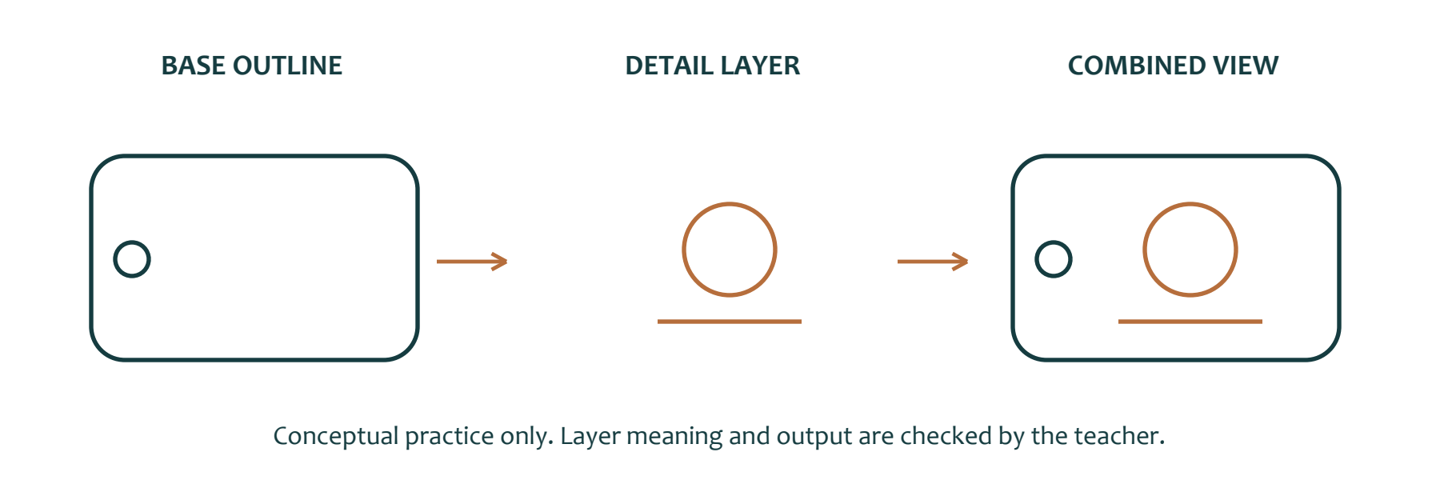
Figure 07. A conceptual two-layer key tag separates the base outline and added details. This is a practice example, not a final lamp graphic.

Paths and layers
A vector design describes shapes using editable lines and curves rather than a fixed grid of pixels. This means a shape can be resized or adjusted without relying on the same pixel structure as a photograph. Vector design is useful when students need to create clear outlines, organise parts of an idea and communicate what should be included in a digital design.
Layers help separate different parts of the design. A base layer can hold the main outline, while another layer can contain added details such as text, symbols or smaller shapes. Keeping these parts organised makes the design easier to inspect, explain and edit. Simplicity matters because unnecessary detail can make paths harder to follow and the intended result less clear.
The authorised 2D Design practice activity teaches vector-software skills through a two-layer key tag. Layer 1 is the base outline in a chosen shape. Layer 2 adds details such as buttons, text or a name. For this practice task only, the design must have two clear layers, remain within 80 mm × 50 mm, and be simple and suitable for laser cutting. Students export the design from 2D Design and upload it to the assignment section in Google Classroom. The activity is about learning the software, not producing a perfect result.

Prepare for teacher checking
The 80 mm × 50 mm limit applies only to the
key-tag practice. It is not a Programmable Lamp dimension. The earlier image-search and
lamp-iteration activities support reference research and six explained design ideas, but they do not establish lamp manufacturing requirements.
In this section, laser-ready means prepared clearly enough for teacher checking. It does not mean that machine settings are approved, the file has been accepted or a student has permission to operate equipment.
Before export, check that the base outline and added details are placed on clear layers. Inspect whether each outline is closed where intended, whether any open path is deliberate, and whether details remain readable. Confirm the practice-task size and remove unnecessary complexity. Exact export format, file name, imagery approval, laser workflow and machine settings are Teacher to confirm.

Programmable Light Research and design development

02 / Read the matching course section 16

Plan the two-layer practice task
Folio 05 • Paper planning followed by teacher-led software practice
Design a simple key tag within the source maximum of 80 mm ×50 mm. This size applies only to this software practice. Draw the base outline and detail layer separately below; label deliberate openings and any detail that may be too small.
Base layer • Sketch and annotate the outline.


Detail layer • Show the added text, symbol or shape.


After teacher-led software practice, record the exported filename and one improvement for next time.

Programmable Light Research and design development

02 / Read the matching course section 17

Six ideas with six different reasons
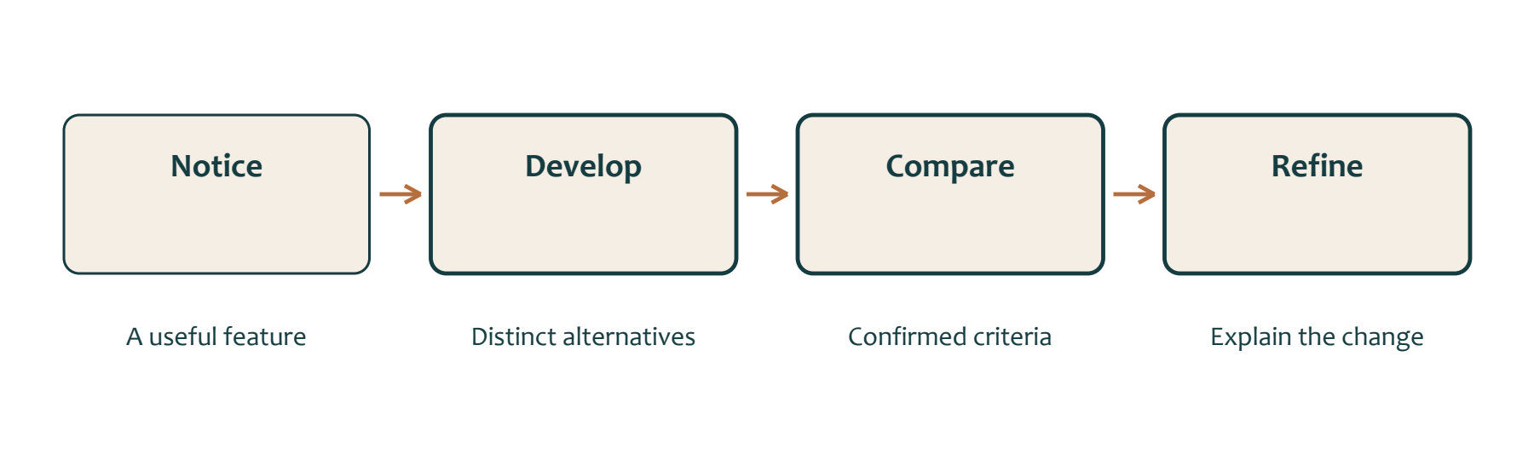
Figure 08. Design iteration connects a visible change to a reason. A recoloured copy may explore colour but does not establish six different forms.

Develop alternatives
Iteration means repeating a design process so that each cycle moves towards a more suitable result. It does not mean producing the same idea several times. A useful iteration changes, combines, refines or rejects features for a stated reason. Comparing several ideas helps a designer avoid choosing too early and provides evidence for later decisions.
Each idea should communicate more than a picture. It should identify the object, logo or item being considered, include a reference image where required and explain how the idea might influence the lamp. Research images and recorded resolution information can support this process, but they do not decide which idea is best.
The authorised Lamp Idea Iteration worksheet provides six spaces for design ideas. Each space includes an object, logo or item, a PNG photo and an explanation. The Gold Coast Titans example with blue and yellow light shows one student’s possible response only. It does not set a required logo, theme or colour choice.

Compare with criteria
Ideas should be compared against the
class-agreed success-criteria categories: Design, Function, Construction/Build Quality, Electronics & Programming, and Aesthetics. Observations of example lamps may include shape, size, materials, finish and light effects. These observations can help students discuss what successful work might look like, but the final criteria must be agreed by the class with the teacher.
A useful criterion is observable and can be applied later when evaluating the finished solution. For example, a criterion should describe something that can be checked rather than using a vague statement such as “looks good”. Constraints involving materials, size, time, safety or assessment remain blank until class discussion confirms them.
A personal goal is different from a project criterion. A personal goal identifies something one student wants to improve, while a project criterion applies to the solution being designed and evaluated.
Check that several ideas have been explained, not merely collected. Compare features against each success-criteria category and record why a feature should be retained, refined, combined or rejected. Do not assume all six ideas will be manufactured. Final criteria, constraints and any selection decision are Teacher to confirm through class discussion.

Programmable Light Research and design development

02 / Read the matching course section 18

Explore ideas 1 to 3
Folio 07 • Six explained lamp ideas
Use each space for a distinct idea. Label the feature explored, the source or inspiration, and how the idea differs. These are proposals for discussion, not manufacturing instructions.
Idea 1 • Shape or arrangement, intended effect and reason for the variation


Idea 2 • Shape or arrangement, intended effect and reason for the variation


Idea 3 • Shape or arrangement, intended effect and reason for the variation


Programmable Light Research and design development

02 / Read the matching course section 19

Explore ideas 4 to 6
Folio 07 • Six explained lamp ideas
Use each space for a distinct idea. Label the feature explored, the source or inspiration, and how the idea differs. These are proposals for discussion, not manufacturing instructions.
Idea 4 • Shape or arrangement, intended effect and reason for the variation


Idea 5 • Shape or arrangement, intended effect and reason for the variation


Idea 6 • Shape or arrangement, intended effect and reason for the variation


Programmable Light Research and design development

02 / Read the matching course section 20

Select, justify and refine
Folio 08 • Selected design and justification
Idea | Evidence against a confirmed criterion | Strength or limitation

Develop the selected idea. Annotate one refinement and its purpose.


Why is this the strongest direction? What feasibility question is still unresolved?

Programmable Light Research and design development

02 / Read the matching course section 21

Check research and design thinking
Circle one answer for each question, then explain your thinking.
2.1 | What is the main purpose of image research in design?  ○ A. To avoid developing original ideas  ○ B. To collect references and compare possible ideas  ○ C. To guarantee that an image can be manufactured  ○ D. To select the first image found

2.11 | What does a vector design use to describe shapes?  ○ A. Editable lines and curves  ○ B. A fixed grid of timber dimensions  ○ C. Electronic pin assignments  ○ D. A photograph’s colour settings

2.21 | What does iteration mean in the design process?  ○ A. Repeating a process so each cycle builds towards a desired result  ○ B. Manufacturing every idea that is generated  ○ C. Selecting the first idea that appears suitable  ○ D. Copying the same drawing without changes

Explain why a large, sharp downloaded photograph may still be unsuitable as a laser design.

Programmable Light Research and design development

02 / Read the matching course section 22

Explain a design decision
Circle one answer for each question, then explain your thinking.
2.9 | Why is vector-design practice useful before developing a final lamp graphic?  ○ A. It proves any downloaded image can be manufactured  ○ B. It supplies the lamp’s final dimensions  ○ C. It develops skills with outlines, layers and simplification  ○ D. It removes the need to compare ideas

2.19 | Why can a high-resolution photograph not automatically be treated as a finished vector design?  ○ A. High-resolution images contain no visual detail  ○ B. Resolution describes pixels, while a vector requires deliberate editable paths  ○ C. Photographs always have two vector layers  ○ D. Resolution fixes all manufacturing decisions

2.28 | What is the relationship between a personal goal and a project criterion?  ○ A. They are always the same statement  ○ B. A personal goal automatically applies to the whole class  ○ C. A personal goal concerns one student, while a criterion applies to the solution  ○ D. Project criteria are optional once a personal goal is chosen

Write one observable project criterion and one personal goal. Explain how they differ.

Programmable Light Timber and production planning

03 / Read the matching course section 23
03 | Timber groups are a starting point
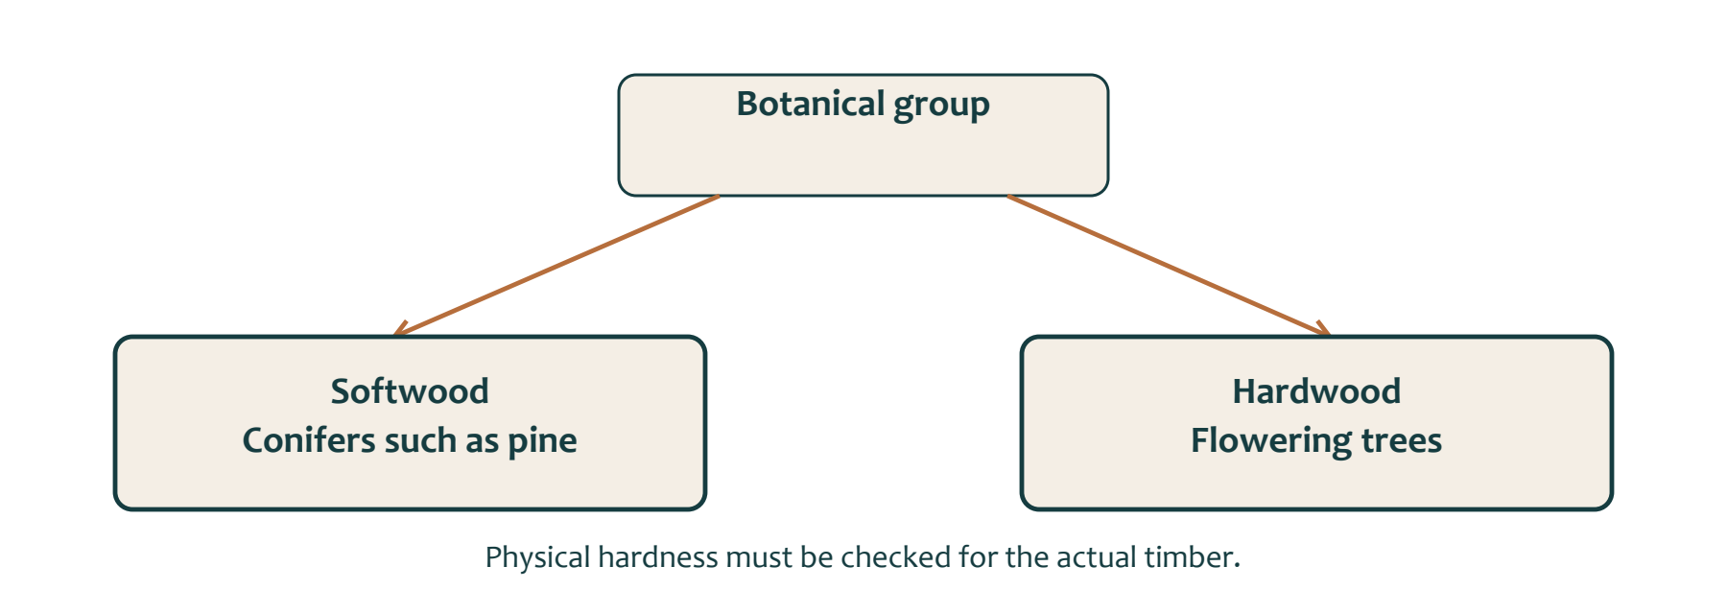
Figure 09. Botanical grouping does not measure the hardness or suitability of a particular board.

Classify accurately
Hardwood and softwood identify botanical timber groups; the names do not guarantee how physically hard or soft a particular piece will be. Softwood comes from conifers such as pine, regardless of the timber’s actual softness. Australian Government forestry information notes that the anatomical classification commonly, but not always, produces softer and lighter timber.
Comparing timber requires more than memorising its group. The Timber Production worksheet asks students to investigate tree type, growth speed, grain pattern, examples, uses, cost and sustainability. Its comparison table is blank, so it does not establish one approved description or prove that hardwood or softwood is always better.
A reasoned material choice should connect evidence to the intended function. Relevant considerations may include the timber’s confirmed properties, workability, appearance, availability and sustainability evidence. Claims about cost, grain or performance must come from verified information about the actual timber, not from the hardwood or softwood label alone.

Justify with relevant evidence
The authorised Tool and Materials Identification Worksheet names radiata pine as the timber for the Programmable Lamp project. Radiata pine is a pine and therefore a softwood. Australia’s commercial softwood plantations are mainly radiata pine, and plantation forests are intentionally established and managed stands used for wood production. Naming radiata pine does not provide its stock dimensions, grade, finish, specific properties or approved selection rationale. Students should not claim that it was selected simply because all softwoods are cheap, fast-growing, light or easy to work. Those generalisations are not established by the project sources.
A justified choice might explain that the supplied project information identifies radiata pine and then state which additional evidence must be confirmed before judging its suitability.
Identify the timber’s botanical group, then separate confirmed facts from assumptions. Compare possible materials using evidence connected to the lamp base’s intended function. Record any missing information rather than inventing it. The teacher-approved stock, specification and final material rationale are Teacher to confirm.

Programmable Light Timber and production planning

03 / Read the matching course section 24

Ask where the timber came from
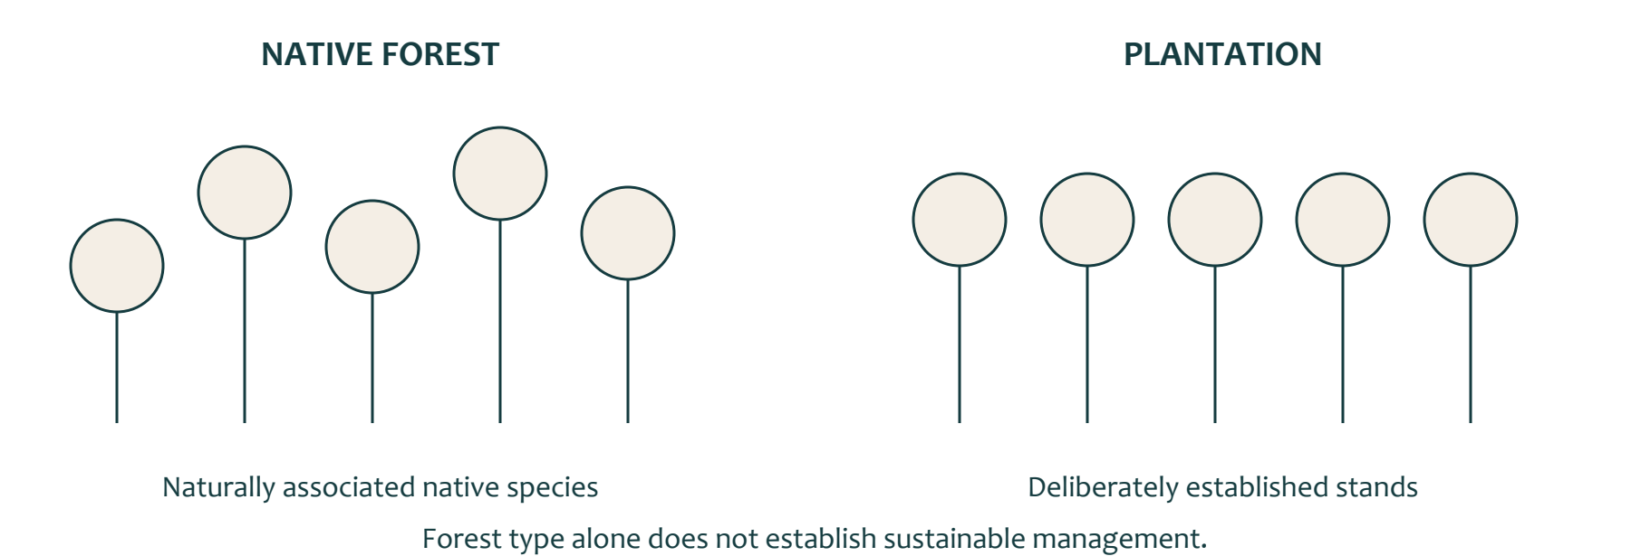
Figure 10. A concept comparison of forest types. Neither picture proves a particular management practice or sustainability claim.

Forest type and management
A native forest is dominated by native tree species naturally associated with that location and growing within their natural range. A plantation is a deliberately established and intensively managed stand created by regularly planting seedlings or seeds. Commercial plantations are managed to produce wood. These terms describe different forest types; they do not, by themselves, prove whether a particular harvesting or management decision is sustainable.
Sustainability means considering environmental, social and production effects over time. Relevant questions include where timber came from, how the forest was managed, whether trees will regenerate or be replanted, and how soil, water, habitats and communities may be affected. Forests support ecosystems and biodiversity, protect soil and water, and contribute to climate resilience. Australian forest management also operates through government systems and environmental law.
The Timber Production worksheet asks students to investigate native forest logging, plantation forestry, possible plantation benefits, concerns about native forest harvesting, and disadvantages of relying only on plantation timber. It does not provide approved answers or declare either source automatically sustainable.

Look for supporting evidence
Plantations can supply wood from stands established and managed for production. However, a plantation should not be called sustainable without evidence about its establishment, management, harvesting and regeneration. Native forests contain important ecological values, but describing timber as
native-forest timber does not prove that every harvesting operation is harmful. The effects depend on the location, management decisions, protections and evidence available.
A sound material decision therefore separates forest type from management practice. Students should investigate origin, management and regeneration instead of relying on labels alone.
Identify whether evidence refers to a native forest, plantation or particular harvesting practice. Look for reliable information about origin, management, protection and regeneration. Avoid automatic claims that one source is always better. The Programmable Lamp timber’s actual origin and preferred sourcing decision are Teacher to confirm.

Programmable Light Timber and production planning

03 / Read the matching course section 25

Make a material claim you can support
Folio 09 • Materials and sustainability
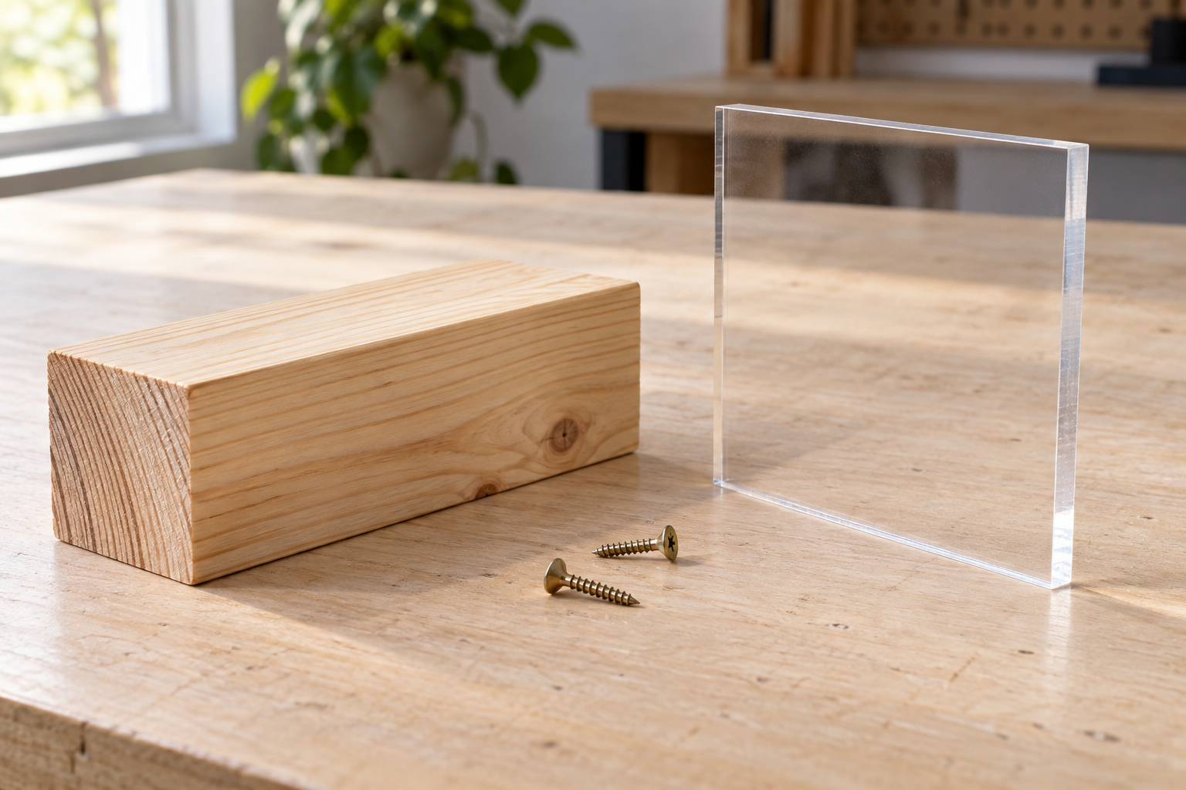
Figure 11. Illustrative pine, clear acrylic and wood screws. Observe visible differences without treating sample dimensions as the project specification.
Claim | Evidence needed
This timber is suitable for the intended purpose.
This timber was sourced sustainably.
This acrylic detail is suitable for the proposed design.

Justify a material decision using one confirmed fact, one relevant reason and one limitation in the available evidence.

Programmable Light Timber and production planning

03 / Read the matching course section 26

Plan from the drawing and keep evidence
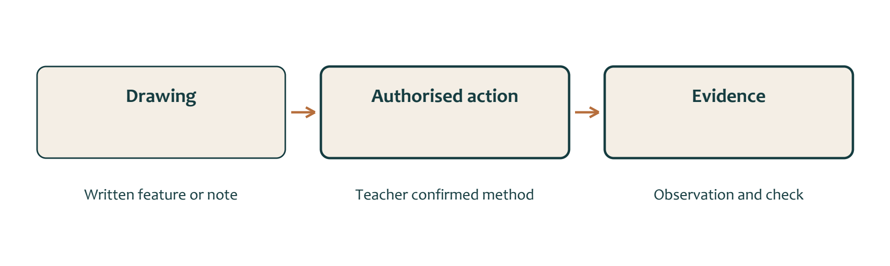
Figure 12. A checkpoint connects a source, an authorised action and an observation. This is not a complete construction sequence.

Start with confirmed information
A production plan turns drawing information into an organised proposal for making and checking a product. It should begin with evidence from the supplied drawing, not assumptions about how the lamp base might normally be constructed.
The Programmable Lamp drawing shows an overall scale of 1:2 and some detail views at 1:1. These scales describe how the views are presented, while written dimensions represent intended real sizes. Students should follow written drawing information rather than measuring from a screen or resized print. Units may need to be converted between millimetres, centimetres and metres, but the chosen unit must remain clear and consistent.
The drawing provides only three explicit process labels: “1 Cut First and Sand”, “2 Cut Second and Sand” and “3 Cut Third”. A proposed production sequence must preserve this order. It must not add unconfirmed tools, settings, dimensions, procedures or extra stages as though they came from the drawing. Where geometry, measurements or process details are unclear, students should record the uncertainty and seek teacher confirmation before practical work begins.

Checkpoints make decisions visible
The tools and materials worksheet identifies radiata pine and several project tools and materials. However, naming an item does not prove that it is required for a particular cut or stage. Tool allocation, supplied stock, practical methods and safety controls must be confirmed by the teacher.
Useful checkpoints can be planned without inventing project facts. Before work, students can check the drawing title, scale, relevant view, units and teacher-confirmed instructions. During production, they can pause after an authorised stage to compare the developing work with the drawing. Evidence might include dated photographs, annotated drawing references, recorded measurements, brief observations and teacher-confirmed corrections.
A cautious plan is therefore a proposed sequence supported by evidence. It does not replace teacher demonstration, approval or the missing practical sequence.

Programmable Light Timber and production planning

03 / Read the matching course section 27

Investigate timber production
Teacher-led media extension • Worksheet sequence evidence
The website timber worksheet includes a thirteen-stage ordering task based on a video. The supplied files do not identify that video or provide its answer key. Use this record only when your teacher supplies the matching media. Keep the observation order separate from the order for making your lamp.
Observed order | Stage or process | Evidence from the supplied media
1
2
3
4
5
6
7
8
9
10
11
12
13

Which source did you use? What could you not verify from it?

Programmable Light Timber and production planning

03 / Read the matching course section 28

Check timber and planning knowledge
Circle one answer for each question, then explain your thinking.
3.1 | What do the terms hardwood and softwood mainly describe?  ○ A. Guaranteed timber strength  ○ B. Botanical timber groups  ○ C. The price of the timber  ○ D. The required surface finish

3.11 | What best describes a native forest?  ○ A. A stand planted only for commercial timber  ○ B. A forest dominated by native species associated with that location  ○ C. Any forest containing one native tree  ○ D. A forest that can never be harvested

3.21 | What should be the starting point for a timber production plan?  ○ A. A sequence remembered from another project  ○ B. Confirmed evidence from the supplied drawing  ○ C. The tools currently available on a bench  ○ D. An assumed method for making a lamp base

Explain why the label “softwood” cannot by itself prove that a piece is cheap, easy to work or suitable for this lamp.

Programmable Light Timber and production planning

03 / Read the matching course section 29

Connect a choice to evidence
Circle one answer for each question, then explain your thinking.
3.9 | Which claim should a student avoid without supporting evidence?  ○ A. Radiata pine is named in the project worksheet  ○ B. Pine is classified as softwood  ○ C. All softwoods are cheaper and easier to work  ○ D. Material choice should consider intended function

3.19 | Which conclusion is most defensible when comparing native-forest and plantation timber?  ○ A. One forest type is always sustainable  ○ B. All native-forest harvesting is harmful  ○ C. Sustainability depends on evidence about origin, management, regeneration and impacts  ○ D. All plantation timber has no environmental effects

3.28 | Which item could provide useful production evidence?  ○ A. An undocumented change made during practical work  ○ B. A guessed dimension written after production  ○ C. A copied sequence from an unrelated project  ○ D. A dated photograph linked to a confirmed stage

Put these plan labels in their stated order: Cut Third; Cut First and Sand; Cut Second and Sand. Then explain what the labels do not tell you.

Programmable Light Coding and system thinking

04 / Read the matching course section 30
04 | Write the behaviour before the code
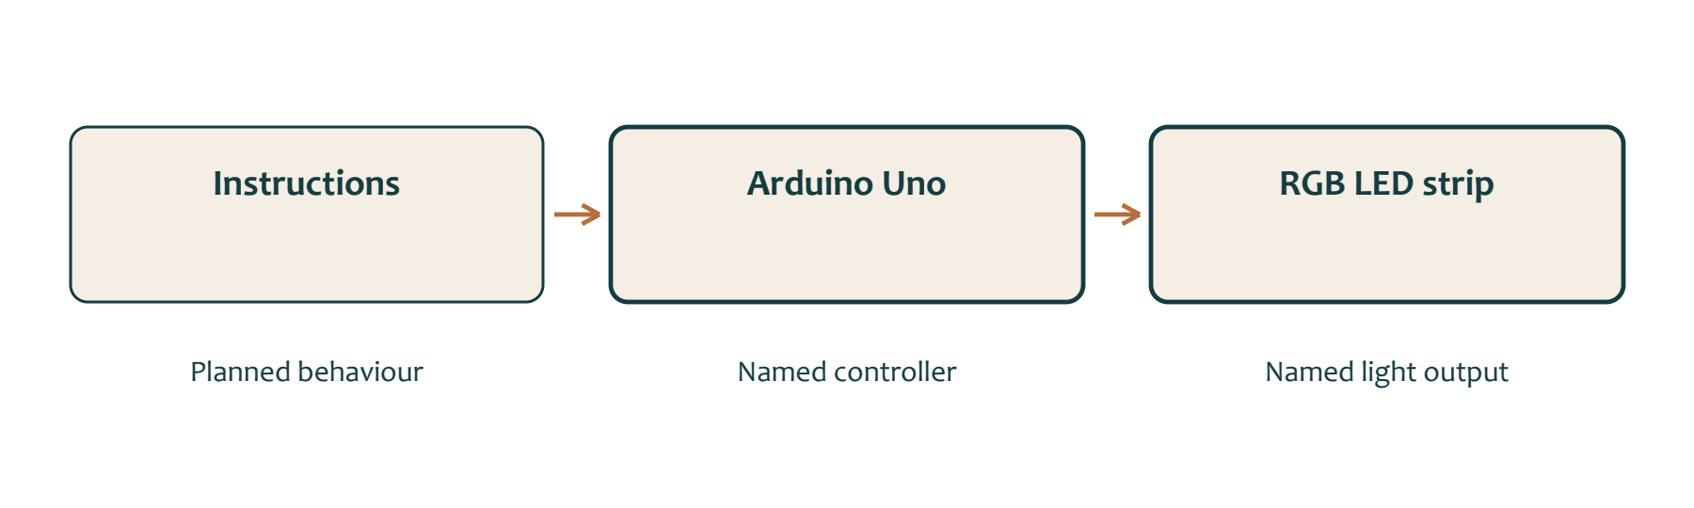
Figure 13. Conceptual information flow links instructions, a controller and light output. Arrows do not represent wires or a power arrangement.

Algorithm and sequence
Coding is the process of writing instructions in a programming language so that a digital system can carry out an intended behaviour. Before writing language-specific code, a designer needs to understand what the system should do and how the instructions should be organised.
An algorithm is a clear set of steps for completing a task or producing a result. It can be written in ordinary human-readable language before any programming language is chosen. For the Programmable Lamp, an algorithm could describe the intended light behaviour as ordered actions without naming hardware connections, timings or code commands.
Sequencing means arranging instructions in the correct order. Order matters because changing the sequence may change the result. A designer should identify what happens first, what follows and when the planned behaviour ends or repeats. This ordered explanation can then be reviewed before it is translated into code.

Language and syntax
Syntax means the rules for writing instructions correctly in a particular programming language. Different languages may use different words, symbols and structures. An algorithm can remain understandable to people even when the final programming language has not been confirmed, but actual code must follow the syntax of the selected language.
The Programmable Lamp combines code, electronics, light and physical design. The supplied materials list names an Arduino Uno, USB cable, jumper wires and an RGB LED strip. However, these items do not establish the programming language, circuit, hardware configuration or instructions needed to control the light.
A cautious coding process begins by deciding the intended behaviour, describing it as an algorithm and checking that the sequence is clear. Translation into code should occur only after the teacher confirms the programming language and hardware configuration. Students can then communicate and review whether the coded behaviour matches the intended design.

Programmable Light Coding and system thinking

04 / Read the matching course section 31

Store, repeat and choose
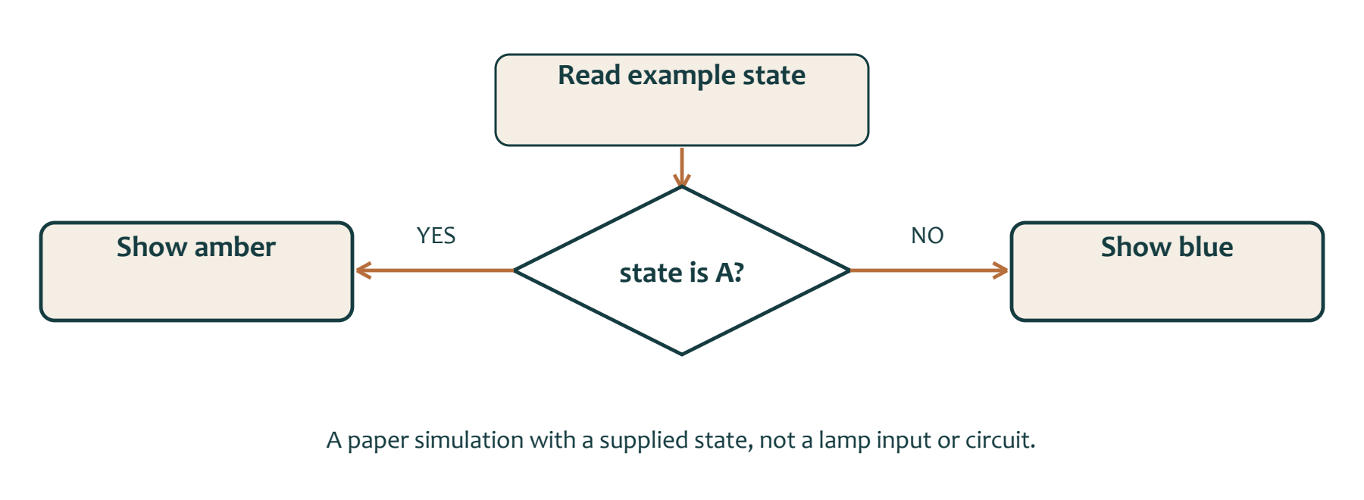
Figure 14. A fictional paper example chooses between two outcomes. It does not specify a lamp sensor, input or control method.

Named information and repetition
A programmable system needs ways to represent information, repeat actions and choose between possible actions. Variables, loops and conditionals help organise these behaviours. The authorised coding worksheet identifies all three terms for investigation, but its blank spaces do not provide approved definitions or confirm how they will be used in the Programmable Lamp.
A variable is a named place or value used to represent information that may change while a program operates. Conceptually, a lamp plan might use changing information to represent part of its intended light behaviour. However, the actual variable names, types and values depend on the teacher-confirmed programming language and project configuration.
A loop repeats an instruction or group of instructions under an approved rule. Repetition can help describe a light behaviour that continues or occurs again rather than being written as many separate instructions. The number of repetitions, stopping rule and any timing must be confirmed before language-specific code is developed.

Choices depend on a condition
A conditional selects an action depending on whether a stated condition is met. It allows a system to make a controlled choice between possible behaviours. For example, an algorithm might state conceptually that one light action occurs when an approved condition is met and another action occurs when it is not. The project sources do not identify the condition, input or device that would provide this information.
The official Arduino Language Reference organises its language information into functions, values including variables and constants, and structure. This supports the general idea that stored values and program structures contribute to organised digital behaviour, but it does not establish the project’s exact code.
For the Programmable Lamp, students should first communicate the intended behaviour in
language-neutral terms. They can identify what information may change, what actions may repeat and what decisions may be required. Translation into code should occur only after the teacher confirms the language, hardware arrangement and control rules.

Programmable Light Coding and system thinking

04 / Read the matching course section 32

Think in system roles

Figure 15. A role diagram identifies the named controller and output. The actual input, connections and electrical requirements remain teacher controlled.

Instructions and components
A system is a group of related components that work together for a purpose. In the Programmable Lamp, the confirmed project idea combines code, electronics, light and physical design. Each part has a different role, but the sources do not yet provide the exact configuration that connects them.
The intended behaviour begins with instructions. These instructions may first be planned as an algorithm or ordered sequence, then translated into code using teacher-confirmed syntax. The instructions describe what the system is intended to do, but they are not a physical component.
The Arduino Uno is the named controller. A controller processes instructions and helps coordinate the behaviour of a digital system. The RGB LED strip is the named light-producing output because it is the component intended to produce visible light. The USB cable and jumper wires are named supporting connection materials. Their presence confirms that connections are part of the project, but it does not show exactly how they are used.

Roles are not wiring
Information flow can be described cautiously as: planned instructions are processed by the controller, and the controller influences the light output. This explanation identifies system roles without inventing a circuit, signal type, input device or power arrangement.
A block diagram can communicate this relationship using simple labelled boxes and arrows. A suitable conceptual diagram is:
confirmed control/input — controller — light output
The controller block can be labelled Arduino Uno, and the light-output block can be labelled RGB LED strip. The first block must remain Teacher to confirm because the sources do not identify a sensor, switch, user control or other input method.
Students should distinguish between a role, a physical component and an unconfirmed configuration. “Controller” is a role; “Arduino Uno” is the named component filling that role; its exact wiring and operation remain unconfirmed.

Programmable Light Coding and system thinking

04 / Read the matching course section 33

Trace a sequence on paper
Worked logic exercise • No hardware required
This is a fictional language-neutral exercise. It is not code to upload and its values are not lamp settings. Follow each instruction in order and record the resulting named colour.
• Set colour to blue, then record the colour.
• Set colour to amber, then record the colour.
• Repeat this blue and amber sequence twice more.
Record number | Named colour
1
2
3
4
5
6

What repeats, what changes, and how many recorded outputs result? Explain using the words sequence, variable and loop.

Programmable Light Coding and system thinking

04 / Read the matching course section 34

A condition changes the path
Paper simulation • Trace every branch before coding

Figure 16. Use only the supplied fictional state in each case. No input device is implied.
Supplied state | Is state A? | Named output
A
B
A
C

A student says that state C gives no output because it is not B. Explain the mistake.

Why does this exercise not tell you what sensor, wiring or code your lamp will use?

Programmable Light Coding and system thinking

04 / Read the matching course section 35

Communicate your intended behaviour
Folio 10 • Algorithm and digital-system plan
Describe the behaviour you would like the light to show. State what begins, what may change and what repeats or stops.

Draw a flowchart or write language-neutral pseudocode. Label the controller and light-output roles separately from the instructions.


Give one observable paper test case and its expected result. List one detail that must be confirmed before implementing this idea.

Programmable Light Coding and system thinking

04 / Read the matching course section 36

Check coding concepts
Circle one answer for each question, then explain your thinking.
4.1 | What is coding?  ○ A. Measuring electronic components  ○ B. Writing instructions in a programming language  ○ C. Drawing the lamp base  ○ D. Connecting any available hardware

4.11 | What is a variable used to represent?  ○ A. A named value or piece of information that may change  ○ B. A physical connection between components  ○ C. A fixed drawing dimension  ○ D. A workshop safety procedure

4.21 | What is a system?  ○ A. One component operating without a purpose  ○ B. A group of related components working together  ○ C. A completed circuit diagram  ○ D. A list of workshop tools

In one example, explain the difference between an algorithm and a physical component.

Programmable Light Coding and system thinking

04 / Read the matching course section 37

Check how the system is described
Circle one answer for each question, then explain your thinking.
4.9 | A set of correct actions has been placed in a confusing order. Which coding concept needs improvement?  ○ A. Resolution  ○ B. Sustainability  ○ C. Sequencing  ○ D. Material classification

4.19 | Before coding a light behaviour, what should the algorithm identify?  ○ A. Only the final appearance  ○ B. The forest-management method  ○ C. Every machine setting  ○ D. What information may change, what actions may repeat and what decisions are required

4.28 | An input device has not yet been chosen. How should it appear on an early block diagram?  ○ A. As a specific sensor selected by guesswork  ○ B. As the light output  ○ C. As a timber component  ○ D. As a generic input or control block

A diagram shows boxes labelled Arduino Uno and RGB LED strip joined by an arrow. What can the arrow explain, and what can it not establish?

Programmable Light Integration, testing and evaluation

05 / Read the matching course section 38
05 | Bring the parts together
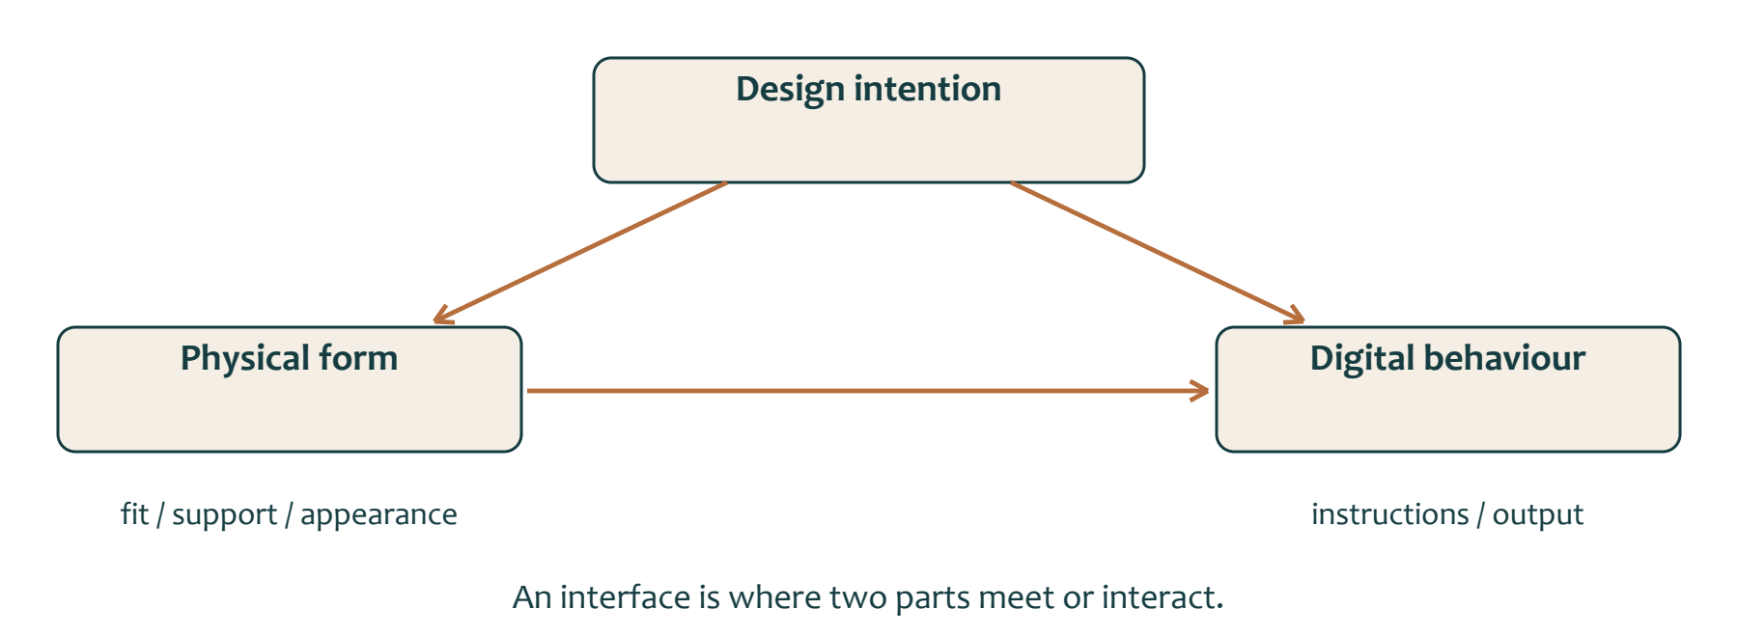
Figure 17. The map shows related design considerations and interfaces. It is not a wiring diagram or construction order.

Connections between decisions
Integration means making different parts of a solution work together rather than treating each part as a separate task. In the Programmable Lamp, the confirmed areas are design intent, timber and acrylic structure, electronics, light and code. Each area has a role, but the sources do not yet provide a complete specification showing every connection or practical detail.
The design intent explains what the solution is meant to communicate or achieve. The named structural materials are radiata pine and clear acrylic. The Arduino Uno is the named controller, while the RGB LED strip is the named light output. Code or instructions describe the intended digital behaviour. Jumper wires and a USB cable are named connection materials, but their exact use is not confirmed.
design intent — timber/acrylic structure — Arduino Uno controller — RGB LED strip output — code/instructions
The map shows relationships, not a construction order. Connections, fit and the exact arrangement between parts remain Teacher to confirm.

Check the interfaces
Integration decisions interact. A change to the design idea may affect the structure. A structural change may affect where electronic components can fit. A change to the intended light behaviour may affect the required code or controller configuration. Students should therefore avoid changing one part without considering the others.
An interface is the point where two parts of the solution meet or interact. Interfaces may include the relationship between timber and acrylic, the controller and light output, or code and intended behaviour. A useful integration checkpoint asks whether the two confirmed parts can work together as intended and identifies any missing information before proceeding.
Traceable design communication records where each decision came from. Students can refer to the drawing, idea-development worksheet, named components and class-agreed success categories. Notes, labelled diagrams and checkpoint records should separate confirmed evidence from assumptions.

Programmable Light Integration, testing and evaluation

05 / Read the matching course section 39

Test one thing and record the result
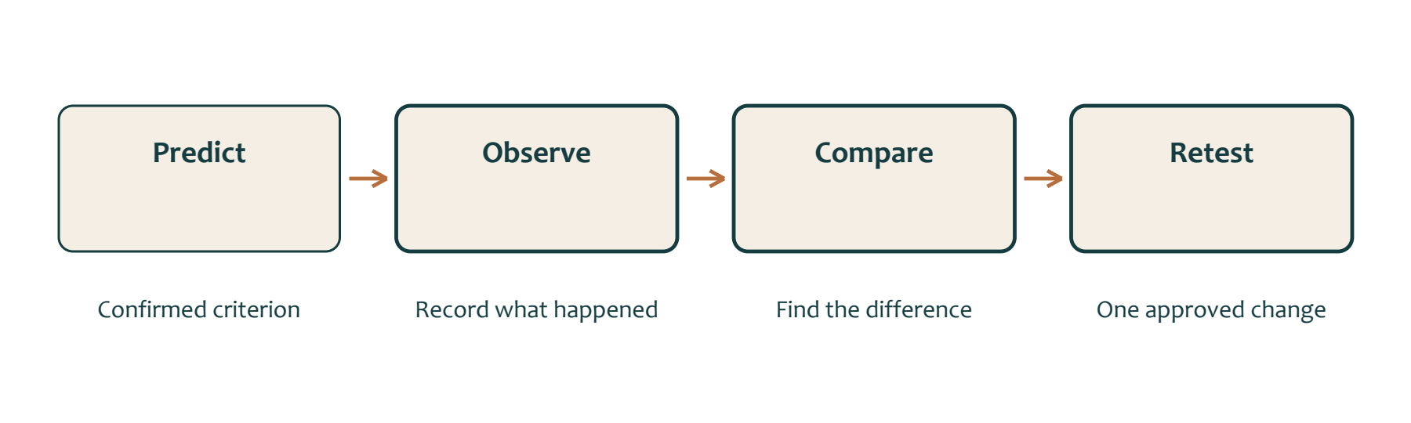
Figure 18. A testing cycle compares observations with a confirmed expectation. Only approved practical changes are made.

Predict and observe
Testing is the process of comparing an observed result with a confirmed criterion. A criterion describes what the solution should achieve or demonstrate. Testing is useful only when the criterion is known, the observation is recorded and the comparison is clear. The Programmable Lamp sources identify broad categories such as design, function, construction quality, electronics and programming, and aesthetics, but they do not provide completed criteria or pass thresholds.
Debugging is a systematic process used to locate, explain and correct a fault in a digital system or plan. It should not involve random changes. A controlled debugging cycle begins by stating the confirmed criterion and predicting what should happen. Students then test one aspect, record what they observe and compare the evidence with the prediction.
If the result does not match the criterion, the next step is to identify a likely cause. Diagnostic headings may help organise thinking:
Possible diagnostic areas are design or material, connection or component, code or logic.

Explain an improvement
These headings identify areas to investigate; they do not prove what caused a problem in this lamp. The supplied sources do not provide a fault table, circuit, code or confirmed symptoms.
After teacher approval, students should change one controlled element. Changing one element helps show whether that change affected the result. The same aspect should then be retested under the confirmed procedure. Evidence may include observations, dated photographs, labelled notes, comparison statements or
teacher-confirmed corrections.
Improvement is demonstrated when recorded evidence shows that the revised result more closely meets the confirmed criterion. A change should not be described as an improvement simply because something was altered or because the result looks different.
A suitable cycle is: state the criterion; predict; test one aspect; record evidence; compare; identify a likely cause; approve and change one element; retest; document the result. Exact criteria, safe testing procedures and technical settings remain teacher controlled.

Programmable Light Integration, testing and evaluation

05 / Read the matching course section 40

Make a judgement from evidence
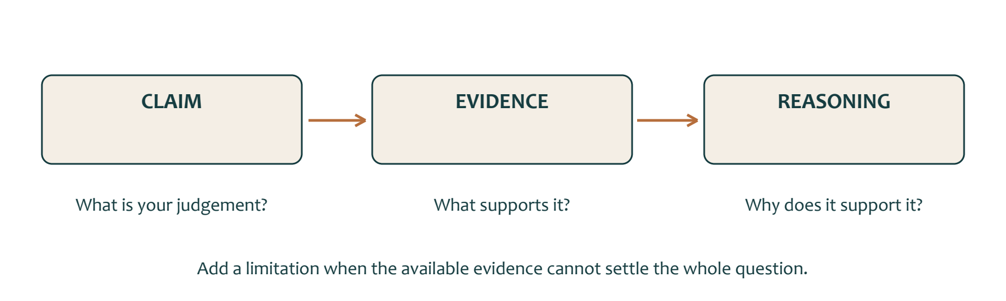
Figure 19. A claim becomes useful when evidence and reasoning support it. State a limitation when the evidence is incomplete.

Product quality and sustainability
Evaluation is a reasoned judgement based on confirmed criteria and evidence. It is more than saying that a solution is good, bad or finished. A strong evaluation explains the claim being made, identifies the evidence supporting it and gives reasoning that connects the evidence to the criterion.
The first evaluation lens is quality and fitness for purpose. Students compare observations, test records, photographs, measurements or design notes with teacher-confirmed criteria. The broad project categories include design, function, construction or build quality, electronics and programming, and aesthetics. However, the authorised worksheet does not provide completed criteria or performance thresholds. A judgement about quality must therefore wait until the relevant criterion and evidence are confirmed.

Learning and limitations
The second lens is sustainability. Students should consider environmental, social and production effects over time. Timber may come from native forests or plantations, but these labels do not prove whether a source is sustainable. Native forests have ecological values that require management and protection, while plantations are deliberately established and managed stands that can supply wood. A balanced evaluation considers origin, management, regeneration, resource use and available evidence. The project sources do not identify the supplied timber’s origin, certification or life-cycle impacts.
The third lens is learning. Students can compare their work with the personal goal recorded at the beginning of the project. They should identify what evidence shows progress, what still needs improvement and one realistic next step. A personal learning judgement is not the same as evaluating the product against class criteria.
A useful structure is claim, evidence and reasoning. The claim states the judgement. The evidence identifies what was observed or recorded. The reasoning explains why that evidence supports the judgement. Limitations should also be acknowledged, especially where criteria, sourcing information or final test results are missing.

Programmable Light Integration, testing and evaluation

05 / Read the matching course section 41

Keep the test and retest connected
Folio 11 • Testing and problem solving
Test planning | Your record
Confirmed criterion and source
What should happen
Teacher-approved method and safe boundary

Test evidence | Your observation
Date and first result
Comparison with the expected result
Likely cause and evidence for it
One teacher-approved change
Retest result under the same check

What does the comparison allow you to conclude, and what remains uncertain?

Programmable Light Integration, testing and evaluation

05 / Read the matching course section 42

Record the work as it happens
Folio 11 • Production and evidence log
Record authorised work in order as it happens. Connect each action to the source or teacher checkpoint, then explain the result. Keep photo originals separately and identify them here if used.
Date and stage | Authorised action or decision | Observation and next check

Choose one problem. Explain your response, the teacher advice used and what the later evidence showed.

Programmable Light Integration, testing and evaluation

05 / Read the matching course section 43

Check testing and evaluation
Circle one answer for each question, then explain your thinking.
5.1 | What does integration mean in this project?  ○ A. Completing each part without considering the others  ○ B. Making different parts work together as one solution  ○ C. Following a complete supplied build sequence  ○ D. Using only electronic components

5.11 | What is testing?  ○ A. Changing several parts until the result looks better  ○ B. Comparing an observed result with a confirmed criterion  ○ C. Copying another student’s solution  ○ D. Assuming the system works because it starts

5.21 | What is evaluation?  ○ A. A statement that the project is finished  ○ B. A list of materials without explanation  ○ C. A personal preference with no comparison  ○ D. A reasoned judgement based on criteria and evidence

A student changes the design, code and connections together, then the light behaves differently. Why is the cause difficult to explain?

Programmable Light Integration, testing and evaluation

05 / Read the matching course section 44

Support your final judgement
Circle one answer for each question, then explain your thinking.
5.9 | What makes design communication traceable?  ○ A. Recording only the final idea  ○ B. Removing notes about uncertainty  ○ C. Treating assumptions as facts  ○ D. Linking each decision to relevant evidence such as drawings, tests and design records

5.19 | When can a change be described as an improvement?  ○ A. Whenever the solution looks different  ○ B. When evidence shows the result more closely meets the criterion  ○ C. When the student prefers the change  ○ D. Whenever a component is replaced

5.28 | How is a personal goal different from a project criterion?  ○ A. A personal goal applies to every student’s product  ○ B. A project criterion records one student’s improvement  ○ C. A personal goal guides individual learning, while a criterion judges the solution  ○ D. They must always use identical wording

Write a claim about your learning, name evidence that could support it, and explain the link. Keep it separate from a claim about the finished product.

Programmable Light Integration, testing and evaluation

05 / Read the matching course section 45

Evaluate against the agreed criteria
Folio 12 • Final evaluation
Confirmed criterion | Evidence and page reference | Judgement and reason

Which strength is best supported by evidence? Explain why that evidence is convincing.

Programmable Light Integration, testing and evaluation

05 / Read the matching course section 46

Recognise a limitation and a next step
Folio 12 • Improvement, sustainability and learning
Identify one limitation in the product or available evidence. Propose a realistic improvement and explain its expected effect.

What did you learn about material sourcing, resource use or waste? Distinguish evidence from an assumption.

Return to your personal goal on page 12. What evidence shows progress, and what will you practise next?

Programmable Light Integration, testing and evaluation

05 / Read the matching course section 47

Recognise tools and explain their purpose
Folio 02 • Tools and equipment
These items are named in the source worksheet. Describe their normal purpose and possible contribution to the project. Your teacher confirms actual allocation, method, settings and permission. Recognition is not authorisation to operate.
Named item | Normal purpose | Possible project contribution
Tenon saw
Tri-square
Pencil
Steel rule
Soldering iron
Helping-hands stand
Solder
ULS4.0/4.6 laser cutter

Choose one item. Sketch or describe the visible feature that helps you identify it accurately.

Programmable Light Integration, testing and evaluation

05 / Read the matching course section 48

Materials and electronic components
Folio 02 • Contributions and confirmed limits
Named item | Role or possible contribution | Detail still to confirm
Radiata pine
Wood screws
3mm clear acrylic
Arduino Uno
RGB LED strip
Jumper wires
USB-A to USB2.0 cable

Choose two items and explain how their different roles contribute to one solution.

Programmable Light Integration, testing and evaluation

05 / Read the matching course section 49

Use the language precisely
Term | Meaning in this course
Criterion | A requirement used to judge the solution.
Iteration | A repeated design cycle with a reasoned change.
Resolution | The pixel dimensions of an image.
Vector | Editable lines and curves defining shapes.
Algorithm | Ordered steps describing a task or behaviour.
Syntax | The writing rules of a programming language.
Variable | Named information or a value that may change.
Loop | A structure that repeats instructions.
Conditional | A choice controlled by whether a condition is met.
Interface | Where two parts meet or interact.
Evidence | An observation or record supporting a claim.
Evaluation | A judgement linking criteria, evidence and reasoning.

Course source: stevencowell.github.io/programmable-light-guided-course/ • This workbook adapts all fifteen named sections. The teacher guide lists the original plan, resource files, selected knowledge checks and source boundaries.

Programmable Light Integration, testing and evaluation

05 / Read the matching course section 50

Check your evidence is ready
A complete record is clear, honest and traceable
Use this index to locate the twelve evidence purposes from the website folio. Mark a record ready only when it contains your own appropriate evidence. Your teacher confirms formal submission requirements.
Folio record | Workbook pages | Ready or next action
01 Purpose and criteria | 12
02 Tools and components | 47–48
03 Safety and controls | 5–6
04 Drawing interpretation | 8–9
05 Vector practice | 16
06 Research and sources | 14
07 Six ideas | 18–19
08 Selection and refinement | 20
09 Materials and sustainability | 23–27
10 Algorithm and system plan | 30–35
11 Production and testing | 41–42
12 Final evaluation | 45–46

Record the teacher-confirmed submission route, required files or attachments, and your next action.

