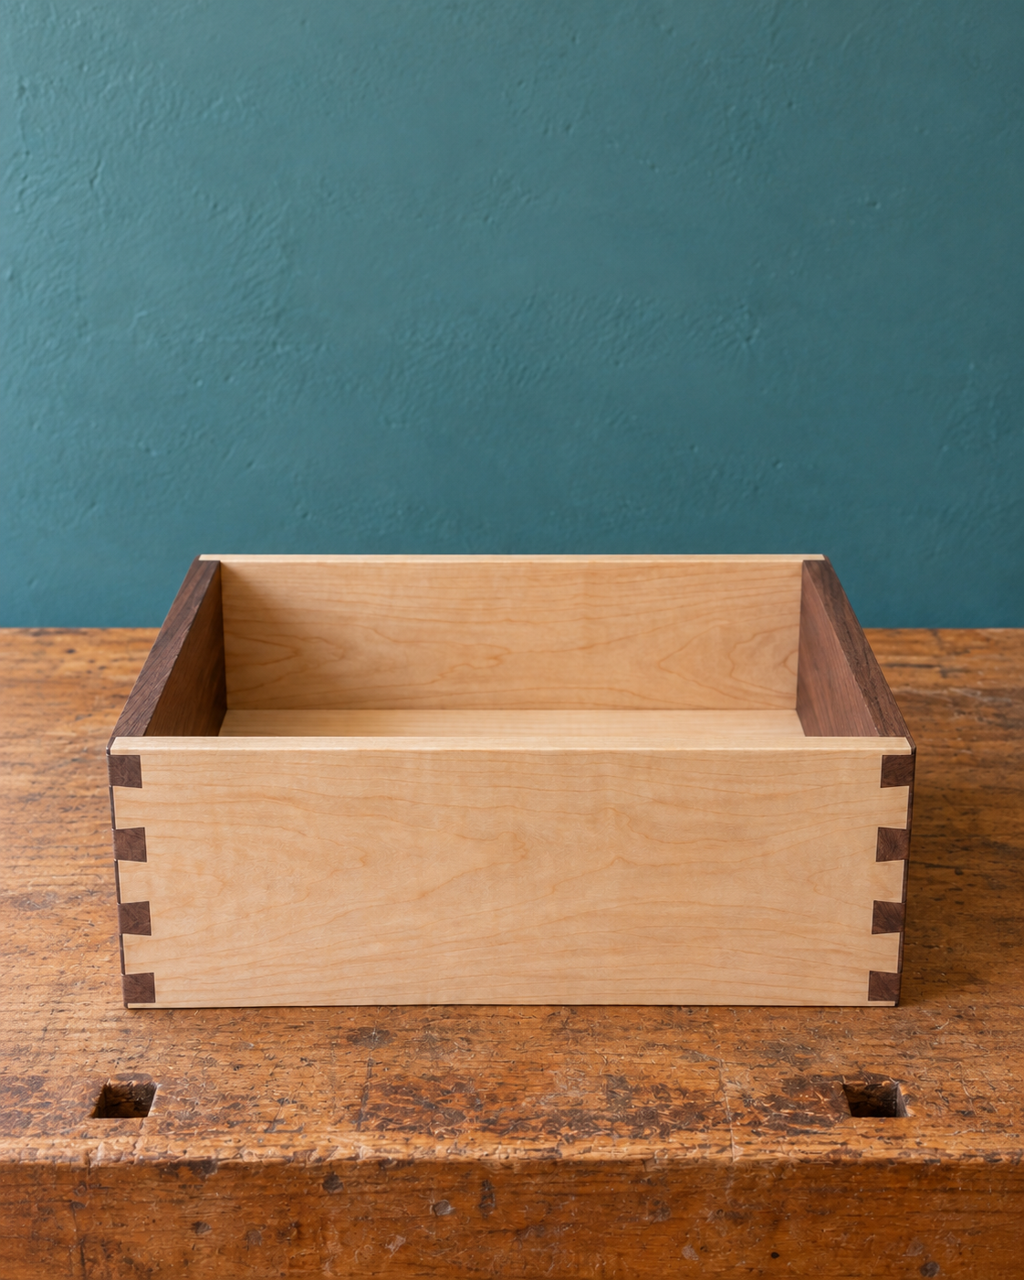
STUDENT WORKBOOK
Small Box
Understand. Make. Record.
Understand the joints. Control the fit. Tell the story of your work.

One optional open-box example. A lid is optional. Generated illustration, not a construction plan or student work.
A companion to the Year 9 Small Box course. Read, draw, discuss and record your learning while the teacher uses the website, presentations, videos and workshop demonstrations.
STUDENT | CLASS / TEACHER

Small Box The brief, timber and preparation

01 / Read the matching course section 2
STUDENT WORKBOOK

A book for the whole build
Read the ideas, apply them on paper, then record what actually happened in the workshop.
YOUR ROUTE | PAGES
Choose your option and record the technical source | 3
1 Brief, materials, marks and workshop controls | 4–19
2 Joints, dry fitting, glue-up and corrections | 20–33
3 Optional lid, surface, finish and evaluation | 34–50

Read / discuss / check / record
Seventeen readings explain all nine course sections. The lid is optional. All 36 knowledge checks and twelve written prompts use the current course wording. Some checks ask you to reason about a lidded example; your own practical and folio evidence follows the open-box or lidded option you choose. Twelve folio pages record your actual project.

Connect the paper and the course
Use the matching module when the teacher opens a presentation or video. A photograph, labelled sketch or recorded check can support the Small Box folio. The teaching program also names checkpoint photographs during practical work; keep these as directed. Attach a print or record the reference and add a caption explaining what it proves. Browser records are not submitted automatically.
 Remember
The current teacher-issued technical source, school SOPs, demonstrations and approved product information control practical work. Confirm assessment marks, dates, conditions and submission arrangements with the teacher. Completing this book does not authorise equipment use.

50 pages • 25 double-sided sheets • Edition 1.1
Choose an open box or the lidded option with your teacher. Record evidence for the version you actually make.

Small Box The brief, timber and preparation

01 / Read the matching course section 3
PROJECT SOURCE / TEACHER CONFIRMATION

Begin with the confirmed brief
The course supplies an outcome and high-level pathway. Use the teacher’s technical source for construction detail.
Make a small timber box. The lid is optional: choose an open box or the original lidded option. Obtain timber from the teacher and confirm the component list for your choice. Hinges are teacher supplied or approved only when needed for a chosen lid.
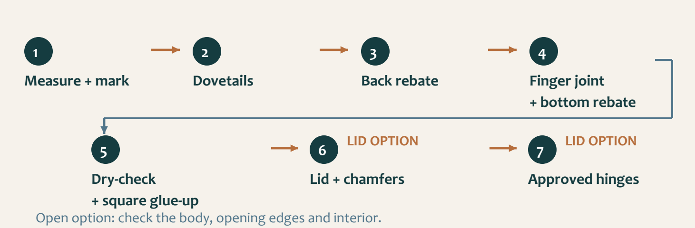
Figure 01. Original body pathway with optional lid stages. The teacher confirms the technical details for your chosen option.
 Technical source required
The supplied course snapshot contains no dimensional project-plan PDF. Before marking, identify the current teacher-issued plan or technical resource. Do not measure the workbook illustrations to obtain missing values.

CHOICE / TEACHER-ISSUED SOURCE | REFERENCE / CONFIRMED DETAIL
My option: open box or lidded
Plan title, version or date
Where my class accesses it
Teacher confirmation / questions to resolve

Small Box The brief, timber and preparation

01 / Read the matching course section 4
MODULE 1 / SECTION 1 / READ AND UNDERSTAND
01 | Understand the whole box
A useful brief connects the finished object with the checks that will prove its quality.

Start with your chosen outcome
The lid is optional. You may make an open small timber box or choose the original lidded version. Both need a sound body and a usable result. Record your choice with the teacher, then connect its requirements with the checks you will make. A good-looking surface cannot compensate for poor joint contact or an unstable box.
The original lidded brief names sides, top and bottom when calculating stock. Your actual component list must match your chosen option and the approved technical source. Obtain timber from the teacher; do not include a lid component simply because the original example has one. Photographic proportions cannot supply missing measurements, and the optional lid does not automatically authorise a divider or another feature.
 Think about it
Look at the image: which features can you observe, and which details would still require the approved technical source?

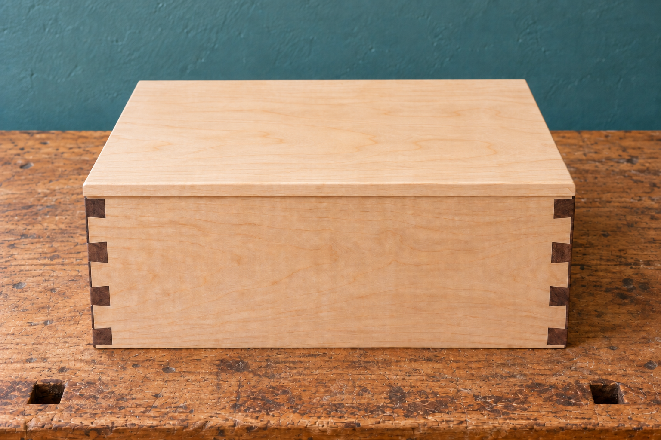
Figure 02. Generated study of one optional lidded example. The open-box option is equally valid; neither photograph supplies construction dimensions.

Connect the brief to evidence
For a hinged lid, use small teacher-supplied or approved hinges and check their suitability before fitting decisions. Students are not required to purchase them. The open option does not require lid hardware. It still needs deliberate inspection of the opening edges, interior access and the assembled body rather than being treated as an unfinished lidded box.
Turn each relevant requirement into an observable check. Both options need joint contact, squareness, stability and surface-quality evidence. A chosen lid adds alignment, intended movement and hinge-security checks. An open box needs evidence of its opening and usable interior. Record the criterion first so your final judgement can refer to your actual choice, including questions and corrections along the way.

Small Box The brief, timber and preparation

01 / Read the matching course section 5
MODULE 1 / SECTION 1 / READ AND UNDERSTAND

A source you can trust
Different sources answer different questions; use the one that has authority over the decision.
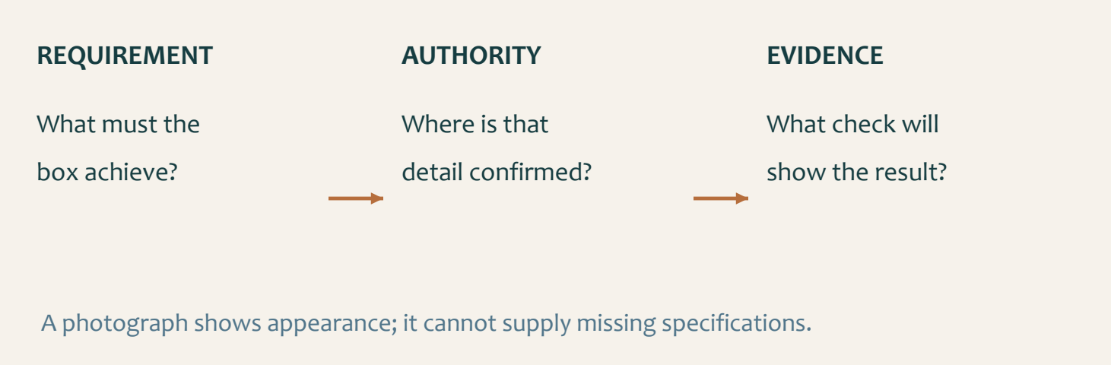
Figure 03. A requirement, its authority and its evidence form one traceable chain.

Separate explanation from specification
The website, presentations and videos explain the ideas behind the Small Box. Current teacher directions confirm that the lid is optional and take precedence where older resources describe a compulsory lid. The approved technical source controls construction detail: an explanation of a rebate helps you understand a drawing, but cannot supply its missing size. Keep the source for your chosen option beside the workbook.
Before accepting a detail, identify where it came from and what it applies to. Is it part of the current Small Box brief, an approved plan, a teacher demonstration or a generic example? A neat drawing is not automatically an approved drawing. A number remembered from another project has no authority here, even if it seems reasonable.

Keep decisions reversible
Suppose a component length is unclear. The useful next action is to locate the relevant view and ask a precise question before marking or cutting. “Which approved dimension controls this part?” is more useful than “Does this look right?” Record the answer and the source so the decision can be checked again when the component is moved or the lesson changes.
Evidence of source control can include a plan reference, a checked mark, a teacher confirmation or a correction note. Distinguish a student record from practical sign-off: writing that a setup is safe does not authorise its use. When the source, stock, hardware or next action is uncertain, stop and clarify the uncertainty while changes are still possible.

 Think about it
A missing value is a question to resolve. It is not an invitation to measure an illustration.

Small Box The brief, timber and preparation

01 / Read the matching course section 6
MODULE 1 / SECTION 2 / READ AND UNDERSTAND

Read the timber before layout
The material itself gives you information that a component list cannot.

Inspect more than the colour
Look across the broad faces, along the edges and at the ends before marking components. Notice the grain, visible defects and whether the stock appears straight. These observations affect where parts can be placed and which questions need teacher attention. An attractive patch of timber may still be unsuitable for a particular component; appearance alone is not enough to decide.
A visible knot is a feature to inspect, not an automatic instruction to cut around it or include it. Its position and condition must be considered with the approved component layout. Describe what you actually see. “A knot is near the proposed edge” is an observation; “this piece will fail” is an unsupported conclusion without further evidence.
 Think about it
Use the photograph to practise observation. Use your own stock and approved source for the actual layout.

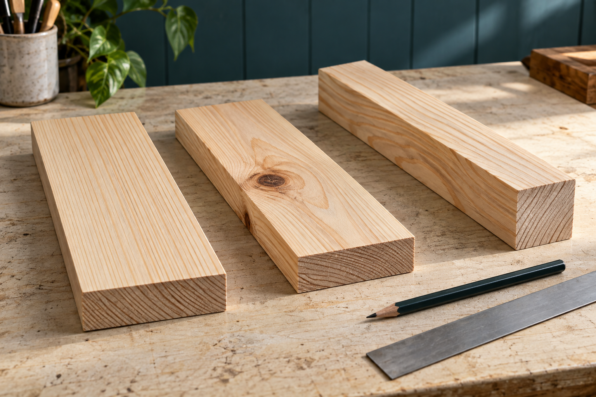
Figure 04. Generated material study: compare grain, the visible knot and the faces and edges. These are not the assigned stock pieces or a species guide.

Preserve the chosen relationship
Arrange the required components against the approved information before committing to their positions. Consider grain direction, face and edge references, visible features and responsible use of the available material together. Saving a small offcut is not a benefit if the arrangement loses the material needed for an accurate component. Ask about any conflict before cutting.
Identify the orientation of each piece so the layout remains understandable after parts are separated or turned over. Record why a face or position was selected and what the inspection changed. If the original arrangement remains suitable, say so and explain the check that supported it. Good evidence shows a reasoned choice; it does not require inventing a defect or a change.

Small Box The brief, timber and preparation

01 / Read the matching course section 7
MODULE 1 / SECTION 2 / READ AND UNDERSTAND

Make the mark traceable
A correct number can still produce an incorrect component when its reference or orientation changes.
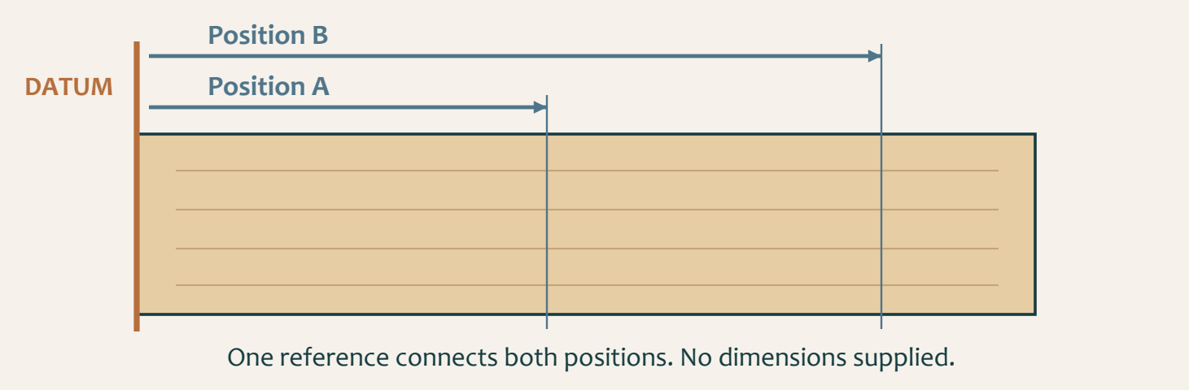
Figure 05. Conceptual positions A and B share one reference. The diagram contains no Small Box dimensions.

Begin at the right place
Identify the required information in the approved technical source, then establish the face or edge from which the mark is to be taken. This reference connects related measurements. If you measure one position from one end and a related position from an unintended end, the numbers may be copied correctly while their relationship becomes wrong.
Keep the reference visible as the component is handled. Match the intended inside, outside, top and bottom relationships before using the marking tool demonstrated by the teacher. Do not assume that two similar-looking pieces can be exchanged. A mark has meaning only when the component, orientation and reference can still be identified.

Check before the boundary is lost
A clear mark is easier to check than several competing lines. If a position is wrong or uncertain, remeasure and correct the layout using the workshop method. Do not choose whichever line seems closest when it is time to cut. Compare the final marked component with the approved source and obtain the required check before material is removed.
A useful pre-cut record names the component, the source used, the reference and the result of the check. It can be a labelled sketch or a brief note beside a photograph. This record helps explain how accuracy was protected. The check is most valuable while an error can still be corrected by changing a mark rather than replacing timber.

 Think about it
Before a cut, point to the source, the reference and the intended mark. If one is unclear, pause.

Small Box The brief, timber and preparation

01 / Read the matching course section 8
MODULE 1 / SECTION 3 / READ AND UNDERSTAND

Choose controls that change risk
Personal protective equipment is one part of a controlled task.
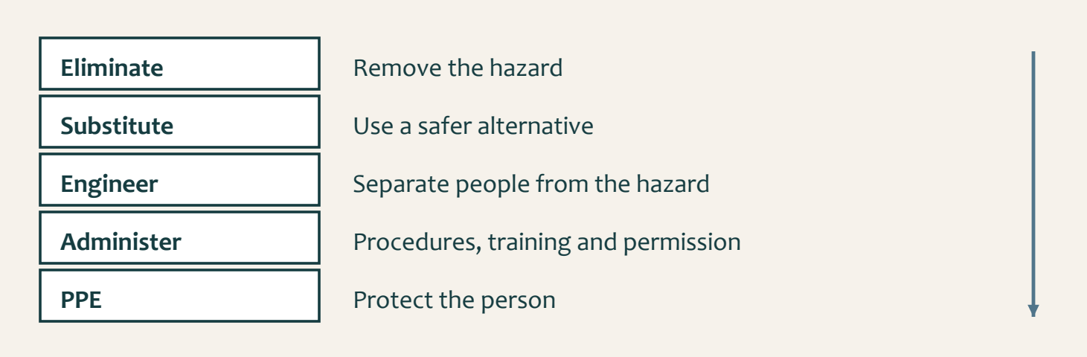
Figure 06. The hierarchy moves from removing a hazard to protecting the person. Apply the school’s current controls and teacher direction.

Understand the hazard pathway
A hazard is something that can cause harm. Describe how the harm could occur, then consider the control that changes that pathway. For example, unsecured work can move during a task. Required eye protection may protect against some particles, but it does not stop the work moving. Secure support and the approved method address different parts of the risk.
The hierarchy of controls prioritises eliminating a hazard, then substitution and engineering controls, followed by administrative controls and PPE. In a school workshop, students follow the controls selected through school procedures and teacher direction. Recognising a stronger control does not authorise a student to modify equipment, remove a guard or invent a new setup.

Connect controls to the real task
Before work, check the space, the workpiece and the demonstrated setup. Keep movement areas clear and use required guards, extraction and secure support. Training, permission, signs and safe operating procedures help control how the task is undertaken. Wear the protective equipment directed for the actual process and keep hair and loose items controlled.
A useful WHS record explains why the control mattered. “I wore PPE” leaves the hazard unclear. A stronger account names the hazard, the
teacher-approved control and the check that showed it was in place. Keep claims accurate: a risk pathway describes what could happen; it does not prove that an incident actually occurred or that one action removed every risk.

 Think about it
Discuss the hierarchy with the teacher’s selected course video, then identify the controls in your actual task.

Small Box The brief, timber and preparation

01 / Read the matching course section 9
MODULE 1 / SECTION 3 / READ AND UNDERSTAND

Know when the task has changed
Stopping at the right moment protects both the student and the material.
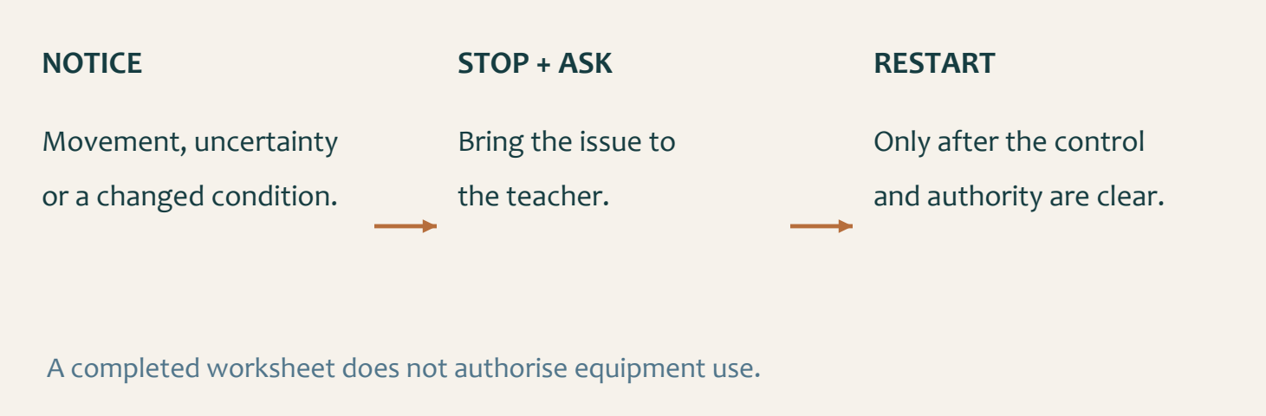
Figure 07. Notice the changed condition, stop and resolve it, then restart only with clear authority.

Recognise an uncertainty early
Practical work depends on conditions remaining controlled. A component that shifts, an unclear line or unexpected resistance means the task is no longer exactly the one you prepared for. Do not compensate by reaching further, using more force or continuing from memory. Stop by the demonstrated safe method and draw the teacher’s attention to the changed condition.
Uncertainty can come from information as well as equipment. If the next operation, stock, guard, clamp, extraction or hand position is unclear, the missing detail needs to be resolved before proceeding. Waiting for teacher direction is productive when it prevents an irreversible mistake. Use the pause to describe the issue precisely and locate the relevant source.

Keep permission separate from confidence
Being able to name a hand saw, chisel, marking gauge, router table, finger jointer, clamp, hand plane or mallet does not establish permission to use it. Current SOPs, teacher demonstrations, risk controls and supervision determine the actual method. Neither a video nor a completed knowledge check replaces the required practical instruction.
Record a meaningful permission point rather than a general claim that everything was safe. State what was checked, what remained uncertain and what allowed work to resume. If the teacher changes the sequence or control for the class, update your record. A reliable workshop habit is to recognise the boundary of your current authority and make the next decision with the right support.

 Think about it
Before restarting, explain what changed and how the required control or instruction has been restored.

Small Box The brief, timber and preparation

01 / Read the matching course section 10
KNOWLEDGE + APPLIED THINKING

Check the chosen brief
Circle one answer for each current brief question. Then record the open-box or lidded option you will make.
1 | What is the approved project outcome?  ○ A. A small timber box with an optional lid  ○ B. An open tray with removable sections  ○ C. A timber clock case  ○ D. A storage rack with shelves

2 | Which components are named when calculating the required timber stock?  ○ A. Sides and bottom, plus the top/lid only if selected  ○ B. Legs, rails and seat  ○ C. Drawer front and runners  ○ D. Handle, wheels and axle

3 | If the selected lid uses hinges, how should those hinges be obtained?  ○ A. From any online seller chosen by the student  ○ B. Teacher supplied or teacher approved  ○ C. Made from scrap sheet metal without approval  ○ D. Omitted whenever they are difficult to source

Record your actual choice
DECISION | MY CHOICE / SOURCE OR AUTHORITY
Open box or lidded; components needed
Required technical dimensions
Hardware, if needed; confirmation

Small Box The brief, timber and preparation

01 / Read the matching course section 11
KNOWLEDGE + APPLIED THINKING

Check the mark
Circle one answer for each question. Return to the reading to explain any choice you find difficult.
4 | What controls dimensions and technical details for this project?  ○ A. The approved brief, teacher-issued resources and teacher direction  ○ B. A photograph found online  ○ C. Another student's completed box  ○ D. A generic woodworking video

5 | What is the strongest marking routine before a cut?  ○ A. Read the approved source, mark from a reliable reference, verify, then seek the required check  ○ B. Copy a classmate's marks and cut immediately  ○ C. Estimate the size from the hero image  ○ D. Make several marks and choose one during cutting

6 | What should happen when a dimension or mark is unclear?  ○ A. Choose the nearest value  ○ B. Stop and ask the teacher before continuing  ○ C. Cut oversize without recording the uncertainty  ○ D. Use a value from a different box project

Order a verified mark
Number the steps 1–5 to create a traceable mark before cutting.
[ ] Check the component’s orientation and marked position.
[ ] Identify the required information in the approved source.
[ ] Obtain the required pre-cut confirmation.
[ ] Establish the approved reference face or edge.
[ ] Make a clear mark using the demonstrated method.

Small Box The brief, timber and preparation

01 / Read the matching course section 12
KNOWLEDGE + APPLIED THINKING

Check the controls
Circle one answer for each question. Return to the reading to explain any choice you find difficult.
7 | What is a useful first material check?  ○ A. Visible defects, straightness and suitability  ○ B. Only the colour of the timber  ○ C. Whether the piece is the cheapest  ○ D. Whether it matches a friend's piece

8 | Which evidence best shows a controlled start to the project?  ○ A. A dated sequence of source checks, marks, approvals and corrections  ○ B. One final photograph only  ○ C. Copied notes with no link to the student's work  ○ D. A list of tools with no decisions recorded

9 | Why is PPE not the only workshop control?  ○ A. Hazards should also be removed or reduced through stronger controls where possible  ○ B. PPE is only needed after an incident  ○ C. PPE replaces teacher instruction  ○ D. PPE makes every setup safe

Control the hazard pathway
SITUATION | CONTROL TO CONFIRM BEFORE WORK
Workpiece can move
Dust control is uncertain
The next action is unclear

In a teacher-led pair discussion, compare one control choice. Record the useful feedback and the check you would use before proceeding.

Small Box The brief, timber and preparation

01 / Read the matching course section 13
KNOWLEDGE + APPLIED THINKING

Check your authority
Circle one answer for each question. Return to the reading to explain any choice you find difficult.
10 | What authorises the use of a workshop machine or process?  ○ A. Student confidence  ○ B. Current school SOP, teacher demonstration and permission  ○ C. A video watched at home  ○ D. Previous experience on a different project

11 | What is the best response to a visible hazard or uncertain setup?  ○ A. Work faster to reduce exposure time  ○ B. Stop, reassess and apply the required control before continuing  ○ C. Ask another student to proceed first  ○ D. Continue if the timber is already marked

12 | When is this module ready to close?  ○ A. When the brief, stock plan, marking checks, safety controls and evidence plan are understood and recorded  ○ B. As soon as a box image has been selected  ○ C. When the first tool has been chosen  ○ D. When another student begins construction

The confident shortcut
A student says, “I watched the video, so I can use the machine while the teacher is busy.” Explain what the video does provide and what must happen before use.

Small Box The brief, timber and preparation

01 / Read the matching course section 14
STUDIO / PROJECT EVIDENCE

Explain the brief and marks
Explain the action, its reason and the relevant check. Write about your chosen open-box or lidded option.

Summarise the approved Small Box brief
Explain the approved project outcome, your open or lidded choice, the timber components required and who controls any hardware.

Describe your marking verification plan
Explain how you will move from the approved source to a verified mark without guessing.

Small Box The brief, timber and preparation

01 / Read the matching course section 15
STUDIO / PROJECT EVIDENCE

Explain safe preparation
Explain the action, its reason and the relevant check. Write about your chosen open-box or lidded option.

Explain one workshop control decision
Choose one likely workshop hazard and explain the stronger controls that should be applied before relying on PPE.

Plan a useful evidence trail
Describe four evidence items that will show your project began with source control, accurate marking and safe preparation.

Small Box The brief, timber and preparation

01 / Read the matching course section 16
STUDIO / PROJECT EVIDENCE

Criteria you can check
Folio checkpoint 01 / Project brief and success criteria
Show that you understand the Small Box requirements and how evidence is judged in this unit.
REQUIREMENT FOR MY CHOICE | OBSERVABLE EVIDENCE / CHECK
Open interior / access OR chosen lid function
Body construction and fit
Surface / finish quality

What must your Small Box do and what evidence proves it was achieved?

Evidence note / reference: what does your own photograph, sketch or check prove?

Small Box The brief, timber and preparation

01 / Read the matching course section 17
STUDIO / PROJECT EVIDENCE

A layout that stays readable
Folio checkpoint 02 / Project planning, marking and layout
Show how your planning and marking protected accuracy before cutting.
Draw your planned component layout from the teacher’s technical source. Label the reference face or edge, component identities, orientation and a pre-cut check. Enter dimensions only when verified.


Why was your planning sequence critical before any irreversible cuts?

Evidence note / reference: what does your own photograph, sketch or check prove?

Small Box The brief, timber and preparation

01 / Read the matching course section 18
STUDIO / PROJECT EVIDENCE

Make the control visible
Folio checkpoint 03 / WHS, WMS and workshop controls
Show how risk was controlled for each cutting and fitting task.
ACTUAL TASK / HAZARD | CONTROL AND TEACHER CHECK

Which control prevented the highest-risk incident pathway?

Evidence note / reference: what does your own photograph, sketch or check prove?

Small Box The brief, timber and preparation

01 / Read the matching course section 19
STUDIO / PROJECT EVIDENCE

Inspect and place the timber
Folio checkpoint 04 / Timber inspection and material placement
Explain how timber quality and orientation decisions affected this build.
Sketch your actual stock and proposed component placement. Label grain, visible features or defects, reference faces and any placement decision made after inspection.


How did inspection change your final component layout?

Evidence note / reference: what does your own photograph, sketch or check prove?

Small Box Joinery, fit and assembly

02 / Read the matching course section 20
MODULE 2 / SECTION 1 / READ AND UNDERSTAND
02 | Recognise the joint features
A joint’s name helps you identify its role before choosing a process.
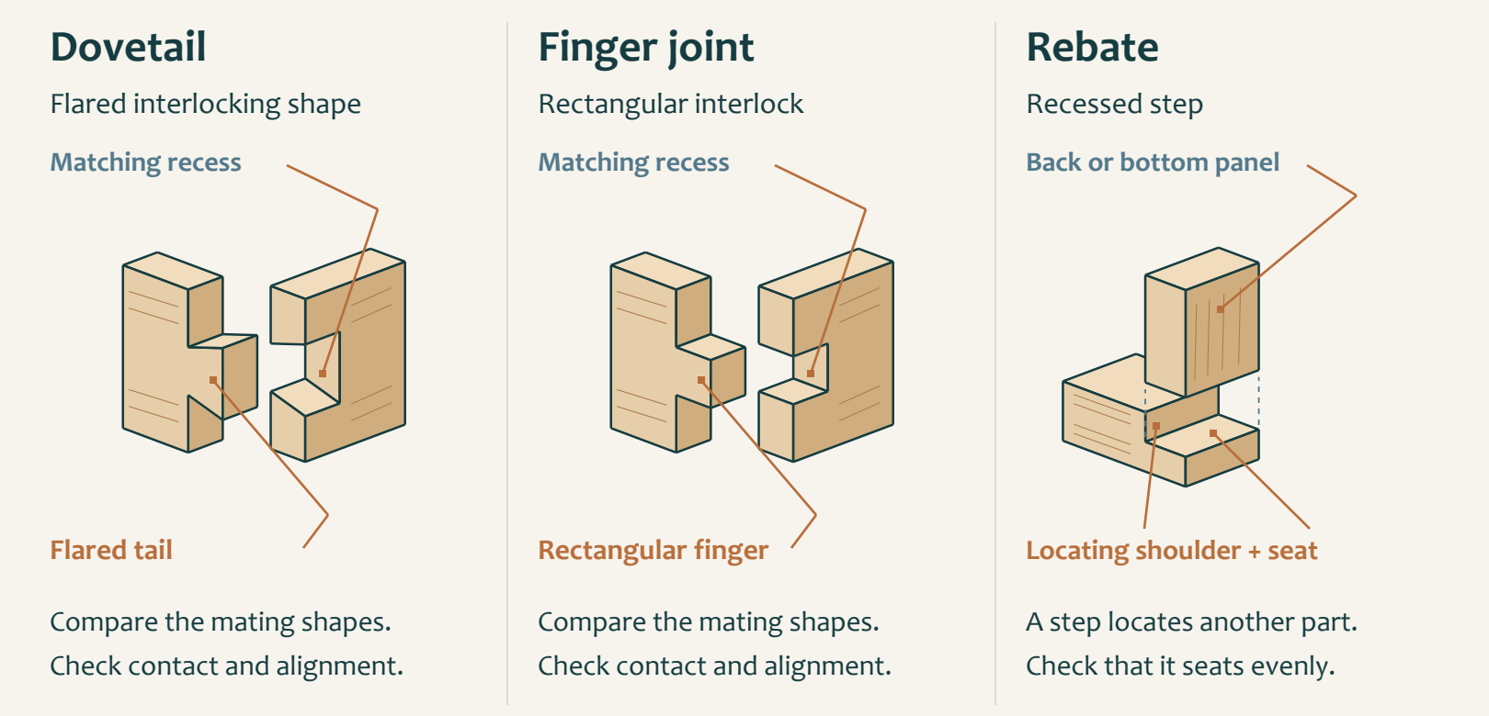
Figure 08. Enlarged mating concepts: a flared dovetail, a rectangular finger and a recessed rebate. These are not joint templates.

Connect form with connection
The Small Box pathway names dovetail joints, a back rebate, a finger joint and a bottom rebate. These features organise how components connect and locate against one another. Recognise them in the approved source before thinking about tools. A joint diagram can explain a feature while leaving its exact size, number and position to the project information.
A dovetail has a flared interlocking profile; a finger joint uses rectangular interlocking projections. Their visibly different shapes matter when interpreting a drawing or checking that the correct feature has been prepared. The conceptual examples here are deliberately enlarged. Do not trace them onto timber or count the illustrated features as the required quantity.

Read a rebate as a relationship
A rebate is a recessed step that allows another component to sit into the work. The back and bottom rebates belong to specific places in the confirmed sequence. Their purpose is understood by identifying the component being located and the surfaces that should meet. An unexplained recess is not enough information to begin removing material.
Before each feature, identify the component, orientation and approved marks. Afterwards, inspect the result against the same source and record the relevant check before moving on. Errors in one feature can affect the fit of a later component, so the sequence is a chain of verified relationships. Obtain teacher direction for the geometry, method and setup that the overview does not supply.

 Think about it
Find each named feature in the teacher’s approved technical source and identify the surfaces intended to meet.

Small Box Joinery, fit and assembly

02 / Read the matching course section 21
MODULE 2 / SECTION 1 / READ AND UNDERSTAND

Make the sequence meaningful
The order of work gives each stage a checked foundation for the next.

Figure 09. The confirmed high-level pathway. It gives order, not machine settings or permission to begin.

Read the whole route first
The original pathway begins with measuring, marking and square-cutting the required components. Dovetails precede the back rebate, then the finger joint and bottom rebate. After the dry check, the body is glued and clamped square. Lid preparation, chamfers and teacher-approved hinges follow only when the lidded option is chosen. The open option proceeds to relevant body, opening-edge and surface checks.
This order helps you recognise where you are in the build, but it is not a complete operating procedure. The plan, demonstration and teacher directions supply the detail for the actual class. If a feature or intermediate check is unclear, raise the question before continuing. Do not use a neat sequence diagram to fill a missing practical instruction.

Put checks between the operations
A good sequence note includes the evidence needed to leave a stage. After marking, the evidence may be a checked component layout. During joinery, it may show the intended feature and its fit. Before glue-up, contact, alignment and squareness must be understood. These checks make later work more reliable because an unresolved error is not simply passed forward.
Compare two features and explain why each matters to the assembled box. A rebate may locate a component; a joint connects mating parts. The quality of either affects the later dry fit. A practical record should link the feature to its function and the check, rather than list tool names without explaining their purpose. Keep any correction within the approved method and record the result before advancing.

 Think about it
Ask: what must be true before I leave this stage, and what evidence will show it?

Small Box Joinery, fit and assembly

02 / Read the matching course section 22
MODULE 2 / SECTION 2 / READ AND UNDERSTAND

Use the dry fit to learn
Trial assembly reveals relationships while the components can still be separated.
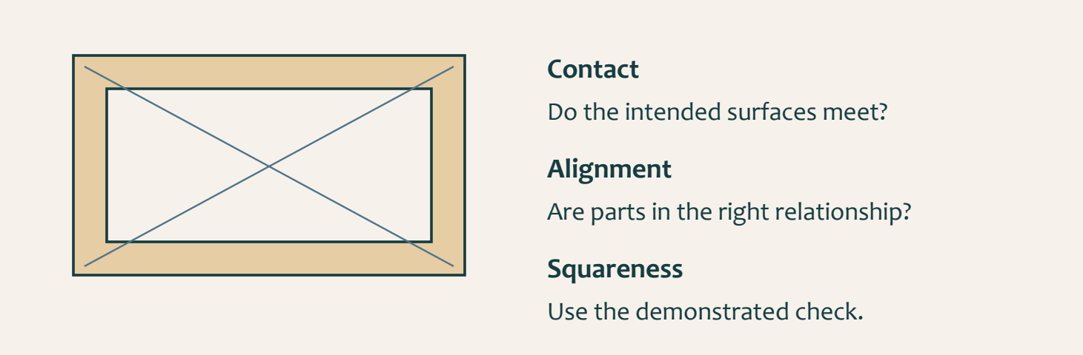
Figure 10. Check contact, alignment and squareness as a whole. Diagonal lines indicate a comparison concept, not the only authorised checking method.

Inspect without adhesive
A dry fit brings the prepared components together without glue. Use the intended orientation and the teacher’s demonstrated method, then examine how the parts meet. Look for consistent contact, intended alignment and the correct relationship between the joints and rebates. A successful fit at one corner does not prove that the whole box is ready.
Do not force a joint that does not seat consistently. Resistance is an observation that needs a cause, not a command to press harder. Check the source, orientation and contact before proposing a correction. Randomly removing material can convert one tight point into a loose joint or change a feature that was already correct.

Square is an assembly condition
The box must be checked for squareness before glue-up and kept square during assembly. Use the method demonstrated for the actual project and record the result. An attractive view of one side is not proof of the whole geometry. The diagram shows why you must consider the complete shape instead of one isolated joint.
When a correction is approved, repeat the relevant contact, alignment and squareness checks. Compare the new observation with the first one and record what changed. If the cause remains uncertain, ask the teacher before introducing adhesive. Dry fitting is the last opportunity to understand the complete arrangement while it is readily reversible; it is a learning stage, not a rehearsal to rush through.

 Think about it
A dry-fit note should explain the observation, any approved correction and the result of the repeated check.

Small Box Joinery, fit and assembly

02 / Read the matching course section 23
MODULE 2 / SECTION 2 / READ AND UNDERSTAND

Prepare for a square glue-up
Adhesive makes preparation and timing part of the quality of the assembly.
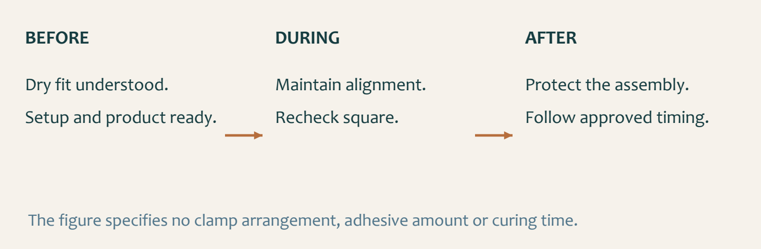
Figure 11. Preserve the verified dry fit during glue-up and protect the assembly afterwards. No clamp layout or timing is specified.

Prepare the whole operation
Begin only when the dry fit is understood and the teacher has confirmed readiness. Have the approved adhesive, support and clamping arrangements prepared through the demonstrated method. Work out how the parts will be identified and kept in their intended orientation. Searching for equipment after adhesive is introduced can turn an orderly sequence into a rushed one.
Clamping holds the assembly while the adhesive process develops. It should preserve the required relationship between the parts, not conceal a poor fit. Recheck alignment and squareness during the approved sequence because components may move as they are held. A large force is not evidence of a good joint; the relevant evidence is the condition of the assembly.

Compare products by evidence
The extension activity names PVA, polyurethane and epoxy as adhesive families. A family name alone does not establish suitability, water resistance, gap performance or the controls for a particular product. Compare the actual
teacher-approved product information, intended materials and process requirements. A generic internet claim is too weak a basis for changing an adhesive.
Record the adhesive actually approved and the timing and handling instructions supplied for this build. Leave the assembly protected as directed and record any movement or quality issue honestly. Do not invent a curing interval, add extra adhesive to hide a gap or disturb the work because the surface seems dry. The demonstrated process and product information control the next action.

 Think about it
A comparison is a reasoning exercise. It does not authorise a different product or a change to the workshop procedure.

Small Box Joinery, fit and assembly

02 / Read the matching course section 24
MODULE 2 / SECTION 3 / READ AND UNDERSTAND

Diagnose before you correct
A useful correction begins with an observation that another person could check.
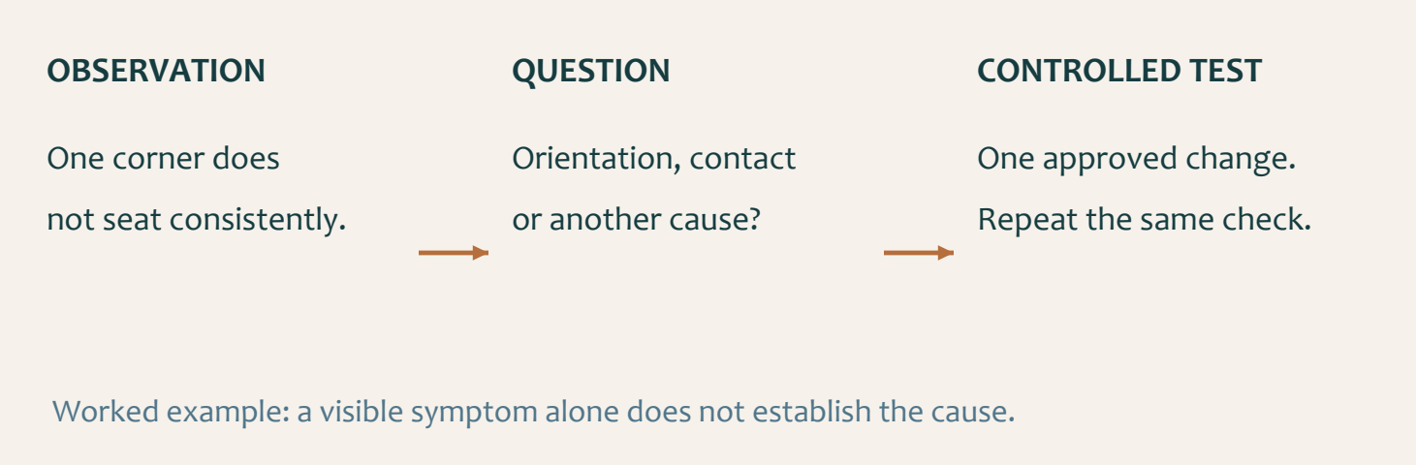
Figure 12. A non-seating corner is an observation. Orientation or contact may be causes to investigate; neither is proved by the symptom alone.

Separate the symptom from its cause
“One corner does not seat consistently” describes a visible fit issue. “The entire joint is too large” is already a diagnosis. Keep these ideas separate until the evidence supports the cause. Identify where the issue appears, what check revealed it and whether it changes when the parts are in their verified orientation.
Use the approved source to check the intended relationship before changing material. Similar symptoms may come from different causes, so the first plausible explanation is not always the right one. Ask the teacher to confirm the correction. Hiding a gap, forcing a fit or altering several faces at once makes the original problem harder to understand.

Change one approved factor
A controlled correction changes one approved factor and then repeats the relevant check. This makes the result interpretable: you can connect the action with the new observation. If several unrelated changes are made together, an improved fit does not tell you which change helped or which may have introduced another problem.
Record a concise before-and-after account. Name the issue, the evidence used in diagnosis, the teacher-supported action and the outcome of the repeated check. If the result is still unsatisfactory, say so and seek further direction. Problem solving does not require every first correction to work; it requires an honest, safe process that uses evidence to choose the next step.

 Think about it
Use “possible cause” until the check supports the explanation. Confidence should follow evidence.

Small Box Joinery, fit and assembly

02 / Read the matching course section 25
MODULE 2 / SECTION 3 / READ AND UNDERSTAND

Make a correction visible
A good evidence trail explains what changed and why the later result can be trusted.
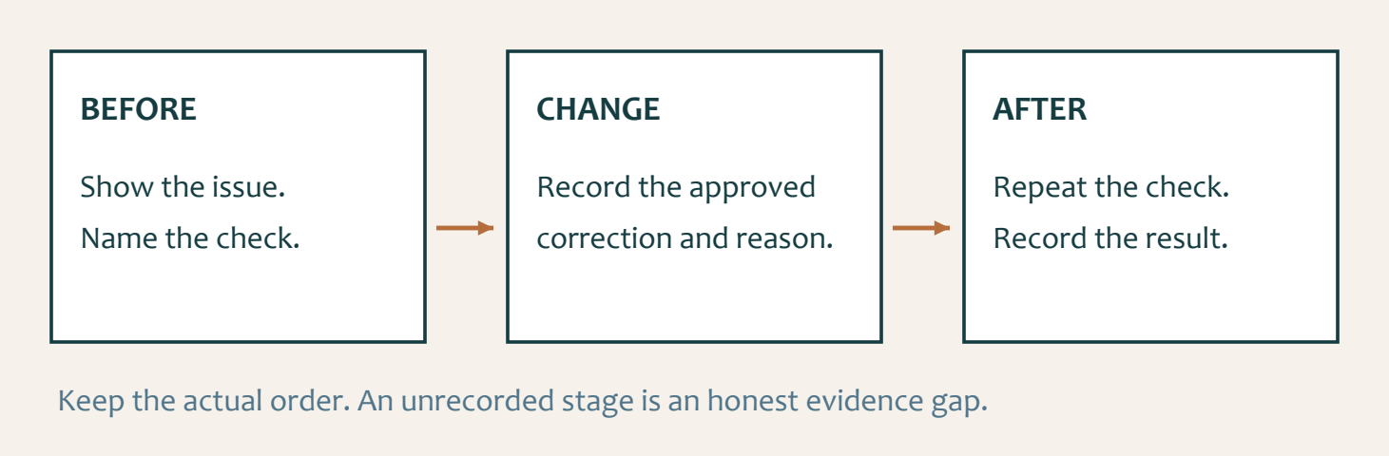
Figure 13. The same check links the before and after records. Keep the real order and identify any missing evidence honestly.

Choose evidence that answers a question
A photograph of the finished box cannot show every decision that led to it. Select an image, sketch or check that makes the issue visible at the relevant stage. The reader should understand what you were trying to establish: joint contact, alignment, squareness or another confirmed quality requirement. Repeated decorative images add little to that explanation.
Write the first observation before describing the correction. Locate the feature and state the result of the check without exaggeration. A labelled sketch can point to a contact problem more clearly than an uncaptioned photograph. Keep personal information and classmates’ unrelated work out of the evidence as directed by the teacher.

Close the evidence loop
Explain the approved action and its reason, then repeat the relevant check and record the result. “Fixed it” leaves both the action and the proof unclear. A stronger record connects the initial observation with the controlled change and the later condition. Include teacher support where it affected the decision; it is part of learning, not a weakness to hide.
Use the genuine chronology. If a stage was not photographed or a check was not recorded, identify the gap and discuss suitable evidence with the teacher. Do not stage a later photograph to imply that it proves an earlier check. Your folio can include a real build photograph, labelled sketch or check, but the caption must state accurately what that item demonstrates.

 Think about it
A useful caption names the stage, observation, action, reason and checked result.

Small Box Joinery, fit and assembly

02 / Read the matching course section 26
KNOWLEDGE + APPLIED THINKING

Check the features
Circle one answer for each question. Return to the reading to explain any choice you find difficult.
13 | Which joint is confirmed for joining the Small Box corners?  ○ A. Dovetail joint  ○ B. Mortise and tenon joint  ○ C. Lap joint  ○ D. Dowel-only joint

14 | What is a rebate in timber work?  ○ A. A recessed step or channel that allows another component to sit into the work  ○ B. A decorative paint pattern  ○ C. A round hole made for a dowel  ○ D. A flexible metal fastener

15 | Which parts of the approved sequence include rebates?  ○ A. The back and bottom stages  ○ B. The lid hinges only  ○ C. The outside finish only  ○ D. The project folio only

Link feature to purpose
FEATURE | RELATIONSHIP TO CHECK
A rebate
A dovetail or finger joint

Small Box Joinery, fit and assembly

02 / Read the matching course section 27
KNOWLEDGE + APPLIED THINKING

Check the dry fit
Circle one answer for each question. Return to the reading to explain any choice you find difficult.
16 | Which additional joint is named before the bottom rebate stage?  ○ A. Finger joint  ○ B. Scarf joint  ○ C. Bridle joint  ○ D. Mitre spline

17 | Why is a dry fit important before glue-up?  ○ A. It allows joint contact, alignment and squareness to be checked while corrections remain reversible  ○ B. It makes teacher approval unnecessary  ○ C. It guarantees every joint without checking  ○ D. It replaces the approved production order

18 | What is the central quality check during glue-up?  ○ A. Keeping the box square while the approved joints are held in position  ○ B. Applying the largest possible amount of adhesive  ○ C. Hiding every joint with finish  ○ D. Removing clamps immediately

Read the dry fit
OBSERVATION | NEXT CHECK BEFORE A CORRECTION
One corner does not seat
The box does not appear square
A component is hard to locate

Small Box Joinery, fit and assembly

02 / Read the matching course section 28
KNOWLEDGE + APPLIED THINKING

Check the correction
Circle one answer for each question. Return to the reading to explain any choice you find difficult.
19 | What should happen if a joint does not seat consistently during a dry fit?  ○ A. Force it together  ○ B. Stop, identify the cause, make one approved correction and recheck  ○ C. Add finish to the joint  ○ D. Ignore it if the outside looks acceptable

20 | Why should only one correction be changed at a time?  ○ A. So the result can be linked to a specific cause and adjustment  ○ B. So evidence can be avoided  ○ C. So the source order no longer matters  ○ D. So the box can be completed without rechecking

21 | Which evidence best supports a joinery correction?  ○ A. Before-and-after observations with the identified issue, approved adjustment and recheck result  ○ B. A final photo with no explanation  ○ C. A copied description of another student's work  ○ D. A claim that the joint felt better

One change, one useful result
Two faces are sanded, a component is reversed and more clamp pressure is added at once. The fit changes. Explain why the evidence is difficult to interpret and propose a better correction record.

Small Box Joinery, fit and assembly

02 / Read the matching course section 29
KNOWLEDGE + APPLIED THINKING

Check the evidence
Circle one answer for each question. Return to the reading to explain any choice you find difficult.
22 | Who controls the exact methods, dimensions and machine settings used to prepare these joints?  ○ A. The teacher, current SOPs and approved project resources  ○ B. The student website summary alone  ○ C. Any online tutorial  ○ D. The first student to reach the stage

23 | Which sequence best matches controlled assembly?  ○ A. Prepare the confirmed joints, dry fit, check alignment and square, correct, then complete the teacher-approved glue-up  ○ B. Glue first, then decide which joints are needed  ○ C. Finish the surfaces before checking joint contact  ○ D. Skip the dry fit if the marks look neat

24 | When is Module 2 ready to close?  ○ A. When the approved joinery sequence, dry-fit checks, square glue-up controls and correction evidence are understood and recorded  ○ B. When the box has been coloured  ○ C. When one joint has been hidden  ○ D. When the student is working faster

Compare adhesive evidence
INFORMATION TO FIND | APPROVED EXAMPLE A | APPROVED EXAMPLE B
Product / adhesive family
Intended materials and use
One control or timing requirement

Small Box Joinery, fit and assembly

02 / Read the matching course section 30
STUDIO / PROJECT EVIDENCE

Explain sequence and fit
Explain the action, its reason and the relevant check. Write about your chosen open-box or lidded option.

Explain the approved joint sequence
Explain how dovetails, the back rebate, finger joint and bottom rebate fit into the confirmed high-level Small Box sequence.

Describe a controlled dry fit
Explain the checks that should be made during a dry fit before the square glue-up stage.

Small Box Joinery, fit and assembly

02 / Read the matching course section 31
STUDIO / PROJECT EVIDENCE

Explain a controlled correction
Explain the action, its reason and the relevant check. Write about your chosen open-box or lidded option.

Record one correction loop
Describe a likely fit or alignment issue and show how one approved correction would be tested and recorded.

Explain why control matters more than speed
Reflect on one point in the joinery or glue-up sequence where slowing down protects quality and safety.

Small Box Joinery, fit and assembly

02 / Read the matching course section 32
STUDIO / PROJECT EVIDENCE

Record the decisive dry fit
Folio checkpoint 05 / Approved joinery and dry fitting
Explain how the confirmed joints and rebates were checked before square glue-up.
FEATURE OR CHECK | FIRST OBSERVATION | RECHECK / EVIDENCE
Dovetail / finger joint
Back / bottom rebate
Alignment and square

Which joint or alignment check changed your confidence the most?

Evidence note / reference: what does your own photograph, sketch or check prove?

Small Box Joinery, fit and assembly

02 / Read the matching course section 33
STUDIO / PROJECT EVIDENCE

Keep the assembly controlled
Folio checkpoint 06 / Assembly and clamp control
Show how clamp setup supported safe, repeatable assembly.
Draw the assembly arrangement demonstrated for your project. Label the actual support or clamp positions, possible movement and where alignment and squareness were checked.


What prevented movement at the most critical assembly moment?

Evidence note / reference: what does your own photograph, sketch or check prove?

Small Box Finish, evaluate and reflect

03 / Read the matching course section 34
MODULE 3 / SECTION 1 / READ AND UNDERSTAND
03 | Inspect the chosen edge
Learn the original lid’s chamfer, then apply the relevant edge check to your chosen option.
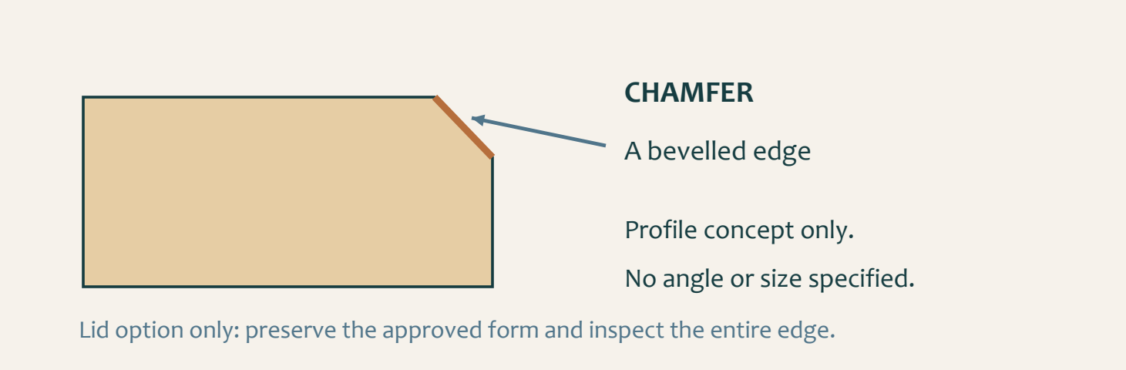
Figure 14. A chamfer is a bevelled edge. This enlarged section explains the shape without specifying an angle, depth or process.

Lidded option: recognise the chamfer
The original lid pathway includes chamfers. A chamfer is a bevelled edge, visible as a flat sloping surface between adjoining faces. Recognising the form helps you inspect a chosen lid, but this illustration supplies neither size nor angle. Confirm the lid requirement in the approved technical source before preparing it; this work is optional for students choosing a lid.
Consider a chosen lid as a complete component. Its relationship with the body, edge treatment and intended movement all matter. Inspect the entire prepared edge, not just the easiest area to see. Refining one patch should not become an unplanned change to the overall form. Use only the demonstrated process and seek advice before correcting an uncertain feature.

Open option: inspect the opening
An open box has no lid to chamfer. Instead, examine the opening edges, corners and interior using the teacher-approved check. Look for unresolved roughness, marks or unintended changes that affect handling or use. Do not add a chamfer or another edge profile merely to reproduce the lidded example; any treatment still needs the appropriate technical direction.
Record the relevant edge condition before and after any approved correction. A labelled sketch or clear image can locate the feature and explain the repeated check. Both options need deliberate edge preparation that preserves the intended form. The evidence should show what your actual option requires, not a simulated lid task for an open box or a claim that one smooth patch proves the whole object.

 Think about it
Choose the relevant branch. The chamfer is a lid example, not a required feature on every open-box edge.

Small Box Finish, evaluate and reflect

03 / Read the matching course section 35
MODULE 3 / SECTION 1 / READ AND UNDERSTAND

Check access and movement
The lidded and open options need different functional evidence, supported by the same careful observation.
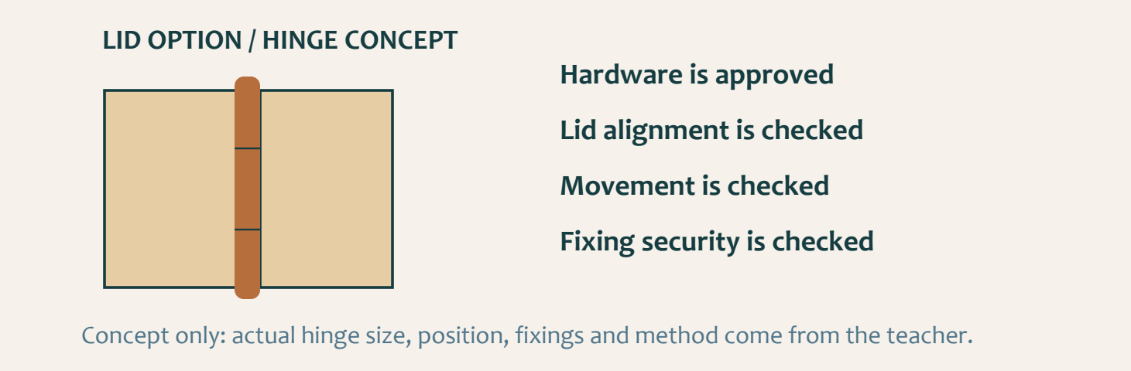
Figure 15. Hinge concept for the optional lidded version only. An open box does not require hinge-fitting evidence.

Lidded option: approved hardware
If you choose the original hinged lid, use the small hinges supplied or approved by the teacher. Size, profile and appearance need to suit the actual project. You are not required to purchase them. Confirm the intended alignment, hinge placement, fixings and demonstrated fitting method before preparing the parts. The drawing does not authorise a hardware choice or position.
Check that the chosen lid aligns and moves as intended without force. Body alignment, lid preparation and secure fitting contribute to the result. If movement catches, stop for teacher review. Keep before-and-after evidence of the approved hardware, fitting check and any supported correction. A photograph alone cannot prove that movement was actually tested.

Open option: a usable interior
For an open box, inspect access to the interior and the condition of the opening and corners. Check the assembled body’s joint condition and stability through the teacher-approved method. An open top is a valid design choice, not evidence of an incomplete lid stage. Do not create hardware or lid records for work that was not part of your project.
Explain what the observation shows and what remains uncertain. An image may locate a rough opening edge or visible gap; a caption should identify the check and its result. If a correction is required, record the authorised action and repeat the relevant observation. Both routes need evidence of a usable object, but the evidence must match the chosen version rather than a generic checklist.

 Think about it
Lid chosen: alignment, movement and hardware. Open box: opening, interior access and body condition. Both: honest checks.

Small Box Finish, evaluate and reflect

03 / Read the matching course section 36
MODULE 3 / SECTION 2 / READ AND UNDERSTAND

Inspect the whole surface
Readiness for finish depends on the entire box, including its edges and less obvious areas.
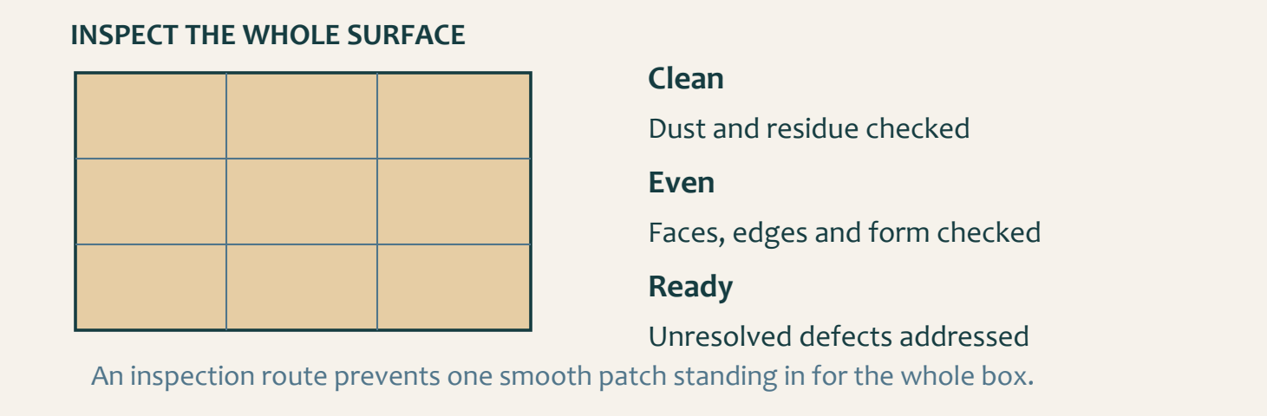
Figure 16. A systematic inspection route supports complete coverage. The grid is an inspection aid, not a sanding pattern.

Look for a consistent condition
The surface should be clean, dry and even, with unresolved defects addressed before the approved finish. Inspect the assembled box rather than judging a single smooth patch. Look across faces and around edges for remaining marks, residue, uneven preparation or changes to the intended form. Use the teacher’s demonstrated inspection conditions to make faults easier to notice.
Record the location of an issue before correcting it. Unnecessary work over the whole object can alter sound areas while the real defect remains. Use the approved preparation stage, manage dust through the directed controls and inspect again. The workbook does not create an abrasive grit sequence, a removal allowance or a machine method.

Readiness includes the workspace
Surface preparation is connected to what happens next. Dust or residue can interfere with the intended finish, while handling or storage can contaminate a surface that has already been prepared. Protect the work and confirm the approved product and process before application. PPE, ventilation and safe handling remain part of the task.
A useful readiness record explains how you checked every relevant area, what needed attention and what the repeated inspection showed. If a defect remains unresolved, do not label the surface ready simply to reach the next stage. Ask the teacher how it should be addressed. Good preparation is visible in the evidence of systematic checking, not just in a list of sanding activities.

 Think about it
State what “ready” means for the actual box and approved finish, then show the check that supports that judgement.

Small Box Finish, evaluate and reflect

03 / Read the matching course section 37
MODULE 3 / SECTION 2 / READ AND UNDERSTAND

Compare finishes responsibly
A finish choice connects appearance, protection, process and the consequences of using the product.
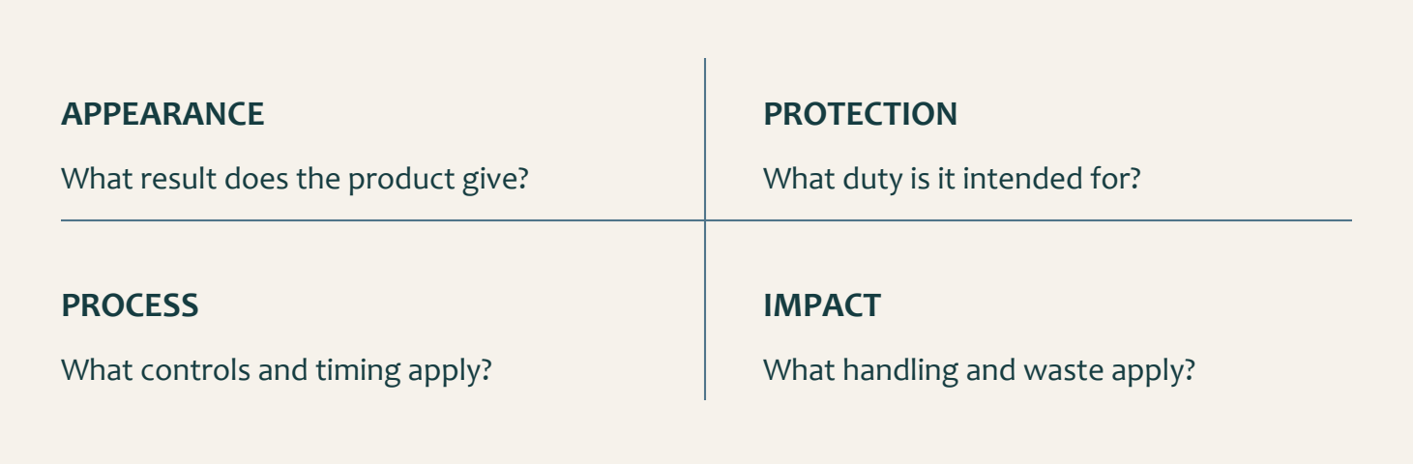
Figure 17. Use actual product information to compare a finish. A family name cannot supply the complete process or environmental evidence.

Ask a more precise question
The extension material introduces oil, wax, lacquer, varnish and shellac. These names describe finish families, not one identical product in each group. Their appearance, durability and handling depend on the actual formulation and application. Avoid claiming that every product in a family behaves the same way. Begin with the teacher-approved examples and their information.
Compare the intended visual effect and protection with the requirements of the box. Then examine the application controls, handling, timing and care information. A finish that looks appealing in a photograph may need a different process from the one approved for the class. A comparison exercise should explain these differences without silently changing the project product.

Keep quality and controls together
Environmental reasoning needs evidence about quantity, handling, waste and useful life, not just a label such as “natural”. Follow the directed controls and disposal arrangements for the actual product. Do not invent a safe waste method from the general finish family. The teacher, school procedures and product information govern the practical response.
During the approved finish process, record the observations and checks at the stages actually required. If there are checks between coats, explain how they affected quality. If the approved process has no such stage, state that honestly and document the check that did occur. Never add a coat or a timing interval merely to match a worksheet. The evidence should describe your real controlled process.

 Think about it
A thoughtful comparison can end with “information still required”. That is stronger than an unsupported product claim.

Small Box Finish, evaluate and reflect

03 / Read the matching course section 38
MODULE 3 / SECTION 3 / READ AND UNDERSTAND

Evaluate a working object
A balanced judgement connects a requirement with a visible or observed result.
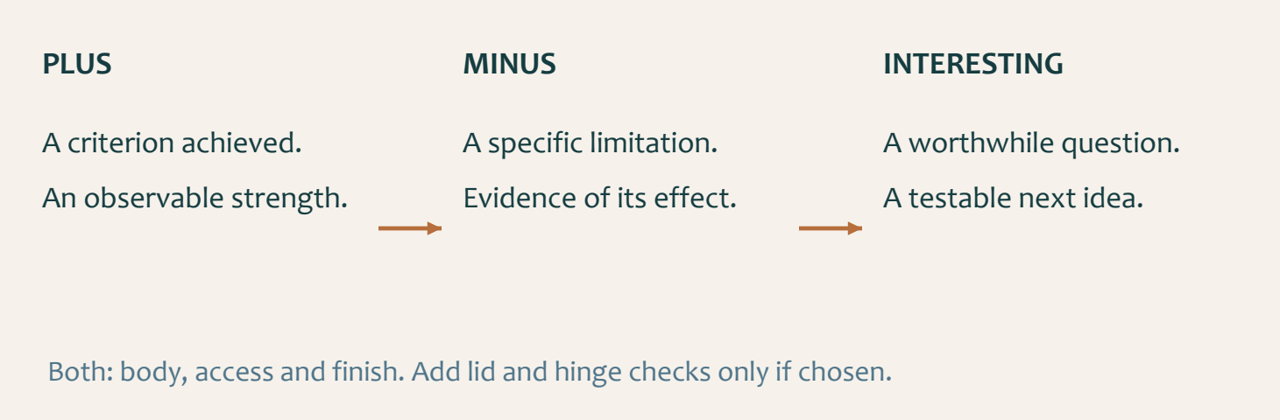
Figure 18. PMI organises strengths, limitations and worthwhile questions. Each needs evidence from the actual project.

Inspect function as well as appearance
Return to your chosen brief and check joint condition, box stability and surface or finish quality. For a chosen lid, add movement and hinge-security checks. For an open box, examine opening edges and interior access. Use the teacher-approved methods; do not invent a load test or claim an unobserved result. A tidy photograph cannot prove every functional requirement.
Describe the observation before judging it. For an open box, a caption might record the inspected opening-edge condition. For a lidded box, it might record intended movement at the final check. “The box is perfect” names neither a check nor an uncertainty. Use your planning and correction records to explain the result without turning a possible cause into an established fact.

Make PMI lead to an improvement
A Plus is a strength supported by evidence. A Minus is a specific limitation and its effect. An Interesting point is a worthwhile question or future improvement to investigate. It does not need to be a new decorative feature. An earlier inspection routine may be more useful when it addresses the cause of a real problem.
Finish by choosing habits to carry forward. Explain when you will use each habit and how you will check whether it helps. Clear source references, verified marks, complete dry fits and honest correction records are transferable because they support decisions in many timber projects. Your evaluation should make the next attempt more reliable, rather than simply praise or criticise this one.

 Think about it
For an extension, identify two evidenced strengths and two worthwhile improvements; explain the next check for each improvement.

Small Box Finish, evaluate and reflect

03 / Read the matching course section 39
KNOWLEDGE + APPLIED THINKING

Check your chosen option
Answer the knowledge questions, including the optional-lid examples. For the applied task, choose the case that matches your box.
25 | What is a chamfer?  ○ A. A bevelled edge  ○ B. A round hole  ○ C. A flexible hinge  ○ D. A glue stain

26 | For the approved lidded version, where are chamfers named in the sequence?  ○ A. On the lid stage  ○ B. On a removable internal section  ○ C. On the project folio  ○ D. On the workshop bench

27 | If the approved lid uses hinges, how are they controlled?  ○ A. They are teacher supplied or teacher approved  ○ B. Any hinge can be used if it is cheap  ○ C. Students must make their own metal hinges  ○ D. Hinges can be omitted without approval

Check the option you chose
Choose one case. Lidded box: the lid catches during movement. Open box: an opening edge is rough although the outside looks neat. Explain the relevant check, teacher-supported response and evidence you would record.

Small Box Finish, evaluate and reflect

03 / Read the matching course section 40
KNOWLEDGE + APPLIED THINKING

Check surface readiness
Q28 asks about a hinged version. Answer this knowledge scenario, then apply surface-readiness thinking to your own choice.
28 | For a hinged version, what should be checked before the hinges are finally fitted?  ○ A. Lid alignment, movement, hardware suitability and the approved fitting process  ○ B. Only the colour of the hinge  ○ C. Whether another student has finished  ○ D. Whether the finish can hide a poor fit

29 | When is a timber surface ready for the approved finish?  ○ A. When it is clean, dry, even and free of unresolved defects that require correction  ○ B. When one area feels smooth  ○ C. When the product label is visible  ○ D. When the class period is nearly over

30 | What controls the exact finish product and application process?  ○ A. Teacher direction, the school SOP and approved product information  ○ B. A generic online recommendation  ○ C. The strongest-smelling product  ○ D. Another student's leftover material

Order surface readiness
Number the stages 1–4. Each one should protect the planned form.
[ ] Use the approved preparation or correction and dust controls.
[ ] Inspect faces, edges and less obvious areas.
[ ] Recheck the complete condition and confirm readiness.
[ ] Identify and record the areas needing attention.

Small Box Finish, evaluate and reflect

03 / Read the matching course section 41
KNOWLEDGE + APPLIED THINKING

Check finish decisions
Answer the checks, including the hinged-box evidence example. Your own finish comparison applies to either box choice.
31 | Which safety controls remain relevant during finishing?  ○ A. Approved PPE, ventilation and handling controls  ○ B. No controls once cutting is complete  ○ C. Only careful colour selection  ○ D. Closing every window

32 | What should a final functional check include?  ○ A. Joint condition, stability, access and finish; lid movement and hinge security only where fitted  ○ B. Only the final colour  ○ C. Only the project title  ○ D. Only whether the box looks expensive

33 | For a hinged box, which evidence best shows the lid and hinge stage was controlled?  ○ A. A before-and-after record of alignment, approved hardware, fitting checks and final movement  ○ B. One photograph with the lid closed  ○ C. A copied hinge description  ○ D. A claim that the lid works

Compare actual finish information
COMPARISON | OIL EXAMPLE | WAX EXAMPLE | LACQUER EXAMPLE
Product identity / source
Appearance or intended duty
Control, waste or care detail

Small Box Finish, evaluate and reflect

03 / Read the matching course section 42
KNOWLEDGE + APPLIED THINKING

Check your judgement
Circle one answer for each question. Base your own PMI judgement on the version you actually make.
34 | What makes a PMI evaluation credible?  ○ A. Each plus, minus and interesting point is supported by observable project evidence  ○ B. Only strengths are included  ○ C. Problems are hidden  ○ D. The response repeats the instructions

35 | How should a remaining limitation be reported?  ○ A. State the observed limitation and a realistic next improvement  ○ B. Cover it with finish and omit it  ○ C. Blame the material without evidence  ○ D. Copy another student's reflection

36 | When is the project evidence ready to close?  ○ A. When applicable lid or open-box checks, surface and finish controls, final function and balanced evaluation are recorded  ○ B. When the last coat is applied  ○ C. When the box is photographed once  ○ D. When the student runs out of time

Turn praise into evaluation
Rewrite “My Small Box is excellent” as an evidence-based judgement for your chosen option. Include a Plus, a Minus and an Interesting next question. Use real observations, or clearly label a hypothetical example.

Small Box Finish, evaluate and reflect

03 / Read the matching course section 43
STUDIO / PROJECT EVIDENCE

Explain readiness for your option
Explain the action, its reason and the relevant check. Write about your chosen open-box or lidded option.

Explain your lid or open-box checks
For a lidded box, describe the checks that show the lid and any teacher-approved hinges are ready for final fitting. For an open box, describe checks of the opening, edge condition and access to the intended contents instead.

Determine finish readiness
Explain how you would decide that the assembled Small Box is ready for the approved finish.

Small Box Finish, evaluate and reflect

03 / Read the matching course section 44
STUDIO / PROJECT EVIDENCE

Evaluate and transfer
Explain the action, its reason and the relevant check. Write about your chosen open-box or lidded option.

Complete a balanced PMI review
Write a Plus, Minus and Interesting review of the finished Small Box using observable evidence.

Transfer two process habits
Explain two Small Box habits you will carry into a future Timber project and why each matters.

Small Box Finish, evaluate and reflect

03 / Read the matching course section 45
STUDIO / PROJECT EVIDENCE

Prove surface readiness
Folio checkpoint 07 / Surface preparation
Describe how you prepared each face for finishing.
AREA / CONDITION | PREPARATION OR CHECK | RESULT
Faces
Opening edges / lid if chosen
Dust / residue / readiness

What made you confident the surface was ready for finishing?

Evidence note / reference: what does your own photograph, sketch or check prove?

Small Box Finish, evaluate and reflect

03 / Read the matching course section 46
STUDIO / PROJECT EVIDENCE

Record the actual finish process
Folio checkpoint 08 / Finish process and quality checks
Record how finish application was controlled for safety and quality.
Use the stages required for your approved product. If the process has no between-coat stage, state that and explain the check that did occur.
STAGE / PRODUCT INFORMATION | OBSERVATION / CONTROL / RESULT
Approved product and information source
Required application or handling stage
Required recheck / correction

How did checks between coats improve your final finish quality?

Evidence note / reference: what does your own photograph, sketch or check prove?

Small Box Finish, evaluate and reflect

03 / Read the matching course section 47
STUDIO / PROJECT EVIDENCE

Build a clear evidence flow
Folio checkpoint 09 / Photos, captions and evidence flow
Build a complete evidence sequence linking planning, making and evaluation.
STAGE IN THE REAL BUILD | EVIDENCE REFERENCE | WHAT IT PROVES
Choice / planning / marking
Joinery / assembly
Relevant fit / finish / evaluation

Which evidence item best proves your best design/process decision?

Evidence note / reference: what does your own photograph, sketch or check prove?

Small Box Finish, evaluate and reflect

03 / Read the matching course section 48
STUDIO / PROJECT EVIDENCE

Explain one worthwhile correction
Folio checkpoint 10 / Problem solving and adjustment
Describe one real assembly or fitting issue and the corrected process.
BEFORE / OBSERVED ISSUE | APPROVED CHANGE | RECHECK / RESULT

Show the affected feature before and after the correction. Label the check that connects both views.


Which correction had the biggest learning impact?

Evidence note / reference: what does your own photograph, sketch or check prove?

Small Box Finish, evaluate and reflect

03 / Read the matching course section 49
STUDIO / PROJECT EVIDENCE

A balanced final judgement
Folio checkpoint 11 / PMI evaluation
Evaluate the final project with balanced strengths, limits and questions.
PMI | EVIDENCE FROM MY SMALL BOX
Plus: a requirement achieved
Minus: a limitation and its effect
Interesting: a useful next question

How strongly does your Small Box meet the brief?

Evidence note / reference: what does your own photograph, sketch or check prove?

Small Box Finish, evaluate and reflect

03 / Read the matching course section 50
STUDIO / PROJECT EVIDENCE

Carry a better routine forward
Folio checkpoint 12 / Project reflection and transfer
Identify what you will take to your next Timber task.
ROUTINE | WHEN I WILL USE IT | HOW I WILL CHECK IT

Propose one future refinement to your chosen Small Box. Sketch and label its benefit, a possible consequence and the approval or technical information needed before trying it.


Which two routines will you repeat next time and why?

Evidence note / reference: what does your own photograph, sketch or check prove?

