GETTING STARTED

Desk Tidy student workbook
Stage 4 Technology | Materials and production processes

Illustrative design example. Develop your own organiser for its intended user; this is not a construction plan.

Design and make a useful timber organiser
Explore the need, develop ideas, plan the build and test your finished Desk Tidy. This workbook brings the course reading, activities and project evidence together. Your teacher will use the website, slides, videos and demonstrations to support each stage.
Name

Class and teacher

GETTING STARTED

Using your workbook
Read the short explanations and study the pictures. Mark up key ideas, discuss them when asked, then write, draw or test something that shows what you understand. Use your own words and keep improvements visible.
Course section | Pages | What you will develop
1 Brief, safety and materials | 3-10 | User needs, measurable criteria and responsible choices
2 Research and design | 11-18 | Four concepts, respectful research and justified selection
3 Drawings and planning | 19-26 | Working drawings, parts list, schedule and marking
4 Production and assembly | 27-34 | Controlled work, suitable joints and quality checks
5 Finishing and evaluation | 35-42 | Finish records, functional tests and reflection
Project folio sheets | 43-50 | Drawing space, planning, build records and evidence review

Use the book with your teacher
Your teacher can display the matching course section and choose a slide, clip, physical sample or demonstration. Record what you notice in this book. All core questions can be completed on paper. If a research source is needed, your teacher can provide it as a printout or show it to the class.
Practical work starts only after the required induction, demonstration and teacher authorisation. Use the current school procedures and approved drawing. A completed worksheet does not give permission to use equipment.
The activities are practice and folio evidence. Your teacher provides formal task instructions, assessment requirements and submission arrangements. The final checklist helps you locate evidence already produced; you do not need to copy it into a second folio.
Course home: stevencowell.github.io/desk-tidy/
Videos: use Video learning on the course site.
Editorial edition | Prepared 10 September 2026 | 50 printed pages
MODULE 1 / BRIEF, SAFETY AND MATERIALS

Designing for an organised workspace
Pens, pencils, cables and paperclips can quickly take over a desk. When small objects have no clear storage place, they are harder to find, reduce useful working space and may fall onto the floor. A timber Desk Tidy should solve this real problem for a particular user.

Illustrative design example. Notice the arrangement of compartments and the different items they could hold.

A design brief explains what is needed, who it is for and what it should achieve. In this project you research, design, plan, build and evaluate a functional wooden organiser. The brief gives direction while leaving room for your own layout.
Start by finding out what your user stores and how they work. Think about which items need separate spaces, which can be grouped together, and how easily each can be reached and returned. The organiser must also fit the intended desk area.
Design criteria turn these needs into statements that can be checked. “It looks good” is too vague. “It holds the selected stationery and remains stable as each item is removed” names observable performance. Your dimensions should come from the items and workspace, rather than the example image.

Look closely: identify one visible feature and explain how it might help the user.

Read the matching course section
MODULE 1 / BRIEF, SAFETY AND MATERIALS

Hazards risks and controls in the timber workshop
A hazard is a source of possible harm, such as a sharp edge, moving tool, dust or damaged equipment. Risk concerns the likelihood and seriousness of harm. A control removes a hazard or reduces the risk. These terms describe different parts of the same safety problem.
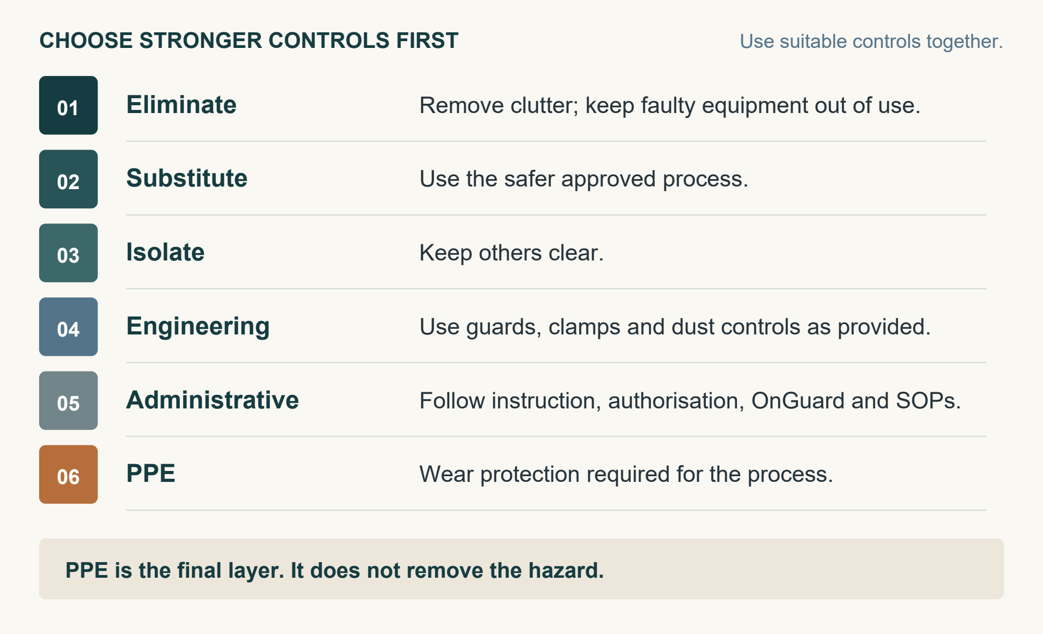
Stronger controls come first. PPE supports other controls; it does not remove the hazard.
The hierarchy of controls starts with stronger actions. PPE is the final layer. Use several suitable controls together, following the teacher’s demonstration and the requirements for the particular process.
Before measuring or marking, clear the bench and secure the timber. For cutting or drilling, use only the tool and process you have been taught and authorised to use. Do not distract anyone operating equipment. Sanding, adhesives and finishes have their own dust or product risks.
Return tools, manage leads and clear waste using the approved method. Stop and report damage, spills, unusual noise or anything unfamiliar. Completing this workbook does not authorise you to use equipment.
Read the matching course section
MODULE 1 / BRIEF, SAFETY AND MATERIALS

Choosing materials responsibly
A material’s properties influence how an organiser looks, feels and performs. Sample investigations help you compare strengths and limitations before deciding. Investigating a material does not mean it will be used in your project: the final choice follows teacher and project requirements.
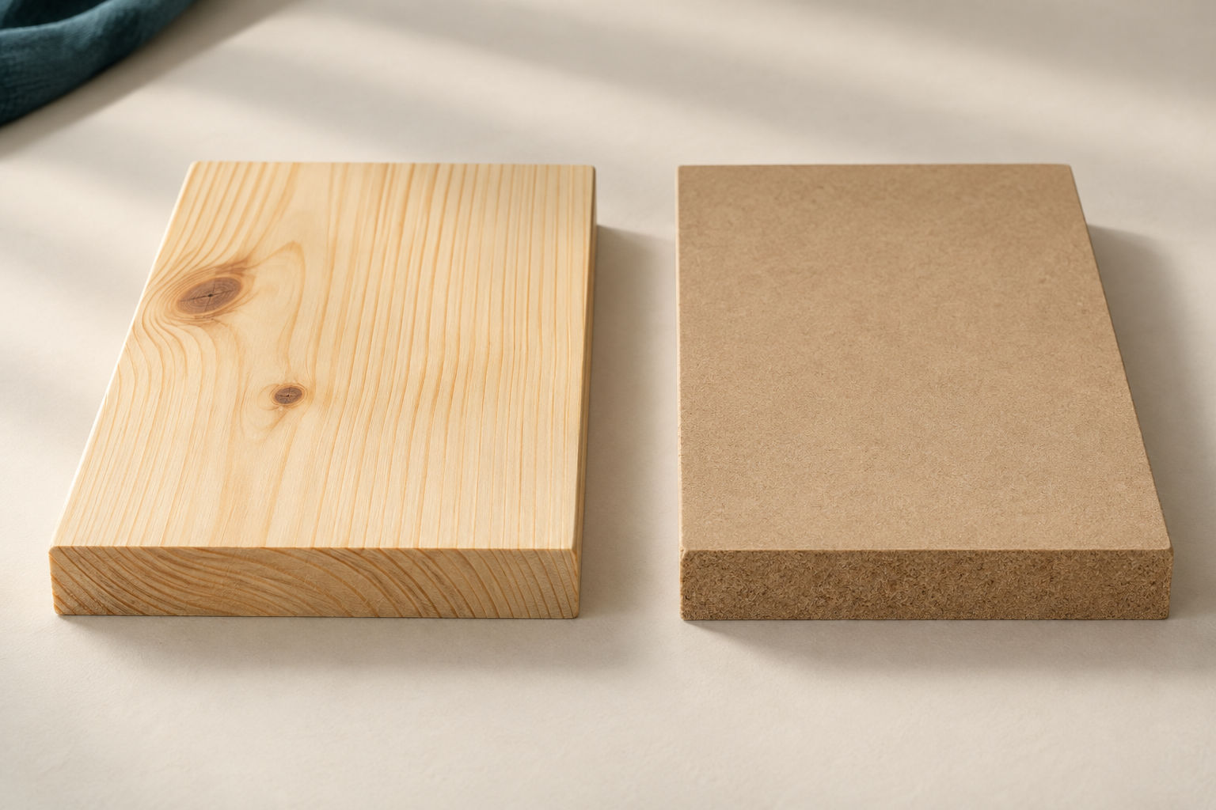
Illustrative material samples: radiata pine on the left; MDF on the right. Compare the faces and cut edges.

Radiata pine is solid timber with visible natural grain. It is generally straightforward to shape and sand. MDF, or medium-density fibreboard, has a smooth, uniform face without natural timber grain. Its edges and working characteristics differ from solid timber.
Look beyond appearance. A small organiser needs enough strength for normal use, edges that can be finished neatly, and a material suited to accurate measuring, shaping and assembly. No sample observation proves that one material is best for every design.
Responsible use includes selecting suitable stock, planning the component layout before marking and keeping usable offcuts. Carefully sourced renewable timber can still be wasted. Responsible sourcing, accurate work and efficient use all matter.

1. Which observation describes radiata pine?
a) No natural grain
b) Visible natural grain
c) A uniform fibre face
d) No finishing needed

2. What does a sample comparison provide?
a) A compulsory material choice
b) Permission to use any tool
c) Evidence for a decision
d) A finished production plan

Read the matching course section
MODULE 1 / BRIEF, SAFETY AND MATERIALS

My user brief and success criteria
Folio evidence: find out about a real user before sketching. Use their items and available workspace, or the classroom example your teacher supplies.
My intended user is… Their main workspace problem is…

Item to organise | How it is used or reached | Relevant size or space to check

Write a brief that leaves room for ideas
I will design and make a wooden organiser for… It needs to…

Turn the need into three tests
Success criterion | How I will check it
1.
2.
3.

Check your wording: does each criterion describe observable success? Avoid prescribing the reference layout or promising a colour that “everybody” will like.
Read the matching course section
MODULE 1 / BRIEF, SAFETY AND MATERIALS

Build a safety chain and repair a dodgy answer
Use the safety reading to connect the source of harm, possible consequences and controls. Write H (hazard), R (risk), C (control), P (PPE’s place) or F (first priority) beside each statement.
Statement | Letter
1. A tool is visibly damaged before use.
2. A hand could be injured if that tool is used.
3. Stop, leave the tool unused and tell the teacher.
4. Safety glasses add a final protective layer.
5. Consider removing the hazard before relying on PPE.

Fix the dodgy answer
“I have safety glasses on, so I can use the damaged tool carefully. I will tell the teacher after I have finished.”
Cross out the unsafe ideas. Rewrite the answer using stop, report and a stronger control.

Apply it to an example demonstrated by your teacher
Hazard: what could cause harm? | Risk: what could happen? | Controls: what changes the situation?

Discuss: why would asking another student to try the damaged tool fail to control the risk?
Read the matching course section
MODULE 1 / BRIEF, SAFETY AND MATERIALS

Investigate samples and challenge a claim
Folio evidence: observe teacher-provided radiata pine and MDF samples. Carry out only a comparison or test your teacher has approved. Record what you actually see, rather than what you expect.
What to compare | Radiata pine observation | MDF observation
Face and grain
Edge appearance or behaviour
Approved shaping/sanding observation

Evidence action or unsupported claim
Write E for observable evidence, A for a responsible action or U for an unsupported claim.
Statement | E / A / U
1. This pine sample shows natural grain.
2. Plan the part layout before marking out.
3. MDF is automatically best for every Desk Tidy.
4. This MDF sample has a smooth face without natural grain.
5. Keep larger usable offcuts for later work.
6. Timber is always sustainable, whatever its source or waste.

Choose one unsupported claim. Replace it with a statement supported by the reading or your observations.

Read the matching course section
MODULE 1 / BRIEF, SAFETY AND MATERIALS

Use the text then check your understanding
Circle one answer for each question. Find evidence in the three readings when you are uncertain.
3. What is the main job of a design brief?
a) Give every finished dimension
b) List only workshop tools
c) Explain the need and user
d) Replace final testing

4. Which criterion can be tested?
a) Looks cool
b) Matches the example
c) Everyone loves it
d) Stays stable as items are removed

5. Which control should be considered first?
a) PPE
b) Eliminating the hazard
c) A reminder sign
d) Working faster

6. You notice damaged equipment. What next?
a) Try it carefully
b) Ask a friend to test it
c) Repair it yourself
d) Stop and report it

Text hunt prove your answer
Find the sentence that explains why the reference image should not set your dimensions. Underline it in the reading, then explain the idea in your own words.

Find two actions in the materials reading that would reduce avoidable waste.

Read the matching course section
MODULE 1 / BRIEF, SAFETY AND MATERIALS

Explain how you will work safely
Extended response • Use the process demonstrated by your teacher. Explain a hazard, its risk and at least three controls from different levels of the hierarchy. Explain why PPE supports the plan rather than replacing it.
• Name the process and actual source of harm.
• Explain who could be harmed and how.
• Link a physical control, instruction/authorisation and PPE to that risk.
• Explain when you must stop and ask the teacher.
My process is… The hazard is… This creates a risk because… A stronger control is… I must also… PPE helps by…

Folio checkpoint
Evidence I have prepared | Ready / next action
User need, brief and three testable criteria
Material observations based on approved samples
Safety explanation linked to the teacher’s process

Keep these pages: your criteria will guide concept selection and the tests on your finished organiser.
My completed induction or OnGuard record and relevant SOP reference or location

Read the matching course section
MODULE 2 / RESEARCH AND DESIGN DEVELOPMENT

Researching organisers and generating four concepts
Purposeful research examines how different organisers solve storage problems. Compare what they hold, the arrangement of compartments, access, base and proportions. Visible grain, edges, joints or repeated shapes can suggest how a product was made. Separate an observation from a guess about the manufacturing process.
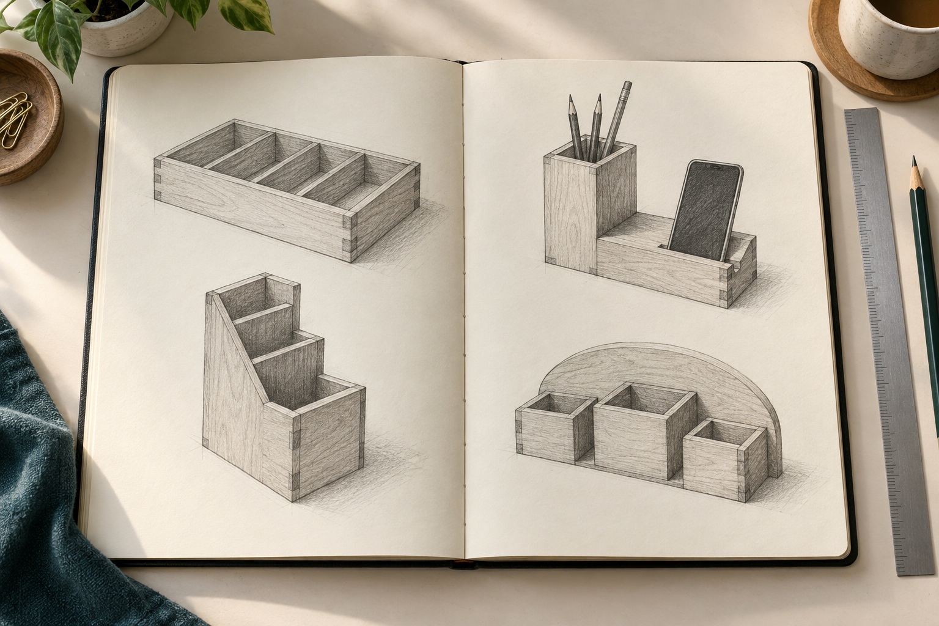
Illustrative concept sketches. Four different arrangements explore the same storage need.

A designer identifies needs and communicates ideas. Producers and manufacturers plan the materials, tools and processes needed to make products consistently and safely. Look for evidence of these decisions rather than judging only decoration.
Record each example’s creator and source, along with available reuse conditions. Public access does not automatically permit copying. Transform useful lessons into your own solution.
Develop four genuinely different concepts. Change layout, access or overall form, not merely colour. Label functions and add approximate sizes based on your user’s items and desk. These are design estimates, not final dimensions.

Teacher-shown organiser source | Useful observation / possible limitation
Example A:
Example B:

Read the matching course section
MODULE 2 / RESEARCH AND DESIGN DEVELOPMENT

Comparing concepts and justifying a preferred design
Compare all four concepts against the same criteria. These may include storage, easy access, stability, material use, manufacturability and appearance. Manufacturability means how realistically a design can be made with the available time, materials, processes and skills. Rank important criteria to reflect your user’s needs.

Illustrative concept sketches. Apply the same criteria to each idea when comparing alternatives.

A decision matrix organises the evidence using scores or comments. Explain the scores: excellent storage might require more material, while a compact shape might restrict access. These trade-offs are normal.
The highest total does not automatically identify the best design. A serious weakness, teacher feedback or workshop constraint may change the decision. Teacher approval is required before the preferred concept is developed or produced.
Before final drawings, test an uncertainty with a teacher-approved prototype, model or sample. It might test fit, access, stability or a joint. Create it for a clear purpose, test it, record the evidence, then refine the concept. Keep a record of what changed and why.

1. A high-scoring concept blocks access. What should you do?
a) Select it automatically
b) Change scores to favour it
c) Review and refine using evidence
d) Ignore the user

Read the matching course section
MODULE 2 / RESEARCH AND DESIGN DEVELOPMENT

Learning respectfully from Aboriginal and Torres Strait Islander design knowledge
Aboriginal and Torres Strait Islander design knowledge is diverse and connected to Country, community and context. Use teacher-approved, authoritative sources that identify whose knowledge is shared. Avoid claiming that one example represents all communities.
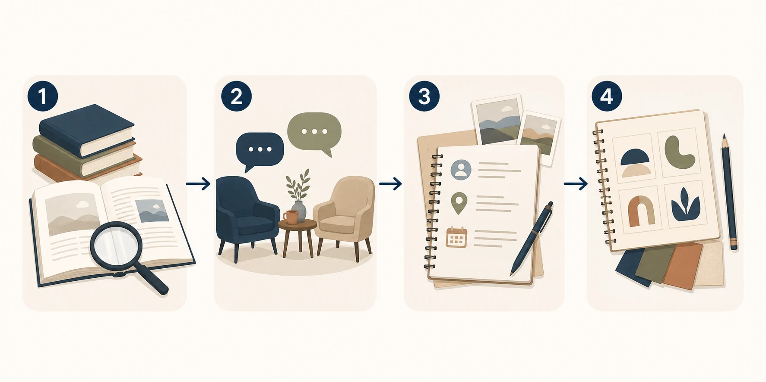
Research carefully → seek teacher guidance → record context and attribution → develop an original design.
Indigenous Cultural and Intellectual Property concerns rights in cultural knowledge, stories, designs and expression. An image appearing online does not give permission to copy it. Record attribution and check conditions. Your teacher will guide whether local consultation is appropriate; community members are not expected to provide cultural content on demand.
Do not reproduce restricted, sacred or culturally significant designs, or add unfamiliar symbols as decoration. Learn from suitable broad principles, such as careful material use, longevity and repair, while keeping your Desk Tidy original. If authority or reuse conditions are unclear, pause and ask your teacher.
Source supplied or approved by teacher | My research note
Creator / organisation and title
Country, community or context identified
Suitable principle I can apply without copying

Reuse conditions or permissions checked and how my design will remain original

2. An online cultural design has no clear reuse guidance. What next?
a) Change its colour
b) Copy part of it
c) Assume it is free
d) Pause and ask the teacher

Read the matching course section
MODULE 2 / RESEARCH AND DESIGN DEVELOPMENT

Explore two different storage ideas
Folio evidence • Use your user’s items and criteria. Make quick, readable sketches. Add arrows and notes for what goes where, access, stability and approximate overall sizes.
Concept 1: explore one clear storage layout.

This layout responds to my user because…

Concept 2: change the arrangement, access or overall form.

This is different from Concept 1 because…

Read the matching course section
MODULE 2 / RESEARCH AND DESIGN DEVELOPMENT

Push the ideas further
Folio evidence • Aim for alternatives that test different solutions. Label the useful features and one possible weakness in each. Do not simply redraw an earlier design more neatly.
Concept 3: try another approach to stability or organisation.

A strength and a limitation of this idea are…

Concept 4: combine useful lessons into another distinct solution.

Research influenced this feature… I changed it for my user by…

Read the matching course section
MODULE 2 / RESEARCH AND DESIGN DEVELOPMENT

Compare my four concepts fairly
Folio evidence • Use the same criteria for each concept. Use this practice scale: 1 = weak, 2 = needs improvement, 3 = meets the criterion, 4 = meets it strongly. Scores must have reasons. A total cannot override a serious weakness.
My user’s most important criterion is… because…

Criterion | C1 | C2 | C3 | C4
Stores the selected items
Allows easy access
Remains stable
Uses material efficiently
Can be made within project constraints
Total / 20

Explain one score using an observation from a sketch, user research or model.

Which trade-off matters most? Explain a benefit you may gain and a limitation you may accept.

Peer or teacher feedback: record one specific change worth testing.

Read the matching course section
MODULE 2 / RESEARCH AND DESIGN DEVELOPMENT

Check your design decisions
Circle one answer for each question. Use the readings to explain your choices.
3. What makes four concepts genuinely different?
a) Different colours only
b) Different layouts or forms
c) Neater copies
d) Different page borders

4. What makes product research useful?
a) Copying the first example
b) Collecting decoration only
c) Recording features and sources
d) Hiding where ideas came from

5. What should support a matrix score?
a) A reason linked to evidence
b) The largest drawing
c) A decorative border
d) A guess about the winner

6. Which prototype best tests access?
a) A colour sample alone
b) A suitable model used with intended items
c) A title page
d) A photograph with no test

Put the design steps in order
Number the steps 1-6 to show a sensible workflow. Then circle the step that records where the ideas came from.
Step | Order
A. Add function labels and approximate sizes.
B. Clarify the user, items and available desk space.
C. Gather feedback before comparing the concepts.
D. Record creators, sources and reuse guidance.
E. Sketch four genuinely different concepts.
F. Compare features and possible production decisions.

Read the matching course section
MODULE 2 / RESEARCH AND DESIGN DEVELOPMENT

Test an uncertainty and justify my direction
Folio evidence • Agree on a prototype, model or sample with your teacher before making it. Use its results, your matrix and feedback to decide what to develop.
Test record | My evidence
Uncertainty and teacher-approved model or sample
Test performed and result observed
Change I will make because of the result

Extended response
Justify your preferred concept. Name the concept and strongest evidence. Explain the most important user criterion, a trade-off, feedback and a change. Explain why the revised idea is realistic for the project.
I would develop Concept… because… The matrix and test show… Feedback identified… I will refine… The main trade-off is…

Teacher checkpoint: discuss your preferred direction and refinements before further development or production. Record the next agreed action below.
Next agreed action / teacher initials:

Read the matching course section
MODULE 3 / DRAWINGS, PLANNING AND MARKING OUT

Working drawings explain your design
Working drawings explain what your Desk Tidy should look like and how its parts relate. They allow you and your teacher to check that the selected design is complete and practical before production begins. Drawings must show your approved design, including agreed refinements.
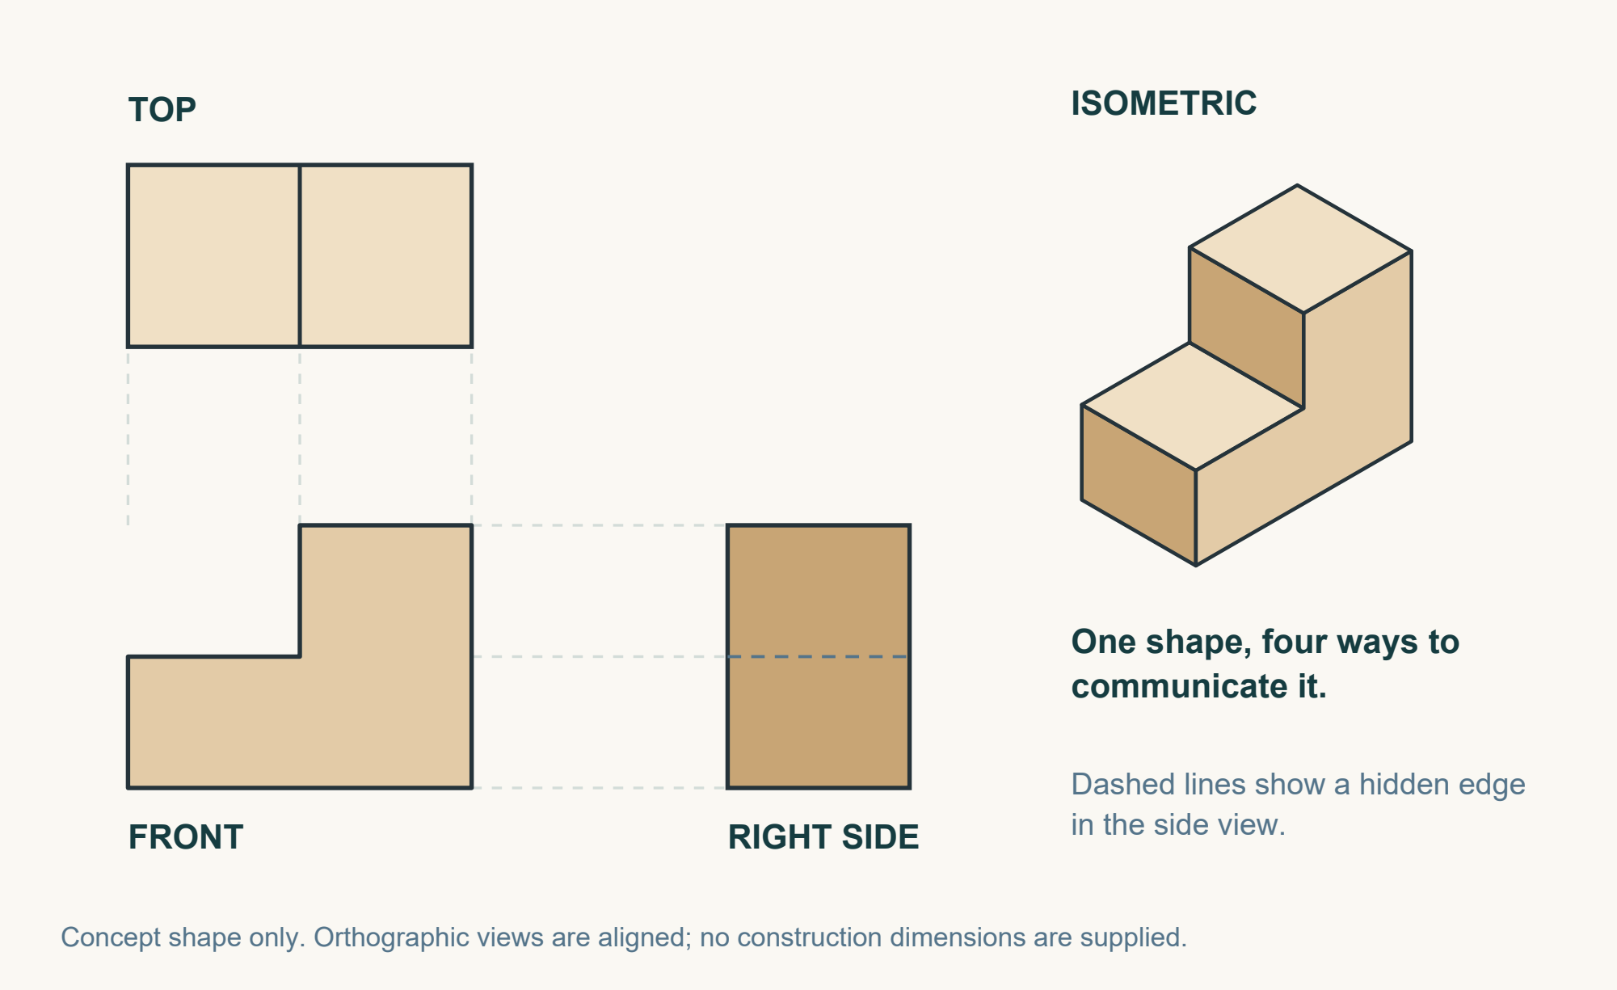
Conceptual views of the same stepped form. Corresponding features align between the orthographic views.

Orthographic drawings show separate views, such as front, top and side, without perspective. The project unit requires orthographic views at a scale of 1:10, supported by written dimensions. At this scale, one unit on the drawing represents ten units on the actual product. An isometric drawing helps the viewer understand the overall three-dimensional form and compartment arrangement.
Scale and dimensions do different jobs. Scale controls the drawn size; written dimensions state the intended actual size in millimetres. A photocopy can change size, so do not measure a printed picture to decide a cutting dimension. Use the written dimensions on the approved drawing.
Include a title, view labels, dimensions and useful notes. Compare the views: matching parts and positions must agree. Correct conflicts and obtain teacher approval before marking or cutting material.

Read the diagram: why is more than one view useful? Name a feature that a single view could hide.

Read the matching course section
MODULE 3 / DRAWINGS, PLANNING AND MARKING OUT

Cutting lists and a realistic schedule
A cutting list turns your approved drawings into a record of the parts needed. Each entry names the part, quantity, material and exact dimensions from the drawing. Check that every drawn component is included and that matching components have matching dimensions. Missing information must be resolved with the teacher; it cannot be guessed.
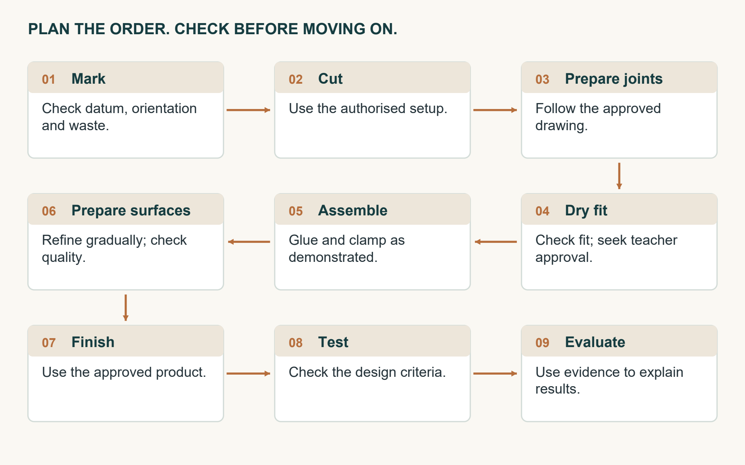
A sensible production sequence includes checks before irreversible work and assembly.

A production schedule places work in a sensible order: marking, cutting, joint preparation, dry fitting, assembly, surface preparation, finishing, testing and evaluation. A dependency is a task that relies on earlier work being complete. For example, glue-up depends on a successful dry fit and teacher approval.
A Gantt chart shows when stages are expected to happen and their planned duration. Milestones identify important checkpoints, such as approved drawings or a successful dry fit. Consider shared tools, teacher availability and workshop resources. Contingency time allows for corrections, delays and extra checks so that the plan does not depend on everything going perfectly.
A schedule guides progress but does not authorise the next operation. If a check fails, resolve the problem and update the plan. Rushing past a fault usually creates more work later.

Give one dependency in your project and one sensible use of contingency time.

Read the matching course section
MODULE 3 / DRAWINGS, PLANNING AND MARKING OUT

Datums and accurate marking out
A datum is a reliable starting point for measurement. It may be a straight reference edge or identified face-side and face-edge surfaces. Taking related measurements from the same datum reduces the chance that small errors will build up. Starting each measurement from a different, uneven edge can leave parts out of alignment.
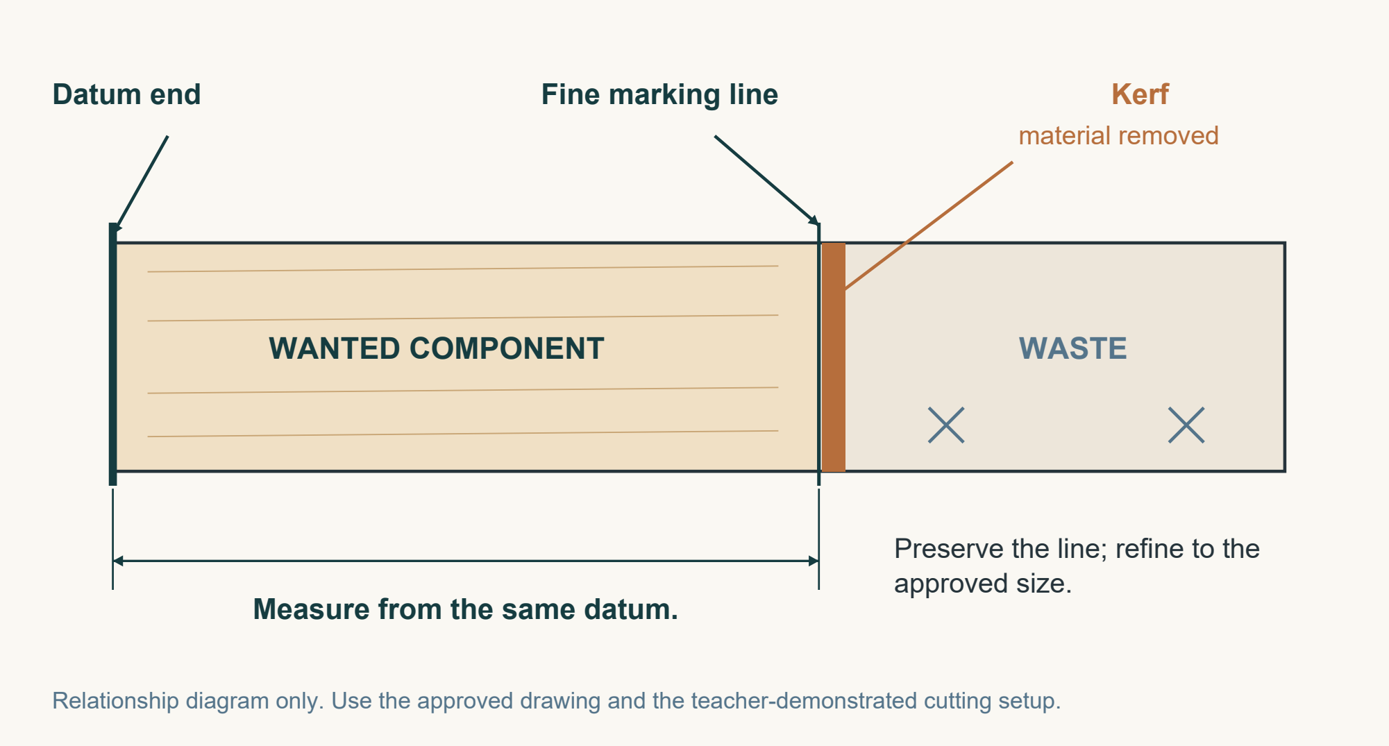
Use a common datum. Keep the kerf on the waste side so the wanted part retains its marked size.

Use a steel rule to measure in millimetres and a sharp pencil to make a clear, fine mark. Check that the rule’s zero mark, rather than simply its physical end, aligns with the datum. Look directly above the scale. Viewing from an angle can cause parallax: the mark appears to meet the wrong place on the scale.
Use the demonstrated square to extend lines that must be perpendicular to the reference edge. Identify component orientation and mark the waste side clearly. Compare matching parts against the approved drawing and cutting list before cutting.
‘Measure twice, cut once’ means checking the dimension, datum, orientation and waste side, not repeating an unchecked guess. If the rule moves, two marks disagree or the waste side is uncertain, stop and recheck. A partner can help check your evidence; teacher authorisation still controls production.

Circle the marking line in the image. What two checks would you need before that line could guide a cut?

Read the matching course section
MODULE 3 / DRAWINGS, PLANNING AND MARKING OUT

Check your planning knowledge
Circle one answer for each question. Then explain one answer to a partner using a term from the reading.
1. What does a scale of 1:10 mean?
a) The drawing is ten times larger.
b) One drawn unit represents ten actual units.
c) Only one view is needed.
d) All dimensions can be estimated.

2. The photocopied drawing has changed size. What controls the intended component size?
a) Its apparent size on the paper.
b) A classmate’s similar component.
c) The written dimensions on the approved drawing.
d) The amount of timber available.

3. Which cutting-list entry contains the necessary information?
a) Part, quantity, material and exact dimensions.
b) Tool, operator and favourite colour.
c) Part name and estimated length only.
d) A photograph with no labels.

4. A second mark disagrees with the first because the rule moved. What happens next?
a) Choose whichever line saves timber.
b) Cut between the marks.
c) Ask a partner to approve cutting.
d) Stop and recheck from the datum against the approved drawing.

My explanation: choose one question and explain why a tempting wrong answer would cause a problem.

Read the matching course section
MODULE 3 / DRAWINGS, PLANNING AND MARKING OUT

Drawing detective and scale practice

1 Make the language stick
Write the matching term: orthographic, isometric, scale, dimension or millimetres.
Clue | Term
Aligned front, top and side views
A view that shows the overall three-dimensional form
A written size that remains useful if the page is resized
The relationship between drawn and actual size
The unit used for workshop dimensions

Calculate a drawing size at one tenth scale
Practice numbers only; these are not Desk Tidy component dimensions. Divide the actual measurement by 10. Example: an actual 300 mm length is drawn as 30 mm.
Actual practice length | Length drawn at 1:10
240 mm | ________ mm
90 mm | ________ mm
150 mm | ________ mm

3. Spot the fault: one view labels a practice part 240 mm long, but the cutting list says 204 mm. Why must you stop, and how would you resolve the conflict?

Read the matching course section
MODULE 3 / DRAWINGS, PLANNING AND MARKING OUT

Watch mark and check
Watch the teacher’s marking-out demonstration or the teacher-selected course resource. Record the demonstrated setup. Complete any practice on timber only when authorised.
Sketch the demonstrated component and rule. Label the datum, zero mark, fine line, square and waste side. Use arrows to show where you would look from.


Stop or ready for a check
Write STOP or CHECK. CHECK means ready for teacher/partner checking; it is not permission to cut. For each STOP, add the smallest useful correction.
Observation | Decision and correction
Datum is clear and matching component marks agree.
Waste side is not marked and orientation is uncertain.
Drawing is missing, so a remembered dimension is used.
Rule was read from directly above; the fine line is square.

One detail from the demonstration that will make my marking more reliable is…

Read the matching course section
MODULE 3 / DRAWINGS, PLANNING AND MARKING OUT

Explain why planning protects quality
Scenario: Alex has an approved concept sketch but incomplete working drawings. Alex wants to measure the picture, cut the timber first and prepare the cutting list later to save a lesson.
Plan your explanation: name one risk in Alex’s approach and the evidence needed to resolve it.

Write a connected explanation
Explain how working drawings, a cutting list, a realistic schedule and a datum routine work together to reduce waste and rework. Apply your explanation to Alex’s situation.
• Start: ‘Alex should first… because…’
• Connect the documents: ‘The cutting list must agree with…’
• Explain a dependency: ‘Before… can happen, … must be checked.’
• Link accuracy to the result: ‘Using a consistent datum helps…’
My explanation

Self-check: underline a cause-and-effect explanation. Circle one workshop term you have used accurately. Check that you have included teacher approval before production.
Read the matching course section
MODULE 3 / DRAWINGS, PLANNING AND MARKING OUT

Folio ready to make
Use the drawing, cutting-list and schedule pages at the back of this workbook. These support website folio cards 5 (Working Drawings), 6 (Cutting List and Schedule) and 8 (Datums and Accurate Mark-Out). Record evidence of your own approved design.
Evidence to locate | Page or evidence reference / next action
Orthographic views at 1:10 with written millimetre dimensions
Isometric view showing the approved arrangement
Checked part names, quantities, materials and dimensions
Schedule with dependencies, checkpoints and contingency
Mark-out showing datum, orientation and waste marks

Explain one feature of your drawing that helps another person understand how the parts relate.

What information or correction still needs teacher confirmation before you can start the next practical stage?

Teacher review | Record
Feedback / required action
Approved next stage, initials and date

Read the matching course section
MODULE 4 / PRODUCTION, JOINERY AND ASSEMBLY

Cutting and shaping accurately
Cutting and shaping remove material to form the components on your approved drawings. Begin only after the mark-out has been checked and the teacher has authorised production. Accurate making depends on control and regular checking, not on removing material quickly.
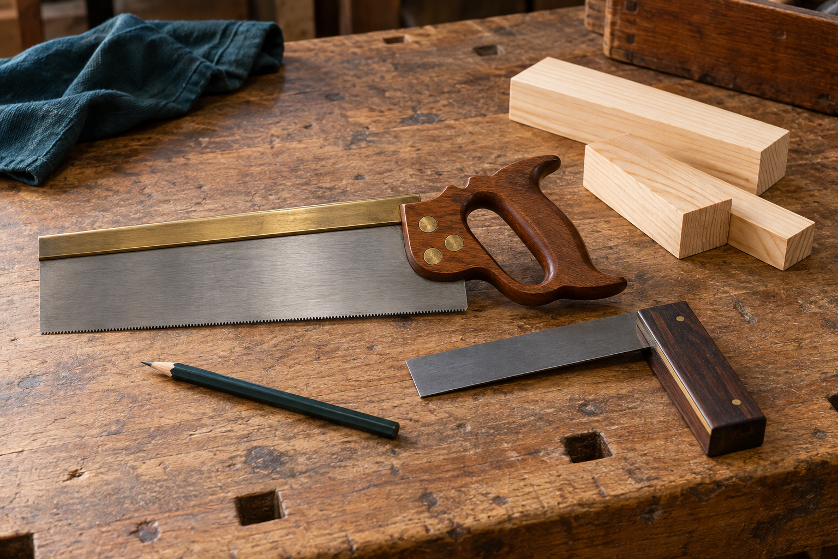
Illustrative tools at rest. Your teacher chooses and authorises the equipment and demonstrates the approved setup.

Teacher-approved tools may include a tenon saw, bevel-edged chisel or block plane, depending on the task and your authorisation. Use each tool only after instruction and demonstration. Secure work in the demonstrated bench hook or vice setup so that the component remains stable and hands remain controlled.
Identify the waste side before cutting. The kerf is the narrow width of material removed by the saw. Keep it on the waste side to protect the wanted component and preserve the fine line as a reference. Leave material for gradual refinement rather than overcutting.
Check squareness where required, compare matching components and check against the approved drawing. If the cut wanders, the tool binds or the surface becomes uneven, stop and seek teacher guidance. Do not force the tool or attempt an unfamiliar correction. Any required drilling is a separately authorised, teacher-controlled process.

Why is a cut that removes too much material harder to correct than one that leaves material for refinement?

Read the matching course section
MODULE 4 / PRODUCTION, JOINERY AND ASSEMBLY

Butt rebate and dowel joints
A joint connects components so they work as one structure. Its suitability depends on the parts being joined, alignment, appearance and achievable accuracy. Compare joint types to understand their behaviour; the approved drawing and teacher direction determine the joints used in your Desk Tidy.
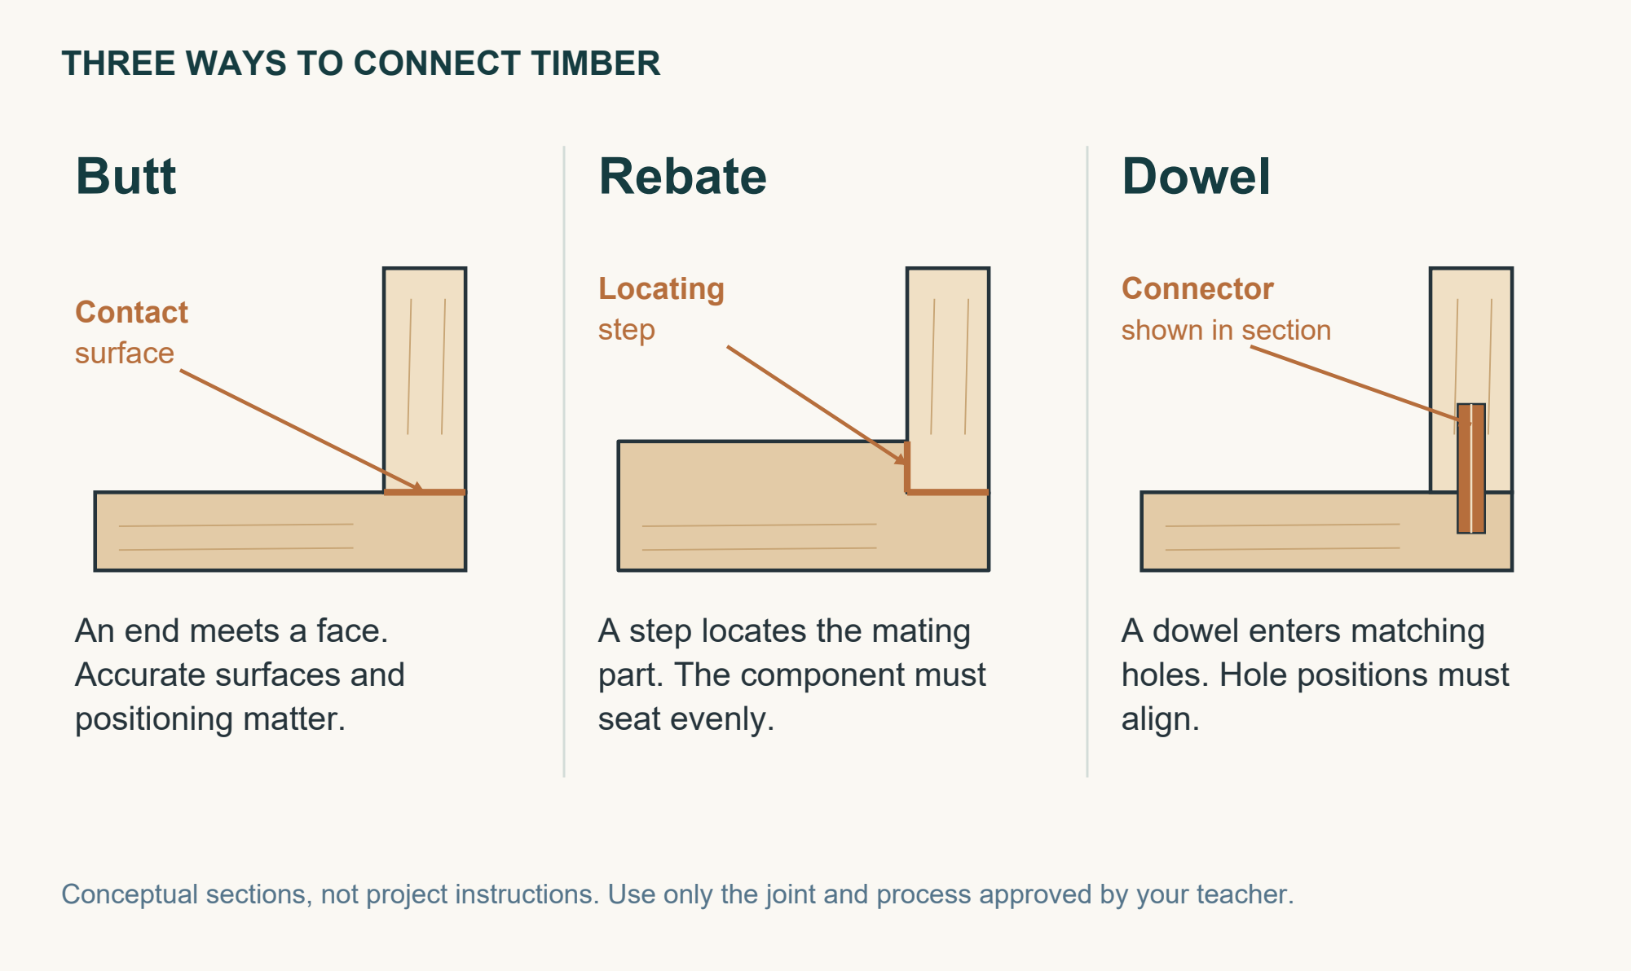
Conceptual joint sections show a butt contact, a locating rebate and a dowel connector.

A butt joint has a simple component relationship. It relies on accurate edges and careful positioning, and its glue contact area may be smaller than that of some other joints. A rebate has a step or recess that locates a part and may increase glue area. The recess must be accurately formed so the component seats evenly.
A dowel joint uses concealed cylindrical connectors. Matching hole positions are critical: an error can create an offset or prevent the joint closing. Preparation and any drilling follow teacher instruction and authorisation.
Dry fit every approved joint before glue. Check even contact, squareness and alignment. A gap, twist or offset is evidence to investigate with the teacher, not something to hide with glue or force together.

Joint | Key dry-fit check
Butt | Square contact with no rocking.
Rebate | Even seating along the recess.
Dowel | Parts close without offset.

Read the matching course section
MODULE 4 / PRODUCTION, JOINERY AND ASSEMBLY

Dry fitting PVA and surface preparation
A complete dry fit assembles all prepared parts without glue. Compare the assembly with the drawing. Check part order, joint closure, squareness and stability on a flat surface. Gaps, twist, rocking or misalignment must be diagnosed before permanent assembly.
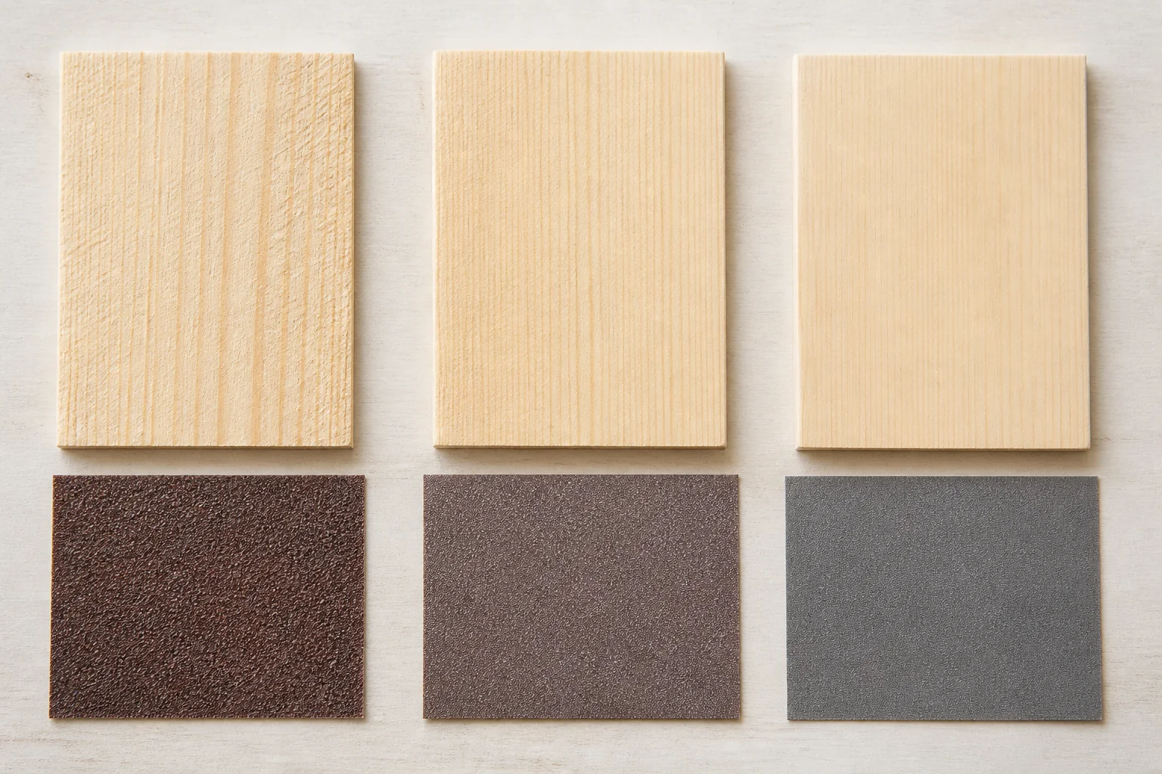
Compare the illustrated surface progression from coarser to finer preparation. The course sequence is 80, 120 then 240 grit, unless your teacher directs otherwise.

The dry fit also rehearses the assembly sequence and clamp arrangement. Resolve faults and obtain teacher approval for both fit and plan before applying PVA. Apply adhesive to prepared joint surfaces using the demonstrated method and product instructions. Position clamps as shown, with enough pressure to close joints appropriately. Excessive pressure can shift parts or damage edges.
Manage squeeze-out by the approved method, then recheck alignment, squareness and stability: parts can move during clamping. Photographs of the assembly and quality checks can support your folio, using the teacher’s arrangements for capturing evidence.
When curing, product instructions and teacher direction allow, prepare surfaces through the authorised 80, 120 and 240 grit sequence unless directed otherwise. Each stage removes marks left by the previous grit. Preserve intended corners and edges, sand evenly and remove dust as directed. Moving to a finer abrasive will not hide a fault that still needs correction.

Read the matching course section
MODULE 4 / PRODUCTION, JOINERY AND ASSEMBLY

Check your making knowledge
Circle one answer for each question. Revisit the relevant reading when you are unsure.
1. Where should the saw’s kerf be kept?
a) On the wanted side of the line.
b) Centred on any thick pencil mark.
c) On the waste side of the line.
d) Wherever the saw naturally moves.

2. Which joint uses a step or recess to help locate a component?
a) Rebate joint.
b) Butt joint.
c) Dowel joint.
d) Every joint uses a recess.

3. A dry fit shows a gap and the structure rocks. What is the best next action?
a) Fill the gap with more PVA.
b) Add maximum clamp pressure.
c) Sand one part without checking the cause.
d) Stop, diagnose the fault and seek teacher guidance.

4. What is the course’s authorised sanding progression, unless the teacher directs otherwise?
a) 240 → 120 → 80.
b) 80 → 120 → 240.
c) 80 → 240 → 120.
d) Use one grit to hide all faults.

Explain why adding more glue or clamp pressure is not a reliable solution to a poor dry fit.

Read the matching course section
MODULE 4 / PRODUCTION, JOINERY AND ASSEMBLY

Workshop detective find the cause

1 Match the joint clues
Write B for butt, R for rebate or D for dowel. Match the evidence; this activity does not choose the joint for your actual design.
Evidence | B, R or D
An end or edge meets another surface directly.
Hidden cylindrical connectors need matching holes.
A step helps a part locate and seat evenly.
Check square contact with no rocking.
Check the parts close without an offset.
Check even seating along the recess.

2 Diagnose do not disguise
For each observation, name something to check and the safest next action. More than one cause may be possible; do not claim a cause without checking.
Observation | What to check / next action
A saw begins to bind during a cut.
The dry-fitted parts meet with a visible gap.
The structure shifts out of square when clamped.

Which fault could become harder to correct after glue is applied? Explain why.

Read the matching course section
MODULE 4 / PRODUCTION, JOINERY AND ASSEMBLY

Rebuild the assembly sequence
The stages below are scrambled. Number them 1–6. Underline the stage that must happen before PVA is applied. Teacher direction and product instructions govern actual workshop work.
Order | Stage
 | A. Apply PVA and clamp using the demonstrated method.
 | B. When cured and authorised, sand 80, 120, then 240 grit and remove dust as directed.
 | C. Dry fit all parts; check order, fit, square and stability.
 | D. Record the assembly, clamp arrangement and quality checks.
 | E. Resolve faults and gain teacher approval for fit and assembly plan.
 | F. Manage squeeze-out and recheck alignment, square and stability.

Watch for a detail you can use
During the teacher demonstration or teacher-selected course video, notice how parts are kept in order and how quality is checked. Record observations of what was shown.
Sketch one demonstrated check or clamp arrangement. Label what is being checked and where parts might move. This is an observation, not approval for your own setup.

A detail I would check again after clamping is… because…

Read the matching course section
MODULE 4 / PRODUCTION, JOINERY AND ASSEMBLY

Explain how checks improve the result
Scenario: Sam notices a gap during dry fitting but wants to glue the parts immediately. Sam plans to tighten the clamps harder and move straight to fine sandpaper so the Desk Tidy looks finished.
Before writing: identify two problems with Sam’s plan.

Build an explanation with evidence
Explain how dry fitting, controlled clamping and progressive surface preparation contribute to quality. Give Sam a sensible next step and explain why it is needed.
• Identify: ‘The gap may indicate…; this needs checking because…’
• Explain: ‘Before glue-up, Sam should…’
• Connect: ‘Clamping still requires checking because…’
• Conclude: ‘Surface preparation should proceed when…’
My explanation

Self-check: have you explained causes and consequences, included teacher approval, and avoided guessing the cause of the gap? Underline your clearest reason.
Read the matching course section
MODULE 4 / PRODUCTION, JOINERY AND ASSEMBLY

Folio show how you made it
Record your own practical evidence for folio cards 9 (Joint Selection and Production) and 10 (Dry Fit, PVA and Clamping). Continue the build journal at the back of the workbook. Use a labelled sketch or a teacher-arranged photograph to make your checks visible.
Name one joint actually approved for your design. Why is it suitable for these parts? If it is not yet confirmed, record what needs teacher confirmation.

Show one joint or the dry-fitted assembly. Add arrows to a fit, alignment, square or stability check. Label any fault honestly.

Practical record | My evidence / observation
Date and component / stage
What the check showed
Correction or next action agreed with the teacher
Photo, sketch or journal reference

Teacher review | Record
Approved next stage, initials and date

Read the matching course section
MODULE 5 / FINISHING, TESTING AND EVALUATION

Applying a clear finish safely and evenly
A finish protects the timber surface, improves its appearance and makes the Desk Tidy easier to care for. The project unit specifies one coat of water-based clear varnish. A clear finish does not hide poor preparation: the final result depends on careful sanding, clean surfaces and controlled application.
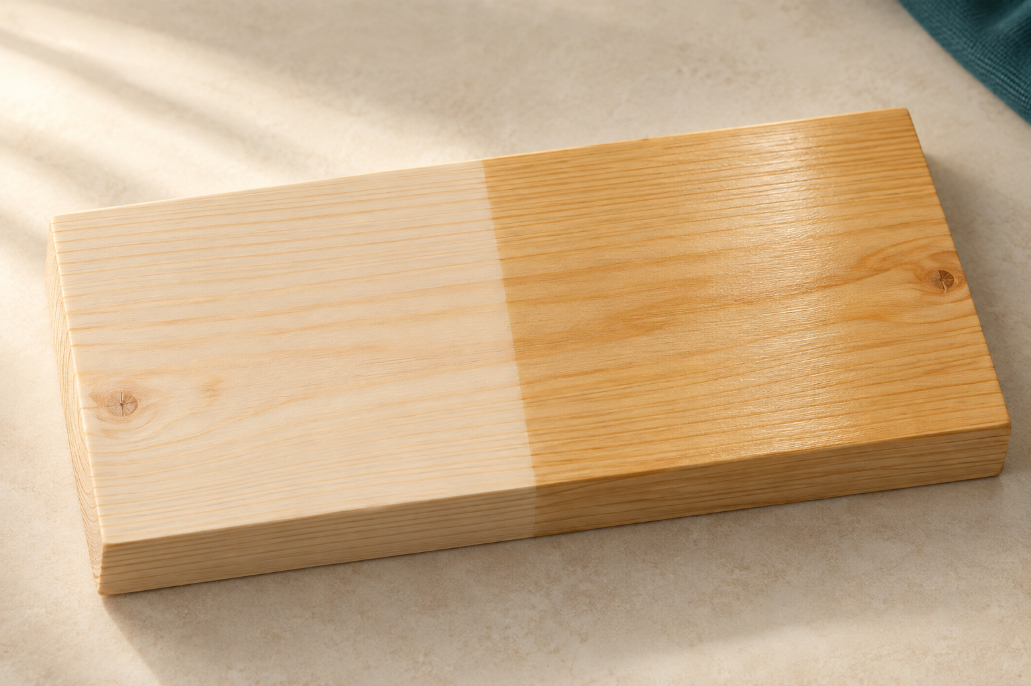
Illustrative finish sample: raw pine on the left and clear-finished pine on the right. Real timber and finishes vary.

Prepare apply protect

Inspect the entire product under good light. Look for scratches, rough areas, dents, glue residue, rounded edges and dust in corners. Correct identified faults only through teacher guidance, then remove dust using the approved workshop method. The surface should be clean and dry before the container is opened.
Apply the varnish only after the teacher demonstration and according to the product information. Use a controlled amount and work methodically across approved surfaces. Watch for runs on vertical faces, pooling in corners and missed edges. Repeatedly working over finish that has begun to settle may create an uneven surface.

Dry does not always mean ready
Drying means the surface has lost enough moisture to feel dry. Curing means the finish has developed its full working strength. A touch-dry surface may still be too soft to handle or test. Protect the work from dust and contact in the teacher-approved location. The actual product instructions and teacher decide when you may move or use it.
Read with a purpose: underline one preparation check, circle one application fault and explain to a partner why touch-dry is not permission to test.

Read the matching course section
MODULE 5 / FINISHING, TESTING AND EVALUATION

Inspect the finish and record the process
Quality detective: compare the three illustrated samples. Identify what you can actually see before deciding what might have caused it. Do not attempt repairs to your own finish without teacher approval.
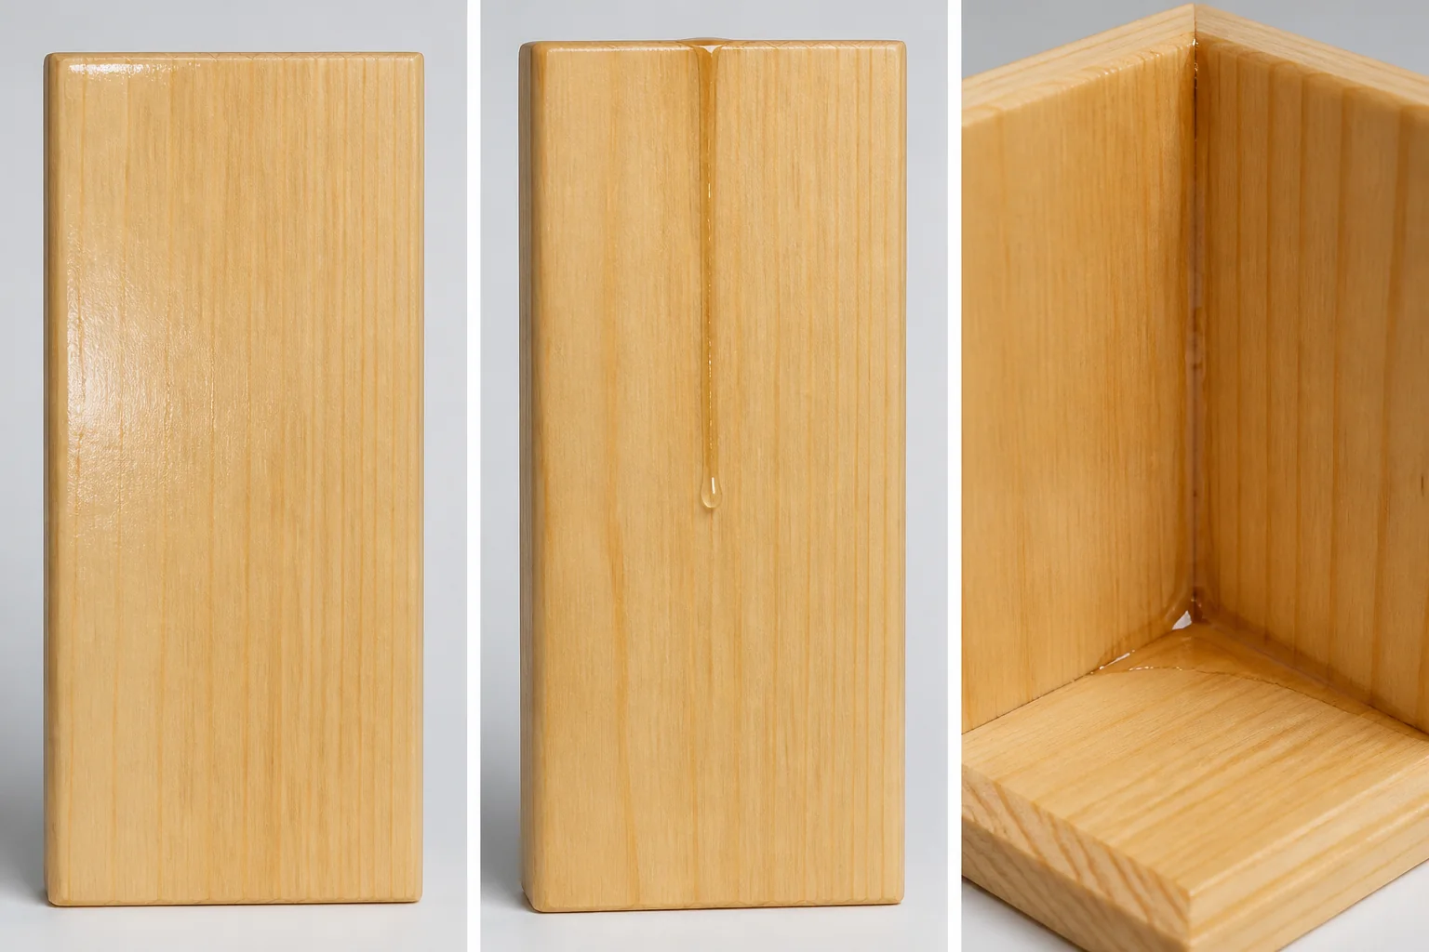
Samples A, B and C, from left to right. Light reflected across the surface helps reveal changes in coverage and shape.
Sample | Even coverage, run or pooling? | Visible evidence
A
B
C

My finishing record folio card 11
Checkpoint | My observation or teacher instruction
Surface checks and approved dust removal
Approved product and application controls
Application date / protected storage location
Result and teacher permission before testing

Record your actual sanding stages or evidence location. What does your finished-surface photo or labelled sketch prove?

Read the matching course section
MODULE 5 / FINISHING, TESTING AND EVALUATION

Functional testing against the design criteria
Functional testing checks whether the Desk Tidy works as intended, not just whether it looks complete. A fair test uses the design criteria developed earlier and the intended stationery: pens, pencils, scissors and paperclips. Keep the method consistent so you can compare the result with your approved design brief.
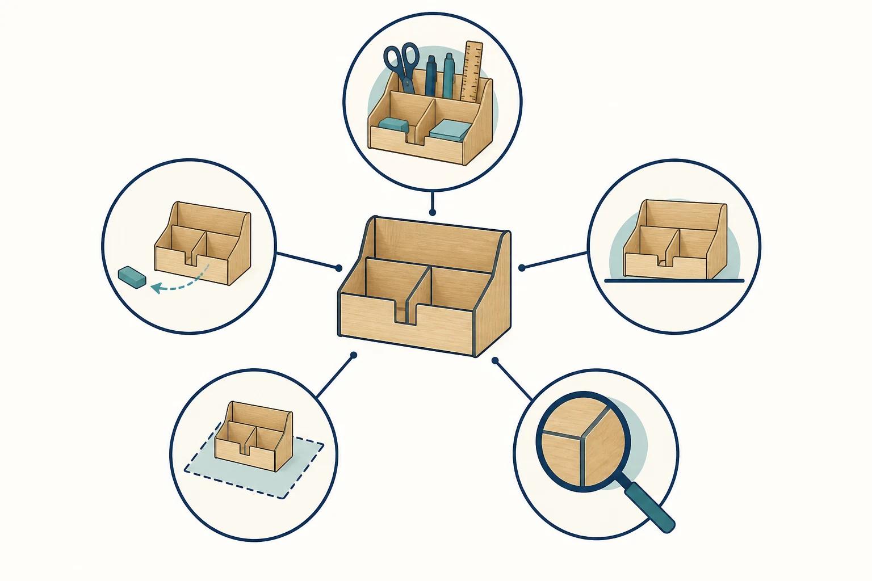
Five separate checks: capacity at the top; access at the left; stability at the right; desk fit at the lower left; workmanship at the lower right. This is a teaching illustration, not a construction plan.

Begin with capacity and access. Put the intended items into their planned compartments. Do they fit without crowding, falling over or becoming hard to remove? Can the user reach commonly used items easily? Check that the organiser fits the intended desk space without causing an obstruction.
Check stability on a flat surface as items are added and removed. Inspect rough or damaged edges, gaps or movement in joints and component alignment. Workmanship includes accuracy, surface quality and care across the completed product.

Observe first judge second
Evidence can be observed, measured or shown in a photograph. ‘It looks good’ is an opinion. ‘The organiser rocked when the scissors were removed’ records an observation. Link each result to a criterion. If a test reveals a fault, record it honestly, diagnose a possible cause and discuss it with the teacher. Never force parts or make an unapproved alteration.

Read the matching course section
MODULE 5 / FINISHING, TESTING AND EVALUATION

My functional test record
Folio card 12. Use your original criteria, intended items and approved design. Complete this record only when your teacher authorises testing. Write actual results, including any fault; do not replace a result with what you hoped would happen.
Testing date, intended user and items used:

Test area and method | Actual observation / measurement | Criterion met? Evidence label
Capacity: place intended items into the planned storage.
Access: remove and return commonly used items.
Stability: observe normal use on a flat surface.
Desk fit: compare the footprint with the intended space.
Workmanship: inspect edges, joints, alignment and finish.

Choose one result to investigate. What is a possible cause, what would you check next, and what must be discussed with your teacher before any adjustment?

Read the matching course section
MODULE 5 / FINISHING, TESTING AND EVALUATION

Evaluation presentation and reflection
Evaluation means judging the completed Desk Tidy against the design criteria developed earlier. Use functional tests, observations, photographs and approved drawings. Avoid vague claims such as ‘it worked well’. Explain what was tested, what happened and whether the result met the need for storage, access, stability, desk fit, appearance and workmanship.
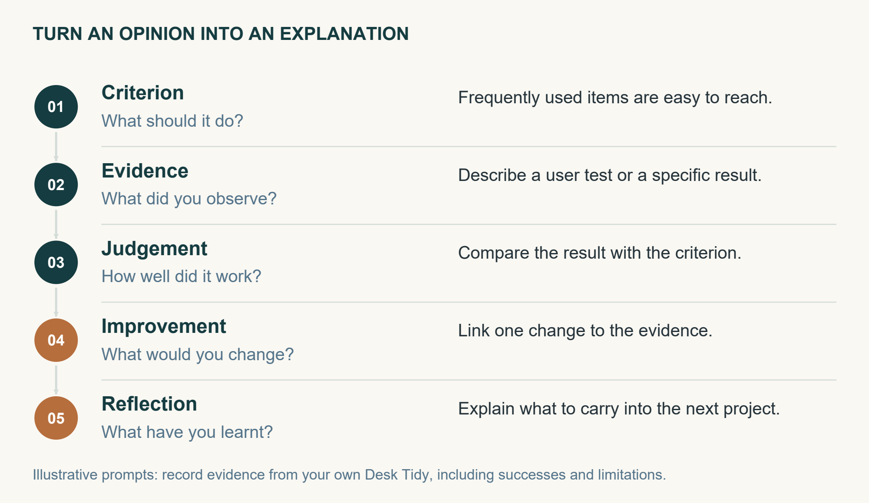
Connect the criterion to evidence, a judgement and a justified improvement.

A balanced evaluation identifies successful decisions as well as faults. A useful layout may keep frequently used items within reach. A weakness could be awkward access, uneven alignment, a gap or a poor surface. Some faults can be improved with teacher approval; others should be recorded as limitations of the final product.

Explain your choices and their consequences
Justify the selected material and production methods. How did they suit the product, the available time and your skills? Discuss sustainability as a trade-off: consider suitable stock, waste reduction, durability, repair and responsible material use. A clear finish uses another material but may help a product last longer; explain the evidence for your own decisions.
For a short presentation, arrange the design journey logically: early sketches, selected concept, working drawings, process evidence, assembly checks, finished product and test results. Reflection then explains your learning. Identify a significant challenge, the response you tried, a skill that improved and one realistic change for next time. Present your own evidence and decisions.
Read with a purpose: number the five pathway stages on the illustration. Which stage is missing when someone says only ‘my Desk Tidy is great’?

Read the matching course section
MODULE 5 / FINISHING, TESTING AND EVALUATION

Decisions under review
Circle the best answer. Be ready to explain the evidence or rule behind your decision.
1. The clear finish feels dry. What determines whether testing may begin?
a) The colour of the timber
b) The product instructions and teacher approval
c) The number of photos taken
d) Whether another student has finished

2. Which finish does the project unit specify?
a) An unspecified oil
b) Three coats of paint
c) One coat of water-based clear varnish
d) Any finish available

3. Which statement is the strongest evidence of successful access?
a) The organiser looks attractive
b) I like the compartment layout
c) My friend said it was excellent
d) The user removed and returned each intended item without obstruction

4. A stability test reveals rocking. What is the appropriate next step?
a) Record the fault and discuss its cause and any adjustment with the teacher
b) Change the criterion so the test passes
c) Force the organiser flat
d) Remove the result from the folio

5. Which sustainability reflection explains a trade-off?
a) Timber is always sustainable
b) Appearance matters more than waste
c) Finishing uses material but may extend useful life; I should also reduce offcuts
d) My project has no environmental impact

Evidence or opinion
Write E or O beside each statement: (a) The pencil compartment is fantastic. ____ (b) The organiser fits inside the measured desk area. ____ (c) There is a visible gap at one joint. ____
Read the matching course section
MODULE 5 / FINISHING, TESTING AND EVALUATION

My evaluation using evidence
Folio card 12. Bring together your brief, original criteria and completed tests. Evaluate at least three criteria below. A judgement can be ‘met’, ‘partly met’ or ‘not met’, but it needs an explanation supported by evidence.
Original criterion | Test evidence and its location | Judgement: how well was the need met?

Explain one successful design or production decision. Connect the choice you made with a specific result from your product.

Explain one limitation and a realistic improvement. State how the change would address the cause. Any physical alteration requires teacher approval.

Useful sentence pattern: ‘My criterion was… The test showed… Therefore… A realistic improvement would be…’ Use your own results, even when they reveal a problem.
Read the matching course section
MODULE 5 / FINISHING, TESTING AND EVALUATION

What I learned and what I would change
Your final reflection should explain learning, not simply list completed jobs. Refer to your sketches, workshop journal, process evidence and test results. An honest account of a problem and a thoughtful response is useful evidence.

Write one connected reflection
• Describe your most significant design or practical challenge and how you responded.
• Explain one skill that improved and point to evidence that shows the change.
• Justify one material or process choice, including a sustainability trade-off such as waste, durability or repair.
• Finish with one realistic change for next time, linked to what your evidence taught you.
Use the prompts above to write in your own words.

Prepare your short presentation
Choose three useful evidence items to show. Record their workbook page or evidence label and the point each will help you explain.

Final check: my account includes a strength, a limitation, actual evidence and an improvement. My teacher will confirm the presentation and submission arrangements.
Read the matching course section
PROJECT FOLIO

My orthographic working drawings
Draw the front, top and side views of your selected design using the layout your teacher demonstrates. Keep corresponding features aligned. The course specifies a scale of 1:10. Write the actual dimensions in millimetres, name each view and record the scale. Use an additional teacher-approved sheet if you need more space.
Drawing title and revision __________________________ Scale __________

Teacher accuracy check and changes required before production

Read the matching course section
PROJECT FOLIO

My isometric working drawing
Use an isometric view to communicate how the parts fit together in three dimensions. Use your own selected design. Label parts and the approved joint locations so a reader can connect this view with your orthographic drawings and cutting list. The dots are a drawing guide, not dimensions.
Drawing title and revision __________________________

Explain one connection between this view and your orthographic drawings

Read the matching course section
PROJECT FOLIO

My approved cutting list
Use the approved drawing to list every part. Enter quantities, the agreed material and actual length, width and thickness in millimetres. Check that repeated parts match. Do not calculate construction dimensions by measuring a workbook picture.
Part name or ID | Qty | Material | Length mm | Width mm | Thickness mm

Material layout and waste reduction notes

Teacher check against the drawing and approved corrections

Read the matching course section
PROJECT FOLIO

My production schedule
Agree the available practical sessions with your teacher. Enter the tasks for your design and shade the sessions in which each task is planned. A milestone is a check that must be completed before the next stage. Include a realistic allowance for teacher checks, tool access, glue setting and the approved finish drying.
Task or checkpoint | 1 | 2 | 3 | 4 | 5 | 6 | 7 | 8

Session dates or lesson references: 1 ______ 2 ______ 3 ______ 4 ______
5 ______ 6 ______ 7 ______ 8 ______
Which task depends on an earlier check being completed? Explain the dependency.

My contingency if a tool is unavailable or a part needs correction

Read the matching course section
PROJECT FOLIO

My build journal
Record the decisions and checks that matter. State what you did, what the evidence showed and what happens next. Keep the teacher demonstration and the approved procedure in control of practical work.

Build record 1
Date, task, approved equipment and the control that mattered most

What I checked, what I found and the action I took

Build record 2
Date, task, approved equipment and the control that mattered most

What I checked, what I found and the action I took

Read the matching course section
PROJECT FOLIO

My improvement record
Choose one real problem or improvement from your build. A useful folio explains how you responded, including changes to your plan. A labelled sketch is suitable evidence if a photograph is unavailable.
Before and after evidence | Label the feature that changed

The problem I observed and the check that revealed it

The teacher-approved correction I made and why it was suitable

What the repeat check showed and what I would do earlier next time

Read the matching course section
PROJECT FOLIO

My project evidence gallery
Add two useful photographs or labelled sketches from your own project. Show a process check and your finished product in use. You can also reference evidence kept on another sheet. Each caption should explain what the evidence proves.
Evidence 1 | A process or quality check

Date and caption explaining the evidence

Evidence 2 | The completed Desk Tidy in use

Date and caption explaining the evidence

Read the matching course section
PROJECT FOLIO

My folio evidence check
Locate your evidence before handing in the work your teacher requests. Tick when the evidence is present and meaningful. Write a page number or attachment name; one good piece of evidence may support more than one row.
Evidence from the course folio | Where to look | My page or attachment
[ ] 1 Brief, user and criteria | 3-10
[ ] 2 Research and four concepts | 11-18
[ ] 3 Comparison and approval | 11-18
[ ] 4 Respectful design research | 11-18
[ ] 5 Working drawings | 19-26, 43-44
[ ] 6 Cutting list and schedule | 19-26, 45-46
[ ] 7 Work health and safety | 3-10, 47
[ ] 8 Datums and marking out | 19-26
[ ] 9 Joints and production | 27-34, 47
[ ] 10 Dry fit, PVA and clamping | 27-34
[ ] 11 Surface preparation and finish | 27-36
[ ] 12 Functional tests and evaluation | 37-42, 49

The evidence I still need to improve or attach

Source acknowledgement: learning text, photographs and teaching illustrations are selected and adapted from the Desk Tidy Guided Course and its project unit. Some course illustrations are generated teaching examples. They explain concepts and do not supply an approved construction plan. New paper activities and record sheets support the same learning sequence.
Read the matching course section

