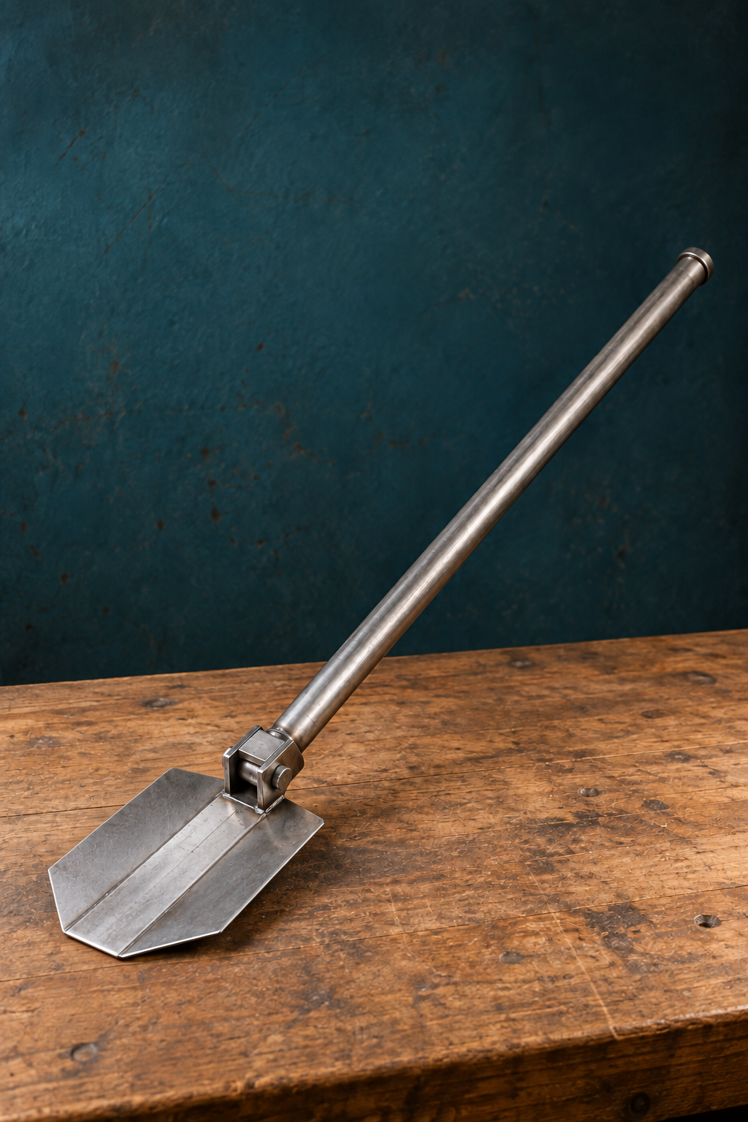
YEAR 10 / INDUSTRIAL TECHNOLOGY METAL

Folding
Camping Shovel
STUDENT WORKBOOK

Name __________________________ Class __________
70 pages · A4 · 35 sheets duplex · Edition 1.1 · Course companion
Illustrative cover. Use teacher-issued project plans for construction.

NAVIGATION

Your learning and evidence route
Five modules, six original drawings and one connected project folio.
Learning route | Pages
Original drawing package | 3–8
1. Drawings, planning and impacts | 9–18
2. Shovel-head production | 19–28
3. Lathe, fits and threads | 29–38
4. Pivot, milling and RPM | 39–48
5. Assembly and evaluation | 49–58
Twelve-part project folio | 59–70

Read the named theory, inspect the useful examples, answer every printed question and save your own evidence. The website and five matching presentations support teacher-led lessons. Written tasks sit beside their reading; the extended RPM record is on page 48. Continue longer project evidence in the matching folio.
This student book is exactly 70 A4 pages, including cover and contents: 35 sheets printed double-sided on the long edge. Preserve the six landscape drawing pages and use actual-size printing. The complete source sheets retain their original notes. Never measure a resized picture to obtain a missing dimension.
Use the current issued sources The brief, drawings, SOPs, WMS and teacher demonstrations control practical details and permission. The original 2014 pivot assessment panel is historical; current assessment conditions are Teacher to confirm.
I have completed the theory, checks and written evidence, then saved or printed it as directed.
Modules 1–3 | Modules 4–5
[ ] Module 1 | [ ] Module 4
[ ] Module 2 | [ ] Module 5
[ ] Module 3

Course: stevencowell.github.io/Yr-10-Metal/folding-camping-shovel/ . Full references, image credits and answers are in the teacher guide. A checked box records readiness; it does not submit work or authorise practical activity.

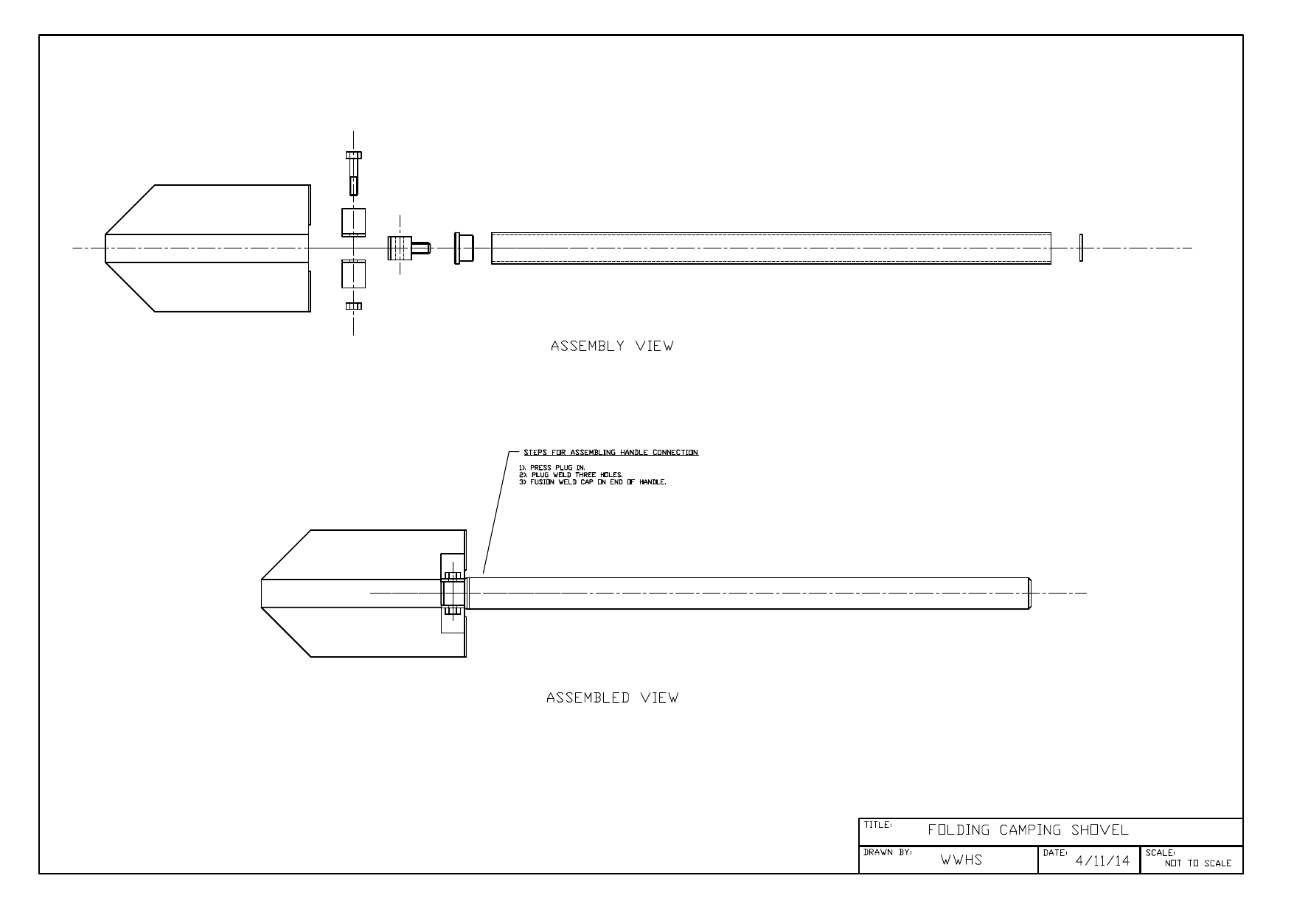
Folding Camping Shovel — assembly · Original WWHS drawing dated 4/11/14, reproduced complete and rotated for readability. Confirm the current issued version with your teacher; do not scale from this page.
Original drawing note (verbatim): STEPS FOR ASSEMBLING HANDLE CONNECTION
1). PRESS PLUG IN. 2). PLUG WELD THREE HOLES. 3). FUSION WELD CAP ON END OF HANDLE.

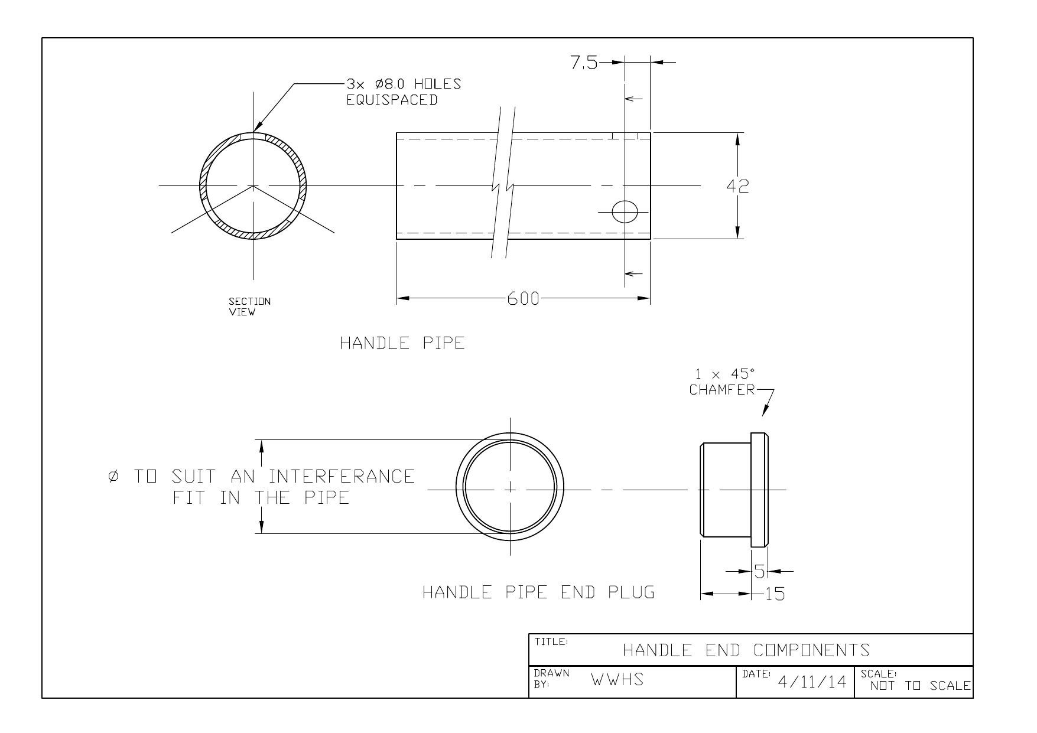
Handle End Components · Original WWHS drawing dated 4/11/14, reproduced complete and rotated for readability. Confirm the current issued version with your teacher; do not scale from this page.

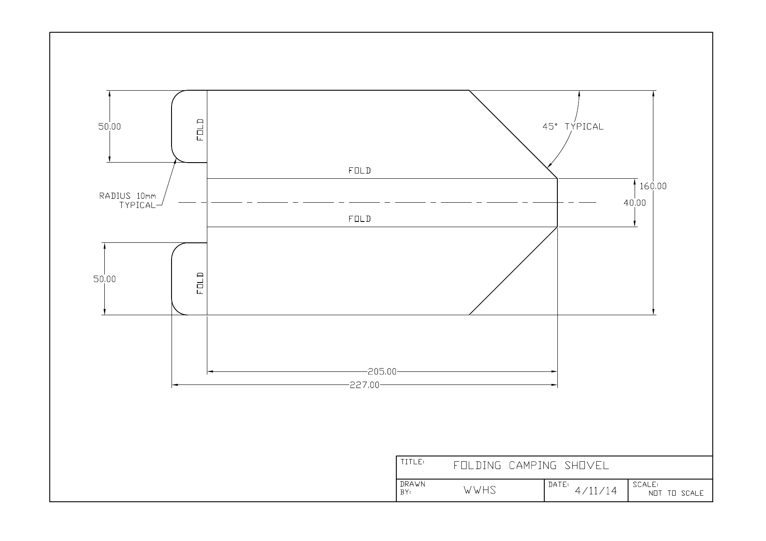
Folding Camping Shovel — head flat pattern · Original WWHS drawing dated 4/11/14, reproduced complete and rotated for readability. Confirm the current issued version with your teacher; do not scale from this page.

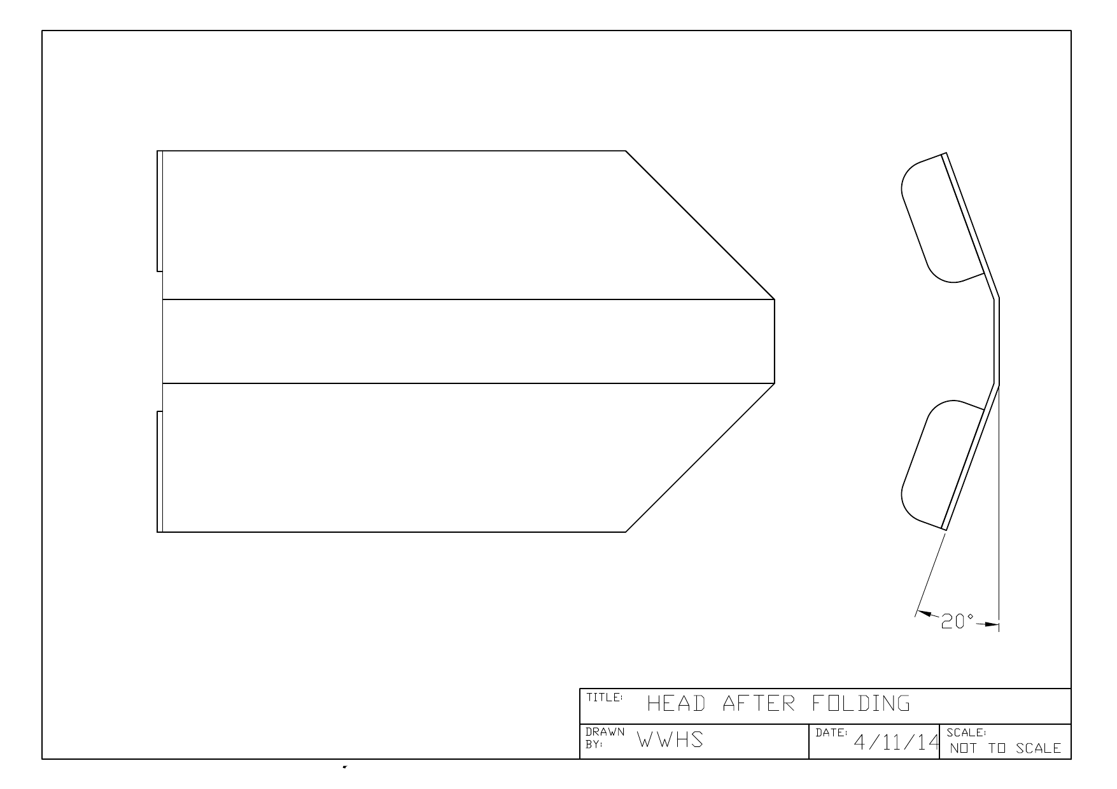
Head After Folding · Original WWHS drawing dated 4/11/14, reproduced complete and rotated for readability. Confirm the current issued version with your teacher; do not scale from this page.

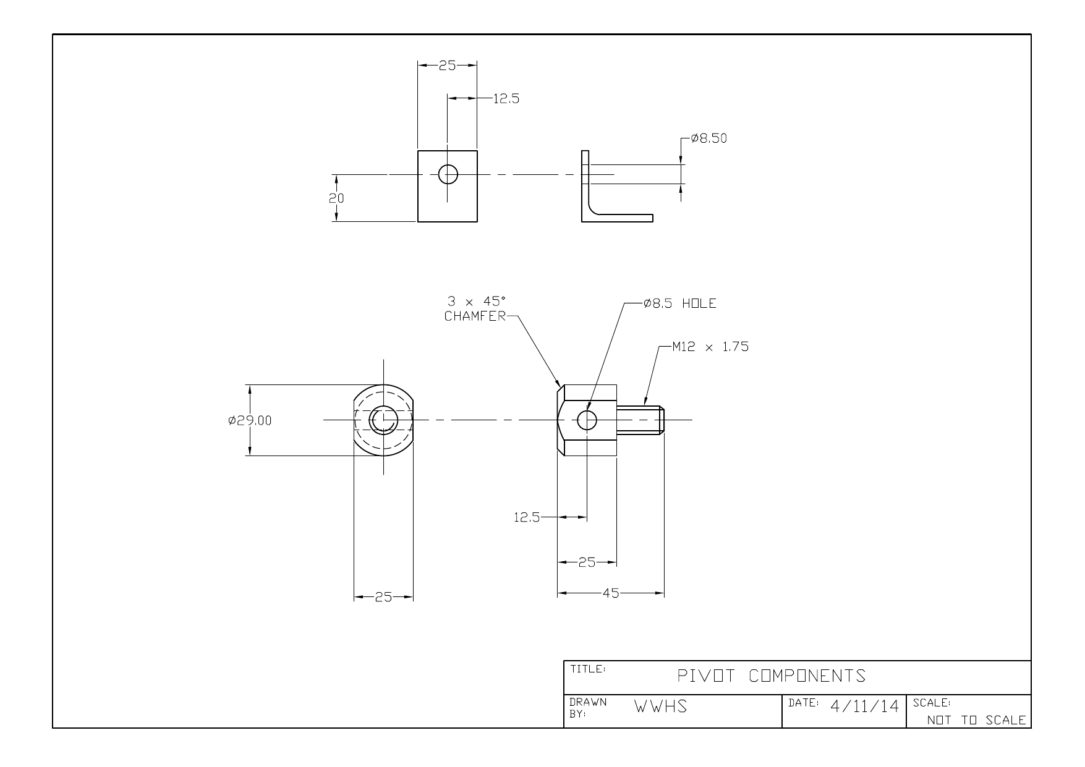
Pivot Components · Original WWHS drawing dated 4/11/14, reproduced complete and rotated for readability. Confirm the current issued version with your teacher; do not scale from this page.

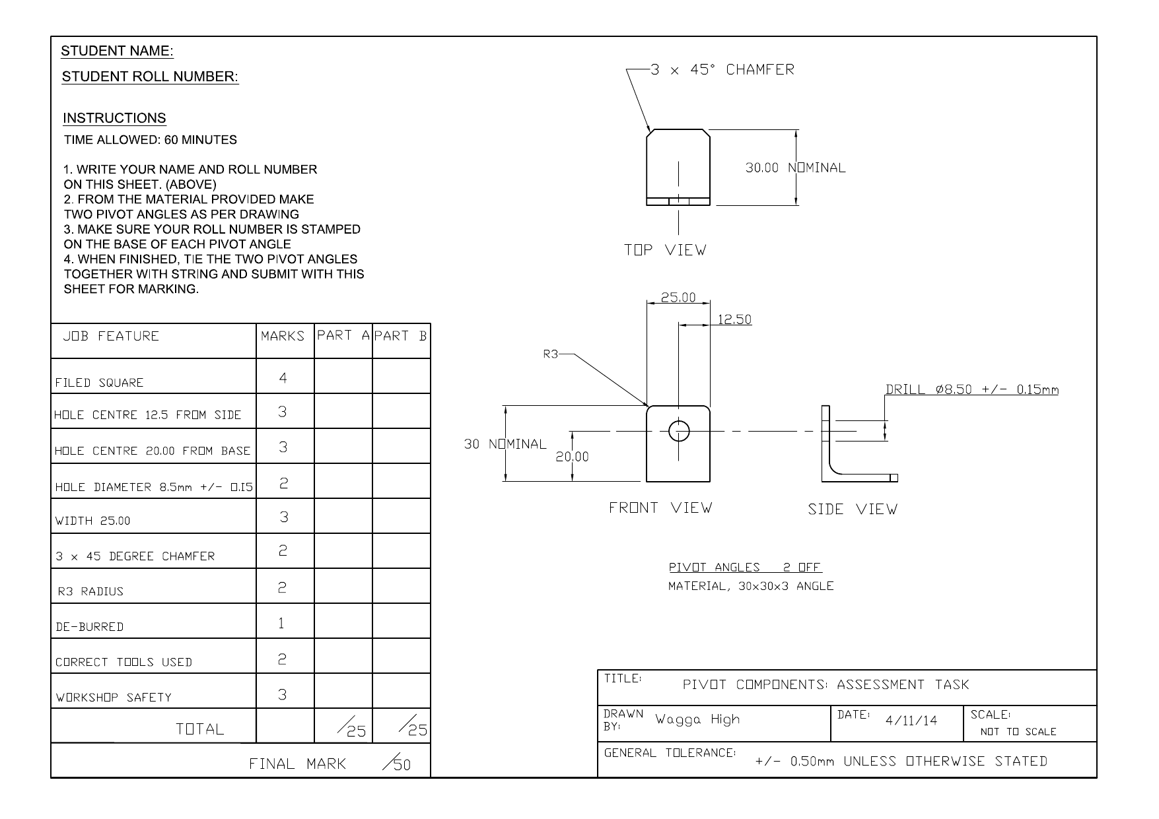
Pivot Components: Assessment Task · Original WWHS assessment sheet dated 4/11/14. Its time and marks are historical source content. Current assessment conditions are Teacher to confirm. Do not scale from this page.

READ / OBSERVE / APPLY

Reading the folding-shovel system through its drawings
10.1 / Drawings, planning and impacts

The folding shovel is a system of related components. Its head, handle pipe, end plug and pivot must work together, so one drawing rarely answers every question. An assembly view explains where the parts belong. A detail view describes an individual part. A sectional view cuts through the imagined object to reveal information that an outside view hides.
Begin with the title and date of the current issued sheet, then identify the same component in another view. The six supplied WWHS sheets are dated 4/11/14: assembly, handle end components, head flat pattern, folded head, pivot components and the pivot-angles assessment sheet. Read them as one package. A later teacher-issued version takes precedence when your teacher confirms it.

For example, the assembly locates the handle near the pivot, while the handle detail includes a section through the pipe and an end-plug detail. Together they explain a relationship that neither view communicates completely. This does not justify inventing a plug diameter or fit allowance. A written note may require a fit to the actual pipe rather than provide a single number.
Written dimensions, symbols and notes control interpretation. A resized page is not a measuring instrument. Trace a component from assembly to detail, record what each view establishes, and flag any uncertainty before marking or machining. That trail connects the source, the physical part and your production plan, making a later decision explainable.

Figure 1. Source-sheet overview for locating related views. Read the complete, legible original on page 3; use its written information, not measurements from this overview.
Explain how two confirmed views/details combine to describe one component relationship.

READ / OBSERVE / APPLY

WMS planning for a multi-process product
10.2 / Connect each approved stage to the evidence it needs.

A Work Method Statement (WMS) makes the authorised production plan visible. The folding shovel involves related work on the head, handle and end plug, fits or threads, pivot, assembly and finish. A useful WMS connects these stages rather than listing tools. It records the approved task, hazards, controls, permissions and evidence needed at that point.
The connection between stages is a dependency: later work relies on an earlier result. If a component has not been checked, its uncertainty travels into the next operation. A quality hold point interrupts that chain. The work pauses until a named criterion has been compared with evidence and the teacher has confirmed the next action.

For example, a hypothetical plan may require a component check before related parts are assembled. “Check the part” is too vague. A stronger entry names the component, drawing reference, approved check, result to record and person who clears the hold point. This is an evidence model, not the shovel’s authorised making sequence.
The whole-product WMS and metal-lathe Standard Operating Procedure (SOP) have different jobs. The WMS coordinates the project; the SOP governs the approved machine process. Neither grants permission by itself. A changed drawing, setup or workpiece condition requires stopping, reporting and teacher-directed review before the plan is updated.

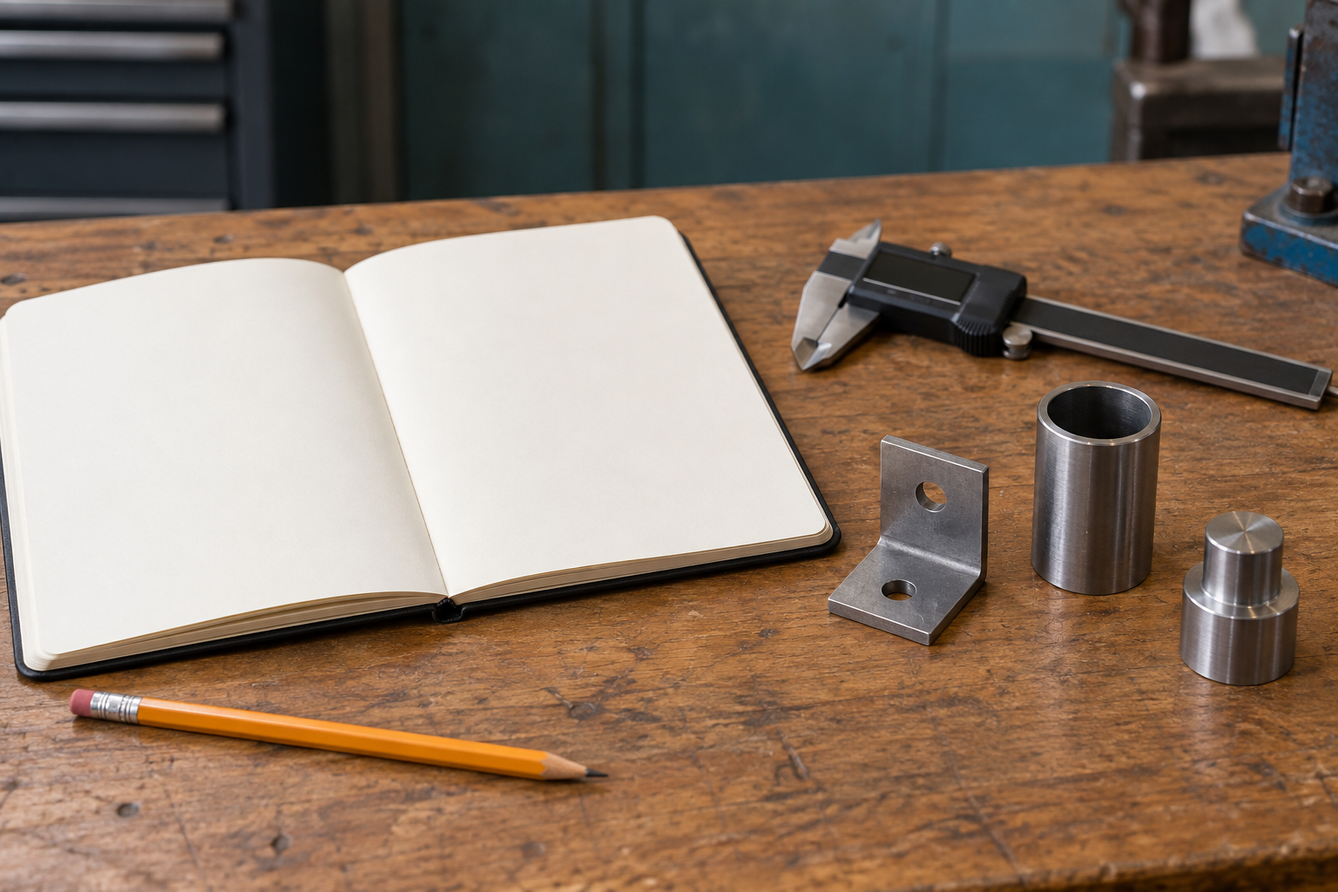
Figure 2. Planning evidence connects a drawing reference, the condition of a part and a recorded decision. Illustrative studio view; tools are at rest.
Justify one WMS hold point that must be cleared before a later shovel process begins.

READ / OBSERVE / APPLY

Societal and environmental criteria before manufacture
10.3 / Drawings, planning and impacts

Impact investigation begins before making because some choices become difficult to reverse after material has been processed. Start with the confirmed need and intended user. Ask how the product will be used, maintained, repaired and eventually recovered or disposed of. These questions connect its immediate function with its longer life.
Societal criteria concern people and use: whether the product meets an actual need, can be maintained, and supports responsible long-term use. Environmental criteria concern resources, processing, waste, maintenance and end of life. The categories overlap. A repairable product may remain useful longer, but the possibility of repair must be supported by its actual construction and access to suitable knowledge or parts.

A trade-off occurs when improving one criterion has a cost elsewhere. A choice intended to improve durability might require more material or processing. Using less material might reduce initial resource demand while affecting manufacture or service life. These are questions to investigate, not automatic conclusions about this shovel.
For example, replace “It is eco-friendly” with a question about a confirmed decision: what evidence would show that this choice reduces waste over the product’s life? Identify the material or process record needed, a credible external source and a limitation. Research becomes useful when it explains what could support or challenge the claim. Record uncertainty honestly; a strong report does not pretend that every decision has only benefits.

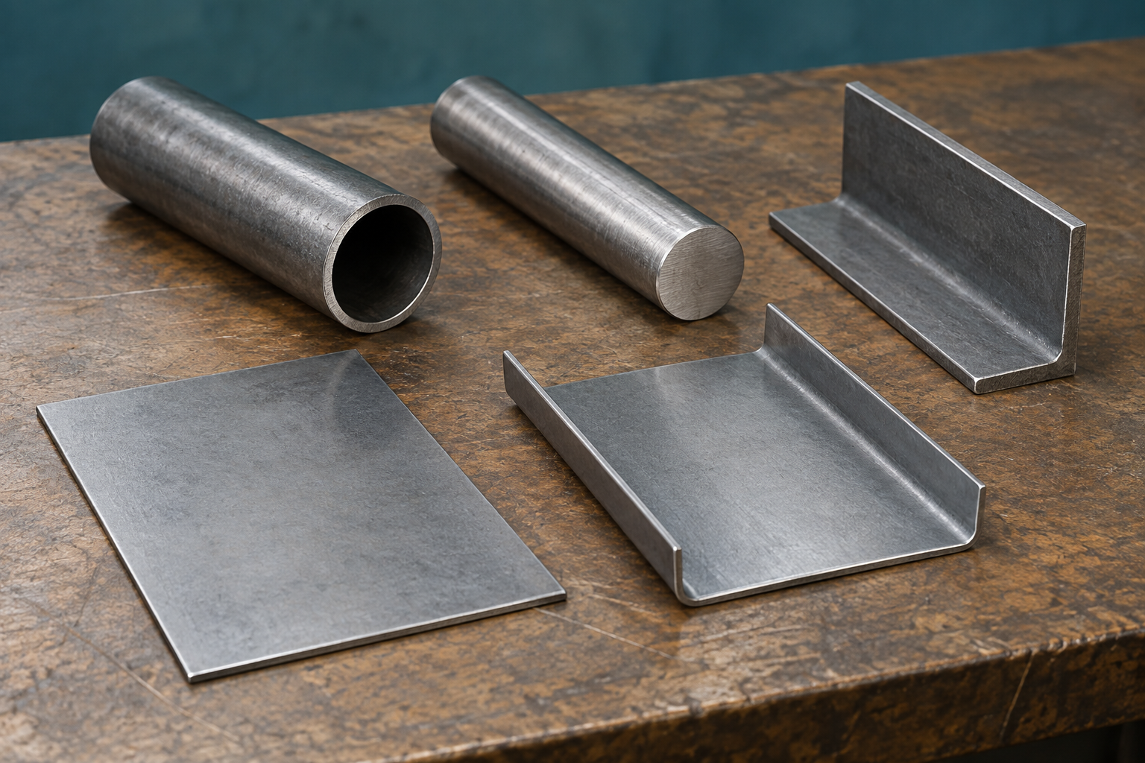
Figure 3. Resource choices have consequences before and after manufacture. Illustrative stock study; actual shovel materials remain controlled by the issued sources.
Frame one societal and one environmental research question tied to a confirmed shovel design/production decision.

MODULE 1 / KNOWLEDGE CHECK

Reading the folding-shovel system through its drawings
Questions 1–5 · Circle one answer for each question.
Reading: page 9.
1. What is the main purpose of an assembly drawing?
○ A. Show how major parts connect
○ B. Provide dimensions for one component
○ C. Replace all detail drawings

2. Why should students cross-reference assembly, detail and sectional views?
○ A. To estimate missing dimensions
○ B. To understand complete component relationships
○ C. To avoid checking drawing revisions

3. Which source should be used if a written dimension and the picture appear different?
○ A. The picture
○ B. The written dimension
○ C. An estimated average

4. What may a sectional view reveal that an outside view cannot?
○ A. Workshop assessment marks
○ B. Internal or hidden relationships
○ C. Material costs

5. A feature shown on one component controls the fit of another. What does this demonstrate?
○ A. Components form an interconnected system
○ B. Each drawing is independent
○ C. Only detail drawings matter

MODULE 1 / KNOWLEDGE CHECK

Reading the folding-shovel system through its drawings
Questions 6–10 · Circle one answer for each question.
Reading: page 9.
6. Before marking or machining begins, what should students confirm?
○ A. Estimated dimensions
○ B. Workshop schedules
○ C. Information controlling position, movement or fit

7. Besides dimensions, what should be checked to ensure production uses the correct drawing?
○ A. Component identity and drawing revision
○ B. Estimated manufacturing time
○ C. Personal drawing preferences

8. If drawing information is conflicting or unclear, what is the correct action?
○ A. Choose the most detailed image
○ B. Record the issue and refer it to the teacher
○ C. Scale the drawing to fill the gap

9. Why should students avoid scaling an image?
○ A. Scaled drawings always match measurements
○ B. Scaled images simplify production
○ C. Written dimensions and notes are the authoritative source

10. Tracing each component across assembly, detail and sectional views before practical work mainly supports what?
○ A. Reliable production planning based on verified information
○ B. Faster estimation of missing details
○ C. Replacing teacher demonstrations

MODULE 1 / KNOWLEDGE CHECK

WMS planning for a multi-process product
Questions 11–15 · Circle one answer for each question.
Reading: page 10.
11. What is the main purpose of a whole-product Work Method Statement (WMS)?
○ A. Coordinate the authorised construction processes
○ B. Replace teacher demonstrations
○ C. Create a new production sequence

12. According to the theory, what should a WMS show between construction stages?
○ A. Estimated completion times
○ B. Dependencies between stages
○ C. Alternative machine settings

13. Why are quality hold points included in a whole-product WMS?
○ A. To prevent unverified work progressing
○ B. To reduce the number of processes
○ C. To replace final inspection

14. How does the whole-product WMS differ from the metal-lathe SOP?
○ A. The WMS authorises machine use
○ B. The lathe SOP replaces the WMS
○ C. The WMS coordinates the overall project while the SOP covers the lathe process

15. Which information is identified for each stage in the WMS?
○ A. Task, hazards, controls, permissions and quality hold points
○ B. Machine purchase details
○ C. Student assessment marks

MODULE 1 / KNOWLEDGE CHECK

WMS planning for a multi-process product
Questions 16–20 · Circle one answer for each question.
Reading: page 10.
16. A component has not passed its quality hold point. What should happen next?
○ A. Continue assembly to save time
○ B. Wait until the result is verified before dependent work continues
○ C. Ignore the hold point if the part looks correct

17. If teacher-issued drawings or instructions change during the project, what should students do first?
○ A. Revise the sequence independently
○ B. Continue using the original WMS
○ C. Stop, report the change and update the WMS only with teacher direction

18. Which statement best describes the relationship between the WMS and teacher supervision?
○ A. Neither replaces teacher demonstration, supervision or authorisation
○ B. The WMS replaces teacher supervision once completed
○ C. Teacher supervision is only needed for lathe work

19. Why should dependencies be visible within a whole-product WMS?
○ A. To estimate project cost
○ B. To show which stages rely on earlier completed and inspected work
○ C. To compare different drawing scales

20. When an unresolved process detail is not stated in the WMS, what controls the correct action?
○ A. Student judgement
○ B. Previous class projects
○ C. The current teacher-issued drawings, SOPs, WMS template and demonstrations

MODULE 1 / KNOWLEDGE CHECK

Societal and environmental criteria before manufacture
Questions 21–25 · Circle one answer for each question.
Reading: page 11.
21. Why should societal and environmental impacts be considered before manufacture?
○ A. Because some production decisions are difficult to reverse later
○ B. To reduce drawing dimensions
○ C. To replace teacher demonstrations

22. Which question belongs in a balanced impact framework?
○ A. Who will assess the report?
○ B. What colour should the product be?
○ C. How durable and repairable is the product expected to be?

23. What should societal criteria be based on?
○ A. The confirmed folding-camping-shovel context and reliable evidence
○ B. Personal opinions about useful products
○ C. Assumed customer preferences

24. Which statement best reflects environmental criteria?
○ A. Only the product's appearance matters
○ B. Consider resources, waste, maintenance and end-of-life outcomes
○ C. Estimate impacts without evidence

25. Why should students avoid describing the product as eco-friendly?
○ A. The term is only suitable after manufacture
○ B. The teacher must approve every environmental statement
○ C. Such claims require verified supporting information

MODULE 1 / KNOWLEDGE CHECK

Societal and environmental criteria before manufacture
Questions 26–30 · Circle one answer for each question.
Reading: page 11.
26. Which example best shows an evidence-based trade-off?
○ A. Improving durability may require more resources or processing
○ B. Choosing the fastest option is always best
○ C. Reducing waste always improves service life

27. If evidence about an impact is incomplete, what should the report do?
○ A. Ignore the issue
○ B. Explain what evidence is still needed before reaching conclusions
○ C. Replace missing evidence with assumptions

28. Which claim follows the theory most closely?
○ A. Longer service life always reduces manufacturing impacts
○ B. Repairability is irrelevant once manufacture begins
○ C. Responsible long-term use should be considered using reliable evidence

29. Which source should resolve uncertain impact details?
○ A. The teacher-issued brief, drawings, approved research sources and demonstrations
○ B. A student's personal experience
○ C. Estimated manufacturing details

30. Which pair of factors is specifically identified as a possible trade-off?
○ A. Drawing title and revision
○ B. Durability and resource use
○ C. Appearance and assessment marks

WORKED EXAMPLE

Turn an impact claim into an argument
Module 1 / Worked comparison and evidence investigation
An impact claim becomes useful when it connects a decision to a consequence and evidence. A statement such as “This product is good for the environment because it is metal” skips the reasoning. Material category alone cannot establish resource demand, service life, repairability or recovery at the end of use.
Weak claim | More careful reasoning
“Metal can be recycled, so this shovel has no environmental impact.” | Recycling may recover useful material, but collection, processing and manufacture still require resources. The actual material, production waste, expected service life and available recovery route need evidence.
“A durable product is always the best choice.” | A longer useful life may reduce replacement. Compare that possible benefit with extra material, processing, maintenance and the user’s actual need.

The reasoning chain Decision → likely effect → evidence needed → limitation. A supported trade-off is stronger than a broad label such as “eco-friendly”. A proposed benefit remains a possibility until evidence supports it.
Choose either weak claim above. Write a more precise research question, name two pieces of evidence needed to answer it, and explain one limitation that would stop you making a final claim.

Keep useful sources for Folio 5 (research and ideas) and Folio 11 (industry and impacts). Record who produced each source and what it can actually establish.

READ / OBSERVE / APPLY

Translating the shovel-head drawing into a controlled sequence
11.1 / Shovel-head production

A drawing becomes a production plan when each required feature is linked to a controlled action and check. First identify the shovel-head component, the issued drawing version and the written information. Compare the flat-pattern sheet with the folded-head sheet. They describe related states of the same part; neither supplies permission to choose an unconfirmed making method.
A datum is an agreed reference from which features are located or checked. Consistent references prevent a student from unknowingly measuring related features from different places. Orientation marks preserve which face or edge belongs in a particular relationship. Together, references and orientation make it possible to connect a mark on the work to a feature in the drawing.

Some features depend on others. A useful plan therefore asks what must be established and checked before later work relies on it. The teacher’s production plan sets the actual sequence. Hold points belong before irreversible stages and before an error could be carried into another feature. A list of operations without these connections is an incomplete plan.
For example, a plan entry can name a verified fold feature, its drawing reference, the authorised operation category, the required check and the evidence to save. It should not invent a forming allowance or tool setting. Clear component labels, dated observations and authorised photographs provide traceability: another reader can follow the reasoning from source to developing part and folio record.

Figure 4. Source-sheet overview for locating related views. Read the complete, legible original on page 5; use its written information, not measurements from this overview.
Convert one confirmed drawing feature into a plan entry containing reference, operation category, check and evidence.

READ / OBSERVE / APPLY

Material behaviour during forming and shaping
11.2 / Shovel-head production

Forming changes shape through controlled force. Material properties influence the response, but a property name does not predict every result. Ductility concerns deformation without failure, particularly under tensile loading; malleability concerns deformation under compressive loading. Hardness concerns resistance to indentation and may affect further deformation or cutting. Thickness also influences resistance to a change of shape.
Manufacture can give material a directional character. Where relevant to the confirmed stock, orientation may affect forming consistency. Repeated deformation can cause work hardening: the material becomes more resistant to further deformation. Springback is a partial return towards the earlier shape when the applied force is removed. These are concepts to recognise, not instructions to compensate by an invented amount.

Watch the actual work during a teacher-approved demonstration or process. Record changes in shape, resistance and surface condition, then compare them with the drawing and agreed criterion. An unexpected shape may have more than one explanation. The observation alone cannot prove which property or process caused it.
For example, “the shape changed after the force was removed” is an observation consistent with springback. Before proposing an adjustment, identify the confirmed material, process and check that would distinguish this from a reference or measurement error. Report the evidence for teacher review. The optional malleability and ductility video reinforces these terms; the current SOP and demonstration still control practical action.

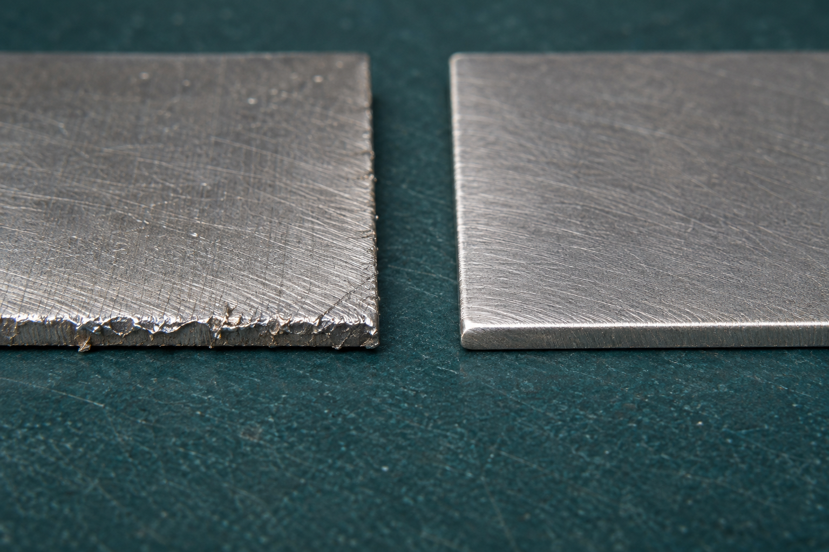
Figure 5. Observe form and surface condition before explaining a result. Illustrative material study; appearance alone does not establish a cause or an approved correction.
Explain one observed material response and the evidence needed before deciding on a teacher-approved adjustment.

READ / OBSERVE / APPLY

Checking head geometry, edges and assembly readiness
11.3 / Shovel-head production

The shovel head is ready for the next stage only when relevant checks support that decision. Inspection compares the developing component with the current drawing and teacher-confirmed criteria. Appearance can alert you to a possible issue, but a tidy-looking part may still have the wrong shape, feature position or relationship to another component.
Check geometry, symmetry where it is specified, feature location, distortion, and surface and edge condition. These features interact. Distortion may change alignment; an unsuitable edge condition may interfere with fitting. Use the authorised measurements or observations for the feature being checked, and identify the component and stage in the record.

A useful record separates criterion, evidence, result and response. The criterion states the requirement. Evidence describes what was actually measured or observed. The result compares the two. A possible cause is a hypothesis, not another observation. The response records the teacher-confirmed action and any recheck; it does not hide the original finding.
For example, “a feature is misaligned with the confirmed reference” describes a finding. Earlier marking, orientation, forming or handling might be investigated, but the record must show what supports any cause. Do not pass the head simply because the next components are ready. A hold point protects later work from a defect that could become harder to diagnose after assembly.

Figure 6. Condition, geometry and the source criterion belong in the same inspection record. Illustrative close-up; your own component supplies the actual evidence.
Complete a quality record separating criterion, inspection evidence, result, possible cause and authorised next step.

MODULE 2 / KNOWLEDGE CHECK

Translating the shovel-head drawing into a controlled sequence
Questions 1–5 · Circle one answer for each question.
Reading: page 19.
1. What should students identify before planning manufacture of the shovel head?
○ A. The correct component and current drawing revision
○ B. The fastest machining method
○ C. The cheapest production process

2. Why should the drawing be read together with the teacher demonstration?
○ A. To estimate missing dimensions
○ B. To avoid relying on assumptions about typical shovel construction
○ C. To replace the written production plan

3. What is the main purpose of datums during manufacture?
○ A. To decorate the drawing
○ B. To estimate finished appearance
○ C. To provide consistent reference points for locating and checking features

4. What do orientation marks help preserve?
○ A. The relationship between faces, edges and the folding assembly
○ B. The colour of the finished component
○ C. The order of classroom seating

5. Why should students identify feature dependencies?
○ A. To avoid recording evidence
○ B. To recognise that some features depend on earlier verified work
○ C. To replace the approved production plan

MODULE 2 / KNOWLEDGE CHECK

Translating the shovel-head drawing into a controlled sequence
Questions 6–10 · Circle one answer for each question.
Reading: page 19.
6. When should inspection points be placed?
○ A. Only after the product is complete
○ B. Only when a mistake is obvious
○ C. Before irreversible stages and before later work depends on the result

7. What should students confirm at each inspection point?
○ A. The component's identity and orientation
○ B. The estimated retail value
○ C. The preferred manufacturing method

8. What should students do if they find uncertainty or a mismatch?
○ A. Ignore it if most features match
○ B. Refer it to the teacher before continuing
○ C. Correct it using assumptions

9. What best demonstrates traceability during shovel-head manufacture?
○ A. Working from memory
○ B. Completing the task without notes
○ C. Using clear labels, photographs and annotated observations

10. Which documents should remain connected through traceability?
○ A. The drawing, production plan, physical component and folio record
○ B. The classroom timetable and attendance roll
○ C. The equipment catalogue and supplier brochure

MODULE 2 / KNOWLEDGE CHECK

Material behaviour during forming and shaping
Questions 11–15 · Circle one answer for each question.
Reading: page 20.
11. Which property describes a material's ability to change shape without failing?
○ A. Hardness
○ B. Ductility
○ C. Thickness

12. According to the theory, hardness mainly affects a material's resistance to what?
○ A. Indentation, cutting or further deformation
○ B. Springback after forming
○ C. Surface orientation during manufacture

13. What may influence how strongly a workpiece resists a change in shape?
○ A. Drawing title
○ B. Thickness
○ C. Revision number

14. If a confirmed material has a manufacturing direction, what may affect how consistently it forms?
○ A. Teacher availability
○ B. Surface colour
○ C. Material orientation

15. What is work hardening?
○ A. A material becoming more resistant to further shaping after repeated deformation
○ B. A material permanently returning to its original shape
○ C. A material becoming softer after repeated deformation

MODULE 2 / KNOWLEDGE CHECK

Material behaviour during forming and shaping
Questions 16–20 · Circle one answer for each question.
Reading: page 20.
16. What is springback?
○ A. A surface becoming harder after cutting
○ B. A material partly returning towards its earlier form after shaping force is removed
○ C. A workpiece cracking during forming

17. A material behaves differently from expected during approved work. What should students do first?
○ A. Apply greater force immediately
○ B. Assume the material is faulty
○ C. Record the response and refer it to the teacher

18. Which combination should students observe during approved work?
○ A. Changes in shape, resistance and surface condition
○ B. Only the finished dimensions
○ C. Only the colour and appearance

19. Why should students avoid assuming the cause of an unexpected material response?
○ A. Because every unexpected response proves only one cause
○ B. Because an unexpected response does not prove a cause by itself
○ C. Because drawings always explain unexpected behaviour

20. According to the source boundary, what controls unresolved forming, shaping and
material-behaviour details?
○ A. Previous student projects
○ B. General workshop experience
○ C. Teacher-issued material information, workshop drawing, SOP, WMS and demonstration

MODULE 2 / KNOWLEDGE CHECK

Checking head geometry, edges and assembly readiness
Questions 21–25 · Circle one answer for each question.
Reading: page 21.
21. What should the completed shovel head be compared with during inspection?
○ A. Its overall appearance
○ B. The teacher-issued drawing and confirmed quality criteria
○ C. Other completed components

22. Which observation could interfere with later fitting if left unresolved?
○ A. Unsuitable edge condition
○ B. A neatly labelled photograph
○ C. A completed inspection note

23. Why should geometry, feature position and edge condition be inspected together?
○ A. To reduce the number of photographs
○ B. Because these checks can influence one another
○ C. To avoid using approved measurements

24. What should be recorded before suggesting a possible cause of a problem?
○ A. The observed fault
○ B. The expected correction
○ C. The next assembly step

25. Which evidence best supports an inspection record?
○ A. Memory of the inspection
○ B. Approved measurements, photographs and annotated notes
○ C. An estimate based on appearance

MODULE 2 / KNOWLEDGE CHECK

Checking head geometry, edges and assembly readiness
Questions 26–30 · Circle one answer for each question.
Reading: page 21.
26. If inspection results are uncertain, what should happen before assembly continues?
○ A. Continue because later parts are ready
○ B. Ignore the uncertainty if geometry looks acceptable
○ C. Document the doubt and refer it to the teacher

27. A student thinks poor handling caused visible distortion. According to the theory, how should this be reported?
○ A. State handling definitely caused it
○ B. Describe the distortion before suggesting handling as a possible cause
○ C. Leave the distortion out of the record

28. Which detail should inspection evidence identify?
○ A. The component, inspection stage and comparison reference
○ B. The student's preferred correction
○ C. The estimated production time

29. Why should a shovel head not proceed simply because later components are ready?
○ A. Later components determine geometry
○ B. Assembly readiness depends only on appearance
○ C. Readiness must be confirmed through inspection and teacher review

30. According to the source boundary, what controls unresolved inspection, acceptance and correction details?
○ A. Previous student projects
○ B. General workshop experience
○ C. The teacher-issued drawing, quality criteria, WMS and demonstration

INVESTIGATE / APPLY

Audit a head-production record
Module 2 / Distinguish a finding from an unsupported conclusion.
The following three statements are hypothetical records, not observations of your own shovel. An audit asks what each record establishes and what still needs checking. Use the drawing and inspection principles before deciding which statement is strongest.
Record | Hypothetical inspection note
A | The head looks neat, so it is ready for assembly.
B | An edge was observed to differ from the confirmed reference. The component and inspection stage were recorded; the cause remains for review.
C | The head is distorted because the material is wrong. A correction was chosen without checking the source or teacher demonstration.

For A, B and C, identify the strongest evidence present and the most important missing information or unsupported claim. Explain which record provides the best starting point for a teacher review.

Rewrite either A or C as an honest provisional inspection record. Include a source criterion, the evidence still needed and the next teacher checkpoint; do not invent a completed check.

LOOK CLOSELY

Metal-lathe SOP evidence for handle and end-plug work
12.1 / Lathe, fits and threads

Explain the demonstrated controls
Metal-lathe SOP evidence should explain understanding, not merely copy a procedure or collect a signature. In the handle and end-plug work, connect the teacher-confirmed machining purpose to the correct drawing and the current Standard Operating Procedure. The record should identify the component or feature as well as the procedure used.
During the demonstration, recognise the important control points. They may concern permission, the approved setup, workpiece security, clearances, controlled use, stopping and inspection. Explain why two actual controls matter in that demonstrated context. The exact actions come from the local SOP and teacher; this workbook does not supply substitute operating steps.

Record what the evidence shows
A control and its evidence are different. Naming a requirement says what should happen. An annotated observation or authorised photograph shows what was observed. For example, a caption should identify the demonstrated control, its purpose and what the evidence actually shows, without claiming that a still image proves every action was performed correctly.
Approval applies to the demonstrated conditions. A changed drawing, workpiece, machine, setup or instruction needs reporting and review; do not assume earlier permission continues. Inspection closes the chain by comparing the machined feature with the current drawing and acceptance criteria before later fitting. Preserve both the result and any teacher review so the folio explains what happened, why it mattered and what remained unresolved.

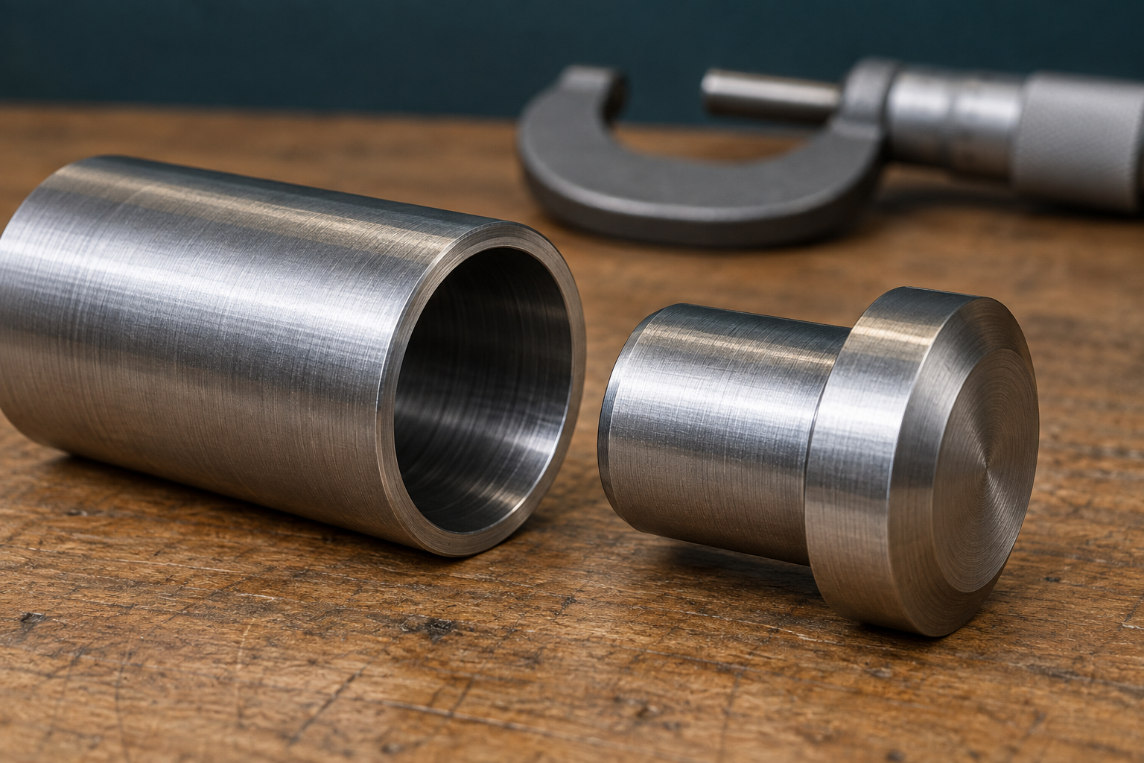
Figure 7. A machined component is evidence of an outcome, not proof that every control was followed. Link the actual process record to the drawing and current SOP.
Explain the purpose of two teacher-confirmed SOP controls and the evidence that they were applied.

LOOK CLOSELY

Functional fits connect dimensions to movement and assembly
12.2 / Lathe, fits and threads

Choose the intended relationship
A fit is a dimensional relationship between parts that must assemble or move together. A clearance fit leaves space between related parts. A transition fit may give slight clearance or slight interference. An interference fit produces a tight dimensional relationship. These terms explain possible behaviour; they do not identify the required fit everywhere in the shovel.
The drawing and acceptance criteria establish which relationship is intended. The handle
end-plug sheet specifically calls for an interference fit to the pipe. It does not supply a universal allowance that can be copied onto another component. The actual mating parts, current source and
teacher-confirmed measurement method matter.

Verify the fit
A suitable fit can influence movement, alignment, unwanted looseness, wear and serviceability. This is why machining is more than producing one isolated number. The size of one component has meaning in relation to the part that receives it. Progressive checks allow a developing feature to be reviewed before additional material removal or assembly makes a problem harder to resolve.
For example, a record that lists only the outside appearance cannot establish a fit. A stronger record identifies both components, their sourced requirements, approved measurements and the evidence supporting the judgement. Unexpected movement or assembly difficulty is a reason to document and review the relationship, not to force the parts or choose a correction from appearance. Keep the proposed cause separate from the verified finding.

Figure 8. Fit concerns the relationship between mating parts. This illustrative detail does not specify a project allowance or demonstrate an accepted fit.
Explain how drawing values and measurements would support a teacher-confirmed fit judgement for one nominated pair.

LOOK CLOSELY

Threads as controlled geometry and evidence
12.3 / Match the specified geometry, then record the check.
A thread is a repeated form that lets matching components engage. An external thread is on the outside of a part; an internal thread is inside an opening. The crest is the high part of the profile and the root is the low region between crests. Pitch is the distance between corresponding points on neighbouring forms, measured along the thread axis.
Major diameter is the largest thread diameter and minor diameter the smallest. These names describe geometry; they do not prove that two parts match. Form, size and condition all matter. The original pivot sheet has a written thread callout. Read that callout in its component context rather than choosing an apparently similar fastener.
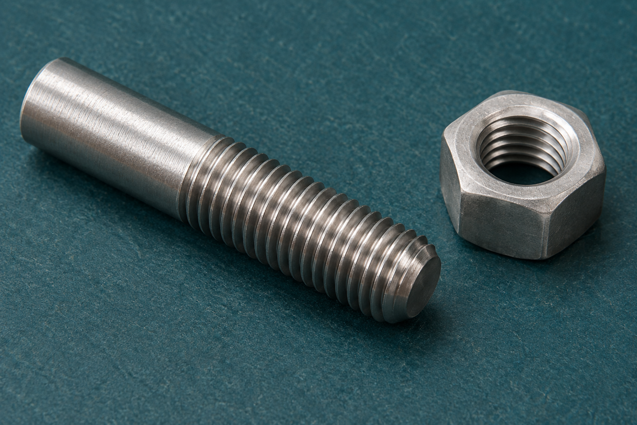
Figure 9. A thread’s repeated crests and roots can be observed closely. This illustrative detail is not a gauge or a substitute for the specified check.
Inspection links the identified component and specification to a teacher-approved gauge or checking method. Record what was checked, the evidence, the criterion and the result. A thread that looks clean can still have the wrong geometry. Damage, contamination or incomplete form may affect engagement; resistance alone does not identify the cause.
Observation before diagnosis “Resistance was observed” describes evidence. “The pitch is wrong” is a proposed cause that needs checking. Record the symptom and refer it for teacher review; do not force a fit or invent a correction.
Produce an inspection explanation showing how a specified thread would be identified, checked and recorded using teacher-approved evidence.

MODULE 3 / KNOWLEDGE CHECK

Metal-lathe SOP evidence for handle and end-plug work
Questions 1–5 · Circle one answer for each question.
Reading: page 29.
1. What should metal-lathe SOP evidence primarily demonstrate?
○ A. Understanding of the authorised process
○ B. A copied SOP document
○ C. A completed signature

2. According to the theory, what should strong SOP evidence identify?
○ A. Only the drawing revision
○ B. The SOP used, component and recognised control points
○ C. Every machine control setting

3. Where must exact machining actions come from?
○ A. Previous workshop experience
○ B. A generic lathe guide
○ C. The current SOP and teacher demonstration

4. A drawing changes after approval. What should happen before machining continues?
○ A. Report the change and review the process
○ B. Continue because approval already exists
○ C. Ignore the difference if it seems minor

5. Which situation means the original approval cannot simply be assumed to continue?
○ A. The workpiece, setup or instruction changes
○ B. The component name stays the same
○ C. The completed work is photographed

MODULE 3 / KNOWLEDGE CHECK

Metal-lathe SOP evidence for handle and end-plug work
Questions 6–10 · Circle one answer for each question.
Reading: page 29.
6. What completes the evidence chain after machining?
○ A. Collecting another signature
○ B. Inspection against the verified drawing and teacher-controlled criteria
○ C. Starting the next machining task

7. What is the main purpose of photographs with concise annotations?
○ A. Decorate the folio
○ B. Replace the inspection process
○ C. Show observations, applied control points and whether review was needed

8. Why should students connect the machining purpose to the authorised process and drawing?
○ A. To demonstrate understanding of the evidence
○ B. To avoid reading the SOP
○ C. To memorise a standard sequence

9. Which evidence best reflects the inspection stage?
○ A. A remembered description of the demonstration
○ B. A comparison with the verified drawing and approved criteria
○ C. An estimate based on appearance alone

10. If equipment differs from the demonstrated setup, what should students do first?
○ A. Adapt the process independently
○ B. Continue if the component is unchanged
○ C. Report the changed condition before proceeding

MODULE 3 / KNOWLEDGE CHECK

Functional fits connect dimensions to movement and assembly
Questions 11–15 · Circle one answer for each question.
Reading: page 30.
11. What does a functional fit describe?
○ A. The surface appearance of a component
○ B. The dimensional relationship between components that assemble or operate together
○ C. The machining sequence for producing a component

12. Which fit category always requires parts to engage tightly?
○ A. Interference fit
○ B. Transition fit
○ C. Clearance fit

13. Why should students connect verified dimensions to functional purpose?
○ A. To understand how dimensions influence movement, alignment and assembly
○ B. To estimate missing drawing information
○ C. To improve the appearance of machined surfaces

14. What should determine the required fit for the shovel project?
○ A. The student's preferred fit category
○ B. The teacher-issued drawing and acceptance criteria
○ C. The easiest fit to machine

15. According to the theory, what is the purpose of progressive inspection?
○ A. To confirm the component remains suitable before more material is removed or assembly begins
○ B. To replace the need for final inspection
○ C. To improve the visual finish after machining

MODULE 3 / KNOWLEDGE CHECK

Functional fits connect dimensions to movement and assembly
Questions 16–20 · Circle one answer for each question.
Reading: page 30.
16. Why is appearance alone insufficient for confirming a functional fit?
○ A. Because only colour determines fit
○ B. Because functional relationships must be checked against verified drawings and
teacher-controlled criteria
○ C. Because polished surfaces always hide defects

17. Which statement correctly describes a transition fit?
○ A. It always provides space between components
○ B. It always requires tight engagement
○ C. It may produce either slight clearance or slight interference

18. Besides assembly and movement, what else can a suitable fit influence?
○ A. Wear, maintenance and whether parts can later be separated or serviced
○ B. The colour of the finished component
○ C. The order of workshop activities

19. What should a student do if unexpected movement or assembly difficulty is found?
○ A. Remove more material immediately
○ B. Document the issue and refer it to the teacher before attempting correction
○ C. Ignore the problem if the parts still fit together

20. According to the key takeaways, dimensional checks should primarily be linked to what?
○ A. Tool selection and machining speed
○ B. Surface appearance and finish quality
○ C. Movement, alignment and serviceability

MODULE 3 / KNOWLEDGE CHECK

Threads as controlled geometry and evidence
Questions 21–25 · Circle one answer for each question.
Reading: page 31.
21. What does the pitch of a thread describe?
○ A. The distance between corresponding points on neighbouring thread forms
○ B. The largest diameter of the thread
○ C. The lowest area between adjacent crests

22. Which statement correctly describes an external thread?
○ A. It is formed within an opening
○ B. It is formed on the outside of a component
○ C. It always has the largest possible diameter

23. Why should a thread not be judged by appearance alone?
○ A. Appearance alone cannot confirm the specified form, size or condition
○ B. Threads always look different even when identical
○ C. Appearance determines whether a thread is acceptable

24. Which thread feature is the outermost part of the thread form?
○ A. The root
○ B. The pitch
○ C. The crest

25. What is the purpose of using a teacher-approved thread gauge or checking method?
○ A. To compare the thread with the drawing and acceptance criteria
○ B. To make any thread fit during assembly
○ C. To estimate the thread size by feel

MODULE 3 / KNOWLEDGE CHECK

Threads as controlled geometry and evidence
Questions 26–30 · Circle one answer for each question.
Reading: page 31.
26. If a thread shows resistance during engagement, what should a student do?
○ A. Force the components together
○ B. Document the issue and refer it to the teacher before assembly
○ C. Replace it with a similar-looking fastener

27. What does the major diameter of a thread describe?
○ A. The distance between adjacent crests
○ B. The largest thread diameter
○ C. The smallest thread diameter

28. Why should a generic fastener not automatically replace a specified thread?
○ A. Generic fasteners are always weaker
○ B. Apparently similar threads may not match the required specification
○ C. Generic fasteners cannot have external threads

29. Which information should be recorded during thread inspection?
○ A. Component identity, specified thread information, inspection evidence and any uncertainty
○ B. Only whether the thread looked acceptable
○ C. Only the component name and date

30. A drawing specifies an internal thread. What does this tell you?
○ A. The thread is formed on the outside of the component
○ B. The thread is formed within an opening
○ C. The thread has the largest major diameter

DRAW / EXPLAIN

Diagnose before changing a part
Module 3 / Fits and threads require evidence, not force.
In this hypothetical inspection, two related parts do not engage as expected. The first note says: ‘The parts resist movement, so the thread must be wrong.’ That combines an observation with an unproven cause. More than one feature or condition may explain the same symptom.
A useful diagnostic sequence Start by identifying the parts and their current specification. Separate the observed resistance from possible causes such as mismatched specification, condition, incomplete geometry or another assembly relationship. An approved check can provide evidence; appearance alone cannot. Record uncertainty and seek teacher review before any correction.
Draw an evidence map with the observed symptom in the centre. Add three possible causes as branches and write one teacher-approved type of check or source needed to investigate each. Mark any unconfirmed method ‘Teacher to confirm’.

Explain why matching one visible feature does not prove a functional fit. State what must be established before either component is altered or the assembly proceeds.

LOOK CLOSELY

Pivot parts: centres, alignment and movement path
13.1 / Pivot, milling and RPM

Locate the pivot
A pivot centre defines where related components rotate. Its position affects the path of movement and how surrounding parts interact. The drawing’s written centre references therefore matter as much as the outer shape. Trace the relevant centre across the original pivot and assembly sheets instead of estimating its position from a photograph.
Where features must align, consistent datums and orientation preserve their intended relationship. Small differences between several parts can accumulate. Contact faces also matter: their condition and alignment influence how parts sit together. A component can look acceptable alone yet reveal a mismatch when compared with its related parts.

Check clearance and movement
Clearance is the available space between parts. Too much or too little may change alignment or movement, but the required amount must come from the issued drawing and teacher criteria. Do not invent a gap because a generic mechanism uses one. Similarly, an attractive image cannot establish an authorised locking action or operating position for this shovel.
Dry assembly is a reversible diagnostic stage carried out only as demonstrated. It checks identity, orientation, contact, alignment and the controlled movement path before finishing or final locking. If movement binds, record where and under what confirmed conditions it occurs. Compare that observation with measured or visual evidence before proposing a cause. Teacher review determines the next action; the purpose of the check is to reveal uncertainty while it can still be investigated.

Figure 10. Source-sheet overview for locating related views. Read the complete, legible original on page 7; use its written information, not measurements from this overview.
Explain a dry-assembly check that traces one observed movement issue back to measured or visual evidence.

LOOK CLOSELY

Milling as a controlled relationship between tool, work and reference
13.2 / Pivot, milling and RPM

Connect the cutter, work and reference
Milling removes material through the relative movement of a rotating cutter with multiple cutting edges and a controlled workpiece. The outcome depends on the relationship between tool, work and reference. Simply bringing a cutter into contact with material does not define a valid setup, movement or finished feature.
A datum links the operation to the drawing. It provides a consistent basis for locating the work and checking where a feature develops. If the reference changes or the workpiece moves, a measurement may no longer refer to the intended location. Accurate results therefore depend on maintaining the demonstrated relationship, not only reading a scale carefully.

Confirm the setup and inspection
The exact workholding, clearances and movement path come from the current SOP and teacher demonstration for that job. A setup seen elsewhere is not automatically suitable. Authorisation is tied to the confirmed drawing, workpiece, equipment and process. Any change or unexpected result requires reporting and review before continuing.
Progressive inspection connects the developing feature back to its requirement before more material is removed. A traceable record identifies the drawing feature, confirmed reference, authorised setup and inspection hold point. For example, the record can explain why a check is needed before a later operation depends on the feature. It must not supply an unconfirmed feed, cutter, depth, tool path or correction. This turns machine observation into evidence of controlled decision-making.

Figure 11. The record connects the drawing reference to a confirmed process and inspection result. Illustrative inspection context; no machine setup is prescribed.
Describe how a drawing reference, confirmed setup and inspection hold point form a traceable milling record.

LOOK CLOSELY

Drilling RPM calculations: formula, units and authorised setting
13.3 / Pivot, milling and RPM
Spindle speed describes revolutions per minute (RPM). Cutting speed describes the distance travelled at the cutting edge in one minute. The two are related, but they are not interchangeable numbers. For the same cutting speed, a larger drill diameter travels a greater distance per revolution and therefore requires fewer revolutions per minute in the calculation.
Metric arithmetic relationship
n = (1000 × vc) ÷ (π × D)
| n: RPM | vc: m/min | D: mm. Theoretical speed and authorised setting are different records.
For metric arithmetic practice, n = (1000 × vc) ÷ (π × D), where n is RPM, vc is cutting speed in metres per minute and D is drill diameter in millimetres. The factor 1000 converts metres to millimetres. The denominator π × D is a circumference. Using consistent units allows distance per minute to become revolutions per minute.
Illustrative worked substitution
Illustrative example only: with vc = 20 m/min and D = 10 mm, n = 20,000 ÷ (π × 10) ≈ 636.6 RPM.
These invented practice inputs are not the shovel’s material data, a drill choice or an instruction to set a machine. They demonstrate substitution and units. Follow your teacher’s rounding direction for actual work.
A theoretical result is not an authorised setting. For the nominated operation, confirm the formula, current cutting-speed data and drill diameter with the teacher, then compare the calculated value with available machine settings through the current SOP and demonstration. Record the approved choice and who confirmed it. Missing values, mixed units or an unexplained setting require clarification before work proceeds.
In the practice example, explain what the factor 1000 does and why the calculated value cannot by itself authorise a machine setting.

Complete the practice and the exact source calculation task in the larger record on page 48.

MODULE 4 / KNOWLEDGE CHECK

Pivot parts: centres, alignment and movement path
Questions 1–5 · Circle one answer for each question.
Reading: page 39.
1. What does the pivot centre primarily control in the folding mechanism?
○ A. The relative movement path of related components
○ B. The finished surface appearance
○ C. The order of assembly

2. Where should the pivot centre information come from?
○ A. The overall shape of the component
○ B. The teacher-issued drawings
○ C. A similar completed project

3. Why are consistent datums and orientation marks important when features must align across several parts?
○ A. They reduce the need for inspection
○ B. They improve the component's appearance
○ C. They help preserve the intended relationship between matching features

4. What is the main risk if small differences occur between corresponding features on related parts?
○ A. The differences may accumulate and affect movement during assembly
○ B. The component automatically becomes unsafe
○ C. The drawing revision changes

5. Why should contact faces be inspected before final assembly?
○ A. To estimate the required clearance
○ B. Because their condition and alignment may influence how parts sit and move together
○ C. To identify the drawing revision

MODULE 4 / KNOWLEDGE CHECK

Pivot parts: centres, alignment and movement path
Questions 6–10 · Circle one answer for each question.
Reading: page 39.
6. According to the theory, how should the required clearance be determined?
○ A. By adjusting parts until movement feels correct
○ B. By comparing with another student's project
○ C. From the approved drawing and teacher criteria

7. What is the best response if the clearance seems incorrect during inspection?
○ A. Record the issue and refer it to the teacher
○ B. Modify the parts until they fit
○ C. Ignore it if movement is possible

8. Why is dry assembly completed before finishing or final locking?
○ A. To permanently secure the assembly
○ B. To check identity, orientation, contact, alignment and movement while changes are still reversible
○ C. To remove the need for later inspection

9. During dry assembly, which observation should be recorded and referred to the teacher?
○ A. A polished surface
○ B. The component colour
○ C. Binding, unexpected movement or a mismatch

10. If the movement path appears different from what was expected, what should students use to confirm the correct relationship?
○ A. The teacher-issued drawings, acceptance criteria, assembly plan and demonstration
○ B. Their memory of a previous project
○ C. The external shape of the assembled parts

MODULE 4 / KNOWLEDGE CHECK

Milling as a controlled relationship between tool, work and reference
Questions 11–15 · Circle one answer for each question.
Reading: page 40.
11. According to the theory, what does milling primarily control?
○ A. The relationship between the rotating cutter and the secured workpiece
○ B. The speed at which material disappears
○ C. The appearance of the finished surface

12. Why is a datum or reference surface used during milling?
○ A. To estimate where features should be located
○ B. To provide a consistent basis for locating and checking the work
○ C. To reduce the number of drawing measurements needed

13. If the workpiece shifts during milling, what is the most likely consequence described in the theory?
○ A. The result may no longer match the intended position or form
○ B. The cutter will automatically correct the error
○ C. The drawing no longer applies

14. A student notices the setup differs from the teacher demonstration. What should they do?
○ A. Continue if the setup looks similar
○ B. Copy another student's setup instead
○ C. Stop and follow the teacher-approved setup and demonstration

15. What is the purpose of progressive inspection during milling?
○ A. To compare the developing feature with verified drawing information before removing more material
○ B. To estimate the finished dimensions by eye
○ C. To replace the need for the teacher-issued drawing

MODULE 4 / KNOWLEDGE CHECK

Milling as a controlled relationship between tool, work and reference
Questions 16–20 · Circle one answer for each question.
Reading: page 40.
16. Which source should control unresolved milling setup and inspection details?
○ A. General machine knowledge
○ B. The teacher-issued drawing, milling SOP, approved setup and demonstration
○ C. A similar project completed earlier

17. Why should students avoid copying a milling setup from another job?
○ A. Every approved setup relates to the confirmed workpiece, drawing and demonstrated process
○ B. Every milling job uses different machine brands
○ C. Different setups always produce identical results

18. During machining, a reference surface changes unexpectedly. What does the theory require?
○ A. Ignore the change if the feature still appears correct
○ B. Continue until the feature is complete
○ C. Report the changed condition immediately

19. What best explains why the cutter simply touching the material is not enough?
○ A. Material removal depends on controlling the authorised relationship between tool and work
○ B. Surface finish alone determines machining quality
○ C. The cutter always follows the drawing automatically

20. When uncertain about movement paths or reference details during milling, what should a student use?
○ A. Personal judgement based on previous experience
○ B. The teacher-issued drawing, milling SOP, approved setup and demonstration
○ C. The workpiece appearance alone

MODULE 4 / KNOWLEDGE CHECK

Drilling RPM calculations: formula, units and authorised setting
Questions 21–25 · Circle one answer for each question.
Reading: page 41.
21. Before calculating drilling RPM, where should the cutting-speed and drill-diameter values come from?
○ A. The teacher-provided data table for the nominated operation
○ B. A remembered value from a previous job
○ C. A similar drill size used by another student

22. Why should the units be checked before substituting values into the approved RPM formula?
○ A. To make the calculation look neater
○ B. To ensure the calculation uses consistent, teacher-approved units
○ C. To avoid writing the formula

23. Which working best demonstrates that an RPM result came from verified information?
○ A. Writing only the final RPM answer
○ B. Estimating the answer mentally
○ C. Showing the formula, units, substituted values and working

24. According to the theory, what does the calculated RPM represent?
○ A. A theoretical spindle speed that still requires comparison with authorised settings
○ B. The exact drill-press setting to use immediately
○ C. The only acceptable speed for every drill press

25. A calculated RPM does not exactly match a drill-press speed. What should happen next?
○ A. Select the closest setting without checking
○ B. Compare the result with available settings using the SOP and teacher demonstration
○ C. Repeat the calculation until the numbers match

MODULE 4 / KNOWLEDGE CHECK

Drilling RPM calculations: formula, units and authorised setting
Questions 26–30 · Circle one answer for each question.
Reading: page 41.
26. What should a student do if the drill diameter needed for the calculation is missing?
○ A. Estimate a likely diameter
○ B. Use a value from another material
○ C. Resolve the missing information before calculating or drilling

27. Why should values from another material not be substituted into the RPM calculation?
○ A. They may not apply to the nominated drilling operation
○ B. They make the formula longer
○ C. They always produce larger RPM values

28. When should the RPM result be rounded?
○ A. Whenever the student thinks it looks reasonable
○ B. Only as directed by the teacher
○ C. Before substituting values into the formula

29. Which record best supports an evidence-first approach to an RPM calculation?
○ A. Only the final machine setting
○ B. Only the approved formula
○ C. Verified values with units, the formula, substitutions and working

30. If there is uncertainty about the formula, data table or machine setting, what should the student do?
○ A. Refer to the teacher-provided formula, data table, SOP and demonstration before proceeding
○ B. Choose the most common drilling RPM
○ C. Copy another student's completed calculation

INVESTIGATE / APPLY

Calculate, interpret, then confirm
Module 4 / Theoretical RPM is one part of the evidence chain.
Use the metric formula on page 41. Arithmetic practice only: a hypothetical cutting speed of 15 m/min and drill diameter of 12 mm are supplied below. These values do not specify a shovel material, drill or machine setting.
For the second task, name the data source and record vc, D, their units, the approved formula, working, rounding direction, available setting and teacher confirmation. If the values or authorisation have not been provided, record what is pending instead of inventing a result.
Calculate the theoretical RPM for vc = 15 m/min and D = 12 mm. Show the formula, substitution and units. Round the arithmetic result to one decimal place, then explain why it is not automatically an authorised setting.

Present a fully labelled calculation using teacher-supplied values, then state how the authorised available setting is confirmed and recorded.

READ / OBSERVE / APPLY

Handle and pivot assembly as a functional quality gate
14.1 / Assembly and evaluation

Assembly is a functional quality gate: it brings separately made components together and tests their relationships against the issued drawing and criteria. Confirm the identity, orientation and intended position of each part before interpreting movement. A fault in the complete assembly may originate in an earlier feature or an incorrect relationship between otherwise tidy parts.
Use the teacher-approved check to observe whether components sit correctly and follow the controlled movement path without unexpected resistance, contact or misalignment. Where a thread or fastener relationship is confirmed by the drawing, inspect it by the authorised method. Force and appearance cannot replace evidence about fit or engagement.

Trial assembly keeps the work reversible while the checks occur. Repositioning or separating parts may be allowed by the demonstrated process. Rework is different: it changes a manufactured feature. A student must not treat an assembly difficulty as permission to remove material, alter a component or adopt a different fastener.
For example, an observation might locate unexpected contact during a teacher-approved movement check. Record the condition and reference, investigate possible reasons with suitable evidence, and identify the
teacher-confirmed response. Keep the original observation in the record even after the issue is resolved. Photographs and annotations should explain what was checked and what remains uncertain. The student record supports review; the current criteria and teacher approval control readiness for finishing or handover.

Figure 13. Source-sheet overview for locating related views. Read the complete, legible original on page 7; use its written information, not measurements from this overview.
Write an assembly quality-gate record covering confirmed criterion, movement evidence, issue diagnosis and teacher-confirmed action.

READ / OBSERVE / APPLY

Societal and environmental impact report with evidence
14.2 / Assembly and evaluation

The final impact report should evaluate what was actually made and recorded. Begin by separating project evidence from external information. A material list, production photograph or waste record describes this project. A credible external source may explain wider material or manufacturing effects. Each supports a different type of claim.
Societal impacts include confirmed user value, maintenance, repairability and possible service life. Environmental impacts include resource use, manufacturing waste, finishing and end-of-life options. Evidence for one category does not automatically prove another. A good-looking surface, for example, does not by itself establish durability or responsible material use.

Use a claim–evidence–limitation structure. State a bounded claim, cite the relevant record or source, explain how it supports the claim, and acknowledge what it cannot establish. If durability is proposed as a way of reducing early replacement, evidence about quality and intended use is still needed. Do not invent a service life from a photograph.
A balanced conclusion makes trade-offs visible. A decision may improve serviceability while increasing material use or processing. Describe both effects and identify a realistic improvement linked to the records. Where evidence is missing, state the limit rather than filling it with an optimistic estimate. Correctly acknowledge external sources and distinguish a possible benefit from a verified outcome. The report should show why its conclusion is reasonable, not simply attach a label such as “sustainable”.

Figure 14. Material and process records support bounded claims about resources. Illustrative stock view; the report must use the actual project’s records.
Write one supported impact paragraph containing claim, evidence/source, limitation and realistic improvement.

READ / OBSERVE / APPLY

PMI, project report and authentic Task 2 submission
14.3 / Assembly and evaluation

The final project report connects the evidence chain from brief to evaluation. Bring together the approved requirements and drawings, WMS, SOP evidence, cutting and costing list, production records, quality checks and impact report. A collection of disconnected activities does not yet explain how the product developed through decisions.
Use photographs as evidence, with captions that name the stage, explain what the image proves and connect it to a criterion or decision. Cost and component records must describe what was actually used and made. If actual use differs from the plan, record the change and its reason rather than editing history to look unchanged.

PMI means plus, minus and interesting. A plus identifies a supported success; a minus identifies a limitation; an interesting point identifies a significant finding or question. Explain each point’s effect and, where evidence permits, its likely cause. An improvement should be achievable and connected to the finding rather than a vague promise to “do better”.
For example, a recorded alignment check may help explain an observed assembly result; liking the appearance does not prove that relationship. Be honest about faults, assistance, missing evidence and pending approval. Acknowledge sources and teacher demonstrations. The current
teacher-issued notice controls assessment timing, marks and submission. This workbook does not issue a new Task 2 notice or turn a completion checkbox into submission or practical approval.

Figure 15. An evidence chain connects source, observation, decision and evaluation. Illustrative planning scene; your report must describe your own as-built work.
Draft a concise final report conclusion that integrates quality, impact, cost/production evidence, limitation and next-step improvement.

MODULE 5 / KNOWLEDGE CHECK

Handle and pivot assembly as a functional quality gate
Questions 1–5 · Circle one answer for each question.
Reading: page 49.
1. Why is the handle and pivot assembly described as a functional quality gate?
○ A. It checks whether completed components work together as required before final completion.
○ B. It permanently locks every component into its final position.
○ C. It replaces the need to compare the assembly with the drawing.

2. Before final finishing or handover, what should students confirm first?
○ A. That the assembly looks complete from a distance.
○ B. Each part's identity, orientation and intended position.
○ C. That every fastener has been tightened permanently.

3. According to the theory, how should fit be assessed?
○ A. By applying extra force until parts fit together.
○ B. By judging whether the assembly looks correct.
○ C. By using verified evidence rather than force or appearance.

4. What should students check when assessing the movement of the assembled parts?
○ A. That the assembly follows its controlled movement path without unexpected resistance, contact or misalignment.
○ B. That the assembly moves as quickly as possible.
○ C. That every moving part feels loose.

5. If thread or fastener engagement is specified on the drawing, what should students do?
○ A. Ignore it if the parts seem secure.
○ B. Inspect its condition and engagement using the approved method.
○ C. Replace it with any similar fastener.

MODULE 5 / KNOWLEDGE CHECK

Handle and pivot assembly as a functional quality gate
Questions 6–10 · Circle one answer for each question.
Reading: page 49.
6. Why is trial assembly completed before final finishing?
○ A. To permanently join every component.
○ B. To avoid checking the drawing again.
○ C. To keep the work reversible while relationships between parts are checked.

7. According to the theory, what makes rework different from trial assembly?
○ A. Rework changes a manufactured feature and requires teacher review and authorisation.
○ B. Rework is simply another name for trial assembly.
○ C. Rework always happens before any inspection.

8. Which record best provides evidence of an assembly inspection?
○ A. A verbal statement that everything worked.
○ B. Photographs, annotated observations and recorded checks identifying any uncertainty.
○ C. Only the completed assembly with no written evidence.

9. When may a student declare the assembly safe or complete?
○ A. As soon as all components are fitted together.
○ B. After the assembly looks correct.
○ C. Only after teacher approval using the confirmed acceptance criteria.

10. If a student is unsure about the correct movement, engagement or approval requirements, what should guide the next decision?
○ A. The teacher-issued assembly drawing, acceptance criteria, SOP, WMS and demonstration.
○ B. The way a similar assembly was completed previously.
○ C. The student's preferred assembly method.

MODULE 5 / KNOWLEDGE CHECK

Societal and environmental impact report with evidence
Questions 11–15 · Circle one answer for each question.
Reading: page 50.
11. What should be the main basis for judging the completed shovel's impacts?
○ A. Evidence from the completed project and credible referenced sources
○ B. General opinions about similar products
○ C. What usually happens in metalwork projects

12. Which statement best reflects the relationship between societal and environmental impacts?
○ A. Evidence for one category automatically proves the other
○ B. The categories are connected but each requires its own supporting evidence
○ C. Only environmental impacts require evidence

13. A student claims the shovel is sustainable without providing supporting evidence. What should the report do instead?
○ A. State the product is sustainable because it was completed
○ B. Explain benefits, limitations and supporting evidence
○ C. Remove all discussion of impacts

14. Which source provides the strongest evidence for resource use in the project?
○ A. Actual project material records
○ B. A classmate's opinion
○ C. A guess based on the finished product

15. Why should an impact report discuss trade-offs?
○ A. Because every production decision has only positive effects
○ B. Because improvements in one area may increase impacts in another
○ C. Because trade-offs are only required for environmental impacts

MODULE 5 / KNOWLEDGE CHECK

Societal and environmental impact report with evidence
Questions 16–20 · Circle one answer for each question.
Reading: page 50.
16. If information needed to support an impact claim is unavailable, what should the report do?
○ A. Estimate a likely conclusion
○ B. State the limitation instead of inventing a conclusion
○ C. Ignore the missing information

17. Which combination represents stronger evidence than assumptions?
○ A. Production photographs, waste observations and documented quality checks
○ B. Personal beliefs and internet comments
○ C. A description based only on appearance

18. Where should unresolved impact claims be checked before being included in the report?
○ A. Teacher-issued requirements, project records and approved referenced sources
○ B. Another student's completed report
○ C. A social media post about metal products

19. A report argues that durability reduces early replacement. According to the theory, what else is needed?
○ A. Evidence about construction quality and intended use
○ B. A statement that all metal products last longer
○ C. No further evidence because durability proves the claim

20. Why should external information be acknowledged correctly in the report?
○ A. To make the report appear longer
○ B. Because credible external facts must be properly referenced
○ C. Because project evidence cannot be used

MODULE 5 / KNOWLEDGE CHECK

PMI, project report and authentic Task 2 submission
Questions 21–25 · Circle one answer for each question.
Reading: page 51.
21. What is the main purpose of the final PMI evaluation and project report?
○ A. To consolidate the complete evidence chain for the project
○ B. To introduce new production activities
○ C. To replace the production records

22. Which combination of evidence best reflects the report described in this section?
○ A. Only the finished photographs and final product
○ B. Planning, production, costing, quality and impact evidence
○ C. A personal opinion about the project

23. A photograph in the folio is most useful when it includes a caption that:
○ A. Explains the production stage, what the image proves and its connection to a decision or criterion
○ B. Only names the tool shown
○ C. States that the work looks good

24. How should cost evidence and component records be presented?
○ A. Estimated from similar projects
○ B. Adjusted to match the original plan
○ C. Recorded to reflect what was actually used and made

25. Which PMI point best follows the guidance in this section?
○ A. The handle worked well because I liked it
○ B. The assembly was successful because it looked professional
○ C. The folding action was smooth, improving usability, likely due to accurate alignment shown in recorded checks

MODULE 5 / KNOWLEDGE CHECK

PMI, project report and authentic Task 2 submission
Questions 26–30 · Circle one answer for each question.
Reading: page 51.
26. What should you do if faults or missing evidence remain before submission?
○ A. Hide them so the report appears complete
○ B. Record them honestly as part of the as-built project
○ C. Remove any photographs showing the problem

27. Which statement best reflects authentic submission?
○ A. Only successful work should be included
○ B. Changes, assistance and unresolved approval should be acknowledged
○ C. Every planned feature must be reported as completed

28. Where should you confirm unresolved assessment details such as submission directions or approval status?
○ A. The current Task 2 handbook, teacher-issued documents and teacher directions
○ B. Another student's folio
○ C. Internet examples of similar projects

29. Why should the project report link the brief, drawings, WMS, SOP evidence and production records?
○ A. To make the report longer
○ B. To show how evidence connects across the completed project
○ C. To replace the final evaluation

30. A report includes the teacher's name, issue date and approval status without checking official sources. According to this section, what should the student do?
○ A. Leave the information unchanged
○ B. Replace it with estimated details
○ C. Refer to teacher-issued sources because those details remain teacher to confirm until formally verified

INVESTIGATE / APPLY

Build a defensible final judgement
Module 5 / Connect assembly evidence, impacts and evaluation.
A final report is more persuasive when a reader can trace the conclusion backwards to a criterion and evidence. Work from your actual records. Where a check is pending, identify it rather than writing the result you expect to obtain.
Choose one significant quality or impact conclusion. Complete an evidence chain: criterion or question → actual source/observation → interpretation → limitation → proposed improvement. Explain the connection at each step.

Audit the chain. Identify any claim that needs more evidence, any assistance that should be acknowledged and the teacher checkpoint still needed before final submission.

PROJECT FOLIO

Project brief and function
Folio 1 / Your source, decision and evidence.
Summarise the need, intended user, function and teacher-issued requirements.
Use the current brief to separate the user’s need from your personal preferences. State the intended function, the confirmed user/context and the requirements that would demonstrate success. Do not add a capacity, load or operating claim that the teacher-issued sources do not establish.
Write a brief that links the need, user, function and confirmed requirements. Identify one requirement that still needs clarification.

Evidence caption — what does this record or authorised photograph demonstrate?

Source or teacher checkpoint — identify the source used and any confirmation.

[ ] Evidence checked and ready. Optional authorised photo may be attached to your evidence record.

PROJECT FOLIO

Requirements and modifications
Folio 2 / Your source, decision and evidence.
Separate requirements from constraints and explain any teacher-approved modification.
A requirement states what the project must achieve; a constraint limits the available choices. A proposed modification becomes part of the project only when the teacher confirms it. Keep the original requirement and the reason for an approved change visible.
Record requirements and constraints, then explain the status of any proposed modification.
Requirement or constraint | Source and implication

Describe a proposed or approved modification, the evidence for it and its current approval status. If none is proposed, explain one requirement that should be preserved.

Evidence caption — what does this record or authorised photograph demonstrate?

Source or teacher checkpoint — identify the source used and any confirmation.

[ ] Evidence checked and ready. Optional authorised photo may be attached to your evidence record.

PROJECT FOLIO

WHS and risk controls
Folio 3 / Your source, decision and evidence.
Record hazards, risk level, stronger controls, PPE and teacher permission points.
Use the current SOP, WMS template, demonstration and teacher directions. The record should connect the actual stage to a hazard, confirmed control and permission point. A general PPE list does not explain how risk is controlled in this particular task.
Record two teacher-confirmed stages and their risk-control evidence.
Stage, hazard and risk level | Confirmed control / permission | Evidence and review

Explain why one confirmed control is appropriate and what changed condition would require the task to be reviewed.

Evidence caption — what does this record or authorised photograph demonstrate?

Source or teacher checkpoint — identify the source used and any confirmation.

[ ] Evidence checked and ready. Optional authorised photo may be attached to your evidence record.

PROJECT FOLIO

Materials investigation
Folio 4 / Your source, decision and evidence.
Compare relevant metals or stock forms and justify the teacher-specified selection.
Compare materials or stock forms against the same requirements. Distinguish a material property from a shape or supply form. Use the teacher-specified material for the project; the comparison explains that choice and does not authorise a substitution.
Compare two relevant candidates or stock forms using verified evidence.
Criterion / evidence source | Candidate or form A | Candidate or form B

Justify the teacher-specified selection using function, manufacture and one relevant trade-off. Identify any missing material evidence.

Evidence caption — what does this record or authorised photograph demonstrate?

Source or teacher checkpoint — identify the source used and any confirmation.

[ ] Evidence checked and ready. Optional authorised photo may be attached to your evidence record.

PROJECT FOLIO

Research and ideas
Folio 5 / Your source, decision and evidence.
Record research, freehand sketches or modification ideas and explain the approved direction.
Record the source of an idea and what it helps you investigate. A commercial product photograph can suggest a question; it cannot replace the teacher-issued shovel drawings. Keep any design exploration clearly separate from an approved construction change.
Sketch or map one researched idea. Label the need or question it addresses, its source and the features that still need verification.

Explain why this idea is useful and state the teacher-confirmed direction or approval still required.

Evidence caption — what does this record or authorised photograph demonstrate?

Source or teacher checkpoint — identify the source used and any confirmation.

[ ] Evidence checked and ready. Optional authorised photo may be attached to your evidence record.

PROJECT FOLIO

Working drawing evidence
Folio 6 / Trace the information from source to component.
Explain how the teacher-issued drawing communicates material, dimensions, shape, tolerance or assembly information.
Choose a component relationship that you can verify in the original sheets on pages 3–8. Use a freehand explanation sketch to connect the relevant views. Label the component, the views or sheet titles and the information each contributes. Copy only confirmed information; write “Teacher to confirm” beside a genuine uncertainty.
Component relationship sketch — identify the views and show how they connect.

Drawing explanation

Evidence caption — what does your sketch or authorised photograph demonstrate?

Source or teacher checkpoint — record sheet title, date and any clarification.

[ ] Evidence checked and ready. Optional authorised photo may be attached to your evidence record.

PROJECT FOLIO

Cutting, costing and resources
Folio 7 / Your source, decision and evidence.
Summarise your spreadsheet list and explain one decision that reduced waste or improved efficiency.
Use the actual spreadsheet cutting and costing list. This paper record helps you explain it; it does not authorise stock dimensions or replace the current list. Record real quantities and costs from verified sources, and preserve the difference between planned and actual use.
Select three entries from your spreadsheet and show what each tells you about resources.
Component / spreadsheet row | Confirmed quantity / source | Cost or waste evidence

Explain one evidenced decision that reduced waste or improved efficiency. Identify the record that supports your conclusion.

Evidence caption — what does this record or authorised photograph demonstrate?

Source or teacher checkpoint — identify the source used and any confirmation.

[ ] Evidence checked and ready. Optional authorised photo may be attached to your evidence record.

PROJECT FOLIO

Production plan and WMS
Folio 8 / Your source, decision and evidence.
Sequence key processes, evidence checkpoints, demonstrations and approvals.
Plan from the approved sequence and current WMS. Show dependencies: what later work relies on each result? Place a hold point where evidence or permission must be established before continuing. A table of tool names alone cannot explain the project plan.
Record two connected stages from the approved plan.
Stage / source reference | Dependency, control and hold point | Evidence / permission

Explain why the hold point belongs before the dependent stage, and how a changed condition would be recorded and reviewed.

Evidence caption — what does this record or authorised photograph demonstrate?

Source or teacher checkpoint — identify the source used and any confirmation.

[ ] Evidence checked and ready. Optional authorised photo may be attached to your evidence record.

PROJECT FOLIO

Production evidence
Folio 9 / Your source, decision and evidence.
Write captions for your own photographs that explain the process, control and result shown.
Choose your own authorised photographs or observations. A caption should identify the stage, explain the control and show what the result establishes. Avoid photographs that expose other students or private information. An image is useful only when its limits are understood.
Plan or record two production evidence items. Attach authorised photographs separately if needed.
Stage / image or observation reference | Process, control and result shown

Explain one decision supported by this evidence and one thing the image or observation cannot prove by itself.

Evidence caption — what does this record or authorised photograph demonstrate?

Source or teacher checkpoint — identify the source used and any confirmation.

[ ] Evidence checked and ready. Optional authorised photo may be attached to your evidence record.

PROJECT FOLIO

Quality and tolerance checks
Folio 10 / Your source, decision and evidence.
Record the approved criteria, measurement or fit evidence, result and any correction.
Select one meaningful quality check from your project. Separate the acceptance criterion from the actual evidence and the judgement. If the result is uncertain, record what must be checked next. A possible cause and a teacher-approved correction are separate parts of the record.
Create a traceable quality record.
Record element | Your project evidence
Confirmed criterion and source
Measurement / observation and method
Comparison and result
Possible cause / authorised next action

State what remains unresolved and the evidence or teacher review needed to close the check.

Evidence caption — what does this record or authorised photograph demonstrate?

Source or teacher checkpoint — identify the source used and any confirmation.

[ ] Evidence checked and ready. Optional authorised photo may be attached to your evidence record.

PROJECT FOLIO

Industry and impacts
Folio 11 / Your source, decision and evidence.
Compare one classroom and industrial process, then explain a societal or environmental impact.
Compare a classroom process with an industrial counterpart using the same basis, such as scale, consistency, resources or quality control. Then connect one societal or environmental claim to real evidence and a limitation. Wider research does not replace your own project records.
Compare one confirmed classroom process with a researched industrial counterpart.
Comparison basis | Classroom evidence | Industrial source

Write an impact paragraph with a bounded claim, evidence/source, explanation, limitation and realistic improvement.

Evidence caption — what does this record or authorised photograph demonstrate?

Source or teacher checkpoint — identify the source used and any confirmation.

[ ] Evidence checked and ready. Optional authorised photo may be attached to your evidence record.

PROJECT FOLIO

PMI and final evaluation
Folio 12 / Your source, decision and evidence.
Use plus, minus and interesting observations to judge function, quality and process, then identify one realistic improvement.
PMI records plus, minus and interesting observations. Connect each to evidence and an effect, then propose an improvement that follows from the findings. Acknowledge help, changes and missing evidence. Use the current teacher notice for submission requirements.
Complete an evidence-based PMI.
PMI | Observation, effect and supporting evidence
Plus
Minus
Interesting

Conclude your report: judge function, quality and process, name a limitation and justify one realistic improvement.

Evidence caption — what does this record or authorised photograph demonstrate?

Source or teacher checkpoint — identify the source used and any confirmation.

[ ] Evidence checked and ready. Optional authorised photo may be attached to your evidence record.

