

YEAR 9 FOOD TECHNOLOGY

Food for
Specific Needs
STUDENT WORKBOOK

Name ____________________________ Class _______________
50 pages • A4 • Edition 1.0 • Illustrative food photography • Duplex long edge
YOUR LEARNING ROUTE

Think, design and justify
Food decisions begin with a person, an occasion and a verified need. This workbook helps you explain those decisions and develop a response whose evidence and limits are clear.
Module / route | Core pages
1. Understanding specific food needs | 3–8
2. Culture, belief and food practices | 9–14
3. Nutrition through the lifecycle | 15–20
4. Allergies, intolerance and safer planning | 21–26
5. Modified foods, fibre and support | 27–32
Learning tools and evidence | 33–42
Design folio: eight connected stages | 43–50

Use the two student books together
For each section, read the explanation and worked example, then write the response on the facing page. The separate Practice & Investigation booklet contains all 150 original knowledge checks and 15 applied activities, with a route back to these core pages.

Learn first; make with approval
Your teacher can use the matching website, slides, videos and demonstrations while you record learning on paper. Practical work requires a teacher-confirmed brief, current recipe, labels and school controls. A paper simulation must be labelled; it cannot stand in for actual making evidence.
Your writing should connect a claim to evidence and a reason. Keep verified facts, assumptions, predictions and unresolved questions distinct. Record only personal information needed for the design.
Print this 50-page workbook on A4, double-sided, flipping on the long edge: 25 sheets. Keep the companion and approved recipe attachments together.
SECTION 1.1 / READ AND REASON

Begin with the person

Begin with the person
A specific food need changes a decision about what someone eats, when they eat or how food is prepared. The reason may involve a diagnosed condition, growth or ageing, culture, religion, ethical values, access to food or a particular circumstance. A preference can matter too, but the phrase “special diet” does not tell a designer which requirement must be met or what could happen if it is missed.

Cause changes the response
Compare a person avoiding an ingredient by choice with a person whose approved allergy plan requires avoidance. Their meals might look similar, yet the authority, consequences and preparation controls differ. Milk allergy and lactose intolerance also require different responses: removing lactose from dairy does not remove the milk proteins that trigger milk allergy. Never test someone’s tolerance or diagnose a need from a classroom discussion.

Verify without collecting private details
A useful brief identifies the person or fictional user, occasion, verified requirement and practical constraints. Record where the requirement came from and who can clarify it. Medical requirements belong with the approved plan and appropriate professionals. Cultural and ethical boundaries need the individual’s account, while school procedures belong with the teacher. A folio needs relevant design evidence, not a copy of someone’s private medical history.

Keep uncertainty visible
Separate three kinds of information: facts already verified, assumptions being used for an idea, and questions that must be resolved before action. An attractive recipe is only a possible response. Current packaging must still be checked because ingredients and manufacturing information can change. If the actual requirement or school control is unclear, stop before preparing or serving food and ask the teacher to resolve the boundary.
Worked reasoning: A fictional brief says that Alex needs a lactose-free snack. One student selects a product labelled lactose-free and assumes it would also suit milk allergy. The label answers only the stated lactose question. The designer must confirm the actual need and inspect the ingredients; lactose-free dairy can still contain milk protein. Neither a similar name nor a previous purchase proves suitability.

Terms in context
specific food need • verified requirement • authority • assumption
Use the facing response page to connect the cause of the need, the evidence available and the decision it supports. Complete the matching companion questions and activity after reading.
SECTION 1.1 / EXPLAIN WITH EVIDENCE

Make the reasoning visible
Circumstances that create specific food needs
Explain why the cause of a specific food need changes the response.

Plan your response
Key idea / claim | Evidence or example to connect

Sentence starter: A suitable response depends on ... because ... Before acting, I would verify ...

Check before you finish
Have I answered the prompt, connected evidence to a reason, and named a relevant uncertainty or limit? Revisit the reading if a claim goes beyond what the evidence can show.
Next: complete Section 1.1 in the Practice & Investigation booklet.
SECTION 1.2 / READ AND REASON

Choices have a context

A choice has several influences
Food choices emerge from a combination of taste, routines, money, time, skills, culture, availability, advertising and environmental concerns. These influences can reinforce one another or create tension. A meal may meet the stated food need but cost more than the person can spend. Another may use available ingredients yet require equipment or preparation skills that the household does not have. Neither situation is solved by blaming the person.

Explain the connection
Analysis goes beyond naming a factor. State the factor, identify evidence that it matters and explain its effect on the decision. “Time matters” is a label; “only fifteen minutes are available before school, so a long cooking method cannot fit” is analysis. A budget and product price provide evidence for cost, while a preparation window, transport route or equipment list can test practicality.

Separate social and environmental influences
Family habits and cultural practice may make a familiar option more acceptable. Advertising can influence what a person notices or wants, but a persuasive claim is not proof of suitability. Seasonal availability and transport impact can shape environmental choices. Avoid assuming that one factor determines every person’s decision. Ask which influences are supported by the brief and which still require confirmation with the individual.

Recommend a workable trade-off
Compare options against the same verified need before choosing between them. A less expensive ingredient may improve access, but it still needs checking against the original requirement. Changing preparation method, portion, service format or shopping choice can improve practicality. A strong recommendation identifies what improves, what limitation remains and why that trade-off is acceptable in this context. Safety and confirmed requirements cannot be traded away to make an option cheaper.
Worked reasoning: In a fictional lunch comparison, Option A costs $4 and needs ten minutes; Option B costs $7 and needs thirty minutes. The brief allows $5 and fifteen minutes. If both meet the verified need, A fits the stated limits better. Its simpler presentation may be a trade-off, but choosing B because it looks more impressive would ignore the evidence.

Terms in context
influence • constraint • analysis • trade-off
Use the facing response page to connect the cause of the need, the evidence available and the decision it supports. Complete the matching companion questions and activity after reading.
SECTION 1.2 / EXPLAIN WITH EVIDENCE

Make the reasoning visible
Factors that shape food choices
Analyse two factors that could shape one person's food choice.

Plan your response
Key idea / claim | Evidence or example to connect

Sentence starter: The first factor is ... which could ... However, ... may ... Therefore ...

Check before you finish
Have I answered the prompt, connected evidence to a reason, and named a relevant uncertainty or limit? Revisit the reading if a claim goes beyond what the evidence can show.
Next: complete Section 1.2 in the Practice & Investigation booklet.
SECTION 1.3 / READ AND REASON

Plan for the circumstance

Write a brief before a menu
A meal plan answers a defined problem. Identify the user, eating occasion and verified food need, then add time, budget, equipment, access and safety constraints. These details make it possible to judge a proposal. “Make a suitable lunch” is difficult to test; “prepare a lunch within thirty-five minutes using the listed equipment and the confirmed ingredients” provides evidence that can be checked.

Consider the pattern across the day
One nutritious ingredient does not establish that a whole day is varied or suitable. The Australian five food groups provide a broad planning framework: vegetables and legumes; fruit; grain foods; lean meats and alternatives; and milk, yoghurt, cheese or alternatives. Consider how breakfast, lunch, dinner and relevant snacks contribute across the pattern. General guidance must be interpreted within the individual’s verified needs rather than used to override medical advice.

Make the plan achievable
Each choice needs a reason connected to the brief. Think about preparation time, transport, safe storage, portion and service as well as ingredients. A meal that requires unavailable equipment has not yet met the brief, even if its food-group contribution looks strong. Compare possible swaps by asking whether they preserve the requirement and improve a named criterion, rather than changing foods simply because a new recipe looks appealing.

A plan remains a proposal
Before service, check current ingredient labels, confirm that the preparation and storage controls can be met, and resolve any outstanding requirement with the teacher. Keep packaging available where required. Evaluate the proposed plan against the criteria and record evidence for each judgement. If information is missing, state the uncertainty and pause; completing a menu table does not establish that the food has been prepared safely or approved for someone’s medical needs.
Worked reasoning: A fictional day plan includes breakfast, a packed lunch and an evening meal. The lunch contains several food groups but requires refrigeration that the brief does not provide. The planner marks the storage criterion “not yet met” and revises the idea or proposes an approved cold-storage arrangement. That visible correction is stronger evidence of design thinking than calling the first menu perfect.

Terms in context
brief • food pattern • criterion • verification
Use the facing response page to connect the cause of the need, the evidence available and the decision it supports. Complete the matching companion questions and activity after reading.
SECTION 1.3 / EXPLAIN WITH EVIDENCE

Make the reasoning visible
Meal planning for a specific circumstance
Justify a meal-plan decision against the person, need and constraints.

Plan your response
Key idea / claim | Evidence or example to connect

Sentence starter: The plan is suitable for ... because ... It also responds to ... The final checks are ...

Check before you finish
Have I answered the prompt, connected evidence to a reason, and named a relevant uncertainty or limit? Revisit the reading if a claim goes beyond what the evidence can show.
Next: complete Section 1.3 in the Practice & Investigation booklet.
SECTION 2.1 / READ AND REASON

Ask about individual practice
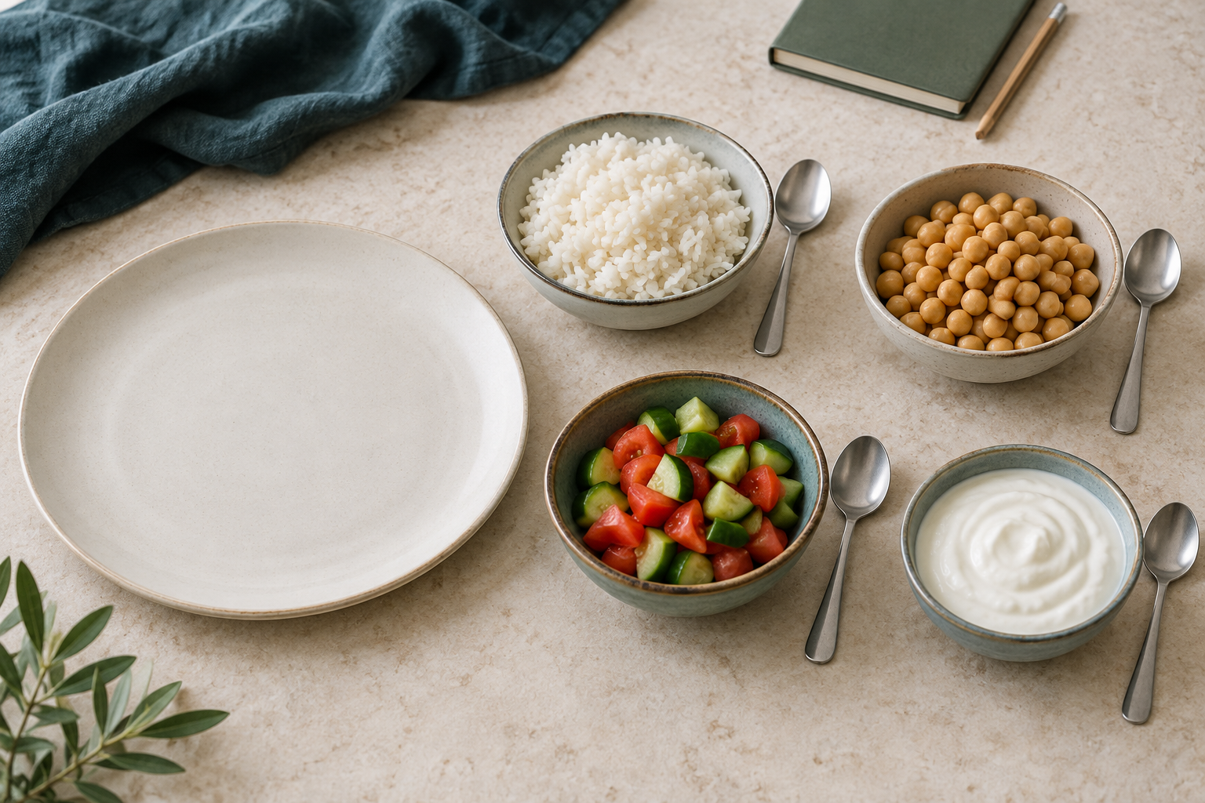
Illustrative components for discussion. Ask about personal requirements; appearance does not establish ingredients, certification or suitability.

Food carries meaning
A food taboo is a social or cultural rule that limits a food or eating practice in a particular context. It may be connected with belief, identity, history, environment, symbolism, safety or community expectations. Understanding that context helps explain why a food familiar to one person may be avoided by another. A designer’s own experience is one viewpoint, not a universal definition of normal food.

Patterns are not universal rules
People within a community do not necessarily observe the same practices. Place, family, migration, generation and personal interpretation can influence how a practice is understood. Practices may also change over time. A statement beginning “everyone in this culture” therefore needs much stronger evidence than a single example or website. Qualified wording such as “some people may observe” makes the scope of a finding more accurate.

Describe before judging
Calling an unfamiliar food disgusting or weird communicates the observer’s reaction but explains little about the food practice. Replace the judgement with a description: name the food, identify the relevant context and investigate who eats or avoids it and why. Respectful investigation can still ask clear questions and compare evidence. It should not turn a person or community into an exhibit or require anyone to explain their identity.

Test the relevance of evidence
A recognised community source may help explain a practice, but check which place, time and community it describes. An older account from another location may be informative without establishing current local observance. Record the source and the limited claim it supports. Before designing for an individual, confirm their actual practice and any ingredient or process boundary. General research can prepare a useful question; it cannot answer that question on the person’s behalf.
Worked reasoning: A fictional article describes a food restriction observed by some families in a particular place. A student writes, “Everyone from that culture avoids it.” The evidence supports a narrower statement: “The article describes this practice among some families in that setting.” The designer still needs a current, relevant source and the individual’s own boundary before deciding what to serve.
SECTION 2.1 / EXPLAIN WITH EVIDENCE

Make the reasoning visible
Food taboos and cultural patterns
Explain how to investigate a food taboo without stereotyping.

Plan your response
Key idea / claim | Evidence or example to connect

Sentence starter: The evidence suggests ... in this context. It does not prove ... I would confirm ...

Check before you finish
Have I answered the prompt, connected evidence to a reason, and named a relevant uncertainty or limit? Revisit the reading if a claim goes beyond what the evidence can show.
Next: complete Section 2.1 in the Practice & Investigation booklet.
SECTION 2.2 / READ AND REASON

Respect the chosen boundary

Identify the source of the boundary
Religious observance may influence permitted ingredients, foods that are avoided, fasting, preparation, certification or separation during production. An ethical choice may respond to animal welfare, labour conditions, environmental effects or fairness. Both can change a menu and a workflow, but their reasons and sources of authority differ. Food design begins by learning the person’s actual boundary rather than assigning one from a group label.

Ask about the individual practice
A broad term such as vegan or vegetarian is useful orientation, but it cannot answer every question about ingredients, processing or personal exceptions. Religious observance also varies between individuals. Ask a relevant, respectful question: which ingredients and processes need to be considered for this brief? Record the stated requirement without treating a person as inconsistent because their own ethical practice differs from an internet definition.

Check ingredients and process
A menu title or symbol provides a starting point for checking, not complete evidence. Read ingredient information, retain packaging and investigate uncertain certification claims. Shared equipment or preparation methods may matter even when each visible ingredient appears suitable. A designer should describe the process honestly and identify what is known, what is unsuitable and what still needs verification. Do not redraw or invent a certification mark.

Make the information transparent
Transparent service makes relevant ingredient and process information available so the person can make an informed choice. It also protects against a guess being repeated as a fact. Compare religious and ethical influences by explaining how each changes the same design decision, then identify their different authorities. A suitable recommendation may require changing an ingredient, separating a process or pausing for clarification; a broad menu label alone cannot settle those decisions.
Worked reasoning: A fictional guest avoids animal-derived ingredients for an ethical reason and asks about a labelled vegan dessert. The menu title is relevant, but the designer checks the full ingredient list and asks about the person’s process boundary. If a topping has unclear ingredients, the correct next step is verification. The guest’s stated requirements guide the decision rather than a guessed rule.

Terms in context
observance • ethical choice • certification • transparency
Use the facing response page to connect the cause of the need, the evidence available and the decision it supports. Complete the matching companion questions and activity after reading.
SECTION 2.2 / EXPLAIN WITH EVIDENCE

Make the reasoning visible
Religious and ethical food choices
Compare one religious and one ethical influence on food design.

Plan your response
Key idea / claim | Evidence or example to connect

Sentence starter: Both choices may affect ... The religious boundary may ... while the ethical boundary may ...

Check before you finish
Have I answered the prompt, connected evidence to a reason, and named a relevant uncertainty or limit? Revisit the reading if a claim goes beyond what the evidence can show.
Next: complete Section 2.2 in the Practice & Investigation booklet.
SECTION 2.3 / READ AND REASON

Investigate without assumptions

Authority depends on the question
A reliable source has a clear basis for the claim it makes. A government food regulator can explain Australian labelling rules; a recognised community source can explain the practices within its stated context; a first-person account can describe lived experience. None automatically answers every question. Ask who created the information, what expertise or standing they have and whether that authority matches the decision you need to make.

Check purpose, currency and evidence
A source may aim to inform, represent a community, persuade or sell. Its purpose can shape what it includes and leaves out. Check when the information was produced or updated, which evidence it uses and whether its place and audience match the brief. An authoritative source from another country may be useful background while remaining insufficient for a current Australian label rule or a local practice.

Respect permission and limits
Cultural knowledge is not simply material available for anyone to copy. Local Aboriginal Cultural Knowledge requires appropriate local authority and permission. Finding material online or combining several general accounts does not create that authority. Cultural humility means recognising the limits of your knowledge and seeking the right guidance. You can describe the research question and permission required without inventing the answer or speaking on a community’s behalf.

Make the conclusion traceable
Record the source title, organisation or author, date, link and relevant finding. Explain which limited claim the evidence supports and what remains unresolved. When credible sources disagree, compare their contexts rather than hiding the disagreement or choosing the shortest answer. A final use decision may be to use a source for a narrow claim, combine it with another source, or pause until the necessary authority and permission are established.
Worked reasoning: Two fictional source cards discuss a food practice: a current community page describes its own event, while an old overseas article claims that everyone follows one rule. For a current local event, the community page is more relevant, but it still cannot establish every individual’s practice. The student records the limited finding and identifies who can confirm the actual design boundary.

Terms in context
authority • currency • relevance • cultural humility
Use the facing response page to connect the cause of the need, the evidence available and the decision it supports. Complete the matching companion questions and activity after reading.
SECTION 2.3 / EXPLAIN WITH EVIDENCE

Make the reasoning visible
Respectful investigation and evidence
Evaluate whether a source is strong enough for a cultural-food design decision.

Plan your response
Key idea / claim | Evidence or example to connect

Sentence starter: This source is/is not suitable because its authority ... Its purpose ... A remaining limitation is ...

Check before you finish
Have I answered the prompt, connected evidence to a reason, and named a relevant uncertainty or limit? Revisit the reading if a claim goes beyond what the evidence can show.
Next: complete Section 2.3 in the Practice & Investigation booklet.
SECTION 3.1 / READ AND REASON

Needs change across life
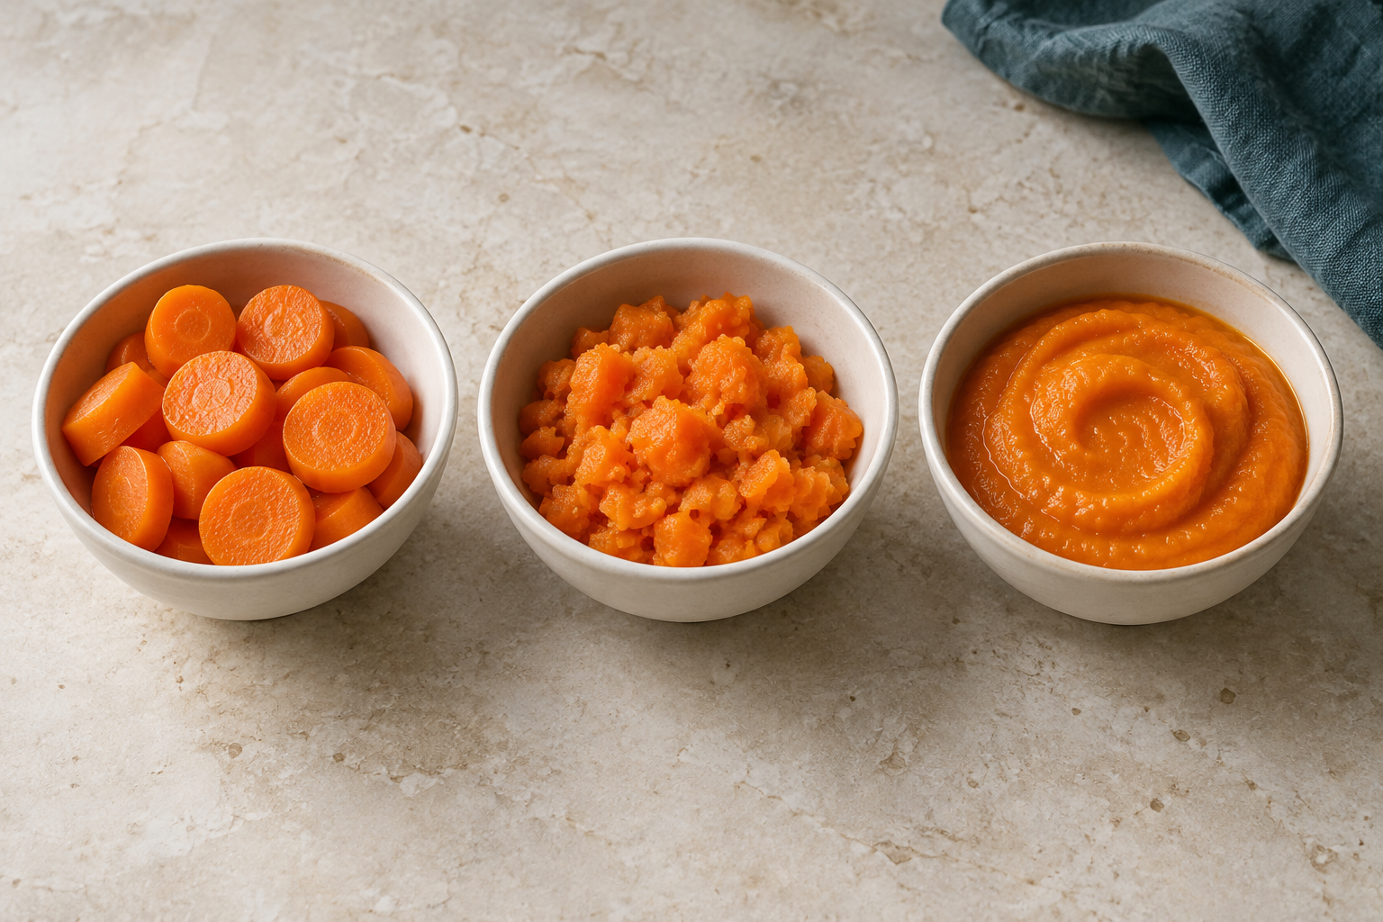
Illustrative texture comparison: rounds, coarse mash and smooth puree. These appearances do not prescribe a texture for any age or medical need.

Needs change through life
The lifecycle includes infancy, childhood, adolescence, adulthood and older age. Growth rate, body size, activity, pregnancy, breastfeeding, health and ageing can change nutrition priorities. These influences explain why one standard menu cannot suit every stage or every person within a stage. Lifecycle analysis should connect a change with a reason and then consider a practical food response, while keeping individual requirements visible.

Link development with practicality
Infancy involves rapid early growth and developing eating skills, so appropriate feeding and texture need current guidance from the responsible adults and qualified professionals. During adolescence, growth combines with increasing independence and activity. In older age, appetite, access, preparation effort or physical ability may affect meals, although these vary greatly between people. Do not assume that everyone of the same age has the same abilities or difficulties.

Use broad guidance carefully
Australian dietary guidance provides a population planning framework. It does not diagnose a person’s nutrient status or authorise a student to prescribe supplements. Culture, health, resources, preferences and the eating occasion also shape the response. An active person and a less active person within the same stage may have different energy needs. Appearance alone cannot establish those needs or show that someone has a deficiency.

Explain a design response
A useful explanation follows “stage, reason, response”. An older adult whose fictional brief states a low appetite may benefit from an idea that places useful nutrients in manageable portions, but the actual person’s advice and preferences still matter. Texture, portion, food access and preparation effort need evidence from the brief. Evaluate whether the response is achievable and record what requires professional or teacher confirmation instead of claiming an age-based menu is perfect.
Worked reasoning: Two fictional briefs describe an adolescent taking lunch to school and an older adult who prefers small meals. Both need varied suitable food, but their contexts differ. The adolescent’s design needs transport and storage planning; the older adult’s design may focus on manageable portions and preparation effort. The distinction comes from the supplied circumstances, not an assumption that age alone fixes a menu.
SECTION 3.1 / EXPLAIN WITH EVIDENCE

Make the reasoning visible
How needs change across life stages
Explain why nutrition priorities change across two lifecycle stages.

Plan your response
Key idea / claim | Evidence or example to connect

Sentence starter: During ... the priority is ... because ... By contrast, during ...

Check before you finish
Have I answered the prompt, connected evidence to a reason, and named a relevant uncertainty or limit? Revisit the reading if a claim goes beyond what the evidence can show.
Next: complete Section 3.1 in the Practice & Investigation booklet.
SECTION 3.2 / READ AND REASON

Support adolescent growth

Growth meets independence
Adolescence combines growth with more independent decisions about food. A school timetable, travel, activities, friends and available money can influence when and what a student eats. A useful plan supports a varied food pattern while fitting those circumstances. It should not judge health from body shape, compare classmates’ bodies or treat a fashionable nutrition claim as a measure of whether someone is eating well.

Connect foods with their contribution
Regular meals and varied choices across the five food groups help supply energy and nutrients. Protein contributes to growth and repair, calcium is important for bones, and iron is relevant to growth and individual physiological needs. Foods contribute combinations of nutrients, so planning is more useful than searching for one perfect ingredient. A broad food-group pattern helps identify variety without turning the exercise into a personal medical assessment.

Reference values need context
Nutrient reference values describe population guidance. They do not establish an individual diagnosis, and a classroom calculation cannot show that a person needs a supplement. Age, body size, activity, health and other circumstances can affect needs. Restrictive diets and supplements should not be recommended casually. If a real person has symptoms, a diagnosed condition or a treatment question, an appropriately qualified health professional needs to guide individual advice.

Plan for an actual school day
Consider the time available before school, recess and lunch breaks, transport, safe storage and the journey home. A nutritious idea is incomplete if the person cannot obtain it or keep it suitably stored. Explain affordable, available choices and realistic preparation steps. Evaluate variety and practicality together, and describe what would need changing if the timetable, activity or access changed. Use fictional briefs when discussing these issues so private household information is not required.
Worked reasoning: A fictional student leaves early and has only ten minutes for breakfast. A complicated cooked meal may look appealing but does not fit. A simpler breakfast, packed lunch and planned after-school food can distribute variety across the day. The designer explains how each choice fits time and access, and checks storage rather than assuming every food can remain in a school bag.

Terms in context
adolescence • food-group variety • reference value • access
Use the facing response page to connect the cause of the need, the evidence available and the decision it supports. Complete the matching companion questions and activity after reading.
SECTION 3.2 / EXPLAIN WITH EVIDENCE

Make the reasoning visible
Adolescent nutrition and growth
Justify a realistic school-day food pattern for an adolescent.

Plan your response
Key idea / claim | Evidence or example to connect

Sentence starter: This pattern supports ... through ... It is realistic because ... It would need adjusting if ...

Check before you finish
Have I answered the prompt, connected evidence to a reason, and named a relevant uncertainty or limit? Revisit the reading if a claim goes beyond what the evidence can show.
Next: complete Section 3.2 in the Practice & Investigation booklet.
SECTION 3.3 / READ AND REASON

Design for a life stage
Illustrative texture comparison: rounds, coarse mash and smooth puree. These appearances do not prescribe a texture for any age or medical need.

Turn the lifecycle brief into a problem
A lifecycle meal brief identifies the stage, person or fictional user, eating occasion, broad priorities and practical constraints. It may specify equipment, preparation time, budget, transport or a verified food need. Texture and portion can matter too, but their importance must come from the brief rather than an age stereotype. These details give the designer a problem that can be explored and evaluated.

Write criteria that can be tested
Criteria describe what a successful response must achieve. “Looks good” leaves the judgement unclear; “can be prepared in thirty minutes using the listed equipment” can be tested through a workflow. Variety across food groups, cost within a limit and suitable packing may also be criteria. State how evidence will be collected for each one, because a criterion without a way to check it remains difficult to evaluate.

Compare more than one idea
Sketching or describing alternatives reveals choices that may otherwise be missed. Two ideas can meet similar nutrition priorities yet differ in cost, preparation effort or likely acceptance. Compare them against the same criteria. A microwave-only brief, for example, constrains the available method. A meal that needs unavailable equipment must be revised even if its ingredients look suitable. Explain the trade-off when choosing the stronger idea.

Use evidence to improve the design
Evaluation compares evidence with each criterion and records whether it is met, partly met or not met. A proposed packed lunch may meet variety and cost criteria while failing its storage requirement. The useful response is a specific revision connected to that failure. Distinguish predicted results from actual tested results. A classroom design can claim to meet its supplied brief; it cannot guarantee individual medical suitability or practical success without the relevant checks.
Worked reasoning: A fictional meal must take no more than thirty minutes and use only a microwave. Idea A needs forty minutes in an oven; Idea B fits the available method and estimated time. B is stronger on these two criteria, but it still needs ingredient and storage checks. The evaluation identifies the evidence used and the remaining tests, rather than treating selection as approval.
SECTION 3.3 / EXPLAIN WITH EVIDENCE

Make the reasoning visible
Designing a lifecycle meal
Evaluate a lifecycle meal idea against two measurable criteria.

Plan your response
Key idea / claim | Evidence or example to connect

Sentence starter: The idea meets ... because the evidence shows ... It partly meets ... A useful improvement is ...

Check before you finish
Have I answered the prompt, connected evidence to a reason, and named a relevant uncertainty or limit? Revisit the reading if a claim goes beyond what the evidence can show.
Next: complete Section 3.3 in the Practice & Investigation booklet.
SECTION 4.1 / READ AND REASON

Allergy versus intolerance

Use the terms accurately
Food allergy involves an immune response to an allergen in food. Reactions can be mild or severe, and anaphylaxis can be life-threatening. Food intolerance is different: it does not involve the immune system in the same way and may involve difficulty digesting a component. The distinction changes risk communication and controls. It does not make an intolerance imaginary or give classmates permission to dismiss the person’s experience.

A similar symptom is not a diagnosis
Students should not diagnose a condition by comparing symptoms or asking someone to try a small amount of food. Lactose intolerance and milk allergy illustrate why precise information matters: lactose is a sugar, while milk allergy concerns proteins. Lactose-free dairy can still contain milk proteins. Coeliac disease is an autoimmune condition, not a food allergy. Use the confirmed requirement and approved plan rather than guessing from a food label or condition name.

Communicate within your role
For classroom planning, record the verified food or component of concern, the required controls and who can clarify uncertainty. The individual management information available to the school and current school procedures guide action. A previous mild reaction does not justify dismissing the possibility of a severe one. Keep relevant design evidence in the folio without copying unnecessary private medical history, and refer clinical questions to appropriate professionals.

Recognise the emergency boundary
Suspected anaphylaxis requires immediate emergency action: call Triple Zero (000), alert staff and follow the person’s emergency plan and school emergency procedures. Do not wait for an ordinary design approval or use tasting to investigate the cause. Classroom reading does not replace first-aid training, an ASCIA Action Plan or professional care. An accurate food-design explanation states what is verified, what must be controlled and where the student’s responsibility ends.
Worked reasoning: A fictional package says “lactose-free milk”. A student treats that phrase as approval for a milk-allergy brief. The reasoning fails because reducing lactose does not remove milk proteins. The product cannot be approved from that claim. The student stops the planning decision and refers to the verified requirement; this is different from an emergency, when suspected anaphylaxis needs immediate action and 000.

Terms in context
allergy • intolerance • anaphylaxis • approved plan
Use the facing response page to connect the cause of the need, the evidence available and the decision it supports. Complete the matching companion questions and activity after reading.
SECTION 4.1 / EXPLAIN WITH EVIDENCE

Make the reasoning visible
Allergy versus intolerance
Explain why allergy and intolerance require different risk communication.

Plan your response
Key idea / claim | Evidence or example to connect

Sentence starter: An allergy involves ... and can ... An intolerance ... Therefore the designer must ...

Check before you finish
Have I answered the prompt, connected evidence to a reason, and named a relevant uncertainty or limit? Revisit the reading if a claim goes beyond what the evidence can show.
Next: complete Section 4.1 in the Practice & Investigation booklet.
SECTION 4.2 / READ AND REASON

Read labels; trace transfer
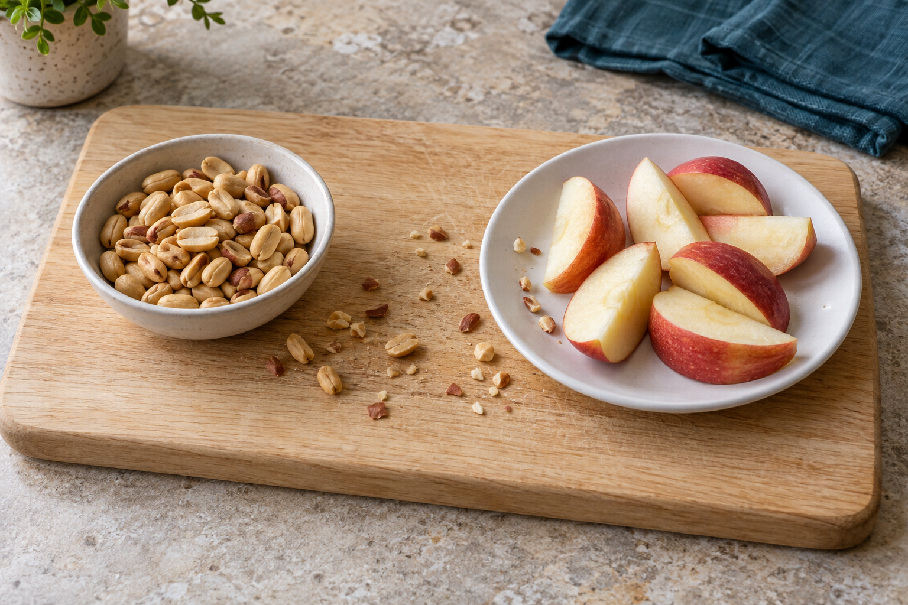
Illustrative problem scene, not an approved setup. Peanut fragments on a shared surface and plate show a potential cross-contact route.

Read the current package
A recipe title, remembered purchase or front-of-pack claim does not establish suitability for a diagnosed food need. Ingredients and manufacturing information can change, so inspect the complete current package at purchase and before use. Record the product, date checked, relevant ingredient or allergen statement and decision. Retaining packaging supports a later check and helps prevent a different product being substituted without anyone noticing.

Locate the allergen evidence
Australian labels provide allergen information through required declarations, including the ingredient list and a separate “Contains” summary where required. Precautionary statements such as “may contain” address possible unintended presence; they are not a signal that the product is automatically suitable. Apply the verified individual plan and school rule. If packaging is missing, wording is unclear or a decisive fact cannot be checked, stop and seek confirmation rather than filling the gap with an assumption.

Trace the transfer pathway
Cross-contact is the unintended transfer of an allergen into another food. Residue can move through hands, knives, boards, storage containers, equipment or service utensils. Imagine the path from a shared knife to a board and then to ready-to-eat food. Removing a visible ingredient does not remove every possible residue. A label check and a workflow check answer different questions, so both are needed.

Match a control to each risk
Plan the order of work, use the approved cleaning procedure, separate ingredients and equipment where required, and prevent mix-ups at storage and service. Communication matters: the food and its retained information need to stay correctly identified. A decision can be to proceed under an approved plan, reject a product or stop for teacher confirmation. The record should explain the evidence and remaining uncertainty; a classroom workflow cannot promise zero risk.
Worked reasoning: A fictional ingredient label appears to match a stated brief, but the workflow uses the same unverified serving spoon for two dishes. The package check has not answered the transfer question. The student marks that pathway unresolved and stops for teacher confirmation of the required control. Removing a visible ingredient or simply using a clean-looking spoon would not establish that the control had been met.
SECTION 4.2 / EXPLAIN WITH EVIDENCE

Make the reasoning visible
Labels, allergen risk and cross-contact
Explain a safe label-and-workflow check for a supplied diagnosed need.

Plan your response
Key idea / claim | Evidence or example to connect

Sentence starter: First I would verify ... on the current package. I would then control ... If uncertain, I would ...

Check before you finish
Have I answered the prompt, connected evidence to a reason, and named a relevant uncertainty or limit? Revisit the reading if a claim goes beyond what the evidence can show.
Next: complete Section 4.2 in the Practice & Investigation booklet.
SECTION 4.3 / READ AND REASON

Plan from a diagnosed need

Start from approved information
A production plan for a diagnosed need begins with the individual management information available to the school. Identify the food or component of concern, the required avoidance or inclusion, and the authority responsible for confirmation. A generic substitution list cannot replace these instructions. Keep verified facts separate from assumptions, and record only information relevant to the task so the plan supports action without collecting unnecessary private details.

Follow the complete food pathway
Trace purchasing, storage, preparation, cooking, service and clean-up. A suitable ingredient can become unsuitable if a process transfers an allergen or the wrong dish is served. Work order helps manage shared equipment, time and transfer risks. The plan needs to explain how ingredients stay identified, when labels are checked, which workspace and equipment controls apply, and how the finished food reaches the correct person.

Build in a real stop point
A useful stop point occurs before a decision can introduce risk, such as teacher verification of a current label before a package is opened. If the recipe conflicts with the individual plan, change the proposal or do not proceed. If equipment, information or required controls are unavailable, pause and tell the teacher. An attractive outcome or an approaching deadline does not justify improvising around a failed control.

Evaluate what actually happened
During an authorised practical, record whether the planned controls were followed and describe any problem or change honestly. Retain labels and handle opened packs or leftovers according to school procedure. If a control fails, stop, communicate and avoid claiming suitability. A responsible conclusion says the process reduced identified risks within approved procedures and states remaining limitations. A completed plan is evidence of thinking; it does not prove that the practical was performed or guarantee zero risk.
Worked reasoning: A fictional plan requires the current package to be checked before opening. During preparation, the team discovers that an ingredient has been transferred into an unlabelled container. The planned control has failed. They stop and tell the teacher instead of assuming it is the intended product. Their evaluation records the missing traceability and the decision, even if no finished dish is produced.

Terms in context
workflow • verification point • control failure • traceability
Use the facing response page to connect the cause of the need, the evidence available and the decision it supports. Complete the matching companion questions and activity after reading.
SECTION 4.3 / EXPLAIN WITH EVIDENCE

Make the reasoning visible
Planning food for a person with a diagnosed need
Justify a safer production plan without claiming zero risk.

Plan your response
Key idea / claim | Evidence or example to connect

Sentence starter: The plan reduces risk by ... The stop point is ... It cannot guarantee suitability because ...

Check before you finish
Have I answered the prompt, connected evidence to a reason, and named a relevant uncertainty or limit? Revisit the reading if a claim goes beyond what the evidence can show.
Next: complete Section 4.3 in the Practice & Investigation booklet.
SECTION 5.1 / READ AND REASON

Look beyond the product claim

Identify what has changed
A nutritionally modified food has a changed nutrient profile, such as reduced sodium or increased protein. Fortification adds vitamins or minerals under conditions permitted by the Food Standards Code. Enrichment commonly describes restoring nutrients lost during processing. These terms explain a change, not a guarantee of suitability. A population fortification program may address a recognised public-health need, while a particular product still needs checking against the individual brief.

Read beyond the front claim
A nutrition-content claim describes a property such as the amount of a nutrient. A health claim concerns a relationship between food and a health effect. Australian rules set conditions for making these claims. Packaging language should lead you to evidence in the nutrition information panel, ingredients and relevant rules. A claim about one nutrient does not evaluate every aspect of a product or establish that it suits all specific needs.

Compare like with like
Record the intended purpose of the modification, then compare products on a common basis. Per-100-gram or per-100-millilitre figures help compare concentration, while per-serve information helps interpret the stated portion. Check serving size, ingredients, cost and practical access as well as the nutrient of interest. A product with added iron, for example, is nutritionally modified, but its name alone cannot diagnose a deficiency or show that it is the best choice.

Explain benefit and limitation
A useful judgement connects the product change to a verified requirement and states the evidence. It also identifies limitations: an ingredient may conflict with the brief, the cost may be too high or individual advice may still be needed. “Fortified” does not mean universally suitable. Choose a product only when the comparison supports the stated purpose, and keep current label checks and any professional advice separate from a classroom marketing claim.
Worked reasoning: Two fictional drinks are compared for a classroom brief seeking a calcium-containing option. Product A lists added calcium; Product B makes an appealing front claim but supplies no calcium figure in the mock data. A provides more relevant evidence, but the designer must still inspect its ingredients and cost. Missing evidence for B is a reason to qualify the comparison, not invent a number.

Terms in context
modification • fortification • enrichment • nutrition-content claim
Use the facing response page to connect the cause of the need, the evidence available and the decision it supports. Complete the matching companion questions and activity after reading.
SECTION 5.1 / EXPLAIN WITH EVIDENCE

Make the reasoning visible
Nutritionally modified and fortified foods
Explain how one nutritionally modified food responds to a specific need.

Plan your response
Key idea / claim | Evidence or example to connect

Sentence starter: The product is ... It has been modified by ... This may support ... but the label still needs ...

Check before you finish
Have I answered the prompt, connected evidence to a reason, and named a relevant uncertainty or limit? Revisit the reading if a claim goes beyond what the evidence can show.
Next: complete Section 5.1 in the Practice & Investigation booklet.
SECTION 5.2 / READ AND REASON

Fibre in a varied pattern
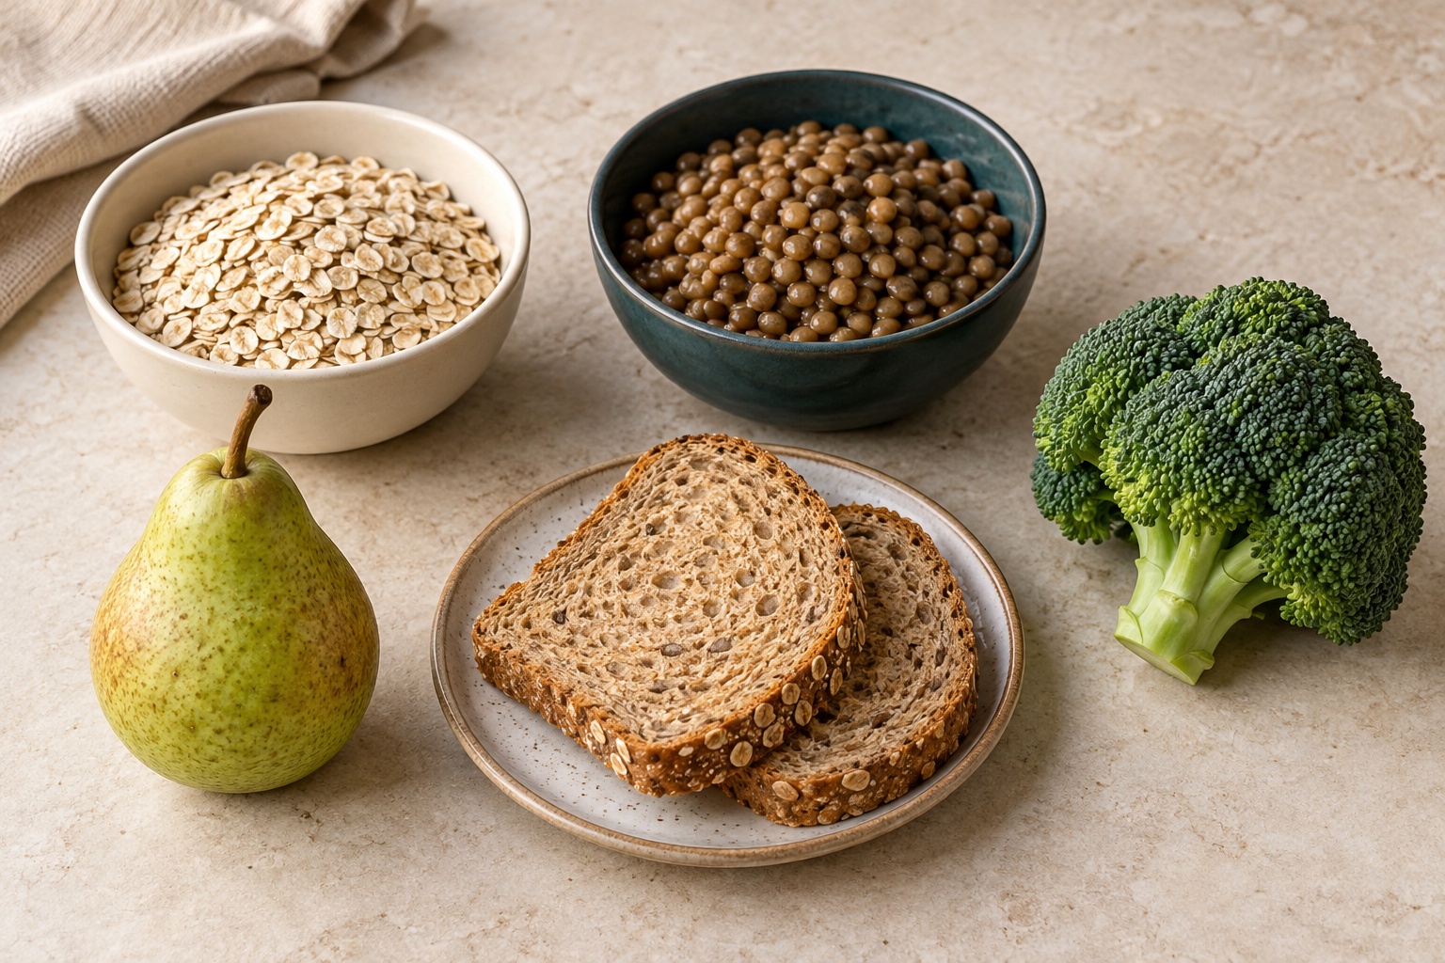
Illustrative fibre-containing foods: oats, lentils, wholegrain bread, pear and broccoli. A varied pattern involves several foods; no serving target is shown.

Understand fibre’s contribution
Dietary fibre includes plant components that resist digestion and absorption in the small intestine. It contributes to normal bowel function and occurs in wholegrains, legumes, vegetables, fruit, nuts and seeds. Foods contain different types and amounts, so variety matters. Soluble fibre can form a gel and slow digestion; insoluble fibre adds bulk and supports regularity. This broad distinction helps explain functions without treating one product as a cure.

Interpret the reference table
Australian adequate-intake values for ages nine to thirteen are 24 grams per day for boys and 20 grams for girls. For ages fourteen to eighteen, the values are 28 grams and 22 grams respectively. These are population reference values, not personal treatment targets or evidence of a diagnosis. The table helps interpret broad guidance; it does not allow a student to prescribe intake for a classmate.

Improve a pattern through realistic swaps
Look across the day for opportunities rather than depending on a single “high fibre” label. A wholegrain bread may provide more fibre than a lower-fibre white bread, while fruit, vegetables, oats and legumes can contribute variety in different meals. Use the actual product information when a numerical comparison is needed. An affordable familiar swap that fits the person’s routine is more useful than an elaborate suggestion they cannot obtain or prepare.

Include fluids and individual context
Fibre absorbs fluid, so include water and other suitable fluids in the planning discussion. Make general dietary changes gradually because sudden large increases can cause discomfort. The task is to explain an achievable food pattern, not treat constipation or another condition. Symptoms, diagnosed needs and treatment questions require individual professional advice. Evaluate the proposal against cost, access, preference and practicality, and make any uncertainty visible instead of promising a particular health outcome.
Worked reasoning: A fictional day contains lower-fibre white toast and few plant foods. The student proposes wholegrain toast and fruit at breakfast, then adds vegetables or legumes elsewhere in the pattern. Each change has a practical reason and the plan includes water and gradual change. The student does not claim that these swaps treat symptoms or calculate an exact intake without reliable quantities and product data.
SECTION 5.2 / EXPLAIN WITH EVIDENCE

Make the reasoning visible
Dietary fibre and adolescent needs
Design and justify a practical way to increase fibre for an adolescent.

Plan your response
Key idea / claim | Evidence or example to connect

Sentence starter: I would add/swap ... because it provides ... This is practical because ... Water and gradual change matter because ...

Check before you finish
Have I answered the prompt, connected evidence to a reason, and named a relevant uncertainty or limit? Revisit the reading if a claim goes beyond what the evidence can show.
Next: complete Section 5.2 in the Practice & Investigation booklet.
SECTION 5.3 / READ AND REASON

Know who can help

Match help to the need
A support network connects people and services with different responsibilities. Family and trusted adults may help with daily routines and practical access. School staff organise the relevant school procedures. A general practitioner, accredited practising dietitian or specialist can provide qualified care within their role. Emergency services respond to urgent situations. Mapping these roles shows why one website or one helpful person cannot meet every information, practical and clinical need.

Use recognised information sources
Healthdirect, Allergy & Anaphylaxis Australia, ASCIA, Coeliac Australia and Diabetes Australia are recognised Australian starting points for relevant information. Their education and resources can help people understand a condition or prepare questions, but a general page does not replace the treating team or approve an individual meal. Peer groups may contribute lived experience and encouragement while lacking authority to diagnose or prescribe treatment. The value of a source depends on the question.

Evaluate access as well as accuracy
Check a service’s authority, purpose, evidence and currency, then consider whether the person can actually use it. Record a website or other verified access route and identify any practical barrier described in the brief, such as transport, language, opening times or internet access. Do not invent contact details or assume availability. A recommendation should explain what help is reachable and which unanswered need requires another person or service.

Make referral and urgency clear
A strong network plan states who does what and how the supports connect. Refer individual clinical decisions to the treating professionals and school-controlled questions to staff. Suspected anaphylaxis requires immediate emergency action and Triple Zero (000), alongside the relevant emergency plan and school procedures; browsing an information page is not the urgent response. Evaluate the network by its accuracy, accessibility, coordination and limits, using evidence instead of simply counting the number of organisations.
Worked reasoning: A fictional excursion brief concerns a student with a diagnosed milk allergy. Family and school staff help communicate the approved information and practical arrangements; recognised allergy resources support general understanding; the treating team handles individual clinical questions. The network also needs an emergency pathway. The designer records these different roles and access routes rather than treating a useful website as permission to serve food.

Terms in context
support network • referral • accessibility • scope
Use the facing response page to connect the cause of the need, the evidence available and the decision it supports. Complete the matching companion questions and activity after reading.
SECTION 5.3 / EXPLAIN WITH EVIDENCE

Make the reasoning visible
Support networks and evaluating reliable help
Evaluate a support network for a person with a specific food need.

Plan your response
Key idea / claim | Evidence or example to connect

Sentence starter: This network can provide ... It can be accessed by ... Its limit is ... For urgent help ...

Check before you finish
Have I answered the prompt, connected evidence to a reason, and named a relevant uncertainty or limit? Revisit the reading if a claim goes beyond what the evidence can show.
Next: complete Section 5.3 in the Practice & Investigation booklet.
LEARNING TOOLS / USE WITH YOUR FOLIO

From a need to a decision
An effective decision follows a chain: person and occasion → verified need → evidence → possible response → checks before action. Keep the reason for each link visible so another person can follow your thinking.
Part of the chain | Fictional example
Person and occasion | Sam needs a packed lunch for a school excursion.
Verified context | The fictional brief says there is no reheating equipment.
Possible response | A cold meal is proposed, with appropriate storage to be confirmed.
Evidence still needed | Current ingredients, the actual lunch storage arrangement and school food-safety controls.

Separate fact, assumption and question
“There is no reheating equipment” is a given fact in this fictional brief. “All cold foods will remain suitable until lunch” is an unsafe assumption. “How will this food be stored and transported?” is a question that must be resolved before production.
Your task: identify a second assumption someone could make about Sam. Replace it with a specific question and name who could confirm the answer.

Transfer to the folio
In Stage 1, identify the actual or fictional user without collecting private medical details. Mark every unresolved constraint “Teacher to confirm” and revisit it before practical work.
LEARNING TOOLS / USE WITH YOUR FOLIO

Ask respectfully; record precisely
Illustrative components for discussion. Ask about personal requirements; appearance does not establish ingredients, certification or suitability.
Unhelpful assumption | A more useful question
Everyone in this community eats the same way. | Which practices matter for this particular occasion and person?
The dish looks vegetarian, so it meets the brief. | Which ingredient and preparation boundaries need to be checked?
A person must explain their private history. | Which practical requirements are necessary for this design?

Consent and scope
Explain the purpose of an investigation, ask permission and accept a person’s choice not to answer. Record only information needed for the design. A community source can explain a practice in context; it cannot confirm every individual’s observance.
Rewrite: “You are from this culture, so you cannot eat this.” Make it a respectful question that could inform a food decision.

LEARNING TOOLS / USE WITH YOUR FOLIO

Development changes the question
Illustrative texture comparison: rounds, coarse mash and smooth puree. These appearances do not prescribe a texture for any age or medical need.
Lifecycle planning considers growth, development, activity, access and individual circumstances. Age is useful context, but a category such as “child” or “older adult” does not prescribe one menu. Observe the problem, confirm the actual requirement and identify the appropriate source.
Context | Planning question
Growing adolescent | How can the response support variety and relevant nutrients within the brief?
Changing ability to prepare food | Which equipment, time or assistance is actually available?
A stated texture requirement | Who has specified it, and what approved instructions must be followed?

Use the photograph: describe two visible texture differences. Explain why appearance alone cannot decide which sample a particular person should eat.

LEARNING TOOLS / LABEL DECISIONS

Follow the evidence chain
A similar-looking meal can need very different controls. Establish the actual requirement before choosing a response.
Question | Evidence to use | Decision it supports
What is the actual need? | Verified brief; approved individual plan when relevant | Define the requirement without collecting private medical history
What is in this product now? | Current ingredients and allergen declarations | Identify ingredients to check against the requirement
Could transfer occur? | Ingredients, surfaces, utensils and workflow | Identify cross-contact controls and teacher-owned stop points
Who resolves uncertainty? | Teacher; person’s approved plan and appropriate professionals | Pause preparation or service until the boundary is resolved

Allergy and intolerance are different
Food allergy involves the immune system and can cause a severe reaction such as anaphylaxis. Intolerance has a different mechanism. Lactose-free dairy may still contain milk protein, so the lactose-free claim does not establish suitability for milk allergy. Do not test a person’s tolerance in class.

Separate prevention from an emergency
During planning, an unclear requirement is a reason to stop and ask the teacher. If anaphylaxis is suspected, follow the school emergency procedure and the person’s action plan immediately, alert staff and call 000. Do not wait for a routine planning discussion.
Application: A label says “plant-based”. Explain why this description alone cannot settle a milk-allergy requirement.

LEARNING TOOLS / USE WITH YOUR FOLIO

Spot the cross-contact route
Illustrative problem scene, not an approved setup. Peanut fragments on a shared surface and plate show a potential cross-contact route.

Observe before proposing a control
The illustration deliberately shows a problem. Visible peanut fragments extend across the shared board and onto the plate rim. A food’s original ingredients do not describe every possible route of allergen transfer during handling.
Identify two observations from the scene. Explain the possible route of transfer and the next teacher-owned decision before any food is handled or served.

A photograph cannot show invisible residues, verify cleaning, establish a person’s allergy or approve a meal. Use current product evidence, the approved individual plan and local procedures.
LEARNING TOOLS / PRODUCTS AND COST

Compare a common amount
Fictional classroom data. These figures are invented for calculation practice and are not a product recommendation.
Fictional drink | Carton volume | Carton cost | Calcium per 100 mL
Drink A | 1000 mL | $2.40 | 120 mg
Drink B | 750 mL | $2.10 | 100 mg

First choose a comparison basis
The smaller carton costs less at the checkout, but it also contains less drink. Comparing both products per litre reveals a different relationship. A costs $2.40 per litre. B costs $2.10 ÷ 0.75 = $2.80 per litre. Record the unit so the numbers can be interpreted.
For a fictional 200 mL amount: A costs $2.40 × 200 ÷ 1000 = $0.48 and provides 120 × 200 ÷ 100 = 240 mg calcium. B costs $2.10 × 200 ÷ 750 = $0.56 and provides 100 × 200 ÷ 100 = 200 mg calcium.

Make a bounded decision
A has the lower cost and more calcium for the same 200 mL in this dataset. That comparison does not establish overall suitability. Current ingredient and allergen evidence, the verified brief and other relevant nutrients still matter. A 200 mL calculation is an example amount, not an individual serving recommendation.

Your turn
Calculate the cost and calcium for 150 mL of B. Show units and explain one limit of the calculation.

LEARNING TOOLS / USE WITH YOUR FOLIO

Confirm the recipe before making
The course contains nine recipe reproductions. A recipe title is a starting point for investigation; it does not confirm suitability for a particular need. Your teacher must select and confirm a current recipe master before practical work.
Course recipe register | Teacher-confirmed copy / date
Banoffee Chia Pudding
Dairy Free Chocolate Coconut Custard
Gluten Free Pineapple Upside Down Cake
High Fibre Banoffee Chia Pudding
High Protein Flank Steak Quinoa
Keto Ricotta Pancakes
Paleo Peri-Peri Chicken Sweet Potato Fries
Peri-Peri Chicken Sweet Potato Fries
Vegan Carrot Cupcakes

Some source reproductions contain inconsistent quantities or incomplete method steps. The teacher guide records these issues. Do not guess missing steps, silently change a quantity or treat a copied recipe as an approved master.
Attach the teacher-confirmed recipe to your workbook. Record its title, version/date, intended portions and any approved adaptation. Current labels and school controls must still be checked.

Recipe chosen and confirmation needed

LEARNING TOOLS / USE WITH YOUR FOLIO

Choose a source for its role
Source or support | Can help with | Does not automatically provide
Family or trusted adult | Practical support, access and personal context | A diagnosis or universal nutrition advice
Qualified health professional | Individual assessment and professional guidance | A substitute for school practical procedures
Recognised organisation | General evidence and education | A decision about every individual case
Teacher | School task, resources, practical approval and procedures | An invented medical requirement

Inspect the claim
Ask who produced the information, which evidence supports it, how current it is and whether the author is qualified for this question. Check for commercial interests and whether a broad claim has been stretched beyond its source. Availability and cost can also affect whether a support service is accessible.
Fictional claim: “This supplement fixes every teenager’s tiredness.” Name two reasons the claim needs scrutiny. Identify a suitable next source of help.

A classroom discussion cannot diagnose tiredness or recommend an individual supplement. Persistent concerns belong with a trusted adult and an appropriate qualified health professional.
LEARNING TOOLS / USE WITH YOUR FOLIO

Bring the ideas together
Five original course questions, revisited across the modules. Circle the best answer, then check the matching explanation in the teacher guide.
1. Which situation is a specific food need rather than a menu preference?
○ A. Ordering the first item pictured
○ B. A diagnosed peanut allergy with an individual plan
○ C. Choosing the blue plate
2. What is a food taboo?
○ A. A context-dependent social rule about food
○ B. A universal list of poisonous foods
○ C. A nutrient reference value
3. Why do nutrition priorities change through life?
○ A. Food groups disappear
○ B. Everyone develops the same preference
○ C. Growth, body size, activity, health and ageing change
4. Which body system is involved in food allergy?
○ A. The skeletal system
○ B. The immune system
○ C. Only the digestive system
5. What is food fortification?
○ A. Adding nutrients to food for a defined purpose
○ B. Removing every ingredient
○ C. Changing only the package colour
LEARNING TOOLS / USE WITH YOUR FOLIO

Language for evidence-based design
Term | Meaning in this unit
Verified need | A requirement supported by the appropriate person, plan or source.
Constraint | A boundary such as time, cost, equipment, ingredients or access.
Food taboo | A restriction with a particular social or cultural context.
Cross-contact | Unintended transfer of an allergen from another food or surface.
Fortified food | A food with specified nutrients added; the claim still needs evidence.
Dietary fibre | Components of plant foods that are not digested in the small intestine.
Criterion | An observable test used to judge whether a response meets the brief.
Limitation | What evidence does not show, or what remains unconfirmed.

Keep learning connected
Read the matching course sections and complete the paper companion. Your teacher can pair them with the website’s slides, videos and demonstrations. Each section has a reading, a worked example, an extended response and an activity route.
Course: https://stevencowell.github.io/Food-for-Specific-Needs/
General evidence: eatforhealth.gov.au • foodstandards.gov.au • healthdirect.gov.au • allergy.org.au. The teacher guide lists the exact sources and verification date.
Use a label such as “fictional”, “observed”, “predicted” or “Teacher to confirm” whenever it changes what your record can honestly show.
FOLIO / STAGE 1 OF 8

The need and design brief
Define the problem, intended user and required result without recording unnecessary private medical details.
Evidence: A clear brief showing the person, occasion, verified need, constraints and items marked Teacher to confirm.
Brief element | Your verified facts / questions
Person and occasion
Need and authority
Required result
Constraints
Teacher to confirm

Think: What must this food response achieve, and what information is authoritative?
Sentence starter: The design brief asks me to ... for ... The verified requirement is ...

FOLIO / STAGE 2 OF 8

Success criteria
Turn the brief into a small set of observable tests.
Evidence: Four to six criteria covering the verified need, nutrition, practicality, cost, safety and respectful practice.
Observable criterion | How will you check it?

Think: How will you know whether the finished response meets the brief?
Sentence starter: The result will be successful if ... This can be checked by ...

FOLIO / STAGE 3 OF 8

Research and ideas
Use reliable evidence and generate at least two genuinely different responses.
Evidence: Source notes plus two labelled ideas with strengths, limits and questions.
IDEA A — label features, strengths, limits and questions.

IDEA B — show a genuinely different response and label the changes.

Source notes and decision changed:
Think: What evidence changes your design decision?
Sentence starter: Source ... supports ... One possible response is ... Another is ...

FOLIO / STAGE 4 OF 8

Chosen idea and plan
Select one direction and make it practical.
Evidence: A justified choice plus ingredients, equipment, sequence, timing and cost notes.
Chosen response and reason:

Plan element | Working notes
Ingredients and quantities
Equipment
Sequence and timing
Cost and basis
Recipe version / approval

Think: Why is this the strongest option against your criteria and constraints?
Sentence starter: I selected ... because it meets ... The main trade-off is ...

FOLIO / STAGE 5 OF 8

Safer production readiness
Identify the controls and teacher-owned stop points before practical work.
Evidence: Current label checks, hygiene and cross-contact controls, plus explicit questions for the teacher.
Control to confirm | Evidence / question / teacher check
Current labels
Hygiene and workflow
Cross-contact
Storage / transport
Stop point

Think: What must be verified before any ingredient is opened?
Sentence starter: Before production I will verify ... I will stop and ask the teacher if ...

FOLIO / STAGE 6 OF 8

Making evidence
Record one authorised checkpoint that proves a decision, process, problem or change.
Evidence: A dated observation or teacher-authorised photo with a meaningful caption; not a competence claim.
Actual practical date: __________ Checkpoint: ____________________
Teacher-authorised photo, labelled sketch or dated observation

Meaningful caption: what decision, process, problem or change does this show?

If no authorised practical occurred, label any paper proposal “simulation” and leave actual making evidence unclaimed.
Think: What happened, what did you change, and what does the evidence prove?
Sentence starter: During production ... I changed ... because ... This evidence shows ...
FOLIO / STAGE 7 OF 8

Testing against criteria
Test the food response using the criteria written in Stage 2.
Evidence: Results for each criterion, supported by observations or a teacher-authorised final photo.
Stage2 criterion | Met / partly / not | Observation and evidence

Teacher-authorised final photo or further evidence: attach with a meaningful caption if used.
Think: Which criteria were met, partly met or not met, and what is your evidence?
Sentence starter: Criterion ... was met/partly met/not met because ...

FOLIO / STAGE 8 OF 8

Evaluation and improvement
Make a justified final judgement and name one realistic next change.
Evidence: A conclusion tied to the brief, criteria, evidence and limitations.

Judgement against the brief

Strongest evidence and limitations

One realistic next change and why

Think: How well did the result solve the problem, and what would you change next time?
Sentence starter: Overall, the response ... The strongest evidence is ... Next time I would ... because ...

