
YEAR 9 ENGINEERING

Geared Lolly
Dispenser
50-page learning companion
Design build and test a repeatable mechanism

Illustrative dispenser concept. Final dimensions, materials, food-contact suitability and safety features must be approved by your teacher.
Name | Class

Use with the current course and teacher-approved project instructions.
01 MECHANISMS

Your learning route
Read the explanation, study the figures, then show your reasoning. This book supports the current course and teacher demonstrations. Your CAD files, moving evidence, drawings, photographs and complete project records remain part of the real folio.
Learning route | Pages | Main evidence
Start here | 1–3 | Brief, confirmed instructions and course route
Mechanisms | 4–17 | Ratios, cams, ratchets and a linked mechanism
Design and CAD | 18–27 | Concepts, materials, drawings and full-cycle motion
Supervised manufacture | 28–34 | Approved processes, build photos and checks
Test and evaluate | 35–44 | Complete trials, data, improvements and judgements
Folio and continuation | 45–50 | Showcase, reflection, handover and remaining checks

Original questions and complete work
Fourteen original open-response questions are printed with their original numbers. The other twenty-four continue through the exact module routes on page 49. There are no replacement multiple-choice questions. Practical, CAD and evidence activities retain their full conditions; a file-reference field locates the complete artifact rather than replacing it.
Keep evidence authentic
Use your actual observations, approved values and dated revisions. Label examples and teacher demonstrations. Mark an unperformed trial or unresolved approval honestly. Keep testing separate from eating; the school must approve food-contact use.
Write one mechanism question you want this project to help you answer.

Current Geared Lolly Dispenser course
01 MECHANISMS

The brief and current assessment
The project asks for a geared dispenser that separates and releases one item during a defined cycle, operates smoothly and safely, and improves through recorded testing. A requirement says what the design must achieve; a constraint limits choices such as approved equipment, stock or space. Confirm the actual cycle and criteria before designing.
The linked notification is a draft: Task 2, Projects & Reports 2, 40%, Week 6 Term 4 and IND5-1–10. Its issue date, exact deadline, submission method and component marks need teacher approval. Another course guide gives later weeks. Use the current teacher-issued notification; this workbook does not issue marks, deadlines or policy.
Record the current teacher-confirmed instructions, or the exact question still unresolved.
Item | Confirmed instruction / question
Task and cohort
Due date/time and submission route
Folio/project scope and criteria

Identify a requirement and a constraint for your own design. Explain how you will find out whether each is met.

Read the source draft notification
Approved construction details, local workshop procedures, safety controls and food-contact suitability remain teacher decisions. No concept figure supplies a cutting plan.
MECHANISMS and PURPOSE

One cycle one result

A system not just a set of gears
A dispenser must do more than turn smoothly. It must separate one item, move it to the release point, let it leave and return ready for the next cycle. The handle provides an input. Gears transmit rotary motion; a cam can move a gate; a ratchet can block reverse rotation. The hopper and guides feed items into that controlled sequence.
These jobs interact. Changing the gear ratio alters how much handle rotation is needed for the same output movement. A cam mounted on a different shaft may then open the gate at a different phase. A ratchet stops back-rotation, but does not by itself prevent two items passing through an oversized opening.

Define what success means
Agree with your teacher what counts as one complete handle cycle. A cycle might mean a specified movement from one home position back to it; it is not automatically one full handle revolution. Record the actual definition before calculating turns per dispense or counting successes.
Success means exactly one item is released during that defined cycle with the intended safe operation. A jam, double or incomplete release needs its own record. The useful question is not “Did it work once?” but “How consistently did it work under stated conditions?”

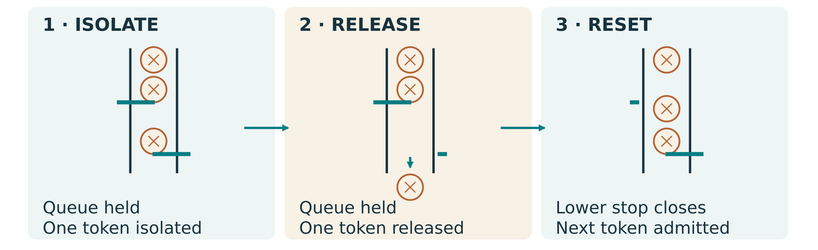
Figure 1. Inspect the feed, separation and release path. A ratchet and the gate solve different problems.
Explain one interaction that could make a freely turning dispenser release two items.
GEAR RELATIONSHIPS

Simple pairs speed and torque
For this book, gear ratio g = driven teeth ÷ driver teeth. The driver receives input rotation; the driven gear supplies the output. With a 20-tooth driver and 60-tooth driven gear, g = 60 ÷ 20 = 3. The output makes one revolution for three input revolutions, and an external meshing pair reverses direction.
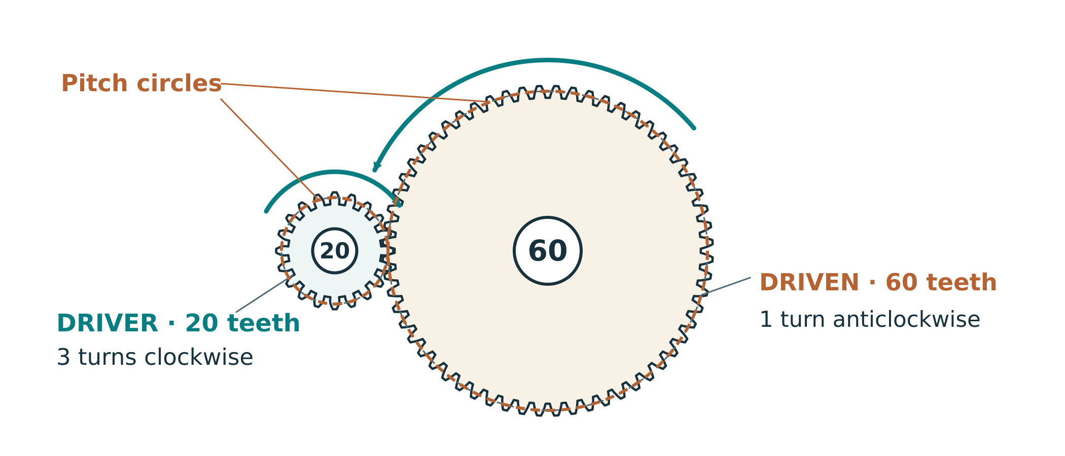
Figure 2. Illustrative 20-tooth driver and 60-tooth driven gear: compare pitch circles and rotation arrows, not the outer tooth-tip circles.

Speed changes
Output speed = input speed ÷ g. An illustrative input of 60 rpm gives 60 ÷ 3 = 20 rpm at the output. rpm means revolutions per minute. Use the same time unit throughout a calculation.

Torque changes
Ignoring losses, output torque = input torque × g. Real friction reduces available output torque. Torque is a turning effect; handle force also depends on the distance from the shaft to where the user pushes. A torque ratio is not automatically a force ratio.

Geometry matters
Pitch circles describe the ideal rolling relationship. Compatible tooth geometry and approved centre distances are required. Tooth-tip gaps are not a universal setting; never force a binding handle.

A 30-tooth driver turns a 90-tooth gear. Predict output rpm when input is 45 rpm, and state the direction relative to input. Show working.
GEAR GEOMETRY and FIT

Mesh begins with geometry
A gear’s pitch circle is an imaginary circle used to describe its ideal meshing relationship. The tooth tips lie outside it; the roots lie inside it. Two external spur gears with compatible tooth geometry roll at their pitch circles. Their shafts must also be aligned and parallel so the teeth engage across the intended face width.
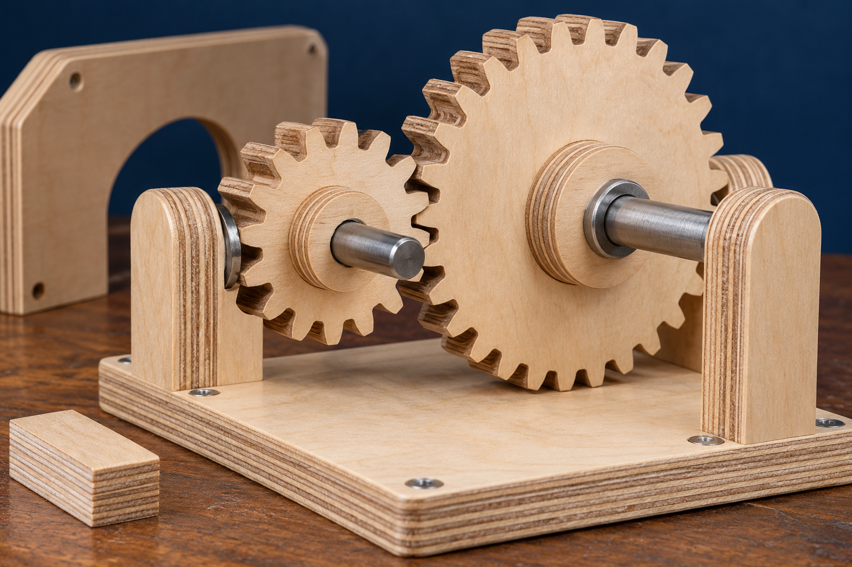
Figure 3. Inspect tooth engagement, shafts and supports. Use Figure 2 on the previous page for ideal pitch-circle spacing. Illustrative at-rest inspection; no operation with guards removed.
Correct the source shortcut
For an ordinary external spur pair, nominal centre distance = (driver pitch diameter + driven pitch diameter) ÷ 2. It is not one pitch diameter plus an arbitrary clearance. Approved gear design data may specify corrections; use the teacher-approved geometry. The website’s generic tooth-clearance numbers are not machine or assembly settings.

Explain the difference between centre distance, tooth-tip clearance and backlash. What would you inspect if a handle binds?
GEAR ARRANGEMENTS

Idlers and compound trains
A simple train has one gear on each shaft. In the chain 20 → 10 → 40, the middle gear is an idler. The ratio is (10 ÷ 20) × (40 ÷ 10) = 2. Its tooth count cancels from the overall ratio; it changes layout and adds a direction reversal. Two external meshes make the final output rotate in the same direction as the input.
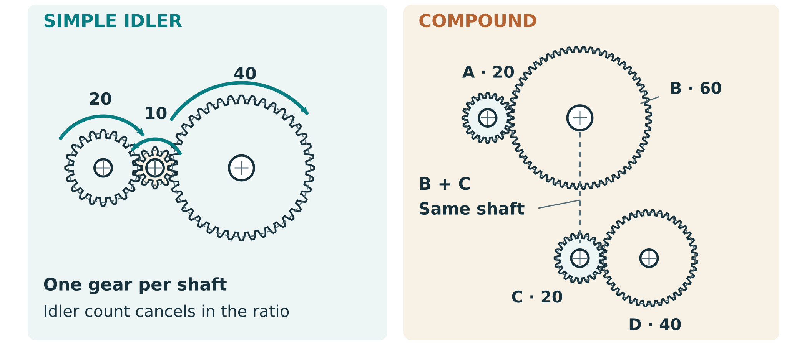
Figure 4. A simple idler chain and a true compound train are different: inspect the shared intermediate shaft.
In a true compound train, two different gears are fixed to the same intermediate shaft. The driven gear of the first stage and the driver of the next turn together. Multiply the driven/driver ratio of each actual stage. Two 2:1 stages give 4:1; adding ratios would give the wrong prediction.
An illustrative train uses 10 → 30, then 15 → 45, with 30 and 15 fixed together. Calculate total ratio and describe output direction.
PREDICT and COMPARE

Worked example four input turns
Illustrative design requirement: four input revolutions for one output revolution. The required ratio is g = 4. This is a teaching example, not a required carousel layout or class specification.
Option | Working | Meaning
One pair: 20 → 80 | 80 ÷ 20 = 4 | One external mesh; output reverses
Simple chain: 20 → 10 → 80 | (10 ÷ 20) × (80 ÷ 10) = 4 | The middle gear is an idler; output matches input direction
True compound: 20 → 40, then 20 → 40 | (40 ÷ 20) × (40 ÷ 20) = 4 | Two middle gears share a shaft; output matches input direction

A source correction
The website labels its three-gear chain “compound”. Its overall arithmetic is useful, but the chain is a simple train with an idler. A true compound arrangement uses two intermediate gears fixed to the same shaft. Check the actual shaft connections before multiplying stages.

The compound option can distribute reduction across smaller gears, but adds shafts, supports and alignment work. Tooth counts alone do not establish which layout fits the frame. Compare approved compatible gear geometry, space and assembly before selecting a design.
Create a different true compound 4:1 option. Name both intermediate gears as sharing one shaft, calculate each stage and total ratio, and explain one comparison with a single pair.
GEAR RATIO PRACTICE

Calculate predict compare
Source activity, adapted for paper: calculate at least three simple pairs. For each show ratio, speed relationship and ideal torque relationship. Use the illustrative pairs below, or teacher-approved alternatives. Ideal predictions ignore losses; they do not establish actual handle effort.
Complete all three gear-pair calculations.
Driver → driven | Ratio: show working | Output at 60 rpm input | Ideal output torque ÷ input
10 → 40
20 → 60
40 → 20

Compare the first and third pair. Which would require more input rotation for the same output movement? Explain the torque trade-off.

Design two different illustrative gear arrangements giving four input turns per output turn. Show connections and working.
CAM MOTION

Cams give rotation a pattern

Follow the profile
A cam rotates while its follower moves according to the profile and the follower’s constraint. An eccentric circular cam has an offset axis, so the distance to a radial follower changes through the turn. A centred circular cam gives no rise for that arrangement. A shaped cam can provide a deliberate lift, holding period and return.
The follower can be a sliding contact or a roller. Sliding contact is simpler but can have more rubbing; a roller can reduce sliding at the contact but adds parts and alignment work. The actual mechanism must keep contact safely through its intended motion.

Rise dwell and fall
Rise means increasing follower displacement; fall means decreasing it. Dwell means displacement stays constant over a range of cam angle. For a suitably constrained radial follower, a constant-radius cam region can produce dwell. The following physical-example page shows the cam and follower relationships. A flat line on a displacement-versus-angle graph shows dwell; it does not mean the physical cam edge must be straight.
A longer angular dwell lasts longer only at the same rotation speed. Timing also depends on the cam shaft’s relation to the handle, the feed path and whether the gate isolates one item. A steep transition may create abrupt movement and higher drive effort for the same lift and load.

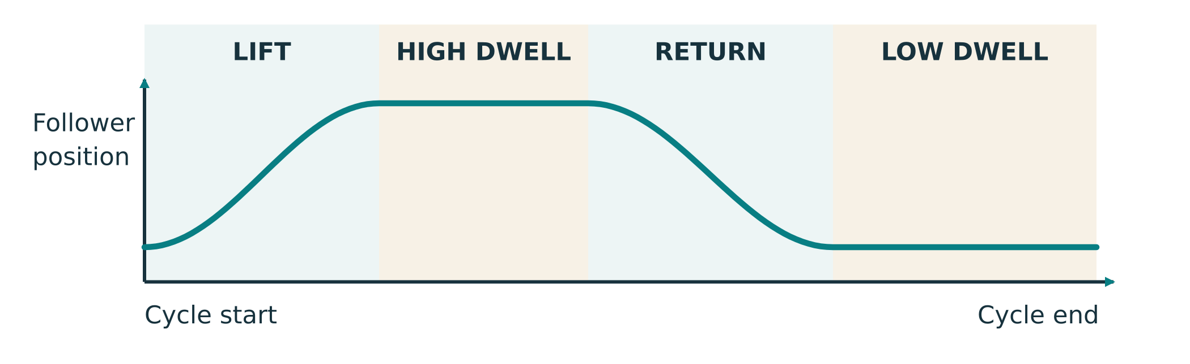
Figure 5. Follower displacement plotted against cam angle. A flat graph segment means constant displacement; this graph is not a picture of the physical cam profile. Compare it with the following physical-example page.
Why is the cam’s shaft connection as important as its shape when planning a dispensing gate?
PHYSICAL CAM EXAMPLES

Cam profiles and follower contact
A physical cam profile is the boundary that contacts the follower. Its shape, rotation axis and follower constraint determine movement together. Locate the shaft axis before judging the profile. An eccentric circle has an axis offset from its geometric centre; the illustrated shaped cam instead has deliberate motion regions about its rotation axis.
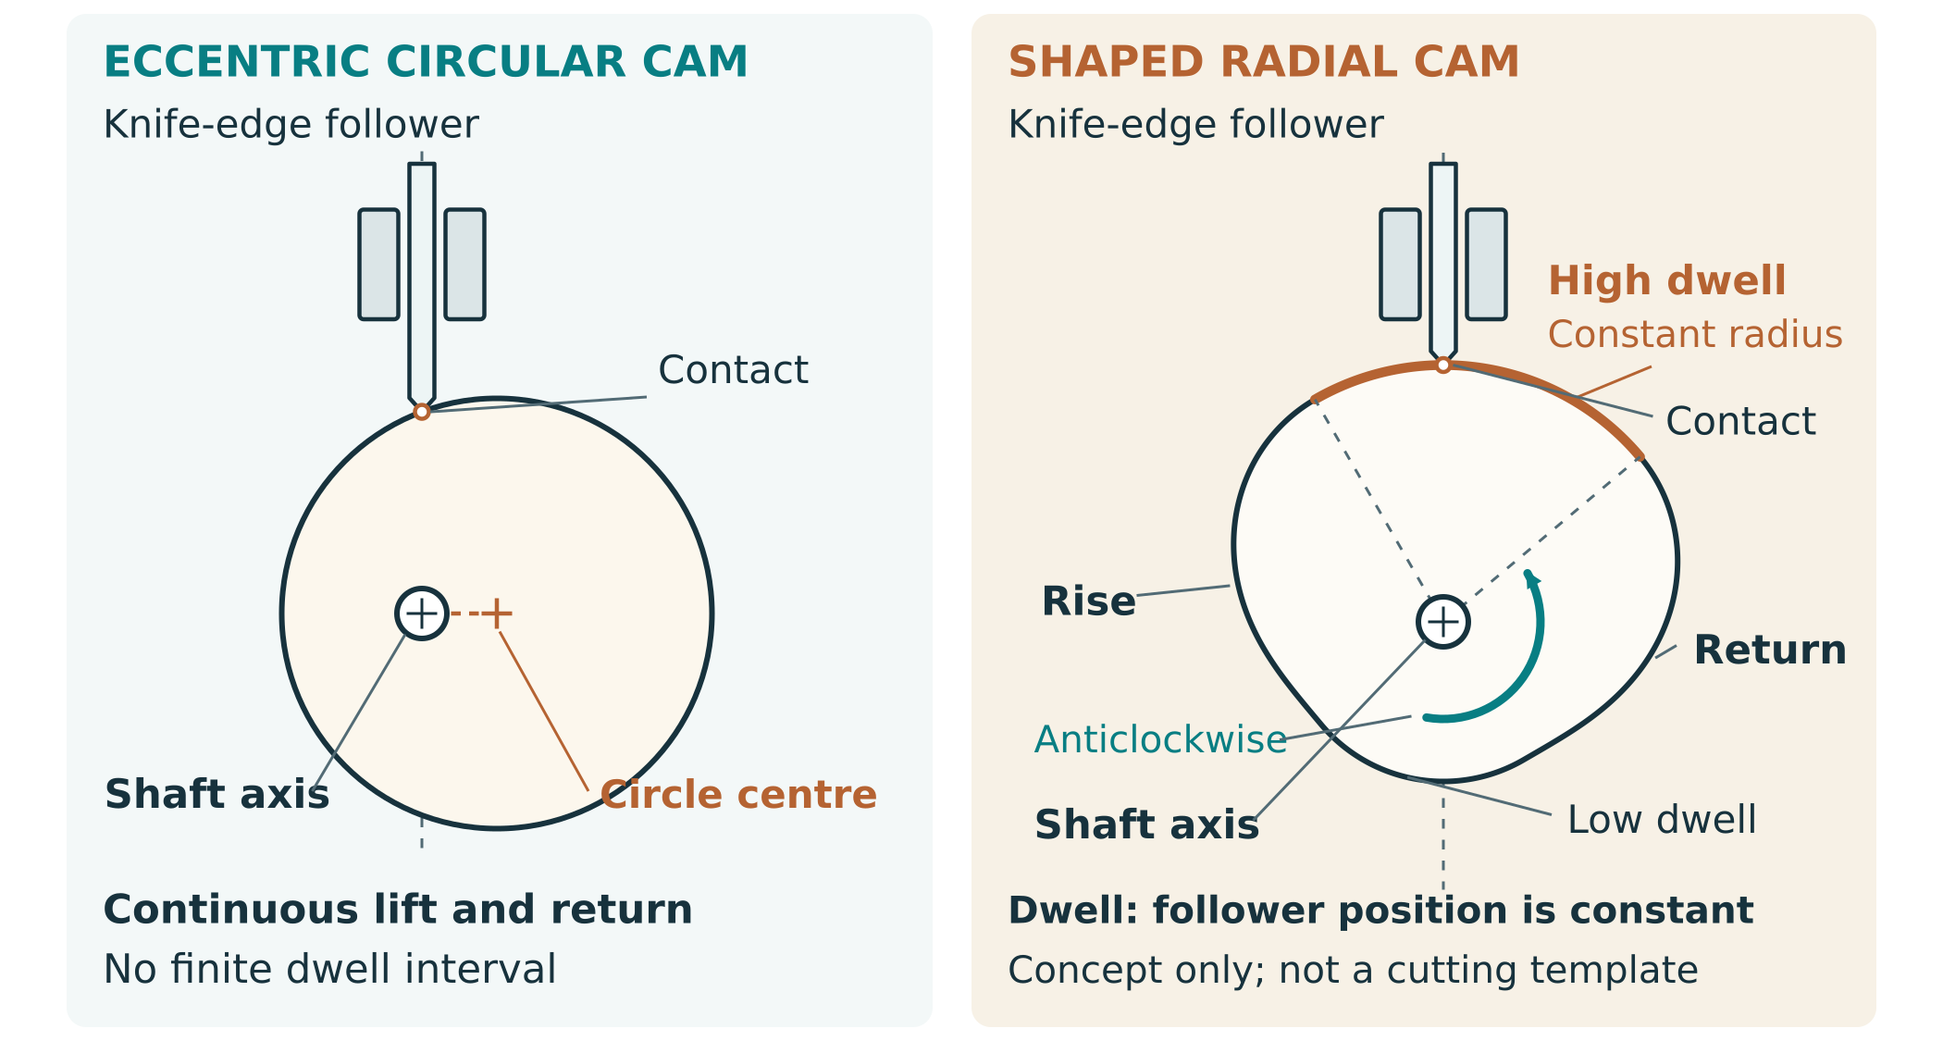
Figure 6. Physical concepts with simplified knife-edge radial followers: offset-axis eccentric circle and shaped rise–dwell–return cam. The shaped cam’s shown rotation is anticlockwise. Inspect shaft axes and contact. These explain mechanisms, not cutting templates or recommended follower constructions.

Eccentric circle
As the offset circle turns, its contact relationship changes and the follower rises and falls smoothly in this conceptual arrangement. It has no finite true dwell region. Reaching a highest or lowest position for an instant is not the same as holding constant displacement over a range of cam angle.

Shaped rise dwell and return
A deliberate profile can raise the constrained follower, hold its displacement and then return it. For this radial concept, a constant-radius arc measured from the rotation axis provides dwell. The follower must remain in the intended contact throughout the cycle; a teacher-approved return/contact arrangement is part of any actual mechanism. The simplified drawing does not specify that construction.

Read the graph and the object differently
The preceding displacement graph describes follower movement, not the cam’s outline. Its horizontal dwell segment means no displacement change. Use the physical axis, profile and follower arrangement to explain that graph. Teacher-approved geometry, travel, return and guards control any actual design; no dimensions or spring settings are supplied here.
CAM DESIGN EVIDENCE

Compare two cam profiles
Source activity, adapted for paper: sketch at least two cam profiles and their intended follower motions. Use an eccentric profile and a shaped rise–dwell–fall profile, or approved alternatives. A centred circle has no rise for a radial follower: label “no rise/fall” rather than invent those phases.
Two profile sketches: show axes, follower contact, rotation direction and matching rise/dwell/fall motion

For each profile explain opening, holding and closing motion. Which would you investigate for your gate, and what is the effort/timing trade-off?
ONE WAY MECHANISMS

Ratchets allow one direction
A ratchet wheel and pawl work together. During intended forward movement, the pawl lifts over a tooth and returns into engagement. Reverse movement brings a locking tooth face against the pawl. The pawl’s pivot, contact angle and return force must allow consistent engagement without dragging excessively or blocking forward motion.
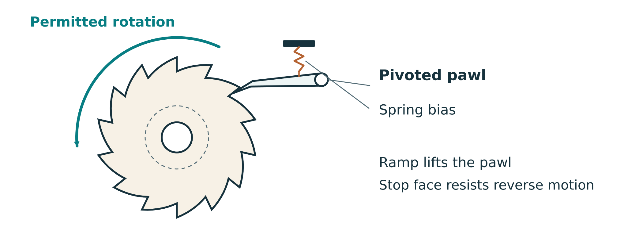
Figure 7. Observe the pawl’s pivot and contact face. Direction control is different from one-item separation.

Useful with limits
Ratchets occur in socket tools and winches because they permit selected movement and resist the opposite direction. In a dispenser they can discourage accidental back-rotation. They do not decide how many items pass through an open gate; that still depends on separation and timing.

Compare alternatives
A one-way bearing or clutch can also allow rotation in one direction. It may be compact and smooth but needs compatible shafts, mounting and suitable components. A visible low-speed pawl is easier to explain and inspect, but adds wear/contact points. Choose using approved parts and the actual task.

Predict two problems caused by a pawl that returns too weakly, and one caused by excessive contact resistance.
RATCHET INVESTIGATION

Research a one way device
Source activity, adapted for paper: research an approved real example such as a socket wrench or winch. Record the source, then draw how pawl and wheel engage. Compare with a one-way bearing or clutch. Do not operate or dismantle unfamiliar equipment without teacher approval.
Real example: labelled wheel, pawl, pivot, forward movement and reverse stop

Compare the two approaches for your dispenser.
Comparison | Ratchet and pawl | One-way bearing or clutch
Mounting/parts
Inspection, wear and fit
Suitability for my dispenser

Source title/URL or teacher demonstration, and what you learned from it:
01 MECHANISMS

Make the mechanism sequence visible
A motion-flow diagram shows what drives what; a timing sequence shows when each job occurs. Draw your actual proposed gear train, cam/gate and ratchet where used. Label shafts, tooth counts, motion directions and the isolation–release–reset sequence. A changed gear ratio can alter cam phase relative to the carousel; check the actual shaft connections.
My proposed mechanism: components, shaft connections, motion and safe access

Complete the timing sequence for your proposed design.
Stage of the defined cycle | What must happen? | My timing/check
Ready/home | Item feed and mechanism in repeatable start state
Position/isolate | Only one item reaches release path
Release | Gate motion permits the isolated item to leave
Close/reset | Next item remains contained; mechanism returns ready

If you change the carousel gear ratio but keep the cam on the input shaft, what might change? Explain the checks needed.
01 MECHANISMS

Force motion and efficiency
A rack and pinion converts rotation to linear travel. One ideal pinion revolution moves a compatible rack by one pitch-circle circumference: travel = π × pitch diameter. A cam follower instead follows a profile. Neither relationship supplies the approved dimensions or gate construction.
Mechanical advantage compares corresponding forces: MA = output (load) force ÷ input (effort) force. Velocity ratio compares corresponding movement over the same interval: distance VR = effort-point distance ÷ load-point distance. Use the actual input/output points and their motion along the force directions. For a simple constant-force movement, efficiency = useful output work ÷ input work = MA ÷ VR; multiply by 100 for a percentage.
Quantity | Worked calculation | Meaning
Force MA | 25 N ÷ 10 N = 2.5 | Output force is 2.5 times input force
Distance VR | 120 mm ÷ 40 mm = 3 | Effort point moves 3 times as far
Efficiency | (2.5 ÷ 3) × 100 ≈ 83.3% | Useful work is about 83.3% of input work

For corresponding force-distance movements, ideal MA = VR; real losses reduce efficiency. Gear reduction predicts shaft rotation and ideal torque, not an arbitrary hand-force ratio. Actual force points, perpendicular handle radii and losses matter.
Practice, paper only: input force 8 N, output force 32 N, effort movement 150 mm and load movement 30 mm over the same interval. Calculate MA, distance VR and efficiency. Show working.

Why can a dispenser’s 4:1 gear reduction not by itself prove force MA = 4 or efficiency = 100%?
01 MECHANISMS / ORIGINAL SOURCE CHECKS

Mechanisms original source checks
Write your reasoning and show calculations where needed. These are four exact original questions from Toolkit 1. Continue questions 4–7 online using the route on page 49.
1. A handle gear with 30 teeth drives a carousel gear with 90 teeth. Calculate the gear ratio and explain its effect on speed and torque.

2. Why use a compound gear train instead of a single gear pair? Give an example.

3. How does a cam profile affect gate motion in a lolly dispenser? Explain the trade-offs.

8. How does a cam dwell period affect dispensing reliability?
02 DESIGN AND CAD

Analyse your approved brief
Source activity, adapted for paper: annotate the approved class brief, then make a design checklist. Turn broad words into evidence you can collect. “Reliable” needs a defined cycle, approved conditions and an agreed success target; “safe” needs identified hazards and verified controls. Leave unconfirmed limits blank rather than guessing.
Analyse the approved brief and identify how each point will be verified.
Requirement / constraint | Confirmed value or description | Evidence/check
Function and cycle definition
Reliability target and test length
Allowed material/stock/equipment
Size/capacity or other constraints
Safety and user needs

Choose a requirement that most affects your mechanism. Explain how the theory informs a design decision.

For your chosen design, calculate the required ratio from its confirmed input/output movement. Show every stage and justify the arrangement in your complete design record. Label tooth counts, shaft positions and teacher-approved centre distances in the page-15 mechanism sketch or its linked CAD drawing. Locate your three simple pairs, genuine compound calculation, two 4:1 options, two cam profiles and one-way-device comparison before recording teacher feedback.
What change will I make after feedback, and why?
CONCEPT DESIGN

Compare two dispenser concepts
Develop two genuinely different arrangements before choosing. Show feed/gate route, shafts, gears, cam and one-way control where required. Use the same confirmed brief so your comparison is fair. These are your concepts, not approved plans.
Concept A: label input/output and separation–release sequence

Concept B: a different arrangement or mechanism integration

Choose a concept using two criteria. Name one trade-off and one point needing verification.
02 DESIGN AND CAD

Materials parts and stock
Choose each material by its job. Solid timber varies with grain and moisture; plywood can offer stability; MDF is uniform but its dust, edges and use conditions need control; acrylic can provide visibility but can crack. Compare strength, stability, workability, cost and sustainability. None is automatically approved for food contact. Record teacher-approved stock and finish decisions.
Compare all four candidates for your actual components.
Material / part | Strength / stability | Workability / cost | Sustainability / decision
Solid timber
Plywood
MDF
Acrylic

Complete the entire approved bill of materials and cut list: every part, quantity, material, thickness and finished size. Use the rows below; if the design has more parts, retain the complete list in the project CAD pack and record its exact file/revision here.
Complete your verified bill of materials and cut list.
Part / quantity | Material / thickness | Finished size or CAD ref. | Stock / cost source
NESTING and WASTE

Plan the sheet before cutting
Nesting places approved part profiles efficiently within actual usable stock. It must preserve grain/face orientation, safe separation and any teacher-confirmed process allowances. A dense layout is not good if it weakens a part, places a hole in damaged stock or leaves no appropriate holding/support area.
Nesting plan: outline actual usable sheet, label parts/quantities and grain/face direction

Explain two choices that reduce waste without compromising part strength, fit or process safety.

Complete list file/revision and cost source:
02 DESIGN AND CAD

Build the CAD assembly in layers
A top-level assembly groups meaningful sub-assemblies such as the gear train, cam/gate, frame and guard. Establish a fixed reference, then use the simplest appropriate fasten, revolute or slider mates. Reference stable faces and axes; excessive mates can lock a part, while missing constraints let it float. Test motion after each mate and inspect interference through the full intended cycle.
Actual top-level assembly screenshot: annotate components, mates and motion relationships.

Actual sub-assembly screenshot: identify grouped parts and explain why they belong together.

Plan your CAD sub-assemblies.
Sub-assembly | Main parts | Why group them?
Gear train
Cam/gate
Frame/base or guard/lid

Assembly file/version and one mate or interference finding:
02 DESIGN AND CAD

Prove full cycle motion
A static view identifies parts; moving evidence demonstrates relationships. Include the home state, operation and return for the actual version. A successful digital cycle does not establish physical clearance, friction, guarding or workshop approval.
Source activity: create a short screen recording or motion study showing the gears and cam operating through a complete assembly cycle. Record its file/link reference, what the moving evidence shows, and one finding or next action. Static screenshots can support labels but cannot replace this moving evidence.

Record what the moving evidence actually shows.
Moment / relationship | Visible evidence and observation
Home/start and shaft relationships
Position, gate release and reset
Complete cycle and any interference

Four digital checks: a locked gear may have a fasten mate instead of the intended rotation; a drifting assembly may lack a fixed base; a failed mate may reference an edited edge instead of a stable face/axis; end-of-travel collision requires checking limits and geometry through the full cycle before an approved revision.
Practice: a gear rotates in one sub-assembly but locks after insertion into the top-level model. Name two checks and explain why.
PARAMETRIC DESIGN

Variables and configurations
A variable names a design quantity so related features can use one controlled value. A configuration groups a deliberate set of choices, such as a tested ratio or size. Neither removes the need to inspect fit and motion after a change. “Hole = shaft diameter” may not provide the required fit; any allowance must come from approved design/calibration.
Record variables used in your actual CAD model.
Variable name | Purpose / linked features | Approved value or source

Document configurations used, or a clearly labelled proposal.
Configuration | What changes? | When useful / what to recheck?

If approved stock thickness changes, which features and outputs could need updating?
02 DESIGN AND CAD

Create a build ready drawing pack
A build-ready drawing must communicate approved geometry without guessing. Use front, top, side and isometric views; add section/detail views where a feature is hidden. Dimension overall size then critical features from consistent datums. Avoid repeated or conflicting dimensions. A complete title block identifies part/assembly, scale, units, material, revision, drafter and date.
Produce at least two actual CAD drawings: one part and one assembly. Export their complete PDFs into the folio. Include the required views, critical shaft centres and approved fits; the record below locates those full drawings. Ensure the drawing pack covers the main frame, base, gear-train sub-assembly and cam/gate mechanism. Combined sheets may cover several subjects.
Plan a useful part or assembly view: datums, centre marks and critical information

Record and review the actual drawing pack.
Drawing / revision / file | Views and critical features | Review finding / next action

What did another reader find unclear, and how will you fix it?
02 DESIGN AND CAD

Exports and the complete CAD pack
An export is a snapshot. After a significant model edit, update the matching drawings and DXF/DWG profiles, check millimetre units and closed geometry, and verify the import in the approved target software. Record who applies kerf/cutter compensation and where; do not apply it twice. Use consistent component names and revision/date identifiers.
Organise SourceCAD for the current model/variables/assembly; DrawingsPDF for readable title-blocked production drawings; LaserExports or CAM exports for approved closed profiles in the correct units and scale; and a readme listing files, materials, revisions, process notes and unresolved questions. A reader must identify exactly what to manufacture.
Prepare and review your complete CAD pack.
Pack item | File/page/revision | What was checked?
Brief and approved criteria
Gear/cam/ratchet layout and calculations
Material/cut list and nesting
Top-level assembly, sub-assembly and full-cycle screen recording/motion study
Drawings and manufacturing exports
Readme and remaining confirmation points

Source reflection: if someone else built from your pack, what would be easy and what might still be confusing?
02 DESIGN AND CAD

CAD original source checks
Answer the exact original questions. Explain your reasoning using the printed learning and your real project evidence. Continue the remaining numbered questions through page 49.
3. What are two things that must be clear on a build-ready drawing for a frame plate?

4. Why is it risky to export DXF/DWG files early and then keep changing the model without updating the exports?

10. How can you test that your assembly mates work correctly before building physical parts?
03 SUPERVISED MANUFACTURE

Ready for supervised manufacture
Manufacture follows the approved design and current workshop procedure. Confirm supervision, equipment training, PPE, stock, workholding and stop/isolation method before work. CAD defines geometry; CAM prepares a path or job; the machine follows its setup. Check material, millimetre units, closed profiles, version and approved compensation before any cut.
Identify hazards and record the approved controls for your work.
Planned operation | Hazard / consequence | Teacher-approved control / check
CAD–CAM cutting
Drilling shaft/fixing holes
Sanding and finishing
Assembly and moving mechanisms
Testing and clearing a fault

Verify your manufacturing export before an approved cut.
Check | Why it matters | My evidence / status
Model, drawing and export revision agree | Prevents cutting superseded geometry
Units and test-import scale verified | Prevents the wrong size
Profiles closed; no duplicate paths | Prevents missing areas or repeated processing
Material identity/thickness and stock plan verified | Keeps process and design compatible
Compensation and holding method teacher-confirmed | Controls fit and process safety

Where will you find the current procedures and who confirms readiness? Name a stop condition you will follow.

If something binds, breaks or behaves unexpectedly, stop and obtain teacher help. No generic website clearance, laser power, feed, spindle or kerf value authorises a local setting.
CALIBRATION and EVIDENCE

Measure kerf and verify fit
Kerf is material removed along a cut. Its effect depends on the material, tool/process and conditions. An outside profile and an inside opening are affected differently. The source’s generic 0.1–0.2 mm values are not approved settings. Use teacher-directed scrap calibration and the correct CAM compensation method.
Illustrative reasoning not a setting
Suppose a teacher-led calibration determines a cut width k for that approved process. A centreline cut removes material on both sides of the path. The intended finished edge may require an offset of k ÷ 2 in the appropriate direction. Whether the workflow uses this offset, a full-width compensation entry or another convention must be confirmed in its software.

Record your teacher-directed calibration or fit trial.
Scrap/test identity | Intended / observed fit | Approved change / recheck

Why could adding the same allowance to both a hole and an outside tab produce the wrong fit?
03 SUPERVISED MANUFACTURE

Fabricate from verified datums
Check the approved cut list, nesting plan, stock dimensions, grain and surface quality before fabrication. Label every part and revision. Use approved cutting/drilling methods and test critical fits on scrap first. A small shaft-position error can prevent smooth gear or follower movement even when the outer part shape looks correct.
Use the approved drawing’s reference faces, edges and centre marks to locate shaft and fixing holes. Check the correct face/orientation before marking. Repeated measurements from a consistent datum reduce accumulated error; square aligned supports help the mechanism turn freely. Your teacher determines the tool, restraint, setup and approved hole/fit method.
Annotated drawing or part sketch: identify datums, shaft axes and checks

Record the critical hole and alignment checks.
Critical feature | Approved drawing value / ref. | Observed result / action
Shaft location/alignment
Hole/shaft fit
Matching support/orientation

Identify a small fabrication error that could become a large mechanism problem. Explain the chain of effects.

Fabrication photo/file reference and actual preparation checks:
03 SUPERVISED MANUFACTURE

Prepare surfaces and assemble
Surface preparation has a functional purpose: burrs, splinters, rough contact faces or residue can increase friction, obstruct feed or injure the user. Use the approved preparation and finish; do not sand away critical geometry simply to force motion. No coating, adhesive, oil or laser-cut surface is assumed suitable for food contact.
Assemble in the approved design sequence and check each sub-system before combining it. Gear alignment includes shaft parallelism, face alignment, centre spacing and retention. Spacers or washers may prevent rubbing where the approved design uses them. A retained shaft should not slide into a new position during repeated operation.
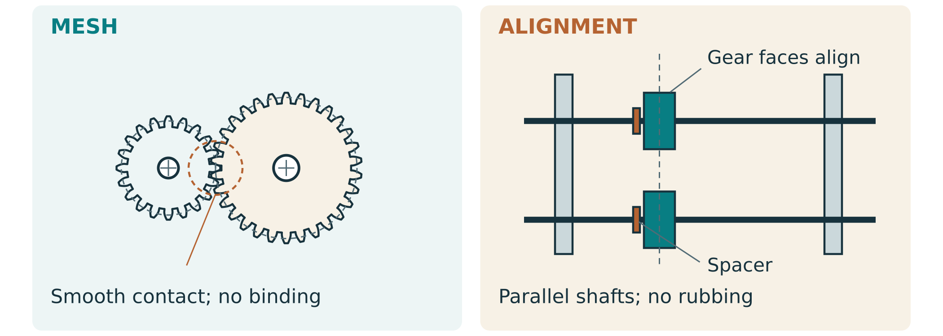
Figure 8. Inspect parallel shafts, support alignment and retention. The illustration explains what to check; it does not specify a fit or clearance.
Record actual preparation and assembly evidence.
Area / interface | Observation / photo reference | Approved action and recheck
Edges, finish and feed surfaces
Frame, shafts and alignment
Gear mesh and retention
Complete assembly version

What evidence would show your physical gear train matches the predicted ratio?
03 SUPERVISED MANUFACTURE

Tune protect and inspect
The cam and follower need maintained contact through the intended motion; the gate must isolate, release and reset at the right phase. The pawl must permit the designed direction and resist reverse rotation without binding. These interfaces interact, so test the approved complete mechanism rather than assuming separate successful parts guarantee success.
Guard the actual finger-access paths to gears, cams and pinch points. Inspect the complete motion range, clearances, sharp edges and fasteners with your teacher. A transparent cover is not proof of adequate protection.
Guarding plan or annotated actual photo: hazards, access path and intended protection

Record the actual timing, guard and pre-test safety checks.
Check | Evidence / finding | Approved next action
Cam contact, gate phase and reset
Pawl engagement and reverse block
Guard access path and full motion
Fasteners, edges and stable base

How will you stop and get help if a jam occurs?
03 SUPERVISED MANUFACTURE

Keep a traceable build log
Keep the complete dated build log and construction photos: approved design reference, work actually done, checks, variations, problems and next actions. Unlabelled photos do not explain decisions. Continue the same columns in your existing project log when needed and identify that complete file below; these six rows do not limit required evidence.
Record actual manufacturing stages and variations.
Date / part or stage | Work / check actually done | Photo/file reference | Variation / next step

Locate the complete record and obtain feedback before testing.
Item | Exact location / finding / action
Full log and construction photographs
CAD/physical version, gears, cam and frame
Guarding, retention, edges and binding checks
Teacher check-in and unresolved pre-test issue
03 SUPERVISED MANUFACTURE

Build original source checks
Answer the exact original questions. Explain your reasoning using the printed learning and your real project evidence. Continue the remaining numbered questions through page 49.
1. Your dispenser works well when it is half full, but jams frequently when almost empty. Give one possible reason.

5. A user reports that the handle feels “jerky” at one point each turn. What are two potential causes you might investigate?

9. How can you use test data to justify design decisions in your evaluation?
TESTING PROTOCOL

Plan a fair reliability trial
A reliability trial asks how often the dispenser completes the defined job under stated conditions. First use the approved unloaded check to identify binding and count intended input/output travel. Begin loaded trials only after teacher review of safety, test pieces and the stop procedure. The source asks for 50–100+ recorded cycles; confirm your required count and conditions with the teacher.

Figure 10. A controlled trial records the mechanism, input cycle, test pieces and each outcome. Use inert non-food pieces if food-contact approval is unconfirmed.
Define and control the actual reliability trial.
Control / definition | My approved plan
One complete cycle / home marks
Test-piece type/size and loading method
Number of cycles / target criterion
Turning method and initial fill condition
Stop/fault procedure and recording roles

Define success, jam, double and partial release so two observers would classify the same cycle alike.
04 TEST AND EVALUATE

Reliability log cycles 1 to 50
Record EVERY performed cycle. S = one correct release; J = jam; D = double; P = partial. Define conditions on page 35. In the note column give condition code, input turns if measured, and a fault/note reference. Mark unused rows “not performed”; never count blanks as successes. Retain the full log if the approved trial exceeds 100 cycles.
Record actual approved outcomes for cycles 1–50.
No. | Result | Condition / turns / note | No. | Result | Condition / turns / note
1 |  |  | 26
2 |  |  | 27
3 |  |  | 28
4 |  |  | 29
5 |  |  | 30
6 |  |  | 31
7 |  |  | 32
8 |  |  | 33
9 |  |  | 34
10 |  |  | 35
11 |  |  | 36
12 |  |  | 37
13 |  |  | 38
14 |  |  | 39
15 |  |  | 40
16 |  |  | 41
17 |  |  | 42
18 |  |  | 43
19 |  |  | 44
20 |  |  | 45
21 |  |  | 46
22 |  |  | 47
23 |  |  | 48
24 |  |  | 49
25 |  |  | 50
04 TEST AND EVALUATE

Reliability log cycles 51 to 100
Record EVERY performed cycle. S = one correct release; J = jam; D = double; P = partial. Define conditions on page 35. In the note column give condition code, input turns if measured, and a fault/note reference. Mark unused rows “not performed”; never count blanks as successes. Retain the full log if the approved trial exceeds 100 cycles.
Record actual approved outcomes for cycles 51–100.
No. | Result | Condition / turns / note | No. | Result | Condition / turns / note
51 |  |  | 76
52 |  |  | 77
53 |  |  | 78
54 |  |  | 79
55 |  |  | 80
56 |  |  | 81
57 |  |  | 82
58 |  |  | 83
59 |  |  | 84
60 |  |  | 85
61 |  |  | 86
62 |  |  | 87
63 |  |  | 88
64 |  |  | 89
65 |  |  | 90
66 |  |  | 91
67 |  |  | 92
68 |  |  | 93
69 |  |  | 94
70 |  |  | 95
71 |  |  | 96
72 |  |  | 97
73 |  |  | 98
74 |  |  | 99
75 |  |  | 100
04 TEST AND EVALUATE

Calculate and compare your results
Reliability = successful defined cycles ÷ all performed cycles × 100%. An illustrative run with 42 successes, 5 jams, 2 doubles and 1 partial has 50 trials: 42 ÷ 50 × 100 = 84%. The eight failures remain in the denominator. This is example data, not your result or an approved pass target.
Summarise and calculate your actual reliability.
My actual run / version | Total | Success | Failure | Reliability %

For intact non-slipping gears, tooth counts fix average rotational ratio; friction changes effort and available torque. Count rotations separately from successful release. Extra turns per good dispense can reflect lost motion, timing, slip or failed feeding; investigate these separately.
Compare predicted motion with actual operation.
Quantity | Prediction / method | Actual result / units
Geometric input/output rotation ratio
Output movement needed for one release
Input turns for a normal defined cycle
Total input turns / successful releases (if used)

What does your percentage show, and what does it not prove?

Your ratio prediction is 4:1, but a loaded run needs extra turns for some good releases. Explain two possible reasons and how to distinguish them.
DATA PRESENTATION

Make patterns visible in a graph
Choose a graph that answers a question. A bar chart can compare failure categories or before/after reliability; a line or cumulative plot can show changes over a stated sequence. Label axes, units, run/version, sample size and conditions. Counts and percentages must not share an unlabeled scale. A graph is evidence only when its values match the source table.
My graph: title, labelled axes, readable scale and actual test data

Explain the main pattern using two actual values and one limitation.
04 TEST AND EVALUATE

Diagnose adjust and retest
Record 2–3 real problems or honest limits, linked to trial conditions. Causes are hypotheses. Change one approved variable at a time and retest comparably. Never invent failures; identify what the evidence cannot establish.
Source activity: document 2–3 problems or honest observed limitations.
Actual symptom / cycles | Possible cause and evidence | One proposed check/change

Document two specific improvements and their evidence.
Iteration item | Change 1 | Change 2
Problem and evidence reference
One approved change or proposal
Engineering reason
CAD/drawing/build revision
Comparable before/after run
Result, limitation and next action

List 2–4 realistic next improvements with evidence and engineering reasons.
Proposed improvement | Problem / evidence / why it could help
1
2
3, if justified
4, if justified
VISUAL EVIDENCE

Before and after show the change
Source activity: annotate at least one actual final dispenser photo with the gear train, cam/gate, handle and safety features. If you made an improvement, show comparable before-and-after views and explain the changed feature. Keep lighting, framing and scale useful; an arrow needs a short claim tied to evidence.
Attach or plan an annotated final photo: label features and the evidence each supports

Connect visual change evidence to the recorded test.
Image / version | Annotation / what changed | Related test evidence
Before:
After:

Write a useful caption that explains one visible feature and one evidence limitation.
USER FEEDBACK

User trials comfort and predictability
Source activity: under teacher approval, gather feedback from 3–5 different users on ease of use, comfort, effort, predictability and satisfaction. Use participant labels rather than unnecessary personal details. Do not recruit younger children or treat a machine as safe for them from a written scenario. Keep the approved operating method and stop procedure consistent.
Record approved user trials and feedback.
User label | Comfort / effort | Predictability / behaviour | Suggested change
A
B
C
D (if used)
E (if used)

Summarise one shared finding and one different experience. What would you investigate next?

If a user tries to turn backwards, what does that reveal about the design or instructions?
04 TEST AND EVALUATE

Evaluate against confirmed criteria
Evaluation makes a judgement against a confirmed criterion and supports it with real data, photos or user feedback. Description tells what you did; evaluation explains how well it performed, how you know and what the evidence cannot establish. Include function, safety, ergonomics, durability, aesthetics and sustainability.
Write a connected evaluation paragraph for EACH criterion in the complete project evaluation, using the table to locate evidence and record your judgement. The full evaluation remains part of your folio; the table is its working index, not a substitute for those paragraphs.
Address all six criteria using actual evidence.
Criterion | Evidence / full paragraph location | Judgement and limitation
Function
Safety
Ergonomics
Durability
Aesthetics
Sustainability

Write one complete evaluation paragraph using criterion + evidence + judgement + limitation.
EVALUATION and IMPACT

Sustainability and practical trade offs
Environmental evaluation uses your actual choices and evidence. Compare usable stock and offcuts, material provenance where verified, avoided rework, durability and repairability. Do not label a design sustainable only because it uses timber. An honest limitation, such as unverified certification or unmeasured waste, is more useful than an unsupported claim.
Evaluate sustainability and impact using your actual project.
Design / process choice | Evidence of impact | Trade-off / improvement
Stock and nesting
Rework / rejected parts
Finish / food-contact boundary
Durability and repairability

Propose one realistic lower-impact change and explain how you would check it still works safely.
PRESENTATION and COMMUNICATION

Showcase your engineering evidence
Your showcase should explain the problem, how the mechanism controls release, the evidence for performance and a justified improvement. Use your actual final photos and a teacher-approved demonstration or video. A polished presentation cannot replace the cycle log or make an unapproved dispenser food-safe.
Plan your showcase board or short presentation.
Showcase section | My evidence / message
Purpose and target user
Gear train, cam/gate and one-way control
Actual trial result and limitation
One improvement and engineering reason
Safety and sustainability evidence

Write a short showcase script a visitor can understand. Include one numerical result with its sample/conditions and one limitation.
PERSONAL REFLECTION

Reflect on your learning
Source activity: write 1–2 connected paragraphs about mechanisms, materials, CAD, testing and problem-solving. Name one challenge and explain the evidence behind your response. Compare what you could do at the start with what you can do now. Link to current teacher-confirmed outcomes only if asked; do not copy a later syllabus code from an example.
What did I learn, what challenged me, and how did I respond? Use one real event and explain the engineering reasoning.

What skill improved, and what would I do differently next time? Link one realistic improvement to evidence.
05 FOLIO AND NEXT STEPS

Make the folio ready for handover
Make the complete folio navigable: cover and brief, design/calculations, CAD and drawings, dated manufacture, trials/data/graphs, evaluation, improvements and reflection. Keep current revision names, labelled real photographs, readable headings and an evidence index. Record the exact current teacher-issued submission instructions; the old draft does not set this deadline.
Create a navigable final evidence index.
Folio section | Exact page/file location | Complete / next action
Cover, purpose, brief and confirmed criteria
Mechanism calculations and concepts
Materials, cut list, CAD pack and drawings
SWMS, operations and build/guarding evidence
Cycle logs, analysis, graphs and user feedback
Evaluation, two improvements and reflection
Showcase and approved submission details

Before handover: verify the actual CAD and built version agree; include full-cycle moving evidence and the complete drawing/export pack; check that trial totals reconcile; locate all six evaluation paragraphs, 2–4 justified improvements and reflection; resolve teacher feedback; keep required originals and backups.
Record the final feedback you acted on and one outstanding question for the teacher.

Current submission route/date and any remaining teacher-confirmation item:
05 FOLIO AND NEXT STEPS

Testing original source checks
Answer the exact original questions. Explain your reasoning using the printed learning and your real project evidence. Continue the remaining numbered questions through page 49.
1. Why is reliability testing important, and how do you calculate reliability?

3. What is the difference between describing your project and evaluating it?

7. How do you structure an evaluation paragraph that links criteria, evidence, and judgement?

9. How do you write a strong personal reflection that demonstrates learning?
05 FOLIO AND NEXT STEPS

Continue the original question set
Complete the remaining ORIGINAL questions at the four module links below. The original question numbers are retained, so use the listed numbers rather than restarting at Question 1. Save responses in the teacher-named course/folio destination and record where they are. These continue the same source set; they are not new questions.
Toolkit 1 · Gear systems and mechanisms
Continue original questions 4, 5, 6, 7.
https://stevencowell.github.io/Engineering-Website/Year9%20T4%20Modules/module1.html
Toolkit 2 · Dispenser design and CAD
Continue original questions 1, 2, 5, 6, 7, 8, 9.
https://stevencowell.github.io/Engineering-Website/Year9%20T4%20Modules/module2.html
Toolkit 3 · Manufacture and assembly
Continue original questions 2, 3, 4, 6, 7, 8, 10.
https://stevencowell.github.io/Engineering-Website/Year9%20T4%20Modules/module3.html
Toolkit 4 · Testing and evaluation
Continue original questions 2, 4, 5, 6, 8, 10.
https://stevencowell.github.io/Engineering-Website/Year9%20T4%20Modules/module4.html
Teacher-named response destination and exact saved file/location:
05 FOLIO AND NEXT STEPS

Terms sources and next steps
Term | Meaning in this project
Driver / driven | Input-receiving gear / gear receiving motion from it
Ratio g | Driven teeth ÷ driver teeth for each actual stage
Torque | Turning effect; force × perpendicular lever distance
Pitch circle / centre distance | Ideal meshing circle / shaft-axis spacing
Dwell | Constant follower displacement over a range of cam angle
Backlash / clearance | Play between tooth flanks / separation preventing interference
Reliability | Successful defined cycles ÷ total performed cycles × 100%
Datum / revision | Measurement reference / identified version of a file or design

Optional gear-systems, ratio/RPM and cam workbooks linked from the course support the named concepts. Use teacher-selected sections; this book does not reproduce those scanned resources wholesale. Videos and demonstrations supplement the printed explanation and do not authorise their machinery, dimensions or methods.
Course overview and resource links
Gear systems and mechanisms source
Design and CAD source
Build and manufacture source
Testing and evaluation source
Original diagrams and worked examples teach relationships; they are not project cutting plans or evidence of your performance. Keep source scans under their original teaching/reuse limits. Current teacher-approved procedures, material and food-contact decisions control practical work.
Teacher-led video, model or demonstration: title/source, two observations and one question about my own design.

