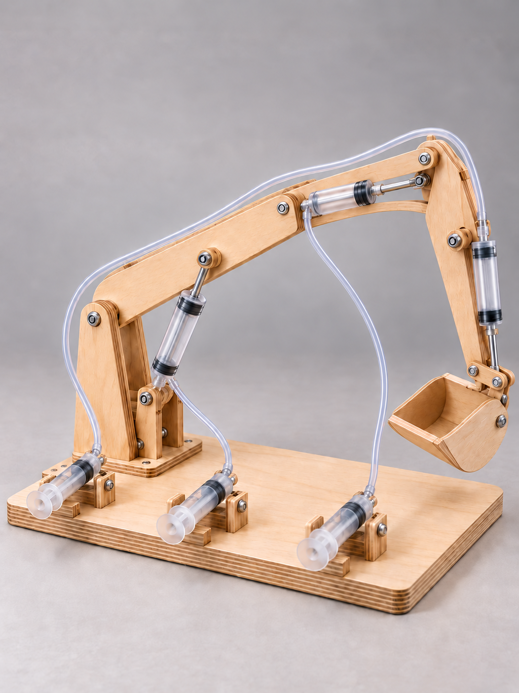
YEAR 9 ENGINEERING

Hydraulic
Digger
Year 9 Engineering
Student learning and folio companion

Figure 1. A tabletop hydraulic digger: water-filled circuits connect hand controls to the boom, dipper and bucket. Illustrative project view, not an approved construction plan.
Name _____________________________________ Class __________________
Group ____________________________________ Teacher _________________
START HERE

Your learning and evidence route
The digger combines hand controls, enclosed water-filled circuits, linear output pistons and rotating linkages. The boom, dipper and bucket use three separate circuits. A useful design must control movement, contain water and produce repeatable evidence of reach, lifting and travel.
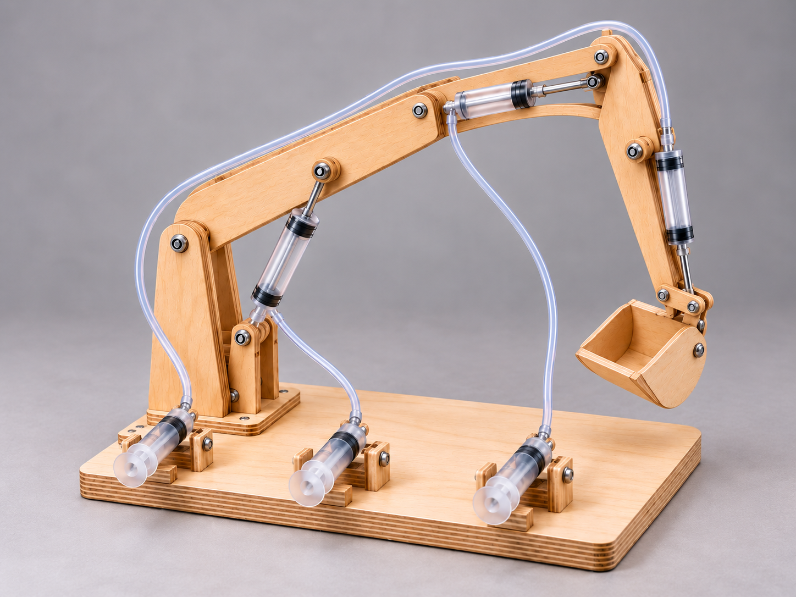
Figure 2. Name the base, boom, dipper, bucket, control syringes and output actuators. This illustrative view is for system identification, not fabrication.
Learning and evidence route | Pages
Fluid power and mechanisms | 3–15
Design, drawings and prediction | 16–27
Construction and setup | 28–31
Testing, analysis and evaluation | 32–40
Costing, lifecycle, pathways and source work | 41–45
Folio evidence and handover | 46–50

Use the current class brief, practical procedures and task notification. The linked task is formative and not graded; your teacher confirms the current targets, dates and submission method. Drawings and illustrative pictures do not authorise dimensions, materials, tools or test limits. Record the class-confirmed criteria on page 16.
What is one thing you want to understand about a hydraulic digger’s force or movement?
FLUID POWER AND MECHANISMS

Pressure links force and area

When you push a control syringe, your hand applies force to the water beneath its piston. In an enclosed, connected liquid-filled circuit, the pressure change is transmitted through the liquid. The output piston responds to that pressure and moves a linkage. Each boom, dipper or bucket circuit has its own control-to-output fluid path.

Force is a push or pull measured in newtons (N). Pressure is force divided by area: P = F/A, so F = P × A. A smaller input area gives more pressure for the same force. A larger output area gives more force at the same pressure. Equal pressure does not mean equal force.

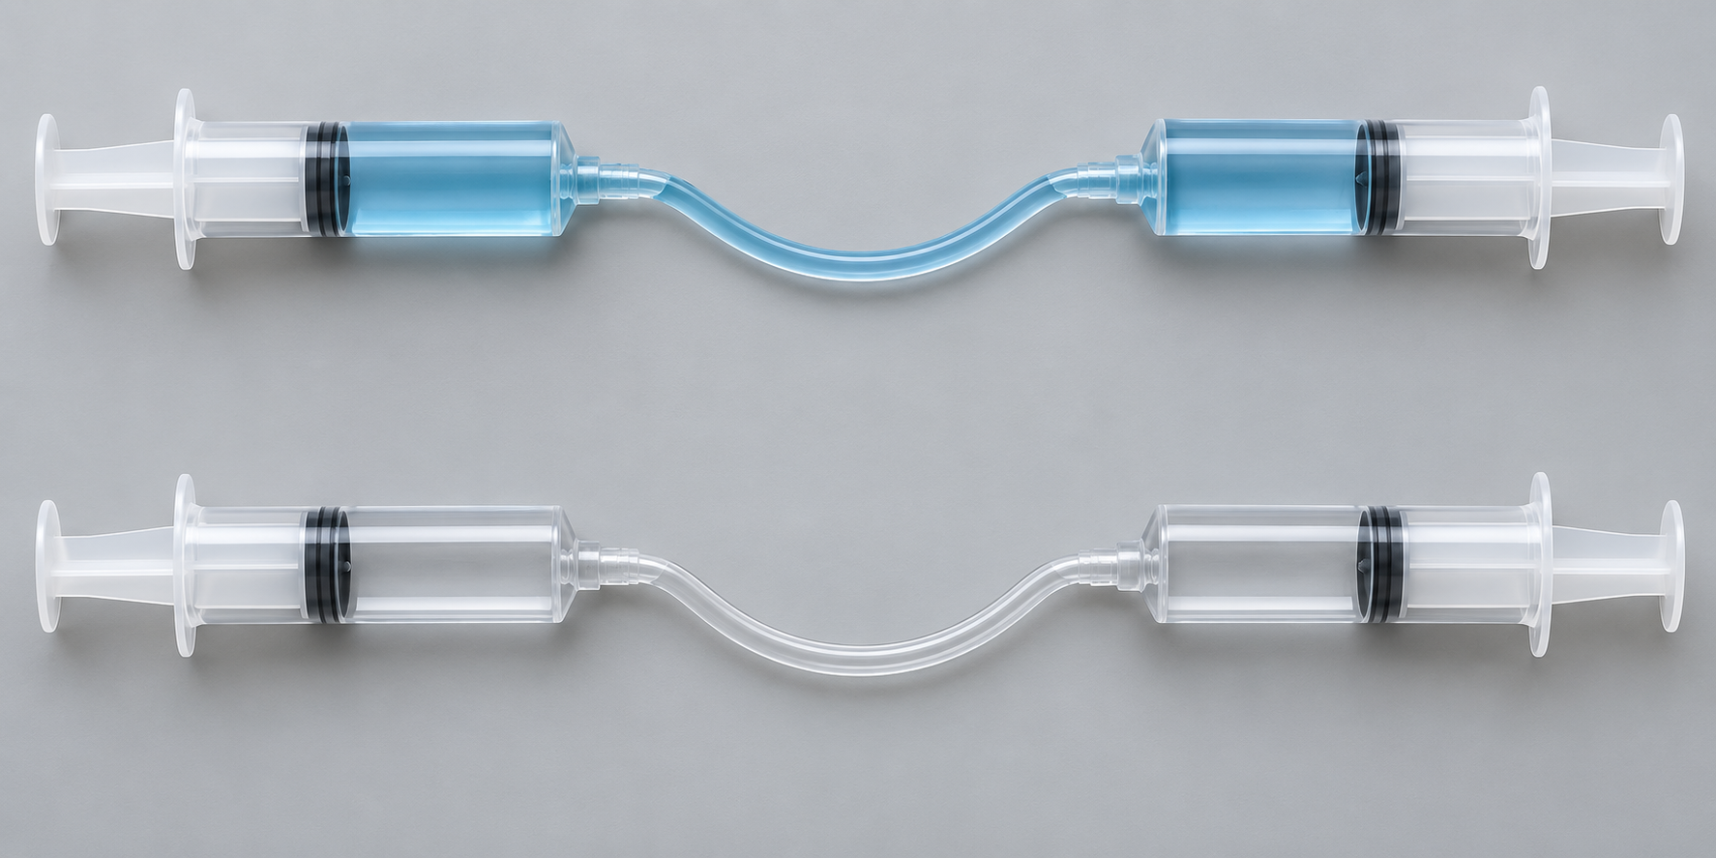
Figure 3. Upper: liquid-filled pair. Lower: air-filled pair. Compare circuit contents; the reading explains their different response. Illustrative comparison, not a pressure rating or filling instruction.
Liquids change volume very little under classroom conditions. An air bubble compresses, absorbing movement before the output responds: this feels spongy. A leak lets fluid escape and can cause drift. Inspect the different causes using the approved procedure; neither is repaired by pushing harder.
Worked observation
10 N ÷ 100 mm² = 0.10 N/mm² = 100 kPa. At the same ideal pressure, 200 mm² gives 20 N. In SI units, 1 Pa = 1 N/m². These are hypothetical values, not equipment ratings.

Practice: a hypothetical piston has area 80 mm² and experiences 8 N. Calculate pressure in N/mm². At the same ideal pressure, what force acts on 160 mm²?
FLUID POWER AND MECHANISMS

A larger piston trades travel for force
Hypothetical calculation only. These numbers are not syringe specifications, project dimensions or approved loads. We compare an input piston diameter of 12 mm with an output diameter of 24 mm, with a 5 N input force and 40 mm input travel. Real piston diameters must be measured or supplied by the teacher.
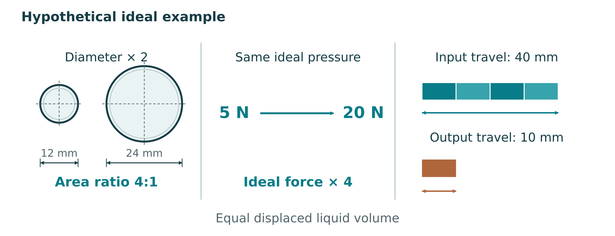
Figure 4. A hypothetical area comparison: doubling diameter gives four times the area. Output travel is shorter because both pistons displace the same volume in an ideal circuit.
Reasoning step | Working
Calculate input area | A₁ = π × 12² / 4 ≈ 113.1 mm²
Calculate output area | A₂ = π × 24² / 4 ≈ 452.4 mm²
Compare areas | A₂/A₁ = 4
Predict output force | F₂ = 5 × 4 = 20 N
Predict output travel | s₂ = 40 / 4 = 10 mm

Check the trade-off: input work is 5 N × 0.040 m = 0.20 J. Ideal output work is 20 N × 0.010 m = 0.20 J. The larger piston does not create energy. A real circuit can need extra effort because friction, deformation and leakage reduce useful output.
Practice: using the same hypothetical area ratio, predict output force and travel for 8 N input and 32 mm input travel. Show units and explain one limitation.
FLUID POWER AND MECHANISMS

Lever classes and turning effect

A lever turns about a fulcrum. Torque is force × perpendicular moment arm: the shortest distance from the pivot to the force’s line of action. A sloping actuator needs that perpendicular distance, not simply the length of the boom.

For ideal balance, effort force × effort arm = load force × load arm. Ideal force MA = effort arm/load arm. Moving an actuator’s line of action closer to the pivot reduces its turning effect for the same force. Real angles and useful moment arms change through the stroke.

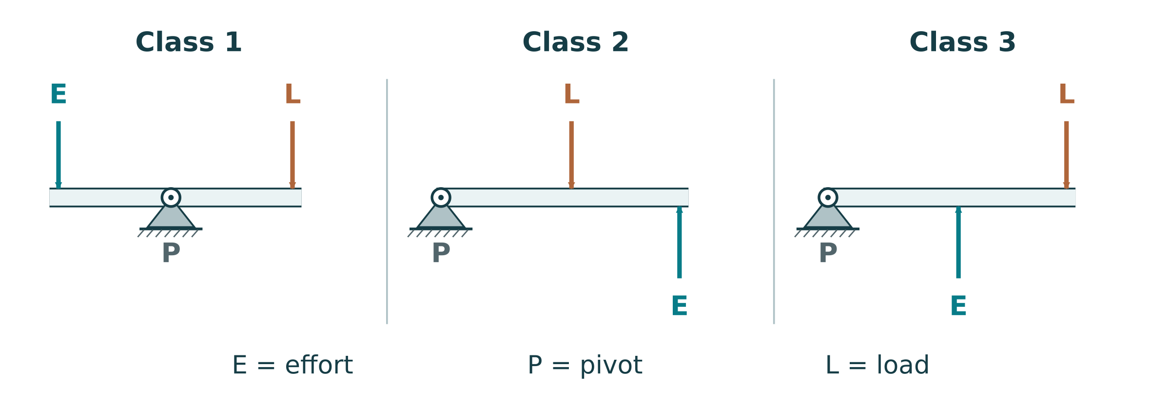
Figure 5. Conventional lever arrangements: class 1 fulcrum between effort and load; class 2 load between; class 3 effort between. Concept diagrams, not project geometry.
Lever class names the middle feature. In class 1 the fulcrum is between effort and load; the arm lengths determine the trade-off. In the conventional class 2 arrangement the load is between, so the longer effort arm multiplies force. In conventional class 3 the effort is between, trading force for movement. All use the same turning-effect balance.
Practice: draw and label an example of each class. Mark the middle feature and the direction of effort and load.
FLUID POWER AND MECHANISMS

Machines trade movement for force
A simple machine changes force, direction or movement; it does not create energy. MA = output force/input force. A lever turns about a fulcrum. A fixed pulley changes pull direction; an ideal two-segment movable pulley shares load between two rope segments and needs twice the input travel. An inclined plane, wedge or screw trades a longer input movement for a shorter output movement against resistance.
For gears, distinguish torque (N·m) from force (N). Two external gears turn in opposite directions. Driven teeth/driver teeth gives the input-to-output turn ratio. Compound stage ratios multiply when gears share shafts; a simple idler can change direction and spacing without changing the first-to-last ratio.
Hypothetical gear pair
A 10-tooth driver and 40-tooth driven gear give VR = 40/10 = 4. Four input turns produce one output turn and ideally four times the torque. Meshing and bearing friction reduce useful output; no extra energy is created.

Practice: a 20-tooth driver turns a 60-tooth driven gear. Find VR, output turns for six input turns, and ideal torque gain.

Practice: sketch the pair and label driver, driven and rotation directions. Add an example engineering use for reduced speed and increased torque.
FLUID POWER AND MECHANISMS

Linkages direct the motion
Linkages use connected members and pivots to constrain motion. Reverse-motion arrangements change the sense of movement; a suitable parallelogram maintains orientation. A crank-and-slider converts rotation and reciprocating linear motion. A bell crank redirects a push or pull. A treadle uses a foot-operated lever to drive a linked mechanism.
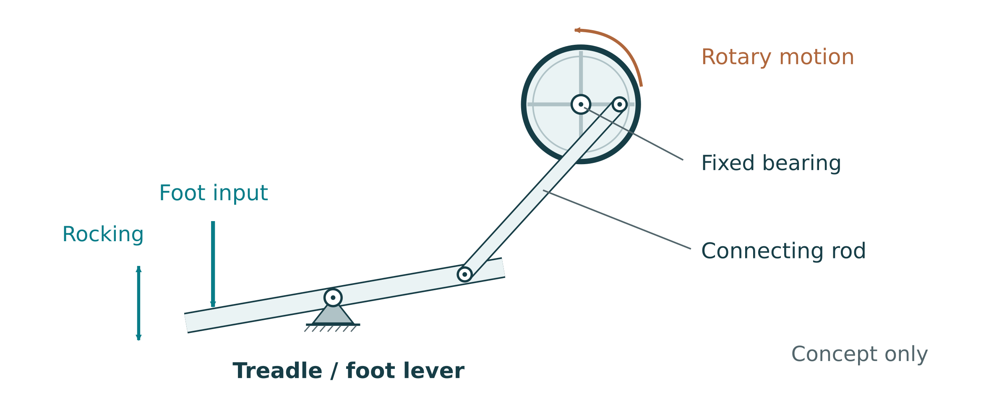
Figure 6. Original conceptual treadle linkage, derived from the motion idea in the linked V. Ryan © 2025 supplement. Notice the foot lever, connecting link and rotating crank; not a construction plan.
In the illustrated treadle, the pedal rocks and the connecting link drives a crank. A flywheel can help maintain rotation between pushes; exact behaviour depends on geometry. It is a motion-conversion example, not a required digger component. Complete the diagram and explanation below, then the whole four-application investigation at the source route on page 42.
Adapted source purpose: draw a simple treadle linkage. Indicate rocking and rotating movement, then label the parts that transfer the input.

Explain how the linkage transfers the foot input to the output.
FLUID POWER AND MECHANISMS

Measure efficiency and choose the drive

For comparable linear measurements, work in = Fin × sin and useful work out = Fout × sout. Efficiency = useful output work/input work × 100%. With MA = Fout/Fin and VR = sin/sout, efficiency = MA/VR × 100%. Use force in the displacement direction and a teacher-supported method when force varies.

For a hypothetical test, 8 N through 0.060 m gives 0.48 J input; 12 N through 0.030 m gives 0.36 J useful output. MA = 1.5, VR = 2 and efficiency = 75%. Friction, flex, misalignment, leaks and moving the arm itself affect useful output. Actual/theoretical force alone is not measured energy efficiency unless the displacement assumptions hold.

Your muscles power the hand-operated digger. Motors change electrical energy into motion while supply and load permit. A raised mass releases gravitational energy but has limited fall distance. Springs or rubber bands store elastic energy; their force changes during release. Compare speed, torque, operating time, controls and engineering use rather than assuming any source runs indefinitely.
Practice: input 10 N moves 80 mm; useful output 24 N moves 20 mm. Calculate MA, VR, input/output work and efficiency.

Practice: choose an energy source for a teacher-led slow-motion mechanism demonstration. Justify it against one alternative and name a needed control.
FLUID POWER AND MECHANISMS

Learn by dismantling, under supervision
Dismantling can reveal how a mechanism’s parts fit and move. Start by tracing the input and output from outside. A hand drill may contain gears; a toy may combine a motor, reduction gears and a linkage. Taking photographs in sequence lets you reconstruct the assembly instead of relying on memory.
A device that looks harmless can contain sharp edges, compressed springs, electricity or other stored energy. The teacher chooses the device, makes it safe and confirms the procedure. Do not release a spring, remove a guard, disconnect wiring or open a pressurised component on your own. Keep small parts in a labelled tray and use the proper tools.
Plan location-specific controls before motion: keep fingers clear of linkages, contain water away from equipment, manage stored energy and use the approved cutting/drilling procedure. Record the hazards, controls and in-motion checks in the SWMS on page 24. Teacher supervision and isolation instructions govern dismantling.
Source activity: Dismantling Investigation
Under teacher supervision, examine an approved device. Photograph disassembly stages, label components, sketch the motion flow, explain the connections, and record how it is safely reassembled. Follow the approved isolation and stored-energy procedure.

Draw the observed arrangement. Label the input/output, energy source, levers/gears/linkages, joins and safety features.

What did looking inside show that you could not tell from the outside?
FLUID POWER AND MECHANISMS

Identify mechanisms in everyday products
Source activity: Mechanism Identification
Examine teacher-approved everyday devices (for example a door closer, can opener, stapler, hand drill or toy). Identify levers, gears, pulleys, cams or linkages. Sketch the input and output motion, label the type, and document how the motion is transferred or transformed.

Practice: choose two linkage types. Explain one motion conversion and one feature you would label in each drawing.
Device / evidence ID | Mechanism and input | Output and transformation

Create an annotated sketch of one device. Show the motion path and one point where force or speed changes.
FLUID POWER AND MECHANISMS

Measure lever and gear relationships
Source activity: MA and VR Calculations
Use teacher-approved lever and gear setups. Measure effort/load arms and forces for levers; tooth counts and input/output turns or speeds for gears. Calculate theoretical ratios and measured ratios, then compare. Record the setup, units, observations and any differences.

For levers, use perpendicular moment arms when forces are angled. For gears, record angular motion and torque if measured; do not divide a torque by a force. If a measurement is unavailable, state that limitation rather than claiming an actual MA.
Setup / dimensions | Predicted MA or VR | Measured inputs / outputs | Comparison / notes

Show one complete calculation from your table, including the formula, substituted values and units.

Practice: compare a fixed pulley and a two-segment movable pulley. Explain the direction and force–distance changes.
FLUID POWER AND MECHANISMS

Investigate efficiency with a fair comparison
Source activity: Efficiency Experiments
For teacher-approved mechanisms, measure input/output force and distance, calculate VR, actual MA and work efficiency, then identify likely losses. Investigate an approved single change, such as alignment or an approved friction treatment. Compare the before/after results and create an appropriate graph.
Source graph prompts: plot actual MA against VR to compare performance, and work efficiency against mechanism type where comparable data is available. Use an additional graph sheet if both are assigned.
Keep the comparison fair
Use the same measurement points, start position, direction and load. An improvement that also changes several other variables cannot show which change caused the result. Use only teacher-approved lubrication or adjustment procedures.
Test / one change | Input force, travel and work | Output force, travel and work | MA, VR and efficiency
Before:
Repeat:
After:
Repeat:

What does your comparison suggest? Name the largest uncertainty before claiming that the change improved efficiency.

Why can a machine make a lifting task feel easier without reducing the ideal work needed?
FLUID POWER AND MECHANISMS

Compare energy sources and prototype motion
Source activity: Energy Source Investigation
Use approved rigs driven by a motor, gravity or a spring. Compare speed, torque or lifting behaviour and operating time, using the same mechanism where possible. Document setup and results, then explain advantages, disadvantages and suitable engineering uses.

Approved source/setup | Speed / torque / operating time (units) | Advantage / limitation
Motor
Gravity
Spring

Source activity: Extension: Cam and Linkage Prototype
If assigned by the teacher, prototype a cam or linkage that changes rotary and linear motion. Document design, construction, safe testing and evaluation. Measure comparable input/output quantities where possible and explain MA/VR or varying geometry. This is an extension, not an extra required digger build.

Extension or teacher demonstration: sketch the motion conversion. Label the input, output, pivots or guide, and explain what changes during one cycle.
FLUID POWER AND MECHANISMS

Selected mechanism questions A
Use the reading and your own evidence to explain your reasoning. Give a clear explanation rather than a list of terms.
What is mechanical advantage, and how do you calculate it?

Why measure efficiency instead of only theoretical MA?
FLUID POWER AND MECHANISMS

Selected mechanism questions B
Use the reading and your own evidence to explain your reasoning. Give a clear explanation rather than a list of terms.
Explain why a conventional class 3 lever needs more effort force than the load force in the ideal model.

What safety controls limit pinch-point injuries when working with mechanisms?

How do different energy sources affect mechanism performance?
DIGGER DESIGN

Turn the brief into testable criteria
The source brief requires smooth, leak-free control of three separate circuits, supported by predictions, tests and a folio. Website reach, lift and syringe-capacity examples are not approved class targets: record the teacher-confirmed values, datums, methods and source below.
Source activity: Design Brief Analysis
Read and annotate the class brief, highlight requirements and constraints, and create a checklist. Identify limits that affect your design before choosing dimensions or materials.

A criterion describes success; its test explains how to recognise it. “Good reach” is vague. A teacher-confirmed horizontal distance from a stated datum and repeatable start position can be checked against later results.
Explain one reason that “it moves” is not enough evidence of success.
Criterion / confirmed target | How it will be checked | Constraint / source
Boom, dipper and bucket circuits
Horizontal reach
Lifting capacity
Control and repeatability
Containment and stability

Name one pair of criteria that may compete. Explain the design trade-off.

Which requirement still needs confirmation before your group starts?
DIGGER DESIGN

Explore two linkage ideas
Source task: sketch 2–3 different digger arm layouts, compare force multiplication, reach and buildability, then select a preferred option. Start with two contrasting ideas here; continue a third on another sheet if it helps. This page is design evidence, not a construction approval.
Label the base, boom, dipper, bucket, pivots and proposed actuator connections. Add arrows for input and output motion. Use teacher-confirmed dimensions only; mark unresolved sizes “Teacher to confirm”.
Concept A: show an arrangement chosen for controlled lifting. Label pivots, load point and actuator line of action.

Concept B: change an attachment or arm arrangement. Annotate what you expect to gain and what you may lose.

Which idea would you develop first, and what evidence would help you choose?
DIGGER DESIGN

Compare concepts before committing
Compare the same class criteria for each concept: force, reach, control, buildability and hose routing. Show enough mechanism detail to explain how it works.
Source activity: Preliminary Sketches
Sketch 2–3 digger arm layouts with different lever arrangements or actuator positions. Compare force multiplication, reach and ease of building. Select a preferred option and justify it.
Optional third concept or refinement: change an engineering feature and annotate the reason. Keep unresolved dimensions clearly marked.

Class criterion | Concept A | Concept B | Preferred / reason
Force/control
Reach/travel
Buildability/safe layout

What must be checked before your preferred concept becomes the build design?
Which part of your design is informed by these views? Explain one decision that still needs a teacher-approved dimension, material or procedure.

Record feedback from the design review and what you changed.
DIGGER DESIGN

Communicate the approved design
Pictorial views communicate overall form; aligned orthographic views show features consistently. Visible edges are solid, hidden detail dashed, centre lines identify centres, and thin dimension/extension lines show written sizes. Use your teacher’s projection convention and only approved dimensions or tolerances. Include title, date, units and scale/not-to-scale identification.
The two original reference sheets that follow show shapes and relationships but provide no construction dimensions. Only sheet 1 prints DO NOT SCALE DRAWING; neither sheet authorises measurement from the image. Actuator placement, materials, thicknesses, fasteners, settings and loading remain teacher-confirmed.
Final design or key assembly view: show pivots, actuator lines, load point, motion path and approved dimensions. Add title, date, units and scale/not-to-scale note.
Practice: identify three features or relationships you can read from this reference, then list two practical facts it does not supply.
Practice: draw a simple teacher-selected part in aligned views. Demonstrate the line types needed and label the title/units/scale. Use approved dimensions only.

Name one way unclear dimensioning could create a making error.

Source working drawing: sheet 1
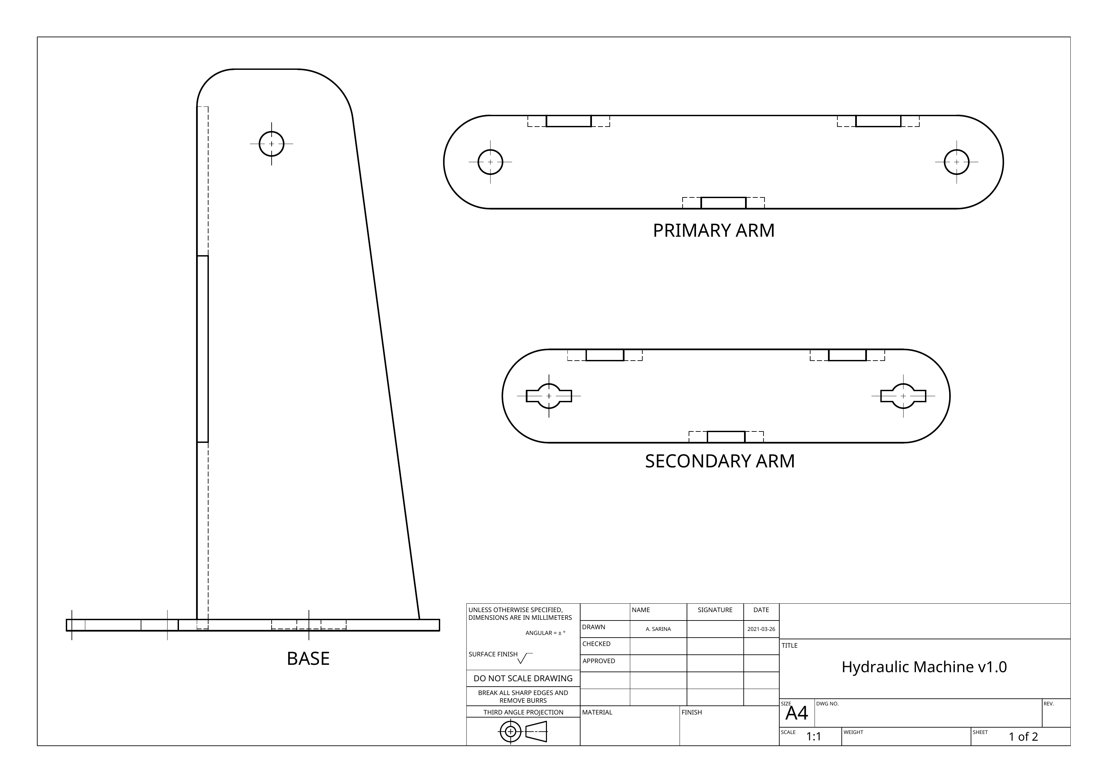
Figure 7. Unchanged undimensioned reference sheet 1. Use teacher-approved dimensions and procedures. Sheet 1 titleblock: DO NOT SCALE DRAWING.
Source working drawing: sheet 2
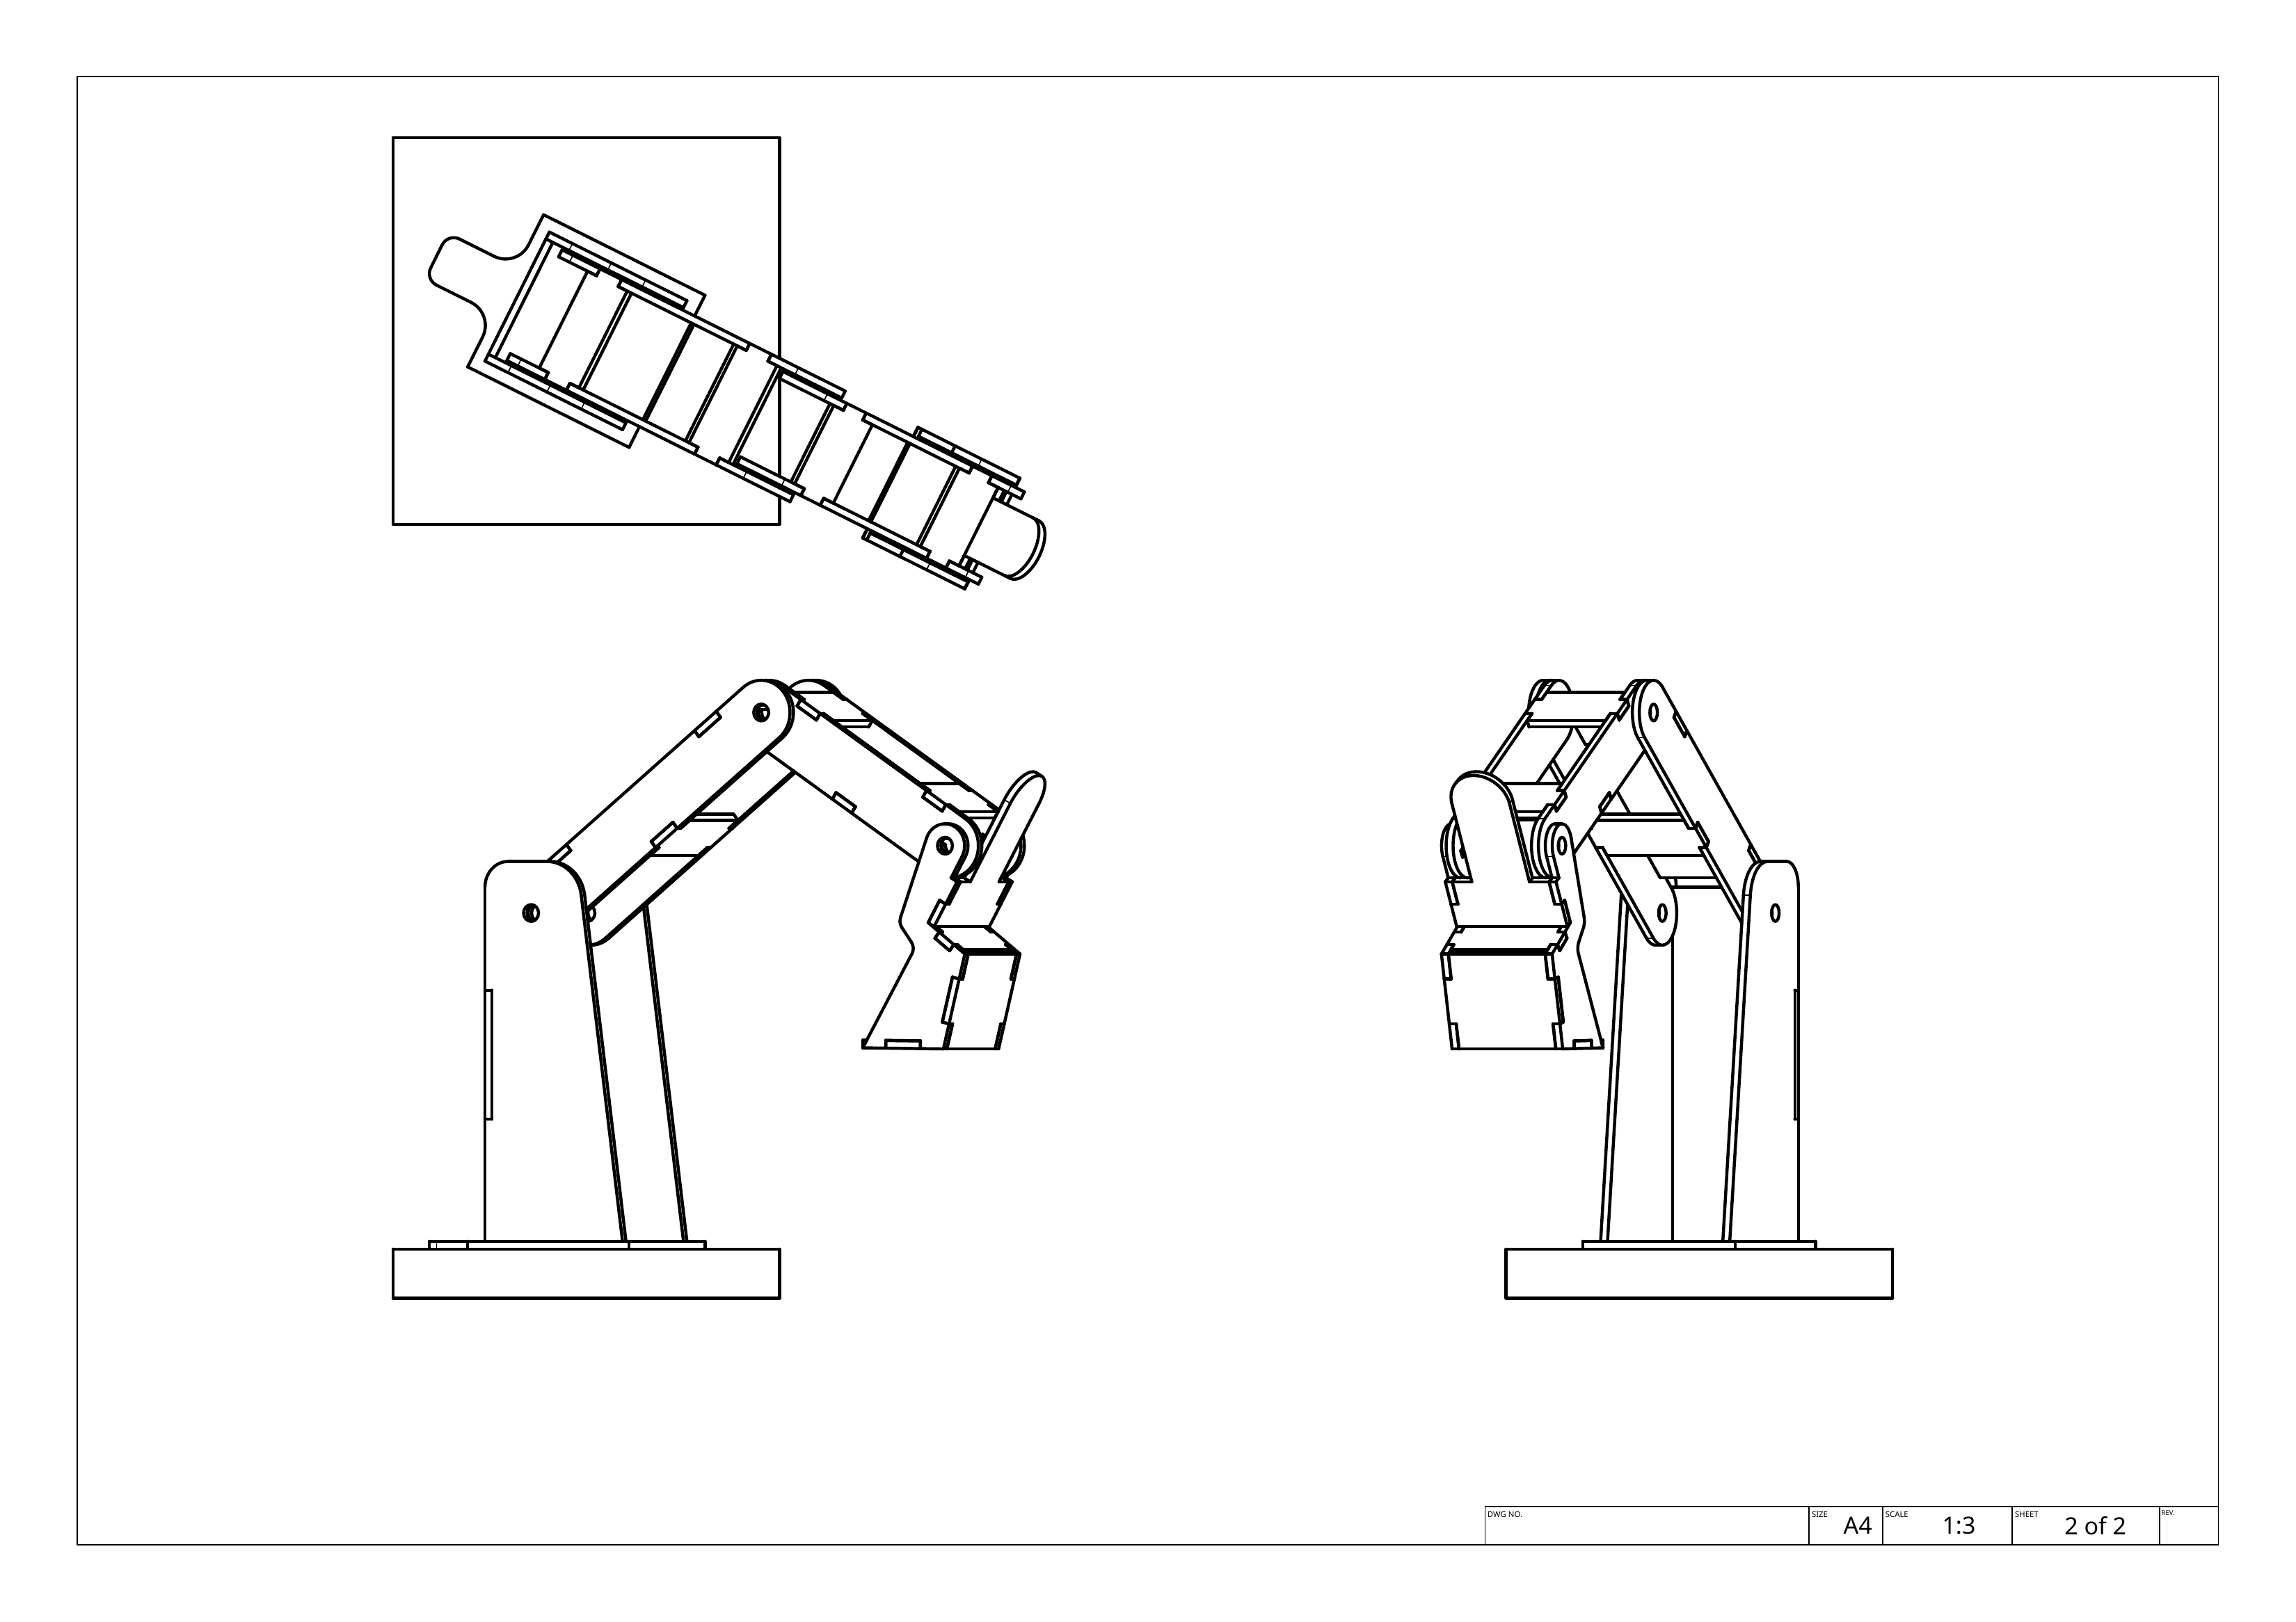
Figure 8. Unchanged undimensioned reference sheet 2. Use teacher-approved dimensions and procedures.

DIGGER DESIGN

Plan three independent circuits
Three separate circuits connect each control syringe to its own boom, dipper or bucket actuator. Piston travel turns an arm about a fulcrum. Trace both tube ends; crossing lines are not connections.
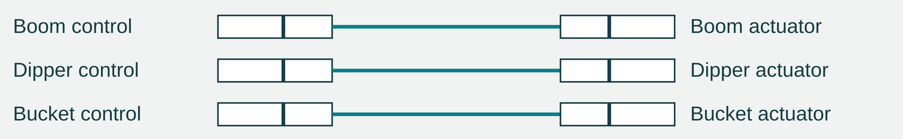
Figure 9. Separate functional paths. Symbols show connections only; they specify no sizes, mounting geometry or working limits.
Allow the approved motion range without kinks, snags, sharp-edge contact or strained joints. Secure mounts must permit required pivoting; misalignment can bind a plunger. Stop at resistance and ask the teacher. Record sizes, areas and predictions on page 23.
Source hydraulic design evidence: draw the three circuits and label inputs/outputs, tubing routes, mounts, pivoting needs and motion arrows. In one circuit, also label the fulcrum and load; distinguish linear and rotating movement.
Practice: sketch one control-to-bucket motion chain. Label input, fluid path, actuator, fulcrum and load; add arrows for linear and rotating motion.

Choose one hose or mount. Explain how you will check it through the approved range of motion.
DIGGER DESIGN

Measure the pistons and predict the system
Capacity is fluid volume, not piston diameter or pressure rating. Use a teacher-supplied specification or measure the working piston face/matching barrel bore, not the outside barrel. Record the source; calculate A = πd²/4.
A larger output area trades travel for force. Match each pair to its function: the boom also lifts the arm; the bucket must curl freely. Predict at a named position using area and perpendicular moment-arm ratios. Piston force is not bucket load force.
Circuit / piston | Capacity label | Working piston/bore d (mm) | Area (mm²) | Dimension source
Boom input
Boom output
Dipper input
Dipper output
Bucket input
Bucket output

Show one area and area-ratio calculation. Explain why your pairing suits the function.

Circuit / named position | Area ratio | Moment-arm ratio | Predicted force/travel | Assumptions
Boom
Dipper
Bucket
DIGGER DESIGN

Write the SWMS for this build
Source activity: Design and Planning
Develop the design calculations and a Safe Work Method Statement for cutting, drilling, assembly, water handling and testing. Apply appropriate hierarchy-of-control choices to actual hazards. Submit the SWMS and calculations for teacher review before practical work.

Record the task, what could go wrong, who may be harmed, the control and how it will be checked. Keep tool-specific instructions with the teacher’s approved procedures. This planning table helps you prepare; it is not a substitute for the school’s current SWMS or permission to operate equipment.
Include moving linkages, water near equipment, stored energy/pressure, and cutting or drilling. Identify each hazard in your actual setup, explain why the control helps, and record the check or teacher instruction.
Task / location | Hazard and possible harm | Control and why it helps | Check / reviewed instruction
Cutting / drilling
Frame / pivot assembly
Filling / connecting circuits
Operating / testing
Adjustment / cleanup

Record what your teacher confirmed and what is still pending before you begin.

Choose one control. How will you check that it remains effective as the arm moves?
DIGGER DESIGN

Plan materials and cost quantities
List part quantities and teacher-approved material/size specifications with their source. Confirm suitable tools; do not take a thickness, bolt size or quantity from an illustration. Use an approved cutting/nesting layout to reduce waste and record its labelled attachment ID below. Build sequence and review checkpoints are on page 41.
Part / quantity | Approved material/size | Source / tool / waste note
Base
Boom / dipper
Bucket / linkages
Pivots / mounts
Syringes / tubes

Cutting-layout attachment / evidence ID: __________________________________
Extended cost = quantity × unit price, with matching units and a rate source/date. In a hypothetical estimate, 2.4 m at $5.00/m is $12.00 and 20 fasteners at $0.10 each is $2.00. A 15% waste allowance on $14.00 gives $16.10; a 10% contingency on that subtotal gives $17.71. These rates and allowances are examples, not requirements or a purchase commitment.
Item / rate source | Quantity / unit | Unit price ($) | Extended cost ($)
Total / stated allowances
DIGGER DESIGN

Explain the hydraulic relationships
Use the reading and your own evidence to explain your reasoning. Give a clear explanation rather than a list of terms. These are the original source questions.
How does Pascal's principle apply to hydraulics?
Explain the mistake in “the large syringe has higher pressure because it produces more force”.

Why use different syringe diameters, and how do you calculate the force multiplication?
DIGGER DESIGN

Selected hydraulic questions B
Use the reading and your own evidence to explain your reasoning. Give a clear explanation rather than a list of terms.
How do lever ratios affect the digger's performance?
Practice: an actuator is moved closer to the pivot while the load point stays the same. Explain the likely force–movement trade-off for the same actuator force.

Why does the digger feel "spongy" or unresponsive, and how do you fix it?
Practice: explain why an air bubble and a leak can both make control poor, but require different checks.
DIGGER BUILD

Build accurately and remove trapped air
Source activity: Frame Assembly. Measure, mark, cut, drill and assemble to the reviewed design using teacher-approved clamping, datum and alignment procedures. Check dimensions, pivot alignment and dry movement. Misaligned pivots add friction, flexible arms absorb motion and loose joints change geometry. Compare with the approved drawing; never force a binding joint or invent a corrective size.
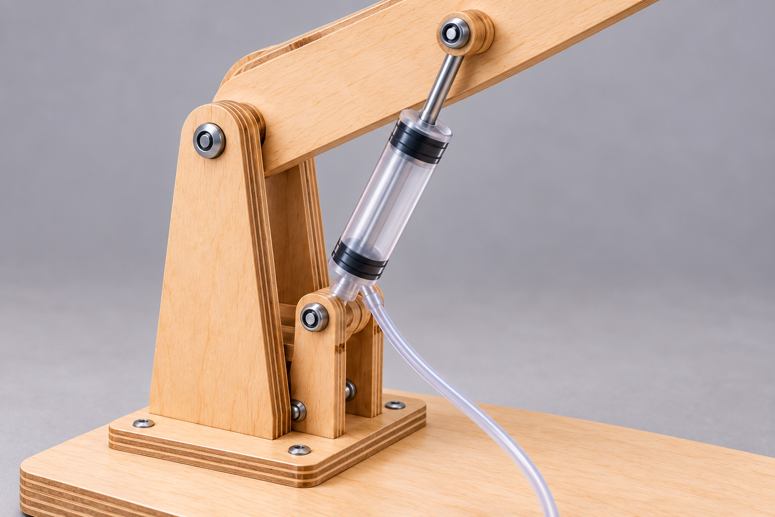
Figure 10. Illustrative details to inspect: aligned pivot, secure actuator mount and free hose path. Follow the approved class hardware and procedures; the image supplies no part specification.
Follow the teacher’s method for filling, connecting and de-airing. Trapped air compresses and delays response; leaks release fluid and can cause drift. Keep connections and the workspace controlled, remove air as instructed, then compare before/after observations for each circuit. Do not compensate with excessive force.
Circuit | Observed before | Teacher-led action / evidence | Observed after
Boom
Dipper
Bucket

How did your observations support or weaken the explanation that trapped air caused poor control?
DIGGER BUILD

Mount, assemble and inspect
Source activities: Mounting Cylinders, Final Assembly and Pre-Test Inspection
Use the approved brackets/clamps and connection points. Check secure support and the movement needed by the design; verify alignment and independent circuit response before final integration.
Connect boom to base, dipper to boom and bucket to dipper according to the reviewed design. Check free pivots, independent circuits and the approved range of motion. Record and explain design changes.
Inspect for loose joints, misaligned pivots, kinks, trapped air and leaks. Confirm the test’s load point, method, limits and stop conditions with the teacher. Secure the base, clear the test area and keep electricity away from water.
Inspection item | Observed condition | Action / teacher review
Base and joints
Pivots / clearances
Mounts / syringe travel
Hose routing / containment
Test zone / load method

Which fault would make you stop? Explain the risk and who should resolve it.

Practice: explain how one small making error could change the measured result even if the syringe pairing is correct.
DIGGER BUILD

Keep a dated log and meaningful captions
Source activities: Construction Log and Photo Documentation. Record each build stage with dates, photos, problems, solutions and reasons for changes. Write entries while the work is fresh; name the accuracy check and actual evidence. Do not recreate a stage photo and present it as contemporaneous.
Capture frame stages, hydraulic connections, mounts, final assembly and pre-test condition with useful whole-project views and close-ups. A caption identifies the part/circuit, date or stage, visible feature and claim. Photos do not by themselves prove safe lifting or correct calculations. Record the named source photo slots on pages 46–48.
Date / stage | What we did and checked | Problem / change / reason | Photo / drawing ID

What is the next authorised stage, and what check must happen first?

Choose one caption. What does the image show, and what would still need a measurement or other record?
DIGGER BUILD

Explain a change from the design
Source activity: Build Quality Assessment
Compare construction with the reviewed design. Identify issues that could affect performance and preserve them in the folio so the later analysis can explain the results.

A change needs a reason and an effect. If a pivot moved, the original lever calculation may no longer apply. If a mount changed, the actuator angle and useful moment arm may differ. If a tube was rerouted, control or clearance may improve. Keep the old drawing and annotate the revised design rather than silently overwriting the history.
Before: show the original detail, planned geometry or fault. Add an evidence reference.

After: show the approved change and label what it affects.

Explain why it changed and which prediction or test must be updated.
TESTING AND EVALUATION

Record a fair and bounded test method
Source activities: Testing Setup and Systematic Testing. Secure the frame; use teacher-approved equipment, loads and methods. Name each circuit, start position, direction and measurement datum. Review area/lever predictions before planning the boom, dipper and bucket sequence.
Hold start angle, load point and measurement points constant. Zero/read equipment as instructed. Stop at the teacher’s limit or a leak, binding, damage, base movement or unsafe condition, whichever comes first. Generic source wording about testing to failure does not authorise destructive tests.
Practice: explain two variables you must hold constant to compare a before/after improvement fairly.

Method detail | Your class-approved method
Circuit / function and start position
Input force/travel measurement points
Output load/travel measurement points
Reach datum and direction
Approved load / increments / limits
Stop conditions and safety controls
Repeat trials / equipment resolution

Write the prediction this test will check. Include its assumptions and where the calculation is recorded.
TESTING AND EVALUATION

Keep the raw force and load results
Record measurements immediately, before calculating ratios. Mass and force are different quantities: a balance may show grams, while a spring force gauge reads newtons. For a static lifted mass, weight can be estimated from F = m × g, with mass in kilograms and the teacher’s chosen gravitational value. Do not place grams directly into a force ratio beside newtons.
The checklist asks for at least three trials for one joint. Use the class-approved loads and repeated start position. Record the last safe successful trial and the reason the test stopped; this does not establish the machine’s destructive failure load. If force was not measured, label it honestly and do not invent actual MA.
Trial / setup | Input force (N) | Mass (kg) or measured output force (N) | Observation / evidence ID
1
2
3
Extra / repeat

Show one valid mass-to-weight conversion if you used it. Otherwise explain the output-force measurement method.

Why did you stop the test, and what can you conclude from that stopping point?
TESTING AND EVALUATION

Measure travel and calculate VR
Travel is displacement between defined start and end positions. For a comparable linear test, VR = input travel/output travel. Measure both during the same motion in matching units. Identify whether bucket travel means vertical lift, horizontal reach or path distance.
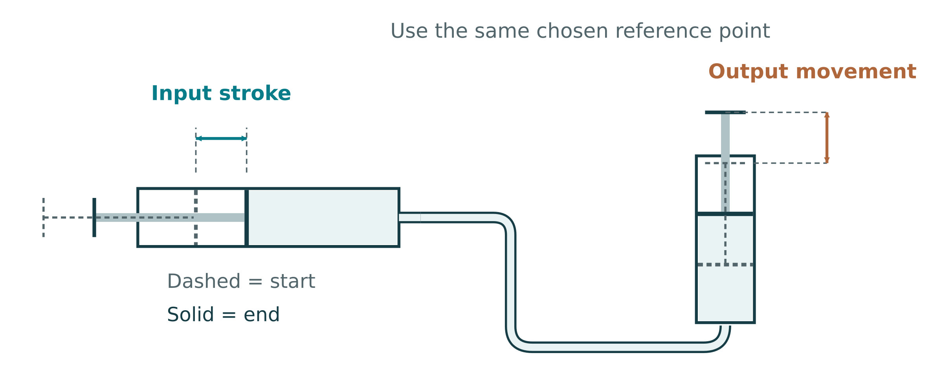
Figure 11. Conceptual input stroke and output reference-point displacement, with start/end positions marked. Measure the actual digger load point for bucket travel; actuator travel is different. Teacher-approved setup and limits control testing.
For an ideal hydraulic pair, Ain × sin = Aout × sout predicts piston travel. Linkages change bucket movement as their angles change. Measured VR over a finite stroke may therefore differ from an instantaneous moment-arm prediction.
Trial / position | Input travel (mm) | Output travel (mm) | VR and observation
1
2
3
After change

Show one calculation and compare it with the ideal piston-area prediction. Explain a possible difference.
Explain two reasons your bucket result may differ from an ideal piston prediction.
TESTING AND EVALUATION

Calculate and compare the performance
Source activity: Data Analysis
Organise test data with headings and units. Calculate actual MA, VR and work efficiency where measurements support them. Compare with predictions, create a graph and identify trends and uncertainties.

Use actual MA = measured output force/measured input force. Use VR = matched input travel/output travel. For the same comparable linear motion, efficiency = (MA/VR) × 100%. If only force predictions and measurements are available, report measured/predicted force percentage and label the missing travel evidence. A ratio alone cannot identify the cause of a loss. Use constant or appropriately averaged forces over the measured motion; a peak force and an unrelated full stroke do not form a valid work calculation.
Trial / evidence | Predicted result | Actual MA | Measured VR | Efficiency / limitation
1
2
3

Show complete working for one trial. State the formula, substituted data, units and rounding.
TESTING AND EVALUATION

A graph should answer a question
A graph makes a pattern visible. Choose quantities that answer your test question, such as input force against output force, or efficiency against load where work efficiency was measured. The axes need quantity names, units and a scale suited to the observations. Ratios such as MA and VR are dimensionless.
For a controlled input variable, place that variable on the horizontal axis and the measured response on the vertical axis. Plot measured points accurately and keep predictions visually distinct. A line through points is not proof of causation; check whether setup or geometry changed. If repeats differ, show them or report the spread.
Plot one graph from your actual table. Give it an informative title; label both axes with units, mark a sensible scale and identify measured/predicted values.

Describe one pattern and one limitation. Refer to values from the graph.
TESTING AND EVALUATION

Diagnose losses from evidence
Hypothetical observation: a control moves a short distance before the arm responds, visible bubbles remain, and the response improves after teacher-led de-airing. That supports trapped air as one cause of the delay. It does not prove that pivot friction vanished or the digger reached an efficiency target.
A different observation may point elsewhere. A mount shifting under load suggests flex or looseness. A wet tube joint and drift suggest leakage. Resistance at the same arm position can suggest binding or an unfavourable actuator angle. More than one cause can act at once, so name evidence rather than guessing a single explanation.
Observed symptom | Possible cause | Evidence needed to test the explanation
Delay / sponginess | Trapped air or flexible components | Bubbles/expansion and matched before/after response
Position drift / fluid loss | Leak or unstable support | Containment check and measured position change
Resistance at one angle | Binding or changing moment arm | Approved dry-motion/alignment and geometry checks

Practice: your group records lower output than predicted but sees no leak. Propose two other explanations and one safe check for each.
TESTING AND EVALUATION

Evaluate against the actual criteria
Source activity: Evaluation and Reflection
Compare the digger with the class brief, explain predicted-versus-measured differences, propose specific practical improvements and connect the reasoning to Pascal’s principle, lever mechanics and losses.

A strong judgement names the criterion and the evidence. “It worked well” does not show reach, lift, control or reliability. State what was measured, the tested conditions and any limit on the claim. If a criterion was not tested, say so. The current task notification asks for at least two specific improvements.
Confirmed criterion | Evidence / result | Judgement and limitation
Reach
Lift
Control / repeatability
Containment / safety
Prediction / efficiency

Explain the most important difference between prediction and measurement using the theory and your evidence.
TESTING AND EVALUATION

Plan two improvements and retest one
An improvement is specific enough to try and evaluate. Changing piston area trades force for travel. Changing actuator geometry affects torque and motion range. Reducing binding can improve the useful response without changing the intended ratio. Describe the expected gain, likely cost and evidence needed before choosing.
Specific proposed change | Theory / expected gain | Trade-off / check needed
Improvement 1:
Improvement 2:

Sketch one improvement. Label the altered feature, expected motion/force effect and what stays the same in the comparison.

If authorised, record the retest evidence and conclusion. If not undertaken, state the proposed test and what it would establish.
TESTING AND EVALUATION

Your final engineering judgement
Bring the argument together: the class criteria, what you made, the results, the theory that explains them and the changes you would make. Your judgement can include strengths and limits. Honest analysis of a fault is more useful than an unsupported claim that everything was perfect.
Source folio: write your final judgement. Explain what worked best, what first limited performance, the strongest supporting evidence, WHS considerations and at least two justified improvements.

Explain what this project taught you about a real engineering system and how your first learning goal changed.

Operation video, if assigned
The guided folio provides an operation-video slot. A teacher-approved short clip can show a full controlled motion cycle. Record its file name and a caption; it supplements the measured data rather than replacing it.
COMMUNICATION AND PROJECT MANAGEMENT

Plan the sequence and keep checkpoints current
Review design and safe methods before irreversible work. Check frame, pivots and dry motion before circuits; de-air and inspect before testing. Actual data must precede analysis and evidence-linked evaluation.
For each stage record its class date/lesson, prerequisite and check before progressing, plus the evidence or teacher review needed. Include accurate holes/pivots, stiffness/bracing and tidy hose routing within the relevant checks. Revise a delayed plan rather than rush unsafe work.
Stage | Class date / lesson | Needed first / check before next stage | Evidence / review status
Research and design
Design / SWMS review
Prepare frame and pivots
Dry movement and mounts
Hydraulic setup / de-airing
Final inspection / test permission
Analysis / evaluation
Folio handover

Choose one delayed or uncertain stage. Explain how you would revise the plan while keeping the necessary checks.
COMMUNICATION AND PROJECT MANAGEMENT

Make lifecycle decisions from evidence
Material decisions affect strength/stiffness, workability, cost, waste, durability and end-of-life. Embodied energy is used to obtain and process materials. A low-impact label alone is insufficient: quantity and useful life also matter. A cutting layout can reduce offcuts, and repairable or separable parts can support later reuse where safe and permitted. Follow school disposal procedures for water and damaged parts; plastics do not all use the same recycling stream.
Lifecycle decision | Evidence / alternative | Benefit and limitation
Material selection
Cutting / waste reduction
Durability / repair
Reuse / end-of-life

Propose one realistic environmental improvement without undermining the project’s function or safety.

Continue the original source work
These routes retain the unprinted source questions, complete treadle research and extended teacher-led media practice; they are not newly optional. The original media prompts remain in the unchanged 81-page edition, pages 72–75.
Mechanism Q&A 02, 05–07, 09–10
Hydraulic Q&A 03, 05, 07–10
Communication Q&A 01, 04–07, 10
Whole treadle four-application investigation and sketch
Source clips; extended responses: old workbook pp72–75
COMMUNICATION AND PROJECT MANAGEMENT

Selected communication questions A
Use the reading and your own evidence to explain your reasoning. Give a clear explanation rather than a list of terms.
Compare two approved material choices using cost and one other factor. Explain your choice.

What should a costing spreadsheet include, and how do you structure it?

How can sustainability be shown in the folio, and what should you include?
COMMUNICATION AND PROJECT MANAGEMENT

Career research and communication questions B
Mechanical engineering concerns machines and energy; civil engineering concerns infrastructure; mechatronics combines mechanics, electronics and control; industrial engineering examines processes and resources. Roles overlap. Your project develops transferable problem definition, drawing, safe testing, data analysis and improvement skills. Trade/apprenticeship, TAFE and university pathways develop them in different ways. Use a current official source for entry requirements, duration and outcomes; do not invent a pathway detail.
How do you present test results effectively in a folio?

How do you link your project to engineering careers and pathways?
Research record: Career and a typical responsibility; Relevant project skill and example; Real-world hydraulic/mechanism use; Official course/apprenticeship source and date; Course/apprenticeship duration and likely pathway outcome; Pathway requirement to verify.
Explain how one piece of your folio demonstrates a skill used in that career.
COMMUNICATION AND PROJECT MANAGEMENT

Check the relationships
Practice questions below are newly written formative checks. Choose one answer for each, then explain one choice using the reading. These are separate from the exact website question set.
1. Which change increases pressure for the same input force?
A. A smaller input piston area
B. A larger input piston area
C. A longer hose, regardless of losses
D. A larger air bubble

2. The output piston has four times the input area. In an ideal sealed liquid circuit, which pair is correct?
A. Four times the force and four times the travel
B. Four times the force and one-quarter of the travel
C. One-quarter of the force and four times the travel
D. Equal force and equal travel

3. For a fixed actuator force, which description correctly uses lever moment arms?
A. A shorter effort moment arm always increases bucket force
B. The effort arm and load arm are irrelevant
C. A longer effort moment arm relative to the load arm gives greater ideal force MA
D. Moving a pivot removes friction entirely

Build a reason, not a repeated option
Name the relationship you used, say what stays the same, then connect the change to its effect. A strong explanation also identifies where the ideal model may differ from a real measurement.

Explain one answer without simply repeating the option.
FINAL FOLIO AND EVIDENCE

Design and assembly evidence register
Retain the guided folio’s named evidence slots. Record your image/file ID and an engineering caption below. Attach the actual images using the teacher’s submission method or on additional sheets. Use your own genuine evidence; illustrative source photo examples are not completed student work.
Named source evidence slot | Your file / page / date | Caption: feature, observation and significance
Linkage Design Photos — Labelled Sketch
Linkage Design Photos — Pivot Layout
Linkage Design Photos — Syringe Mounts
Linkage Design Photos — Bucket Path
Assembly Evidence Photos — Base Frame
Assembly Evidence Photos — Boom / Dipper
Assembly Evidence Photos — Bucket Linkage
Assembly Evidence Photos — Problem + Fix

Which evidence is still missing, and what authorised next step will supply it?
FINAL FOLIO AND EVIDENCE

Hydraulic setup and test-method evidence register
Retain the guided folio’s named evidence slots. Record your image/file ID and an engineering caption below. Attach the actual images using the teacher’s submission method or on additional sheets. Use your own genuine evidence; illustrative source photo examples are not completed student work.
Named source evidence slot | Your file / page / date | Caption: feature, observation and significance
Hydraulic Setup Photos — Filled Syringe
Hydraulic Setup Photos — Hose Routing
Hydraulic Setup Photos — De-airing
Hydraulic Setup Photos — Leak Check
Test Method Photos — Reach Setup
Test Method Photos — Lift Test
Test Method Photos — Travel Measure
Test Method Photos — Safety Zone

Which evidence is still missing, and what authorised next step will supply it?
FINAL FOLIO AND EVIDENCE

Results and redesign evidence register
Retain the guided folio’s named evidence slots. Record your image/file ID and an engineering caption below. Attach the actual images using the teacher’s submission method or on additional sheets. Use your own genuine evidence; illustrative source photo examples are not completed student work.
Named source evidence slot | Your file / page / date | Caption: feature, observation and significance
Results and Data Photos — Data Table
Results and Data Photos — Max Lift
Results and Data Photos — Reach Result
Results and Data Photos — MA / VR Working
Tuning and Redesign Photos — Failure Point
Tuning and Redesign Photos — Adjustment
Tuning and Redesign Photos — Retest
Tuning and Redesign Photos — Improvement Sketch

Which evidence is still missing, and what authorised next step will supply it?
FINAL FOLIO AND EVIDENCE

Check the project, then support every answer
Write Yes / Not yet / Not checked with an evidence reference for your actual project. A positive self-check is not practical approval: follow the teacher-approved dry-motion, hydraulic and test procedures.
Exact source self-check | Status / evidence
Do you know exactly how your digger will be tested?
Does your sketch show pivots and cylinder mounts?
Have you predicted the force/travel trade-off?
Do the arms move smoothly by hand?
Is motion smooth (not spongy) and leak-free?
Do you have enough evidence to justify your evaluation?
Do you have 3 working circuits (boom, dipper, bucket)?
Are syringes secured and hoses routed safely (no kinks/leaks)?
Have you removed air (smooth, repeatable motion)?
Have you recorded syringe sizes/areas and test data (reach, lift, movement)?

Choose the most important unfinished check. Explain the next step and why it matters.

Record your teacher-confirmed submission method, date/time and files/pages included. State one remaining question if needed.
FINAL FOLIO AND EVIDENCE

Assemble a traceable folio
Keep the twelve guided-portfolio sections below. Refer to your completed working pages and actual files instead of rewriting them. In the last column, enter a page/file ID and Ready or a specific gap. Complete the submission record on page 49.
Source section | Evidence to locate | Your page/file ID and status
1 Project Brief | Task, testable criteria and confirmed class targets.
2 WHS and Risk Controls | Hazards, PPE, tools, water, pinch points and safe testing.
3 Fluid Power Basics | Pascal’s principle; pressure, force, area and trapped liquid.
4 Linkage Design | Pivots, mounts, movement path and force–travel trade-offs.
5 Syringe Sizing | Choices, piston areas, force predictions and travel.
6 Build Plan | Sequence for base, arms, bucket, pivots and circuits.
7 Assembly Evidence | Dated log, assembly decisions, problems, fixes and checks.
8 Hydraulic Setup | Filling, tubing, de-airing, leaks, routing and mounting.
9 Test Method | Repeatable setup, start position, reach/lift method and safety zone.
10 Results and Data | At least 3 trials; reach, lift, movement, MA, VR, efficiency and graph.
11 Tuning and Redesign | Performance limits, at least 2 justified improvements and retest plan.
12 Final Evaluation | Evidence-linked judgement, theory, WHS and practical improvements.
Across the folio | Sustainability, costing and career/pathway evidence.

Video slot: “Hydraulic digger operation video”, if teacher-directed. Save the HTML session backup and media ZIP as directed; JSON-only backup excludes video. Browser autosave is not submission.
Teacher-confirmed method, due date and task instructions control handover; this index is not a grade or practical approval.

