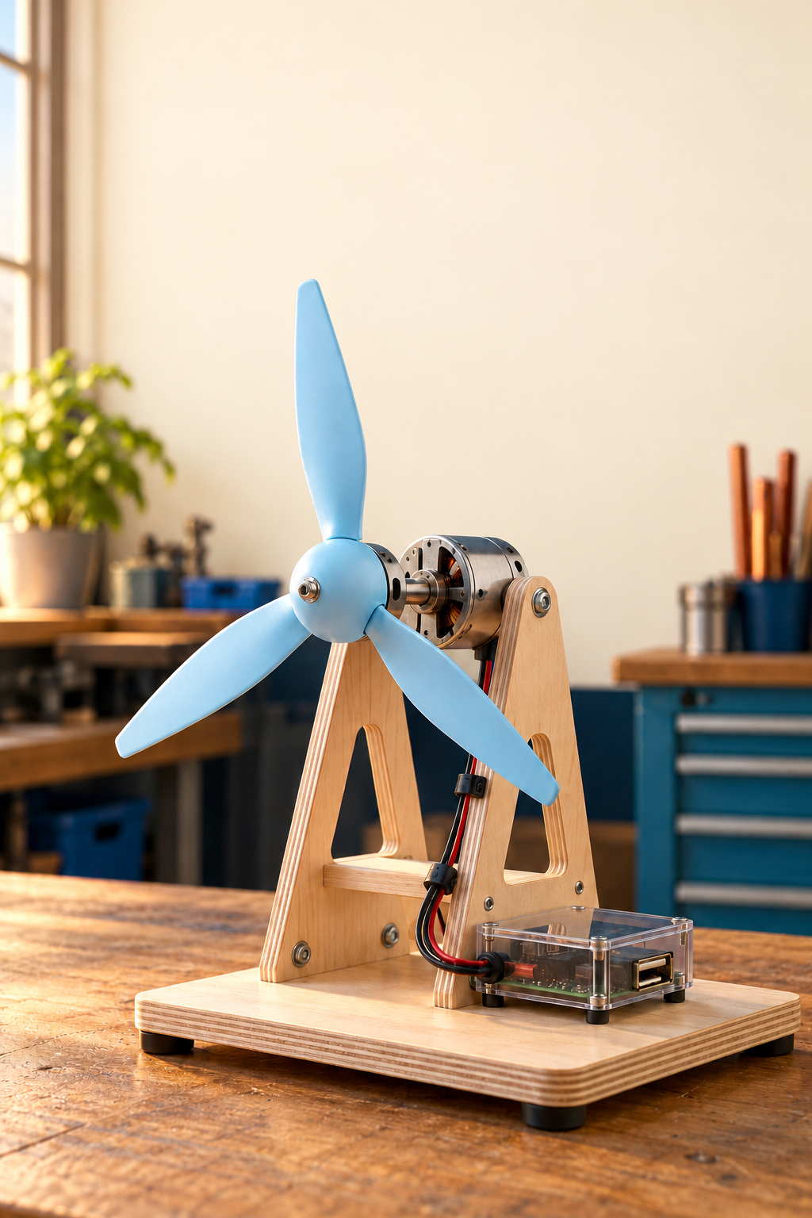
YEAR 10 ENGINEERING

Wind Powered
USB Phone Charger
Student learning and project folio companion

Illustrative prototype concept at rest. It is not a construction plan, confirmed school kit or evidence of output.
Name: ______________________ Class: __________
START HERE

Use the book through the design process
This supplementary workbook helps you learn, plan and record the Wind Powered USB Phone Charger project. Read the connected theory, attempt the checks, compare concepts and collect your own evidence. Practical construction and powered testing remain teacher-supervised. A diagram, photograph or completed page does not approve a component, tool, circuit or phone connection.
Learning route | Pages
Brief and component constraints | 3
Energy research and original questions | 4 to 20
Wind generator design and concepts | 21 to 30
Drawings and communication | 31 to 34
Build test and evaluation | 35 to 47
Folio sources and online continuation | 48 to 50

Keep planned work separate from observed work
A testing plan describes what you intend to do. A result describes what actually happened. Keep those states clear in the folio and date your observations. Leave later practical fields blank until the work is authorised and completed; never invent readings, photos or teacher checks.
Your issued task controls assessment
Use the current issued teacher assessment for your class submission, timing and marking requirements. The online guide and older master folio do not settle a conflicting instruction. This book provides learning and evidence space without issuing formal dates, marks or criteria.

Where will you keep your own sketches, CAD versions, research notes and dated test evidence?

This supplementary book supports the current teacher-issued task. Use the eight selected toolkit questions in print and the twenty-four exact online continuations on page 50. Keep a saved editable copy of your own work.
Optional fabrication is a design decision
Laser cutting and 3D printing are optional processes in the source folio. Discuss whether a process improves fit, accuracy or repeatability. Your teacher confirms access, material, equipment procedure and how any extension is assessed.
PROJECT BRIEF

Design within the confirmed constraints
The brief asks for a portable, compact and well-constructed wind-powered USB charger made around the supplied generator kit. A useful solution combines a wind-catching impellor, mechanical support and energy transfer, generator and USB output interface. The frame must remain stable while the rotor turns; the wiring must remain clear of moving parts.
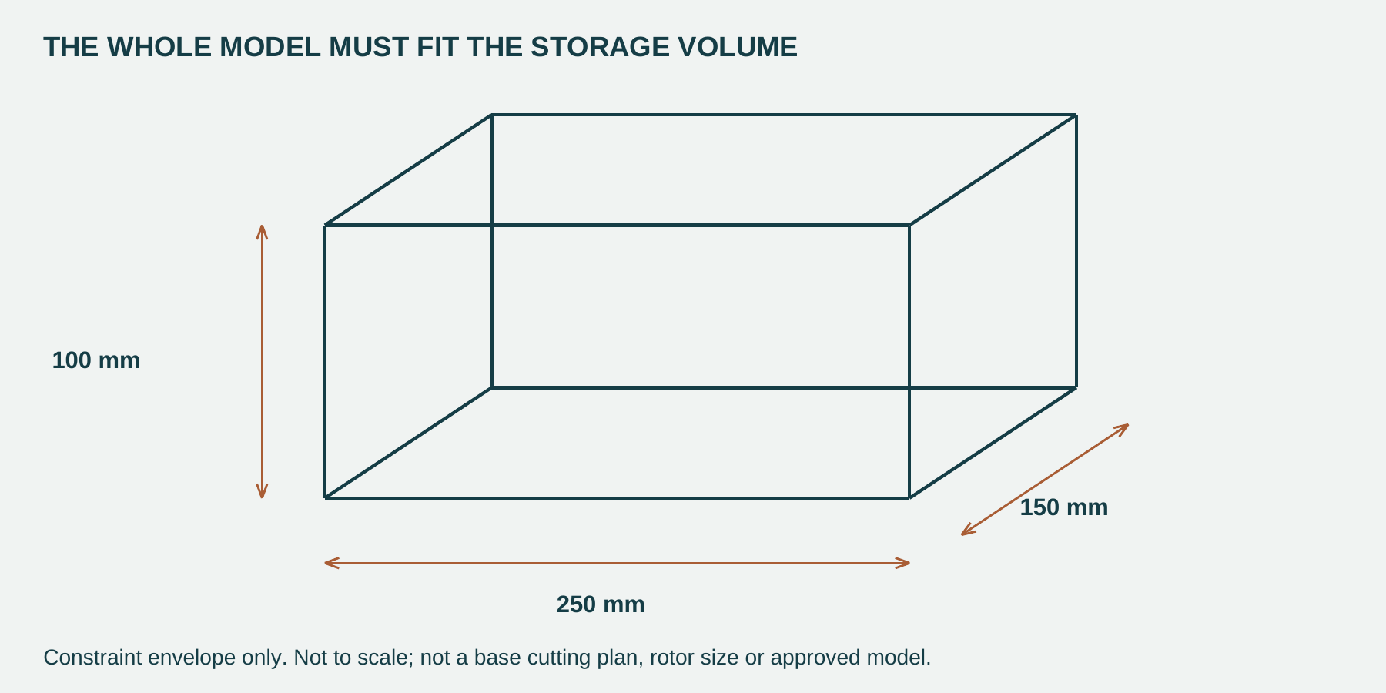
Figure 4. The 250 x 150 x 100 mm storage envelope is a whole-project constraint. It does not specify base cutting sizes or a rotor diameter.
Source parameter | Recorded constraint
Maximum storage volume | 250 x 150 x 100 mm
Generator body | 31 mm long and 24 mm diameter
Generator shaft | 2 mm diameter and 13 mm long
Available bearings | 20 mm outside diameter and 10 mm inside diameter

List everything that must fit inside the storage volume, then explain one design choice affected by it. Explain how two of these dimensions affect your design. Record any part or fit that needs a teacher check.
Wind Generator Parameters Describe the design brief, its size limit and the generator parts that constrain your model.

Complete the labelled constraint-box drawing on page 34; use the same source dimensions and actual confirmed parts.
ALTERNATIVE ENERGY

Trace useful energy and its limits
Renewable sources are replenished by natural processes on a useful human timescale. Wind, sunlight, flowing water and heat from Earth are examples; biomass can be renewable when its source is replaced and managed appropriately. Coal, oil, natural gas and uranium come from finite stocks. Renewable, low-emission and efficient describe different things. A renewable source does not promise that every installation is clean, affordable or reliable.
Materials, manufacturing, transport, maintenance and end-of-life handling affect the environmental result. Compare an energy system’s usefulness in its setting as well as its source. A windy site with suitable access may suit wind generation; a calm indoor setting provides different evidence.
Storage can shift when energy is used, but cannot create the missing input energy. Batteries add their own costs, losses, charging limits and lifecycle impacts. The project studies storage as an idea; it does not authorise adding or charging a battery from an unverified kit output.
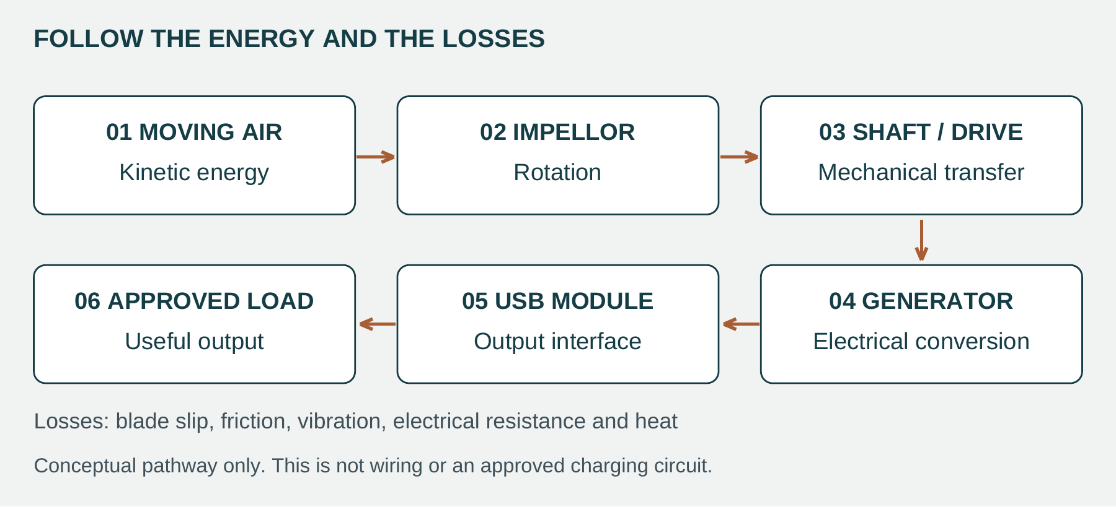
Figure 3. The functional pathway separates capture, transfer, conversion and output. Arrows show energy flow, not wires or a verified circuit.
Moving air carries kinetic energy. The impellor or wind catcher transfers some of that energy into rotation. The shaft carries the rotation to the generator, directly or through the project’s approved transmission arrangement. The generator converts mechanical energy into electrical energy. The intended final stage is the project’s USB interface or output. Whether that output is suitable for any device must be established from the actual components and teacher-approved evidence.
Not all of the input becomes useful output. Air moves past the rotor without giving up all its energy. Bearings or supports can resist motion. Misalignment, vibration and electrical resistance can transfer energy into unwanted movement, sound or heating. The energy has not disappeared; it has moved into less useful forms or left the chosen system boundary.
Worked example: losses are still energy transfers
In a made-up energy budget, 100 units of input energy cross the chosen boundary and 25 units reach the useful electrical output. Efficiency is 25 ÷ 100 × 100 = 25%. The remaining 75 units leave as other transfers or outputs. These are teaching values, not measurements of the classroom charger.

Explain why a spinning rotor is not enough to prove charging.
ALTERNATIVE ENERGY RESEARCH

Compare wind and solar in context
A fair comparison begins with a need. A remote sensor, a household and a town do not require the same amount or timing of energy. Ask what source is available, when energy is needed, what equipment is required and what happens over the equipment’s life. For this project, wind is a useful learning context because the motion and the energy transfers can be observed. That does not establish the prototype as a replacement for a commercial charger.
Wind generation uses moving air to turn a rotor and generator. It needs a suitable wind resource, space and equipment that withstands the conditions. Solar photovoltaic generation converts sunlight directly into electricity. It can be useful on a roof or at a larger site, but output changes with light and shading. Neither system is automatically available at the time it is needed.
Compare Alternate Energies Use these fields for wind and solar. Continue the other sources on the next page. A regional link can be a justified suitability example or a real installation with its source recorded.
Research field | Wind
How energy is produced
Advantage
Limitation
Environmental impact
Suitable site
Local/regional link and evidence

Research field | Solar PV
How energy is produced
Advantage
Limitation
Environmental impact
Suitable site
Local/regional link and evidence
ALTERNATIVE ENERGY RESEARCH

Compare water heat and biomass
Hydropower uses water moving through a turbine to drive a generator. Stored water can provide flexibility, but water availability, landform and environmental effects matter. Geothermal electricity uses suitable underground heat to supply a heat-driven generating system. Finding heat is not enough: the resource, fluids and engineering arrangement must suit electricity generation. Some lower-temperature geothermal resources are more suitable for direct heating.
Bioenergy converts biomass into useful heat, electricity or fuels. It may use agricultural residues or other renewable organic material. Feedstock must be collected, transported and replaced or managed appropriately. Burning biomass can release air pollutants and carbon dioxide, so an environmental judgement must examine the whole supply chain.
Your local link can be a reasoned suitability statement, rather than a claim that a plant exists near school. For example, a farming region with a reliable stream of agricultural residues might consider bioenergy. Identify the conditions that make the idea plausible, then record a source if you name an actual installation.
Research field | Hydro | Geothermal | Biomass
How energy is produced
Advantage
Limitation
Environmental impact
Suitable site
Local or regional link and evidence

Explain why wind suits the learning purpose of this charger, and what must be verified before useful charging is claimed.
ALTERNATIVE ENERGY RESEARCH

Compare the same energy service
A low purchase price does not necessarily mean low-cost useful energy. An energy system also has installation, maintenance, replacement and end-of-life costs. Reliability matters because a cheap system that rarely supplies the required service may not be a useful choice. Compare systems over the same time period and with the same energy service in mind.
Power and energy are different. Power is the rate of transferring energy, commonly measured in watts (W). Energy is the amount transferred, commonly measured in watt-hours (Wh) or kilowatt-hours (kWh). A cost per watt of installed capacity describes a different thing from a cost per kilowatt-hour delivered. A small prototype cost is also different from a power-station electricity price.
Use the teacher’s current costing sheet when supplied. For researched figures, record the source, publication or quotation date, currency, system size, time period and what is included. Missing or incomparable information should be labelled, not guessed. The numbers in the practice example are invented for learning and are not current prices for any technology or kit.
Worked example: a common comparison boundary
Illustrative System X has an initial cost of A$120 and A$30 maintenance over five years. It delivers 300 kWh over that period. The simplified cost is (120 + 30) ÷ 300 = A$0.50/kWh. This is only a teaching calculation: it ignores finance, changing prices and other costs, and cannot be quoted as a real system price.

Fictional five-year comparison: System A costs A$90 plus A$30 maintenance and delivers 120 kWh; output is available for 60 of 100 defined demand periods. System B costs A$150 plus A$30 and delivers 360 kWh; it is available for 85 of 100 periods. A needs an exposed site; B needs an unshaded site. These are abstract learning systems, not real products.
Calculate the simplified cost per kWh for each. Explain why lower initial cost is not enough to choose the system.
ALTERNATIVE ENERGY RESEARCH

Record real costing evidence
Use the actual teacher costing sheet or traceable researched figures. Compare the same service, scale, time period and units. Keep missing information explicit.
Evidence field | System 1 | System 2
System and scale
Quoted cost and inclusions
Efficiency and measurement basis
Reliability and time basis
Site requirements
Source, currency and date

What is missing to compare efficiency, and which data or conditions still need confirmation?

Explain what a fair costing comparison can establish and what it still cannot prove.
ALTERNATIVE ENERGY RESEARCH

Explain how a solar cell works
A photovoltaic cell converts light directly into electrical energy. In a common silicon cell, the semiconductor absorbs some incoming light and its energy frees mobile charges. A p–n junction is formed between differently treated regions of silicon. The junction’s built-in electric field helps separate the light-generated electrons and holes. When the contacts are connected through an external load, charge can flow and transfer energy to the load.
In the simple conventional cell shown here, a thin n-type region is near the illuminated surface and a p-type region lies below it. Metal front contacts collect current while leaving much of the surface open to light. A rear contact completes the connection. An anti-reflection treatment helps more light enter. This is a simplified educational example: modern cell designs vary, so it is not a universal manufacturing drawing.
A solar cell is not the same thing as a complete panel. A typical panel contains interconnected cells protected by glass, polymer encapsulant and a backsheet or rear glass, often with an aluminium frame. These layers protect fragile cells and help the module survive outdoors. They do not replace the semiconductor’s job of converting light. Solar PV should also be distinguished from solar thermal, which collects heat.
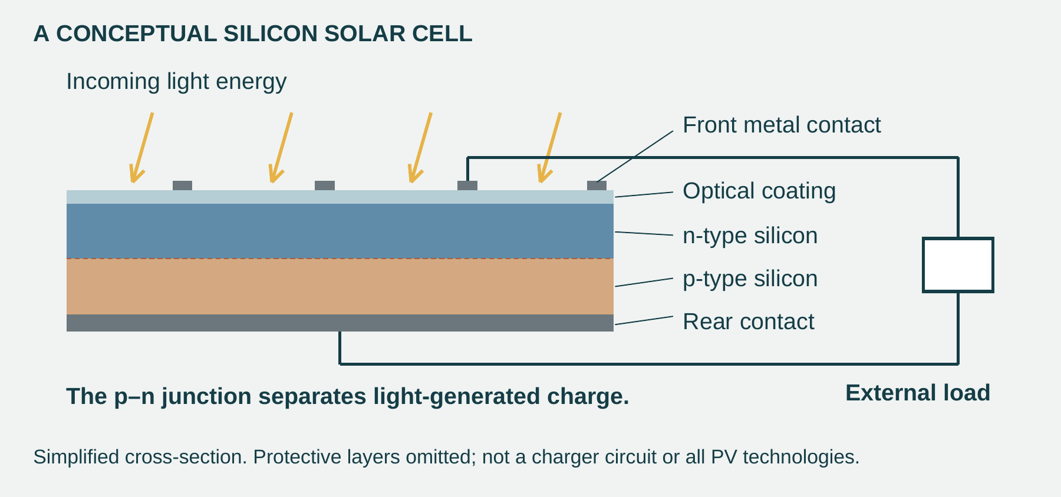
Figure 6. A simplified crystalline-silicon cell cross-section connects the junction, contacts and external load. It is not a wind-charger circuit or a complete manufactured panel.
Use this reading and conceptual figure for the full original research question and your own construction diagram on page 10.
ALTERNATIVE ENERGY RESEARCH

Draw and explain solar cell construction
Use the previous reading and conceptual figure to support question 1. Draw your own labelled cross-section, then explain how one construction feature supports energy conversion. This is a solar-cell learning diagram, not a charger wiring plan.
Explain how a solar cell works; include a diagram explaining how a solar cell is constructed.

Solar cell construction diagram Use your own labelled cross-section to support question 1.

Explain the role of one labelled construction feature in the diagram.
ALTERNATIVE ENERGY RESEARCH

Connect voltage current and resistance
Voltage is the electrical potential difference between two points. It describes energy transferred per unit charge and is measured in volts (V). Current is the rate of charge flow and is measured in amperes (A). Resistance describes opposition to that current and is measured in ohms (Ω). In the formula V = I × R, V is voltage across the resistance, I is current through it and R is resistance.
For an ohmic component at approximately constant temperature, current is proportional to voltage. Keeping the same resistance and doubling the voltage doubles the current. Keeping the same voltage and doubling the resistance halves the current. The rearrangements I = V ÷ R and R = V ÷ I allow the missing quantity to be calculated.
Ohm’s law is a useful model with limits. A phone, a battery and a USB control circuit are not simply fixed resistors. The formula does not certify that a generator is suitable for charging. In this workbook, the numerical examples use invented resistor values so you can practise the relationships without treating them as project wiring instructions.
Worked calculation: identify, rearrange, substitute, check
An illustrative resistor has 6 V across it and a resistance of 30 Ω. The missing quantity is current. I = V ÷ R = 6 ÷ 30 = 0.20 A. Check: V = I × R = 0.20 × 30 = 6 V. These are hypothetical classroom values, not charger specifications.

Explain what Ohm’s law is, and describe each part of the Ohm’s Law formula.

Try a separate fictional resistor: 4 V across 20 ohms. Calculate current and predict what happens if resistance doubles with voltage fixed.
ALTERNATIVE ENERGY RESEARCH

Use Earth heat to generate electricity
Geothermal energy is heat from the Earth. A geothermal power station needs a resource and engineering system capable of transferring useful heat to a generating cycle. Wells can bring hot water or steam to the surface. A turbine is driven by flowing vapour, and its shaft drives a generator. The conversion chain is thermal energy → mechanical energy → electrical energy.
In a dry-steam plant, geothermal steam drives the turbine directly. In a flash-steam plant, hot pressurised water partly turns to steam when pressure falls. In a binary-cycle plant, geothermal water transfers heat through a heat exchanger to a separate fluid that vaporises more readily. That second fluid drives the turbine while the geothermal fluid remains in its own circuit and can be returned underground.
Geothermal can offer generation without depending on daylight or wind, but suitability is site-specific. Resource temperature, drilling, geological conditions, fluid management and cost all matter. Do not confuse geothermal electricity generation with a ground-source heat pump used for heating and cooling. Both relate to the ground, but they do different jobs. A warm groundwater resource does not automatically support a power station.
Geothermal energy is a possible solution to large scale energy production. Explain what geothermal power is, and how is electricity created from it?

Optional pathway sketch Trace heat source, working fluid or steam, turbine and generator for the system you explained.
ALTERNATIVE ENERGY RESEARCH

Store energy for a different time
Solar panels can produce electricity at a different time from when a household needs it. A compatible home battery system, such as the product category represented by Tesla Powerwall, can store some surplus energy for later use. Electricity is converted into stored chemical energy and later converted back into electrical energy. This helps match generation and demand, but storage introduces losses rather than creating extra energy.
Stored energy capacity describes how much energy can be held, commonly in kWh. Power capacity describes how quickly it can be supplied, commonly in kW. A battery with enough total energy may still be unable to supply every load at once. Backup during an outage also depends on the complete system design, supported equipment and installation; a battery name alone does not guarantee it.
The same timing problem matters to wind: the rotor can stop while the need remains. Storage could make a correctly designed system more useful, but adds components, cost, ageing, material impacts and safety responsibilities. This is a discussion of system design. It does not authorise adding cells, modifying a power bank or connecting storage to the classroom kit.
At grid scale, a smart grid uses measurements, two-way communication and control systems to coordinate electricity supply, storage and demand. Better information can help manage changing renewable output or shift a suitable demand to another time. The information is a control tool; it does not create electricity or remove the need for energy sources and capacity.
Explain why battery systems like the Tesla Powerwall, in conjunction with solar panels such an important pairing?

Explain why adding a battery would require separate verified charging, protection and safety information.
ALTERNATIVE ENERGY RESEARCH

Convert heat through a Stirling engine
A Stirling engine is a heat engine that repeatedly heats and cools a sealed working gas. Gas expands at the hot end and is compressed at the cool end. The changing pressure and volume act on moving parts to produce useful mechanical work. Heat is supplied from outside the working gas, so the heat source can be chosen separately from the engine’s internal cycle.
A regenerator temporarily stores heat from gas moving towards the cool region and returns some of that heat when the gas moves back towards the hot region. This reduces repeated heating and cooling losses. Engine arrangements differ: some use a rotating crankshaft and others use a free-moving piston coupled to an alternator. A temperature difference and a way to reject waste heat are both necessary.
In a solar dish–Stirling system, a curved dish of mirrors concentrates sunlight onto a receiver. The receiver transfers heat to the engine, which drives a generator. The chain is sunlight → heat → mechanical motion → electricity. This is solar thermal generation, unlike PV cells that convert light directly. Dish–Stirling systems have been developed and demonstrated; they should not be presented as the standard household solar panel.
Stirling conversion has also been investigated for specialised power systems, including NASA space-power research. The common engineering idea is to use a temperature difference to produce motion and electricity. A Stirling system’s actual usefulness depends on the heat source, cooling, equipment reliability and the task.
What is a Stirling engine? Explain how it works, and where it may be used? Describe how Stirling engines are being proposed for use in solar electricity production.

Optional heat-to-electricity pathway Show why the engine needs a hot and a cooler region.
ALTERNATIVE ENERGY RESEARCH

Evaluate more efficient propulsion
A battery-electric car stores energy in a battery and uses electric motors to turn its wheels. A petrol or diesel internal combustion engine burns fuel, then converts some of the released thermal energy into mechanical motion. Much of that energy leaves as heat and other losses. Electric drivetrains generally deliver a greater fraction of their supplied energy to vehicle motion.
Regenerative braking allows an electric motor to act as a generator while slowing the vehicle. Some of the vehicle’s kinetic energy can be returned to the battery instead of being dissipated entirely by friction brakes. Recovery is incomplete and depends on conditions; regeneration does not supply energy from nothing.
Evaluation is more than listing benefits. An electric car may be well suited to a driver with regular access to charging and trips within its practical range. A user travelling long distances through places with limited charging needs different evidence. Battery manufacture, electricity production, vehicle size, use and end-of-life all affect the wider environmental judgement. Zero tailpipe emissions should not be described as zero lifecycle impact.
Keep the comparison boundary clear. Drivetrain efficiency compares an energy input with useful output at the wheels. Lifecycle emissions include materials, manufacturing, energy supply, operation and end-of-life. A claim about one boundary cannot automatically answer the other.
Evaluate one method of propulsion for cars that is more energy efficient than internal combustion engines.
ALTERNATIVE ENERGY RESEARCH

Investigate lithium mining impacts
Lithium is used in many rechargeable batteries, linking phones, electric vehicles and energy storage to mineral extraction. Two important sources are hard-rock minerals and lithium-rich brines. These are different extraction systems, so their impacts should not be described as identical.
Hard-rock extraction disturbs land and requires mineral processing, energy and water. Waste rock, tailings, dust and transport need management. In an Australian example, the WA EPA’s Greenbushes expansion record identifies a proposed extension of the mine and native-vegetation clearing. This is evidence of a site-specific proposal and assessed impact, not proof that every lithium mine has the same footprint.
Brine operations can pump salty underground fluids to evaporation ponds. In dry regions, water demand and changes to the water system raise concerns for ecosystems and other users. Brine and fresh water are not interchangeable, and the relationship between pumping and nearby wetlands needs local hydrogeological evidence. Do not use one global water-use number as though it applies to every mine.
Communities may gain jobs, contracts and infrastructure, while also facing pressure on water, land access, livelihoods or culturally important places. Primary interview and documentary research in Chile records Indigenous community concerns about water and territory. A balanced discussion asks whose benefits and costs are counted, whether communities have meaningful participation, and what monitoring and rehabilitation evidence is available.
Outline the impact lithium mining has on the environment and the communities where lithium is mined.

Record one site-specific source used to support the environmental or community claim.
ALTERNATIVE ENERGY RESEARCH

Materials have different jobs
Large wind turbine blades are usually composite structures. Glass fibres, and carbon fibres in some designs, reinforce a polymer resin such as epoxy. The fibres provide important strength and stiffness; the resin holds them together and transfers loads between them. These materials are chosen as a system rather than as one uniform substance.
A typical crystalline-silicon solar panel combines several materials with different roles. Silicon cells perform the light-to-electricity conversion. Fine metal contacts and interconnections collect and carry current. Front glass admits light and protects the cells. Polymer encapsulant supports and protects the cell assembly. The rear may use a polymer backsheet or another glass sheet, and an aluminium frame commonly reinforces the edges.
Figure 6. Simplified crystalline-silicon cell cross-section. The junction, contacts and load explain cell operation; protective module layers are omitted.
Keep the component boundary clear. The steel tower of a wind turbine is not a blade material. A solar panel is more than its silicon cells, and a complete solar installation has mounting and electronics as well. Thin-film and other solar designs can use different semiconductor materials; the module description here concerns a typical crystalline-silicon panel, not every possible panel; Figure 6 shows a simplified cell cross-section with protective layers omitted.
Industrial blade materials are context for comparison. They are not instructions to use those materials in your classroom prototype. Your prototype’s materials must follow the approved project information and teacher direction.
ALTERNATIVE ENERGY RESEARCH

Explain each material choice
Material Selection:
Outline what materials are typically used in the construction of wind turbine blades and solar panels?
Component material | Role and typical example
Blade fibres
Blade resin
Solar cells
Contacts / interconnections
Protective front / rear layers
Panel frame

Strength is the ability to withstand load without failure. Stiffness is resistance to deformation. A blade needs both: it must survive loads and hold a useful aerodynamic shape. Fibre-reinforced composites can provide these properties without the mass of an equivalent solid metal structure. Lower mass can reduce structural loads, but “lighter” alone does not guarantee better performance.
Panel materials are selected for different requirements. Silicon has useful semiconductor properties for PV conversion. Conductive metal pathways carry the current. Glass provides a stiff protective surface that admits light, while encapsulant holds and protects the cell assembly. Aluminium framing offers structural reinforcement with relatively low mass. Glass adds weight, but removing protection can shorten service life or allow damage.
Link each property to its job. Saying “all the materials are strong and efficient” hides the distinctions. A good explanation identifies the component, the property that matters and its effect, then recognises a trade-off such as cost, weight, durability or end-of-life separation.
Explain why are these materials chosen in terms of strength, weight, and efficiency?
ALTERNATIVE ENERGY RESEARCH

Judge end of life from evidence
Service life ends when equipment is no longer suitable for its job. Repair, reuse and repurposing can extend the value of components. Recycling processes recover materials for further use. Disposal sends what is left to a waste-management destination. These routes are different: using part of a blade as a structure does not mean its original fibres have been recovered for another blade.
The criticism of wind-blade materials has a valid basis. A cured composite bonds fibres and resin together for strength and durability, which makes separation difficult. Large blades also need transport and processing infrastructure. Much of a turbine’s metal can use established recycling routes, so “no wind turbine material can be recycled” is too broad. The difficult blade fraction still matters.
Research and some commercial processes recover fibres, process composites into other products or repurpose blade sections. New blade materials may make future recycling easier. Their availability, cost, recovered-material quality and local acceptance need evidence; a process demonstrated somewhere does not guarantee a nearby recycling service. A fair judgement compares the real end-of-life problem with the system’s lifetime benefits and realistic options.
There is some criticism of the materials used in the production of wind turbines based on the recyclability and the disposal or reuse of the materials at the end of their service life. Discuss the validity of this criticism.

Actual prototype choice | Property and function | Realistic reuse separation or disposal

Sustainability Reflection Connect one valid wind-blade recycling criticism to two actual prototype material choices. Explain a realistic reuse, separation or disposal improvement and the evidence it needs. Record a source or local service check needed before claiming the proposed end-of-life route is available.
ENERGY SELF CHECK

Explain the energy pathway
Efficiency describes the fraction of input energy delivered as the specified useful output over the same boundary and period. Changing wind also changes the available input, so comparing two designs needs comparable conditions. A rotor that spins fastest with no electrical load may not deliver the best useful electrical output under load. Use evidence rather than appearance alone.
Wind Charger Energy Diagram Draw your own wind, impellor, shaft, generator and USB output chain. Label energy forms and at least three losses.

Caption the pathway and explain how it helps you evaluate the prototype. Keep it for the final folio.

How does the wind-powered USB charger convert energy from moving air into usable electrical output?

Why does renewable energy not automatically mean unlimited or impact-free energy?
WIND GENERATOR DESIGN

Check risk alignment and fit
A hazard is a source of harm; risk concerns what could happen and how likely or serious it could be in the actual task. Identify the hazards of the chosen blade, drive, frame, materials and process before practical work. Do not transfer a risk rating from a generic web table to your actual setup without the teacher’s judgement.
Hazard in this project | Possible consequence | Design or planning control
Rotating blades or exposed gear mesh | Contact, entanglement or pinch injury | Separate moving parts from hands and leads; stop input before adjustment
Unbalanced or loose rotor/support | Vibration, detached parts or damaged shaft | Plan secure supports, balance and controlled checks
Sharp edges or cutting/drilling work | Cuts, unstable work or unsafe rework | Use approved process, workholding and teacher instruction
Unverified wiring/output | Component damage, heat or damaged device | Teacher circuit check and approved measurement/load

Alignment keeps the rotating parts on their intended centre line. A hub that is loose or off-centre can wobble; a shaft that rubs a support wastes energy and may damage parts. Support decisions therefore depend on the actual interfaces, not only the names of the components.
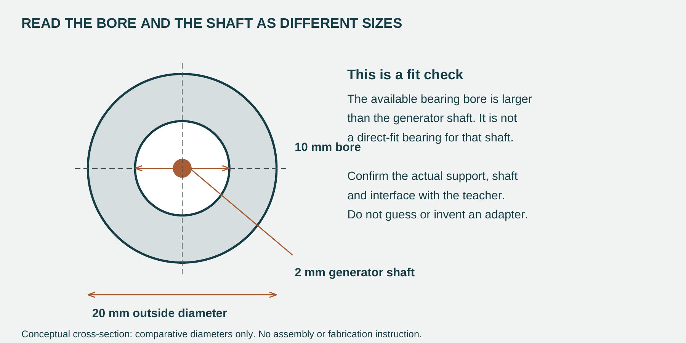
Figure 5. Comparative source diameters expose a fit gap: a 10 mm bore is larger than the 2 mm generator shaft. This is not an adapter or assembly instruction.
The source lists bearings with 20 mm outside diameter and 10 mm inside diameter. It separately gives a 2 mm generator shaft. These values do not establish that the bearing fits that shaft. The teacher must verify the actual support or shaft arrangement, mounting method and permitted load; a guessed sleeve is not a checked solution.
Record your own hazard, proposed control and confirmed shaft/support interface in the fields on page 25.
WIND GENERATOR DESIGN

Compare the ways blades catch wind
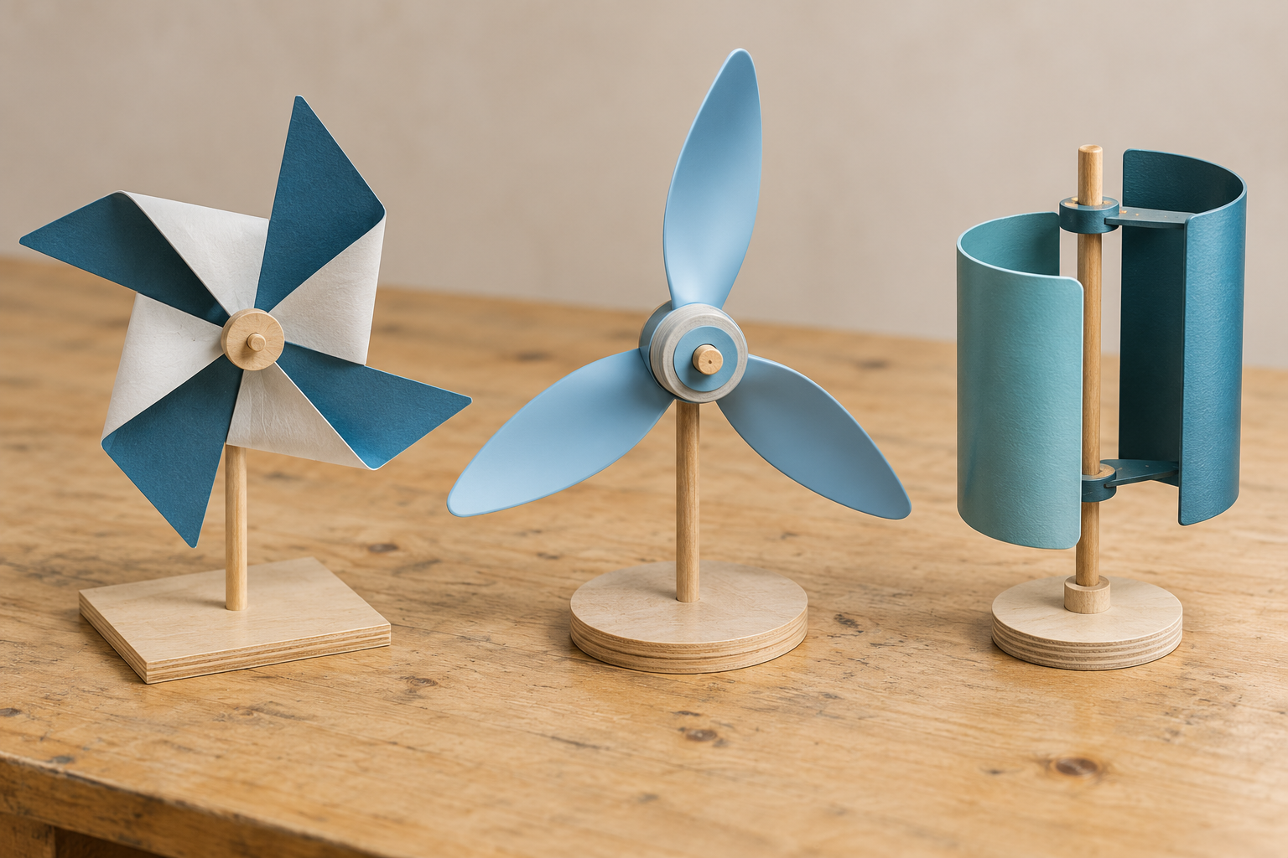
Figure 2. Illustrative alternatives at rest: folded pinwheel, pitched blade rotor and cup-style wind catcher. Appearance does not establish performance or suitability for the supplied kit.

Catch air and start turning
A drag-style wind catcher uses a difference in air resistance to create turning force. Cups and broad surfaces can catch moving air, but their exposed area also resists motion. A lift-style blade uses its shape and angle to create a force with a turning component. These ideas are alternatives to investigate, not a ranking based on a photograph.
Starting matters. A rotor must overcome friction and the resistance of the connected generator before it accelerates. A heavy or rubbing assembly may fail to start even if it looks like a large turbine.

Choose a testable change
Blade count, pitch, area and material can each change starting, speed and balance. More blade area can capture more air but may add weight and drag. Increasing pitch can help in one setup and make another stall. There is no universal best angle in this book.
Compare one variable at a time using the approved wind source and load. Keep the other conditions and repeated trials consistent. Record starting, output and wobble so the chosen design is supported by more than spin speed.

Choose two alternatives above. Predict one meaningful difference and describe a fair test of your prediction.
WIND GENERATOR DESIGN

Investigate blades and material choices
An investigation compares an idea against a reasoned prediction. Select at least three blade or wind-catcher ideas for the learning activity. Predict starting, speed and stability separately: a rotor that starts easily may not give the largest useful electrical output.
Blade or catcher idea | Starting / speed / stability prediction | Material or sustainability issue

A blade material needs to hold the chosen shape while remaining light enough to start. Card is easy to modify for early trials but has limited durability. Sheet plastic can be light and resistant to moisture, yet may flex or crack. Thin plywood can be stiff but adds mass. These are options to compare, not a materials list for every model.
The frame holds the generator, shaft support and output module in a stable relationship. Deflection under rotor forces can increase rubbing or change gear mesh. Select stock and fixing methods that suit the load, access and intended disassembly or repair.
My part and function | Possible material/process | Reason and limitation
Blade
Frame/support
Module protection

Impellor and Blade Design Describe your proposed blade count, shape, pitch, size and material. Explain why it should catch wind and remain balanced.

Use the fair-test variable and controlled-conditions field on page 40 as part of this investigation plan.
WIND GENERATOR DESIGN

Compare direct and geared drive
Direct drive
In direct drive the rotor transfers its rotation to the generator without an intervening gear train. This reduces the number of parts, possible friction points and alignment problems. It also means the generator speed follows the rotor speed. A simple arrangement is useful only if its output meets the agreed purpose under test.
Geared drive
Gears can change rotational speed, direction or layout. A larger driver gear turning a smaller driven gear increases driven speed while reducing ideal available torque. Torque is the turning effect that helps a shaft overcome a resisting load. Gearing cannot create extra energy; real gears also add friction and need accurate alignment.
The source design example describes a small four-blade rotor that spins steadily but gives weak generator output. Its hypothesis is that higher generator speed may help. A gear-up trial is one possibility; a weak electrical connection, poor matching or losses could also matter. Treat the idea as a hypothesis to test, not a proven fault diagnosis.
Sketch direct drive and one geared option. Label driver, driven member, generator, supports and intended direction of rotation.

Explain the speed and torque trade off, then choose which option you would build or investigate first and why.

Mechanical Drive and Frame Explain how rotation will reach the generator and how the frame keeps the shaft and parts aligned.
WIND GENERATOR DESIGN

Explain your design decisions
Use the design reading and your own evidence. Explain the relationship and give a practical reason; a list of terms is not enough.
Why might a gear or cog system improve performance, and why might it make performance worse?

Why is the 250 x 150 x 100 mm size limit an engineering constraint rather than just a classroom instruction?

The other six original Design checks have exact continuation links on page 50.
My hazard and risk | Proposed control | Teacher feedback or check

Record the actual shaft, support and hub interface checked for your design. Leave unconfirmed sizes and methods clearly marked.
CONCEPT FOLIO

Develop a different concept
Make a meaningful change to the impellor, drive, frame, generator support or protective layout. These are concept ideas for comparison; the teacher-approved final drawing controls practical work.
Concept 1 Label the impellor, shaft or drive, generator, support, frame and USB module. Indicate the wind direction, wiring route and important clearance.

State the strongest feature and one weakness of this concept. Explain how each affects function, safety, compactness or construction.

Useful concept annotations
An annotation earns its place when it names a feature and explains its effect. Keep unsupported performance claims as predictions until they are tested.

Record one useful peer or teacher comment and the change you made in response.
CONCEPT FOLIO

Develop concept 2
Explore a genuinely different functional idea. Change the blade or catcher, power transfer, support or protective arrangement. Show how it could work before judging its appearance.
Concept 2 Label the impellor, drive, shaft support, generator, frame, USB module, wiring route and relevant clearances.

Record a strength, a weakness and one uncertainty to investigate. Link each to a design criterion.
CONCEPT FOLIO

Develop concept 3
Explore a genuinely different functional idea. Change the blade or catcher, power transfer, support or protective arrangement. Show how it could work before judging its appearance.
Concept 3 Label the impellor, drive, shaft support, generator, frame, USB module, wiring route and relevant clearances.

Record a strength, a weakness and one uncertainty to investigate. Link each to a design criterion.
CONCEPT FOLIO

Explore two more concept directions
The source folio provides five concept positions. Use this page for concepts 4 and 5, or a teacher-approved refinement when the required count differs. Show functional differences, not just a new colour.
Concept 4 Change a meaningful feature and label its intended effect.

Concept 5 Explore another route or refine an earlier uncertainty.

Which differences are most worth testing before selecting the final design?
FINAL DESIGN CHOICE

Compare concepts and choose the design
Compare function, safety, compactness, likely efficiency, available materials and build quality across all five concepts. Record strengths and weaknesses with reasons, rather than scores alone. Put peer or teacher feedback in the concept field on page 26.
Concept | Strengths | Weaknesses or risks
1
2
3
4
5

Final Onshape design evidence Insert or sketch the selected layout with a clear version or file reference.

Chosen Design Description Describe the parts, layout and intended energy transfer.

Why This Design Was Chosen Compare it with another concept using function, safety, compactness, materials and likely performance.
TECHNICAL DRAWING

Make the drawing communicate the build
A front, top or side view communicates size and position without perspective distortion. An isometric view helps the reader understand overall form and assembly. A detail view enlarges a small but important connection, such as the hub or generator mount. Choose enough views to reveal the parts that one view hides.
Linework should distinguish visible edges, hidden details and centre lines where needed. A shaft centre line helps the reader check alignment. Clear leaders connect labels to the intended feature, rather than crossing the drawing or ending in blank space.
Include overall extents, rotor clearance, generator and USB location, support positions, material thickness, fixing points and critical interfaces. Use consistent units and a stated scale or not-to-scale note. A CAD screenshot with no dimensions cannot show that a model fits the source envelope.
Dimension the selected version, not an abandoned concept. Avoid contradictory repeated measurements. Fit, clearance and tolerance need actual component measurements and teacher-approved methods; a tidy dimension line is not proof that the assembly can be made.
Drawing check | Present and clear? | Missing detail or action
Overall dimensions and source envelope
Impellor diameter and clearance
Shaft centre line and generator mount
USB module and protected wire route
Actual materials, thickness and fixings
Assembly / access and necessary detail

Explain one possible build problem that the audit revealed and how the drawing should change.

Teacher feedback and drawing version checked
FINAL DRAWINGS

Dimension the final drawing and detail
Convert the selected Onshape model or sketch into a dimensioned drawing, as required by the master folio. Include the views, labels, materials and critical dimensions that show fit and assembly. This field holds your evidence; it is not an approved plan supplied by the workbook.
Final Drawings Insert the final exported drawing or produce your teacher-approved drawing with dimensions and labels.

Detail view Show the actual hub, shaft support or generator mounting relationship. Label verified sizes, centre lines, support and clearances.

Identify the drawing file or version and one measurement that proves a design constraint.

Explain the fit, alignment, friction or inspection benefit of your detail in the response field on page 34.
CAD AND DRAWING COMMUNICATION

Test whether another reader can build
CAD helps compare geometry, maintain dimensions and communicate a selected version. A screenshot should show the frame and impellor, generator and USB location, dimensions or a linked drawing export, and a short explanation of the design. A random isolated shape is weak evidence.
Possible process | Information the file must communicate | Uncertainty to confirm
Laser cutting | Flat profile, holes, stock thickness, fit and relevant allowance | Approved stock/process and actual fit
3D printing | Hub/interface, wall/part geometry, orientation and supports | Layer weakness, mass and verified component fit
Hand cutting or drilling | Clear centre positions, sizes and workholding allowance | Approved method and accurate alignment
Assembly | Part order, connections and access | Testing, repair and wiring protection

Digital fabrication is useful when it improves accuracy, repeatability or function. It can also increase mass, waste or preparation time. Choose the process from the part’s needs and the resources actually approved for class.
Give the selected drawing to a partner. Ask them to identify the parts and propose the assembly order without explaining every feature yourself. Their questions reveal what the drawing communicates and what it assumes.
Reader’s question or uncertainty | Drawing improvement | Reason it helps

Record the build sequence your partner understood from the drawing. Where did they need to guess?

Which material, fabrication decision or file detail must the teacher confirm before manufacture?
DRAWING SELF CHECK

Explain and refine your drawing
What dimensions are essential for the wind-powered USB charger drawing?

How can a technical drawing reveal a problem before construction starts?

Drawing Reflection Explain how the revised drawing helps prevent a build problem. Use dimension, clearance, alignment, support, assembly, component or tolerance accurately.

Keep the checked file or drawing version with your folio. The other six original Drawing checks are linked on page 50.
Draw a labelled constraint box using the source dimensions. Place the main functional parts as a rough layout without adding invented cutting sizes.

Use page 3 for the box dimensions. For the last response, refer to your enlarged detail on page 32.
Explain how this detail prevents a specific fit, alignment, friction or inspection problem.
BUILD PLANNING

Plan materials and the build sequence
A build plan turns the selected drawing into a manageable sequence. Begin with checked materials and interfaces, then construct the frame and mechanical system before connecting and testing the electronics. Record dependencies so a hidden fixing or wiring route is not trapped by later assembly.
Part or component | Actual quantity / material | Source or verified detail

Planned stage | Check before the next stage | Evidence to collect
Checked drawing and materials
Frame and supports
Rotor / shaft / generator alignment
Teacher-approved electrical work
Controlled output test

Identify one dependency that would make an early assembly choice hard to repair or inspect.
ELECTRICAL CONNECTION AND SAFETY

Explain the electrical connection boundary
The generator converts rotation into electrical output, but a USB connector alone does not tell you how the supplied module works. Its documentation determines input polarity, permitted range, output behaviour and load capability. The teacher confirms the actual kit and circuit before any connection or test.
Voltage is the electrical potential difference across two points. Current is the rate of charge flow through a circuit. A voltage reading with no load does not prove that the generator can sustain useful output while a device draws current. Do not improvise current measurement, add storage or connect a personal phone based on the workbook example.
The real kit controls the circuit
Use the approved circuit and instruments under teacher instruction. The book does not provide pin labels, soldering temperature, wiring ratings, battery charging instructions or a guaranteed USB output specification.

Electrical Connection and Safety Describe how the actual generator connects to the approved USB module and which details must be verified.

Explain why the output should be checked with approved equipment before a phone or other device is connected.
TEACHER CHECK RECORD

Record real checks before testing
Before construction, the teacher checks the design, materials, intended processes and component support. Before powered output testing, the teacher checks the actual stable frame, secure rotor/drive, clear test zone, wire routing, polarity and approved instruments/load. A student tick cannot substitute for that check.
Readiness check | Observation or pending action | Actual teacher check record
Drawing and component interfaces
Stable frame and secure moving parts
Clearances, guards or separated test zone
Protected wiring and verified circuit
Approved wind source, instruments and load

Stop and report a fault
Stop testing and move clear if the rotor wobbles badly, rubs, loosens or the frame moves; stop if wires heat or the module behaves unexpectedly. Follow the teacher’s safe stop method for the wind input and electrical setup. Do not reach into moving parts or make an adjustment while the test continues.
Record the stop condition and safe response confirmed for your actual test setup.
BUILD EVIDENCE

Keep a visible record of the build
Photograph stages while important details are visible. A finished image may hide shaft support, fixings or wire routes. Captions should state the stage, what the image shows and a decision or problem it records.
A change record explains why the build differs from the drawing. Update the drawing when a teacher-approved change affects a dimension, location or connection. Keep the earlier version so your reasoning can be followed.
Date each stage. Add rows or use the online folio for further stages.
Dated own photograph or sketch | Caption decision problem and check
Build evidence 1 Insert a real photo or sketch of the frame and support stage. | Caption the evidence and explain one decision or problem at this stage.
Build evidence 2 Show the actual impellor attachment and generator position before details are hidden. | Caption the evidence and record what needed checking before the next stage. Include one decision or problem from this stage.
Build evidence 3 Insert a real photo or sketch of the relevant change. | Problem or feedback; change and reason; drawing update or check.

Explain one difference between your selected drawing and the built model, and how it was managed.
WORKED TEST EXAMPLE

Use readings to judge an improvement
A stronger reading is useful only when the comparison measures the same thing. Voltage measured with no load cannot be compared fairly with voltage under a load. Wind source, distance, blade design, circuit and test load can affect the result. Record the measurement method and units each time.
Worked example with fictional classroom data
Trial setup | Voltage | Current | Power
Original blade setting | 3.0 V | 0.080 A | 0.240 W
Changed blade setting | 3.2 V | 0.070 A | 0.224 W

Follow the calculation
For this example, both readings were taken across the same approved load under the same wind conditions. Electrical power P = V × I. Original: 3.0 × 0.080 = 0.240 W. Changed: 3.2 × 0.070 = 0.224 W. The higher voltage does not mean higher power because current fell.

These are invented learning numbers, not kit limits or test targets. Repeated readings and observed faults are still needed. A single comparison can suggest an improvement or a problem, but cannot prove reliable phone charging.
Try a separate fictional pair: 2.5 V at 0.10 A and 3.0 V at 0.07 A. Calculate each power and explain which gives more output in this comparison.

What would you record to keep a voltage comparison fair when current cannot be measured with the approved equipment?
PLANNED TEST METHOD

Write the testing method before results
A repeatable method states what is changed, what is held constant, what is measured and how trials are repeated. Use the same approved wind source, recorded distance/direction, test load and instrument method for a comparison. If equipment does not measure an item, record that limit rather than inventing a reading.
Testing Method and Results Plan your testing method: purpose, setup, variable, controls, measurements, repeat trials and stop conditions.

Method detail | My confirmed setup
Wind source, distance and direction
Blade and drive baseline
Approved circuit / load / instrument method
Repeated trials and success criterion
Safety check and stop condition

Identify one variable to compare and the conditions you will hold constant.
ACTUAL TEST RESULTS

Record the actual baseline trials
Complete this page only after the teacher-approved test occurs. Keep failed and incomplete trials visible. Record units and whether the reading was made with the approved load or without load; these conditions cannot be silently mixed.
Trial / condition | Blade / drive / wind setup | Output with units or observation | Fault / stability notes

What do the actual baseline results show, and what is still uncertain?
FAULT FINDING AND CONTROLLED RETEST

Diagnose a fault and retest one change
A symptom is an observation; a cause is an explanation that still needs checking. Wobble may result from balance, support or a loose hub. Weak output may involve speed, load, alignment or an electrical fault. Change one checked feature at a time after the system is stopped and the teacher approves the investigation.
Observed symptom | Possible cause to check | Safe next check / evidence
Rotor struggles to start
Rotor wobbles or rubs
Output weak or unstable
Frame moves during testing

An improvement is supported when a controlled retest supplies better evidence against the same criterion. Keep the original baseline. Record the exact changed feature and any difference in conditions; a new fan distance would make a blade comparison harder to interpret.
Actual fault and trial | Hypothesis and checked change | Retest evidence

Baseline and changed feature | Controls retained | Result and units / observations

Use the actual results and limitation fields on page 45 to evaluate this controlled retest.
CONCEPT MODEL EVALUATION

Evaluate the concept model honestly
A concept model investigates whether the idea behaves as expected before the final presentation model. If the result differs from the prediction, record the difference and use it to improve the design or testing method.
A clear folio shows the status of its evidence. Research, concepts, final choice, drawings, energy pathway, blade design, drive/frame, electrical planning and planned test method can be developed before construction. Concept-model evaluation, finished photographs, actual readings and final judgement depend on the authorised practical work actually occurring.
Evidence status | How to write it honestly
Planned | State the intended method, prediction or design and its uncertainty
Completed | Describe what actually occurred and identify its evidence
Revised | Record the earlier version, approved change and reason
Pending check | Name the unanswered fit, circuit, safety or assessment issue

Performance vs Expectation State what you expected and what the actual concept-model evidence showed.

Problems Encountered Explain the most important problem and its evidence.

Design Changes and Justifications Record the approved change, its reason and the retest evidence or pending test.
PRESENTATION MODEL EVIDENCE

Show the finished model from two views
The master folio asks for at least two photos of the finished model with brief captions. Use your own images after the practical work is completed. One view should show the whole model; another can reveal a useful detail, such as support, wiring protection or assembly quality.
Own finished model photograph | Caption and visible evidence
Presentation Model Photo 1: the complete actual finished model. | Caption 1 Explain the feature and evidence the photo shows.
Photo 2: a different view or meaningful construction detail. | Caption 2 Explain what this view adds to the first photo.

Use genuine finished-model photographs and specific captions. If practical work is pending, record that status; concept artwork is not evidence of your finished model.
BUILD AND TEST SELF CHECK

Explain safe testing and useful data
Why must the charger have a teacher safety check before powered output testing?

What data should be recorded to evaluate charger performance properly?

Use your actual baseline and retest records on pages 41–42 for the final two responses below. The other six original toolkit checks are linked on page 50.
Did the change improve performance, stability or usefulness? Quote specific trial evidence and acknowledge a limitation.

What further change or test would be worthwhile, and why?
WHOLE SYSTEM EVALUATION

Evaluate the whole engineering outcome
Function and reliability
Judge useful output under the actual approved test conditions, not only rotor motion. State the intended criterion and cite repeated readings or observations. Starting, alignment, vibration and stable support can explain a limitation. Distinguish a successful trial from reliable repeated performance.
Check compactness and portability with actual overall measurements and handling evidence. A strong base may still have a projecting rotor or vulnerable wiring. Describe construction quality with observable details such as square support, secure mounts and clear access.
Cost and lifecycle
Use actual research and costing evidence to discuss materials, fabrication waste, durability, repair and end-of-life handling. A renewable input does not erase electronics, frame or blade impacts. Reusable parts and separable connections may reduce waste, but need a realistic explanation.
Finish with one improvement linked to evidence. Name the weakness it addresses and the new test or check it would need. If the prototype did not meet the function criterion, an honest analysis of cause and next step is more useful than a vague success claim.
Evaluation criterion | My strongest evidence | Limitation or improvement
Useful output / repeated behaviour
Size, portability and build quality
Safety and protected components
Cost, waste, reuse and end of life
FINAL EVALUATION

Write the final evaluation from evidence
Use your own build record, drawings, test table, faults and improvements. Link each judgement to a specific piece of evidence. A teacher-confirmed pending item is still a limit; do not conceal it to make the conclusion sound stronger.
What Went Well? Explain the strongest result and evidence against the brief.

What Did Not Go As Planned? Explain a limitation, problem or uncertainty and its consequence.

What Would You Change? Propose a realistic next version and the evidence needed to judge it.
FOLIO HANDOVER

Check all thirteen folio purposes
The current guided folio contains these thirteen evidence sections. Check that your record answers their purpose and identifies where your own evidence can be found. Your issued teacher task determines what is due for the current class; this checklist does not set a new submission date or mark.
Guided folio section | My page/file/evidence | Status or next action
Wind Generator Parameters
Research and Costing
Concept Sketching
Final Design Choice
Final Drawings
Energy Pathway
Impellor and Blade Design
Mechanical Drive and Frame
Electrical Connection and Safety
Evaluation of Concept Model
Presentation Model
Testing Method and Results
Final Evaluation
SOURCES AND REFLECTION

Keep sources and reflection traceable
Explain ideas in your own words, record the source and show what you used it for. A copied paragraph or unexplained picture does not show understanding. Keep creator or organisation, title, URL or publication detail and access date beside research evidence.
Source creator / title | URL or publication detail | What it helped me explain

Course and controlling resources
Course: https://stevencowell.github.io/Engineering-Website/year10_term2.html
Guided Wind USB Charger portfolio
Master project folio
Current teacher-issued assessment reference
Source-use notice: The linked course site states that its images and resources are provided solely for teaching and learning with the school’s enrolled students. It warns that further copying or communication may be subject to copyright protection.
What engineering idea became clearer during this unit, and which evidence shows your learning?

Original illustrative cover and rotor concepts are generated educational artwork. Exact process diagrams are conceptual teaching figures. Neither is a construction plan, school kit specification or evidence of student performance.
ONLINE CONTINUATION

Continue the original toolkit checks
Eight selected original toolkit questions are in this book. Use these exact links to continue the other twenty-four questions and reveal the source model answers after your attempt. Keep your responses with your folio; the ten original Alternative Energy research questions remain in the printed research section.
Toolkit 1 Alternative Energy Context
Source check 1 Wind speed and safety
Source check 3 Compare energy sources
Source check 4 Energy context evidence
Source check 6 Check before connecting a device
Source check 7 Storage benefits and risks
Source check 8 Observe before charging
Toolkit 2 Wind Generator Design
Source check 1 Alignment
Source check 2 Reduce friction
Source check 3 Frame flex
Source check 5 Prove improvement
Source check 6 Control rotating parts
Source check 7 Justify the chosen design
Toolkit 3 Technical Drawing
Source check 2 Generator location
Source check 4 Useful labels
Source check 5 Final drawing before building
Source check 6 Drawing standards and WHS
Source check 7 Drawing evidence in the folio
Source check 8 Protected wiring route
Toolkit 4 Build Test and Evaluate
Source check 2 Controlled testing steps
Source check 3 Wobble rub and vibration
Source check 5 Change one feature
Source check 6 Evaluate size safety and function
Source check 7 Build and test folio evidence
Source check 8 A worthwhile next version
For paper use, open the course address on page 49, choose the named toolkit and use the source-check numbers above. The digital PDF and Word links go directly to each continuation.

