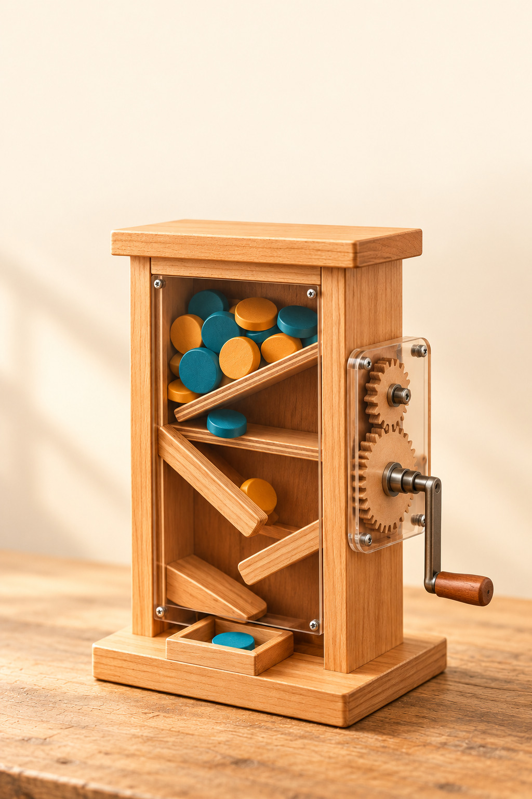
YEAR 9 ENGINEERING

Geared Lolly
Dispenser
50-page learning companion
Understand, design, build and test a working mechanism

Illustrative dispenser concept. Final dimensions, materials, food-contact suitability and safety features must be approved by your teacher.
Name | Class

Use with the simplified course and your teacher’s project instructions.
01 MECHANISMS

Your learning route
Read the short explanations, look carefully at the pictures, then explain your ideas in words. Use labelled sketches and actual observations. This book supports your class website and teacher demonstrations. Keep your project drawings, photos and build notes together.
Learning route | Pages | Main evidence
Start here | 1–3 | Brief, confirmed instructions and course route
Mechanisms | 4–17 | Gears, movement, cams, ratchets and safe use
Design and CAD | 18–27 | Brief, sketches, materials, drawing and build plan
Supervised manufacture | 28–34 | Approved methods, build photos and checks
Test and evaluate | 35–44 | Observations, fair comparisons and improvements
Folio and continuation | 45–50 | Showcase, reflection and remaining concept checks

Concept checks and useful evidence
This edition focuses on concepts, not calculations. Short written questions match the simplified website toolkits. Some are printed in this book; page 49 links to the rest. Use clear sentences, labelled sketches and real project observations to show what you understand.
Keep evidence authentic
Describe what you actually observed, made or changed. Label teacher demonstrations and example pictures. Use approved plans and record the feedback you receive. Keep testing separate from eating; your teacher must approve any food-contact use.
Write one question about how a lolly dispenser works.

Current Geared Lolly Dispenser course
01 MECHANISMS

Understand your project brief
Your dispenser should do the job in your class brief: move the mechanism, release the lolly as intended and be safe to use. A requirement is something it must do. A constraint is a limit, such as the supplied materials or available space. Read the teacher’s instructions before designing.
Your teacher provides the current assessment instructions, due date and submission method. Use that information when completing this book. The workbook helps you learn and collect evidence; it does not set a deadline or change the assessment requirements.
Record the instructions your teacher has confirmed, or a question you need to ask.
Item | Teacher-confirmed instruction or question
Task and cohort
Due date/time and submission route
Folio/project scope and criteria

Name one thing your dispenser must do and one limit you need to work within. How will you check them?

Open the current unit assessment page
Use the teacher-approved plans, materials, safety instructions and food-contact decisions. The example pictures explain ideas; they are not cutting plans.
MECHANISMS and PURPOSE

Follow one complete cycle

Input, mechanism and output
A mechanism is a group of parts that create movement. The input is the user turning the handle. The gears pass on the turning movement. The output is the movement of the dispensing part. The storage area and guides help lollies reach the outlet. A cam or ratchet may have a job in the demonstrated design.
The parts need to work together. The gear system moves the dispensing part; a gate may open and close to release the lolly. If a design uses a ratchet, it helps stop reverse turning. A ratchet does not by itself control how many lollies can pass through an opening.

Know what a successful cycle looks like
A cycle is one complete sequence of movement. Ask your teacher to show the start, the release and the return to the ready position. Follow the actual class design; a cycle does not always mean one full turn of the handle.
Watch whether the dispenser releases as intended and returns ready for another use. Notice a jam, an incomplete release or extra lollies escaping. The useful question is “Does it work consistently?” Describe what happens rather than calculating a success rate.

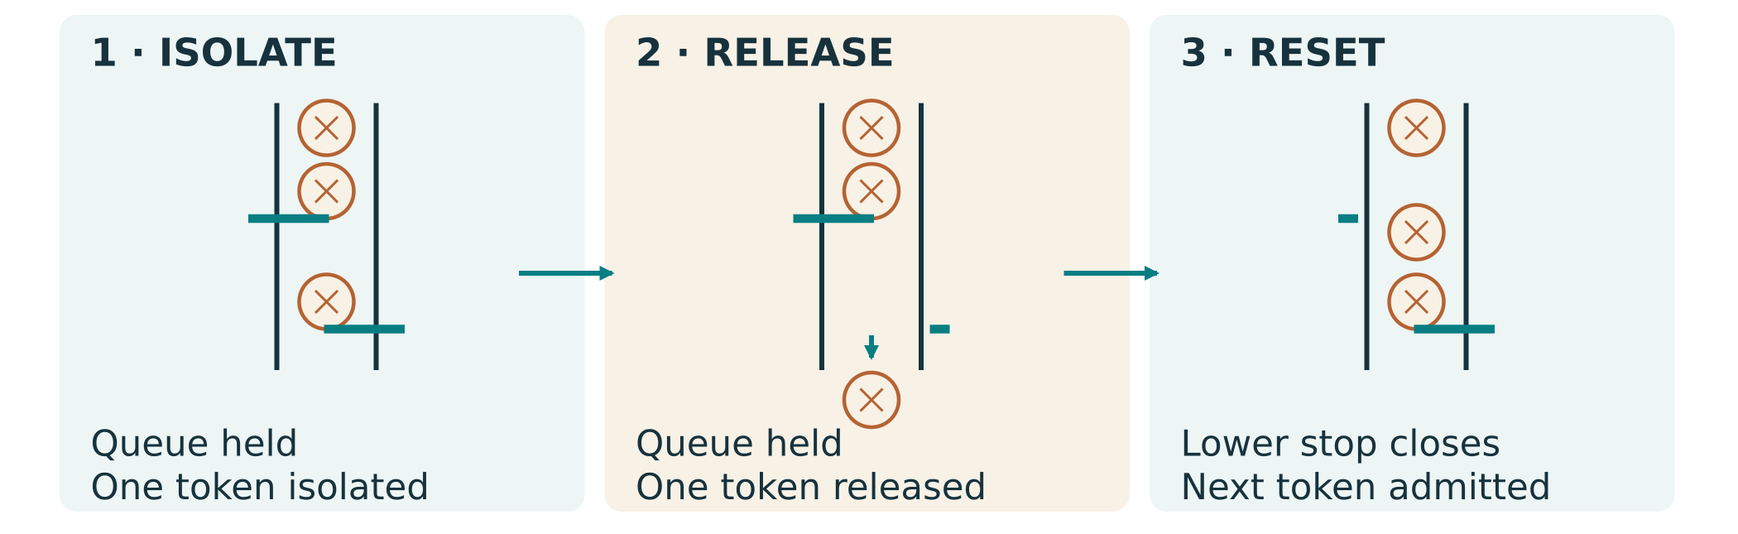
Figure 1. Follow the path from storage to release. A gate controls release; a ratchet, where used, controls direction.
Why might a dispenser turn smoothly but still release too many lollies?
GEARS AND MOVEMENT

Simple gears pass on movement
A gear is a wheel with teeth. Meshing means the teeth fit together so one gear turns another. The driver provides the movement; the driven gear receives it. In a simple pair of external gears, the gears turn in opposite directions. A shaft is the rod supporting a turning part.
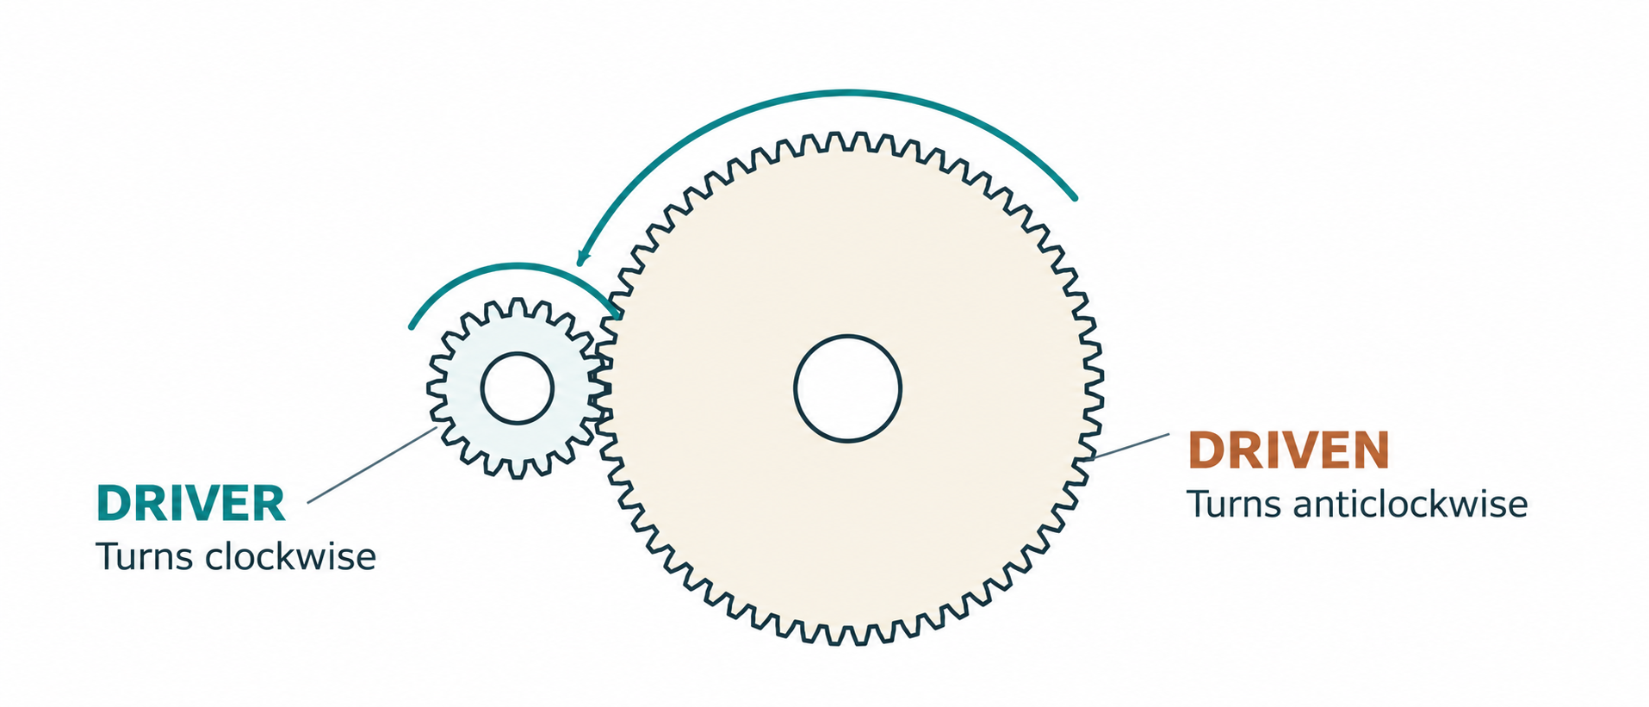
Figure 2. Find the driver and driven gear. Follow the arrows to see that these external gears turn in opposite directions.

Faster and slower
A small driver turning a larger driven gear makes the output turn more slowly. A large driver turning a smaller driven gear makes it turn faster. With matching gears of the same size, their turning speeds are the same.

Turning force
A small driver turning a larger driven gear gives the slower output more turning force. Turning a smaller output gear faster gives it less turning force. Explain this change in words. Friction, which is resistance between rubbing surfaces, can still make a mechanism difficult to move.

Smooth movement matters
Suitable gears need the correct positions and fit. Use the approved plan. If a handle becomes stiff, stop and ask for help rather than forcing it.

A small driver turns a larger driven gear. Describe the output as faster or slower, and name its direction compared with the driver.
GEAR FIT AND ALIGNMENT

Gears need to line up
Alignment means parts are in the correct positions. Gears need suitable teeth and spacing so they mesh smoothly. Shafts need support so gears do not lean or slide out of place. Too much rubbing can make a handle stiff; teeth that do not engage can slip. Use the actual fit shown in the approved plan.
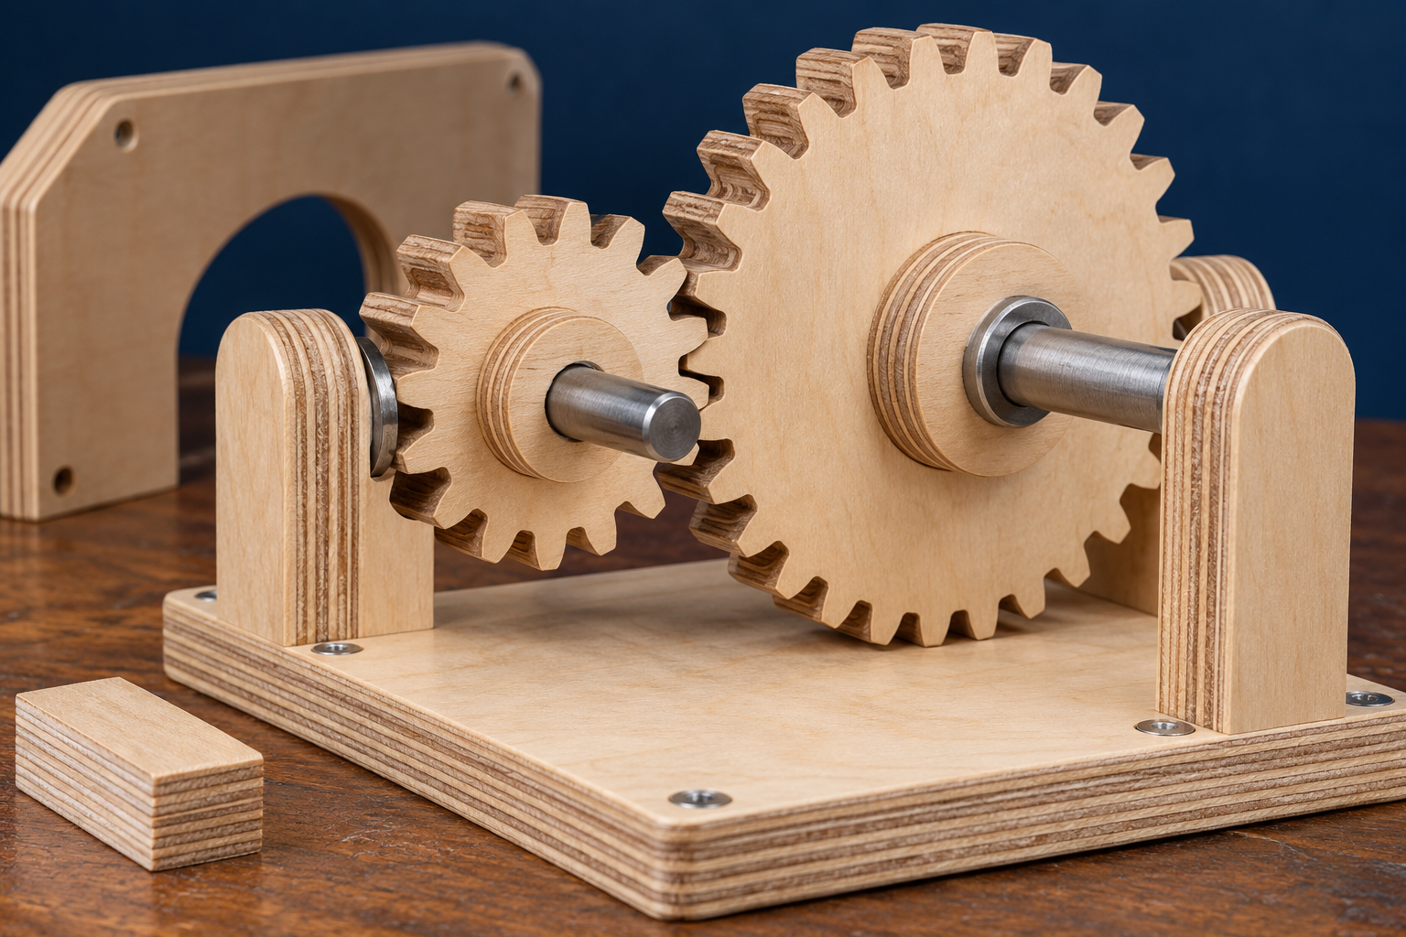
Figure 3. Look at the gear teeth, shafts and supports. This is a still example for inspection, not a direction to operate a mechanism without guards.
Check the fit
Gears need to mesh without rubbing or slipping. Check where shafts are supported and whether parts are held in position. Use the teacher’s spacing and fit instructions; do not guess an allowance.

What would you look for if the handle suddenly became difficult to turn?
GEAR ARRANGEMENTS

Idlers and compound trains
A gear train is a connected group of gears. An idler is an extra gear between the driver and the driven gear. In a simple three-gear line, each pair reverses direction. The first and last gears therefore turn in the same direction. Point to the middle gear and explain how it passes on movement.
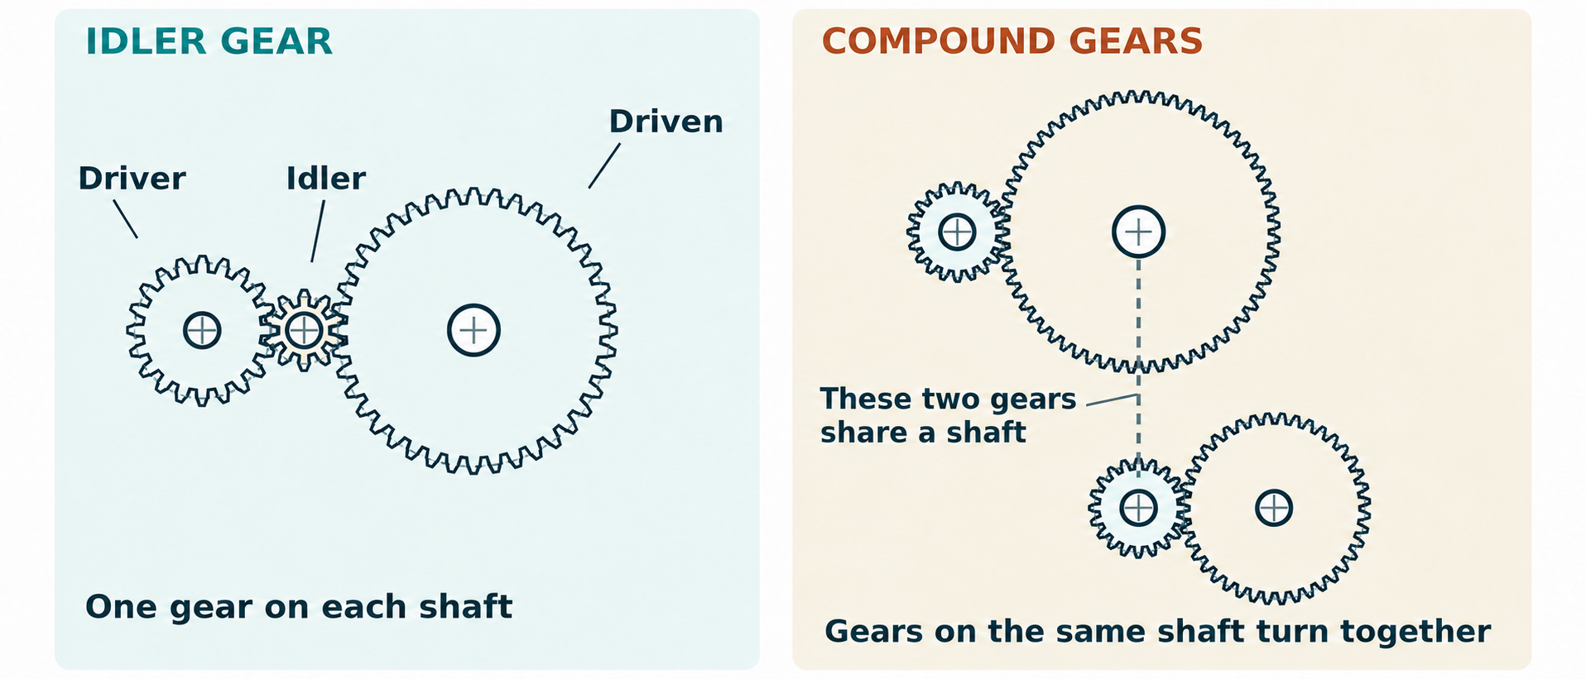
Figure 4. In the simple line, each gear has its own shaft. In the compound train, two gears are fixed to the same shaft and turn together.
A compound gear train has two gears fixed to the same shaft. They turn together and link one gear pair to the next. This arrangement can pass movement through a compact space. A line of separate gears is not automatically a compound train. Look at the shaft connections to tell the difference.
How can you tell the difference between a simple idler train and a compound train?
PREDICT AND EXPLAIN

Compare the gear arrangements
Different arrangements can pass movement between parts and change direction or speed. Use the examples below to explain what connects to what. You do not need tooth counts or calculations. Your actual project uses the gears and positions in the approved class plan.
Arrangement | What connects? | What to notice
One gear pair | Driver touches driven gear | External gears turn in opposite directions
Simple idler train | A middle gear links first and last | First and last turn in the same direction
Compound gear train | Two gears share a shaft and turn together | Look at shaft connections, not just the number of gears

Look at the shafts
An idler is an extra gear between driver and driven gears. A compound train has two gears fixed to the same shaft. Point to the connections to explain which arrangement you are looking at.

More gears can help route movement, but they also add parts to align and support. When comparing a layout, ask where the shafts go, which gears touch and whether the parts have room to move. The best choice must fit the project brief and supplied parts.
Which arrangement is easiest for you to explain? Sketch it and label the driver, driven gear and shafts.
GEAR CONCEPT PRACTICE

Observe, predict and compare
Look at a teacher demonstration or simple gear drawings. First predict how the driven gear will move, then check your idea. Use faster, slower or same speed. Describe direction with words or arrows. The purpose is to explain movement without calculating it.
Complete the observations in words.
Gear pair | Output: faster, slower or same? | Direction compared with driver | My explanation
Small driver → larger gear
Same-size gear pair
Large driver → smaller gear

Compare a small driver turning a larger gear with a large driver turning a smaller gear. How is the output movement different?

Sketch one gear arrangement from the class example. Add labels and movement arrows, then explain its job in a sentence.
CAM MOTION

A cam can move a gate

Cam and follower
A cam is a shaped turning part. A follower rests against it. As the cam turns, the shape can lift, lower or push the follower. The follower can move a gate or lever. Look at the turning part first, then follow how its movement reaches the gate.
The follower must stay in contact with the cam and return as intended. Gravity or a spring may do this in the demonstrated design. A cam does not automatically pull every follower back. Use the contact and return arrangement in the approved plan.

Lift, hold and return
Lift or rise means the follower moves up. Return or fall means it moves back. Dwell means the follower stays at the same position for part of the cam’s turn. A dwell is a pause in the follower’s movement; it does not mean the cam has to have a straight, flat edge.
The shape of a cam affects the movement you see. A smooth change in shape can give smoother movement. A sudden change can make the follower jerk. If the cam works a gate, the gate needs to open when ready and close without trapping the lolly.

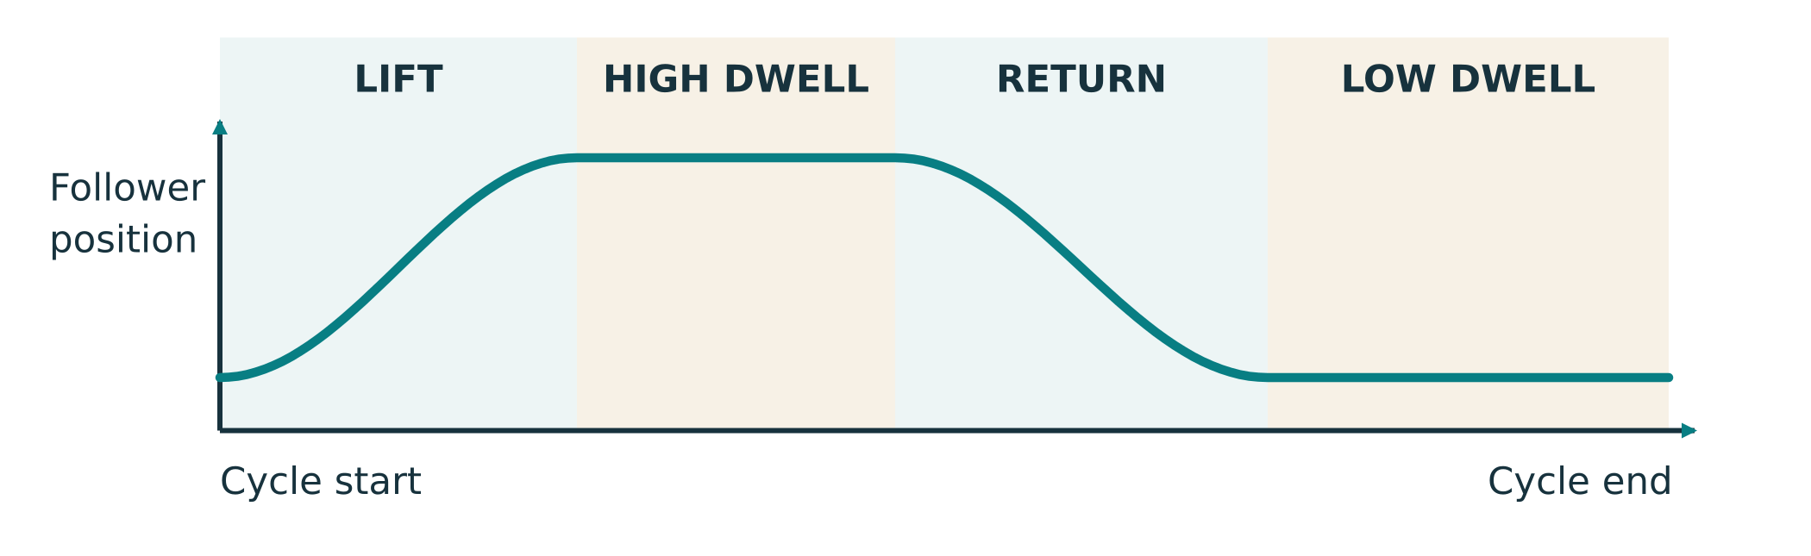
Figure 5. Follow the follower’s position from cycle start to end: lift, hold, return and hold. This shows movement; it is not the outline of a physical cam.
How can a turning cam make another part move up and down?
PHYSICAL CAM EXAMPLES

Compare two cam shapes
The profile is the outside shape of the cam that touches the follower. Find the centre the cam turns around and the point where it touches the follower. Different shapes can produce different movement. These diagrams explain possible mechanisms; your teacher selects the actual construction.
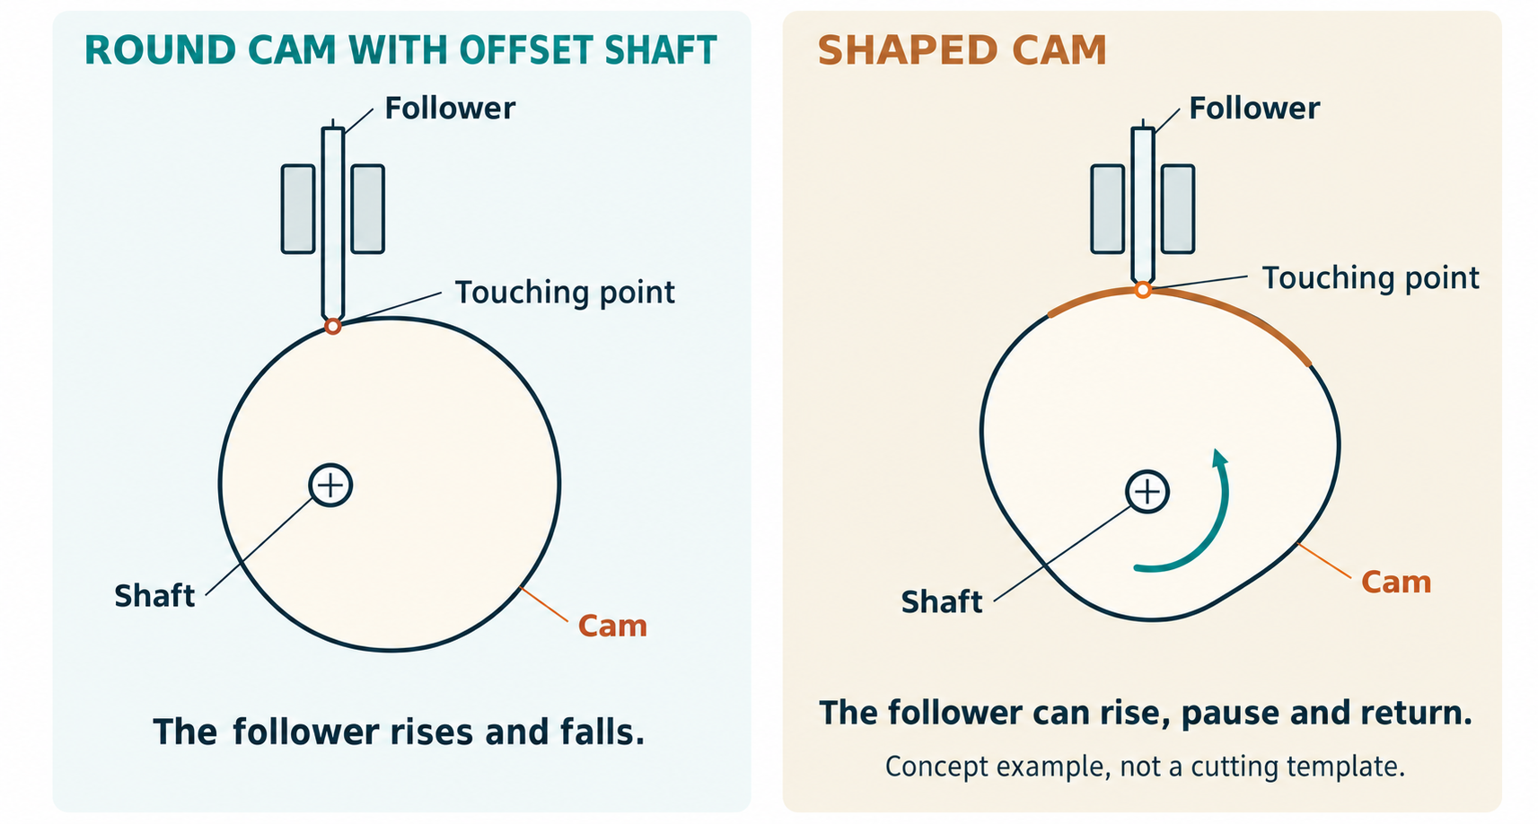
Figure 6. Compare a circle that turns off-centre with a shaped cam. Identify the turning part and follower. These are concept examples, not cutting templates.

An off-centre circle
This circle turns around a point away from its centre. Its changing contact with the follower makes the follower rise and fall. The follower reaches a high point and then comes back; briefly reaching a high point is different from holding there.

A shaped cam
A shaped cam can lift the follower, hold it at one position and let it return. Dwell means that holding part of the movement. The follower needs to stay in contact and return safely. Follow the teacher’s demonstrated design rather than copying the picture as a part plan.

Read movement and shape differently
A movement line shows where the follower is during the cycle. It is not a cutting outline. Look at the physical cam and follower together. Your teacher’s plan controls the actual shape, return arrangement and guards.

CAM DESIGN EVIDENCE

Sketch and explain a cam
Observe a cam in a teacher demonstration, drawing or video. Sketch the cam and follower and show where they touch. Add an arrow showing the cam turning and another showing the follower’s movement. You may compare the two pictures if your teacher asks.
Labelled cam sketch: turning part, follower, contact and movement arrows

Explain what moves first and how that movement reaches the follower. What helps the follower return?
ONE WAY MECHANISMS

A ratchet controls direction
A ratchet wheel has teeth and a small catch called a pawl. In the allowed direction, the pawl passes over the teeth. If the wheel tries to turn back, a tooth catches against the pawl. The pawl must be able to return into position, as shown in the teacher’s example.
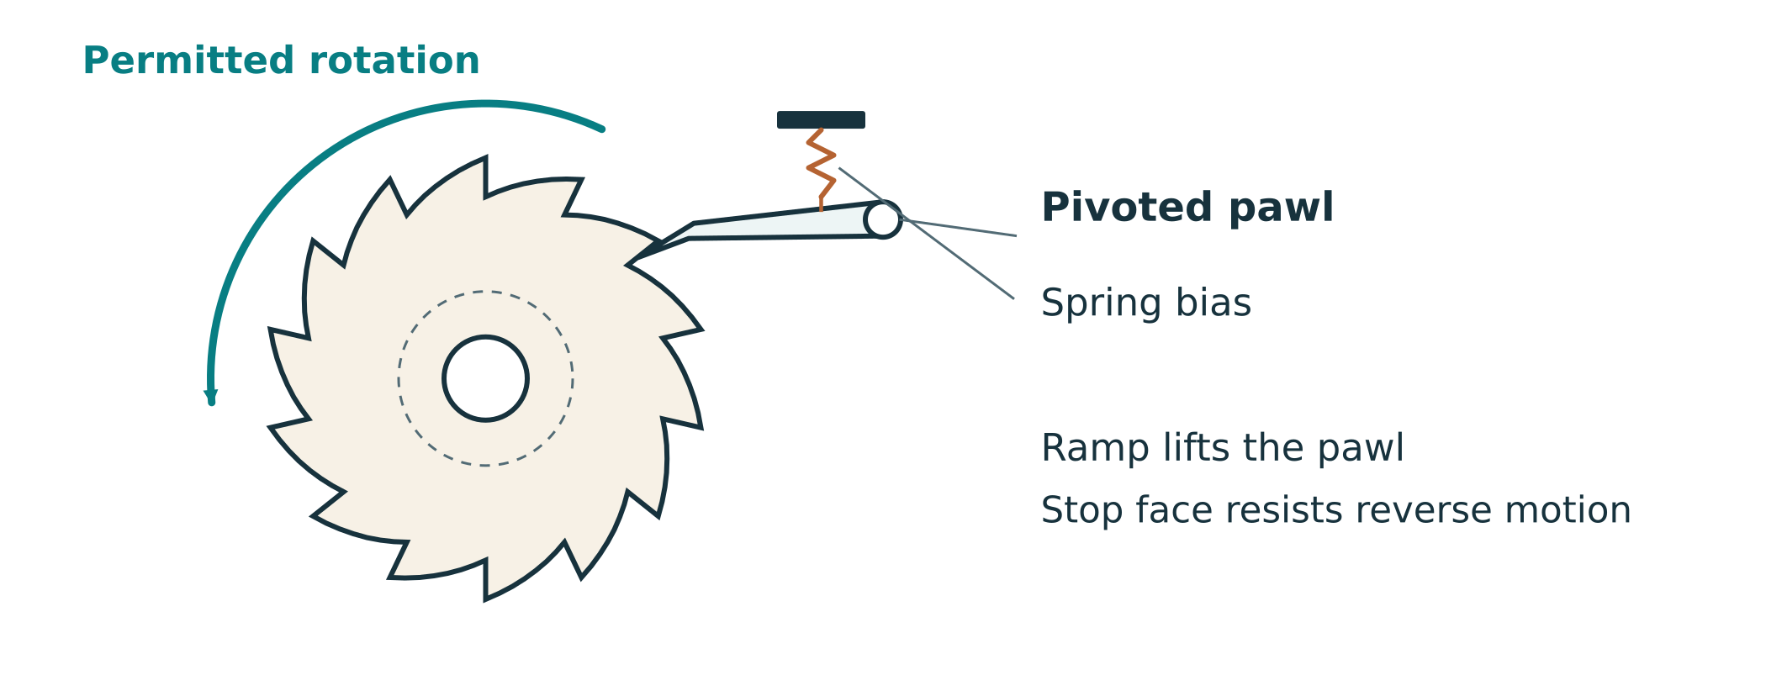
Figure 7. Find the toothed wheel and the pawl. Follow the allowed direction and identify where reverse movement is stopped.

Useful, with a clear job
Some socket tools and winches use ratchets. A ratchet can allow one-way movement and resist movement the other way. In a dispenser it may stop accidental reverse turning. It does not decide how many lollies can pass through the gate; the release parts still need to do their job.

Look at a real example
Use a teacher-selected picture or demonstration of a ratchet. Find the wheel, the catch and the allowed direction. Listen for the click if it is demonstrated. Do not operate or take apart unfamiliar tools without the teacher’s permission.

What could happen if the pawl did not return into contact with the ratchet teeth?
RATCHET INVESTIGATION

Explain a one-way mechanism
Use an approved picture or teacher demonstration, such as a ratchet socket tool. Draw the wheel and pawl. Add an arrow showing allowed movement. Mark where the pawl stops reverse movement. Explain what the catch does; you do not need to compare advanced bearing or clutch designs.
Real example: label the ratchet wheel, pawl and allowed direction

Explain how the wheel and pawl work together.
Part | What it does | What I can point to
Ratchet wheel
Pawl
Allowed direction and reverse stop

Picture source or teacher demonstration, and one thing I learned:
01 MECHANISMS

Show the movement sequence
A motion-flow diagram uses arrows to show what drives what. Draw your actual proposed mechanism from handle to dispensing part. Label gears and shafts. Include a cam, gate or ratchet only where it belongs in the approved design. Describe what happens first, next and last.
My mechanism: main parts, movement arrows and places fingers must stay clear of

Describe the sequence for your proposed dispenser.
Stage of the cycle | What should happen? | My explanation or check
Ready to start | Mechanism is ready for the user
Move into position | Lolly reaches the intended release point
Release | The dispenser releases as intended
Return ready | Mechanism is ready to use again

What might happen if the gate opens before the lolly is in the right position?
01 MECHANISMS

Smooth movement and safe use
Rotary motion means turning around a centre. Linear motion means movement in a straight line. A wheel turns; a sliding gate moves back and forth. Some mechanisms change one kind of movement into another. Point to an example in the class dispenser or demonstration.
Friction is resistance when surfaces rub together. A rough edge, a crooked shaft or a part scraping the frame can make a mechanism stiff. Clearance is the space needed for a part to move without rubbing or colliding. Correct alignment keeps parts in their intended positions.
Part or idea | Its job | What to check
Handle | Provides the input movement | Can the user operate it as intended?
Gears and shafts | Pass movement to the output | Do they line up and move without rubbing?
Guard | Helps keep fingers away from moving parts | Does it protect the actual access points?

If the handle becomes stiff, stop rather than force it. Keep fingers away from moving parts and ask the teacher before adjusting the mechanism. Use the required guards. A pinch point is a place where moving parts can trap fingers.
Describe one possible cause of a stiff handle. What safe step would you take next?

Why should fingers stay clear of moving gears?
01 MECHANISMS / CONCEPT CHECKS

Mechanism concept checks
Answer in your own words. Use the printed explanations and sketches to help. These question numbers match Toolkit 1 online; page 49 links to the other questions.
1. What are the input and output of a hand-operated lolly dispenser?

4. A small driver turns a larger driven gear. How does the output movement change?

7. How can a cam and follower move a gate?

8. What does the pawl do in a ratchet mechanism?
02 DESIGN AND CAD

Understand your approved brief
Read the class brief and make a short checklist. A requirement is something your dispenser must do. A constraint is a limit on choices, such as the materials, parts or space. Ask your teacher about unclear instructions. Use the actual project brief rather than a target from an example.
List the main requirements and how you will check them.
Requirement / constraint | Approved description or given size | How I will check
What it must do
What reliable use looks like
Supplied materials, parts and equipment
Given dimensions or other limits
Safety and ease of use

Choose one requirement and explain a design decision that helps meet it.

Trace the movement from handle to output on your chosen sketch. Label the driver, driven gear and shafts, and add arrows showing direction. Use the gear arrangement and dimensions in the approved plan. You do not need to calculate ratios or design new tooth shapes. Show your teacher the idea before building.
What will I change after feedback, and why?
CONCEPT DESIGN

Compare two dispenser ideas
Sketch two different layouts before choosing. Show the handle, gears, container, outlet and base. Label movement with arrows and mark places fingers need protection. Include a cam or ratchet only if the approved design uses one. Compare ideas against the same class brief.
Idea A: label input, output and the path the lolly follows

Idea B: a different layout to compare

Which idea best meets the brief? Give a reason linked to a feature on your sketch.
02 DESIGN AND CAD

Choose materials for their jobs
Choose from the materials your teacher approves. The base supports the project; gears pass on movement; a guard protects moving parts. Timber has grain; plywood is made from layers of wood; acrylic can be clear but may crack. Ask which material suits each job. No material is automatically approved for food contact.
Compare the supplied material options for useful parts.
Approved material | A useful property | A suitable part | Reason for my choice
Solid timber
Plywood
MDF
Acrylic

A parts list helps you prepare for building. Record each main part, how many you need, its approved material and its size from the plan. Keep the full list with your drawings if it needs more space. You are recording the given sizes, not calculating gear shapes.
Complete your approved parts list.
Part and quantity | Approved material | Size from the plan | Drawing or list reference
PLAN MATERIALS AND REDUCE WASTE

Think before you cut
Nesting means arranging part shapes on a sheet to reduce waste. Use the teacher’s approved spacing and grain direction. Avoid damaged areas and leave the space the cutting process needs. A crowded sheet is not a good plan if parts become weak or cannot be made safely.
Sheet plan: label the parts, useful offcuts and grain direction where it matters

Explain two choices that reduce waste while keeping the parts suitable for their jobs.

My complete parts-list file or page reference:
02 DESIGN AND CAD

Use a basic CAD model if directed
CAD means computer-aided design. A part is one component; an assembly shows how components fit together. A mate is a CAD connection that controls how parts sit or move. Follow the teacher’s basic demonstration. Name the parts and check their positions. Advanced assembly features are not required for this theory work.
Drawing or CAD screenshot: label the main components and movement

Detail sketch or screenshot: show how two parts fit together

Identify the main parts and their jobs.
Main part or group | Its job | What I will check
Gear system
Gate or other release part, if used
Frame, base and guard

Drawing or CAD file name, and one thing I checked:
02 DESIGN AND CAD

Follow the movement before building
Look at a class example, your drawing or a basic CAD model. Follow the input through the connected parts to the output. Explain what happens first, next and last. A digital picture may help you see a clash, but it does not prove that the real project will move smoothly or be safe.
Label a drawing or screenshot with movement arrows. If using CAD, follow the teacher’s demonstration to check that fixed parts stay still and moving parts can move as intended. A screen recording or advanced motion study is not required.

Record what the picture or demonstration helps you understand.
What to look at | What I notice or understand
Input and output
Movement through connected parts
Room to move without rubbing or collision

Look for simple problems: a gear that cannot turn, parts overlapping, a shaft in the wrong place or a gate with no room to move. Ask the teacher before changing the design. Check the physical parts too; a computer model does not show every real fit or rubbing problem.
A model shows one part overlapping another. What would you check before making the parts?
BUILD PLANNING

Put the steps in a sensible order
A build plan lists what you will do and when you will check it. Some parts need to be fitted before other parts enclose them. Use the teacher’s actual construction sequence. Include safety checks, fit checks and a final inspection before testing. Clear steps help you avoid redoing work.
Write the main stages of your build plan.
Build stage | What I will do | Check before moving on
Check instructions and safety
Prepare the main parts
Check fit and assemble
Check movement and protection
Teacher inspection before testing

Choose one possible problem and a change to discuss with the teacher.
Problem I might find | Change to discuss with the teacher | Why it might help

Why is it useful to check the fit before final assembly?
02 DESIGN AND CAD

Make a clear final drawing
Your final drawing should help another person understand the build. A front view shows height and arrangement; a top view shows the layout. Add part names, approved materials and the dimensions needed from the supplied plan. Use millimetres and keep labels readable. Show movement with arrows.
Make a careful hand drawing or a basic CAD drawing, as your teacher directs. Include the views that show the important parts clearly. Record the file or page below. Ask a partner to identify the input, output, materials and joining points, then improve anything they found confusing.
Plan a useful front or top view: labels, movement arrows and given dimensions

Record and review your final drawing.
Drawing or file name | Views, labels and given dimensions | Feedback and next step

What did another reader find unclear, and how will you improve it?
02 DESIGN AND CAD

Keep your design files organised
Save work with clear names so you can find the current drawing. An export is a saved copy in another file type. If you change a drawing or CAD model, update any matching export. Ask your teacher to check files needed for manufacture before a part is made.
Keep your brief, sketches, final drawing, parts list and build plan together. Add CAD screenshots or cutting files only if your class uses them. A short cover note can explain which files are current and what each contains. You do not need advanced CAD features for the theory tasks.
Check that your design pack is easy to follow.
Design-pack item | File or page | What I checked
Brief and requirement checklist
Labelled mechanism sketch and movement arrows
Materials, parts list and sheet plan
Basic CAD screenshot, if used
Final drawing and any required cutting file
Build plan and remaining questions

If another person used your design pack, what would be easy to understand and what might need a clearer label?
02 DESIGN AND CAD

Design concept checks
Answer in words using your drawings and the printed learning. These question numbers match Toolkit 2 online. Page 49 links to the other questions.
7. What information should a final design drawing include?

8. What is the difference between a CAD part and a CAD assembly?

9. Why should your build plan put steps in a sensible order?
03 SUPERVISED MANUFACTURE

Make safely and check as you go
Follow your approved design and the workshop process demonstrated by your teacher. Before work, confirm the equipment, supervision, protective equipment and how to stop safely. CAD is computer drawing; CAM uses computer information to help make a part. Check that you are using the current drawing and file before a part is made.
Identify hazards and the safety checks your teacher requires.
Planned operation | Hazard / consequence | Teacher-approved control / check
Computer-assisted cutting, if used
Drilling shaft/fixing holes
Sanding and finishing
Assembly and moving mechanisms
Testing and clearing a fault

Check the drawing and file before making a part.
Check with the teacher | Why it matters | My evidence / status
Current drawing and file match | Helps make the right version
Size and units checked | Helps parts fit as intended
Cutting file checked by the teacher | Helps avoid an incorrect cut
Correct material and thickness | Matches the approved design
Machine setup and holding approved | Supports safe and accurate making

Where will you find your class workshop instructions? When would you stop and ask for help?

If a part binds, breaks or moves unexpectedly, stop and ask the teacher for help. Use only the machine settings, methods and safety controls approved for your class.
CHECKING FIT

Try the fit before final assembly
Parts need the right fit for their job. A fixed joint must hold securely; a moving part needs room to move. Try a teacher-directed fit check on scrap where appropriate. Look for a part that rocks, sticks or rubs. Your teacher guides any adjustment; you do not need to calculate cutting allowances.
Fit needs checking
A cutting process removes some material. That can affect how parts fit. Your teacher guides the process settings and any adjustment. A trial on scrap helps check the fit before making the final parts. No cutting-allowance calculation is needed here.

Record a teacher-directed fit check.
Part or scrap test | What I noticed | Teacher-guided next step

Why is it useful to check a fit before making or assembling every part?
03 SUPERVISED MANUFACTURE

Mark out and line up the parts
Use the approved drawing and parts list. Check the material, grain direction and surface before marking out. Label parts so you know where they belong. A hole in the wrong position can leave a shaft leaning and make a gear rub, even if the outside shape looks neat.
A reference edge is the edge you measure from. Use the reference edges and centre marks shown on your approved drawing. Check the correct face before marking out. Ask for the required teacher check before cutting or drilling. Careful marking helps the shafts and supports line up.
Label a sketch or drawing: reference edge, shaft positions and checks.

Record the hole-position and alignment checks you made.
Feature to check | Drawing or teacher guidance | What I noticed / next step
Shaft positions line up
Hole and shaft fit
Parts face the right way

What might happen if a shaft hole is in the wrong place? Explain the effect on the moving parts.

Add a progress-photo reference and the checks you made.
03 SUPERVISED MANUFACTURE

Smooth edges and assemble carefully
Rough edges can rub, catch lollies or cause splinters. Friction is resistance when surfaces rub together; it can make a handle feel stiff. Prepare surfaces using the class method. Do not remove material just to force a part to move. Your teacher must approve finishes and any food-contact use.
Follow the approved build sequence and check parts as you go. Alignment means parts are lined up in the right positions. Shafts should sit correctly so gears meet without rubbing on the frame. Clearance is space that lets a moving part move freely. Use your approved plan and teacher guidance for the actual fit.
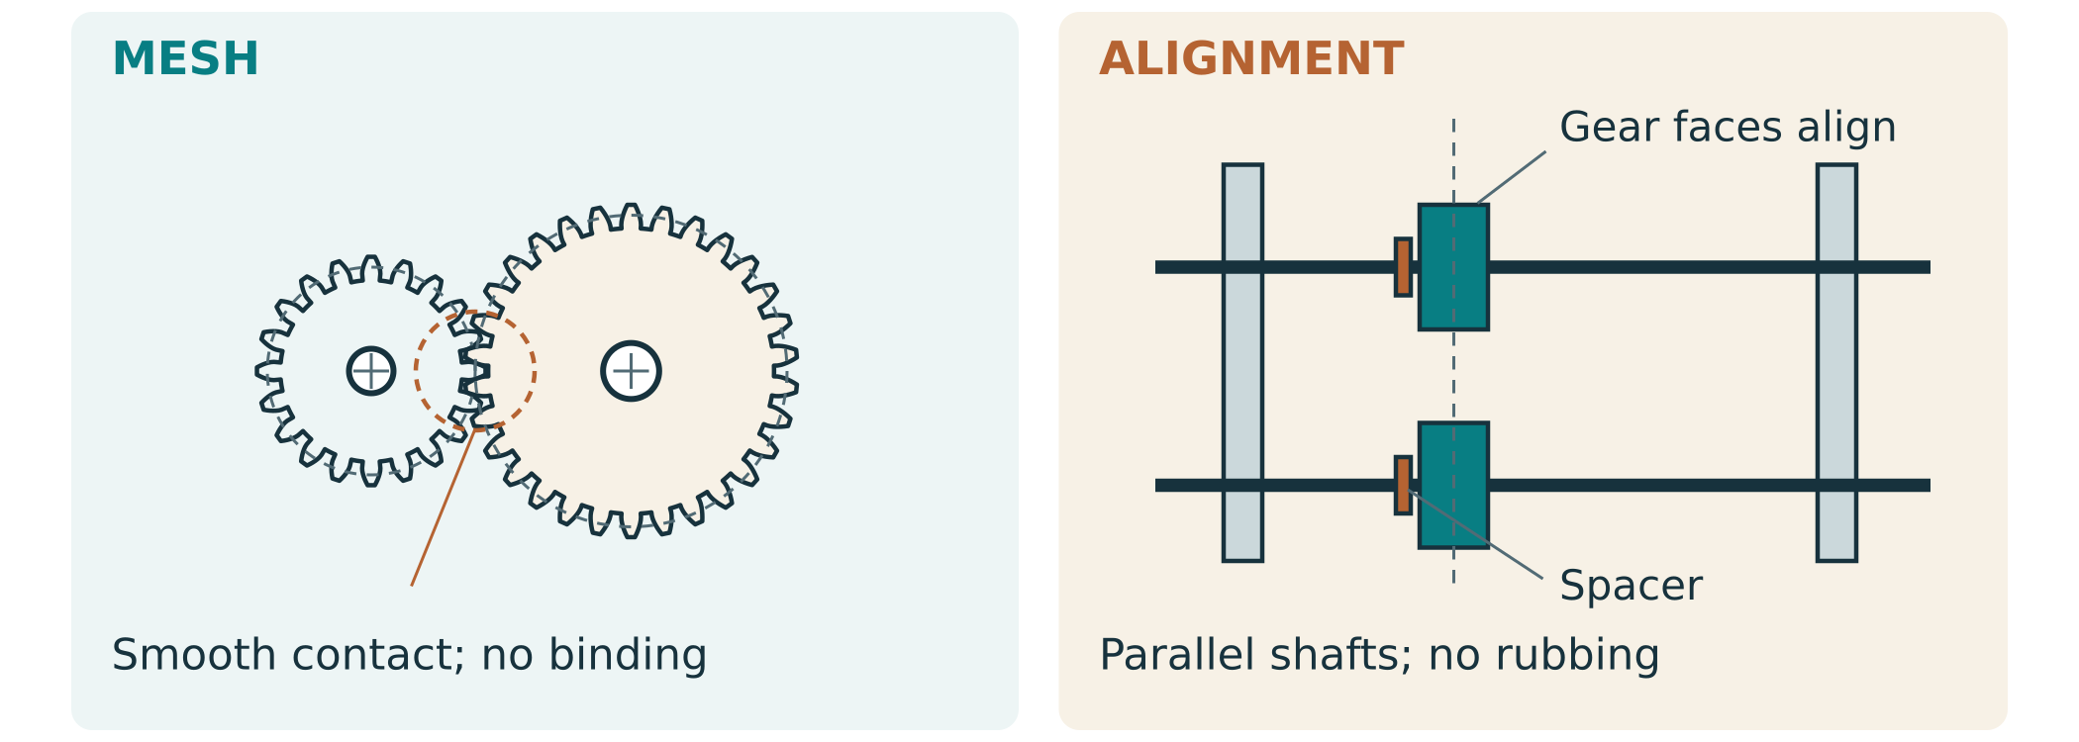
Figure 8. Look for lined-up shafts, supported gears and parts held in position. This illustration explains checks; it is not a cutting plan.
Record what you prepared, assembled and checked.
Part or feature | Observation or photo | Next step and recheck
Edges and feeding surfaces
Frame and lined-up shafts
Gears turn and stay in place
Complete dispenser

What would you look for to check that the gears move freely?
03 SUPERVISED MANUFACTURE

Check movement and fit the guards
Where your design uses them, a cam moves a follower to operate the gate, and a ratchet helps control turning direction. Check that the gate opens and returns as intended. Check the parts together as well as separately: a working gear and gate still need to work together.
Guards help keep fingers away from moving gears, cams and pinch points. Ask the teacher to check the complete mechanism, including guards, sharp edges, fixings and the base. A clear cover lets you see the mechanism, but it must also protect the actual places fingers could reach.
Label a photo or sketch: moving parts, finger-access points and guards.

Record the movement, guard and pre-test checks.
Check | What I noticed | Teacher-approved next step
Cam and gate move and return
Ratchet controls direction, if used
Guards protect moving parts
Secure fixings, smooth edges, steady base

What will you do if the dispenser jams?
03 SUPERVISED MANUFACTURE

Keep a short build log
After a practical lesson, say what you made, what you checked, a problem or change, and your next step. Add a clear photo when it helps explain your work. Keep the same record as the project continues. Describe what you actually did, including changes from your drawing.
Record your building progress and changes.
Date / part or stage | What I made or checked | Photo or file | Problem, change or next step

Show your build record to the teacher before testing.
Item | Where it is / next step
Build log and progress photos
Drawing and finished parts match
Movement, edges and guards checked
Teacher feedback before testing
03 SUPERVISED MANUFACTURE

Build concept checks
Answer these questions in words. Use a labelled sketch or your own project photo if it helps. The numbers match the current Toolkit 3 self-checks online.
1. Why should you use the approved drawing when making a part?

4. A gear rubs against the frame. What should you do?

10. What should a useful build-log entry include?
FAIR TESTING

Plan a safe and fair test
Reliability means how consistently the dispenser does its job. Follow the teacher's pre-test safety check, test method and stop procedure. Watch how the mechanism moves and whether it releases as intended. Repeat the same test so you can notice a recurring problem. Describe your observations in words; calculations and a fixed cycle count are not required for this learning.
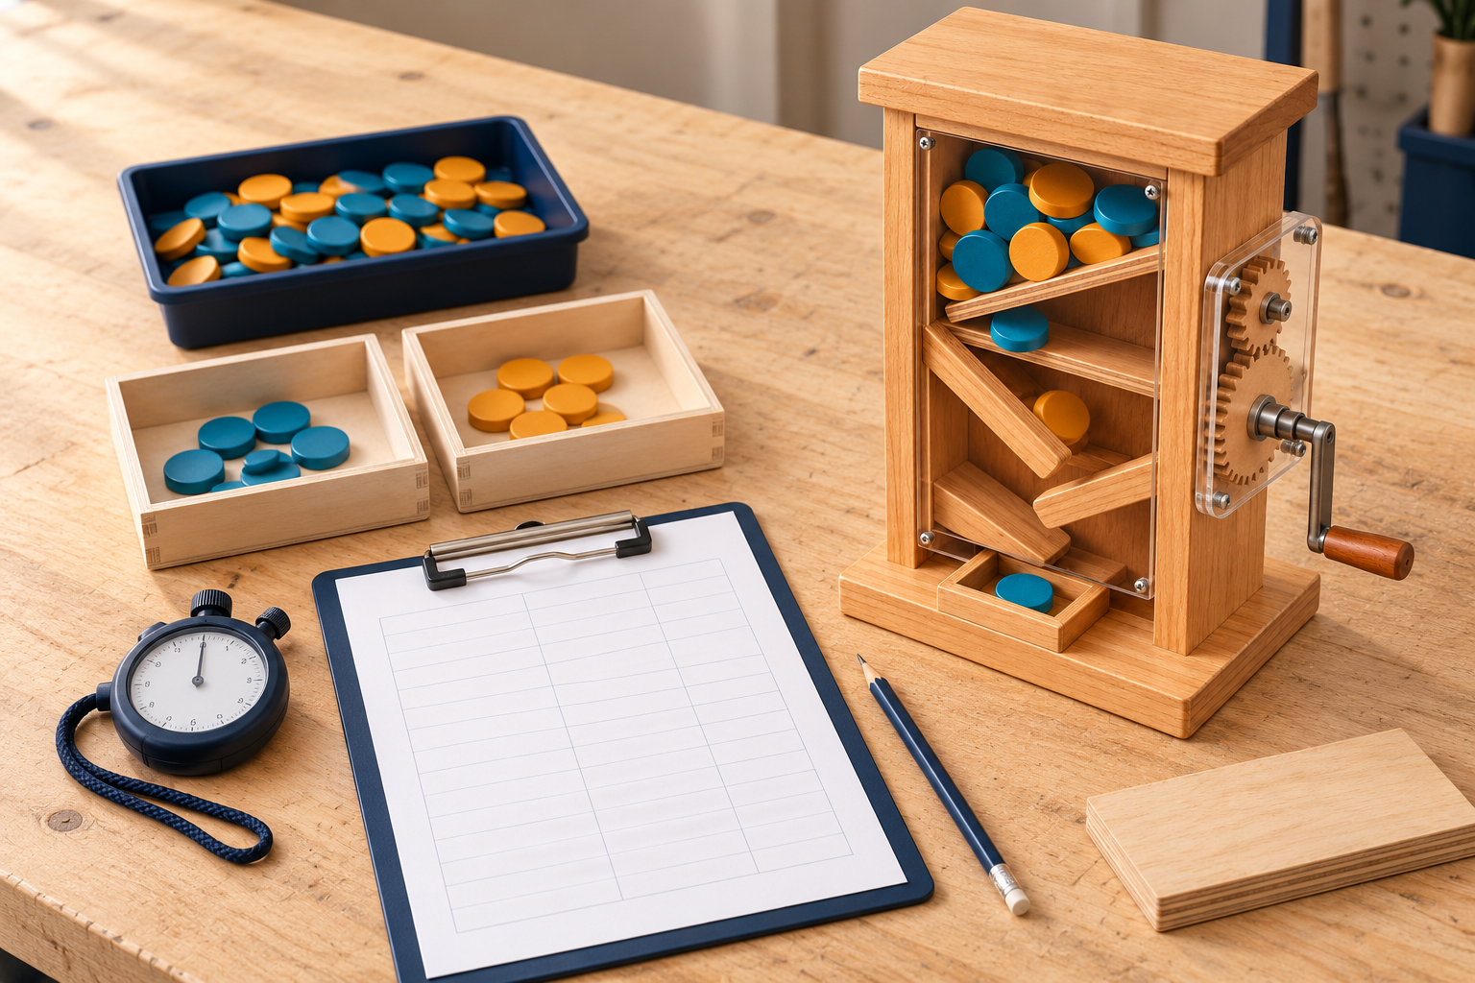
Figure 10. A test uses the same pieces and method so results can be compared fairly. Use teacher-approved non-food pieces if food-contact use is unconfirmed.
Plan what you will observe and how you will test safely.
Test question | My teacher-approved plan
What should happen when I use it?
Which pieces will I use?
What will I look for?
How will I keep the test fair?
When will I stop and ask for help?

Explain what a normal release looks like and how you will recognise a jam or an incomplete release.
04 TEST AND EVALUATE

Observe the moving parts
Follow the teacher's approved testing method. Watch the handle, gears, gate and base. Write what you notice: smooth movement, rubbing, wobbling or a catch. Keep fingers clear. Stop and ask for help if something jams or becomes unsafe. Use the spaces for useful observations rather than counting a set number of turns.
Record what you notice and the next safe step.
Part or feature | What I noticed | Next safe step
Handle
Gears and shafts
Gate and feeding path
Frame and base
Guards and edges
Another observation
04 TEST AND EVALUATE

Compare before and after
Choose one teacher-approved change to investigate. Describe the problem first. Test again using the same pieces and method, then describe what changed. If the adjustment did not help, record that honestly. Changing one thing at a time helps you tell what affected the result.
Record one change and your before-and-after observations.
What I checked | Before the change | After the change
Teacher-approved change
Handle movement
Lolly release
Gate returning
Stability and ease of use
What this comparison tells me
04 TEST AND EVALUATE

Explain what your test shows
Useful results can be described in words. “The handle turned smoothly” describes movement. “The gate caught as it closed” identifies a problem. Reliability means consistency during repeated use, not a calculation for this unit. Explain what happened, where it happened and what you think caused it.
Summarise your observations in words.
What I tested | Movement | Release | Problem | Next step

Keep observations separate from guesses. “The gear rubbed on the frame” is an observation. “The shaft may be out of line” is a possible cause to check. After a teacher-approved adjustment, repeat the same test and say whether the problem changed.
Compare what you expected with what you observed.
Part or action | What I expected | What I observed
Turning the handle
Gears moving together
Gate opening and returning
Lolly reaching the outlet

What does your observation show? What would you need to check again?

The handle turns but a lolly does not come out. Suggest a possible cause and a safe check you could discuss with the teacher.
ANNOTATED EVIDENCE

Show what happened with a sketch
A labelled sketch or photo can explain a problem more clearly than a long paragraph. Use an arrow to show where a part rubbed or a lolly caught. Add a short note about what happened. Show your actual observation, and label a proposed change as a proposal rather than a completed fix.
My labelled sketch or photo: the problem, its location and a possible change

Explain what your image shows and why the proposed change might help.
04 TEST AND EVALUATE

Find a problem and try one change
Choose a problem you actually noticed. Describe what happened and suggest a possible cause. Agree on one safe change with the teacher, then repeat the same test. Explain whether the change helped. If you found no problem, describe one feature you checked and what you observed.
Describe a real problem or a feature you checked.
What happened? | Possible cause and observation | One safe check or change

Explain a change you tried or would discuss with the teacher.
My improvement | Change I tried | Another idea, if useful
Problem I noticed
One teacher-approved change
Why it might help
Photo, sketch or file of the change
Same test before and after
What happened and next step

Suggest a realistic next improvement and explain why it could help.
Improvement idea | Problem it could solve and why
1
Another idea, if useful
VISUAL EVIDENCE

Before and after show the change
Label an actual photo of your finished dispenser. Identify the handle, gears, gate and guard where present in your design. If you changed a part, add before-and-after views and a short note explaining what changed. Clear arrows and labels help a reader understand your evidence.
Add or plan a labelled photo of the finished dispenser.

Link the change in your image to what you observed in testing.
Photo or sketch | Label what changed | What I noticed in testing
Before:
After:

Write a caption explaining one feature and how it helps the dispenser work.
USER FEEDBACK

Listen to another user
After teacher approval, ask a classmate to use the dispenser as instructed. Ask whether the handle is comfortable, the direction is clear and the lolly is easy to collect. Record a useful comment. Follow the same operating and stop procedure. Your teacher controls who may take part and whether food-contact use is allowed.
Record useful comments from an approved user trial.
User | Comfort and ease | What was clear or confusing | Suggested change
A
B, if used
C, if used
D (if used)
E (if used)

What did the user notice? Explain one change their comment suggests.

If a user is unsure which way to turn the handle, how could the design or instructions help?
04 TEST AND EVALUATE

Judge how well your design works
Evaluate means judge how well your dispenser meets its purpose. Description says what you made or did; evaluation says how well it worked and how you know. Use your brief and criteria. Useful evidence includes a test observation, a labelled photo or a user comment.
Use the table to record a short judgement about each part of the design. Explain a strength and an area to improve using something you actually observed. Use plain language: function means how it works; ease of use means how clear and comfortable it is to operate.
Use actual observations to judge the design.
Design question | What I observed | My judgement / improvement
Does it do its job?
Are safety features in place?
Is it easy to use?
Does it hold together?
Is the finish neat?
Were materials used carefully?

Write a short evaluation: “My dispenser … because I observed … . I would improve … because … .”
EVALUATION and IMPACT

Use materials carefully
Think about the materials you used and the waste you made. Careful planning can reduce offcuts and avoid remaking parts. A dispenser that can be repaired may last longer. Do not assume timber alone makes a product sustainable. Use examples from your own project and say what you do not know.
Explain how your project used materials carefully.
Project choice | What I noticed | Possible improvement
Planning cuts and offcuts
Parts I had to remake
Approved finish and use
Repairing or replacing a part

Suggest a way to reduce waste or make a part easier to repair. Explain why it could help.
PRESENTATION and COMMUNICATION

Share how your dispenser works
Explain the problem, show how the dispenser releases an item, and describe something you learned from testing. Use your own final photos and a teacher-approved demonstration or video. Point out a safety feature and explain one improvement. Follow teacher approval for any use with food.
Plan a short showcase explanation or display.
Showcase idea | What I will show or say
Purpose and user
How the gears and gate work
What I noticed in testing
One improvement and why
Safety and careful material use

Write a short explanation a visitor can understand. Include what worked, how you know and one improvement.
PERSONAL REFLECTION

Reflect on your learning
Reflect means think about what you learned and how you could improve next time. Use a real project example. You might explain a mechanism you now understand, a building skill you developed, or a problem you worked through with feedback.
“I understand that … . A challenge I worked through was … . I did this by … .”

“A skill I improved was … . Next time I would … because … .”
05 FOLIO AND NEXT STEPS

Put your folio in a clear order
Organise your folio: cover and brief; labelled design sketches and approved drawings; materials and build photos; test observations and user feedback; evaluation, improvements and reflection. Use clear headings, captions and current file names. Follow your teacher's current instructions for the final format and submission.
List where each part of your folio can be found.
Folio section | Page or file | Ready / next step
Cover, purpose, brief and criteria
Mechanism labels and explanations
Materials, sketches and approved drawings
Safety record and build photos
Test observations and user feedback
Evaluation, improvement and reflection
Showcase and teacher submission instructions

Before handover, check that your drawings and photos match what you made. Include the evidence your teacher requested. Make your observations, evaluation, improvement and reflection easy to find. Act on teacher feedback and keep a backup of your work.
What feedback did you use? Is there a question you still need to ask the teacher?

Current teacher instructions for submission:
05 FOLIO AND NEXT STEPS

Testing and evaluation concept checks
Answer these questions in words using your own observations where helpful. The numbers match the current Toolkit 4 self-checks online.
1. What does reliability mean for your dispenser?

8. How is evaluation different from describing your build?

9. Improve this sentence: “My dispenser is good.”

10. What makes an improvement useful?
05 FOLIO AND NEXT STEPS

Continue your concept checks
Use the four current toolkit links below to review the explanations and complete the remaining concept checks. Use words and labelled sketches. Record your responses where your teacher asks you to keep them. These are learning checks; follow your teacher's instructions for final submission.
Toolkit 1 · Gear systems and mechanisms
Review Toolkit 1 and finish its remaining concept checks.
https://stevencowell.github.io/Engineering-Website/Year9%20T4%20Modules/module1.html
Toolkit 2 · Dispenser design and CAD
Review Toolkit 2 and finish its remaining concept checks.
https://stevencowell.github.io/Engineering-Website/Year9%20T4%20Modules/module2.html
Toolkit 3 · Manufacture and assembly
Continue questions 2, 3, 5, 6, 7, 8 and 9.
https://stevencowell.github.io/Engineering-Website/Year9%20T4%20Modules/module3.html
Toolkit 4 · Testing and evaluation
Continue questions 2, 3, 4, 5, 6 and 7.
https://stevencowell.github.io/Engineering-Website/Year9%20T4%20Modules/module4.html
Teacher-named place to save your responses:
05 FOLIO AND NEXT STEPS

Useful words and next steps
Term | Meaning in this project
Driver / driven | Driver starts the movement; driven receives movement from it
Gear size and speed | Gear size can change how fast another gear turns
Friction | Resistance when surfaces rub together
Alignment | Parts lined up in the right positions
Cam and follower | A turning shaped part pushes a follower to make movement
Clearance | Space that lets a moving part move freely
Reliability | How consistently the dispenser does its job
Reference edge / current version | Edge used for marking out / the latest agreed drawing or file

Use the current toolkit explanations, class models and teacher demonstrations to review the concepts. A video or example can help explain how a mechanism works, but it does not replace your class plans, workshop procedures or teacher approval.
Course overview and resource links
Gear systems and mechanisms source
Design and CAD source
Build and manufacture source
Testing and evaluation source
The figures explain ideas. They are not cutting plans or evidence of your own performance. Use your own observations and photos in your folio. Your teacher controls practical methods, materials, guarding and any food-contact use.
Teacher-led demonstration: title, something I noticed and a question about my own design.

