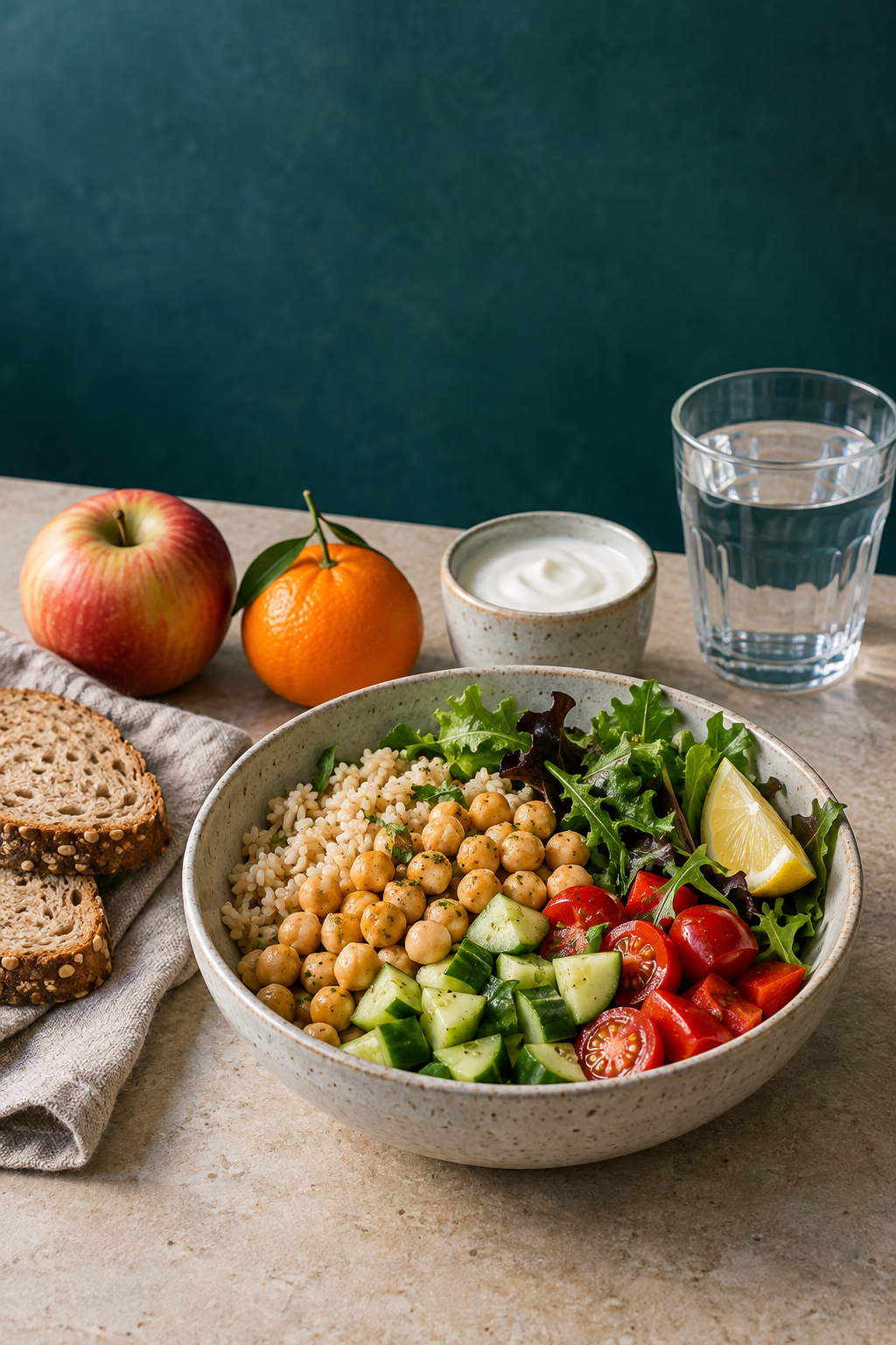

YEAR 9 FOOD TECHNOLOGY

Food Selection
and Health
STUDENT WORKBOOK

Name ____________________________ Class _______________
50 pages • A4 • Edition 1.0 • Illustrative food photography • Duplex long edge
START HERE

Use this workbook
Learn how food selection affects nutrition, health and everyday decisions. Read each section, test your understanding in the matching practice booklet, then use the response page to explain your reasoning.
Module | Teaching and response pages
1. Ready to work safely | 3–8
2. Nutrients and the body | 9–14
3. Reading food labels | 15–20
4. Food choices and influences | 21–26
5. Food patterns and technology | 27–32
6. Health and informed decisions | 33–38
Evidence tools and review | 39–42
Learning folio stages 1–8 | 43–50

Your complete paper package
The companion Practice and Activities booklet contains all 180 course multiple-choice questions, the 18 applied activities and their fictional practice data. Section numbers match this workbook. The teacher guide provides answers, reasoning and open-task criteria.

Keep evidence that explains a decision
Use the response pages for extended answers. Keep labelled diagrams, calculations, annotated practice cards and revised conclusions from the companion booklet. In the folio, select evidence and explain what it shows; do not simply repeat a finished answer.
Before practical work, the teacher confirms the approved recipe, ingredients, equipment, risk controls and supervision. HelloEats pages are formative planning until the current formal assessment notice is confirmed. This book does not set marks, due dates or submission rules.
Print at actual size on A4. Double-sided, long-edge printing uses 25 sheets for this workbook. Keep the companion booklet nearby. Discuss fictional cases respectfully; do not infer someone’s health from appearance.
SECTION 1.1 / LEARN

Personal hygiene and readiness
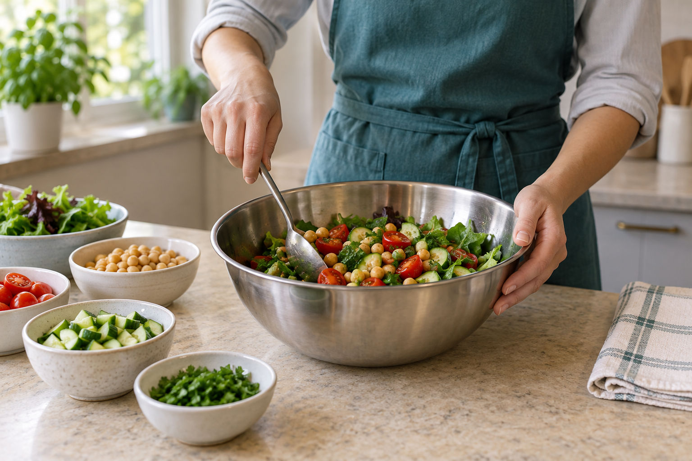
Figure 1. Illustrative preparation scene. An organised bench is visible; personal health, handwashing and cleaning history still need checking.

Preparation interrupts a pathway
Food safety begins with the route a contaminant could follow. A phone may transfer microorganisms to a hand, which then touches bread. Loose hair can fall into food. A bag on a shared bench can transfer dirt to equipment. Readiness means interrupting these routes before ingredients are handled. Clean appearance alone cannot establish whether a person, tool or surface is food-safe; its recent use and cleaning matter.

Wash, protect and separate
Wash hands with soap and running water, using friction across palms, backs, fingertips, thumbs, between fingers and around nails, then dry thoroughly. Repeat after an action that could recontaminate them. Gloves also collect contamination: they require clean hands and appropriate changes between tasks. A clean apron forms a cleaner outer barrier; restrained hair reduces falling strands and hand-to-hair contact. Jewellery, watches and damaged long nails can trap soil or interfere with washing.

Report before starting
Tell the teacher about vomiting, diarrhoea, fever or an infected wound before food handling. Reporting allows a suitable role and controls to be chosen; students should not diagnose the cause. A small covered cut still needs the teacher’s wound-protection directions. Hiding symptoms or relying on a glove removes information needed for a safe decision. Follow the current school requirements for clothing, allergies, protective coverings and personal items.

Check the person, then the place
Move through a calm routine: report health concerns, prepare yourself, check the workstation and review the method. Store phones and bags away from food surfaces. Confirm that the bench and equipment have the required cleaning status and that clean items have a protected place. Pause if a control is missing. Explain each check using “This prevents…because…”. That reasoning makes the checklist useful when the situation changes.
Kai washes their hands, then replies to a message before assembling a sandwich. The first wash does not make the later contact safe. The phone is a new possible source, Kai’s fingers are the route and the bread is the destination. Storing the phone and washing and drying hands again interrupts the route before ready-to-eat food is touched.
SECTION 1.1 / EXPLAIN

Show your reasoning
Personal hygiene and readiness
Justify a five-point readiness routine for a Year 9 food practical. For each point, explain the contamination pathway or safety problem it controls and evaluate why simply looking clean is insufficient.

Build your response
• Name five person-to-place checks in a logical order.
• For each check, identify what could be transferred or go wrong.
• Explain how the action interrupts that pathway.
• Include one example of recontamination after handwashing.
• Evaluate the misconception that clean-looking means food-safe.
Label a pathway, sequence or before-and-after comparison to support your explanation.

Folio handoff: Save as “M1.1 Readiness control plan” with a labelled contamination-chain example and one question about local room procedures.
Review: underline one claim, circle its evidence and add any missing link in your reasoning.
SECTION 1.2 / LEARN

Contamination, temperature and food safety

Locate the hazard and its route
Biological hazards include harmful microorganisms. Chemical hazards include cleaning chemicals; physical hazards include broken fragments. An allergen hazard occurs when an allergen reaches food intended for someone who must avoid it. A single scene can contain several categories. Trace what moves, from where, through which person, surface or tool, to which food. Raw-food juices carried by a knife onto salad show cross-contamination; labelling a board “salad” does not make it clean.

Combine separation and cleaning
Keep raw food, ready-to-eat food and relevant allergens effectively separated, using the teacher’s approved arrangements. Control hands and shared utensils as well as boards. Cleaning removes food residue, grease and dirt. Sanitising then reduces microorganisms on an already clean food-contact surface. Follow the product and room directions for rinsing, concentration, contact time and drying; never improvise chemical mixtures. Cooking can destroy many microbes, but later contamination can undo that control and heat does not remove every hazard.

Measure time and temperature
Potentially hazardous foods need controlled holding conditions: 5 °C or colder for cold holding, or 60 °C or hotter for hot holding. A suitable thermometer gives evidence to compare with these limits; touch, smell and visible steam do not provide a reliable measurement. Add all time between 5 °C and 60 °C during preparation, transport and display. Returning food to a fridge does not erase time already accumulated.

Use the cumulative-time rule
Under two hours, food may be used immediately or refrigerated for later. Between two and four hours, use it immediately; do not refrigerate it for later use. After more than four hours, discard it. These rules help manage refrigerated potentially hazardous food temporarily outside temperature control. They do not authorise unnecessary delay or replace other safety controls. When history is uncertain, stop and ask the teacher; do not invent a safe time.
Potentially hazardous food at 5–60 °C | 2-hour/4-hour rule
Less than 2 hours in total | Use immediately or refrigerate
Between 2 and 4 hours in total | Use immediately; do not refrigerate for later
More than 4 hours in total | Discard

A fictional chilled filling spends 45 minutes being prepared, 35 minutes travelling and 70 minutes on display between 5 °C and 60 °C. The total is 150 minutes, or 2 hours 30 minutes. Its clock has not restarted between stages. Under the cumulative-time rule it must be used immediately and cannot be refrigerated for later. Other contamination controls still need to be satisfactory.
SECTION 1.2 / EXPLAIN

Show your reasoning
Contamination, temperature and food safety
Analyse a lunch-preparation scene where raw food, ready-to-eat salad and chilled filling share a bench. Identify four hazards, trace their transfer or growth pathways, and justify controls using separation, cleaning, time and temperature.

Build your response
• Classify at least four hazards.
• Trace each source-to-food or source-to-person route.
• Place the earliest practical control on each route.
• Use 5°C, 60°C and one cumulative-time example accurately.
• Evaluate why appearance, smell or a coloured board alone is weak evidence.
Label a pathway, sequence or before-and-after comparison to support your explanation.

Folio handoff: Save as “M1.2 Hazard-route plan” with the annotated visual, time calculation and one decision per food.
Review: underline one claim, circle its evidence and add any missing link in your reasoning.
SECTION 1.3 / LEARN

Safe decisions and incident response

Separate hazard, risk and control
A hazard is something that can cause harm. Risk considers both how likely harm is and how serious it could be in this situation. A control reduces likelihood or consequence. A knife is sharp in either location, but a knife hidden under cloudy washing water is more likely to contact an unsuspecting hand than one stored correctly. Naming the situation helps the class choose a useful response instead of simply saying “be careful”.

Stop, isolate and tell
When conditions become unsafe, stop the task, keep others clear where it is safe to do so and tell the supervising teacher. Give the location, observed hazard, people affected and action already taken. Avoid handling unfamiliar electrical faults, chemicals, fire equipment or injuries beyond your training. An attempted rescue or repair can create a second hazard. The teacher directs the approved response, including first aid, equipment isolation or evacuation where required.

Match the response to the problem
A spill may cause a slip and spread contamination. Fragments beside uncovered food may contaminate the food even when only a few pieces are visible. A cut concerns both the person and food handling; a burn requires prompt teacher-led assistance. Do not pick up unseen fragments by hand or taste suspect food. Immediate controls protect people while an authorised person decides what cleaning, disposal, first aid or other action is needed.

Redesign before a repeat
Prevention is stronger when built into the workflow. Keep routes clear, boards stable, floors dry and handles away from edges; stage preparation so hot, sharp and wet pathways do not cross. Report near misses even when nobody was hurt because they reveal a control weakness. Record observable facts before interpretations. “Water lay between the sink and oven” is evidence; “someone was careless” is a judgement. Test a layout, timing or role change linked to the original hazard.
Hazard | Risk | Control
Something that can cause harm | Likelihood and consequence in context | An action that removes or reduces the risk

In a fictional lesson, a student sees a hot tray projecting over a bench edge beside a busy walkway. The hazard is heat; the situation increases the chance of contact and a burn. The student stops nearby movement, warns others from a safe position and tells the teacher. A later redesign creates a teacher-approved landing area away from the route, reducing the same contact pathway.
SECTION 1.3 / EXPLAIN

Show your reasoning
Safe decisions and incident response
Evaluate a food-room near miss. Separate observed facts from assumptions, rate the risk, justify stop–isolate–tell actions and redesign the workflow to prevent a repeat.

Build your response
• Describe only directly observed facts.
• Name hazard, likely harm, likelihood and consequence.
• Sequence the first three actions and justify the order.
• Identify actions reserved for trained or authorised people.
• Redesign layout, timing or roles to break the pathway.
Label a pathway, sequence or before-and-after comparison to support your explanation.

Folio handoff: Save as “M1.3 Near-miss redesign” with before-and-after workflow sketches and one measure of success.
Review: underline one claim, circle its evidence and add any missing link in your reasoning.
SECTION 2.1 / LEARN

Six nutrients and their roles
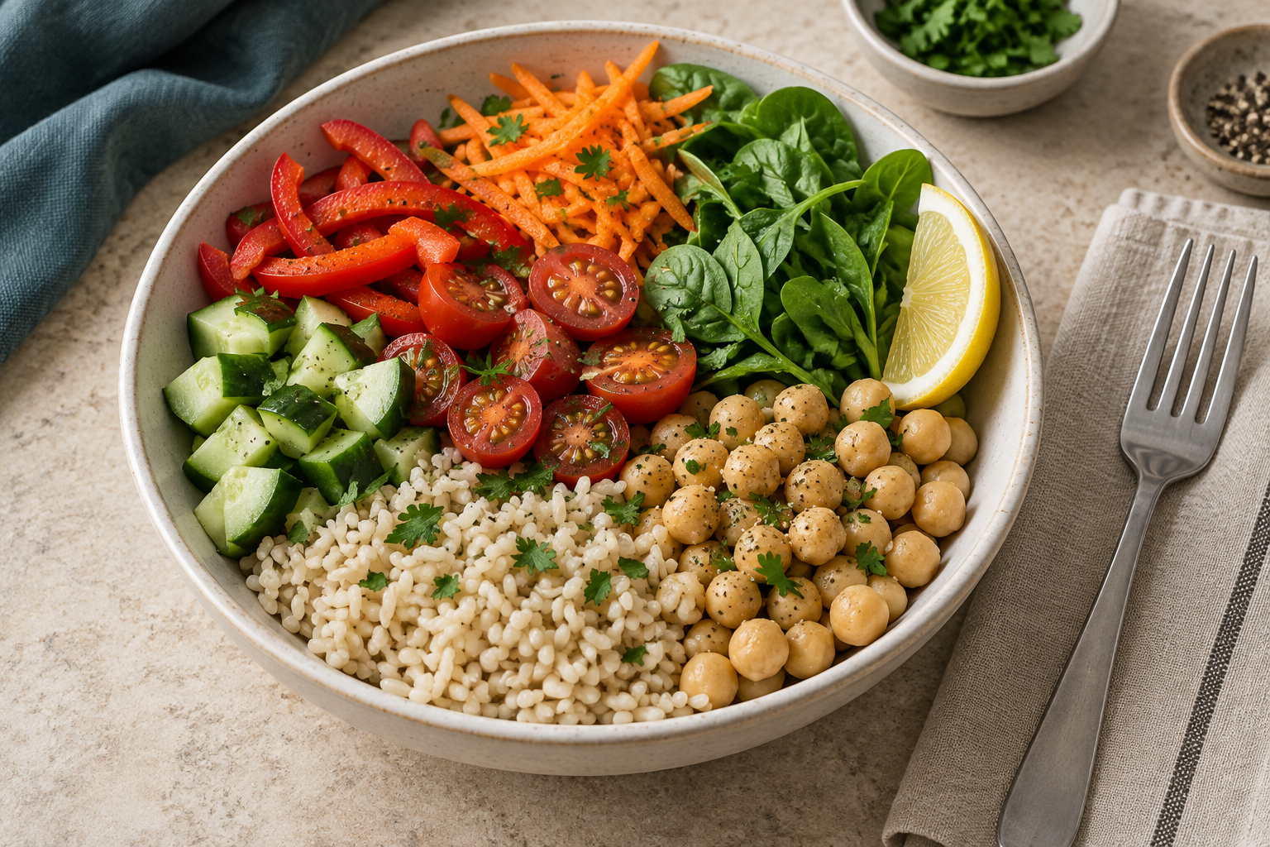
Figure 2. Illustrative mixed meal. Foods can contribute several nutrients; appearance cannot establish amounts or personal suitability.

One food can do several jobs
The six-group nutrient model names carbohydrate, protein, fat, vitamins, minerals and water. These substances support energy supply, growth, repair and regulation. Most foods contain a mixture: milk contributes water, protein, carbohydrate, minerals and varying amounts of fat. A food should therefore appear in more than one function group when the evidence supports it. Carbohydrate, protein and fat supply energy measured in kilojoules; the other three do not supply usable energy in the same way.

Energy and building materials
Digestion breaks carbohydrate mainly into glucose, an important fuel for cells. Sources include grains, fruit, legumes, starchy vegetables and milk products. Wholegrain bread and confectionery can both contribute carbohydrate while differing in fibre, micronutrients and structure. Protein provides amino acids for tissue growth and repair, enzymes and other body components. It is needed beyond sport. Chickpeas, lentils, tofu, nuts and seeds contribute plant protein alongside familiar animal sources.

Small amounts, important functions
Fat provides concentrated energy, supports cell membranes and helps the body absorb fat-soluble vitamins. Its type, amount and food source matter; it is not a substance to eliminate completely. Vitamins and minerals have specific jobs. Iron is involved in oxygen transport, while calcium contributes to bones and teeth. Vitamin C can improve absorption of non-haem iron. One ingredient cannot supply every nutrient, and an unprescribed supplement is not a substitute for food-based reasoning.

Water and complementary variety
Water supports transport, temperature regulation and body reactions even though it supplies no kilojoules. Requirements vary with activity, heat and other circumstances. Fibre is a plant-food component considered alongside the six nutrients; it supports bowel function and parts of the gut microbiome. Choosing across the five Australian Guide to Healthy Eating food groups builds complementary contributions. The aim is a varied pattern that fits a person’s context, rather than a single “perfect” food.
A fictional lunch combines a wholegrain roll, hummus, carrot, plain yoghurt and water. The roll supplies carbohydrate and fibre; hummus adds plant protein and fibre; carrot adds plant variety; yoghurt contributes protein and calcium. Several foods contribute more than one nutrient. The reasoning is stronger than “bread gives energy and everything else is extra” because it links the combination to several body functions.
SECTION 2.1 / EXPLAIN

Show your reasoning
Six nutrients and their roles
Design and justify a varied lunch using at least four foods. Explain how they work together for energy, growth and repair, and regulation, and evaluate the claim that one ‘superfood’ could replace the variety.

Build your response
• List the foods and their roles in the meal.
• Connect each food to at least two nutrients or useful components.
• Group contributions under energy, growth/repair and regulation.
• Explain why overlapping contributions are useful.
• Evaluate the ‘superfood’ claim.

Folio handoff: Save as “M2.1 Nutrient-team lunch” with a labelled food image and three-function map.
Review: underline one claim, circle its evidence and add any missing link in your reasoning.
SECTION 2.2 / LEARN

Energy, growth and repair

Energy is a measure, not a verdict
A kilojoule measures energy. The body needs energy for breathing, circulation and temperature regulation even while resting, as well as movement, learning, growth and repair. More energy does not automatically make a food unsuitable. Ask what the person is doing, when they will eat again and what else the food contributes. “This option supplies more energy” describes evidence; “this food is guilty” attaches a judgement that does not help the comparison.

Look across time and context
Energy balance relates energy consumed to energy used over time. Needs change with growth, physical activity and other circumstances, while portions and eating patterns change intake. One lunch cannot establish a person’s long-term balance or health. A Year 9 design task should compare stated situations, not calculate a supposedly perfect personal requirement. Individual medical or energy advice belongs with a qualified professional who can consider information unavailable in a classroom scenario.

Use nutrient density as another lens
Nutrient density asks what useful nutrients a food contributes relative to its energy. Two snacks with similar kilojoules may have different protein, fibre, vitamin and mineral contributions. Ingredients and food structure also matter. A sustaining meal can combine a carbohydrate food, a protein source, vegetables or fruit and fluid, with fats and flavours that suit the eater. There are many culturally meaningful and vegetarian ways to build this combination; cost, access and enjoyment remain relevant.

Compare the amount you will use
Compare similar products per 100 g or 100 mL to control for amount. Then use per-serve data or a calculation for the portion actually planned. A manufacturer’s serve may differ from a whole pack or the eater’s portion. A defensible recommendation uses energy, nutrients, ingredients, amount and purpose together. Name missing evidence and explain what new information might change the decision instead of assigning a permanent “best food” label.
Need | Reasoning example
Energy | Activity and growth change demand
Growth and repair | Protein provides material; energy must also be available
Regulation | Vitamins, minerals and water support processes

Two fictional snacks each supply 600 kJ, but one includes protein, fibre and fruit while the other contributes little of those components. Equal energy does not mean an equal contribution. For an afternoon with a long gap before dinner, the first may better fit the stated purpose. The decision still needs portion, ingredient, allergy and cost information; the kilojoule match alone cannot settle it.
SECTION 2.2 / EXPLAIN

Show your reasoning
Energy, growth and repair
Compare two lunch options for a Year 9 student with afternoon sport or physical practical work. Justify the stronger fit using energy, nutrient density, portion and pattern, then explain what could change the decision.

Build your response
• Describe the eater's activity and timing.
• Compare options on a common basis and realistic portion.
• Identify carbohydrate, protein, plant-food and fluid contributions.
• Explain nutrient density without automatically choosing the lowest kilojoules.
• State a decision and one context change that could reverse it.

Folio handoff: Save as “M2.2 Context-based meal decision” with an evidence table and conditional recommendation.
Review: underline one claim, circle its evidence and add any missing link in your reasoning.
SECTION 2.3 / LEARN

Digestion and nutrient absorption

Break down, then move across
Digestion and absorption are different processes. Mechanical digestion breaks and mixes food physically, exposing more surface for chemical digestion. Enzymes help break large molecules into smaller forms; stomach conditions also support digestion. Absorption occurs when suitable molecules cross the digestive-tract wall into transport systems. Food does not simply fall into the blood. The body first prepares smaller molecules and then moves them across specialised surfaces for distribution to cells.

Follow the route from the mouth
Teeth chew food while saliva moistens it and starts digestion of some carbohydrate. After swallowing, waves of muscular contraction called peristalsis move the food through the oesophagus; gravity is not the only force. The stomach mixes food with acidic juices and enzymes that begin substantial protein digestion. It releases partly digested material into the small intestine. The stomach is one stage in the pathway, not the place where all digestion and absorption finish.

See why the small intestine matters
Most chemical digestion and nutrient absorption occur in the small intestine. Pancreatic and intestinal enzymes help digest carbohydrate, protein and fat. The liver makes bile, which is stored in the gall bladder and released into the intestine. Bile disperses fat into smaller droplets, increasing the surface available to enzymes; bile itself is not an enzyme. Folds, villi and microvilli provide a large, thin absorption surface close to transport vessels.

Distinguish transport from elimination
Simple sugars and amino acids enter blood; many fat-digestion products enter lymph before reaching blood. These systems carry absorbed materials to tissues for use, storage or change. Unabsorbed material passes into the large intestine, where water and some dissolved substances are absorbed and remaining material forms faeces. Gut microorganisms interact with some fibres. Fibre helps bowel function rather than being useless waste. Symptoms can have many causes and should be discussed with an appropriate adult or health professional.
Stage | What happens
Mouth and stomach | Mechanical mixing and chemical digestion begin
Small intestine | Most digestion and nutrient absorption occur
Large intestine | Water absorption and microbial activity continue

A fictional mouth-to-intestine diagram says “the stomach absorbs the whole sandwich”. Repair it by separating the jobs. Chewing increases surface area; stomach mixing and acidic juice begin substantial protein digestion; small-intestine enzymes continue breakdown. Suitable small molecules then cross villi into blood or lymph. This explains why removing the small intestine from the diagram leaves out the main absorption stage.
SECTION 2.3 / EXPLAIN

Show your reasoning
Digestion and nutrient absorption
Trace a meal containing carbohydrate, protein and fat from mouth to large intestine. Explain mechanical and chemical changes, identify absorption sites, and evaluate the claim that the stomach does all digestion.

Build your response
• Sequence the major organs.
• Separate movement, mechanical change and chemical change.
• Explain enzymes and bile without calling bile an enzyme.
• Show how sugars, amino acids and fat products enter transport.
• Use villi and large-intestine function to evaluate the claim.
Label a pathway, sequence or before-and-after comparison to support your explanation.

Folio handoff: Save as “M2.3 Journey of a mixed meal” with an organ flow and digestion-versus-absorption key.
Review: underline one claim, circle its evidence and add any missing link in your reasoning.
SECTION 3.1 / LEARN

Ingredients, servings and nutrition panels

Ask the label the right question
A package has several evidence zones: ingredients, allergen information, the nutrition information panel, date marking and storage directions. Each answers a different question. The front claim may attract attention but cannot replace those zones. Start with the eater’s purpose and any safety needs. A product with a favourable protein number is still unsuitable for a person whose allergy management plan rules out an ingredient it contains.

Read ingredients and allergens together
Ingredients are generally listed from greatest to least ingoing weight when the product was made. This shows relative order, not the exact amount of every ingredient. A compound ingredient may contain several components. A long list is not automatically unhealthy, and a short list is not automatically appropriate. Read the current ingredient and allergen declarations using the relevant management plan and adult guidance. Do not guess safety from a brand, a picture or a previous package.

Match serves and amounts
The food business sets the serving size used for per-serve figures. It may not match a whole pack or the portion actually eaten, and similar products can use different sizes. Compare similar solid foods per 100 g, or liquids per 100 mL, then check the intended serve. Total sugars combines naturally present and added sugars where present. The ingredient list helps identify sources, but usually cannot tell the exact amount contributed by each one.

Dates and storage change the decision
A use-by date is about safety: do not eat the food after it. A best-before date concerns expected quality when storage directions are followed; it is not the same safety cut-off. Storage directions remain important before and after opening. A useful scan therefore checks safety first, comparable nutrition second and realistic portion third. Record both a supported conclusion and something the label cannot establish, such as whether this product meets all of one person’s needs.
Purpose | Evidence zone
Check safety | Current allergens, date and storage
Compare similar products | Per 100 g or per 100 mL
Estimate the planned amount | Serving size and per-serve data

A fictional yoghurt panel reports 8 g of total sugars per 100 g and lists milk before sugar. It supports the statement “the product contains 8 g of total sugars in 100 g”. It does not show that all 8 g is added sugar: milk contains naturally occurring sugars. Ingredient order adds context, but an exact added-sugar amount would need further evidence.
SECTION 3.1 / EXPLAIN

Show your reasoning
Ingredients, servings and nutrition panels
Create a label-reading guide for choosing between two similar snacks. Explain the order for ingredients, allergens, serves, per 100 g data, dates and storage, and justify why each answers a different question.

Build your response
• State the eater's purpose and safety requirement.
• Map each question to the correct label zone.
• Explain ingredient order and its limitation.
• Compare per 100 g, then translate to planned serve.
• Finish with date, storage and one thing the label cannot prove.

Folio handoff: Save as “M3.1 Label evidence pathway” with an annotated package and checklist.
Review: underline one claim, circle its evidence and add any missing link in your reasoning.
SECTION 3.2 / LEARN

Comparing foods fairly

Define what the choice must achieve
A fair comparison starts with a decision question: who is the food for, on what occasion and for what purpose? A refrigerated lunch yoghurt may need a useful protein contribution, an acceptable portion, affordable cost and safe storage. A recipe ingredient may need different qualities. State the criteria before looking for a winner. Otherwise, it is easy to choose whichever number favours a product already preferred.

Control the comparison basis
Choose products that serve a similar role and use the same units. For similar solid foods, compare per 100 g first; for liquids, use per 100 mL. This removes the effect of different stated serve sizes. It does not make unrelated foods interchangeable or describe a whole meal. Check whether a product is concentrated, diluted or prepared with another ingredient, because preparation can change the question the numbers answer.

Restore the realistic portion
After the common baseline, calculate the amount planned: per-100-g value × portion in grams ÷ 100. A smaller listed serve may look lower even when the food contains more per 100 g. Read the package’s per-serve value where the planned portion matches it, recognising that displayed figures may be rounded. If the portion is unknown, state the uncertainty or show sensible scenarios. Do not fabricate a precise total from missing quantities.

Explain trade-offs and conditions
More is not always better, and less is not always better. Select nutrients relevant to the purpose and interpret total sugars alongside ingredients. Then consider allergy needs, cold storage, culture, cost and packaging. A serious safety constraint can outweigh a small numeric advantage. Finish with “For this context, I recommend…because…; this would change if…”. That statement connects evidence to the actual decision while recognising that labels cannot describe a person’s complete eating pattern.
Comparison step | Why it matters
Match food type and amount | Avoid a misleading comparison
Read ingredients and nutrients | A front claim is only part of the evidence
State a limitation | Suitability depends on context

Fictional Product X contains 6 g protein per 100 g and Product Y contains 5 g. At an equal 150 g portion, X supplies 9 g and Y supplies 7.5 g. The common baseline and the actual portion support the same protein comparison. They still do not decide cost, allergy suitability or taste. Those criteria need their own evidence before a final recommendation.
SECTION 3.2 / EXPLAIN

Show your reasoning
Comparing foods fairly
Compare two similar packaged foods for a Year 9 context. Make a conditional recommendation using common baseline, portion, nutrients, ingredients and one non-nutrient factor, then identify missing evidence.

Build your response
• Define audience, occasion and decision question.
• Check the products are comparable.
• Compare three relevant values per 100 g or 100 mL.
• Translate to planned portion and interpret ingredients.
• Add safety, access, cost, culture or environment and conclude conditionally.

Folio handoff: Save as “M3.2 Fair food comparison” with evidence table, calculations and conditional recommendation.
Review: underline one claim, circle its evidence and add any missing link in your reasoning.
SECTION 3.3 / LEARN

Marketing claims, ethics and health

Notice the first impression
Words, colours, images and placement direct attention before the full label is read. A truthful claim can still give an incomplete impression by highlighting one useful feature. “Source of calcium” says nothing by itself about allergens, total sugars, affordability or the whole diet. Critical reading checks the claim’s exact wording and evidence. It neither assumes all advertising is false nor lets one favourable feature answer every question.

Test what the claim actually says
Nutrition and health claims have conditions in the Food Standards Code. Students do not need to memorise every threshold to practise checking: locate the relevant panel or ingredient evidence, identify the comparison basis for words such as “reduced”, and avoid extending the claim. A testimonial is not proof of a health effect. Vague language such as “natural energy” needs explanation before it can support a precise nutritional conclusion.

Give ratings their proper role
The source course presents Health Star Rating as a half-to-five-star aid for comparing similar packaged foods. It summarises selected nutritional information; it does not replace ingredients, allergens, the full panel or the eater’s context. Comparing stars on unrelated categories does not answer which fits a particular meal. A star is also separate from ethical or environmental evidence: recyclable packaging alone does not prove nutritional suitability, and useful nutrients do not prove responsible sourcing.

Evaluate audience and omission
Athletes, influencers, popularity and repetition can create social proof without adding scientific evidence. Urgency and discount framing can shorten the time available to check. Ask who benefits, who is being persuaded and what information is missing. Ethical communication should be identifiable as promotion and avoid misleading impressions, especially for younger audiences. A fair judgement acknowledges real benefits, names omissions and remains conditional where evidence is absent. Rewrite the message so a reader can distinguish fact from persuasion.
Claim | Evidence question
“Supports wellbeing” | Which measurable effect is actually supported?
“Someone online recommends it” | What is their expertise and commercial interest?
“One nutrient is high” | What does the rest of the label show?

A fictional snack displays a large berry picture beside “made with real berries”. Its ingredient list reports berry purée at 2%. The claim and picture can be examined separately: the product does include berries, but the image may suggest they dominate. A fairer message states the amount and invites checking the whole formulation. It does not turn “contains berries” into a guarantee of health.
SECTION 3.3 / EXPLAIN

Show your reasoning
Marketing claims, ethics and health
Evaluate a fictional food promotion aimed at teenagers. Analyse how it frames attention, test two claims, explain one omission, and judge its health, audience and ethical responsibilities.

Build your response
• Describe audience and first impression.
• Identify two exact or implied claims.
• Match each claim to evidence without extending it.
• Explain one omission and its likely effect.
• Make a conditional judgement separating health, environment and social evidence.

Folio handoff: Save as “M3.3 Claim–evidence–omission audit” with annotated promotion, source links and a fairer revised message.
Review: underline one claim, circle its evidence and add any missing link in your reasoning.
SECTION 4.1 / LEARN

Active non-nutrients and food variety
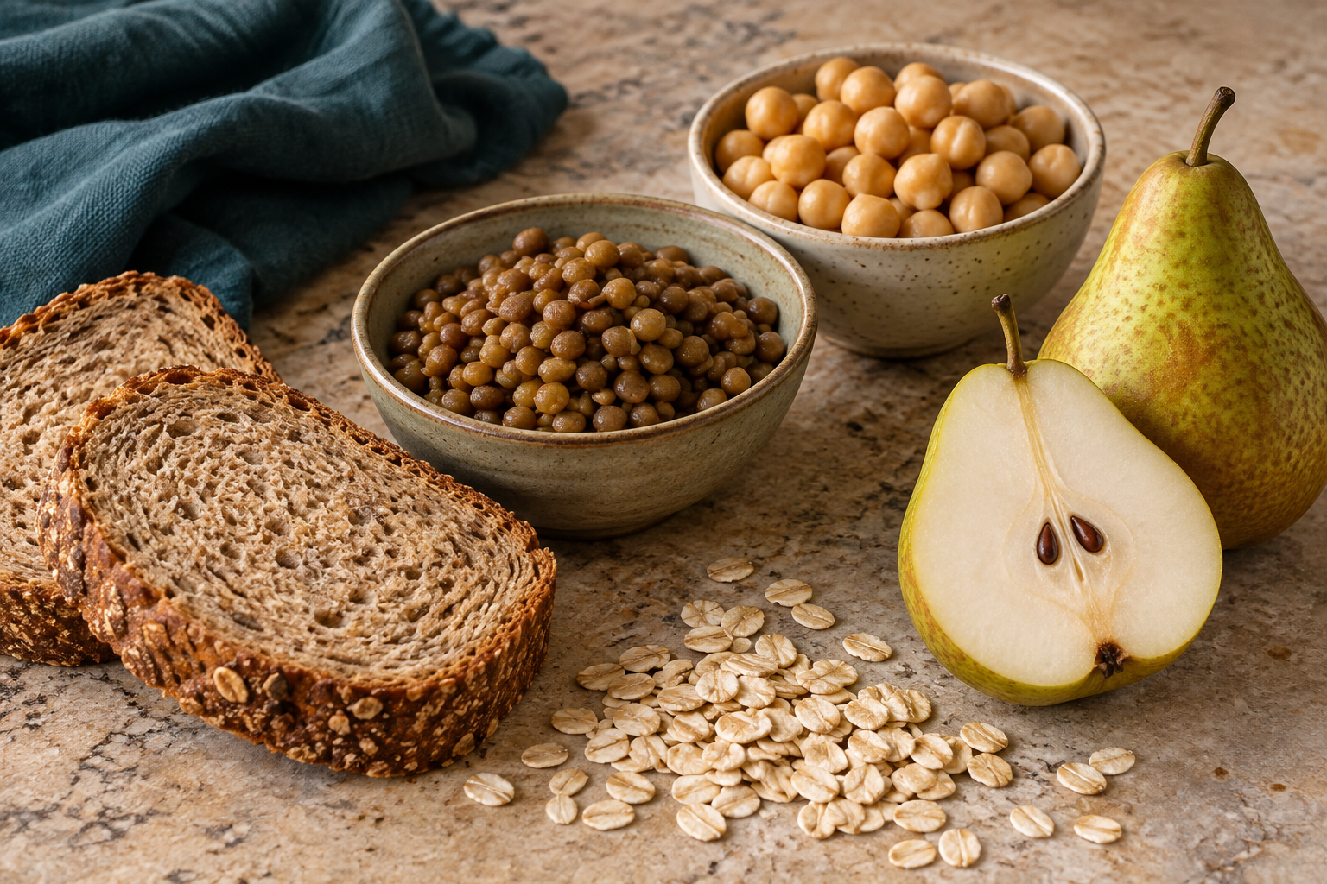
Figure 3. Illustrative fibre-containing foods: grains, legumes and pear. Observe variety without inferring an exact fibre amount.

Clarify nutrients and other components
Water is one of the six nutrient groups, alongside carbohydrate, protein, fat, vitamins and minerals. This section also considers fibre and naturally occurring plant compounds, which sit outside that simple six-group model. “Active non-nutrient” describes a component that may affect body processes; it does not mean a medicine, a cure or something to consume without limits. Keep water’s classification clear even when discussing it together with fibre and plant variety.

Connect fibre with the digestive route
Fibre resists full digestion in the small intestine. Some forms add bulk and help material move through the bowel; others can be fermented by microorganisms in the large intestine. Wholegrains, vegetables, fruit, legumes, nuts and seeds contribute different forms and combinations. A practical increase uses varied fibre-rich foods gradually with water, rather than a sudden supplement chosen from a social-media promise. The aim is a useful eating pattern that remains comfortable and realistic.

Use water and colour thoughtfully
Water supports transport, body reactions and temperature regulation. It comes from drinks and water-containing foods, including fruit, vegetables, soup and yoghurt. Needs vary with weather, activity and individual circumstances. Different plant colours can prompt variety in flavour, texture and components, but they are not a precise nutrient calculator. Two red foods are not identical, and one purple drink cannot cancel the effects of a wider pattern or guarantee protection from disease.

Make variety fit everyday life
“Superfood” is mainly a marketing term, not a food group in the Australian Guide to Healthy Eating. Frozen vegetables, canned legumes and familiar seasonal foods can contribute useful variety without an expensive special ingredient. Improve a meal by identifying what it already offers, then choosing a change for a clear purpose. Consider taste, culture, access, price, allergies and storage. Explain what the change contributes using cautious language, rather than labelling foods or people good or bad.
A fictional lunch contains white bread, cheese and water. It already provides useful food and fluid. Swapping to a suitable wholegrain bread may add fibre; adding grated carrot broadens plant variety and texture. These are two explained improvements, not a claim that the original lunch is worthless. The redesign still needs to fit taste, affordability, allergy requirements and safe storage.
SECTION 4.1 / EXPLAIN

Show your reasoning
Active non-nutrients and food variety
Evaluate a familiar lunch and justify two realistic changes that would broaden its useful food variety without using superfood, detox or cure claims.

Build your response
• Describe the lunch neutrally and identify what it already contributes.
• Identify one fibre, water or plant-variety gap supported by the section.
• Propose two changes that suit the person's taste, access, cost and storage context.
• Explain the mechanism or contribution expected from each change.
• State one limit to your conclusion so the response does not overclaim.

Folio handoff: Save the before-and-after lunch comparison and its two evidence statements as formative learning evidence under Folio > Food-choice reasoning.
Review: underline one claim, circle its evidence and add any missing link in your reasoning.
SECTION 4.2 / LEARN

Nutrition across the lifecycle

Begin with the person’s actual context
Life stage is a useful starting point, but age alone cannot describe someone’s food needs. Growth, activity, body size, illness, recovery, pregnancy, breastfeeding and ageing can change what matters. Access, skills, schedule, preference and cultural meaning also affect the design. Separate facts supplied in a brief from assumptions. An unstated medical requirement or swallowing difficulty must be confirmed, not added because the person belongs to an age group.

Support growth and daily activity
Adolescence combines growth with increasing independence and changing school, sport, work and sleep routines. Energy, protein, iron, calcium and varied food contributions deserve consideration, but exact individual needs differ. A portable meal may improve access between commitments; its portion, storage and acceptability still need checking. Adult needs also vary with activity and circumstances. Copying another person’s supplement routine or restricting food to match a social-media ideal is not an evidence-based design response.

Adapt without stereotypes
Some older people may benefit from nutrient-dense foods, manageable portions, softer textures or easy-to-hold serves. These features should respond to the stated brief. Age does not prove low appetite, limited ability or a need for texture modification. Family meals, enjoyment and independence may be important design priorities too. A useful adaptation connects a confirmed need to an ingredient, texture, portion, portability or preparation feature, then checks whether the change is practical and welcomed.

Use guidance within its limits
Nutrient Reference Values provide reference points for population groups and professional planning; they do not diagnose an individual or generate a personal prescription from age alone. In class, use broad public guidance to compare possibilities and state uncertainty. Follow a clear chain: read the brief, identify the need, select a feature, explain its effect and check safety and practicality. A successful design satisfies the stated context while keeping unknown medical and allergy details visible.
Context | A consideration, not a prescription
Growth and development | Nutrient needs change with life stage
Older adulthood | Appetite, chewing and access may affect choice
Medical restriction | Use qualified advice and the current management plan

A fictional user says they enjoy lunch with family but find a large rigid container awkward to hold. The evidence concerns handling and social preference, not age-based incapacity. An easier-to-hold container could respond directly while preserving the shared meal. Before changing texture or ingredients, the designer asks for the missing requirements. A practical adaptation solves the stated problem without inventing another one.
SECTION 4.2 / EXPLAIN

Show your reasoning
Nutrition across the lifecycle
Compare the needs in two lifecycle case studies and justify one food-design adaptation for each, showing which details are evidence and which still need confirmation.

Build your response
• Summarise each person's stated life stage and context without stereotypes.
• Identify one relevant nutrition or practical need in each case.
• Select one food or design feature that could respond to each need.
• Explain the reasoned design chain for both adaptations.
• Mark one unknown in each case as requiring confirmation and explain why it matters.

Folio handoff: Save the two-case comparison and highlighted confirm-before-design notes under Folio > User needs and constraints.
Review: underline one claim, circle its evidence and add any missing link in your reasoning.
SECTION 4.3 / LEARN

Personal, social, cultural and digital influences

Map a choice before judging it
Food choices emerge from interacting influences. Hunger, taste, habits, skills, allergies and values are personal factors. Family, friends, celebrations and religion add social and cultural meaning. Price, time, transport, shop location and kitchen access shape what is possible. Environmental priorities and digital platforms add further pressures. A single purchase cannot prove a person’s character or overall health. Mapping the conditions makes a more useful response possible than blaming the eater.

Look for connections and conflicts
Influences can reinforce or compete with each other. A friend’s suggestion may fit a person’s taste but exceed their budget; reusable packaging may suit environmental values while a distant shop limits access. Culture is not a fixed checklist shared identically by everyone. Ask what food means to the intended user and examine ingredients and context respectfully. Two people can make different, well-reasoned choices because their priorities or available options differ.

Inspect the digital message
Platforms influence which products appear first and how discounts are presented. Influencers may have a commercial interest through payment, gifts or discount codes. Large audiences and attractive images do not establish nutrition expertise. Urgent countdowns, testimonials and “before-and-after” stories can draw attention away from missing evidence. Check who made the message, what action they want, what evidence they supply and what remains unknown. A sponsored claim still needs the same careful evidence check as a package.

Pause, check, decide
Pause to name the purpose and the pressures acting now. Check suitable evidence: current ingredients, a nutrition panel, total price, relevant Australian guidance and stated user requirements. Decide on a workable option, then reflect without shame. A drink decision can consider serve size, additions, frequency, enjoyment and budget rather than treating the product as forbidden or assuming advertising has no effect. Agency means using available evidence within real constraints, while recognising that more information may change the choice.
Influence | Possible interaction
Cost and access | Budget affects which available option is practical
Culture and family | Shared practices can shape preference and meaning
Digital marketing | Convenience messages can interact with time pressure

A fictional after-school offer combines a ten-minute countdown, a friend’s recommendation and a discount. The student wants a drink but has limited money. Pause identifies urgency, social influence and budget pressure. Checking the full price and ingredient information may reveal that the offer is less suitable than it first seemed. Buying, changing the order or declining can each be defensible if the decision uses the evidence.
SECTION 4.3 / EXPLAIN

Show your reasoning
Personal, social, cultural and digital influences
Analyse a realistic after-school food or drink choice by explaining how at least three influences interact, then justify a decision using pause-check-decide.

Build your response
• Describe the choice and its purpose in neutral language.
• Identify at least three influences from different categories.
• Explain one interaction between two of those influences.
• Check one relevant source of product or guidance evidence.
• Justify a workable decision and acknowledge one reasonable alternative.
Label a pathway, sequence or before-and-after comparison to support your explanation.

Folio handoff: Save the influence map and pause-check-decide justification under Folio > Influences on selection.
Review: underline one claim, circle its evidence and add any missing link in your reasoning.
SECTION 5.1 / LEARN

Australian food-consumption patterns

A population pattern has a defined scope
A food-consumption pattern describes a tendency in a particular group, time or setting. Researchers may measure food eaten, purchases, meal frequency, nutrients or food groups. These measures answer different questions: buying six apples does not prove who ate them. Before interpreting a figure, identify the source, population, date, measure and unit. Ask whether the data reflects usual consumption, one day, self-report or purchasing records.

Read averages without erasing variation
A group average does not describe every person. Age, culture, location, income, access and household circumstances can differ within a national result. Survey method also affects what can be concluded. Use wording such as “the surveyed group averaged…” rather than “everyone always…”. A school design decision needs local information as well as broad evidence. To compare dates, check that the measures and methods are sufficiently similar before calling a difference a trend.

Distinguish evidence from explanation
Current ABS analysis estimates that in 2023, 2.1% of children aged 2–17 met the vegetable, legume and bean recommendation, and 50.7% met the fruit recommendation. The release date is 10 July 2026; it is not the data-collection year. These national estimates describe usual food-group consumption. They do not establish this class’s behaviour or explain its causes. Price, availability, time and familiarity are possible questions for investigation, not conclusions already proved by those percentages.

Design a proportionate response
Australian guidance provides a comparison point for a varied pattern, not a moral score for an individual lunch. A designer could investigate whether an appealing, affordable vegetable-rich option helps a defined school audience. Specify the audience, possible barrier, intended change and success measure. Use appropriate feedback to test the idea and revise it. One new product cannot be claimed to solve a national pattern, and a low uptake figure does not prove lack of willpower.
Read a population claim | Record the evidence
Who and when? | Population, age range and reference year
What was measured? | Indicator, percentage and comparison basis
What remains unknown? | An individual’s intake, reasons or diagnosis

A fictional school team reads a national estimate, then proposes “all our students avoid vegetables”. The evidence does not support that jump. A repaired statement keeps the national population and year, then asks what local evidence is needed. The team could investigate which vegetable options intended users find affordable and appealing, test one concept, and measure feedback instead of claiming the survey already describes their school.
SECTION 5.1 / EXPLAIN

Show your reasoning
Australian food-consumption patterns
Interpret a current government dietary-behaviour excerpt and evaluate what food-design response it supports for a clearly defined school audience.

Build your response
• Identify the source, date, population, measure and unit.
• State one pattern using cautious group language.
• Explain two limits or kinds of variation hidden by the summary.
• Propose a small response matched to one plausible barrier.
• Describe how you would test whether the response helps the intended audience.

Folio handoff: Save the annotated evidence excerpt and response proposal under Folio > Using population evidence.
Review: underline one claim, circle its evidence and add any missing link in your reasoning.
SECTION 5.2 / LEARN

Convenience, delivery and food technology
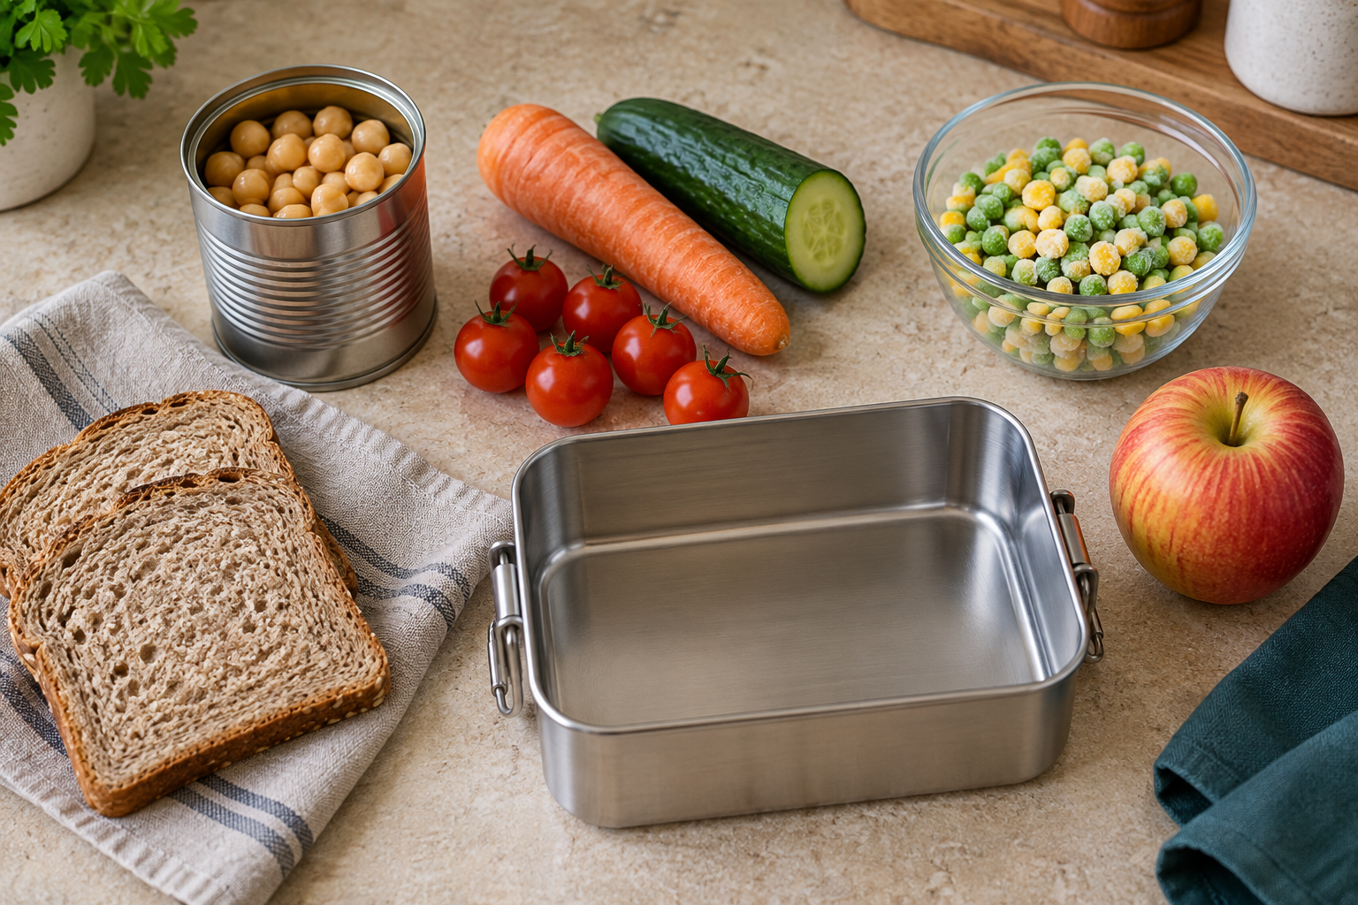
Figure 4. Illustrative planning ingredients. Compare fresh, frozen and tinned forms; this scene is not a storage procedure.

Name the convenience being provided
Convenience may reduce shopping, planning, preparation, cooking, transport or cleaning. Frozen vegetables, canned beans, meal kits and delivered meals provide different shortcuts. Processing is not automatically a disadvantage: washing, freezing, canning and pasteurisation can improve safety, shelf life or access. Start with the user’s need and the whole product. “Homemade” and “processed” alone do not tell us nutrition, affordability, safety or suitability.

Trace technology and packaging
Freezing slows microbial growth; canning uses heat and a sealed container; pasteurisation uses controlled heat to reduce risk. These technologies do not remove the need for intact packaging, dates, storage directions and careful handling. Packaging protects food and carries ingredients, allergens and other required information. It can also add waste and cost. A green-looking design or recycling symbol needs proper disposal and sourcing context before supporting a broad environmental claim.

Follow the delivery chain
A delivered meal passes through preparation, packing, waiting, transport and handover before eating or storage. Time, temperature and contamination controls matter throughout. A sealed bag may provide tamper evidence but cannot prove the full temperature history. Receive food promptly, check obvious problems and follow appropriate storage directions. When evidence is missing, identify it rather than assume the food remained safe. Current teacher directions govern any practical handling in class.

Compare the complete trade-off
Apps influence convenience through rankings, bundles, minimum orders, service charges and delivery fees. Total cost includes these additions, not only the menu price. A comparison should also examine time, skills, ingredients, allergies, nutrition, portion, appeal, access, packaging and waste. A meal kit may save planning while adding packaging; delivery may help someone without kitchen access but cost more. Improve the relevant stage while preserving the benefit the user actually needs, and make the recommendation conditional on unknown facts.
A fictional meal costs $8 on a menu, but a $3 delivery charge and $1 service fee make the total $12. Calling it the cheaper $8 option would hide part of the comparison. The extra cost may still be acceptable if delivery solves an access problem. Safety, portion, ingredients and arrival time require separate evidence; a price calculation does not settle them.
SECTION 5.2 / EXPLAIN

Show your reasoning
Convenience, delivery and food technology
Evaluate two ways of obtaining the same meal—one prepared from a convenience product and one ordered through delivery—and recommend the better fit for a stated user and situation.

Build your response
• Define the user's purpose, available time, facilities and constraints.
• Trace the technologies and handling stages in each option.
• Compare nutrition evidence, allergen suitability, safety, total cost, appeal, packaging and waste.
• Explain two important trade-offs rather than searching for a perfect option.
• Recommend one option and propose one improvement to reduce its main limitation.
Label a pathway, sequence or before-and-after comparison to support your explanation.

Folio handoff: Save the comparison matrix, delivery-chain annotation and recommendation under Folio > Technology and trade-offs.
Review: underline one claim, circle its evidence and add any missing link in your reasoning.
SECTION 5.3 / LEARN

Designing responsible food solutions

Turn a broad aim into a brief
“Make a healthy meal” leaves too much undefined. A useful food-design brief identifies the user, purpose, occasion and problem to address. It may require a portable lunch that fits a budget and can be held safely until eating. List unknowns before choosing ingredients. Allergies, facilities, school procedures and actual practical approval require confirmation; an attractive concept drawing is not permission to prepare the food.

Agree criteria and constraints first
Criteria describe qualities used to judge success, such as appeal, variety, safe handling, cost and portability. Constraints set limits, such as maximum time, available equipment or a budget cap. A maximum price can be both a constraint and a basis for judging success. Decide these before selecting an idea so the rules do not change to favour a preferred concept. Safety requirements must not be traded away for a higher total score.

Compare alternatives with evidence
Generate several concepts and compare each against the same criteria. Use sketches and ingredient maps to expose differences early. Labels support ingredient and nutrient comparisons; Australian guidance supports variety reasoning; intended-user feedback supports appeal. A decision matrix makes priorities visible, but its scores still depend on evidence and assumptions. “I like it” is valid personal preference, not proof that every intended user agrees. Test whether a changed constraint would change the leading option.

Evaluate and improve responsibly
Trade-offs are common: individual packaging can improve portability but add material, and a perishable filling may need stronger cold control. Consider access, sourcing, waste and cost without relying on an unsupported green claim. Evaluate a prototype using observations, measurements and structured feedback against the original criteria. Record what worked, what needs improvement and one change to test next. A specific finding about leakage, texture or cost leads to a better decision than simply writing “it was good”.
Design criterion | Evidence to seek
Consumer needs | Relevant nutrition, preference and access
Practicality | Available time, skills, equipment and cost
Consequences | Safety, waste, packaging and realistic trade-offs

A fictional lunch concept scores well for portability and cost but its filling leaks during a test. The evidence does not justify calling it finished because the total score is high. The designer identifies containment as the failed criterion and trials a revised filling or container while retaining safe storage. The next test measures the same issue so the effect of the change can be judged.
SECTION 5.3 / EXPLAIN

Show your reasoning
Designing responsible food solutions
Develop and justify a responsible concept for a portable school meal using a supplied user brief, then evaluate the concept against competing criteria before any practical production.

Build your response
• Translate the user brief into at least five criteria and three constraints.
• Generate two distinct concepts and compare them using the same evidence.
• Select one concept and justify its ingredients, handling, packaging and user fit.
• Identify two trade-offs, including one environmental or ethical consideration.
• Describe a prototype test and the evidence that would trigger an improvement.

Folio handoff: Save the criteria matrix, two concepts, selection justification and test plan under Folio > Responsible food design.
Review: underline one claim, circle its evidence and add any missing link in your reasoning.
SECTION 6.1 / LEARN

Under- and overnutrition

Distinguish energy from nutrient adequacy
Malnutrition is a mismatch between what the body needs and what it receives or can use. Undernutrition may involve too little energy, protein or particular micronutrients. Overnutrition can involve sustained excess energy or particular components. A narrow pattern can provide ample energy while lacking fibre or some vitamins and minerals, so excess and inadequacy can occur together. These concepts describe possible health mechanisms, not a person’s effort, character or worth.

Use repeated evidence and cautious language
A single skipped breakfast, celebration meal, photograph or body shape does not establish a long-term nutrition pattern. Look at repeated observations and what remains unknown. Distinguish “the record contains few varied plant foods” from “this person has a deficiency”. Use may or could when linking a pattern to a possible mechanism. Appetite, illness, absorption, actual portions and individual needs may change the interpretation. Students cannot supply a diagnosis from the limited classroom evidence.

Look for interacting causes
Undernutrition can involve food insecurity, high prices, transport barriers, limited cooking facilities, illness or difficulty absorbing nutrients. Telling someone simply to eat more does not resolve these causes. Sustained excess or imbalance can also be shaped by portion availability, work patterns, marketing, sleep, stress, medicines, genetics and activity. A systems explanation identifies how conditions interact. It avoids assuming that a body’s appearance reveals what a person eats or how healthy they are.

Design support within your role
Useful responses can improve access to affordable varied foods, suitable meal time, drinking water and reliable information. A food concept should address the stated barrier and be checked for practicality and acceptance. If eating or food access is causing distress, encourage private contact with a trusted adult or appropriate health support. Do not monitor classmates’ bodies, disclose private information, prescribe diets or promise treatment. Respectful language helps people use support without shame, while qualified professionals handle individual concerns.
Concept | Careful interpretation
Undernutrition | Insufficient energy or nutrients over time
Overnutrition | Excess energy or particular nutrients over time
Appearance | Cannot establish intake, cause or diagnosis

A fictional record shows repeated missed meals during a week when household food ran short. The observed pattern suggests an access problem worth addressing; it does not diagnose a nutrient deficiency. A useful design response might improve access to affordable varied food and connect the person privately with support. Explaining the possible mechanism and the limits is stronger than blaming the person or promising that one snack will fix it.
SECTION 6.1 / EXPLAIN

Show your reasoning
Under- and overnutrition
Analyse a fictional community nutrition case by explaining the possible undernutrition, overnutrition or imbalance mechanism, the interacting causes and a respectful support response without diagnosing an individual.

Build your response
• State only the food-pattern and context evidence provided.
• Explain the possible energy or nutrient mechanism using cautious language.
• Identify at least three interacting biological, social or environmental factors.
• Propose one food-design response and one broader system support.
• State the limits of the evidence and where professional help would be appropriate.

Folio handoff: Save the case mechanism map and respectful response under Folio > Nutrition patterns and support.
Review: underline one claim, circle its evidence and add any missing link in your reasoning.
SECTION 6.2 / LEARN

Nutrition-related conditions and prevention

Explain risk without a guarantee
A risk factor is associated with a greater chance of an outcome; a protective factor with lower risk. Neither guarantees what will happen. Age, genetics, medicines, health care, movement, sleep, access and eating patterns can interact. “Supports health” or “can reduce risk” is more accurate than promising that a food prevents or cures disease.

Blood and cardiovascular systems
Haemoglobin in red blood cells carries oxygen. Iron is needed to make it, but iron deficiency is only one possible cause of anaemia; blood loss, illness and other causes also matter. Tiredness alone cannot diagnose it. Cardiovascular health concerns the heart and blood vessels. Blood pressure, blood lipids, smoking, diabetes, family history, age, movement and food patterns can affect risk. One ingredient cannot remove all those influences.

Bone strength develops over time
Calcium, vitamin D, protein, hormones and weight-bearing activity all contribute to bone health. Osteoporosis weakens bones and raises fracture risk; it cannot be guaranteed away with one calcium-rich snack. Adolescence is an important period for bone development. Food designers can improve access to suitable calcium-containing choices, while considering allergies, intolerance, vegan choices, culture and availability. Alternatives must be checked for their actual nutrient contribution rather than assumed equivalent.

Glucose regulation and wider context
Insulin helps regulate blood glucose. In type 2 diabetes the body does not respond effectively to insulin and may not produce enough. Genetics, activity, food patterns and other biological or environmental factors can influence risk. The condition does not prove personal failure. People’s management needs are individual, so classroom design should support inclusive varied choices without prescribing treatment or assuming that every person needs the same restriction.

Keep personal concerns private
Body size does not reveal someone’s complete diet, fitness, blood results or wellbeing. Study mechanisms and supportive environments without weighing classmates or commenting on bodies. Food, sleep, movement and access can support health without controlling every outcome. If symptoms or personal condition questions arise, speak privately with a trusted adult and seek qualified health advice; a quiz cannot replace professional assessment.
Strong explanation | Keep the boundary
Pattern → mechanism → possible effect | Describe relationships cautiously
Prevention or support | Suggest realistic food and access changes
Diagnosis or treatment | Requires qualified professionals

A fictional advertisement says, “Our calcium snack prevents osteoporosis.” Calcium is relevant to bone health, but the claim ignores vitamin D, protein, hormones, activity and other factors. A defensible revision is: “This food can contribute calcium as part of a varied pattern that supports bone health.” Whether it suits a particular person still depends on the full label, dietary needs and appropriate guidance.
SECTION 6.2 / EXPLAIN

Show your reasoning
Nutrition-related conditions and prevention
Choose one nutrition-related condition from the section and explain its mechanism, interacting risk and protective factors, and a food-design response that supports health without promising prevention or treatment.

Build your response
• Describe the body system and what changes in the selected condition.
• Explain one nutrition-related mechanism accurately.
• Distinguish modifiable, non-modifiable and environmental factors.
• Propose an inclusive food-design or access response and justify it.
• Write a limitation statement and identify when professional advice is needed.

Folio handoff: Save the mechanism map, redesigned prevention claim and inclusive response under Folio > Nutrition-related conditions.
Review: underline one claim, circle its evidence and add any missing link in your reasoning.
SECTION 6.3 / LEARN

Australian guidance and the HelloEats challenge
Figure 5. Illustrative meal concept. Use evidence about the consumer, ingredients and practical constraints before making a design claim.

Match each tool to its purpose
The Australian Guide to Healthy Eating helps plan variety across five food groups over an eating pattern. A nutrition information panel gives product amounts of energy and selected nutrients. Ingredients show descending ingoing weight, while allergen declarations and storage directions answer safety questions. Health Star Rating is one aid for comparing similar packaged foods; it is not a whole-diet score. No single tool captures the eater’s complete circumstances or decides every design criterion.

Use evidence to shape the concept
For a ready-to-eat meal, name the fictional user, occasion and constraints. Connect features to food-group variety, flavour, texture, portability, cost and packaging. Compare similar packaged components per 100 g or 100 mL, then the planned portion; use ingredients and safety information alongside the numbers. A token vegetable or a healthy-sounding name does not establish a balanced concept. Explain the contribution of the combination and state what evidence is still missing.

Keep HelloEats status clear
In this unit, HelloEats is a formative food-design context. It supports practice in analysing patterns and influences and proposing a responsible meal concept. The course does not issue current due dates, marks, weighting, submission rules or approved practical conditions. Those come only from the current teacher-issued notification. A paper workbook entry or locally saved website folio is evidence of learning, not proof of formal submission or practical performance.

Make the proposal reviewable
Show a concept sketch, product comparison, source notes, decision reasons and evaluation plan. Distinguish measured facts from preferences and assumptions. Include safety and allergy checks, and explain cost, packaging and waste trade-offs without promising medical benefits. Before production, the teacher must confirm the practical plan, ingredients, equipment and controls. If a formal task is later issued, the teacher determines which evidence transfers and in what form. Keep unconfirmed requirements visible so another reader can assess the draft honestly.
A fictional concept uses a grain-and-bean bowl with vegetables and a yoghurt component. AGHE supports the variety discussion, while the two yoghurt panels support a component comparison on a common amount and then per tub. Neither source supplies an approved recipe or due date. The concept board records the evidence, missing allergy and storage information, and the status “formative draft—not submitted”.
SECTION 6.3 / EXPLAIN

Show your reasoning
Australian guidance and the HelloEats challenge
Create a draft HelloEats ready-to-eat meal concept for a fictional Year 9 user, justify it with Australian guidance and label evidence, and explain that any formal conditions come only from the current teacher-issued notification.

Build your response
• Define the fictional user, eating occasion, criteria and constraints without private health data.
• Use the Australian Guide to Healthy Eating to explain the intended food-group pattern.
• Compare two similar packaged components using per 100 g or mL, serves, ingredients and any Health Star Rating in context.
• Justify the concept's appeal, cost, portability, safety confirmation points and environmental trade-off.
• Add a current-notification check for practical controls and formal task conditions, then state what the local folio does and does not prove.

Folio handoff: Save the concept board, product comparison, source list and current-notification check under Folio > Draft HelloEats concept; label it formative learning evidence, not submission.
Review: underline one claim, circle its evidence and add any missing link in your reasoning.
03 / READING FOOD LABELS

Read the right evidence
Use a label zone that can answer your question. Each zone has limits.
Label zone | Useful evidence | Limit to recognise
Ingredients | Generally descending ingoing weight | Not the exact amount of every ingredient
Allergen declaration | Named allergens in the current product | Use with the person’s management plan
Per 100 g or 100 mL | Comparison on a common amount | Compare similar products and relevant nutrients
Per serve | Nutrients in the stated serving size | A manufacturer’s serve is not a recommendation
Date and storage | Use-by, best-before and storage directions | Packaging appearance cannot establish safety

A fair comparison has a shared basis
Two products can list different serving sizes. Comparing their per-serve sugar values alone may hide that difference. Use per 100 g to compare similar solid foods, then use the amount actually planned to estimate intake. For liquids, check per 100 mL and use millilitres consistently.
Total sugars can include naturally present and added sugars. An ingredient list provides context about sources, but it does not normally quantify each sugar source. A “no added sugar” claim does not mean the food contains no sugars.
Safety first: current allergen information and the person’s management plan can rule out an option before a nutrient comparison. Do not eat food after its use-by date. A best-before date mainly describes expected quality when stored as directed.

Apply the reading
Explain why the nutrition panel alone cannot decide whether a snack suits a person with a serious allergy.

03 / EVIDENCE AND CLAIMS

Compare equal amounts
Fictional practice data show why the comparison basis matters.
Practice yoghurt | Stated serve | Energy per serve | Energy per 100 g
Plain A | 170 g | 510 kJ | 300 kJ
Vanilla B | 125 g | 500 kJ | 400 kJ

Look beyond the first number
The per-serve energy values look close: 510 kJ for A and 500 kJ for B. But A’s stated serve is 45 g larger. The per-100 g values reveal that B has more energy for the same mass. That observation is a comparison, not a verdict that one food is suitable for everyone.
Worked calculation: 150 g of A contains 300 × 150 ÷ 100 = 450 kJ. For the same 150 g, B contains 400 × 150 ÷ 100 = 600 kJ. Keep the amount and unit beside each result.

Explain the limitation
A decision still needs allergen information, ingredients, other nutrients, date and storage directions, cost and the eater’s purpose. Neither a calculation nor a front-of-pack claim supplies all that evidence.

Your turn
Fictional cereal C has 80 mg sodium per 100 g. How much sodium is in 40 g? Show your working, then state one thing this calculation cannot establish.

REVIEW / SIX MODULES

Connect the ideas
Each item comes from a different module. Circle one best answer. Original item numbering is retained.

1. Why wash hands again after putting a phone away?
○ A. The second wash makes food cook faster.
○ B. Phone screens always have visible mould.
○ C. The phone may transfer contamination back to clean hands.
○ D. Only fingerprints can move from a phone.
1. Which three nutrients can supply energy measured in kilojoules?
○ A. Vitamins, minerals and water.
○ B. Carbohydrate, protein and fat.
○ C. Water, calcium and vitamin C.
○ D. Iron, fibre and water.
1. What does ingredient order usually represent?
○ A. Alphabetical order.
○ B. Descending ingoing weight when made.
○ C. Healthiest ingredient first.
○ D. Most expensive first.

1. Which statement best describes an active non-nutrient in this lesson?
○ A. A food component that can affect body processes but is not one of the six nutrient groups
○ B. A substance that has no effect in the body
○ C. A medicine added to every healthy food
○ D. A nutrient that always supplies a large amount of energy
1. What does a food-consumption pattern describe?
○ A. A repeated tendency in a defined group, time or setting
○ B. The personality of every person in a country
○ C. A rule that all individuals must follow
○ D. The quality of one photograph
1. Which statement best defines malnutrition in this section?
○ A. A mismatch between needs and the energy or nutrients received or used
○ B. Only having too little food
○ C. A judgement about self-control
○ D. A condition visible from one photograph

REFERENCE / WORDS AND SOURCES

Use precise language
Term | Meaning in this unit
Contamination pathway | The route by which a contaminant reaches a food, person or surface.
Nutrient | A substance the body needs; the six groups here include water.
Absorption | Movement of digested nutrients across the intestinal wall.
Per 100 g or 100 mL | A common quantity used to compare similar products.
Food pattern | A repeated tendency across a defined group or time, not a diagnosis.
Criterion | A requirement used to judge a design with evidence.
Trade-off | A decision that improves one feature while limiting another.
Inference | An interpretation that goes beyond a directly observed fact.

Course and public references
Course: stevencowell.github.io/Year-9-Food-Selection-and-Health/
Current course snapshot: 3 September 2026. Section numbers in both booklets match the website.
Food Standards Australia New Zealand: foodstandards.gov.au
NSW Food Authority: foodauthority.nsw.gov.au
Australian dietary guidance: eatforhealth.gov.au
Australian Bureau of Statistics: abs.gov.au
Health information: healthdirect.gov.au
The teacher guide contains exact source links, data dates and teaching notes. Food photographs are original illustrative images; they do not verify portions, allergens or a complete nutrient profile. Tables and fictional practice examples are learning tools, not personal medical advice.
LEARNING FOLIO / STAGE 1

Safe-practice decisions
Use evidence from Module 1 to explain one hazard, the control you used or would use, and how the response protects people.
• Name the context and hazard.
• Explain the control and why it works.
• Identify the teacher or local procedure that controls the real practical.

Evidence and explanation
Attach or draw a labelled evidence example. Add a caption that explains what it shows.

Evidence source or companion page: __________________________________________
LEARNING FOLIO / STAGE 2

Nutrients and the body
Explain a nutrient–body relationship using an accurate mechanism and one everyday food example.
• Make a precise claim.
• Use a cause-and-effect chain.
• State a limit so one food is not overclaimed.

Evidence and explanation
Attach or draw a labelled evidence example. Add a caption that explains what it shows.

Evidence source or companion page: __________________________________________
LEARNING FOLIO / STAGE 3

Food-label comparison
Compare two foods fairly and justify which better fits a named person, purpose or context.
• Use a matched comparison basis.
• Include ingredients or serving evidence.
• Explain the context and trade-off.

Evidence and explanation
Evidence | Food A | Food B
Product and comparison amount
Relevant ingredient/nutrient evidence
Safety and practical considerations

Justify your decision for the named person or context, including one limitation.

Evidence source or companion page: __________________________________________
LEARNING FOLIO / STAGE 4

Influences audit
Analyse interacting influences on one food choice without blaming or moralising.
• Identify at least three influences.
• Explain one interaction.
• Suggest a realistic, respectful response.

Evidence and explanation
Attach or draw a labelled evidence example. Add a caption that explains what it shows.

Evidence source or companion page: __________________________________________
LEARNING FOLIO / STAGE 5

Patterns and technology
Use evidence to explain how a food-consumption pattern or technology can change availability, choice or consequences.
• Separate pattern from individual judgement.
• Link technology to a mechanism.
• Include one benefit and one trade-off.

Evidence and explanation
Attach or draw a labelled evidence example. Add a caption that explains what it shows.

Evidence source or companion page: __________________________________________
LEARNING FOLIO / STAGE 6

Health and guidance
Apply Australian guidance to a food-choice or design decision using cautious, non-diagnostic language.
• Use a current public source.
• Describe prevention or support without diagnosing.
• Keep individual medical advice with qualified professionals.

Evidence and explanation

Evidence source or companion page: __________________________________________
LEARNING FOLIO / STAGE 7

HelloEats concept
Develop a draft nutritious ready-to-eat meal concept for a named consumer and justify key choices. This is formative orientation until your teacher confirms the current task notice.
• Describe the consumer and context.
• Use nutrition, safety and practicality evidence.
• Flag every unconfirmed formal condition.

Evidence and explanation
CONCEPT A Label ingredients, intended consumer and the purpose of each choice.

CONCEPT B Show an alternative that responds to the same brief.

Compare the concepts and identify the evidence still needed before choosing.

Evidence source or companion page: __________________________________________
LEARNING FOLIO / STAGE 8

Final synthesis and evaluation
Select your strongest evidence from the unit and evaluate how your food-selection reasoning improved.
• Identify a change in thinking.
• Use two pieces of evidence.
• Set one realistic next step for future practical or design work.

Evidence and explanation

Evidence source or companion page: __________________________________________

