TECHNOLOGY MANDATORY / FOOD AND AGRICULTURAL PRACTICES
The Riv Burger
Student workbook / investigate, design, produce and evaluate
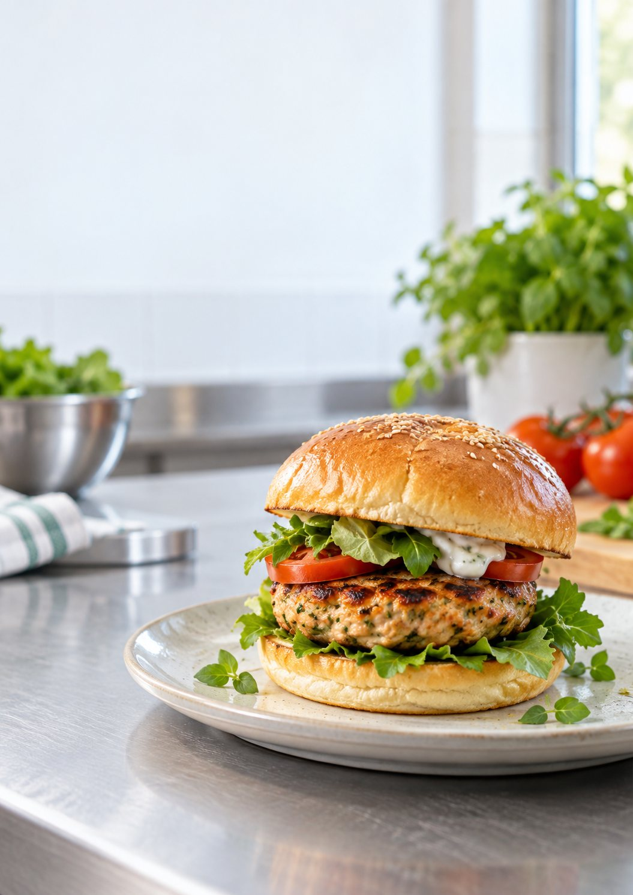
Illustrative burger image. Your final design, recipe and ingredients come from the current class brief.
Name ______________________________________________________
Class _______________________________________________________

YOUR ROUTE THROUGH THE UNIT
Read. Test. Design. Make.
Each module joins short teaching, a check for understanding, a source-based Busy Work activity and a place to record your own evidence.
No. | Module | Pages
01 | The challenge | 3-6
02 | Safe food practices | 7-10
03 | Tools and workflow | 11-14
04 | Burger anatomy | 15-18
05 | Ingredients and agriculture | 19-22
06 | Develop your design | 23-26
07 | Garden to kitchen | 27-30
08 | Plan production | 31-34
09 | Produce and present | 35-38
10 | Evaluate and reflect | 39-42
Project folio
Pages 43-50 collect the brief, research, design, production and evaluation evidence for your own Riv Burger.
Current teacher directions come first
Confirm the class recipe, available ingredients, allergies, lesson timing, practical procedure, assessment conditions and submission method with your teacher. Do not treat examples in this book as permission to start a practical task.

MODULE 01 / READ AND OBSERVE
The challenge
Understand the design situation before proposing a solution.
1.1 Design situation and brief
A design situation explains the need or opportunity. In this unit, a small local food business wants a burger that appeals to young people while showing that fresh, local and more sustainable choices can compete with familiar fast-food products.
The design brief turns that situation into action: develop a signature burger featuring locally grown produce and home-grown herbs. Your solution needs to be realistic for a school food-technology setting.
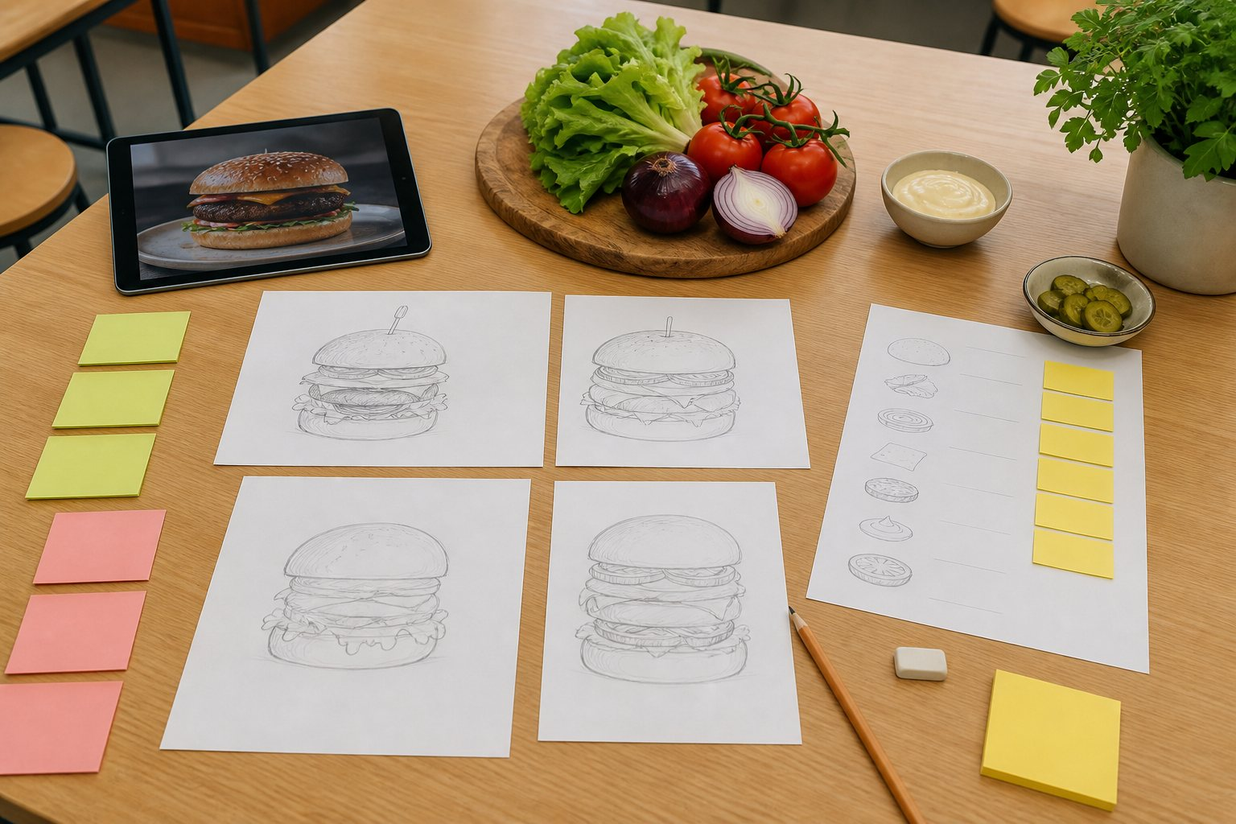
An illustrative design-planning scene; use the current brief for your own choices.
1.2 Users and needs
A successful burger is designed for people, not only for a photograph. A young customer may value flavour, appearance, value, convenience and a size that is comfortable to hold and eat. The cook needs a clear recipe, safe method, suitable tools and enough time.
These needs can compete. Extra height may look impressive but reduce ergonomics. Many fillings may add flavour but make production slower and the burger unstable.
Record a useful idea from this reading before moving to the check.

MODULE 01 / READ AND CHECK
The challenge
1.3 Criteria and constraints
Criteria are the qualities used to judge success: function, appearance, creativity, ergonomics, ethical choices, environmental impact and time management. Constraints are real limits such as lesson time, available equipment, ingredient access, budget, skills, safety and dietary needs.
DESIGN NOTE Design habit: write criteria so they can be tested. “Easy to hold without fillings falling out” is more useful than “good”.
Check your understanding
01 What is the main purpose of a design brief?
[ ] A. To list every ingredient immediately
[ ] B. To turn a need or opportunity into a clear design task
[ ] C. To guarantee the first idea will work
02 Which statement is a testable design criterion?
[ ] A. The burger is nice
[ ] B. The burger uses food
[ ] C. The burger can be held and eaten without the fillings falling out
03 Which is most likely a constraint in a school practical?
[ ] A. The available lesson time
[ ] B. The colour of the heading on this page
[ ] C. Whether burgers exist
04 Why can a very tall burger create a problem?
[ ] A. Height always removes flavour
[ ] B. It can reduce comfort and stability for the user
[ ] C. It makes food hygiene unnecessary
05 Who should be considered when designing the solution?
[ ] A. Only the person taking a photo
[ ] B. The customer and the person producing the burger
[ ] C. Nobody until after production
06 A student writes “My burger will be nice.” What should happen next?
[ ] A. rewrite it as a specific observable quality
[ ] B. use “good” as the only success measure
[ ] C. ignore the issue and remove it from the record
Choose the best answer, then explain one choice to your partner or teacher.

MODULE 01 / BUSY WORK AND PRACTICE
The challenge
Use the source activity to make the vocabulary and decisions from this module your own.
01 Design language find-a-word
Find the words that help a designer turn a need into a clear, testable task.
F | U | N | C | T | I | O | N | K | B | Q
R | C | W | N | N | T | N | K | E | F | Y
O | K | E | V | I | D | E | N | C | E | N
D | N | S | O | A | Z | O | A | S | I | D
R | W | G | Q | R | V | M | M | B | R | M
C | C | R | I | T | E | R | I | A | B | K
H | S | U | A | S | V | S | N | I | R | N
Q | K | K | R | N | E | H | U | N | U | M
E | U | K | X | O | O | D | C | E | A | U
L | P | R | C | C | N | T | B | N | H | K
T | G | L | M | N | Q | S | F | E | Q | F
Word bank / CONSTRAINT, CRITERIA, FUNCTION, EVIDENCE, DESIGN, BRIEF, USER, NEED
Choose two found words and explain how they connect: ________________________________
Revisit / 1.1 Design situation and brief
02 Brief sorter
Write N (need), U (user), CR (criterion) or CO (constraint) beside each statement.
Statement or action Answer
The burger should appeal to young people.
The burger must be realistic in a school food-technology setting.
The final burger should remain stable when held.
A local business wants a fresh signature burger.
Locally grown produce and home-grown herbs should feature.
Lesson time and available equipment limit production.
Quick finish: Which statement would be easiest to test, and why? ___________________________________ Revisit: 1.2 Criteria and constraints

MODULE 01 / APPLY AND RECORD
The challenge
Brief and criteria studio
Translate the design situation into student language, then write criteria you can actually test.
Rewrite the design brief in your own words. Include the product, intended user and two important qualities.

Explain the needs of the intended customer and the cook. Identify one likely trade-off between those needs.

Write three testable success criteria and two realistic constraints for your Riv Burger.

What need or opportunity is the burger responding to?

Intended user and their needs

Important constraints

Three testable criteria written as complete statements

Teacher to confirm: current practical method, ingredients, safety controls and submission conditions.

MODULE 02 / READ AND OBSERVE
Safe food practices
Protect people by controlling hygiene and food-production risks.
2.1 Personal hygiene
Food handlers can transfer microorganisms, hair, dirt and allergens to food. Before production, secure hair, remove or control jewellery as directed, cover cuts, wear the required protective clothing, and wash hands thoroughly with soap and running water before drying them.
Wash hands again after touching raw food, waste, your face or hair, and after any task that may contaminate them.
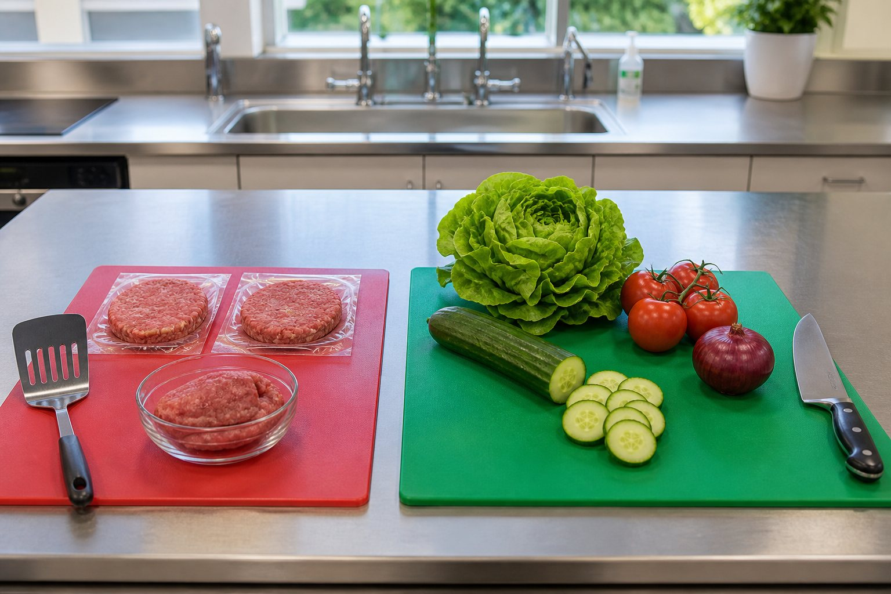
Illustrative food-safe practice; follow your teacher's local procedures.
2.2 Cross-contamination
Cross-contamination happens when harmful microorganisms or allergens move from one food, surface, tool or person to another. Keep raw ingredients separate from ready-to-eat foods. Use the colour-coded boards and equipment directed by your teacher, clean and sanitise work areas, and never reuse a utensil that has touched raw food without washing it correctly.
DESIGN NOTE Non-negotiable: follow teacher instructions for storage, cooking, cooling and allergen controls. If unsure, stop and ask.
Record a useful idea from this reading before moving to the check.

MODULE 02 / READ AND CHECK
Safe food practices
2.3 Hazards and controls
A hazard is something with the potential to cause harm. A risk control reduces the chance or severity of that harm. Knife controls include a stable board, correct grip, a safe cutting technique, full attention and carrying the knife only as instructed. Heat controls include dry oven mitts, clear handles and warning others about hot equipment.
Safety also includes garden work: use gloves and follow instructions when handling potting mix, minimise dust, work in ventilation and wash hands afterwards.
Check your understanding
01 When should hands be washed again during a practical?
[ ] A. After touching raw food or waste
[ ] B. Only when the lesson ends
[ ] C. Only if the teacher is watching
02 What is cross-contamination?
[ ] A. A burger with two sauces
[ ] B. The transfer of harmful microorganisms or allergens
[ ] C. Cooking two items at once
03 Which action best controls a knife hazard?
[ ] A. Cut quickly on a moving board
[ ] B. Use a stable board and the instructed technique
[ ] C. Leave the knife hidden in washing-up water
04 What should you do if an allergen requirement is unclear?
[ ] A. Guess from the packaging colour
[ ] B. Continue and fix it later
[ ] C. Stop and ask the teacher
05 Which is a suitable potting-mix control?
[ ] A. Create as much dust as possible
[ ] B. Follow instructions, minimise dust and wash hands
[ ] C. Eat while filling pots
06 A chopping board slides while a student is cutting. What should happen next?
[ ] A. stop and stabilise the board before continuing with the instructed technique
[ ] B. name a hazard without changing how the task is performed
[ ] C. ignore the issue and remove it from the record
Choose the best answer, then explain one choice to your partner or teacher.

MODULE 02 / BUSY WORK AND PRACTICE
Safe food practices
Use the source activity to make the vocabulary and decisions from this module your own.
01 Food-safety clue challenge
Use the word bank to answer each clue.
Across 1 Free from visible dirt and unwanted contamination. ___________________
Across 5 A substance that can trigger an allergic reaction. ___________________
Down 1 An action used to reduce a risk. ___________________
Down 2 Keep raw and ready-to-eat food apart. ___________________
Down 3 Personal and workplace practices that help keep food safe. ___________________
Down 4 Something with the potential to cause harm. ___________________
Word bank / ALLERGEN, CLEAN, CONTROL, HAZARD, HYGIENE, SEPARATE
Circle the answer most directly linked to preventing cross-contamination.
Revisit / 2.1 Hygiene, allergens and contamination

02 Hazard-control match
Match each situation A-F with the most specific control 1-6.
A-F 1-6
A. Raw patty mixture and salad share one board. 1. Stop, identify the knife and wash it separately.
B. A spill is left in a walkway. 2. Tie hair back before beginning.
C. A wet oven mitt is beside a hot tray. 3. Use separate cleaned equipment for ready-to-eat food.
D. An ingredient label is not checked. 4. Check the label and follow the teacher's allergen process.
E. A knife is hidden under washing-up water. 5. Clean and dry the spill promptly and warn others.
F. Long hair is loose near food. 6. Replace it with a dry mitt and follow the hot-equipment routine.
Matches: A-__ B-__ C-__ D-__ E-__ F-__
Quick finish: Which control requires you to stop and ask the teacher? ______________________________ Revisit: 2.2 Managing hazards and risk

MODULE 02 / APPLY AND RECORD
Safe food practices
Safety scenario lab
For each situation, identify the hazard or contamination path and give a specific control.
Write your before-cooking hygiene routine as a clear six-step checklist.

Explain how cross-contamination could occur during burger production and give three controls that break the pathway.

Identify one biological, one physical and one heat or equipment hazard. Give a specific control for each.

Decision record
Situation | Hazard or problem | Specific control
Raw patty mixture and salad are prepared on the same board.
A wet oven mitt is beside a hot tray.
A spill is left in the walkway.
Teacher to confirm: current practical method, ingredients, safety controls and submission conditions.

MODULE 03 / READ AND OBSERVE
Tools and workflow
Prepare an efficient workstation and use tools for their intended purpose.
3.1 Mise en place
Mise en place means putting everything in place before production. Read the complete method, wash hands, sanitise the bench, collect and check equipment, measure ingredients, prepare waste containers and preheat equipment only when instructed.
This preparation reduces rushing and helps you notice missing ingredients or unsafe conditions before they become problems.
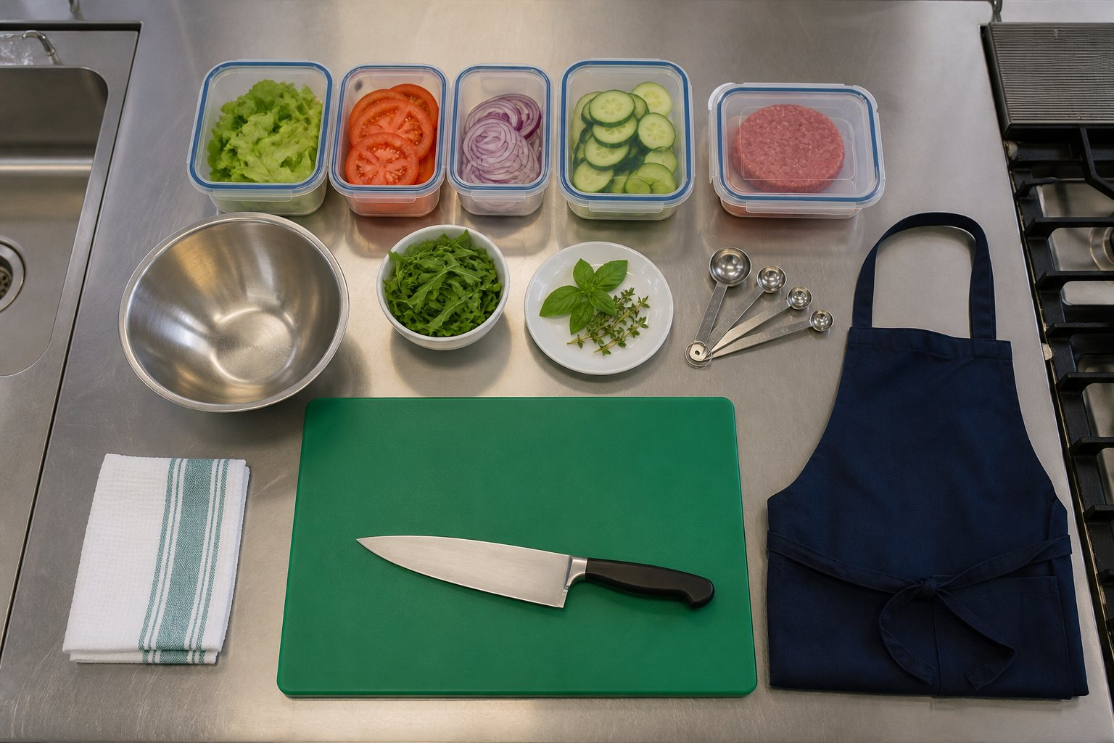
A prepared workstation helps you notice missing tools and hazards before cooking.
3.2 Selecting tools
Select a tool because its function suits the job. A cook's knife can chop larger ingredients; a small knife provides control for smaller preparation; measuring spoons suit small quantities; a digital scale measures mass; and a spatula can turn a patty while keeping hands away from heat.
Use every tool only after demonstration and according to classroom rules.
Record a useful idea from this reading before moving to the check.

MODULE 03 / READ AND CHECK
Tools and workflow
3.3 A clean workflow
Plan movement from preparation to cooking, assembly and cleaning. Keep handles away from bench edges, wipe spills promptly, return ingredients to safe storage, and clean as you go without placing sharp tools into hidden washing-up water.
At the end, wash, rinse and dry equipment as directed, sanitise the workstation and complete the teacher's practical checklist.
Check your understanding
01 What does mise en place achieve?
[ ] A. It organises ingredients, equipment and tasks before cooking
[ ] B. It replaces the recipe
[ ] C. It means washing only after cooking
02 Which tool directly measures mass?
[ ] A. Measuring spoon
[ ] B. Digital scale
[ ] C. Spatula
03 Why read the whole method before starting?
[ ] A. To spot the sequence, equipment and timing needs
[ ] B. To avoid measuring ingredients
[ ] C. To make every step optional
04 Where should a sharp knife be placed during cleaning?
[ ] A. Hidden in cloudy sink water
[ ] B. In the safe location directed by the teacher
[ ] C. Under a tea towel
05 Which action supports an efficient workflow?
[ ] A. Leave every spill until the end
[ ] B. Move pan handles over the bench edge
[ ] C. Clean as you go and keep movement paths clear
06 A spill appears beside the main movement path. What should happen next?
[ ] A. make the area safe and clean the spill promptly
[ ] B. hide sharp tools in washing-up water
[ ] C. ignore the issue and remove it from the record
Choose the best answer, then explain one choice to your partner or teacher.

MODULE 03 / BUSY WORK AND PRACTICE
Tools and workflow
Use the source activity to make the vocabulary and decisions from this module your own.
01 Mise en place shuffle
Number the actions 1-8 to create a calm preparation sequence. Teacher directions always come first.
Statement or action Answer
Gather the teacher-approved ingredients and equipment.
Read the recipe and current teacher instructions.
Begin the first preparation task in the workplan.
Wash hands and prepare personal hygiene requirements.
Check that the work area is ready and hazards are controlled.
Measure ingredients and organise them for use.
Confirm the correct boards, knives and other tools.
Keep the bench organised as production begins.
Quick finish: Why does reading the plan come before collecting equipment? _________________________ Revisit: 3.1 Mise en place and workflow

02 Tool-to-job match
Match each tool A-F with its best job 1-6. Then underline the job that also needs a safety check.
A-F 1-6
A. Digital scale 1. Turn or lift food using the planned technique.
B. Spatula 2. Measure a small ingredient quantity.
C. Chopping board 3. Protect hands when handling teacher-approved hot equipment.
D. Measuring spoon 4. Weigh ingredients accurately.
E. Oven mitt 5. Provide a stable preparation surface while preventing contamination.
F. Chef's knife 6. Cut ingredients using the demonstrated grip and technique.
Matches: A-__ B-__ C-__ D-__ E-__ F-__
Quick finish: One setup check I would make before using a knife is: _______________________________ Revisit: 3.2 Tools, equipment and safe technique

MODULE 03 / APPLY AND RECORD
Tools and workflow
Practical readiness checklist
Turn the supplied practical checklist into a routine you can follow without rushing.
Describe how you would set up a safe workstation for preparing a burger patty and fresh salad.

Choose four tools for your likely recipe. Explain the function of each and one safe-use point.

Plan a clean workflow from preparation to final workstation check. Explain how it prevents two problems.

Practical readiness checklist
Before cooking: six actions | During cooking: four controls | Cleaning and pack-up: six actions
1. | 1. | 1.
2. | 2. | 2.
3. | 3. | 3.
4. | 4. | 4.
5. |  | 5.
6. |  | 6.
When will you stop and ask the teacher?

Teacher to confirm: current practical method, ingredients, safety controls and submission conditions.

MODULE 04 / READ AND OBSERVE
Burger anatomy
Use structure and sensory properties to make the product work.
4.1 A layered food system
A burger is a system of interacting parts. The bun contains the product and gives structure. The main filling provides body and a central flavour. Fresh components add colour, texture and freshness. Sauces add moisture and flavour but can also make the bun soggy. Each layer affects the whole product.
LAYER FUNCTIONS Top bun · hold and protectFresh layer · colour and crunchSauce · flavour and moistureMain filling · body and proteinBase bun · stable foundation
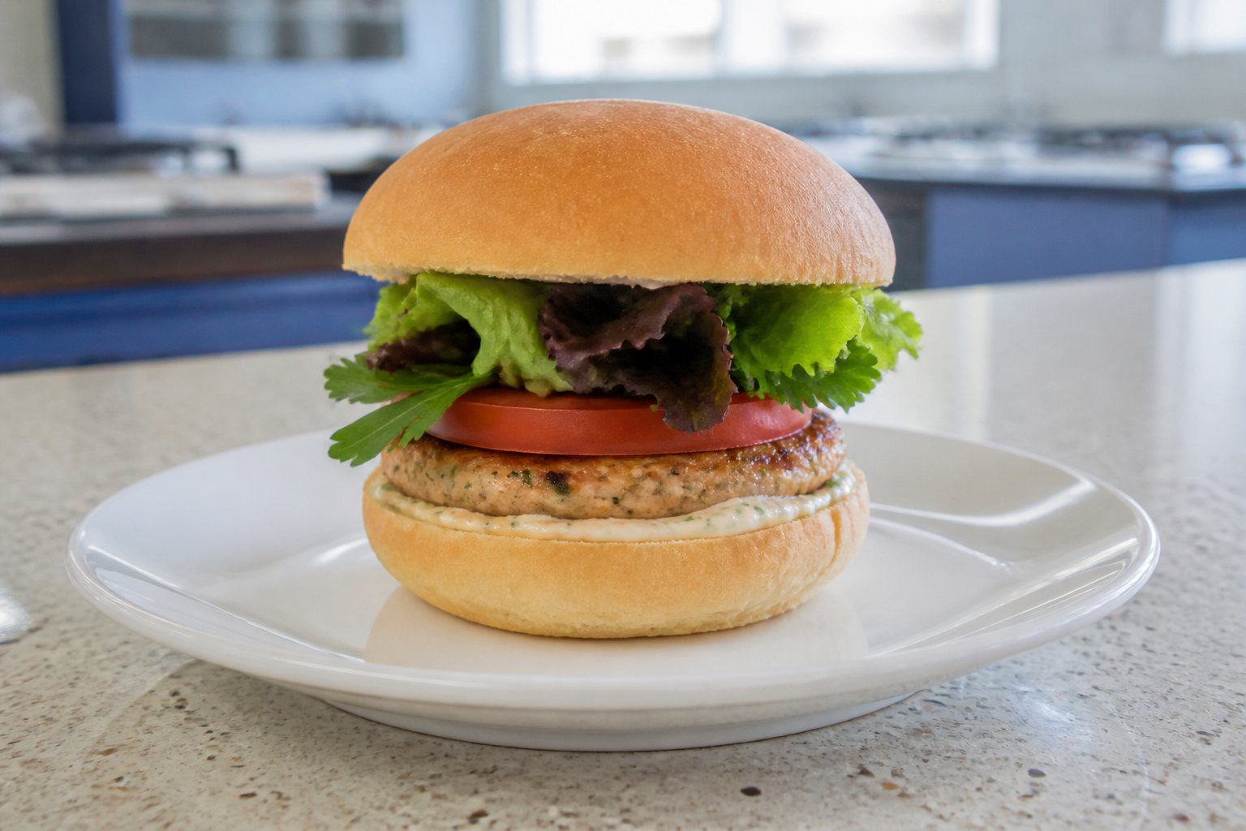
An illustrative burger stack, not the required class recipe or final design.
4.2 Sensory properties
Sensory properties are features detected by the senses: appearance, aroma, flavour, texture and sound. Designers can create contrast—such as a crisp vegetable with a soft bun—but too many competing flavours or textures can make the product confusing.
Use precise words in evaluation: golden, crisp, juicy, smoky, fresh, balanced or overly salty are more useful than “good”.
Record a useful idea from this reading before moving to the check.

MODULE 04 / READ AND CHECK
Burger anatomy
4.3 Function and stability
Place wet ingredients away from surfaces that become soggy quickly, drain washed vegetables, match the bun size to the filling, and avoid layers that slide against each other. The base should sit flat and the assembled burger should remain comfortable to hold.
A product can look appealing and still fail if it collapses, leaks or is difficult to eat.
Check your understanding
01 What is a main function of the bun?
[ ] A. To remove every flavour
[ ] B. To contain the product and provide structure
[ ] C. To make hygiene optional
02 Which is a sensory property?
[ ] A. Aroma
[ ] B. Submission date
[ ] C. Desk number
03 Why should washed vegetables be drained?
[ ] A. To reduce excess moisture and sogginess
[ ] B. To remove all texture
[ ] C. To make the burger taller
04 Which evaluation is most precise?
[ ] A. It was good
[ ] B. The crisp lettuce contrasted with the soft bun
[ ] C. I liked it
05 Which change is most likely to improve stability?
[ ] A. Match bun and filling sizes
[ ] B. Add every possible sauce
[ ] C. Stack slippery layers without a plan
06 The filling slides out when the burger is lifted. What should happen next?
[ ] A. adjust component size, surface contact or layer order
[ ] B. stack several wet, sliding layers directly on the base
[ ] C. ignore the issue and remove it from the record
Choose the best answer, then explain one choice to your partner or teacher.

MODULE 04 / BUSY WORK AND PRACTICE
Burger anatomy
Use the source activity to make the vocabulary and decisions from this module your own.
01 Burger layer find-a-word
Find the terms used to explain how burger layers work together.
R | O | J | M | N | R | B | Z | X | L | P
H | N | Q | K | F | I | H | Y | H | E | F
C | G | G | V | R | Y | A | T | B | I | L
N | R | U | A | W | G | A | I | L | P | A
U | E | F | P | M | V | D | L | C | G | V
O | T | X | Q | W | O | I | I | Y | H | O
U | R | E | Y | E | N | R | B | S | S | U
I | G | T | E | G | X | Q | A | B | E | R
I | O | X | V | T | E | X | T | U | R | E
T | W | O | E | C | U | A | S | N | F | E
K | K | O | C | K | D | L | L | S | H | C
Word bank / STABILITY, FILLING, TEXTURE, FLAVOUR, SAUCE, FRESH, AROMA, BUN
Which two words are most closely linked to whether a burger is easy to hold? ___________
Revisit / 4.1 Burger systems and layer functions
02 Stack stability trouble-shooter
For each burger problem, select the best first design response and explain your choice.
Statement or action Answer
The filling slides out when the burger is lifted.
The bun becomes soggy before serving.
Every layer feels soft and similar.
The burger is too tall for the intended user.
Quick finish: Which response changes function without automatically changing flavour? _______________ Revisit: 4.2 Sensory and functional analysis

MODULE 04 / APPLY AND RECORD
Burger anatomy
Burger deconstruction lab
Deconstruct a burger into functional layers, then consider taste, nutrition, appearance, price and stability.
Plan a burger stack from bottom to top. Explain the function of each layer.

Write a sensory profile for your intended burger using precise appearance, aroma, flavour and texture words.

Explain three design decisions that will improve your burger’s stability and ease of eating.

Layer decisions
Layer | Chosen ingredient | Function and sensory effect | Possible problem
Top and base
Main filling
Fresh ingredients
Sauce and herbs
Nutrition: what does each major ingredient contribute?

Price: which ingredients or choices may affect cost? Check current prices.

Teacher to confirm: current practical method, ingredients, safety controls and submission conditions.

MODULE 05 / READ AND OBSERVE
Ingredients and agriculture
Trace ingredients to industries, producers and places.
5.1 From primary production to plate
Agriculture supplies plant and animal products. Wheat may be milled into flour for buns; cattle or legumes may supply a patty ingredient; dairy farming supplies milk for cheese; and horticulture supplies vegetables and herbs. Processing, packaging, transport, retail and food service connect primary production to the burger.
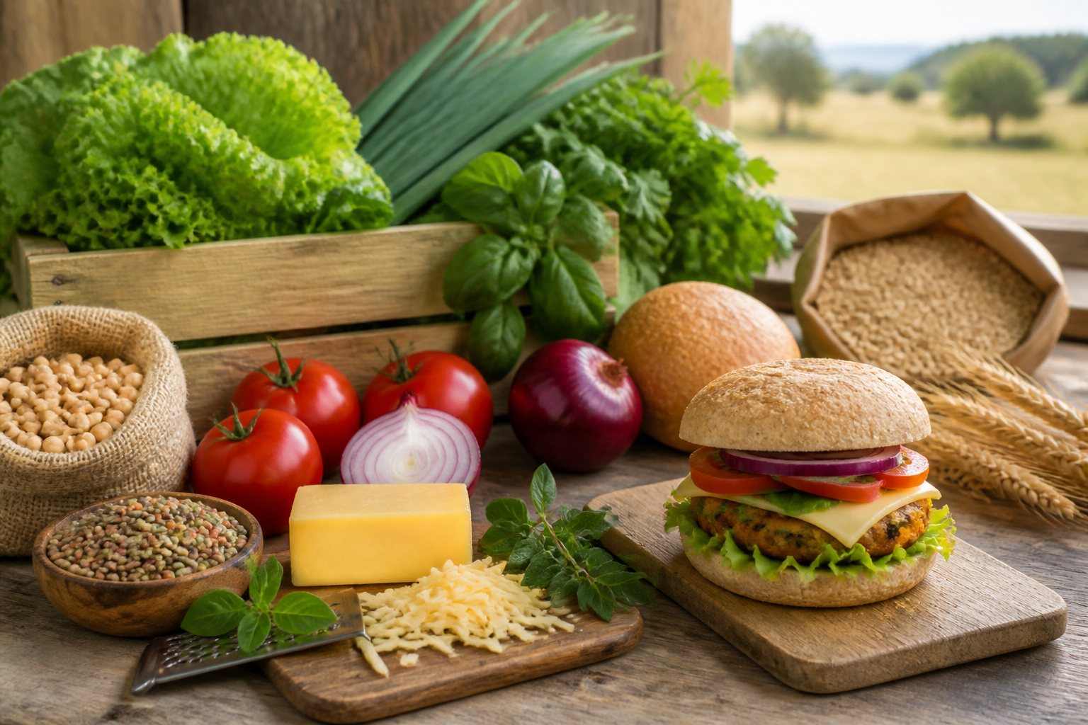
Illustrative ingredients; confirm actual provenance before calling a product local.
5.2 Local and seasonal choices
“Local” should be supported by evidence, not used as a vague label. It may refer to a grower, producer or business within a defined region. Seasonal produce can be plentiful and suitable for local conditions, but availability and price still need checking.
Research the producer, ingredient origin, distance, season and the evidence used to make each claim.
Record a useful idea from this reading before moving to the check.

MODULE 05 / READ AND CHECK
Ingredients and agriculture
5.3 Ethical and environmental factors
Food choices can affect soil, water, biodiversity, animal welfare, energy use, packaging, transport and waste. No ingredient is automatically perfect. A responsible comparison considers reliable evidence and the full production system.
Practical actions include planning quantities, using suitable portions, choosing reusable equipment, separating waste as directed and using garden produce effectively.
Check your understanding
01 Which industry commonly supplies lettuce and herbs?
[ ] A. Horticulture
[ ] B. Mining
[ ] C. Textile manufacturing
02 What makes a “local” claim stronger?
[ ] A. A green label
[ ] B. A defined region and evidence about the producer or origin
[ ] C. A guess based on price
03 Which occurs after primary production?
[ ] A. Processing and transport
[ ] B. Sunlight reaching a crop
[ ] C. Roots taking up water
04 Which is an environmental consideration?
[ ] A. Packaging and food waste
[ ] B. The page number
[ ] C. The font used in a recipe
05 Why avoid claiming one ingredient is automatically sustainable?
[ ] A. Sustainability depends on evidence and the production system
[ ] B. All ingredients are identical
[ ] C. Evidence never matters
06 Two ingredients have different packaging, transport and waste impacts. What should happen next?
[ ] A. compare the relevant impacts rather than choose from one feature alone
[ ] B. declare an ingredient perfect without investigating its production system
[ ] C. ignore the issue and remove it from the record
Choose the best answer, then explain one choice to your partner or teacher.

MODULE 05 / BUSY WORK AND PRACTICE
Ingredients and agriculture
Use the source activity to make the vocabulary and decisions from this module your own.
01 Ingredient journey clue challenge
Use the word bank to answer each clue.
Across 3 A set of actions that changes or prepares a food. ___________________
Across 4 A person or business that grows or makes food. ___________________
Across 5 The stage where products are sold to customers. ___________________
Down 1 Available at a particular time of year. ___________________
Down 2 Information used to support a claim. ___________________
Down 6 A word that needs a defined distance or region before it is a useful claim. ___________________
Word bank / EVIDENCE, LOCAL, PROCESS, PRODUCER, RETAIL, SEASONAL
Put a star beside the answer needed to support a local-food claim.
Revisit / 5.1 From farm to plate

02 Claim detective
Write S (supported) or V (vague). If vague, note the evidence that is missing.
Statement or action Answer
This herb came from our school garden; the harvest record is attached.
This is definitely the most sustainable ingredient.
The producer's current website identifies the NSW growing region.
Local food is always better for the environment.
The package names the producer and place of origin.
It looks fresh, so it must have travelled the shortest distance.
Quick finish: Rewrite one vague claim so it could be checked: _____________________________________ Revisit: 5.2 Local, seasonal and sustainable choices

MODULE 05 / APPLY AND RECORD
Ingredients and agriculture
Ingredient journey investigation
Choose two plant ingredients and two animal or animal-alternative ingredients. Use reliable sources and record the URL—do not invent figures.
Choose four likely burger ingredients. Trace each to an agricultural industry and identify one processing or transport step.

Define what “local” will mean in your design, then record the evidence you would need to support two local ingredient claims.

Compare two possible ingredients using two environmental or ethical factors, then justify the more responsible choice.

Define “local” for this investigation and explain how you checked the claim.

Four ingredient journeys
Ingredient | Agricultural industry and NSW location | Production journey | Evidence URL
Plant ingredient 1
Plant ingredient 2
Animal or alternative 1
Animal or alternative 2
For every row, name a NSW location, trace production to the burger and record a source URL.
Teacher to confirm: current practical method, ingredients, safety controls and submission conditions.

MODULE 06 / READ AND OBSERVE
Develop your design
Generate alternatives, test them against criteria and justify a direction.
6.1 Divergent thinking
Do not stop at the first idea. Generate several distinct burger concepts by changing the main filling, bun, herbs, vegetables, sauce, form or flavour profile. Four genuinely different options create a stronger comparison than four drawings of almost the same product.
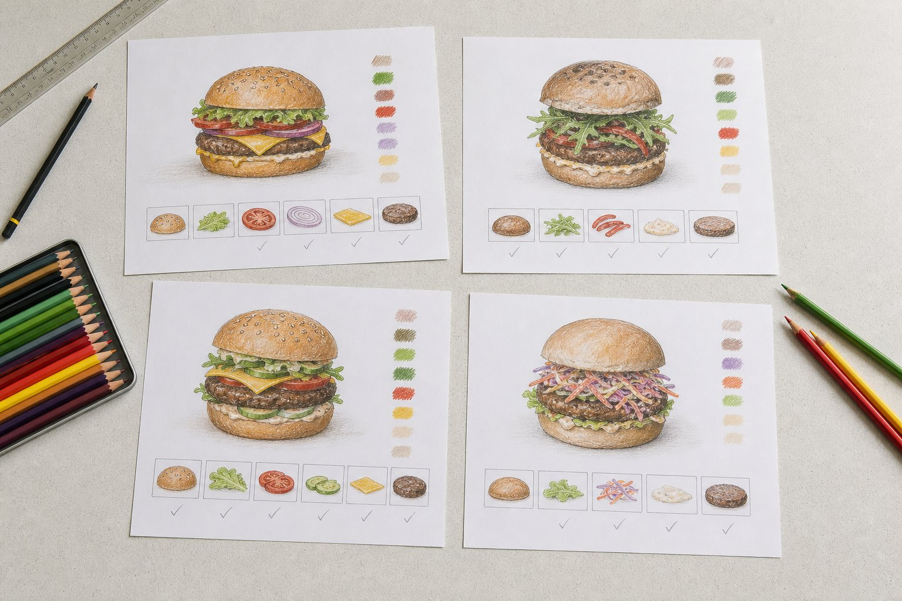
Different choices should be compared against the same design criteria.
6.2 Annotating concepts
An annotation explains a design decision. Label ingredients, layer order, sensory effect, source, function, safety issue or expected user benefit. “Parsley yoghurt sauce adds freshness and uses a garden herb” communicates more than an arrow labelled “sauce”.
Record a useful idea from this reading before moving to the check.

MODULE 06 / READ AND CHECK
Develop your design
6.3 Choosing with evidence
Use your criteria to compare options. A decision matrix can make trade-offs visible, but scores need reasons. The highest total does not remove your responsibility to explain why the chosen design best fits the brief and constraints.
DESIGN NOTE Appropriate response example: “I selected Concept C because its flat patty and matching bun improve stability, while garden parsley supports the brief. I will reduce the sauce quantity to control sogginess.”
Check your understanding
01 Why generate several concepts?
[ ] A. To explore genuinely different ways to meet the brief
[ ] B. To avoid making a decision
[ ] C. To repeat the same idea four times
02 Which annotation is most useful?
[ ] A. Nice
[ ] B. Sauce
[ ] C. Parsley yoghurt sauce adds freshness and uses a garden herb
03 What should support a decision-matrix score?
[ ] A. A reason linked to criteria
[ ] B. A random number
[ ] C. The order concepts were drawn
04 What makes four options genuinely different?
[ ] A. Different title colours only
[ ] B. Meaningful changes to ingredients, form or flavour
[ ] C. Drawing the same burger four times
05 A strong final justification should mention:
[ ] A. Only personal preference
[ ] B. Criteria, constraints and any planned refinement
[ ] C. Only the highest score
06 Concept C scores highest but has a serious stability weakness. What should happen next?
[ ] A. acknowledge the weakness and refine it before production
[ ] B. select the highest total without checking the reasons behind it
[ ] C. ignore the issue and remove it from the record
Choose the best answer, then explain one choice to your partner or teacher.

MODULE 06 / BUSY WORK AND PRACTICE
Develop your design
Use the source activity to make the vocabulary and decisions from this module your own.
01 Concept variation find-a-word
Find the features that can be changed deliberately when generating burger concepts.
S | G | P | J | U | S | S | R | H | P | Z
F | L | E | L | B | A | T | E | G | E | V
K | L | R | H | U | C | R | U | N | V | U
U | H | A | C | A | B | U | T | I | T | H
Q | V | B | V | C | S | C | L | L | X | C
X | D | N | U | O | A | T | L | L | Q | J
T | U | C | D | N | U | U | H | I | Y | O
L | Q | N | U | C | C | R | E | F | W | O
S | C | B | Z | E | E | E | Y | F | U | B
I | I | A | B | P | F | H | P | W | T | K
B | F | E | J | T | T | N | A | Y | M | L
Word bank / VEGETABLE, STRUCTURE, FILLING, FLAVOUR, CONCEPT, SAUCE, HERB, BUN
Name three features you would change to make two concepts genuinely different: ________
Revisit / 6.1 Generating design options
02 Concept quick-test
Read each design move. Decide whether it strengthens the concept (S), weakens it (W), or needs more evidence (E).
Statement or action Answer
The student checks the chosen concept against four written criteria.
The final option is chosen only because it is the student's favourite.
A local ingredient claim is made without naming a source or region.
The student compares stability, sensory qualities and production limits.
All four concepts change only the sauce colour.
Quick finish: What evidence would turn the third move into a stronger decision? _____________________ Revisit: 6.2 Selecting and justifying a concept

MODULE 06 / APPLY AND RECORD
Develop your design
Four-concept design studio
Create four genuinely different burger options. Annotate how each responds to the brief.
Describe four distinct burger concepts. For each, identify the main filling, local or garden feature and flavour direction.

Write six purposeful annotations for one concept. Cover function, sensory effect, sourcing and a user benefit.

Select one concept. Justify it against at least four criteria and identify one change needed before production.

Four concepts continue in the folio
Complete full annotated sketches for Concept A and Concept B on page 45, and Concept C and Concept D on page 46. Use this page for your comparison; make the final selection and refinement on page 47.
Concept | Distinctive ingredient or form | How it meets the brief | Issue to test
Concept A
Concept B
Concept C
Concept D
Decision time: select one concept and justify it against at least four criteria.

Teacher to confirm: current practical method, ingredients, safety controls and submission conditions.

MODULE 07 / READ AND OBSERVE
Garden to kitchen
Connect plant needs, herb production and responsible resource use.
7.1 What plants need
Healthy plants require light, water, air, suitable temperature, nutrients and a growing medium that supports roots. Too little water can cause wilting; too much can reduce oxygen around roots. Light and temperature affect growth, while nutrients support plant processes.
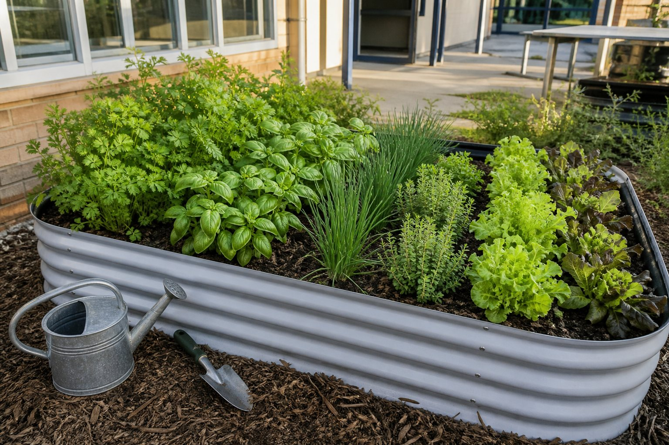
Identify and harvest herbs only with the teacher's permission and directions.
7.2 Growing and harvesting herbs
Herbs such as parsley, basil or chives can add flavour, aroma and colour. Identify plants correctly, harvest only with permission, select healthy material, wash produce as instructed and use clean tools. Harvesting methods should allow the plant to continue growing where possible.
Record a useful idea from this reading before moving to the check.

MODULE 07 / READ AND CHECK
Garden to kitchen
7.3 Sustainability in practice
Sustainable practice aims to meet present needs while protecting future environmental, social and economic wellbeing. In a school garden and kitchen, this includes efficient watering, caring for soil, planning harvests, avoiding unnecessary food waste and valuing the work required to grow ingredients.
A claim should connect an action to an effect—for example, measuring ingredients carefully can reduce avoidable waste.
Check your understanding
01 Why can overwatering harm roots?
[ ] A. It can reduce available oxygen around them
[ ] B. It creates extra sunlight
[ ] C. It always adds nutrients
02 Which is a safe harvesting action?
[ ] A. Taste unknown plants
[ ] B. Harvest any plant without permission
[ ] C. Identify the herb and use clean tools as instructed
03 What can fresh herbs add to a burger?
[ ] A. Flavour, aroma and colour
[ ] B. A guaranteed submission mark
[ ] C. A replacement for safe food handling
04 Which action can reduce avoidable food waste?
[ ] A. Measure planned quantities
[ ] B. Collect ingredients without a recipe
[ ] C. Discard usable ingredients immediately
05 A strong sustainability explanation links:
[ ] A. An action to its likely effect
[ ] B. A colour to a personal guess
[ ] C. A slogan to no evidence
06 A group measures only the herbs needed for its recipe. What should happen next?
[ ] A. explain that planned quantity reduces unnecessary harvest and waste
[ ] B. harvest more produce than the recipe can use
[ ] C. ignore the issue and remove it from the record
Choose the best answer, then explain one choice to your partner or teacher.

MODULE 07 / BUSY WORK AND PRACTICE
Garden to kitchen
Use the source activity to make the vocabulary and decisions from this module your own.
01 Plant-needs clue challenge
Use the word bank to answer each clue.
Across 4 Substances plants need for healthy growth. ___________________
Across 6 Energy source needed for plant growth. ___________________
Across 7 Plant structures that take up water and help anchor the plant. ___________________
Down 1 Collecting usable plant material at an appropriate time. ___________________
Down 2 Needed around leaves and roots. ___________________
Down 3 Needed in suitable amounts; too much or too little can cause problems. ___________________
Down 5 Growing medium that can hold water, air and nutrients. ___________________
Down 8 Room that reduces competition between plants. ___________________
Word bank / AIR, HARVEST, LIGHT, NUTRIENTS, ROOTS, SOIL, SPACE, WATER
Circle the two answers most directly affected when plants are overcrowded.
Revisit / 7.1 Plant needs and herb growth

02 Garden problem solver
Match each observation A-F with the most sensible first investigation 1-6. Ask the teacher before changing the garden.
A-F 1-6
A. Several plants are crowded together. 1. Check drainage and the watering routine.
B. Leaves are wilting. 2. Review spacing and competition.
C. Growth is leaning towards one side. 3. Check light direction and access.
D. Soil stays very wet. 4. Review the harvesting amount and timing.
E. Leaves show unexpected damage. 5. Check water availability and recent conditions.
F. Herbs are being removed faster than they regrow. 6. Observe carefully and seek teacher guidance before acting.
Matches: A-__ B-__ C-__ D-__ E-__ F-__
Quick finish: Why is observation needed before changing the garden? ______________________________ Revisit: 7.2 Garden planning and responsible harvesting

MODULE 07 / APPLY AND RECORD
Garden to kitchen
Herb and garden investigation
This activity adapts the teacher-posted herb worksheet and plant-needs reading.
Explain how light, water, air, nutrients and soil or growing medium support a healthy herb plant.

Describe the safe path for an approved herb from the school garden to your burger.

Propose three realistic garden-to-kitchen sustainability actions and explain the likely effect of each.

Chosen herb: appearance, edible part and flavour

Fresh, cooked, dried, paste or garnish uses

How and when it is best harvested

Light, water, soil, air, nutrients and spacing needs

Three local meat or plant producers and the evidence used to identify them
Producer | NSW locality | Meat or plant product | Evidence URL
1
2
3
Describe your garden layout, plant locations, spacing and watering method. Actual bed dimensions: Teacher to confirm.
Label plant locations and spacing; note the watering method. Actual bed dimensions: Teacher to confirm.
Teacher to confirm: current practical method, ingredients, safety controls and submission conditions.

MODULE 08 / READ AND OBSERVE
Plan production
Turn the selected concept into an accurate, manageable production plan.
8.1 A production-ready recipe
A recipe must communicate exact ingredients, quantities and an ordered method. Use consistent units, name preparation requirements such as “finely chopped”, and include the yield. Sequence steps so preparation, cooking and assembly can happen safely within the available time.
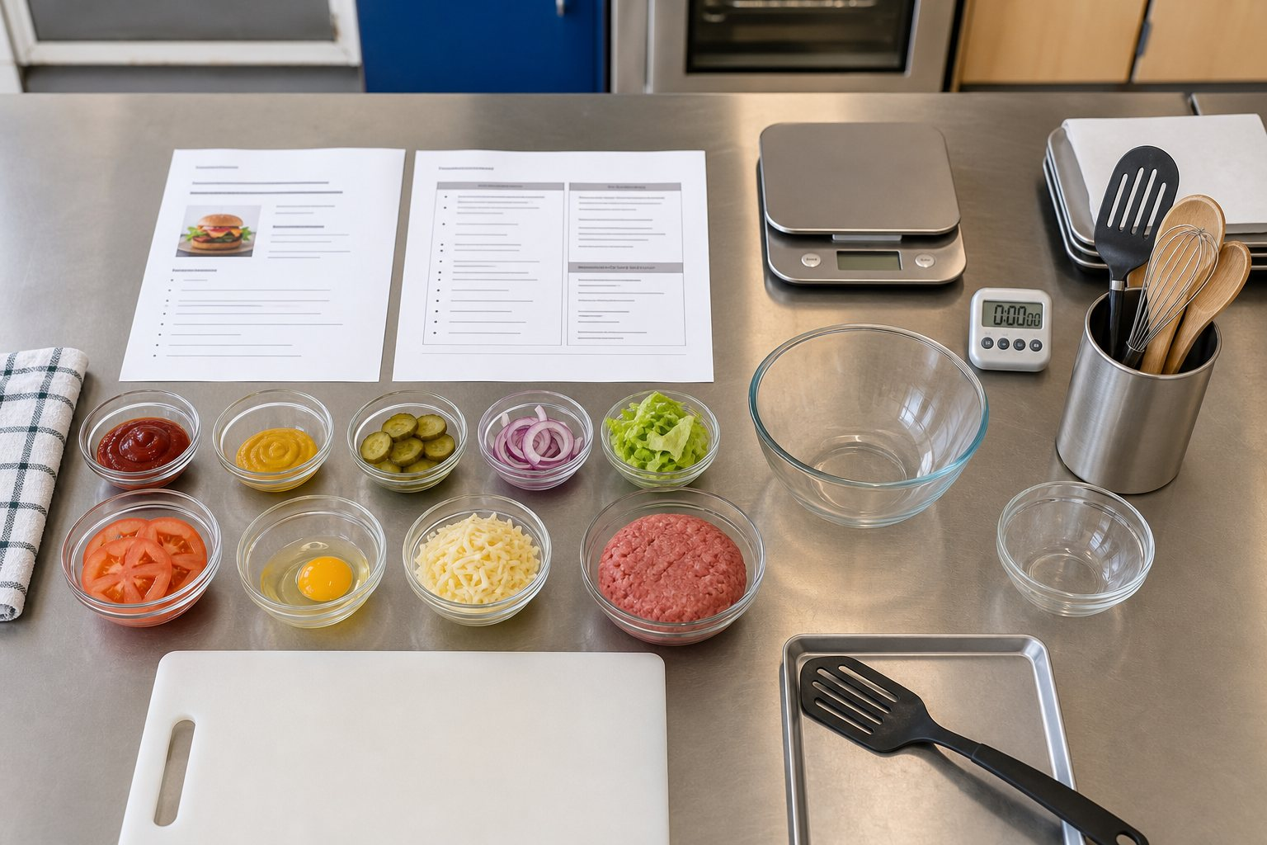
Plan quantities, order and quality checks before starting practical work.
8.2 Food order and resources
A food order totals the ingredients required for the planned yield. Check what the school supplies and what must be ordered or brought, according to teacher directions. Avoid duplicates, use realistic quantities and identify any ingredient with an allergen or storage requirement.
Record a useful idea from this reading before moving to the check.

MODULE 08 / READ AND CHECK
Plan production
8.3 Workplan
A workplan maps time, activity, equipment and ingredients. Begin with hygiene and setup, identify tasks that can overlap safely, allow time for cooking and checking, and protect enough time for assembly, photography, cleaning and evaluation.
Dates, lesson length, supplied ingredients and submission arrangements are Teacher to confirm.
Check your understanding
01 What belongs in a production-ready recipe?
[ ] A. Exact quantities and an ordered method
[ ] B. Only a product name
[ ] C. Unmeasured ingredients
02 Why include the recipe yield?
[ ] A. To match ingredient quantities to the intended number of serves
[ ] B. To replace food safety
[ ] C. To choose a font
03 What should a food order avoid?
[ ] A. Ingredient names
[ ] B. Realistic quantities
[ ] C. Unnecessary duplicates
04 What should the workplan protect time for?
[ ] A. Only assembly
[ ] B. Setup, production, recording and cleaning
[ ] C. Waiting without a task
05 Who confirms current lesson timing and supplied ingredients?
[ ] A. A previous year's document
[ ] B. The teacher
[ ] C. This website automatically
06 The plan reaches lesson end immediately after assembly. What should happen next?
[ ] A. revise earlier stages to reserve time for recording and cleaning
[ ] B. plan only the cooking and assembly steps
[ ] C. ignore the issue and remove it from the record
Choose the best answer, then explain one choice to your partner or teacher.

MODULE 08 / BUSY WORK AND PRACTICE
Plan production
Use the source activity to make the vocabulary and decisions from this module your own.
01 Recipe language find-a-word
Find the words that make a recipe and production plan precise enough to follow.
I | D | T | I | A | K | S | L | S | P | R
X | N | Y | I | E | L | D | I | L | B | Z
K | W | G | E | L | Q | F | K | I | L | X
J | W | O | R | K | P | L | A | N | M | R
S | E | Q | U | E | N | C | E | E | D | M
M | C | P | S | K | D | O | H | T | E | M
G | Q | U | A | N | T | I | T | Y | A | F
J | L | C | E | R | A | P | E | R | P | R
K | Y | U | M | G | C | C | G | N | U | T
S | T | M | M | D | C | T | S | C | T | P
K | I | G | K | S | X | M | B | L | O | Q
Word bank / INGREDIENT, QUANTITY, SEQUENCE, WORKPLAN, PREPARE, MEASURE, METHOD, YIELD
Which word tells you how many servings the recipe should make? ______________________
Revisit / 8.1 Recipe, yield and quantities
02 Production timeline puzzle
Number the actions 1-8 to form a sensible high-level workplan. Exact timing is Teacher to confirm.
Statement or action Answer
Assemble and present the burger when components are ready.
Read the final recipe, workplan and teacher directions.
Complete the teacher-approved cleaning and pack-up routine.
Prepare personal hygiene and the workstation.
Record quality checks and any changes during production.
Measure and organise ingredients and equipment.
Complete preparation tasks in a safe, efficient order.
Use the planned cooking or production method under supervision.
Quick finish: Where would you include a checkpoint for a teacher decision? _________________________ Revisit: 8.2 Workplans and production sequencing

MODULE 08 / APPLY AND RECORD
Plan production
Production planner
Prepare the three connected records used in the class sequence: recipe, food order and workplan.
Draft your recipe with yield, exact quantities and a numbered method. Include preparation words and safe sequencing.

Prepare a food order for your final recipe. Show totals, supply responsibility and any allergen or storage note.

Create a timed workplan from setup to cleaning. Identify equipment, ingredients and one quality check at each major stage.

Final recipe: yield, exact ingredients and numbered method

Food order grouped by salad, filling, condiments, herbs/spices and other

Timed workplan from hygiene and setup through teacher-approved cleaning

Teacher to confirm: current practical method, ingredients, safety controls and submission conditions.

MODULE 09 / READ AND OBSERVE
Produce and present
Manage safety, timing and quality while making the final product.
9.1 Follow, monitor, adapt
Use the workplan as a guide, not as an excuse to ignore evidence. Monitor appearance, texture, temperature controls and time. If a safe change is needed, pause, consult the teacher when required, record what changed and explain why.
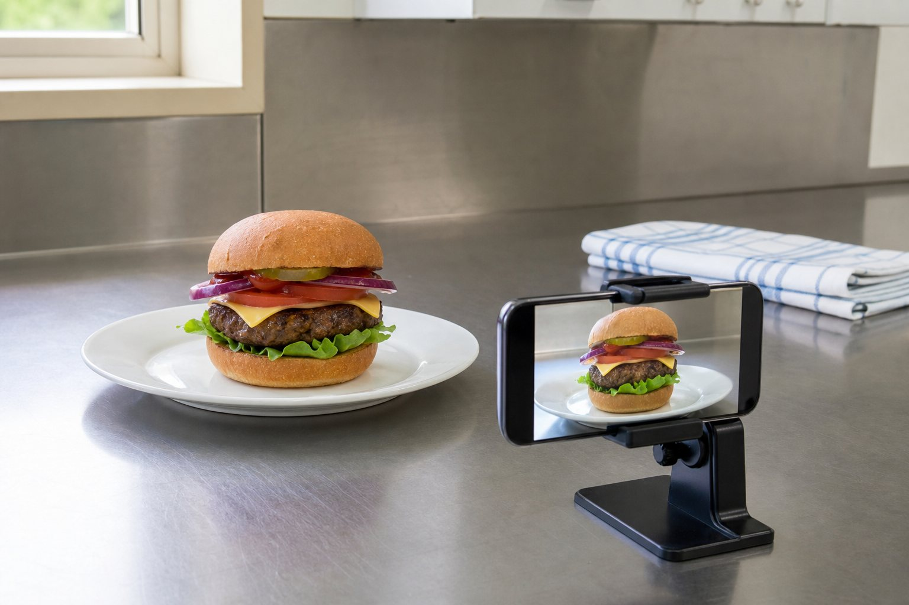
Record the real product and actual production decisions made in class.
9.2 Quality control
Quality control checks the product during production rather than waiting until the end. Examples include checking ingredient measurements, patty size, even preparation, browning, bun condition, layer order and workstation hygiene. Follow teacher instructions for checking that food is safely cooked.
Record a useful idea from this reading before moving to the check.

MODULE 09 / READ AND CHECK
Produce and present
9.3 Presentation and evidence
Presentation should support the intended user and make the burger's structure visible. Use a clean plate or board, remove distracting spills and avoid inedible decoration. Photograph the finished product in good light from an angle that shows its layers and scale.
Record the final burger promptly. A photograph supports evidence but does not replace written evaluation.
Check your understanding
01 What should you do when a safe change to the plan is needed?
[ ] A. Hide it
[ ] B. Record what changed and explain why
[ ] C. Ignore the problem
02 When does quality control occur?
[ ] A. Only after submission
[ ] B. During production at planned checkpoints
[ ] C. Before reading the recipe
03 Which is a useful quality check?
[ ] A. Patty size and even preparation
[ ] B. Whether the page is green
[ ] C. How fast another group works
04 What makes strong photographic evidence?
[ ] A. A cluttered bench in poor light
[ ] B. A clear view showing the product and layers
[ ] C. A photo of an unrelated burger
05 Does a photograph replace written evaluation?
[ ] A. Yes, always
[ ] B. Only if it has a filter
[ ] C. No; it supports but does not replace evaluation
06 The final photograph hides the burger layers behind decoration. What should happen next?
[ ] A. remove distractions and reframe the real product clearly
[ ] B. use an unrelated or heavily misleading image
[ ] C. ignore the issue and remove it from the record
Choose the best answer, then explain one choice to your partner or teacher.

MODULE 09 / BUSY WORK AND PRACTICE
Produce and present
Use the source activity to make the vocabulary and decisions from this module your own.
01 Quality-control clue challenge
Use the word bank to answer each clue.
Across 3 Information used to support a judgement. ___________________
Across 4 A sensory quality felt in the mouth or by touch. ___________________
Across 5 Capture what happened so it can be reviewed later. ___________________
Down 1 Practices that support safe food preparation. ___________________
Down 2 Observe progress during production. ___________________
Down 6 Compare what is happening with the plan or criterion. ___________________
Word bank / CHECK, EVIDENCE, HYGIENE, MONITOR, RECORD, TEXTURE
Which three answers form a useful cycle during production? __________________________
Revisit / 9.1 Monitoring and adapting production

02 Evidence-to-claim match
Match each evidence item A-F with the claim it can support 1-6.
A-F 1-6
A. A labelled setup photograph 1. The final appearance and assembly can be reviewed.
B. A timed workplan with changes noted 2. Changes were made for stated reasons.
C. A final burger photograph 3. The workstation and mise en place were prepared.
D. A teacher or peer feedback note 4. Pack-up actions were completed.
E. A quality-check record 5. An external response informed reflection.
F. A cleaning checklist 6. Production was monitored against selected qualities.
Matches: A-__ B-__ C-__ D-__ E-__ F-__
Quick finish: Why is a photograph stronger when it has a label or caption? _________________________ Revisit: 9.2 Capturing useful practical evidence

MODULE 09 / APPLY AND RECORD
Produce and present
Production evidence log
Theory help: presentation and evidence
Write a production log: what followed the plan, what changed, why it changed and how safety was maintained.

Record four quality-control checks for your final practical and the evidence you will collect for each.

Plan the photographs needed to prove production and final-product quality. Explain what each image must show.

Before: readiness and setup evidence

During: four quality-control checkpoints
Checkpoint | Observation or measurement | Evidence collected
1
2
3
4
Changes to the plan and reasons

Final photograph filename and what it shows
Filename: __________________________________________
Caption: ___________________________________________
Teacher to confirm: current practical method, ingredients, safety controls and submission conditions.

MODULE 10 / READ AND OBSERVE
Evaluate and reflect
Judge the solution with evidence and use the result to improve.
10.1 Evaluate against criteria
Evaluation is a reasoned judgement, not a description of what you did. Return to each success criterion, state the result, cite evidence and explain the judgement. Evidence may include observations, measurements, photographs, user feedback and comparison with the design plan.
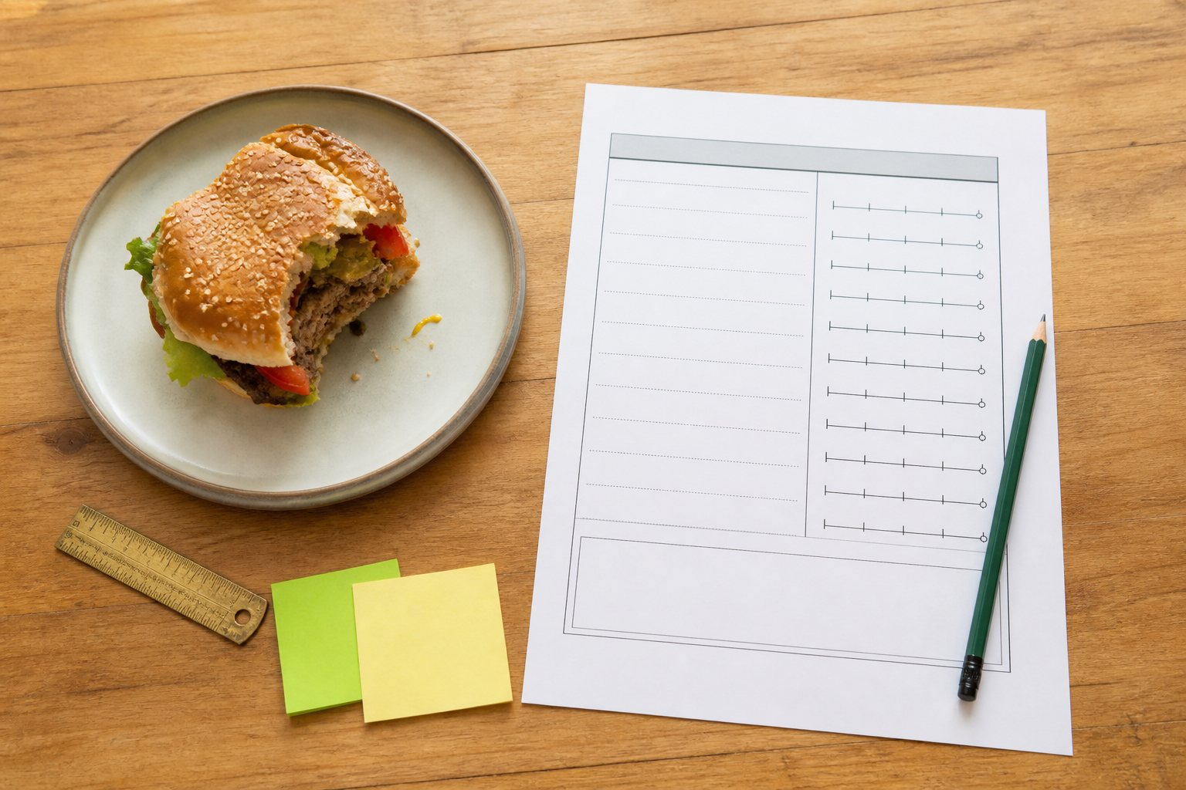
Use observed evidence, not the illustrative image, in your final evaluation.
10.2 Consider the whole solution
Evaluate function, appearance, sensory properties, ergonomics, cost, resource use, safety, cultural suitability, ethical factors, sustainability and technical quality where relevant. Not every factor will be equally important, so explain priorities.
Feedback is useful evidence, but one person's preference should not automatically outweigh the brief or safety requirements.
Record a useful idea from this reading before moving to the check.

MODULE 10 / READ AND CHECK
Evaluate and reflect
10.3 Reflect and improve
A useful improvement is specific and achievable: name what would change, how it would change and the expected effect. “Reduce the sauce from two tablespoons to one so the base stays firm” is stronger than “make it better”.
Finish by reflecting on your planning, practical skills, independence and response to problems. Honest reflection shows learning.
Check your understanding
01 What makes an evaluation a judgement?
[ ] A. It uses evidence to decide how well criteria were met
[ ] B. It lists the method again
[ ] C. It says “good” without a reason
02 Which can be evaluation evidence?
[ ] A. Measurements, observations and user feedback
[ ] B. An unrelated advertisement
[ ] C. A guess made before production
03 Why might criteria have different importance?
[ ] A. The brief and user needs create priorities
[ ] B. Safety never matters
[ ] C. All design factors are identical
04 Which improvement is most specific?
[ ] A. Make it better
[ ] B. Use less sauce so the base stays firm
[ ] C. Try harder
05 What should final reflection include?
[ ] A. Planning, skills, independence and problem-solving
[ ] B. Only the product name
[ ] C. Only another student's result
06 The base became soggy because the sauce quantity was high. What should happen next?
[ ] A. reduce and reposition the sauce, then predict a firmer base
[ ] B. write only “make it better next time”
[ ] C. ignore the issue and remove it from the record
Choose the best answer, then explain one choice to your partner or teacher.

MODULE 10 / BUSY WORK AND PRACTICE
Evaluate and reflect
Use the source activity to make the vocabulary and decisions from this module your own.
01 Evaluation vocabulary find-a-word
Find the words used to turn description into a supported evaluation.
D | Y | R | O | S | N | E | S | Y | C | P
R | T | C | E | L | F | E | R | R | A | S
U | T | K | C | M | E | F | I | H | Q | A
C | G | K | N | O | I | T | C | N | U | F
Y | T | N | E | M | E | G | D | U | J | E
A | V | K | D | R | V | M | M | I | J | T
H | U | B | I | T | O | L | A | L | J | Y
C | S | O | V | Q | R | M | W | A | N | Q
T | N | C | E | P | P | T | O | W | K | N
C | Y | W | A | P | M | A | F | J | I | O
Q | I | H | U | N | I | B | R | S | F | B
Word bank / CRITERION, JUDGEMENT, EVIDENCE, FUNCTION, IMPROVE, REFLECT, SENSORY, SAFETY
Use three found words in one evaluation sentence: __________________________________
Revisit / 10.1 Evaluating against criteria
02 Evaluation sentence builder
Write D (description), E (evidence), J (judgement) or I (improvement) beside each statement.
Statement or action Answer
The burger used a toasted bun, patty, salad and herb sauce.
The tasting notes described a fresh herb aroma and balanced texture.
The burger mostly met the stability criterion because the layers stayed aligned.
Next time I would reduce the sauce quantity to limit moisture.
The production record shows assembly finished later than planned.
The final result was successful because it met three of the four tested criteria.
Quick finish: Combine one evidence statement with one judgement using because: ____________________ Revisit: 10.2 Reflection and specific improvements

MODULE 10 / APPLY AND RECORD
Evaluate and reflect
Evaluation builder
Build each judgement from a criterion, evidence and a specific improvement.
Evaluate your final burger against at least six criteria. For each, give evidence and a clear judgement.

Explain which evaluation factors were most important for this project and how you balanced a trade-off.

Identify three specific improvements and reflect on your planning, practical skills, independence and response to problems.

Evidence against at least six criteria
Criterion | Evidence | Judgement | Specific improvement
Function and ergonomics
Sensory and appearance
Safety and production
Ethical and environmental choices
Additional criterion 5
Additional criterion 6
Three specific improvements

Reflect on planning, practical skills, independence and problem-solving.
Planning: __________________________________________
Practical skills: __________________________________________
Independence: __________________________________________
Problem-solving: __________________________________________
Teacher to confirm: current practical method, ingredients, safety controls and submission conditions.

RIV BURGER FOLIO / STAGE 01 OF 08
Brief and success criteria
Define the need, young user, constraints and testable criteria.
Need or opportunity

Intended user

Three testable criteria

Constraints

Teacher to confirm: Current class directions where these differ from source activities.

RIV BURGER FOLIO / STAGE 02 OF 08
Safety and source evidence
Record key food-room controls, readiness, layer function and supported ingredient origin.
Hazard and specific control

Practical readiness

Layer function

Ingredient origin and source URL

Teacher to confirm: Teacher approval and current local practical arrangements.

RIV BURGER FOLIO / STAGE 03 OF 08
Design concepts A and B
Draw and annotate two genuinely different burger concepts.
Concept A annotated sketch
Concept B annotated sketch
Teacher to confirm: Current class directions where these differ from source activities.

RIV BURGER FOLIO / STAGE 04 OF 08
Design concepts C and D
Draw and annotate two more distinct options to complete the four-concept set.
Concept C annotated sketch
Concept D annotated sketch
Teacher to confirm: Current class directions where these differ from source activities.

RIV BURGER FOLIO / STAGE 05 OF 08
Selection, refinement and herb rationale
Compare the four options, justify one, refine it and explain its herb/garden connection.
Criteria comparison

Chosen concept and reason

One refinement

Herb choice and plant needs

Garden-to-kitchen rationale

Teacher to confirm: Teacher approval and current local practical arrangements.

RIV BURGER FOLIO / STAGE 06 OF 08
Final recipe and food order
Record a student-designed recipe with exact quantities and a checked supply list.
Yield and exact ingredients

Numbered method
1.
2.
3.
4.
5.
6.
If the approved current teacher recipe or method is longer, attach the complete master or a full approved copy. Do not omit steps.
Food order totals

Supply and allergen/storage notes

Teacher to confirm: Teacher approval and current local practical arrangements.

RIV BURGER FOLIO / STAGE 07 OF 08
Workplan and production record
Plan safe supervised production, then record checks, changes and honest evidence.
Timed workplan

Safety and quality checkpoints

Changes and reasons

Production photograph caption

Teacher to confirm: Teacher approval and current local practical arrangements.

RIV BURGER FOLIO / STAGE 08 OF 08
Evaluation and reflection
Judge the result against criteria using evidence and name precise improvements.
Criterion

Evidence

Judgement

Specific improvement

Skills reflection

Teacher to confirm: Current assessment and submission requirements.

