YEAR 10 / INDUSTRIAL TECHNOLOGY – TIMBER

Folding Chair

An illustrated companion to the 20-week guided course
Illustrative chair view, based on the supplied project form. Use the original plans for construction.
Name | Class / Teacher

Use the book with the course

Read the matching pages as your teacher introduces each course module. Use the examples to learn the idea, then record your own reasoning and project evidence. The website holds the full lesson sets, presentations, videos and digital folio; this book provides a complete paper learning companion with selected formative checks.
Module | Focus | Pages
01 / Weeks 1–2 | Brief, plans, WHS and mark-out | 3–6
02 / Weeks 3–4 | Timber preparation and joinery | 7–10
03 / Weeks 5–6 | Bandsaw shaping and refinement | 11–14
04 / Weeks 7–8 | Drilling, pivots and dry assembly | 15–18
05 / Weeks 9–10 | Design decisions and drawings | 19–22
06 / Weeks 11–12 | Assembly, costing and planning | 23–26
07 / Weeks 13–14 | Surfaces, finishing and quality | 27–30
08 / Weeks 15–16 | Chemical safety and sustainability | 31–34
09 / Weeks 17–18 | Portfolio, evaluation and revision | 35–38
10 / Weeks 19–20 | Final quality and reflection | 39–42
Original plans | All four unchanged source sheets | 43–46
Your project folio | Design, parts, making and evaluation | 47–50

Keep the practical work connected
Use pages 47–50 throughout the project. Date observations and name the component. Your teacher confirms machine use, product instructions, practical checks, local assessment and submission requirements. The workbook does not grant permission to operate equipment or certify a chair as safe.

Course: https://stevencowell.github.io/folding-chair-guided-course/
50 A4 pages • 25 double-sided sheets • Print at actual size and flip on the long edge. The reproduced plans are resized: use written dimensions, never measurements from their pictures.

A chair with two jobs
The design succeeds only when its structure and movement work together.

Read the brief as a set of decisions
A project brief defines the user, the problem, the required function and the limits on a solution. This chair must be stable when open and move into its folded position without parts colliding. A chair that looks attractive but binds at a pivot has not met the brief. Function, safety, strength and manufacture must be considered together.
Separate requirements from choices. The approved mechanism and structural arrangement control the project. An edge profile or backrest detail may offer scope for a teacher-approved variation, but appearance does not justify removing timber that carries a load or changing a pivot centre.

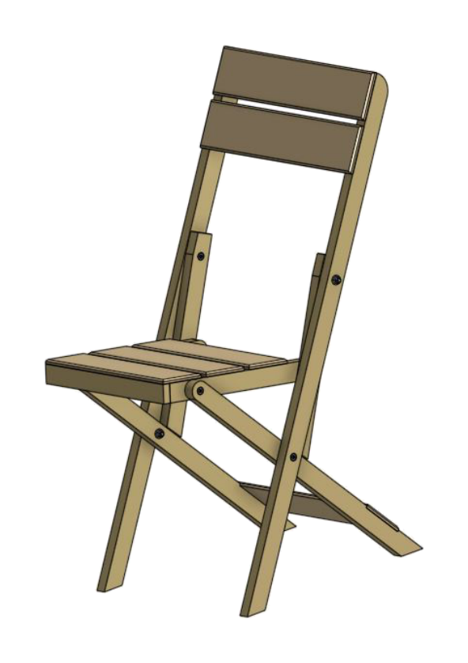
Figure 1. Source project view: inspect the seat, frame and pivot relationships.

Use the drawing to settle the detail
Front and side views describe the same product from different directions. The front view reveals width and symmetry; the side view explains height, slope and the relationship between pivots. On the overview plan, the width is 384 mm, overall height 780 mm and seat height 405 mm. Trace each dimension line to its own feature.

Read numbers, not picture size
DO NOT SCALE DRAWING means a ruler measurement taken from this reduced page cannot control manufacture. Use the written dimensions and notes on the original plan sheets, reproduced on pages 43–46.

Explain why both the open and folded positions belong in your design brief.

Movement needs controlled space
Look for the cause of movement or resistance before changing a component.

A pivot is a centre of rotation. Moving its hole changes the path travelled by the connected member, so an accurate outline cannot compensate for an incorrect pivot centre. The assembly notes specify M6 × 50 countersunk bolts, washers between components and under the nut, and a locknut. Read the full hardware arrangement on plan sheet 4 before assembly.
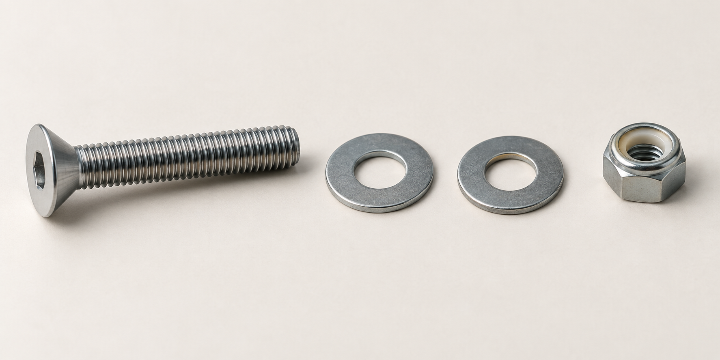
Figure 2. Illustrative loose hardware: a countersunk hex-drive bolt, two washers and a locknut. Assembly order is shown on page 46.

The bolt provides the pivot; the washers separate timber faces and spread pressure; the locknut helps retain adjustment through repeated movement. Too much looseness permits play and racking. Excessive tightening can compress timber, trap the washers and cause binding. Smooth controlled movement depends on the whole assembly, not simply tightening every nut harder.
Make a safety judgement
A hazard has the potential to cause harm. Risk considers how likely the harm is and how serious it could be. A control removes or reduces that risk. At a drill press, rotating tooling and unsecured timber present hazards. Secure work holding, the approved setup, supervision and the machine SOP manage exposure; eye protection is an additional layer. Start with elimination or substitution where possible, then engineering and administrative controls before relying on PPE.
Identify one hazard at a moving chair pivot, describe the possible harm and propose a suitable control.

Measure from reliable references
The correct number must be attached to the correct reference and face.

Datums prevent a chain of small errors
A datum is a fixed reference face, edge, point or line. Mark the prepared face side, face edge and squared datum end so related features share the same references. If each measurement starts from the previous pencil line, every small error can carry into the next feature. A fixed datum lets you check each position against the drawing independently.
Lay a steel rule flat, align its zero carefully and place your eye above the graduation. Looking from an angle causes parallax: the apparent position changes even though the rule has not moved. Use fine marks, square the required lines from the correct reference and identify the waste side before any material is removed.
A pair can match without being identical
Matching parts share size and orientation. Mirrored parts share size but have opposite handedness. The frame plan requires left- and right-hand countersink faces. Arrange the pair as it belongs in the chair, label it and check the intended outside faces before drilling or countersinking. A perfectly measured countersink on the wrong face is still an incorrect part.
Design sketches make these decisions visible. Show alternatives, then annotate the selected idea with movement arrows, component names and the reason for an approved variation. Compare function, strength, safety, appearance and manufacturing time. A thin curve may look elegant yet create short grain or unnecessary machining. Explain the compromise rather than writing only that it looks better.
Worked example: two left-hand parts
Hypothetical case: both members have correct centres, but both outside-face marks were copied with the boards facing the same way. First arrange them in their assembled left/right positions. The outer faces now oppose one another, exposing the handedness mistake. Keep the verified centres; recheck the countersink symbols and label the intended outside faces before machining. Correct measurements did not prove correct orientation.

One student measures a hole from a squared datum end; another starts from a hand-shaped curve. Their rule readings match. Explain why their hole centres may still differ.

Check, explain, apply
Choose one answer for each question. Then explain your reasoning in the application task.

1. The plan is displayed smaller on your screen than it was when it was drawn. Which information should control the chair dimensions?
○ A Measurements taken from the picture with a ruler
○ B The written dimensions and notes on the drawing
○ C An estimate based on the completed chair image
○ D The measurements used by the student beside you

2. Why are washers placed between moving timber components at a pivot?
○ A To glue the components together permanently
○ B To separate the faces, spread pressure and reduce friction and wear
○ C To make the timber absorb more finish
○ D To replace the locknut

3. The drawing says to countersink left- and right-hand components as pairs. What does this mean?
○ A Countersink both parts on whichever face is easiest to reach
○ B Make two identical left-hand components
○ C Arrange the parts as mirror images and countersink the intended matching outside faces
○ D Countersink every hole from both sides

Explain a reliable marking routine for a mirrored pair, from reference surfaces to the final pre-cut check.

Choose the timber before the cut
A clear face is only one part of a sound material decision.

A cutting list turns a drawing into a manufacturing record: component, quantity, material and size. Every entry needs a written dimension, plan note or approved decision. Keep finished dimensions separate from the rough blank. Controlled allowance leaves enough material to remove damaged ends, saw marks and distortion, but excessive allowance wastes timber and time. The teacher confirms the stock and practical allowances for this project.
Inspect the whole board before allocating a component. Grain, knots, moisture and storage affect stability and machining. A short piece that suits a slat may be unsuitable for a long frame member. A knot near a pivot can interrupt fibres in a critical location; grain that runs out of a narrow curved member can leave a weak short-grain section.
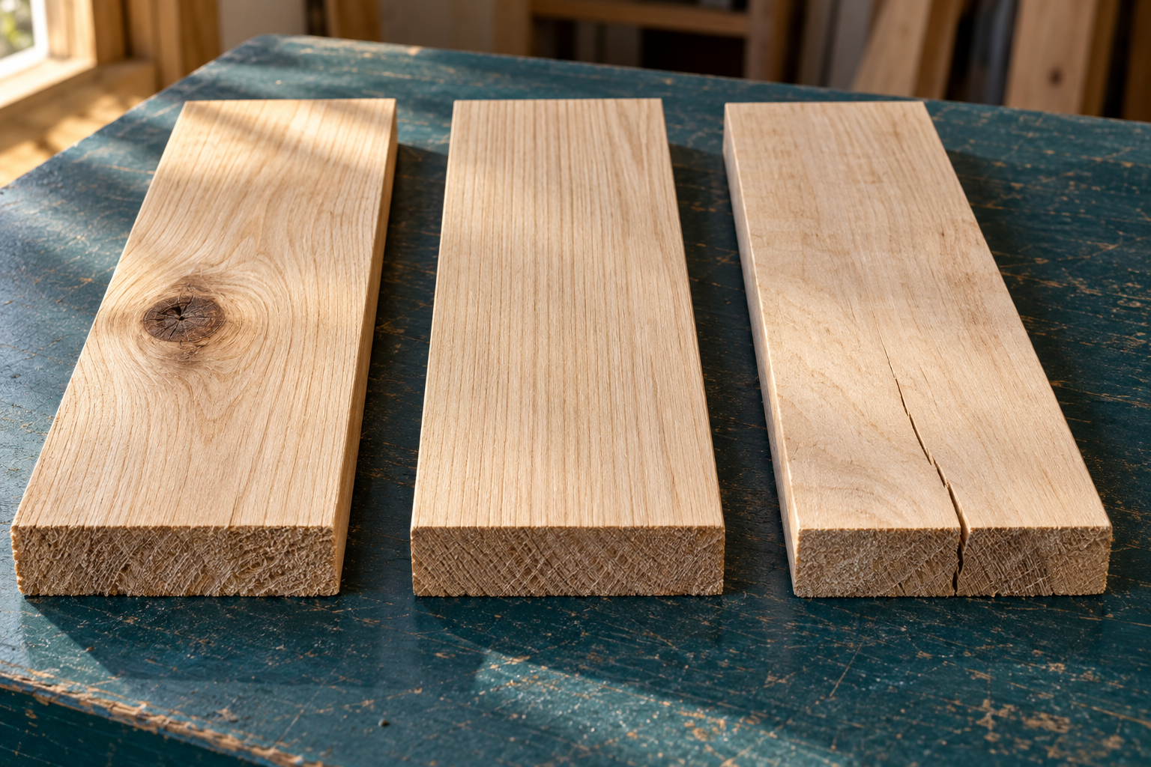
Figure 3. Illustrative inspection samples: trace grain around the knot, along the clear face and into the split. Appearance alone does not approve stock.

Bow curves along the face; cup curves across the width; spring curves along an edge; twist leaves the corners out of one plane. Dressed All Round (DAR) stock still needs checks for movement, squareness, dimensions and defects. Trying to remove severe twist may leave a component undersize. Selecting another suitable piece can be the more efficient decision.
A knot is near a proposed pivot centre. What information should you check before accepting that board?

Build the references in order
Every later measurement inherits the quality of its starting surface.

FEWTEL means Face, Edge, Width, Thickness, End and Length. Each stage makes a reference for the next. Establish a flat face and a straight adjacent edge before using them to produce parallel surfaces. Mark those references so measuring, joint cutting and assembly use the same starting points.
Stage | What it establishes
Face | One flat reference face; mark the face side.
Edge | One straight edge square to the face side.
Width | The other edge parallel at the required width.
Thickness | The other face parallel at the required thickness.
End | One squared end, used as the length datum.
Length | The opposite end at the required final length.

A jointer or buzzer can establish a reference face and edge. A thicknesser makes an upper face parallel to the surface supported on its bed. If that underside is distorted or unstable, the machine can reproduce the fault rather than remove it. Machine names and settings do not replace direct checks on the timber.
Check flatness with a straightedge or stable reference; check squareness with a try square; compare width and thickness at several positions. Measure length from the squared datum end and compare paired members directly. Follow the teacher-approved preparation method, inspect for foreign material and read the grain before machining. Passing one measurement does not prove that every reference is ready.
Worked check
Two members have the same measured width, but one rocks on the bench. The matching widths are useful evidence; the rocking still indicates a reference problem. Resolve that fault before marking a pivot from the surface.

Why can preparing final length before a square datum end produce a misleading result?

A close fit has a purpose
Understand the contact surfaces before removing more timber.

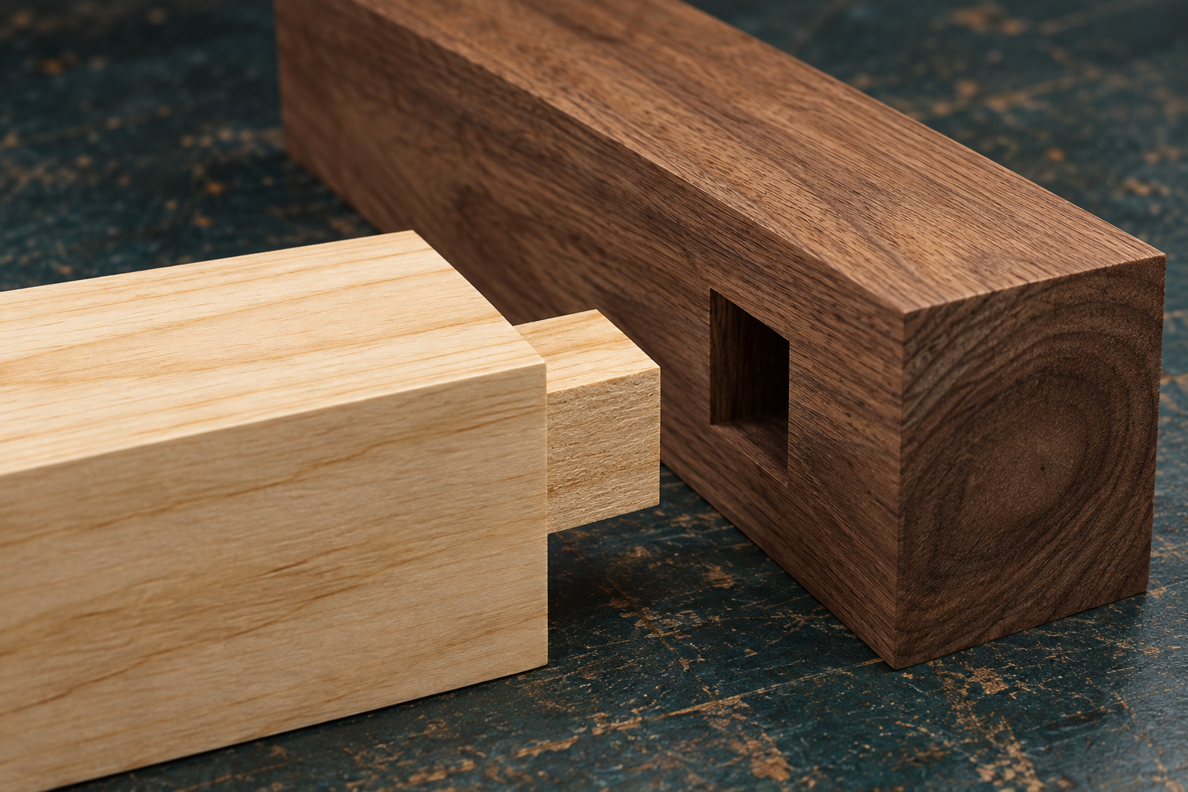
Figure 4. Generic practice joint: the mortise receives the tenon. The chair plans retain authority for project joints.

A mortise is a rectangular cavity; a tenon is the matching projecting tongue. The cheeks provide contact within the mortise and the shoulders locate the adjoining surfaces. A sound fit closes under firm hand pressure with aligned parts and full shoulder contact. Excessive force can split the receiving member; an overly loose fit loses support and contact area.
A hollow-chisel mortiser combines a rotating auger, which removes waste, with a square chisel, which forms the corners. The teacher-approved setup controls bit/chisel clearance, alignment and depth. The work must sit flat against the table and fence and be held securely so it cannot lift or rotate. Controlled overlapping plunges remove waste progressively; changed vibration, binding or moving work requires stopping and teacher assistance.
Test fitting diagnoses a problem. Unequal cheeks or an out-of-square shoulder may start the joint crooked. A local high spot or compacted waste may stop it part-way. Identify the contact, remove a small verified amount using the approved technique and test again. Random sanding can round useful surfaces and make a tight joint loose.
Fixed and moving joints do different jobs
Mortise-and-tenon learning is joint practice and design knowledge. It does not replace the chair plan’s trenches, rebate or bolted pivots. A fixed joint must resist movement; a pivot must allow controlled rotation.

Why is adding glue a poor response to a joint that has not passed its dry fit?

Check, explain, apply
Choose one answer for each question. Then explain your reasoning in the application task.

1. What does DAR mean, and what should a careful maker still do before using it?
○ A Dried After Routing; use it without checking
○ B Dressed All Round; inspect it for movement, defects, size and squareness
○ C Designed At Random; redraw every component
○ D Dimensioned Against Rule; scale the picture

2. Why can a thicknesser fail to remove twist from an undressed board?
○ A It has no cutting blades
○ B It makes the upper face parallel to the surface supported on the bed, so an unstable underside can reproduce the distortion
○ C It only cuts across the grain
○ D It measures length rather than thickness

3. Why are bolts, washers and locknuts used at the chair pivots instead of gluing a mortise-and-tenon joint there?
○ A The pivot must allow controlled rotation
○ B Glue is never used in timber projects
○ C Mortise-and-tenon joints are always weak
○ D Hardware removes the need for accurate marking

Put FEWTEL in order, then explain how its first two references protect later pivot marking and assembly.

Plan the curve before cutting
Marking, waste removal and safe support must agree.

A bandsaw uses a continuous toothed blade running around two wheels. A narrow blade can follow tighter curves; a wider blade generally supports straighter cutting. The fitted blade must suit the task. Blade selection, tension and tracking are teacher responsibilities. Students follow the specific machine SOP and report damage or an abnormal setup before use.
The upper guide and guard support the exposed blade close to the work. Excess height exposes unnecessary blade and allows more sideways deflection. The work needs stable support on the table, a visible finished line, marked waste and planned hand positions. A clear drawing is not a safe cutting plan until the operator can support and guide the work through the proposed path.
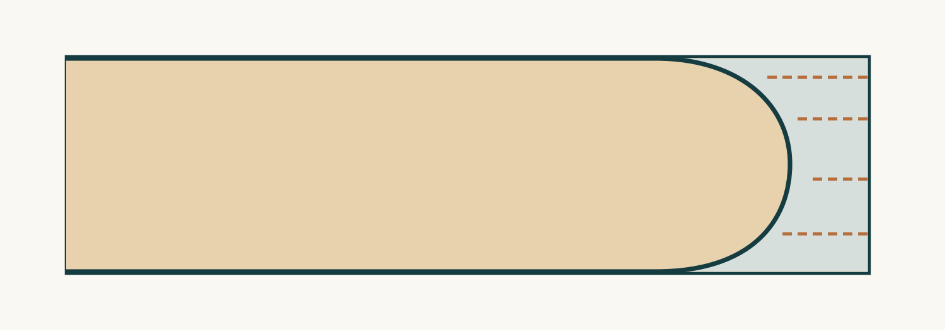
Figure 5. Conceptual mark-out: the dark curve is retained; short relief paths end in the shaded waste. This is not a machine setup.

The chair frame drawing includes R32 and R16 profiles. Use their written radii or the approved template, leaving the finished line for later refinement. Relief cuts divide waste into smaller pieces so a large offcut does not trap the blade or require an excessively sharp turn. They stop short of the finished line. Do not twist a blade sideways in the kerf or force a curve beyond its capacity; stop and seek the approved alternative.
Explain why a curved cut should retain the finished line and why a relief cut must remain in waste.

Use a procedure when conditions change
A useful procedure tells you what to do when the original plan no longer fits.

An SOP covers the whole operation
A Standard Operating Procedure describes safe, consistent use of one machine or process. Read the school’s current machine-specific version with the teacher. A general explanation in this workbook supports that instruction but does not authorise equipment use. The pre-start check brings together authorisation, PPE, clear access, extraction, guard position, visible blade condition and the marked cutting plan.
Stage | Evidence of control
Before starting | Task authorised; setup checked; waste and support planned.
During cutting | Timber supported; controlled feed; hands clear of the blade path.
Changed conditions | Stop feeding; switch off as directed; wait for full stop; report.
After cutting | Remain until stopped; clear waste by the approved method; report faults.

A sudden vibration, a stalled blade or lifting timber changes the task. Continuing to push can turn a manageable fault into injury or damage. Do not try to rescue a cut while the blade is moving. The appropriate response is controlled stopping and teacher assistance, with the machine left safe for the next person.
Loose clothing, jewellery and long hair must be secured. Gloves can create entanglement and reduce feel around moving woodworking machinery; follow the school SOP. PPE does not replace guarding, work support and a suitable process. Good shutdown and fault reporting belong to the operation just as much as producing the curve.
Sequence puzzle: number these actions after unusual vibration: A seek teacher help; B stop feeding; C wait for the blade to stop; D switch off as directed. Explain why cutting must not continue.

Refine the fault you can prove
Correctable faults become expensive when carried into the next stage.

A tight practice joint is a problem to investigate, not an invitation to hit harder. Check the tenon cheeks, shoulder contact, squareness and the reference faces. Witness marks can show where contact occurs. A local high spot requires a local correction; sanding every face can destroy the shape and make a repairable joint loose.
Use the approved hand tool to remove a very small amount, then retest. The desired result is alignment, firm hand-pressure assembly and full shoulder contact. Glue is not a lubricant for an unverified fit. Force and random sanding hide evidence that would help you choose an accurate correction.
Check before the next irreversible step
A quality gate is a checkpoint before work continues. Check the curve against the template, compare paired lengths and profiles, and confirm labels before drilling. Small errors can combine: a shortened member and a flattened radius may no longer match the pair, and a later hole can then be correctly marked on an already incorrect component.
Observation | Evidence needed before continuing
The curved pair looks similar. | Direct profile/template and length comparison.
The joint closes only under hammer blows. | Locate contact fault; correct and retest by approved method.
One reference mark was sanded off. | Re-establish verified identity and datum before marking.

Choose one observation above. Explain the cause you would investigate and what would count as a successful recheck.

Check, explain, apply
Choose one answer for each question. Then explain your reasoning in the application task.

1. What is the safest response if a marked curve is too tight for the fitted bandsaw blade?
○ A Force the timber around the blade
○ B Stop and use an approved blade, jig or alternative process
○ C Lift the timber off the table while turning
○ D Cut inside the line so the turn is shorter

2. Which condition requires the operator to stop feeding and switch off as directed?
○ A The cut is progressing steadily
○ B The timber lifts and the blade begins to stall
○ C The marked line is clearly visible
○ D The extraction system is operating normally

3. Why should paired R32 or R16 profiles be compared directly after shaping?
○ A To make both components darker
○ B To confirm matching length, curve and transition before later drilling
○ C To avoid using the working drawing
○ D To decide which component is left unfinished

A curve is tighter than the fitted bandsaw blade can follow. Explain the safe response and how you would protect the finished profile.

A hole needs three kinds of accuracy
The diameter is only one part of a successful pivot hole.

A pivot hole needs the correct centre, a perpendicular axis and clean entry and exit surfaces. The original plan specifies 6.5 mm diameter holes for the M6 hardware. That clearance assists assembly; it does not make centre location unimportant. Use written dimensions from reliable datums, not a hand-shaped curve or an uncertain rounded end.
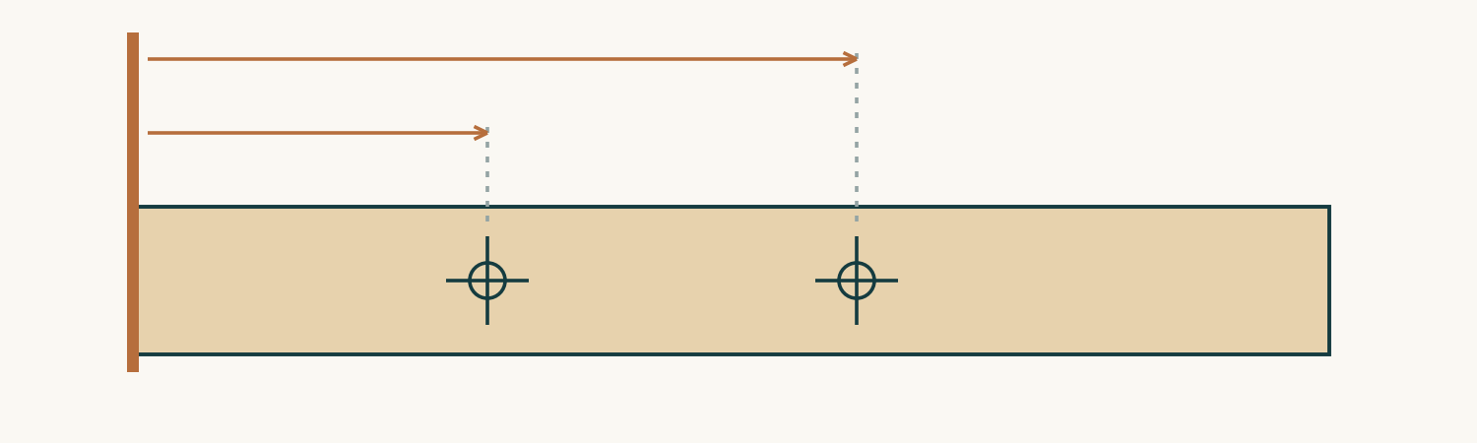
Figure 6. Conceptual mark-out: centre positions are taken independently from the same straight datum end. No project dimensions are implied.

Locate a centre with fine intersecting lines and cross-check it before making a starting mark by the approved method. Confirm the part, left/right identity and final shape first. Paired parts can be compared on a temporary bolt or alignment rod. Drilling a stack needs the teacher-approved method, sufficient clamping and suitable machine capacity; it is not an automatic shortcut.
At a drill press, the table, support, bit and clamping determine whether the hole stays perpendicular. Use a suitable backing board where required and secure timber against spinning, lifting or shifting. Hands are not a substitute for work holding. Confirm the stationary drill point against the mark before starting, follow the machine SOP for speed and feed, and clear chips as directed.
A hole enters on the marked centre but exits off-centre. Explain what was and was not proved by the entry mark.

Seat the head and preserve movement
A secure moving joint must still be able to move.

A countersink forms a conical recess that matches the bolt head. Too shallow leaves the head projecting; too deep removes useful timber and weakens its support. A recess off-centre can seat the head unevenly. Use the approved cutter and actual hardware for frequent checks rather than making a large recess in one pass.
The chair members are mirrored. Read the countersink symbols, including the note about the other side of a hole, then arrange the pair in its assembled position. Confirm the intended outside faces before machining. Similar outlines and matching centres do not make the faces interchangeable.

Figure 7. Recognise the components before reading the assembled stack: bolt, washers and locknut.

The plan places washers between moving timber components and under the nut. The interposed washer limits direct rubbing; the washer under the nut spreads pressure onto the timber. The locknut helps retain the adjustment. Tightening it excessively can trap the moving members or pull the bolt head into the timber. Insufficient control leaves side play. Adjustment remains teacher-supervised and must be judged through the range of movement.
Read the assembly from head to nut
Countersunk bolt head → timber member → washer → moving member → washer → locknut. This describes a two-member pivot; use plan sheet 4 for the actual chair assembly.

Explain why “the locknut is fitted” does not prove the pivot is correctly adjusted.

Use the dry fit to find the cause
A checkpoint has value when the next action changes if the evidence fails.

Dry assembly brings components together without permanent adhesive or finish so faults can still be corrected. Check frame and seat alignment, paired members, cross-member fit and the whole open-to-folded path. The chair may look square in one position and still bind during movement. Inspect where resistance begins and which surfaces actually touch.
Hypothetical symptom | Check before removing timber
Movement tightens at one point. | Contact faces, washer positions, head seating and pivot alignment.
The frame has side play. | Hardware adjustment and component alignment.
The mechanism is smooth, but the frame rocks. | Racking, twist and foot contact as separate causes.

A missing washer or excessive nut tension can feel like inadequate clearance. Sanding timber may hide the symptom while leaving the real error untouched. Diagnose, choose the least invasive teacher-approved correction, retest and record the result. Finishing waits until the mechanism is ready.
SOP and WMS answer different questions
An SOP describes use of a particular machine. A Work Method Statement describes this job: component checks, sequence, equipment, hazards, controls and hold points. The drawing says what must be made; the quality record shows whether it met the requirement. A useful WMS includes what happens when a hole is incorrect or a dry fit fails, rather than assuming every step will succeed.
Write one hold point for your drilling-to-assembly sequence. State the evidence required and the action if it fails.

Check, explain, apply
Choose one answer for each question. Then explain your reasoning in the application task.

1. Why does the chair drawing specify a 6.5 mm hole for an M6 pivot bolt?
○ A To create a small clearance for assembly and rotation
○ B To make the bolt permanently loose
○ C Because 6.5 mm is the outside diameter of the locknut
○ D To allow the hole to be marked without dimensions

2. Why is a washer placed between the moving timber members?
○ A To glue the pieces together
○ B To separate bearing faces, spread pressure and reduce friction and wear
○ C To prevent the chair folding
○ D To sharpen the bolt thread

3. Which item belongs in a useful WMS for drilling and assembling the chair pivots?
○ A Only the student’s favourite tool brand
○ B Sequence, hazards, controls, quality checks and response if a fault appears
○ C A promise that nothing will go wrong
○ D A scaled measurement taken from the plan image

The chair binds during dry assembly. Describe a reasoned diagnostic sequence before any timber is removed.

Make the feature earn its place
A convincing justification connects a preference to an observable requirement.

A design criterion explains how an option will be judged. Function asks whether the chair supports sitting, handling, storage and folding. Strength and safety consider fibres, clearances and stability. Appearance considers proportion, line, colour, grain and unity. Manufacturability considers whether the available skills, time, materials and equipment can produce the detail accurately.

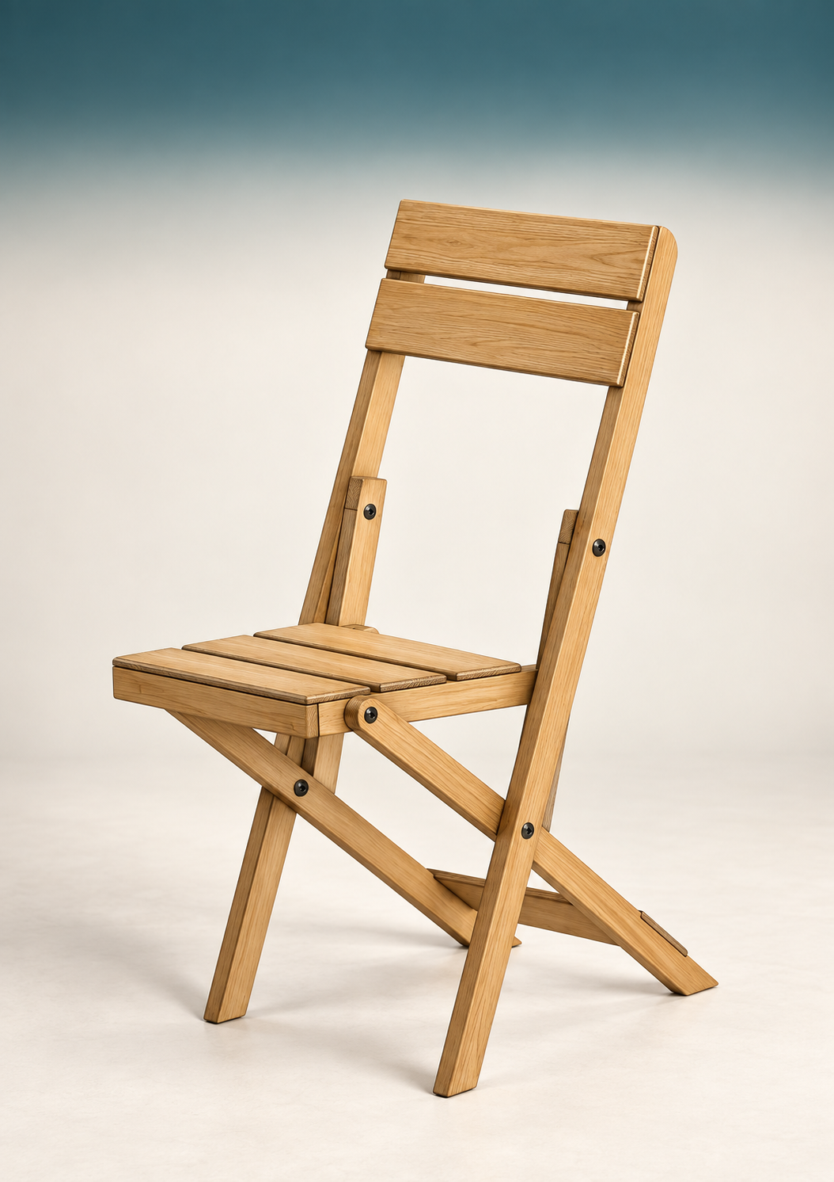
Figure 8. Inspect a proposed feature in relation to loaded, moving, contact and visible zones.

Use the right zone
Loaded zones include pivots, joints and narrow sections. Preserve enough sound timber there. Moving zones need clearance through the complete folding path: an inlay or projecting fixing can collide only part-way through closure. Contact zones need comfortable edges without over-thinning. Visible zones benefit from coherent grain and proportion, rather than unrelated decoration.
Criteria can conflict. A deeper cut-out may improve carrying but reduce the section near a load path; a thicker member can add mass and machining. Make a specific claim and name the evidence that would test it. “Even spacing produced with one template” is clearer than “looks good”. User testing and any design change require the teacher’s approved method.

Choose one permitted design detail. Identify two competing criteria and the evidence you would need before recommending it.

Compare options on equal terms
Use a score to organise reasoning, then test the design claim.

A decision matrix compares alternatives against the same criteria. Weighting expresses importance, but a high total cannot cancel a failed safety or functional requirement. The scores make reasoning visible; they do not supply evidence by themselves. Document why a score was chosen and what still needs checking.
Hypothetical feature | Possible benefit | Question still requiring evidence
Carry cut-out | May improve grip or portability. | Does it preserve the section and folding clearance?
Rounded top rail | May simplify manufacture and contact edges. | Does it meet the user’s handling need?

These are comparison examples, not approved modifications. The source course uses a carry cut-out and rounded rail to demonstrate trade-offs. Neither is automatically the correct answer. Retain early sketches, explain rejected options and obtain the teacher’s decision before changing the working drawing. An approved change needs to reach the drawing, cutting list and production notes together.
CAD makes revision precise, not automatically correct
CAD tools can mirror parts, align features and constrain geometry. Layers separate visible edges, hidden detail, centres, dimensions and notes. Snaps and constraints help maintain relationships, but the software follows the entered data. A hole accurately constrained from the wrong datum remains wrong. Check units, plan values and component orientation independently, then identify the current revision.
A design has the highest matrix score but collides when folded. Explain your decision and the records that need updating after an approved revision.

Make each view agree
Views, line types and notes cooperate to describe one object.

Orthogonal views describe shape without perspective distortion. The front view shows width and height; the top view shows width and depth; the side view shows depth and height. The chair plans use third-angle projection: the top view belongs above the front view and the right-side view belongs to its right. A feature must align at the corresponding height or width across views.
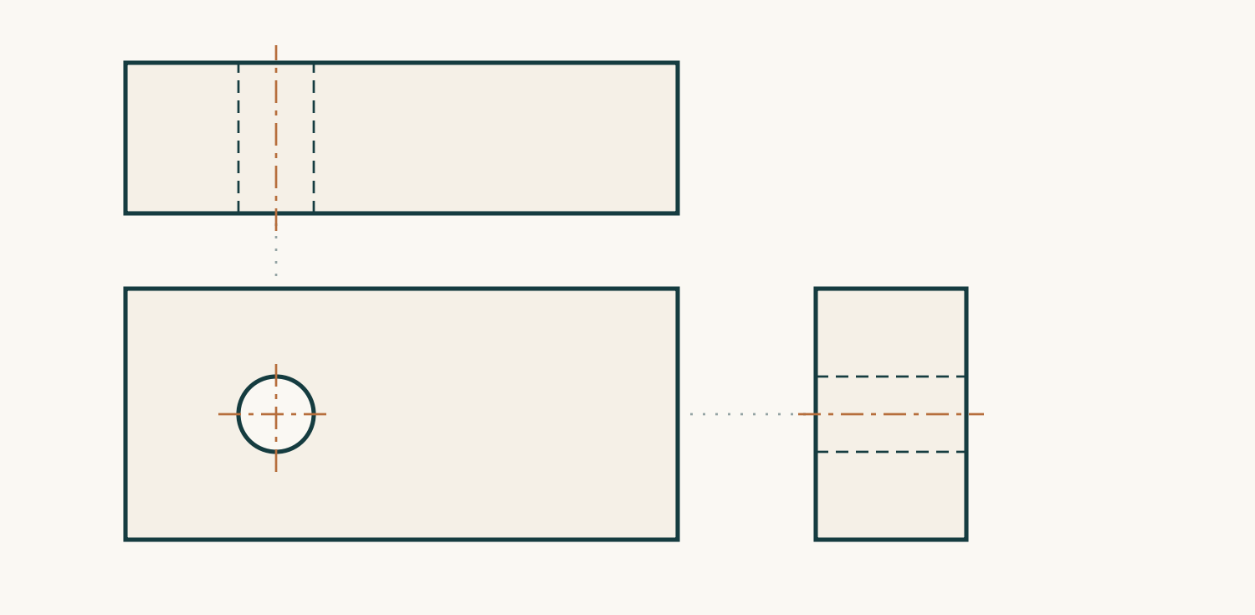
Figure 9. Concept block with a through-hole: top above front, right-side view to the right. Projection guides align matching features; no chair dimensions are implied.

Line types have different jobs. A continuous outline shows visible edges. Dashed hidden lines show concealed edges. Centre lines identify an axis or symmetrical feature. Dimension and extension lines attach a number to the exact features it controls. A leader connects a written note to a feature. A radius uses R; a diameter uses Ø. The plan specifies millimetres.
Select the view that explains a feature clearly, then read the whole dimension and its extension lines. Avoid conflicting or unnecessary duplicate dimensions. A correct number attached to the wrong centre is still misleading. The printed scale does not authorise measuring this resized workbook illustration; the written plan information controls manufacture.
On the concept diagram, explain why the front hole is circular but the corresponding top and side features use hidden lines.

Check, explain, apply
Choose one answer for each question. Then explain your reasoning in the application task.

1. In third-angle projection, where is the top view placed?
○ A Below the front view
○ B Above the front view
○ C Inside the side view
○ D Anywhere that fits

2. What does “6.5 mm Ø” mean?
○ A A radius of 6.5 mm
○ B A circular hole with a diameter of 6.5 mm
○ C A square trench 6.5 mm deep
○ D A line 6.5 mm thick

3. Why must a CAD drawing still be checked against the project plan?
○ A CAD can draw a wrong dimension very accurately
○ B CAD always changes millimetres to centimetres
○ C Computer drawings cannot contain centre lines
○ D The plan image must be scaled with a ruler

Explain how you would check a revised CAD drawing before it guides manufacture. Include units, views, references and version control.

Read • connect • apply

A glue-up begins before the glue

Rehearse the assembly
Assembly order affects access, accuracy and the time available to correct a fault. A subassembly is a group of parts joined and checked before it becomes part of the whole chair. Working on a manageable group can make joint closure, seat spacing and squareness easier to see. It also leaves room for clamp pads and measuring tools. The dry fit rehearses the order as well as testing the fit. Confirm labels and orientations, arrange the clamps and decide which measurements will show that the assembly is still aligned. Hardware must remain accessible, and adhesive must stay away from faces that need to move.
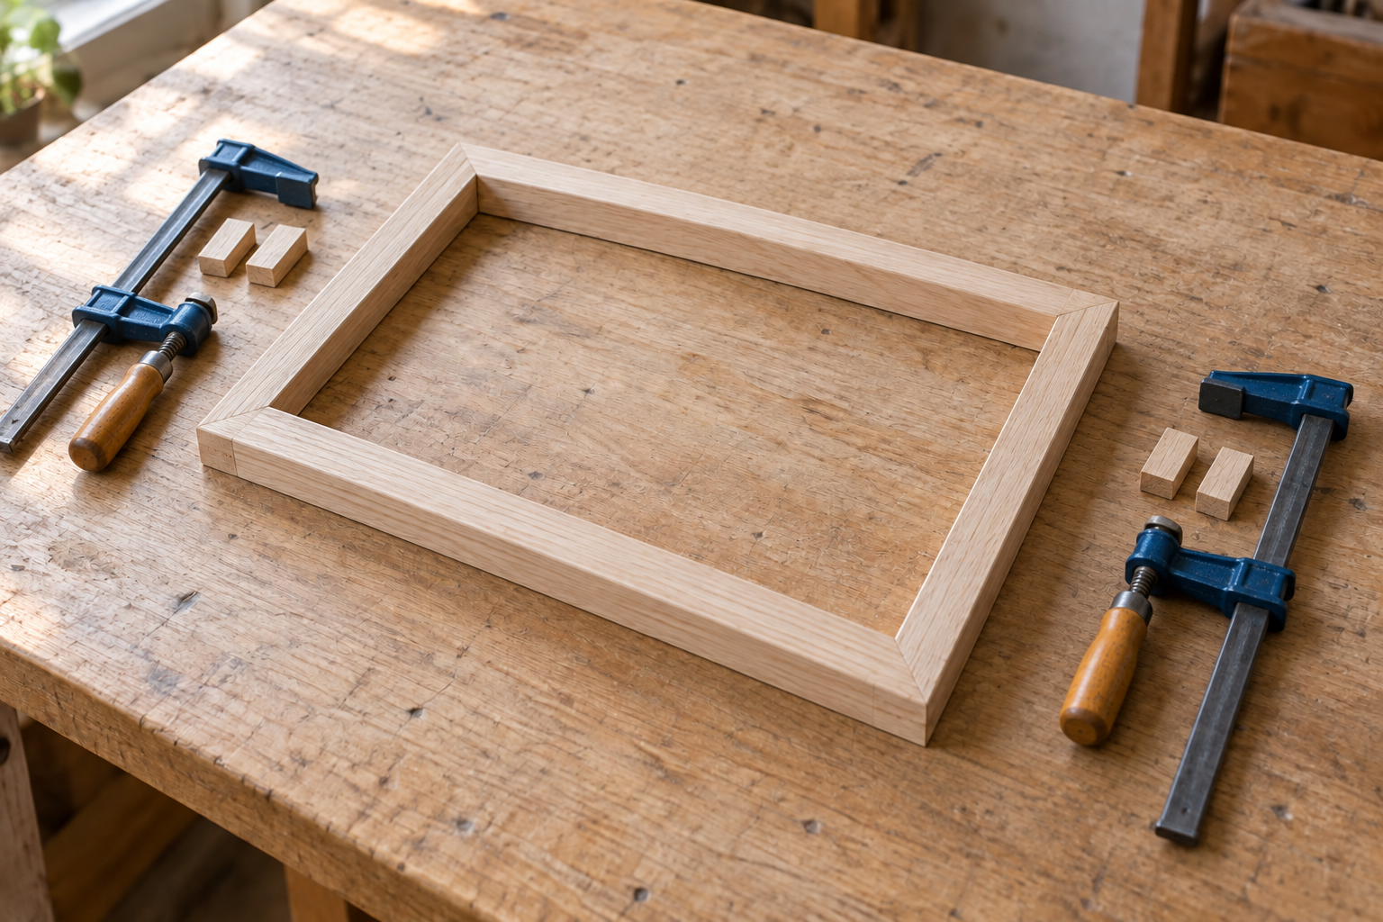
Illustrative practice frame. Loose clamps and pads are prepared before rehearsal; this is not the chair’s construction plan.

Know the adhesive’s three clocks
The adhesive needs accurately fitted, clean, sound surfaces. A suitable woodworking PVA can form a strong bond in many indoor timber assemblies, but it does not repair poor joinery. A thin, continuous film between well-fitted long-grain surfaces supports contact. Dust, oil and old coating interfere with that contact; end grain may need a different approved preparation. Use the selected product’s instructions and school procedure to determine suitability and clean-up.
Open time is the working period before the joint should be closed. Clamp time is the period it must remain supported under pressure. Cure time is the longer development of the bond’s intended properties. These periods have different purposes: dry-looking squeeze-out does not prove that a joint is ready to be unclamped or machined. Rehearsal protects the open time, and planning protects the later waiting periods.

Worked example • three decisions, three references
When must the joint close?: Product open time and a rehearsed sequence. When may support be removed?: Product clamp time and required conditions. When may later work begin?: Product cure requirements and teacher direction.

A student finds that the last rail blocks access to a clamp. Explain one change to the rehearsal and why extra adhesive would not solve this problem.

Read • connect • apply

Pressure, proof and project cost

Close the joint without bending the frame
Clamps direct force towards the joint. Pads spread that force and protect the timber from metal jaws. Useful pressure brings mating surfaces and shoulders into contact; excessive pressure can crush fibres, bow rails or rack a frame. On a wide assembly, suitable clamp positions above and below can help balance the forces. Check while adjustment is still possible. Tightening everything harder is not a diagnosis.
Check geometry; then check quantities
Comparing diagonals helps reveal racking in a rectangular frame. Measurements must use consistent corner points, and straight members and other geometry checks still matter. In the course example, one diagonal is 412 mm and the other is 416 mm. The difference is evidence that the frame needs a controlled adjustment of position or pressure before the adhesive sets. Recheck both diagonals and the joint closure after the adjustment.
Costing uses the same habit: expose the evidence behind the result. Multiply component quantity by length, convert millimetres to metres where necessary, then apply the price in matching units. Include a justified allowance for waste rather than hiding it inside an unexplained total. Hardware, adhesive, abrasives and finishing materials also contribute. Record whether a consumable is charged as a whole purchase or estimated use. Labour and overhead are separate items only where the task requires them. The example below uses the source’s hypothetical figures, not current school prices. An as-built change should update the quantities and total so the record continues to describe the chair actually made.
Hypothetical costing • source example
Item | Calculation / amount
Timber | 3.8 m × $9.50 per m = $36.10
Hardware and consumables | $12.40 + $5.50 = $17.90
Example total | $36.10 + $17.90 = $54.00

Write a brief correction note for each error: “More clamp pressure will fix the unequal diagonals” and “A price per metre can be multiplied directly by a length in millimetres.”

Read • connect • apply

Plan the work; protect the checks

Dependencies set the order
A dependency means that one task must be complete before another can begin reliably. Final size and shape support accurate pivot locations. A successful dry assembly and prepared surface support finishing. These relationships are more useful than a list of tasks with no reason for their order. A production plan also identifies the equipment, materials, estimated duration, person responsible and quality check. Some work can happen alongside waiting: the folio can be updated while an approved glued subassembly remains clamped.

Hold points prevent expensive rework
The critical path is the chain of dependent tasks controlling the earliest possible completion. It is not automatically the hardest task. A short delay can hold up everything after it. Put a realistic buffer where uncertainty exists, such as adjustment, curing or a finish test. Do not recover lost time by assuming a required drying or cure period can be shortened.

A hold point is a planned stop to examine evidence before permanent or costly work continues. Before glue-up, check fit, orientations, spacing and clamp access. After the specified clamp time, inspect joint closure, alignment and distortion. Before finishing, check movement, hardware, glue residue and surface quality. Teacher approval may be required for structural or safety decisions; the exact local sign-off is Teacher to confirm. If the plan slips, revise it honestly. Record actual time, explain the variance and identify work that can run in parallel. Decorative extras should not displace sound construction, functional movement or the evidence needed to evaluate the project.
Worked example • a useful waiting period
Glue-up → required clamp period: Keep the assembly supported for the specified period. Folio caption during that period: Record the actual joint and squareness evidence. Inspection → surface preparation: Continue only after the relevant check is resolved.

A subassembly needs longer before the next operation, and finishing is planned next. Write one useful parallel task and one hold point that should remain in the revised plan.

Check • reason • apply

Check the plan before committing

Choose one answer for each source question. Then apply the module ideas to the paper task below. These workbook tasks support learning; your teacher confirms formal assessment requirements.
1. Why should a complete dry fit occur before adhesive is opened?
○ A To confirm fit, sequence, clamp access and measurements while correction is still easy
○ B To make the adhesive dry faster
○ C To remove the need for labels
○ D To avoid checking squareness

2. A timber component is 450 mm long and costs $8.00 per metre. What is the material cost for one component before waste allowance?
○ A $0.36
○ B $3.60
○ C $36.00
○ D $360.00

3. What is the critical path?
○ A The chain of dependent tasks that controls the earliest completion date
○ B The most decorative route through the workshop
○ C Every task completed by one student
○ D The list of all optional features

Hypothetical production problem: the dry-fit frame is racked, the adhesive is ready, and the plan has fallen behind. Explain a revised sequence that protects fit and adhesive timing. Include a hold point, a useful parallel task and one costing record that may need updating.

Read • connect • apply

Prepare the surface without losing the shape

Inspect before reaching for abrasive
Surface preparation starts with diagnosis. Use strong, angled light and touch to locate dried glue, machining marks, torn grain, dents, pencil lines and abrupt transitions. Check paired profiles as well as the visible faces. Fine sanding cannot correct a wrong shape efficiently, and uncontrolled sanding can change a correct one. Deal with geometry first, then surface defects, then final cleaning. Moving faces need particular care: removing timber can increase side play, while later coating build can reduce clearance.

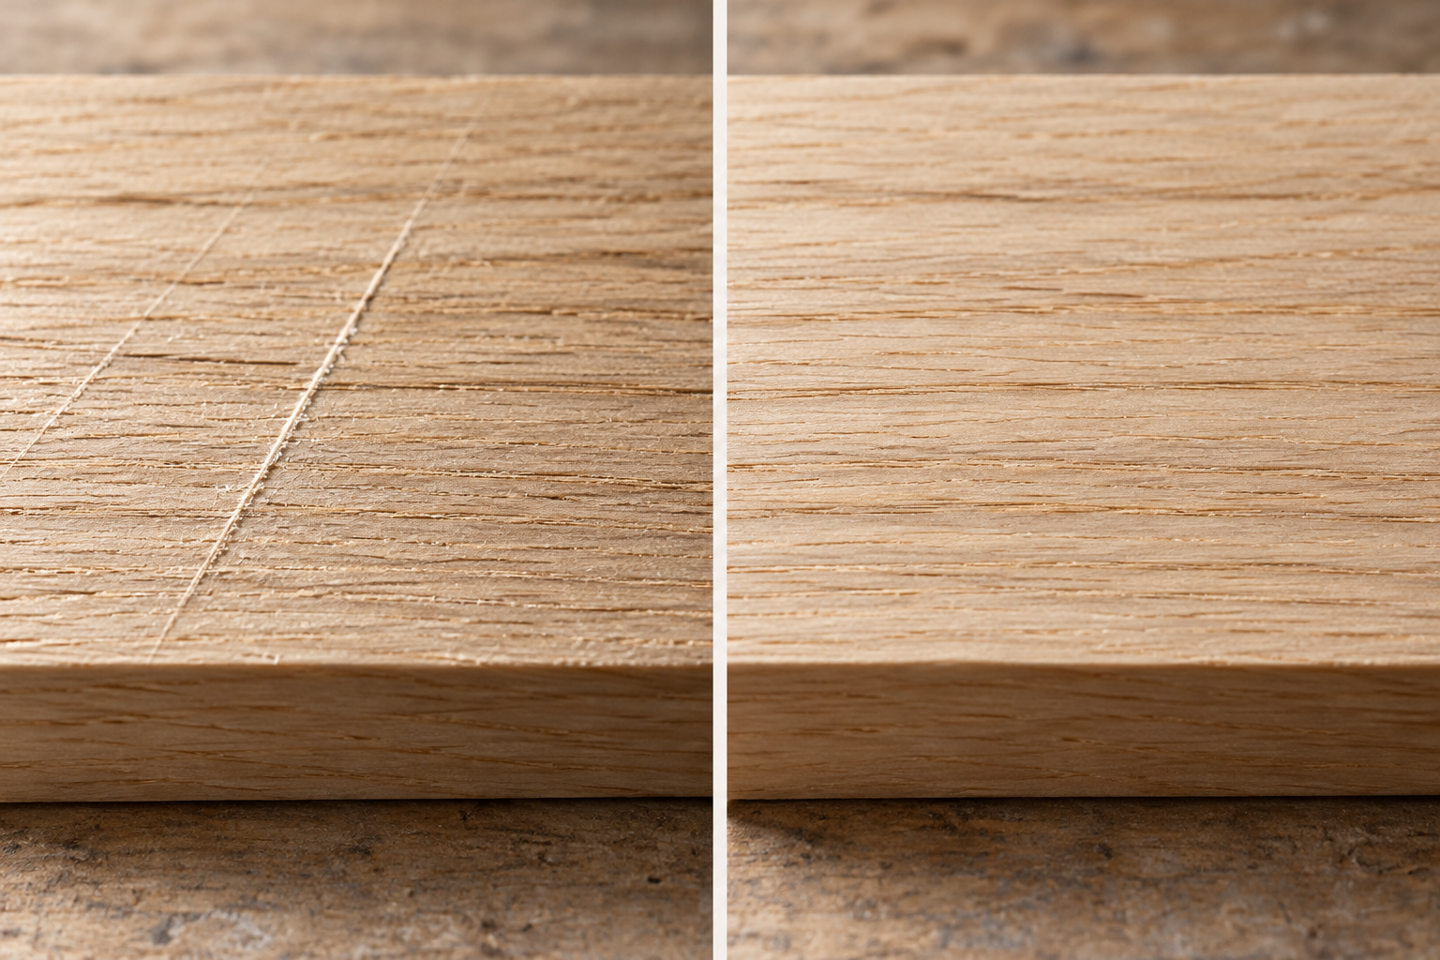
Illustrative matched surface study: cross-grain scratches at left; an evenly prepared face at right. Angled light reveals the difference.

Let each grit complete its job
Abrasive grains cut the surface. A lower grit number generally means larger particles and a coarser scratch pattern. Begin only as coarse as the actual defect requires. Each later grade must remove the scratches from the previous one; moving to fine paper too soon can polish the surrounding surface while leaving deep lines behind. Sand visible timber with the grain so remaining scratches are less conspicuous. A firm block distributes pressure across a flat rail and helps prevent finger grooves or rounded edges.
Support a curve in a way that preserves its radius and compare paired shapes or the approved template. Thick glue residue needs the approved removal method before ordinary sanding: sanding a ridge can spread residue and hollow the surrounding timber. Glue contamination may later appear as a pale patch under finish. The sequence below is a course example, not a compulsory recipe. Timber, the chosen finish and teacher direction determine the suitable starting and final grades. Inspect between stages and remove dust by the approved method before the final surface check.
Illustrative abrasive sequence • inspect at every arrow
120 → 180 → 240 grit: The previous scratch pattern has been removed. Before coating: Shape, cleanliness and selected finish requirements are satisfied.

A rail feels smooth but still has one deep cross-grain scratch and a rounded edge. Explain why moving immediately to finer paper is a poor next step.

Read • connect • apply

Choose the finish as a complete system

Match protection to use and movement
A finish changes colour, sheen and feel and can reduce staining, wear and moisture exchange. It cannot strengthen defective joinery or make any chair suitable for any environment. Choose a system for the intended use, handling, maintenance and available application controls. A penetrating oil commonly emphasises grain with a thinner surface build. A clear film finish forms a more defined protective layer. Stain changes colour before its compatible protective coat; wax may be a maintenance layer rather than a complete protective system.
Dry is a stage; cured is a condition
Test the whole system on matching scrap prepared to the proposed grit. The trial can reveal colour change, uneven end-grain absorption, raised fibres and an unsuitable sheen. Record the exact product, colour or batch, preparation and application conditions. Consult the current label, product directions and exact-product SDS provided by the teacher. These sources determine the controls, application method and waiting periods; this workbook does not prescribe a coating product.
Thin, even application reduces runs and avoids flooding joints or moving faces. Support coated surfaces so they can dry without sticking. Drying reaches a condition suitable for the next specified handling step; curing is the longer development of intended hardness and resistance. A touch-dry coating can still mark under pressure or stick when the chair folds. De-nibbing lightly removes raised dust or fibres between coats at the stage and with the material directed for that product. It should preserve edges and avoid cutting through the coating. Remove dust appropriately before recoating, and keep the mechanism protected until the system is ready.
Worked comparison • questions before selection
Finish family | Decision to investigate
Penetrating oil | Expected wear, maintenance interval and suitability for use.
Clear film finish | Surface protection, film build at moving faces and cure needs.

Explain why both the matching-scrap test and the cure requirements matter to a folding chair. Include one appearance issue and one movement issue.

Read • connect • apply

Read defects as evidence

A symptom points to a process
A finish fault is a clue, not a direction to add another coat. Describe what it looks and feels like, where it occurs and when it appeared. Runs often suggest a heavy or uneven coat on a surface where liquid can flow. Dust nibs suggest contamination in the surface, applicator or air. Blotchy colour may relate to inconsistent sanding, end grain or residual glue. Poor adhesion has several possible causes, including contamination or an incompatible coating. Location and process records help distinguish these possibilities.

Build quality into the process
Correction depends on the identified product and its state of cure. Stop and investigate before trapping contamination or increasing thickness. A binding pivot also needs a movement diagnosis; finish build or premature reassembly may be involved. Use teacher and manufacturer guidance for the smallest suitable correction, then record the result. A record of the defect and its likely cause helps prevent recurrence rather than simply hiding the outcome.

Industry applies this reasoning through quality assurance and quality control. Quality assurance is the planned system that helps prevent defects: current drawings, work instructions, training, maintained tools and reliable jigs. Quality control checks an output or process against requirements. A template controls repeated shape; an inspection checks whether the actual part matches it. Traceable material and finish records connect a fault to what was used and when. Clear handovers and fault reports help several workers maintain the same standard. A useful industry question therefore asks how components are checked before assembly or how a faulty batch is traced, rather than simply which machine is most expensive.
Hypothetical fault record • observation is not certainty
Dust nibs across a face: Surface, applicator or airborne contamination. Pale patch beside a glue line: Residual adhesive or uneven preparation. One sag on a vertical rail: An overly heavy or uneven coat.

Choose one fault above. Write one quality-control observation and one quality-assurance change that could reduce its recurrence.

Check • reason • apply

Diagnose the finish, improve the process

Choose one answer for each source question. Then apply the module ideas to the paper task below. These workbook tasks support learning; your teacher confirms formal assessment requirements.
1. Why should dried glue be removed before normal finish sanding?
○ A It can block finish absorption and appear as a pale patch
○ B It makes the timber stronger and should be left
○ C It automatically becomes invisible under clear finish
○ D It increases the chair’s folding clearance

2. What is the main difference between drying and curing?
○ A Drying is an early handling stage; curing is the longer development of hardness and resistance
○ B They are exactly the same
○ C Curing always occurs before application
○ D Drying only applies to timber, not coatings

3. What is quality assurance?
○ A Planned systems that prevent defects and ensure requirements are built into the process
○ B Only the final visual inspection
○ C A method for hiding rework
○ D A decorative finish name

Hypothetical first coat: dust nibs cover one face, a sag appears on a rail and a pale patch sits beside a joint. Explain likely causes and a controlled response. Include one preventive change for the next coating session and explain why a further coat should wait.

Read • connect • apply

Read the label; find the right SDS section

Identify the exact chemical
A chemical label identifies the product, intended use and immediate precautions. Hazard information may include pictograms, a signal word such as Danger or Warning, and hazard and precautionary statements. Read the words as well as the symbol: one product can present more than one hazard. A familiar colour or container shape does not establish identity, and deliberately smelling a chemical creates exposure without reliably identifying it. Keep chemicals in approved labelled containers and follow the school process for any working quantity.
Use the document as a map
The Safety Data Sheet supplies more detailed information for handling, storage, exposure controls, emergencies and disposal. It must match the exact product and supplier. Its standard 16-section structure makes information easier to locate. Identification appears in Section 1 and hazards in Section 2. Section 4 covers first aid, Section 6 accidental release, Section 7 handling and storage, and Section 8 exposure controls and PPE. Section 10 helps identify incompatible conditions or materials; later sections address environmental, disposal and other information.
Before a practical activity, the teacher supplies or confirms the current SDS for the product actually held at school. The older turpentine document linked by the course is a classroom example only; it is not operational advice for an unidentified or different product. The map below teaches where to look. It does not replace the school emergency procedure or the product instructions. For a real splash, spill or exposure, alert the teacher immediately and follow that procedure. Do not delay help to complete a workbook lookup, improvise treatment or choose protective equipment from a generic picture.
Document navigation • locate, then read
Question being investigated | Start with
What product and supplier is this? | Section 1
What first-aid information applies? | Section 4
How is a release handled? | Section 6
What exposure controls and PPE are specified? | Section 8

For planning only: name the SDS section you would use to check storage and the section for glove selection. Explain why the exact product name still has to be checked first.

Read • connect • apply

Control exposure; care for the cured finish

Use several layers of control
The hierarchy of controls favours removing the hazard before relying on individual protective equipment. Elimination removes the hazardous chemical or task. Substitution uses a less hazardous suitable alternative. Isolation separates people from exposure, while engineering changes the physical environment, such as effective local exhaust. Administrative controls include procedures, training, labels and scheduling. PPE is a final layer because its effectiveness depends on correct selection, fit and use every time. A substitute still needs its own product assessment; lower hazard does not mean no hazard.
Maintenance follows diagnosis
For finishing, the approved product, designated area, appropriate ventilation, controlled access and clear procedure work together. The exact-product SDS and school controls determine the protective equipment. If an unknown spill occurs, alert the teacher and keep others away. Do not improvise with absorbents or disposal methods. Contaminated rags and residues can have fire or environmental hazards and must enter the specified waste system.

Polishing is also a product-dependent process. It may refine a cured coating, apply a compatible maintenance layer or restore sheen after cleaning. A method suitable for one finish can soften or contaminate another. Wait until the coating has reached the cure stage required for that process; touch-dry alone is insufficient evidence. Clean soft materials help avoid scratching, but grit must be removed first and a sample or inconspicuous area tested where directed. Avoid unknown products or residue accumulating in joints and moving faces. A dull patch may only need cleaning. A stiff pivot needs mechanical inspection, not an extra chemical. Choose the simplest compatible maintenance that addresses the actual condition.

Worked distinction • appearance or mechanism?
Dull area on a cured coating: Is it dirt, wear or an incompatible residue? Unusual resistance at a pivot: What is contacting or restricting movement?

Explain two flaws in this plan: “I will use gloves as the only vapour control, then add polish to make a stiff pivot move.”

Read • connect • apply

A long service life is a material decision

Look beyond the word renewable
Timber can be renewable, but that alone does not prove a particular product is sustainable. Forestry management, supplier evidence, transport, processing energy and material yield all matter. Straight stock suits long components, while shorter sound sections may suit smaller parts. Accurate cutting lists and consistent templates can reduce wasted material and rework. Durability matters too: a weak chair that soon needs replacement may consume more resources over time than one made carefully from a slightly greater initial quantity.
Follow the whole life cycle
Life-cycle thinking considers sourcing, transport, manufacture, use, repair and end of life together. A lower-hazard finish may reduce application impacts if it still suits the chair’s service conditions and protects adequately. A more durable coating may need less maintenance but bring different application hazards. Explain that trade-off using evidence rather than calling one option universally best. Reducing component thickness is not a free environmental gain if it compromises geometry or service life; dimensions remain governed by the approved design.


Illustrative loose hardware: bolt, washers and locknut. Their display order is not the chair’s assembly order.

Worked trade-off • replacement or repair?
Proposal | Evidence needed before deciding
Replace worn standard pivot hardware | Sound surrounding timber; specified compatible parts; assessed geometry.
Replace the whole chair | Whether damage prevents a sound, suitable repair.

The folding chair’s accessible mechanical pivot hardware can support repair because a worn standard part may be replaced while sound timber is retained. That benefit depends on the holes and surrounding members remaining sound, suitable hardware remaining available and the geometry being preserved. The waste hierarchy begins by avoiding unnecessary material, then reducing waste, reusing and recycling where practical. Disposal is the last option for material that cannot be safely recovered. Clean timber offcuts and chemical-contaminated waste follow different routes. A strong proposal identifies an impact, explains its cause, compares a realistic alternative and names the evidence needed to judge the improvement.
Choose either material yield or repairability. Explain one realistic improvement and one condition that must remain satisfied for it to be a sustainable choice.

Check • reason • apply

Use evidence for chemicals and sustainability

Choose one answer for each source question. Then apply the module ideas to the paper task below. These workbook tasks support learning; your teacher confirms formal assessment requirements.
1. Which SDS section is the first place to look for eye-exposure first aid?
○ A Section 4
○ B Section 7
○ C Section 9
○ D Section 14

2. Why is PPE placed near the bottom of the hierarchy of controls?
○ A It depends on correct selection, fit and use and does not remove the hazard
○ B It is never useful
○ C It always costs more than elimination
○ D It changes the product into a harmless substance

3. How does standard replaceable pivot hardware support sustainability?
○ A Worn hardware can be inspected and replaced without discarding the whole chair
○ B It makes the timber grow faster
○ C It removes all need for maintenance
○ D It guarantees zero environmental impact

Hypothetical maintenance plan: a chair has a dull surface and a stiff pivot. Explain how you would decide whether cleaning, compatible polishing or mechanical assessment is needed. Include the current product information and controls required, then explain how a sound repair could reduce waste.

Read • connect • apply

Build an evidence chain, not a scrapbook

Every item should prove something
A portfolio makes a structured argument: what the brief required, why decisions were made, how manufacture proceeded and how the completed chair was judged. The evidence chain connects success criteria, research, plans, cutting lists, production, costing, sustainability and evaluation. Select evidence by purpose. A clear view of paired members against the relevant template can show more than several similar photographs of a busy bench. Keep drafts that reveal development or a useful correction; duplicates with no explanation add volume rather than understanding.

Caption the decision and the result
A photograph records visible detail, but it rarely explains why the detail matters. A strong caption identifies the stage, the action or decision, the evidence and the outcome or next action. “This is my chair” supplies almost none of that information. A pivot detail needs enough surrounding context to locate it, while an overall image should show the chair clearly in the relevant open or folded position. Consistent lighting and orientation help comparisons.

Use authentic work and accurate dates, acknowledge supplied plans and assistance where required, and avoid including other students unnecessarily. The example below is hypothetical: it demonstrates a caption structure, not an inspection or teacher approval that has happened. Your own caption must match your actual record. If a movement check remains incomplete, say so and identify the next check instead of borrowing a successful result. This is also how the course folio’s evidence notes work: they explain what a photograph, sketch or check proves. Clear formatting supports that explanation, but cannot repair missing or misleading evidence.
Hypothetical caption • useful even before success
Stage and action: During dry assembly, I inspected the specified pivot hardware. Evidence and next action: The washer positions are visible; a full movement check is still to be recorded.

Replace “This is my chair” with a two-sentence caption for a real or clearly labelled hypothetical detail. Include the stage, evidence and next action or verified outcome.

Read • connect • apply

Judge the result; retrieve the reasoning

Evaluation explains how well and why
Description says what happened; evaluation judges it against a criterion using evidence. A useful evaluation identifies the requirement, the observation or measurement, the judgement and its practical significance. It then considers the cause and a specific improvement. “The chair folds” is a description. A stronger judgement would connect an actually recorded movement check to the relevant criterion and state any remaining binding or side play. Do not invent a test count, load or successful result to make the paragraph sound convincing.
Use recall to find the gaps
Honest limitations improve an evaluation. A fault can reveal where the process needs a better checkpoint, while a successful result can identify a habit worth keeping. Replace “be more careful” with a precise action that can later be verified, such as comparing paired pivot locations before the next approved operation. The evidence should explain why the proposed action addresses the cause rather than simply making the portfolio longer.

Retrieval practice uses the same evidence-seeking approach to learning. Close the notes, attempt an explanation from memory, then compare and correct it. Rereading alone can make an answer look familiar without proving you can produce it. Interleaving mixes related areas, such as drawings, safety, costing and finishing, so you practise deciding which idea applies. Return across several sessions and keep an error log with the misconception, corrected principle and a chair example. A correction is most useful when you later retry it without seeing the answer. This links revision to practical reasoning: you must select the right principle and explain its consequence in the project.

Hypothetical evaluation frame
Criterion and evidence: Against the requirement to …, my recorded check showed … Judgement and improvement: This means …; next time I would … and verify it by …

Close the reading. Write from memory the difference between description and evaluation, then add one chair-specific example. Reopen it and correct one omission if needed.

Read • connect • apply

Answer the command; connect the stages

The verb sets the job
A command word tells you the depth and type of response required. Identify means name a relevant item. Describe gives characteristics or a sequence. Explain links how or why to a consequence. Justify supports a choice with reasons and evidence, while evaluate makes a judgement against criteria and limitations. Compare addresses relevant similarities and differences. Technical vocabulary helps precision, but a list of terms does not automatically explain a relationship.

Plan a chain of causes
Read the whole question before writing. Circle or underline its command word, content areas and requested number of examples. If it asks for two controls, develop two relevant controls rather than giving one long general paragraph. Use chair-specific evidence when the question names the project. For example, an explanation of washers should link their position and separation of moving surfaces to friction and timber wear; simply naming a washer does not explain its purpose.

Longer answers often connect stages. Accurate folding action depends on reliable reference faces and edges, correct mark-out, matched shaping, accurate pivot drilling and a complete dry assembly. These are dependencies, not isolated facts. Plan the response as principle, chair application and consequence. A reference error can pass into repeated parts; a later mechanism problem may therefore begin well before final hardware fitting. Use the relevant source and approved drawing to check exact details, then connect them in a logical paragraph. Finish by returning to the question: have you supplied the required reasoning, examples and scope? This final coverage check catches a fluent answer that has still missed half the task.
Worked progression • depth changes the answer
Command | What the answer must add
Identify a pivot component | Name the component.
Explain its purpose | Connect its role to an effect on the mechanism.
Evaluate the mechanism | Judge recorded performance against a criterion and limitation.

For “Explain how accurate folding action depends on manufacture”, draft a three-link answer plan. Name a principle, its chair application and a consequence.

Check • reason • apply

Make the evidence do the explaining

Choose one answer for each source question. Then apply the module ideas to the paper task below. These workbook tasks support learning; your teacher confirms formal assessment requirements.
1. What should a strong photograph caption include?
○ A The stage, process or decision, evidence and outcome
○ B Only “my chair”
○ C The student’s favourite colour
○ D A copied paragraph unrelated to the image

2. What is retrieval practice?
○ A Trying to recall information before checking the answer
○ B Reading the same paragraph repeatedly without testing
○ C Copying a model response word for word
○ D Studying only the easiest topic

3. A long-response question asks how accurate folding action is achieved. Which answer plan is strongest?
○ A Connect datums, prepared reference surfaces, paired shaping, pivot drilling and dry assembly with cause and effect
○ B Write only about the finish colour
○ C List tool names without explaining their purpose
○ D Describe one isolated step and ignore the mechanism

Choose a real project stage, or label a hypothetical one. Write a short evaluation paragraph that states a criterion, identifies evidence, makes a judgement and proposes a specific improvement. Finish with one retrieval question you could use later to check the principle behind that improvement.

Read • connect • apply

Inspect in sequence; correct the cause

Move from structure to surface
A systematic final inspection finds more than the most obvious cosmetic fault. Begin with fixed members and joints, then the seat and backrest, pivot hardware, movement path, floor contact and stability, and finally the finish and evidence. Compare both sides with the drawings and as-built record. Look for splits, open shoulders, distortion, sharp edges and loose hardware. Check bolt seating and the specified washer arrangement. Slow, controlled movement lets you notice scraping, changing gaps or resistance and locate where it begins.


Illustrative finished chair for locating inspection areas. It is not a student’s inspected or approved product.

Choose the least invasive correction
Stability checks use a level surface under teacher supervision and the approved procedure. Do not stand on the chair or invent a load test. An observation is a starting point, not a complete diagnosis. Binding can arise from missing hardware, excess tension, misaligned holes, twisted timber or coating contact. Rocking may relate to floor contact, loose hardware or frame geometry. Compare plausible causes with the actual evidence before changing anything.
The least invasive correction restores the requirement while changing the least sound material. Checking the hardware stack or an approved tension adjustment comes before removing timber or enlarging a hole. A scratched coating during folding may indicate a clearance problem, projecting hardware, grit or inadequate cure; extra polish does not identify which. Report significant structural faults instead of concealing them with filler or finish. After an approved correction, repeat the full inspection and controlled movement check, because changing one area can affect another. Record what was observed, what was changed and the actual result. The final evidence must describe the corrected chair, including any unresolved limitation.
Diagnostic example • one symptom, several checks
Binding near one position: Exact contact location; hardware seating and washer stack. Rocking on a level surface: Contact points, hardware and fixed-frame geometry.

A pivot binds only near the folded position. Explain why sanding the frame immediately is a weak response, and identify two observations to record first.

Read • connect • apply

Hand over the workshop and the evidence

Know the boundary of your responsibility
Cleaning removes dust, waste and residue. Routine maintenance includes approved care and checks that keep equipment suitable for use. Repair restores faulty equipment and belongs to authorised people. Students should not dismantle guards, work on electrical equipment or attempt specialist machine repairs. Stop and report a fault, following the school direction for isolating or tagging equipment. A useful report names the machine, describes the observed condition, says when it occurred and identifies the operation underway. Keep observation separate from guesses about the cause.

Make the submission match the chair
A professional handover includes clean tools returned to their proper places, protected measuring edges, clear access paths and correctly secured chemicals. Store clamps so their bars and threads are protected. PPE inspection and storage follow its equipment procedure. Sort clean reusable offcuts separately from dust, contaminated rags and chemical residues. The waste systems differ because the materials present different hazards and recovery opportunities.

Submission is another quality check. Present the chair and portfolio in a condition that makes their evidence easy to assess. Confirm suitable cure and completed authorised checks before handling or making a last-minute change. Order the folio clearly, use correct units, check calculation totals and attach captions that explain the actual photographs. An as-built record identifies approved differences from the earlier plan; it must agree with the finished object. Include useful overall and detail evidence as directed, and evaluate against the original criteria. Acknowledge supplied drawings, sources and assistance. Local submission details, dates and identification requirements are Teacher to confirm. Neat presentation helps, but authentic and accurate records establish integrity.
Worked distinction • reporting rather than guessing
“The machine is broken.”: Machine name + observed condition + when + operation underway. “My folio is finished.”: Current plans + actual records + relevant captions + criterion-based evaluation.

Write a two-sentence handover note: one sentence reports a hypothetical equipment fault without diagnosing beyond the evidence; the other identifies a portfolio check before submission.

Read • connect • apply

Make the next project better

Turn reflection into a verifiable action
Reflection links an event to a future practice. State what happened without exaggeration, explain the likely cause using evidence, and identify the effect on quality, time, cost, safety or function. Then propose a specific change and the evidence that would show whether it worked. “Start earlier” is too vague to guide the next project. A useful change names a task and checkpoint, such as completing the full hardware dry fit before the finishing stage and recording the washer arrangement and movement result.
Care continues after submission
Balanced reflection also identifies a successful habit worth repeating. Pairing components, maintaining clear datums or stopping when conditions changed may explain a good result. Name one practice to keep, one to change and one skill to transfer. Use the actual record rather than claiming a perfect project or inventing a fault simply because a worksheet asks for one. If no fault occurred in the chosen stage, analyse a sound decision and how it was verified.

Care instructions protect the same relationships over the chair’s service life. Use the chair for its intended purpose, store it dry and avoid conditions unsuitable for its timber and finish. Inspect moving hardware, surrounding timber, fixed joints and feet for looseness, splits, crushing, wear or unusual resistance. Never force the mechanism through a stiff point. Cleaning and finish maintenance must be compatible with the actual cured coating. Repairs must preserve the specified geometry and safe operation; standard hardware does not justify any convenient replacement. If the chair becomes unstable or damaged, remove it from use until assessed. The exact maintenance product and any repair method must be confirmed for the product and by the teacher.

Worked reflection frame • keep the evidence visible
Cause and effect: Because I …, the record showed … Future action and proof: Next time I will …; I will check this by …

Choose one practice to keep or change. Explain how you will verify it next time, then add one care instruction that protects the finished chair’s movement or timber.

Check • reason • apply

Complete the chair and the handover

Choose one answer for each source question. Then apply the module ideas to the paper task below. These workbook tasks support learning; your teacher confirms formal assessment requirements.
1. What does “least invasive correction” mean?
○ A Restore the requirement while changing or removing the least sound material
○ B Remove as much timber as possible
○ C Hide the fault with filler
○ D Make several changes at once so the cause is unknown

2. What is an as-built record?
○ A Documentation of the product as it was actually completed, including approved differences
○ B A copy of the first sketch only
○ C A list of tools without dates
○ D A plan measured from the screen

3. What is the correct response if the chair becomes unstable during later use?
○ A Remove it from use until the cause is assessed and repaired appropriately
○ B Keep using it until it collapses
○ C Tighten every fastener as hard as possible without checking
○ D Cover the fault with wax

Prepare a concise final handover note for your chair. Include a completed or pending inspection, an unresolved issue or verified strength, the matching portfolio evidence, one workshop handover action and one specific care instruction. Keep unknown details visibly pending rather than inventing a successful check.

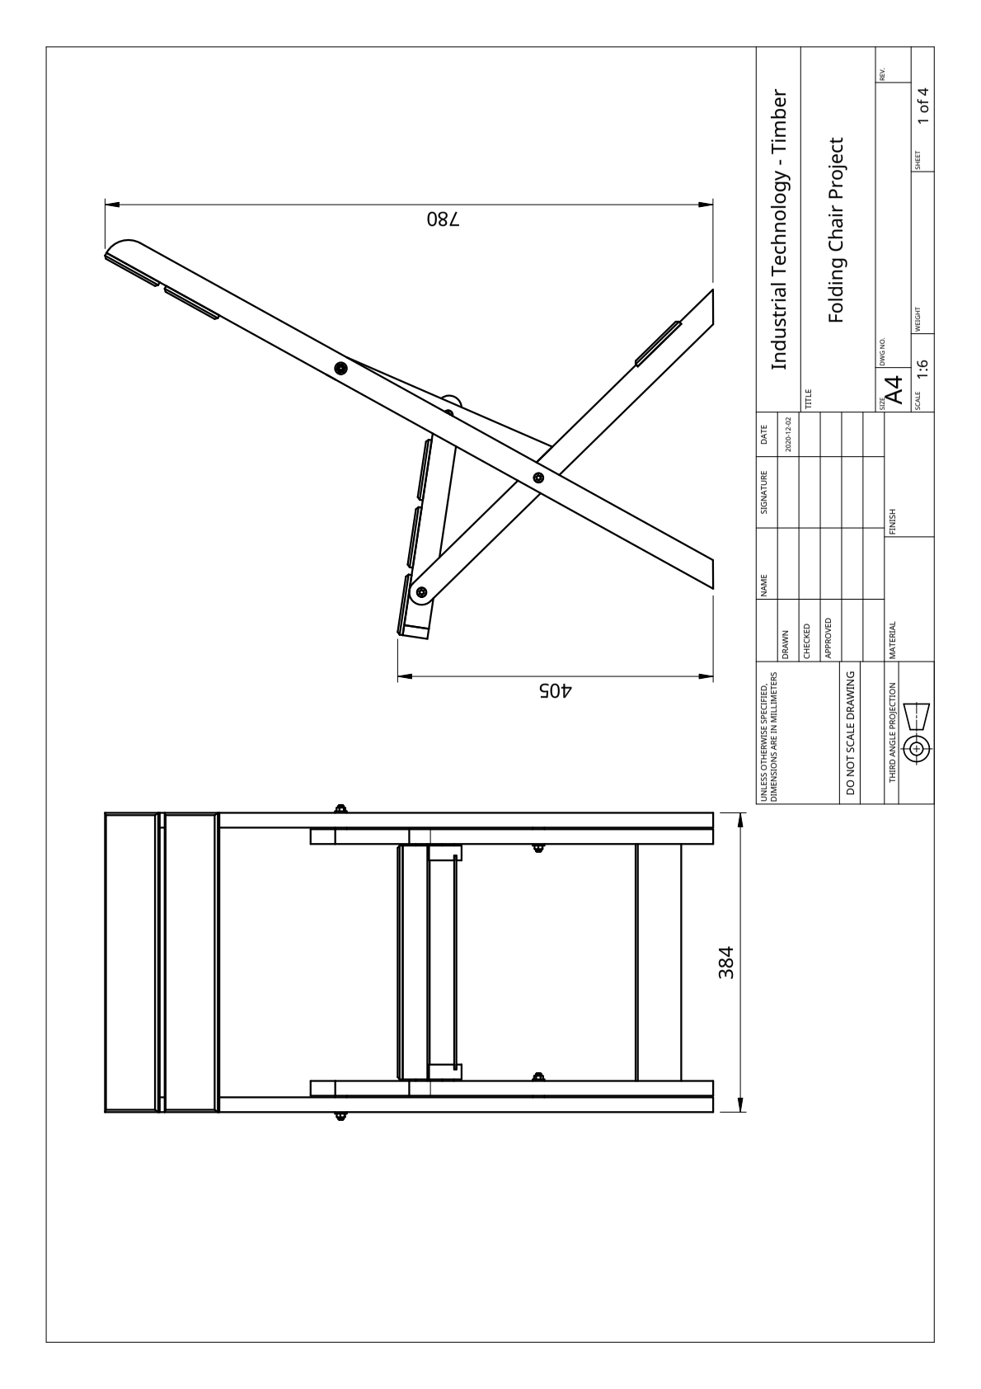
Overview: front and side views. Original plan sheet 1 of 4, rotated and resized for this workbook. Dimensions in millimetres. DO NOT SCALE DRAWING.

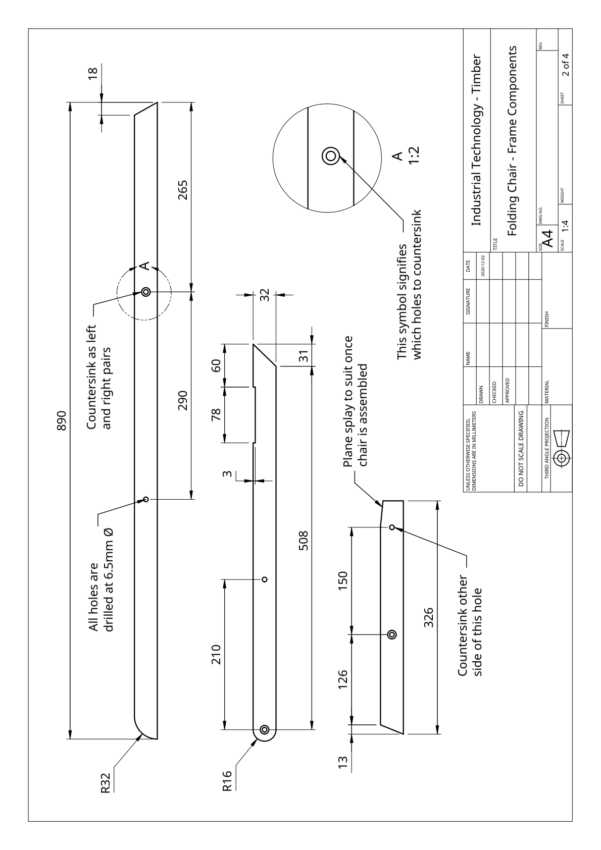
Frame components. Original plan sheet 2 of 4, rotated and resized for this workbook. Dimensions in millimetres. DO NOT SCALE DRAWING.

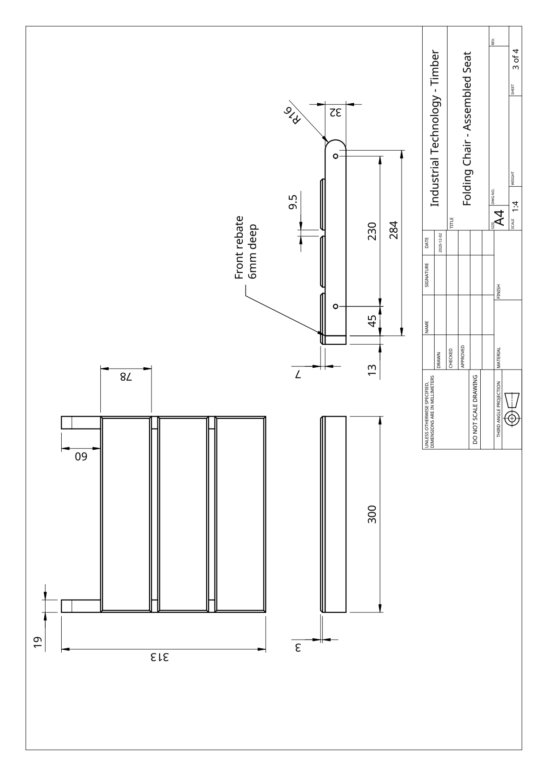
Assembled seat. Original plan sheet 3 of 4, rotated and resized for this workbook. Dimensions in millimetres. DO NOT SCALE DRAWING.

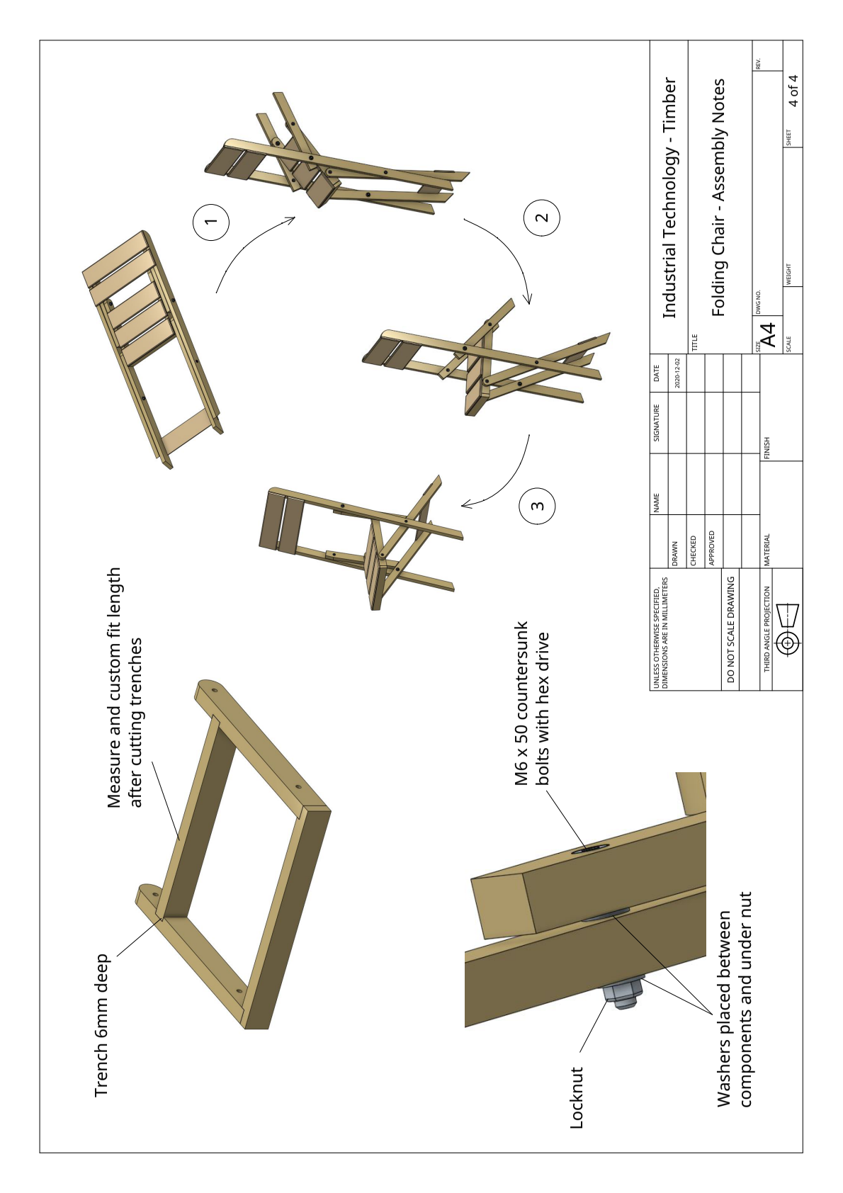
Assembly notes and hardware. Original plan sheet 4 of 4, rotated and resized for this workbook. Dimensions in millimetres. DO NOT SCALE DRAWING.

Show the decision you made
Use the approved chair geometry as your starting point. Record a permitted variation and the evidence behind it.

Concept A: sketch and annotate the proposed detail. Identify what stays fixed.

Concept B: show an alternative. Add a movement or clearance note where relevant.

Compare the concepts against two criteria. Which do you recommend, and why?

Teacher discussion / approved decision and date

Turn the drawing into parts
Use the written plan information. Teacher to confirm actual stock and preparation allowances.

Sketch one component or detail from the original plans. Add its datum, centre line, waste side and relevant written dimensions.

Component / quantity | Finished L × W × T (mm) | Stock / allowance / note

Record the actual timber, one inspection finding and your component-allocation decision.

Record the datum and pair/handedness check you completed before cutting.

Record the making, not just the result
Keep details specific enough for another person to understand your judgement.

Add a labelled process sketch or attach a photograph of your own work. Show the component, operation and feature checked.

Caption: date and stage → what you did → evidence checked → correction or result.

Checkpoint | Your result / evidence location
Fixed joints and assembly squareness
Pivot hardware and controlled movement
Seat/back slats: support, spacing and alignment
Surface preparation and finish record

Name a hazard from this stage and the control you actually used.

Evaluate honestly and hand over well
Separate what you observed from what still needs checking.

Final check | Finding / next action
Structure, joints and stability
Folding path, hardware and clearance
Surface, cure and documentation

Choose one success criterion. Give your evidence, a judgement, a limitation and one specific improvement.

Which working habit will you carry into the next project? Explain what happened, why it mattered and how you will verify the improvement.

Record the teacher-confirmed care advice and any unresolved handover issue.

