
2026 COURSE COMPANION
Graphics
Technology
YEAR 10

Ideas made clear. Decisions made visible.
Graphic design · Architecture · Engineering · Your project
NAME __________________________________ CLASS ______________
Illustrative studio image • 50 pages • A4 • Duplex long edge • Edition 1.0

01 / GRAPHIC DESIGN & COMMUNICATION
Your route through the course
Twelve connected sections. One practical companion.
Read • investigate • explain • keep evidence
Use this companion with the guided website, teacher demonstrations and current class sources. Every named section has teaching, original questions and a complete selected paper task. The rest of the required source work remains online; only the four review puzzles are optional.
Section | Learning route | Pages
M01S01 | Safety signs and visual conventions | 3–6
M01S02 | Vector graphics and Illustrator workflows | 7–10
M01S03 | Design principles, audience, culture and intellectual property | 11–14
M02S01 | Spatial planning and architectural research | 15–18
M02S02 | CAD drafting, drawing views and conventions | 19–22
M02S03 | Sustainability, building context and professional roles | 23–26
M03S01 | Projection systems and freehand communication | 27–30
M03S02 | CAD modelling, materials and manufacturing | 31–34
M03S03 | Dimensioning, standards, assemblies and animation | 35–38
M04S01 | Brief, audience, criteria and constraints | 39–42
M04S02 | Ideation, project management and digital development | 43–46
M04S03 | Presentation, feedback and evaluation | 47–50

Keep the authority clear
This companion follows the pinned 2026 GT5/2019 course. The source schedule records 35% / 35% / 30% for three tasks, but its linked notices are drafts. Historical 2025 dates and marks are not new requirements. The student-negotiated project remains required learning. Current teacher-issued tasks, drawings, templates and licensed standards control actual requirements.

Printed selection: 36 original MCQs, four whole activities, four whole capstones and four whole folio cards. Complete the other 84 MCQs and eight of each task type through the section links. Saving or exporting online evidence does not submit it.
Open the Year 10 Graphics Technology guided course
Print all 50 A4 student pages double-sided on the long edge: 25 sheets. Use the PDF for controlled printing; Word keeps the learning text and fields editable.

01 / GRAPHIC DESIGN & COMMUNICATION
Read the complete sign
Safety signs and visual conventions
A system, not one clue
Safety signs communicate important information in a particular place. They may warn about a hazard, prohibit an action, identify something that must be done or direct a person to safety-related facilities. Read colour, shape, symbol, contrast and any wording together. A familiar colour alone does not establish the meaning: the claim that red always means danger is too simple.
Make recognition deliberate  Visual hierarchy is the order in which information attracts attention. Give the main message priority and keep supporting wording concise. A realistic illustration can contain detail that competes with recognition. Purposeful simplification removes what the viewer does not need while retaining the features that communicate the idea. | The graphic belongs somewhere  Audience, location and viewing conditions affect whether a sign can be understood. A symbol that looks clear at close range on a bright screen may be difficult to recognise across a corridor, among other notices or against a busy background. Establish the intended message and setting before copying or proposing a redesign. Current signs and teacher instructions remain authoritative.

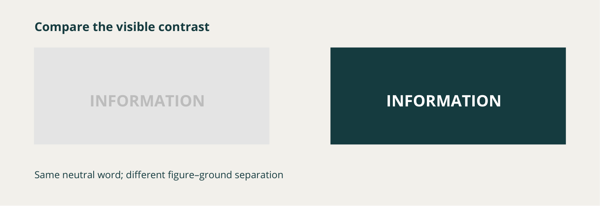
Conceptual communication study, not a safety-sign standard. The same neutral information word is easier to separate from one background. Contrast is one feature to inspect; purpose and context still control interpretation.
Identify one visible feature and one context question you would keep separate.

01 / GRAPHIC DESIGN & COMMUNICATION
Context changes communication
Apply the explanation, then check your reasoning.
Observe before judging
A useful critique identifies a visible feature, explains its likely effect and names the context that could change the judgement. “The pale symbol has weak contrast” is an observation. “Nobody can understand it” claims an audience result that has not been tested. A sign supports safety communication; it does not replace induction, supervision or other risk controls.
A worked communication decision
One designer checks the audience and viewing location, gives the main symbol priority and removes unnecessary detail. Another copies a familiar picture, adds a realistic scene and writes a long explanation underneath. The first approach better supports quick recognition because its hierarchy and simplification serve the stated purpose. This is a communication comparison, not permission to change a local safety sign.
Before you redraw
Identify the purpose, intended audience and location. Then inspect how colour, shape, symbol, contrast and wording contribute. Look for competing details and crowded text. Check the graphic at its intended viewing size. Clean edges alone cannot make the wrong message appropriate. These deliberate shapes and relationships will also be useful when you construct editable vector graphics.
Circle one best answer for each original course question.
1. Which approach gives the most reliable interpretation of a safety sign?
○ A. Use its colour alone because each colour has one universal meaning.
○ B. Read its colour, shape, symbol, contrast and wording together.
○ C. Judge it by how realistic the picture appears.

2. Why might a clear symbol on a computer screen perform poorly in its intended location?
○ A. Digital symbols cannot be used in physical signs.
○ B. Distance, background clutter or competing signs may reduce recognition.
○ C. A sign only works when its audience designed it.

3. Which critique uses the strongest visual evidence?
○ A. It looks professional, so it must be effective.
○ B. It is good because I personally like the colours.
○ C. The main symbol is recognised quickly because contrast and hierarchy separate it from supporting text.

01 / GRAPHIC DESIGN & COMMUNICATION
Context before colour
Context before colour: safety-sign evidence audit
A safety-sign graphic should be read as a complete communication, not guessed from colour alone. Sort the statements, then write a short evidence-based critique.
Read each statement without imagining a local workshop rule.
Sort it as observed visual evidence, a context question, or an unsupported conclusion.
Check the sort, revise any weak decisions, then complete the three-sentence critique.
Classify each statement about a fictional sign shown in a busy public corridor.
Choose from: Observed visual evidence • Context question • Unsupported conclusion
Source statement | Your choice
The pale symbol has weak contrast against its background.
Who needs to recognise this sign while moving through the corridor?
The sign makes the whole location safe.
Three detailed images compete with the main symbol.
What action or information is the complete sign intended to communicate?
Red proves that the sign means danger.

01 / GRAPHIC DESIGN & COMMUNICATION
A critique grounded in evidence
Continue every stage of the same source activity.
Write a three-sentence critique: identify one visual feature, explain its likely effect on recognition, then name one context fact you would check before recommending a redesign.
The visual evidence I can observe is …

This may affect recognition because …

Before recommending a change, I would check …

Check your critique
Check: Names visible evidence
Check: Explains an effect rather than a preference
Check: Does not claim a local safety rule
Check: Includes audience, purpose or location
Support for revising a decision
Ask: can I actually see this, do I need context to know it, or am I claiming more than the graphic shows?

Required online continuation
Complete original questions 02, 03, 04, 07, 08, 09, 10 and the remaining required tasks below. Paper work does not update browser progress or submit itself.
M01S01 • original check and capstone
M01S01 • required folio

01 / GRAPHIC DESIGN & COMMUNICATION
Build with editable geometry
Vector graphics and Illustrator workflows
Choose a representation for its job
Raster images store a grid of pixels. They suit photographs because pixels can represent fine changes in texture, light and colour. Enlarging a raster far beyond its intended size can make its pixels noticeable. Vector graphics store mathematical paths, points and shapes; their geometry can be recalculated when the graphic changes size. Vectors are not higher-resolution photographs. Select the representation for the communication purpose.
Control paths, fills and strokes  Anchor points control straight or curved path segments. Use only the points needed for the intended form: unnecessary anchors can introduce bumps and make editing harder. A fill describes the inside of a shape; a stroke describes its outline. Live shapes keep geometric properties adjustable. Keeping major elements editable lets you revise a decision without reconstructing the whole graphic. | Organise the artwork  The artboard defines the working area. Layers separate elements so you can select, hide and edit them reliably. Alignment controls establish consistent relationships. A technically tidy file can still communicate poorly, so inspect hierarchy, contrast and text placement as well as path geometry.

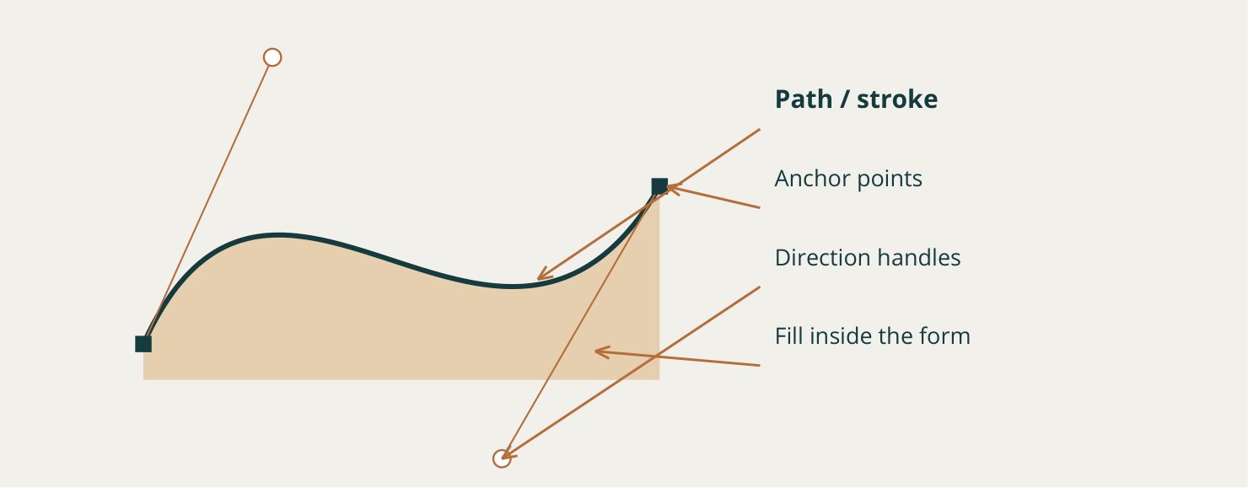
Conceptual vector path. The curve, its anchor points and direction handles have different jobs. This is an explanatory diagram, not a screenshot of a particular Illustrator version.
Explain one edit that would be easier with separate, editable vector elements.

01 / GRAPHIC DESIGN & COMMUNICATION
Keep the workflow recoverable
Apply the explanation, then check your reasoning.
A controlled class example
The source stop-sign exercise uses an octagonal form, a white border, sans serif capitals and a deep red example around RGB 204, 2, 2, with the teacher’s small variation allowed. These are exercise settings, not universal legal specifications. Follow the current teacher example and do not treat an accurate tracing as approval to use a sign in another context.
Object colour is not document mode
Entering an RGB value changes the selected artwork’s colour. It does not by itself change the colour mode of the entire document. Check the document and artboard setup separately from object fills, strokes and colour values. The current teacher instructions determine the required setup; a generic software panel is not evidence of the local settings.
Keep an editable source; inspect the export
Construct the main geometry, style it deliberately, organise layers and alignment, then inspect the whole communication. Preserve the editable working file before preparing the required export. Reopen or view that export in the form and at the size the audience will encounter. Check text, spacing, hierarchy, accidental objects and unwanted path changes. A successful export command proves that a file was produced, not that the message survived clearly.
Circle one best answer for each original course question.
1. Which statement accurately distinguishes vector and raster graphics?
○ A. Vectors use paths and shapes, while rasters use a grid of pixels.
○ B. Vectors are simply photographs saved at a higher resolution.
○ C. Rasters remain perfectly sharp at every enlargement because they use pixels.

2. What happens when a student enters an RGB value for selected artwork?
○ A. The selected artwork’s colour can change, but the document colour mode does not automatically change.
○ B. Every object and the document mode must change together.
○ C. The artwork is automatically converted from vector to raster.

3. What is the strongest final step after preparing the required export?
○ A. Inspect the exported result at the intended viewing size.
○ B. Delete the editable source immediately.
○ C. Assume numerical settings guarantee effective hierarchy.

01 / GRAPHIC DESIGN & COMMUNICATION
Plan a vector workflow
Develop one connected response across both pages.
Justify an editable Illustrator workflow for constructing, checking and exporting a clear vector safety-sign graphic for a stated audience and purpose.
Planning support: Move from construction decisions to organisation, communication checks and final export verification.
Explain why vector geometry is appropriate and how paths, live shapes, anchor points, fill and stroke would be controlled.

Describe how layers, alignment, artboard setup and editable objects support an efficient workflow.

01 / GRAPHIC DESIGN & COMMUNICATION
Check the finished export
Continue the same capstone; support each judgement with evidence.
Explain how audience, purpose, hierarchy and viewing size guide the design checks.

Describe how you would inspect the editable file and exported result without treating class exercise settings as universal standards.

Success criteria
Connects software choices to editability and communication rather than listing commands.
Includes purposeful pre-export and post-export checks linked to the intended audience and use.
Required online continuation
Complete original questions 02, 03, 04, 06, 07, 08, 10 and the remaining required tasks below. Paper work does not update browser progress or submit itself.
M01S02 • original check
M01S02 • required activity
M01S02 • required folio

01 / GRAPHIC DESIGN & COMMUNICATION
Make a message work
Audience and purpose turn preference into design reasoning.
Design for a viewer  A graphic might inform, explain, persuade or direct. Its audience is the group who must understand it. Start with what those people need to notice and the conditions in which they will see the message. A quick-glance graphic cannot carry the same density as a close-view explanation.  A convincing rationale connects a choice to that communication job. “I enlarged the heading so the main message is noticed before supporting detail” explains a decision. “I like large type” records a preference without showing why it suits the audience. | Organise visual weight  Composition arranges elements; proportion controls their relative size. Together they establish a reading order. Tone is lightness or darkness. Contrast can separate important information, but many competing contrasts can make every element demand attention.  Balance does not require symmetry. An asymmetrical page can feel stable when size, position and tone distribute visual weight deliberately. Change one element, then inspect the whole composition: a larger image may improve recognition while weakening the heading’s priority.

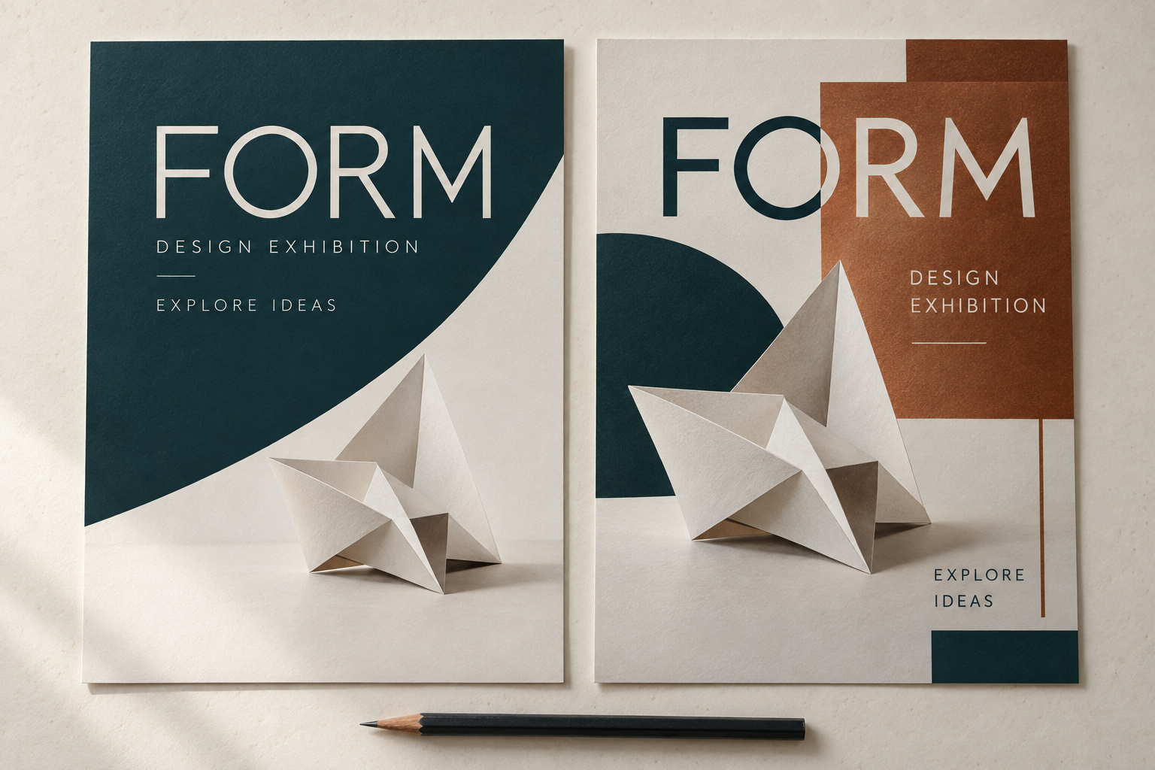
Figure 1. Original illustrative mockups. The same words and similar imagery use different spacing, contrast and placement. Visible features support a comparison; audience effectiveness still needs testing.
Name one visible difference. How might it change the order of attention?

01 / GRAPHIC DESIGN & COMMUNICATION
Source, rights and cultural authority
Apply the explanation, then check your reasoning.
Source access is not permission
Inspiration means developing your own response to an idea. A reference provides information or context. Copying reproduces a substantial visual element. Recolouring copied artwork does not automatically make it original, and an online logo is not automatically free to use. Copyright and trade marks concern different protections; do not assume one follows the other’s registration process.
Record authority, not just a link
Record the source, creator, intended use and available permission or reuse basis. Attribution does not automatically replace permission. Consider privacy before including identifiable people or personal information. For First Nations cultural knowledge, designs, stories, symbols or other expressions, ICIP and cultural authority matter. Do not create a generic “Aboriginal-style” treatment. Pause for current teacher and relevant custodian/community guidance rather than treating cultural material as decoration.
Circle one best answer for each original course question.
1. Which design decision best responds to an identified audience and purpose?
○ A. Choosing elements because the designer likes them.
○ B. Selecting hierarchy and imagery that help the intended viewers recognise the required message.
○ C. Copying a popular graphic because many people have seen it.

2. Which statement about balance is accurate?
○ A. A balanced design must be perfectly symmetrical.
○ B. Asymmetrical elements can still create a stable composition.
○ C. Balance means every element must be the same size.

3. What should a student do if a concept may involve First Nations cultural material?
○ A. Use it immediately if the design message is positive.
○ B. Pause and seek current teacher and appropriate community guidance.
○ C. Change one visual detail and proceed without checking.

01 / GRAPHIC DESIGN & COMMUNICATION
Show the reading order
Audience, hierarchy and rights check
Select a graphic and justify its reading order for the intended audience, then record one release check.
Visual quality and responsible source use must be resolved together.
Evidence to select: An annotated graphic or hierarchy sketch plus a concise source, privacy, permission or cultural-authority record.
Your evidence: draw, annotate or attach a permitted extract

What does the annotation prove about audience and responsible release?

Source / version / date of the evidence

01 / GRAPHIC DESIGN & COMMUNICATION
Justify and check before release
Explain what the evidence supports and what it does not.
What should be noticed first, why does that suit the audience, and what must be checked before sharing?
The intended audience needs…

Hierarchy is created by…

Before release I must check…

Keep the claim bounded
Learning and project-development evidence only; no public release is authorised by this folio.

One source, privacy, permission or teacher-controlled point still to check

Required online continuation
Complete original questions 03, 04, 05, 06, 07, 09, 10 and the remaining required tasks below. Paper work does not update browser progress or submit itself.
M01S03 • original check and capstone
M01S03 • required activity

02 / ARCHITECTURAL DRAWING
Relationships before walls
Spatial planning and architectural research
Read a plan as relationships
A floor plan communicates the arrangement of spaces from above. Furniture can suggest use, but the important relationships include rooms, openings and movement. Zones group related activities: private, shared and service areas can have different needs. Adjacency asks which spaces should connect, sit near one another or remain separated. These are questions to test against the brief, not universal housing rules.
Trace the route  Circulation describes movement through and between spaces. The shortest route is not automatically the best. It may cross a private room, interfere with furniture or create congestion. A clearer, slightly longer route may serve the occupants better. Consider access, privacy, daylight and site orientation as factors to investigate; do not invent regulatory requirements or minimum dimensions. | From brief to bubbles  The source class concept is about 60 square metres and includes a bedroom, toilet, kitchen, laundry and bathroom. Combined living/dining, storage, a porch or a garage are possible additions where the exercise allows them. Begin with the required spaces as labelled bubbles. Test zones, useful connections and movement before detailed walls. Room areas should respond to activities and the available space, not to a desire for equal-looking boxes.

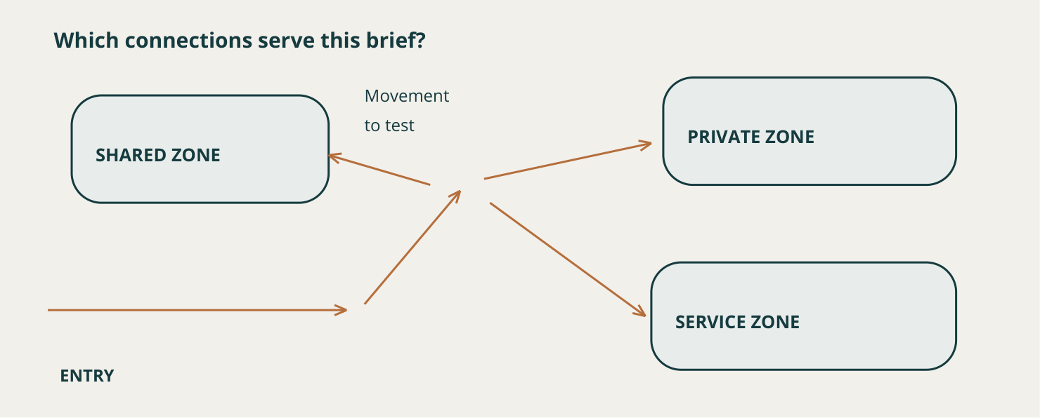
A dimension-free relationship study. Arrows indicate possible connections and movement, not walls, room sizes or an approved plan. The current class brief controls required spaces.
Name a circulation conflict that a bubble study could reveal before detailed drafting.

02 / ARCHITECTURAL DRAWING
Research a spatial possibility
Apply the explanation, then check your reasoning.
Keep the proposal changeable
For example, test a kitchen–shared-area relationship, a bedroom separated from the entry, and a compact service grouping. Then trace access to the toilet without passing through the bedroom. This is an adjacency study, not a finished or required solution. Move the bubbles when a route exposes a conflict; early revision is cheaper than redrawing a detailed plan.
Learn a principle from a precedent
Precedent research studies how a designer responded to users, space, materials, climate or another problem. Record the architect, project and context from credible evidence. Official organisations, established cultural institutions, universities, recognised professional bodies and reputable publishers are useful starting points. Cross-check important claims and keep sources with your notes.
Transfer the reasoning, not the building
If a reliable source identifies a clear circulation spine in a compact building, test that principle in your own brief. Do not copy the building’s appearance and call it research. Explain what you observed, why it worked in its original context and what your proposal still needs to test. The source’s references to NCC and BASIX establish professional context, not classroom approval advice or current compliance values.
Circle one best answer for each original course question.
1. What does adjacency describe in spatial planning?
○ A. The planned relationship between spaces.
○ B. The decorative style of furniture in a room.
○ C. The final lineweight of the CAD drawing.

2. What is the best use of a bubble diagram early in planning?
○ A. To test zones, adjacencies and circulation with simple shapes.
○ B. To specify final construction dimensions without a source.
○ C. To copy the appearance of a precedent building.

3. What is a responsible use of architectural precedent?
○ A. Copy the building shape because a famous architect used it.
○ B. Study a decision, test its principle in the new context and record the influence.
○ C. Use the first image-search result without checking its source.

02 / ARCHITECTURAL DRAWING
Spatial relationship studio
Spatial relationship studio
A compact floor plan begins with relationships, not detailed walls. Sort the planning statements, then build a written bubble-plan proposal that can still be revised.
Classify each statement by the planning idea it tests.
Use the supplied class spaces without inventing dimensions.
Write one relationship proposal and one question that still needs evidence.
Identify the planning idea used in each statement.
Choose from: Zone • Adjacency • Circulation • Context or evidence to investigate
Source statement | Your choice
Group more private spaces so they are separated from busy shared activity.
Test whether the kitchen and shared eating area benefit from a direct relationship.
Trace movement from entry to shared, private and service spaces and look for conflicts.
Check site orientation and daylight information before claiming an opening location is effective.
Keep the bathroom and laundry near each other as one option for a compact service relationship.

Using the class exercise spaces, describe one possible set of zones, one adjacency to test and one circulation conflict to avoid. Finish with one source or context question.
Possible zones …

Adjacency to test … because …

02 / ARCHITECTURAL DRAWING
Draw and explain a proposal
Continue every stage of the same source activity.
Using the class exercise spaces, describe one possible set of zones, one adjacency to test and one circulation conflict to avoid. Finish with one source or context question.
Bubble study: label spaces, relationships and one movement path

Circulation conflict to avoid …

Information still needed …

Check: Uses relationship language • Does not invent exact room dimensions • Treats the arrangement as a proposal • Names evidence still needed
Required online continuation
Complete original questions 01, 02, 04, 05, 07, 09, 10 and the remaining required tasks below. Paper work does not update browser progress or submit itself.
M02S01 • original check and capstone
M02S01 • required folio

02 / ARCHITECTURAL DRAWING
One building, several views
CAD drafting, drawing views and conventions
Give each view a job
A floor plan shows spaces, walls, openings and circulation from above. An elevation shows the external appearance of one side. A section imagines a cut through the building to expose internal and vertical relationships. A site plan relates the building to its site. A detail enlarges an area that needs closer explanation. No single view supplies every kind of information.
Describe the same building  Follow one fictional window through the drawing set. The plan establishes its position along a wall. The elevation must place it consistently. A section through that opening must show the opening, not uninterrupted wall material. If the views disagree, return to the controlling source, determine the correction and check related annotation. Neater linework cannot resolve contradictory geometry. | Precision and readability  Model space holds numerical geometry, but final output must also be readable. Confirm the correct file, units and teacher template before drawing. A consistent drawing in the wrong units is still unsuitable. Layers organise walls, openings, dimensions and other information; they are more than a colour system. Use the current template’s layer names and settings.

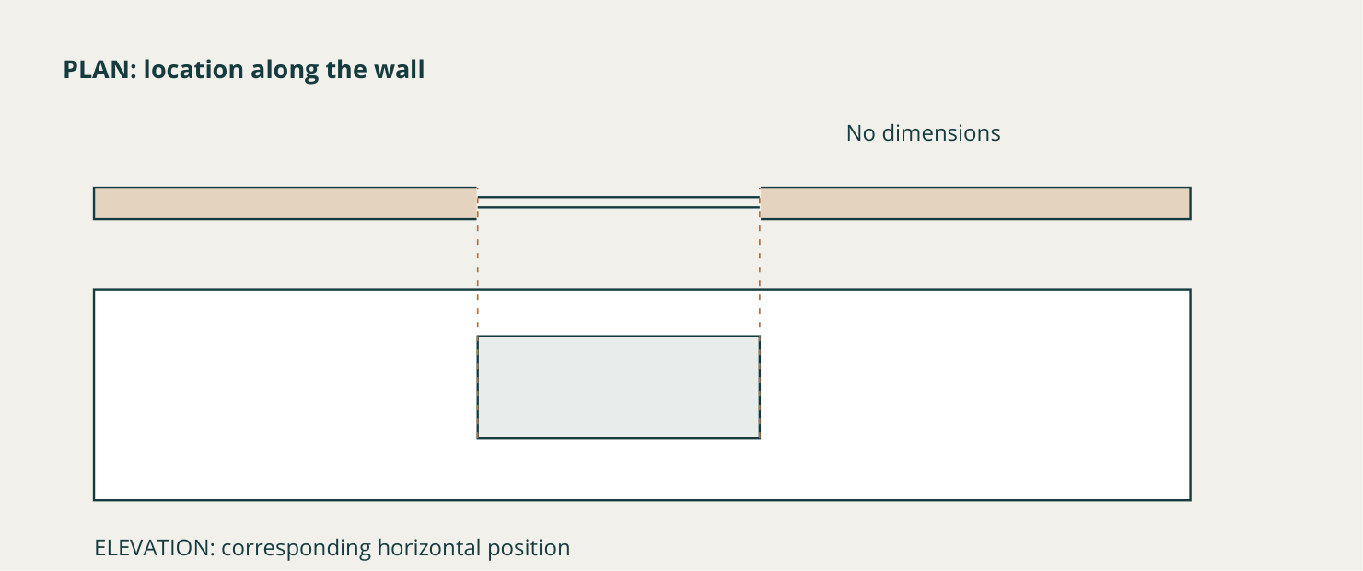
Conceptual plan/elevation relationship for one opening. Dashed projectors identify the same horizontal location. There are no project dimensions or construction details.
What should a section show if its cutting location passes through the same window opening?

02 / ARCHITECTURAL DRAWING
Coordinate the drawing system
Apply the explanation, then check your reasoning.
Make hierarchy informative
Linetype and lineweight help distinguish outlines, secondary information, reference information and annotation. They communicate structure rather than decoration. Construct major geometry systematically, then coordinate doors and windows with the walls. Plan dimensions, text, north information and titles as part of the drawing. A geometric change can make an old dimension or note incorrect.
Check one feature through every view
In the fictional window example, compare horizontal position in plan and elevation. If the section crosses the same place, inspect whether its opening agrees. No numerical dimensions are needed for this logic check. CAD places geometry precisely where instructed, including precisely the wrong place.
A final-check routine
Check geometry, source match, layers, line hierarchy, annotation and cross-view agreement before preparing output. Read the exported drawing at its intended scale, because on-screen zoom can hide weak labels and lineweights. Teacher-supplied dimensions, title blocks and conventions remain controlling. Historical TAFE drawings are reading evidence; resized scan labels do not establish workbook scale, current construction instructions or standards approval.
Circle one best answer for each original course question.
1. When is a section especially useful?
○ A. When internal levels or construction relationships need to be shown.
○ B. When only the site boundary and north point are required.
○ C. When the designer wants a decorative colour palette.

2. Why are CAD layers more than a colour system?
○ A. They organise categories of drawing information and can control their properties.
○ B. They guarantee the drawing is accurate.
○ C. They replace the need for different drawing views.

3. A window moves in the floor plan. What is the strongest next action?
○ A. Update the plan only because it is the main view.
○ B. Check and revise every related elevation, section and annotation.
○ C. Hide the window layer in every view.

02 / ARCHITECTURAL DRAWING
Audit a changed opening
Develop one connected response across both pages.
Explain how you would build and check a coordinated CAD drawing set so that plan, elevation, section, site information, detail and annotation communicate one consistent design.
Planning support: Structure the answer as view purpose, CAD organisation, cross-view test and revision response.
Explain the distinct question answered by each relevant drawing view.

Describe how model space, layers, linetypes, lineweights and annotation organise the information.

02 / ARCHITECTURAL DRAWING
Explain a controlled correction
Continue the same capstone; support each judgement with evidence.
Use one feature, such as an opening, to show how cross-view consistency would be checked.

Explain how a revision should trigger checks of geometry and related dimensions without inventing values.

Success criteria
Accurately differentiates view purposes and drawing conventions.
Demonstrates a repeatable coordination check that keeps geometry and annotation consistent with authorised source information.
Required online continuation
Complete original questions 01, 02, 04, 06, 07, 08, 09 and the remaining required tasks below. Paper work does not update browser progress or submit itself.
M02S02 • original check
M02S02 • required activity
M02S02 • required folio

02 / ARCHITECTURAL DRAWING
Sustainability needs evidence
Sustainability, building context and professional roles
Make the claim checkable
Sustainability concerns relationships among resources, energy, water, comfort and environment. It belongs in early planning, not as a decorative feature added after the design is drawn. The pinned course identifies water, energy use and thermal performance as BASIX themes. Real project requirements must be checked through current official processes; this workbook does not supply approval advice.
Look for interacting decisions  Orientation, openings and shade affect how internal spaces relate to the site. Water or energy systems can affect service locations and planning. Material decisions involve purpose, resource use and life-cycle considerations. One attractive feature cannot demonstrate that the whole design is sustainable. A change may help one aspect while creating a question elsewhere. | Use coordinated evidence  A site plan can locate the building in its context. Plans show spaces and openings; elevations show external relationships; sections reveal vertical relationships. Use these together to explain a decision. A handsome perspective cannot prove energy performance, thermal comfort, structural resolution or construction readiness.

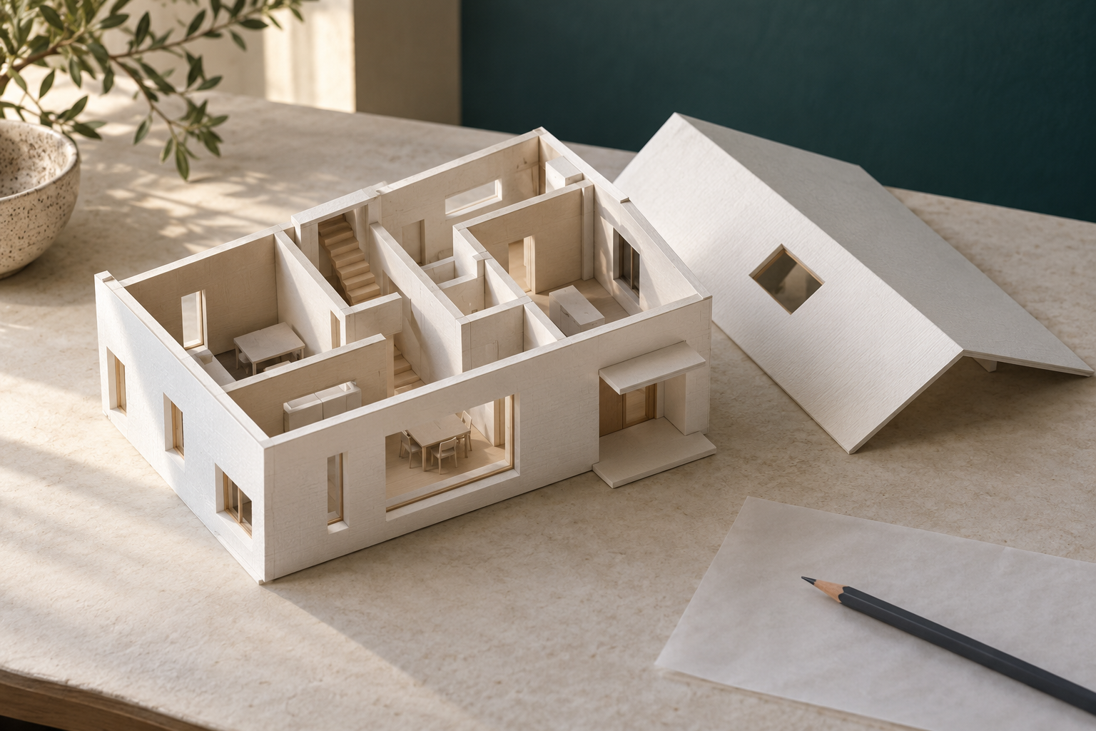
Original illustrative concept model. Openings and some internal relationships are visible; construction completeness, circulation, orientation and environmental performance remain unproven.
Write one bounded observation and one performance claim this picture cannot support.

02 / ARCHITECTURAL DRAWING
A change crosses disciplines
Apply the explanation, then check your reasoning.
Read the model carefully
The illustrative cutaway makes some spaces and openings visible, but it does not establish a complete circulation system, current room sizes or site orientation. Its appearance is a starting point for questions. A defensible claim identifies exactly which drawing or source supports it, and states what further evidence remains necessary.
Several roles share the information
An architect may coordinate the building concept, site and spatial design. An interior designer examines how interior spaces support users, finishes, fixtures and movement. Engineers address relevant technical systems and problems. Other specialists contribute according to the project. These responsibilities overlap; avoid rigid claims that one role owns every drawing decision.
Follow the ripple of a change
If a window moves, check the floor plan, matching elevation, related section, shading, notes and details. Revisit the sustainability rationale because the opening–room–site relationship has changed. Keep revisions consistent so another reader sees one current design. Updating one symbol does not prove better performance or compliance; it demonstrates only the particular change until supported by further evidence.
Circle one best answer for each original course question.
1. Which approach treats sustainability as an integrated design concern?
○ A. Add solar panels after every other decision is fixed.
○ B. Consider site, orientation, openings, shade, water, energy and materials through design development.
○ C. Choose the most attractive rendering style.

2. Which statement best describes professional roles in a building project?
○ A. One professional makes and owns every drawing decision.
○ B. Different professionals contribute specialised knowledge and coordinate related decisions.
○ C. Professional roles are interchangeable and need no communication.

3. A design change moves an external window. Which response is coordinated?
○ A. Update only the floor plan and leave the remaining set unchanged.
○ B. Update related views, annotations, shade information and the rationale as required.
○ C. Keep the old rationale so the original idea remains visible.

02 / ARCHITECTURAL DRAWING
Locate your site evidence
Site and sustainability evidence
Make one bounded sustainability claim and support it with site or drawing evidence.
Appearance alone cannot prove energy, water, comfort or compliance performance.
Evidence to select: A site-plan annotation, drawing extract or source note linked to one design decision.
Your evidence: draw, annotate or attach a permitted extract

What site relationship or source supports this decision?

Source / version / date of the evidence

02 / ARCHITECTURAL DRAWING
Bound the sustainability claim
Explain what the evidence supports and what it does not.
What does your evidence support, and what important approval or performance claim remains unproven?
The evidence supports…

This may improve… because…

It does not yet prove…

Keep the claim bounded
Learning and drawing-development evidence only; this is not building approval or compliance evidence.

One source, privacy, permission or teacher-controlled point still to check

Required online continuation
Complete original questions 02, 03, 05, 07, 08, 09, 10 and the remaining required tasks below. Paper work does not update browser progress or submit itself.
M02S03 • original check and capstone
M02S03 • required activity

03 / ENGINEERING DRAWING
Choose the view that answers
Several coordinated views can explain more than one convincing picture.
Read relationships across views
An orthographic view shows a form from one controlled direction. Related views let you compare the same width, height or feature position rather than redraw each view independently. A pictorial view combines faces so the overall form is easier to imagine; it does not automatically reveal every internal feature.
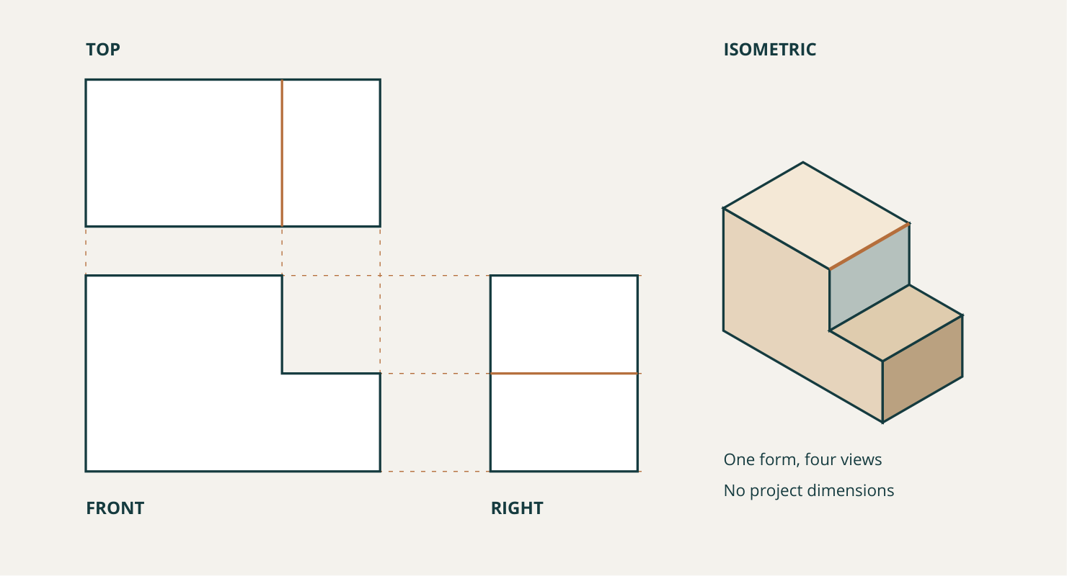
Figure 2. Dimension-free concept study, not a project plan. The step appears in all four representations. The light projectors align shared extents. Use the current teacher template for class view arrangement and conventions.
Select for a purpose  Isometric keeps corresponding receding edges parallel. Perspective uses apparent convergence and size reduction to suggest visual depth. Oblique presents one main face directly and projects depth away from it. Dimetric and trimetric use other axis relationships; choose the system that serves the message. | Reveal what is hidden  A section represents the object as if part were cut away. Use one when an internal hole or recess remains unclear in ordinary views. Extra views should add necessary information. A smaller, coordinated set is more useful than repeated views that merely fill a sheet.

Which relationship can you cross-check between two views of this concept?

03 / ENGINEERING DRAWING
Think before strengthening lines
Freehand drawing is disciplined visual thinking, not careless drafting.
Build lightly, then check
Begin with the overall proportions. Use light construction lines to align related views and locate the major features. Check the same step, hole or edge in each view before darkening the required outlines. This separates a geometry decision from its final presentation and keeps corrections manageable.
A realistic-looking picture may still conceal the internal form. A section is useful when it answers a question the ordinary views leave unclear. Keep source dimensions unchanged, and leave an absent dimension unresolved rather than estimating it from a resized picture.
Circle one best answer for each original course question.
1. How does isometric differ from perspective?
○ A. Isometric uses a controlled axis relationship; perspective represents apparent convergence and reduced size with depth.
○ B. Isometric is a photograph and perspective is a CAD file.
○ C. They are identical except for line colour.

2. Which statement best describes accurate freehand communication?
○ A. Freehand means proportions and alignment do not matter.
○ B. It can use informal lines while maintaining proportion, alignment and feature relationships.
○ C. It must reproduce every detail before the overall form is checked.

3. When should a section view be considered?
○ A. When part of the object must be imagined cut away to reveal internal features.
○ B. Whenever there is empty space left on the page.
○ C. Only when the object has no internal features.

Explain one check you would make before darkening a freehand view.

Continue the remaining seven original questions and the required online capstone and folio for this section. The complete Projection choice workshop is on pages 29–30.
Section 3.1 • original check and capstone
Section 3.1 • required folio continuation

03 / ENGINEERING DRAWING
Projection choice workshop
Projection choice workshop
Different views answer different questions. Match each communication need to a useful representation, then rebuild the freehand routine.
Choose the view that best answers each question; one view may not answer everything.
Order the freehand routine.
Recommend a compact view set for a fictional bracket and justify every included view.
Match the need to the most directly useful representation.
Choose from: isometric pictorial • coordinated orthographic views • section view • perspective
Source statement | Your choice
Show the overall three-dimensional form without perspective convergence.
Compare a hole position across flat controlled views.
Reveal an internal recess that hidden lines do not explain clearly.
Communicate visually realistic depth and apparent size reduction.

Order the freehand view-building routine.
Freehand step | Order
Add major features with construction lines
Strengthen required lines and clarify only necessary information
Block the overall form lightly
Check shared feature relationships across views
Align related views

03 / ENGINEERING DRAWING
Make every view earn its place
Continue every stage of the same source activity.
For a fictional bracket with a hidden internal hole, name the smallest useful view set and explain what question each view answers.
VIEW 1 • its communication job |  | VIEW 2 • the different information

Additional view only if it adds necessary information

Explain what each included view answers and how you would check alignment.

Check: Each view adds different information • Includes a way to reveal the hidden feature • Uses alignment logic • Does not add dimensions
Required online continuation
Complete original questions 01, 02, 04, 06, 07, 09, 10 and the remaining required tasks below. Paper work does not update browser progress or submit itself.
M03S01 • original check and capstone
M03S01 • required folio

03 / ENGINEERING DRAWING
Build the design intent
CAD modelling, materials and manufacturing
Model relationships deliberately
A CAD model often begins with a 2D sketch that supports later features. Constraints control relationships such as alignment and position; dimensions control sizes and locations. A fully constrained sketch has its intended degrees of freedom controlled. That does not prove that the design is suitable, accurately sourced or well planned.
Preserve design intent  Suppose a hole must remain centred across a rectangular base. Define its position from that centre relationship. If an authorised width changes, the dependent feature can update predictably. A hole placed at an unrelated fixed location may look correct initially and become off-centre after the change. Test dependencies, rather than judging only the first smooth-looking result. | Choose a modelling approach  Parametric feature-based modelling uses dimensions, constraints and feature relationships to control change. Direct modelling edits geometry more directly without relying on the same history structure. Neither is universally superior. NURBS and other freeform methods can represent complex curves and surfaces; many prismatic components are efficiently built from simpler sketch profiles. Match the method to the geometry and the purpose.


Original illustrative samples with similar geometry and different surface appearances. The image does not establish material grade, properties, manufacturing method or suitability for any class component.
What relationship should remain true when an authorised base width changes?

03 / ENGINEERING DRAWING
Connect geometry, material and method
Apply the explanation, then check your reasoning.
Geometry is not a material decision
Materials differ in strength, stiffness, hardness, density, durability and manufacturing response. Resource use, waste and service life also matter. A CAD appearance or material setting does not establish a real grade, suitability or performance. The sample image makes visible differences worth noticing; it cannot supply those properties or approve a material for the towbar exercise.
CAD connects to CAM through checked information
CAD develops and communicates design information. CAM uses digital information to support manufacturing processes. Shared geometry can reduce repeated work, but a polished model can still contain wrong geometry, missing information or unsupported assumptions. Computer-controlled processes also need checking; modelling does not authorise manufacture, machine settings, cutting quantities or costing.
Keep the two source contexts separate
The first towbar practice explicitly begins with a 50 mm outside square. The later historical dimensioned sheet shows 52 outside and 42 inside. These belong to different exercise/source contexts and are not one combined specification. Use only the current assigned drawing and teacher instructions. Do not change 50 to 52, infer missing sizes from a raster, or invent materials, tolerances, loads or manufacturing details.
Circle one best answer for each original course question.
1. Which model best preserves the design intent that a hole remain centred when a base width changes?
○ A. A model where the hole is independently placed and merely looks centred at first.
○ B. A model where the hole centre is constrained to the centre of the base.
○ C. A model exported as an image before the width changes.

2. Who or what selects a suitable material for a design?
○ A. The CAD system automatically, once the model looks complete.
○ B. The designer, using appropriate evidence about properties, purpose and manufacturing.
○ C. The colour assigned to the model.

3. How should dimensions be handled in the Onshape towbar practice?
○ A. Use the supplied 50 mm initial outside square and obtain all other values from the authorised drawing or current teacher instruction.
○ B. Estimate every remaining value from the screenshot.
○ C. Reuse dimensions remembered from a different towbar model.

03 / ENGINEERING DRAWING
Explain a recoverable model
Develop one connected response across both pages.
Evaluate a CAD model’s design intent and its readiness to inform material or manufacturing decisions, using only authorised geometry and evidence.
Planning support: Separate geometric evidence, editing behaviour, material evidence and manufacturing readiness before making the judgement.
Identify the geometric relationships that should survive change and explain how constraints or dependencies represent them.

Compare how a parametric or direct-modelling approach could support the expected edits.

03 / ENGINEERING DRAWING
Check the source before manufacture
Continue the same capstone; support each judgement with evidence.
Identify the material-property and manufacturing evidence that is present, missing or still requires authority.

Judge what CAD/CAM use is justified now and what must be checked before any manufacturing claim.

Success criteria
Distinguishes controlled design intent from a model that only looks correct initially.
Makes a source-safe readiness judgement that does not invent dimensions, material properties or manufacturing requirements.
Required online continuation
Complete original questions 02, 03, 04, 05, 07, 08, 09 and the remaining required tasks below. Paper work does not update browser progress or submit itself.
M03S02 • original check
M03S02 • required activity
M03S02 • required folio

03 / ENGINEERING DRAWING
Dimensions carry meaning
Dimensioning, standards, assemblies and animation
Separate size from location
The size of a hole does not tell a reader where it belongs. Its location does not define its size. A useful dimensioning system communicates both, without unnecessary duplication. If several features relate to common references, dimensions from those references may make intent clearer than a long chain. Follow the controlled source: no one scheme is a universal answer.
Communicate controlled variation  A nominal size is a stated reference size. Upper and lower limits bound permitted variation; tolerance expresses the allowable variation associated with a dimension. It does not mean acceptable carelessness. A digital model’s exact-looking geometry cannot establish physical manufacturing accuracy. | Understand fits without guessing them  A clearance fit provides clearance between mating features. A transition fit may result in clearance or interference depending on actual sizes. An interference fit creates interference between the mating features. Do not select a fit because CAD parts appear to touch or overlap. Exact limits and notation require the authorised source.

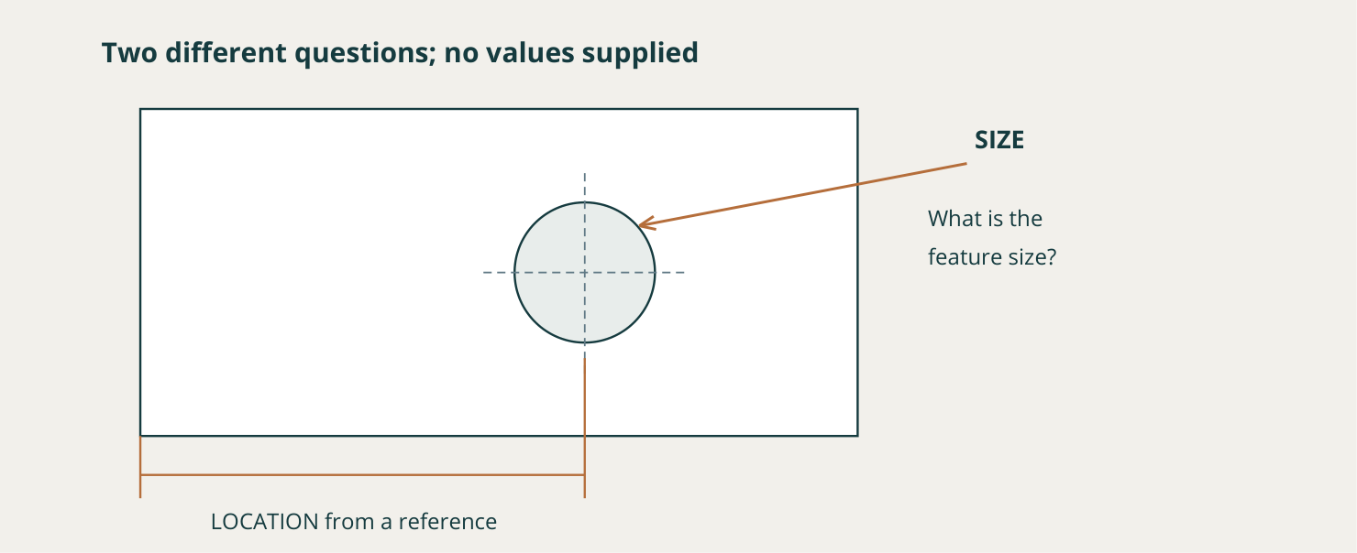
Dimension-free teaching schematic. Hole size and centre location are separate questions. The current issued drawing supplies actual values, references and notation.
Explain how repeating a dimension could create a contradiction after a revision.

03 / ENGINEERING DRAWING
Assemblies show relationships
Apply the explanation, then check your reasoning.
Treat notation as information
Surface-finish and weld information communicate requirements, not decorative technical detail. The course refers to Australian drawing conventions, including AS 1100, as a shared framework. Exact wording, symbols, values, tolerances and fits remain controlled by current teacher sources and licensed standards access. This concept figure deliberately provides no numerical values or substitute symbol table.
Part, assembly and motion answer different questions
A part drawing describes one component; an assembly drawing explains component relationships. Mates or assembly constraints hold parts or permit defined movement. Animation can reveal an unexpected direction, too much movement or visible interference. Inspect useful viewpoints rather than trusting one smooth sequence.
Keep the claim inside the evidence
Motion demonstrates the represented geometry and relationships. It does not prove physical safety, compliance, load capacity or manufacturing readiness; relevant forces, materials and variation may be absent. Before release, check source dimensions, size/location information, authorised notation, part-to-assembly agreement and visible motion conflicts. The historical fastener and towbar sheets remain source-reading evidence, not current standards approval or a combined new specification.
Circle one best answer for each original course question.
1. How do nominal size and tolerance differ?
○ A. Nominal size is a reference size, while tolerance deliberately defines permitted variation.
○ B. Nominal size is a colour, while tolerance is a lineweight.
○ C. They are identical terms for the measured result.

2. What does a mate control in a CAD assembly?
○ A. The relationship between components in the digital assembly.
○ B. The legal permission to manufacture the product.
○ C. The material properties of every component.

3. What should happen before drawing or assembly information is treated as release-ready?
○ A. Verify source dimensions and notation, coordinate related views and identify unresolved requirements.
○ B. Assume a polished animation proves the whole package.
○ C. Add plausible values wherever information is missing.

03 / ENGINEERING DRAWING
Record a drawing or motion check
Drawing, assembly and motion check
Select one drawing, assembly or motion check and state exactly what it demonstrates.
Digital coordination evidence is useful only when its claim stays within the represented model.
Evidence to select: A labelled drawing or assembly view, interference observation or motion screenshot with a bounded claim.
Your evidence: draw, annotate or attach a permitted extract

What design-intent relationship is visible here?

Source / version / date of the evidence

03 / ENGINEERING DRAWING
Say what the model cannot prove
Explain what the evidence supports and what it does not.
What coordination issue did you check, what evidence did you find, and what remains unproven physically?
The check demonstrates…

The drawing or motion revealed…

It does not prove…

Keep the claim bounded
Learning and CAD-development evidence only; safety, manufacture and standards compliance are not automated judgements.

One source, privacy, permission or teacher-controlled point still to check

Required online continuation
Complete original questions 01, 03, 04, 05, 07, 08, 10 and the remaining required tasks below. Paper work does not update browser progress or submit itself.
M03S03 • original check and capstone
M03S03 • required activity

04 / STUDENT NEGOTIATED PROJECT
Turn a topic into a brief
Keep the communication problem clear while the solution is still changeable.
A brief gives an idea a purpose
An interest becomes a brief when you define the communication problem, audience and viewing context. Choose software and format after these decisions, so familiar tools do not determine the solution.
Worked example • a fictional small facility
STARTING TOPIC  “I want to design something about a small community facility.”  The audience and purpose are still missing. |  | COMMUNICATION PROBLEM  Help a defined audience understand the layout and intended use of a fictional small facility.  This is concept communication, not a construction document.

Develop the reasoning
01 Audience | Identify who will use the graphics and how closely they will inspect them. This affects detail, type and hierarchy.
02 Criterion | Check whether labels are readable at the intended presentation size and related views agree. Name something observable.
03 Evidence | Propose the concept graphics needed to judge the communication. The current teacher confirms the deliverables and manageable scope.
04 Approval | Record sources, reuse conditions and any privacy or cultural-authority questions. Take the proposal for teacher review before production.

A useful constraint focuses the work
Required features serve the approved brief. Consider preferred and optional features only when they add communication value within the agreed scope.

Write one audience-and-purpose sentence for a possible project direction.

04 / STUDENT NEGOTIATED PROJECT
Make criteria observable
Apply the explanation, then check your reasoning.
Make success observable
A success criterion describes something that can be examined against audience and purpose. “Looks professional” is too vague. Readable labels at the intended size or agreement between related views can be tested. Separate required features, which the approved solution needs, from preferred improvements and optional extras. The terms organise scope; they do not create a new marking scheme.
Make scope feasible before production
Constraints include available time, skills, appropriate tools, source evidence and ethical limits. They focus creative work rather than only restricting it. Check whether essential deliverables can realistically be developed and evaluated. Record sources, reuse conditions, attribution, privacy and cultural-authority questions. Take the brief, scope and evidence for current teacher approval while change is practical. Publicly visible cultural material is not automatically available to reuse, and attribution alone does not resolve permission.
Circle one best answer for each original course question.
1. Which statement best connects audience, purpose and context?
○ A. They guide communication decisions such as hierarchy, detail and presentation.
○ B. They are interchangeable words for the software used.
○ C. They matter only after the final graphic is complete.

2. Which statement is the strongest success criterion?
○ A. The final design will be awesome.
○ B. The intended audience can identify the main message from the final graphic hierarchy.
○ C. The student will use every available software effect.

3. When should the brief, scope and proposed evidence be taken for teacher approval?
○ A. Before production begins, after feasibility and source checks have shaped the proposal.
○ B. Only after every final output has been completed.
○ C. Only if the student decides the project is important enough for review.

04 / STUDENT NEGOTIATED PROJECT
Brief refinery
Brief refinery
“I want to make a poster” names a format, not a complete graphics problem. Sort the brief components, then refine a vague idea without choosing software or adding unsupported requirements.
Match each statement to the brief component it supplies.
Identify the weak criterion.
Write a compact brief outline and run the approval-readiness check.
Match each statement to the brief component.
Choose from: graphics problem • audience • purpose • context • deliverable • success criterion • constraint
Source statement | Your choice
The people who need to understand the fictional concept
Help that group identify the main relationships in the concept
A close-view presentation rather than a quick-glance sign
A required piece of graphical evidence in the approved project
Related views remain consistent when checked
Use only source material with a responsible, recorded basis
The communication need the project will solve

Replace “It must look professional” with one observable criterion linked to the chosen audience and purpose.
The intended audience can …

This will be checked by …

Check: Observable • Audience-linked • Does not prescribe an unapproved solution • Can be evaluated with evidence

04 / STUDENT NEGOTIATED PROJECT
Build an approval-ready outline
Continue every stage of the same source activity.
Create an outline containing problem, audience, purpose, context, essential evidence, required/preferred/optional features, criteria, constraints, source or privacy checks and the question to take to your teacher before production.
Problem | Audience | Purpose
Context | Essential evidence | Required features
Preferred features | Optional features | Criteria
Constraints | Source privacy checks | Approval question

Use the twelve labelled boxes from the digital outline. Star required evidence, circle unresolved ethical or source questions and take the completed canvas to the current approval discussion.
Required online continuation
Complete original questions 01, 03, 05, 06, 07, 08, 09 and the remaining required tasks below. Paper work does not update browser progress or submit itself.
M04S01 • original check and capstone
M04S01 • required folio

04 / STUDENT NEGOTIATED PROJECT
Explore before selecting
Ideation, project management and digital development
Generate genuinely different directions
Divergent ideation explores several responses before selecting one. Different colours on the same layout are not necessarily different concepts. One direction could use a labelled diagram, another a sequence and another a 3D representation. The first idea may simply be the most familiar. Alternatives give you evidence for comparison.
Use an efficient thinking tool  Thumbnail sketches test composition and relationships quickly. Storyboards suit sequence or motion; freehand views or block models may suit spatial work. Annotate the reason for a choice, such as moving a label nearer its feature. Excessive early polish can make it harder to abandon a weak idea because of time already invested. | Compare against the same brief  Convergent thinking weighs the alternatives against the approved audience, purpose, criteria and constraints. A small matrix can record strong, uncertain or weak with a reason. Avoid invented numerical precision or a score that supposedly chooses automatically. A promising approach may combine one direction’s clarity with another’s useful sequence.

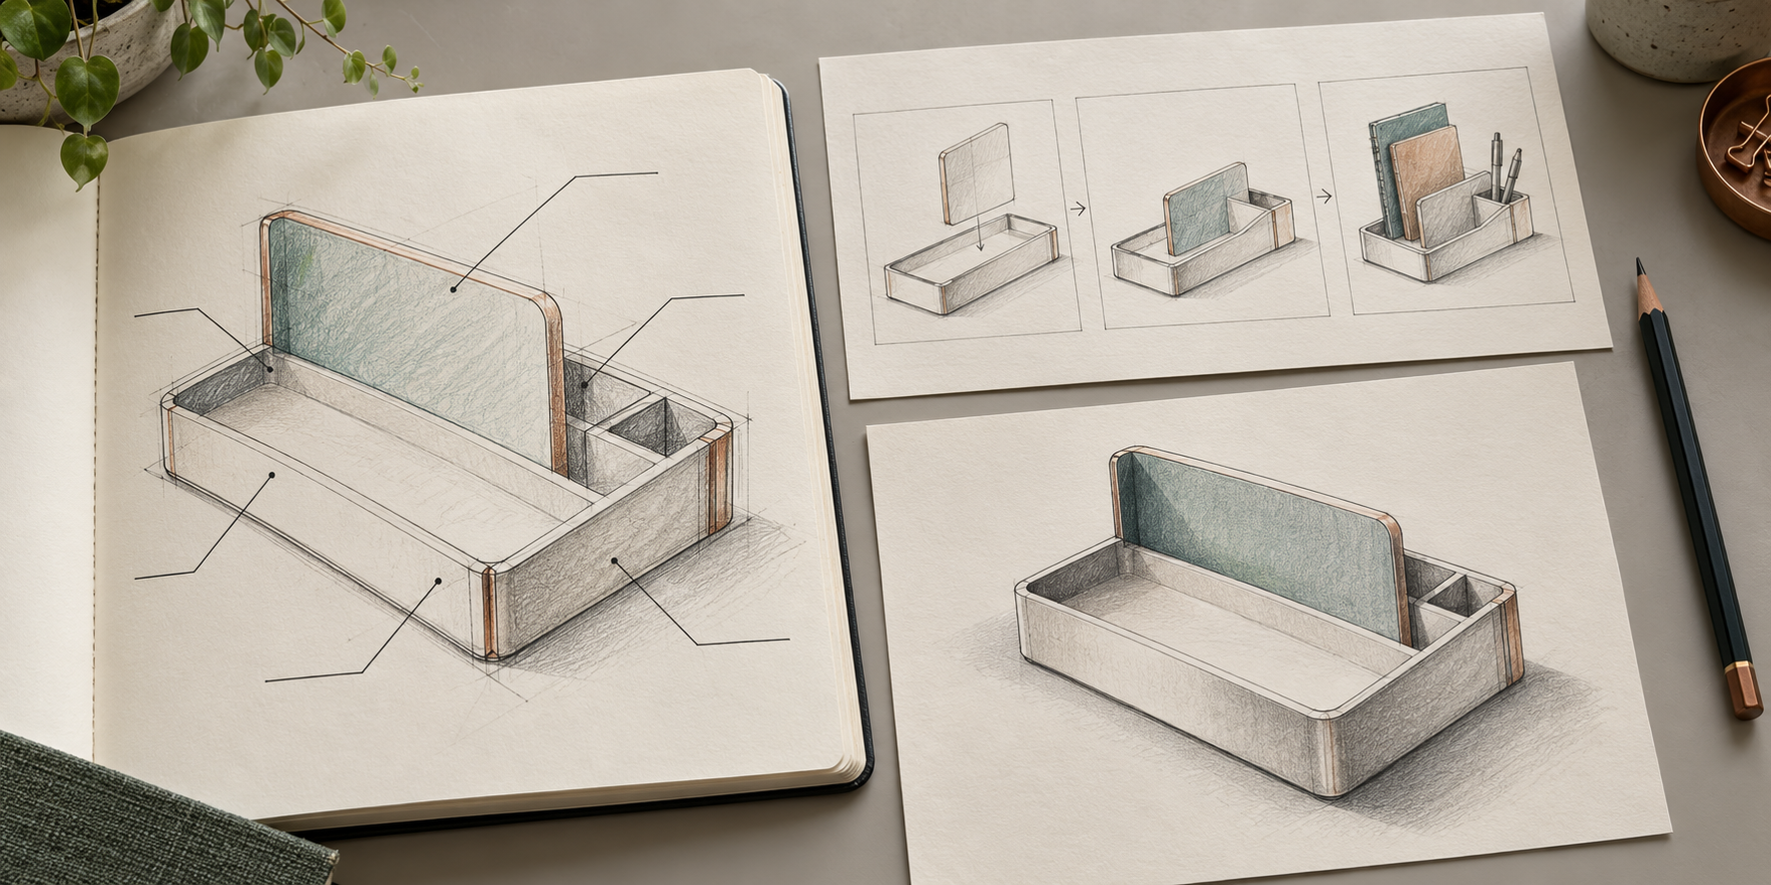
Original ideation study: the left sketch has unfinished leader lines; the top-right sequence shows stages; the lower-right view shows overall form. Completed annotation needs readable notes linked to features. Conceptual only; not construction instructions or evidence of testing.
State a meaningful difference between two approaches, beyond colour or decorative detail.

04 / STUDENT NEGOTIATED PROJECT
Control change and preserve versions
Apply the explanation, then check your reasoning.
Plan meaningful milestones
A milestone marks a resolved stage, such as verified research, concept selection, a prototype or a review. Identify dependencies: final graphics may rely on an approved concept or checked source information. Begin with the decisions that could otherwise force later work to be rebuilt. A simple schedule should make delay and unresolved decisions visible.
Use a midpoint scope check
Ask whether the work still solves the approved problem, whether evidence is developing and whether optional extras are consuming required-work time. Identify dependencies and decide what can be simplified, deferred or removed without losing essential criteria. A controlled change explains what was learned and how the revised direction still serves the brief.
Make development recoverable
Choose tools for the communication job. Prototype, inspect, gather specific feedback and revise. Preserve stable versions before major changes and keep appropriate backups; follow the current teacher’s naming rules. A progress log records attempts and next steps. A decision log records issue, evidence, decision and reason. Provenance records preserve source origins. Automatic cloud history may store files without explaining why a design changed.
Circle one best answer for each original course question.
1. What is the purpose of divergent ideation?
○ A. To generate genuinely different possible responses to the brief.
○ B. To add detail to the first idea until no alternative is possible.
○ C. To choose software before the audience is considered.

2. Why should dependencies be identified in a project plan?
○ A. They show which tasks rely on earlier information or approval.
○ B. They prove that every task can be completed in any order.
○ C. They replace the need for progress checks.

3. Why are controlled file versions stronger evidence than repeatedly saving over one file?
○ A. Versions preserve recovery points and show meaningful stages of iteration.
○ B. Versions guarantee that every design decision is correct.
○ C. Versions remove the need for backups.

04 / STUDENT NEGOTIATED PROJECT
Compare directions and dependencies
Develop one connected response across both pages.
Evaluate a development strategy for an approved graphics brief, showing how idea generation, evidence-based selection, project control and recoverable digital iteration will keep the work aligned and feasible.
Planning support: Organise the response as idea range, comparison, selected direction, milestone/dependency plan and digital evidence controls.
Describe at least three genuinely different idea directions and the early evidence each would communicate.

Compare the ideas against audience, purpose, approved criteria, constraints and feasibility without using fake numerical precision.

04 / STUDENT NEGOTIATED PROJECT
Plan recoverable development
Continue the same capstone; support each judgement with evidence.
Plan meaningful milestones and dependencies, including a midpoint scope check and a response to possible drift.

Explain the prototype, iteration, version, backup, progress-log, provenance and decision evidence that will make development recoverable and traceable.

Success criteria
Makes a justified concept-selection judgement based on the approved brief rather than detail or software novelty.
Presents a practical control and evidence strategy without inventing local software, naming, schedule or submission requirements.
Required online continuation
Complete original questions 02, 03, 04, 05, 06, 08, 10 and the remaining required tasks below. Paper work does not update browser progress or submit itself.
M04S02 • original check
M04S02 • required activity
M04S02 • required folio

04 / STUDENT NEGOTIATED PROJECT
Present selected evidence
Presentation, feedback and evaluation
Present evidence for a purpose
A final presentation is another communication task. Select evidence for the intended audience, establish a clear hierarchy and use captions to explain why a graphic matters. A collection of every screenshot can bury the decisions that demonstrate learning. Choose evidence of a significant problem, change or result, then connect it to the brief.
Distinguish description and justification  “I changed the label” describes an action. “I moved it nearer the feature to reduce the viewer’s search” justifies the decision. A caption can identify the version and the feature while explaining the significance of that change. Clear file selection matters: an old prototype should not be presented as the final version. | Ask feedback that tests something  “Does it look good?” encourages a preference. “What do you notice first, and what does this diagram explain?” tests hierarchy and meaning. Compare the response with an approved criterion and a relevant visual or technical check. Feedback is evidence to interpret, not a popularity vote.

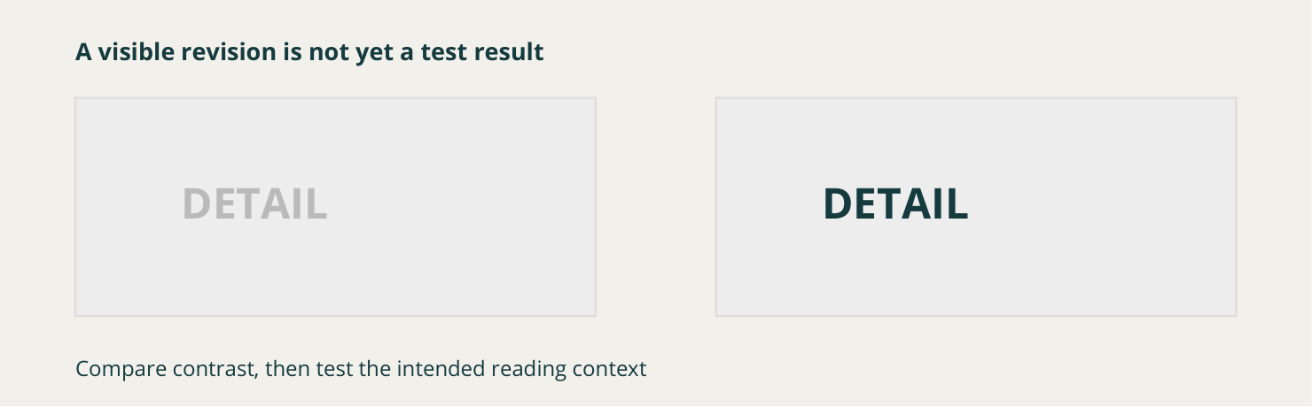
Separate illustrative label comparison, not a student test result. A visible contrast change is an observation; an improvement in audience understanding still requires an appropriate check.
Write one feedback question that tests understanding rather than asking for a preference.

04 / STUDENT NEGOTIATED PROJECT
Use feedback to test a claim
Apply the explanation, then check your reasoning.
A source-grounded example
In the course’s fictional example, a viewer recognises the main message but hesitates over a secondary label. The designer checks that label at its intended size and identifies weak contrast. A controlled revision can then be tested. The useful record connects observation, criterion, change and new evidence; it does not invent perfect results from a polished final image.
Evaluate with claim, evidence and reasoning
A claim states a judgement. Evidence identifies an observable feature, test, feedback response or development record. Reasoning explains why that evidence supports the judgement against the approved brief. Include a strength, a limitation and a justified improvement. A process list describes events; it does not judge effectiveness.
Check before presenting or sharing
Confirm the intended file version and source attribution. Check privacy, rights and cultural authority, including relevant permissions. Removing a name does not remove identifiable images, locations or other information, nor does it resolve copyright or cultural responsibilities. Current teacher directions control presentation, release and submission. Saving, printing or exporting evidence does not submit it automatically.
Circle one best answer for each original course question.
1. What is the most useful role of a caption beside project evidence?
○ A. Identify the evidence and explain the decision, change or outcome it demonstrates.
○ B. List every software command used to create the image.
○ C. Claim that the image proves every criterion.

2. Why should feedback be compared with criteria and technical checks?
○ A. Triangulation helps test whether different evidence supports the same judgement.
○ B. The most popular response automatically decides the design.
○ C. Technical checks become unnecessary once feedback is positive.

3. What relationship should claim, evidence and reasoning have in an evaluation?
○ A. Evidence supports the claim, and reasoning explains why that evidence matters.
○ B. The claim replaces all need for evidence.
○ C. Evidence should be included without explaining its significance.

04 / STUDENT NEGOTIATED PROJECT
Evaluate with evidence
A judgement is stronger when the evidence and its limits are visible.
Select the final and process evidence that best supports one strength, one limitation and one next improvement.
Evidence to select: A final graphic, purposeful before-and-after comparison or focused feedback record with a claim-evidence-reasoning evaluation.
FINAL EVIDENCE • identify the version |  | PROCESS / FEEDBACK • show one significant change

What does this evidence prove about effectiveness or improvement?

How effectively does the result meet the approved brief, what evidence supports that judgement, and what remains limited?
The result meets… because…

Evidence for this judgement is…

A remaining limitation is…, so I would…

Student-negotiated learning context; exact presentation and formal task conditions come from the current teacher.
Use page 50 for the evidence limit, next improvement and source/release check. Do not include private student work or share project material without the required permission.

04 / STUDENT NEGOTIATED PROJECT
Close the loop and continue online
Complete the source folio card begun on page 49.
Evaluation makes a judgement from criteria and evidence; it is not a list of steps or a claim of perfection.
Strength: connect one approved criterion to specific final evidence.

Limitation: what remains uncertain, partly met or unsupported?

Next improvement: what controlled change or further test follows from that limitation?

Before presentation or release
Confirm the intended version, attribution, permissions, privacy and cultural authority. Follow current teacher directions for presentation and submission. Removing names alone does not make material safe to share.

Required online continuation
Complete original questions 01, 03, 04, 06, 08, 09, 10 and the remaining required tasks below. Paper work does not update browser progress or submit itself.
M04S03 • original check and capstone
M04S03 • required activity

