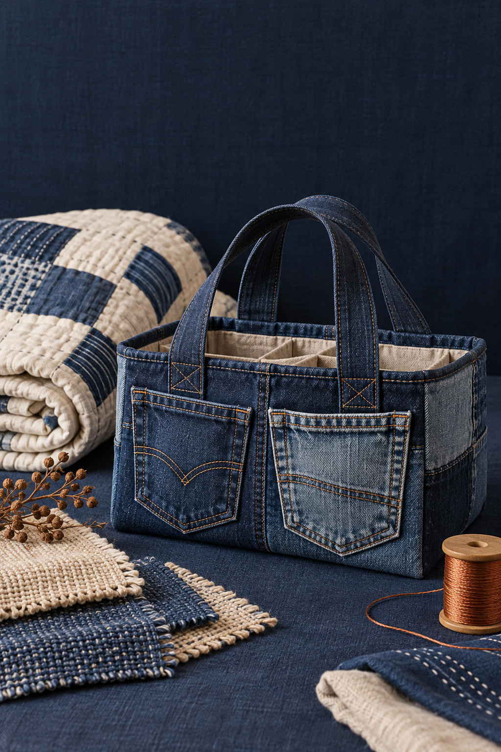
YEAR 10 / TEXTILES TECHNOLOGY

Year 10
Textiles
STUDENT WORKBOOK

Materials, design and evidence
A classroom companion for textile investigations, original course practice and teacher-approved project evidence.
NAME ____________________________________ CLASS ______________
Illustrative cover | 50 A4 pages | 25 sheets duplex, long edge | Edition 1.0

CONTENTS
Use the course and this book
Read, practise and build evidence for the project your teacher approves.
Learning route | Pages
01 Course launch and textile safety | 3–6
02 Fibres, fabrics and performance | 7–10
03 Sustainable fashion and textile waste | 11–14
04 Upcycling design challenge | 15–18
05 Cultural textiles and respectful design | 19–22
06 Kimono design and production | 23–26
07 Furnishings, Quillow and fabric manipulation | 27–30
08 Costume design and influence | 31–34
09 Industry, innovation and careers | 35–38
10 Testing, evaluation and course review | 39–42
Concept studio and selected folio evidence | 43–50

The book teaches all 30 sections and prints selected original checks and activities. Continue the other question-bank practice and the source module-application prompts at the exact module routes in each footer when assigned. Those application tasks retain their source evidence requirements.
Pages 43–49 rehearse the original upcycling concept studio. Page 50 explains the separate Quillow, Upcycle and Costume folio routes. Use only the project your teacher approves. This supplementary book does not set formal assessment conditions, practical settings or pattern dimensions.
Current teacher-approved project and submission route

INTEGRATED READING
Connect theory and making
1.1 How Year 10 Textiles works
Year 10 Textiles combines theory, design, practical production and evaluation. Students investigate why textile products are made, how materials perform, how ideas are developed and how safe processes lead to quality outcomes.
The course website saves practice evidence on the device you use. It does not submit work to Google Classroom. Your teacher remains the authority for the current project, equipment, deadlines and submission instructions.
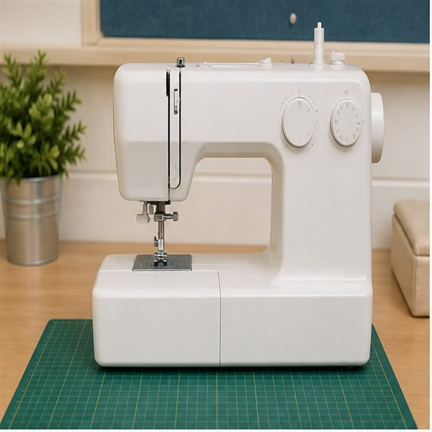  Figure 1. A source-deck illustration of a sewing station. Its appearance does not establish your classroom machine controls. |  | Make the evidence agree  A material decision should appear in more than one place: the folio explains why it was chosen, the production record shows how it was used, and the finished item can be checked against that reason. A change during making needs a matching explanation in the record.

1. Which claim establishes the core meaning of How Year 10 Textiles works?
○ A. Theory should inform design and practical decisions.
○ B. A folio is only a collection of finished-product photographs.
○ C. Practical work can be completed without theory or planning.
○ D. Practical work alone demonstrates the whole design process.

Explain how theory, practical work and folio evidence connect in this course.

INTEGRATED READING
Hazards risks and controls
1.2 Hazards, risks and controls
A hazard is something with the potential to cause harm. Risk considers how likely the harm is and how serious it could be. A control reduces the chance or consequence of harm.
Textile-room hazards include moving machine parts, needles, pins, scissors, hot irons, steam, trailing cords and clutter. Strong controls include teacher demonstrations, guards, stable equipment, clear work zones, safe carrying routines and stopping when a fault appears.
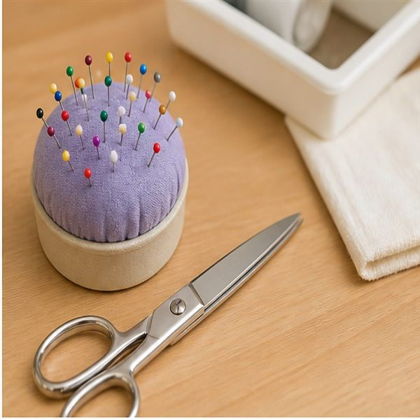  Figure 2. Source-deck illustration: controlled pin storage and closed scissors. Follow the carrying and storage routines demonstrated in your room. |  | Separate the three ideas  Loose pins are a hazard. The chance that a person could step on one, and the possible injury, form a risk judgement. Returning pins to the approved container is a control. The control needs to be used and checked; naming it alone does not make the room safe.

2. Which statement correctly describes how risk is judged?
○ A. A warning sign removes every hazard.
○ B. A risk judgement considers likelihood and consequence.
○ C. Risk and hazard mean exactly the same thing.
○ D. Students should repair powered equipment themselves.

Use hazard, risk and control correctly in one textiles-room example.

INTEGRATED READING
Safe sewing and pressing
1.3 Safe sewing and pressing routines
Before sewing, secure hair and loose clothing, clear the table, check the needle area and wait for the approved demonstration. Keep fingers away from the needle, control fabric without pulling it and stop the machine before adjustments.
Carry scissors closed with points down, store pins in a container and never place pins in your mouth. Treat irons and steam as burn hazards: use the heat-safe zone, check the fibre and fabric first, and follow the class shutdown routine.
  Figure 3. Illustrative stored equipment: upright unplugged iron, closed scissors and contained pins. This is not a temperature or electrical setup guide. |  | Plan the pause as well as the start  Safe production includes a deliberate pause before adjustments and a controlled finish to the lesson. If the machine behaves unexpectedly, stop and ask for help. For pressing, identify the fibre and fabric before following the approved setting and shutdown routine. Never copy a setting from a picture.

3. Which statement is the misconception about Safe sewing and pressing routines?
○ A. Machine adjustments are made with the machine stopped.
○ B. Fabric and fibre type affect safe pressing choices.
○ C. Pulling fabric through the machine improves stitch control.
○ D. Pins belong in an approved container, not in the mouth.

Write a start-to-finish safe routine for one practical lesson.

APPLIED LEARNING
Sewing and pressing ready-check
Original course activity BW02
Safe practical work begins with preparation: secure hair and loose clothing, clear the work zone, inspect the needle area and wait for the approved demonstration. The machine is stopped before adjustments. Scissors are carried closed, pins stay in a container and pressing choices respond to the textile.
1 Build the lesson sequence
Number the items in a defensible start-to-finish order.
Original item | Order
Complete the class shutdown and storage routine
Sew with hands clear and guide rather than pull the fabric
Secure hair and clothing and clear the work zone
Inspect the needle area and approved machine setup
Stop the machine before any approved adjustment
Check the textile and use the approved heat-safe pressing area

2 Reject unsafe shortcuts
Select every action that should be rejected.
1. [ ] Pull the fabric firmly to make the machine sew faster
2. [ ] Carry scissors closed with points down
3. [ ] Place pins in your mouth while fitting fabric
4. [ ] Stop when equipment behaves unexpectedly
5. [ ] Use one iron temperature for every textile
6. [ ] Keep fingers clear of the needle path
7. [ ] Adjust the needle area while the machine can run
8. [ ] Follow the current teacher demonstration
Write a concise start-to-finish routine for a practical textiles lesson and explain why two of the controls matter. Aim for at least 40 useful words.

TECHNICAL EXPLANATION
Trace fibre to item
2.1 From fibre to textile item
Fibres are the smallest textile units. Textile materials may use natural fibres, manufactured fibres or blends of fibres. Fibres can be spun into yarns; yarns can be woven or knitted into fabrics; fibres may also be bonded or felted into non-wovens.
The chain from fibre to yarn to fabric to textile item helps explain performance. Designers examine each stage rather than selecting material by colour alone.
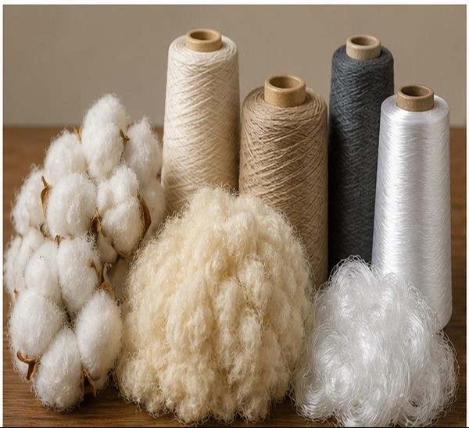  Figure 4. Source-deck fibre and yarn study. Appearance helps you observe form; a label or reliable source is still needed to identify fibre content. |  | Trace a decision through the chain  A designer can work backwards from an item: identify its fabric structure, then examine the yarn and fibre information. A sheet of felt-like material does not require the same yarn stage as woven cloth. Keeping that distinction prevents the mistaken claim that every textile follows one identical production path.

4. Which statement correctly identifies a structural difference to consider when selecting a textile?
○ A. Colour alone determines performance.
○ B. Woven, knitted and non-woven fabrics have different structures.
○ C. Every fabric is woven.
○ D. A fibre and a finished textile item are the same thing.

Explain the path from fibre to a finished textile item.

TECHNICAL EXPLANATION
Read the fabric structure
2.2 Fabric structures
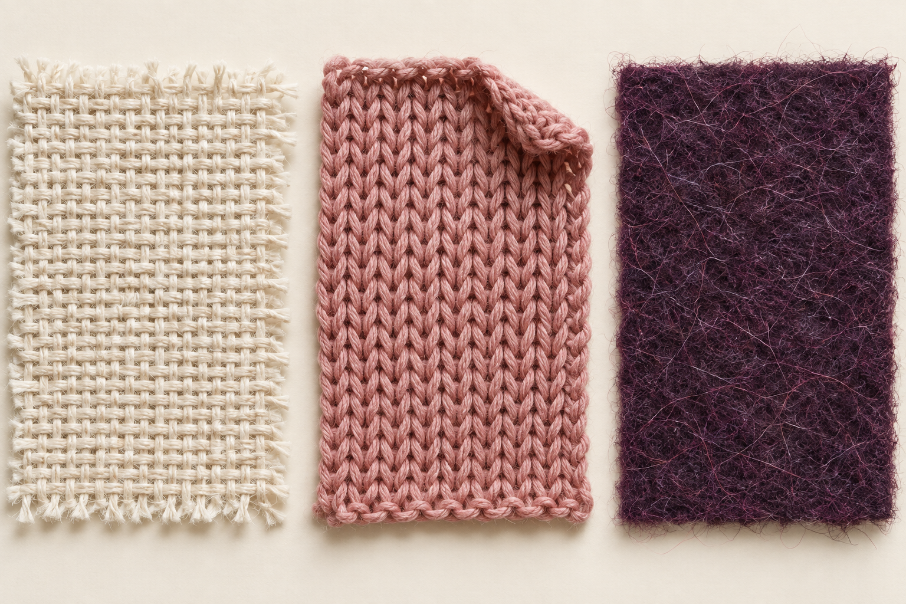
Figure 5. Enlarged illustrative samples, left to right: woven interlacing, knitted loops and entangled non-woven fibres. Compare real samples before choosing material.
Structure changes construction behaviour
Woven fabrics interlace warp and weft yarns and are often stable along the grain. Knitted fabrics form interlocking loops and commonly stretch more. Non-wovens are produced by bonding or entangling fibres.
Grainline, selvedge and bias matter when laying patterns and controlling shape. The bias usually stretches and drapes more than the straight grain. In a woven fabric, compare directions before cutting: a design that needs a stable edge may behave differently if that edge runs on the bias.
Observe first, then test the claim
Look for interlacing, loops or bonded fibres. Structure is evidence for a prediction, but the actual fibre, finish and fabric condition also matter. A photograph alone cannot establish shrinkage or strength.

5. Which statement is the misconception about Fabric structures?
○ A. Woven fabric interlaces yarn systems.
○ B. Bias behaviour differs from straight grain.
○ C. Knitted fabric is made by gluing fibres only.
○ D. Knitted fabric is based on loops.

Compare woven, knitted and non-woven structures for construction.

INTEGRATED READING
Choose for performance
2.3 Properties, performance and end use
Properties include strength, durability, absorbency, elasticity, drape, warmth, handle and resistance to abrasion. Performance is how the textile behaves in use, care and production.
A strong justification links a measured or observed property to the demands of an end use. For example, a washable furnishing cover needs different performance from a theatrical costume used for quick movement and visual impact.
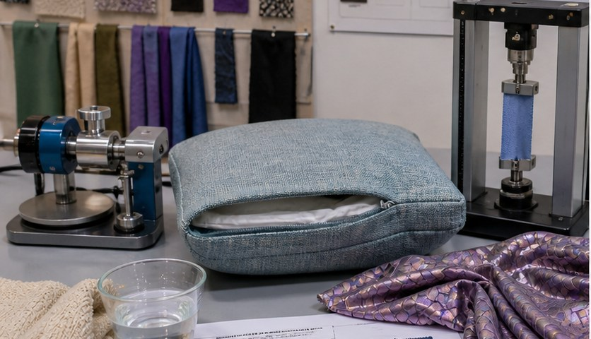  Figure 6. Source-deck illustration of materials and testing. No result, safe test load or machine setting is established by this image. |  | A property becomes useful in context  A soft handle may support comfort in a cushion, but the cover must also withstand its intended wear and care. A costume may need movement and visible form. Explain the demand first, identify a relevant property, then state what observation or test would support your selection.

6. Which Properties, performance and end use statement would best support a justified conclusion?
○ A. Aesthetic appearance is the only selection factor.
○ B. End use does not affect material choice.
○ C. Care and construction are part of performance.
○ D. The most expensive fabric is always best.

Justify one material choice using property, evidence and end use.

KNOWLEDGE CHECK
Fabric structure detective
Original course activity BW04
Woven fabrics interlace warp and weft yarns. Knitted fabrics use interlocking loops. Non-wovens bond or entangle fibres. Bias direction in a woven fabric generally stretches and drapes more than straight grain.
1 Identify from evidence
Choose the most likely structure. Write W for woven, K for knitted or N for non-woven.
Observation | W / K / N
Two yarn systems cross over and under
Loops can run or ladder when damaged
Fibres appear bonded without visible yarns
Clear selvedge and grain direction
High stretch from interlocking loops
Felt-like sheet made by entangling fibres

2 Sort cutting behaviour
Use S = straight grain / selvedge direction, B = bias direction or T = needs observation or testing.
Statement | S / B / T
Generally more stable during layout
Usually shows greater stretch and drape
Runs diagonally at about 45° to warp and weft
Exact shrinkage after washing
Grainline arrow is commonly aligned here
Whether a specific fabric twists after care

Explain how identifying fabric structure and grain direction would change one cutting or construction decision. Aim for at least 35 useful words.

INTEGRATED READING
Consider the whole life cycle
3.1 Textile life cycles
Life-cycle thinking follows a textile from raw material extraction through fibre and fabric production, dyeing, manufacture, transport, retail, use, care, reuse and disposal. Impacts shift between stages.
A claim such as “sustainable” needs a defined comparison and evidence. Durability, repair, repeated use and suitable care can matter as much as the original material.
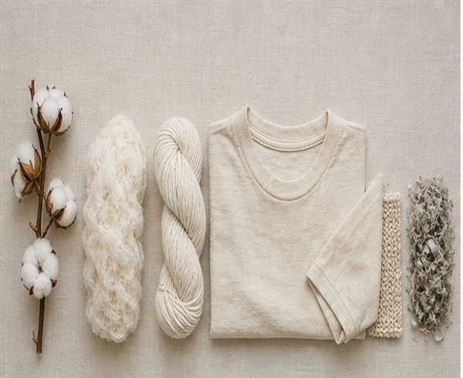  Figure 7. Source-deck material sequence. The whole life cycle also includes production, transport, use, care and later recovery decisions. |  | Follow more than the first stage  Two items made from the same named fibre may have different useful lives. Repair, repeated use and suitable care can change how often an item needs replacement. A credible comparison therefore states the stages it covers, the use pattern assumed and the impacts that remain unknown.

7. Which statement is the misconception about Textile life cycles?
○ A. Life-cycle thinking includes production, use and end of life.
○ B. Sustainability claims need evidence and comparison.
○ C. Only disposal matters in a life cycle.
○ D. Repeated use can change a product’s overall impact.

Explain why a complete life cycle is stronger than judging one material label.

INTEGRATED READING
Find the waste point
3.2 Fast fashion and waste
Fast fashion can accelerate trend cycles, production and disposal. Waste may be generated before sale through cutting scraps, damaged stock and overproduction, and after sale when consumers discard garments.
Designers can reduce waste through careful pattern layout, durable construction, repairability, timeless use, reuse and planned end-of-life pathways. No single response solves every impact.
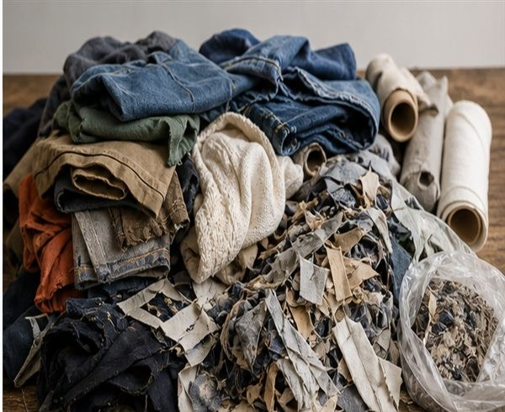  Figure 8. Source-deck illustration of garments and offcuts. Their condition and composition must be checked before choosing a recovery pathway. |  | Locate the waste before choosing an action  Cutting scraps arise during production; an unwanted garment is a different waste point after purchase. Careful layout can address the first, while repair or a suitable reuse pathway may address the second. Describe the particular waste stream so the proposed response actually fits the problem.

8. Which Fast fashion and waste statement would best support a justified conclusion?
○ A. Recycling removes the need to reduce waste.
○ B. Faster trend cycles always increase durability.
○ C. Design decisions can support repair and longer use.
○ D. Consumers are the only source of textile waste.

Identify two waste points and a realistic response for each.
Waste point | Realistic response and reason
Before or after sale:
A different point:

INTEGRATED READING
Check an ethical claim
3.3 Ethical and informed choices
Ethical textile decisions consider people as well as materials: workplace safety, pay, transparency, cultural responsibility and truthful claims. Consumers, designers, manufacturers and governments all influence the system.
Evidence-based action is specific. Instead of “buy better”, state what will change, why it addresses an identified impact and how success will be checked.
Make an action checkable
For a purchasing decision, a specific action is to seek traceable information about working conditions and material origin. The record should name the source and what it supports. A colour, slogan or attractive photograph cannot demonstrate fair pay or safe conditions. Unknown information should remain visible.

Claim to investigate | Evidence to seek
Responsible production | Named workplace and supply-chain information
A better choice | A defined comparison and a way to check the change

9. Which two statements work together to explain ethical responsibility in textile decisions?
○ A. Ethical decisions include working conditions and transparency. Responsibility is shared across a system.
○ B. Ethics applies only to product colour. Responsibility is shared across a system.
○ C. Ethical decisions include working conditions and transparency. One consumer controls the entire supply chain.
○ D. One consumer controls the entire supply chain. A vague promise is stronger than measurable action.

Write one specific ethical textile action and how you would verify it.

APPLIED LEARNING
Sustainability claim courtroom
Original course activity BW06
A product label says: “Our green tote is completely sustainable.” No comparison, durability result, material percentage, worker information or end-of-life pathway is supplied. A defensible claim defines what changed, compared with what, and what evidence supports it.
1 Select the evidence needed
Select every item that would materially strengthen or test the claim.
1. [ ] Verified fibre composition and recycled-content percentage
2. [ ] A greener shade of product photography
3. [ ] Durability or repeated-use evidence
4. [ ] A defined product used for comparison
5. [ ] Named supply-chain or workplace evidence
6. [ ] The word eco repeated in larger type
7. [ ] Care requirements and expected use pattern
8. [ ] A stated recovery or disposal pathway
2 Classify the statement
Identify the role of each statement in an evaluation.
Key: A = Evidence; B = Limitation; C = Marketing claim.
Statement | Key
Independent abrasion test completed after 5,000 cycles
The study did not examine worker conditions
The planet’s favourite tote
Measured recycled fibre content: 65%
No data was supplied for product lifespan
100% guilt-free style

Rewrite the original “completely sustainable” claim as a cautious, testable statement and name the evidence still required. Aim for at least 40 useful words.

INTEGRATED READING
Reuse recycle or upcycle
4.1 Upcycling, recycling and reuse
Reuse keeps an item or component in use. Recycling processes material into feedstock for another product. Upcycling redesigns existing material or products into a new item with renewed usefulness or value.
Upcycling still requires sound design. A changed item must meet a real need, be safe, be durable enough for its purpose and make effective use of the material recovered.
Follow what changes
Wearing a repaired shirt again retains its use. Processing textile material into feedstock changes its material form. Turning sound fabric from an old garment into a different useful product changes the design. The new function must still suit the recovered material and be checked against the user need.

Pathway | What happens to the material
Reuse | The item or component remains in use
Recycling | Material is processed into feedstock
Upcycling | Existing material gains a different useful form

10. Which evidence best supports an upcycling claim?
○ A. A green colour palette
○ B. A list of sustainability slogans
○ C. Before-and-after material use and a tested new function
○ D. The price of a new garment

Distinguish reuse, recycling and upcycling

INTEGRATED READING
Read the original item
4.2 Deconstruction and material audit
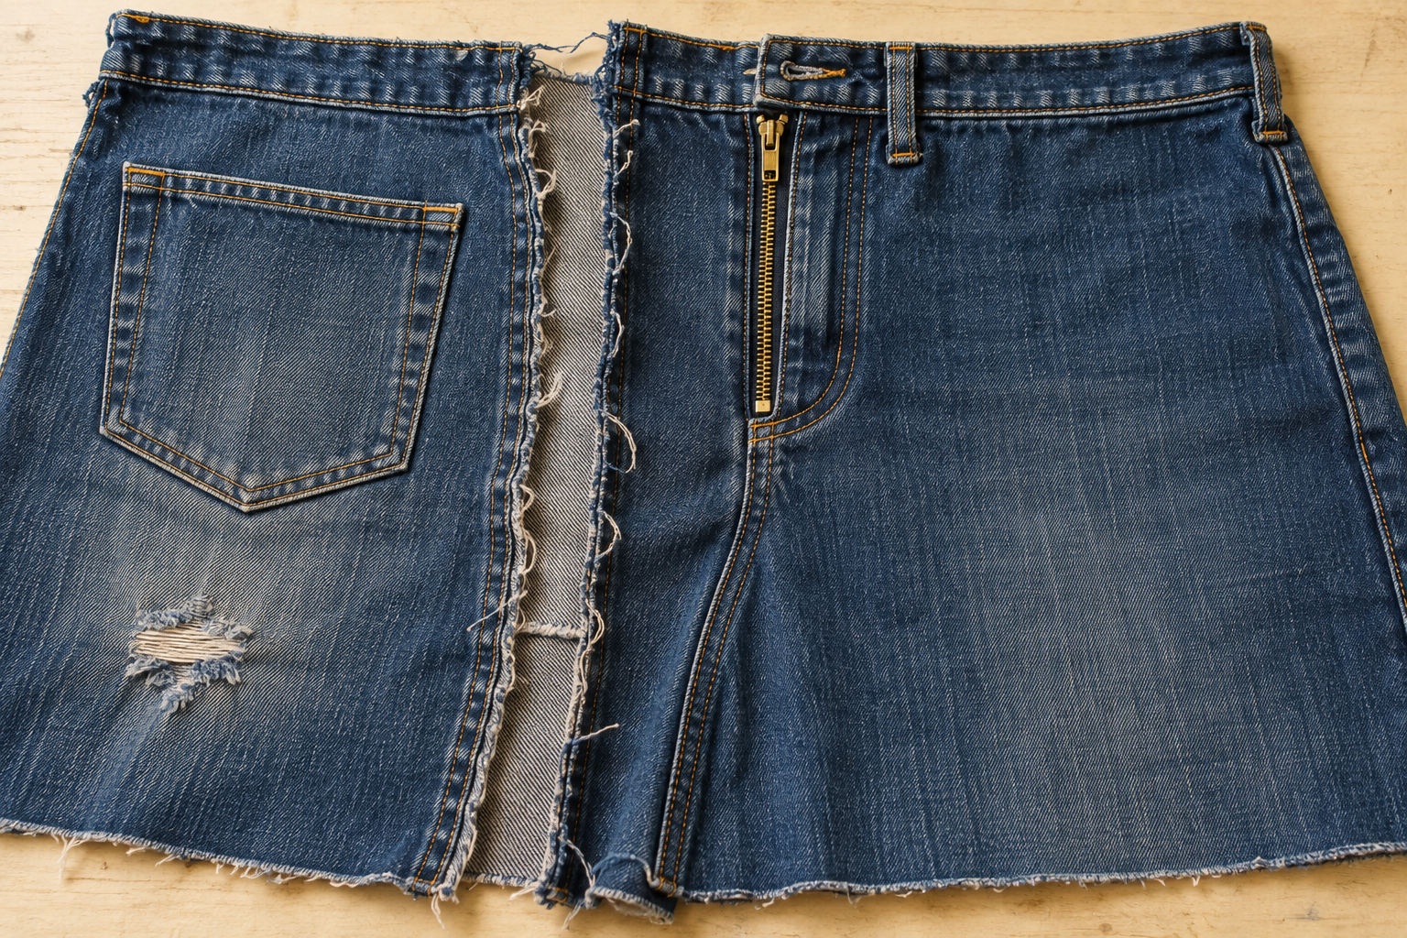
Figure 9. Illustrative reclaimed denim: an intact pocket and closure sit beside worn and opened areas. The image is an observation prompt, not a pattern or a measurement record.
Inspect before cutting  Before cutting, inspect seams, closures, damage, fibre content, grain, useful panels and decorative features. Record dimensions and defects. Unpick where this preserves more material than cutting.  A photograph identifies a feature; a labelled audit explains whether that feature is useful for the proposed redesign. |  | Turn observation into a decision  A material audit turns the original item into evidence: what can be retained, what needs reinforcement and which ideas are realistically supported by available area and construction quality.  Measure the clear panel between seams or damage. The garment size on a label does not show whether a new pattern piece will fit.

11. A panel is worn where the new bag handle would attach. What is the strongest response?
○ A. Ignore the wear because denim is strong
○ B. Test it and redesign, avoid or reinforce the load area
○ C. Cover it with decoration only
○ D. Use a heavier zip

Plan a material audit
Explain what you would inspect, measure, test and record before redesigning one textile item. Link each record to a decision.

INTEGRATED READING
Develop a feasible concept
4.3 Concepts, specifications and production
Generate alternatives before choosing a final direction. Vary form, function, construction, closure and surface treatment—not only colour. Annotate sketches with materials, dimensions, techniques and reasons.
Manufacturing specifications include a production drawing, pattern pieces, resources, construction sequence, safety controls, quality checks and costing. Photograph meaningful checkpoints, not just the finished item.
Compare before committing
A zip pouch, organiser and cushion can use the same reclaimed material in different ways. Compare useful area, retained features, user need and construction before selecting. A strong specification then connects the labelled drawing to resources, sequence, controls, costs and the evidence needed at meaningful checkpoints.

A useful annotation names a feature, its purpose and a reason. For example: retain a sound existing pocket to provide accessible storage, after checking its condition and position.
12. Concept A uses the existing zip but exceeds the available fabric. Concept B fits the material and meets the user need. Which decision is best supported?
○ A. Choose A because zips look professional
○ B. Choose B because it meets the material and user criteria
○ C. Choose either without recording a reason
○ D. Combine both without checking dimensions

Justify a final concept and its evidence

WORKED EXAMPLE
Calculate usable material
Original course activity BW07
A pair of jeans provides two front panels of 68 × 24 cm and two back panels of 64 × 25 cm. Damage removes 320 cm² from the total panel area. Treat these as practice values only; measure the actual item before making.
Worked example with separate practice values
Hypothetical scrap: 20 cm × 15 cm = 300 cm². If 40 cm² is damaged, 300 − 40 = 260 cm² remains. This area alone does not prove that a pattern fits: its shape and grain must also suit the piece.

1 Calculate usable area
Enter numbers only. Use the practice measurements above.
Calculation | Answer in cm²
Area of both front panels: 2 × 68 × 24
Area of both back panels: 2 × 64 × 25
Total panel area before damage
Usable area after removing 320 cm² damage

2 Decide what to do with each feature
Write R = retain or reuse, T = test or reinforce, X = exclude from load-bearing use.
Audit finding | R / T / X
Sound metal zip that opens and closes reliably
Large undamaged panel with useful grain direction
Thinned area beside a future handle attachment
Seam with uncertain strength but enough allowance for a sample
Torn fabric with fibres breaking under light handling
Stained section that also shows structural damage

Use the audit evidence to recommend one realistic upcycled product and explain one limitation the design must respect. Aim for at least 40 useful words.

INTEGRATED READING
Read function and meaning
5.1 Textiles as expressive and functional media
Textiles can protect, carry, identify, decorate, communicate status and support ceremony. Their meaning comes from cultural context, not appearance alone.
Research should identify who made or owns the work, where it comes from, how it is used and what permissions or restrictions apply. A museum label, community source or named designer is stronger than an unattributed image board.
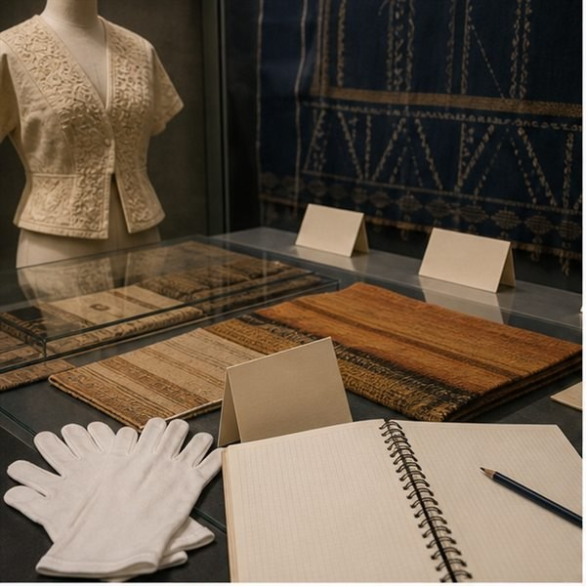  Figure 10. Source-deck illustration of a research setting, not an identified cultural collection or authentic historical artefact. |  | Description is a starting point  A textile may have a practical function and communicate meaning at the same time. Colour and texture are visible; cultural ownership or ceremonial significance cannot be read from appearance alone. Use a named maker, community or authoritative collection source to support those claims, and record any limits on use.

13. Which two statements work together to explain why both function and cultural context matter when analysing textiles?
○ A. Cultural context helps explain textile meaning. Textiles can be functional and expressive.
○ B. Appearance alone explains cultural meaning. Textiles can be functional and expressive.
○ C. Cultural context helps explain textile meaning. All online images are culturally neutral.
○ D. All online images are culturally neutral. Attribution is optional when a pattern looks traditional.

Analyse one textile item through function, expression and cultural context.

INTEGRATED READING
Respect cultural authority
5.2 Indigenous Cultural and Intellectual Property
Indigenous Cultural and Intellectual Property includes cultural knowledge, designs, stories, symbols and practices. Respect means recognising ownership, authority and the right of communities to control how cultural material is used.
Students should use teacher-approved, community-authored or authoritative sources, credit artists and communities, and avoid copying sacred, restricted or culturally specific motifs. Inspiration is not permission.
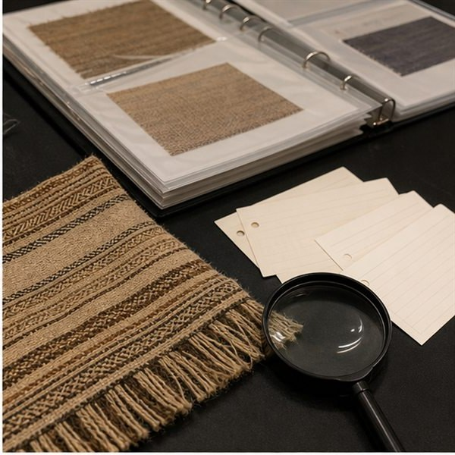  Figure 11. Source-deck illustration of documented textile samples. The image does not identify a community or authorise reuse of a design. |  | A source note does not grant permission  An online image can help locate a work and its maker, but availability is not permission to copy a motif. Credit identifies the source; cultural authority determines appropriate use. Where a restriction or ownership question is unresolved, seek the teacher-approved source or choose another permitted direction.

14. During project work, which Indigenous Cultural and Intellectual Property principle should guide the next action?
○ A. Inspiration automatically grants permission to copy.
○ B. Cultural authority matters when using Indigenous designs.
○ C. Traditional-looking motifs have no owners.
○ D. Changing one colour removes cultural responsibility.

Explain the difference between respectful research and copying.

INTEGRATED READING
Support a case study
5.3 Case studies and design influence
A case study examines a designer or textile tradition through evidence. Record sources of inspiration, materials, processes, design features, context and influence on contemporary work.
Analysis goes beyond description. It explains how evidence connects: for example, how a material choice supports climate, movement, symbolism or method of production.
  Figure 12. Source-deck illustration of a discussion and documentation setting. Real case-study claims require named sources and traceable evidence. |  | Build an analysis statement  Begin with a visible feature, identify a reliable source that explains its context, and connect that evidence to a claim. For instance, a claimed relationship between garment form and movement needs more than a photograph. State what the source supports and what remains your interpretation.

15. Which statement correctly describes an evidence-based analysis?
○ A. Description and analysis are identical.
○ B. A designer’s context never affects material choice.
○ C. Analysis explains relationships, not just appearance.
○ D. A mood board alone is a complete case study.

Turn one visual observation into an evidence-based analysis statement.

APPLIED LEARNING
Cultural source strength ladder
Original course activity BW09
Strong cultural research identifies the maker or community, place, function, context, permissions and source. An unattributed image board is weak evidence even when it looks visually convincing.
1 Rank sources for cultural authority
Number the sources from strongest starting point to weakest.
Original item | Order
Unattributed repost on a visual-sharing platform
Community-controlled cultural organisation explaining its own textile practice
Museum catalogue entry naming maker, place, date and context
Image-search thumbnail without source details
Named artist’s or designer’s own statement about the work
Retail listing using the word “tribal” without attribution

2 Build a traceable source note
Select every detail that improves attribution and context.
1. [ ] Maker or community name where known
2. [ ] Source title and link or publication details
3. [ ] Function or cultural context supported by the source
4. [ ] “Found online” with no original source
5. [ ] Date accessed for a web source
6. [ ] Permission or restriction information where relevant
7. [ ] A new label invented from appearance
8. [ ] Clear separation between evidence and your interpretation
Write a model source note for a cultural textile example. Identify what the source supports and one fact you would not claim without stronger authority. Aim for at least 45 useful words.

INTEGRATED READING
Kimono form and context
6.1 Kimono form and context
Kimono design is recognised by its wrapped T-shaped form, straight-cut panels, sleeves and sash. Uses, materials and decoration have changed across time, place and purpose.
A sound investigation separates evidence from stereotypes. Use named sources to study construction, social context and contemporary adaptation, then state exactly what the source supports.
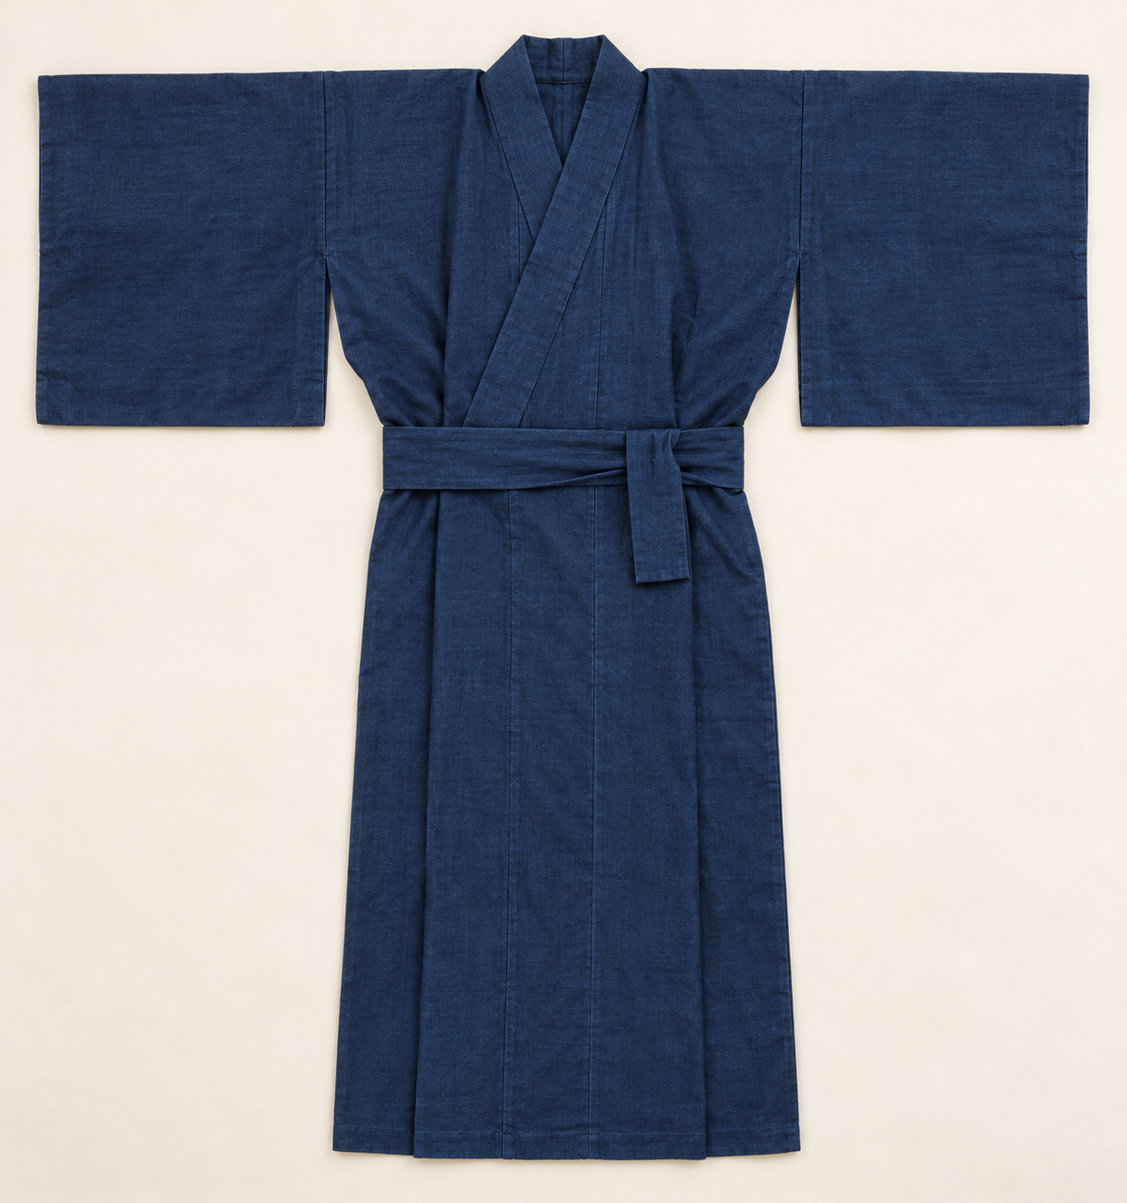  Figure 13. Illustrative full-form study with plain sleeves, wrapped front and sash. It is not a dated artefact, cutting pattern or approved class design. |  | Keep form and context distinct  The wrapped T-shaped form helps identify a construction idea, but it does not tell you the garment’s date, occasion or wearer. Investigate those details through a named source. Describe the form you can observe, then distinguish historical evidence from a contemporary adaptation of that form.

16. Which principle correctly describes the broad construction logic of kimono form?
○ A. Every kimono has identical meaning.
○ B. Kimono form uses straight-cut panel logic.
○ C. A costume image proves Japanese history.
○ D. Unattributed social media is sufficient authority.

Describe kimono form while identifying one context that affects its use.

INTEGRATED READING
Sample before decorating
6.2 Colouration and decoration
Textile decoration can include dyeing, printing, embroidery, appliqué and resist techniques. The selected technique must suit the fibre, fabric, scale, end use and available equipment.
Sample before working on final material. Record recipe or method, safety controls, result and refinement. Cultural responsibility still applies when selecting motifs and references.
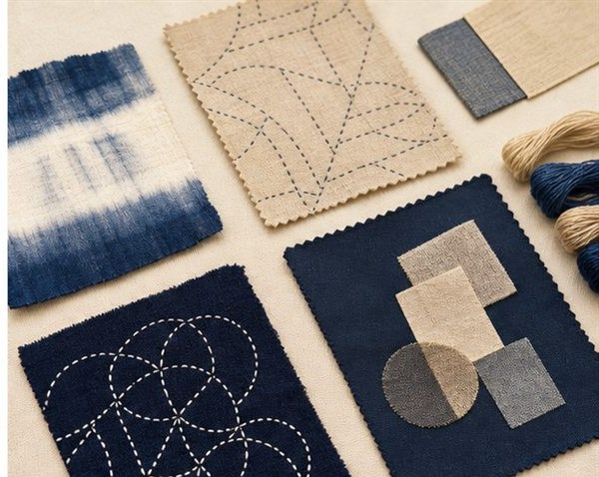  Figure 14. Source-deck illustrative surface samples. They show varied effects; they do not establish recipes, cultural provenance or measured performance. |  | Change one variable deliberately  A fair sample comparison might hold fabric, sample size and method constant while changing one teacher-approved colouration variable. Label each sample and record the method before comparing the result. Do not invent a recipe or outcome. Check cultural responsibilities before selecting any reference or motif.

17. Which statement correctly describes the role of sampling before final production?
○ A. Sampling wastes time and evidence.
○ B. Decorative motifs never carry cultural meaning.
○ C. Sampling provides evidence before final production.
○ D. Every dye behaves the same on every fibre.

Plan a fair sample test for one colouration or decoration technique.

TECHNICAL EXPLANATION
Pattern and quality checks
6.3 Pattern, sequence and quality
Commercial and teacher-provided patterns use grainlines, notches, cutting lines and other symbols to control assembly. Check scale, orientation and required seam allowance before cutting.
A production sequence should include layout, marking, cutting, decoration, construction, pressing, quality checks and evaluation. Use the exact pattern, dimensions and processes issued for your class project.
Use a checkpoint while correction is possible
Matching notches before stitching can reveal an orientation error before it becomes a finished seam. Checking scale and seam information before cutting protects material that cannot be restored after removal. Record the check and any approved correction so the production evidence explains how quality was controlled.

Check point | What the record should establish
Before cutting | Scale, grain, orientation and required seam information
During construction | Matching features, approved sequence and quality corrections

18. Which statement is directly supported by the section evidence about quality control?
○ A. Supported: Quality control occurs throughout production.
○ B. Supported: Pattern pieces can be rotated without checking grain.
○ C. Supported: Pressing is never part of construction.
○ D. Supported: Quality is checked only after submission.

Explain how pattern symbols and checkpoints prevent one production problem.

APPLIED LEARNING
Pattern communication check
Original course activity BW12
Teacher-provided or commercial patterns can show grainline, notches, cutting lines, fold lines and seam information. Check scale, orientation and the required seam allowance before cutting. Use the pattern dimensions and construction method issued for your class project.
1 Match information to purpose
Match each pattern feature to the job it performs.
Key: A = Show where the pattern edge is cut; B = Place an edge on the fabric fold; C = Define distance between stitching and cut edge; D = Align the piece with fabric grain; E = Match joining points during assembly.
Feature or criterion | Key
Grainline arrow
Notch
Cutting line
Place-on-fold marking
Seam allowance

2 Select meaningful quality evidence
Select every checkpoint that can prevent or explain a production problem.
1. [ ] Confirm print scale before using the pattern
2. [ ] Check grain orientation before pinning or weighting
3. [ ] Assume seam allowance without checking
4. [ ] Match notches before stitching
5. [ ] Record a photograph only after the item is finished
6. [ ] Check pressing and seam quality during construction
7. [ ] Record a correction when a checkpoint finds a problem
8. [ ] Rotate pieces freely to fit without checking grain
Describe one pattern-reading error, the checkpoint that would detect it and how the evidence should be recorded. Aim for at least 40 useful words.

INTEGRATED READING
Design for furnishing use
7.1 Furnishing requirements
Furnishings must suit location, user, cleaning, wear, comfort and appearance. A cushion cover, quillow or other teacher-approved item needs functionally suitable fabric, closure and construction.
Aesthetic features concern appearance and sensory qualities; functional features concern use and performance. Good specifications name both and explain how they will be achieved.
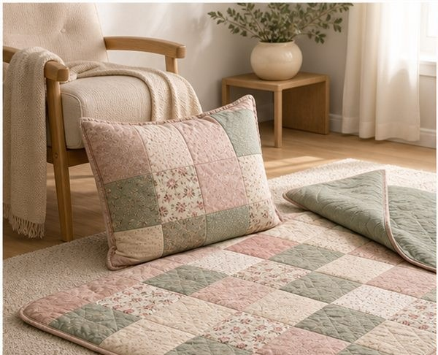  Figure 15. Source-deck illustration of furnishing forms. The image is not evidence of a particular Quillow pattern, size or folding mechanism. |  | Link appearance to use  A furnishing can have a calm colour scheme and a soft texture, but it must still fit its location, withstand the required care and work for its user. Keep aesthetic and functional criteria separate enough to test, then explain how the design brings them together.

19. Which statement correctly describes the balance required in furnishing design?
○ A. Aesthetic and functional mean the same thing.
○ B. Cleaning requirements never affect material choice.
○ C. Aesthetic and functional features are both important.
○ D. Furnishings are selected only by colour.

Distinguish aesthetic features from functional features in one furnishing example.
Aesthetic feature | Functional feature

INTEGRATED READING
Compare surface techniques
7.2 Manipulation and embellishment samples
Fabric manipulation changes surface or form through techniques such as pleating, gathering, tucking, quilting, patchwork, chenille, fabric flowers, appliqué or embroidery. Embellishment adds visual or tactile detail.
Samples should use labelled materials and controlled variables. Compare stability, scale, texture, time, suitability and finish before selecting a technique for the final item.
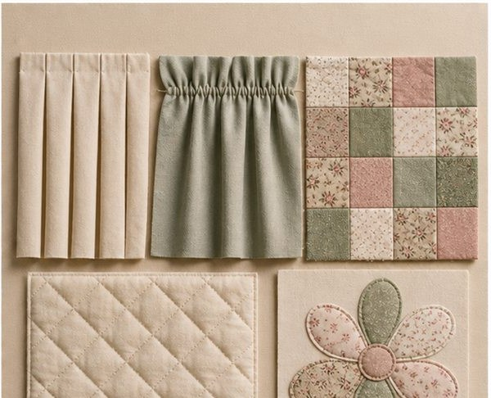  Figure 16. Source-deck surface comparison: pleating, gathering, patchwork and stitched treatments. The partial lower details are surface observations, not full construction instructions. |  | Compare the samples against the brief  A dramatic texture may take more time or be less stable than a quieter treatment. Compare labelled samples using the same criteria, such as wash suitability, scale, finish and production time. The strongest choice is the one supported for the intended item, not simply the most difficult technique.

20. Which statement is directly supported by the section evidence about scale and stability?
○ A. Supported: Scale and stability affect the final result.
○ B. Supported: A sample needs no label or method.
○ C. Supported: The most complex technique is always best.
○ D. Supported: Time and end use do not affect selection.

Design a comparison test for three manipulation techniques.
Technique | Controlled comparison and evidence
1
2
3

TECHNICAL EXPLANATION
Choose a construction detail
7.3 Closures, piping and production evidence
Closures such as zips, buttons or ties must match the function and construction. Piping can define an edge and may use bias-cut strips to curve smoothly. Teacher demonstrations control the approved method.
Record pattern pieces, production drawing, materials, costing, construction steps, care label, progress photographs and evaluation. Evidence should show decisions, problems and corrections.
  Figure 17. Illustrative finished details: zip opening, fabric ties and a piped corner. Their appearance does not specify your project’s dimensions or making method. |  | Choose a detail for its job  A closure needs to allow the required access while staying secure in use. Piping can define an edge; the source notes that bias-cut strips may help it follow a curve. Record the chosen detail, why it suits the furnishing and the quality check used, then follow the approved demonstration.

21. Which response best corrects the claim “Only the finished item belongs in a folio.”?
○ A. Only the finished item belongs in a folio.
○ B. Any closure suits every furnishing.
○ C. Piping strips must always follow straight grain.
○ D. Progress evidence should record decisions, problems and corrections, not only the finished item.

Explain how one construction detail supports furnishing function and quality.

APPLIED LEARNING
Manipulation sampler selector
Original course activity BW14
Ratings are out of 5. A higher time rating means more time required.
Technique | Stability | Texture | Time | Wash result
Pleating | 4 | 3 | 3 | 4
Gathering | 3 | 4 | 2 | 3
Patchwork | 5 | 3 | 4 | 5
Fabric flowers | 2 | 5 | 5 | 2

1 Read the evidence table
Choose the technique best supported by each stated priority.
Key: A = Pleating; B = Gathering; C = Patchwork; D = Fabric flowers.
Statement | Key
Highest stability and wash result
Strongest texture rating regardless of time
Lowest time demand
Balanced stability and wash performance with moderate time

2 Rank for a frequently washed quillow
Rank from most to least suitable using stability, wash result and time together.
Fabric flowers | Pleating | Patchwork | Gathering

Recommend one manipulation technique for a frequently used furnishing. Cite at least two values from the table and acknowledge one trade-off. Aim for at least 40 useful words.

INTEGRATED READING
Costume communicates
8.1 Costume communicates
Costume helps communicate character, time, place, culture, status and mood in theatre, film, dance, festivals and other settings. Design is read alongside movement, lighting, setting and performance.
A costume classification may be historical, cultural, theatrical or contemporary, and categories can overlap. The designer must explain the evidence behind the classification.
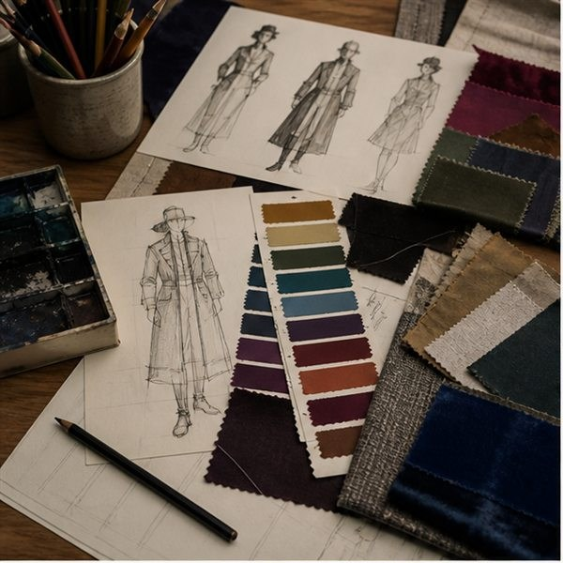  Figure 18. Source-deck illustrative costume sketches and swatches. They support observation of form and material, not a verified historical classification. |  | Explain what the audience can read  Silhouette, colour and detail can work together to suggest a role or mood. Their effect may change with lighting, distance and movement. Name three features and explain how each supports the intended character or setting, rather than claiming that a costume category is obvious from one feature.

22. Which statement is directly supported by the section evidence about costume classifications?
○ A. Supported: Costume classifications can overlap.
○ B. Supported: Costume is only decorative clothing.
○ C. Supported: Lighting and movement never affect costume design.
○ D. Supported: Every costume fits one category only.

Explain how three costume features communicate character or setting.
Costume feature | Character or setting communicated
1
2
3

INTEGRATED READING
Evidence and interpretation
8.2 Historical, cultural and contemporary influence
Historical research can guide silhouette, materials, colour and detail, but designers also adapt for performance, budget, safety and audience. Cultural sources require attribution and respectful use.
Contemporary costume may combine new technologies with historical references. Clearly separate accurate historical evidence from creative interpretation.
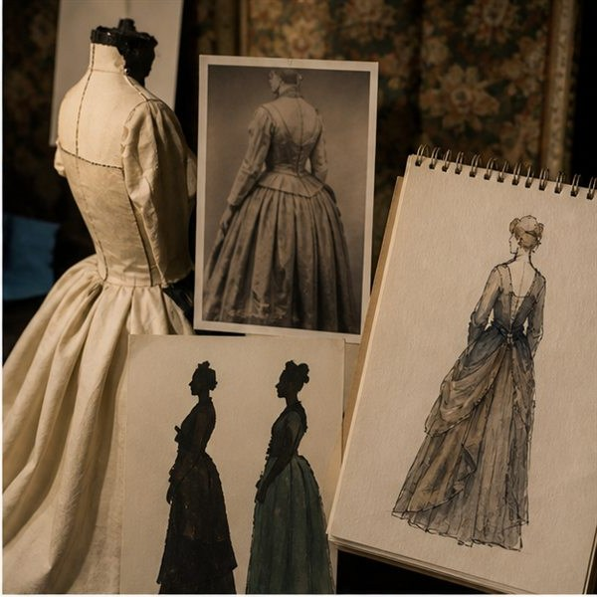  Figure 19. Source-deck illustration of reference and sketch relationships. It is not an authenticated historical photograph or evidence for a date. |  | Label an adaptation honestly  A designer may use a historical silhouette as a starting point while changing a fastening for a performance need. The source must support the historical feature; the fastening change should be labelled a creative adaptation. Explaining that distinction makes the design argument more accurate and useful.

23. Which response best corrects the claim “Cultural references need no attribution in theatre.”?
○ A. Cultural references need no attribution in theatre.
○ B. Any old-looking detail is historically accurate.
○ C. Budget and safety never affect interpretation.
○ D. Cultural sources require attribution and respectful use.

Separate historical evidence from creative interpretation in a costume idea.

INTEGRATED READING
Test costume function
8.3 Functional costume production
Costume fabrics may be selected for movement, stretch, weight, visibility, durability, comfort and quick changes. Notions, fastenings and decoration must survive the required performance.
Test movement and closure under realistic conditions. Evaluate construction quality, communication and wearer needs, then propose a specific improvement.
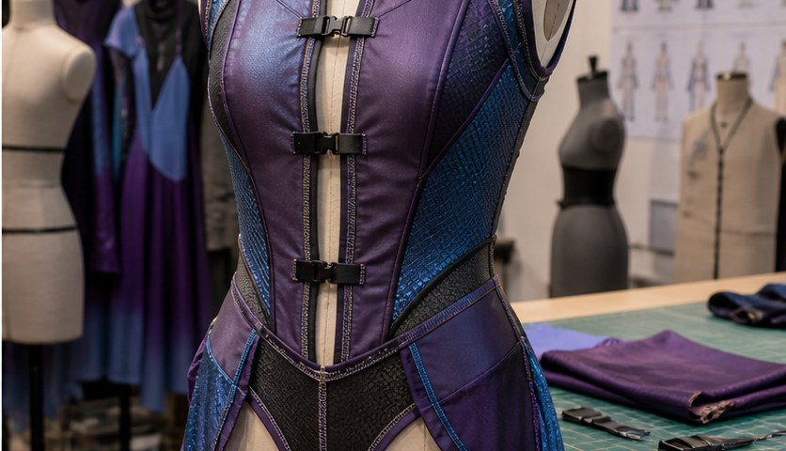  Figure 20. Source-deck costume detail. Visible closures and panels suggest features to inspect; only a real approved test can establish wearer function. |  | Test the function directly  A still photograph cannot show whether a wearer can reach, kneel or complete a quick change. Choose a realistic, teacher-approved test that matches the function, record the conditions and observe the result. After a permitted refinement, repeat the matched test before claiming improvement.

24. Before using a fastening in a performance costume, which principle should guide its testing?
○ A. Stage appearance is the only costume criterion.
○ B. Fastenings should be tested under realistic conditions.
○ C. Comfort cannot affect performance.
○ D. A quick-change closure needs no testing.

Design a realistic test for one costume function.
Test element | Your proposed method
Function or criterion
Method and conditions
Evidence and limitation

APPLIED LEARNING
Performance movement-test route
Original course activity BW16
The performer needs to reach overhead, kneel, cross the stage quickly and complete a fast costume change. The costume uses a stretch side panel and a concealed fastening.
1 Follow the test-and-improve route
Choose the next step based on the evidence.
1. What is the strongest first test?
[ ] A. Rehearse the required movement sequence under realistic conditions
[ ] B. Judge movement from a still photograph
2. The side seam strains during the overhead reach. What next?
[ ] A. Stop the test, record where strain occurs and inspect the construction
[ ] B. Repeat with more force until it works
3. After an approved construction refinement, how is success checked?
[ ] A. Repeat the same movement test and compare the evidence
[ ] B. Declare success because the change looks neater
2 Match the criterion to its test
Choose the most direct test for each costume criterion.
Key: A = Consistent-light audience visibility check; B = Repeated opening and closing cycle; C = Wearer feedback after rehearsal; D = Timed fastening trial; E = Full movement rehearsal.
Feature or criterion | Key
Quick change under 12 seconds
Movement through the required choreography
Design reads from the back of the performance space
Closure durability
Comfort and pressure points

Design one realistic costume test. State the criterion, method, evidence to record and what would trigger an improvement. Aim for at least 45 useful words.

INTEGRATED READING
Map the textile system
9.1 The textile industry system
The textile industry connects fibre production, material development, design, manufacturing, marketing, retail, care, repair and resource recovery. Decisions in one stage affect others.
Australian textile work includes design, small-scale manufacturing, technical textiles, costume, education, retail, sustainability, testing and digital production.
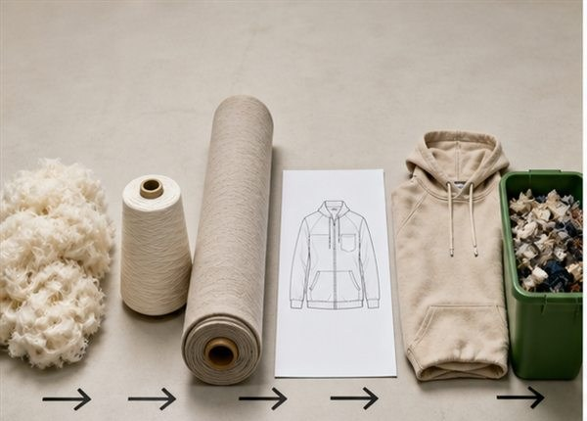  Figure 21. Source-deck product pathway illustration. Use it as a starting point, then add the industry stages and relationships your chosen item requires. |  | A change travels through the system  A design decision can affect pattern layout, production time, care and eventual recovery. Mapping at least five stages helps you see those links. Include work beyond making, such as design, retail, repair or testing, so the industry is represented as a connected system rather than a single occupation.

25. Which response best corrects the claim “All textile work is garment sewing.” in the context of The textile industry system?
○ A. All textile work is garment sewing.
○ B. The industry begins and ends at retail.
○ C. Material development is unrelated to design.
○ D. Textile careers extend beyond fashion design.

Map one textile product through at least five industry stages.

INTEGRATED READING
Evaluate an innovation
9.2 Innovation and evidence
Innovation may change materials, processes, products or systems. Source material includes examples such as fibres made with agricultural by-products, recycled ocean plastics and textile-waste recovery.
Evaluate a claim by asking what problem is addressed, how the technology works, what evidence supports performance, what trade-offs remain and whether the solution can scale.
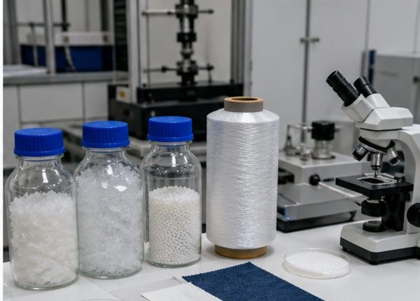  Figure 22. Source-deck laboratory illustration. It does not identify a verified new fibre, establish its composition or report a performance result. |  | Separate a benefit from an overclaim  Recovered input may address one waste problem, yet the process can still need evidence about durability, resources, workers or scale. Ask what was verified, under which conditions and against which comparison. A promising pilot result should not become a claim that every impact has been solved.

26. Before accepting a performance claim about an innovation, which principle should be applied?
○ A. A new product is automatically sustainable.
○ B. Performance claims require evidence.
○ C. Innovation has no trade-offs.
○ D. Marketing language is the same as test evidence.

Evaluate an innovation claim using problem, evidence, benefit and limitation.

INTEGRATED READING
Connect skills and pathways
9.3 Pathways and transferable skills
Textile pathways include designer, machinist, pattern maker, costume worker, production manager, buyer, merchandiser, textile technologist, educator, conservator and sustainability specialist.
Transferable skills include safe work, communication, digital documentation, teamwork, quality control, planning, problem-solving and evaluation. A pathway investigation should name training requirements and reliable sources.
Show a transferable skill with evidence
A dated quality check can demonstrate careful observation and problem-solving. A clear production plan can demonstrate organisation and communication. Link a course record to the work of a named textile role, then check current training requirements from a reliable provider rather than guessing a qualification.

Role example | Relevant course evidence
Pattern maker | Accurate drawing and interpretation of pattern information
Production manager | Ordered plan, checkpoints and response to delays
Textile technologist | Controlled tests and careful evaluation of claims

27. Which claim establishes the core meaning of Pathways and transferable skills?
○ A. Textile careers require varied technical and communication skills.
○ B. Only drawing skill matters in textiles careers.
○ C. Training details never change.
○ D. Quality control is not transferable beyond school.

Connect three course skills to a textile career pathway.

APPLIED LEARNING
Innovation evidence stress-test
Original course activity BW18
A company says its fibre uses recovered textile waste and performs like a conventional fibre. The summary provides a pilot-scale fibre-content test but no durability, care, energy, chemical, worker or scale-up evidence.
1 Select the next evidence needed
Select every item required for a stronger evaluation.
1. [ ] Verified percentage and source of recovered content
2. [ ] Durability and care performance compared with a defined fibre
3. [ ] A celebrity endorsement
4. [ ] Energy, water and chemical data for the process
5. [ ] Worker and supply-chain implications
6. [ ] Evidence that the process can operate beyond pilot scale
7. [ ] A new product colour range
8. [ ] End-of-life limits and recovery pathway
2 Classify each evaluation statement
Choose the role each statement plays.
Key: A = Supported benefit; B = Known limitation; C = Unresolved question; D = Overclaim.
Statement | Key
The pilot sample contains verified recovered textile fibre
The evidence covers pilot scale only
How does repeated care affect performance?
This fibre has eliminated textile waste everywhere
Recovered input may reduce demand for some virgin input
Worker impacts have not been reported

Write a balanced recommendation about whether the innovation is ready for wider use. Include one benefit, one limitation and two evidence gaps. Aim for at least 45 useful words.

INTEGRATED READING
Match tests to criteria
10.1 Testing against criteria
Testing should match the success criterion. A closure criterion needs a closure test; a strength criterion needs a controlled load or use test; a communication criterion needs feedback from an appropriate viewer.
Record the method, conditions, result and limits. A photograph can support evidence, but it needs a caption explaining what it proves.
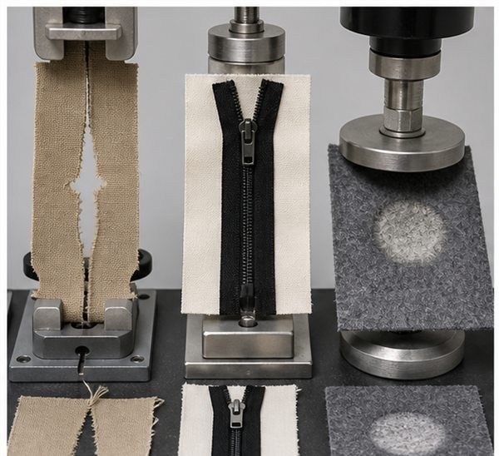  Figure 23. Source-deck testing illustration. The equipment and samples are examples, not a class test method, approved load or measured result. |  | Match the evidence to the question  A quick-change criterion needs a timed fastening trial, while a movement criterion needs the required movement to be attempted safely. Record the same relevant conditions when comparing trials. An image should name the feature tested and explain what it proves, including the test’s limits.

28. Before using test results as evidence, which information should be recorded?
○ A. One appearance photo tests every function.
○ B. Method and conditions belong in evidence.
○ C. A result can be invented if the product looks finished.
○ D. Test conditions do not affect results.

Match three criteria to fair and realistic tests.
Criterion | Fair test and conditions
1
2
3

INTEGRATED READING
Evaluate and improve
10.2 Evaluation and improvement
Evaluation connects criterion, evidence, judgement and improvement. State whether the criterion was met, cite the observation or measurement and explain what should change.
Balanced evaluation recognises strengths and limitations. It avoids vague claims such as “it turned out good” and avoids proposing changes unrelated to evidence.
  Figure 24. Source-deck illustration of a product review record. Real judgements need your own labelled evidence and confirmed criteria. |  | Make the improvement follow the evidence  A useful evaluation might say that a criterion is only partly met and identify the observation supporting that judgement. The improvement should address that specific limitation. Suggesting a different colour would not resolve an observed closure problem unless evidence connects the colour to the criterion.

29. Which claim establishes the core meaning of Evaluation and improvement?
○ A. Evaluation links judgement to evidence.
○ B. Evaluation is a description of appearance only.
○ C. Every criterion must be declared perfect.
○ D. An unrelated redesign is the strongest improvement.

Write one evidence-based evaluation paragraph.

INTEGRATED READING
Prepare evidence and review
10.3 Course review and folio readiness
Review fibres, structures, properties, sustainability, cultural responsibility, design development, safe production, innovation and evaluation. Practise applying concepts to unfamiliar textile scenarios rather than memorising isolated definitions.
Before submission, check that folio evidence is labelled, source-aware, complete and consistent with the actual item. Effective revision compares examples, explains reasoning and corrects misconceptions.
Choose a focused next step
If you can define a term but cannot use it to justify a material choice, practise applying the concept to a new end use. Check that folio images, captions and design changes agree with the actual item. Use the current teacher instructions for what, where and when to submit.

Check | Evidence to revisit
Knowledge | One concept applied to an unfamiliar scenario
Folio | Labelled evidence that matches the actual project
Submission | Current teacher notice and authorised destination

30. Which statement correctly describes how folio evidence should relate to the project?
○ A. Folio evidence can describe work that was not completed.
○ B. Folio evidence should match the actual project.
○ C. Memorising one definition covers the whole course.
○ D. Re-reading without applying ideas is enough revision.

Create a focused review plan that links course concepts to evidence you can apply.
Review focus | Practice action and evidence
Concept
Application
Folio readiness

APPLIED LEARNING
Evaluation and review studio
Original course activity BW20
A useful evaluation names the criterion, cites the test evidence, makes a justified judgement and proposes a related improvement. Course review should practise applying fibres, structures, sustainability, cultural responsibility, design, safe production, innovation and evaluation to unfamiliar scenarios.
1 Build an evaluation paragraph
Arrange the parts into the strongest reasoning order.
Original item | Order
Propose a specific improvement related to the evidence
Cite the observation or measurement
Name the success criterion
Judge whether and how well it was met
State how the change would be retested

2 Sort the review action
Classify each study action by the kind of learning it strengthens.
Key: A = Recall; B = Apply to a scenario; C = Build or check evidence.
Original statement | Key
Define fibre, yarn and fabric structure
Select a fabric for a stated end use and justify it
Check that a folio photograph has a caption explaining what it proves
List the stages of a textile life cycle
Respond to an unfamiliar cultural-source decision
Match each criterion to a fair test

Write a short final evaluation using criterion, evidence, judgement, improvement and retest. Then name one course topic that needs further review. Aim for at least 45 useful words.

FOLIO
Record the original material
Use your own observed evidence before any redesign or cutting.
Original item and starting evidence
Identify the item, its current condition and why it is available for redesign. Record the photograph filename or describe the exact view you need to capture.

Material audit
Record fibre/care clues, usable dimensions, grain, seams, closures, pockets, decorative features, damage and any test still required.
Record | Your measured or observed evidence
Fibre and care clues
Usable dimensions and grain
Seams closures and pockets
Decorative features and condition
Damage and test still needed

Labelled view or photograph reference

FOLIO
Define need and gather sources
Make criteria and research useful for a real design decision.
User need and criteria
Define who will use the new item, what it must do and at least four criteria you can judge later.

Criterion | How you will recognise success
1
2
3
4

Research and inspiration
Name the source of each useful idea. Explain what you learned about form, function, construction or surface treatment without copying one finished product.
Source and relevant permission | Design information learned

Which research finding most changed your thinking about the product?

FOLIO
Explore three different concepts
Formative design practice from the original eight-stage studio
Describe or attach references to three labelled sketches. Vary form, function or construction, not only colour.
Concept A Label the useful form, retained material and construction approach.

Concept B Change a substantial design feature. Show how the material is used.

Concept C Explore another useful direction. Label one strength and one limitation.

How does each concept use the original material differently?

Next: compare the three concepts against your real criteria on page 46. This formative studio does not replace the number of ideas or evidence required by your current formal task.

FOLIO
Choose a feasible direction
Compare the ideas against your real evidence and constraints.
Compare the concepts against user need, usable material, time, skill, safety, quality and waste avoided. State why one idea is strongest.
Criterion | Concept A | Concept B | Concept C
User need
Usable material
Time
Skill
Safety
Quality
Waste avoided

Why is this concept stronger than the other two?

Developed concept with feature labels and any dimensions still to confirm

FOLIO
Plan production and evidence
Use the teacher-approved process and your own verified resources.
List ordered construction stages, teacher demonstrations required, safety controls, quality checkpoints and photographs to capture.
Stage | Demonstration or control | Quality check and evidence
1
2
3
4
5
6

Resources measurements and cost of added materials
Resource or detail | Verified amount or source

Where is the plan most vulnerable, and what is your backup approach?

Continue longer plans at the original online stage when needed. Current patterns, demonstrations and formal requirements remain teacher-controlled.

FOLIO
Record trials and refinement
Record real observations; leave results blank until the work is done.
Technique experiments
Trial and material source | Method and observation | Decision supported
Trial 1
Trial 2

Which trial is most suitable for the reclaimed material, and what evidence supports that choice?

Feedback and design refinement
What change produced the strongest improvement in use, waste reduction or quality?

Checkpoint and waste log
Checkpoint or remaining material | Problem action or destination

Which decision produced the clearest environmental or quality benefit?

FOLIO
Plan tests and evaluate value
A plan names evidence to collect; an evaluation uses actual evidence.
Match each success criterion to a fair test. Leave actual results blank until you have observed or measured them.
Success criterion | Fair test and conditions | Evidence to collect

Actual evidence record after testing
Criterion and observed result | Judgement limitation or improvement

Did the project create genuine added value? Support your judgement with evidence.

FOLIO
Assemble the approved folio
Use one teacher-approved project route and its current formal instructions.
Open the course folio and choose your approved project in the selector. Each route has twelve original evidence cards. The studio and selected records in this book do not replace the complete evidence required for your assigned project.
Quillow and Furnishings
Design brief and user; specification; inspiration; samples; two design ideas; final design; production drawing; costing and sequence; safe making; feedback and refinement; product label; testing and evaluation.
Upcycle
Need and criteria; original item audit; sustainability research; experiments; three concept ideas; final decision; production plan; safe making; refinement; checkpoint and waste log; final product and care; testing and evaluation.
Costume
Performance brief; criteria; context research; samples; developed ideas; final design; management plan; wearer safety; making record; fitting; labels and final record; peer and self-evaluation.
Selected Upcycle making and final record
Describe a moment when the material behaved differently from your plan.

What visible evidence best proves this is a useful transformation rather than simple decoration?

Before submitting: check labels, source notes, approved changes, actual test evidence and the teacher-confirmed destination. The website saves locally; saving there does not submit to Classroom.

