

YEAR 11 / PRELIMINARY

Design and
Technology
Student workbook

Name _____________________________ Class __________________
Illustrative design study / Supplementary learning / 50 A4 pages / Duplex long edge
COURSE MAP / USING THIS WORKBOOK

Read practise and keep evidence
Read the teaching pages, then complete the whole module activity. This companion supports the website and teacher-led lessons; it does not replace current assessment notices, practical approvals or formal folios.
Module | Pages
01 Design and Technology foundations | 3–5
02 Factors affecting design | 6–8
03 Research that informs design | 9–11
04 Design and production settings | 12–14
05 Communicating research and design knowledge | 15–17
06 Creativity and collaborative design | 18–20
07 Briefs, users and criteria | 21–23
08 Graphical and design communication | 24–26
09 CAD and rapid prototyping | 27–29
10 Testing, materials and evaluation | 30–32
11 Camping design project | 33–35
12 Project management and safe production | 36–38
13 Manufacturing, quality and production evidence | 39–41
14 Marketing, sustainability and final evaluation | 42–44
15 Preliminary synthesis and Year 12 bridge | 45–47

Pages 48–50 contain three complete 150–250-word responses. The selected print practice is 15 original MCQs and all 15 module applications. The other 435 MCQs, 42 written responses and 20 Busy Work tasks stay online.
Optional online folio cards: need; research; brief and criteria; ideas; concept selection; technical communication and CAD; prototypes; production and WHS; ongoing evaluation; final evaluation and communication.
stevencowell.github.io/Main-Page/Year-11-Design-and-Technology/
Busy Work / all 20 original activities
My folio / all ten original learning cards
01 / DESIGN AND TECHNOLOGY FOUNDATIONS

Connect designing and producing
Understand the course, the work of designers and the adaptable processes used to move from a need to an evaluated solution.

What Design and Technology studies
Design and Technology is not a drawing course with a project bolted on. It combines design thinking, practical production, research, communication, technology and evaluation. The Preliminary course develops this knowledge through hands-on work and at least two design projects.
Designing identifies and develops a response to a need or opportunity. Producing turns a developed idea into a product, system or environment using suitable resources and processes. Evaluation occurs throughout the project and again when the solution is completed. A design folio records evidence of decisions, testing, changes and evaluation rather than merely decorating the final result.
Worked example
A student has built a neat object but cannot explain who needs it or how it was tested. What is the best next action? Return to the identified need, establish criteria and collect evidence through testing before claiming the design is successful.

Design professions and design practice
Design professions differ in scale, specialisation and output, but they share a need to understand users, manage constraints, communicate ideas and evaluate results. A single project may involve industrial designers, engineers, graphic designers, researchers, marketers and manufacturers.
Professional design work is shaped by a client, user, context and purpose. Design professions overlap because complex projects require different knowledge and skills. Designers communicate with technical and non-technical audiences using methods suited to each audience. Studying an Australian designer should connect the designer’s practices, tools and decisions to the impact of the resulting product or service.
Worked example
A team is developing an accessible public drinking fountain. Which approach best reflects professional design practice? Combine user research, industrial design, engineering, manufacturing advice and testing with intended users.

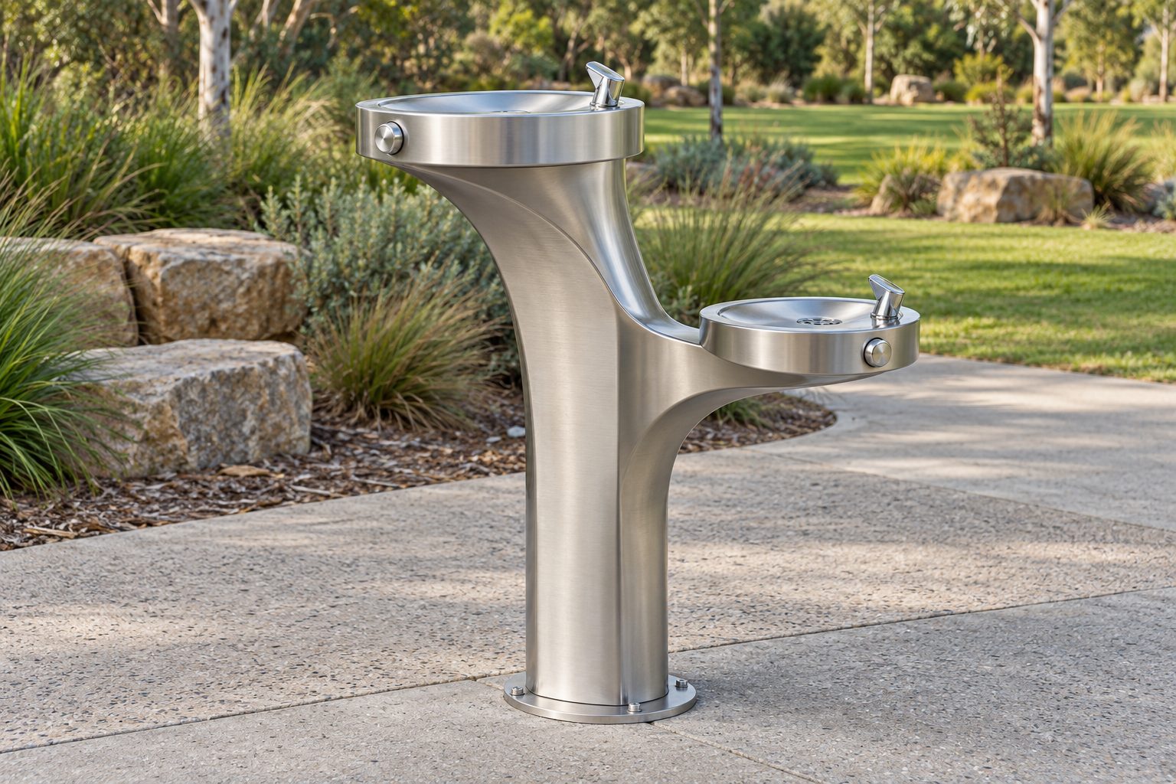
Figure 1. Illustrative fountain concept. Its two basins and controls prompt different questions for user research, engineering and manufacture.

One project different expertise
The industrial designer develops form and interaction. Engineering checks functional requirements; manufacturing advice tests feasibility. User research checks needs that the team cannot establish from appearance. These roles inform one another, so a change in one area may send the team back to an earlier decision.
A photograph does not certify accessibility, safe installation or compliance. The design-profession map on the next task page asks you to trace responsibilities and evidence.

01 / DESIGN AND TECHNOLOGY FOUNDATIONS

Design processes across contexts
Design processes are adaptable rather than rigid. Designers may move backwards, repeat tests or work on several stages at once. The scale, people, resources, risk and purpose of a setting change how the process is managed, but the need for evidence and evaluation remains.
A design process can be iterative, with research, testing and evaluation causing earlier decisions to change. Domestic projects are often small and flexible, while industrial and commercial projects usually involve specialised roles and formal systems. Community design requires meaningful consultation with the people affected by the outcome. The process should be adapted to the project rather than followed as a fixed one-way checklist.
Worked example
A community group rejects an early playground concept because it excludes some users. What should the design team do? Use the feedback to revisit needs and criteria, develop alternatives and test a revised concept with stakeholders.
A sequence to guide the decision
Step | What to attend to
1 | Clarify the context and stakeholders
2 | Establish needs, criteria and constraints
3 | Develop, test and refine possible solutions
4 | Realise, communicate and evaluate the outcome

Check your understanding
Which evidence most clearly shows that designing and producing were connected?
○ A. A dated sequence showing research, annotated ideas, prototype results, modifications and the final evaluation.
○ B. A mood board with no explanation of design decisions.
○ C. A list of workshop rules copied from a poster.
○ D. A single final photograph.
Use the evidence and reasoning from this module in the complete applied task on the next page.
Continue online / M01 original questions and written responses
01 / DESIGN AND TECHNOLOGY FOUNDATIONS

Map two design professions
Create a design-profession map and compare how two designers move from client need to final presentation.
Design profession map
Stage | Designer or profession A | Designer or profession B
Client need
Research
Develop ideas
Testing
Presentation

Compare the two routes / Shared decisions different responsibilities and evidence

02 / FACTORS AFFECTING DESIGN

Judge a design in its context
Analyse how needs, function, aesthetics, ergonomics, finance, quality, safety and environmental consequences interact.

Needs, function and appropriateness
A design begins with a need or opportunity, but success depends on how accurately that need is understood. Function describes what the solution must do. Appropriateness is broader: the solution must suit the user, setting, resources, culture, risks and likely consequences.
A need should be supported by research rather than assumed from the designer’s personal preference. Functional requirements should be observable or testable wherever possible. An appropriate solution fits the intended context, not merely the designer’s technical ability. A product can perform its basic function and still be inappropriate because of cost, access, safety or environmental consequences.
Worked example
A compact camping table supports a load but is too heavy for its target users to carry. What is the strongest conclusion? It meets one functional requirement but is not yet appropriate because portability is part of the intended context.

Aesthetics, ergonomics and quality
Aesthetics, ergonomics and quality are connected rather than separate finishing touches. Aesthetics shape visual and sensory appeal. Ergonomics considers how people physically and cognitively interact with a solution. Quality includes the level and consistency with which the design performs its intended purpose.
Aesthetic choices should support the target market, context and intended identity of the solution. Ergonomic decisions should be based on user characteristics, tasks, reach, force, visibility, comfort and safety. Quality includes reliable performance and consistency, not simply an expensive or polished appearance. Improving one factor may affect another; for example, a larger handle may improve grip but alter size, appearance and cost.
Worked example
A jar opener is visually appealing but requires high grip strength. What is the most defensible modification? Test alternative handle shapes and operating forces with intended users, then refine the form while retaining a suitable visual identity.


Figure 2. Illustrative handle comparison. The openings and grip surfaces differ; neither image proves comfort or successful use.

A trade off needs evidence
A larger handle may change grip, size, appearance and cost. The intended user and task determine which effects matter. Treat the image as a reason to plan trials, then compare reach, force, errors and completion rather than claiming success from the attractive surface.
Your audit on page 8 should name both a benefit and a possible consequence, supported by the evidence available.

02 / FACTORS AFFECTING DESIGN

Finance, WHS, environment and product life
Design decisions create costs and consequences across production, use and end-of-life. Finance includes development, material, production, maintenance and selling considerations. Work health and safety requires hazards to be controlled. Environmental thinking examines short- and long-term effects, including obsolescence and the product life cycle.
A finance decision should consider total project and production costs rather than material price alone. WHS begins with identifying hazards and applying suitable controls; personal protective equipment is only one part of the system. Life-cycle analysis examines impacts from raw materials through manufacture, distribution, use, maintenance and end-of-life. Durability, repairability, recyclability and obsolescence can create trade-offs that require evidence-based judgement.
Worked example
A durable housing is difficult to recycle but can be repaired and used for many years. What should the designer do? Compare whole-of-life impacts, expected service life, repair pathways and end-of-life options before making a justified selection.
A sequence to guide the decision
Step | What to attend to
1 | Identify costs, hazards and life-cycle stages
2 | Compare options using relevant evidence
3 | Select controls and mitigation strategies
4 | Monitor and evaluate consequences during the project

Check your understanding
Which evidence best tests ergonomic quality?
○ A. A designer’s sketch annotation saying “comfortable”.
○ B. A material supplier’s colour chart.
○ C. Target-user trials measuring comfort, force, reach, errors and task completion under realistic conditions.
○ D. A photograph of the product on a clean background.
Use the evidence and reasoning from this module in the complete applied task on the next page.
Continue online / M02 original questions and written responses
02 / FACTORS AFFECTING DESIGN

Audit success and failure
Complete a product success-and-failure audit that identifies evidence, trade-offs and consequences.
Product success and failure audit
Feature or criterion | Evidence and judgement | Trade off or consequence

A success supported by evidence

A weakness its consequence and a defensible next check

03 / RESEARCH THAT INFORMS DESIGN

Choose evidence for a decision
A useful research method answers a question about the user, product or context.

Primary and secondary research
Primary research is collected first-hand for a particular project. Observation can show where a task becomes difficult; an interview can explore why. Measurements and user tests can reveal whether a feature performs as intended. Choose the method after defining the decision that needs evidence.
Secondary research already exists. Product specifications, reliable publications and ergonomic guidance can help a designer understand existing solutions and constraints. Check who produced the information, its purpose and whether it applies to this user and setting.
For a packaging closure, photographs alone cannot explain why older users struggle. Combine observation and interviews with suitable measurements and a review of existing closures. Compare the findings rather than treating the quickest method as sufficient. Disagreement between methods may expose a limitation worth investigating.

Qualitative and quantitative data
Qualitative data describes experiences, reasons and meaning. A user might explain that a tab is hard to locate or that its direction is confusing. Quantitative data records counts or measurements, such as time, force, dimensions or the frequency of errors. Neither kind answers every design question.
In the source example, 70% of participants take longer than ten seconds to use a latch, while interviews describe confusion about its direction. The timing identifies a performance issue in that trial. The comments suggest which cues to investigate. Together they guide a change more precisely than either finding alone.
Organise the results, look for patterns and state limits. A small or unrepresentative sample cannot show what every user will do. Translate a supported finding into a criterion or modification, then plan how to test it.

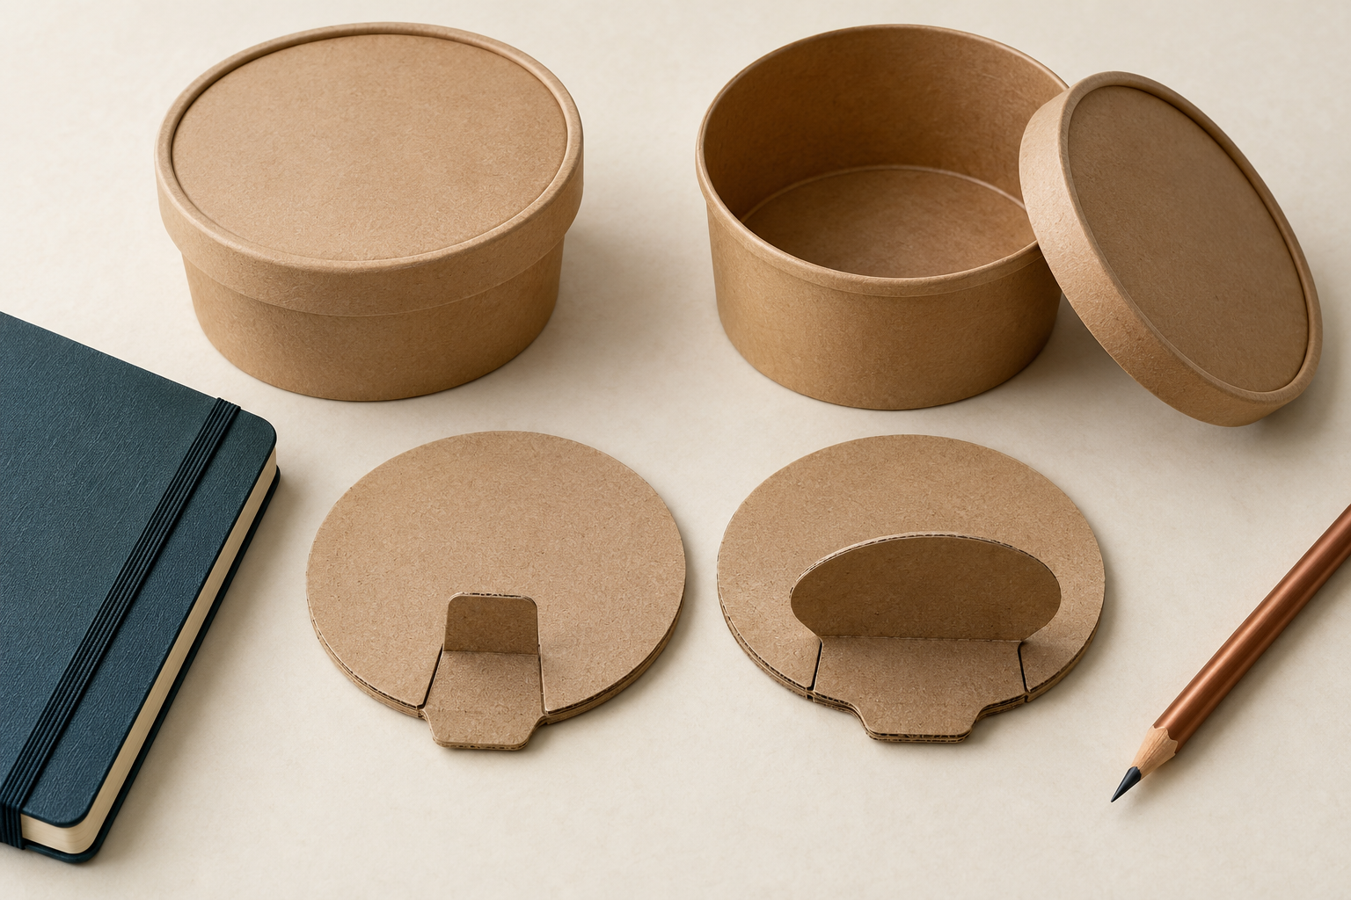
Figure 3. Illustrative packaging models offer contrasting grasp tabs. Their appearance suggests research questions; it is not evidence of comfort or successful use.

Try this
For the illustrated tabs, name one observation you would collect and one question you would ask the intended user. Explain how the two kinds of evidence could lead to different design changes.
Observation question and possible change

03 / RESEARCH THAT INFORMS DESIGN

Make the evidence traceable
Ethical collection and honest synthesis make a design claim more defensible.
Ethical research and evidence synthesis
Before collecting information from people, explain the purpose, activity and intended use of their information. Participation must be voluntary. Protect personal details and obtain the appropriate permission before including a photograph or identifiable comment in a presentation. An educational purpose does not remove this responsibility.
Synthesis means comparing findings across methods and sources. Evidence may disagree because people use a product differently, because the context changed or because the method missed something. Examine that difference instead of hiding it or selecting only the result that supports your preferred concept.
A conclusion should distinguish what was observed from what was inferred and what still needs testing. Record enough about each source and method for another reader to judge its relevance. This makes a later design change understandable and lets you return to an uncertain claim without starting the investigation again.
Check your understanding
Which evidence best demonstrates responsible synthesis?
○ A. A paragraph that combines all sources without identifying them.
○ B. A conclusion based only on evidence that supports the chosen idea.
○ C. A bibliography containing links that were not read.
○ D. A source table showing method, date, participant or publication, main finding, limitation and how the finding influenced the design.
Explain why one rejected option does not demonstrate responsible synthesis

Continue online
The complete Module 3 question bank and written responses remain in the course. Use the evidence-synthesis section to revisit a misconception before completing the research-plan activity on page 11.
Open Module 3 research and original practice
03 / RESEARCH THAT INFORMS DESIGN

Prepare a useful research plan
Prepare a research plan that combines methods, identifies participants and shows how findings will affect decisions.
Research plan
Decision and question | Method and participants | How findings affect the design

Consent privacy and voluntary participation arrangements to confirm

One limitation and the method that could check it

04 / DESIGN AND PRODUCTION SETTINGS

Compare the production context
Relate school design projects to domestic, community, industrial and commercial practices and technologies.

Domestic, community, industrial and commercial settings
Settings influence scale, purpose, accountability, equipment, labour, quality systems and communication. Domestic work is often personal and flexible. Community work responds to shared needs. Industrial and commercial settings use organised systems to produce goods or services, often at greater scale.
Domestic production is commonly small-scale, adaptable and completed by one person or a small group. Community design should involve affected groups and consider equitable access and public benefit. Industrial production commonly uses specialised equipment, standardised processes and defined roles. Commercial decisions connect user needs with cost, market demand, production capacity and financial viability.
Worked example
A handmade product begins supplying a national retailer. Which change is most likely? The producer may need standardised components, specialised equipment, reliable suppliers, formal quality control and production scheduling.

Technologies in industrial and commercial settings
Technology includes tools, machines, digital systems, knowledge and organised processes. Industrial and commercial settings select technologies for reasons such as scale, accuracy, consistency, safety, customisation, speed and cost. A school project can use related principles without reproducing the entire industrial system.
Technology should be selected because it suits the task and context, not because it is new. CAD, CAM and CNC can create an integrated flow from digital design to controlled manufacture. Automation can improve repeatability and remove some hazardous or repetitive work, but it requires investment, maintenance and skills. Appropriate technology balances benefit with scale, cost, resources, user needs and social or environmental consequences.
Worked example
A small maker needs 20 customised components each month. What technology decision is most defensible? Compare manual, jig-assisted and digital production against volume, accuracy, setup cost, skill and customisation before selecting a process.

Setting | What changes in the design process
Domestic | Small scale and flexible decisions; resources and personal needs remain important.
Community | Consultation must include people affected by the outcome and access barriers.
Industrial or commercial | Specialist roles, repeatability, suppliers, scheduling and market viability need explicit control.

04 / DESIGN AND PRODUCTION SETTINGS

Impacts on individuals, society and the environment
Design activity affects more than the purchaser. It may change safety, access, work, skills, behaviour, communities, resource use and waste. Strong analysis identifies who or what is affected, explains the mechanism and considers both intended and unintended consequences.
Individual impacts can include safety, convenience, cost, privacy, independence, health and access. Societal impacts can include employment, equity, infrastructure, cultural practices, regulation and community participation. Environmental impacts can occur during extraction, manufacture, transport, use, maintenance and end-of-life. The same technology may create benefits and costs for different stakeholders, so conclusions should be balanced and conditional.
Worked example
A shared e-bike scheme is proposed for a regional city. What is the strongest analysis? Examine user access and safety, transport choice and public-space management, plus energy, battery and end-of-life impacts under realistic use conditions.
A sequence to guide the decision
Step | What to attend to
1 | Identify the design activity and stakeholders
2 | Trace individual, social and environmental consequences
3 | Compare benefits, risks and distribution of impacts
4 | Make a qualified judgement and suggest mitigation

Check your understanding
Which evidence best supports a comparison of settings?
○ A. A list of machinery used in one factory.
○ B. Information about scale, people, equipment, workflow, quality control, cost and stakeholder relationships in each setting.
○ C. Photographs of two workplaces without explanation.
○ D. The number of products sold without production details.
Use the evidence and reasoning from this module in the complete applied task on the next page.
Continue online / M04 original questions and written responses
04 / DESIGN AND PRODUCTION SETTINGS

Compare production settings
Compare one school production process with a domestic and an industrial/commercial process.
Production setting comparison
Setting | Process resources roles and controls
School process
Domestic process
Industrial or commercial

Compare what can transfer to the school project and what cannot be assumed

05 / COMMUNICATING RESEARCH AND DESIGN KNOWLEDGE

Match the message to the audience
Choose communication methods for purpose and audience, use command verbs accurately and complete the Research Assignment with evidence.

Communication methods and audience
Design communication is purposeful. A technical audience may need dimensions, tolerances and production specifications. A non-technical audience may need a clear explanation, visual comparison and user benefit. The strongest method is the one that conveys the required information accurately and accessibly.
Communication choices should respond to audience knowledge, purpose, context and access needs. Annotated sketches combine visual form with information about dimensions, materials, function and decisions. Models and prototypes communicate scale, form and interaction but may need labels or explanation to prevent misinterpretation. Digital presentations should use clear hierarchy, readable graphics, source acknowledgement and restrained detail.
Worked example
A designer must explain a proposed kitchen accessory to a parent audience and a manufacturer. What is the best approach? Use a clear visual explanation and benefits for parents, then provide dimensioned technical information and production details for the manufacturer.

Command verbs and evidence-based responses
Command verbs indicate the kind of thinking and evidence required. A strong response does not simply become longer as marks increase; it changes structure. Explain shows how or why. Justify supports a choice. Analyse identifies relationships and implications. Evaluate makes a supported judgement using evidence, strengths and limitations.
Identify or list requires relevant points without unnecessary explanation. Explain requires a clear relationship, reason or cause-and-effect link. Justify requires a defensible choice supported by evidence and context. Analyse and evaluate require connected reasoning, implications and, for evaluation, a supported judgement.
Worked example
A question asks students to justify the selection of plywood for a prototype. Which response is strongest? Select plywood and link its verified properties, workability, availability and cost to the prototype’s requirements and available processes.

Command | How the response develops
Identify | Name a relevant point.
Explain | Link a cause or reason to an effect.
Justify | Defend a choice using evidence and the context.
Evaluate | Weigh evidence and limits, then make a supported judgement.

05 / COMMUNICATING RESEARCH AND DESIGN KNOWLEDGE

Research Assignment synthesis
The authorised Research Assignment asks students to explain Design and Technology fields, examine a specific design profession and Australian designer, identify management, tools, technology and education, and explain the impact of an invention on individuals, society and the environment. The presentation should be coherent rather than a set of disconnected facts.
The selected profession should be described through its purpose, work practices, tools, technologies and outputs. The Australian designer and invention should be supported by reliable and acknowledged sources. The presentation should identify the relevant domestic, community, industrial or commercial setting and explain why it applies. Impact analysis should connect evidence to individuals, society and the environment, including limitations or trade-offs where relevant.
Worked example
A student has strong information but the presentation jumps between profession, invention and impacts. What should be improved? Use a logical through-line: introduce the field and profession, examine the designer’s process and invention, identify its setting, then analyse impacts.
A sequence to guide the decision
Step | What to attend to
1 | Define the audience and required content
2 | Research profession, designer, invention and settings
3 | Analyse impacts using evidence
4 | Design, rehearse, reference and refine the presentation

Check your understanding
Which evidence best shows command-verb accuracy?
○ A. A response that repeats the question several times.
○ B. A response plan that identifies the verb, key content, required relationships, evidence and final judgement where needed.
○ C. A glossary definition copied before answering.
○ D. A memorised paragraph used for every question.
Use the evidence and reasoning from this module in the complete applied task on the next page.
Continue online / M05 original questions and written responses
05 / COMMUNICATING RESEARCH AND DESIGN KNOWLEDGE

Rehearse and improve the message
Rehearse and improve a parent-night presentation using source evidence, audience needs and command-verb accuracy.
Presentation rehearsal
Part of the message | Source evidence and audience need
Profession and practice
Australian designer and invention
Setting and impacts
Command verb and supported judgement

Feedback from the rehearsal

Revision and why it improves communication

06 / CREATIVITY AND COLLABORATIVE DESIGN

Create a genuine range of ideas
Generate alternatives, use cognitive organisers deliberately and collaborate through clear roles and evidence.

Idea-generation techniques
Creativity is not waiting for inspiration. Designers use structured techniques to challenge assumptions, generate alternatives and make connections. Brainstorming, mind mapping, SCAMPER, morphological analysis, PMI, sketching and experimentation serve different purposes and are most effective when used deliberately.
Early ideation should generate range before ideas are judged against criteria. SCAMPER prompts a designer to substitute, combine, adapt, modify, put to another use, eliminate or rearrange features. A morphological chart separates a problem into functions or features and recombines alternatives. Cognitive organisers are tools for thinking; they do not replace research, testing or designer judgement.
Worked example
A group keeps generating variations of the same utensil holder. What is the best next action? Change the thinking method: separate functions in a morphological chart or use SCAMPER to transform assumptions about storage, access and assembly.

Six Thinking Hats and collaboration
The Kitchen Companion brief requires a Six Thinking Hats session. The method separates types of thinking so a team can examine facts, feelings, cautions, benefits, creativity and process without arguing every point at once. Collaboration also requires clear roles, shared files, respectful participation and traceable decisions.
The White Hat focuses on known information, evidence gaps and facts that need verification. The Red, Black, Yellow and Green Hats deliberately examine feelings, cautions, benefits and possibilities. The Blue Hat manages the process, roles, sequence and decision record. A useful session records contributions and shows how the team used them to develop or select concepts.
Worked example
During a Six Hats session, the group jumps between facts, objections and ideas and no decision is recorded. What should the Blue Hat do? Set the sequence, clarify the question, allocate time, summarise evidence and record the agreed next test or decision.

Thinking move | How it changes the exploration
SCAMPER | Transform an assumption about storage, access or assembly.
Morphological chart | Separate functions and recombine possible solutions.
Six Thinking Hats | Separate facts, feelings, cautions, benefits and possibilities; record the next decision.

06 / CREATIVITY AND COLLABORATIVE DESIGN

Selecting and justifying concepts
Concept selection should not be a popularity contest or a defence of the first idea. Designers establish criteria and constraints, compare alternatives, identify trade-offs, combine useful features and explain why the selected direction offers the strongest fit for the need and context.
Criteria should come from the brief, research, users, safety, resources and intended performance. A weighted decision matrix can organise comparison but the weighting and scores still require justification. A concept may be modified or combined before final selection when comparison reveals strengths worth retaining. A justification connects the selected features to evidence and acknowledges important limitations or further testing.
Worked example
A concept scores highly for appearance but poorly for stability and print time. What should the team do? Review the weighting and evidence, modify or combine concepts, and select only after critical requirements such as function and safety are addressed.
A sequence to guide the decision
Step | What to attend to
1 | Confirm criteria and constraints
2 | Compare distinct concepts using evidence
3 | Develop or combine promising features
4 | Justify the selection and identify tests still required

Check your understanding
Which evidence best supports concept selection?
○ A. Annotated concepts, criteria derived from research, a transparent comparison and prototype or feasibility evidence for critical features.
○ B. A high-quality rendering of the selected concept only.
○ C. A class vote with no user profile.
○ D. A paragraph stating that the team preferred one idea.
Use the evidence and reasoning from this module in the complete applied task on the next page.
Continue online / M06 original questions and written responses
06 / CREATIVITY AND COLLABORATIVE DESIGN

Record collaborative possibilities
Run and document a Six Thinking Hats session that produces several feasible Kitchen Companion directions.
Six Thinking Hats record
Hat | Contribution and useful evidence
White / facts
Red / feelings
Black / cautions
Yellow / benefits
Green / ideas
Blue / process

Several feasible directions from the session

How the group used the contributions

07 / BRIEFS, USERS AND CRITERIA

Turn needs into design criteria
Translate evidence about users and contexts into a clear brief, practical boundaries and criteria that guide testing.

Design situation, brief and constraints
The design situation explains the context and problem. The design brief states what is to be designed and for whom, without naming the final answer. Constraints are fixed boundaries such as time, budget, equipment, dimensions, material availability or an authorised project rule.
A useful design situation explains the context, affected users and reason a response is needed. A useful brief identifies the intended user, need, purpose and important boundaries while leaving room for design development. Constraints should be recorded early because they influence feasible research, ideas, materials and processes. A brief can be refined when research reveals that the original need or boundaries were inaccurate.
Worked example
Which revision most improves the brief “Design a kitchen gadget”? Design a compact, 3D-printed kitchen accessory for a clearly identified user that addresses a researched problem and can be assembled without glue or screws.

Target market, equity and accessibility
A target market is a group whose relevant characteristics, needs and context make the design appropriate for them. Good user definition is specific enough to guide decisions but avoids stereotypes. Equity asks whether people have a fair opportunity to access and benefit from the design.
User profiles should include relevant abilities, tasks, environment, preferences and access requirements rather than assumptions based on age or identity alone. Inclusive design considers variation in strength, reach, vision, dexterity, cognition, language and resources where relevant. Equity may require different support or features so users can achieve fair access rather than identical treatment. Direct participation by intended users can reveal barriers that designers and proxy users overlook.
Worked example
A kitchen accessory is intended for users with reduced grip strength. Which decision is most defensible? Research grip, reach and operating-force needs with intended users and test alternative forms under realistic tasks.

From research to testing | Keep the distinctions clear
Need | What problem affects the intended user and why it matters.
Constraint | A non-negotiable boundary that limits feasible solutions.
Criterion | The performance that will count as success, linked to a planned test.

07 / BRIEFS, USERS AND CRITERIA

Criteria to evaluate success
Criteria to evaluate success convert the need, research and brief into standards that can guide decisions and testing. Strong criteria are specific, relevant and supported. Some can be measured numerically; others need structured user or expert judgement.
Each criterion should state what successful performance looks like for the intended user and context. A testing method should be planned with the criterion so evidence can be collected later. Criteria may cover function, ergonomics, aesthetics, safety, durability, quality, size, cost and environmental performance. Criteria should be reviewed when research changes the understanding of the need, but not altered merely to make the final design appear successful.
Worked example
Which criterion is strongest for a 3D-printed sliding component? The slider must move through its full travel ten times without binding or separating when tested after the authorised print and finishing process.
A sequence to guide the decision
Step | What to attend to
1 | Derive criteria from need, research and constraints
2 | State observable success and a test method
3 | Use criteria during concept and prototype decisions
4 | Evaluate results and explain limitations

Check your understanding
Which evidence best supports the boundaries in a brief?
○ A. The dimensions of a competitor product only.
○ B. A sketch made before the context was investigated.
○ C. Authorised task requirements, available equipment and materials, user research, timing and measured context information.
○ D. Assumptions about what the teacher probably wants.
Use the evidence and reasoning from this module in the complete applied task on the next page.
Continue online / M07 original questions and written responses
07 / BRIEFS, USERS AND CRITERIA

Connect user needs to criteria
Build a user-needs, constraints and criteria matrix for the Kitchen Companion design.
Kitchen Companion source context: work in a group of 2–3; the functional accessory is 100% 3D printed, assembled without glue or screws, with a nominated 0.2 mm moving-part tolerance and one eight-page group digital folio. Confirm practical permissions and the current teacher-issued brief.
User needs constraints and criteria
User evidence and need | Constraint or access issue | Criterion and planned test

Evidence gap to resolve before the brief is fixed

08 / GRAPHICAL AND DESIGN COMMUNICATION

Make the form understandable
Choose views that reveal the feature you need to explain.
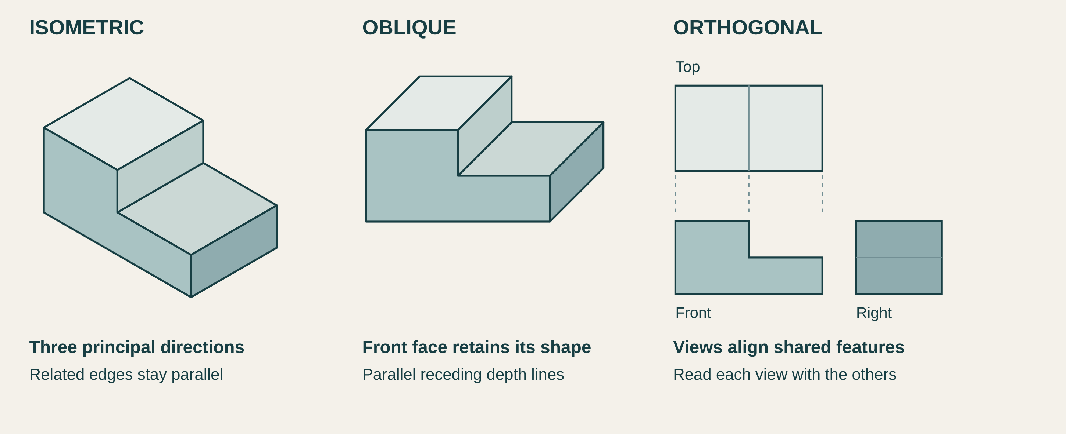
Figure 4. The same conceptual stepped solid is shown pictorially and in aligned orthogonal views. It has no project dimensions and is not a construction plan.

Freehand sketching and annotation
A freehand sketch helps a designer think while an idea is still easy to change. Begin with light construction lines, simple forms and proportion. Explore alternatives before spending time on polished rendering. A single attractive view can hide a problem with a join, moving part or the arrangement of components.
Add another view or a detail where it answers a question. An annotation should identify a relevant feature and explain its function, material, movement or design reason. Dimensions and joining information belong where they are known and needed. Do not invent construction details to make a concept appear resolved.
Judge the sketch by what another person can understand. If assembly remains unclear, a quick exploded or detail sketch is more useful than additional shading.

Isometric oblique and orthogonal views
An isometric view shows the overall form using three principal directions. Keep matching edges parallel and use a consistent scale along those directions. An oblique view keeps the front face in true shape and uses parallel receding lines to show depth. These pictorial systems help communicate relationships between visible features.
Orthogonal projection separates the object into aligned views. Compare the width, height and depth across the views: a feature missing from one view may be clear in another. This makes view selection essential when communicating information for production.
Use appropriate line types, scale and non-duplicated dimensions when exact working information is required. A shaded picture without dimensions does not give a manufacturer exact hole positions. Cross-check the views before relying on the drawing.

Check the relationship
Trace the step across the three orthogonal views. Then use the concept-sheet task on page 26 to choose views for your own idea.
08 / GRAPHICAL AND DESIGN COMMUNICATION

Models, presentations and folio communication
Different communication methods reveal different information. A rough model can test scale or interaction. A CAD model can communicate geometry and support manufacture. A presentation can explain reasoning to an audience. A folio should connect these artefacts into an evidence trail.
Low-fidelity models can test form, size, layout and interaction before detailed resources are committed. Digital models can be revised, measured, shared and linked to manufacturing processes, but they still require verification. A presentation should select evidence for the audience rather than reproducing the entire folio. Folio pages should label evidence and explain what it showed, what changed and why.
Worked example
A cardboard model shows that a handle blocks access to a control. What is the best folio record? Include the model evidence, explain the observed conflict, show the revised idea and identify the next test.
A sequence to guide the decision
Step | What to attend to
1 | Choose the question or message
2 | Select the communication method
3 | Create and label the artefact
4 | Interpret the evidence and record the decision

Check your understanding
Which evidence best demonstrates drawing accuracy?
○ A. A detailed title block only.
○ B. Aligned views or controlled axes, consistent proportions, correct line use and dimensions that agree with the developed design.
○ C. A drawing that looks three-dimensional but cannot be measured.
○ D. Dark outlines on every construction line.
Use the evidence and reasoning from this module in the complete applied task on the next page.
Continue online / M08 original questions and written responses
08 / GRAPHICAL AND DESIGN COMMUNICATION

Build an annotated concept sheet
A learning record that connects an idea, its form and the information still needed.
Produce an annotated concept sheet containing a freehand idea, a pictorial view and essential working information.
Freehand idea / Explore the form and annotate the purpose of a feature

Pictorial view / Show the same concept clearly in isometric or oblique

Essential working information / Label known details and flag what needs confirmation

Evidence caption / What is clear and what needs another view or test

Keep labels close to the feature they explain. A drawing is useful when its information can be checked. This supplementary sheet does not replace a teacher-issued assessment folio.
09 / CAD AND RAPID PROTOTYPING

Model relationships and test risks
Build controlled digital models, transfer information to production and use rapid prototypes to test assumptions.

CAD modelling and design intent
CAD supports accurate modelling, rapid modification, communication and manufacture. A strong model captures design intent: the dimensions and relationships are organised so expected changes update the model predictably rather than breaking geometry or requiring complete rebuilding.
Sketch constraints and dimensions should control important geometry rather than merely make the sketch appear complete. Feature order affects how easily a model can be understood, edited and repaired. Named parts, versions and meaningful comments reduce confusion in collaborative or iterative work. CAD accuracy must be checked against the brief, material, manufacturing process and physical tests.
Worked example
A team changes one width and several holes move incorrectly. What is the best response? Inspect the sketch references and feature order, rebuild the relationships around design intent, then verify dependent dimensions.

Rapid prototyping and 3D printing
Rapid prototyping converts digital information into a physical model quickly enough to support iteration. In 3D printing, the designer must consider orientation, layer behaviour, support, wall thickness, clearances, material, print time, post-processing and the limits of the specific machine.
A prototype should answer a defined design question rather than simply demonstrate that a file can be printed. Print orientation can affect surface quality, strength, support and accuracy. Small test pieces often provide faster and cheaper evidence than printing a complete design. The result should be measured and observed, then used to modify the digital model or production plan.
Worked example
A hinged feature is uncertain and the full print will take eight hours. What is the best strategy? Print a small representative hinge test using the intended orientation and settings, measure performance and update the model before the full print.

Model decision | How to preserve design intent
Reference | Choose a meaningful datum or relationship for a feature.
Change | Vary a controlling parameter and inspect dependent geometry.
Check | Compare the revised model with the brief and the physical test.
Record | Name the part and version so collaborators use the same decision.

09 / CAD AND RAPID PROTOTYPING

Use the test to change the model
A CAD dimension is an intention. A controlled test supplies evidence about the fit.
Tolerance fit and the Kitchen Companion
Tolerance describes allowable variation from a specified size; clearance is the intended gap between mating parts. The Kitchen Companion brief nominates a 0.2 mm tolerance for moving parts. That named-project value still needs interpretation and testing with the actual printer, material, orientation and geometry. It is not a universal printer setting.
Nominal CAD dimensions do not guarantee the same printed dimensions. A representative test should check fit, movement, retention and repeatability. Record the common conditions, measurements and behaviour, then document the approved model change so the whole team works from the same decision.
Worked example
Hypothetical observation: a 0.2 mm sliding test binds in one orientation but moves in another. This shows that orientation or related process effects need investigation; it does not prove that every final part will work.
Reasoning step | What the team records
Observe | Label the two orientations and record fit, movement and measurements.
Compare | Check which conditions stayed common and which changed.
Decide | Plan a systematic retest, then justify the clearance and approved model revision.

Keep the evidence honest. Do not force or finish a sample until it moves and then report that the original test succeeded. Practical testing needs the teacher-approved method and conditions.
Check your understanding
Which evidence best demonstrates a valid tolerance test?
○ A. One pair of parts that can be forced together.
○ B. A CAD screenshot showing a 0.2 mm dimension.
○ C. A labelled test series with known clearances, common settings, repeated movement checks, measurements and a justified selection.
○ D. A final product that moves after extensive finishing.
State one limit on the hypothetical result

09 / CAD AND RAPID PROTOTYPING

Record a representative tolerance test
Create and document a 0.2 mm tolerance test before committing the Kitchen Companion final print.
Complete this record only through the teacher-approved testing method. The brief’s nominated 0.2 mm value must be interpreted for the actual geometry and process; no printer settings are supplied here.
Representative test record
Part of the test | Evidence to retain
Feature and required behaviour
Geometry orientation and common conditions
Measurements and movement checks
Retention and repeatability
Approved model revision and reason

Next test and the remaining uncertainty

10 / TESTING, MATERIALS AND EVALUATION

Choose materials using evidence
Select resources through evidence, plan fair tests and use evaluation to refine prototypes before final production.

Material selection and evidence
Material selection is a design decision rather than a shopping list. Designers translate functional and aesthetic requirements into required properties, investigate feasible materials and processes, test critical performance and explain trade-offs. Availability and school-authorised processes are part of the context.
Required properties should be derived from the user, load, environment, expected life, appearance and maintenance needs. Supplier information is useful but should be checked against the actual form, process and use condition. Testing can verify strength, stiffness, wear, fit, finish, weather response or workability where these are critical. A justified selection explains why the material is more appropriate than feasible alternatives, including limitations.
Worked example
A camping product needs low mass, weather resistance and safe school manufacture. What is the best approach? Compare feasible materials against all three requirements, verify critical properties and consider joining, finish, cost, availability and end-of-life.

Manufacturing processes and scale
Manufacturing processes transform materials into components and assemblies. Selection depends on the material, form, tolerance, volume, finish, skills, equipment, safety, cost and waste. Processes may be manual, machine-based, digital, additive, subtractive, forming, joining or finishing.
The required geometry and material behaviour narrow the feasible manufacturing processes. One-off production supports customisation but usually has higher unit labour and less specialised tooling. Batch and mass production use standardisation, jigs, tooling or automation to improve consistency and output. Process selection should include quality checkpoints and a realistic plan for errors, maintenance and waste.
Worked example
A design requires twelve identical holes in a small batch of plywood components. Which approach is most defensible? Compare a drilling jig, CNC process and manual layout against accuracy, setup time, safety, equipment and batch size.

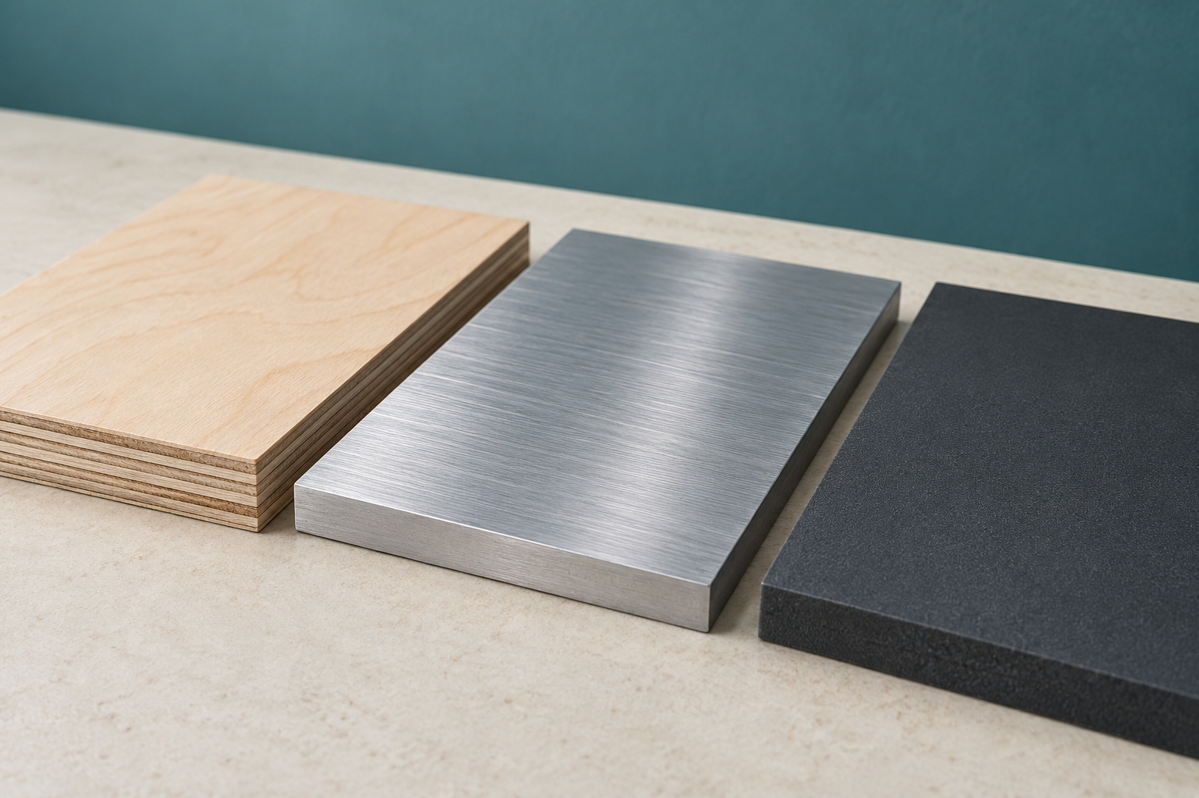
Figure 5. Illustrative material close-up. Layering and surfaces are visible; grade, strength and suitability still need evidence.

Appearance is one observation
A layered edge can suggest how a board is structured, but the actual specification, form and test conditions determine whether it meets a requirement. Compare feasible materials against the same need and consider the process used to shape them.
The controlled test on page 32 records the decision changed by the result, rather than simply choosing the best-looking sample.

10 / TESTING, MATERIALS AND EVALUATION

Prototype testing and continual evaluation
A prototype is valuable because it reduces uncertainty. Tests should correspond to criteria and control relevant variables. User feedback can reveal comfort, understanding and preference, while performance tests can measure function, strength, stability, durability or accuracy. Evaluation continues as evidence is collected.
Each test should identify the criterion, method, conditions, measurement or observation and decision rule. A fair comparison changes one important variable at a time or records other differences clearly. User feedback should involve representative users and focused tasks rather than general liking. Evaluation explains what the evidence means, what changed and what uncertainty remains.
Worked example
Two handle prototypes are made from different materials and tested by different users doing different tasks. What is the problem? Too many variables changed, so the result cannot show whether shape or material caused the difference; redesign the comparison.
A sequence to guide the decision
Step | What to attend to
1 | Select the criterion and question
2 | Plan a controlled and safe test
3 | Collect measurements, observations and feedback
4 | Interpret, modify and retest where needed

Check your understanding
Which evidence best supports material selection?
○ A. A requirements-property matrix combined with verified source data, relevant tests and a comparison of alternatives.
○ B. A product advertisement naming the material.
○ C. A list of material advantages copied from several websites.
○ D. A labelled material sample with no analysis.
Use the evidence and reasoning from this module in the complete applied task on the next page.
Continue online / M10 original questions and written responses
10 / TESTING, MATERIALS AND EVALUATION

Use a controlled test
Complete one controlled material or feature test and document the decision it changes.
Controlled material or feature test
Part of the investigation | Evidence and decision
Criterion and test question
Method variable and common conditions
Results and observations
Interpretation and limitation
Design change and retest

Record actual evidence when testing is authorised. If a classroom scenario is used, label the results as hypothetical.
11 / CAMPING DESIGN PROJECT

Find a need before a solution
Identify a genuine camping need and convert evidence, constraints and project criteria into a feasible compact product direction.

Identifying a genuine camping need
A strong camping project begins with a problem experienced by a defined user in a realistic context. The current task asks for an item that is practical, compact and marketable. Those requirements do not identify the product; research must establish which need is worth addressing and why.
A need statement describes the user, context, difficulty and consequence before proposing a solution. Observation, interviews, questionnaires and existing-product analysis can reveal different parts of the camping problem. A target market should be specific enough to guide decisions without relying on stereotypes. The final need should be significant, feasible and supported by more than one piece of evidence.
Worked example
A student wants to make a folding camp shelf because it looks interesting. What should happen before the brief is finalised? Investigate who has the storage problem, where it occurs, what existing solutions fail to do and whether the problem is feasible within the task constraints.

From situation to design brief
The design situation explains the broader context and why the project matters. The design brief then states what is to be designed and produced, for whom and for what purpose. Constraints and criteria add boundaries and standards, but should remain separate so they can be managed and evaluated clearly.
A design situation describes the context, people and problem that create the opportunity. A design brief identifies the intended user and purpose while leaving room for alternative concepts. Constraints set non-negotiable boundaries such as time, cost, available equipment or size. Criteria translate research and task requirements into standards that can later be tested.
Worked example
Which revision most improves the weak brief “Design a useful item for campers”? Design and produce a compact, practical and marketable solution for a defined camping user that addresses an evidenced need within the current project constraints.


Figure 6. Illustrative camping context. Packing volume and retrieval suggest research questions, not a predetermined product or real trial result.

Start with the difficulty
A camper may need to retrieve an item without unpacking a bag, reduce carried volume or manage a wet surface. These are possible questions, not established needs. Identify a target user, collect more than one kind of evidence and explain the consequence of the difficulty before proposing a solution.
The source Camping task sets a compact, practical, marketable solution with construction cost no greater than A$30. The current teacher-issued task controls formal requirements.

11 / CAMPING DESIGN PROJECT

Camping proposal and degree of difference
A proposal explains the direction the project will explore and why it deserves development. Its degree of difference is the meaningful improvement or distinction from existing products. Difference has value only when it better addresses the identified need, not when novelty is added for its own sake.
A proposal connects the need, target market, design direction, likely resources and intended evidence. Degree of difference may come from function, usability, portability, repair, materials, manufacture, access or another justified improvement. Feasibility should be checked against time, cost, size, skills, equipment, safety and access to materials. A proposal remains provisional and may change when concept testing produces stronger evidence.
Worked example
An idea adds a powered mechanism to a compact organiser, but users mainly need simple one-handed access. What is the best response? Compare the powered and non-powered concepts against user evidence, reliability, cost, size, safety and the value each adds before selecting a direction.
A sequence to guide the decision
Step | What to attend to
1 | Restate the evidenced need and user
2 | Compare existing solutions and locate a gap
3 | Propose a feasible design direction and meaningful difference
4 | Identify evidence needed before committing to production

Check your understanding
Which evidence best shows that a brief grew from research?
○ A. The brief includes several fashionable features.
○ B. The final sketch is attached beneath the brief.
○ C. The brief’s user, purpose and boundaries can be traced to documented findings and the authorised task requirements.
○ D. The wording resembles an existing product advertisement.
Use the evidence and reasoning from this module in the complete applied task on the next page.
Continue online / M11 original questions and written responses
11 / CAMPING DESIGN PROJECT

Develop a supported camping proposal
Investigate a camping problem, define a target market and develop a justified proposal using current task requirements.
Target user context difficulty and consequence

Evidence for the need
Source or method | Finding and limitation

Proposed direction / Show the benefit and a meaningful degree of difference

Feasibility / Cost time resources skills and practical approval

12 / PROJECT MANAGEMENT AND SAFE PRODUCTION

Manage the work and resources
Use action, time, finance, resource and WHS planning as active decision tools during project development and production.

Action plans, time plans and milestones
Project management is not a decorative table completed before practical work. An action plan identifies what must be done, while a time plan shows when tasks occur, overlap or depend on one another. Milestones and checkpoints make delays visible early enough to respond.
Tasks should be broken into observable actions rather than broad labels such as “work on project”. Dependencies identify work that cannot begin until an earlier decision, material or process is complete. Milestones mark important decisions or completed stages; quality checkpoints verify requirements before work continues. Actual progress should be recorded and the plan updated when evidence, delays or resource changes occur.
Worked example
A critical material will arrive one week late. Which response demonstrates effective project management? Update the plan, identify dependent tasks, bring forward independent research or prototype work and record the effect on milestones.

Finance and resource management
The current camping task sets a construction-cost limit of A$30. A finance plan should therefore inform design decisions before materials are committed. Resource management also considers quantities, stock sizes, equipment access, labour, energy, waste, storage and contingency.
Estimated quantities and unit costs should be based on the intended design and updated as it changes. A contingency allows for reasonable uncertainty but does not replace accurate estimating. Material yield and stock dimensions can affect cost more than the nominal price of a small component. Resource selection should balance function, quality, safety, sustainability, availability and cost.
Worked example
A material is cheap per metre but must be bought in a large minimum quantity. What should the designer do? Calculate the actual purchase and usable yield, compare alternatives and document how the choice affects budget, waste and performance.

A material is delayed | A useful management response
Find dependencies | Identify tasks that require the missing resource.
Use available time | Bring forward independent research or prototype work.
Check consequences | Revise milestones, cost and resource choices without bypassing approval.
Keep the record | Compare planned and actual progress, with reasons for the change.

12 / PROJECT MANAGEMENT AND SAFE PRODUCTION

WHS, risk controls and production readiness
WHS involves more than wearing personal protective equipment. The designer and producer should identify hazards in materials, tools, processes and the work environment, assess risk, use the strongest reasonably practicable controls and follow current school procedures and training.
Eliminating or substituting a hazard is generally more effective than relying only on PPE. Engineering controls such as guards, extraction and secure work holding reduce exposure through the work setup. Administrative controls include training, safe operating procedures, supervision, signage and planned sequencing. Production should not begin until required induction, teacher approval, equipment checks and controls are in place.
Worked example
A dusty process can be replaced with a lower-dust method that still meets the design criteria. Which control is strongest? Substitute the lower-dust method, then add any required extraction, procedure and PPE controls for the remaining risk.
A sequence to guide the decision
Step | What to attend to
1 | Confirm the production sequence and processes
2 | Identify hazards and assess relevant risks
3 | Select layered controls and required procedures
4 | Gain approval, check equipment and monitor conditions

Check your understanding
Which evidence best demonstrates production readiness?
○ A. A statement that the student has used similar tools before.
○ B. A signed risk table with no link to the chosen processes.
○ C. A complete design sketch and material receipt.
○ D. Approved drawings and sequence, completed training, identified hazards and controls, checked equipment and confirmed materials.
Use the evidence and reasoning from this module in the complete applied task on the next page.
Continue online / M12 original questions and written responses
12 / PROJECT MANAGEMENT AND SAFE PRODUCTION

Plan and respond to disruption
Construct an integrated action, time, finance, resource and risk plan for the camping project, then update it after a simulated disruption.
Integrated plan
Action and dependency | Time or milestone | Cost resource and control

Simulated disruption: an expected resource is unavailable for one lesson. Update the affected dependency, cost or resource choice and risk controls. Do not bypass teacher approval.
Updated plan after the disruption
Change and reason | Consequence and revised action

13 / MANUFACTURING, QUALITY AND PRODUCTION EVIDENCE

Build quality into the process
Plan and document a controlled production sequence that links workshop decisions to industrial and commercial practice.

Production sequence and quality assurance
A production sequence converts the resolved design into manageable operations. The order matters because some dimensions, joints, finishes or assemblies depend on earlier accuracy. Quality assurance plans the system that prevents defects; quality control checks the work and identifies whether requirements have been met.
Critical dimensions and reference surfaces should be identified before components are processed. Quality checkpoints should occur before errors become hidden or expensive to correct. Jigs, templates, gauges and documented settings can improve repeatability. A production plan should include safe setup, process, inspection, correction and evidence capture.
Worked example
A joint becomes inaccessible after assembly. When should its fit and strength be checked? Before final assembly, using defined acceptance criteria and recording any correction before the joint is concealed.

Industrial and commercial production links
The Preliminary course asks students to connect their designing and producing with industrial and commercial practice. A credible comparison identifies the common purpose of a process, then explains differences in scale, equipment, specialisation, documentation, quality systems, cost and risk.
School prototyping and commercial production may use similar design logic but different equipment, volume and accountability. Industrial settings often divide work among specialist roles and formalise specifications, traceability and quality checks. Commercial decisions include demand, lead time, unit cost, reliability, compliance, distribution and after-sales responsibility. A useful comparison explains what could transfer to the school project and what cannot be assumed.
Worked example
A student laser-cuts one component, while a manufacturer cuts thousands. What is the strongest comparison? Compare file preparation and cutting purpose, then explain differences in nesting, automation, quality assurance, maintenance, throughput and unit cost.

Weak record | Evidence that makes it useful
“I made the part.” | Name the operation and the requirement it needed to meet.
“It looked good.” | Record an observation or measurement against the checkpoint.
“I fixed it.” | Explain the problem, authorised correction and next decision.

13 / MANUFACTURING, QUALITY AND PRODUCTION EVIDENCE

Recording practical skills and production decisions
Production evidence should allow another person to understand what was done, why it was done, what result was observed and what followed. Photographs are useful only when selected and captioned to show a decision, process, quality issue, modification or skill.
A strong caption identifies the operation, relevant requirement, observation and next decision. Evidence should be captured at critical stages rather than recreated after completion. Practical skill is shown through control, accuracy, safe setup, appropriate technique and response to problems. The folio should select representative evidence rather than include every photograph taken.
Worked example
A photograph shows a component clamped during drilling. Which caption is strongest? The component was secured against a drilling jig to control hole position and prevent movement; the first hole measured within tolerance, so the setup was retained for the batch.
A sequence to guide the decision
Step | What to attend to
1 | Plan the evidence needed at critical stages
2 | Capture clear process and result records
3 | Annotate why the evidence matters
4 | Select and organise evidence against criteria and outcomes

Check your understanding
Which evidence best shows controlled production quality?
○ A. Dated work-in-progress evidence with measurements, checkpoint results, identified defects, corrective action and rechecking.
○ B. A list of operations written after production.
○ C. A final product photograph under good lighting.
○ D. A statement that tools were used carefully.
Use the evidence and reasoning from this module in the complete applied task on the next page.
Continue online / M13 original questions and written responses
13 / MANUFACTURING, QUALITY AND PRODUCTION EVIDENCE

Plan production and its evidence
Develop a production plan with process trials, quality checkpoints, evidence captions and an industrial/commercial comparison.
Production record
Process and trial | Quality checkpoint | Evidence caption and next action

Industrial or commercial comparison / What transfers and what does not

14 / MARKETING, SUSTAINABILITY AND FINAL EVALUATION

Make a supported final judgement
Evaluate the completed solution and communicate a credible market position using evidence rather than unsupported claims.

Ongoing and final evaluation
Final evaluation should synthesise evidence gathered throughout the project. It is not a fresh opinion written after completion. A strong evaluation judges functional and aesthetic performance, explains limitations, considers the effectiveness of the process and identifies justified improvements.
Each conclusion should refer to the relevant criterion, test or user evidence. A balanced judgement distinguishes confirmed success, partial success, failure and unresolved uncertainty. Process evaluation considers research, planning, communication, resources, production and continual decision-making. Recommended improvements should address a demonstrated limitation and explain the likely benefit.
Worked example
A compactness criterion was met, but user testing found the product awkward to set up. What is the strongest evaluation? Judge compactness as successful, usability as only partly successful, explain the test evidence and propose a targeted setup modification and retest.

Marketing and commercial viability
Marketing connects a design solution with its intended market. Product, price, place and promotion are related decisions. A credible proposal recognises production cost, likely value, distribution, communication, competition and evidence of demand rather than promising that an attractive product will be profitable.
The product decision includes features, quality, appearance, packaging, service and the need being addressed. Price must consider cost, perceived value, target-market affordability and the margin required across the supply chain. Place describes how and where the product reaches the user, which can affect packaging, stock, delivery and price. Promotion should communicate supportable benefits to the target market through suitable channels and messages.
Worked example
The product is intended for lightweight backpackers but requires bulky retail packaging. What should be reconsidered? Review product, packaging, distribution place, shipping cost and promotion together because the current package conflicts with the market’s portability values.

Marketing choice | Connection to evidence
Product | Features and supportable benefits for the intended user.
Price | Real cost, affordability, perceived value and supply-chain margin.
Place | Distribution, delivery, stock and packaging requirements.
Promotion | A message and channel suited to the market, without unsupported claims.

14 / MARKETING, SUSTAINABILITY AND FINAL EVALUATION

Life-cycle thinking and responsible design claims
A product’s impact is distributed across raw-material extraction, processing, manufacture, transport, use, maintenance and end-of-life. Designers should avoid treating one recycled component or low-waste process as proof that the whole product is sustainable. Claims need scope, evidence and acknowledgement of trade-offs.
Life-cycle thinking identifies where significant impacts and opportunities occur across the whole product system. Durability, repairability, replaceable parts and disassembly can extend useful life and improve end-of-life options. A lower-waste manufacturing process may still have high energy, transport or material impacts. Responsible evaluation considers effects on individuals, society and the environment, including who benefits and who bears costs.
Worked example
A student claims the product is environmentally friendly because offcuts were reused. How should the claim be repaired? Limit the claim to the observed waste reduction, then discuss material source, production, durability, repair, use and end-of-life evidence that is still required.
A sequence to guide the decision
Step | What to attend to
1 | Map the product life-cycle stages
2 | Identify impacts, benefits and affected stakeholders
3 | Compare credible improvement options and trade-offs
4 | Make a qualified judgement and state evidence limitations

Check your understanding
Which evidence best supports a marketing proposal?
○ A. The prototype cost and one preferred retail price.
○ B. A logo, slogan and social-media mock-up.
○ C. Target-market research, competitor comparison, realistic production and distribution assumptions, tested benefits and identified evidence gaps.
○ D. A list of stores that sell camping equipment.
Use the evidence and reasoning from this module in the complete applied task on the next page.
Continue online / M14 original questions and written responses
14 / MARKETING, SUSTAINABILITY AND FINAL EVALUATION

Evaluate and qualify a claim
Complete a criteria-based evaluation, life-cycle review and qualified marketing proposal for the camping product.
Criteria based judgement
Criterion and test | Result and limitation | Judgement or improvement

Life cycle review
Stage and impact evidence | Improvement and trade off

Qualified marketing proposal / User benefit price place promotion and limits

15 / PRELIMINARY SYNTHESIS AND YEAR 12 BRIDGE

Connect what your evidence shows
Integrate Preliminary knowledge, practise evidence-rich responses and carry disciplined project habits into the HSC course.

Connecting the Preliminary course
The Preliminary course is strongest when its topics are connected. Research identifies a need and informs criteria; design factors shape trade-offs; communication records and tests thinking; management organises resources; production realises decisions; and evaluation sends evidence back into development.
A change in one design factor can affect cost, function, aesthetics, manufacture, sustainability and market acceptance. Research is useful only when findings influence criteria, concepts, resources, tests or evaluation. Communication methods should preserve design intent across users, collaborators, producers and assessors. Evaluation connects the whole process by turning observations and results into judgements and modifications.
Worked example
A prototype fails a stability test late in development. Which course connections matter most? Revisit the criterion and design factors, analyse research and technical communication, update management, modify the design and record the evaluation evidence.

Responding to command verbs and stimuli
High-quality Design and Technology responses do more than list remembered facts. They answer the exact question, use the stimulus, connect causes and consequences, apply relevant course terminology and make a supported judgement when required.
Identify and list questions require relevant points; outline and describe require increasing feature detail. Explain shows how or why by linking cause and effect. Analyse identifies relationships and draws out consequences or implications. Justify, discuss and evaluate require evidence, reasoning and an explicit position or judgement suited to the wording.
Worked example
The command is “Evaluate the usefulness of a questionnaire for a new public product.” What structure is strongest? Make a judgement, explain relevant strengths and limitations in the public-product context, use evidence or examples and state how another method could address the gaps.

Evidence trail | Why the connection matters
Research → criterion | Findings define what success should mean.
Concept → test | The prototype targets an important uncertainty.
Result → modification | The evidence explains what changed and why.
Evaluation → next step | A judgement identifies the remaining limit or investigation.

15 / PRELIMINARY SYNTHESIS AND YEAR 12 BRIDGE

Readiness for the HSC course and Major Design Project
The HSC course applies and synthesises Preliminary learning through innovation study and the Major Design Project. Year 11 does not require students to preselect an MDP. It should build reliable habits: identifying a genuine need, using ethical research, managing scope, testing risk early, documenting decisions and evaluating honestly.
An MDP opportunity should be investigated before a solution or technology is fixed. A manageable scope allows depth of development, production quality and credible evaluation. Early prototypes and experiments reduce uncertainty in high-risk functions, materials or processes. A folio becomes stronger when evidence is captured as decisions occur rather than reconstructed near submission.
Worked example
A possible MDP is exciting but depends on unfamiliar electronics, custom fabrication and a large external client. What is the best
Year 11-style response? Investigate the need and stakeholders, test the highest-risk technologies, reduce scope where necessary and decide only after feasibility evidence is available.
A sequence to guide the decision
Step | What to attend to
1 | Review evidence and habits from Preliminary projects
2 | Identify strengths, recurring weaknesses and high-risk gaps
3 | Set practical routines for research, management and evidence capture
4 | Enter Year 12 with questions and methods, not a locked solution

Check your understanding
Which evidence best demonstrates MDP readiness?
○ A. A list of possible Year 12 product ideas.
○ B. A reflective audit showing how the student used research, scope control, management, experimentation, production evidence and criteria-based evaluation across Preliminary projects.
○ C. A collection of images showing innovative technologies.
○ D. A completed folio template with placeholder headings.
Use the evidence and reasoning from this module in the complete applied task on the next page.
Continue online / M15 original questions and written responses
15 / PRELIMINARY SYNTHESIS AND YEAR 12 BRIDGE

Connect the evidence and next step
Complete a course audit, extended-response practice and MDP-readiness reflection based on evidence from the year.
Course audit
Evidence from this year | Connection and evidence still needed
Research to decision
Concept to production
Test to evaluation

Extended response practice: use the complete original readiness question, its scaffolds and success criteria on page 50. Write the full 150–250-word response there, drawing on this course audit.
MDP readiness reflection / An opportunity, its main uncertainty and an early test

One next step and the evidence that would justify it

EXTENDED RESPONSE / EXPLAIN

Explain a justified decision
Explain how the principles in 'Command verbs and evidence-based responses' should guide a designer responding to this situation: A question asks students to justify the selection of plywood for a prototype. Which response is strongest?

Plan your response
Identify the user, context, need or decision being considered.
Select specific evidence or a course principle rather than relying on preference.
Link the evidence to consequences, trade-offs or implications.
Finish with a conclusion that directly matches the command verb.

Check your response
Uses accurate Design and Technology terminology in context.
Responds directly to the supplied situation and command verb.
Shows cause-and-effect links using evidence or a credible example.
States limitations or a supported judgement where required.

Write 150-250 words

EXTENDED RESPONSE / JUSTIFY

Qualify an environmental claim
Justify the most defensible design response to this situation using the ideas in 'Life-cycle thinking and responsible design claims': A student claims the product is environmentally friendly because offcuts were reused. How should the claim be repaired?

Plan your response
Identify the user, context, need or decision being considered.
Select specific evidence or a course principle rather than relying on preference.
Link the evidence to consequences, trade-offs or implications.
Finish with a conclusion that directly matches the command verb.

Check your response
Uses accurate Design and Technology terminology in context.
Responds directly to the supplied situation and command verb.
Shows cause-and-effect links using evidence or a credible example.
States limitations or a supported judgement where required.

Write 150-250 words

EXTENDED RESPONSE / JUSTIFY

Justify a manageable opportunity
Justify the most defensible design response to this situation using the ideas in 'Readiness for the HSC course and Major Design Project': A possible MDP is exciting but depends on unfamiliar electronics, custom fabrication and a large external client. What is the best
Year 11-style response?

Plan your response
Identify the user, context, need or decision being considered.
Select specific evidence or a course principle rather than relying on preference.
Link the evidence to consequences, trade-offs or implications.
Finish with a conclusion that directly matches the command verb.

Check your response
Uses accurate Design and Technology terminology in context.
Responds directly to the supplied situation and command verb.
Shows cause-and-effect links using evidence or a credible example.
States limitations or a supported judgement where required.

Write 150-250 words

