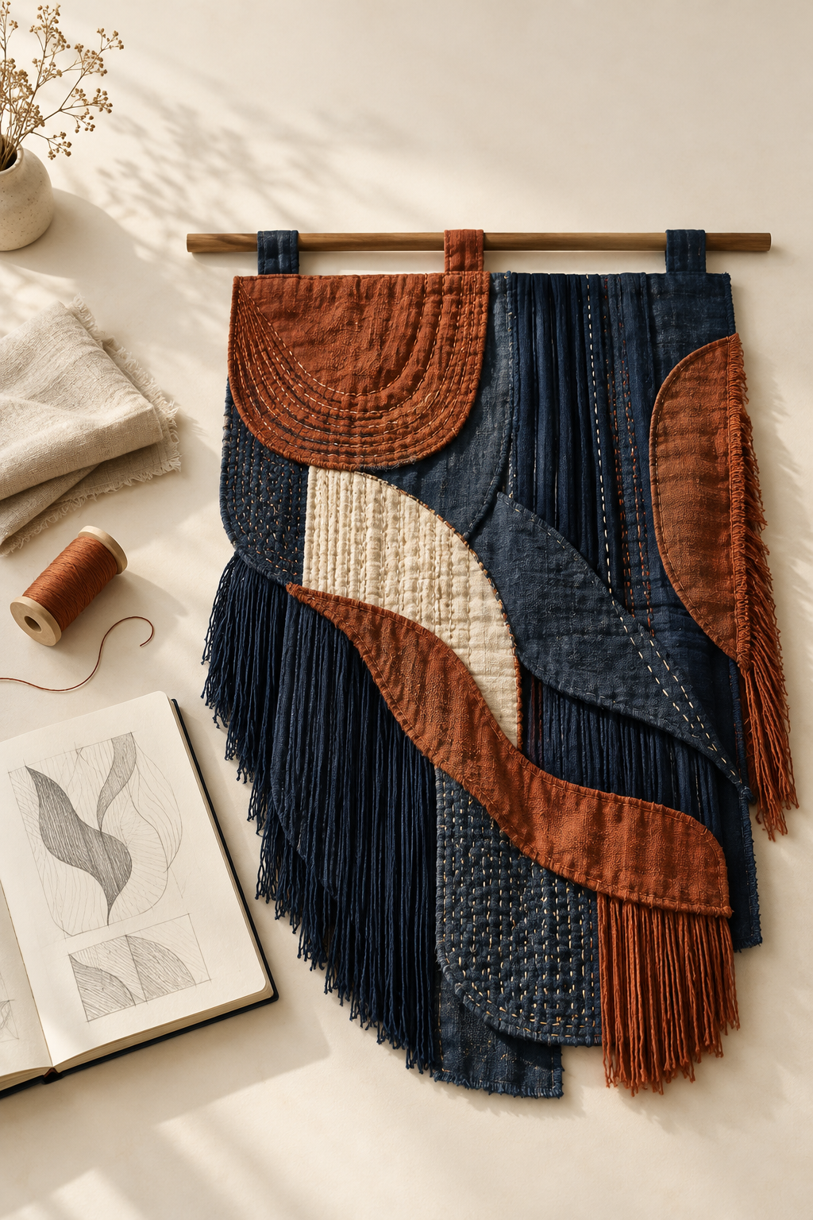
YEAR 12 / HSC

HSC Textiles
and Design
SUPPLEMENTARY STUDENT WORKBOOK

Make textile decisions with evidence
Read, compare and justify. Use this companion with the course website and your teacher’s current instructions.
NAME ____________________________________ CLASS ______________
Illustrative textile study | 50 A4 pages | Duplex long edge | Supplementary formative learning

NAVIGATION
Use the book and the course
A 50-page printed companion with selected practice and linked online continuation.
Module | Pages
01 HSC Transition and MTP Launch | 3–5
02 Historical Design Development | 6–8
03 Contemporary Designers and Trends | 9–11
04 Colour Principles and Fabric Colouration | 12–14
05 Decoration Techniques and Sampling | 15–17
06 Cultural Influences: Hmong Textile Traditions | 18–20
07 MTP Design Development | 21–23
08 Experimentation and Design Decisions | 24–26
09 Innovations and Emerging Textile Technologies | 27–29
10 Enhanced Performance | 30–32
11 Machinery, Seamless Technology and Enhancement | 33–35
12 End Use, Finishes and Care | 36–38
13 The Australian Textiles Industry and Marketplace | 39–41
14 Sustainability, Technology and Current Issues | 42–44
15 MTP Handoff and HSC Synthesis | 45–47

Work from each reading into its task. The book selects 30 original multiple-choice questions, four written prompts, seven complete applied tasks and ten folio stages. Further explanations, media and the remaining practice stay with the matching website sections.
Folio route: 01 p3; 02 p5; 03 p11; 04 p23; 05 p21; 06 p22; 07 p26; 08 p48; 09 p49; 10 p50. These are supplementary learning records, not formal submission evidence.
Current teacher instructions control projects, practical procedures, formal assessment and MTP logistics. The website’s 2027 planning basis does not confirm your cohort. Historical notices are not current assessment instructions.
Course: https://stevencowell.github.io/Year-12-HSC-Textiles-and-Design/

INTEGRATED READING
Connect foundations to decisions
Keep observations, evidence and decisions connected.
The HSC course map and two-year bridge
Preliminary knowledge supplies the fibre, yarn, fabric, design and industry foundations you use more independently in HSC study. Theory, the Major Textiles Project and examination preparation operate together. The course source maps Design and Properties and Performance at 20% each, Australian Textiles, Clothing, Footwear and Allied Industries at 10%, and the MTP at 50% of indicative course time. These proportions are not a new school assessment schedule.
Independent reasoning begins with a requirement. If comfort and durability matter, identify relevant structural evidence, explain its likely performance effect and justify a choice. Naming a fabric as “strong” does not make that connection. Earlier knowledge supports the HSC decision; it does not turn Preliminary and HSC learning into the same course.
Check. Which statement best describes the relationship between Preliminary and HSC Textiles and Design?
○ A. Preliminary learning provides foundations for more independent HSC application.
○ B. Preliminary learning is replaced completely when HSC study begins.
○ C. Preliminary and HSC study are the same course content repeated twice.
○ D. Preliminary learning remains separate and should not influence HSC decisions.

Folio 01 Evidence record
Preliminary foundation

HSC application

How the decision becomes more independent

WORKED EXAMPLE
HSC Transition and MTP Launch
Keep observations, evidence and decisions connected.
MTP focus areas, requirements and evidence
The individual Major Textiles Project combines a textile item or items with supporting documentation. The five focus areas are apparel, furnishings, costume, textile arts and non-apparel. A focus area establishes context, not a prescribed product. Your teacher confirms the project direction and current requirements.
Documentation should connect inspiration, visual development, specifications, investigation, experimentation and evaluation. For an illustrative geometric textile-arts idea, compare arrangements and samples before selecting a direction. Show why evidence changed the decision, then evaluate the result against its intended purpose. A collection of attractive pages without these links is not a convincing evidence chain.
From design inspiration to a workable brief
Inspiration suggests qualities to investigate; a brief gives those qualities a purpose. Identify a need, intended user, end use, functional and aesthetic requirements, and realistic constraints. Leave material and process choices open until evidence supports them.
For coastal rock-pool inspiration, investigate layering, curved lines or contrast rather than copying a complete image into a fixed product. A workable brief could seek a useful indoor textile with an organic layered character. Test which structures can provide the required performance and visual effect. Feasibility includes time, resources, expertise and approved practical access; an attractive idea still needs a workable route.
Inspiration | Evidence-led decision
Layering or contrast | Investigate a textile response against the brief

Check. How can a realistic constraint contribute positively to a design brief?
○ A. It removes the need to investigate alternative design directions.
○ B. It helps keep development realistic by identifying boundaries that the solution must respond to.
○ C. It guarantees that the simplest possible design will always be the strongest solution.
○ D. It allows functional and aesthetic requirements to be ignored when time is limited.

Identify one formal MTP question still needing teacher confirmation and one design choice that should remain open for investigation.

FOLIO
Focus area, purpose and workable brief
Keep observations, evidence and decisions connected.
Folio 02 Focus area, purpose and workable brief
Record the teacher-confirmed focus area and build a concise brief from an identified need, intended user, end use and design intention.
The focus area, project identity, formal requirements and approval state are Teacher to confirm. Do not use this scaffold as project approval.
Confirmed context — My teacher-confirmed focus area and context are…

Need, user and end use — The identified need is… The intended user/end use is…

Draft workable brief — I will investigate and develop… so that…

READ AND CHECK
Explain continuity and change
Compare selected evidence within the same textile focus area.
Trace a focus area over time
A historical trace explains what changed, what remained similar and why it matters. Select examples from different times within the same broad focus area, then compare useful lenses: end use, form, material, construction, decoration, performance or user context. Continuity is a recognisable similarity; change is an evidence-supported difference. A later design is not automatically better.
For two hypothetical apparel items, the end use may remain similar while materials and construction change. Explain how the changed feature could affect weight, fit or production. State what the selected sources actually establish and qualify what remains uncertain. The fuller comparison continues on page 7.
Connect factors to a design response
Design change usually involves interacting factors. User needs may create pressure for change, while available materials and production capability determine possible responses. Culture, markets and environmental concerns can also influence the choice. Build a factor → evidence → design response → consequence chain, rather than merely naming a factor.
If users need easier movement and quicker drying, that requirement gives a reason to reconsider restrictive or moisture-retaining features. Material possibilities may enable a response, but cost, appearance or durability can create trade-offs. Do not invent the exact textile from the need alone.
Trace the evidence | Explain the consequence
Selected feature → observed difference | What changed in use or production?
1. In a comparison of two apparel examples, what is continuity?
○ A. A feature that remains recognisably similar across the selected examples
○ B. Any feature that appears only in the later example
○ C. A judgement that both examples are equally successful
○ D. A sequence where every design feature stays exactly the same

2. Which sequence best represents the causal structure recommended for explaining a textile design change?
○ A. Design response → opinion → factor → description
○ B. Factor → evidence → design response → consequence
○ C. Consequence → feature → assumption → factor
○ D. Evidence → consequence → unrelated factor → design response

Name one source-supported change and one consequence you would investigate.

WORKED EXAMPLE
Historical Design Development
Keep observations, evidence and decisions connected.
Continue the historical comparison
Use the same comparison lenses for both examples. If their broad end use remains similar, explain what the continuity lets you compare fairly. A change in form or material can affect performance, manufacture or appearance. Identify the observable difference and the evidence supporting its consequence; dates alone do not explain development.
Connect the factors rather than listing them. A changed user need may create pressure for redesign, available materials may enable a response, and production capability may make it feasible. Markets or cultural expectations can affect adoption. A stronger explanation identifies these relationships and states what source evidence would support or challenge each link.
Turning historical evidence into analysis
Observation describes what the source actually shows. Inference proposes an explanation. An evidence-supported explanation links a visible difference to relevant contextual information; an overclaim goes beyond that support. Keep these different jobs visible in historical analysis.
In the fictional garments below, sleeve length, neckline and body shape can be compared directly. Appearance alone cannot establish fibre composition, wearer comfort, production date or a social cause. If a dated, attributed source later links an altered form to a changed user need, you can explain that relationship within the source’s context. Without that evidence, state the uncertainty.
Continuity provides a fair basis for comparison: both examples may serve the same broad apparel purpose while their forms differ. Change is not automatically improvement. A shorter sleeve could alter coverage or movement, but whether that is preferable depends on use. Interacting user priorities, materials and production capabilities can explain a response only when evidence connects them. Build a conclusion from selected lenses, a supported consequence and an explicit limitation.
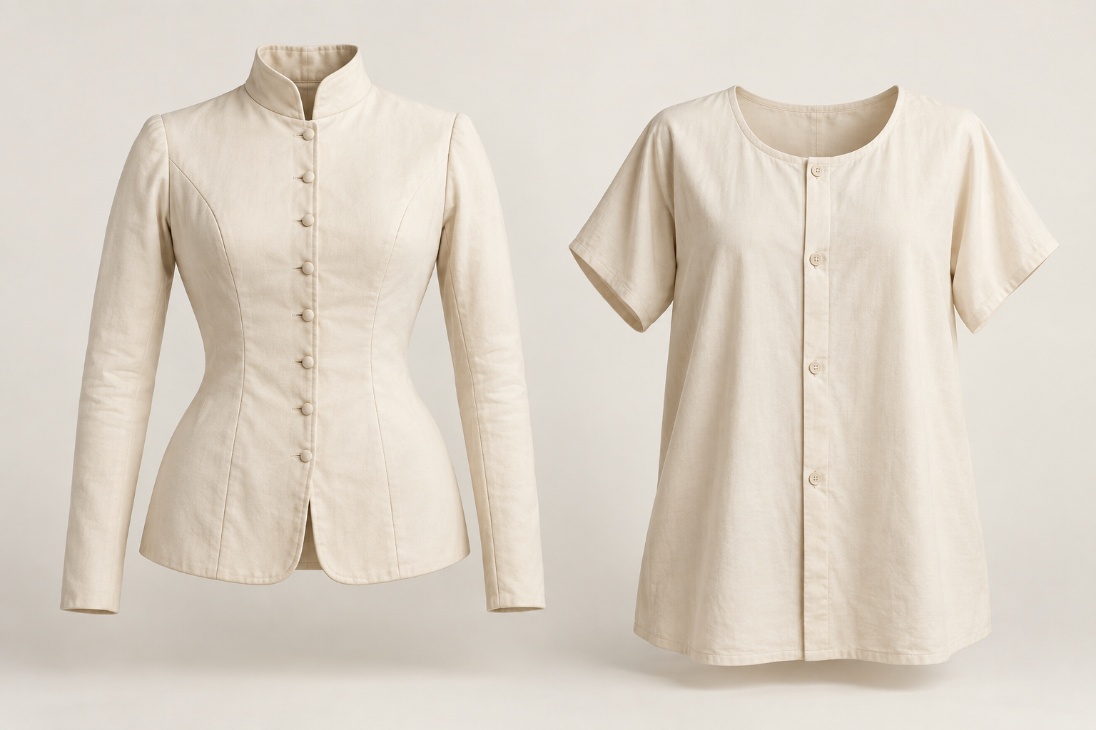
Fictional garments A (left) and B (right). Observe visible form; neither is an authenticated historical example.

For the fictional pair, write one observation and one cautious inference. Name evidence needed to connect a difference to a design cause.

APPLIED PRACTICE
Observation or overclaim
Complete every step using the supplied paper support. Formative practice only.
Paper cards refer to the fictional garments on page 7. Added fictional context note: a user brief requests reduced arm coverage in warmer conditions; it does not establish a historical date or cause.
1. Read each statement about the fictional garment pair.
2. Sort each statement into observation, inference, evidence-supported explanation or overclaim.
3. Underline the words or evidence that justify your classification.
4. For each overclaim, rewrite the statement so it becomes cautious and defensible.
5. For each inference, identify what additional source evidence would strengthen or challenge it.
6. Choose one evidence-supported explanation and label its claim, evidence and explanation components.
A. Garment B has shorter sleeves than A.
B. B might allow easier movement.
C. Because the fictional brief requests reduced coverage, B’s shorter sleeve responds to that requirement.
D. All people changed to this form because it was superior.
Classify A–D and underline the decisive wording

Repair an overclaim; name evidence for an inference; label a supported explanation

INTEGRATED READING
Contemporary Designers and Trends
Keep observations, evidence and decisions connected.
Designer practice, inspiration and signature
Analyse a designer’s decisions rather than only describing an attractive product. Keep observation, attributed statements and inference separate. A recurring combination of form, colour, layering or surface treatment across several works may support a qualified claim about a signature; a logo or one isolated feature does not.
For example, several authorised images might show layered surfaces and contrasting colour. Those are observations. A claim about the inspiration requires an attributed source. Use evidence → recurring pattern → interpretation → qualified claim. A designer’s name alone does not establish biography or motivation.
Internal and external success factors
Internal factors include expertise, philosophy, resources, business decisions and production capacity. External factors include consumers, markets, trends, technology and economic or social conditions. Explain how they interact rather than listing strengths and opportunities.
A small-batch designer may have expertise suited to careful individual work. Rising demand could create an opportunity, but rapid expansion might conflict with capacity or intended quality. A limited increase may be more defensible than maximum output. Define success through the actual need or design intention and identify evidence for the claimed consequence.
Observation | Attribution | Inference
Visible recurring feature | What a named source states | What the evidence may suggest

Check. Which sequence best represents the analysis chain described in the section?
○ A. Interpretation → biography → evidence → conclusion
○ B. Pattern → assumption → observation → final label
○ C. Claim → evidence → inspiration → repetition
○ D. Evidence → pattern → interpretation → qualified claim

Separate one visible feature from a possible explanation. Identify an internal and an external factor that could interact.

WORKED EXAMPLE
The relationship between designers and trends
Keep observations, evidence and decisions connected.
A trend is an observable direction across time and groups, not one preference or a short burst of attention. Designers can respond to, reinterpret, resist or help shape it. The relationship is reciprocal: market evidence informs a response; audiences encounter the work; adoption or adaptation may then change the trend evidence.
Imagine irregular stitched textures become more visible in a fictional marketplace. A designer reinterprets that direction through an existing practice. Later related surfaces appear elsewhere. This sequence may justify investigating influence, but similarity and timing alone do not prove that this designer caused the change.
Compare dated evidence about what was already occurring, the designer’s response and subsequent audience or market behaviour. Words such as “contributed to” or “may have influenced” can match a limited evidence base. Explain the specific relationship and its limits. Do not invent a lasting trend from several similar images collected on one day.
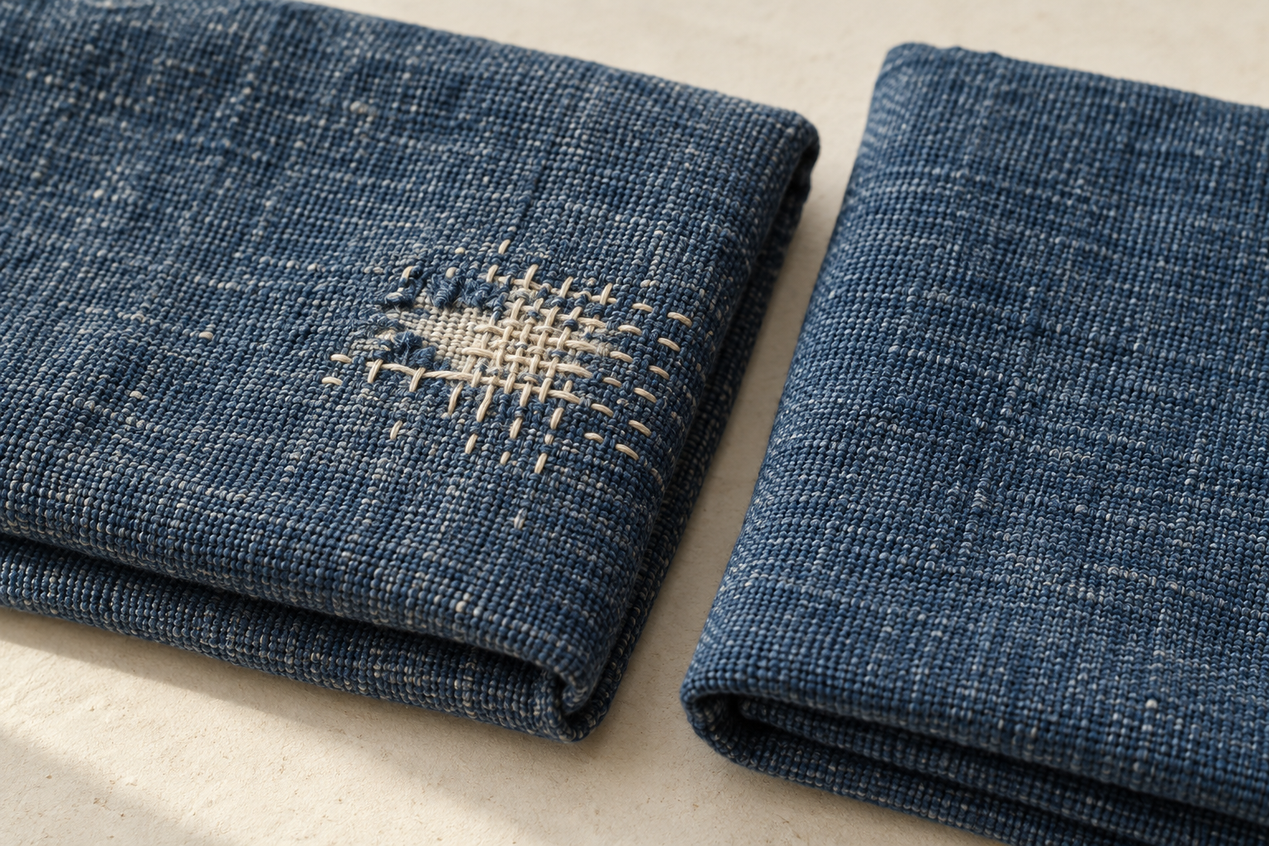
Illustrative repaired textile detail. Repeated repair-focused features could prompt a trend investigation; one example does not prove a trend.

Check. Which description best distinguishes a trend from a short-lived preference?
○ A. A preference becomes a trend whenever one designer uses it repeatedly.
○ B. A trend is any visual feature that attracts attention for a short period.
○ C. A trend is a recognisable direction that can be observed across time and among groups.
○ D. A trend exists whenever several similar products appear at the same moment.

Sketch a two-way trend loop and label one link that still needs evidence.

FOLIO
Inspiration and attributed influences
Keep observations, evidence and decisions connected.
Folio 03 Inspiration and attributed influences
Include creator/source, title or description, date/access record and permission status. Add one internal and one external factor that could interact in the observed design context.
Collect relevant inspiration, record its source and explain how an observed feature could influence a design decision without copying.
Do not copy culturally significant motifs or claim meanings without attributed evidence. Current reproduction permissions remain Teacher to confirm.
Source and attribution — Creator/source, title or description, date/access record and permission status…

Observed feature and supported context — I can observe… The attributed context establishes…

Transformed design influence — This could influence my own decision by… without copying…

INTEGRATED READING
Colour Principles and Fabric Colouration
Keep observations, evidence and decisions connected.
Colour principles for a specific end use
Hue is the colour family; value is its lightness or darkness; intensity is its brightness or strength. Harmony creates a coordinated effect, while contrast can distinguish a feature or establish emphasis. The useful choice depends on the user, setting and intended effect.
A light muted-blue organiser with a dark muted-blue pocket can combine related hues with clear value contrast. A medium blue body and medium green pocket differ in hue but may separate less clearly by value. Check the light–dark relationship as well as the hue; no colour is universally the best choice.
Printing and dyeing processes
Dyeing generally colours the treated fibre, yarn, fabric or item. Printing places colour or a design in selected surface areas, making motif position, scale and repetition part of the decision. Both depend on compatibility between the textile and the colourant system.
Investigate dyeing for an even all-over colour; investigate printing for repeated leaves separated by uncoloured areas. A photograph cannot prove which process produced a sample. Confirm the process from its source record, then compare coverage, placement and production stage. Equipment, quantities and safe practical methods remain teacher-approved.
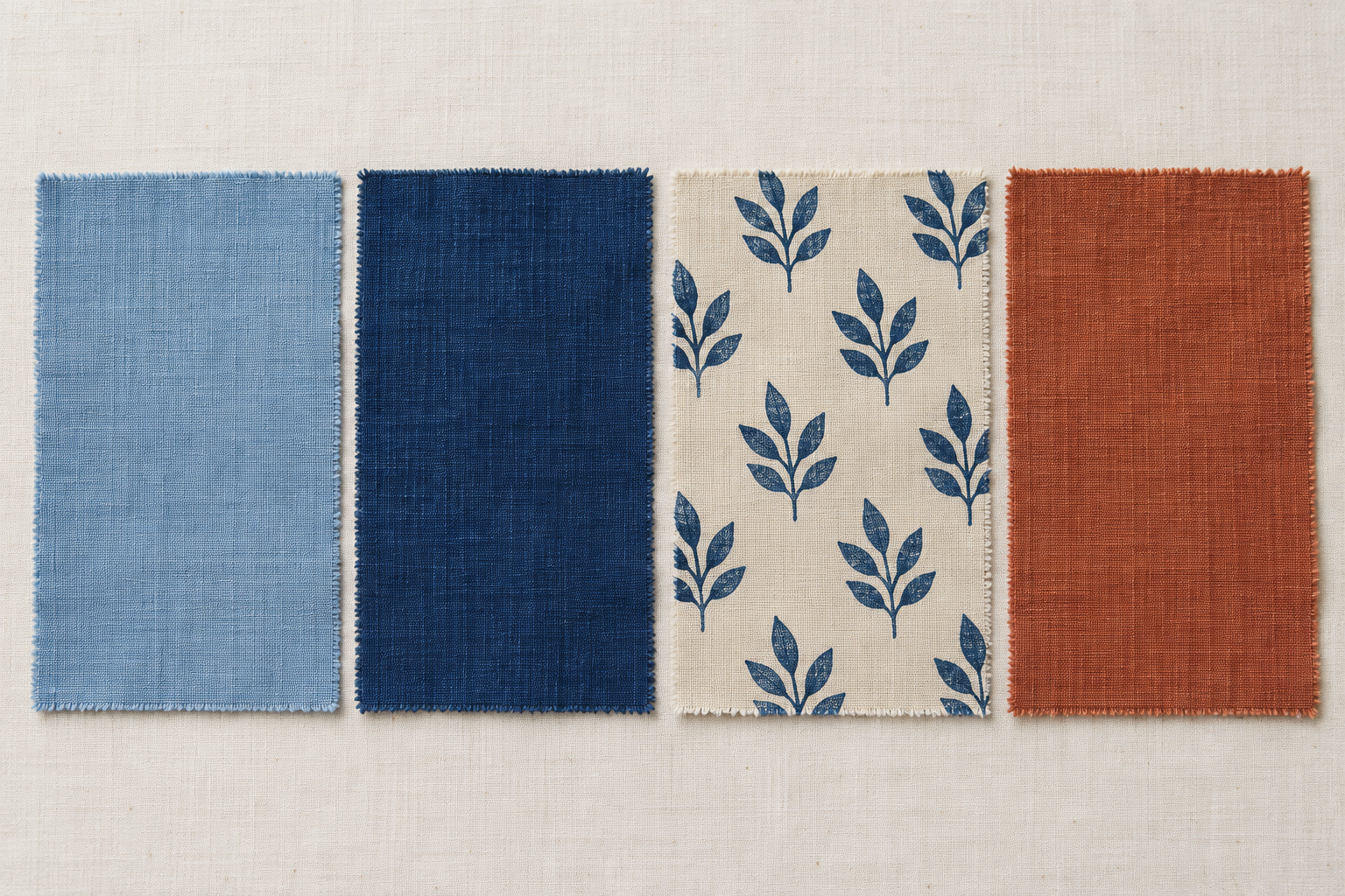
Illustrative colours and placement. Notice value contrast and selected motifs; appearance alone does not verify a colouration process.

Check. Which colour property describes how light or dark a colour appears?
○ A. Hue
○ B. Value
○ C. Intensity
○ D. Harmony

Explain one useful value contrast. Identify when all-over colour or selected print placement fits the intended effect.

WORKED EXAMPLE
Planning controlled colouration evidence
Keep observations, evidence and decisions connected.
Begin a colouration investigation with a design question. Identify the independent variable you deliberately change, the response you observe or measure, and relevant conditions kept consistent. Decide what evidence will answer the question before seeing a preferred result.
For example, compare one planned colouration difference across otherwise comparable labelled swatches. Record the actual approved method and conditions rather than filling gaps with invented quantities or timings. Keep each observation connected to its sample identifier. The comparison becomes weaker if several relevant conditions change together.
A useful record separates description from judgement: “the motif edge is less distinct” is different from “this is the best process”. Link evaluation to the intended design criterion and acknowledge limitations. The result may support a narrow choice or a targeted retest; it does not establish universal performance. Use the investigation-logic activity to connect the question, variable, controls, record, limitation and decision.

Illustrative coded-record context. Keep observations attached to a known sample; the image supplies no test result.

Check. Why should colouration samples be clearly labelled and linked to their observations?
○ A. So each result can be traced to the correct variation being compared
○ B. So the labels can replace written observations about the samples
○ C. So the samples automatically demonstrate durability and care performance
○ D. So the most attractive sample can be selected without considering end use

State a single variable, one relevant control and a limitation for a colouration comparison.

APPLIED PRACTICE
Build the investigation logic
Complete every step using the supplied paper support. Formative practice only.
Authored planning scenario: an organiser needs a clearly visible pocket motif. Compare two planned motif-intensity conditions on otherwise comparable labelled swatches, using only the colouration method approved by the teacher. No practical quantities or results are supplied.
1. Arrange six card types into a logical investigation sequence: question, variable, controls, evidence record, limitation and decision.
2. For the question card, identify the colouration comparison and the design or end-use reason for investigating it.
3. For the variable card, state the single factor intended to change across the labelled samples.
4. For the controls card, identify relevant conditions that should remain consistent without inventing local procedures.
5. For the evidence-record card, specify how sample identity and observations will be connected.
6. For the limitation card, identify one reason the evidence may not support a broad conclusion.
7. Complete the decision card with a cautious choice that refers to the stated priority and remains within the available evidence.
Question and single changed variable

Controls and connected sample evidence record

Limitation and cautious decision or next step

INTEGRATED READING
Read what decoration changes
A surface technique changes how a textile looks and how it behaves.

Figure 1. Illustrative same-motif comparison: added cloth shapes on the left; a design built with stitches on the right. The picture shows surface differences, not tested durability, care or drape.
Added pieces and added stitches  Appliqué attaches shaped textile pieces to a base. The added layer can make a bold silhouette and strong colour contrast. It can also increase thickness, weight and stiffness. A striking shape is useful only if those changes still suit the end use.  Embroidery builds a design with thread and stitches. Sparse stitching may change the base only slightly; dense stitching can make an area firmer or less flexible. Neither technique is automatically better. Compare the intended visual effect with handle, drape, durability and care requirements. |  | Choose an approach for its purpose  Hand work allows direct adjustment and deliberate variation, but repeated motifs can demand substantial time and expertise. Machine support may help controlled repetition and consistency; material response, complexity and operator skill still affect the result. A hybrid combines the two where each serves the design purpose.  For a design needing repeated motifs and one expressive focal detail, machine support could produce related repeats while hand work develops the individual feature. Compare intended character, time, control and finish. Faster or handmade does not automatically mean better. Practical methods need teacher approval.

Notice and apply: name one visible difference between the samples. Explain how it could matter for a textile that needs fluid drape.

WORKED EXAMPLE
Comparing and evaluating samples
Keep observations, evidence and decisions connected.
Compare clearly labelled samples against the same relevant criteria. Appearance, texture, handle, weight, drape, durability and care do not have equal importance in every end use. Choose criteria because they address the requirement, then observe before judging.
“The decorated area is raised” is an observation; “the raised area is unsuitable” needs a connection to the intended use. If flexibility matters, evidence about how a sample bends is relevant. An attractive surface alone does not prove comfortable handle or suitable care.
Build requirement → evidence → interpretation → judgement. Identify a similarity, difference and trade-off before selecting a sample. Either sample can be defensible if its evidence fits the priority. For repeated motifs plus an expressive focal detail, explain whether hand, machine or hybrid work would support those separate aims.
Check. Which statement most accurately describes appliqué?
○ A. It builds a design entirely from stitches and thread.
○ B. It attaches shaped textile pieces to a base textile.
○ C. It is any technique that changes the appearance of a textile surface.
○ D. It always produces a lighter and more flexible textile surface.

Check. Which sequence best represents the reasoning chain used to justify a sample selection?
○ A. Judgement → preference → observation → requirement
○ B. Observation → judgement → requirement → interpretation
○ C. Interpretation → rating → preference → observation
○ D. Requirement → evidence → interpretation → judgement

Choose hand, machine or hybrid work for repeated motifs plus one expressive feature. Name a trade-off and one observation needed before judging the sample.

APPLIED PRACTICE
Match technique to purpose
Complete every step using the supplied paper support. Formative practice only.
Authored neutral scenario: a lightweight hanging should show a clear botanical motif while retaining a fluid drape. Compare appliqué and embroidery. The samples on page 15 illustrate appearance only.
1. Select a neutral end-use scenario card.
2. Match an appliqué or embroidery technique card with a plausible feature card, such as added layering, stitched detail or increased surface texture.
3. Match that feature to one or more possible effects on appearance, texture, handle, weight, drape, durability or care.
4. Explain whether the matched effects support or complicate the scenario's stated priorities.
5. Create a second valid match using the other technique and compare the trade-offs.
Techniques: appliqué; embroidery
Features: added cloth layers; sparse stitches; dense stitching
Possible effects: stronger silhouette; finer detail; increased thickness; changed flexibility
Priority: clear motif with fluid drape
Chain 1: technique → feature → possible effect → priority, with one benefit and trade-off

Chain 2: use the other technique, then compare the trade-offs

INTEGRATED READING
Cultural Influences: Hmong Textile Traditions
Keep observations, evidence and decisions connected.
Cultural context and respectful evidence
Cultural study connects an observed feature with attributed contextual evidence and a cautious interpretation. Hmong communities are diverse. A feature documented in one community, place or period must not be claimed for all Hmong people.
Repeated geometric forms are observable; a ceremonial meaning needs reliable contextual support. Record who produced the source, its community/context, date and relevance. “In this documented context” marks a useful limit. Missing meaning remains unknown; an attractive story or visual resemblance cannot fill the gap.
Meanings, resources, skills and processes
Trace resource → material property → skill or process → observable feature. Add documented use or meaning only when an attributed source supports that final link. Prepared thread, dyed cloth or layered stitching can explain a visible structure without proving a symbolic meaning.
Fibre preparation, dyeing, embroidery or appliqué may occur in particular documented Hmong sources, but are not universal claims about every community. Do not infer who performed a process or why it was chosen. If sources differ, identify the difference. Respectful analysis can study the relationship without copying a motif.
Check. Which phrase best signals a cautious interpretation of cultural evidence?
○ A. This obviously proves that...
○ B. In this documented context, the source suggests that...
○ C. All Hmong textiles demonstrate that...
○ D. The motif must mean that...

Write a resource–process–feature chain from an attributed source. Mark where the evidence stops and cultural meaning remains unknown.

WORKED EXAMPLE
Design influence without appropriation
Keep observations, evidence and decisions connected.
Studying cultural evidence, learning a broad design principle, adapting an identifiable feature and copying a culturally significant motif are different actions. Good intentions do not establish permission or make copied imagery original. A small colour change does not necessarily transform it.
Use a respect check: provenance, significance, permission or consent, attribution, benefit and transformation. Ask what each source establishes and what remains uncertain. Public visibility does not establish unrestricted reuse. Consider whether the cultural feature is needed at all.
In the course example, a student likes the rhythm of a documented Hmong motif but lacks evidence about its significance and appropriate reuse. The student keeps the lesson about repetition and instead develops original units from overlapping leaf shadows. Attribution to the research remains, while the identifiable motif is unused. This is an active design decision based on evidence and uncertainty, not a claim that a different colour makes copying acceptable.
Action | Evidence question
Study a source | What does this documented context establish?
Use a broad principle | Can I develop original forms independently?
Adapt an identifiable feature | What do provenance, significance and permission establish?
Copy a cultural motif | Do not treat a minor colour change as transformation.

Check. What does provenance help a designer establish?
○ A. Where a feature or source comes from and the context in which it was documented
○ B. Whether changing a feature's colours automatically makes it original
○ C. Whether a motif has the same meaning wherever it appears
○ D. Whether a designer personally likes the cultural feature being considered

Name two respect-check factors that would change your decision about using an identifiable cultural feature.

APPLIED PRACTICE
Choose a respectful influence
Complete every step using the supplied paper support. Formative practice only.
Authored scenario A: a named cultural textile image has clear attribution, but the meaning and reuse permission of its recognisable motif are unknown; a student proposes recolouring that motif. Scenario B: the student attributes the research, leaves the motif unused and creates original units from observed leaf shadows to explore repetition. No community-wide permission is claimed.
1. Read each supplied design scenario and examine the available information about provenance, cultural significance, permission or consent, attribution, benefit and transformation.
2. Rate each factor as supported, uncertain or unsupported without treating any single factor as an automatic answer.
3. Choose whether the strongest response is to proceed, reconsider the design direction or leave the cultural feature unused, then record a brief evidence-based justification.
Factor | A | B
Provenance
Significance
Permission or consent
Attribution
Benefit
Transformation
Non-use option

Mark supported, uncertain or unsupported. Justify the strongest decision for each scenario.

INTEGRATED READING
MTP Design Development
Keep observations, evidence and decisions connected.
Generating ideas and choosing a final direction
Generate genuinely different directions for the same authorised need before narrowing the choice. Concepts can vary in form, arrangement, construction, surface or user interaction. Annotate what a feature should achieve, not only what it looks like.
Functional and aesthetic analysis
Functional requirements describe what the item must do; aesthetic requirements describe its intended visual qualities. They interact. Shape may influence movement and appearance; texture can affect handling as well as visual character.
For an authorised design direction, link a specific feature to each requirement. A firmer layered surface may create strong visual structure yet reduce desired drape. Judge that trade-off against the actual end use and evidence. “Looks good” is not sufficient analysis. Record the requirement, feature, evidence and whether the balance needs refinement.
Check. Which selection criterion is most directly concerned with whether a concept can perform its intended role?
○ A. Functional suitability
○ B. Aesthetic suitability
○ C. Personal familiarity
○ D. Number of sketches produced

Folio 05 Evidence record
Functional requirement and evidence

Aesthetic requirement and evidence

Interaction and judgement

WORKED EXAMPLE
Communicate the design
Keep observations, evidence and decisions connected.
Drawings, specifications and time planning
A presentation drawing communicates overall appearance and intended use. A production drawing communicates construction-relevant relationships such as components, feature positions and joining intentions. Use the view that makes the particular information understandable; add detail only when it reduces uncertainty.
Specifications translate confirmed decisions into clear records. Do not invent dimensions, materials or methods to make a sheet look finished. Time planning identifies task dependencies, checkpoints and contingency. A delayed sample decision can affect a later specification or making stage.
Check drawings and specifications against each other, identify what a technical or non-technical reader needs, and record the next question for the teacher. Revision should explain what changed and why. A well-drawn concept or completed timeline does not approve equipment, procedures or formal submission arrangements.
Check. What is the purpose of contingency in a design time plan?
○ A. To allow capacity for unexpected revision, investigation or changed information
○ B. To remove the need to identify dependencies between tasks
○ C. To make every task longer regardless of its complexity
○ D. To ensure the original design can never be changed

Folio 06 Evidence record
Current specification formats, dates, dimensions, machinery and production procedures remain Teacher to confirm.
What the record communicates

Gap, dependency or checkpoint

Revision made and reason

FOLIO
Develop a range then decide
Folio 04 Idea range and final direction
Compare functional suitability, aesthetic suitability, feasibility and available evidence. Explain ratings and priorities; a weighted total helps show thinking but does not make the decision automatically. Changing a priority may change the ranking. Select a direction with reasons and explain why alternatives were not chosen.
Range of ideas: sketch and annotate three genuinely different concepts.
A Different form or arrangement

B Different construction approach

C Different surface or user interaction

Criteria and comparison: name the most important criterion. Compare all three concepts using evidence or a clearly identified design judgement.

Selected direction: justify your choice and explain why each alternative was not selected.

Annotate intended purpose. Keep the authorised need and end use. These sketches are not project approval; confirm the direction and practical method with your teacher.

INTEGRATED READING
Experimentation and Design Decisions
Keep observations, evidence and decisions connected.
Building a fair and useful investigation
A useful investigation resolves a design uncertainty. Begin with the decision question and a criterion linked to the end use. The independent variable changes; the dependent variable is the observed or measured response; controls are relevant conditions held consistent.
If two seam options are compared, changing both the seam and fabric introduces another possible explanation for a difference. Repair the comparison or qualify the conclusion. Set the criterion before seeing the results. Use only the approved method and record its reference; the workbook supplies no practical procedure.
Recording samples, observations and results
A traceable record links a unique sample code, relevant conditions, observation and supporting evidence. A photograph is useful only when its sample identity and context remain known. Keep raw description separate from interpretation.
For two samples, use the same observation categories and record missing information as unknown. “A is best” cannot replace the actual result. Summarise a pattern without claiming more than the record supports. A reader should be able to work backwards from a conclusion to the correct sample and conditions.
Sample code | Comparable conditions | Observation
A / B | Record what changed and stayed consistent | Separate result from interpretation

Check. In a comparison of two seam options, what is the independent variable when the seam option is deliberately changed?
○ A. The observed response
○ B. The seam option
○ C. Every factor kept consistent
○ D. The final design decision

Name the changed variable and an observed response for a fair comparison. Show how a sample code would connect the evidence.

WORKED EXAMPLE
Make a bounded judgement
Mixed evidence can still support a useful next step.
Evaluation connects a claim, relevant evidence and reasoning. Compare the evidence with a criterion stated before the results were known. The reasoning explains why the result matters to the design requirement; it should not turn one advantage into a claim of overall superiority.
Worked example from the course
Two generic samples are compared with a pre-stated end-use criterion. Sample A is more favourable for one relevant characteristic; Sample B has an advantage for another. This qualitative example does not establish that either sample is superior in every respect.
Claim: Retain the feature represented by A for the characteristic where its evidence is stronger.
Reasoning: That result addresses part of the criterion. It does not resolve the characteristic where B is stronger.
Limit and next step: The comparison does not show whether a small change could retain the advantage and improve the weaker aspect. Make a limited modification, then target that uncertainty in a retest.
Confidence should match the consistency, relevance and fairness of the evidence. “Under the conditions compared” is useful only when it accurately describes the limit. A targeted retest has a purpose; repeating everything without identifying the unresolved question does not strengthen the reasoning.
Apply the original written prompt
Evaluate mixed investigation evidence from two generic textile samples and justify an appropriate keep, modify, reject or retest decision for the design feature being investigated.
Use a pre-stated criterion, relevant evidence and its reasoning link, at least one limitation, and a specific justified action. Work from teacher-provided or clearly identified generic comparison evidence.

FOLIO
Experimentation, samples and material decisions
Keep observations, evidence and decisions connected.
Folio 07 Experimentation, samples and material decisions
Record one teacher-authorised investigation from question and fair comparison through observations, evaluation and design consequence.
Use only the safe method, equipment, quantities and controls supplied or approved by your teacher. This page provides no practical procedure.
Question, comparison and controls — The investigation asked… I compared… I controlled… The approved method was…

Observations and results — The coded evidence showed… A pattern, difference or limitation was…

Evaluation and design consequence — This evidence supports changing/keeping… because…

INTEGRATED READING
Innovations and Emerging Textile Technologies
Keep observations, evidence and decisions connected.
Innovation definitions, needs and drivers
An invention creates a new possibility; an improvement modifies something existing; innovation applies a new or improved idea with demonstrated value. An emerging technology is developing or beginning to influence a context. Novelty alone proves none of its benefits.
Begin with a need, then investigate, test, evaluate, refine and consider production and adoption. A moisture-management sample may address comfort while creating a handle or manufacturing compromise. Evidence can justify refinement or rejection. Production does not guarantee that users will adopt the result.
Emerging fibres, yarns and fabrics
Locate a change at fibre, yarn or fabric level, then explain structure → property → end-use performance. Fibre fineness may alter surface area; packing, fabric density and finishes can alter how that possibility appears in a finished textile.
Build an evidence profile: changed structure, possible effect, relevant use, demonstrated evidence and remaining uncertainty. A fibre-level claim does not prove full-product performance. “Emerging” does not automatically mean smart, synthetic, sustainable or superior. Use the complete material system and evidence to qualify the judgement.
Changed structure | Possible property | Evidence question
Fibre / yarn / fabric | Qualified predicted effect | Does it occur in the complete textile?

Check. What is the most appropriate starting point for the innovation chain described in the theory?
○ A. Choosing the newest available technology
○ B. Planning widespread production immediately
○ C. Predicting that consumers will adopt the product
○ D. Identifying and defining a textile need or problem

Locate a generic innovation at fibre, yarn or fabric level. Explain one possible property effect and what remains unproven.

WORKED EXAMPLE
Product, process and societal impacts
Keep observations, evidence and decisions connected.
Product innovation changes the textile itself; process innovation changes how it is developed, produced, maintained or recovered. They can interact. An intended user benefit does not establish an overall social or environmental benefit.
Trace effects through stakeholders and life-cycle stages. A generic temperature-managing textile may offer a plausible comfort benefit, yet require more complex manufacture or care. Permanently combined layers may make repair or separation harder. These are questions for evidence, not automatic conclusions.
Distinguish demonstrated results, reasonable inference and unknowns. Evidence for heat behaviour cannot by itself prove worker, community or environmental effects. Consider reversibility: can a component be adjusted, replaced or separated if an uncertain effect becomes a problem? A defensible evaluation identifies who benefits, where a burden could shift, what evidence is missing and the conditions under which the innovation would be worthwhile.
Illustrative repair detail. Access for repair and material separation are useful questions when evaluating an innovation.

Check. What is the main purpose of combining stakeholder and life-cycle lenses?
○ A. To identify who may be affected and at which stage possible benefits, costs or uncertainties arise.
○ B. To prove that every life-cycle stage affects every stakeholder in the same way.
○ C. To replace analysis of textile performance with analysis of social consequences only.
○ D. To determine whether an innovation is emerging based on how many stakeholders use it.

Name a stakeholder benefit and a possible life-cycle trade-off for the same innovation.

APPLIED PRACTICE
Build a supported response
Use the original course prompt and explain the relevant relationships.
Evaluate a generic textile innovation as both a product and process change. Consider intended and unintended consequences for different stakeholders and life-cycle stages, then make a qualified judgement about its overall value.
Identify the product innovation and any related process changes.
Explain the intended benefit and distinguish it from possible unintended effects.
Map at least three relevant stakeholder or life-cycle impacts, including where evidence is strong, limited or absent.
Explain at least one trade-off and consider whether an important decision or consequence is reversible.
Finish with a qualified overall judgement that matches the strength and limits of the evidence.
The response evaluates both benefits and limitations across multiple stakeholders or life-cycle stages rather than describing the innovation only.
The final judgement is supported by relevant evidence, identifies uncertainty and avoids assuming that performance benefit proves broader social or environmental benefit.
Use the generic temperature-managing textile from page 28 or a teacher-provided comparison. Treat proposed effects as conditional unless evidence demonstrates them.

TECHNICAL EXPLANATION
Trace structure to performance
A technology name identifies an idea; it does not guarantee an outcome.
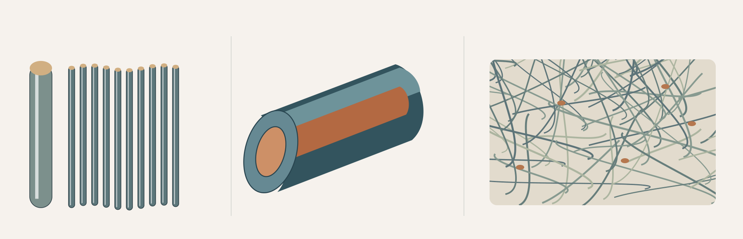
Figure 2. Conceptual structures, not to scale. Left: relative fibre fineness. Centre: cutaway of one possible two-component arrangement. Right: a bonded web, rather than woven warp and weft. The sketch is not a product specification.
Three structural ideas  Microfibre describes very fine fibres or filaments, not a particular polymer. Fineness can change surface area and packing. Possible softness, flexibility or moisture interaction still depends on the polymer, assembly and finish.  Bicomponent structures combine two material components within one fibre or yarn arrangement. Different arrangements can influence bonding, shape or texture. Two components do not mean every bicomponent textile behaves alike.  Washable webs are nonwoven structures engineered to withstand the intended repeated care. Fibres or filaments form a bonded web. Bonding, fibre choice, density and finish all affect whether it remains coherent. |  | Make the layers explain each other  Fibre characteristics contribute to performance, but yarn twist and arrangement can alter cohesion, bulk and surface behaviour. Fabric construction then organises elements through interlacing, looping or bonding. A finish acts on this existing structure.  For a smooth lining, low bulk and flexibility may matter. For a removable absorbent insert, liquid uptake, shape retention and repeated care may matter more. Either decision needs evidence about the complete textile, not just its technology label.  Use the chain fibre → yarn or fibre arrangement → fabric construction → finish → observable property → end-use performance. Explain each link and qualify any claim that has not been demonstrated.

Annotate one arrow in the chain: what further evidence would you need before selecting a washable web for the insert?

WORKED EXAMPLE
Selecting performance for end use
Keep observations, evidence and decisions connected.
Start with an end-use profile, not a favourite fibre. Sort requirements into must, should and could. Write observable criteria: shape retention during expected use is more useful than “excellent quality”. Compare each candidate against the same priorities.
Link available evidence to fibre, yarn, fabric and finish interactions. A strong feature in one criterion may accompany a weakness elsewhere. Record unknown when evidence is absent. An attractive feature should not displace an essential requirement.
For a removable absorbent insert, repeated care and shape retention may be must requirements, while a preferred surface colour may be less important. Select provisionally using the evidence, state a trade-off and identify a consequential gap. A technology label does not substitute for an actual performance record.
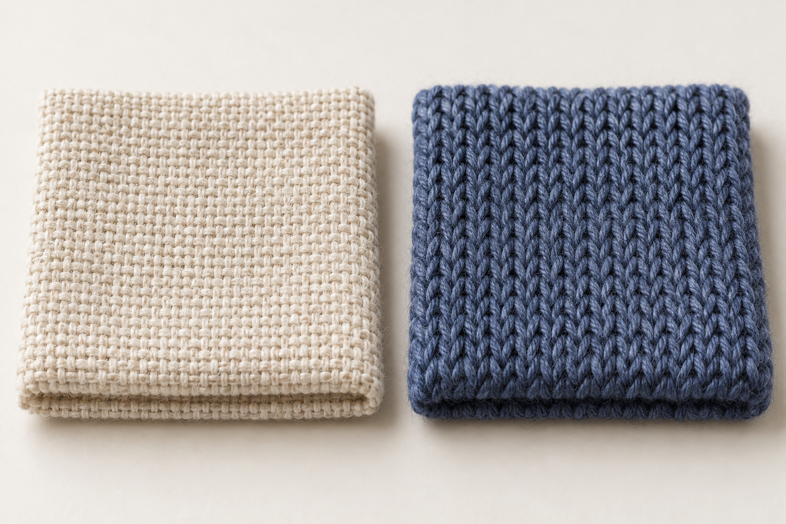
Illustrative woven and knitted structures. Visible structure supports observation, not a measured performance or fibre-composition claim.

Check. Which factor is especially central to a washable bonded web?
○ A. Warp density
○ B. Bonding
○ C. Yarn twist
○ D. Weft direction

Check. Which criterion is framed most usefully?
○ A. Use a specific fibre
○ B. Remain flexible during handling
○ C. Be the best fabric
○ D. Pass an unnamed official test

Write a must requirement and a trade-off for an absorbent removable insert; state one missing piece of evidence.

APPLIED PRACTICE
Match structure and end use
Complete every step using the supplied paper support. Formative practice only.
Authored matching cards extend the source activity. Match each technology to its structure, a plausible qualified property and an end-use priority. More than one end-use link may be defensible if explained.
1. Match each technology card to its most accurate structural description.
2. Match each pair to one plausible property statement using may or can.
3. Match each set to a suitable generic end-use priority.
4. Explain one match by identifying another factor that could change the result.
Technologies: A microfibres; B bicomponent structures; C washable webs
Structures: 1 two material components in one arrangement; 2 fine fibres or filaments; 3 fibres formed into a bonded nonwoven web
Possible effects: i may support softness/low bulk; ii can use different component behaviours; iii can retain coherence in intended care
Priorities: lining flexibility; controlled structural response; removable insert that survives repeated care
Record the three four-part matches and qualify the property links

Explain one match and another factor that could change its result

READ AND CHECK
Judge the whole pathway
Separate a technology’s function from its demonstrated effects.
Machinery and production technologies
A production technology provides a function, such as carrying out a repeated task or storing and communicating production information. Its function does not guarantee better quality. Controlled repetition may support consistency, but compare actual outputs against relevant requirements. Consistency in an unwanted feature is not success.
Compare the whole pathway: time saved in one repeated operation may add preparation, checking or communication elsewhere. Include labour, resources and scale.
Seamless technology changes construction
Seamless technology forms all or much of a product with fewer conventional cut-and-sewn seams; it does not simply hide a seam. Some joins, edges or separately added parts may remain. Panel construction forms separate sections and joins them. A seamless pathway can reduce or relocate shaping and joining, changing the design opportunities.
For a close-fitting item, fewer selected joins could support stretch continuity or appearance. Actual fit, comfort, durability and production effects require evidence. Continue on page 34.
Analyse the pathway | Test the claimed benefit
Function → possible effect | Relevant evidence + constraint
1. Why should speed be treated as a possible production effect rather than an automatic overall benefit?
○ A. Speed matters only when production scale remains unchanged throughout the pathway.
○ B. Faster production always reduces consistency, creating an unavoidable trade-off between speed and quality.
○ C. Speed cannot be compared because conventional and computer-supported pathways have unrelated production functions.
○ D. One stage may become faster while preparation, checking, communication or other demands remain elsewhere in the pathway.

2. Which statement best explains what seamless technology means in textile construction?
○ A. It means conventional seams are always hidden from view.
○ B. It forms all or much of a product with fewer conventional cut-and-sewn seams.
○ C. It guarantees that no joins or separate components remain anywhere.
○ D. It describes any textile product with a smooth surface appearance.

Name a claimed benefit and the evidence needed to test it.

WORKED EXAMPLE
Machinery, Seamless Technology and Enhancement
Keep observations, evidence and decisions connected.
Continue the pathway comparison
For the production pathway, distinguish function from a measured quality outcome. A repeated operation may save time, but the wider preparation, checking, labour and resource demands matter. Compare outputs against the same relevant criterion and record limitations. A newer system is defensible when its evidence fits the production context, not simply because the system offers automation.
For a close-fitting product, conventional panels provide control over separate sections while their joins influence structure and appearance. Fewer selected joins may improve continuity, but may change shaping and repair opportunities. Compare fit, comfort, durability and process demands in the actual textile. A qualified judgement names the particular useful effect and what remains unknown rather than assuming a seamless route is superior.
Decorative enhancement, efficiency and quality
Decorative enhancement should serve a design intention and maintain relevant product quality. Compare consistency, placement, visual effect, material response and production demands. Increased output is not useful if the result repeatedly fails the intended requirement.
For a set of repeated motifs, choose visible quality criteria before inspecting samples. Check the same characteristics consistently and record exceptions. A result can be deliberately varied without being faulty; judge variation against the intended character rather than a universal rule.
Use the production analysis to connect a function, possible effect, evidence and constraint. When a construction pathway changes, inspect the resulting quality rather than assuming fewer operations mean improvement. A source-supported comparison should explain both the benefit and what still needs testing.
Intended quality | Evidence to record
Consistent repetition | Compare placement or spacing using the same criteria
Deliberate variation | Explain how the variation serves the design character

State a quality criterion for a repeated motif and evidence needed to judge a construction or production claim.

APPLIED PRACTICE
Build a supported response
Use the original course prompt and explain the relevant relationships.
Compare conventional panel construction with a seamless pathway for a hypothetical close-fitting textile product, explaining how the construction change could influence production, design and performance while evaluating relevant trade-offs.
How does seamless technology differ from merely hiding conventional seams?
What stages or relationships in the construction pathway could change when conventional panels or joins are reduced or relocated?
What possible effects could the construction change have on fit, comfort, stretch continuity, appearance, material use, production or design?
Which effects represent potential advantages, and what trade-offs or limitations prevent them from being treated as universal benefits?
How should the final comparison be qualified according to product, material, process and end use?
Accurately distinguishes seamless technology from simply concealed conventional seams and compares the two construction pathways.
Builds clear links from construction change to possible production, design or performance effects.
Evaluates at least one meaningful trade-off and qualifies conclusions according to product, material, process and end use.
Use a generic close-fitting product. Do not invent a manufacturing method, machine setting or measured performance result.

INTEGRATED READING
End Use, Finishes and Care
Keep observations, evidence and decisions connected.
Defining end-use requirements
End use identifies purpose and context before textile selection. Translate the situation into relevant functional and aesthetic requirements, and distinguish known demands from assumptions. Comfort, care, dimensional stability, drape, colour and texture matter differently in different settings.
For an everyday interior item, repeated handling and appearance retention may be priorities. A different item may need absorbency or insulation. State assessable criteria tied to that context rather than asking for every desirable property. A preferred fibre name is not a criterion.
Finishes, performance and care
A finish modifies appearance, handle or performance. It may aim for crease resistance, shrinkage control, repellency, soil release, softness or another effect. Judge treatment → intended effect → compatibility → end use; a change is not an automatic improvement.
If a sample forms droplets more readily, it may support a limited repellency claim under similar conditions. It does not prove permanent waterproofness or every performance benefit. Consider durability of the effect and the care guidance for the actual textile. This book does not prescribe a care treatment for an unidentified sample.
Illustrative samples. Appearance is one part of an end-use profile; it does not establish handle, care or performance evidence.

Write one assessable end-use requirement and explain how a finish could support or conflict with it.

WORKED EXAMPLE
Evidence-based fibre, yarn and fabric justification
Keep observations, evidence and decisions connected.
A strong justification explains interactions across fibre, yarn, fabric and finish. Name the feature that matters, show how it can influence an observable property and connect that property to the prioritised end-use requirement. A list of disconnected facts is not causal reasoning.
For a reusable carry product, suppose Fabric A better meets the highest-priority criterion while Fabric B offers a lower-priority advantage. Select A only with the relevant evidence, explain the structure to performance link and state B’s useful trade-off. Retail words such as “premium” or “easy care” remain claims until supported.
A complete argument includes need, relevant structure, effect, evidence, judgement and limitation. Repair skipped levels or absolute conclusions. “Better supported for this end use” makes the context visible. If evidence applies to only one property or care condition, keep the conclusion within that boundary.
Illustrative structural contrast. Explain a causal link rather than selecting by fibre name or appearance alone.

Repair this claim: “The fibre is strong, so the whole product is suitable.” Add the missing structural and evidence links.

KNOWLEDGE CHECK
Choose with textile evidence
Circle one answer for each original course question.
1. Which criterion is written in the most assessable way for an end-use comparison?
○ A. The textile should be really good quality.
○ B. The textile should look better than the alternatives.
○ C. The textile should maintain its shape during the expected use.
○ D. The textile should have the best possible properties overall.

2. What is the most accurate purpose of a textile finish?
○ A. To modify fabric appearance, handle or performance for a relevant purpose
○ B. To make every characteristic of a fabric perform better
○ C. To prove that the fabric will remain suitable for every end use
○ D. To remove the need to consider the original fabric when selecting a textile

3. Which statement best explains how textile performance should be justified?
○ A. Identify the fibre name because it determines the final textile performance independently.
○ B. Explain how relevant fibre, yarn, fabric and finish characteristics interact to influence performance.
○ C. Focus on the finish because it overrides the contribution of earlier structure levels.
○ D. List separate fibre, yarn, fabric and finish facts without connecting their effects.

Explain one choice using a link between an end-use requirement, a textile feature and the evidence you would need. A claim alone is not evidence.

Further practice: Module 12, all three section checks, on the companion website. These three questions retain their original wording and option order.

INTEGRATED READING
The Australian Textiles Industry and Marketplace
Keep observations, evidence and decisions connected.
Industry sectors and supply relationships
Australian textile, clothing, footwear and allied industries form a network of material supply, production, design, manufacture, distribution, retail, services and end users. Products and materials move, but so do specifications, orders, payments, quality information and feedback.
A retailer can send customer observations back to a product team, which may revise a specification. Local, national and global relationships can overlap. A conceptual map needs no invented statistic; current market share, employment or industry-status claims require dated primary evidence.
Marketplace, product development and marketing
Define a target market through relevant needs and use, not stereotypes. Develop through research, ideas, testing and feedback. Align the marketing mix: product is the offer and its features; price is the cost to the customer; place concerns access and distribution; promotion communicates the supported offer. Treat these as connected decisions.
For a fictional organiser intended to improve access, product features might avoid fiddly closures. Price and distribution must fit the context; claims need evidence. Prototype testing alone does not prove maturity or market success. Any product life-cycle position should be justified from what has actually happened.
Forward information | Return information
Specification to manufacture | Quality or user feedback to design

Check. Which map best represents the relationships in a fictional textile-product network?
○ A. A single arrow labelled 'product' moving from supplier to user with every other flow omitted.
○ B. A list of sector names with no arrows because relationships can be explained separately.
○ C. A diagram showing only money flowing from users towards suppliers.
○ D. A network using labelled arrows for materials, finance, specifications, information and feedback, including two-way links where appropriate.

Annotate one material flow and one information/feedback flow; connect a user need to a marketing-mix choice.

WORKED EXAMPLE
Workplace, consumer and global links
Keep observations, evidence and decisions connected.
Industry decisions connect consumer demand, sourcing, competition, technology, skills, workplace organisation, lead times and quality. A requested feature may prompt a material change, which can alter production or communication needs. The first effect may create further consequences for other stakeholders.
Ask who is affected first, what happens next, what trade-off appears and what evidence is needed. A shorter lead time cannot be assumed to improve cost and quality simultaneously. Name consumers, workers, producers or service providers where relevant; do not treat a group as having one universal view.
Product communication should reflect supported features, use and care expectations. In MTP learning, explain a hypothetical relationship between an industry decision and the information a user needs. This is relationship analysis, not legal, workplace or assessment-compliance advice.
Illustrative repair detail. A design decision can affect service work and what a user needs to know.

Check. Which statement best applies product communication to a bounded Major Textiles Project learning example?
○ A. Explain how a hypothetical production change could affect supported product information, while identifying what evidence would be needed before making firm claims.
○ B. State that every internal workplace change must be reported to consumers in the project.
○ C. Use the learning example to decide what legal statements a textile producer must make.
○ D. Change product claims whenever production changes, even if no supporting evidence has been reviewed.

Trace one direct stakeholder effect and a later consequence of a changed product feature.

APPLIED PRACTICE
Map the connected industry
Complete every step using the supplied paper support. Formative practice only.
Authored network example: an unbranded reusable carry product. Choose needed roles from the list below and draw labelled arrows. To apply the marketplace and stakeholder sections, annotate one user need, its product communication and who may be affected.
1. Use role cards representing material supply, textile production, design and development, manufacture, distribution, wholesale, retail, services and end users.
2. Choose the roles needed for one fictional textile product; do not assume every role must appear in every network.
3. Connect related roles with string or printable arrows to show the network structure.
4. Place flow tokens on connections to identify material, information, finance, specification or feedback flows.
5. Add arrow directions and include at least one two-way information or feedback relationship.
6. Review the network and explain one connection that would be misleading if shown as a one-way product chain only.
7. Identify any proposed current statistic, status or market claim as requiring a dated primary source rather than inventing supporting evidence.
Draw the chosen roles and labelled arrows here.

Explain a two-way connection, user need and related product communication

INTEGRATED READING
Sustainability, Technology and Current Issues
Keep observations, evidence and decisions connected.
Appropriate textile technology
Appropriate technology fits its purpose and context. Compare users, production scale, available skill and resources, maintenance, repair, lifespan and consequences. Newest, fastest or cheapest does not automatically mean appropriate.
A specialised repeated-operation system may suit a sustained batch with trained support. A familiar flexible route may better suit a small changing range. If scale or maintenance support changes, reconsider the criteria. Explain the context that supports the choice and the evidence that could change it.
Environmental sustainability across a product life cycle
Use a whole life-cycle boundary: raw materials, production, distribution, use/care/repair and end of life. A hotspot is provisionally significant within the available evidence; it is not a universal label for a material or stage.
A durable complex textile may last well under demanding use but be harder to separate or repair. A simpler textile may need replacement sooner yet be easier to repair. Burden shifting occurs when improvement at one stage increases a pressure elsewhere. State the comparison assumptions and revise the judgement when care, repair, lifespan or disposal evidence changes.
Check. Which statement best defines an appropriate textile technology?
○ A. The newest available technology for the product category
○ B. The technology that best fits the defined purpose and context
○ C. The option with the highest level of automation
○ D. The option with the lowest initial cost

Check. Which statement best describes an environmental hotspot?
○ A. The stage that always occurs first in a product life cycle
○ B. Any stage involving manufacturing machinery
○ C. The final stage where a textile product is discarded
○ D. A stage or process appearing especially important within the chosen boundary

State why a technology suits one context and identify a provisional life-cycle hotspot with a limitation.

WORKED EXAMPLE
Analysing social, consumer and industry issues
Keep observations, evidence and decisions connected.
Frame an issue with a defined question and timeframe. Separate a claim from the evidence offered for it. Check source authority, date, method, scope and relevance; an impressive statement without a supporting basis does not become reliable through repetition.
Consider relevant consumers, workers, producers, retailers, repair providers and communities. In a rapid-trend-turnover discussion, one consumer may value frequent change while another prioritises longevity. Do not assume either preference describes everyone. Trace the consequences across the product life cycle.
A qualified judgement compares perspectives, explains trade-offs and identifies missing evidence. A repair strategy could extend use, but that outcome depends on accessible repair, actual durability and user behaviour. Use the hotspot activity to see how a changed boundary can alter the strongest conclusion. Keep current factual claims tied to dated evidence.
Perspective | Question for evidence
Consumer | Does actual use favour frequent change, longevity or repair?
Producer or retailer | What evidence supports the product and marketplace claim?
Repair or service provider | Is repair accessible and does it extend useful life?

Separate a claim from evidence in the rapid-turnover versus repair issue. Name a stakeholder perspective and a missing source.

APPLIED PRACTICE
Test life-cycle boundaries
Complete every step using the supplied paper support. Formative practice only.
Authored qualitative cards for the same generic product: A uses a durable complex textile with permanently combined layers; B uses a simpler textile designed for access to repair. These are scenario assumptions, not measured environmental outcomes. Initial boundary: intended whole life under demanding use.
1. Place each supplied evidence card under raw-material sourcing, production, distribution, use/care/repair or end-of-life.
2. Mark the evidence you consider strongest and nominate one provisional hotspot, explaining why the evidence supports it.
3. Draw a boundary-change card and identify what has changed in the comparison.
4. Reconsider the hotspot, trade-offs and possible burden shifting, then revise or defend your original judgement with a qualification.
R: sourcing evidence is incomplete
P: A requires additional layer-combining steps
D: distribution evidence is not supplied
U: A is assumed durable; B permits local repair
E: A’s layers may be harder to separate
Boundary change: damage is local and repair access is available; reconsider useful lifespan
Map R/P/D/U/E to the five stages; identify strongest evidence and a provisional hotspot

Apply the boundary change; revise or defend the judgement and explain a trade-off

INTEGRATED READING
MTP Handoff and HSC Synthesis
Keep observations, evidence and decisions connected.
MTP completion and evidence handoff
Compare the final item with its supporting documentation. A credible record links need, investigation, refinement, specifications and evaluation. A changed closure on the item with an unchanged earlier specification creates a mismatch; it does not justify inventing a perfect history.
Tag each important feature-to-evidence relationship as match, mismatch, missing or uncertain. Prioritise genuine accuracy and traceability. A missing record differs from evidence that exists but is unclear. Submission, display, packaging, collection and certification remain teacher-controlled.
Command terms and response planning
The command term defines the intellectual job. Explain connects how and why; compare identifies meaningful similarities and differences; analyse examines parts and relationships; discuss considers relevant issues or perspectives; evaluate makes a criteria-based judgement; justify supports a decision with reasons and evidence.
Plan verb → job → scope → evidence → paragraph roles → conclusion. The same textile technology evidence supports different structures: an explanation traces structure to property and effect; an evaluation first establishes criteria, weighs evidence and reaches a qualified judgement. Changing only the verb on an unchanged plan does not perform the new job.
Check. When should a feature-to-documentation relationship be tagged as uncertain rather than missing?
○ A. When the feature and its supporting evidence clearly agree
○ B. When both the feature and documentation exist but directly contradict each other
○ C. When expected supporting evidence cannot be located at all
○ D. When available material exists but does not support a confident judgement about the relationship

Change a short response plan from explain to evaluate. Identify what must change besides the first word.

WORKED EXAMPLE
Whole-course synthesis and revision
Keep observations, evidence and decisions connected.
Whole-course synthesis connects Design, Properties and Performance, Industry and the MTP. Use Preliminary foundations as tools for explanation. A fibre property alone cannot prove a final product’s performance: yarn, fabric, finish, construction, context and evidence remain part of the chain.
Retrieve before checking notes. Space retrieval across sessions, interleave related topics and elaborate by asking how, why or under what conditions an idea applies. An error log records the failed relationship, diagnoses it, corrects it from reliable course knowledge and creates a later retrieval question.
For a generic protective textile, start from the end-use need, explain the relevant structure and performance, then consider production or industry consequences. Locate an unsupported link and repair it. Revision should repeatedly connect and correct knowledge, not only reread familiar notes or collect confident-sounding claims.
Use an observed structural difference as a starting point for a connected, evidence-qualified explanation.

Check. Which revision method best represents retrieval practice combined with spacing?
○ A. Attempt to recall an idea without notes, check it, then retrieve it again after a gap.
○ B. Reread the same notes repeatedly in one session until the wording feels familiar.
○ C. Copy a model explanation several times without testing whether the idea can be recalled independently.
○ D. Highlight every important sentence before attempting any recall or explanation from memory.

Write one cross-course connection and a retrieval question that would test a weak link.

APPLIED PRACTICE
Build a supported response
Use the original course prompt and explain the relevant relationships.
Apply command-term decoding and evidence-led planning to show how one body of generic textile evidence would need to be organised differently for an explain response and an evaluate response.
What intellectual job does explain require, and what relationships must the evidence establish?
What additional criteria, benefits, limitations and evidence considerations become necessary when the command changes to evaluate?
How would the paragraph roles differ between the two plans?
What conclusion could each plan support without claiming more than the evidence demonstrates?
Accurately distinguish the intellectual jobs required by explain and evaluate.
Reorganise the same generic textile evidence into paragraph roles appropriate to each command term.
Show a causal structure–property–performance pathway for explain and a criteria-based, qualified judgement pathway for evaluate.
Keep conclusions within the limits of the evidence rather than introducing unsupported claims.
Explain plan | Evaluate plan

FOLIO
Making checkpoints and approved changes
Use your genuine evidence and the current teacher-confirmed requirements.
Folio 08 Making checkpoints and approved changes
Record a meaningful project checkpoint, the evidence observed, any teacher-approved response and the next quality check.
Record only the procedure, equipment and change actually approved. This folio cannot certify authorship, safe practice or practical competence.
Checkpoint and evidence — At this checkpoint the visible or recorded evidence showed…

Approved response — After teacher feedback/approval I… because…

Result and next quality check — The result was… The next thing to verify is…

FOLIO
Evaluation against purpose and evidence
Use your genuine evidence and the current teacher-confirmed requirements.
Folio 09 Evaluation against purpose and evidence
Judge the developed result against confirmed functional and aesthetic requirements, using specific evidence and a realistic improvement.
Use teacher-confirmed requirements. Do not turn external HSC marking criteria into an internal project rubric.
Confirmed requirements used — The relevant confirmed requirements are…

Evidence-based judgement — The result met… because the evidence shows… It was less successful in…

Realistic improvement — A realistic improvement or future decision would be… because…

FOLIO
MTP evidence handoff and HSC synthesis
Use your genuine evidence and the current teacher-confirmed requirements.
Folio 10 MTP evidence handoff and HSC synthesis
Separate what belongs in the formal teacher-controlled MTP handoff from what helps you retrieve and communicate whole-course theory for the written examination.
Submission, certification, packaging, display, collection and examination logistics remain Teacher to confirm. A saved record here is not submission evidence.
MTP handoff readiness — The evidence I have organised is… The teacher-controlled requirements I still need to verify are…

Whole-course connections — A connection across Design, Properties and Performance, Industry and the MTP is…

HSC response plan — For the command term… I will use the evidence… and organise the response by…

