GUIDED COURSE

Year 8 Science
Learning and evidence companion

Name ________________________ Class ______________
Illustrative cover • 50 pages • A4 • Duplex long edge • Supplementary learning

COURSE MAP AND LEARNING BOUNDARIES

Use your science companion
Read each section, follow its worked reasoning, attempt three original checks and complete the matching whole activity. Record thinking and evidence on paper or in the editable Word fields. This book supports the Guided Course; your teacher controls actual investigations and formal assessment.
Module | Reading and activity pages
Data science 1 part A | 3–13
Living systems | 14–22
Periodic table and atomic structure | 23–31
Change | 32–40
Data science 1 part B and depth study | 41–50
Print and online work together
All 15 named sections are taught here. The book selects 45 original multiple-choice questions and all 15 Busy Work activities. The other 105 MCQs, 14 further full written responses, videos and the existing simulation remain at the exact online routes shown beside each section. The complete synthetic-temperature response is on pages 12–13. The simulation on page 46 needs the existing website.
https://stevencowell.github.io/Year-8-Science-Guided-Course/
Short links printed later begin after this course address; the digital links are clickable. Section numbers such as M02-S02 match the website. Online prompts that refer to supplied samples, models, observations or datasets need those genuine teacher-supplied inputs; this book does not invent them.
Keep evidence and authority clear
Synthetic datasets and illustrative pictures are not real observations. Simulation output is not independent experimental evidence. Use non-identifying or appropriately authorised data; do not export personal digital traces for these tasks. Keep provenance, assumptions and limits with your claims.
Your teacher controls methods, equipment, chemicals, quantities, supervision, WHS, local depth-study duration and formal assessment. No practical method or safety approval is supplied here. The source’s “five-hour” depth-study wording does not establish a local timetable. Section responses and activity records form the paper evidence pathway; no standalone folio autosave, import or submission is promised.
Source: Year 8 Science Guided Course, pinned 29 August 2026. Original and generated explanatory artwork is illustrative. Source and visual credits are in the companion teacher guide. Print 50 A4 pages as 25 sheets, double-sided on the long edge.

M01-S01 / READ AND CONNECT

Data sources and safe use
Where scientific data comes from  Scientific data are observations or values used to investigate a question. First-hand data are collected directly by the investigator for that investigation: a bird count they record or readings from their sensor, for example. Secondary-source data were collected by someone else and reused. A public weather dataset can help answer a new question even though the analyst did not make its measurements.  A dataset is an organised collection of records. Its fields can contain numbers, categories, dates or broadly described locations. Data science combines scientific thinking, mathematics and computational tools to organise and interpret these records. A computer can sort thousands of rows quickly, but a large dataset is not automatically useful. The variables, coverage and quality still need to fit the question.  Digital traces and privacy  A digital trace is information left when a device or online service records an event. A networked weather sensor can store a time and temperature; a website can record a visit or button selection. Many small records may reveal a pattern that is difficult to notice individually. |  | Some traces expose personal information. Names, exact locations or contact details may be unnecessary for a science question. Even apparently harmless fields can identify someone when combined. Use non-identifying or appropriately authorised data and retain only what is needed. The activities here use paper scenarios and synthetic or public-data examples; they do not ask you to export personal browsing history.  Provenance and safe use  Provenance describes a dataset’s origin and what happened to it before analysis. Record who or what collected it, how and when it was collected, what each field means, and whether values were changed, removed or combined. A missing observation day or a change in sampling time can affect whether a comparison is fair.  Safe use also means respecting privacy and consent, checking permitted access, and considering storage and sharing. Bias occurs when some groups, places or times are represented more strongly than others. Incomplete data may hide variation: summer-only weather is weak evidence about a whole year. Describe these limits in a conclusion. Recognising a limitation makes interpretation more responsible; it does not automatically make a dataset useless.
Record | What provenance should explain
Weather readings | Collector, station region, dates, units, gaps
Animal counts | Observer or source, place, frequency, method, limits
Full section and additional learning: modules/y8s-m01/#section-m01-s01

M01-S01 / WORKED REASONING AND CHECKS

Trace before trusting
A reposted graph may look convincing but omit its collector, date, units or method. First trace the original dataset, then check what each field means and whether it addresses the question. A clear source record lets another reader check a conclusion. If the provenance remains uncertain, state that limitation rather than treating the polished graph as stronger evidence. A useful-looking digital trace can also contain private information; suitability includes safe and permitted use.
An attractive display is not a provenance record.
1. Which example is first-hand scientific data?
○ A. A public weather table collected last year
○ B. Bird counts recorded by the investigator today
○ C. A graph copied from a science report
○ D. A published dataset from another research team

2. Why can several harmless-looking data fields become a privacy concern when combined?
○ A. They always become inaccurate
○ B. Together they may make a person easier to identify
○ C. They stop being scientific data
○ D. They automatically become first-hand data

3. Which information is part of data provenance?
○ A. Only the final graph title
○ B. Only the number of rows
○ C. Whether the conclusion sounds convincing
○ D. Where, how and when the data was collected

Seven further original checks remain online: modules/y8s-m01/#check-m01-s01

BW-M01-S01 / APPLY AND RECORD

Can I trust this source?
Inspect each information source. Record what it contains, who produced it and whether it is safe and suitable for the stated science purpose.
Paper scenarios only. Do not export or share your own browsing history. Decision choices: usable / trace-first / private.
Bureau weather dataset with date and station metadata
Decision: __________________ Producer or origin: __________________
What it contains and why it is safe/suitable or needs caution
Unlabelled screenshot of a graph reposted on social media
Decision: __________________ Producer or origin: __________________
What it contains and why it is safe/suitable or needs caution
Your own browsing history exported from a school device
Decision: __________________ Producer or origin: __________________
What it contains and why it is safe/suitable or needs caution
Peer-reviewed study with authors, methods and references
Decision: __________________ Producer or origin: __________________
What it contains and why it is safe/suitable or needs caution
Matching whole activity online: busy-work/#bw-m01-s01
Paper adaptation: the online “Choose” placeholder is omitted; substantive choices and original task wording are retained.

M01-S02 / READ AND CONNECT

Plan a scientific dataset
Building useful scientific questions  A useful scientific question is specific enough to be addressed with observations or data. “Which month is better?” depends on opinion. A stronger question compares a defined weather measure across periods, or animal counts between locations in an existing dataset. Ask what will be compared, what can change and what needs to be recorded.  The question guides evidence selection without demanding a preferred result. Little difference or no clear relationship can still be a useful finding. Refine an overly broad question before collecting unrelated values. A clearly defined comparison helps you decide whether a dataset has the variables and coverage needed.  Variables data types and dataset structure  A variable can change, be measured or be kept consistent. In a fair test, the independent variable is deliberately changed, the dependent variable is measured, and relevant controlled variables are kept consistent. In an observational dataset, variables may be recorded without anyone deliberately changing them. |  | Numerical data are measurements or counts; categorical data place records in named groups. Keep field names, units and category labels consistent. A temperature field needs its unit, while a location category needs clear definitions. Plan an appropriate range of values, places or times and a recording frequency that suits the question. Metadata explain field meanings, units, origins, timing and changes. Record missing values consistently rather than guessing them.  Collecting data you can trust  Consistent fields, units, categories and recording intervals make comparisons easier to interpret. Repeated observations can reveal natural variation and whether an unusual result is typical. For numerical values, the mean summarises a typical value when appropriate; the range describes the difference between highest and lowest. Keep the original records as well as summaries.  Reliability concerns consistency across repeated observations or measurements. Validity concerns whether the data and process actually address the intended question. Consistent results can still answer the wrong question. Before using a dataset, check that variables match the question, repetitions and coverage are adequate, and metadata explain the records. Repeated model output is a different evidence type from repeated real-world observations.
Data type | Example field meaning
Numerical | A measurement or count, with appropriate units
Categorical | A defined named group, with consistent labels
Metadata | Origin, date, units, definitions and known changes
Full section and additional learning: modules/y8s-m01/#section-m01-s02

M01-S02 / WORKED REASONING AND CHECKS

Worked planning decision
The source contrasts a broad question such as “How does weather change?” with a focused comparison of one weather measure across defined periods. First name the comparison, then identify the records needed. Check that the selected time span and recording frequency can reveal the pattern you are asking about. Keep the question open to either a difference or no obvious difference; it should guide the evidence rather than demand a preferred answer.
1. Which field would contain categorical data?
○ A. Observation location: north, central or south
○ B. Temperature in degrees Celsius
○ C. Plant height in centimetres
○ D. Number of animals observed

2. Which statement best describes validity?
○ A. The data and process address the scientific question that was intended.
○ B. All repeated values must be exactly the same.
○ C. The dataset contains as many rows as possible.
○ D. Every field contains numerical data.

3. A dataset has several records where a value was not available. What is the best approach when planning the dataset?
○ A. Replace each missing value with a guessed number.
○ B. Delete any field that ever contains a missing value.
○ C. Record missing values consistently so their meaning is clear.
○ D. Leave the spaces unexplained and assume readers will understand.

Check your reasoning after choosing. Point to the information in the question that makes one option stronger than the others.
Seven further original checks remain online: modules/y8s-m01/#check-m01-s02

BW-M01-S02 / APPLY AND RECORD

Ask a testable question
Use the supplied scenario only; do not design a practical method. A computer model is run with different input temperatures and records the predicted rate of a process.
Write an investigable question that connects the two variables.
Independent variable
○ Input temperature ○ Predicted rate ○ Model name
Dependent variable
○ Input temperature ○ Predicted rate ○ Model name
Why should each model setting be run more than once?
Keep the evidence type clear: a predicted rate is model output, not a measurement of a real-world process.
Matching whole activity online: busy-work/#bw-m01-s02
Paper adaptation: the online “Choose” placeholder is omitted; substantive choices and original task wording are retained.

M01-S03 / READ AND CONNECT

Analyse patterns and solutions
Representing and comparing data  A table preserves individual records; a graph can make patterns and differences easier to see. Choose a representation suited to the data type and question. Give a graph a descriptive title, labelled axes, units, a sensible scale and a source note. A neat graph can still mislead if its scale or labels hide what it represents.  The mean is the total of the values divided by their number. The range is the highest value minus the lowest. Two groups can have similar means but different spreads, so use both when appropriate. An extreme value can affect a mean. Retain the individual values alongside the summaries and check missing records and provenance before comparing. Organising data makes existing evidence easier to inspect; it does not create new evidence.  Patterns outliers and conclusions  A pattern occurs across a dataset, such as an increase, decrease, repeated feature or relationship. An outlier is noticeably different from other values. Check it and its context rather than deleting it automatically: it might be a real difference, a recording problem or something not yet understood. |  | A conclusion answers the original question using a pattern, comparison or summary measure as evidence. Its strength depends on reliability, validity and provenance. Small samples, missing values, unclear origins or disagreement with reliable observations reduce confidence. Variables that change together may be correlated, but the pattern alone does not establish cause; another variable could influence both. Separate what the data show from what needs further evidence.  Evaluating and justifying solutions  Define the problem, then state criteria for comparing possible strategies. Criteria might concern how well a strategy targets the problem, how practical it is or how closely it fits the evidence. Set them before choosing, so the decision is not just personal preference.  A reasoned recommendation identifies the problem, compares options against the same criteria and links the preferred choice to evidence. A sensible option is not guaranteed to work. Name important limitations and consider other reliable information where available. Agreement can increase confidence; disagreement should prompt further investigation. The temperature task on pages 12–13 supplies a complete hypothetical dataset and two explicit criteria for practising this reasoning.
Read the evidence in layers: individual records → suitable representation → summary measures → qualified conclusion. Keep the original values available for checking.
Full section and additional learning: modules/y8s-m01/#section-m01-s03

M01-S03 / WORKED REASONING AND CHECKS

Make a graph interpretable
Consider a hypothetical temperature graph with the title “Results” and a vertical axis labelled “Value”. The display does not yet tell a reader what the values mean. Repair the title so it names the comparison. Label the temperature axis with degrees Celsius, name the horizontal variable and use evenly spaced scale intervals. Retain a note identifying the dataset and its origin. These changes make the existing evidence easier to inspect; they do not create new observations.
Worked reasoning: identify the missing meaning → add labels and units → check the scale → retain the source. A neat shape alone is not an interpretable graph.
1. Two hypothetical datasets have the same mean, but Dataset A has a much larger range than Dataset B. What is the best interpretation?
○ A. Their typical values may be similar, but Dataset A is more spread out.
○ B. The datasets must contain exactly the same individual values.
○ C. Dataset B must have an outlier.
○ D. The range proves that Dataset A is more reliable.

2. One value in a hypothetical dataset is noticeably different from all the others. What should happen first?
○ A. Replace it with the mean.
○ B. Delete it so the graph looks clearer.
○ C. Assume it proves the prediction is wrong.
○ D. Check the value and its context before deciding how to treat it.

3. In a hypothetical dataset, two variables increase together. What can be concluded from this pattern alone?
○ A. The first variable definitely caused the second.
○ B. The second variable definitely caused the first.
○ C. The variables may be related, but the pattern alone does not prove causation.
○ D. One of the variables must be invalid.

Seven further original checks remain online: modules/y8s-m01/#check-m01-s03

BW-M01-S03 / APPLY AND RECORD

Choose useful data
Analyse this synthetic simulation dataset: input 1, 2, 3, 4, 5 produces output 12, 21, 31, 42, 52.
Input | Output
1 | 12
2 | 21
3 | 31
4 | 42
5 | 52
Most suitable graph
○ Line graph
○ Pie chart
○ Pictogram
Overall output change from input 1 to input 5
Describe the pattern and state one limitation of using five points.
Choose the best evidence-based claim
○ Output generally rises as input rises
○ Output is always exactly ten times input
○ The model proves the same pattern occurs in every real system
Matching whole activity online: busy-work/#bw-m01-s03
Paper adaptation: the online “Choose” placeholder is omitted; substantive choices and original task wording are retained.

M01-S03 / SYNTHETIC DATA RESPONSE

Compare three temperature zones
Use this explicitly hypothetical, non-identifying dataset of temperature readings for three public-space zones over four recorded days: Zone A: 24, 25, 24, 25 °C; Zone B: 29, 30, 29, 35 °C; Zone C: 25, 26, 25, 26 °C. First create a processed representation by showing a suitable graph or a clear summary that includes the mean and range for each zone. Then identify one pattern, write an evidence-based conclusion about which zone had the highest readings, name one limitation of the dataset, and justify one proposed solution. Compare these two proposed strategies: Strategy 1 prioritises Zone B for a cooling change; Strategy 2 applies the same cooling change equally to all three zones. Use these stated criteria: focus on the zone with the clearest high-temperature pattern, and avoid unnecessary changes elsewhere. Do not claim that the data prove the cooling change will cause temperatures to fall.
Choose a suitable graph OR a clear summary. The optional table and grid below are alternative working spaces; preserve the task’s mean/range requirement.
Optional summary | Mean (°C) | Range (°C)
Zone A
Zone B
Zone C
Optional graph space. Add your own descriptive title, axes, units, scale and source note.

M01-S03 / SYNTHETIC DATA RESPONSE CONTINUED

Explain and justify your choice
Use the representation and original task on page 12. Your response must identify a pattern, reach an evidence-based conclusion, name a limitation, compare the two proposed strategies against both stated criteria and justify a proposed solution. The figures are hypothetical, non-identifying readings; they do not prove a cooling change will cause temperatures to fall.
What does your representation show?
Which pattern best answers the question?
What important limitation should you name?
Which strategy best meets both criteria, and why?
Original complete task: modules/y8s-m01/#response-m01-s03

M02-S01 / READ AND CONNECT

Human body systems
Levels of organisation  Multicellular organisms contain specialised cells with features suited to particular jobs. Related cells work together as tissues; different tissues form organs; organs cooperate in organ systems. These systems contribute to the functioning organism. Each level depends on coordinated activity at the levels below it.  Structure is the arrangement or form of a part; function is what it does. Thin surfaces support exchange over a short distance. Folds increase the area available for absorption. Branching blood vessels extend transport pathways, and specialised blood cells help move substances. A diagram can clarify these relationships, but it simplifies the many simultaneous processes in a real body.  Major body systems  The digestive system breaks food into substances that can be absorbed and used. Its parts include the mouth, oesophagus, stomach, small intestine and large intestine; the liver and pancreas also contribute. Folded absorptive surfaces provide a large area for substances to enter transport pathways. Remaining material continues through the digestive system. |  | The respiratory system uses airways and lungs for gas exchange. Oxygen moves into the body and carbon dioxide moves out across thin exchange surfaces. The circulatory system uses the heart, blood and branching vessels to transport oxygen, absorbed nutrients and wastes. The heart drives blood movement. The excretory system includes kidneys and associated urinary structures; it removes dissolved metabolic wastes from blood and helps regulate water balance.  How body systems work together  Cells need supplies and produce wastes. Absorbed nutrients enter transport pathways from the digestive system; oxygen enters from the lungs. Blood carries these materials to cells. Carbon dioxide is transported towards the respiratory system for removal, while some dissolved metabolic wastes travel towards the kidneys. Systems therefore rely on one another rather than operating independently.  If a component cannot perform its usual role, effects can spread. In a hypothetical transport-system disruption, substances may reach cells less effectively, affecting connected systems and the whole organism’s normal functioning. This is a systems explanation, not a diagnosis. Trace what enters, moves through and leaves each part before explaining a consequence. A four-system representation is useful when its arrows name the transported material and its limits are clear.
Connection | Material moved
Lungs → blood → cells | Oxygen
Digestive absorption → blood → cells | Nutrients
Cells → blood → lungs | Carbon dioxide
Blood → kidneys | Dissolved metabolic wastes
Full section and additional learning: modules/y8s-m02/#section-m02-s01

M02-S01 / WORKED REASONING AND CHECKS

Follow a material through systems
Trace one useful material rather than listing organs separately. Oxygen moves from the lungs into blood, then through branching vessels to cells. Carbon dioxide produced by cells is carried towards the respiratory system for removal. In a separate pathway, absorbed nutrients enter circulation from digestion. A disorder in one transport component can affect the supply reaching cells and therefore other systems. This hypothetical systems explanation does not diagnose a person or identify a practical test.
Name the transported substance on each connection; arrows without labels leave the relationship unclear.
1. Which sequence correctly shows increasing levels of organisation in a multicellular organism?
○ A. Tissue → specialised cell → organ → organ system
○ B. Specialised cell → tissue → organ → organ system
○ C. Organ → tissue → specialised cell → organ system
○ D. Specialised cell → organ → tissue → organ system

2. Why can a folded surface be useful in a part of the digestive system involved in absorption?
○ A. It provides a larger surface area for absorption.
○ B. It prevents all substances from moving across the surface.
○ C. It changes the digestive system into a transport system.
○ D. It means the surface no longer needs specialised cells.

3. In a hypothetical model, a disease or disorder reduces how effectively one component of a transport system performs its usual function. Which explanation best shows the possible systems consequence?
○ A. Only the affected component can change because organ systems work independently.
○ B. The reduced transport can affect its organ system, connected systems and whole-organism functioning.
○ C. The digestive, respiratory and excretory systems must immediately stop functioning completely.
○ D. The effect can only be understood by diagnosing the particular disease or disorder.

Seven further original checks remain online: modules/y8s-m02/#check-m02-s01

BW-M02-S01 / APPLY AND RECORD

How body systems work together
Complete the information flows between systems, then explain why the systems are interdependent.
Choices for each row: oxygen / digested nutrients / nitrogenous wastes
Source item | Your choice
Respiratory → circulatory
Digestive → circulatory
Circulatory → excretory
Explain one consequence if a component in this exchange network cannot perform its function.
Matching whole activity online: busy-work/#bw-m02-s01
Paper adaptation: the online “Choose” placeholder is omitted; substantive choices and original task wording are retained.

M02-S02 / READ AND CONNECT

Plant systems
Plant organs working together  A multicellular plant is organised into cells, tissues and organs. Roots, stems and leaves have different jobs, but each depends on the others. Water absorbed at the roots reaches the leaves through the stem. Sugars made in leaves are transported to parts that use or store them.  Roots anchor a plant and absorb water and dissolved mineral ions. A root-hair cell has an extended surface, providing more area for absorption. The stem supports the leaves and connects transport tissues between roots and shoots. Leaves capture light and exchange gases. Photosynthesis uses light energy to form sugars from carbon dioxide and water, releasing oxygen.  Specialised cells and transport tissues  Inside leaves, palisade cells contain many chloroplasts. This structure supports photosynthesis when light, carbon dioxide and water are available. Stomata are openings for gas exchange; guard cells regulate them. Gas exchange is linked to water loss, so leaf function involves both taking in carbon dioxide and managing water loss.  Xylem transports water and dissolved mineral ions mainly from the roots through the plant. Phloem carries dissolved sugars from a source, such as a mature leaf, to a sink where they are used or stored. A growing shoot can be a sink above a source leaf; roots can be sinks below it. Phloem transport is not a downward-only process. |  | 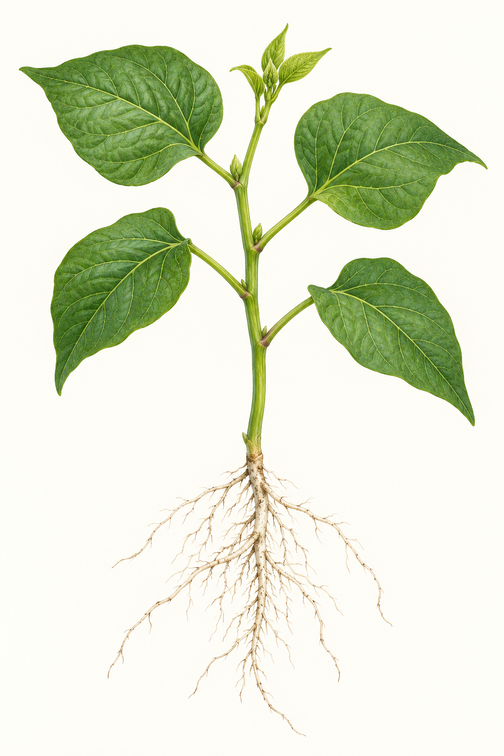  Figure 1. An illustrative plant connects roots, stem, mature leaves and a growing shoot. External form is shown; microscopic tissues are not visible.  Follow the organs: locate a mature leaf, the growing shoot, the stem and the roots. Transport tissues run inside the plant.
A connected plant system
These processes form one connected system. If a hypothetical plant absorbs less water at its roots, less is available for transport and for processes in its leaves. If gas exchange is reduced, the supply of carbon dioxide for photosynthesis can also be affected. A change in one part can influence others.
A useful scientific representation therefore links structure to function. Follow the organs in the illustration, then connect them to the transport tissues described here. The illustration shows external organs, not microscopic cells or transport vessels. Like any model, it simplifies a real system with three dimensions.
Transport direction checked against OpenStax Biology 30.5. This illustration is a model, not an actual observation.
Full section and additional learning: modules/y8s-m02/#section-m02-s02

M02-S02 / WORKED REASONING AND CHECKS

Trace sugar from source to sink
A mature leaf can supply dissolved sugars to a growing shoot above it or to roots below it. First identify where sugars become available, then identify where they are being used or stored. These roles determine the useful direction label. A bare downward arrow cannot describe every case. The plant representation therefore separates an external organ picture from the transport explanation instead of pretending that visible leaf veins show an observed flow.
Identify the source and sink before adding a transport arrow to an explanatory model.
1. Which structure-function link is correct for a root-hair cell?
○ A. Its extended surface supports absorption of water and dissolved mineral ions.
○ B. Its many chloroplasts transport sugars through the stem.
○ C. Its stomata move water from roots to leaves.
○ D. Its guard cells anchor the plant in the ground.

2. What is the role of stomata and guard cells in a leaf?
○ A. They help regulate gas exchange and water loss.
○ B. They transport sugars from leaves to roots.
○ C. They anchor the plant and absorb mineral ions.
○ D. They form the stem's main supporting structure.

3. A hypothetical plant absorbs less water through its roots. Which conclusion best shows systems thinking?
○ A. Only the roots could be affected because organs work separately.
○ B. Less water may become available to other parts of the plant, affecting connected processes.
○ C. The change would cause phloem to become xylem.
○ D. The leaves would no longer need carbon dioxide.

Seven further original checks remain online: modules/y8s-m02/#check-m02-s02

BW-M02-S02 / APPLY AND RECORD

Match plant parts to jobs
Match each plant structure to its main function, then compare two structures.
Choices for each row: absorb water and mineral ions / transport sugars / transport water and mineral ions / capture light and exchange gases
Source item | Your choice
Roots
Xylem
Phloem
Leaf
Compare how xylem and phloem support the plant as a multicellular organism.
Matching whole activity online: busy-work/#bw-m02-s02
Paper adaptation: the online “Choose” placeholder is omitted; substantive choices and original task wording are retained.

M02-S03 / READ AND CONNECT

Ecosystems and changing populations
Relationships in ecosystems  An ecosystem includes organisms and non-living parts of their environment. Biotic factors include plants, animals, fungi and microorganisms. Abiotic factors include light, temperature, water and physical surroundings. Organisms depend on both. A change in water availability can affect producers and then the consumers connected to them.  Producers make their own food using energy from their surroundings. Consumers obtain energy by eating other organisms. Decomposers break down dead organisms and wastes, returning matter that can be reused. These roles connect organisms into a system; they are not isolated labels.  Food webs and energy flow  A food chain shows one feeding pathway; a food web combines several. Arrows point in the direction of energy transfer from the organism eaten to the organism eating it. A web is often more complete because organisms can have several food sources or predators. |  | Energy enters through producers and passes to consumers. At each transfer, organisms use energy for life processes and transfer some to their surroundings, leaving less available at higher feeding levels. An energy pyramid represents this pattern without implying an exact percentage unless data support it. Energy flows through rather than cycling back. Matter can be reused through processes such as decomposition.  Populations change and extinction  A population consists of one species in a particular area. Food, water, habitat, competition, predation, disease and abiotic conditions can limit growth. A population graph can show change without proving its cause. Link a possible explanation to additional evidence about the ecosystem.  Australian population decline and extinction can involve interacting pressures: habitat loss, fragmentation, introduced species, changed disturbance patterns, pollution, overexploitation and climate-related change. Fragmented habitat may reduce shelter while an introduced predator adds pressure. Extinction means no living members of a species remain; effects can spread through a food web. Compare multiple lines of evidence instead of assuming one cause always explains decline.
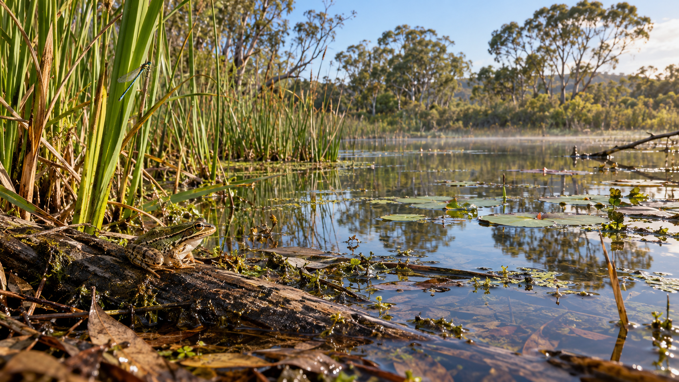 |  | Figure 2. Illustrative wetland: living organisms share a setting with water, light and other non-living conditions. This image is not an observed dataset or proof of a particular food-web link.
Full section and additional learning: modules/y8s-m02/#section-m02-s03

M02-S03 / WORKED REASONING AND CHECKS

Trace one pathway through a web
A consumer may feed on more than one organism and may itself have several predators. A food chain captures only one route through those connections. To read a web, choose a starting producer and follow one connected pathway, then look for an alternative route. Check each arrow’s legend and direction. The web is a simplified model of feeding relationships; its layout does not establish the abundance of each organism or show every interaction in the ecosystem.
Name the organisms connected by an arrow before interpreting what that arrow represents.
1. What is one important role of decomposers in an ecosystem?
○ A. They return matter from dead material and wastes to the environment
○ B. They create all of the energy used by an ecosystem
○ C. They prevent consumers from eating producers
○ D. They make abiotic factors become living

2. Which statement correctly compares matter and energy in an ecosystem?
○ A. Matter may be recycled, while energy flows through the ecosystem
○ B. Both matter and energy cycle endlessly in the same way
○ C. Energy is recycled, while matter permanently leaves after one use
○ D. Neither matter nor energy can move between organisms

3. In an Australian ecosystem, a species population is declining where habitat has become fragmented, an introduced species is present and climate-related conditions are changing. Which conclusion is most scientifically appropriate?
○ A. Several interacting pressures may be contributing, and evidence is needed to judge their relative importance
○ B. Habitat fragmentation must be the only cause because it affects where organisms live
○ C. The introduced species must be the only cause because introduced species can affect native populations
○ D. Climate-related pressure must be the only cause because environmental conditions are changing

Seven further original checks remain online: modules/y8s-m02/#check-m02-s03

BW-M02-S03 / APPLY AND RECORD

Follow energy in an ecosystem
Build a valid energy pathway and interpret the supplied fictional population data.
Use these source terms in the four positions: Sun / grass / grasshopper / frog
Position 1 | Position 2 | Position 3 | Position 4
Survey | Native insects | Introduced predator
1 | 80 | 5
2 | 72 | 8
3 | 61 | 12
4 | 49 | 17
The table shows native insects and an introduced predator over four surveys. Describe the relationship, then give one reason this pattern alone cannot prove cause.
Matching whole activity online: busy-work/#bw-m02-s03
Paper adaptation: the online “Choose” placeholder is omitted; substantive choices and original task wording are retained.

M03-S01 / READ AND CONNECT

Classify and choose materials
Classifying elements compounds and mixtures  An element contains one type of atom. A compound contains atoms of different elements chemically joined. Both are pure substances with consistent composition. A mixture contains two or more substances together without those substances becoming one new substance; they retain their chemical identities and their proportions can vary.  Use composition evidence to classify a sample. Similar appearance does not establish the same category. A sample containing one atom type is an element; chemically joined different elements in a pure substance form a compound; separate substances together form a mixture.  Physical properties and broad material groups  Physical properties can be described without changing a substance into another substance. Examples include electrical and thermal conductivity, hardness, flexibility, brittleness, lustre and the ability to be shaped. The property that matters depends on the intended use. |  | Many metals conduct heat and electricity, appear shiny when freshly exposed and can be shaped. Many solid non-metals are poorer conductors and more brittle. Metalloids such as silicon combine or sit between some tendencies. Silicon’s electrical behaviour can be controlled in electronic components. These are broad patterns, not universal rules about every element.  Using evidence to select a material  Copper’s electrical conductivity and ability to be drawn into wire support its use in wiring. Silicon occurs in many minerals and requires special processing for electronic use. Silicon dioxide, found in quartz and sand, is a common raw material for glass. Useful properties and suitable availability both influence material choices.  To recommend a material, identify the requirements, compare relevant properties, then consider availability and processing. Recognise trade-offs: one helpful property does not make a material suitable for every purpose. State why the chosen option is appropriate for this use and these supplied facts, rather than calling it the best material in general.
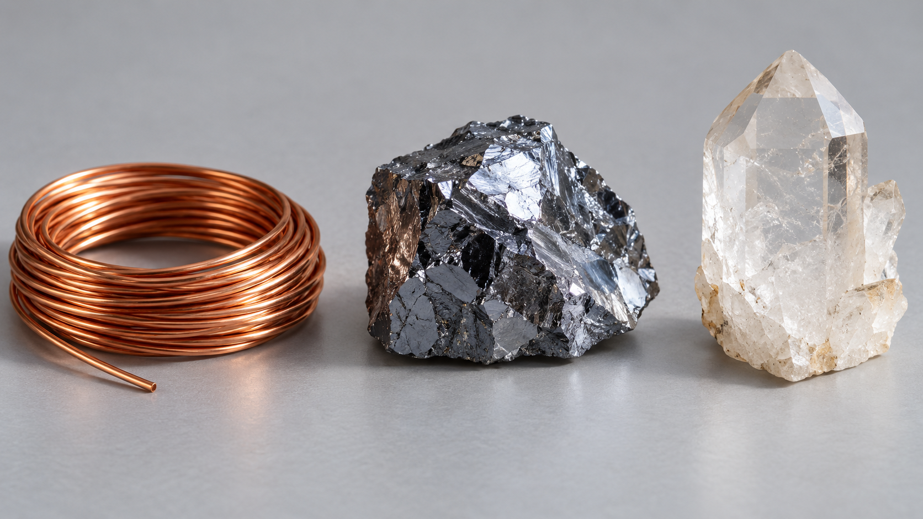 |  | Figure 3. Illustrative copper coil, silicon and quartz. Visible appearance is a starting point; it cannot confirm identity, composition or suitability by itself.
Full section and additional learning: modules/y8s-m03/#section-m03-s01

M03-S01 / WORKED REASONING AND CHECKS

Match a property to a purpose
The same material can be useful for one purpose and unsuitable for another. Start with the stated need, identify the relevant properties, then compare the supplied evidence. Electrical conductivity matters for carrying current; flexibility and the ability to be formed may also matter. Availability and processing affect whether an otherwise useful material is practical. A careful recommendation recognises a trade-off rather than claiming that one property makes a material best in every situation.
The material photograph is illustrative; appearance alone cannot verify identity or performance.
1. Which observation best supports classifying a sample as a mixture?
○ A. It contains only one type of atom
○ B. It contains different substances together and their proportions can vary
○ C. It contains different elements chemically joined in a fixed pure substance
○ D. It conducts electricity

2. Which statement about metals, non-metals and metalloids is most scientifically accurate?
○ A. Every metalloid has exactly the same properties
○ B. Metalloids can show a combination of some metal and non-metal tendencies
○ C. All non-metals conduct electricity better than metals
○ D. Every shiny element must be a metal

3. Silicon dioxide is a compound found in materials such as quartz and sand and is an important raw material in glass production. Which reasoning best connects classification, availability and use?
○ A. It is an element because it is found naturally
○ B. It is useful only because all compounds have the same properties
○ C. It must be a metal because some glass is shiny
○ D. It is a compound whose availability and relevant properties help support its use as a glass-making raw material

Seven further original checks remain online: modules/y8s-m03/#check-m03-s01

BW-M03-S01 / APPLY AND RECORD

Sort materials by their properties
Classify each material, then connect a stated property to a suitable use.
Choices for each row: metal / non-metal / alloy / compound
Source item | Your choice
Copper
Sulfur
Brass
Sodium chloride
A cable needs a material that conducts electricity and can be drawn into wire. Recommend copper or sulfur and justify using the stated properties.
Matching whole activity online: busy-work/#bw-m03-s01
Paper adaptation: the online “Choose” placeholder is omitted; substantive choices and original task wording are retained.

M03-S02 / READ AND CONNECT

Atoms and changing models
Inside an atom  An atom is the smallest unit of an element that retains its chemical properties. A simple model places protons and neutrons in a small central nucleus, with electrons outside it. A proton has positive relative charge, a neutron has no charge and an electron has negative relative charge.  Atomic number is the number of protons and identifies the element. Changing proton number changes element identity. A neutral atom has equal numbers of protons and electrons, so the charges balance. Protons and neutrons each have relative mass about one; an electron’s mass is much smaller and is treated as negligible in this simple comparison. Neutron number does not determine element identity.  Reading simple atomic models  A shell-style representation organises electron information around a nucleus. Labels let you compare particle types, charges and masses and identify proton number. It is not a literal picture: the sizes and distances are not to scale, and circular shell lines are not fixed paths travelled by little electron objects. |  | Judge a model against its purpose. A simple representation can explain a selected relationship while leaving more complex behaviour out. State what it communicates and what it simplifies rather than rejecting it because it is incomplete.  Why scientific models change  Improved technology can reveal evidence that an earlier model cannot explain. Scientists revise or replace the model when evidence supports a better explanation. The source’s historical sequence runs from a solid-sphere model, to electrons embedded in positive matter, to a small positive nucleus with mostly empty space, then to electrons in defined energy levels.  This sequence shows evidence refining explanations; it does not mean each earlier model becomes useless for every purpose. A simple shell model remains useful for introductory electron arrangements while more complete models are needed for other questions. Link each model’s usefulness to its purpose and identify its limitations.
Particle | Relative charge | Relative mass
Proton | +1 | About 1
Neutron | 0 | About 1
Electron | −1 | Much smaller; negligible here
Full section and additional learning: modules/y8s-m03/#section-m03-s02

M03-S02 / WORKED REASONING AND CHECKS

Use a model for its purpose
The historical sequence is: solid sphere → electrons embedded in positive matter → small positive nucleus with mostly empty space → electrons in defined energy levels. Each step changes what the representation can explain. The current introductory shell model organises particle and electron information, but does not depict true scale or fixed circular paths. New evidence can reveal a limitation without making every previous use of an older model invalid.
Link model revision to evidence, not simply to a change in drawing style.
1. Which pairing of particle and relative charge is correct?
○ A. Proton negative, electron positive
○ B. Neutron positive, electron neutral
○ C. Proton positive, electron negative
○ D. Proton neutral, neutron negative

2. Which comparison of the relative masses of subatomic particles is most accurate?
○ A. A proton and neutron are each approximately one relative mass unit, while an electron has a much smaller mass
○ B. A proton has almost no mass, while an electron has approximately one relative mass unit
○ C. An electron and neutron have equal relative masses, while a proton has no mass
○ D. All three particles have approximately the same relative mass

3. A diagram shows electrons placed on circular lines around a nucleus. Which interpretation is most accurate?
○ A. The lines prove that electrons follow fixed circular tracks
○ B. The lines are a simplified way of representing electron arrangement
○ C. The circles show the atom at its true physical scale
○ D. The lines represent rings of solid matter around the nucleus

Seven further original checks remain online: modules/y8s-m03/#check-m03-s02

BW-M03-S02 / APPLY AND RECORD

How ideas about atoms changed
Place the model descriptions in historical order, then explain why scientific models change.
Choices for each row: 1 / 2 / 3 / 4
Source item | Your choice
Solid-sphere model
Electrons embedded in positive matter
Small positive nucleus with mostly empty space
Electrons in defined energy levels
Explain how new evidence or technology can lead scientists to revise an atomic model without making the earlier model useless in every context.
Matching whole activity online: busy-work/#bw-m03-s02
Paper adaptation: the online “Choose” placeholder is omitted; substantive choices and original task wording are retained.

M03-S03 / READ AND CONNECT

Read periodic patterns
Reading element symbols and atomic numbers
An element symbol begins with a capital letter; a second letter is lowercase. H and He identify different elements, and Na is one symbol. Atomic number is the number of protons and identifies the element. Elements are ordered by increasing atomic number. Use both the number and the correctly capitalised symbol when reading the table.
Period | G1 | G2 | G13 | G14 | G15 | G16 | G17 | G18
1 | 1  H |  |  |  |  |  |  | 2  He
2 | 3  Li | 4  Be | 5  B | 6  C | 7  N | 8  O | 9  F | 10  Ne
3 | 11  Na | 12  Mg | 13  Al | 14  Si | 15  P | 16  S | 17  Cl | 18  Ar
Figure 4. Small number = atomic number; letters = element symbol. G = displayed group. Groups 3–12 are omitted because they contain none of the first 18 elements.
Periods groups and simple electron patterns
Periods are rows and groups are columns. In the simple model for the first 18 elements, the first shell holds up to two electrons. A new period begins a new occupied electron shell. Across a period, electrons are added while the number of occupied shells stays the same. Group patterns can support cautious predictions about properties or reactivity; they do not make every element in a group identical. Scientists refined periodic organisation as stronger evidence revealed recurring patterns.
From element symbols to chemical formulas
A capital letter starts each element symbol in a formula. H₂O contains H and O, two element types. O₂ contains only O, one element type, even though it represents more than one atom. Co is one symbol; separate capital C and O are two symbols. Shell lines and comma-separated occupancies organise information; they are not literal electron paths or a picture drawn to scale.
Shell occupancy: H = 1; Li = 2,1; Na = 2,8,1. Commas separate occupied shells, not literal electron paths.
Full section and additional learning: modules/y8s-m03/#section-m03-s03

M03-S03 / WORKED REASONING AND CHECKS

Read a formula one symbol at a time
A capital letter begins an element symbol; a following lowercase letter belongs to it. In NaCl, identify Na and Cl before counting the different element types. There are two. In O₂, there is only one element symbol even though more than one atom is represented. In the first-18 table, compare positions and electron patterns to make cautious predictions, then check the relevant evidence. A table position is not a guarantee of every property.
When explaining a formula, keep the number of atoms separate from the number of different element types.
1. In a simplified model of the first 18 elements, what pattern is shared by elements in the same period?
○ A. They all have exactly the same number of electrons
○ B. They have the same number of occupied electron shells
○ C. They have identical properties
○ D. They all use two-letter symbols

2. Why did the arrangement of the periodic table change as scientific knowledge improved?
○ A. Scientists stopped comparing element properties
○ B. Element symbols became unnecessary
○ C. New evidence allowed recurring patterns to be represented more consistently
○ D. Atomic numbers were changed to make elements fit groups

3. Why do Co and C followed by O need to be read carefully?
○ A. Co always represents two atoms of the same element
○ B. Capital letters have no meaning in chemical symbols
○ C. C and O together must always be read as Co
○ D. Co is one element symbol, while C and O are two separate element symbols

Seven further original checks remain online: modules/y8s-m03/#check-m03-s03

BW-M03-S03 / APPLY AND RECORD

Find patterns in the periodic table
Use periodic information for the first 18 elements to complete each interpretation.
Atomic number of oxygen
○ 6
○ 8
○ 10
○ 16
Neutral oxygen atom: number of electrons
○ 6
○ 8
○ 10
○ 16
Element in the same group as lithium
○ beryllium
○ sodium
○ neon
○ chlorine
Elements present in H₂O
○ hydrogen only
○ oxygen only
○ hydrogen and oxygen
○ helium and oxygen
Describe one pattern that can be inferred from the positions of lithium and sodium, while avoiding a claim that position alone proves every property.
Matching whole activity online: busy-work/#bw-m03-s03
Paper adaptation: the online “Choose” placeholder is omitted; substantive choices and original task wording are retained.

M04-S01 / READ AND CONNECT

Energy stores and transfers
Systems and energy stores  A system is the object or group of objects being studied; everything outside its boundary is the surroundings. Defining the boundary helps track where energy is stored and what crosses it. An open system exchanges matter and energy. A closed system is treated as not exchanging matter, but it may still exchange energy: closed does not mean isolated.  Energy stores include chemical energy associated with substances such as food or fuels, kinetic energy of movement, gravitational potential energy associated with position, elastic energy in stretched or compressed objects, and thermal energy associated with matter’s internal energy and temperature. Several stores can be involved at once.  Energy transfers and transformations  Conduction transfers thermal energy through interactions between neighbouring particles without overall movement of the material from place to place. Convection involves movement of a liquid or gas. Radiation transfers energy by electromagnetic waves and does not require matter to travel through. These mechanisms explain different transfer pathways. |  | Mechanical work transfers energy when forces cause movement; electrical interactions can also transfer energy. A transformation describes a change between energy stores, such as a decrease in a chemical store linked to increases in kinetic and thermal stores. Energy is conserved: it is not created or destroyed. Account for transfers within the system and across its boundary.  Useful energy and energy spread  Not all transferred energy remains useful for the intended purpose. Some spreads into the surroundings, often increasing thermal stores. It becomes harder to use for the original purpose, but it has not disappeared. Conduction, convection and radiation can each contribute to this spreading.  Read an energy diagram by identifying system, surroundings and boundary, deciding whether matter can cross, then tracing labelled arrows. Name the stores and transfer mechanisms and include energy reaching the surroundings. Arrow width or colour has no special numerical meaning unless a legend explicitly supplies one. A qualitative diagram can show relationships without invented measurements.
Boundary model | Energy crossing | Matter crossing
Open system | Possible | Possible
Closed system | Possible | Not in the model
Full section and additional learning: modules/y8s-m04/#section-m04-s01

M04-S01 / WORKED REASONING AND CHECKS

Define the lamp boundary
Treat only a lamp as the chosen system. An electrical interaction transfers energy into it. Light is a useful outward transfer for illumination, while energy also reaches the surroundings and increases thermal stores. Accounting for both avoids describing energy as disappearing. A different boundary, such as including the battery, changes which stores and transfers are inside the system. State the boundary before interpreting a diagram.
Closed systems may exchange energy even when matter is treated as staying inside.
1. Which statement best describes an open system?
○ A. Neither energy nor matter can cross its boundary
○ B. Energy can cross its boundary but matter cannot
○ C. Both energy and matter can cross its boundary
○ D. It contains only one energy store

2. What distinguishes radiation from conduction and convection?
○ A. Radiation always transfers matter as well as energy
○ B. Radiation can transfer energy without matter being present between the source and receiver
○ C. Radiation occurs only inside closed systems
○ D. Radiation creates new energy as it travels

3. What does conservation of energy mean when energy spreads to the surroundings?
○ A. The spread energy has stopped existing
○ B. Energy is conserved only if it stays inside the system
○ C. The surroundings destroy energy that is no longer useful
○ D. The energy still exists even though it may be more widely spread and less useful

Seven further original checks remain online: modules/y8s-m04/#check-m04-s01

BW-M04-S01 / APPLY AND RECORD

Track energy moving
Complete a representation of energy changes in a solar-battery-light system.
Sun → solar panel
○ radiant transfer
○ conduction
○ chemical store
Solar panel output
○ electrical energy
○ elastic energy
○ nuclear energy
Battery storage
○ kinetic store
○ chemical store
○ gravitational store
Light output
○ radiant energy
○ elastic energy
○ gravitational energy
Treat the lamp as the system. Explain one energy input, one useful output and one transfer to the surroundings.
Matching whole activity online: busy-work/#bw-m04-s01
Paper adaptation: the online “Choose” placeholder is omitted; substantive choices and original task wording are retained.

M04-S02 / READ AND CONNECT

Physical and chemical change
Physical and chemical changes  A physical change alters form, state or arrangement while the substances remain the same. A change of state, shape or some mixing processes can therefore be physical. In a chemical change, new substances form. Starting substances are reactants; substances formed are products. A dramatic appearance or difficulty reversing a change is not enough to decide which type occurred.  Chemical reactions involve energy transfers between the reacting system and surroundings. They should not be classified solely by whether something seems warmer or cooler. Consider evidence about the substances themselves.  Using observations and word equations  Gas formation, an unexpected colour or temperature change, or a new solid called a precipitate can be evidence of chemical change. No single observation automatically proves it: there may be another explanation. Consider the context and several observations together. |  | A word equation names reactants before an arrow and products after it. The arrow means the starting substances form products; it is not a practical procedure. Photosynthesis is summarised as carbon dioxide + water → glucose + oxygen, with light energy entering the process. Cellular respiration is summarised as glucose + oxygen → carbon dioxide + water. It transfers energy that can support cellular processes, with some reaching the surroundings. These are overall qualitative relationships, not every reaction step.  Conservation and judging evidence  Atoms are rearranged in a chemical change but are conserved. In a closed system, with no matter entering or leaving, total mass is expected to remain the same although the substances change. A change in an open system needs careful accounting for matter that crosses its boundary.  Match a conclusion to the quality of the evidence. Were observations clear and consistent? Was information missing? Could another explanation fit? If the evidence supports a chemical change without establishing it completely, state that uncertainty. The paper activity supplies descriptions to interpret; it does not authorise carrying out the reactions.
Substance identity is the key question. Physical change: same substances. Chemical change: new substances. Evidence, not dramatic appearance, decides the interpretation.
Full section and additional learning: modules/y8s-m04/#section-m04-s02

M04-S02 / WORKED REASONING AND CHECKS

Separate a clue from a conclusion
A temperature change is an observation, but by itself does not identify which substances are present. Ask what other evidence supports formation of a new substance and whether another explanation fits. A word equation summarises known reactants and products; it is not a recipe for generating evidence. In a closed reacting system, atom rearrangement changes substances while total matter is conserved. Match the certainty of the conclusion to the evidence actually supplied.
Photosynthesis and respiration are chemical processes; their word relationships describe overall changes, not practical instructions.
1. Which statement best describes energy during a chemical reaction?
○ A. Energy is always destroyed during the reaction
○ B. Energy can be transferred to or from the surroundings
○ C. Energy changes occur only when a reaction produces a gas
○ D. Every chemical reaction must make its surroundings warmer

2. Which qualitative word relationship best represents photosynthesis?
○ A. glucose + oxygen → carbon dioxide + water
○ B. carbon dioxide + water → glucose + oxygen
○ C. oxygen + water → carbon dioxide + glucose
○ D. glucose + carbon dioxide → oxygen + water

3. What should happen to total mass during a chemical change in a closed system?
○ A. It should remain the same because matter is conserved
○ B. It should always increase because products are formed
○ C. It should always decrease because reactants are used
○ D. It should become impossible to compare

Seven further original checks remain online: modules/y8s-m04/#check-m04-s02

BW-M04-S02 / APPLY AND RECORD

What kind of change is it?
Classify each described change from evidence only. No practical procedure is supplied or implied.
Choices for each row: physical / chemical
Source item | Your choice
Ice melts but remains water
Iron forms a new rust substance
Sugar dissolves and can be recovered by removing water
Magnesium and oxygen form magnesium oxide
Write the word equation for the final example.
Explain why one observation alone may be insufficient to classify an unfamiliar change.
Matching whole activity online: busy-work/#bw-m04-s02
Paper adaptation: the online “Choose” placeholder is omitted; substantive choices and original task wording are retained.

M04-S03 / READ AND CONNECT

Read geological evidence
Geological change and the rock cycle  Weathering breaks down or changes rock at the surface; erosion removes material, transport moves it and deposition leaves it elsewhere. Rocks and minerals can be described using colour, grain or crystal size, texture, lustre, transparency, layering and visible fossils. Several properties provide stronger identification evidence than one.  The rock cycle connects igneous rocks formed from cooled molten material, sedimentary rocks formed from accumulated sediments and metamorphic rocks changed without complete melting. It is not one fixed route: existing rocks can follow different pathways. The model simplifies geological processes operating over different timescales.  Fossils rock layers and relative age  Fossils are preserved remains, traces or evidence of past organisms. Layers and fossils reveal past environments and event sequences. In a sequence that has not been overturned or greatly disturbed, lower layers are generally older. Relative age compares older and younger; it does not supply an exact numerical age. Missing or disturbed layers limit the inference. |  | Authorised Aboriginal and Torres Strait Islander Cultural accounts can preserve evidence of geological events across generations. They require appropriate permission, source context and respectful attribution. Do not invent, copy or retell a particular Cultural account without the authority needed to share it.  Evidence for moving plates  Matching rock and fossil patterns on separated land areas can suggest former connections. Continental-margin shapes can suggest a fit but are not sufficient alone. Earthquakes can release built-up stress where plates interact, and molten material can sometimes rise to produce volcanic activity. The concentration of many earthquakes and volcanoes around plate boundaries supports active crustal change.  Independent lines of evidence strengthen explanations. A plate model combines rock and fossil patterns, land positions and earthquake/volcano distributions while remaining a simplification. Relevant authorised Cultural accounts may contribute with proper permission and context. Compare what each line shows, where they agree and what remains uncertain.
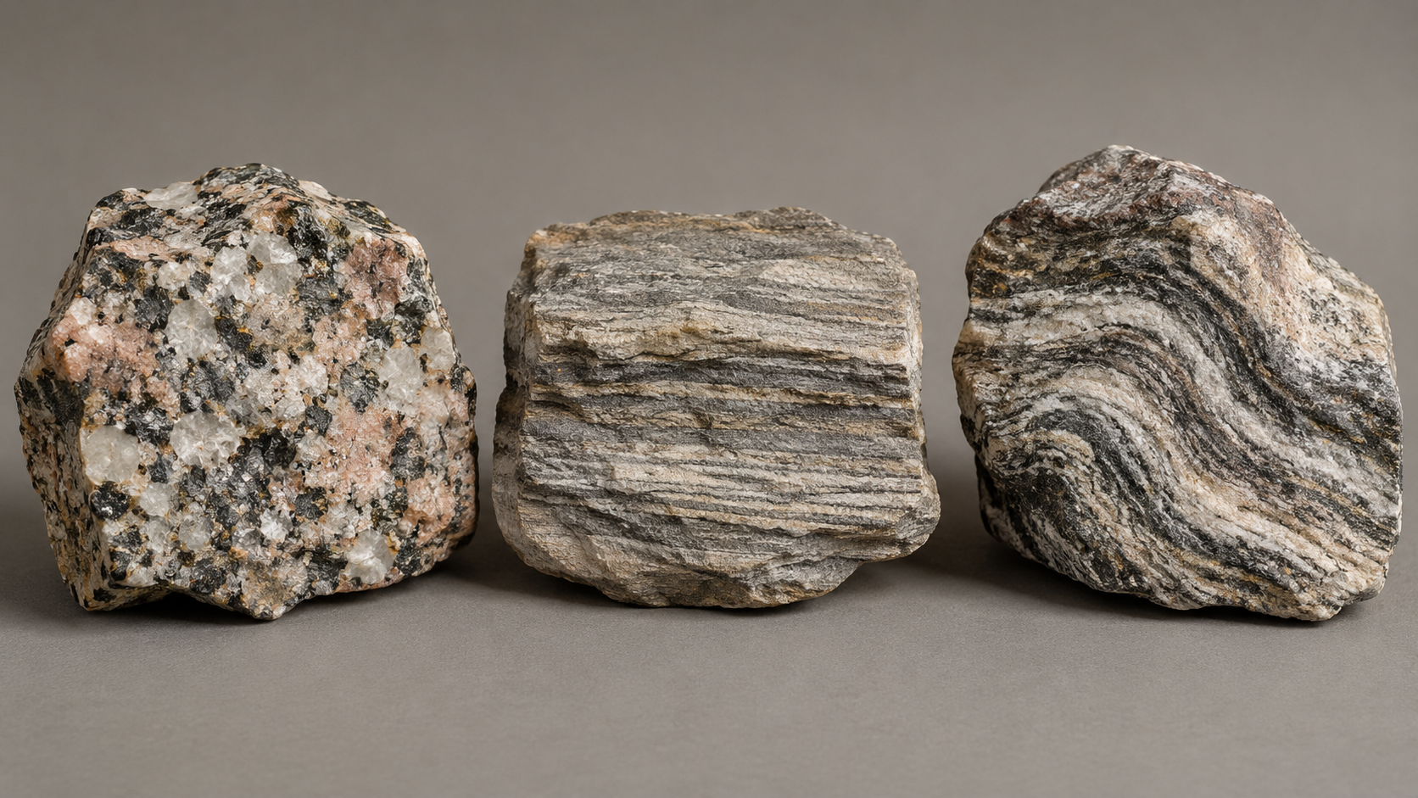 |  | Figure 5. Illustrative textures: compare visible grains, layers and bands. Appearance alone does not establish a rock’s identity or complete formation history.
Full section and additional learning: modules/y8s-m04/#section-m04-s03

M04-S03 / WORKED REASONING AND CHECKS

Compare like parts of planets
Elemental composition depends on the part being compared. Earth’s whole-planet composition includes large amounts of iron, oxygen, silicon and magnesium, whereas the crust is particularly rich in oxygen and silicon. Mars surface rocks and dust also contain oxygen, silicon and iron, but their proportions and geological settings differ. A comparison between a whole planet and another planet’s surface can therefore be misleading. Name the system boundary before drawing a conclusion from composition.
Continental shape is a clue. Multiple independent rock, fossil and active-boundary patterns provide stronger support for a plate model.
1. Why must an Earth-and-planet elemental comparison state whether it refers to a whole planet, crust or surface?
○ A. Different parts of a planet can have different elemental compositions
○ B. Every part of every rocky planet has an identical composition
○ C. Only Earth's atmosphere contains elements
○ D. Planetary composition can be compared only by using exact percentages

2. In an undisturbed sequence of sedimentary rock layers, what conclusion is generally supported?
○ A. Every layer formed at exactly the same time
○ B. The upper layer must contain the oldest fossils
○ C. Layer position gives the exact age of each rock in years
○ D. The lowest layer is generally older than layers above it

3. How should an Aboriginal or Torres Strait Islander Cultural account of a past earthquake or volcanic event be used in geological learning?
○ A. Rewrite it freely so that it sounds local to the class
○ B. Treat every Cultural account as if it describes the same geological event
○ C. Use it only when it is authorised for sharing and its source and Cultural context are respected
○ D. Remove its source information so that only the geological details remain

Seven further original checks remain online: modules/y8s-m04/#check-m04-s03

BW-M04-S03 / APPLY AND RECORD

What tells us plates move?
Use only the supplied observations: matching magnetic stripes occur on both sides of a mid-ocean ridge; earthquake and volcano locations cluster in narrow global belts.
Evidence that supports movement at the ridge
○ matching magnetic stripes
○ the ocean is blue
○ all rocks are the same age
Evidence that supports plate-boundary locations
○ random city locations
○ clustered earthquake and volcano belts
○ daily temperature
Write a claim-evidence-reasoning response explaining how the two observations support a model of moving tectonic plates. State one limitation of the evidence set.
Matching whole activity online: busy-work/#bw-m04-s03
Paper adaptation: the online “Choose” placeholder is omitted; substantive choices and original task wording are retained.

M05-S01 / READ AND CONNECT

Scientific models and evidence
What scientific models represent  A scientific model represents selected features or relationships in a system. It may be a diagram, physical representation, mathematical relationship or computer model. Models describe organisation, explain relationships or predict what might happen under stated conditions. They are useful because they focus attention; that same selection means they are not the real system.  A model can have inputs, components, variables, parameters, relationships and outputs. Variables can change. A parameter sets a value or condition affecting how the model behaves. Assumptions simplify the system so selected relationships can be explored. Identify these parts before interpreting a prediction.  Comparing models with evidence  Raw observations or measurements provide evidence. A model uses selected evidence and relationships to represent a system. Comparing a model’s prediction with suitable observations helps evaluate it. Agreement supports usefulness for that purpose without proving perfection. Disagreement may reveal an assumption, input or relationship that needs investigation and revision. |  | Scientific inquiry uses testable questions, systematic evidence and explanations that can change with new evidence. Other approaches to knowledge can have different purposes, traditions or bases. Treat them respectfully without assuming they all do the same work. A belief, tradition or opinion is not automatically scientific evidence; a scientific claim needs investigation using scientific methods.  Limitations and appropriate use  Every model leaves features out. It might omit a variable, simplify a relationship or apply only over a restricted range. A limitation does not make it useless; it helps define appropriate use. A rainfall-runoff model that omits soil type, for example, cannot account for differences due to that variable.  Keep conclusions within the model’s purpose, conditions and evidence. Do not extend a prediction to very different conditions without support. Before relying on an output, ask which assumptions matter, which variables are absent and what observations would help test its usefulness. Distinguish the model’s representation from the original evidence and from your own interpretation.
Evidence | Model | Interpretation
Original observations or measurements | Selected relationships and assumptions | A reasoned claim with stated limits
Full section and additional learning: modules/y8s-m05/#section-m05-s01

M05-S01 / WORKED REASONING AND CHECKS

Identify a model’s components
Start a model audit by naming what goes in and what comes out. In the source rainfall-runoff example, rainfall and ground cover are inputs and predicted runoff is the output. Identify the relationship used to connect them and which conditions define the model. This makes the representation easier to discuss than referring vaguely to its result. A clear component record also lets another reader check whether two runs used the same inputs and settings.
Use labels consistently: an input, a parameter, a relationship and an output play different roles.
1. Which statement correctly distinguishes raw evidence from a scientific model?
○ A. Evidence is a prediction, while a model is always an observation
○ B. Evidence includes observations or measurements, while a model represents selected relationships using evidence
○ C. Evidence and models are exactly the same thing
○ D. A model is evidence only when it contains no assumptions

2. Which comparison between scientific inquiry and other approaches to knowledge is most accurate?
○ A. Scientific inquiry uses testable questions and systematic evidence, while other approaches may have different purposes, traditions or bases for knowledge
○ B. Scientific inquiry accepts explanations that can never be revised, while other approaches always change
○ C. All non-scientific approaches are the same and should be treated as opinions
○ D. Any strongly held opinion counts as scientific evidence

3. A model leaves out one variable that could matter under some conditions. Which interpretation is best?
○ A. The model must be completely useless
○ B. The missing variable shows that the observations are wrong
○ C. The omission is a limitation that may restrict when the model should be used
○ D. The model should be treated as reality because it is simpler

Seven further original checks remain online: modules/y8s-m05/#check-m05-s01

BW-M05-S01 / APPLY AND RECORD

What can a model show?
Audit a simplified rainfall-runoff model that uses rainfall and ground-cover inputs to predict runoff.
Choices for each row: inputs / output / limitation
Source item | Your choice
Rainfall and ground cover
Predicted runoff
Does not include soil type
Explain what observation or dataset could be used to check the model and why agreement would support, but not prove, the model.
Matching whole activity online: busy-work/#bw-m05-s01
Paper adaptation: the online “Choose” placeholder is omitted; substantive choices and original task wording are retained.

M05-S02 / READ AND CONNECT

Simulations and predictions
How simulations represent systems  A simulation is a model of how parts of a system may change or interact. Inputs supply starting information, parameters set conditions and rules connect them to an output. Changing one parameter while keeping other model conditions constant helps explore how it influences the predicted result.  The resulting pattern is model output, not a direct real-world observation. Report what the simulation predicts under the stated inputs, rules and assumptions. The online activity is deliberately illustrative; it does not supply a real-world forecast or a practical investigation.  Predictions depend on evidence and assumptions  A prediction is conditional on the data, inputs, parameters, assumptions and relationships used. A change in any of these can change the output. A model prediction therefore does not state with certainty what must happen in reality. |  | Compare output with relevant observations to assess usefulness. Agreement can support a model for a purpose; repeated differences invite investigation. Repeating the same settings can test repeatability, but it does not by itself test accuracy against reality. Identical deterministic reruns are not independent experimental observations.  Sensitivity limitations and applications  A model is sensitive to a parameter when a change in that parameter noticeably changes the output. This identifies influential relationships, but also cautions against certainty when the input is uncertain. Small changes in an uncertain input may produce very different predictions.  Models can support decisions about weather, populations or energy use when they suit the question. Evaluate the evidence, assumptions, purpose and limitations before using output in a conclusion. In the activity, record the selected parameter, prediction, actual simulated output and reflection. Keep each prediction separate from the result so the comparison remains honest.
Keep separate | Record
Before the run | Parameter, conditions and prediction
After the run | Simulated output and comparison
Evaluation | Evidence needed and model limitations
Full section and additional learning: modules/y8s-m05/#section-m05-s02

M05-S02 / WORKED REASONING AND CHECKS

Choose an appropriate application
A weather model, population model and energy-use model serve different questions. Begin by naming the question and the system represented. Then identify the available input data, the conditions the model represents and the kind of output needed. A model suited to one context is not automatically appropriate in another. Describe the proposed application in terms of its purpose and evidence rather than choosing a simulation because its display looks impressive.
Record the purpose and conditions alongside an output so another reader knows how it is intended to be used.
1. Two simulation runs use the same inputs and rules, but one parameter is changed. The outputs are different. What does this comparison show?
○ A. The changed parameter may influence the model's output
○ B. The second output must be the real-world result
○ C. The first simulation run must be incorrect
○ D. The simulation has proved the cause of a real-world change

2. A simulation gives the same output every time it is run with identical settings. What does this show most directly?
○ A. The real-world prediction must be correct
○ B. The simulation produces repeatable output under those settings
○ C. Every assumption in the model is true
○ D. The model represents every important feature of the real system

3. Why can high sensitivity to an uncertain parameter be a limitation?
○ A. A small uncertainty in the parameter may lead to very different predicted outputs
○ B. Sensitive models cannot contain any evidence
○ C. A sensitive parameter automatically makes every prediction wrong
○ D. Sensitivity means the parameter never changes

Seven further original checks remain online: modules/y8s-m05/#check-m05-s02

BW-M05-S02 / APPLY AND RECORD

Make a prediction with a simulation
Change the model parameter, predict the output, run the simulation and evaluate the result. The simulation is illustrative, not a real-world forecast.
Run the existing illustrative model: busy-work/#bw-m05-s02
Original parameter range: 1–10. Record your prediction before running. Keep the actual simulation result blank until you have run it.
Model parameter
Predicted output before running
Actual simulated output after running
Compare your prediction with the simulated output and explain one reason the model should not be treated as certainty.
Paper adaptation: the online “Choose” placeholder is omitted; substantive choices and original task wording are retained.

M05-S03 / READ AND CONNECT

Build a depth study evidence trail
Building a focused evidence pathway  A depth study begins with a focused investigable question. It guides the evidence needed and the patterns or relationships to examine. Evidence may come from supplied or appropriately authorised datasets, reliable secondary sources, scientific models or simulations. Choose it because it can address the question, not merely because it is available.  Keep an evidence trail. Raw evidence is the supplied or collected information before processing. A graph, summary table or category system is a processed representation. Preserve the connection between the original evidence and the representation so a reader can check where a claim came from. Label model output and synthetic data accurately.  From evidence to analysis and conclusion  Analysis looks for patterns, differences, relationships and anomalies. An anomaly does not follow the main pattern and may need checking. Consider uncertainty, missing information and whether the evidence is strong enough to support a claim. A graph is only useful if you explain what it shows. |  | A conclusion directly answers the question using the analysed evidence. It does not make a stronger claim than the evidence supports. Name important limits and consider results that do not fit rather than ignoring them. An uncertain conclusion can be scientifically useful when its reasoning and boundaries are clear.  Reflection improvement and source records  Reflection evaluates the usefulness and trustworthiness of evidence and reasoning. Identify a limitation, such as missing data, uncertain assumptions, a restricted range or an omitted model feature. Suggest a realistic improvement and explain how it would strengthen the study. Do not pretend every uncertainty can be removed.  A source record identifies the origin of datasets, models, information and ideas. It distinguishes supplied evidence from your interpretation. Together, question, evidence record, processed representation, analysis, conclusion, reflection and attribution form a coherent portfolio. The source calls this a “five-hour depth-study portfolio”; your teacher must confirm the actual duration, study, permitted evidence and assessment relationship.
The source title says “five-hour depth-study portfolio”. Your teacher controls the actual duration and requirements. Section responses and Busy Work records support learning; no standalone folio transfer or submission is promised.
Full section and additional learning: modules/y8s-m05/#section-m05-s03

M05-S03 / WORKED REASONING AND CHECKS

Make a source record usable
Imagine another reader checking the origin of a dataset used in a study. A record saying only “the internet” would not identify it. Retain the producer or source, title or dataset identifier, date or version, field meanings, units and any known changes. Explain which source supplied which part of the study. These details help another reader retrace the evidence pathway and distinguish supplied information from the student’s own reasoning.
Pages 49–50 are a method-neutral planning record. Your teacher confirms the actual study and duration before practical work or formal submission.
1. What is the main difference between raw evidence and a processed representation?
○ A. Raw evidence is always correct, while processed evidence is uncertain
○ B. Raw evidence is the original supplied information, while a processed representation organises or summarises it
○ C. Processed representations contain no evidence
○ D. Raw evidence can only be numbers

2. A dataset shows a general upward pattern with one result that differs noticeably from the others. What is the best response?
○ A. Delete the unusual result because it weakens the pattern
○ B. Describe the overall pattern and consider the unusual result as a possible anomaly
○ C. Claim there is no pattern because one result differs
○ D. Change the result so it matches the others

3. Which improvement best follows from identifying incomplete evidence as a limitation?
○ A. Make the conclusion more certain without changing the evidence
○ B. Remove evidence that does not fit the conclusion
○ C. Use additional relevant authorised evidence that addresses the missing information
○ D. Replace the source record with a personal opinion

Seven further original checks remain online: modules/y8s-m05/#check-m05-s03

BW-M05-S03 / METHOD NEUTRAL EVIDENCE PLAN

Plan your science investigation
Prepare a method-neutral evidence plan for the five-hour depth-study portfolio. A teacher-approved practical method is not supplied.
The historical five-hour wording does not confirm your local duration. Your teacher confirms the actual study, timetable, evidence and assessment relationship.
□ Question is scientifically investigable
□ Evidence or dataset source is identified
□ Data representation is planned
□ Analysis will address patterns and limitations
□ Conclusion will answer the question
□ Reflection and source record are included
Provisional scientific question
Evidence or dataset needed

BW-M05-S03 / METHOD NEUTRAL EVIDENCE PLAN

Plan analysis and source records
Continue your provisional plan from page 49. Describe what you intend to analyse and keep; do not invent observations, results or a completed conclusion.
How patterns, uncertainty and limitations will be analysed
Source/provenance details to retain
After your teacher confirms the study, retain the original evidence, processed representation, analysis, conclusion and reflection with these records. A plan is not completed investigation evidence.
Original complete planning activity: busy-work/#bw-m05-s03

