
YEAR 9 / GRAPHICS

Graphics
Technology
STUDENT WORKBOOK

Explore ideas and explain your decisions
NAME __________________________ CLASS ______________
Illustrative design context. Follow your teacher’s current task and instructions.

YEAR 9 / GRAPHICS TECHNOLOGY

Use the book and the course
Read the explanations, try the original tasks and keep evidence of your decisions.
This is a supplementary Year 9 Graphics Technology companion. Follow your teacher’s current task, drawing template and instructions. Illustrations and fictional examples do not approve a project or a production process.
MODULE | PAGES
Drawing Foundations and Visual Communication | 3–14
Onshape Product Drawing | 15–26
Graphic Modelling and Prototyping | 27–38
Graphic Design and Communication | 39–50

On paper
Each module has two teaching pages per section, an original-question selection, three whole activities, a capstone and a folio record.

Required online
The other 96 original questions, eight capstones and eight folio cards remain required. Each module’s question page gives exact original numbers; the activity pages identify the remaining capstone and folio routes.

Optional practice
Only the four source review puzzles are optional. Leaving required work online does not make it optional.

Keep your evidence
Paper work and website saving/exporting are not automatic submission. Use the completion and submission method your teacher specifies.

Reading and media
The source’s reading/still-image pathways can be used without a video. Revisit the exact section to check feedback and improve a response.
Open the Year 9 Graphics Technology course

MODULE 1 / SAFE STUDIO, INSTRUMENTS AND LINE LANGUAGE

Choose tools for a communication job
Begin with the information the drawing must communicate.
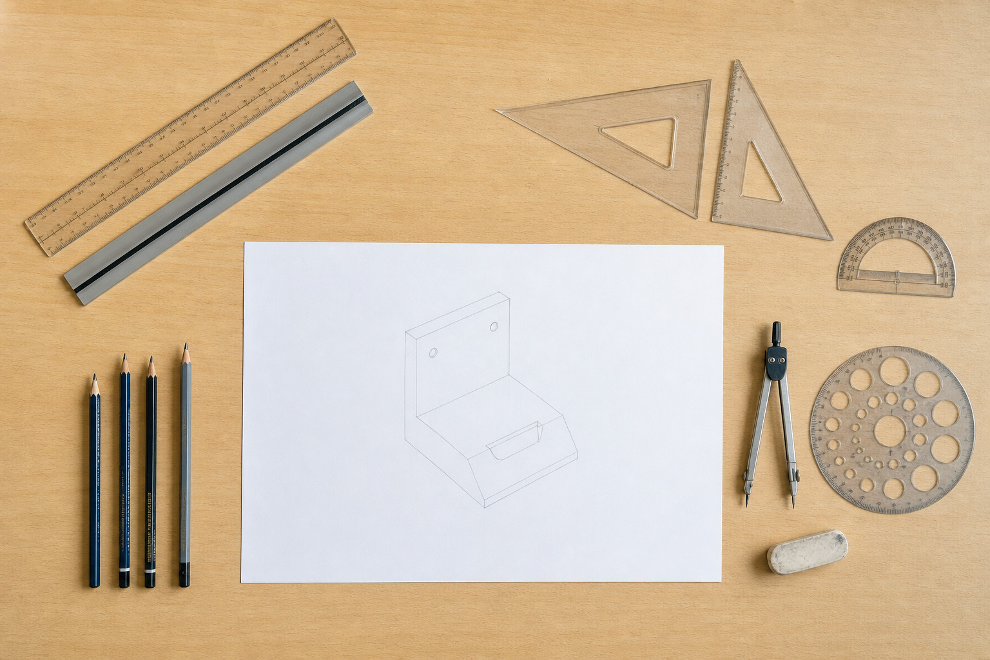
Figure 1. A source concept illustration shows instruments arranged around a drawing. Identify jobs, not exact measurements or an approved operating method.

Notice uncertainty early
Graphics communicates shape, size, position and other information that a reader needs. Planning the drawing also means planning how to work. A hazard has the potential to cause harm; risk considers the possibility and seriousness of harm occurring. An unfamiliar setup is a reason to pause and check the current instruction rather than guess.
Safe judgement continues as the task changes. Notice the situation, consider the risk, check what is required, act appropriately and keep monitoring. A general risk-thinking process does not tell you the exact local rule for every classroom, tool or activity. Those details come from the teacher’s current authorised instruction.

Select by purpose
An instrument drawing uses tools or techniques to control geometry. A straight-line tool supports straightness; angle tools establish or transfer directions; a circle or arc tool controls curved geometry; measuring tools establish sizes and positions. Mark-making tools help distinguish different line purposes. More equipment does not automatically mean clearer communication.
In the source’s fictional example, Mia needs straight geometry, measured positions and a circular feature. She first resolves an uncertainty at her workstation. She then chooses tool categories for those particular jobs and plans which marks are temporary. Her reasoning connects risk-aware preparation with a drawing that another person can read.

Name a drawing job, a suitable tool category and one uncertainty you would check before starting.

MODULE 1 / SAFE STUDIO, INSTRUMENTS AND LINE LANGUAGE

Make line purpose visible
Different marks should help the reader distinguish different kinds of information.
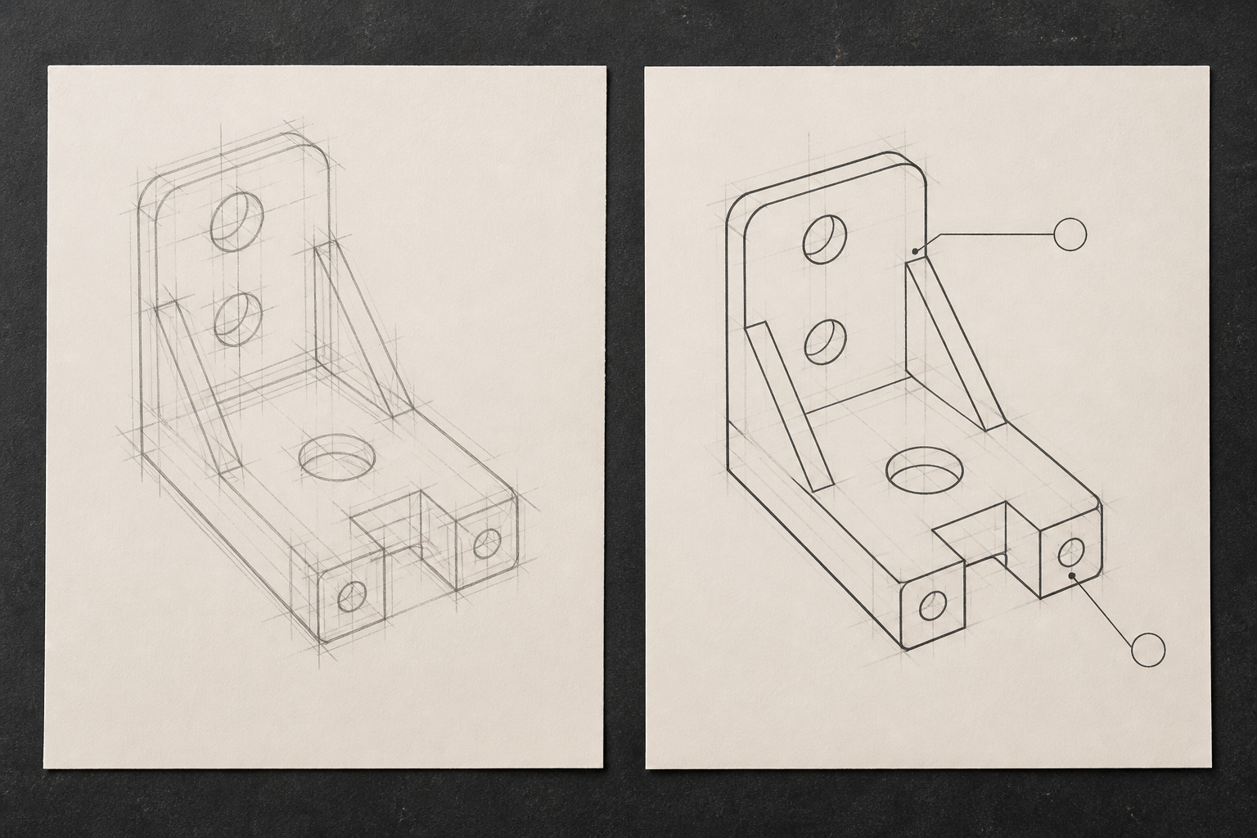
Figure 2. Source line-language illustration: compare supporting marks with stronger outlines and separate leaders. It is not a dimensioned plan or a standards-compliance example.

Working marks and outlines
A construction line is a light working mark used to establish geometry, position or relationships. It helps you reason while drawing, but is not necessarily an edge of the object. A visible outline identifies a boundary intended to be seen in that view. Strengthening the outline while keeping construction marks lighter gives the reader a useful hierarchy.
An annotation adds written or symbolic information that shape alone cannot explain. A short note should identify a particular feature and its purpose. Place it so its leader and wording do not become confused with the geometry. Thickness, darkness and pattern can distinguish line functions; they are communication choices rather than decoration.

Observe before claiming compliance
A convention is an agreed way to represent information consistently. Technical drawing uses conventions for lines, views, scales and page organisation. Relevant standards, including AS 1100 in appropriate contexts, contain requirements that must be checked using authorised current information. A familiar border, line or template does not prove compliance.
Compare the two source illustrations above. In the first, working marks compete for attention. In the second, the main outline is stronger and annotation leaders are separate. You can describe that visible difference without claiming the drawing meets every standard. Before finishing your own drawing, ask which marks describe the object, which support construction and which explain it.

Describe one line change that would help a reader, and explain what it would communicate.

MODULE 1 / SKETCHING, RENDERING AND GEOMETRIC CONSTRUCTION

Explore before you refine
Several quick ideas create choices before you commit to controlled geometry.
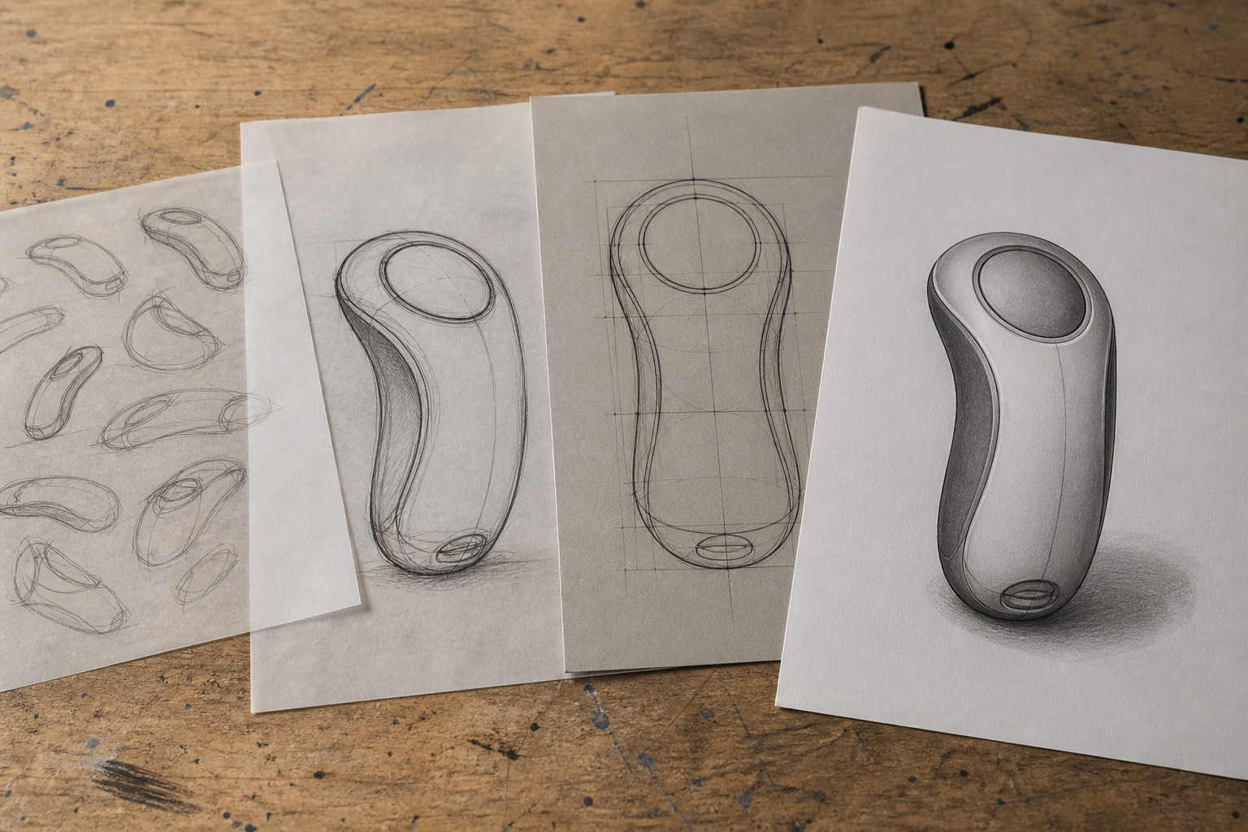
Figure 3. The source’s illustrative progression moves from alternatives to controlled geometry and rendered form. The drawings are concept studies, not exact product specifications.

Use thumbnails to think
A thumbnail is a small, quick sketch of an idea’s main form or arrangement. Several thumbnails let you compare genuinely different possibilities without spending time polishing the first idea. Proportion concerns the size relationships between parts. A sketch can show believable proportions without numerical dimensions, but it does not prove precise geometry.
The source’s fictional hand-held form develops through alternatives: a narrow angular shape, a broader rounded shape and a balanced form with smooth transitions. Choosing the last idea should have a reason linked to what is visible, such as its balanced arrangement. “I like it” does not explain the communication decision.

Construct the relationships
Geometric construction establishes positions logically. A centre line provides a reference for corresponding features. To bisect is to divide into equal parts; symmetry relates corresponding parts about an axis or centre. Establish the main proportions, locate important points and compare both sides before strengthening the final outline.
A tangent relationship makes a line or curve meet another curve smoothly rather than with an unwanted kink. Construction marks reveal how that meeting or symmetry was established. A controlled outline is stronger evidence of geometry than a loose thumbnail, but it still says little about how surfaces appear under light. Each drawing stage has a different job.

Identify one decision a thumbnail can support and one relationship that needs geometric construction.

MODULE 1 / SKETCHING, RENDERING AND GEOMETRIC CONSTRUCTION

Use light to explain form
Rendering adds surface information to the geometry you have already established.
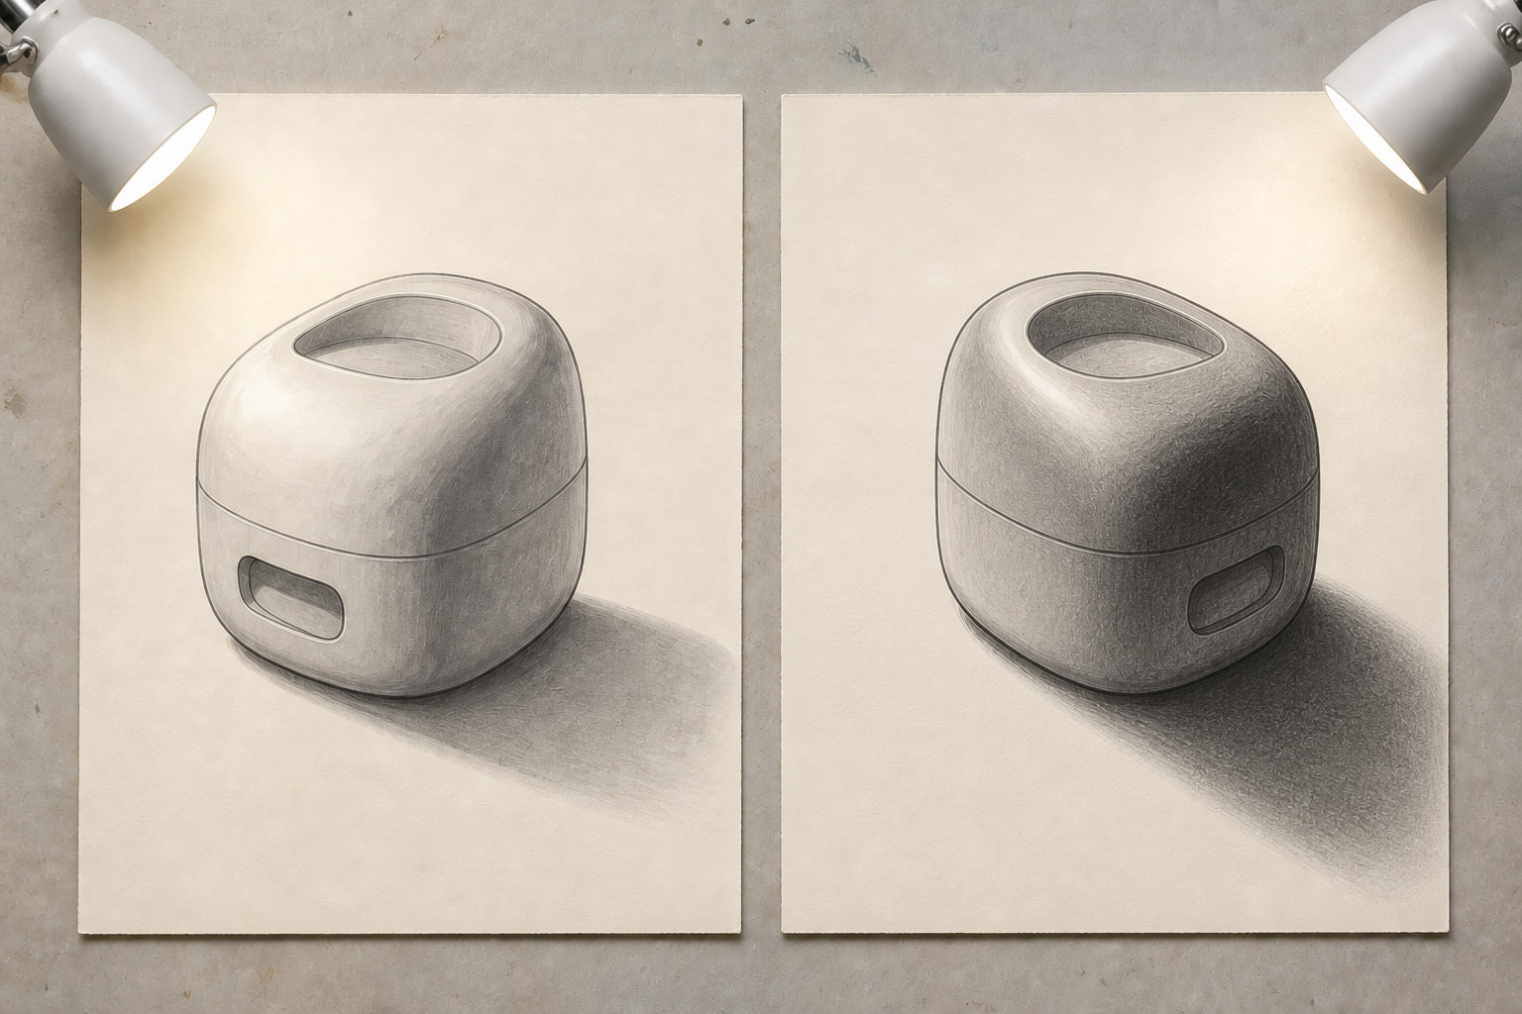
Figure 4. Source lighting comparison. Use the depicted lamp direction, highlights and cast shadows as evidence; the studies do not define a manufactured object.

Highlight, shade and cast shadow
A highlight is relatively light because the surface faces the chosen light direction. Shade is the darker appearance on surfaces receiving less direct light. On a curved form, a gradual tonal change can suggest curvature. On an angular form, neighbouring faces may have more distinct tones.
A cast shadow is on another surface where the object blocks the light. It is different from shade on the object itself. If light comes from above and left, the highlight, darker turning surfaces and cast shadow should support that same explanation. Random dark patches may look elaborate while communicating very little.

Keep one lighting explanation
In the source comparison, the left study uses consistent clues; the right study invites you to notice contradictory lighting information. The important judgement is the relationship between the clues, not how dark the pencil is. State where the light appears to come from and test whether the tones and cast shadow agree.
The complete progression is explore, compare, choose, construct, check and render. A thumbnail explores possibilities; construction controls geometry; rendering helps the viewer read three-dimensional appearance. Rendering does not repair an inaccurate outline or supply the dimensions needed to define a product. Keep the earlier construction available when evaluating the finished image.

Choose one study and explain whether its highlight, shade and cast shadow tell the same lighting story.

MODULE 1 / VIEWS, PROJECTION AND DIMENSIONING

One solid and its views
Each square-on view reveals different information about the same object.
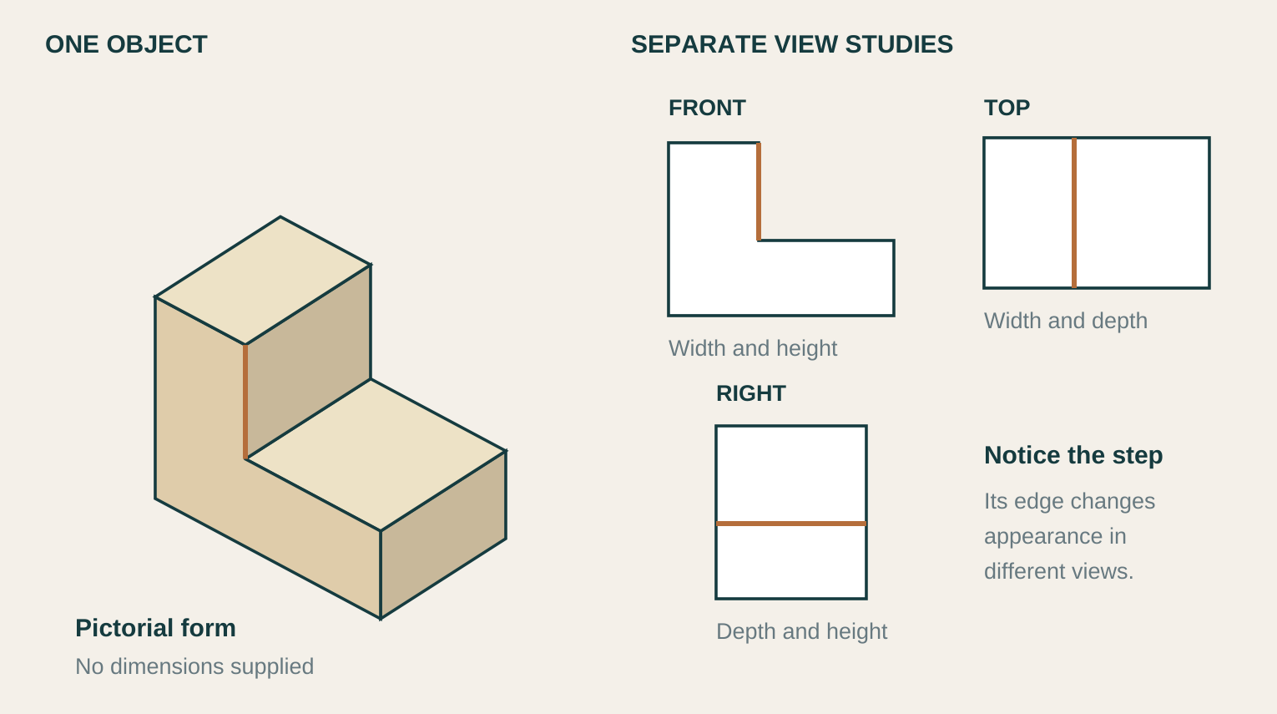
Figure 5. A fictional stepped solid and three separately labelled view studies. This is not a first-angle or third-angle sheet layout and supplies no project dimensions.

Follow the same feature
The front view shows width and the change in height. The top view has a rectangular footprint, with a line where the upper step begins. The right view shows depth and height; its horizontal line marks the top of the lower portion. The same step is present in every view, although its appearance changes.
A pictorial view helps you recognise the overall form. Square-on working views let you compare particular faces and features without perspective. Read them together rather than treating them as unrelated shapes.

Check the drawing system
Before arranging working views on a sheet, verify the required projection symbol or template issued by your teacher. First-angle and third-angle systems place related views differently. This separated study teaches correspondence; it does not select the system for your task.
Check shared widths, heights and feature positions. Then ask which overall sizes, feature sizes and locations need dimensions. Avoid repeating a value merely to fill space, and do not estimate a missing project size from a picture.

Trace the step in the front and top views. Explain one relationship that must agree.

MODULE 1 / VIEWS, PROJECTION AND DIMENSIONING

Select dimensions that remove doubt
A useful dimension set gives necessary information without unnecessary repetition.
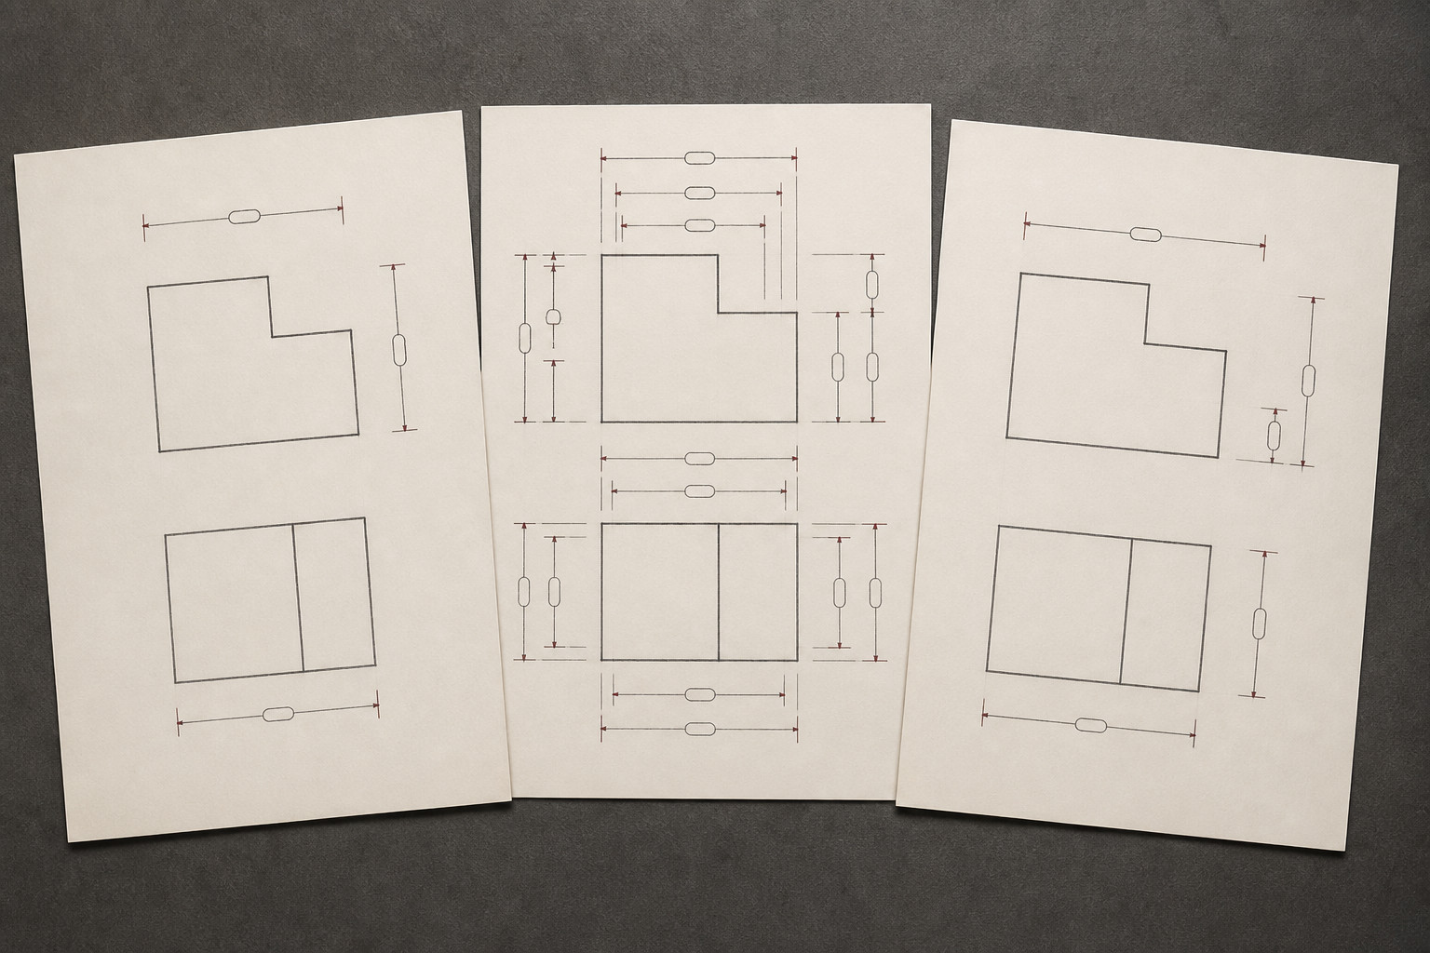
Figure 6. Source concept sheets compare sparse, crowded and more selective annotation. Empty value capsules provide no sizes; they must not be used as a dimensioned key.

Complete does not mean crowded
Views can describe the correct shape while leaving its size unknown. A dimension communicates a required size or location. The reader may need overall width, depth and height, along with the sizes and positions of important features. Ask whether those features could be defined without guessing.
For the fictional stepped block on page 7, overall sizes do not necessarily establish the lower height or where the step begins. Missing either can leave the form incompletely defined. Repeating the same overall width in two views may add no information. Omission leaves uncertainty; duplication can create clutter and inconsistent updates.

Check the drawing as a system
Projection transfers the positions of shared features between views. Verify the required projection symbol or issued template before arranging first-angle or third-angle views. Then use alignment to check corresponding widths, heights and edges. Software defaults and a remembered view arrangement are not enough to establish the required system.
The source checking sequence is object, system, alignment, dimensions and readability. Confirm that the views describe one object, follow the verified system and agree geometrically. Select dimensions that remove a real uncertainty, then inspect their placement. Written values, units and approved source information control a real drawing; never derive a missing project size by measuring an illustration.

For the page-7 solid, name one overall size and one feature location the reader would need to know.

MODULE 1 / ORIGINAL COURSE KNOWLEDGE CHECK

Check the drawing ideas
Circle one answer for each question. Then use the exact required continuation below.
1. A student notices something about the drawing workspace that may affect safe work but is unsure what to do. What is the best response?
○ A. Pause and check the current instruction before continuing.
○ B. Continue if the task looks simple and check only if a problem occurs.
○ C. Invent a rule that seems sensible and use it for the rest of the task.

2. Why should construction lines and visible outlines be visually different in an instrument drawing?
○ A. So the reader can distinguish working geometry from the edges intended to represent the object.
○ B. So the page looks more decorative and contains a wider range of line styles.
○ C. So every line in the drawing attracts the same amount of attention.

3. Which statement best explains proportion in an exploratory sketch?
○ A. It describes how light and dark areas are arranged across the surface.
○ B. It means every part must already have an exact numerical dimension.
○ C. It describes the size relationships between different parts of the form.

4. What does rendering add to a controlled outline?
○ A. It proves that all features have exact dimensions.
○ B. It helps communicate surface form, depth and three-dimensional appearance using light and dark information.
○ C. It replaces the need to establish the underlying geometry first.

5. What is the main purpose of projection when constructing related working views?
○ A. To make the object appear more realistic by adding perspective.
○ B. To enlarge important features so they are easier to notice.
○ C. To transfer the positions of shared features so the views remain aligned and geometrically connected.

6. Which sequence best reflects the final checking routine described in the section?
○ A. Object, system, alignment, dimensions, readability.
○ B. Isometric, decoration, colour, dimensions, title.
○ C. Dimensions, perspective, materials, projection, manufacturing.

Required online continuation uses the original question numbers in each section:
Section 01: questions 2, 3, 5, 6, 7, 8, 9, 10
Section 02: questions 1, 2, 4, 6, 7, 8, 9, 10
Section 03: questions 1, 2, 4, 5, 6, 7, 8, 9

MODULE 1 / SAFE STUDIO, INSTRUMENTS AND LINE LANGUAGE

Pause, read, choose
Rehearse the distinction between communication conventions and local safety directions.
A graphics workstation or instruction is unfamiliar. Which first response best protects both safety and drawing accuracy?
○ A. Pause and check the current authorised instruction.
○ B. Guess from how the tool looks.
○ C. Copy another student's method without checking.
Name one general risk-thinking principle and one detail that must come from current teacher direction.

Sketch one drawing decision and annotate its communication purpose.

Required online capstone: Safe studio, instruments and line language
Required online folio: Safe studio, instruments and line language

MODULE 1 / SKETCHING, RENDERING AND GEOMETRIC CONSTRUCTION

Light logic check
Connect each drawing stage to a clear decision or communication job.
Which rendering decision makes a simple form easiest to read?
○ A. Use one consistent light direction and related tone changes.
○ B. Make every edge equally dark.
○ C. Place highlights wherever space is available.
Explain how one sketch could progress from exploratory lines to a controlled rendered idea.

Sketch a simple form and show a chosen light direction, highlight, shade and cast shadow.

Required online capstone: Sketching, rendering and geometric construction

MODULE 1 / VIEWS, PROJECTION AND DIMENSIONING

View detective
Choose the representation that best reveals a stated feature.
What is the strongest check that several principal views describe the same object?
○ A. Trace shared features and alignment between the views.
○ B. Decorate each view differently.
○ C. Resize each view until the page looks full.
Choose one feature and describe how you would follow it through two different views.

Sketch or annotate one feature in two related views. Use no invented project dimensions.

Required online folio: Views, projection and dimensioning

MODULE 1 / VIEWS, PROJECTION AND DIMENSIONING

Justify the decision
A fictional desk organiser has a rectangular base, one raised section and an offset rectangular recess. A student proposes showing only one isometric view with many dimensions. Justify a clearer drawing approach that would help another student understand the organiser's 3D form and determine the important sizes and feature locations without guessing.
1. Choose an informative principal view and explain what important shape information it should reveal.
2. Explain how front, top and side views could be coordinated through projection, alignment and the verified projection system.
3. Explain how an isometric view could support spatial understanding without replacing the working views.
4. Select the kinds of dimensions needed for a minimal complete description, and identify one likely duplication and one likely omission to avoid.
Response: 150–200 words

MODULE 1 / REQUIRED FOLIO EVIDENCE

Sketch-development evidence
Keep one before-and-after drawing decision.
A selected change can show how construction or rendering improved communication.
BEFORE / Show the drawing feature that needs clearer communication

AFTER / Show the selected change in construction or rendering

Describe the problem, the revision and the effect on the viewer's understanding.

Name the drawing stage and the feature the viewer should notice.

Keep the before state. Saving or printing is not submission; follow your teacher’s instruction.
Open the matching required folio card

MODULE 2 / DOCUMENTS, SKETCH PLANES AND CONSTRAINTS

Find the modelling context
Know which level of the document you are editing before drawing geometry.
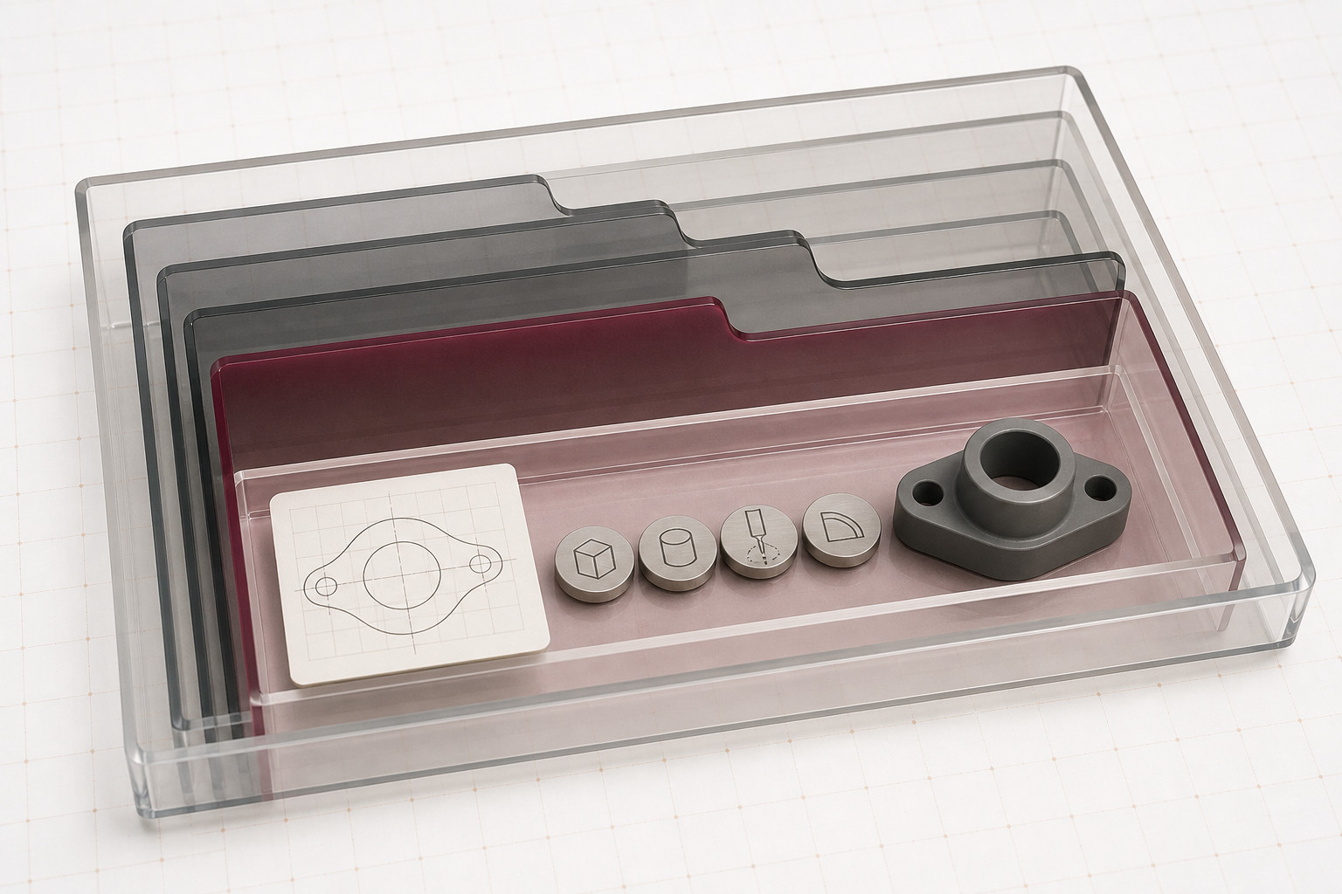
Figure 7. The source uses a physical filing analogy for organised design information. The trays and tokens are not exact Onshape tabs, commands or icons.

Document, tab, sketch and part
An Onshape document is a container for related design information. Its tabs can include Part Studios, Assemblies and Drawings. A Part Studio is the environment for creating sketches and parts; it is not itself the finished part. A sketch contains two-dimensional geometry, while features record modelling operations that create or modify geometry.
The useful chain is document, Part Studio tab, sketches and features, then part. Sketches remain in the parametric history rather than disappearing when a feature is created. A later operation can depend on an earlier sketch. Checking the document name, active tab and Feature list helps prevent an edit in the wrong context.

Choose the plane deliberately
A plane locates and orients a sketch in 3D space. The default Top, Front and Right planes and the origin provide references. The same rectangular outline on different planes can have the same size but a different orientation. Choose the plane for the face or view you intend to define, not simply the first plane you notice.
For the source’s fictional screen-only nameplate, a sketch on the Front plane makes sense when its broad face should face the front. This is a reason for that example, not a rule for every object. Establish the intended centre around the origin, then use movement checks, dimensions and constraints to express it, as page 16 explains.

Explain which document area and plane you would check before starting an outline that will only be modelled on screen.

MODULE 2 / DOCUMENTS, SKETCH PLANES AND CONSTRAINTS

Control the relationship
A sketch needs to behave as intended when the model changes.

Size and position need reasons
A dimension controls a value, such as the width of an outline. A geometric constraint controls a relationship: lines may remain horizontal, two points may stay together, or a profile may remain centred on a fixed reference. Together, these decisions express design intent, the relationships that should survive an edit.
Looking centred is not the same as being controlled. If a rectangle can slide sideways when dragged, its position still has a degree of freedom. If its width can change unexpectedly, another intended value or relationship is missing. Ask what movement is still possible before adding more information.

Test before adding more
Choose the active Part Studio and sketch plane for the intended orientation. Then test the sketch carefully. Observe what moves, read the constraint information and identify the relationship that is missing. Add only what expresses the intended geometry, then test again.
A conflict may mean that two instructions compete, or that a relationship has been defined twice. Inspect the affected geometry and the earliest relevant decision. Adding random dimensions can hide the original problem. Colour is one source of feedback; movement and constraint information are needed to explain what the sketch actually does.

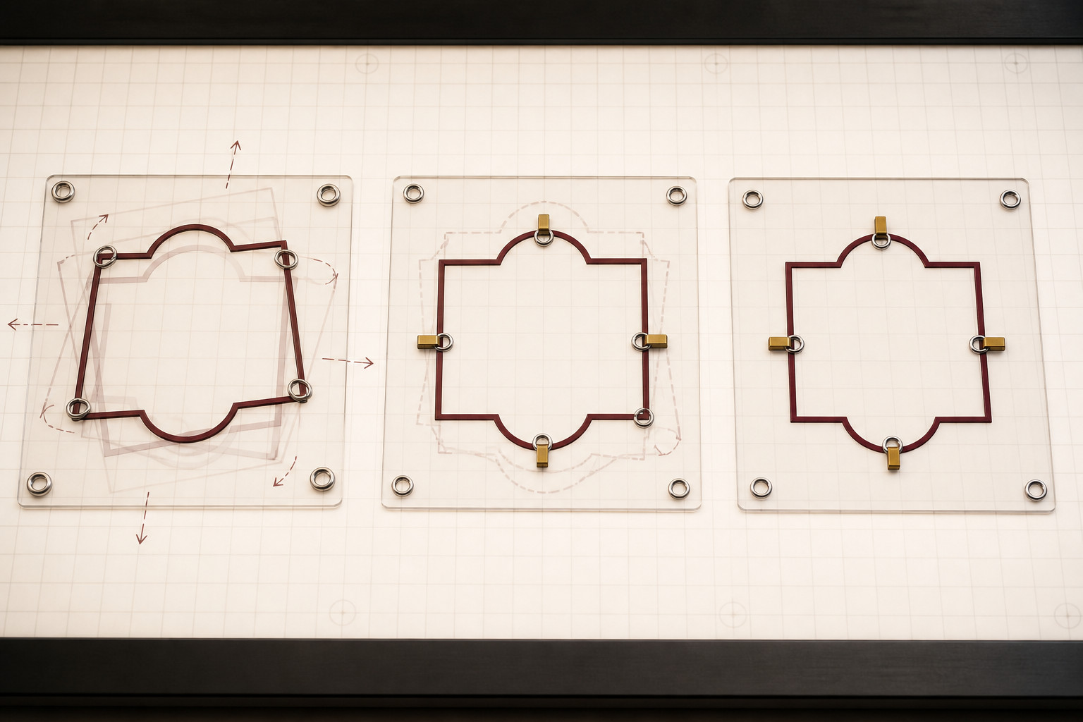
Figure 8. A source concept illustration uses physical restraints as an analogy for controlling movement. It is not an Onshape screen, an icon key or proof that a CAD sketch is fully constrained.

Apply this on pages 22 and 26
Trace the three states as an analogy for controlling movement. The clamps are not software constraints. Complete Constraint clinic on page 22, then the Constraint-intent record on page 26. A fully defined sketch still needs purposeful relationships.

MODULE 2 / FEATURES, ACCURACY AND DESIGN INTENT

Read the model after a change
A useful feature history explains cause and effect, not just the final shape.
The source uses a fictional, screen-only desk tag. Its base, opening and repeated details should retain their intended relationships when a controlling value changes. No size, material or manufacturing process is approved by this example.
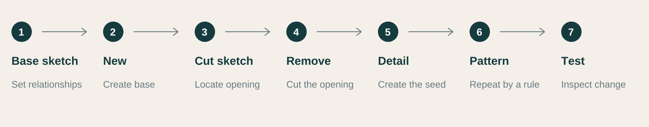
Figure 9. A conceptual feature sequence for the screen-only example. These are modelling decisions, not a reproduction of the Onshape interface.

1 State what should remain true
The opening should stay meaningfully located relative to the base. The repeated details should remain a regular group. A pattern expresses a shared repetition rule more clearly than unrelated copies positioned by eye.

2 Make one purposeful change
Change a controlling value in the base sketch, then inspect the opening and repeated details. A successful rebuild is useful only if the geometry still expresses the intended relationships. Extra decimal places do not repair weak dependencies.

3 Trace an unexpected result
Find the earliest failed or unexpected feature. Identify what it depended on and what changed upstream. Correct the reference or relationship that does not express the intended design, then test again. Do not merely hide the final error.

A checkable prediction
“When the base length changes, the repeated details should still follow the same spacing rule.” This says what to inspect. “The model should look right” does not identify a relationship or a test.

Choose a relationship in a teacher-approved screen exercise. State a change, predict what should remain true, and explain what you would inspect.

MODULE 2 / FEATURES, ACCURACY AND DESIGN INTENT

Choose the intended result
The same profile can express different modelling intentions.
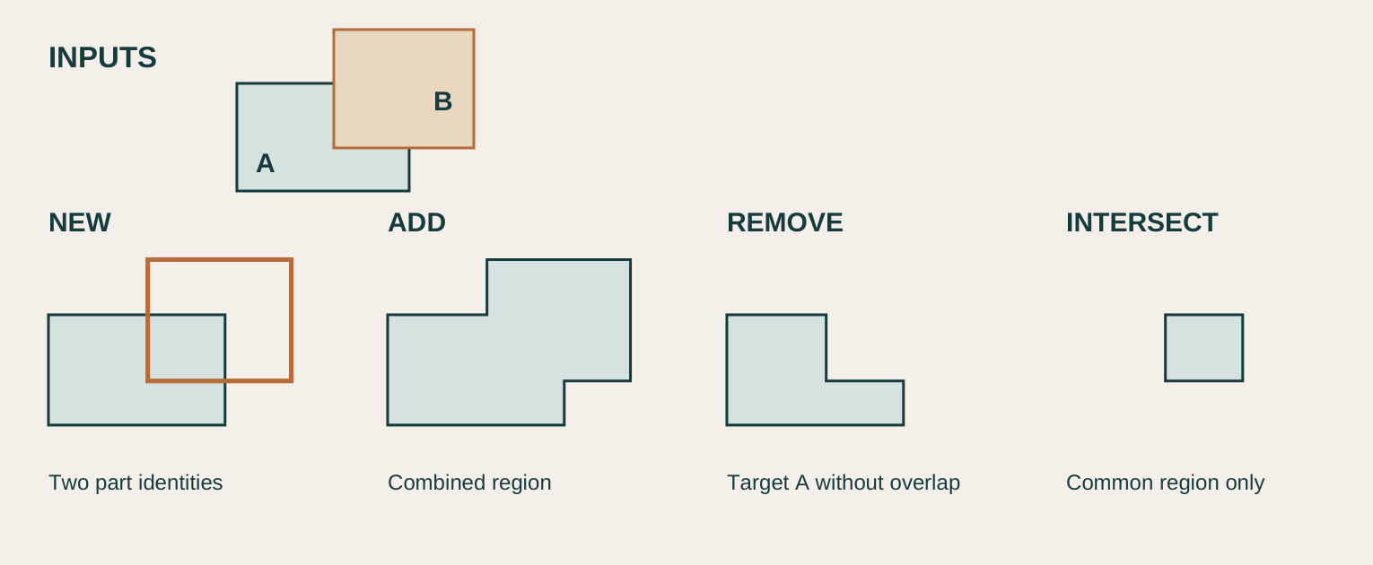
Figure 10. Conceptual region study: the outlines show two inputs and four distinct results. No software buttons, dimensions or fabrication settings are represented.

Create, combine, remove or retain
For a solid extrude, New creates geometry as a new part. Add combines the new geometry with existing geometry. Remove takes overlapping geometry away from an existing part. Intersect retains only the common region. Choose the operation for the intended result before accepting the preview.
The diagram uses two overlapping rectangular regions to make these relationships clear. They are abstract sections, not an Onshape screenshot or a project shape. New keeps a separate part identity; Add makes a combined region; Remove changes the target; Intersect keeps only their overlap. The result changes even when the starting regions do not.

Follow purpose through the history
Boolean operations also express relationships between parts. Union combines them, Subtract removes selected geometry from another part, and Intersect keeps their common region. Shell creates walls from a solid while removing selected faces. A wall value or removed face must suit the intended model; the term alone is not a manufacturing instruction.
A pattern can repeat parts, features or faces when they genuinely share a rule. Shell, patterns and Boolean operations are useful because they capture intent, not because a complicated model is automatically better. Check suitable values, relationships, expected update behaviour and fitness for purpose. Extra decimal places cannot repair an incorrect result type or a fragile dependency.

For an opening through an existing solid, choose a result type and explain what would remain.

MODULE 2 / DRAWINGS, DIMENSIONS, EXPORTS AND VERSIONS

From a model to a drawing
Select information that another person needs to understand.
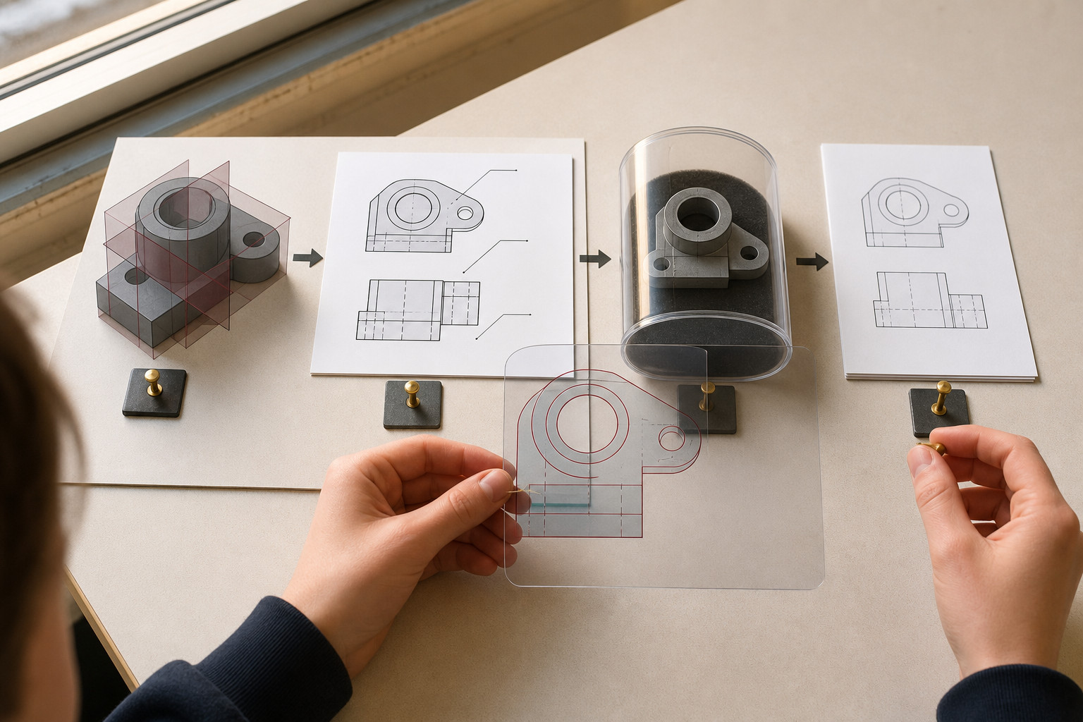
Figure 11. Source handoff analogy: the model, selected drawing, preserved state and output are checked together. It is not an exact projection key or an actual software screen.

Views reference the model
A model can be rotated and explored, but a drawing arranges important information for a reader. In Onshape a Drawing is a separate tab. It can present selected views from a part or Part Studio. A projected view derives from a parent view so related geometry stays coordinated; an isometric view can support recognition of the overall form.
Choose enough views to reveal significant features without unnecessary repetition. A front view may show an informative profile while a side view clarifies depth. You are presenting model information, not rebuilding the object as unrelated lines. When the model develops, check that the drawing still represents the intended state.

Make dimensions readable
Drawing dimensions communicate size or position and attach to relevant geometry. Their units give the numbers meaning. A correct value can still mislead if the reader cannot tell which feature it describes. Check where leaders and extension lines point and whether the view arrangement makes the relationship clear.
For the source’s screen-only desk tag, inspect overall form, opening location and repeated details before handing the drawing on. Look for missing sizes, duplicated information and ambiguous placement. Model, drawing and export checks form one communication process. A successful export command does not establish that the recipient has enough information.

Explain one reason to add a related view and one dimension-placement check for a drawing handoff.

MODULE 2 / DRAWINGS, DIMENSIONS, EXPORTS AND VERSIONS

Keep a recoverable milestone
Know which design state you are communicating and what the output preserves.

Workspace, history and version
A workspace is the active area where design work continues. History records the path of changes. A named version deliberately marks a stable point in that history. These are connected ideas, but not interchangeable names. A meaningful checkpoint makes it easier to identify what was checked before a revision or handoff.
In the fictional desk-tag example, a name such as “Drawing checked” tells a reader why a checkpoint matters. It does not stop later work in the workspace. Before sending a drawing, know whether it references the intended workspace or version and check the model state used by its views.

Export for the recipient’s purpose
An export creates information for use outside the editable design environment. Someone may need a readable drawing, drawing geometry or three-dimensional geometry for another workflow. These needs call for different outputs. Ask what the recipient must do, what information must survive and whether the destination can use the file.
Exported model data does not preserve the original Onshape feature history. Keep the editable document when those modelling decisions matter. The source handoff sequence is to check the model, select coordinated views, check dimensions and units, identify a useful version, choose the output and inspect that exported copy. A later workspace edit does not silently change a previously exported file.

RECORD | COMMUNICATION JOB
Workspace | Continue editing the live design
History | Trace the sequence of changes
Named version | Identify a stable checkpoint
Export | Provide selected information for a destination

Explain what a named version and an exported file each preserve, and why the editable source still matters.

MODULE 2 / DOCUMENTS, SKETCH PLANES AND CONSTRAINTS

Check the module ideas
Circle one answer for each question. Then use the exact required continuation below.
1. Which statement best describes how an Onshape document is organised?
○ A. A document can contain related tabs such as Part Studios, with sketches and features organised inside them.
○ B. A document is only a single sketch, and every new sketch must be stored in a separate document.
○ C. A document is the finished 3D part, while tabs are only used to change the screen view.

2. What is the best distinction between a dimension and a geometric constraint in an Onshape sketch?
○ A. A dimension gives a numerical value, while a constraint controls a geometric relationship.
○ B. A dimension controls colour, while a constraint controls whether the sketch appears in the Feature list.
○ C. A dimension and a constraint always do exactly the same job, so either can replace the other.

3. A student extrudes a sketch to create an opening through an existing solid part. Which result type best matches that design intent?
○ A. New
○ B. Remove
○ C. Add

4. Why can an Onshape pattern communicate design intent better than several manually copied features?
○ A. A pattern shows that the repeated features belong to one controlled repetition rule.
○ B. A pattern guarantees that every possible future model change will succeed.
○ C. A pattern removes the need to create the first feature that is being repeated.

5. Why should a student think about the audience before choosing an export from Onshape?
○ A. Because every export preserves exactly the same information, but some look more professional.
○ B. Because the correct export depends on what the next person needs to read or use.
○ C. Because an export is only useful when the audience also edits the original Part Studio.

6. Which description correctly distinguishes a workspace from a named version in Onshape?
○ A. A workspace is where design work can continue, while a named version records a stable
view-only checkpoint in the document history.
○ B. A named version is the editable area, while a workspace permanently locks the model.
○ C. A workspace and named version are two labels for exactly the same document state.

Required online continuation uses the original question numbers in each section:
Section 01: questions 2, 4, 5, 6, 7, 8, 9, 10
Section 02: questions 1, 4, 5, 6, 7, 8, 9, 10
Section 03: questions 1, 2, 3, 4, 6, 8, 9, 10

MODULE 2 / DOCUMENTS, SKETCH PLANES AND CONSTRAINTS

Constraint clinic
Diagnose which intended relationship is missing from a simple Onshape sketch scenario.
An Onshape sketch still moves sideways when dragged. What is the most useful next step?
○ A. Identify the intended relationship, then add or revise the matching constraint.
○ B. Add several unrelated dimensions.
○ C. Assume the sketch colour proves it is complete.
State the movement you would test and the relationship you want the sketch to preserve.

Show the intended relationship and mark the movement that should be controlled.

Required online capstone: Documents, sketch planes and constraints

MODULE 2 / FEATURES, ACCURACY AND DESIGN INTENT

Feature-history triage
Identify a fragile feature dependency and propose a more readable Onshape modelling decision.
A repeated slot spacing may change later. Which modelling decision best preserves design intent?
○ A. Build the repetition from a purposeful relationship or pattern.
○ B. Copy disconnected geometry until it looks close.
○ C. Enter extra decimal places without changing relationships.
Explain one upstream decision that could make later edits predictable.

Map one upstream decision to a feature that depends on it.

Required online folio: Features, accuracy and design intent

MODULE 2 / DRAWINGS, DIMENSIONS, EXPORTS AND VERSIONS

Handoff checkpoint
Choose the drawing, export and version evidence needed for a stated recipient.
A model has reached a useful milestone before a drawing export. What is the best record?
○ A. Create a clearly named version, check the drawing, then export for the intended purpose.
○ B. Keep only a screenshot of the current screen.
○ C. Duplicate browser tabs and treat them as versions.
List two checks you would make before handing a drawing file to another person.

Plan a handoff checklist for a stated recipient. Keep the editable source and the export distinct.

Required online capstone: Drawings, dimensions, exports and versions
Required online folio: Drawings, dimensions, exports and versions

MODULE 2 / FEATURES, ACCURACY AND DESIGN INTENT

Justify the decision
A student is creating a fictional Onshape name badge with a constrained base, one raised feature, one cut-out feature and a row of matching repeated details. They plan to create every detail separately because the model looks correct on screen. Justify a better modelling approach that would communicate the design intent clearly and remain useful if one important controlling value in the base is changed.
1. State which relationships should survive when the controlling base value changes.
2. Explain how the feature history and suitable New, Add or Remove result types could communicate the modelling decisions.
3. Explain whether the repeated details should be independent copies or controlled by a pattern, and why.
4. Describe how you would test the model after changing one controlling value and what a successful update or failed reference would tell you.
Response: About 150-200 words.

MODULE 2 / DOCUMENTS, SKETCH PLANES AND CONSTRAINTS

Constraint-intent record
Keep one constraint decision and its predicted effect.
A reasoned constraint choice is stronger evidence than a screenshot alone.
Record the sketch relationship and movement check. Add your own annotated evidence.

Explain the intended relationship, the movement it controls and the check used.

Name the Onshape sketch decision shown.

Saving or printing is not submission; follow your teacher’s instruction.
Open the matching required folio card

MODULE 3 / PRODUCT RESEARCH, BRIEF AND CONCEPT CHOICE

Research before you choose
Separate what you can observe from what you infer.
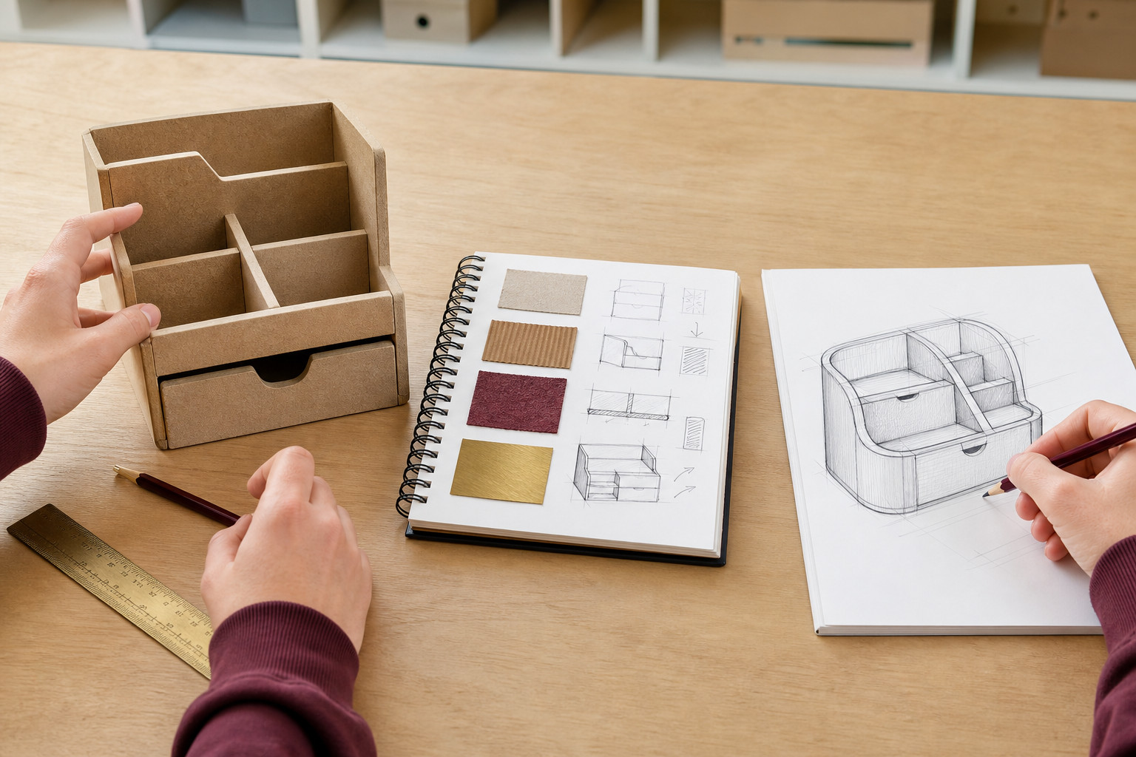
Figure 12. Source research illustration: visible compartments, sketches and samples can prompt questions. They do not prove a material, a hidden joint or a manufacturing method.

Look for useful evidence
Product research investigates how existing designs respond to needs. An observation is something directly seen or established in the available evidence. An inference interprets that observation. You might observe separate storage areas and infer that they may help organise different items. The possible benefit is not proved by appearance alone.
Use cautious language such as “may”, “could” or “suggests” when the evidence is incomplete. Compare contrasting products rather than copying one attractive example. Look at arrangement, access, form and visible relationships, while recording sources. An image does not establish hidden construction, material performance or exact size.

Turn the need into a brief
A design brief identifies what is to be designed, for whom and for what need. It leaves room for alternatives. A specification turns that direction into requirements that can be checked later. A criterion helps judge success; a constraint limits the possible solution, such as the available space.
The source’s hypothetical organiser brief concerns convenient, orderly storage. Its possible specification asks for separation of items, access, compactness and a coherent arrangement. These are illustrative criteria, not the class project. Replace a vague statement like “looks great” with an observable basis for comparison. Not every criterion needs a number, but every judgement needs a reason.

Write one observation, one cautious inference and one checkable criterion suggested by the illustration.

MODULE 3 / PRODUCT RESEARCH, BRIEF AND CONCEPT CHOICE

Compare genuinely different concepts
Use the same criteria to judge alternatives fairly.
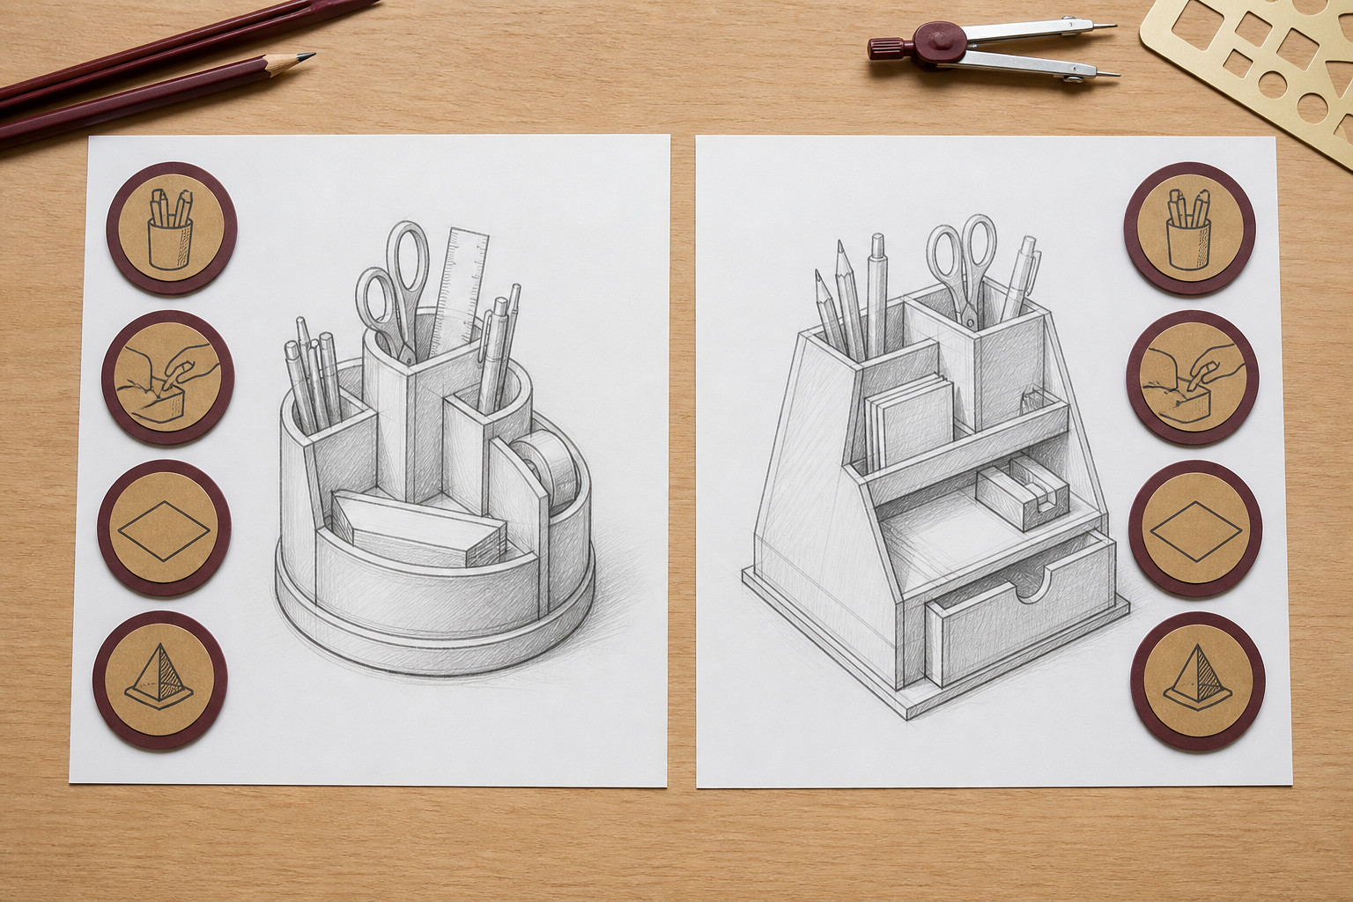
Figure 13. The source compares two visibly different organising concepts against repeated criteria. Treat the sketches as proposals; symbols and appearance do not prove performance.

Develop alternatives that matter
A concept communicates a possible direction before every detail is resolved. Changing only colour or a corner shape may produce cosmetic variants rather than a different solution. Explore changes in arrangement, access, form or component relationships. Annotations should explain a feature’s job or its connection to a specification point.
The source’s written example contrasts a low divided tray with a stepped modular organiser, separately from the pictured proposals. One uses broad subdivision; the other uses levels. Sketches suggest benefits and limitations but do not prove actual access or stability; those need later modelling or testing.

Use evidence and weigh alternatives
Compare both ideas against the same criteria, such as access, compactness and separation of items. A comparison matrix helps organise reasons, but a score without evidence is weak. Do not change the criteria to make a favourite win. Refer to the sketches, research or other available evidence for each judgement.
A defensible choice names the concept, connects its features to the user need and acknowledges a trade-off. A raised rear area may improve visibility while creating a more complex form. State the limitation and the next question to model. Choosing a concept begins refinement; it does not establish a finished product or permission to manufacture it.

Choose one visible difference and explain a possible benefit, trade-off and next question to investigate.

MODULE 3 / PARTS, CUTTING LISTS AND ASSEMBLIES

Keep part identities consistent
Different records describe different aspects of a product.

Parts and instances
A component is an item in a larger product; it can be one part or a subassembly. A part is a separately modelled physical item. An instance is one use of that part or subassembly in an Assembly. If a part is used three times, there are three instances, not necessarily three different part designs.
Decomposing a product means identifying its components and their relationships. The source’s fictional caddy names four parts: Base, Back, Divider and Front Lip. Consistent names reduce confusion between a record, a model and a drawing. These illustrative names do not establish the parts of your class project.

Choose the record for the job
A cutting list supports manufacture by recording stock-piece information, including names, material, required or finished sizes and quantities. A parts list identifies the components and quantities in a product. A bill of materials, or BOM, can also include item numbers, part numbers, descriptions and other properties.
Some fields overlap, but the documents have different purposes. A BOM is not automatically a school cutting-list template or evidence of compliance with a drawing standard. Use the current issued requirements and approved source sizes for actual work. Do not infer quantities or dimensions from a persuasive product illustration.

RECORD | WHAT TO VERIFY
Cutting list | Approved stock-piece name, material, size and quantity
Parts list or BOM | Consistent component identity and required instances
Drawing or assembly | The same component and relationship are identifiable

Explain why a parts list may be insufficient as a cutting list, even when both use the same component names.

MODULE 3 / PARTS, CUTTING LISTS AND ASSEMBLIES

Follow a component through the model
A stable name connects records, geometry and communication.

Follow the Divider
In the source’s hypothetical caddy, the entry in the cutting list, modelled part and assembly component all use the name Divider. A Part Studio creates the part. Inserting it into an Assembly creates an instance. The BOM records the required component quantity, while a Drawing presents selected views for an audience.
That trail makes a check possible: does the record describe the same item that appears in the assembly and drawing? If names drift or quantity is omitted, a reader must guess. A complex product may contain subassemblies, but their instances still need consistent identity within the larger assembly.

Use an exploded view deliberately
An assembled view shows parts in their normal relationship, which can hide some components. An exploded view separates instances temporarily so their identities and relative positions are easier to understand. It does not change the parts themselves or authorise a different design.
In Onshape, an exploded view is created from an Assembly and can be used in a Drawing. Labels or BOM-linked identifiers can connect the visible component with its record. Check the same name, quantity and relationship across representations. An attractive exploded illustration with inconsistent shapes or counts is a reason to consult the authoritative model, not to invent a corrected cutting list.

STAGE | THE SAME IDENTITY
Cutting list | Divider: approved stock information
Part Studio | Divider: named modelled part
Assembly and BOM | Divider instance: required quantity
Exploded view and Drawing | Divider: recognisable relationship and matching identifier

Describe two checks you would use to follow the same component through a record and an exploded assembly view.

MODULE 3 / PROTOTYPE PATHWAY, TESTING AND EVALUATION

Prototype to answer a question
Choose the level of detail that produces the evidence you need.
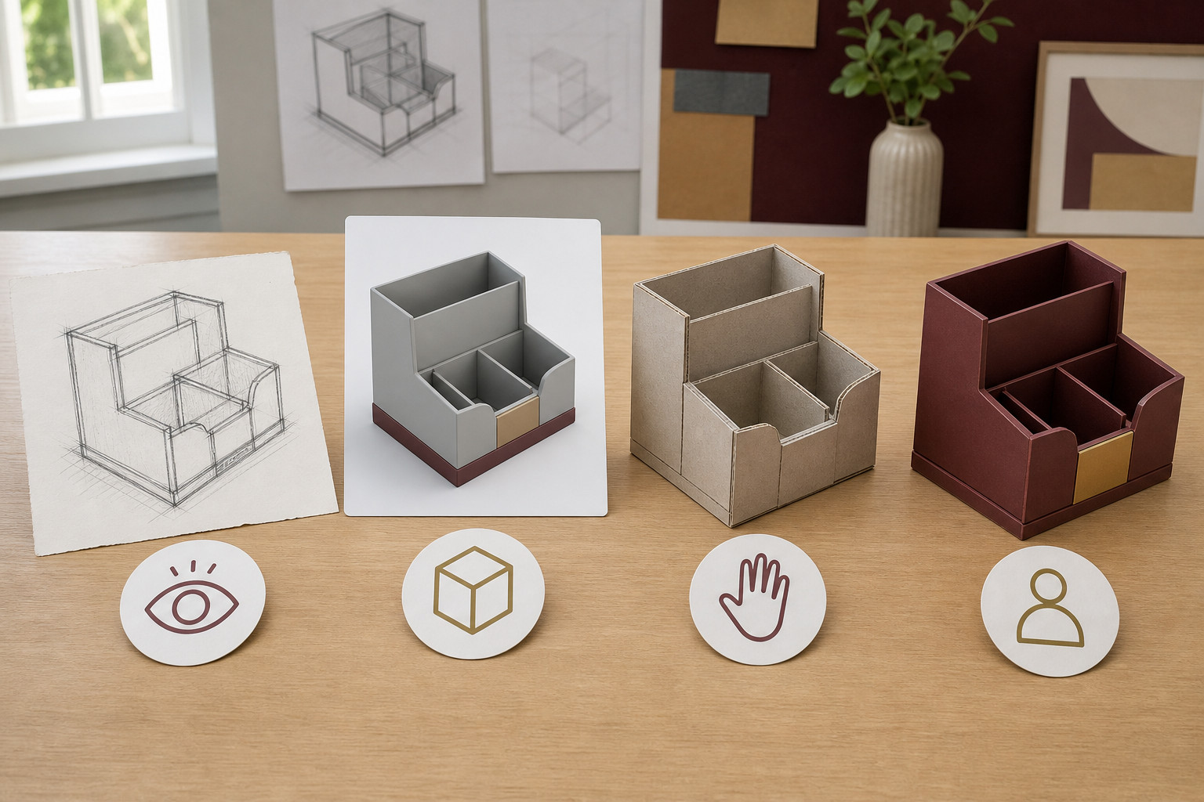
Figure 14. Source prototype concepts show different levels of representation. Choose a level for the question; none of these images records a verified performance test.

Match fidelity to the test
A prototype is a model or representation made to investigate a design question. Fidelity means its level of detail. A simple model may reveal an arrangement, while a fit test needs enough dimensional accuracy to compare intended items with available space. Realistic texture adds little to a fit question if the geometry is wrong.
A render can explain appearance but does not prove function, manufacturability or safety. Begin with a specification point and turn it into a focused test question. “Do intended items fit and remain accessible?” gives you a more useful direction than “Is the organiser good?” The question determines what the method must reveal.

Record something another person can judge
For a digital organiser, representative item forms and several views may reveal that objects fit but one is partly blocked. Record the condition and the result rather than writing that the design “works”. Relevant screenshots, observations and user responses should support the same criterion.
User feedback is evidence to interpret, not an automatic design instruction. Ask what caused a reported difficulty and compare it with the model evidence. A vague dislike needs a focused follow-up question. Digital evidence may flag a balance concern; it cannot prove the behaviour of a physical product. Any physical prototype or test requires current teacher approval and instructions.

Turn one design criterion into a focused test question and identify the evidence you would collect.

MODULE 3 / PROTOTYPE PATHWAY, TESTING AND EVALUATION

Evaluate the revision
Preserve the before state, respond to evidence and repeat the relevant test.
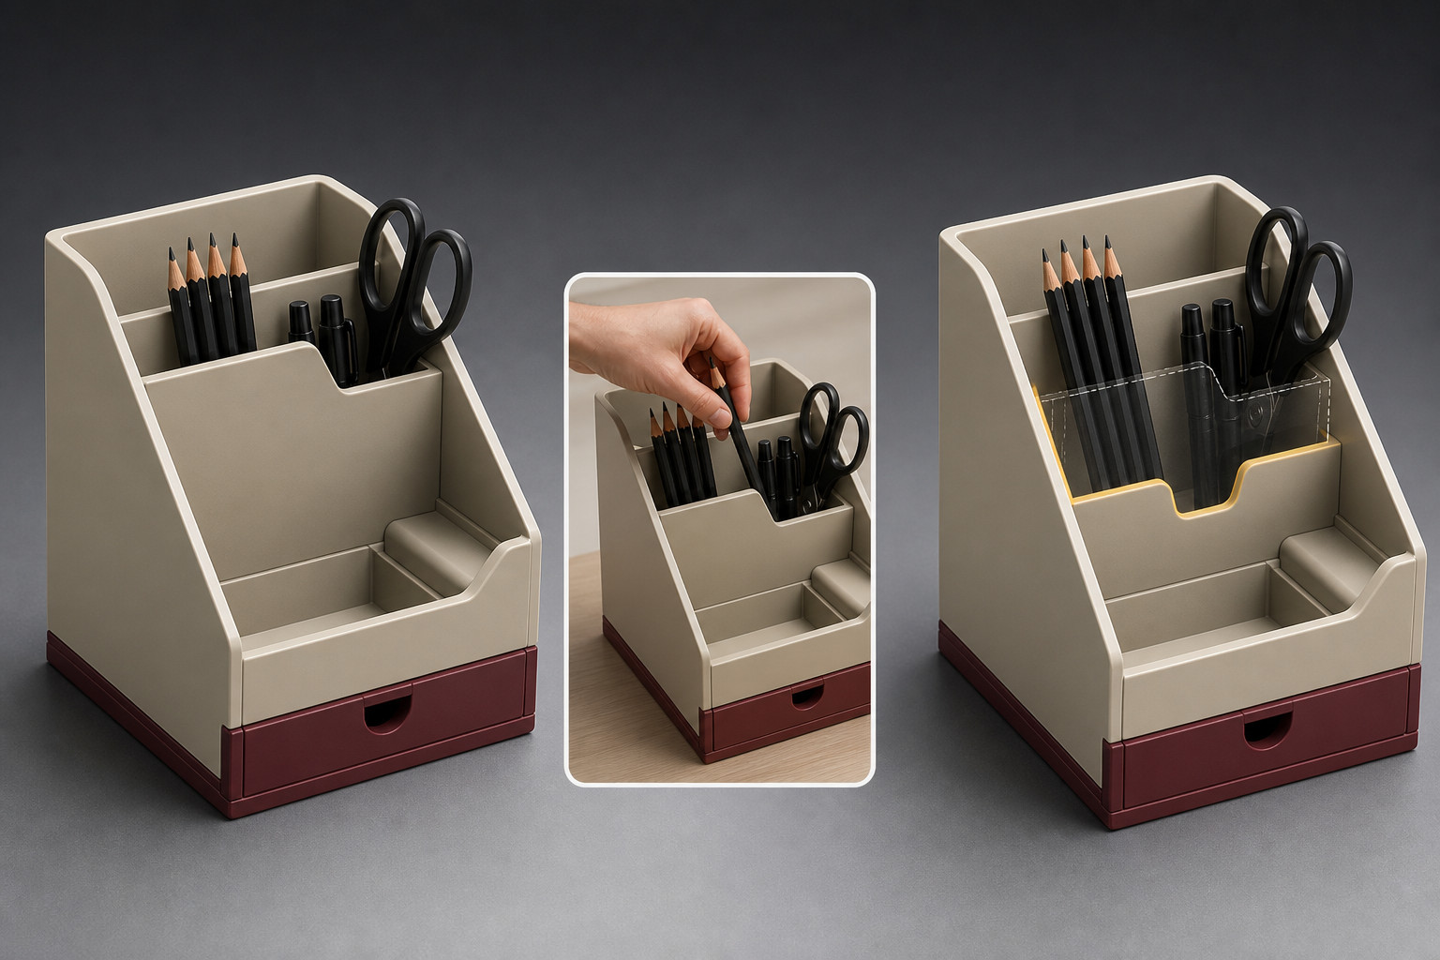
Figure 15. Source revision concept: the front boundary is reconsidered to expose stored items. It illustrates a possible change, not measured before-and-after test results.

Keep a comparison you can explain
Before an important change, preserve the earlier design and its test evidence. Onshape history records changes; a named version deliberately identifies a particular state. A clear checkpoint makes the comparison more useful than relying on memory or a collection of unexplained screenshots.
In the fictional organiser example, the first test shows that the items fit but a frequently used item is obstructed. A user reports the same access difficulty. A revision that opens the access path responds to evidence and the original criterion. Changing only the colour would not address that recorded problem.

Retest before judging success
A change can solve one problem while creating another. Repeat the relevant test with comparable conditions, checking fit and access again. If the items still fit and the obstructed item is easier to reach in the model, the evidence supports a qualified improvement in access. State what changed and why that result matters.
Evaluation connects criterion, evidence, judgement and a remaining limitation. Do not replace this chain with “I like it”. A digital model may suggest a more balanced arrangement without proving physical stability. Identify that limit and a suitable next question. Designing is a cycle of testing, revising and learning rather than proving the first idea was right.

Explain what evidence would justify the pictured revision and what a retest would need to check.

MODULE 3 / PRODUCT RESEARCH, BRIEF AND CONCEPT CHOICE

Check the module ideas
Circle one answer for each question. Then use the exact required continuation below.
1. Which statement best describes the main job of a design brief?
○ A. To define what is being designed, who it is for and the need it should address.
○ B. To list every final dimension, feature and appearance decision before concepts are drawn.
○ C. To rank completed concepts after all design work has finished.

2. A student compares Concept A for “easy access” but compares Concept B for “interesting appearance” and then declares Concept B the winner. What is the main problem?
○ A. The concepts were not compared using the same criteria.
○ B. The student should never compare concepts until one has been built in CAD.
○ C. Every comparison must use only numerical measurements.

3. Which statement best explains the difference between a part and an instance in Onshape?
○ A. A part is a modelled physical item, while an instance is a particular use of that part inside an Assembly.
○ B. A part is always a complete product, while an instance is a stock piece listed for manufacture.
○ C. A part and an instance mean exactly the same thing because each must appear only once in an Assembly.

4. A product uses the same modelled part three times. How should this be understood in an Onshape Assembly?
○ A. The three uses must become three unrelated Part Studios because an Assembly cannot reuse a part.
○ B. The Assembly can contain three instances of the same part.
○ C. The repeated part becomes a cutting list because its quantity is greater than one.

5. Why should the fidelity of a prototype match the evidence needed?
○ A. Because a prototype only needs enough detail to answer its test question effectively.
○ B. Because every prototype should look as close as possible to the final product.
○ C. Because a detailed render can prove that the final product will function correctly.

6. Why should a designer preserve a before state in Onshape before making an important revision?
○ A. So the earlier design can be compared with the revised state using recorded evidence.
○ B. Because Onshape history and named versions are exactly the same feature.
○ C. So the designer never needs to retest after making a change.

Required online continuation uses the original question numbers in each section:
Section 01: questions 1, 3, 4, 5, 6, 8, 9, 10
Section 02: questions 2, 3, 4, 6, 7, 8, 9, 10
Section 03: questions 2, 3, 4, 5, 6, 8, 9, 10

MODULE 3 / PRODUCT RESEARCH, BRIEF AND CONCEPT CHOICE

Evidence before preference
Test whether a preferred concept is actually supported by the brief and research.
Which concept-selection method produces the most defensible decision?
○ A. Compare genuinely different concepts against the same criteria.
○ B. Choose the first attractive sketch.
○ C. Change the criteria until a favourite wins.
Write one observation, one cautious inference and one criterion for a fictional product.

Sketch a visible feature. Label an observation separately from a cautious inference.

Required online capstone: Product research, brief and concept choice

MODULE 3 / PARTS, CUTTING LISTS AND ASSEMBLIES

Part-record repair
Connect a part record to its role and relationship in an Onshape assembly.
A parts record omits quantity for a repeated component. What is the best repair?
○ A. Use a stable part name or ID and record quantity with the required size fields.
○ B. Leave the row vague because the assembly image exists.
○ C. Count the part differently in each document.
Explain how one part record could be checked against both an assembly and a cutting list.

Trace one consistent part name or ID from a record to an assembly relationship.

Required online capstone: Parts, cutting lists and assemblies
Required online folio: Parts, cutting lists and assemblies

MODULE 3 / PROTOTYPE PATHWAY, TESTING AND EVALUATION

Test, evidence, decide
Choose evidence that answers a focused prototype question.
A prototype tilts during a planned use test. What produces the strongest evidence?
○ A. Record the test condition and result, then compare it with the relevant criterion.
○ B. Write that the design is bad without evidence.
○ C. Change the prototype immediately and discard the first result.
Describe one fair test and the evidence that would support a design change.

Map a test question, the method and the evidence to record. Use only an authorised test.

Required online folio: Prototype pathway, testing and evaluation

MODULE 3 / PROTOTYPE PATHWAY, TESTING AND EVALUATION

Evaluate the evidence
A designer has created an Onshape prototype of a fictional desk-storage concept. The specification says that stored items should fit, be easy to access and have an arrangement that appears stable and balanced in the model. An initial test shows that the items fit, but one frequently used item is partly blocked. A user also reports that this item looks awkward to reach. The designer preserves the original state, revises the arrangement and repeats the test. Evaluate the revised prototype by explaining how the evidence should be used to decide whether the revision improved the design and what limitation may still remain.
1. Identify the original criterion or criteria being tested and state a focused test question.
2. Explain what observable evidence and user feedback from the first test show about the design.
3. Describe why preserving the before state, making a justified revision and retesting strengthen the designer's decision.
4. Evaluate the revised design against the original criterion and identify one limitation that the available digital evidence cannot fully resolve.
Response: 150–200 words

MODULE 3 / PRODUCT RESEARCH, BRIEF AND CONCEPT CHOICE

Concept rationale
Keep one comparative concept decision.
The rationale links research and brief requirements to a selected direction.
Show the concepts compared and annotate the deciding evidence.

State the choice, supporting evidence, limitation and next modelling question.

Name the concept comparison and the deciding evidence.

Saving or printing is not submission; follow your teacher’s instruction.
Open the matching required folio card

MODULE 4 / AUDIENCE, DESIGN PRINCIPLES AND ETHICAL SOURCES

Design for the audience
Decide what viewers should notice, understand and do.

Guide the order of attention
Visual hierarchy gives information different emphasis. Contrast in size, weight, tone or spacing can help the title lead, the purpose follow and the practical detail come next. Proportion concerns the relative sizes of those elements. Making everything large or bold removes the useful distinction.
The source uses a fictional youth repair-café poster. Its purpose is to make the activity understandable quickly. If the title, explanation and details compete equally, the viewer must work out where to begin. A revision can strengthen the title, group related information and remove decoration that interrupts the message.

Use space and type deliberately
Composition is the relationship of the parts as a whole. Balance distributes visual weight; it does not require a symmetrical page. Negative space separates groups and gives important information room. Too much separation can disconnect related items, so spacing still needs judgement.
Typography supports reading through clear type, suitable line length, size, weight and alignment. A heading over a busy photograph may become clearer when moved into open space. Both examples below use the same words with different emphasis. Their purpose is to compare hierarchy, not advertise a real event or approve repair activities.

SAME EMPHASIS  Repair café  Explore repair skills  Details from the organiser |  | CLEAR HIERARCHY  Repair café  Explore repair skills  Details from the organiser

Explain one hierarchy or spacing change that would help the intended audience read the example.

MODULE 4 / AUDIENCE, DESIGN PRINCIPLES AND ETHICAL SOURCES

Use images responsibly
A useful source record supports a visual decision; it does not create permission.

Check the intended use
Before reusing an external image, identify its creator and source and check whether permission or a suitable licence covers your purpose. Attribution gives credit, but credit alone does not authorise copying. Keep the relevant conditions and check date with the asset so the decision can be explained later.
An original icon can avoid copying a protected logo or character. A permissioned photograph can add real context when its use suits the audience. Record what the asset is, where it came from and where it appears in the design. Do not assume that an image-search result, a public webpage or a saved filename establishes reuse rights.

Consider people, culture and truth
Aboriginal and Torres Strait Islander Cultural Expressions are culturally situated. They are not generic decoration. Appropriate relationships, local protocols and permissions matter; do not invent or imitate cultural imagery simply to make a design appear Australian.
AI-assisted material also needs human judgement. Check accuracy, privacy, source responsibility and whether the result could mislead someone about a person, event or evidence. A convincing generated picture is not proof. Ethical checks and visual clarity work together: the audience should understand both the message and the status of the material used.

SOURCE-RECORD FIELD | WHAT IT ESTABLISHES
Asset and creator/source | Which material is being considered and where it came from
Permission/licence and conditions | Whether the intended reuse is allowed
Use and check date | Where the asset is used and when the basis was checked

Name two facts a source record should contain before an external image is used, and explain why attribution alone is insufficient.

MODULE 4 / VECTOR, RASTER, COLOUR AND LAYOUT

Choose pixels or paths
Image structure should suit the information and the destination.
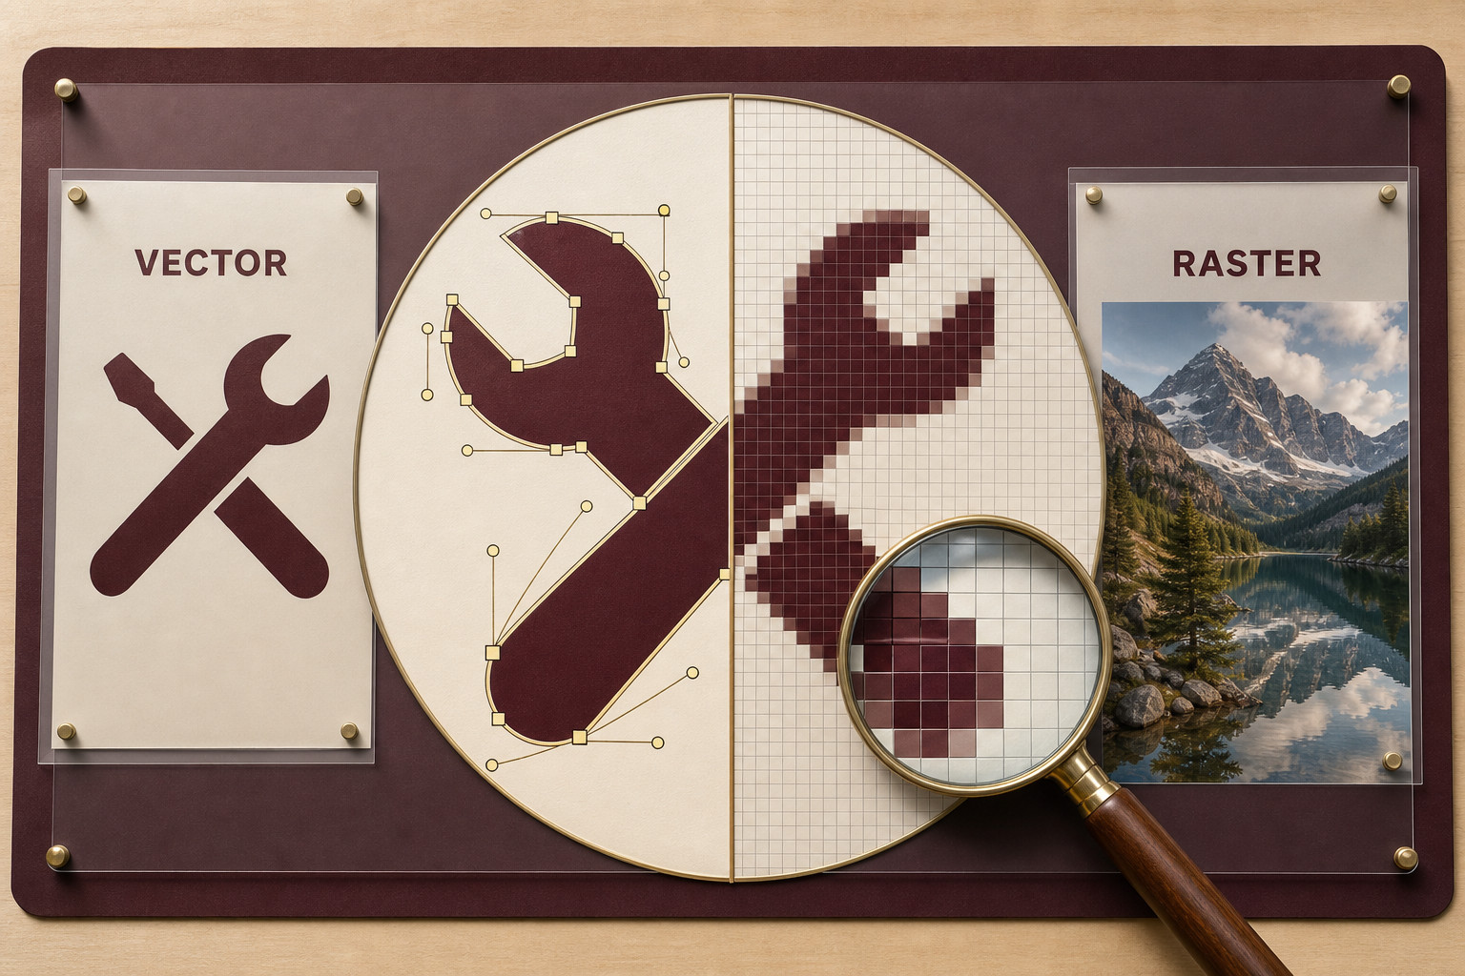
Figure 16. Source illustration of paths and pixels. The enlargement explains image structure; it does not prescribe a resolution, software interface or universal file format.

Different ways to store a graphic
A vector graphic stores mathematically defined shapes, lines and curves with their positions, outlines and fills. Scaling recalculates those shapes, making vector masters useful for simple emblems, icons, lettering and diagrams that need to appear at several sizes.
A raster image stores a grid of pixels. Photographs use this structure to preserve detailed colour, texture, tone and natural variation. Neither type is universally better. A simple symbol may suit vector construction while a permissioned photograph supplies context that a simplified symbol cannot.

Detail is not recreated by a setting
Enlarging a raster image spreads its existing detail over a larger area. Edges can become blocky or soft. Increasing a resolution number or interpolating more pixels cannot recreate genuine detail that was never captured. Begin with enough useful detail for the intended displayed or printed size.
The source comparison enlarges a shaped edge and a pixel grid to show the distinction. It is a concept illustration, not a screenshot of exact editing handles. Keep the vector master editable, check photographs at the final size and judge the output where it will be seen. A tiny screen preview alone is not a reliable quality check.

Choose a simple emblem or a photograph and justify which image structure is useful for its intended output.

MODULE 4 / VECTOR, RASTER, COLOUR AND LAYOUT

Make layout suit its destination
Colour, alignment and output choices need a reason.
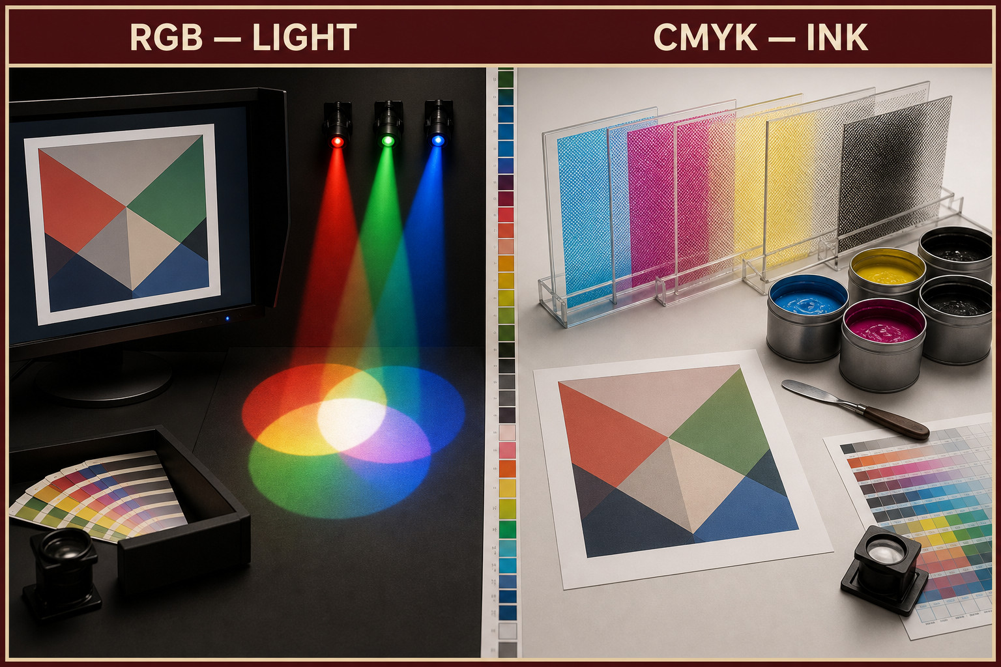
Figure 17. Source colour-workflow illustration: screen light and print inks have different roles. It is not a colour calibration target or a production setting guide.

Light and ink behave differently
RGB uses red, green and blue light and commonly suits screen destinations. CMYK uses cyan, magenta, yellow and black in print workflows. Screens emit light; ink changes the light reflected from a surface. A bright screen colour need not look identical in print.
Appearance also depends on the display, printer, ink, paper and other output conditions. The source’s hypothetical information card is for a screen, making RGB a reasoned choice. A later printed version requires its own checks rather than assuming that the first settings are universally correct.

Use a grid, then check the result
A grid organises columns, rows and repeated spaces; guides are temporary alignment references. Align related edges and group related information so the title, image and details have a clear relationship. Negative space improves separation, but excessive gaps can disconnect ideas. A deliberate exception to the grid should strengthen communication.
Choose an output by asking what the destination supports, what information must survive and whether the quality is practical for that use. Check the final file at its intended size. There is no universal file format, pixel size, DPI/PPI value, bleed, profile or compression setting here. Those decisions depend on the real destination and its requirements.

State one colour-workflow decision and one layout/output check for a screen information card.

MODULE 4 / MOTION, PORTFOLIO AND PRESENTATION

Give motion a communication job
Plan the explanation before polishing effects.

Make each change useful
Motion can reveal information, compare alternatives, explain a sequence, show a relationship or communicate change over time. Ask what the movement helps the viewer understand. If that sentence has no clear answer, simplify or remove the effect. Repeated spins and zooms can distract from the idea.
A storyboard gives each frame a goal, visible content, movement, timing, caption and purpose. Timing should let the audience notice and interpret the important change. It is not enough to draw an object without explaining why the next frame is needed.

Keep meaning available without motion
The source’s fictional organiser explanation begins with the whole, separates labelled parts, shows their relationship and returns to the complete form. A relationship frame is useful when a sudden jump leaves the viewer unsure where a part belongs. The text sequence below carries that reasoning without claiming a construction method.
Provide a readable static sequence or text summary for the essential meaning. Identify parts with names or other clear cues, not colour alone. Essential audio information also needs a visual route. Where motion is interactive, appropriate user control can help. Motion should support attention rather than forcing every viewer to experience the same effect.

SOURCE EXAMPLE FRAME | REASON FOR INCLUDING IT
1. Completed organiser | Establish the whole and the communication goal
2. Labelled separated parts | Identify base, divider and tray
3. Relationship view | Explain where the parts belong using labels and directional cues
4. Completed form again | Reconnect the parts to the whole; retain a static summary

Choose one frame transition and explain its communication job and a static alternative.

MODULE 4 / MOTION, PORTFOLIO AND PRESENTATION

Curate the evidence story
Show how a decision developed and what the evidence lets you judge.
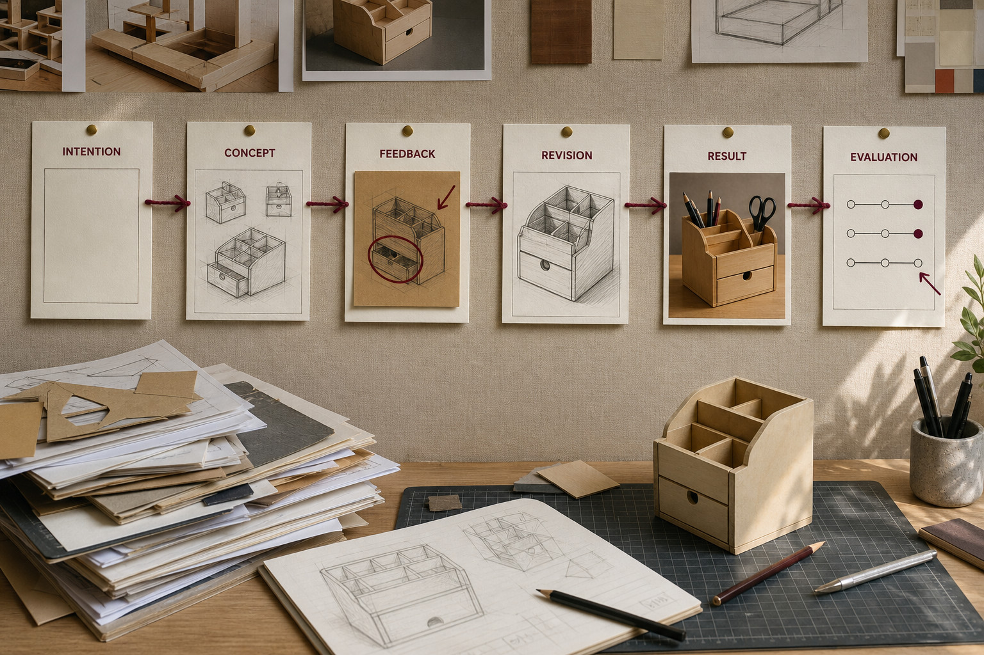
Figure 18. Source portfolio concept: selected evidence links intention, concept, feedback, revision, result and evaluation. The illustration is not a student’s submitted work or proof of measured success.

Select evidence with a job
A portfolio is curated evidence, not a dump of every saved file. Choose an intention, an important decision, useful feedback, a revision and a result. A rough sketch can be valuable when it explains a change; many nearly identical screenshots may add very little.
In the source’s written motion example, feedback showed that a sudden jump from whole to separated parts did not explain the relationship. Adding a relationship frame addressed that problem. A useful caption identifies the decision, the evidence that prompted it and the change made. It does more than name the file.

Present a supported judgement
Evaluate against a criterion using evidence, then identify a limitation or next improvement. “It looks good” is a preference. “The labels explain the part relationship, although one overlaps the object” identifies both a result and a specific weakness.
Build the presentation around context and goal, decision and evidence, then result and next improvement. Show only what helps the audience follow that story. Check the order, label readability and static route to important meaning. A polished final image alone cannot explain development, and a long sequence of unexplained files cannot substitute for a reasoned evaluation.

Write a short evidence caption that links one decision to a reason and a change.

MODULE 4 / AUDIENCE, DESIGN PRINCIPLES AND ETHICAL SOURCES

Check the module ideas
Circle one answer for each question. Then use the exact required continuation below.
1. A designer is starting a poster for a fictional youth activity. Which question should guide the first design decisions?
○ A. What does the audience need to notice, understand and do?
○ B. How many decorative graphics can fit around the main heading?
○ C. Which type style looks most unusual compared with other posters?

2. A student finds an image online, writes the creator's name beneath it and assumes it can now be used. What has the student misunderstood?
○ A. Images never need a source record if the creator is named.
○ B. Attribution alone does not create permission to reuse an image.
○ C. A sourced image can only be used if the designer changes its colours first.

3. Which statement best explains the difference between vector and raster graphics?
○ A. Vector graphics use mathematically defined shapes, while raster graphics use a grid of coloured pixels.
○ B. Vector graphics are always sharper and therefore always better than raster graphics.
○ C. Raster graphics use mathematical shapes, while vector graphics are made from fixed pixels.

4. A small blurry raster image is given a much larger resolution number in software. What is the most accurate conclusion?
○ A. The software may create extra estimated pixels, but it cannot recreate genuine image detail that was never captured.
○ B. The image will regain all missing detail because a higher number always means a sharper original image.
○ C. The image will become a vector graphic because its resolution has increased.

5. Which use of motion has the clearest communication purpose?
○ A. Moving separated parts together to show how they relate in an assembly.
○ B. Making every heading spin onto the screen because the effect looks impressive.
○ C. Adding a different movement to every object so the presentation feels more active.

6. Why should an important motion explanation also have a readable static frame sequence or text summary?
○ A. So the main meaning can still be understood without relying on motion, colour or audio alone.
○ B. So every moving frame can be included in the portfolio whether it is useful or not.
○ C. So motion can be made more decorative because the static version contains the information.

Required online continuation uses the original question numbers in each section:
Section 01: questions 2, 3, 4, 6, 7, 8, 9, 10
Section 02: questions 2, 3, 5, 6, 7, 8, 9, 10
Section 03: questions 2, 3, 4, 5, 7, 8, 9, 10

MODULE 4 / AUDIENCE, DESIGN PRINCIPLES AND ETHICAL SOURCES

Audience and source check
Test a design choice against audience needs and responsible source use.
A graphic uses an image from an unknown webpage. What should happen before it is included?
○ A. Check its source, permission or licence and whether it suits the intended audience.
○ B. Copy it because it appeared in search results.
○ C. Remove attribution so the layout looks cleaner.
Explain how one design principle and one source decision would serve a named audience.

Sketch a hierarchy for the named audience. Use original or appropriately permitted visual material.

Required online capstone: Audience, design principles and ethical sources
Required online folio: Audience, design principles and ethical sources

MODULE 4 / VECTOR, RASTER, COLOUR AND LAYOUT

Pixel or path?
Choose image structure, colour and layout evidence for a stated communication output.
A simple emblem must work at several sizes. Which starting format is usually the stronger choice?
○ A. A vector master built from paths and shapes.
○ B. A small raster image enlarged repeatedly.
○ C. A screenshot cropped from another page.
Justify a vector or raster choice for one fictional communication product.

Plan an image choice for one output and annotate why its structure suits that destination.

Required online capstone: Vector, raster, colour and layout
Required online folio: Vector, raster, colour and layout

MODULE 4 / MOTION, PORTFOLIO AND PRESENTATION

Portfolio story edit
Select and order evidence so a viewer can follow the development and final judgement.
A portfolio shows only a polished final image. Which addition most improves its design story?
○ A. Select evidence of a key decision, test and refinement, each with a purposeful caption.
○ B. Add every draft without explanation.
○ C. Fill empty space with unrelated decoration.
Write a caption that identifies one decision, its evidence and the change it caused.

Plan a short sequence showing one decision, its evidence and the change it caused.

MODULE 4 / MOTION, PORTFOLIO AND PRESENTATION

Evaluate the evidence
A student creates a short motion explanation showing how a fictional folding display changes from a flat form into its standing form. The student uses several decorative movements, identifies important stages mainly by colour, saves every development image in the portfolio, and presents only the polished final motion to the audience. Evaluate this approach and recommend how the student could improve the motion, portfolio evidence and final presentation.
1. Explain which movements should be kept, changed or removed according to their communication purpose.
2. Explain how a storyboard and a readable static sequence or text summary could make the explanation clearer and more accessible.
3. Select the portfolio evidence that would best show intention, development, feedback, revision and result.
4. Evaluate the final communication against a clear criterion, then justify one next improvement and explain how the strongest evidence could be presented to an audience.
Response: About 200–250 words

Continue your response on page 50.

CAPSTONE FROM PAGE 49 / CONTINUE YOUR RESPONSE

Presentation and evaluation evidence
Keep one selected sequence decision and its evidence-based evaluation.
The record shows how evidence was curated to communicate development and judgement.
Select a sequence, storyboard or other evidence that supports your evaluation.

Explain the sequence, motion purpose, evidence selection, limitation and next improvement.

Tell the viewer what this evidence contributes to the presentation story.

