OPTIONAL YEAR 10 METAL / STUDENT WORKBOOK + DESIGN JOURNAL

Illustrative cut-metal artwork from the course. Explore how the remaining metal carries the image; this is not the required student product.
CNC PLASMA CUTTER
From first sketch to finished metal
Think clearly. Draw accurately. Explain your decisions.
YOUR LEARNING JOURNEY Five modules connect the plasma system, precise CAD geometry, checked file handover, teacher-controlled production and evidence-based evaluation.

Name
Class / teacher

50 A4 pages · 25 double-sided sheets · Edition 1.0

FIVE MODULES / ONE EVIDENCE CHAIN

Your learning pathway
Use each three-page lesson in order: read and inspect, check your understanding, then explain your reasoning through an activity or folio record. The website adds demonstrations, enlarged figures and practice feedback.
Module | Learning focus | Pages
01 | Meet the system | 3–11
02 | Design something that can be cut | 12–20
03 | Prepare the production file | 21–29
04 | Understand teacher-controlled production | 30–38
05 | Check, improve and communicate | 39–47

Keep these references close | Page
Coordinate comparison and worked reference | 48
Large design and revision evidence fields | 49
Key words, sources and credits | 50

STUDENT ROLE Prepare and explain designs offline. Observe only from the teacher-designated position. Trained, authorised teachers operate the actual machine, including SureControl simulation.

Keep the evidence honest
Write what you actually checked. Identify files, revisions, units and image captions. Use “Not checked yet” for missing checks. Keep the editable CAD master and DXF separately. Website progress and downloaded files do not submit work automatically.
TEACHER TO CONFIRM The final project, material, practical access, installed process, tolerances, delivery schedule and any formal assessment requirements. This optional Year 10 pathway is formative until the school confirms its programme.

Open the CNC Plasma course

MODULE 1 / LESSON 1 / READ AND INSPECT
How a drawing becomes metal  A useful design passes through several kinds of work before it becomes a production job. Understand what each stage contributes so you can explain a handover, locate an error and recognise what still needs teacher review. | 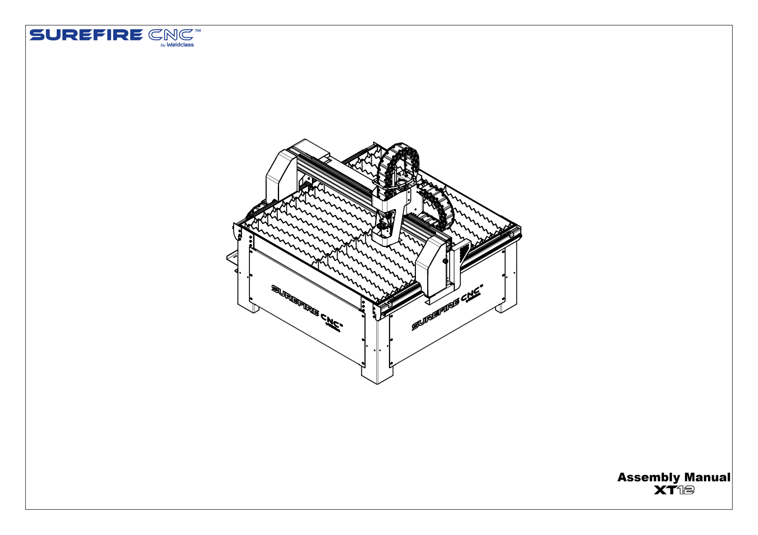  Supplier XT12 overview, Assembly Manual p. 1. It identifies the machine form; the local screened operating area and authorisation must be checked separately.

Heat removes a narrow path
Plasma is an electrically conducting gas. Electrical energy creates a concentrated plasma arc that heats and melts a narrow region of suitable metal. Gas flow removes the molten material, leaving a gap called the kerf. The finished edge therefore depends on the physical process as well as the drawing.
The material must conduct electricity, but this does not make every metal or coating suitable for school use. The trained teacher establishes approved material, thickness, torch parts and the cutting process. A supplier demonstration does not establish settings for this workshop.

The system has different jobs
The table supports the sheet and provides
torch-positioning motion. The torch directs the process; its replaceable consumables must match the approved setup. The power source supplies electrical energy. The computer runs design, preparation or control software. Mechanical extraction manages fumes, while screening, guarding and controlled access protect people. These controls work together; protective equipment does not replace them.

CAD describes; CAM prepares; control acts
Computer-aided design, or CAD, records the intended geometry and dimensions. Keep the editable native master for later changes. A DXF exchanges drawing geometry with another application; its receiving software must still check units, dimensions and contours.
Computer-aided manufacturing, or CAM, prepares toolpaths, sequence and process information. SheetCam uses a verified local configuration. A post-processor converts the prepared job into instructions for a particular control system. The supplier workflow uses TAP, but that extension does not prove the correct configuration or settings.
Computer numerical control, or CNC, uses those instructions to control machine motion and report its state. SureControl performs this role. Its manual also describes basic direct DXF import; software can combine roles, but design, preparation and physical control remain different responsibilities.

Check the right stage
A wrong hole dimension belongs in CAD review; an unsuitable route belongs in CAM review. Loading either error does not repair it. Students prepare and explain design evidence. Trained, authorised teachers operate the machine under the school procedure. A correct file or completed quiz does not authorise student operation.

MODULE 1 / CHECK YOUR UNDERSTANDING

How a drawing becomes metal
Choose one answer for each question. Revisit the reading, explain your choices and keep any corrections visible.

01 What directly describes the plasma cutting process?
○ A A rotating tool mechanically shaves the sheet.
○ B An electrical plasma arc melts a narrow path and gas removes molten metal.
○ C A cold gas jet removes metal without electrical heating.
02 What does kerf mean here?
○ A The gap produced along the cut.
○ B The overall width of the sheet.
○ C The distance between the torch and the sheet.
03 Which component supplies electrical energy for the plasma process?
○ A The DXF drawing.
○ B The extraction system.
○ C The plasma power source.
04 Why does extraction belong in the system explanation?
○ A It automatically determines the drawing’s cutting path.
○ B It manages fumes under the approved installation arrangements.
○ C It removes the need for separate screening.
05 Which record is the best starting point for a later design change?
○ A A photograph of the finished metal only.
○ B The last controller state message.
○ C The native CAD master.
06 What is the main role of a DXF in this workflow?
○ A Exchange drawing geometry between applications.
○ B Store an approved machine-motion program for the controller.
○ C Automatically establish every cutting parameter from the outline.
07 A file ends in .tap. What can you conclude from the extension alone?
○ A The school post-processor was definitely used.
○ B The material and consumables are already approved.
○ C It has the supplier workflow’s program extension, but compatibility still needs checking.
08 Which stage chiefly organises a cutting path and sequence from checked geometry?
○ A CAM preparation.
○ B CAD dimensioning.
○ C CNC control while executing the job.
09 The hole has the wrong diameter in the original drawing. Where should that error first be corrected?
○ A By scaling the entire drawing in CAM without revising the master.
○ B In the native CAD design, followed by a new checked export.
○ C By assuming SureControl will recognise the intended hole.
10 An official video shows a material being cut. What does that establish for this course?
○ A Any sheet of that material may now be cut by students.
○ B The displayed settings must fit every plasma installation.
○ C It demonstrates that example; the local material and process still need teacher approval.

MODULE 1 / APPLY AND RECORD

Match the task to the system
A: Record a square’s dimensions and a circle’s centre in the editable design.
B: Prepare the reviewed path and sequence from checked drawing geometry.
C: Execute the prepared motion instructions and report the machine state.
D: Supply the electrical energy for the plasma process.
E: Manage fumes through the approved installation arrangements.
F: Support the sheet and provide the torch-positioning motion system.
Match A–F to CAD, CAM, CNC control, power source, extraction or table. Explain two easily confused matches.
Use your supported response to explain why a DXF alone is not a ready-to-run program. Discuss feedback and keep any correction visible.
Card | A | B | C | D | E | F
Role

Explain your reasoning
Explain how a student’s proposed square-and-hole drawing becomes a teacher-reviewed production job. Identify what CAD, CAM and CNC control each contribute, and justify two checks that prevent a
plausible-looking file being mistaken for a ready-to-cut program.
BUILD YOUR RESPONSE Trace the native design, exchange file and prepared program. • Choose two checks and explain what each can establish. • Explain the student’s contribution and the trained teacher’s operating responsibility.

Check your response: Correctly distinguishes CAD, CAM and CNC control. • Connects checks to specific geometry, file or process risks. • Keeps file readiness separate from operator authorisation.

MODULE 1 / LESSON 2 / READ AND INSPECT
Your role in the workshop  You can contribute through design, file checking, explanation and evaluation. Responsible participation also means recognising when a task belongs to the trained teacher and keeping learning evidence separate from permission to operate machinery. | 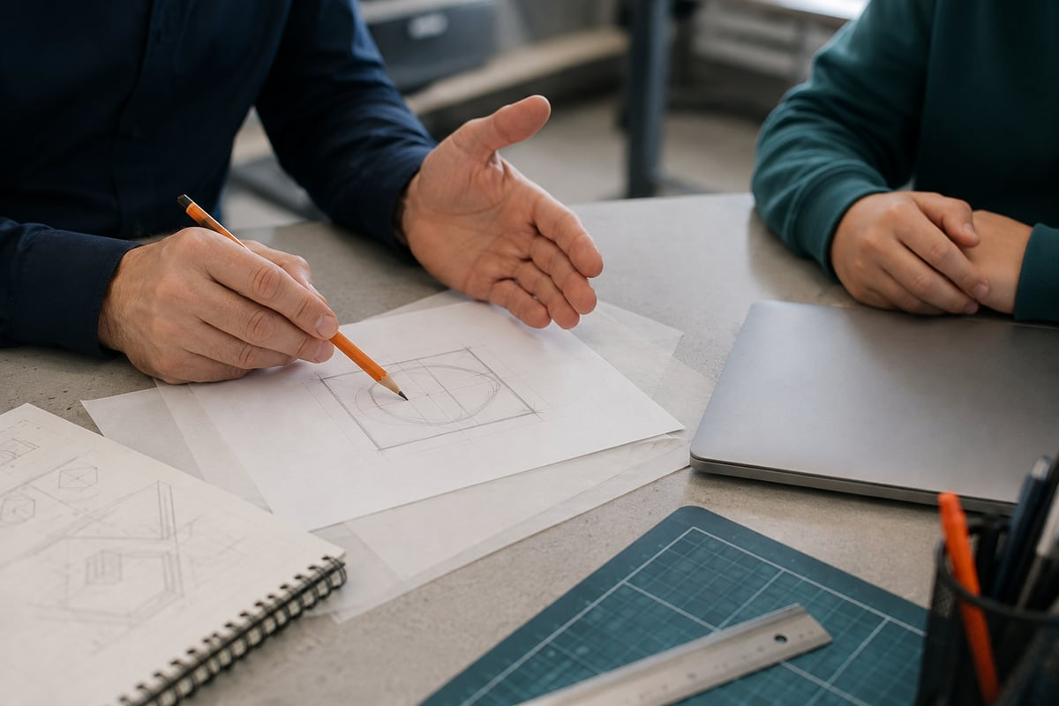  Illustrative design discussion. Students explain drawings and file decisions; the trained teacher controls machine operation.

Prepare without operating
Students may prepare designs and programs before use. Actual operation belongs to a trained, authorised teacher and cannot be delegated. This includes jogging, referencing, test firing, machine simulation and cutting. Use the teacher-approved offline design computer for geometry and proposed-path work. A connected controller can cause physical movement or activate equipment; similar-looking buttons do not establish the same risk.

Match hazards with controls
A hazard has the potential to cause harm. Plasma cutting involves arc radiation, hot metal, electrical energy, fumes, sparks and moving axes. Heavy sheets also create lifting and strain risks. Hazards can remain after the visible cut: quiet stock may be hot and an idle machine may still be energised.
Mechanical extraction manages fumes. Secure screening and welding curtains separate people from automatic cutting. Guards protect exposed drives and pinch points, and controlled access keeps people out of the operating area. Suitable protective clothing and equipment support these arrangements; they do not replace them or permit entry.

Separation includes the teacher
Students remain isolated from the operating work area. During automatic cutting, the trained teacher must also be physically separated by the securely screened area and welding curtains. Observation follows approved school viewing arrangements. Teacher-only operation does not mean the operator stands inside the enclosure while cutting.
Students may enter the shielded area only after the required electrical isolation under the school procedure. Program completion, an extinguished arc, Stop and software Offline do not establish isolation. The authorised teacher decides when access and safe handling are permitted.

A simulation may cause movement
An offline CAM preview displays a proposed path. SureControl Simul followed by Start moves the actual CNC without firing the torch.
Moving-machine hazards remain, so this is
teacher-operated. If movement is unexpected, keep clear and alert the teacher using the agreed arrangements. Do not investigate inside the enclosure or change configuration. Know emergency arrangements before observation.

Knowledge is one kind of evidence
Teacher readiness requires supplier instruction, principal approval and approved site arrangements. Configuration changes belong to qualified support and authorised setup. A journal or quiz can show understanding; it cannot certify competence, replace training or grant operating authority.

MODULE 1 / CHECK YOUR UNDERSTANDING

Your role in the workshop
Choose one answer for each question. Revisit the reading, explain your choices and keep any corrections visible.

01 Which is an appropriate student contribution described here?
○ A Jog the table after completing the CAD drawing.
○ B Reference the table while the teacher watches nearby.
○ C Prepare a dimensioned drawing on the designated offline computer.
02 Why is watching only for a bright arc an incomplete risk check?
○ A Hot stock, electrical energy and moving parts create other hazards.
○ B The arc is the only part that can cause harm.
○ C A machine without an arc is always electrically isolated.
03 How should protective equipment relate to extraction and guarding?
○ A It makes extraction optional for a short demonstration.
○ B It supports the approved controls rather than replacing them.
○ C It permits entry to any guarded area.
04 Where must the teacher be during automatic cutting?
○ A Inside the enclosure because teacher-only operation permits that.
○ B Anywhere that allows a close view of the torch.
○ C At the approved position, physically separated by the screened area and welding curtains.
05 The program has finished. What establishes whether students may enter the shielded area?
○ A The required electrical isolation and the teacher’s controlled access decision.
○ B A progress display showing 100%.
○ C The absence of visible sparks.
06 How does SureControl Simul differ from an offline CAM preview?
○ A SureControl Simul is only a moving picture.
○ B SureControl Simul moves the real machine without firing the torch.
○ C An offline CAM preview also has to move the table.
07 What is the student response to unexpected movement during observation?
○ A Change the axis direction and try the move again.
○ B Enter the enclosure to see which part is catching.
○ C Keep clear and alert the teacher through the agreed arrangements.
08 Which evidence supports teacher readiness in this section?
○ A Comprehensive supplier instruction, principal approval and approved site arrangements.
○ B A perfect score on the course questions alone.
○ C A downloaded supplier video saved on the computer.
09 Which journal statement is appropriately limited?
○ A I watched a dry run, so I can now operate independently.
○ B I explained the dry-run boundary and recorded the teacher’s demonstration.
○ C My correct DXF certifies that the machine is safe.
10 Why must the class identify the correct computer for student practice?
○ A Every computer showing the same file has identical control of the machine.
○ B Any workstation displaying a preview must be offline.
○ C An offline design workstation and a connected controller have different effects.

MODULE 1 / APPLY AND RECORD

1. Set your intention and keep a sketch reference
State your intention for the offline 100 × 100 mm square with a central Ø30 mm hole. Identify the sketch or reference and describe what it shows.
Sketch and label your idea here, or give the filename and teacher-approved storage location of your own reference. Add a caption.
Use your supported response to explain responsible preparation and observation. Your teacher confirms any different project, material or practical work.
Offline drawing intention
Sketch/reference, filename/location and caption

Explain your reasoning
Explain how a group can contribute to a proposed plasma project and observe a teacher demonstration responsibly. Compare offline preview with SureControl Simul, explain the separation and access boundaries, and distinguish learning evidence from operating authorisation.
BUILD YOUR RESPONSE Identify useful student preparation before machine use. • Compare the two kinds of preview or simulation. • Describe where students and the operator remain, and what is required before entry. • Finish by stating what a journal or quiz can and cannot prove.

Check your response: Explains that SureControl Simul causes real movement and remains teacher-only. • Includes operator screening and student access only after required electrical isolation. • Keeps learning evidence separate from operating authorisation.
Use the large evidence fields on page 49 for a sketch or selected image and caption.

MODULE 1 / LESSON 3 / READ AND INSPECT
Dimensions and datums  A diagram is useful when you know what it represents. Read its purpose, dimensions, units and reference point before comparing shapes or using a screenshot as evidence. Numerical geometry is more reliable than screen appearance. | 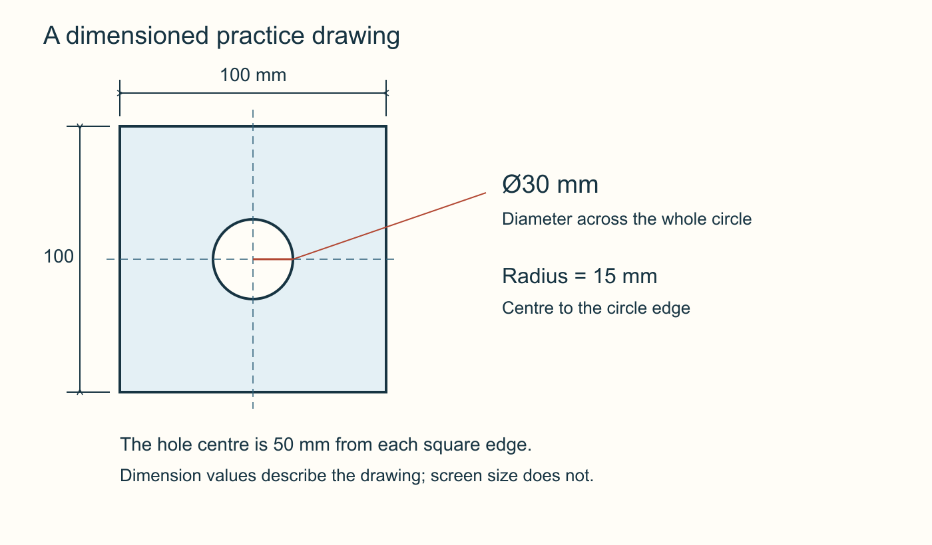  Original course practice geometry: 100 × 100 mm with a central Ø30 mm hole. Use the written dimensions; a resized illustration is not a scale drawing or an approved cutting plan.

Ask what the image can establish
An assembly view identifies parts and relationships. A dimensioned part drawing describes a shape's size and arrangement. A software screenshot records controls and a screen state. None automatically supplies the information carried by the others. Read the title, view, units and notes. Supplier images in this course are references, not records of the current school installation; their numbers may belong to another example.

Read values before appearance
A dimension states an intended measurement. Our practice units are millimetres, written mm: 100 mm equals 10 cm. A number without a known unit is incomplete. Zoom changes apparent size, not numerical geometry. At printed scale 1:2, a 100 mm feature appears 50 mm long on paper but its dimension still means 100 mm. Check actual values after import instead of measuring a screenshot or trusting its fit in a window.

Radius and diameter are different
Radius runs from a circle's centre to its edge. Diameter passes through the centre between opposite edges and equals twice the radius. R commonly identifies radius; Ø identifies diameter. Read the symbol or entry-field label. Our 100 × 100 mm teaching square has a central Ø30 mm hole, so its radius is 15 mm. Entering 30 as a radius produces a different, Ø60 mm circle. These dimensions specify neither thickness nor cutting settings.

A datum gives coordinates meaning
Coordinates locate a point relative to a reference origin or datum. Write horizontal x first, then vertical y. In the 2D Design example, the square extends from (0, 0) to (100, 100), with centre (50, 50). The centred Onshape example extends from −50 to +50 on both axes, with centre (0, 0). Both span 100 mm and have the same central Ø30 mm hole. Different datums can describe identical geometry.

Keep the references distinct
CAD coordinates describe the drawing. Machine reference relates the controller to the table; job origin positions the program relative to the work. The trained teacher deliberately relates these references. SureControl Set Origin assigns current position as job zero; Origin commands movement there. Students interpret these meanings without trying the controls. Handover evidence records units, overall size, hole size and origin layout.

MODULE 1 / CHECK YOUR UNDERSTANDING

Dimensions and datums
Choose one answer for each question. Revisit the reading, explain your choices and keep any corrections visible.

01 Which source best communicates the intended size of a particular part?
○ A An assembly picture with no part dimensions.
○ B A dimensioned part drawing with units.
○ C A controller screenshot from a different job.
02 A dimensioned 100 mm line is printed at 1:2. What length does its dimension specify?
○ A 50 mm, because that is the length on paper.
○ B 200 mm, because the scale contains a two.
○ C 100 mm.
03 Which check establishes imported size more reliably than screen appearance?
○ A Read the actual dimensions in the receiving application.
○ B Zoom until the shape fills the window.
○ C Compare how much of the monitor the shape covers.
04 What radius produces the proposed Ø30 mm hole?
○ A 30 mm.
○ B 15 mm.
○ C 60 mm.
05 A student enters 30 mm into a radius field. What diameter results?
○ A 15 mm.
○ B 30 mm.
○ C 60 mm.
06 Where is the centre of a square extending from (0, 0) to (100, 100)?
○ A (50, 50).
○ B (100, 100).
○ C (0, 100).
07 Why can the centred Onshape square and the 2D Design square have different coordinates but the same size?
○ A One application automatically changes the design’s unit scale.
○ B They use different datums while each spans 100 mm.
○ C Negative coordinates always indicate a smaller part.
08 What does the CAD origin establish by itself?
○ A The physical position of the sheet on the table.
○ B That the machine has completed referencing.
○ C The zero reference used to describe drawing coordinates.
09 Which description correctly distinguishes the SureControl labels?
○ A Set Origin assigns job zero; Origin commands movement to it.
○ B Origin assigns job zero; Set Origin only zooms the picture.
○ C Both labels only change the appearance of the drawing.
10 Why should a supplier screenshot have a clear caption?
○ A A caption makes all displayed settings suitable locally.
○ B It distinguishes a reference example from the current school installation or the student’s result.
○ C It allows the units to be omitted from the drawing.

MODULE 1 / APPLY AND RECORD

Which drawings describe the same shape?
Use coordinates and datums and radius and diameter. These are written practice records, not cutting files. Each uses millimetres.
A: Square bounds (0, 0) to (100, 100); circle centre (50, 50); diameter 30.
B: Square bounds −50 to +50 on both axes; circle centre (0, 0); radius 15.
C: Square bounds (0, 0) to (100, 100); circle centre (50, 50); radius 30.
Calculate each width, height and circle diameter. Identify equivalent records and explain the difference.
Annotate a sketch with x, y, origin, circle centre and R or Ø. Explain why this does not set the physical job origin. Label it “paper comparison — no software import tested”.
Record | Width × height | Circle diameter
A
B
C

ANNOTATE X, Y, ORIGIN AND CIRCLE SIZE

Explain your reasoning
Compare the two coordinate layouts for the proposed 100 mm square with a central Ø30 mm hole. Explain how you would establish that they represent the same geometry, and identify the information the trained teacher still needs before relating the drawing to a job on the table.
BUILD YOUR RESPONSE State the bounds and centre of each layout. • Compare overall size, hole diameter and radius rather than screen appearance. • Distinguish the drawing datum from machine reference and job origin.

Check your response: Correctly identifies equivalent 100 mm spans and central Ø30 mm holes despite different coordinates. • Explains radius/diameter and the need to inspect actual units and dimensions. • Keeps physical positioning and machine controls within the teacher’s verified procedure.

MODULE 2 / LESSON 1 / READ AND INSPECT
Draw the practice shape  A reliable sketch records what must stay true, including dimensions and relationships. Use exact information to create the square-and-hole teaching drawing, then preserve the editable master and check what happens when geometry moves between applications. | 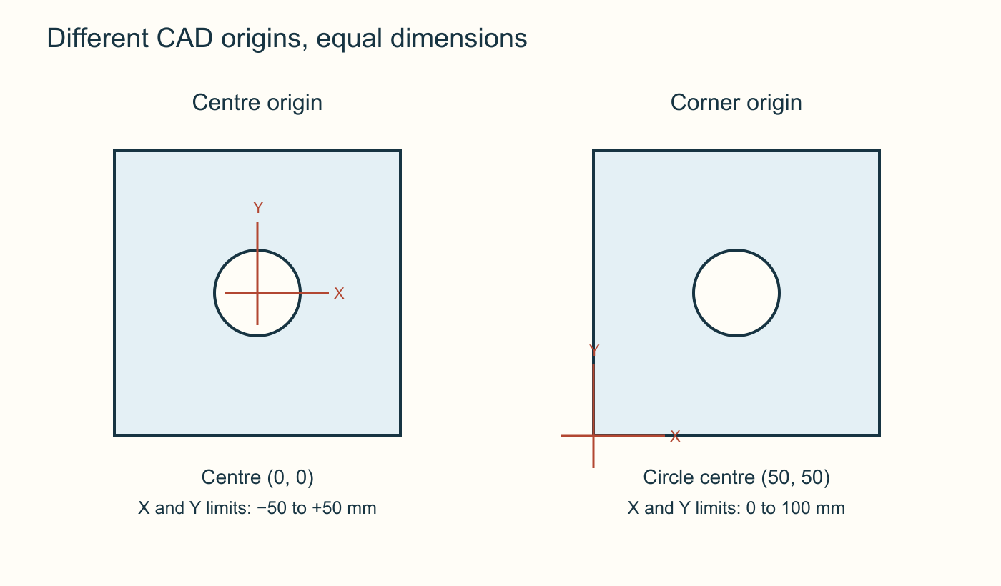  Same geometry, different CAD origins. The centred drawing spans −50 to +50 mm; the corner drawing spans 0 to 100 mm. A CAD origin does not set machine job zero.

Record the design intention
The offline example is a 100 × 100 mm square with a central Ø30 mm hole. Set millimetres and use one 2D sketch or drawing. No material thickness or 3D extrusion is needed to describe these outlines. A drawing may look correct but have a wrong size or centre; numerical and relationship checks provide evidence.

Dimensions and constraints
A dimension controls or reports a size. A geometric constraint records a relationship, such as horizontal alignment or coincident points. Coincident points occupy the same location; a centre that merely looks near the origin may still be wrong. In parametric CAD, driving dimensions control geometry while driven or reference dimensions report it. Extra dimensions can create redundant or conflicting information. Resolve existing relationships rather than ignoring errors or adding measurements indiscriminately.

The centred Onshape pathway
Choose millimetres, start a sketch on the Top plane and anchor a centre rectangle at the origin. Set width and height to 100 mm. Add a centre-point circle at the same origin and set diameter to 30 mm. Shared centre relationships establish position; dimensions establish size. The square extends from −50 to +50 mm on both axes, and the circle centre is (0, 0). Inspect dimensions and relationships before accepting the sketch. Use the Dimension tool or edit an existing dimension.

The 2D Design pathway
Use Absolute coordinate entry to draw the rectangle from (0, 0) to (100, 100). Give the
centre-and-radius circle tool radius 15 mm and centre (50, 50). Do not copy the 30 mm diameter into its radius field. Absolute coordinates use the drawing origin; relative movement uses a previous point. Confirm the entry mode and inspect object properties. This coordinate method should not be described as Onshape's parametric constraint workflow.

Preserve and check the transfer
Both pathways produce equivalent dimensions and a central hole despite different datums. Check two intended closed contours and accidental extra geometry. Preserve the Onshape document and named version, or the 2D Design DTD master. Export a separately named DXF revision and record export choices. Make later changes in the master before exporting again. Receiving-software checks are still required: a correct CAD sketch does not guarantee a correct import.

MODULE 2 / CHECK YOUR UNDERSTANDING

Draw the practice shape
Choose one answer for each question. Revisit the reading, explain your choices and keep any corrections visible.

01 Which statement best records design intention for this practice sketch?
○ A It should look roughly like the example at my current zoom.
○ B It should have the right outer size, with the hole placed approximately near the centre.
○ C It should be 100 mm square with a central Ø30 mm hole.
02 What does a coincident relationship establish?
○ A The points occupy the same location.
○ B The points are approximately the same distance apart as they appear.
○ C The points share a horizontal position but may have different vertical positions.
03 How does a driven or reference dimension differ from a driving dimension?
○ A A reference dimension directly drives geometry whenever its displayed value is edited.
○ B A reference dimension reports a measurement rather than controlling the shape in the same way.
○ C A reference dimension fixes the centre but leaves every size uncontrolled.
04 In the centred Onshape example, what keeps the square and circle aligned?
○ A Entering side lengths and a diameter without locating the centres.
○ B Making both objects appear comfortably inside the window.
○ C Anchoring their centres at the same sketch origin.
05 A sketch reports a dimension conflict. What is the appropriate next step?
○ A Inspect existing dimensions and relationships and resolve the conflict.
○ B Add the same dimension again until the message disappears.
○ C Export immediately because the outline still looks correct.
06 Which inputs create the circle in the documented 2D Design example?
○ A Radius 30 mm; centre (0, 0).
○ B Radius 15 mm; centre (50, 50).
○ C Diameter 15 mm; centre (100, 100).
07 Why check Absolute mode before entering the two rectangle corners?
○ A It makes every entry a movement from the previous point.
○ B It makes unit selection unnecessary for coordinate values.
○ C It ensures the positions are interpreted from the drawing origin rather than a previous point.
08 Which comparison establishes that the two examples describe the same intended shape?
○ A Both have 100 mm spans and a central Ø30 mm circle.
○ B Every coordinate value must match exactly.
○ C Both application windows must show the same zoom percentage.
09 What should be preserved when exporting a DXF?
○ A Only the DXF, because it replaces all design history.
○ B The native master and a traceable exported revision.
○ C Only a screenshot of the export dialog.
10 A native sketch has passed its checks. What can the student honestly record?
○ A The machine has successfully cut the design.
○ B The receiving application must import it correctly without inspection.
○ C The sketch is checked in CAD; transfer checks remain a separate task.

MODULE 2 / APPLY AND RECORD

2. Record the CAD dimensions and revision
Identify your CAD application and editable master or named document/version. Record width, height, hole diameter, centre/origin layout and the method used to check them.
Record a revision, each change and its reason. Write “Not checked yet” for missing checks. Use a labelled paper plan if CAD is unavailable; identify it as planned geometry.
Use your supported response to compare the other CAD pathway and explain why master and export records matter.
Native master / revision | Width / height | Hole / centre / datum

Explain your reasoning
Explain how you would establish and check the intended square-and-hole geometry in either Onshape or 2D Design. Compare that method with the other pathway and justify how the editable master and export record preserve the design intention.
BUILD YOUR RESPONSE State the intended dimensions and central relationship. • Describe how your chosen pathway establishes size and position. • Explain the different datum and radius/diameter entry in the other pathway. • Explain the checks and revision records needed before and after export.

Check your response: Correctly explains dimensions and the method used to locate the centre. • Compares the two coordinate layouts without treating them as different-sized parts. • Preserves the native master and separates native checks from transfer checks.
Use the large evidence fields on page 49 for a sketch or selected image and caption.

MODULE 2 / LESSON 2 / READ AND INSPECT
Geometry that can be cut  A readable file can still contain geometry that needs repair. Follow the boundaries, identify the material you intend to retain and check the transfer carefully before describing a design as ready for its next review. |   Illustrative close-up: an outline can look complete while its endpoints remain separate. Inspect the actual CAD geometry and imported file.

Trace the intended contours
A contour describes a boundary. The teaching square-and-hole drawing needs one closed outer contour and one closed inner contour. Retained material lies between them. A closed contour returns to its starting point without a gap. It may consist of one object or several joined entities: four connected lines can describe one square contour. Two contours does not mean every valid DXF contains exactly two entities.

Investigate hidden faults
Endpoints may look joined while remaining slightly apart. Line thickness or a distant view can hide the gap. Inspect endpoint relationships, geometry checks or object information. Duplicate lines occupy the same location and may create repeated or ambiguous paths. Self-intersections can make inside and outside unclear. Repair these problems in the editable design, then recheck the export. Increasing cutting power cannot repair geometry.

Check how curves travel
Circles, arcs and splines are represented differently. A spline is a flexible mathematical curve often used in logos. Receiving applications vary in supported curve types. A conversion may replace a smooth curve with short straight segments, affecting compatibility and shape. The 2D Design help describes retaining arc commands or approximating arcs with lines, and warns that transfer can leave small gaps. This does not justify converting every curve. Preserve the master, record choices and inspect a separate trial's shape and dimensions.

Decide what must stay attached
Cutting a complete O-shaped opening in a plate may isolate its centre. If that island must remain, it needs an intentional connection, such as a
teacher-reviewed bridge. If the product is a separate ring, the centre may instead be waste. Identify retained material before adding bridges. The example establishes no universal bridge width or minimum detail size.

Preserve, inspect and recheck
The course describes a complex logo DXF for inspection, not an approved cutting file. Use a teacher-supplied copy if this example is provided. Its units are unset and it contains grouped geometry and many splines. Successful opening does not establish intended size or sound boundaries. Preserve the original and work on a labelled copy. Establish size from reliable design evidence, inspect retained regions and investigate gaps, duplicates, crossings and unsupported curves. Make one traceable revision and re-import it. Stop the handover while size or boundary remains uncertain.

MODULE 2 / CHECK YOUR UNDERSTANDING

Geometry that can be cut
Choose one answer for each question. Revisit the reading, explain your choices and keep any corrections visible.

01 What are the intended contours in the proposed square-and-hole drawing?
○ A One closed outer square and one closed inner circle.
○ B One open square and a circle that reaches the square edge.
○ C Exactly two DXF entities regardless of how they join.
02 A square is exported as four lines whose endpoints form a closed loop. How should it be judged?
○ A It is invalid because every square must be one entity.
○ B It is valid for cutting automatically because it has four lines.
○ C It can represent one closed contour, subject to the remaining checks.
03 Why can two apparently touching endpoints still need inspection?
○ A Every pair of touching lines is always duplicated.
○ B A small actual gap may be hidden by the display.
○ C Zooming out permanently closes any small gap.
04 What is a likely concern with duplicate lines?
○ A Repeated or ambiguous path information.
○ B They guarantee a stronger finished edge.
○ C They automatically correct imported units.
05 An outline crosses itself accidentally. What should be investigated?
○ A Whether a different zoom makes the crossing less noticeable.
○ B Whether more current will make the intended region clearer.
○ C The intended contour and retained material at the intersection.
06 What is the sound approach when a receiving program handles a spline poorly?
○ A Convert every curve in the only master without recording changes.
○ B Keep the master, make a recorded trial conversion or export change, and inspect the result.
○ C Assume any shape shown after import is close enough.
07 Why might an O-shaped opening need a bridge in a larger plate?
○ A Its retained centre would otherwise be isolated from the surrounding plate.
○ B Every circular path must always include a bridge.
○ C Every closed path needs a bridge to count as geometrically closed.
08 When would the centre of the same ring shape reasonably be waste?
○ A Whenever an inner circle exists in a drawing.
○ B Whenever the letter is exported as one object.
○ C When the intended product is the separate metal ring itself.
09 What does successfully opening the supplied unitless logo DXF establish?
○ A That its physical size and all boundaries are approved.
○ B That the application could read the file; size and contour checks are still needed.
○ C That the school controller will cut it correctly.
10 Which is a defensible first step in a repair exercise?
○ A Preserve the original and establish intended size before making a labelled working revision.
○ B Resize the logo until it looks attractive on the screen.
○ C Rename the logo file to .tap and load it.

MODULE 2 / APPLY AND RECORD

Find what needs checking in an outline
Read contours, geometric faults and retained islands. Sort these written inspection cards; they are examples, not claimed findings from a school cut.
A: Four joined lines form one closed square; a separate closed circle defines its central hole.
B: Two intended boundary endpoints remain apart when inspected closely.
C: Two identical lines occupy the same part of an outline.
D: A logo opens, but its unit information is unset and no reliable intended size is available.
E: The centre of an O-shaped opening is meant to stay in the backing plate, but has no connection to it.
Classify A–E: contour requirement met; geometry fault; missing size evidence; retained-material decision. Give reasons.
Sketch a B or C repair, keeping original and revision distinguishable. State what to preserve and recheck after export, and why A alone does not approve cutting.
A–E category and reason
B or C repair: preserve, correct, recheck
What card A does not establish

Use page 49 for the before-and-after repair sketch.

Explain your reasoning
Evaluate a proposed handoff of a logo that opens successfully but has unset units, several complex curves and a letter centre that may become detached. Explain a source-preserving inspection and revision plan, and justify why successful opening is insufficient evidence of readiness.
BUILD YOUR RESPONSE Establish intended size and distinguish a readable file from checked geometry. • Identify retained material and inspect contour closure, duplicates and intersections. • Explain how to investigate curve compatibility without losing the master. • Describe what to recheck and when the handoff must stop.

Check your response: Uses specific geometry and unit checks rather than visual appearance alone. • Explains the
retained-island issue in terms of design intention. • Preserves a traceable source and rechecks revised exports. • Does not infer cutting approval from successful import.

MODULE 2 / LESSON 3 / READ AND INSPECT
Design with retained material  A useful design responds to someone’s purpose and can be checked against clear criteria. Develop an idea, examine what the evidence supports, then make a justified revision. An attractive outline is only the beginning. |   Illustrative retained centre. Follow a continuous metal connection from the middle to the surrounding plate; bridge sizes still need process review.

Start with the user and purpose
Identify who would use the proposed product, what it should help them do and where it belongs. An equipment label might help a group recognise its gear. This is a design-discussion example, not an approved manufacturing task. The square-and-hole drawing is also practice geometry; completing it does not establish the final product. Give each feature a useful reason.

Choose criteria you can check
Replace ‘looks good’ with an observable outcome, such as whether an intended viewer recognises the message from an agreed position. Functional criteria concern use; appearance concerns shape, spacing and proportion; production criteria concern preparing and making the design. These can compete. More detail may strengthen identity but create small features that are difficult to produce. State the evidence you would collect for each criterion.

Keep feasibility honest
Feasibility depends on real constraints, including the confirmed material, stock thickness, process and feature limits. Inspect contours, holes, narrow connections and isolated centres. A preview cannot prove a bridge’s strength or a physical edge’s quality. Seek teacher confirmation where the actual process matters. Do not invent a universal bridge width or choose a machine setting to compensate for uncertainty in the design.

Revise one decision for a reason
Compare alternatives against the same criteria. A detailed label might contain disconnected letter centres; a simpler layout might be easier to recognise. Use that observation to explain a revision, such as rearranging lettering and deliberately connecting retained areas. Preserve the earlier version, update the editable master, identify the new revision and repeat relevant checks. Iteration is a cycle of evidence and improvement, not simply making something different.

State what your evidence establishes
Connect the intention, criterion, comparison, change and result in your design record. Caption a useful sketch or CAD view with what it demonstrates. A checked digital dimension supports a digital claim; it does not prove that a part has been cut successfully. Identify unresolved requirements and a justified next improvement. Any production observation must describe what actually happened, with machine operation attributed to the trained teacher.

MODULE 2 / CHECK YOUR UNDERSTANDING

Design with retained material
Choose one answer for each question. Revisit the reading, explain your choices and keep any corrections visible.

01 Which starting point gives the clearest basis for a design decision?
○ A Choose as many decorative features as possible.
○ B State who will use the product and what it should help them do.
○ C Copy the most complicated outline available.
02 How should the equipment-label example be understood?
○ A It is an example for design discussion, not approval to manufacture it.
○ B It establishes the class’s final material and cutting settings.
○ C It means the practice square must be the final product.
03 Which criterion is most directly checkable?
○ A The design should be excellent.
○ B The lettering should have a professional feel.
○ C The intended viewer can recognise the message from the agreed viewing position.
04 Why might two useful criteria conflict?
○ A Criteria must always have exactly the same meaning.
○ B Extra visual detail may strengthen identity but create difficult small features.
○ C A conflict proves the product has already failed physically.
05 What does feasibility concern here?
○ A Whether the proposal can be achieved within its actual requirements and constraints.
○ B Whether the proposal looks attractive before its material and process are known.
○ C Whether a file opens without an error message.
06 A design includes a narrow connection of uncertain suitability. What is the appropriate conclusion?
○ A The preview proves that the connection will be strong enough.
○ B A similar-looking connection in a supplier image must work for this proposal.
○ C It needs review against the confirmed material and process requirements.
07 Which action is a useful iteration?
○ A Change several features at random and discard the previous file.
○ B Revise the lettering after a readability review, preserve the earlier version and check again.
○ C Keep the same drawing but rename it
final-approved.
08 Why use paper or on-screen review before cutting a concept?
○ A It can reveal design issues early and reduce avoidable trial waste.
○ B It replaces every physical and process check.
○ C It authorises students to test the design on the table.
09 Which claim is supported by a CAD measurement record alone?
○ A The finished metal part has the measured CAD dimensions.
○ B The machine’s extraction and guarding have passed inspection.
○ C The stated drawing dimensions were checked in CAD.
10 What makes a final improvement proposal useful?
○ A It promises that no further review will be needed.
○ B It identifies a specific change, why it is needed and how it will be evaluated.
○ C It repeats that the design looks good.

MODULE 2 / APPLY AND RECORD

Choose a revision for a clear reason
Use two criteria: the message should be recognisable from the agreed viewing position, and the intended retained areas should remain connected. In this hypothetical review, Concept A’s crowded lettering requires explanation before the viewer recognises it and contains unconnected letter centres. Concept B is recognised without prompting and includes proposed connections, but their suitability for the eventual material and process has not been reviewed.
This is a hypothetical equipment-label review. Compare A and B against both criteria; mark missing evidence.
Choose a concept, justify one revision/check and explain how its result will be judged. Preserve the earlier version and identify the new master/export. Development choice is not manufacturing approval.
Two criteria: A/B evidence and uncertainty
Selected concept and reason
Next revision/check and version record

Explain your reasoning
Justify a revision to the proposed equipment-label concept using its intended user, purpose and two checkable criteria. Explain the evidence you would collect, the requirements that need confirmation before production, and how you would avoid claiming a physical result from digital evidence alone.
BUILD YOUR RESPONSE State the user and useful purpose of the proposed label. • Choose two observable criteria and compare the concept against them. • Explain one revision and the evidence needed to judge it. • Separate confirmed digital checks from unresolved production or physical-result claims.

Check your response: Connects the proposed revision to purpose and observable criteria. • Identifies a realistic evidence method and relevant constraints. • Preserves traceable iteration and distinguishes digital from physical evidence. • Keeps manufacturing approval and operation within the teacher’s process.

MODULE 3 / LESSON 1 / READ AND INSPECT
Check the DXF handover  An exported drawing is a handover between programs. Keep the editable master, export the intended geometry and reopen the exchange copy independently. A file that opens successfully can still have the wrong size, shape or revision. | 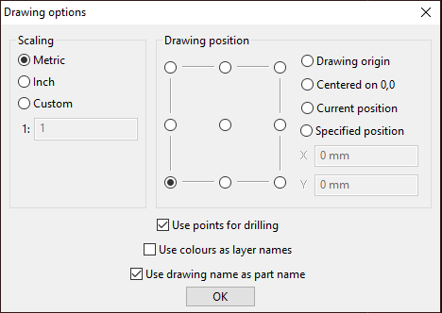  Supplier SheetCam import example, SureControl manual p. 15. Recognise the unit and position choices, then verify the imported dimensions independently.

Keep the master and the exchange copy
The master preserves the design information needed for revision. In Onshape this is the document and named version; in 2D Design it is the native .dtd file. DXF transfers drawing information to another program, but may not preserve every feature identically. Keep both records. Renaming a file extension does not convert its contents, and a saved picture is not proof of transferred geometry.

Export the intended geometry
The practice exercise is a proposed 100 × 100 mm square with a central Ø30 mm hole. In the documented Onshape route, export the whole sketch rather than one edge. In 2D Design, File > Export File > DXF File creates the exchange copy; native Save preserves the master. Its documented curve options retain arcs or approximate them with short lines. Follow the teacher’s tested pathway; do not invent a DXF release selector.

Reopen, measure and record units
Reopen the DXF separately in the offline receiving program. Check units, width, height, hole size and position against the drawing record. Zoom-to-fit can make different sizes look similar. In the documented 2D Design round trip, Interpret units and Position preserves deliberate interpretation; Fit to media may rescale the drawing. The expected square width and height are 100 mm. Its Ø30 mm hole has a 15 mm radius: compare the quantity as well as the number.

Compare geometry, not origin labels
A centred square spanning −50 to +50 mm and a corner-based square spanning 0 to 100 mm both have a 100 mm width. Their hole-centre coordinates differ even when each hole is central. Check bounds, dimensions and position relationships before changing a correct drawing. Neither CAD origin establishes the machine’s physical job zero, which belongs to the trained operator’s later process.

Close the handover record
Inspect closed contours, duplicate lines, stray geometry and annotations that might become unwanted cutting lines. If a check fails, correct the master and make a new identified export. Pairing a v2 master with a v1 DXF leaves the handover incomplete. Record the application, revision, units, export choices and completed checks, including anything unverified. This evidence supports the next CAM stage; it does not approve a machine program.

MODULE 3 / CHECK YOUR UNDERSTANDING

Check the DXF handover
Choose one answer for each question. Revisit the reading, explain your choices and keep any corrections visible.

01 Why retain the native CAD master after exporting DXF?
○ A It preserves the editable design information.
○ B It automatically proves the DXF imported correctly.
○ C It contains the machine-specific cutting program.
02 Which record is the editable master in the Onshape pathway?
○ A A screenshot of the finished sketch.
○ B The Onshape document and named version.
○ C Any DXF downloaded most recently.
03 What should the documented Onshape export include?
○ A Only the outermost edge.
○ B Only the visible dimension labels.
○ C The whole intended sketch.
04 Which 2D Design route creates the documented exchange copy?
○ A File > Export File, then DXF File.
○ B File > Save, then rename .dtd to .dxf.
○ C Select a DXF release selector assumed from LibreCAD.
05 Why is a drawing that fits the window not yet size-checked?
○ A A visible outline proves the units are millimetres.
○ B Zooming or fitting can hide a size difference.
○ C Every receiving program uses the same zoom.
06 The imported circle reports a radius of 15 mm. What does this mean for the 30 mm diameter practice hole?
○ A The hole is half the required diameter.
○ B The hole must be enlarged by changing kerf.
○ C The radius agrees with the intended diameter.
07 Which import choice needs particular care when preserving intended size?
○ A Fit to media.
○ B Recording the displayed unit.
○ C Opening a separate drawing.
08 Two squares have bounds −50 to +50 and 0 to 100 mm. What can be concluded?
○ A Their physical table origins are already identical.
○ B Both span 100 mm despite different coordinate origins.
○ C The second square is twice as wide.
09 A master is v2 but its exchange copy is v1. What should happen?
○ A Use whichever filename looks familiar.
○ B Rename the older DXF to v2 without reopening it.
○ C Export and check an identified copy of the revised master.
10 Which handoff statement is most useful?
○ A The revision, units, export choices and completed checks are recorded.
○ B It looked right, so no further record is needed.
○ C The DXF opened, so it is approved for machine operation.

MODULE 3 / APPLY AND RECORD

Does the drawing keep its size?
Use the training square in the CAD and file guide: proposed practice geometry only, 100 mm wide × 100 mm high with one central 30 mm diameter hole. These dimensions do not approve a material, thickness or physical project.
On paper, compare the course’s centred and corner-origin layouts. Calculate widths, heights and hole dimensions. Record expected values, calculated values, units, centre and extra geometry.
Identify the source/master and revision, or label a paper comparison. Decide the next check or correction. Write “paper comparison — no software import tested”. If you actually test an offline import, use scale 1, avoid Fit to media and record the application and actual measurements.
Drawing layout | What the evidence supports | What remains unchecked
Centred
Corner

Explain your reasoning
Explain how you would check and hand over a revised training-square DXF when its coordinate origin differs from the example. Justify the checks that matter and state what your evidence cannot prove.
BUILD YOUR RESPONSE Identify the editable master and the exchange revision. • Explain how you will compare dimensions, units and circle radius/diameter. • Separate a changed coordinate origin from changed size. • State the next action for a failed check and the limits of offline evidence.

Check your response: Uses dimensions and units to justify the comparison rather than relying on appearance. • Keeps the revision traceable and distinguishes CAD evidence from machine approval.

MODULE 3 / LESSON 2 / READ AND INSPECT
From outline to toolpath  CAD describes the intended shape. CAM plans how a machine could make it. SheetCam combines checked drawing geometry with an operation, tool definition and movement sequence. The resulting toolpath requires its own review before compatible output is prepared. | 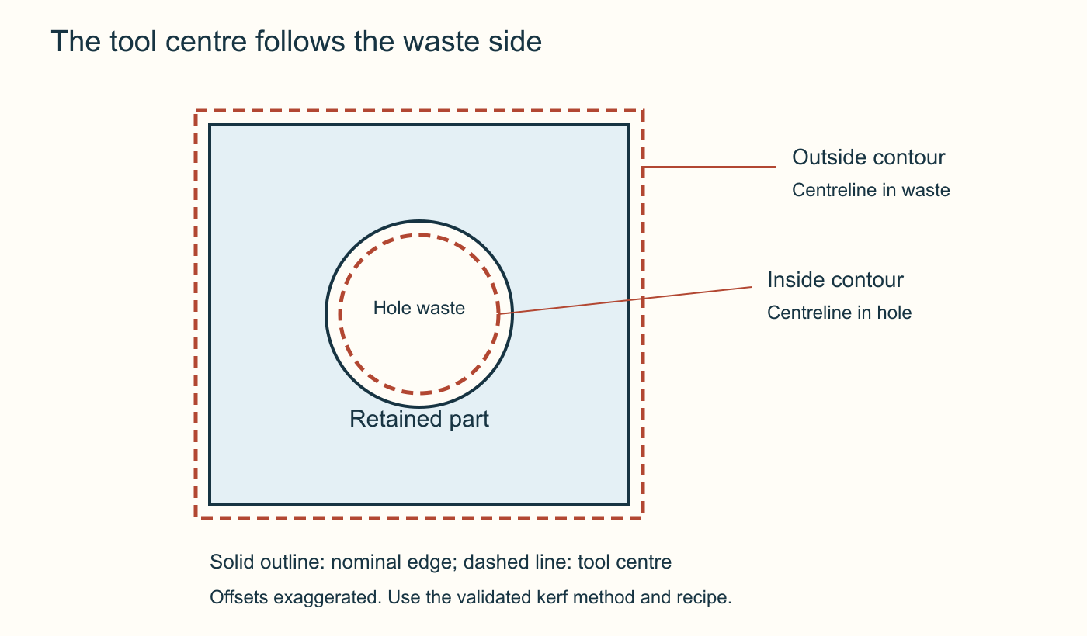  Original course kerf concept. The tool centreline lies on the waste side of each edge. Offsets are exaggerated; this diagram prescribes no cutting value.

Check the transfer into CAM
Importing is another checking boundary, even when the DXF already passed a CAD round trip. Compare units, overall dimensions, hole size and position with the drawing record. Inspect the entities assigned to each operation: a layer name does not prove its contents. Duplicate outlines or forgotten construction lines may become unwanted work. Correct the master where needed, then repeat the identified export and import.

Put the path on the waste side
Plasma removes a strip of metal called the kerf. A torch centreline following the finished boundary exactly would remove some intended material. For an outside profile, the waste lies outside the retained part; for a hole it lies inside the opening. The supplier’s Outside Offset example can include both when closed geometry is interpreted correctly. Inspect each resulting contour. An open path has no enclosed inside or outside and needs separate consideration.

Read the complete route
A lead-in approaches the contour and a lead-out leaves it. These paths require space beyond the nominal edge. Follow cutting paths, rapid moves, directions and start points in the preview. Internal features are normally cut before the surrounding outside profile so they retain support. Examine the hole and outside contour separately, then their sequence together. A correct-looking finished outline does not prove the movements around it are suitable.

Keep settings connected to conditions
The operation uses values such as feed rate, pierce delay and heights. Their suitability depends on confirmed material, thickness, torch, consumables and cutting system. Supplier screenshot numbers illustrate a dialogue; they are not school settings to copy. Students can inspect the prepared route offline. SheetCam’s on-screen simulation does not test physical clearance, material condition or machine readiness. SureControl Simul is different: starting it causes real machine movement and belongs to the trained teacher.

Prepare an identifiable, compatible output
A postprocessor translates CAM work into the required machine-instruction format. The supplier pathway describes TAP output using a SureControl postprocessor. A .tap extension alone cannot establish compatibility with the installed machine. Retain the CAM job and revision, identify the selected postprocessor and record the preview checks. The authorised teacher verifies compatibility and production arrangements before operation; a successful offline preview is evidence about the prepared route only.

MODULE 3 / CHECK YOUR UNDERSTANDING

From outline to toolpath
Choose one answer for each question. Revisit the reading, explain your choices and keep any corrections visible.

01 What does CAM add to a checked CAD outline?
○ A Only a different colour for the same drawing.
○ B A planned toolpath, operation and cutting sequence.
○ C A guarantee that the installed machine is safe.
02 A DXF passed a CAD round-trip. What should happen after import into SheetCam?
○ A Accept the size because it opened successfully.
○ B Match the supplier screenshot’s numerical recipe.
○ C Check units, dimensions and geometry again.
03 Why inspect the contents of a selected layer?
○ A The layer may include unintended or duplicate geometry.
○ B A descriptive layer name automatically closes all contours.
○ C Layers replace the need to retain the CAD master.
04 Why is the torch path offset from a finished contour?
○ A Every contour must move towards the part’s centre.
○ B The kerf removes material on both sides of the path.
○ C Offsetting changes the drawing’s units automatically.
05 For the practice square and hole, where is the waste relative to each contour?
○ A Inside both contours.
○ B Outside both contours.
○ C Outside the square and inside the hole.
06 The operation is named Outside Offset. What is the best review?
○ A Inspect the generated path around every closed contour.
○ B Assume every contour must now be correct.
○ C Delete the hole because outside operations cannot include it.
07 Why can a part fit on the sheet while its planned operation still needs review?
○ A A correctly sized part chooses safe leads automatically.
○ B Lead-ins, lead-outs and travel can extend beyond the outline.
○ C Only the outline affects the space the tool will use.
08 Why are internal features normally cut before the outside profile?
○ A It means the hole dimensions no longer need checking.
○ B It lets the operator use any pierce settings.
○ C The surrounding material still supports the part.
09 Which statement correctly distinguishes the two simulations?
○ A SheetCam previews offline; SureControl Simul can move the real machine.
○ B Both are always motion-free animations.
○ C SheetCam’s preview proves the actual sheet has no obstruction.
10 Why is a .tap filename insufficient to confirm compatibility?
○ A Any CAM file becomes compatible when renamed .tap.
○ B The postprocessor and installed system must also match.
○ C The extension automatically selects the school’s machine settings.

MODULE 3 / APPLY AND RECORD

Trace the file handoff
Use the CAD handoff reference and TAP handoff stage. This is a written trace; do not generate machine code.
Put these records into the documented order: TAP machine program; editable CAD master; checked DXF exchange copy; editable CAM job with reviewed toolpaths.
Review this practice-only handoff note: “The master is now v2. The package still contains the DXF from v1. Please use the most recently modified file.” Identify why that instruction is unreliable and write a precise correction.
For each record, state purpose, how the next is produced and its handover check. Correct the stale-revision instruction.
Write the revision, units, export choices, completed checks and pending teacher checks. Use your supported response for the CAM route review. Keep private links and licence information out; create no machine code.
Ordered file trace: purpose → next action/check
Stale revision and corrected instruction
Handover record with pending checks

Explain your reasoning
Explain how you would review a CAM preview of the practice square and hole before handing it to the authorised teacher. Justify why a correct-looking outline and successful preview are insufficient for production approval.
BUILD YOUR RESPONSE Describe the import checks against the design record. • Explain waste sides, kerf offset and the paths you would inspect. • Explain sequence, lead space and the limits of offline preview. • Identify what the teacher must verify about output compatibility.

Check your response: Connects geometry, offsets and sequence to the intended part. • Distinguishes offline evidence from physical-machine and compatibility approval.

MODULE 3 / LESSON 3 / READ AND INSPECT
A traceable file handover  A useful production handover connects the design, arrangement, file revision and checks. Nesting can reduce material waste, but a tightly packed picture is insufficient. Another person must be able to identify the intended job and its unresolved requirements. | 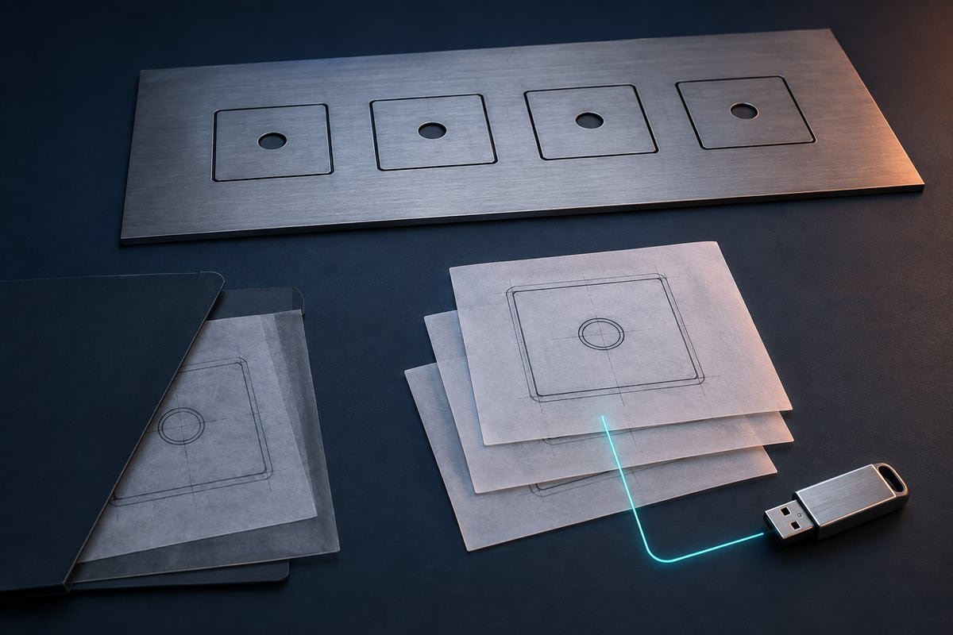  Illustrative file handover. Keep the editable master, exchange file and any reviewed production output connected by clear revision records.

Arrange deliberately
Nesting positions parts within the available sheet area. Moving changes position, rotating changes orientation and copying changes quantity; these actions should preserve intended dimensions. Scaling changes size and must not be used casually to force a fit. Overlapping copies may look like one outline while still creating duplicate work. Compare arrangements offline using the teacher’s brief, with actual sheet dimensions and usable area recorded for production review.

Allow for the whole route
Two part outlines can fit while their leads, kerf offsets and travel need additional space. A
small-looking gap is not evidence of suitable spacing, and the course provides no universal gap value. Review overlaps, unwanted copies, approach paths and rapid moves after arranging the nest. Examine the sequence within and between parts. Internal features are normally completed while the surrounding outside profile still retains support. The teacher confirms process-dependent spacing and the actual layout.

Keep file stages connected
The editable CAD master holds the revisable design; DXF exchanges checked geometry; the CAM job retains arrangements and operations; postprocessing produces machine instructions, described as TAP in the supplier pathway. These records are related but not interchangeable. Changing a hole position in the master may make the old DXF, CAM job and output stale. Renaming an old file does not regenerate it, and keeping only the final output loses the decisions behind it.

Identify the actual revision
Use the agreed naming and storage convention so another person can recognise project, revision and stage. A label such as practice-square-v02 distinguishes an example revision; it does not certify cutting readiness. Match names to contents and records. Retain superseded versions clearly marked for reference. Record applications, units and export choices, plus CAM changes such as quantity or rotation. Avoid descriptions such as ‘the good one’, which require someone else to guess.

Hand over evidence and questions
List intended dimensions, quantity, revision, completed checks, preview observations and the selected postprocessor where that stage exists. State anything unverified. ‘Preview reviewed offline’ is an accurate digital claim; ‘machine tested’ requires a separate authorised test that actually happened. The teacher matches the output to installed software, machine, material and procedure. Resolve missing dimensions or uncertain revisions before proceeding. A familiar filename, TAP extension or tidy nest cannot establish that match.

MODULE 3 / CHECK YOUR UNDERSTANDING

A traceable file handover
Choose one answer for each question. Revisit the reading, explain your choices and keep any corrections visible.

01 What is the main purpose of nesting?
○ A Rescale every part until it fits.
○ B Arrange the required parts while allowing a workable route.
○ C Make every visible gap as small as possible.
02 What should happen when a part is copied in a nest?
○ A Assume overlapping copies count as a single cut.
○ B Treat copying as the same as moving the original.
○ C Check that the added instance matches the required quantity.
03 A part is too large for the available space. Why not simply shrink it?
○ A Scaling changes its dimensions and needs an intentional design decision.
○ B Scaling only moves the drawing origin.
○ C A smaller screen image always uses the original dimensions.
04 Two outlines fit side by side. What still needs inspection?
○ A Nothing, because outline fit proves path clearance.
○ B Leads, offsets, travel and spacing in the complete route.
○ C Only the combined colour of the shapes.
05 Which spacing value should students assume for every nest?
○ A The smallest gap visible at the current zoom.
○ B Whatever gap appears in a supplier screenshot.
○ C No universal value; use the confirmed
teacher-reviewed process.
06 Which record retains arrangement and operation work for revision?
○ A The CAM job.
○ B Only the original DXF.
○ C Only a screenshot of the nest.
07 A hole is moved in the CAD master. What follows?
○ A Keep all downstream files because the outside shape is unchanged.
○ B Review and update affected exports, CAM work and output.
○ C Rename the old TAP file with the new revision number.
08 Which handoff label is most useful?
○ A The good one.
○ B Ready-to-cut, because that guarantees approval.
○ C A project, revision and stage label consistent with its contents.
09 What can a student honestly record after reviewing only an offline preview?
○ A The offline preview was reviewed, with observations listed.
○ B The machine has been tested successfully.
○ C The physical operating area is clear.
10 A tidy nest has an uncertain revision. What is the useful next step?
○ A Proceed because tidy nesting proves compatibility.
○ B Resolve which source and output revision belong together.
○ C Use whichever file has the shortest name.

MODULE 3 / APPLY AND RECORD

3. Record the DXF handoff checks
Identify the DXF revision, units and export choices. Record actual receiving software and checks for size, hole, contours and extra geometry, or write “Not tested yet”.
State the handover status and next action: teacher review, correct/re-export or complete a missing check. Use your supported response to address the proposed nest, file-revision problem and pending production checks. This record does not authorise TAP output or operation.
DXF revision, units and export choices
Receiving checks and actual results, or Not tested yet
Handover status and next action

Explain your reasoning
Evaluate a proposed handoff containing a tidy nest, two differently dated DXFs and a file named
ready-to-cut.tap, but no revision record. Explain how you would make the handoff useful without claiming machine approval.
BUILD YOUR RESPONSE Identify what the tidy layout does and does not demonstrate. • Trace the files back to the intended editable master and revision. • Explain the layout, quantity and route checks that belong in the record. • State unresolved checks for the authorised teacher.

Check your response: Justifies a clear relationship between design revision, exchange geometry, CAM work and output. • Distinguishes completed offline checks from production compatibility and authorisation.
Use the large evidence fields on page 49 for a sketch or selected image and caption.

MODULE 4 / LESSON 1 / READ AND INSPECT

Read the controller screen
SCREEN KEY / LOCATE AND INTERPRET  Upper right — X, Y, Volts, Feed Rate and FRO % describe position or cutting information.  Lower left options — THC, Touch, Laser, Simul, Kerf and Online request functions.  Signals below the options — Touch, Collision, Arc Ok and Limit report inputs.  Bottom commands — Start, Stop, Origin, Set Origin, Load, Reference and Connect.  Status above the commands — DISCONNECTED describes the displayed connection state. | 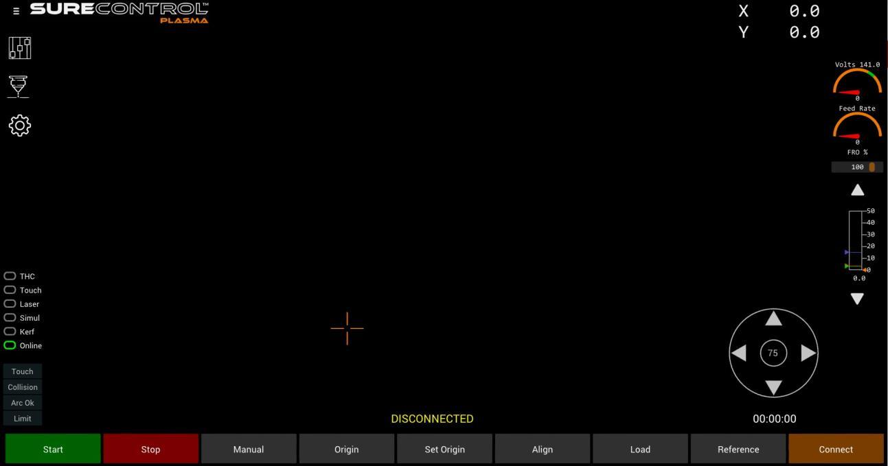  Whole-screen reference from the SureControl V2.1 manual, p. 25. The key at left enlarges the labels. This supplier example does not establish the school’s installed configuration.
Reading a controller screen helps you interpret a teacher demonstration. It does not authorise clicking controls. Students study supplied screenshots and offline activities; a trained, authorised teacher operates the installed machine under its approved procedure.

Separate information from action
The supplier’s SureControl V2.1 screen groups the job view, coordinates, cutting information, status indicators and commands. Ask whether each item is a drawing, value, selected option, machine state or action. A familiar job outline does not prove the correct revision, size or placement, nor the suitability of the actual sheet. The teacher matches the documented screen to the installed version and checks the job record separately.

Give numbers their meaning
Coordinates report position within the controller’s coordinate system; interpreting them requires the known reference and job origin. Read labels and units beside feed information, feed-rate override and arc voltage. An override percentage is relative to a feed value, not itself a speed in millimetres per second. A number’s location or colour cannot establish what quantity it represents or whether it is suitable for production.

A state is not permission
Documented states include Disconnected, Offline, Not Referenced, Idle, Jogging and Executing. They describe controller conditions, not completion of every setup check. Connected or Online does not mean the whole job is approved; Idle does not mean electrical isolation; Executing indicates an active operation. A job can be loaded while origin or other checks remain unresolved. Describe the visible state accurately instead of translating a reassuring message into ‘safe to start’.

Distinguish signals and selections
Touch, Collision, Arc OK and Limit indicators report received signals. Options including Touch, THC, Laser, Simul, Kerf and Online request or enable functions. A selected Touch option does not prove that sensing contact worked; the teacher checks the expected signal through the approved sequence. One green indicator cannot establish that every other condition is satisfactory. Students record observations and questions rather than change sensors or configuration.

Know which controls move the machine
Set Origin assigns the current position as job zero; Origin commands movement to that position. Reference and jogging also cause physical motion. SureControl Simul with Start moves the machine without firing the torch; it is different from an offline SheetCam animation. These actions belong to the trained teacher. Stop and Offline are not electrical isolation. During automatic cutting, the operator remains physically separated by the securely screened operating area and welding curtains.

MODULE 4 / CHECK YOUR UNDERSTANDING

Read the controller screen
Choose one answer for each question. Revisit the reading, explain your choices and keep any corrections visible.

01 What is the first useful question when reading an unfamiliar screen item?
○ A Is its colour similar to a button I already know?
○ B Does it display information, report state, select an option or command an action?
○ C Can I click it to discover what it does?
02 A familiar job outline is visible. What does that establish?
○ A The sheet and material are definitely suitable.
○ B The loaded file must be the latest revision.
○ C A job is displayed, while revision, size and physical setup still need checking.
03 Why read the unit beside a feed-rate override value?
○ A An override percentage is not a feed in millimetres per second.
○ B Every screen number uses millimetres per second.
○ C Units matter only when the file is first exported.
04 The controller says Idle. Which interpretation is justified?
○ A It guarantees the entire setup is approved.
○ B It reports a controller state, not electrical isolation.
○ C It confirms students may enter the machine area.
05 A file is loaded but the controller requires an origin. What does this show?
○ A The file must be corrupt.
○ B The displayed shape supplies the physical origin automatically.
○ C Loading the file does not complete every preparation stage.
06 How does an input indicator differ from a selectable option?
○ A An indicator reports a signal; an option enables or selects a function.
○ B Both always show the same physical result.
○ C An indicator gives permission to bypass physical checks.
07 The Touch option is selected. Which evidence is still needed to verify the sensing function?
○ A Whether all cutting settings have been automatically validated.
○ B Whether the expected sensing signal operates during the authorised check.
○ C Whether the label Touch exists on the screen.
08 What is the difference between Set Origin and Origin?
○ A Both only rename the loaded drawing.
○ B Origin assigns zero and Set Origin returns the machine to it.
○ C Set Origin assigns job zero; Origin commands movement to it.
09 What happens when SureControl Simul is started?
○ A The real machine moves without torch firing.
○ B Only a harmless animation moves on the screen.
○ C The machine becomes electrically isolated.
10 Where must the operator be during automatic cutting?
○ A Beside the moving torch if the screen says Executing.
○ B Physically separated by the securely screened operating area and welding curtains.
○ C Anywhere inside the screened area if the operator is a teacher.

MODULE 4 / APPLY AND RECORD

Review the proposed working arrangement
Consider these written practice statements:
A: “Simul does not fire the torch, so a student can run it on the connected machine.”
B: “Because only the trained teacher is operating, the teacher can stand inside the enclosure during automatic cutting.”
C: “Students can compare the CAD master and exported DXF offline before the teacher reviews the job.”
For A–C, record agreement/disagreement, a precise source reason and the relevant guide stage. Rewrite incorrect statements.
Name one installation/training fact needing real school confirmation and the evidence required. This paper exercise is not a machine pre-use check; students do not try the controls.
A/B/C: decision, source stage and reason
Corrected A/B instructions
Local fact and required confirmation evidence

Explain your reasoning
Explain why a student observing a loaded job, Idle status and a selected Touch option cannot conclude that the machine is ready to cut. Use the difference between information, signals, options and actions.
BUILD YOUR RESPONSE Explain what the displayed job does and does not establish. • Interpret Idle and the selected Touch option separately. • Identify a control that commands real motion and explain the consequence. • Explain the teacher’s role and the required physical separation during cutting.

Check your response: Uses accurate distinctions among display, controller state, input indicator, option and action. • Explains why screen observations cannot replace physical checks, authority or required separation.

MODULE 4 / LESSON 2 / READ AND INSPECT
Understand the settings  A cutting recipe connects a particular material and thickness with equipment, consumables and operating conditions. Understanding the fields helps you inspect a record, but the trained teacher verifies the match and controls any physical setting changes. | 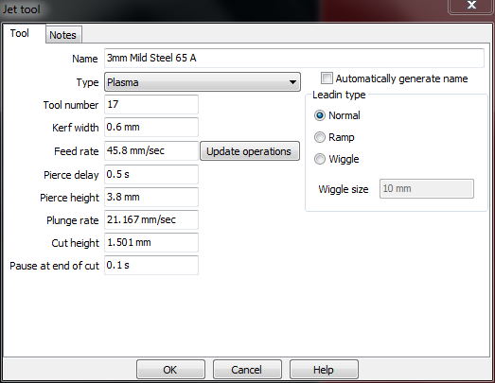  Supplier SheetCam Jet tool, SureControl manual p. 43. The feed field uses mm/sec. Confirm quantity and units before comparing any number with another screen.

Match the whole process
A cut chart may identify the power source, torch, consumables and process before listing values. Matching thickness alone is insufficient if another condition differs. Supplier software examples explain fields; they are not validated school recipes. A useful production record identifies the source chart, its row and the actual setup. Resolve missing information before operation rather than selecting a plausible-looking number from an unrelated example.

Read the quantity and unit
Height and kerf describe distances; feed describes distance travelled per time; pierce delay describes time. Current is measured in amperes and arc voltage in volts. The documented metric feed display uses millimetres per second, while other information may use millimetres per minute. The same physical feed has sixty times the numerical value per minute. Read both the label and unit, and reconcile the expressions without entering values into a live controller.

Check where the control actually is
The software Amp field does not change physical current at the plasma power source. The authorised teacher checks the source control against the confirmed process. A matching software value cannot replace that physical check. If the chart and software agree but the power source has not been checked, the record remains incomplete.
Re-entering the software value does not resolve the missing evidence about the actual equipment.

Distinguish the cutting stages
Pierce height positions the torch for piercing; pierce delay allows that stage time before cutting movement proceeds; cut height concerns following the cutting path. These are different functions. Feed rate controls travel along the route, while kerf width informs path compensation. Feed-rate override changes the commanded feed relative to its base value. It is a percentage, not a feed speed. Read base feed, units and override together to understand the recorded movement.

Use evidence for any review
Torch height control, or THC, uses arc-voltage information to adjust height under the configured system. Its target voltage is not physical amperage. Speed, height, consumable condition and alignment can interact, so a rough edge does not identify one certain correction. Students describe symptoms and unresolved questions. The teacher checks the approved references, records conditions and obtains supplier support where needed; students do not press height arrows, change configuration or invent replacement recipes.

MODULE 4 / CHECK YOUR UNDERSTANDING

Understand the settings
Choose one answer for each question. Revisit the reading, explain your choices and keep any corrections visible.

01 What makes a cut-chart row relevant to a job?
○ A Its values are the easiest to enter.
○ B Its material, thickness and specified setup match the actual process.
○ C Its thickness alone resembles the job.
02 How should a supplier screenshot’s cutting values be used in this course?
○ A As an approved starting recipe for every student design.
○ B As evidence that any consumable will work at that setting.
○ C To understand the fields, without assuming a school recipe.
03 Why retain the unit when recording feed rate?
○ A The numerical expression changes with the time unit.
○ B The unit is just a display decoration.
○ C All cutting software always uses the same feed units.
04 Which quantity is expressed as a percentage in this explanation?
○ A Pierce delay.
○ B Feed-rate override.
○ C Pierce height.
05 What happens to physical amperage when the software Amp field is changed?
○ A It automatically sets the source to the displayed current.
○ B It changes the torch’s cut height instead.
○ C The software field does not change the physical current setting.
06 Software Amp matches the chart, but the source control has not been checked. What is missing?
○ A The authorised teacher’s physical current check.
○ B A second entry of the same software Amp value.
○ C A different filename for the chart.
07 Why are pierce height, pierce delay and cut height separate fields?
○ A The operator may substitute whichever value is easiest to find.
○ B They describe different positions or timing stages.
○ C They are alternative labels for one identical value.
08 What can make a recorded base feed misleading?
○ A Writing its unit next to the value.
○ B Recording which chart the feed came from.
○ C An unnoticed feed-rate override.
09 What does THC use in the documented control process?
○ A Arc-voltage information to adjust torch height.
○ B The software Amp field to set physical current automatically.
○ C The filename to choose the material automatically.
10 A cut edge is rough. What conclusion is justified?
○ A It proves that a student should alter the controller configuration.
○ B Several causes are possible; record evidence and use the approved review pathway.
○ C It proves that the feed must be changed immediately.

MODULE 4 / APPLY AND RECORD

Read the label before the number
Review this practice note: “The software Amp selection has been changed, so the physical power-source current must now match.” Use the source to correct the claim.
Using the reading, make Amp, Cutting Speed/Feed rate and Pierce Height rows: meaning, unit or uncertainty, approved source. Select no production values.
Explain 1 mm/sec = 60 mm/min and the danger of dropping units. Correct the quoted Amp claim. For an unlabelled Cutting Speed screenshot, record known information, missing unit and the teacher verification needed. Change no machine settings.
Amp/feed/pierce height: meaning, unit, approved source
Unit explanation and corrected physical-Amp claim
Unlabelled speed: known, unknown and follow-up

Explain your reasoning
Evaluate a settings record that includes material thickness and software Amp but omits the consumable identity, feed unit and physical current check. Explain why completing those gaps matters before the teacher considers production.
BUILD YOUR RESPONSE Explain what makes the source chart match the actual process. • Explain the risk of a feed value without its unit. • Distinguish the software Amp field from the physical current control. • Identify the evidence needed without inventing replacement values.

Check your response: Connects each missing item to a specific process or interpretation problem. • Proposes
evidence-based checks within the teacher-only production boundary, without inventing a recipe.

MODULE 4 / LESSON 3 / READ AND INSPECT
Observe the production sequence  Production brings a digital plan into contact with moving axes, an electrical arc, hot metal and fumes. Students prepare and review work offline, then observe from the designated position. The trained, authorised teacher controls the physical process. | 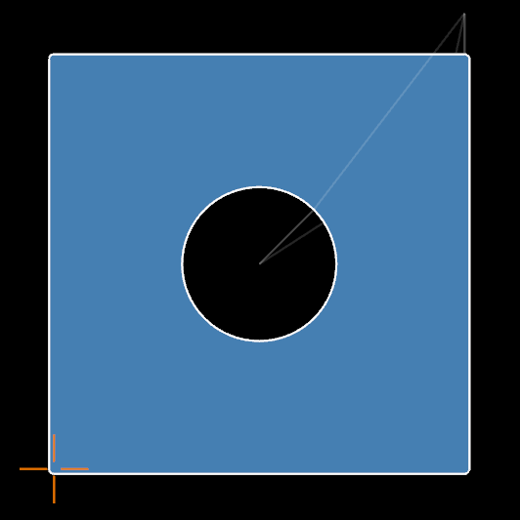  Supplier loaded-part view, SureControl manual p. 18. The origin marker and extra paths support teacher placement checks. A view on screen is not proof of safe motion.

Confirm authority and the job
The operator needs the required school approval, equipment training and local procedure. A teacher new to the system requires the specified training and supported commissioning before live delivery. Reading this unit does not supply that authority. Before preparation, the teacher matches design revision, CAM work and output to the installed system, then checks actual material, consumables and recipe. A correct file paired with the wrong process remains an unsuitable job.

Check the physical operating area
The supplied school requirements include a securely screened operating area, welding curtains and effective fume extraction. During automatic cutting, the operator remains physically separated from the machine by the screened area and curtains. Teacher status does not permit standing inside while it cuts. Students use the designated observation arrangement and do not enter until required electrical isolation has occurred. Clothing, protective equipment and handling follow the approved local procedure; missing requirements stop preparation.

Establish position deliberately
The documented sequence includes connection, reference, job loading and origin preparation. Reference establishes known machine position through real movement. Loading supplies the intended program; Set Origin assigns job zero at the teacher-selected physical position. Neither substitutes for the others. The teacher verifies the expected state at each stage. Touch sensing and test firing are also authorised physical checks. Unexpected sensing or motion calls for the approved response, not student experimentation.

Recognise what a dry run checks
An offline SheetCam preview reviews the planned route. SureControl Simul, started by the operator, moves the real machine without firing the torch and requires the controlled area. If that travel would exceed usable sheet space, a correct digital dimension does not resolve physical placement. The teacher stops, follows the review pathway and repeats necessary checks after a verified correction. Continuing to a live cut is not an appropriate way to investigate the mismatch.

Monitor and finish within the procedure
The teacher completes final checks and monitors automatic cutting from the separated operator position. Unexpected motion, arc faults or abnormal results require the approved stop and escalation response. Students follow directions without approaching, restarting or adjusting settings. Stop and Offline are not electrical isolation. The teacher completes isolation, cooling and safe retrieval before access. A motionless part can remain hot and sharp. Record only the demonstration and explanations that actually occurred.

MODULE 4 / CHECK YOUR UNDERSTANDING

Observe the production sequence
Choose one answer for each question. Revisit the reading, explain your choices and keep any corrections visible.

01 What does completing this course’s formative work establish?
○ A Automatic commissioning of the installed machine.
○ B Evidence of learning, not machine-operator authorisation.
○ C Permission for students to operate independently.
02 Why match the design revision, production output and actual process?
○ A Matching filenames eliminates the need to check contents.
○ B A correct process automatically updates an old design file.
○ C The correct file and correct process must also belong together.
03 Which statement includes the
operator-separation requirement?
○ A The operator is physically separated by the securely screened area and welding curtains during automatic cutting.
○ B Only students must be outside while the teacher stands beside the torch.
○ C The operator can enter when the cutting path looks predictable.
04 When may students enter the shielded area?
○ A Whenever the torch is not visibly firing.
○ B Only after the required electrical isolation and within teacher directions.
○ C As soon as the controller says Idle.
05 What does reference establish in the documented sequence?
○ A The correct revision of the CAD master.
○ B The location of every possible sheet automatically.
○ C A known machine position through real axis movement.
06 An expected Touch signal does not appear during a teacher check. What is the student’s role?
○ A Observe and report while the teacher follows the stop and support pathway.
○ B Alter the sensor configuration until the indicator changes.
○ C Skip the sensing check because the file is correct.
07 Why does SureControl Simul require a controlled operating area?
○ A It automatically isolates the motor power.
○ B It moves the real machine when started.
○ C It is simply an offline animation of a drawing.
08 The offline preview was correct but the physical route would exceed the usable sheet. What follows?
○ A Start cutting to test whether the last section will fit.
○ B Shrink the file without checking the design.
○ C Stop and resolve the setup through the approved review pathway.
09 A fault occurs during production. What should students do?
○ A Follow directions and report observations while the teacher applies the approved response.
○ B Restart from the point that looks unfinished.
○ C Approach to inspect the torch closely.
10 Why is a motionless finished part not immediately ready to retrieve?
○ A The finished outline removes all sharp edges automatically.
○ B Required isolation, cooling and handling checks still apply.
○ C Selecting Offline guarantees it is cool.

MODULE 4 / APPLY AND RECORD

4. Keep an observation or feedback record
Record evidence from an actual teacher demonstration, a safely released sample or teacher feedback on your offline file. Identify the revision/sample and context; distinguish your observation from reported feedback.
Explain what the evidence establishes and its limit. If none is available, write “Awaiting observation or feedback”. Use your supported response for the hypothetical failed-fit scenario; do not claim that it actually occurred.
Evidence type, revision/sample and context, or Awaiting feedback
Observation/teacher feedback, what it shows and its limit

Explain your reasoning
Explain how a class can learn from a teacher-controlled demonstration when the offline preview is correct but the physical dry run fails the fit check. Justify the pause, the student role and the conditions that still apply before any later cut or retrieval.
BUILD YOUR RESPONSE Explain why offline success does not settle the physical fit. • Describe the teacher’s response and what students can record. • Include the operator’s physical separation during any later automatic cutting. • Explain why stopping and retrieval require separate consideration.

Check your response: Explains the purpose and limits of each kind of check rather than treating the pause as failure. • Maintains teacher-only authority, screened operator separation and the required isolation and handling boundary.
Use the large evidence fields on page 49 for a sketch or selected image and caption.

MODULE 5 / LESSON 1 / READ AND INSPECT

Measure before judging
A physical result can test parts of a design that a screen cannot. Begin only with a teacher-cleared sample, preserve its identity and orientation, then compare labelled measurements and visible edge features with the intended result.
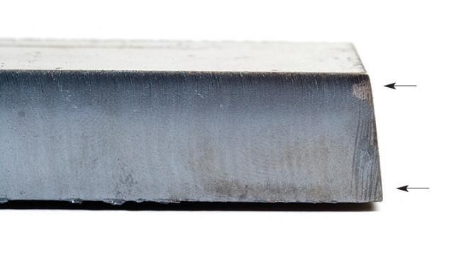
Supplier positive-bevel reference, SureFire CNC cut-quality guidance p. 1. Describe the edge relationship; it is not a result from the school machine.
WORKED EXAMPLE For the hypothetical sample, measured minus intended gives 99.6 − 100 = −0.4 mm for the top outside width. The hole gives 30.3 − 30 = +0.3 mm. The signs describe two feature differences; acceptance still needs an agreed tolerance.

Use a safely released, identified sample
The teacher completes approved finishing, isolation, cooling and retrieval before releasing a safely handled sample and explaining permitted measurement. A stopped program or extinguished arc does not establish electrical isolation; metal can remain hot or sharp. Record part name, CAD and production revisions, material and teacher-recorded recipe identifier. Mark top and bottom in the evidence. Ask how an unsafe edge should be made safe rather than altering it to ease measurement.

Compare the same feature
The nominal dimension is the intended drawing size; the measured dimension is the instrument reading. Record feature, unit, instrument and location. Width is not hole diameter, and radius is not diameter. Repeat important measurements with consistent positioning and the
teacher-demonstrated method. Note difficulties, including uneven edges, and claim only supported precision. Where bevel is visible, identify top, bottom or another defined location: one top width does not establish the bottom width.

Report difference before judging acceptance
Subtract intended size from measured size. For the proposed practice geometry, a hypothetical top width of 99.6 mm against 100 mm gives −0.4 mm; a 30.3 mm hole against Ø30 mm gives +0.3 mm. These are observations, not automatic pass or fail decisions. Tolerance is the agreed permitted variation for a feature and purpose. Without it, report differences and discuss fitness for purpose rather than inventing an allowable error afterwards.

Describe the bevel relationship
Bevel is a cut edge’s departure from square. In the supplier guidance, positive bevel makes the outside smaller at the top than the bottom, while a hole is wider at the top. Negative bevel reverses those relationships. Irregular bevel varies around the part. Compare top, bottom and edge views. A photograph can support a slope observation, but neither an exact unmeasured angle nor a certain machine cause.

Keep deposits and evidence specific
Dross is attached metal around a cut edge. Identify its location on the underside or top. Supplier descriptions distinguish hardened and more easily removed deposits; students must not scrape unsafe edges to classify them. Use teacher-provided observations. When permitted, capture overall and useful detail views with labels and a scale reference. Describe dimensions, bevel, deposits and finish separately: a neat top view cannot prove accurate size or a clean underside.

MODULE 5 / CHECK YOUR UNDERSTANDING

Measure before judging
Choose one answer for each question. Revisit the reading, explain your choices and keep any corrections visible.

01 When can a student begin inspecting the physical sample?
○ A As soon as the program says it has finished.
○ B After the teacher releases a safely handled sample under the approved procedure.
○ C Once no bright arc is visible.
02 Why record a sample’s file revision and recipe identifier?
○ A They connect the observed result to the job that produced it.
○ B They prove the sample is accurate without measuring it.
○ C They give students permission to repeat the cut.
03 A drawing specifies a 30 mm hole diameter. Which measurement compares the same feature?
○ A The overall width of the square.
○ B A radius of 30 mm.
○ C The hole diameter measured in millimetres.
04 A proposed 100 mm width measures 99.6 mm. What is measured minus intended?
○ A +0.4 mm, meaning oversize.
○ B −0.4 mm, meaning below the intended width.
○ C −4 mm, meaning below the intended width.
05 A part differs from its drawing by 0.4 mm, but no tolerance is given. What is justified?
○ A Report the difference and discuss the required fit or purpose.
○ B Declare every difference an automatic failure.
○ C Create a tolerance that makes this result pass.
06 An outside edge has a smaller top width than bottom width. Which description matches the guidance?
○ A Negative bevel.
○ B No bevel because the top view looks square.
○ C Positive bevel.
07 What does a clear photograph of an irregularly sloping edge establish?
○ A The nozzle definitely failed.
○ B The visible edge pattern needs recording and trained review.
○ C The correct numerical height adjustment.
08 What is useful to record about dross before any approved removal?
○ A Its location and appearance, using permitted photographs or teacher observations.
○ B Whether it can be removed with an unprotected finger.
○ C Only whether the top surface looks attractive.
09 Why label a width measurement as ‘top’ or ‘bottom’ when bevel is present?
○ A To replace the need to state units.
○ B To prove a cause without checking the machine records.
○ C Because the measured width can differ between those locations.
10 Which evidence set best supports a judgement about a cut part?
○ A One attractive top-view photograph.
○ B Labelled measurements plus permitted top, underside and edge observations.
○ C Only the filename of the final CAD drawing.

MODULE 5 / APPLY AND RECORD

Make the measurement report useful
Read the measured-difference example and the deposit-recording guidance. Use the lesson’s hypothetical written sample: intended outside width 100 mm; measured top width 99.6 mm; intended hole diameter 30 mm; measured hole diameter 30.3 mm; underside deposits recorded. No tolerance or confirmed cause is supplied. This does not claim that the school machine has produced the sample.
Review this weak report: “The part failed. Both errors and the deposits prove that the speed is wrong. Change the settings.” Separate observations from unsupported conclusions.
Calculate measured minus intended for each feature, with location, unit and sign. Separate observations from unsupported claims.
Rewrite the report using the written-example identity, measurements, deposits and missing evidence. Explain the safe release and teacher-approved method required before real inspection. This is a hypothetical paper exercise.
Feature + location | Measured − intended | Supported / uncertain
Outside width, top
Hole diameter

Explain your reasoning
Evaluate the evidence you would need to judge a teacher-cleared cut sample. Use the proposed 100 mm square with a 30 mm hole, or your teacher-approved design. Explain what you can conclude from measurements and photographs and what remains uncertain.
BUILD YOUR RESPONSE Identify safe access, sample identity and the features you would measure. • Use a measured-minus-intended example with units and a labelled measurement location. • Explain how bevel and deposits would be recorded, and why a photograph alone cannot establish the cause.

Check your response: Connects at least two quality judgements to relevant, labelled evidence. • Distinguishes measured differences, agreed tolerance and possible causes without inventing an approval or setting.

MODULE 5 / LESSON 2 / READ AND INSPECT
Investigate with evidence  A useful investigation protects people, preserves records and separates what happened from what might explain it. Students organise observations and compare files offline. The trained operator handles physical faults, approved diagnostic checks and any equipment changes. | 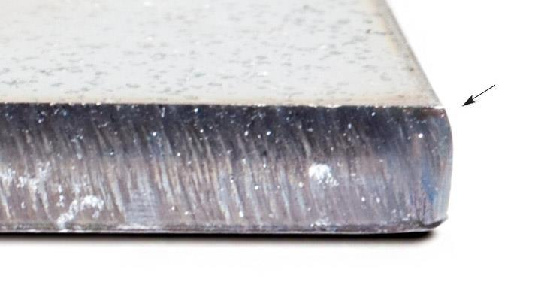  Supplier irregular-bevel reference, SureFire CNC cut-quality guidance p. 2. An uneven edge is evidence to describe, not a cause or remedy by itself.

Make safe and record the event
For unexpected production behaviour, the teacher applies the relevant stop, emergency and isolation procedures. Students remain outside the controlled area without approaching, repeating test fires or trying different controls. Stop and Offline do not establish electrical isolation. When safe, record the exact message or code, file revision and stage: before cutting, at the start or part-way through. A vague statement such as ‘it did not cut’ hides useful distinctions.

Separate observation, possibility and conclusion
An observation has evidence, such as an arc stopping part-way or a hole wider at the top. A possible cause is an explanation to investigate; a conclusion needs supporting checks. Label possibilities honestly. Arc loss alone does not prove a corrupt DXF: several job or equipment conditions may interrupt cutting. The authorised operator follows the actual message, correct manual and approved fault procedure. Students do not bypass controls, change wiring or attempt repairs.

Trace the file chain
Compare the identified CAD master, DXF, CAM job and available production record. Check revisions, units and key dimensions at each stage. If a proposed square is 100 mm in the master but 10 mm after import, resolve that file-stage discrepancy before production. Review export and import records, correct preparation and remeasure offline. Increasing current cannot repair wrong drawing scale. A preview establishes neither physical travel accuracy nor recipe suitability.

Keep physical review controlled
If file dimensions agree but the physical result differs, retain the sample and job record for trained review. Speed, current, height and consumable condition may interact. The supplier guidance considers speed and current, then height, with kerf compensation as the final sizing consideration. This diagnostic relationship is not a student adjustment sequence. Compensation cannot repair every poor cut; using it to hide unexplained bevel or
wrong-scale geometry can conceal the issue.

Write a report that supports the next check
Identify sample and revision, nominal and measured features, edge observations and checks already completed. State limits, such as deposit removal not being assessed. A future authorised comparison needs consistent feature labels and recorded conditions and changes. If no physical test occurred, call it a proposed investigation. Resolving a file discrepancy or identifying missing evidence can be a useful outcome. The aim is a justified next step, not an unsupported claim that the problem is solved.

MODULE 5 / CHECK YOUR UNDERSTANDING

Investigate with evidence
Choose one answer for each question. Revisit the reading, explain your choices and keep any corrections visible.

01 What comes first when production behaves unexpectedly?
○ A Try another control to see if the problem clears.
○ B Edit the DXF immediately.
○ C The trained teacher applies the relevant safety procedure.
02 Which statement is an observation?
○ A The arc stopped halfway around the outline.
○ B The DXF must be corrupt.
○ C A higher current will fix the problem.
03 Why copy the exact fault message and record when it appeared?
○ A It permits students to reset the equipment.
○ B Different messages and timings help distinguish possible causes.
○ C Any fault message proves the file is wrong.
04 An arc-loss report appears. Which conclusion is supported by that report alone?
○ A The work-return connection is definitely faulty.
○ B The controller should be bypassed for one test.
○ C The interruption needs trained review using the actual evidence.
05 The master is 100 mm wide but the imported DXF is 10 mm wide. What is the next useful check?
○ A Review the file-stage units and export/import records offline.
○ B Increase cutting current.
○ C Declare the physical torch worn.
06 What does a successful offline preview establish?
○ A The cutting recipe has been physically validated.
○ B The available geometry and path sequence can be inspected.
○ C The actual machine travelled safely through the job.
07 Why does the supplied guidance consider compensation after other cutting conditions?
○ A Compensation can repair every bevel pattern.
○ B All samples need the same compensation value.
○ C Other cutting conditions affect quality and kerf, so sizing changes need context.
08 Which report is most helpful to the trained operator?
○ A Revision, labelled measurements, observed deposits and the checks still needed.
○ B Bad cut; slow it down.
○ C Looks wrong, but the original file has been overwritten.
09 No physical comparison has been performed. How should an investigation be described?
○ A The problem is solved because a change is planned.
○ B A proposed investigation with the completed checks identified.
○ C A successful machine test because the preview ran.
10 The CAD and DXF dimensions agree, but the sample differs. What can a student do?
○ A Alter several settings until a part looks better.
○ B Bypass the fault input to continue the comparison.
○ C Preserve the sample and job record for trained review.

MODULE 5 / APPLY AND RECORD

Choose evidence that supports the claim
Use the evidence chain and presentation guidance. A student wants to support this limited claim: “My identified export retained the intended digital dimensions.” No physical cut has occurred in this written scenario.
A: The identified native CAD master, revision v2, with its dimension record.
B: The identified DXF exported from v2, with its matching receiving-software dimension checks.
C: An unlabelled screenshot with no known file revision.
D: A credited supplier photograph showing a cut edge from another example.
E: An older v1 drawing containing a geometry change that was later revised.
Select two essential records; explain contributions and matching revisions. Identify any optional item’s label and limit.
Write two captions and a limited digital evaluation. Name the teacher-controlled evidence needed before a physical-result claim. No physical cut occurred in this scenario.
Essential/optional evidence, reasons and limits
Two captions: revision, feature and demonstration
Limited evaluation and next physical-evidence requirement

Explain your reasoning
Explain a justified next step in this proposed investigation: the master and imported DXF have matching dimensions, but a teacher-cleared sample is undersize and has underside deposits. Use the evidence without prescribing a machine-setting change.
BUILD YOUR RESPONSE Separate the observations from possible causes and unsupported conclusions. • Identify records and sample evidence that would help the trained operator. • Explain why changing several settings or altering CAD to hide the difference would weaken the investigation.

Check your response: Uses the matching file dimensions to narrow the investigation without claiming a definite physical cause. • Proposes traceable evidence and an authorised review process, with honest limits on unperformed tests.

MODULE 5 / LESSON 3 / READ AND INSPECT
Explain the finished design  An evaluation connects purpose, criteria and evidence to a judgement and a useful next improvement. Present what the project actually achieved, distinguish digital preparation from physical production, and make every version and contribution clear to another reader. | 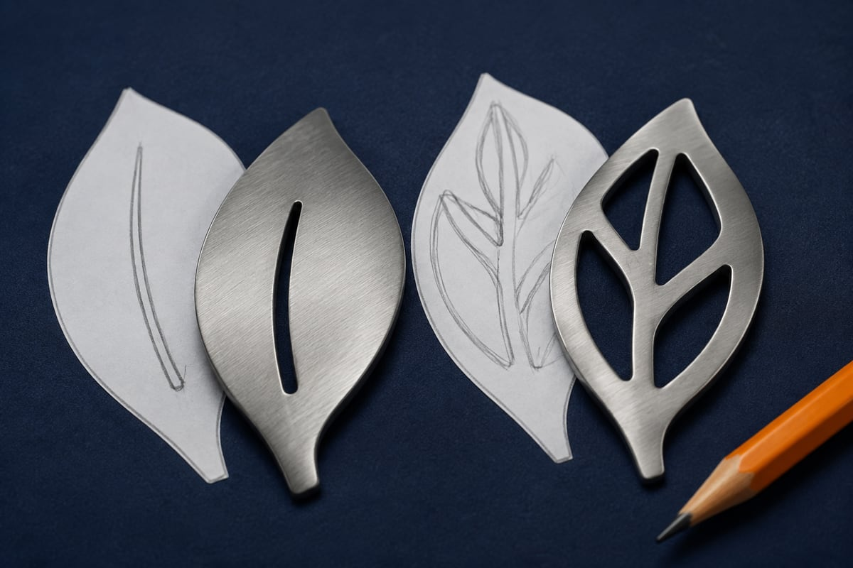  Illustrative design alternatives. Compare the visible openings and retained connections against the same purpose and criterion. Neither picture proves a production test.

Judge against the original purpose
Begin with intended user, function and agreed requirements. Consider dimensions, recognition, retained material, appearance and resource use where they belong to the brief. Do not invent a new requirement to make a result look successful. Distinguish design quality from production quality: an unsuitable design can be cut cleanly, while a sensible drawing can produce a poor edge. Identify which stage each judgement evaluates.

Connect claims to the right evidence
Link the identified master, checked DXF, relevant offline CAM views and any teacher production record with permitted photographs or measurements. A screenshot captures a view; it does not replace the editable file or prove every check. If master and imported width both measure 100 mm, the evidence supports preserved digital scale. It does not establish a 100 mm physical result. When no cut occurred, evaluate digital preparation and identify physical checks still required.

Explain an improvement and its trade-off
Name the feature, benefit and proposed check. A bridge could retain a stencil letter’s centre but alter its appearance. Suitable bridge dimensions still depend on design review, material and process; an illustration supplies no universal width rule. Revise geometry in the editable master, keep the previous version, export again and repeat checks. A suggested machine-setting change belongs to trained review, not student equipment adjustment.

Keep the conclusion proportionate
In the source’s hypothetical example, master and DXF agree on a 100 mm square and Ø30 mm hole, while a teacher-cleared sample measures 99.6 mm across the top and has underside deposits. The export preserved intended dimensions, but physical size and edge quality require review. Without an agreed tolerance, the −0.4 mm width difference establishes neither acceptance nor rejection. Retain records and sample rather than enlarging CAD to hide an unexplained result.

Make the journey understandable
Present purpose, development, checked handover, available production evidence, evaluation and improvement in order. Choose images that reveal the feature discussed: an underside view supports a deposit observation; CAD explains an outline revision. Caption their purpose and credit supplier reference images. Distinguish student work, teacher operation and proposals. Check that filenames, revisions, units and image labels agree, then preserve the editable master and an evidence backup. A useful folio makes limitations and the next check clear.

MODULE 5 / CHECK YOUR UNDERSTANDING

Explain the finished design
Choose one answer for each question. Revisit the reading, explain your choices and keep any corrections visible.

01 What makes an evaluation stronger than ‘I like it’?
○ A More decorative photographs.
○ B A judgement linked to purpose, agreed criteria and evidence.
○ C A claim that every part of the process was successful.
02 Why distinguish design quality from production quality?
○ A A good drawing can have a poor cut, and a clean cut can reproduce a poor design.
○ B A clean edge always proves the design meets its purpose.
○ C An accurate drawing proves the machine’s settings are suitable.
03 Which claim is supported by a master and imported DXF both measuring 100 mm wide?
○ A The physical part must measure exactly 100 mm.
○ B The machine has passed its safety checks.
○ C The checked file transfer preserved that intended width.
04 No physical cut has occurred. What should the evaluation say?
○ A The physical edge finish is satisfactory.
○ B Evaluate the completed digital preparation and identify physical checks still required.
○ C Borrow a supplier photo and label it as the finished project.
05 A geometry improvement is agreed. What preserves a reliable revision trail?
○ A Revise the master, retain the earlier version, export again and repeat checks.
○ B Rename the old DXF without changing its contents.
○ C Overwrite every previous record immediately.
06 What trade-off belongs in a proposal to add a bridge to a stencil letter?
○ A The bridge removes the need for material and process review.
○ B Any bridge width is automatically suitable.
○ C The connection can retain the centre but changes the letter’s appearance.
07 A hypothetical 100 mm part measures 99.6 mm and has deposits. What is a balanced conclusion?
○ A Enlarge the CAD drawing immediately to conceal the difference.
○ B Report the difference and edge observations, then seek trained review against agreed criteria.
○ C The part automatically passes because the error looks small.
08 Which caption is appropriate for a supplier bevel photograph in a folio?
○ A Supplier reference example used to compare the edge pattern.
○ B My final cut, even though no cut was made.
○ C Proof of the school machine’s current condition.
09 Which image is most useful beside an observation about underside deposits?
○ A A decorative photograph of a different workshop.
○ B Only the CAD outline.
○ C A permitted, labelled underside photograph of the identified sample.
10 What should the final presentation make clear about participation?
○ A All work was student-operated because it appears in the student folio.
○ B What the student completed, what the trained teacher operated and what remains proposed.
○ C Any planned improvement has already been physically verified.

MODULE 5 / APPLY AND RECORD

5. Evaluate the evidence and choose one improvement
Compare the evidence in your earlier records with your intention and practice-drawing requirements. State what it establishes and what remains untested.
Choose one useful improvement, justify it and explain how you will check it. Record any new master/export revision. Distinguish your digital work, teacher-controlled production and proposed checks; do not invent a manufacturing result or alter machine settings.
Evidence against intention and remaining uncertainty
One improvement, reason, revision and check

Explain your reasoning
Justify your final evaluation and one practical improvement to your design or file-preparation process. Connect your judgement to evidence and identify what has actually been completed, what the trained teacher undertook and what still needs checking.
BUILD YOUR RESPONSE State the intended purpose and one agreed criterion, then cite the evidence that tests it. • Propose a specific improvement, its expected benefit and a trade-off or further check. • Describe the revision trail and distinguish completed digital work from any physical production or proposed test.

Check your response: Justifies a judgement using relevant evidence while acknowledging its scope and limits. • Explains a specific improvement and a traceable checking process without inventing a physical result or operational permission.
Use the large evidence fields on page 49 for a sketch or selected image and caption.

REFERENCE / REVISIT YOUR COORDINATE COMPARISON

One shape, two datums
Coordinates describe a position relative to a chosen zero. Compare the spans and circle size before deciding whether two drawings describe different geometry.
Same geometry, different CAD origins. The centred drawing spans −50 to +50 mm; the corner drawing spans 0 to 100 mm. A CAD origin does not set machine job zero.
Drawing record | Square span | Circle
A: bounds 0 to 100 on each axis | 100 − 0 = 100 mm | Centre (50, 50); Ø30 mm
B: bounds −50 to +50 on each axis | 50 − (−50) = 100 mm | Centre (0, 0); R15 mm

Both records describe a 100 mm square with a central 30 mm diameter hole. Radius reaches from centre to edge; diameter crosses the entire circle, so R15 mm equals Ø30 mm. The coordinate values differ because the datums differ.
READ THE REFERENCE A CAD origin is a drawing reference. It does not reference the actual machine or set the job position on the sheet; those actions remain with the trained teacher.

Find the origin, label x and y, and explain why different numbers can describe the same shape.

DESIGN JOURNAL / EVIDENCE YOU CAN EXPLAIN

Show the decision
Use your own sketch or selected image to explain one design decision and its revision. Label illustrative references separately from your own work. Keep original files in the teacher-approved location.
Label each entry with its activity or folio stage. Use an extra copy of this page or a labelled continuation sheet for another record.
1 STARTING IDEA / ORIGINAL VERSION
File / revision / source
What this image shows

2 REVISED IDEA / PROPOSED CHANGE
File / revision / source
What changed and why
Next check / unresolved detail

Teacher feedback and permission are separate from this student evidence. Label unperformed checks as “Not checked yet”.

KEEP THE LANGUAGE PRECISE

Key words and sources
Term | Meaning in this unit
Plasma | Electrically conducting gas used in the cutting arc.
Kerf | The width of material removed along a cut.
CAD / native master | Editable geometry and dimensions for the design.
DXF | Drawing-exchange file; receiving checks are still required.
CAM / post-processor | Production preparation / conversion for a control system.
Contour / entity | A boundary / an individual drawing object.
Datum / origin | The reference from which positions are described.
Radius / diameter | Centre to edge / across the circle through its centre.
Bevel / dross | Edge departure from square / attached cut-metal deposits.
Nominal / tolerance | Intended dimension / agreed permitted variation.

Learning sources
Adapted from CNC Plasma: From First Sketch to Finished Metal, five modules, CAD guide, applied activities, design journal and teacher resources. Website snapshot checked 25 September 2026. All 150 original question sets and 15 response prompts are retained; longer readings are synthesised for paper use.
Course, enlarged figures, demonstrations and downloads
Technical illustrations: XT12 Assembly Manual v1.2; SureControl supplier manual V2.1/Draft4; SureFire CNC cut-quality guidance; course CAD/datum/kerf diagrams. Supplier screenshots are historical examples, not current school settings. Editorial cut-art and concept illustrations come from the existing course and classroom decks.
Credit reference images; label your own evidence with file, revision and caption. Keep student faces and other people’s personal information out of shared evidence. The teacher confirms storage and submission arrangements.
KEEP YOUR OWN RECORD Retain the native design, checked exchange file and evidence backup. Label work as digital-only when no physical production occurred.

