Steven Tang

CSE 460

Winter 2017

Lab 1

**Objective:**

In this lab, I am to give 2 examples of Unix commands: ls, cp, rm, mv, cd, mkdir, and vi. After giving examples of each command, I need to create a c++ file that would display a message that takes a string as the input and print it back out to the user.

**LS EXAMPLE:**

* **Basic ls list all visible folders and files in the directory**
* **Ls –a lists everything in the directory.**

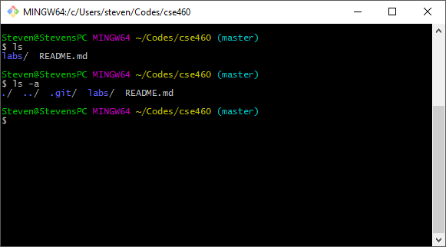

**CP EXAMPLE**

* **Cp can copy a file and rename that copied file**
* **It can also copy a file into a different directory.**

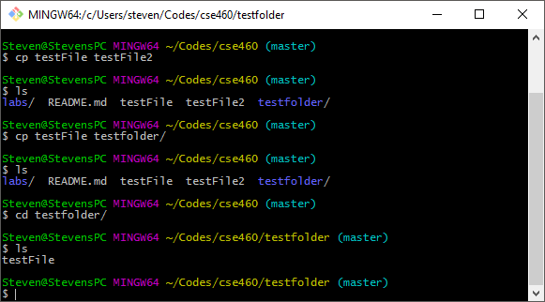

**RM EXAMPLE**

* **Rm can remove a file**
* **Rmdir can remove an EMPTY directory**

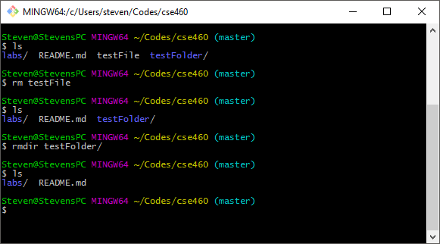

**MV EXAMPLE**

* **Mv can move a file to a different directory**
* **Mv can also RENAME a file**

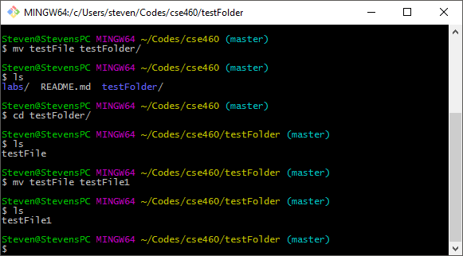

**CD EXAMPLE**

* **Cd changes directory**
* **Cd ~ changes to home directory**

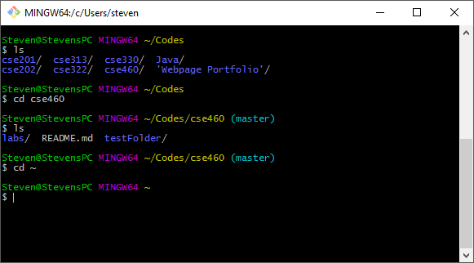

**MKDIR EXAMPLE**

* **Mkdir creates an empty directory**

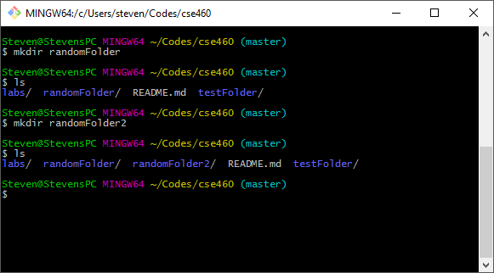

**VI EXAMPLE**

* **Vi is a text editor for UNIX**

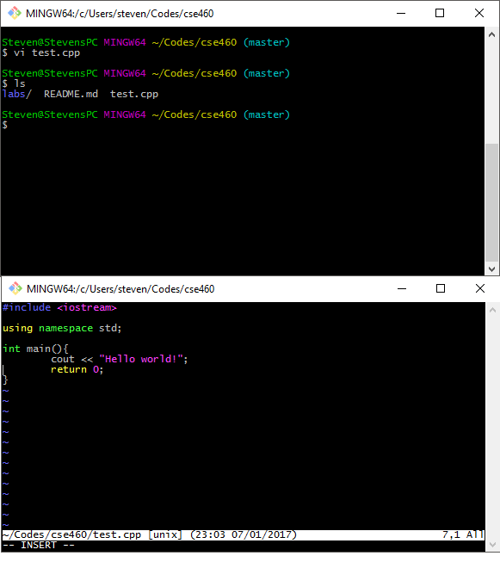

**FUNCTION.H**

1. **void** displayMessage();

**MAIN.CPP**

1. #include <iostream>
2. #include "function.h"
4. **using** **namespace** std;
6. **int** main(){
7. displayMessage();
8. cout << "\n";
9. }

**MESSAGE.CPP**

1. #include <iostream>
2. #include "function.h"
4. **using** **namespace** std;
6. **void** displayMessage(){
7. string message;
8. getline(cin,message);
9. cout << "\n" << message;
10. }

**MAKEFILE**

1. message: main.o message.o
2. g++ -o message message.o main.o
3. message.o: message.cpp
4. g++ -c message.cpp
5. main.o: main.cpp
6. g++ -c main.cpp
7. clean: message.o main.o
8. rm message message.o main.o

**OUTPUT (Used script to record terminal)**

1. Script started on Tue Jan 10 18:18:23 2017
2. [?1034hbash-3.2$ make[K[K[K[Kmake
3. g++ -c main.cpp
4. g++ -c message.cpp
5. g++ -o message message.o main.o
6. bash-3.2$ l[Kls
7. cd_example.png    main.cpp          message.cpp       rm_example.png
8. cp_example.png    main.o            message.o         typescript
9. function.h        makefile          mkdir_example.png vi_example.png
10. ls_example.png    [31mmessage[39;49m[0m           mv_example.png
11. bash-3.2$ ./message
12. CSUSB CSE 460 the Beautiful!
14. CSUSB CSE 460 the Beautiful!
15. bash-3.2$ make clean
16. rm message message.o main.o
17. bash-3.2$ scr[K[K[Kexit
18. exit
20. Script done on Tue Jan 10 18:18:58 2017

**Evaluation**

I have given multiple examples of each command that was required and correctly developed a program that would take an input from the user and output it to the screen. I also correctly created a makefile that would compile most of the files for the user. In the makefile, I also made it an option to have it clean up all the .o files that were not used anymore.

**Score: 20/20**