Regression Line — Running vs. Weight
Data Science Course | Regression Line Submission Assignment

Scatter Plot & Regression Line
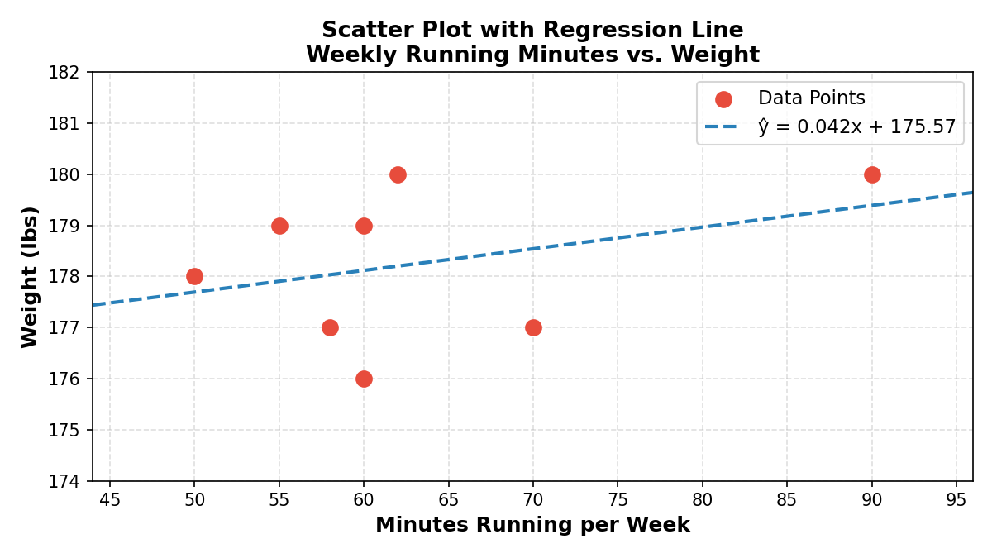
Figure 1 — Each red dot is one week of data. The dashed blue line is the least-squares regression line.
Linear Regression — Step-by-Step Math
Using the least squares method, we find the line ŷ = bx + a that minimises the sum of squared residuals:
- b (slope) = (Σxy − n·x̄·ȳ) / (Σx² − n·x̄²)
- a (y-intercept) = ȳ − b·x̄
Step 1 — Data Table
x (min) | y (lbs) | xy | x²
90 | 180 | 16200 | 8100
50 | 178 | 8900 | 2500
60 | 179 | 10740 | 3600
70 | 177 | 12390 | 4900
62 | 180 | 11160 | 3844
55 | 179 | 9845 | 3025
58 | 177 | 10266 | 3364
60 | 176 | 10560 | 3600
Σx = 505 | Σy = 1426 | Σxy = 90,061 | Σx² = 32,933

Step 2 — Compute Means
n = 8
x̄ = Σx / n = 505 / 8 = 63.125
ȳ = Σy / n = 1426 / 8 = 178.25
Step 3 — Compute Slope (b)
b = (Σxy − n·x̄·ȳ) / (Σx² − n·x̄²)
b = (90,061 − 8 × 63.125 × 178.25) / (32,933 − 8 × 63.125²)
b = (90,061 − 90,016.25) / (32,933 − 31,878.125)
b = 44.75 / 1054.875
b ≈ 0.042
Step 4 — Compute Y-Intercept (a)
a = ȳ − b·x̄
a = 178.25 − (0.042 × 63.125)
a = 178.25 − 2.678
a ≈ 175.57
Regression Line: ŷ = 0.042x + 175.57

Interpretation: For each additional minute of running per week, weight changes by approximately 0.042 lbs. The very small slope and tight weight range (176–180 lbs) suggest a weak positive correlation in this dataset — other variables likely have a stronger influence on weight.

