**GVSU School of Engineering**

**EGR326-902 Semester Project**

**Wave-Motion Arduino Shield**

Design Review Supplemental Packet

**Presented By:**

Jordan Visser

Steven Diemer

Professor: Andrew Sterian

11/4/2011

**Bill of Materials:**



**Microphone Pre-Amplifier:**

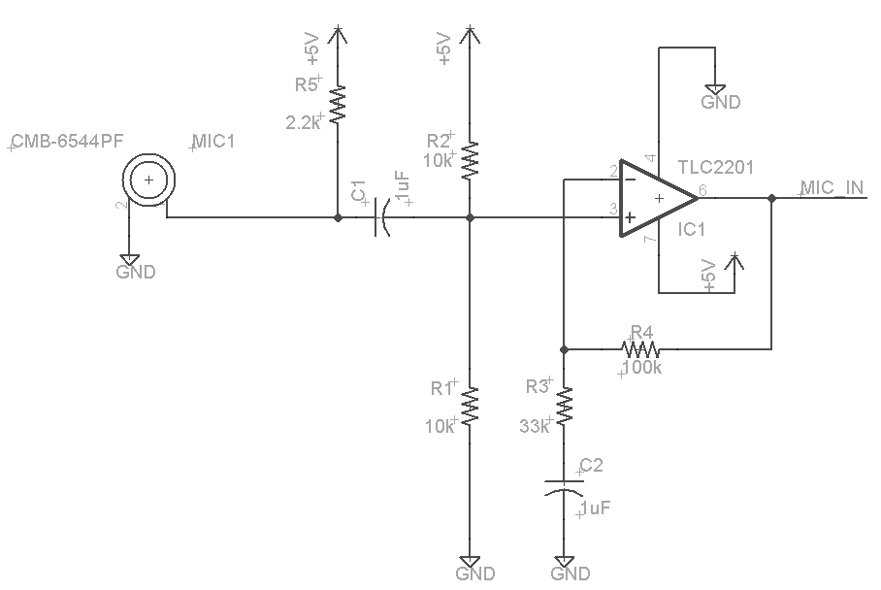

**3-Axis Accelerometer for Re-Sampling Instructions:**

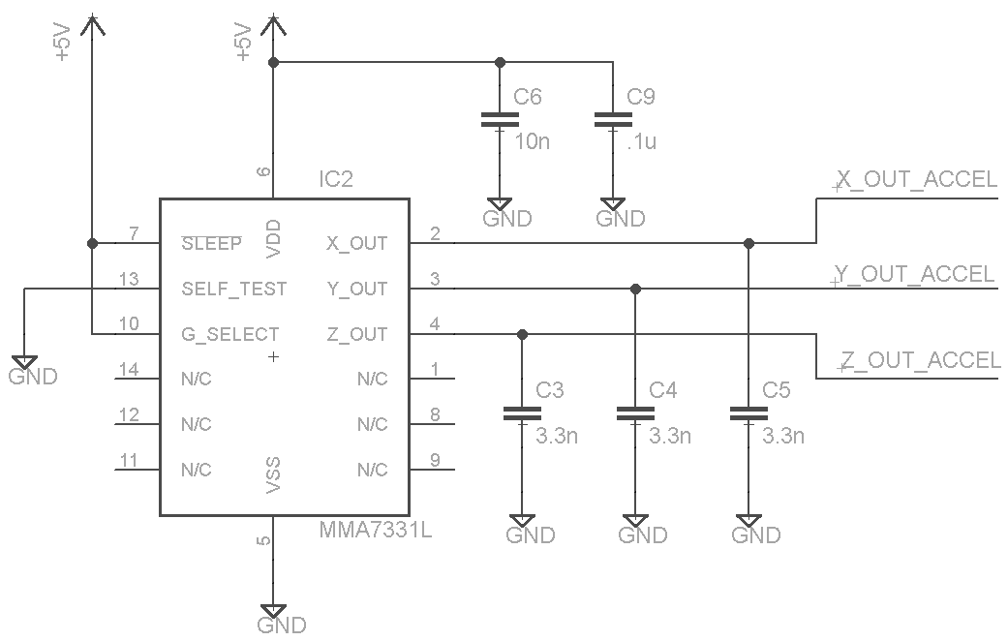

**Arduino Pin Out and Push Buttons and Switch:**

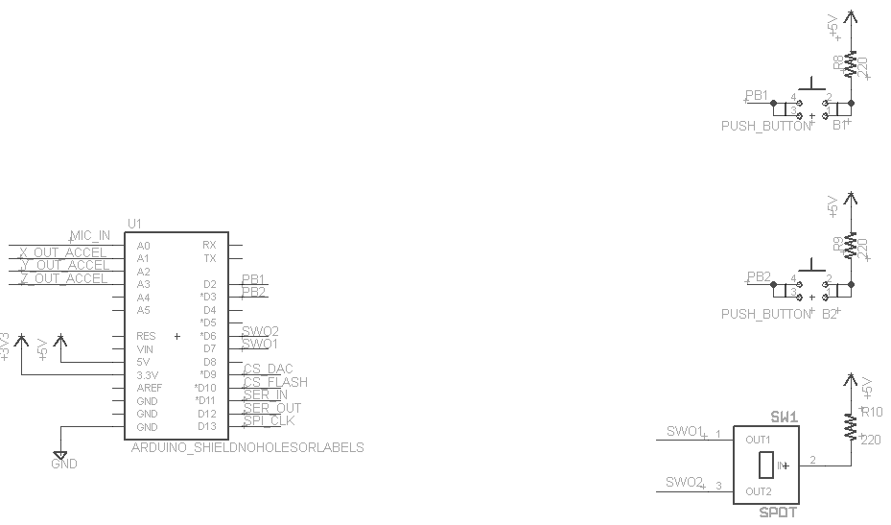

**Level Shifters and Flash Memory:**

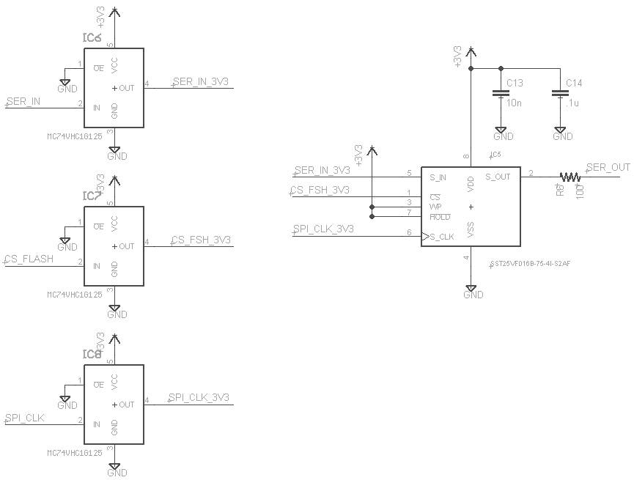

**Digital-to-Analog Converter for Speaker Amplifier Input:**

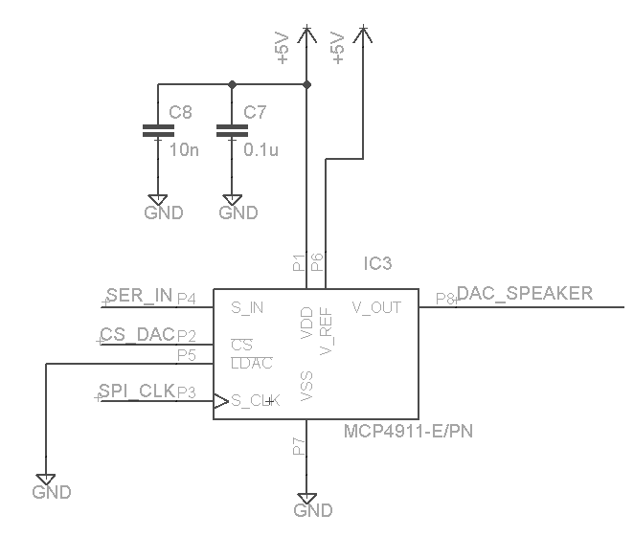

**Speaker Amplifier:**

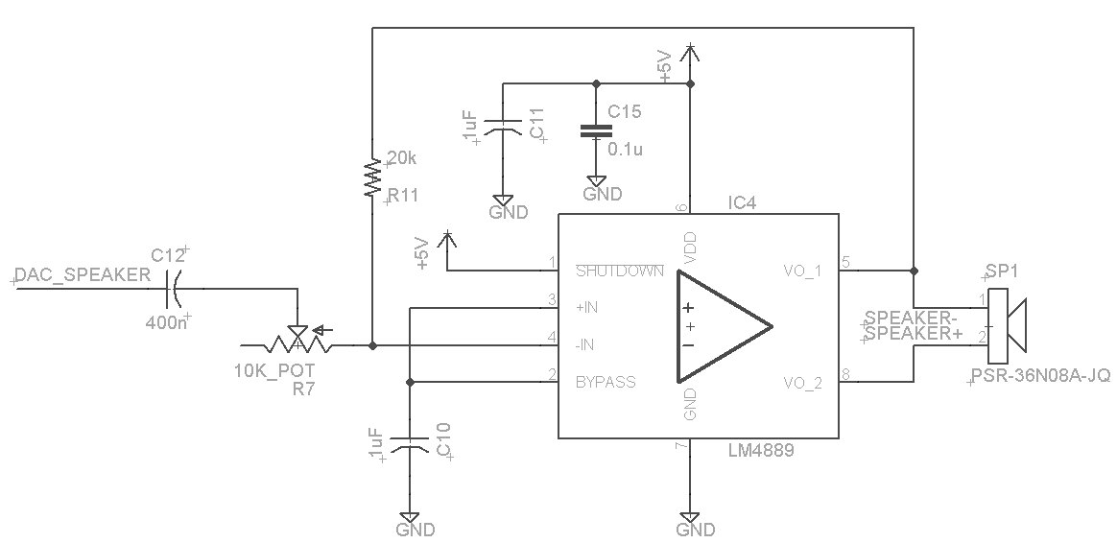

**Software Flow Chart:**

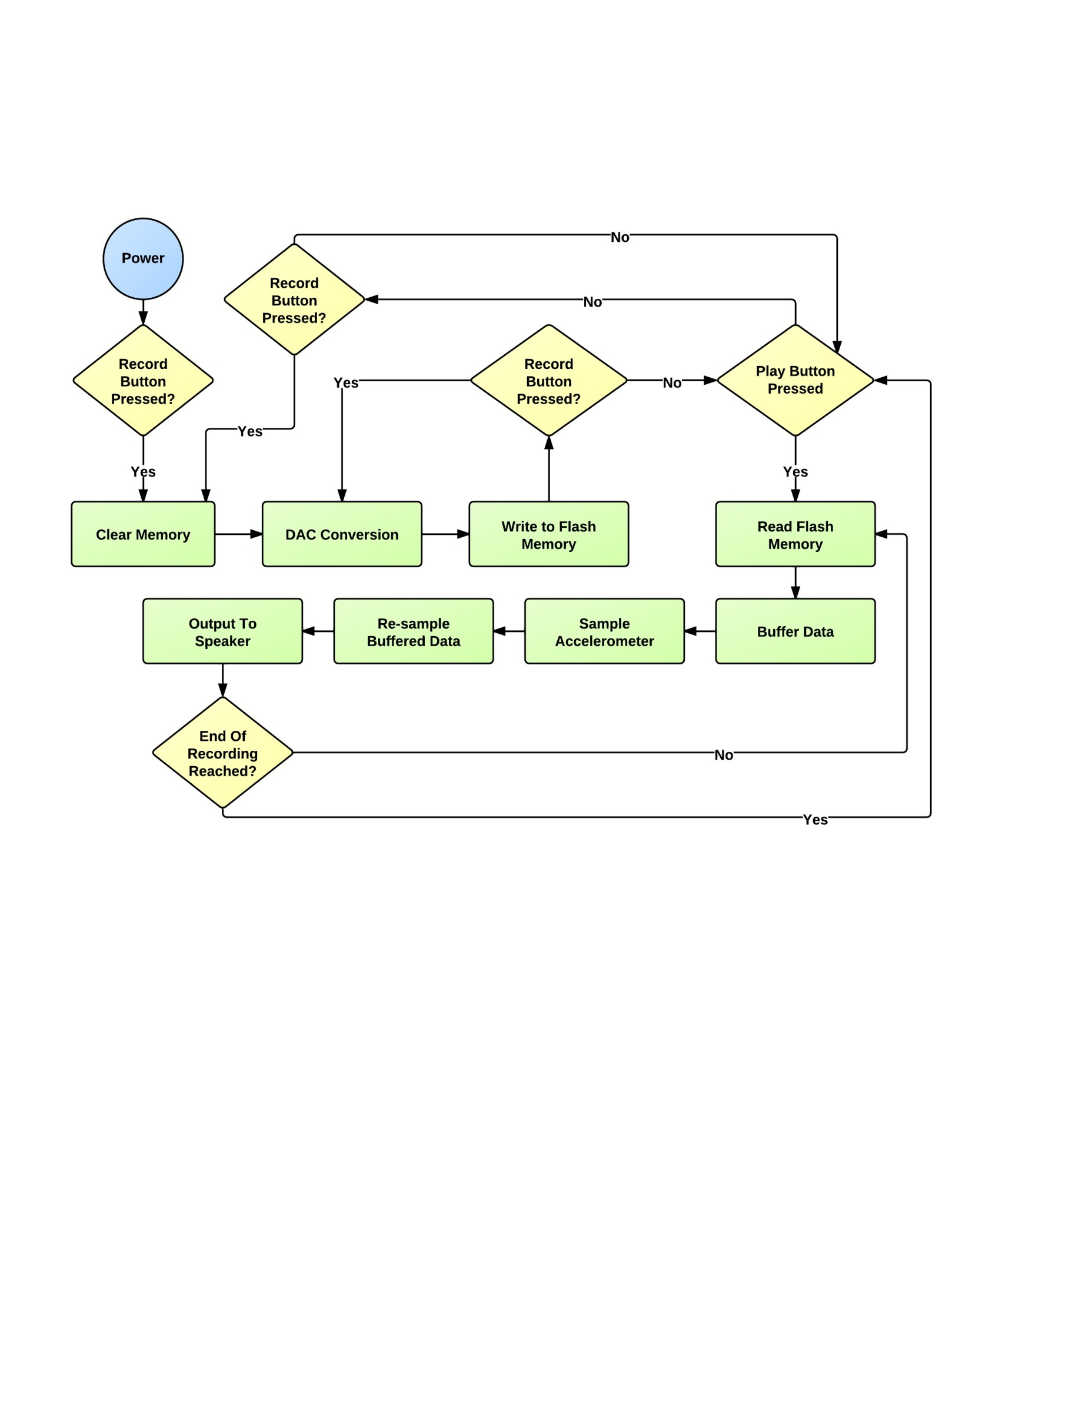

**Electret Condenser Microphone for Audio Input:**

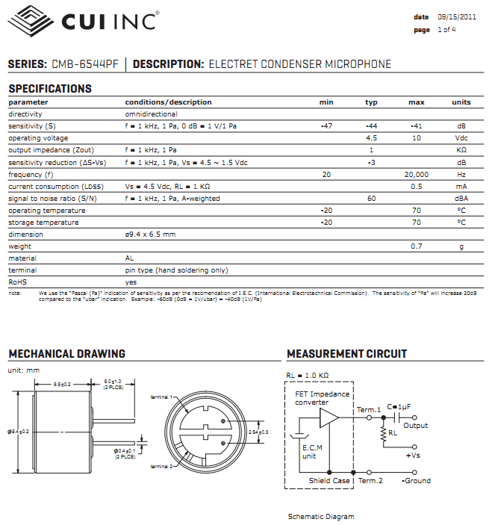

**3-Axis Accelerometer for Re-Sampling Audio:**

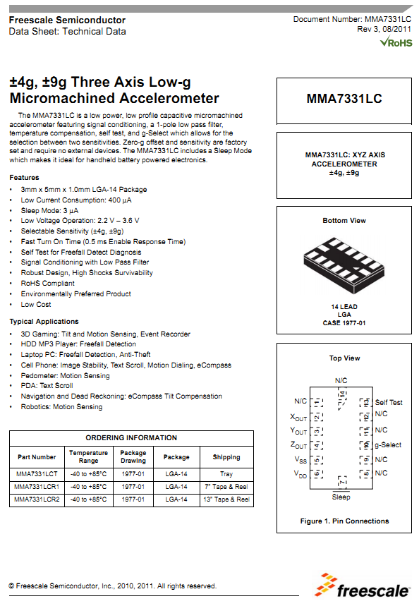

**10-Bit Digital-to-Analog Converter for Speaker:**

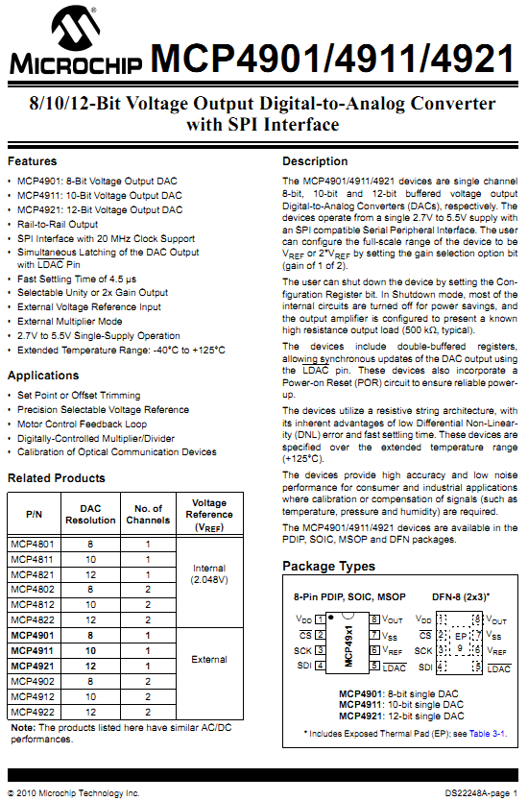

**Audio Power Amplifier for Driving 8Ω Speaker:**

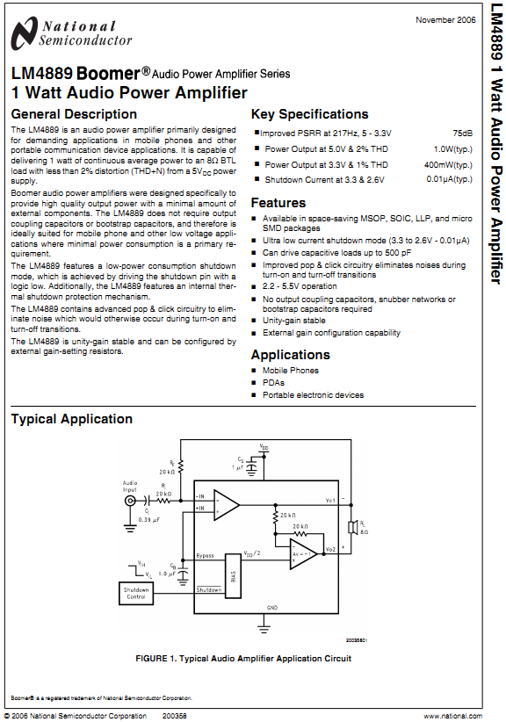

**32Mbit Flash Memory – Page 1:**

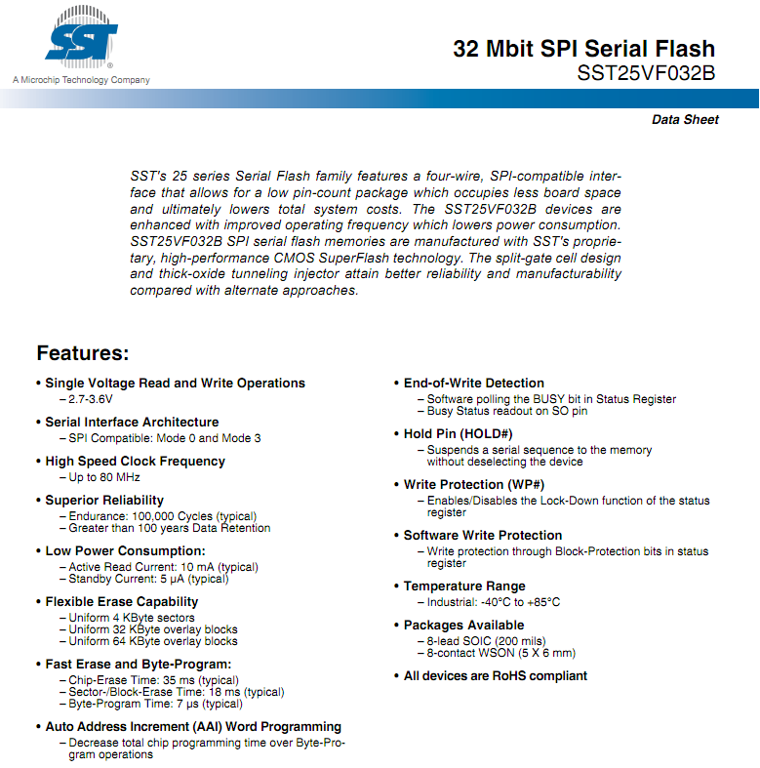

**32Mbit Flash Memory – Page 2:**

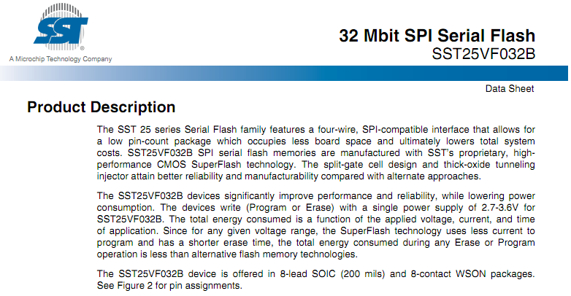

**3.3V Level Shifter for Memory Operation:**

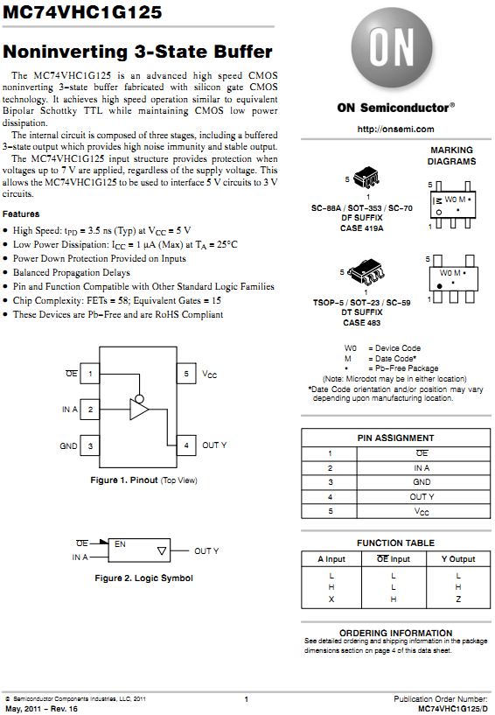

**Push Button for Audio Recording and Playback:**

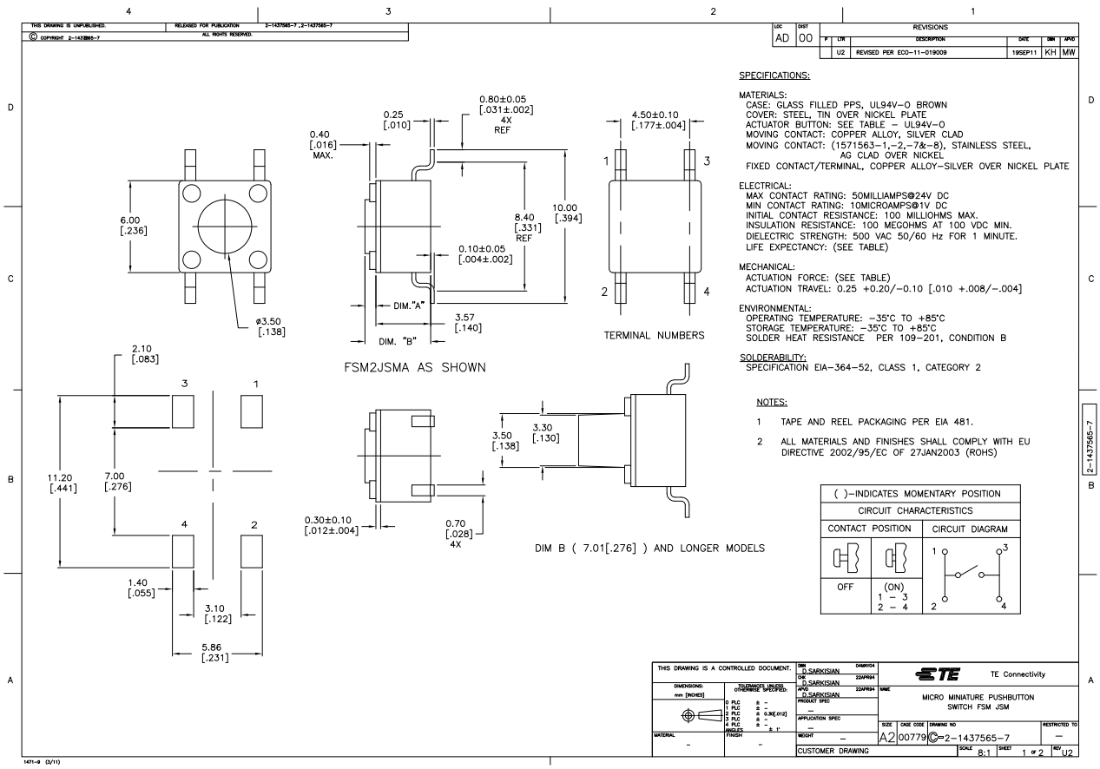

**Single Pull Double Throw Switch for Different Modes of Operation in the Future:**

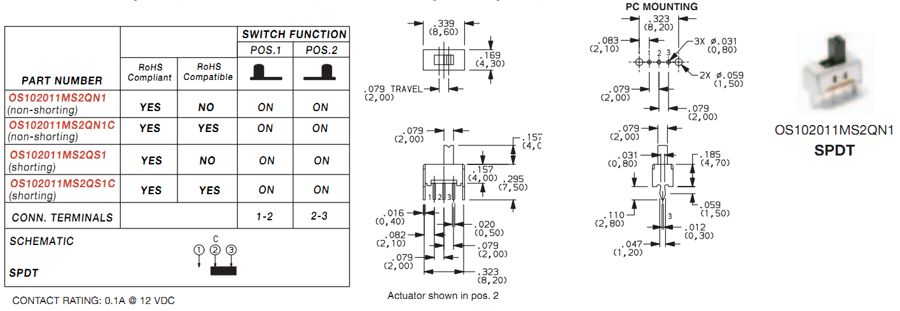

**Sparkfun Connector for Mounting Shield:**

