4. The Context Model

4.1 Goal Statement
The goal of the system is to allow Swapalease to increase sales revenue by x% over the next y years while reducing administrative costs by z% over the same period. It will accomplish this by:
- providing buyers and sellers with a website that meets their lease transfer needs, while allowing them to easily conduct account management tasks, and
- automating key administrative tasks of the lease transfer process.

4.2 Context Diagrams
4.2.1 Overview:
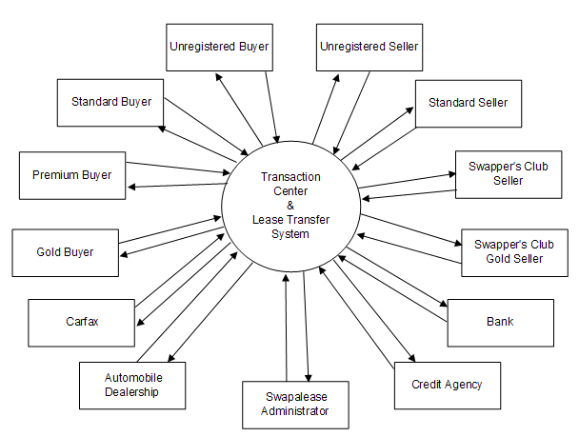
4.2.2 Buyer Registration:
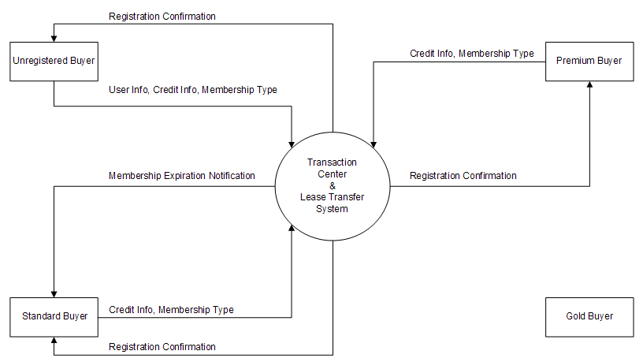
4.2.3 Seller Registration:
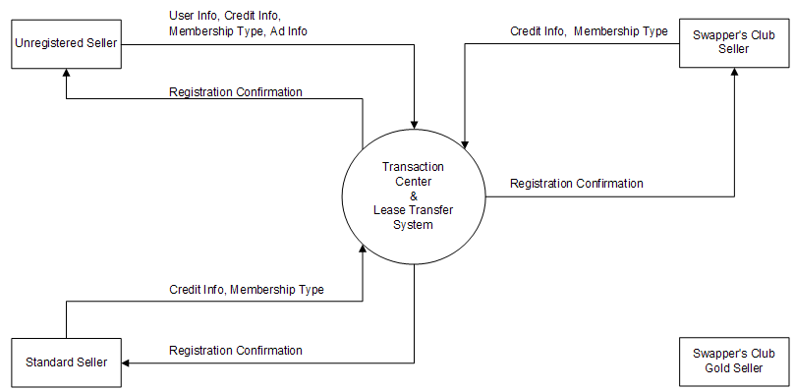
4.2.4 User Logon:
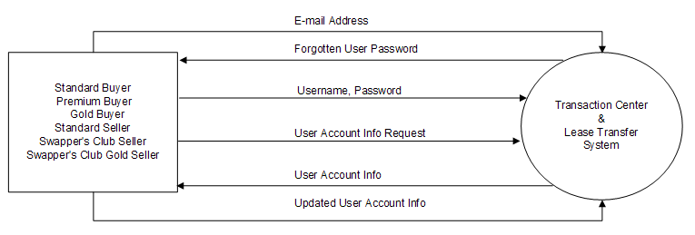
4.2.5 Vehicle Search:
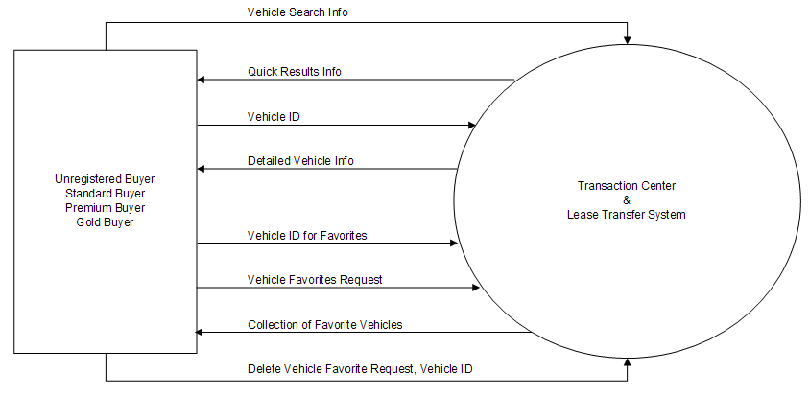
4.2.6 Seller Ad Options:
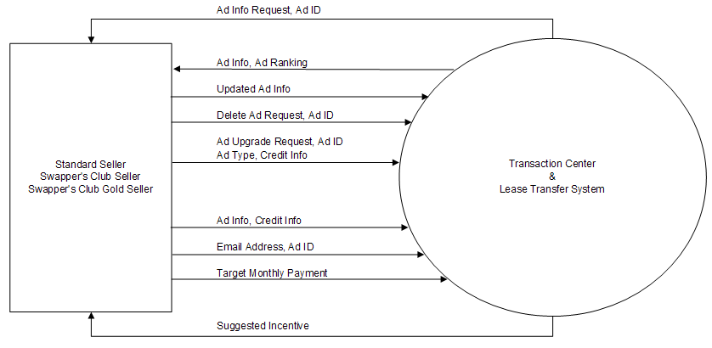
4.2.7 Administrator Management:
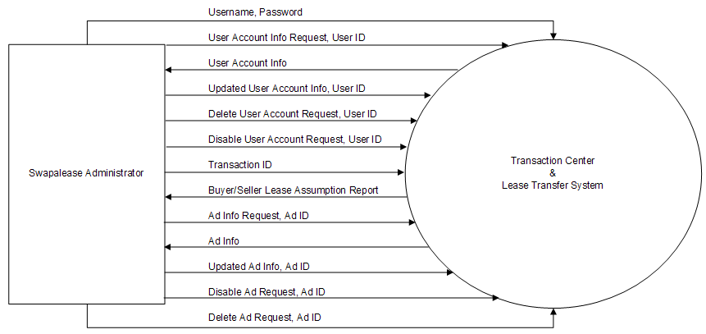
4.2.8 Mailbox System:
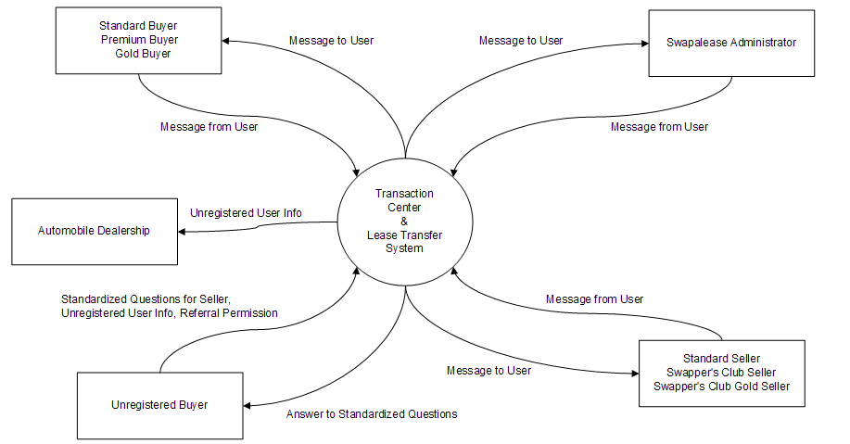
4.2.9 Lease Transfer Process:
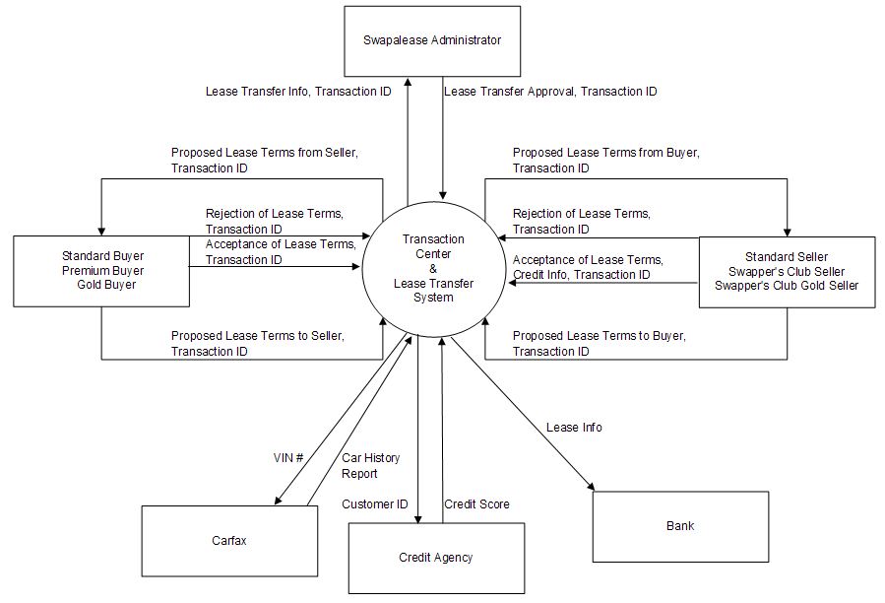

4.3 Data Flow Definitions
This section defines the aggregate data flow terms used in the context diagrams. An asterisk (*) indicates that a data flow is further-defined elsewhere in this section.
Ad Info:
Category, Year, Make, Model, Style, Vehicle Trim, Exterior Color, Interior Color, Engine, Transmission Type, Drive, Mileage, Vehicle Identification Number (VIN), Features: [Anti-Lock Braking System (ABS), AM/FM, CD Player, Heated Seats, Navigation System, Power Steering, Premium Wheels, Sun Roof, Air Conditioning, Cassette, Cruise Control, Keyless Entry, Power Drive Seat, Power Windows, Rear Spoiler, Tilt Wheel, Alloy Wheels, CD Changer, Dual Air Bags, Leather, Power Locks, Premium Sound, Side Air Bags], Incentive, Additional Vehicle Information, Leasing Company, Lease Account Number, Monthly Lease Payment, Total Miles Allowed, Lease Term, Lease-End Buyout, Lease Origination Date, Lease Expiration Date, Asking Price, Photo, Answers To Standardized Question(s), Ad Type*
Ad Type:
Default is Standard Listing. May include one or more of the following enhancements:
Top Swaps Newsletter (per issue) – vehicle featured in weekly newsletter sent to all registered buyers
Featured Autos (2 week placement) – vehicle included in ‘Featured Autos’ section
Banner Ads (2 week rotation) – vehicle placed on top of all searches for similar vehicles
Hi-Lighted Listing – vehicle listing boldly highlighted to attract attention
Photo Gallery – up to 8 pictures or vehicle can be included in ad listing
Ad Ranking:
Number Of Ad Hits, Number Of Buyers, Vehicle Ranking
Credit Info:
Credit Card Type, Credit Card Number, Credit Card Expiration Date, Password, Billing Name, Address, License Agreement Acceptance
Customer ID:
United States – Social Security Number (SSN)
Canada – Social Insurance Number (SIN)
Detailed Vehicle Info:
Year, Make, Model, Monthly Payments, Months Left, Remaining Miles, Miles Per Month Ratio, Incentives, Leasing Company, Lease End Date, Optional Lease End Buyout, Total Miles Style, Mileage, Engine, Transmission, Exterior Color, Interior Color, City, State, Zip, Swapalease Vehicle ID, List Of Vehicle Equipment And Features, Seller’s Comments, Photo Of Vehicle
Membership Type:
Buyers: Standard Buyer, Premium Buyer, or Gold Buyer
Sellers: Standard Seller, Swapper’s Club Seller, or Swapper’s Club Gold Seller
Quick Results Info:
Year, Make, Model, Exterior Color, Interior Color, Miles/Month, State, Months Remaining, Payment, Photo Of Vehicle
Standardized Questions:
Is vehicle available? Cost of lease-end buyout? Cost to assume lease? Offering an incentive? Condition, Any accidents? Any additional options? Is vehicle available? Can I see the vehicle? Do you have pictures? Is it a smoking car? Why do you want out? Is warranty still valid? How will I get the car? What is the over mileage fee? What if I live out of state? Can we initiate a transfer? What is current mileage? Maintenance record on hand?
Unregistered User Info:
First Name, Last Name, Phone Number, Email Address, Address, City, State, Zip, Time Frame To Purchase
User Account Info:
User Info*, Credit Info*, Membership Type*
User Info:
First Name, Last Name, Email Address, Country, Phone Number, Address
Vehicle Search Info:
Type Of Lease, Category, Make, Model, Year, Country, State/Providence, Lease Months Left, Payment Range, Swapalease Vehicle ID

4.4 Data Flow Explanations

Buyer Registration – Unregistered buyers can register by providing their user info, credit info, and membership type. They can choose to register as a standard, premium, or gold buyer. If the credit information is valid and the membership fee successfully charged, they are sent a confirmation message from the system. A standard buyer membership is only good for 45 days. The system will send a membership expiration notification via email 10 days before a user’s standard membership expires. If users wish to continue their membership, they can provide their credit info and membership type. They can choose to renew their standard buyer membership or upgrade to premium or gold buyer status. If the credit info is valid and the membership fee successfully charged, then they are sent a confirmation message from the system. Premium buyers have lifetime memberships and their account does not expire. Premium buyers can upgrade their account to gold member status by providing their credit info. If the credit info is valid and the membership fee successfully charged, then they are sent a confirmation message from the system. Gold buyers will never need to renew or upgrade their account.

Seller Registration – Unregistered sellers can register by providing their user info, credit info, membership type, and ad info. They can choose to be a standard seller, swapper’s club seller, or swapper’s club gold seller. If the credit info is valid and the membership fee successfully charged, then they are sent a confirmation message from the system. Standard sellers can upgrade their membership by providing their credit info and membership type. If the credit info is valid and the membership fee successfully charged, then they are sent a confirmation message from the system. Swapper’s club sellers can upgrade their account to swapper’s club gold seller by providing their credit info and membership type. If the credit info is valid and the membership fee successfully charged, then they are sent a confirmation message from the system. Swapper’s club gold sellers will never need to renew or upgrade their account.

User Logon – Registered users provide their username and password to logon to the system. If they forget their password, they can provide their email address and the password associated with that email address will be emailed to that address. If there is not a registered account matching the provided email address, then no password will be sent. Once logged in, users can request to view their account information from the system. If the data is incorrect, or requires changes, then users can submit updated information to the system.

Vehicle Search – Buyers can provide their vehicle search info and the system will return the quick results info of all the vehicles matching the filters provided. They can then view the detailed results info by selecting a specific vehicle ID from the initial results. They can arrive at this same information by also choosing the vehicle ID from their collection of vehicle favorites. If a particular vehicle is of interest to the buyer, they can request that the vehicle ID be added to their favorites for quick view later. Buyers can request and view their favorites list. They can submit a request to remove any vehicle from their favorites list.

Seller Ad Options – Sellers can request and view the ad information of their existing ads. They can submit changes to their ads. They can submit a request to delete their ads. They can purchase a new ad by providing their ad info and credit info. They can also purchase new features to upgrade their ads by providing the ad type and credit info. Sellers can provide their target monthly payment and the system will provide a suggested incentive.

Administrator Management – A Swapalease administrator can request and view any user account information. They can modify any user account information. They can also disable or delete any user account. A Swapalease administrator can request and view any ad. They can modify any ad information. They can disable or delete any ad. They also generate buyer/seller lease assumption reports which are used during the lease transfer process. These reports contain all of the buyer and seller user info, vehicle info, and all details about the proposed transaction.

Mailbox System – Buyers and sellers are capable of sending and receiving messages to and from each other. Swapalease administrators are also capable of sending and receiving message to and from buyers and sellers. An unregistered buyer who is interested in a particular vehicle can request additional info from the seller by selecting from ten standardized questions. They also need to provide their unregistered user info and indicate whether to allow Swapalease to share this information with local automobile dealerships. They receive the stored answers to the standardized questions from the seller.

Lease Transfer Process – A buyer can propose lease terms to a seller through the system. A seller will receive proposed lease terms from the buyer. The seller can accept the lease terms, propose different terms to the buyer, or reject the terms, ending the transaction process. The buyer receives any counter terms from the seller and can either accept the terms, propose different terms, or reject the terms, ending the transaction process. The cycle will repeat indefinitely until either the seller and buyer accept the terms or reject the terms and fail to counteroffer – ending the process. If the credit info is valid and the success fee successfully charged, the buyer customer ID is submitted to a credit agency and their credit score is returned. The system can also get additional information on a vehicle by providing the VIN# to Carfax. The lease transfer info is then submitted to a Swapalease administrator for approval. Once approved, the lease info is sent to the respective bank.

4.5 System Externals
Unregistered Buyer
An unregistered buyer is a system user who is looking to take on a lease but has not registered as a standard, premium, or gold buyer. An unregistered buyer can:
- Register with the system
- Search for leases
- Ask sellers standardized questions
- Save vehicles as temporary favorites
Standard Buyer
A standard buyer is a system user who is looking to take on a lease and has registered as a standard buyer. By registering, this user has 45 days of membership and direct seller contact information. A standard buyer can:
- Upgrade membership to Premium or Gold
- Log into the system with password
- Create, view, and update account information
- Search for leases
- Ask sellers free form questions
- Save and delete vehicle favorites
- Send and receive messages via the mailbox system
- Submit, counter, accept, and reject lease terms
Premium Buyer
A premium buyer is a system user who is looking to take on a lease and has registered as a premium buyer. By registering, this user has lifetime buyer membership, has direct seller contact information, receives one free Lease Advisor book, and receives one free credit report. A premium buyer can:
- Upgrade membership to Gold
- Log into the system with password
- Create, view, and update account information
- Search leases
- Ask sellers free form questions
- Save and delete vehicle favorites
- Send and receive messages via the mailbox system
- Submit, counter, accept, and reject lease terms
Gold Buyer
A gold buyer is a system user who is looking to take on a lease and has registered as a gold buyer. By registering, this user has direct seller contact information, receives one free Lease Advisor book, receives one free credit report, receives one free copy of Boost Your Credit Score, and has a lifetime seller’s membership. A gold buyer can:
- Log into the system with password
- Create, view, and update account information
- Search leases
- Ask sellers free form questions
- Save and delete vehicle favorites
- Send and receive messages via the mailbox system
- Submit, counter, accept, and reject lease terms
Unregistered seller
An unregistered seller is a system user who attempts to register as a seller but backs out during the process. Their information is kept so Swapalease can follow up with them later. In the system, an unregistered seller can only register as a Standard, Swapper’s Club, or Swapper’s Club Gold seller.
Standard Seller
A standard seller is a system user who is trying to sell a lease and has registered as a standard seller. By registering as a standard seller, the user receives a full page ad with color photo which is listed until the vehicle sells. A standard seller can:
- Upgrade membership to Swapper’s Club or Swapper’s Club Gold
- Log into the system with password
- Create, view, and update account information
- Create, view, update, upgrade and remove one advertisement
- Calculate incentives
- Tell a friend
- Send and receive messages via the mailbox system
- Submit, counter, accept, and reject lease terms
Swapper’s Club Seller
A Swapper’s Club seller is a system user who is trying to sell a lease and has registered as a Swapper’s Club seller. By registering as a Swapper’s Club seller, the user receives a full page ad with color photo which is listed until the vehicle sells, a 10 day ad on the featured vehicles page, and the success fee is waived. A Swapper’s Club seller can:
- Upgrade membership to Swapper’s Club Gold
- Log into the system with password
- Create, view, and update account information
- Create, view, update, upgrade, and remove one advertisement
- Calculate incentives
- Tell a friend
- Send and receive messages via the mailbox system
- Submit, counter, accept, and reject lease terms
Swapper’s Club Gold Seller
A Swapper’s Club Gold seller is a system user who is trying to sell a lease and has registered as a Swapper’s Club Gold seller. By registering as a Swapper’s Club Gold seller, the user receives a full page ad with color photo which is listed until the vehicle sells, a 10 day ad on the featured vehicles page, the success fee waived, a two week banner ad, free buyer registration, eight additional vehicle photos, and $30 off a vehicle inspection. A Swapper’s Club Gold seller can:
- Log into the system with password
- Create, view, and update account information
- Create, view, update, upgrade, and remove one advertisement
- Calculate incentives
- Tell a friend
- Send and receive messages via the mailbox system
- Submit, counter, accept, and reject lease terms
Swapalease Administrator
A Swapalease Administrator is a system user who manages the website. A Swapalease Administrator can:
- Create, view, update, upgrade, disable, and delete buyer or seller accounts
- Create, view, update, upgrade, disable, and delete seller advertisements
- Send and receive messages via the mailbox system
- Review, approve, and reject buyer credit information
- Generate buyer and seller lease assumption reports
Car Dealerships
A car dealership is a Swapalease affiliate who purchases information from Swapalease to find interested buyers. A car dealership receives information from the system.
Bank
A bank is a Swapalease affiliate who receives lease information from the system and generates a tangible lease document.
Credit Agency
A credit agency is a Swapalease affiliate who receives user information from the system and returns a credit score.
Carfax
Carfax is a Swapalease affiliate who receives a vehicle identification number (VIN) from the system and returns the full car history report.

