5. Use Case Model

5.1 System Use Case Diagrams
5.1.1 Buyer Registration
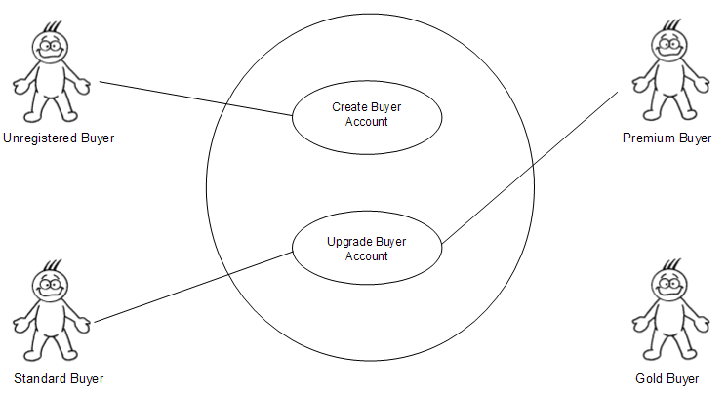
5.1.2 Seller Registration
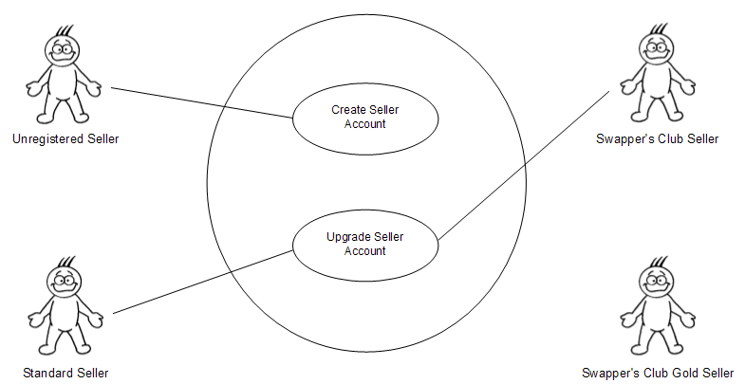
5.1.3 User Account Access and Management
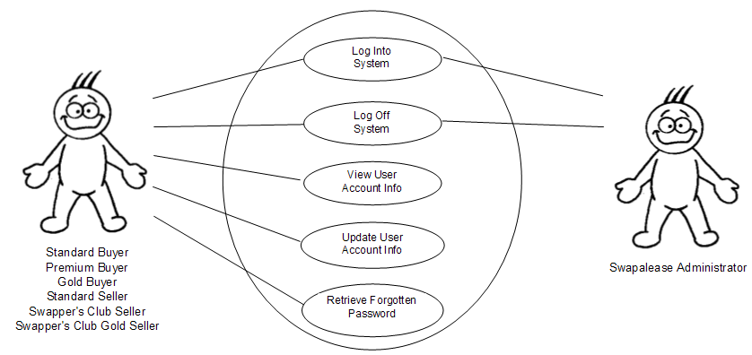
5.1.4 Buyer Vehicle Management
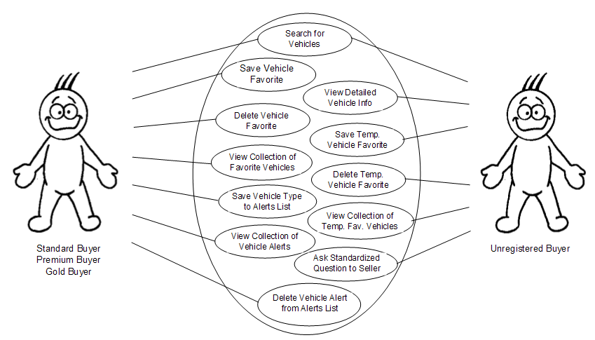
5.1.5 Seller Vehicle Management
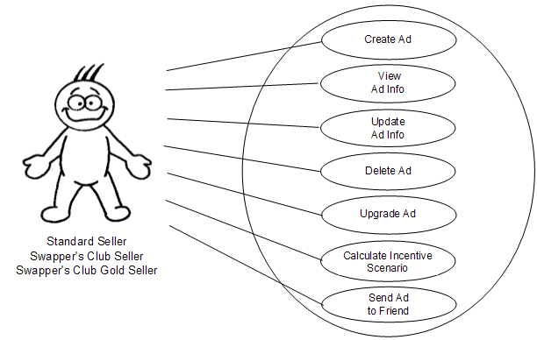
5.1.6 Administrator Management
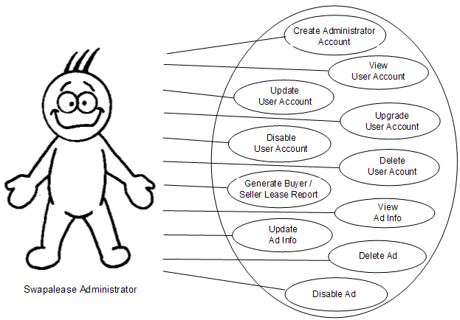
5.1.7 Mailbox Messaging System
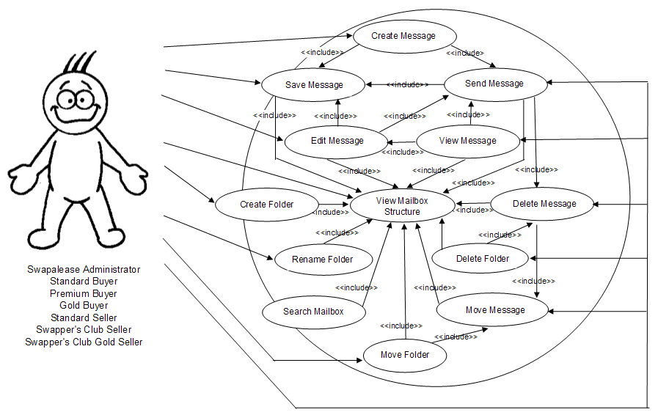
5.1.8 Lease Transfer Process
