CIS 616
Steve Harman
HW #2 – 7-19-04

1) Some reasons for creating models during system development include:
- They allow the analyst to learn more about the system as he/she builds and studies the models.
- Models provide a way of storing information about they system in a way that can later be easily digested.
- Models help facilitate communication between parties involved with the system (such as project team members and with system users). Furthermore, models often help users get a better understanding of the possibilities of the system being built.
- Models also serve as a form of documentation for use by future developers as they extend and/or maintain the system.

2) a. External agent wants something resulting in a transaction: Customer places an order.
b. External agent wants some information: Customer checks order status.
c. Data changed need to be updated: Customer updates account information.
d. Management wants some information: Management checks order status.

3)
Event | Trigger | Source | Activity | Response | Destination
Student registers for classes | Student_ID, Course_ID | Student | Schedule student for courses | Class Schedule | Student
Time to produce grade reports | Temporal | n/a | Gather student grades and print | Report Card | Student

4)
Event | Trigger | Source | Activity | Response | Destination
Agent creates a listing | Listing information | Real Estate Agent | Add listing to system | n/a | n/a
Agent updates a listing | Listing information | Real Estate Agent | Update listing information | n/a | n/a
Agent queries a listing | Search criteria | Real Estate Agent | Search system for listings matching search criteria | Listing reports | Real Estate Agent
Agent deletes a listing | Listing ID | Real Estate Agent | Remove the listing from the system | n/a | n/a
System generates bi-weekly listings | Temporal (15th and 30th of each month) | n/a | Create booklet containing all listings and their information | Listings Booklet | Real Estate Agents

5) 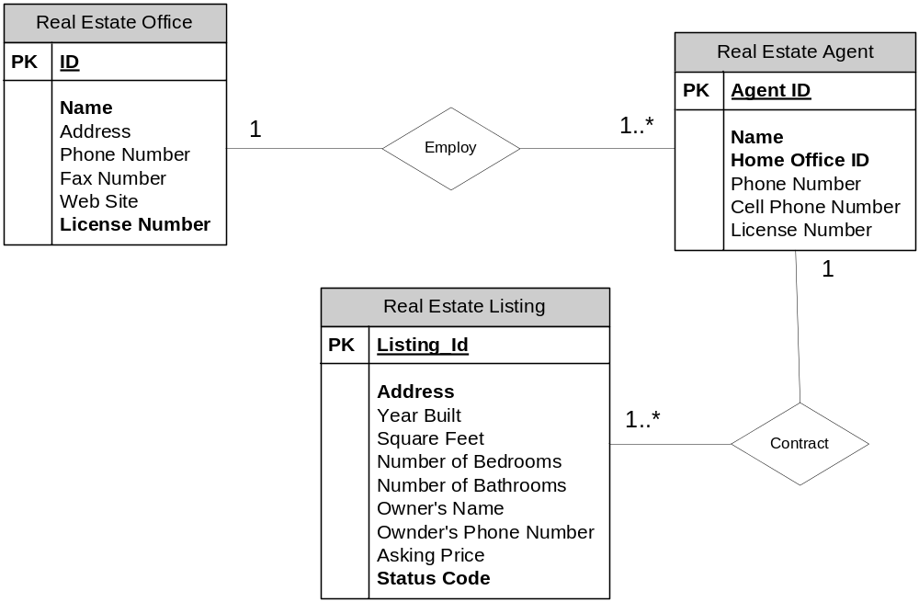

6) Process: a procedure that transforms inputs into outputs.
Data Flow: an arrow that represents data moving from place to place (such as an input to, or output from a process).
External Agent: an agent outside the system that supplies data inputs or accepts data outputs.
Data Store: Data being stored for later use (usually corresponds to a data entity)
Real-time Link: the communications between external agents and processes in the system as the processes are running.

7)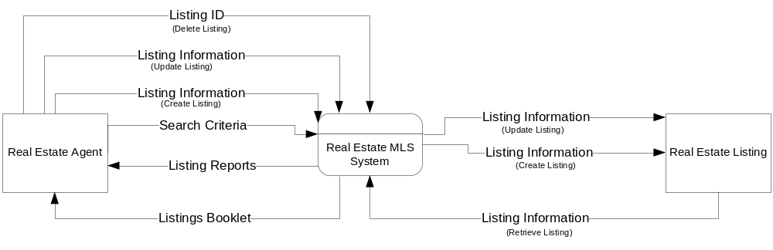

8) I couldn’t find an Appendix D in the book (SAD) in which to find out what the “OABC approach” is, however, after some Googling (http://www.google.com/search?hl=en&lr=&ie=UTF-8&q=oabc+approach&btnG=Search) it seems to be a protocol for communicating messages between people. It stands for “Opening, Agenda, Body, and Closing”. In the opening you state your name and affiliation. In the agenda you identify your message. The body is where you deliver the message you identified in the agenda. And finally, in the closing you give any ending comments.

Again, I hope this is what you were looking for in this question.

