CIS616 Hw#4
Steve Harman
8-13-04

- 10) Polymorphism generally refers to a programming languages ability to process objects differently depending on their class. More precisely, it’s the ability to send the same messaged to several different receivers (classes) and have the message trigger the correct method for each class.

11) Generalization/specialization allows inheritance.

12) Classes can inherit attributes and methods from another class.

13) Inheritance allows the reuse of information from a general class (super class, abstract class, etc...) in the more specific (child) class.

4) This is a whole-part hierarchy. There would be two objects in the system: the family object, and a family member object representing me.

5) This is a generalization/specialization hierarchy. In this situation, there would be only one object (the object representing my account) because the abstract class (the account class) doesn’t have any instances itself, there are only instances of its specialized (child) classes (such as the savings account class).

- Here, you only need two classes… the Family Class which is composed of the aggregation of many instances of the FamilyMember Class. In the family Member class, the attribute Role will determine the type of FamilyMember (such as Father, Mother, Son, Daughter, etc..).
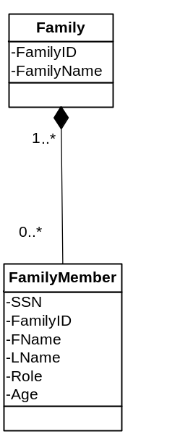Under this model, there would be 9 objects in the system:
Family.Smith + 4 FamilyMember.Smith + Family.Petros + 3 FamilyMember.Smith objects = 9 objects.

- 2) This system contains just one object, a PersonalComputer object.
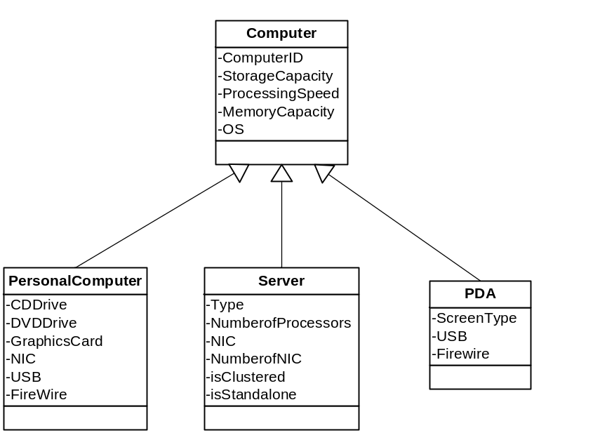

3) The model is far from a true model of a real Personal Computer, but using this model, and assuming that the PC in question has just 1 HDD, 2 Optical Drives, 1 Removable Drive, and 3 Applications, the system has a total of 1+1+1+1+2+1+3= 10 total objects.
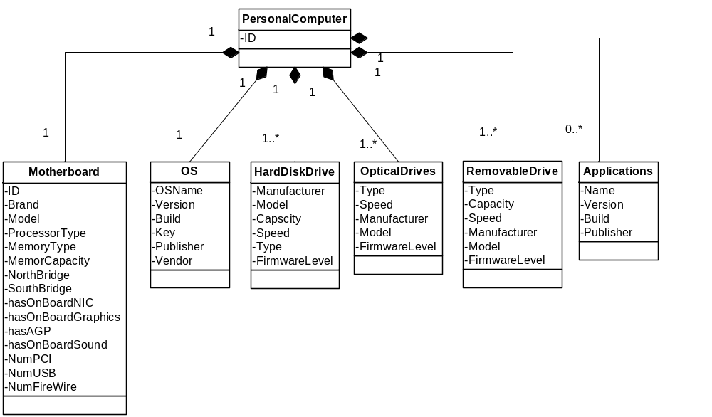

- I believe the usecase scenario was wrong because it seems as though we create a second Contract (to and existing user, and then use that contract the rest of the scenario) and never really finish the first…? Reguardless, this is the sequence diagram as it would go with the scenario as it was on the homework.

