Steven Hornung

AST 191

Activity 3

9.23.13

The Moon.

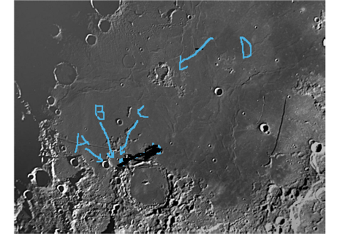

In the first part of activity 3, we were asked to look at an image that contained a portion of the moon’s surface. We were then asked to find four features in the image and relative age date the features. The image is above and I labeled the four features that I will be discussing as A, B, C, and D. In this image, D is the oldest feature. It is a crater that is almost completely covered up. The walls are broken down and nearly non-existent compared to the crater at label A. The Law of Lateral Continuity confirms this because we know that rock layers are deposited the same over large areas so feature A and D both have had the same amount of rock deposited on them which means that D has been there longer and more rock has been deposited on it over time compared to A as it is more covered up. Feature A is the next oldest. The majority of its walls are still in place and it has not been as nearly covered up as D has. We know that A is the next oldest because of the Law of Cross-Cutting. Feature B’s crater wall intrudes on feature A’s wall. That means that feature B came after A was formed and cuts through its wall. That makes feature B the third oldest. Feature C is the youngest feature of the four. Feature C is a small crater in the center of feature B. The Law of Cross-Cutting Relations again confirms that this feature is older than feature B because in order to be able to view B and C as they are, B had to form then C formed on top of it. If it was the other way around we would only see B and C would have been covered up by B.

Europa

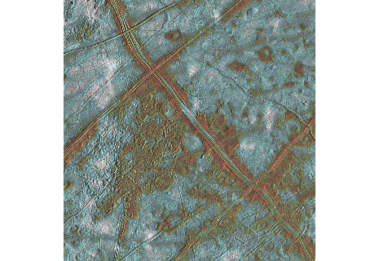

In the second part of activity 3, we were asked to look at an image of Europa and, again, find four features that we could relatively age date. The four features that I am relatively age dating are the 2 parallel large lines. I will refer to the top one as A and the bottom one as B. The single large line from the left top corner to the bottom right I will refer to as C and the smaller line from the top center to the right center of the image will be referred to as D. Feature C is the oldest feature. We know this because of the Law of Superposition. Rock that is on the bottom is the oldest and as we move up, the rock layers are younger. C is the oldest because it lies beneath both feature A and B. Both of these features run across feature C. Feature D runs across feature B so that makes C the oldest. Using the Law of Superposition again, we know that feature B is the next oldest. We know this because feature D lies on top of feature B and feature A sits on top of feature D. That obviously leads to feature D being the next youngest since it sits on top of B and under A. Using the Steno’s Law of Superposition, we have found that the relative age date of the four features are C, B, D, then A.

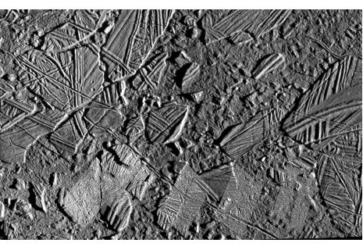

In the last part of activity 3, we were asked to characterize what is happening in the chaotic region focused on by the image above. Focusing on the top left quarter of the image, we can use Steno’s Law of Cross-Cutting Relations to show that there is some tectonic activity in this region. There are multiple fractures, both large and small across this region. A lot of these fractures go through other fractures and we know this because the spots on either side of the fractures are the same but shifted over by the newer fracture. All of these fractures and the clear cross-cutting relations across them show that the chaotic region does in fact have some tectonic activity taking place.