ICYEREKEZO OMS
User Manual
Step by step guide with screenshots
For: everyone who uses the system: factory staff, school administrators and the platform administrator
System: ICYEREKEZO OMS (Operations Management System)
Date: October 2026
Contents
1. Before you start 5
1.1 What you need 5
1.2 How to read this manual 5
1.3 Which part should I read? 5
2. Signing in and getting around 7
2.1 Sign in 7
2.2 Forgot your password 8
2.3 Create a factory account 8
2.4 Change the language 10
2.5 The parts of every screen 11
2.6 Profile and settings 17
2.7 Help and support 18
2.8 Sign out 19
3. Dashboards 20
3.1 Executive dashboard (owner, administrator, manager) 20
3.2 Department dashboards 22
4. Factory owner 24
4.1 Look at stock 24
4.2 Look at purchasing 26
4.3 Look at production and quality 27
4.4 Look at sales and deliveries 28
5. Factory administrator and factory manager 30
5.1 Factory settings 30
5.2 Team and shifts: employees 32
5.3 Production steps (workflow) 35
5.4 Products and recipes 37
5.5 Other pages 38
6. Storekeeper 39
6.1 Answer requests from the factory floor 39
6.2 Stock management 40
6.3 Products and recipes 46
6.4 Incoming goods (receive a delivery) 47
7. Procurement officer 50
7.1 Add a supplier 50
7.2 Save a supplier price 51
7.3 Make a purchase request 52
7.4 Approve a request and make the order 53
7.5 Orders, receiving and payments 55
8. Production planner, manager and supervisor 56
8.1 Create a product recipe 56
8.2 Create a production order 57
8.3 Approve an order 58
8.4 Record the steps 58
9. Garment floor: cutting, sewing, finishing and packing 61
9.1 Cutting operator 61
9.2 Sewing operator 63
9.3 Finishing manager 65
9.4 Packing operator 66
10. Quality control officer 69
10.1 Inspect a packed batch 69
10.2 Record any other inspection 70
11. Machines and maintenance 72
11.1 Register a machine 73
11.2 Report a problem or plan maintenance 74
11.3 Finish a job 74
12. Sales officer and accountant 75
12.1 What the four buttons on an order do 76
12.2 Accept or reject a new order 77
12.3 Upload an invoice 78
12.4 Stock availability 79
13. Financial manager 81
13.1 Approve payment receipts 82
13.2 Orders and invoices 83
13.3 Financial reports 84
14. Logistics officer 86
14.1 At Noguchi 86
14.2 At other factories 89
15. HR officer 94
15.1 Record attendance 94
15.2 Leave requests 95
15.3 Training 96
16. Health and safety officer 98
17. Internal auditor 103
18. Reports: where to click to get your data 104
18.1 The daily factory report 104
18.2 School order reports 105
18.3 Department reports 106
18.4 Quick finder: "I want to know..." 107
19. Platform administrator 108
19.1 Platform overview 108
19.2 Factories 109
19.3 All users 110
19.4 Subscriptions 111
19.5 Audit logs 113
19.6 Announcements and notifications 113
19.7 Support centre 114
19.8 Database backups 115
19.9 System settings 116
20. School administrator 118
21. If something does not work 119

1. Before you start

1.1 What you need
- A computer, tablet or phone with a web browser (Chrome, Edge, Firefox or Safari).
- An internet connection.
- Your sign in details. Factory staff get them from the factory administrator or manager. A school creates its own account.
- The web address of the system. Your administrator will give it to you. You can save it as a bookmark.

1.2 How to read this manual
- Words in bold are names you can see on the screen: buttons, tabs, menu items and field names.
- "Menu, Inventory" means: click Inventory in the menu on the left side of the screen.
- A tab is one of the names in a row near the top of a page. Clicking a tab shows a different part of the page.
- A pop up is a small window that opens on top of the page. You close it with the X at its top right or with Cancel.
- A drop down is a box with a small arrow. Click it to see a list and choose one item.
- The screenshots are black and white and were taken with sample names and numbers. Your screen will show your own data.

1.3 Which part should I read?
Read sections 2 and 3 first, they are for everyone. Then read the part for your role.
If you are... | Read section
Factory owner | 4
Factory administrator or factory manager | 5
Storekeeper | 6
Procurement officer | 7
Production planner, manager or supervisor | 8
Cutting, sewing, finishing or packing operator | 9
Quality control officer | 10
Maintenance technician | 11
Sales officer or accountant | 12
Financial manager | 13
Logistics officer | 14
HR officer | 15
Health and safety officer | 16
Internal auditor | 17
Platform administrator | 19
School administrator | 20 (and the School Portal Guide)
Looking for a report or a number | 18

2. Signing in and getting around

2.1 Sign in
- Open the web address of the system.
- Type your email or username in the first box.
- Type your password in the second box. Click the small eye at the right end of the box to see what you typed.
- Tick Keep me signed in if this is your own computer. Do not tick it on a shared computer.
- Click Sign in.

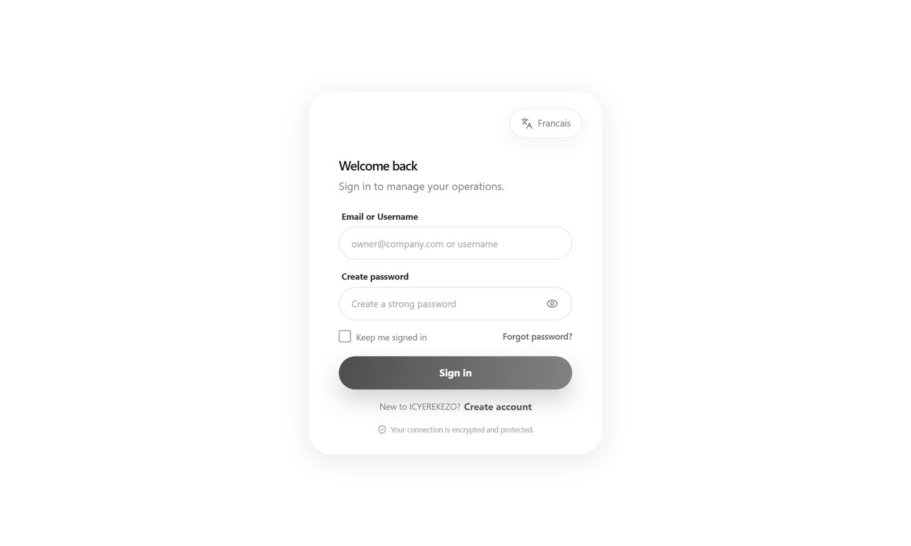
Figure 1. The sign in page
You will see one of these messages if something is wrong:
Message | What it means
The provided credentials are incorrect. | The email, username or password is wrong, or the account is switched off.
Your factory workspace is pending administrator approval. | The factory was registered but the platform administrator has not approved it yet.
The subscription for your factory has expired. | The factory has not paid or renewed. Tell your manager.
The platform is undergoing scheduled maintenance. | The system is closed for a short time. Try again later.
Too many attempts. Please wait. | You tried too many times in one minute. Wait a minute and try again.

2.2 Forgot your password
- On the sign in page click Forgot password?.
- Type your email address and click Send reset link.
- Open the email. It comes from the system. Look in the spam or junk folder if you cannot find it. It can take a few minutes.
- Click the link in the email. Type your new password twice and save it.
- Go back to the sign in page and sign in with the new password.

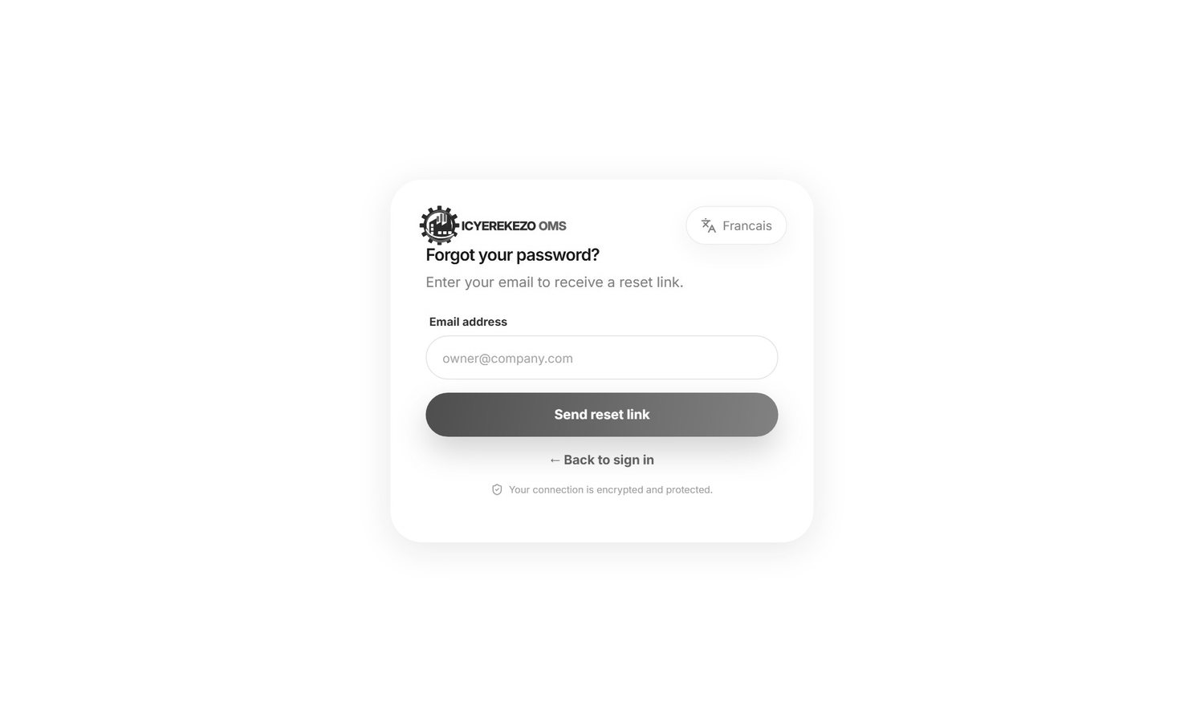
Figure 2. Forgot password
Note The system always shows the same message after you send your email, whether or not the email is known. This keeps accounts private.

A good password has at least 10 characters and contains a capital letter, a small letter, a number and a symbol, for example Kigali#2026x. While you type a new password the screen ticks each rule that is already met.

2.3 Create a factory account
A new factory registers itself like this. The platform administrator can also create a factory for you, in which case you only need your sign in details.
- On the sign in page click Create account.
- Step 1, Account. Type your email address, a password and the password again. Click Continue.
- Step 2, Owner. Type the factory owner's full name. Click Continue.
- Step 3, Factory. Type the factory name and choose the industry type (or choose Other and describe it). Click Create Account.
- The system tells you the account is created and the factory is waiting for approval. You can sign in after the platform administrator approves it.

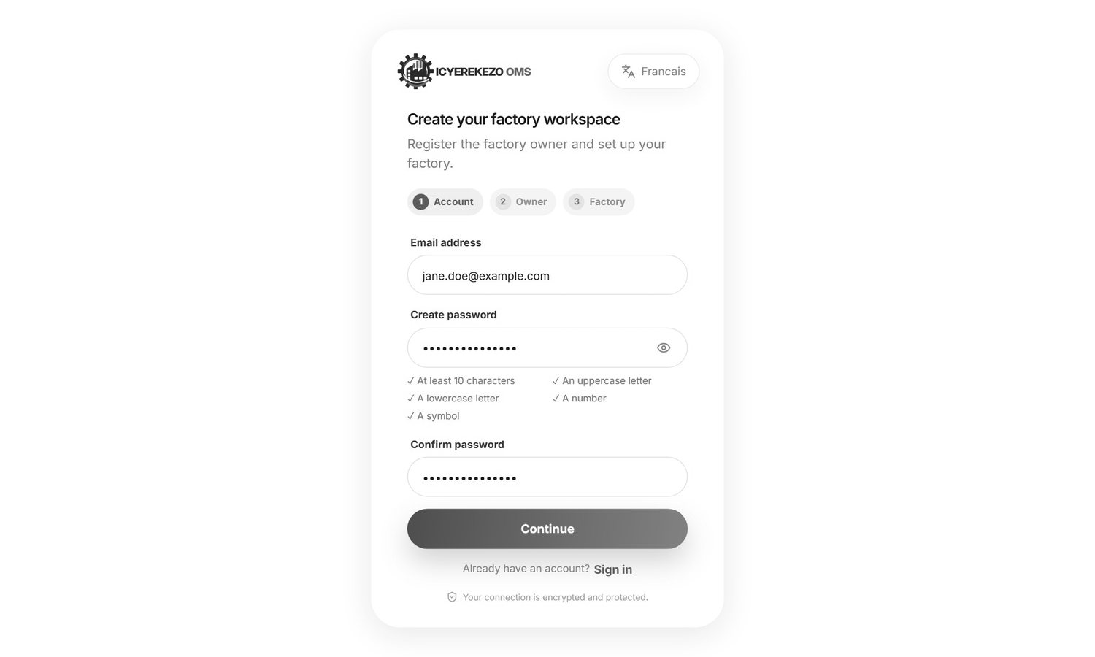
Figure 3. Create account, step 1: email and password
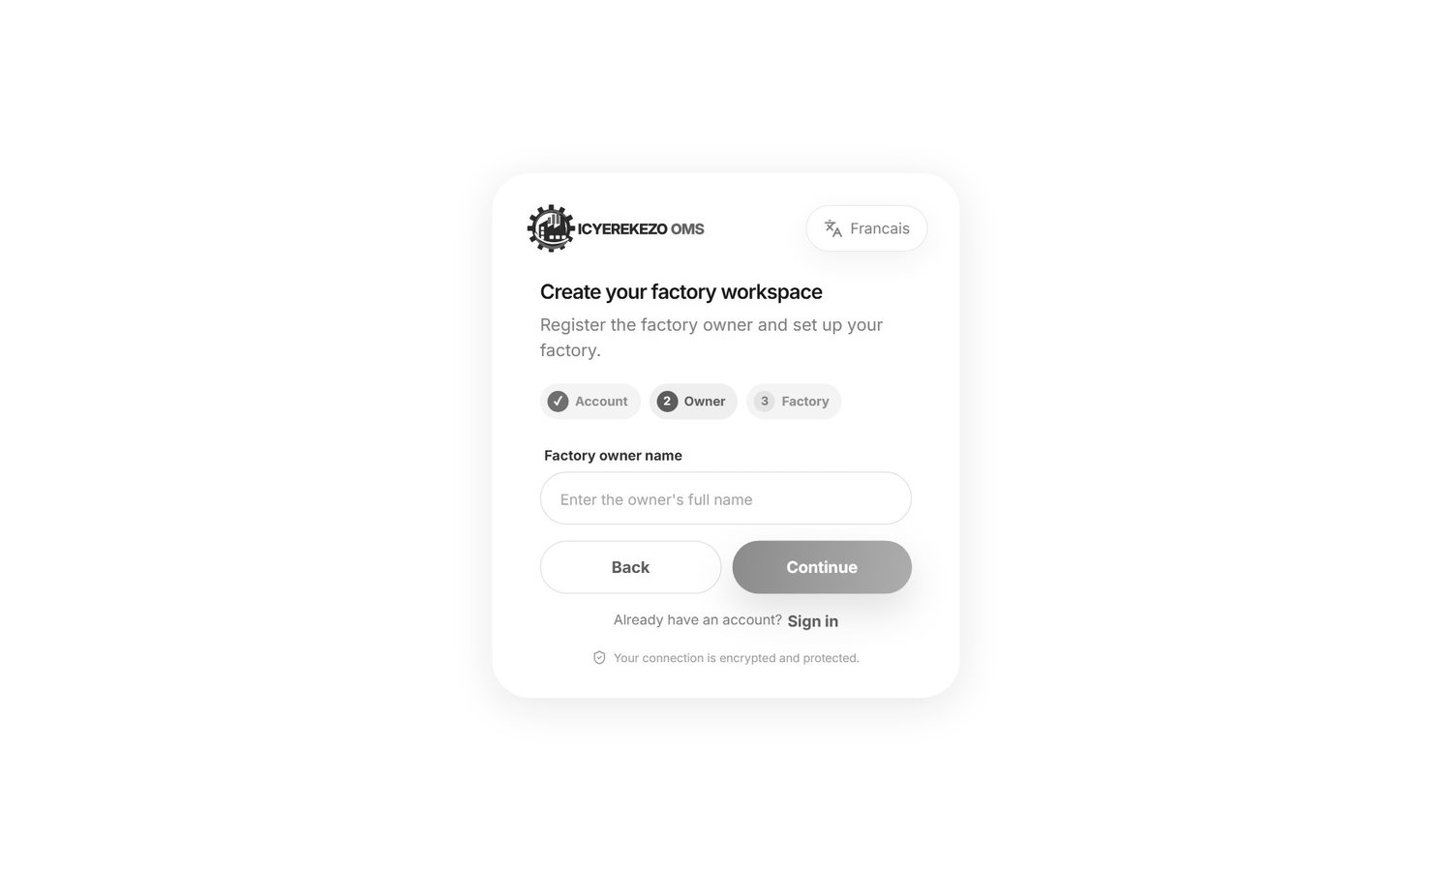
Figure 4. Step 2: the owner name
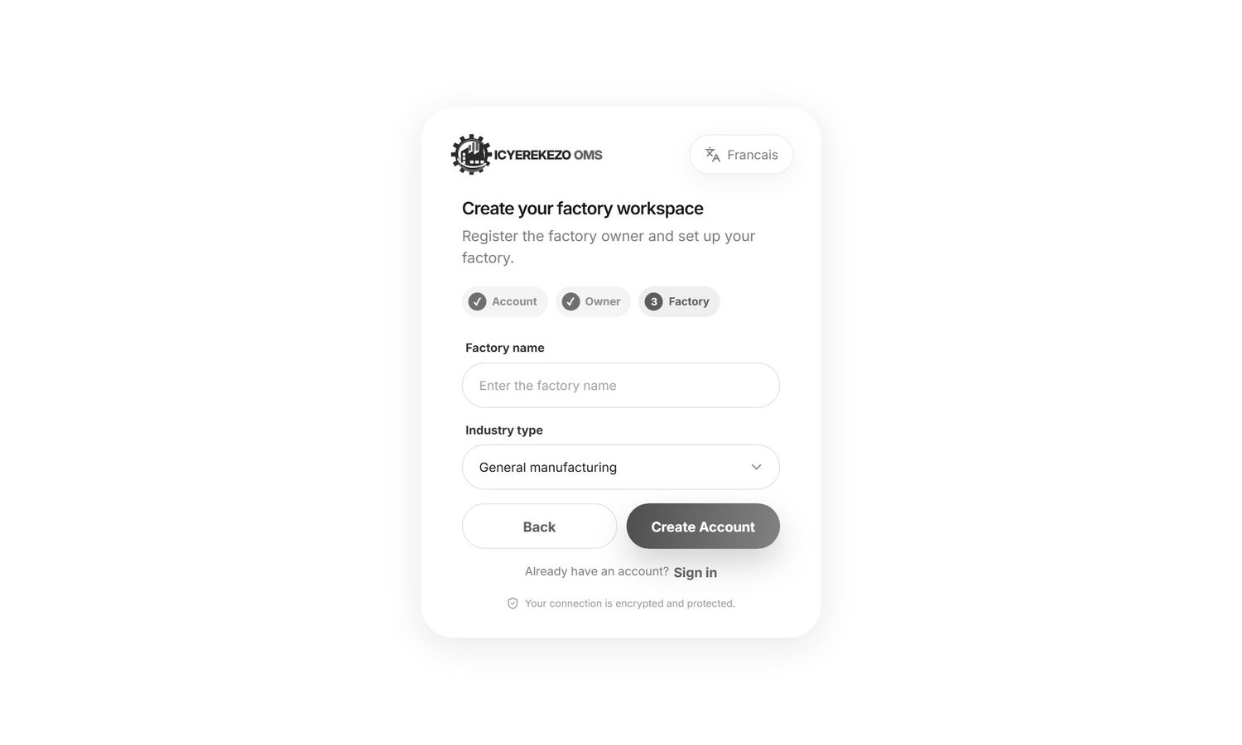
Figure 5. Step 3: factory name and industry

2.4 Change the language
Click FR at the top right to change to French. The button then says EN, click it to change back. The choice is remembered on that browser. You can also set it in Profile and settings, Preferences. On the sign in page use the Francais or English button at the top of the card.
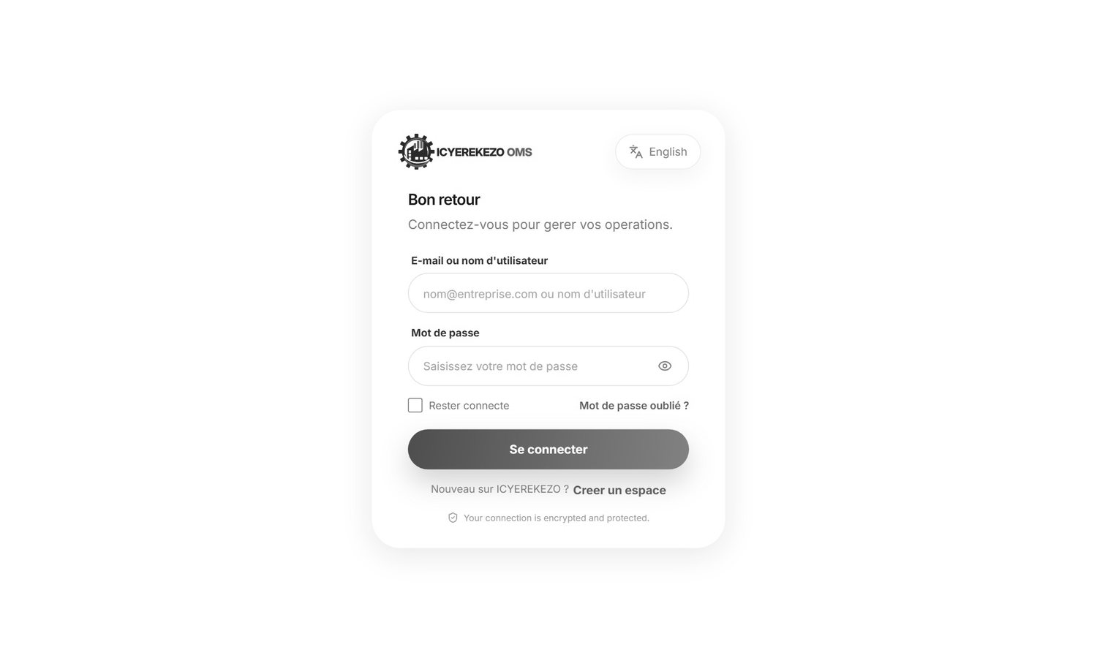
Figure 6. The sign in page in French

2.5 The parts of every screen
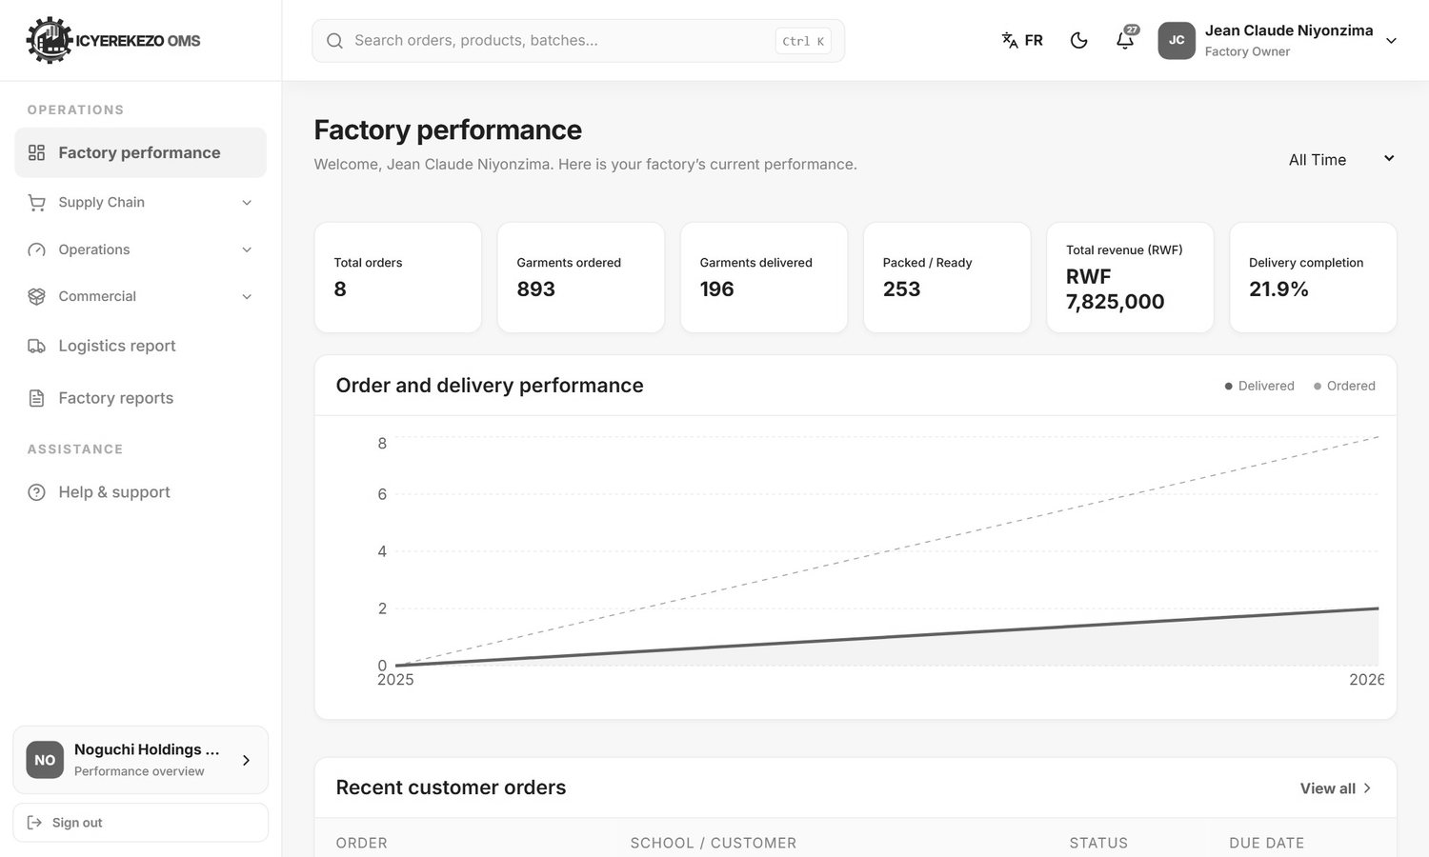
Figure 7. A factory screen: menu on the left, top bar above, page in the middle
Part | Where | What it does
Menu | Left side | Opens the pages you may use. Groups such as Supply Chain open and close when you click them.
Search box | Top, left of centre | Finds pages, items, orders and your support tickets.
FR / EN button | Top right | Changes the language.
Moon or sun | Top right | Light and dark look.
Bell | Top right | Notifications. The red number shows how many are new.
Your name | Top right | Opens the profile menu.
Factory card | Bottom of the menu | Shows your factory. Click it to switch factory if you belong to more than one.
Sign out | Bottom of the menu | Ends your session.

Search
Click the search box (or press Ctrl and K), type at least two letters, and a list of matching pages, items and orders appears. Click one to go there.
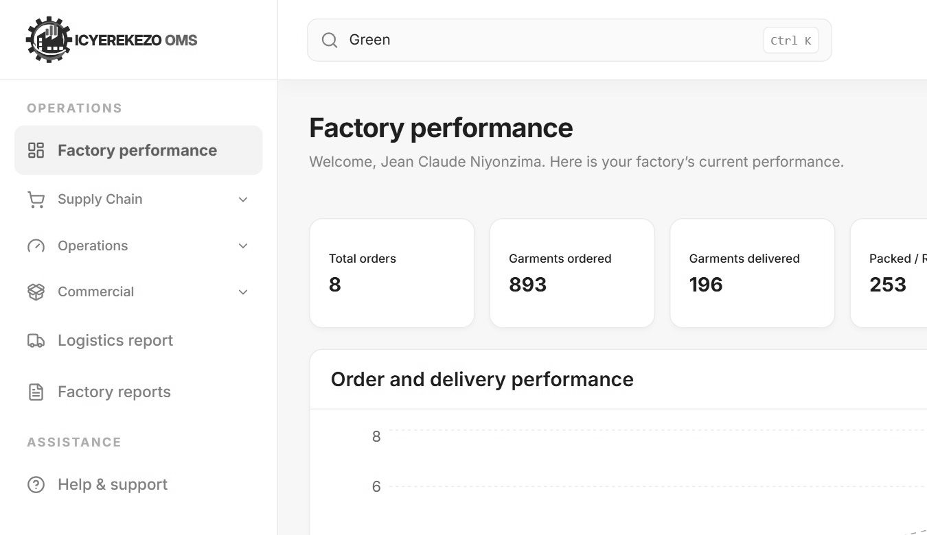
Figure 8. Search results

Notifications
Click the bell. The last notifications are listed. Click one to open the page it is about. Enable browser notifications makes the system show a message on your computer even when the page is closed. View all notifications opens the full list, where Mark all as read clears the new count.
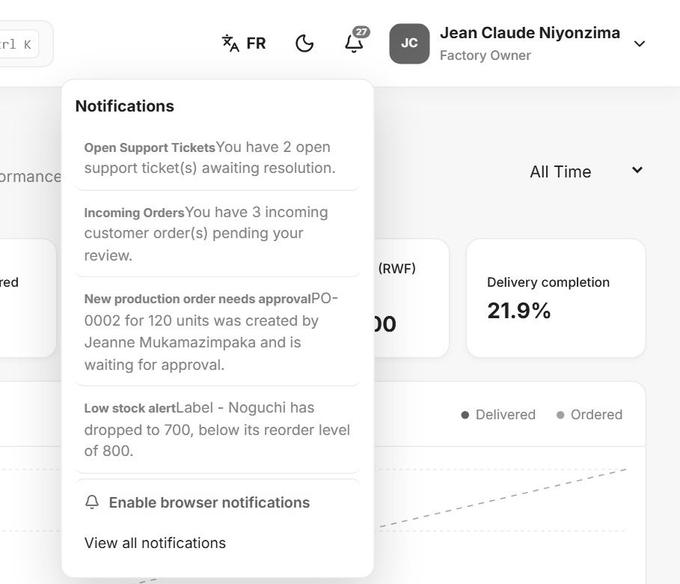
Figure 9. The bell menu
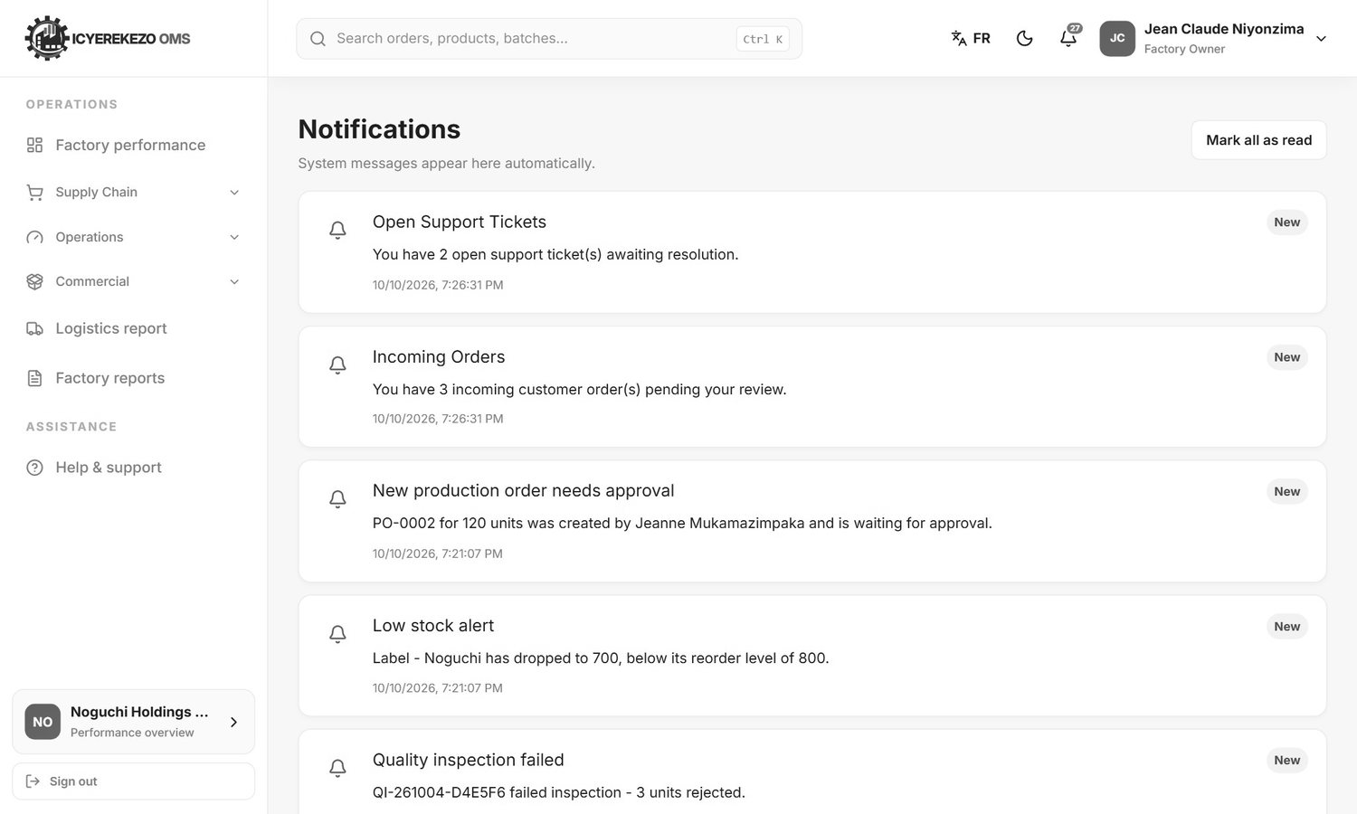
Figure 10. The notifications page

Profile menu
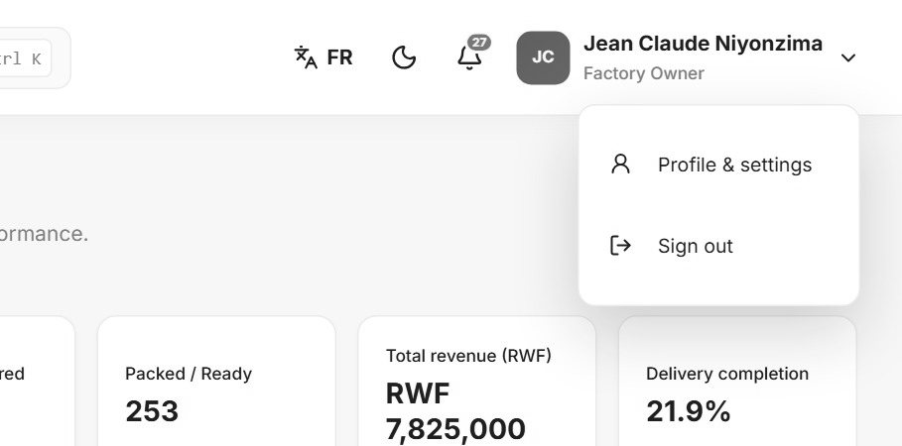
Figure 11. The profile menu
Click your name at the top right. Choose Profile & settings or Sign out.

Dark look and phone screens
The moon button switches to a dark screen that is easier on the eyes at night. On a phone or small tablet the menu hides. Tap the three lines at the top left to open it and the X to close it.
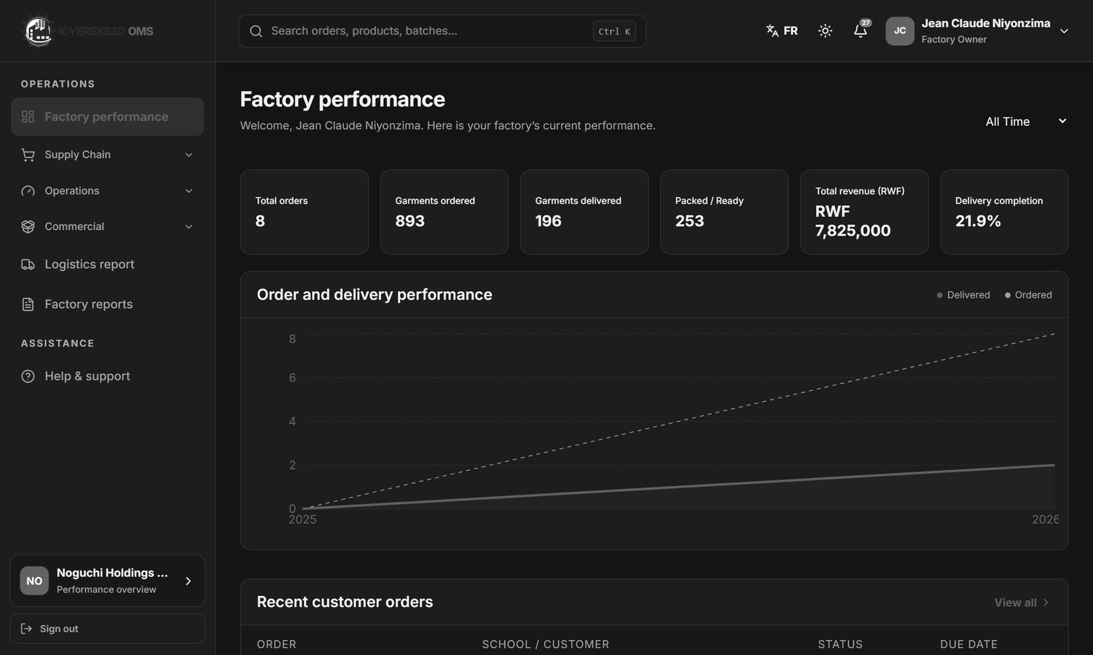
Figure 12. Dark look
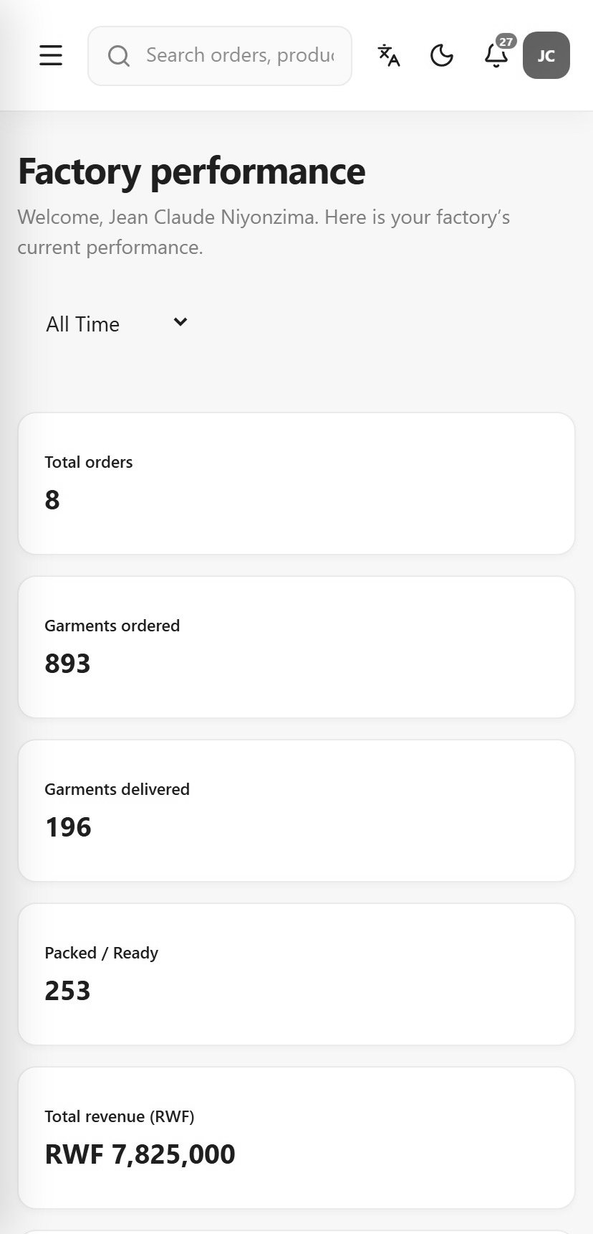
Figure 13. On a phone
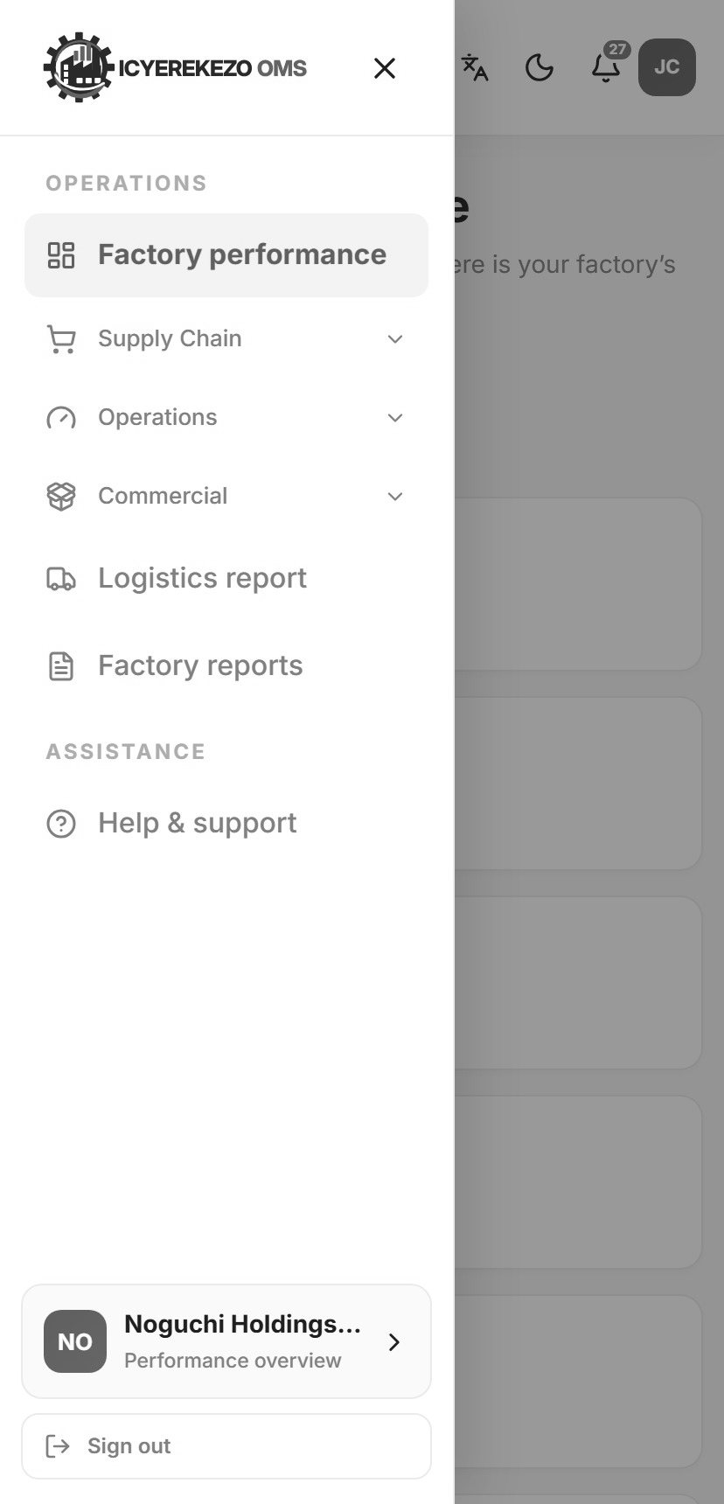
Figure 14. The menu on a phone

Working without internet
If the connection is lost, a bar appears under the top bar. You can keep looking at pages you opened before. Changes you make are kept on the device and sent when the connection returns. The bar then shows how many changes are being sent.

2.6 Profile and settings
Click your name, then Profile & settings. The page has three tabs.
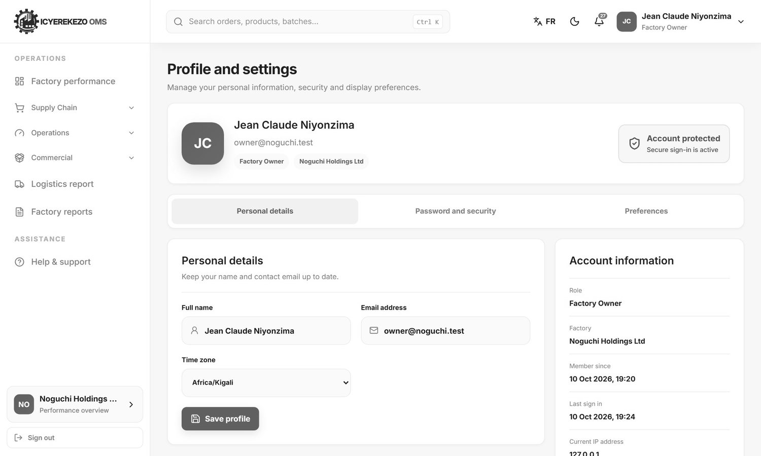
Figure 15. Profile and settings
Tab | What you can do
Personal details | Change your Full name, Email address and Time zone. Click Save profile. The panel on the right shows your role, factory, the date you joined, your last sign in and the address you are connected from.
Password and security | Type your current password, then the new password twice, then save. Use the eye to show or hide what you type.
Preferences | Choose the Language and Light or Dark.

2.7 Help and support
Menu, Help & support opens a private chat with the system administrator.
- Write your message in the box at the bottom. Press Enter to send. Press Shift and Enter for a new line.
- The administrator answers in the same chat. Come back later to read the answer.

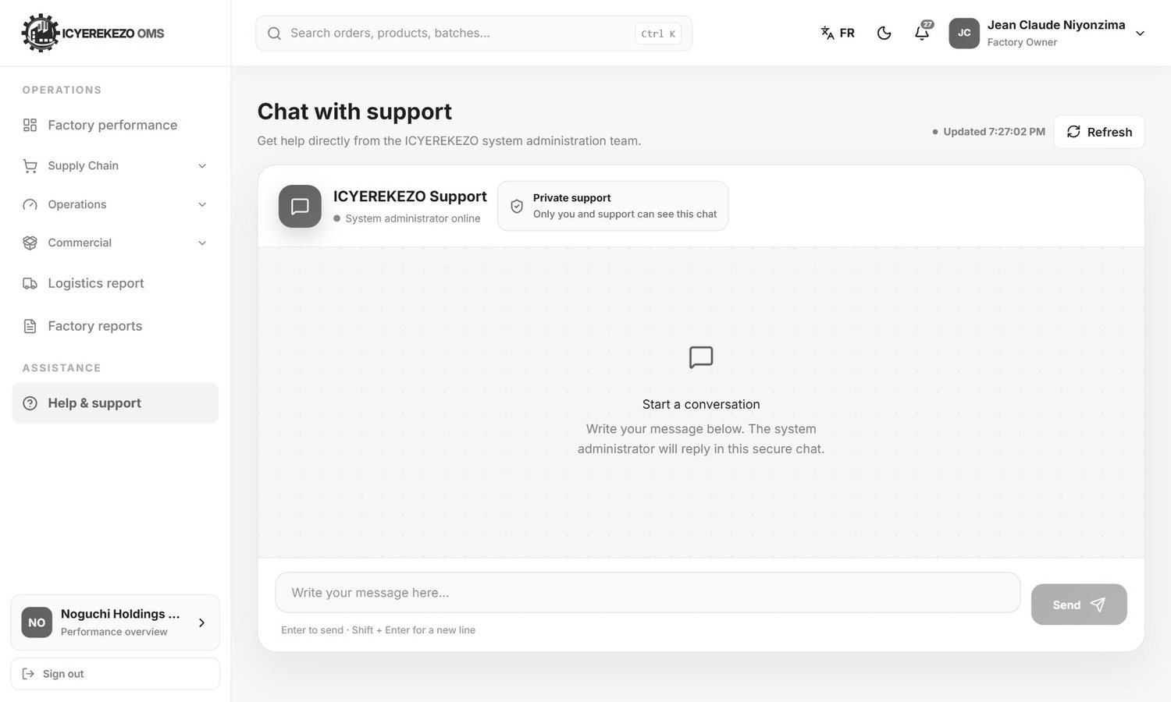
Figure 16. Chat with support

2.8 Sign out
Click Sign out at the bottom of the menu, or open your name menu and click Sign out. Always sign out on a shared computer.

3. Dashboards
The first page after sign in is your Dashboard. It is different for each kind of user.

3.1 Executive dashboard (owner, administrator, manager)
Click Dashboard (for the owner it is called Factory performance).
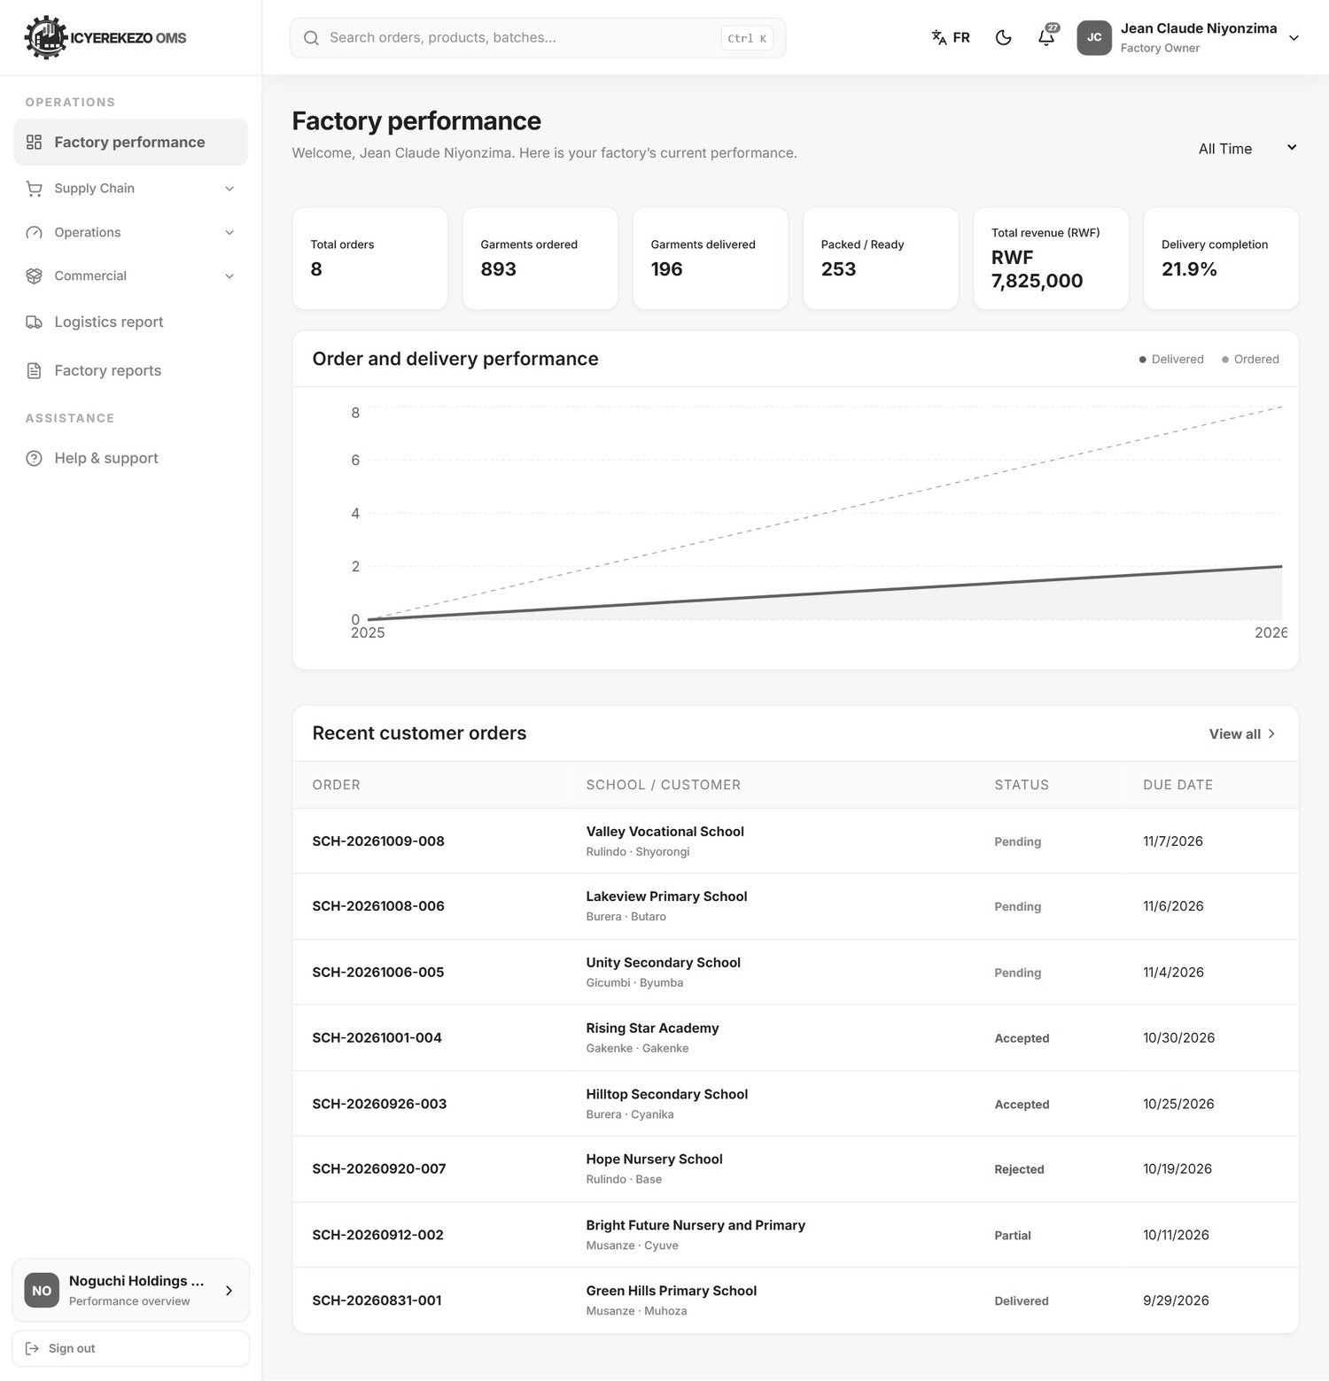
Figure 17. Factory performance
Part | Meaning
Period box (top right) | Daily, Weekly, Monthly, Yearly or All Time. The chart and numbers follow this choice.
Total orders | Number of customer or school orders.
Garments ordered, Garments delivered, Packed / Ready | Quantities from the school orders (at Noguchi).
Total revenue | Total value of orders that are not rejected.
Delivery completion | Delivered quantity divided by ordered quantity.
Order and delivery performance | A chart. The solid line is delivered, the dashed line is ordered.
Recent customer orders | The newest orders. View all opens the order page.

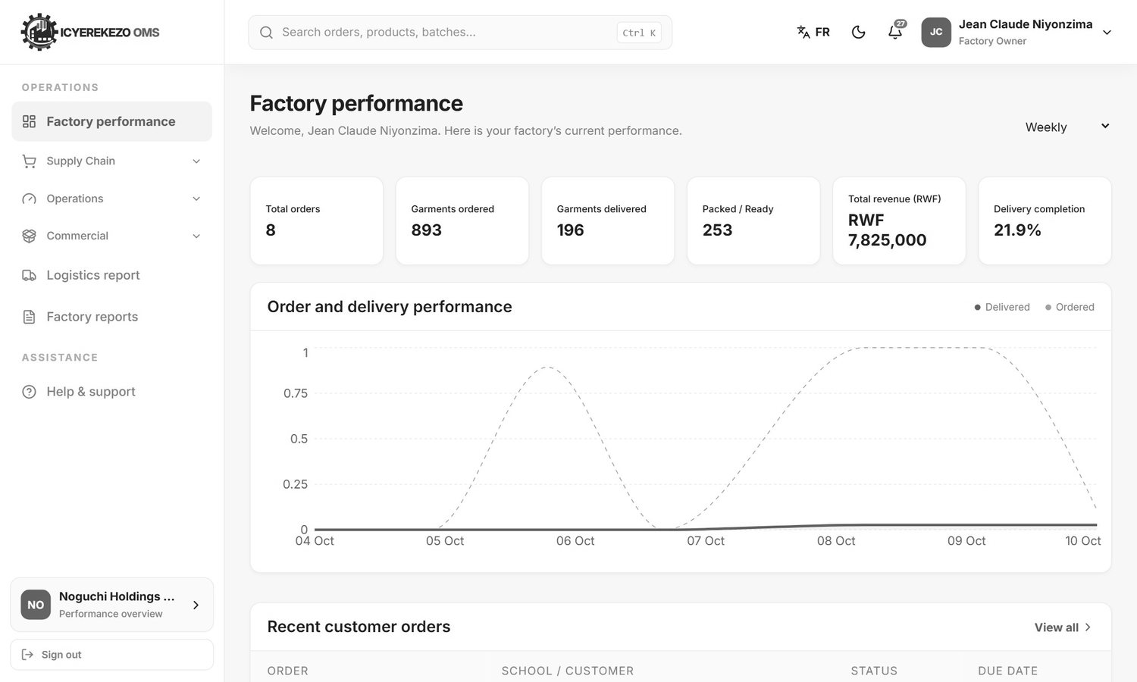
Figure 18. The same dashboard with the weekly period
Other factories see their own figures: production today, open production orders, low stock materials and production completion, plus a production output chart and the active production orders.
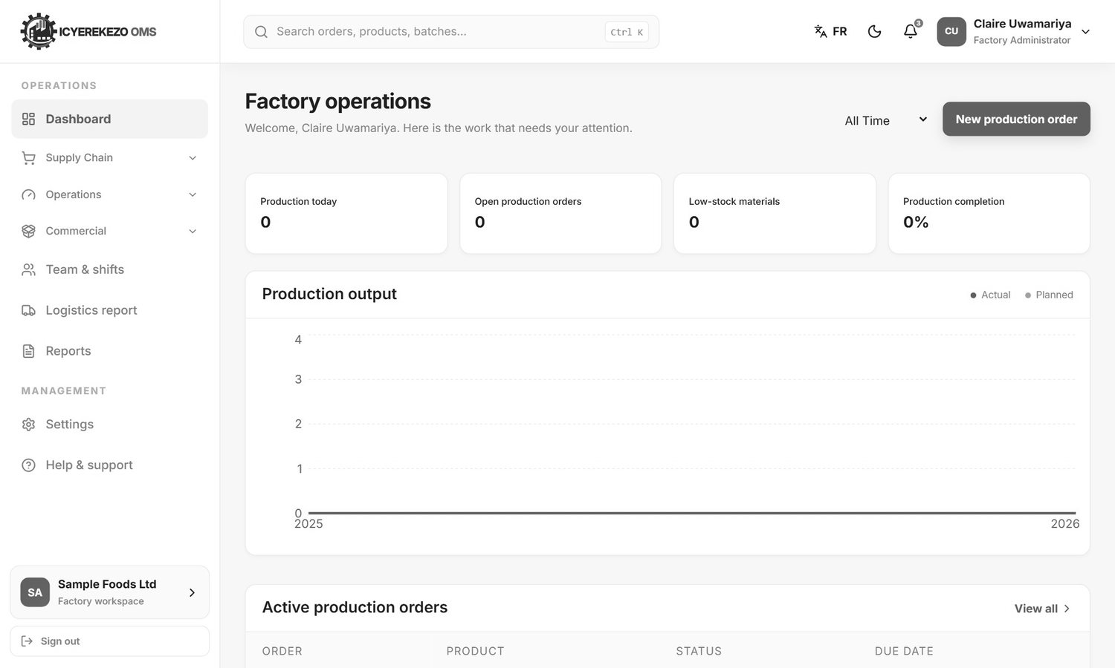
Figure 19. Dashboard of a factory that is not Noguchi (sample factory)

3.2 Department dashboards
Storekeepers, operators, logistics, HR and the other roles get a dashboard for their own area. It shows the work that needs attention, a few numbers for the period you choose (Today, This Week, This Month, This Year, All Time, Specific Date) and charts. The cards at the bottom are shortcuts to the pages you use most.
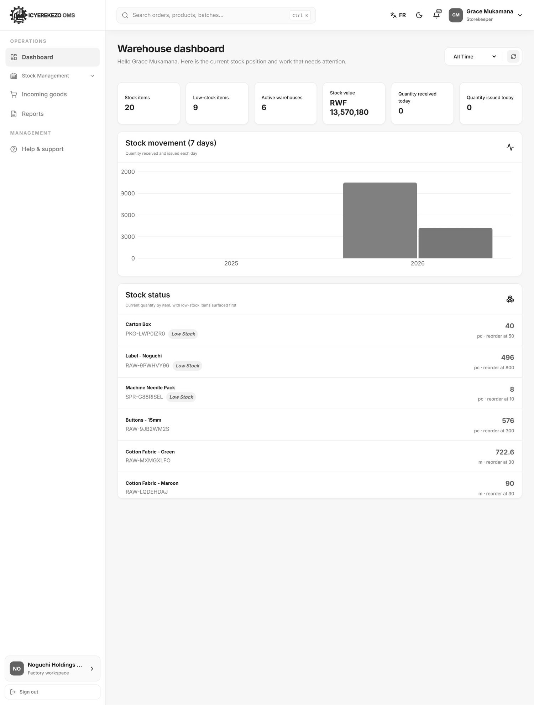
Figure 20. Warehouse dashboard of the storekeeper
Note At the moment the dashboards of the Finishing, Packing and Quality roles can show the message "Server Error" at the top. This is a known fault in the system. Use the work pages in the menu (for example Record finishing). They are not affected.

4. Factory owner
The owner can look at everything that matters but cannot change anything. The menu has these pages.
Menu item | What you see
Factory performance | The executive dashboard (section 3.1).
Supply Chain, Purchasing overview | Purchase requests, orders, goods received and money still to pay.
Supply Chain, Stock overview | All stock items, current stock by warehouse, movements, transfers and counts.
Operations, Production performance | Production orders and step results.
Operations, Quality results | Inspections, pass rate and rejected quantity.
Commercial, Sales overview | All school or customer orders.
Commercial, Delivery overview | Deliveries and the delivery progress.
Logistics report | Quantities by district, sector and school, with print.
Factory reports | The daily factory report (section 18).
Help & support | Chat with the system administrator.

4.1 Look at stock
- Menu, Supply Chain, Stock overview.
- Read the four cards: stock items, warehouses, low stock items and total stock value.
- Click a tab: Stock items, Current stock, Stock movements, Transfers or Stock counts.

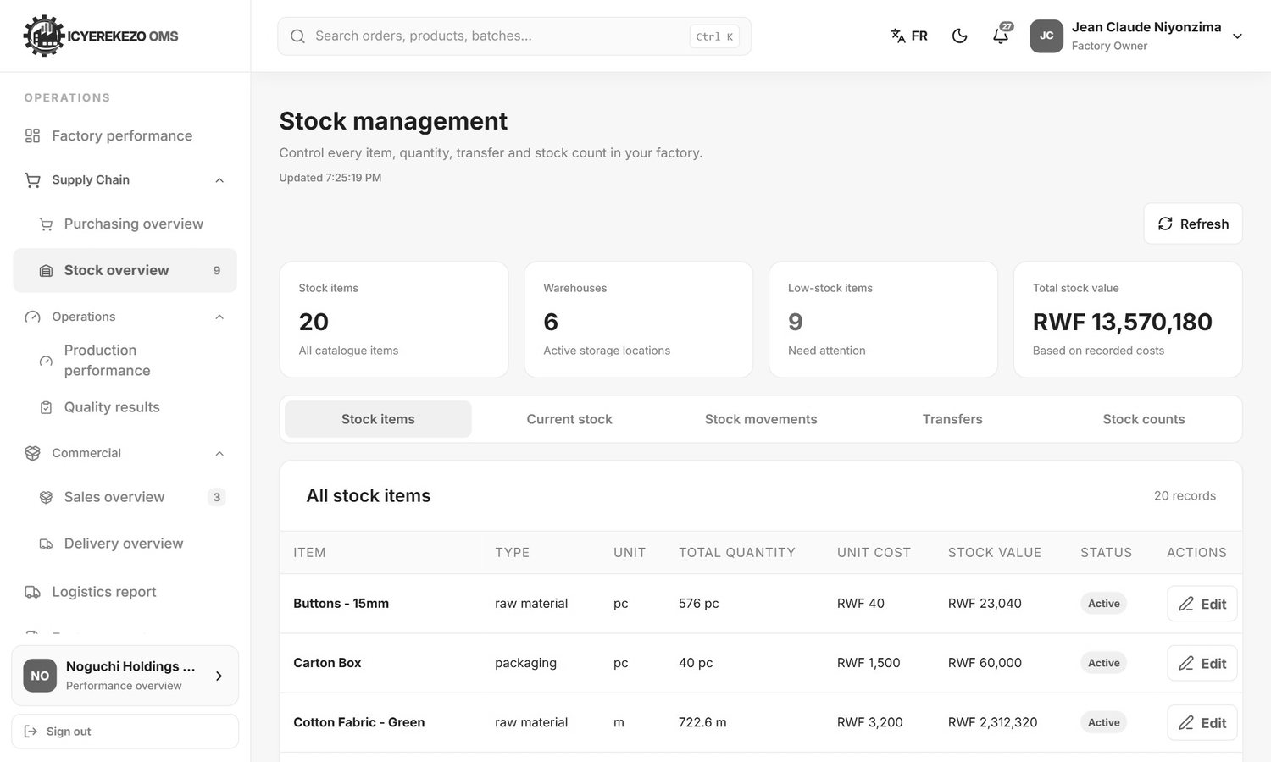
Figure 21. Stock overview
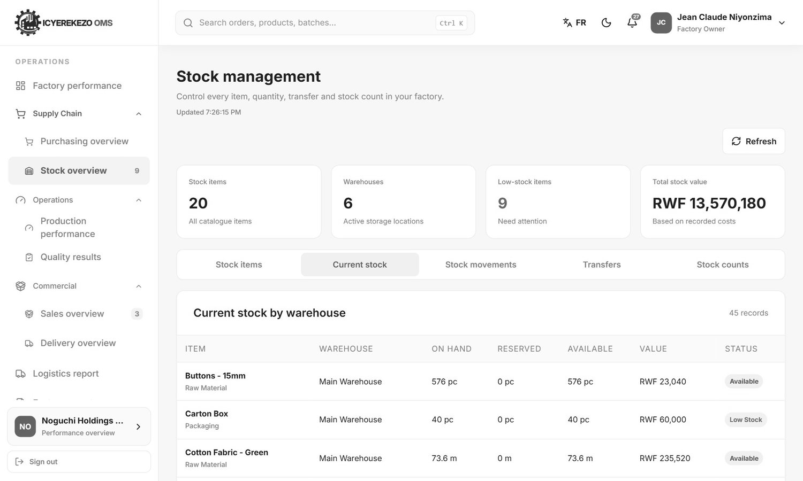
Figure 22. Current stock by warehouse

4.2 Look at purchasing
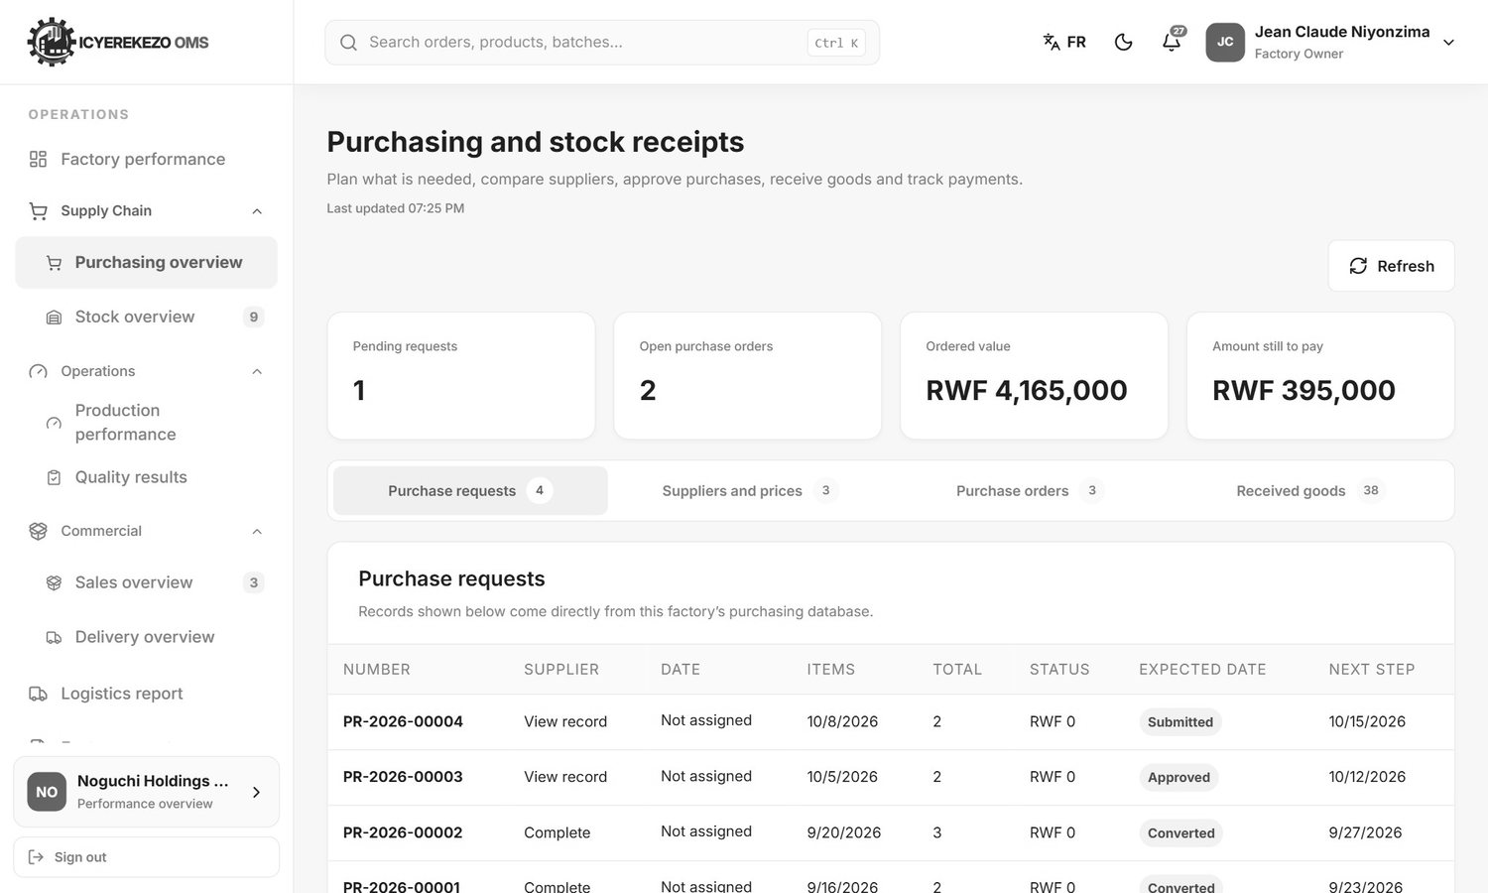
Figure 23. Purchasing overview

4.3 Look at production and quality
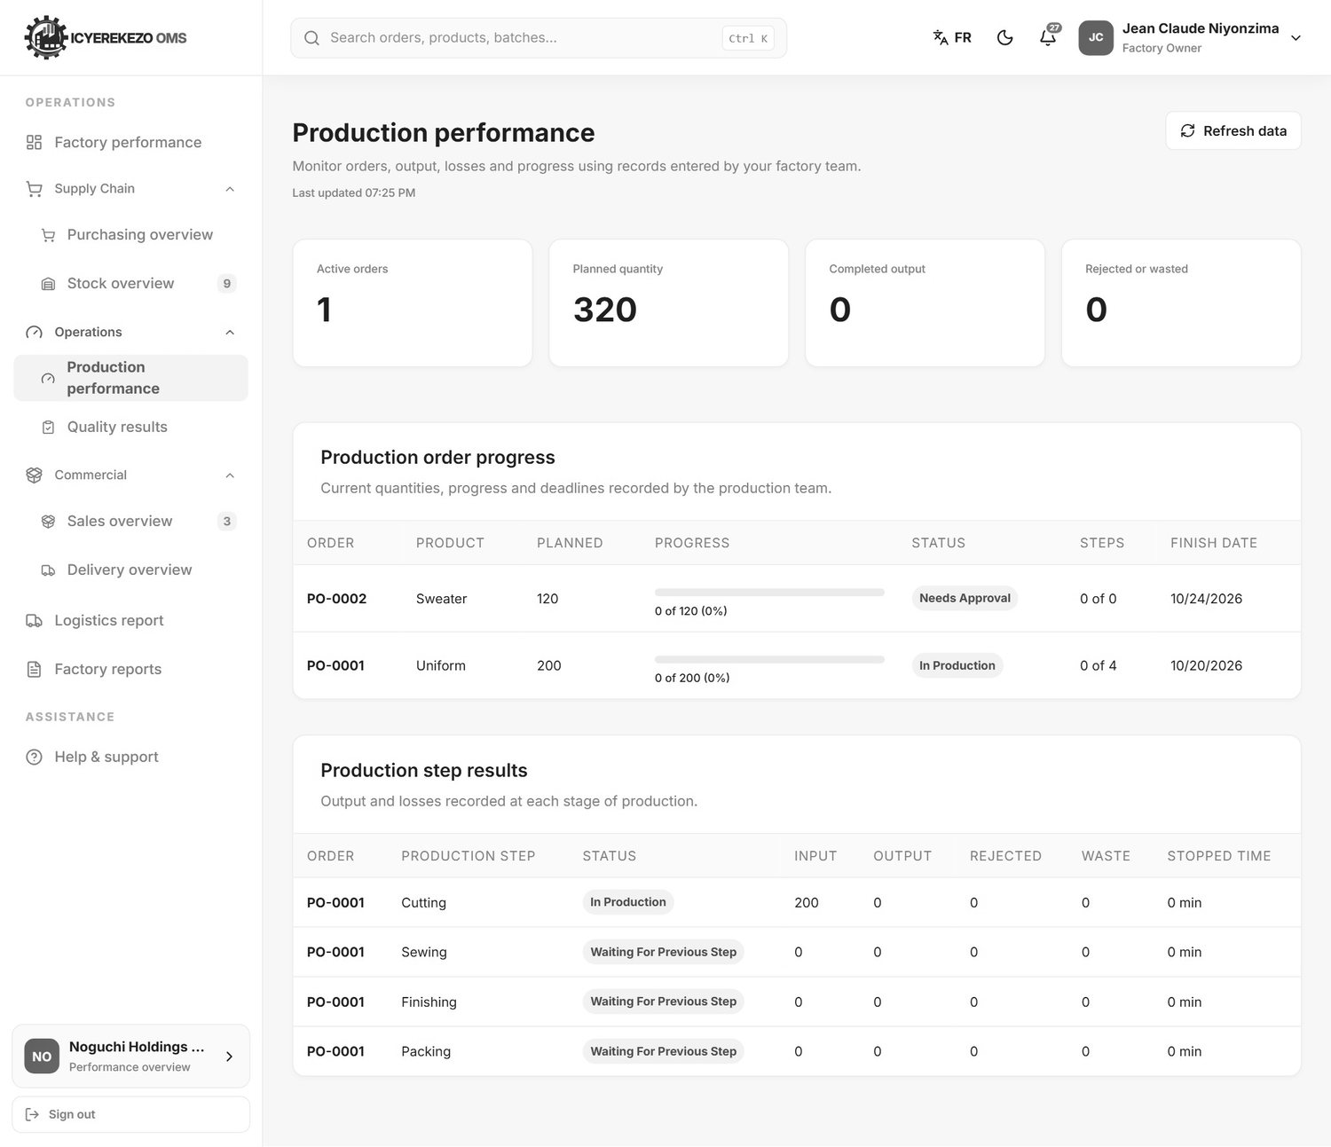
Figure 24. Production performance
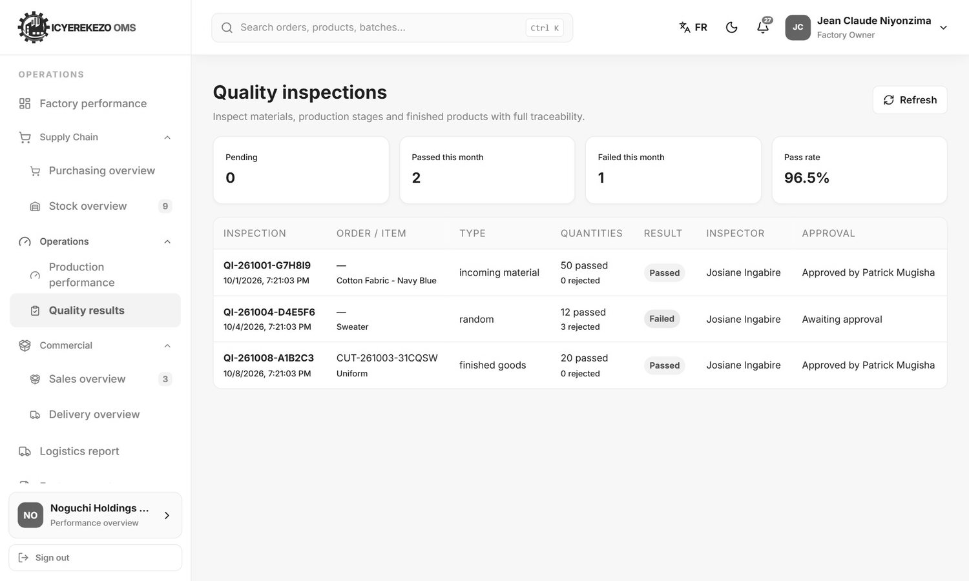
Figure 25. Quality results

4.4 Look at sales and deliveries
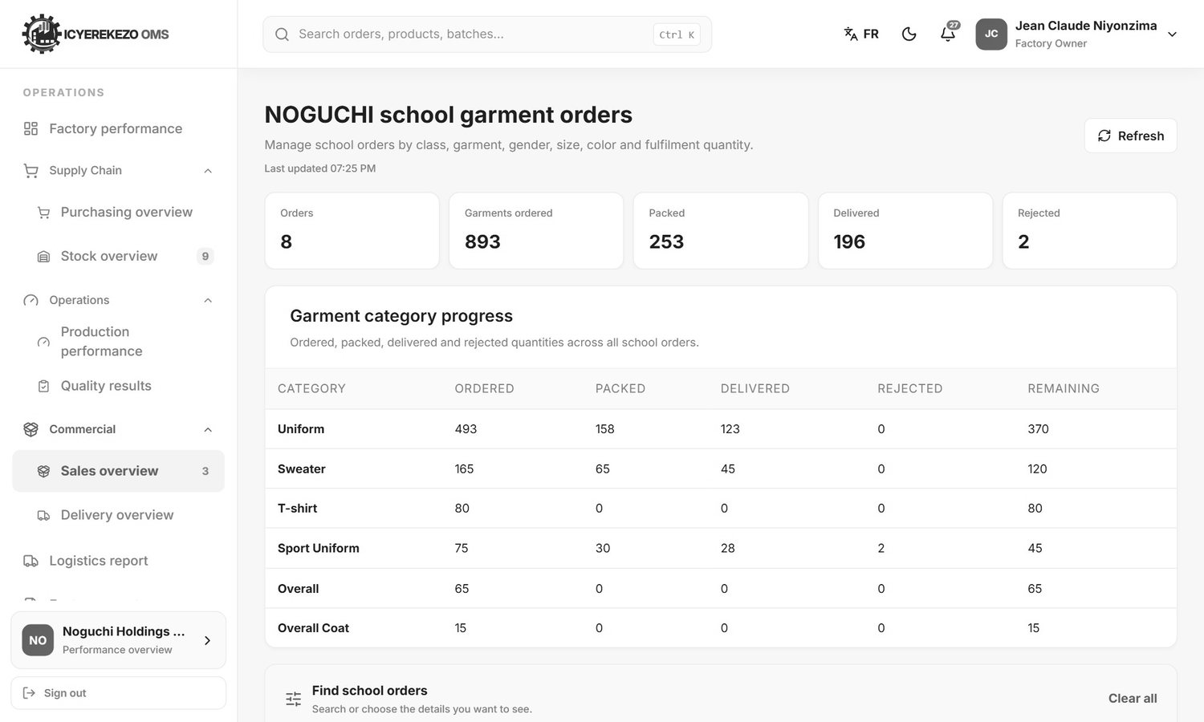
Figure 26. Sales overview: school orders
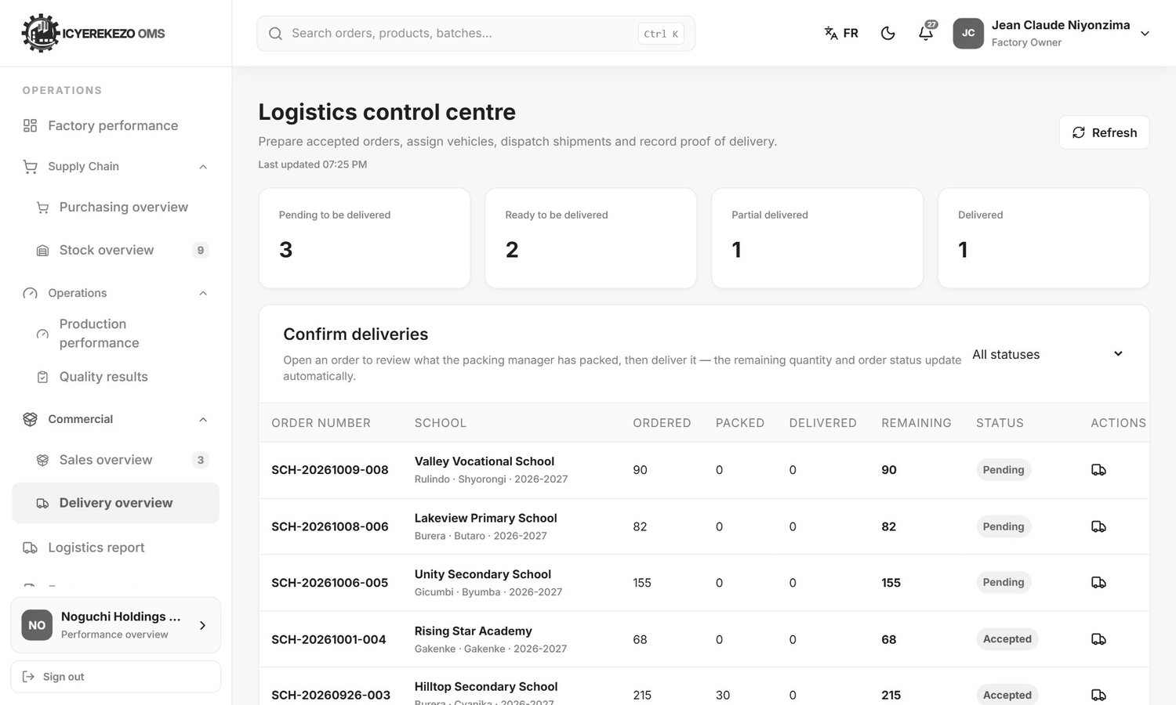
Figure 27. Delivery overview

5. Factory administrator and factory manager
The administrator has every page. The manager has a shorter menu: Dashboard, Production Configuration, Team and shifts, Logistics report, Reports, Settings and Help and support.

5.1 Factory settings
Menu, Settings. The page has five sections. Click Save settings (top right) after you change anything.
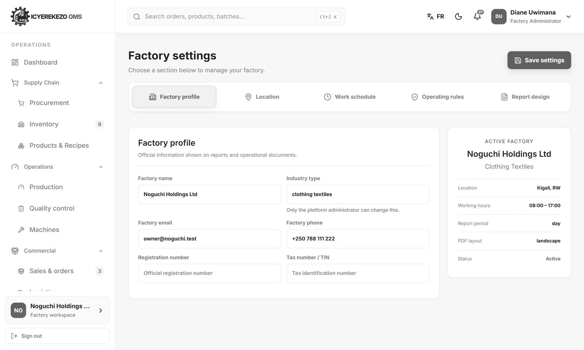
Figure 28. Factory profile
Section | Fields
Factory profile | Factory name, Industry type (only the platform administrator can change it), Factory email, Factory phone, Registration number, Tax number / TIN. The panel on the right shows the active factory.
Location | Street address, City, Country code, Currency (RWF, USD, EUR, KES or UGX), Time zone, Default language.
Work schedule | Opening time, Closing time and the working days (click a day to switch it on or off).
Operating rules | Production order prefix (for example PO), Low-stock alert level, and three switches: Require production approval, Require quality release, Allow stock below zero.
Report design | Report title, Report footer, Default report period, PDF page layout, the labels for received and completed quantities, Product details to record, Common units, and switches to show summary totals, the daily work register, department totals, the stock register and guidance. You can also choose which departments appear in the report.

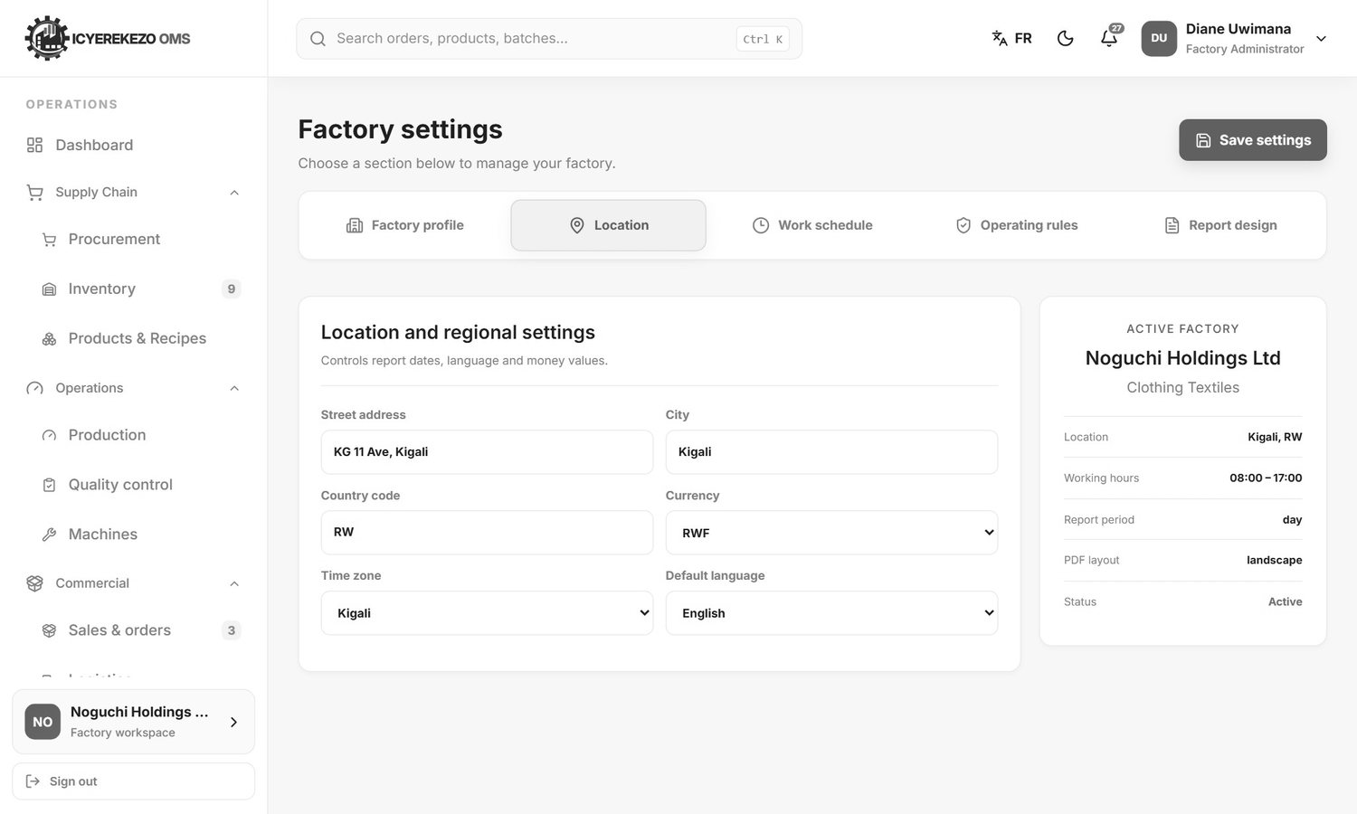
Figure 29. Location and regional settings
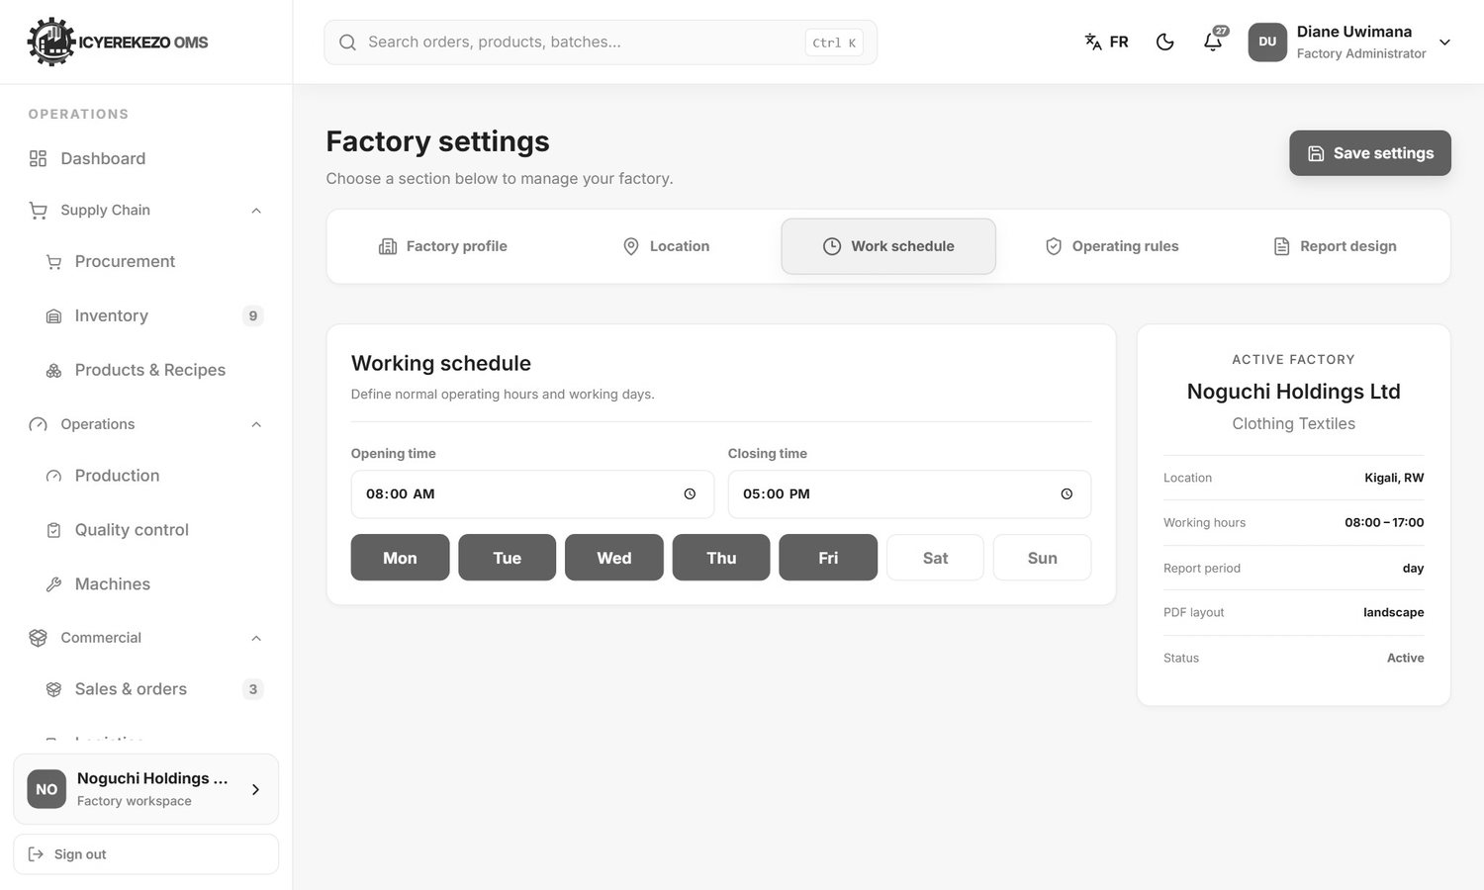
Figure 30. Working schedule
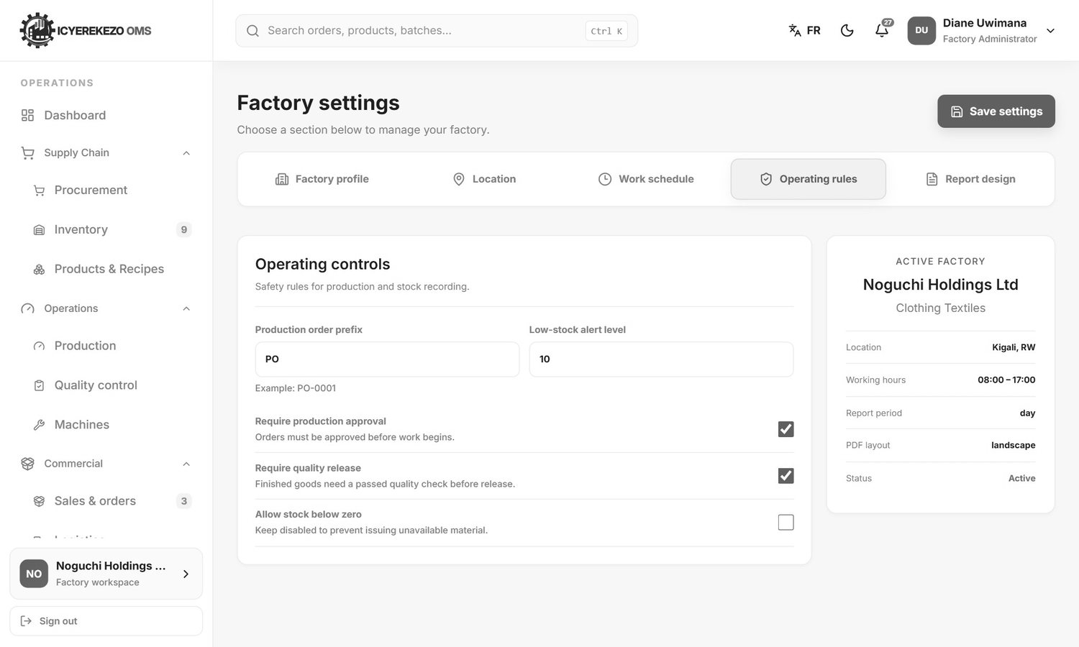
Figure 31. Operating rules
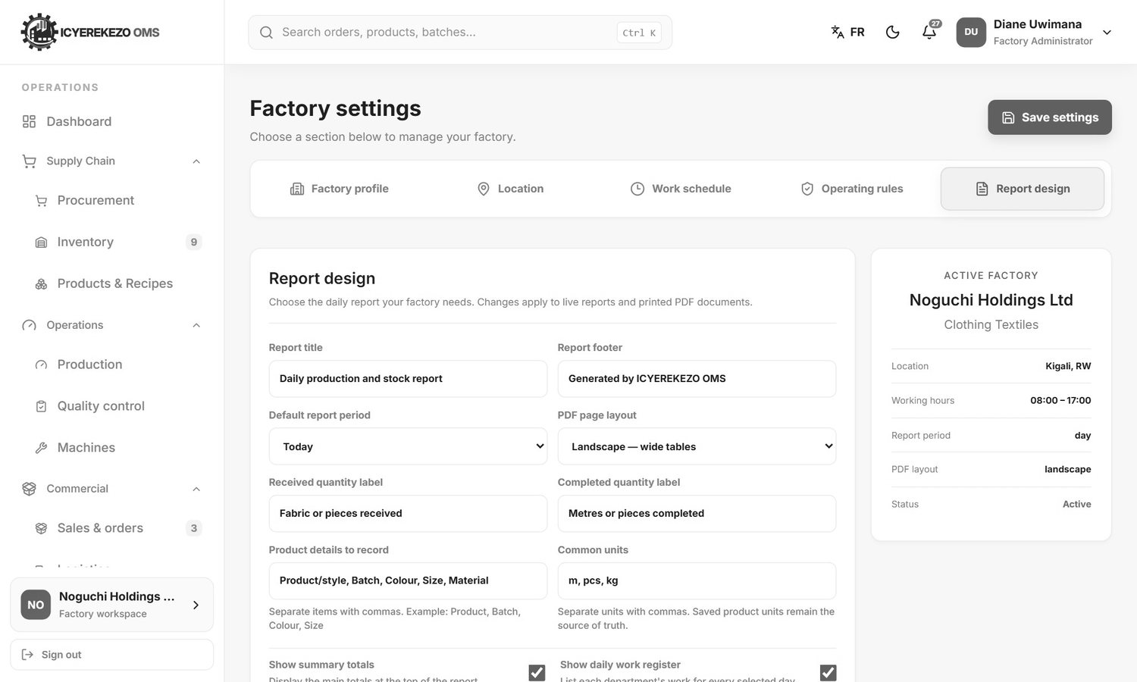
Figure 32. Report design
Warning Do not change the factory name of Noguchi Holdings Ltd. Some features of the school ordering system look for that exact name.

5.2 Team and shifts: employees
Menu, Team & shifts. This page lists everyone who works in the factory.
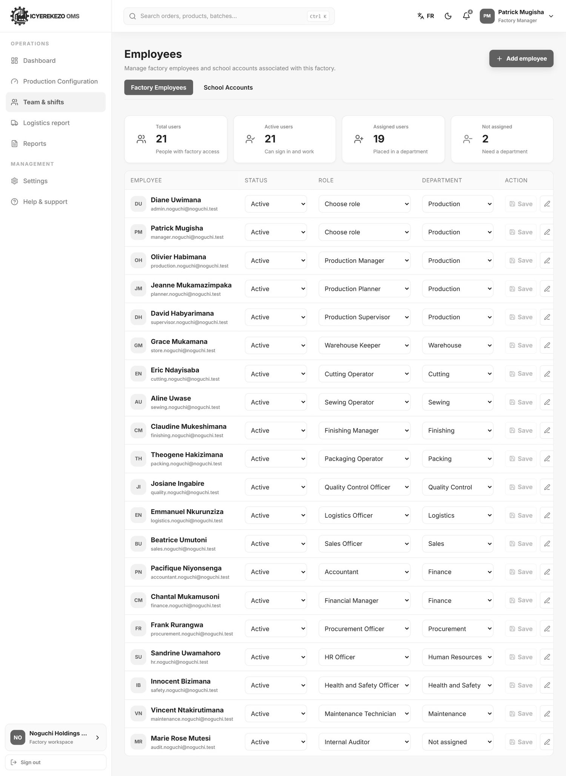
Figure 33. Employees
The four cards show total users, active users, users placed in a department and users not yet in a department. Each row is one employee: name and email, Status, Role, Department and Action.

Add an employee
- Click Add employee (top right).
- Type the Full name and the Email address.
- Choose the Role. This decides what the person can see and do. See section 2 of the System Documentation for the roles.
- Choose the Department, or leave it as Not assigned.
- Type a Temporary password twice. It needs 10 characters, with capital, small letter, number and symbol.
- Click Create employee. Give the person their email and the temporary password. They should change it at their first sign in (section 2.6).

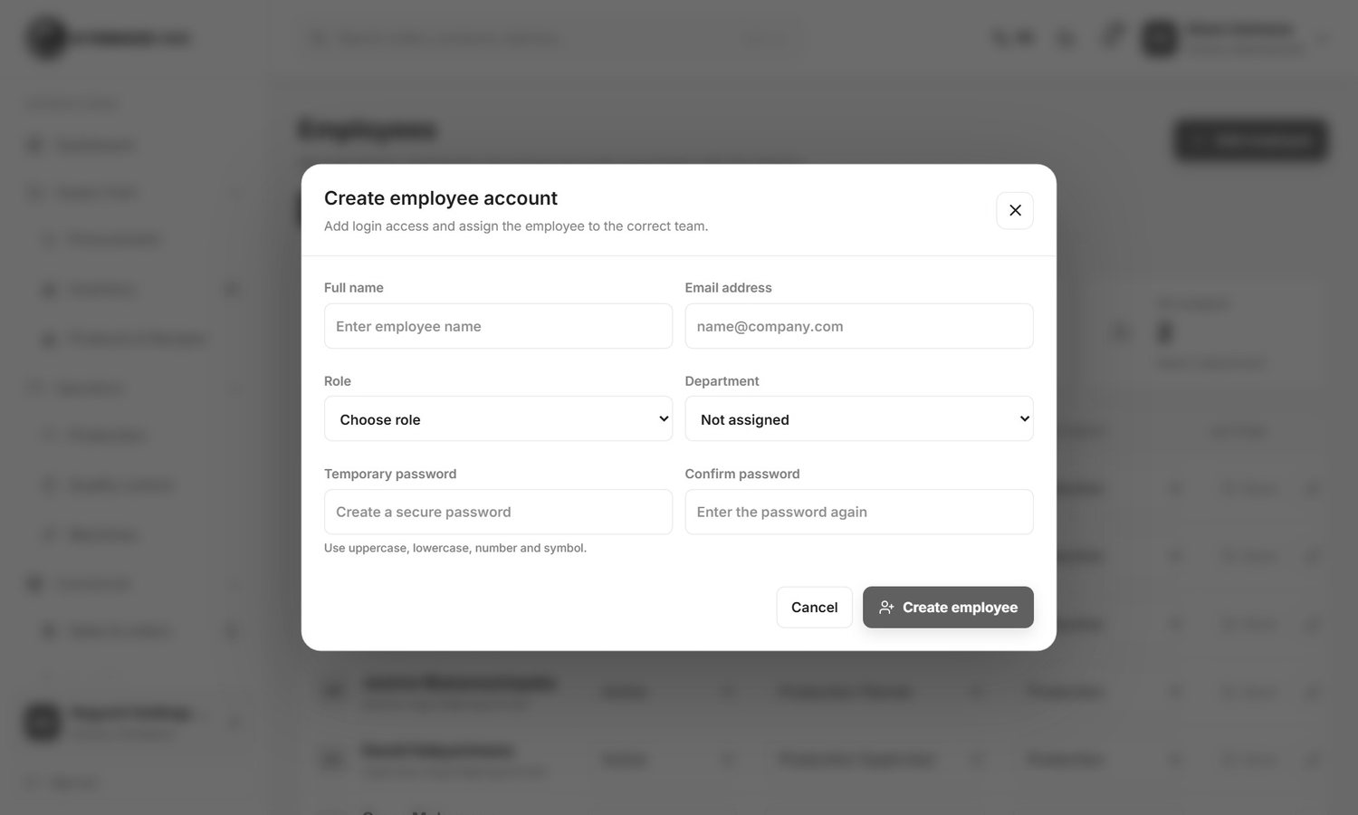
Figure 34. Create employee account

Change a role, department or status
- Find the person in the list.
- Change Status (Active or Inactive), Role or Department with the drop downs on the row.
- Click Save at the end of the row.

An inactive person cannot sign in. Use the pencil button to edit the name and email. Reset Password lets you set a new password for the person. Remove takes the person out of the factory. You cannot remove yourself and you cannot change the factory owner here.
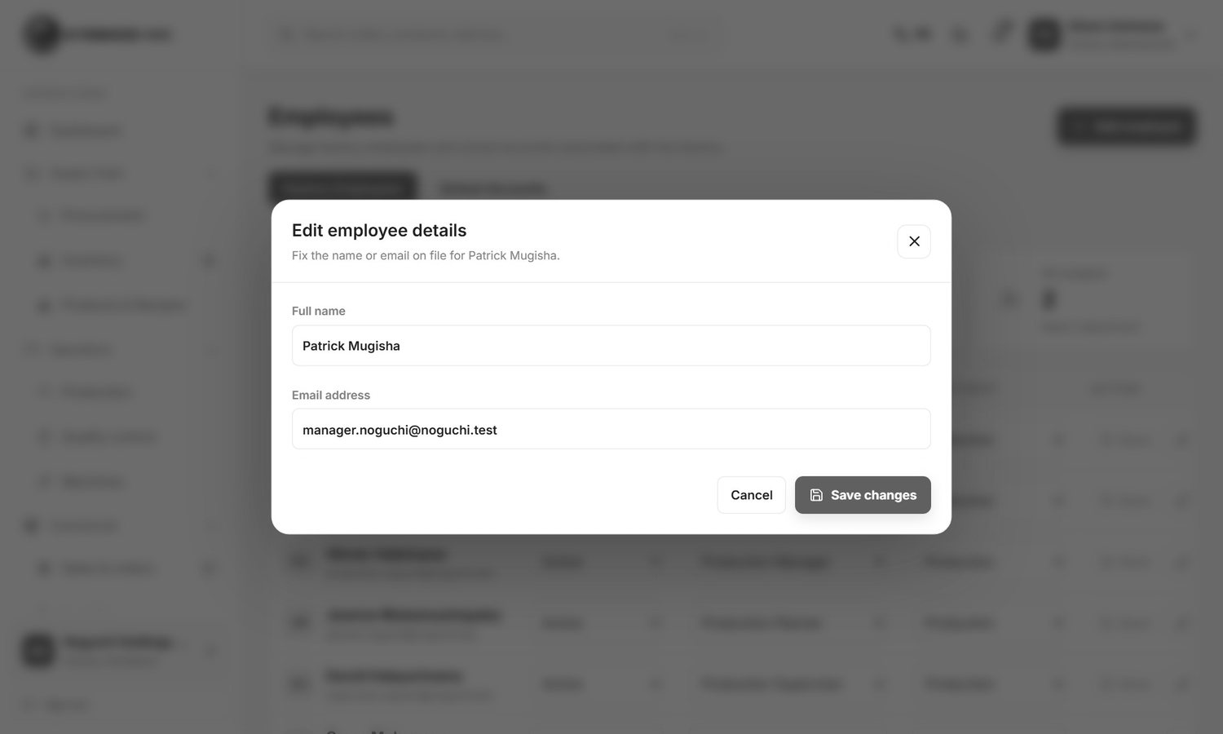
Figure 35. Edit employee details (pencil button)

School accounts
The second tab, School Accounts, lists the school administrators linked to the factory. You can search by school or user name and filter by district and sector. The only action on a row is Reset Password.
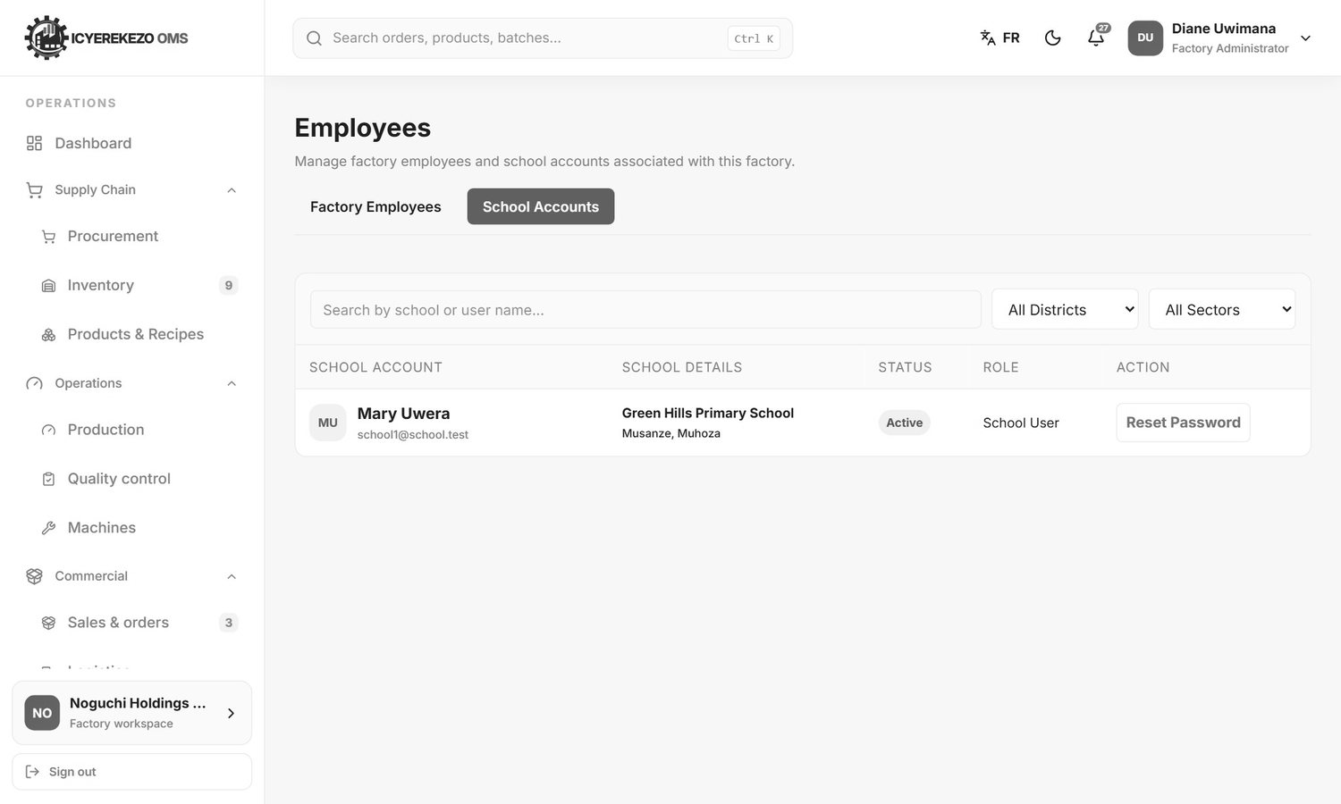
Figure 36. School Accounts tab

5.3 Production steps (workflow)
Menu, Production (administrator) or Production Configuration (manager). This page sets the steps a product goes through. Noguchi has one flow: Cutting, Sewing, Finishing, Packing.
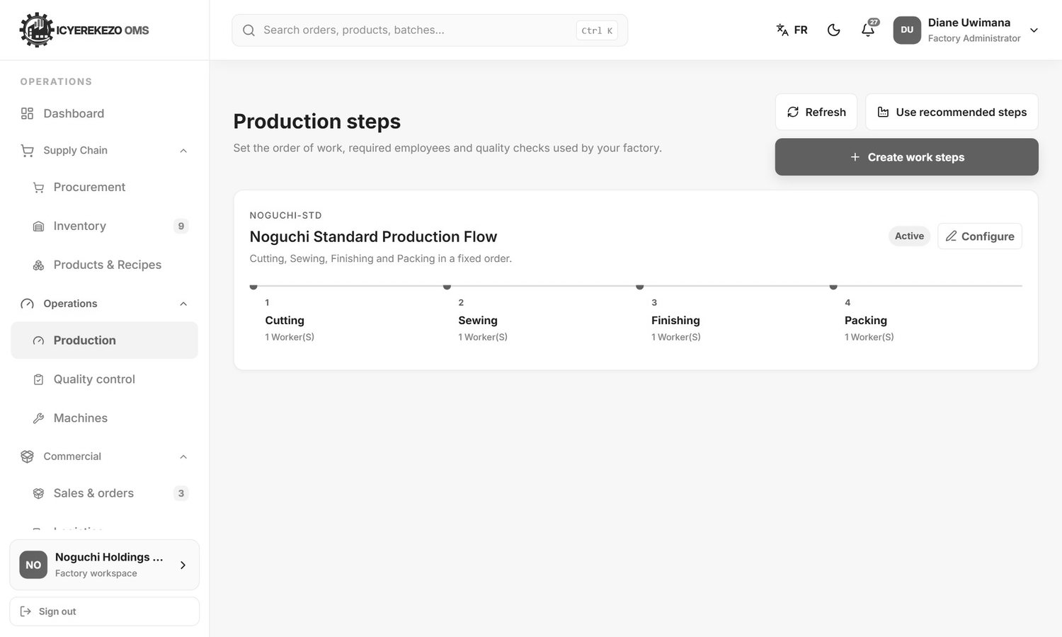
Figure 37. Production steps
Button | What it does
Use recommended steps | Builds departments, workstations and steps that suit your industry. You can apply it again after you change your set up.
Create work steps | Opens a form to create a new flow.
Configure (on a flow) | Opens the flow to change its name, description, status and steps.

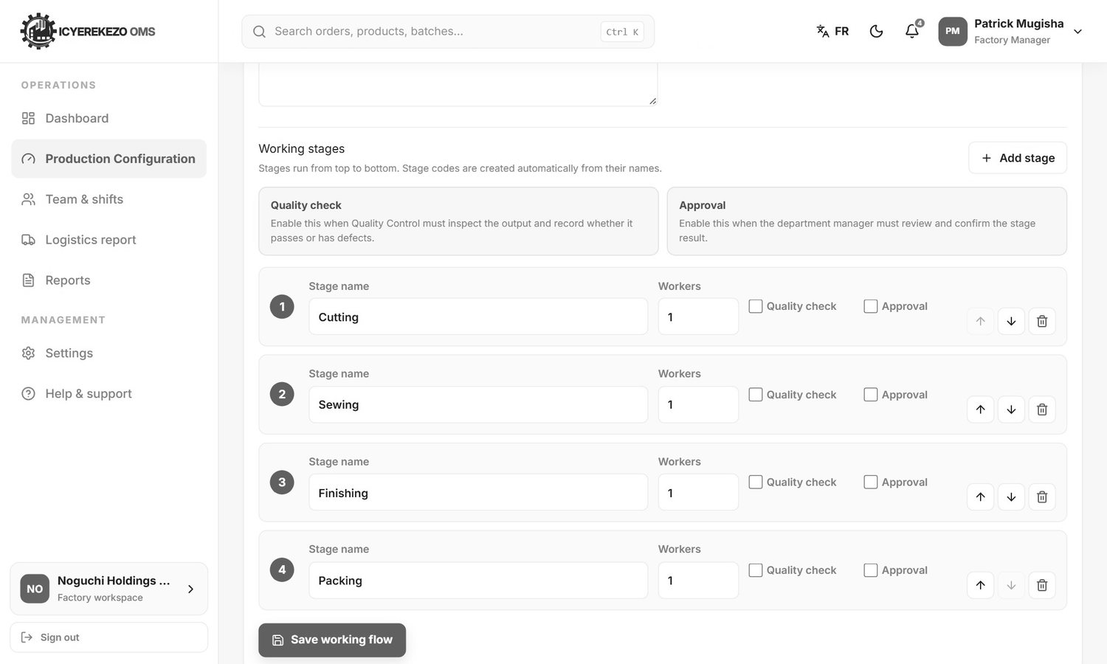
Figure 38. Changing a flow
- Click Configure on the flow.
- Change the name, code, description or status if needed.
- Under Working stages each step has a Stage name, the number of Workers, a Quality check box (Quality Control must inspect the output) and an Approval box (the department manager must approve the step).
- Use the arrows to move a step up or down, the bin to remove it and Add stage for a new one.
- Click Save working flow.

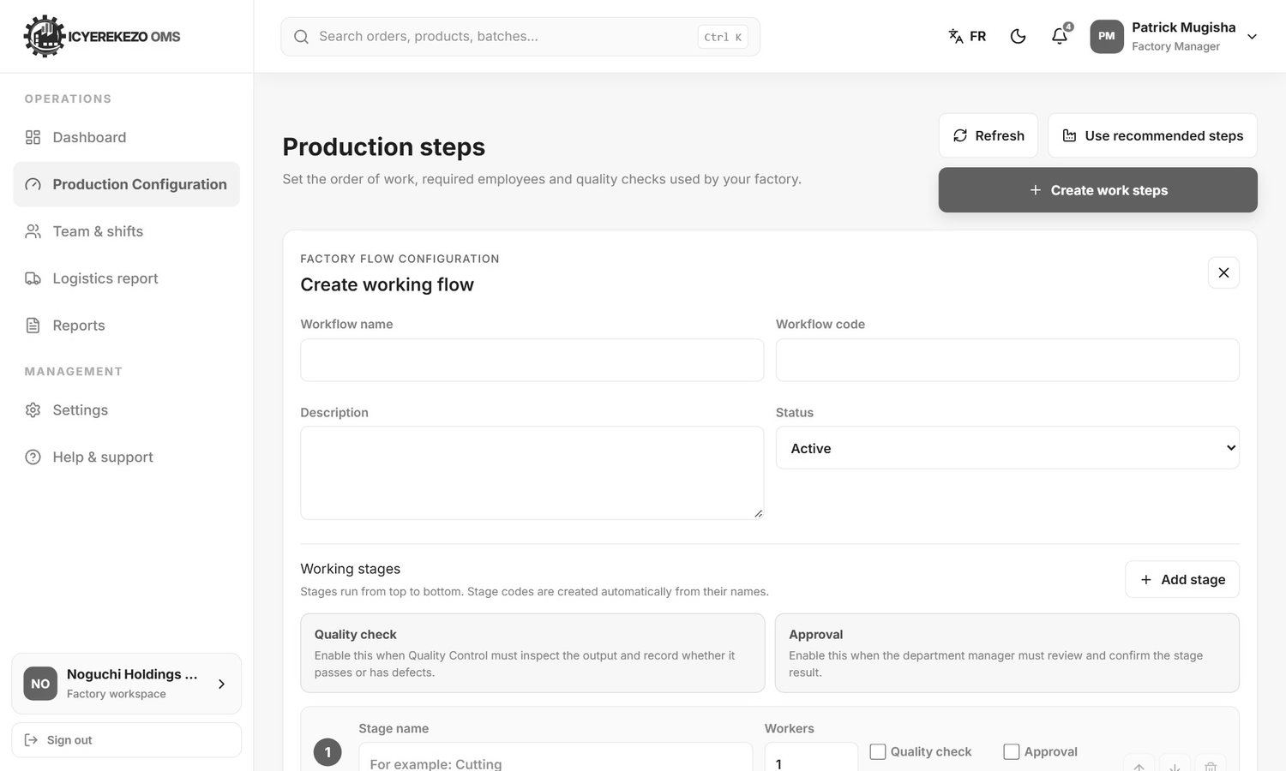
Figure 39. Create working flow

5.4 Products and recipes
Menu, Products & Recipes. Here you create and control items, categories and units.
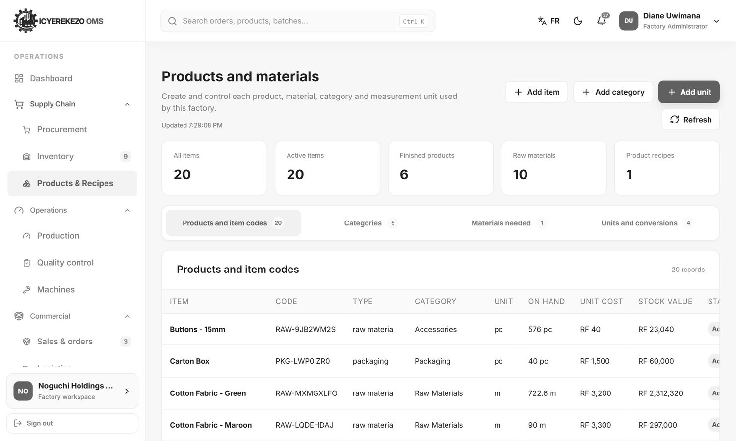
Figure 40. Products and materials
Tab | Content
Products and item codes | Every item with its code, type, category, unit, quantity on hand, cost and stock value.
Categories | Item groups. You can add, edit or delete a category.
Materials needed | The recipe of each product: which materials and how much.
Units and conversions | Measurement units (kg, m, pc, L) and how one converts to another.

Buttons at the top: Add item, Add category, Add unit. Only the storekeeper can add items (section 6).

5.5 Other pages
The administrator also opens Procurement (section 7), Inventory (6), Production orders (8), Quality control (10), Machines (11), Sales and orders (12), Logistics (14) and Reports (18). The menu groups them as Supply Chain, Operations and Commercial.

6. Storekeeper
The storekeeper looks after all stock. Menu: Dashboard, Stock Management (Incoming requests, Inventory, Products and recipes), Incoming goods and Reports.

6.1 Answer requests from the factory floor
When a team (for example cutting) needs material, it sends a request. The request waits in Incoming requests.
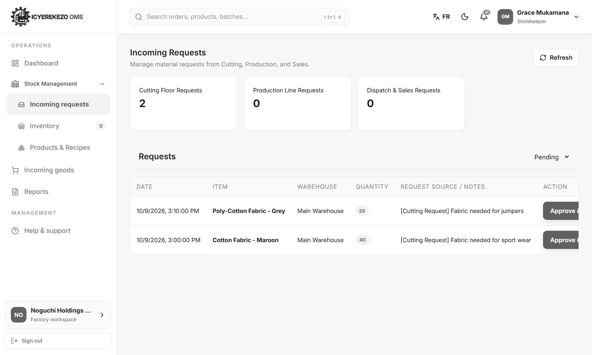
Figure 41. Incoming requests
- Menu, Stock Management, Incoming requests.
- The three cards count the open requests from the cutting floor, the production line and dispatch and sales.
- The table shows the date, the item, the warehouse it will come from, the quantity and the note from the requester.
- Check that the quantity is in stock. Click Approve & Issue to send the stock to the team, or Reject and give a reason.
- Use the box at the top right of the table (Pending, Approved, Rejected, All) to see earlier requests.

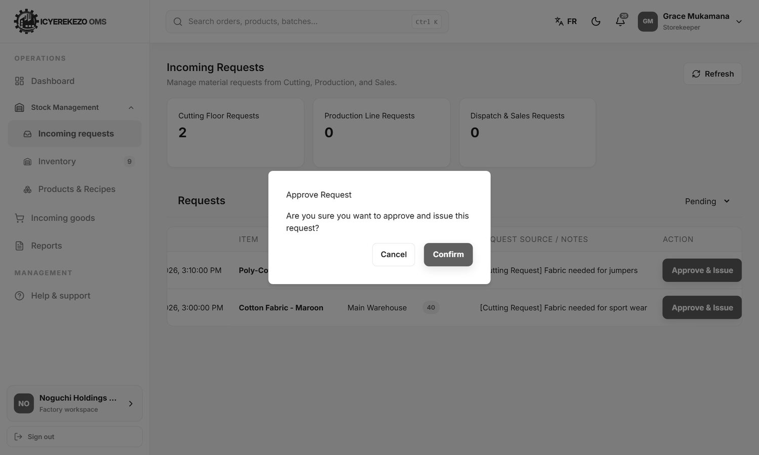
Figure 42. The confirmation window after Approve & Issue
Approving does two things at once: it moves the stock to the team's warehouse and it closes the request. Rejecting closes the request and keeps the stock where it is.

6.2 Stock management
Menu, Stock Management, Inventory.
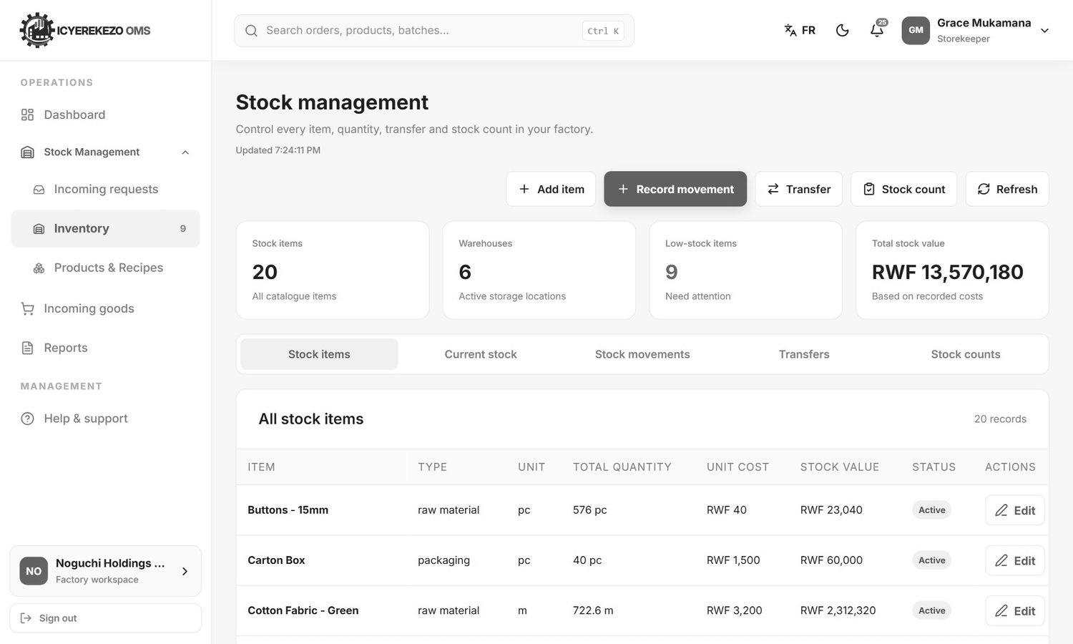
Figure 43. Stock management
The cards show the number of stock items, warehouses, low stock items and the total stock value. A red number next to Inventory in the menu shows the low stock count. The five buttons at the top are Add item, Record movement, Transfer, Stock count and Refresh.
The window opened by Edit on the Stock items tab looks like this. You can change the item name, stock code, type, unit, cost per unit and the low-stock warning level.
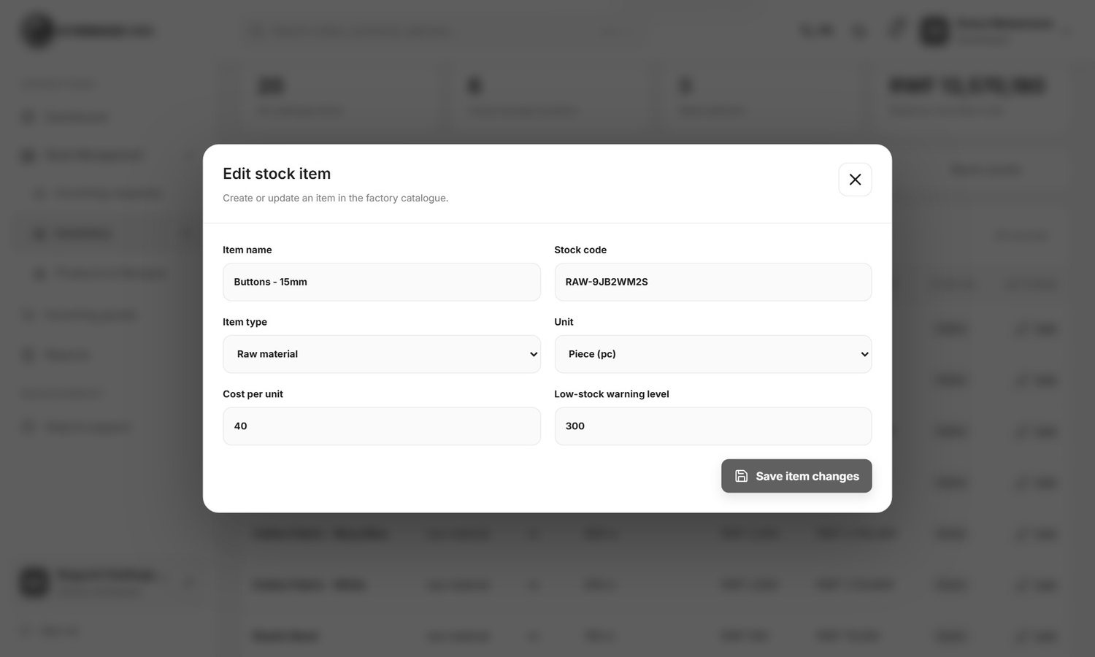
Figure 44. Edit stock item

The tabs
Tab | What you see
Stock items | All items with type, unit, total quantity, unit cost, stock value and status. Edit changes an item. Deactivate hides an item you no longer use (and Activate brings it back).
Current stock | Stock by warehouse: on hand, reserved, available and value, with a Low Stock label where needed.
Stock movements | The history. Every line shows date, item, warehouse, movement, quantity, balance, cost and reason.
Transfers | Moves between warehouses.
Stock counts | Count adjustments you made.

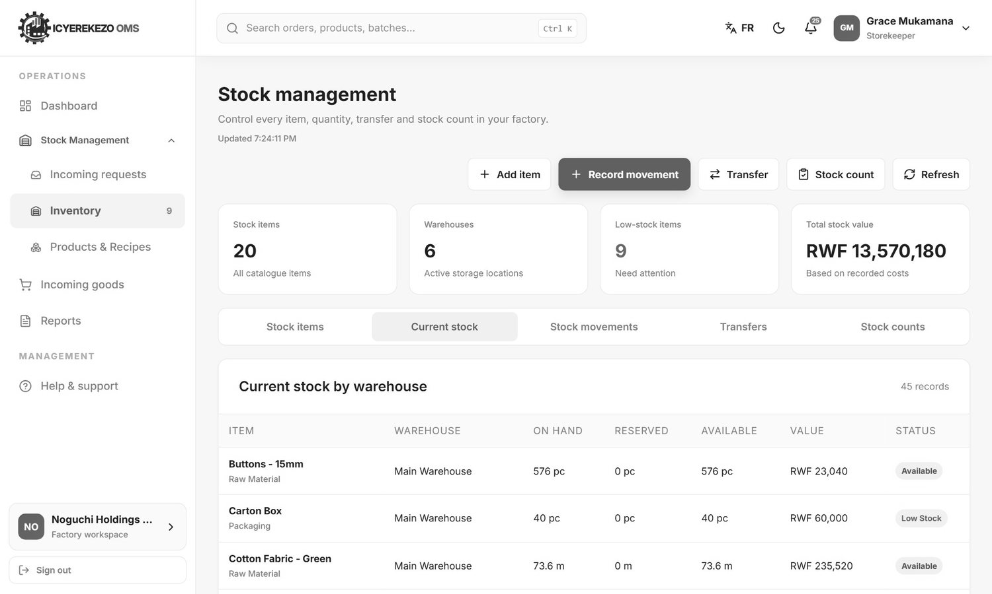
Figure 45. Current stock by warehouse
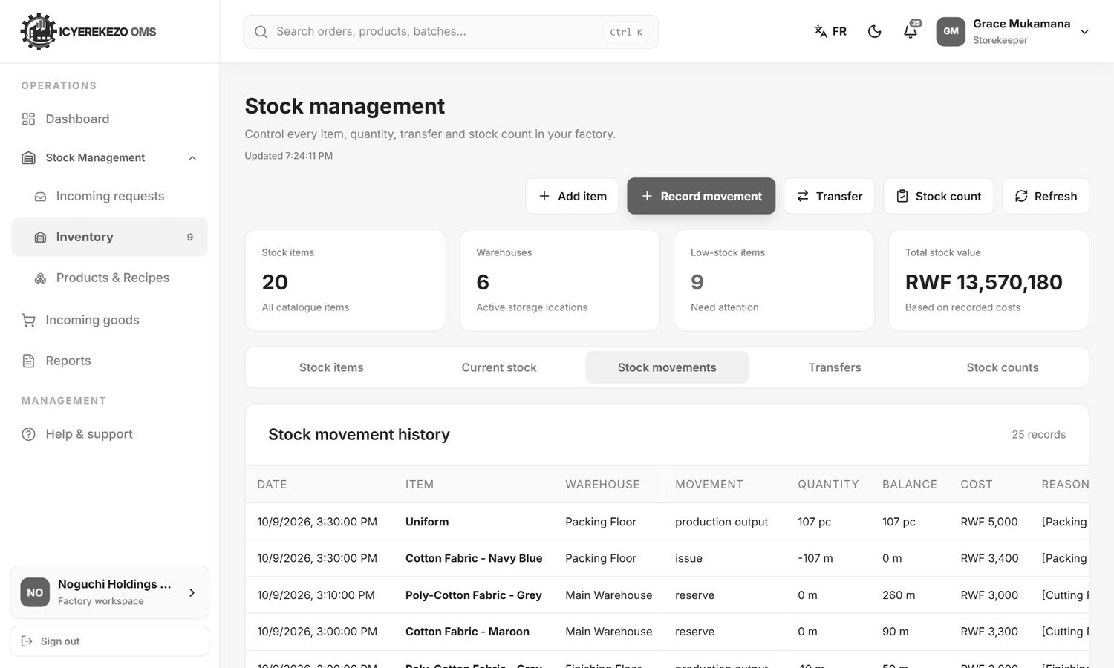
Figure 46. Stock movements

Add a stock item
- Click Add item.
- Type the Item name. The Stock code is made by the system.
- Choose the Item type (raw material, semi finished, finished good, packaging, spare part, waste or by-product) and the Unit.
- Type the Cost per unit and the Low-stock warning level.
- Click Create stock item.

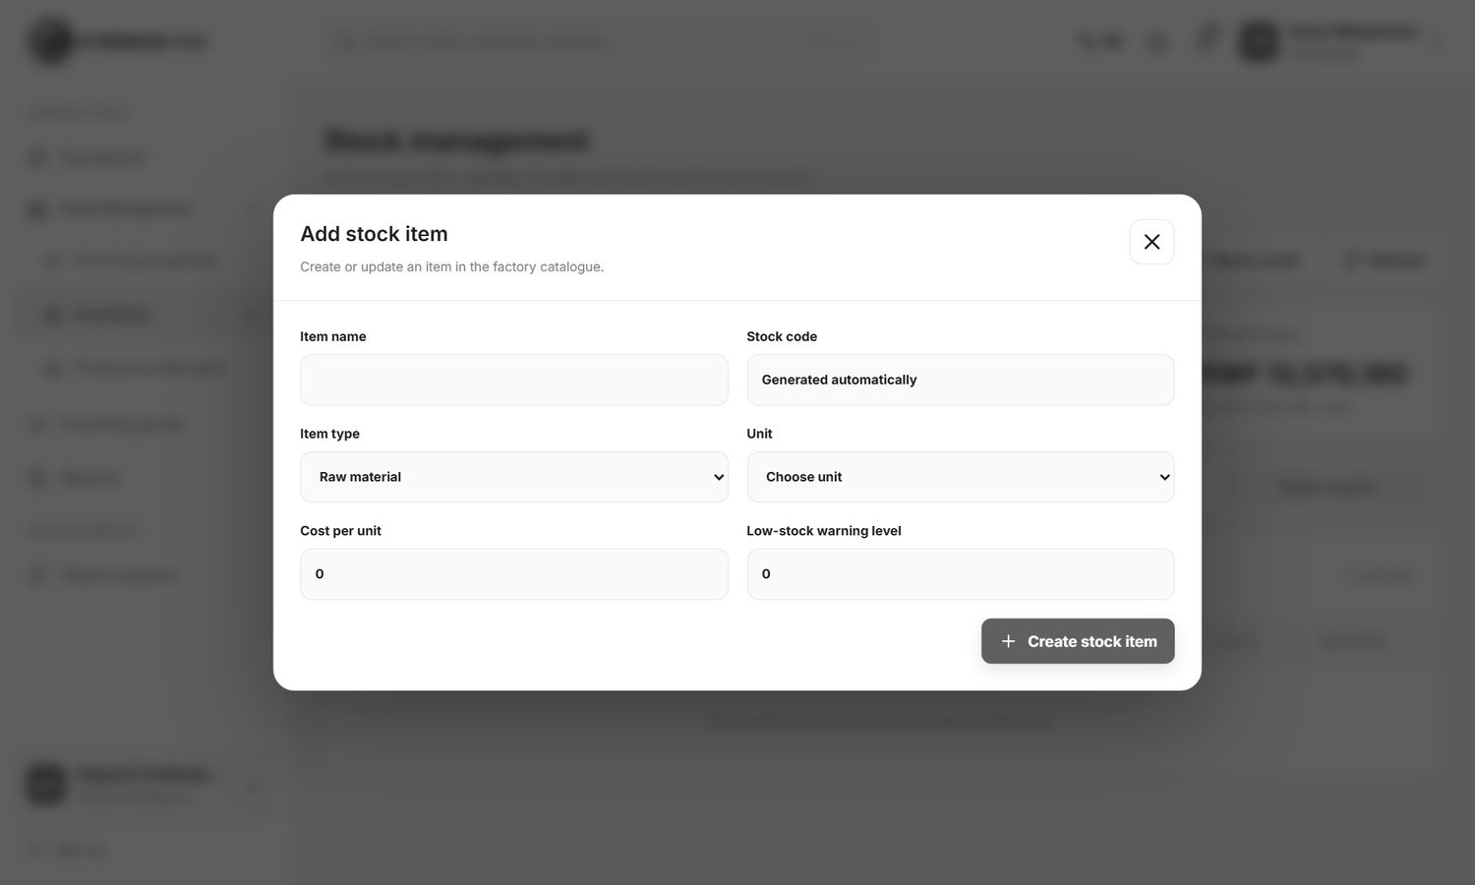
Figure 47. Add stock item

Record a stock movement
Use this for anything that changes stock and has no special button, for example receiving goods from a supplier without a purchase order, or writing off damaged stock.
- Click Record movement.
- Choose the Stock item and the Warehouse.
- Choose the Movement. The choices are written in plain words: Receive stock from a supplier, Add finished goods from production, Put returned items back in stock, Send materials to production, Send goods to a customer, Add or Remove stock after a correction, Record damaged, expired or wasted stock, Hold stock for planned work, Stop holding reserved stock, Hold stock for inspection, Return inspected stock to use.
- Type the Quantity. For a receipt you can type the Purchase cost per unit. If you leave it empty the saved item cost is used.
- Explain Why you are making this change. This text is kept in the history.
- Click Save stock movement.

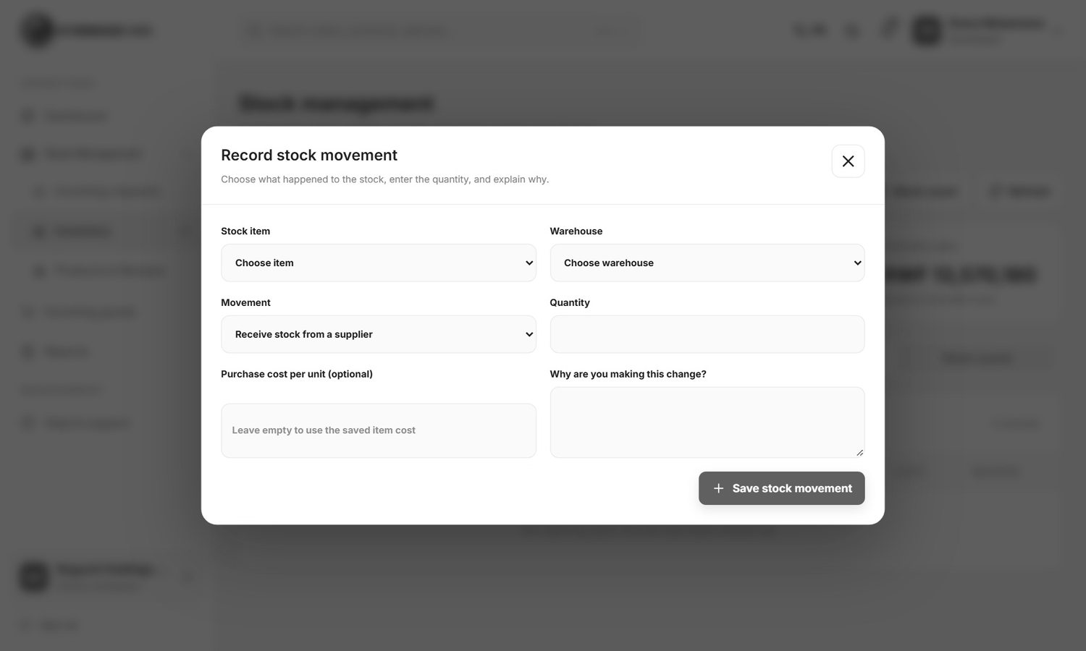
Figure 48. Record stock movement
Note The system will not let you take out more than is available. The message tells you how much you can use.

Transfer stock
- Click Transfer.
- Choose the Stock item and type the Quantity.
- Choose From warehouse and To warehouse.
- Write the Transfer reason and click Transfer stock.

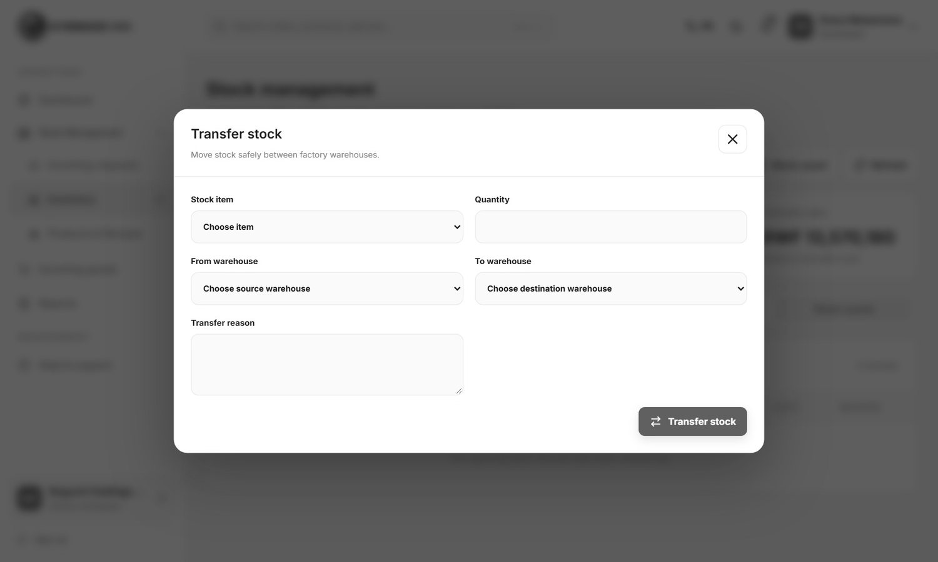
Figure 49. Transfer stock

Count stock
- Click Stock count.
- Choose the item and the warehouse.
- Type the quantity you counted and the reason.
- Click save. If the count differs from the system, the system adds or removes the difference as an adjustment. If it is the same, it says the count is confirmed.

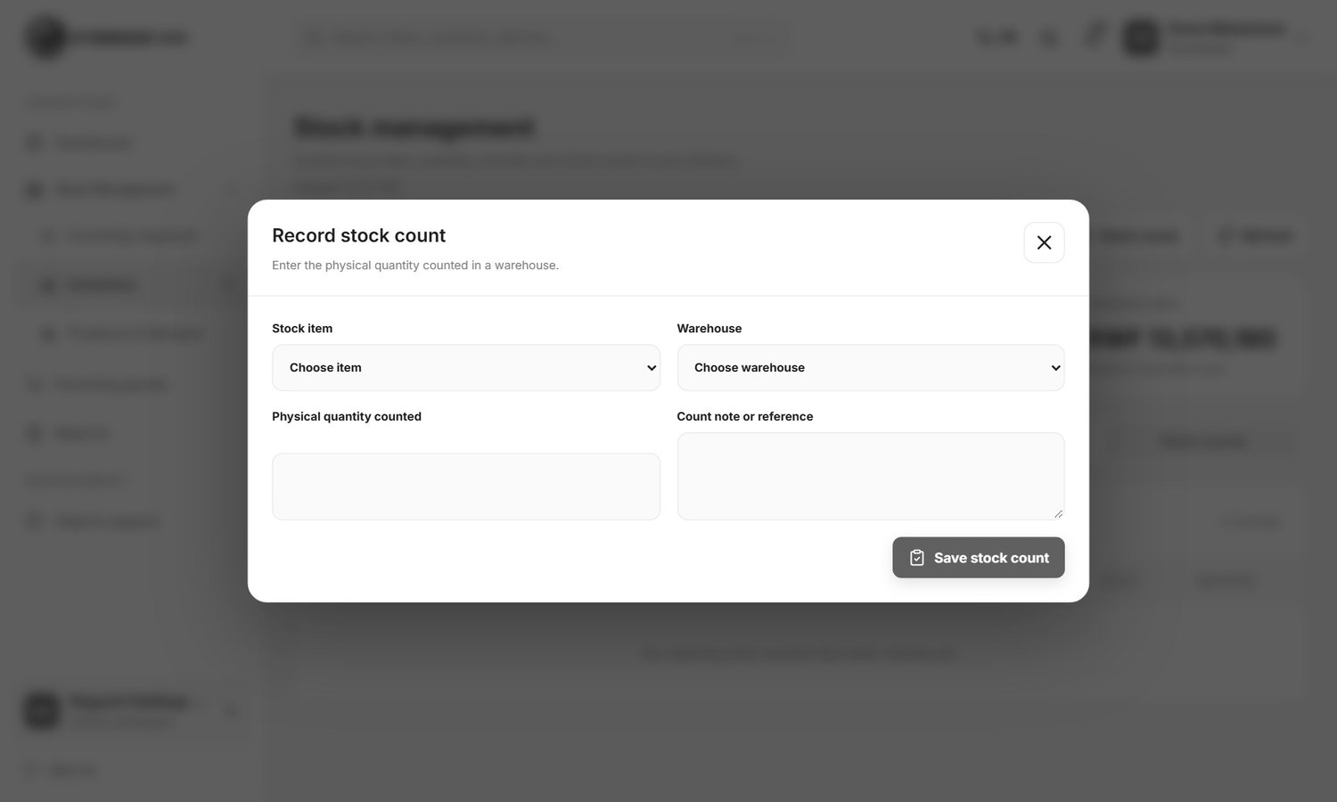
Figure 50. Stock count

Correct a mistake
A record in the history is never deleted. A correction cancels the wrong movement and adds the right one. Both stay visible. Floor staff can correct their own recent records for 24 hours. After that only the storekeeper can.

6.3 Products and recipes
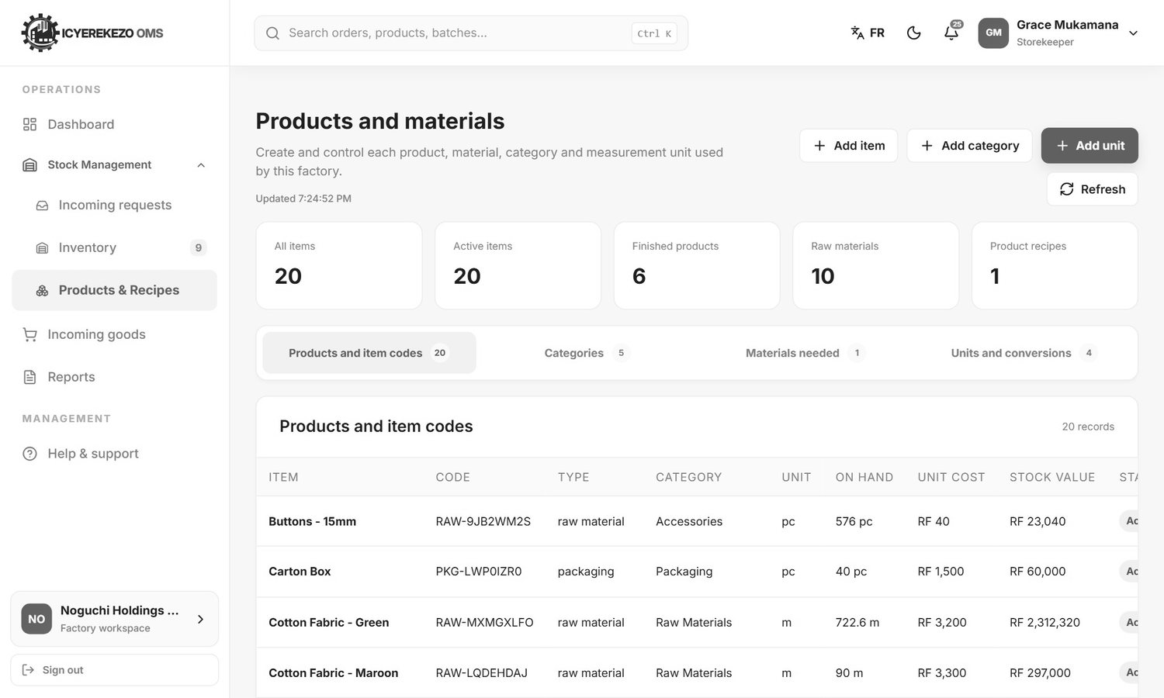
Figure 51. Products and materials (storekeeper)
The storekeeper can click Add item, Add category and Add unit here.
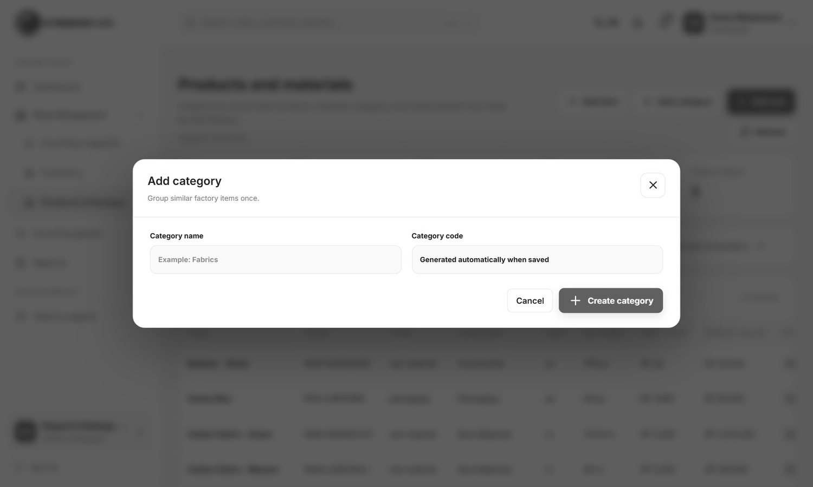
Figure 52. Add category
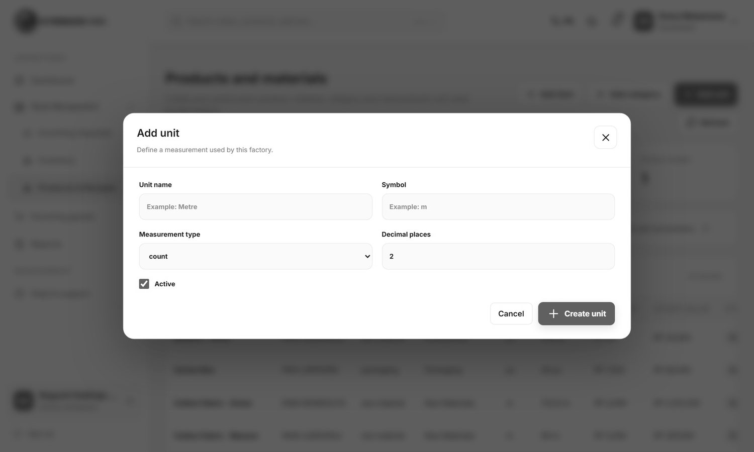
Figure 53. Add unit

6.4 Incoming goods (receive a delivery)
Menu, Incoming goods opens the Purchasing page. Only the storekeeper can receive goods into stock.
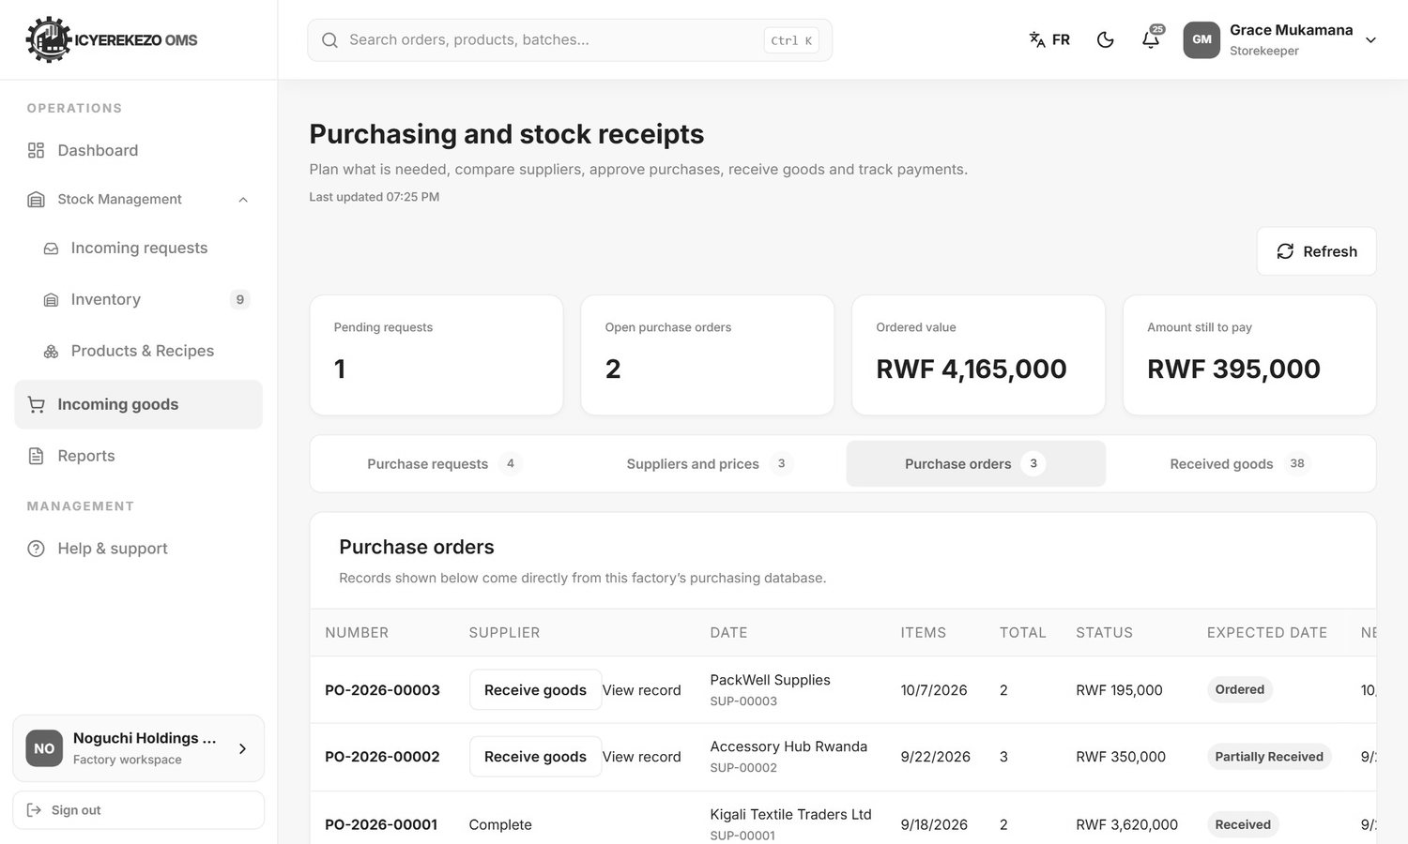
Figure 54. Purchase orders
- Click the tab Purchase orders.
- Find the order. Its status is Ordered or Partially received.
- Click Receive goods at the top of the page. A window called Receive ordered goods opens.
- Choose the Purchase order, then choose the Item received from that order.
- Choose Put goods in (the warehouse) and type the Quantity received.
- Type the Supplier delivery note number from the paper the driver gave you, for example DN-104.
- Click Save. The stock goes up and the order becomes Partially received or Received. If the order has more than one item, do these steps again for each item.

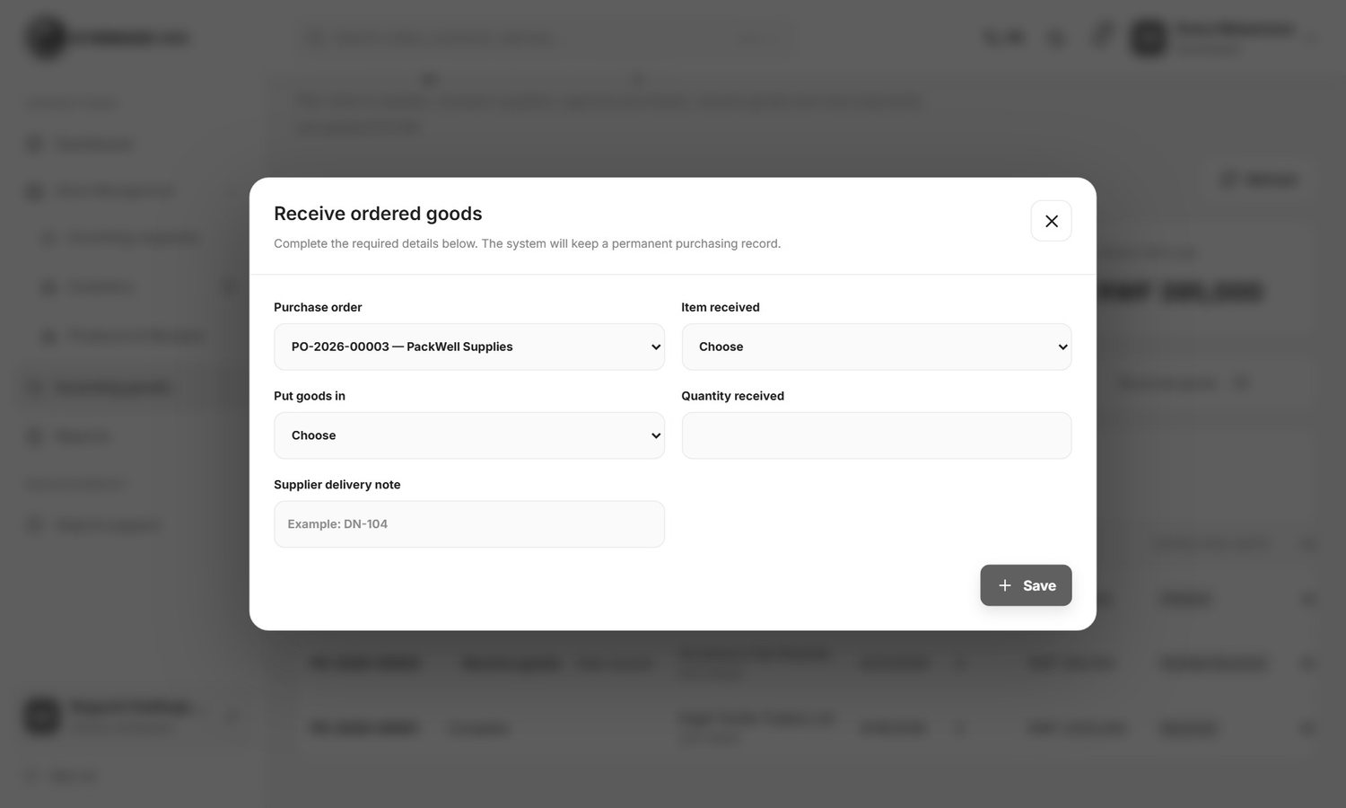
Figure 55. Receive ordered goods
You can see everything that was received on the Received goods tab.
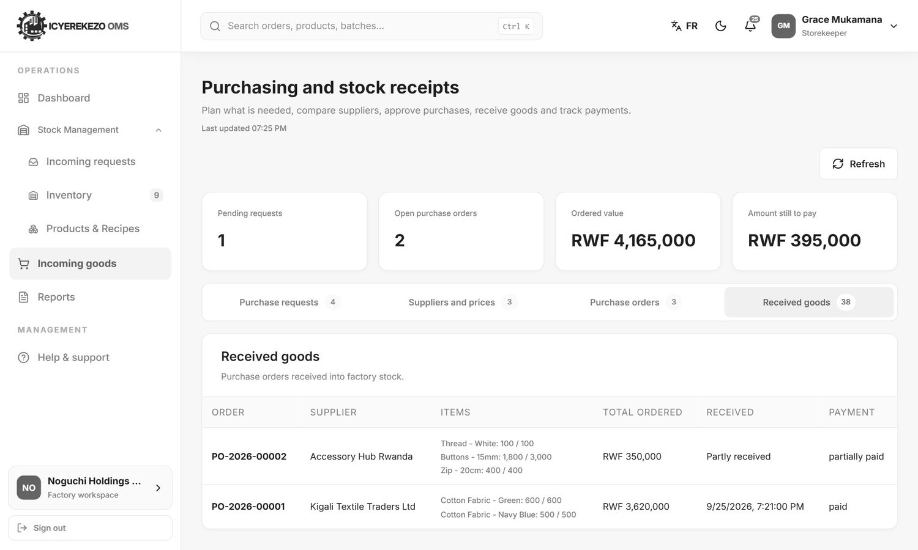
Figure 56. Received goods

7. Procurement officer
Menu: Dashboard, Procurement, Stock levels, Products and recipes, Reports. The Procurement page ("Purchasing and stock receipts") is the main page.
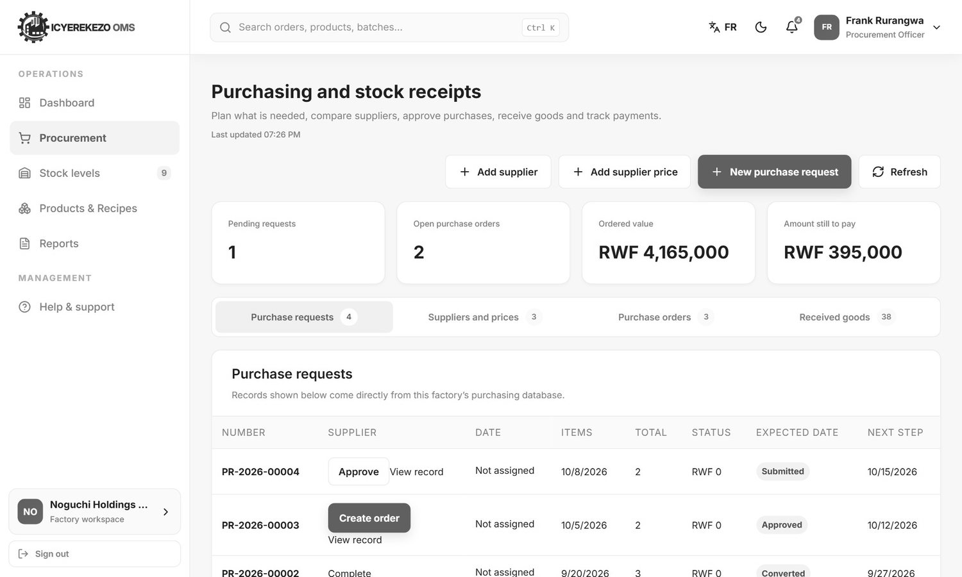
Figure 57. Purchasing and stock receipts
Part | Meaning
Pending requests | Purchase requests waiting for approval.
Open purchase orders | Orders sent to suppliers that are not complete.
Ordered value | Total value of orders sent.
Amount still to pay | Ordered value minus the payments recorded.
Tabs | Purchase requests, Suppliers and prices, Purchase orders, Received goods. The small number is how many records each tab has.

7.1 Add a supplier
- Click Add supplier.
- Type the Supplier name. Add the email, phone number, tax number and address if you have them.
- Choose Payment due after (days).
- Click Save. The system gives the supplier a code such as SUP-00004.

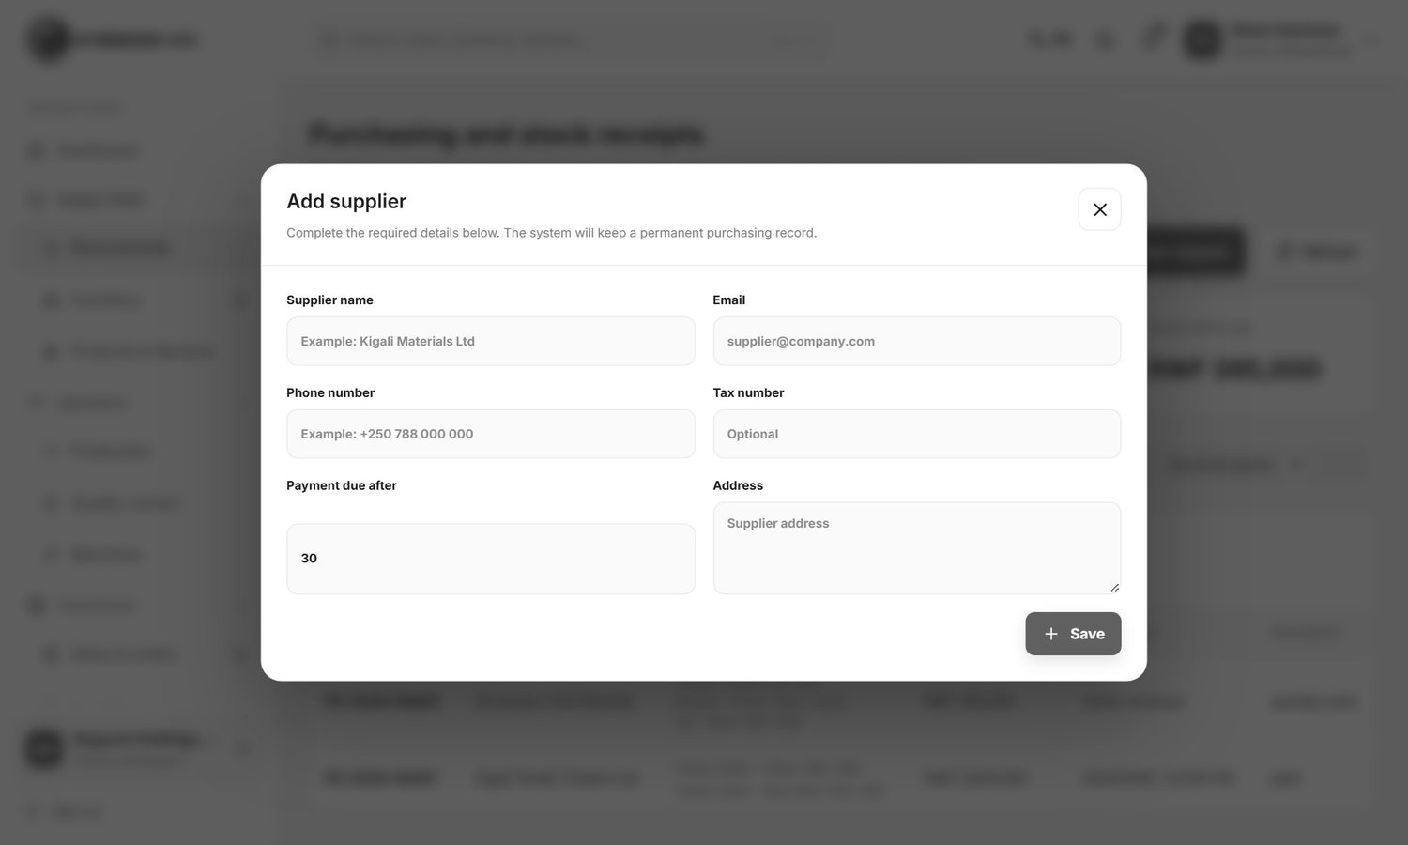
Figure 58. Add supplier

7.2 Save a supplier price
A purchase order takes its prices from here. Save a price for every item before you create an order.
- Click Add supplier price.
- Choose the Supplier and the Item.
- Type the Price for one unit, the Delivery time in days, the Smallest quantity supplier accepts and the supplier's own item code if there is one.
- Click Save.

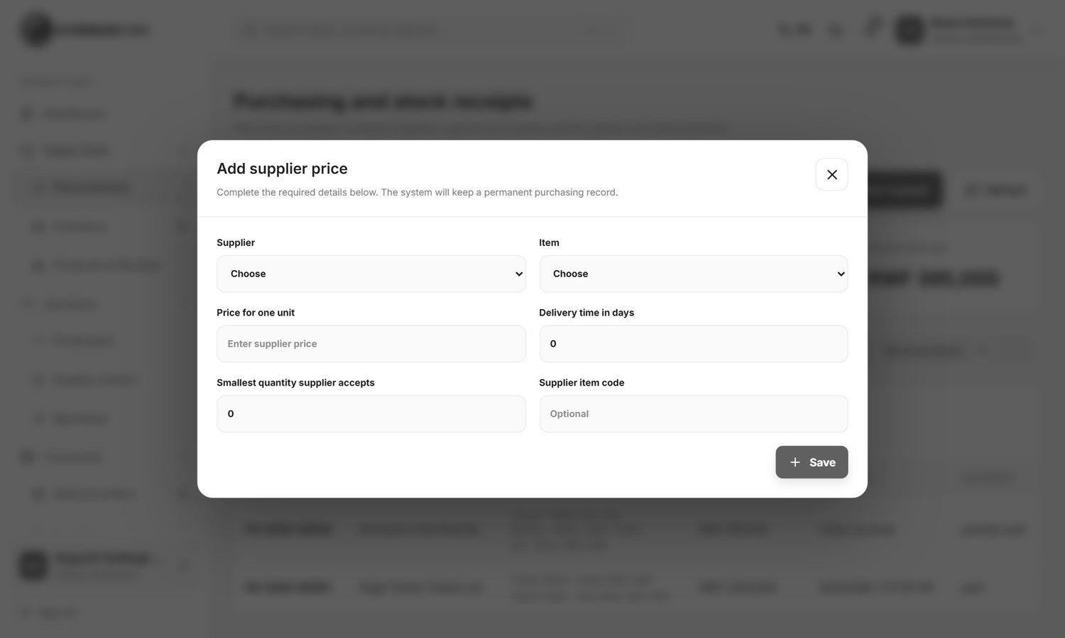
Figure 59. Add supplier price
The Suppliers and prices tab lists all saved prices.
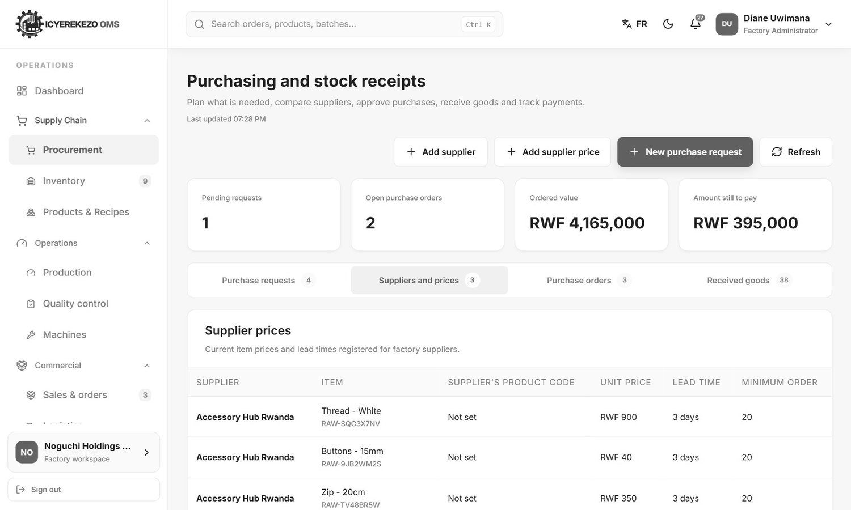
Figure 60. Suppliers and prices

7.3 Make a purchase request
- Click New purchase request.
- Explain Why is this purchase needed?.
- Choose the Item needed, the Quantity needed and the date it is Needed by. Add Extra details such as size, grade or colour.
- Click Save. The request is Submitted.

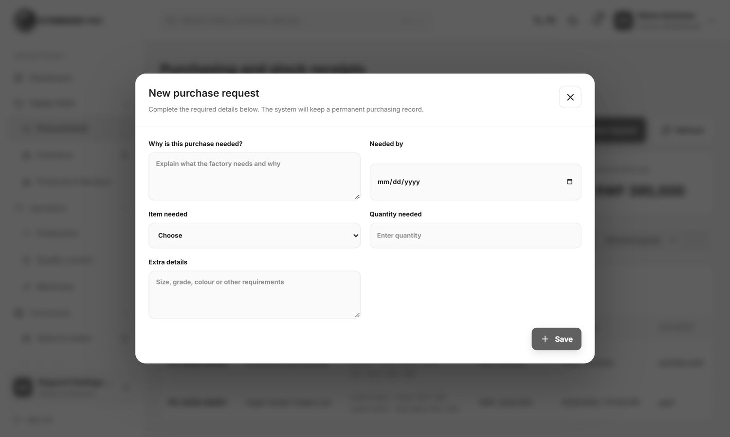
Figure 61. New purchase request

7.4 Approve a request and make the order
- On the Purchase requests tab find the request. In the Next step column click Approve (for a person who can approve). The status becomes Approved.
- Click Create order on the approved request and choose the supplier.
- If the supplier has no price for one of the items, or the quantity is below the supplier's minimum, the system refuses and tells you. Fix the price list and try again.
- The request becomes Converted and a purchase order is created with status Ordered.

Figure 62. Purchase requests
View record shows all details of a request or order.
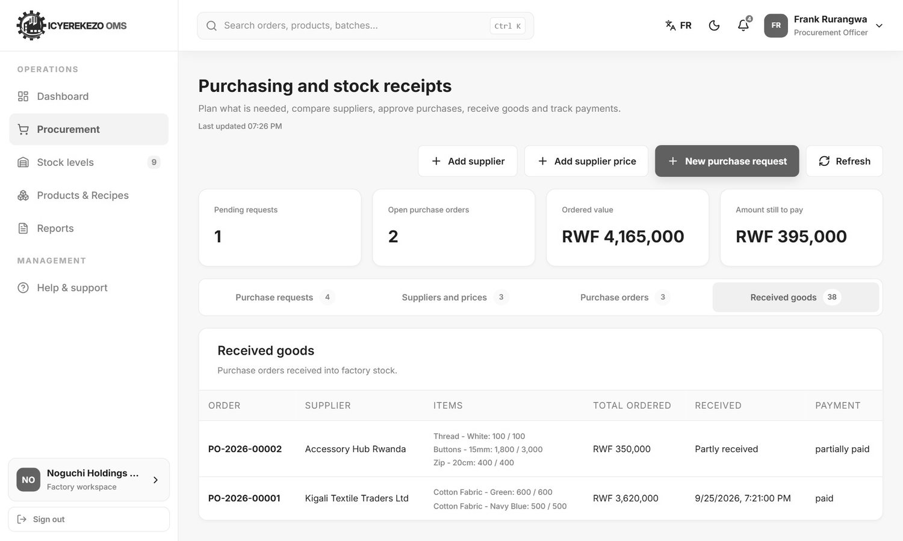
Figure 63. View record

7.5 Orders, receiving and payments
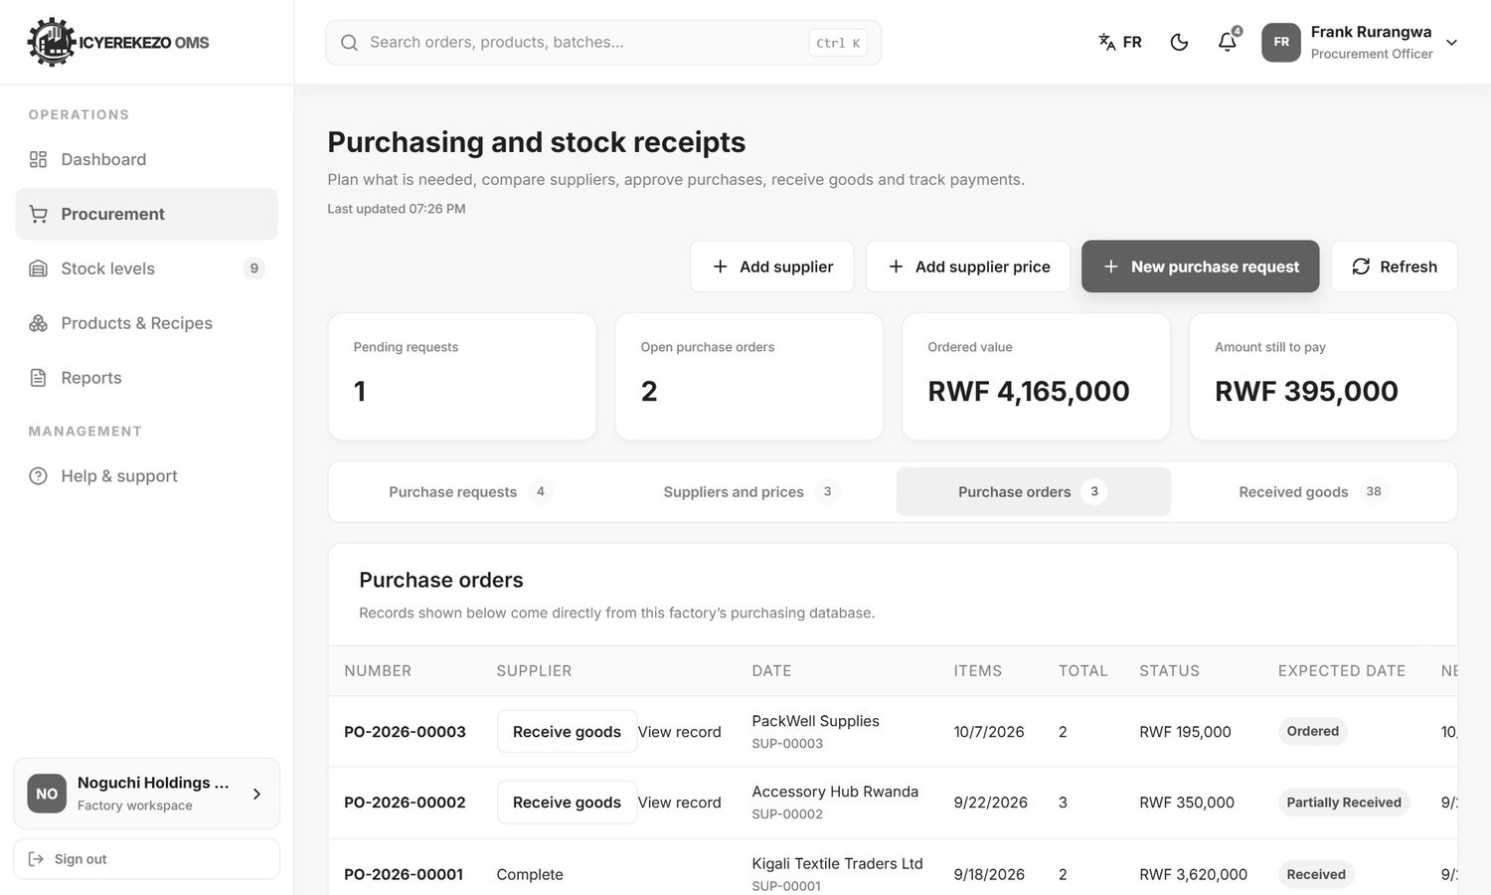
Figure 64. Purchase orders
The Purchase orders tab shows each order with the supplier, date, items, total and status. Receive goods is used by the storekeeper (section 6.4). Record payment is used by the person with finance rights. In the window Record supplier payment, choose the Purchase order (it shows how much is still due), type the Amount paid, choose the Payment method (bank transfer, cash, mobile money, cheque or card), check the Payment date and type the Payment reference such as a bank or cheque number. Click Save. The order shows unpaid, partially paid or paid.
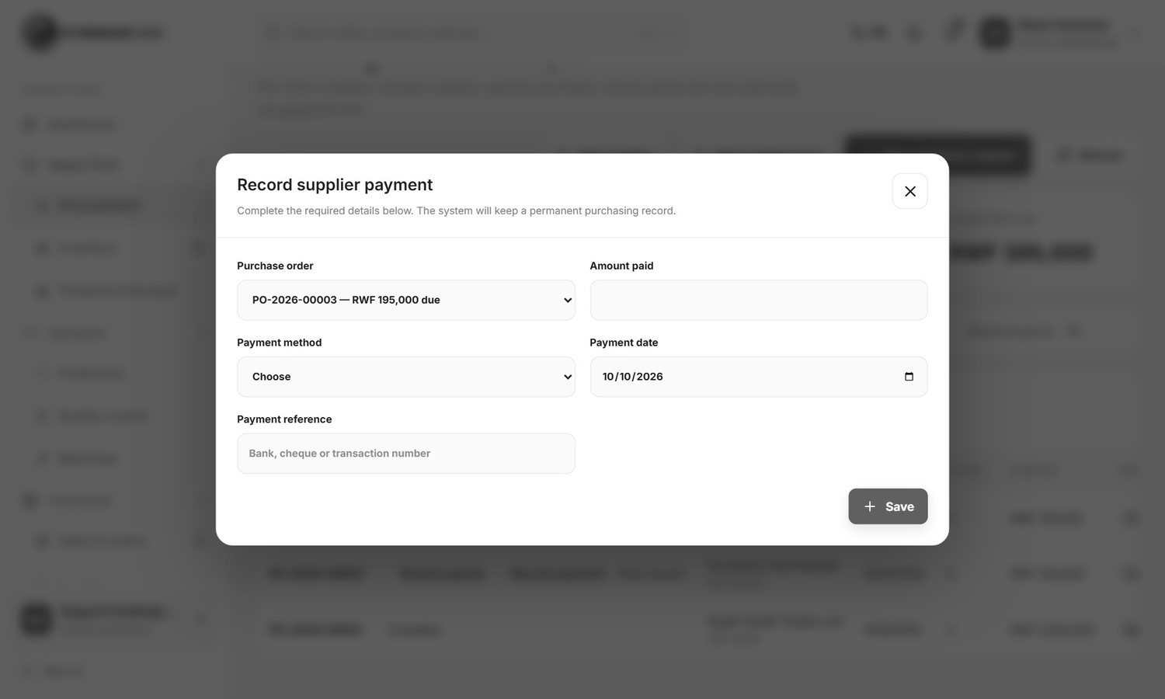
Figure 65. Record supplier payment

8. Production planner, manager and supervisor
These roles work with production orders. The page is called "Production orders". The planner sees it as Production planning, the manager as Production, and the supervisor as Daily production control.
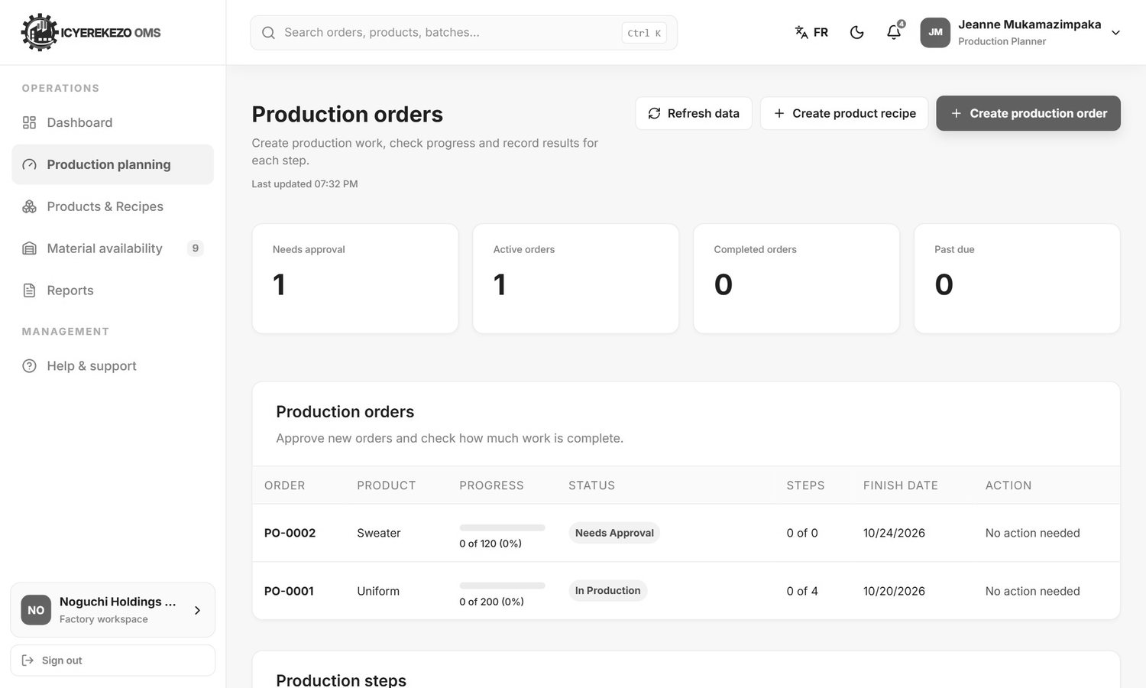
Figure 66. Production orders

8.1 Create a product recipe
A recipe tells the system which materials are needed to make one batch of a product.
- Click Create product recipe. A form opens on the page, under the cards.
- Choose the Finished product (the item this recipe produces) and type the Recipe name. The Version starts at 1.0.
- Type the Output quantity per batch and the Expected waste (%).
- Under Raw materials needed per batch, add each material: choose it, type the Quantity needed and the Waste (%). Tick Optional if the product can be made without it. Use the bin to remove a material.
- Save the recipe. To close the form without saving, click Close recipe form.

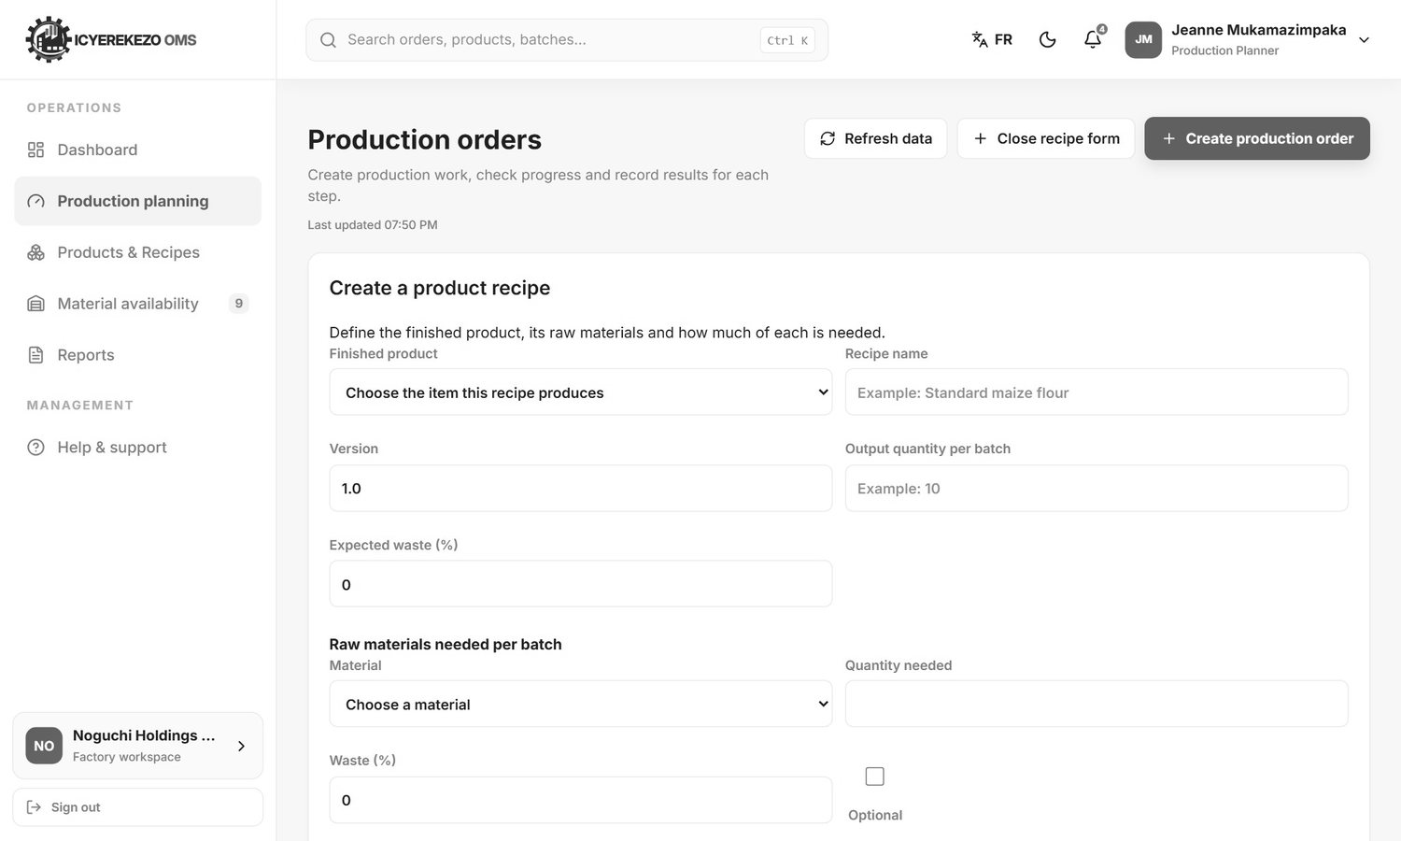
Figure 67. Create a product recipe

8.2 Create a production order
- Click Create production order. A form opens on the page.
- The Order number is filled in for you. You can change it.
- Under Product recipe, choose what to produce.
- Under Production process, choose the production steps (the flow).
- Under Warehouse, choose where the materials come from and where the output goes.
- Type the Quantity to produce and choose the Start date and Finish date.
- Click Create order. To close the form without saving, click Close form.

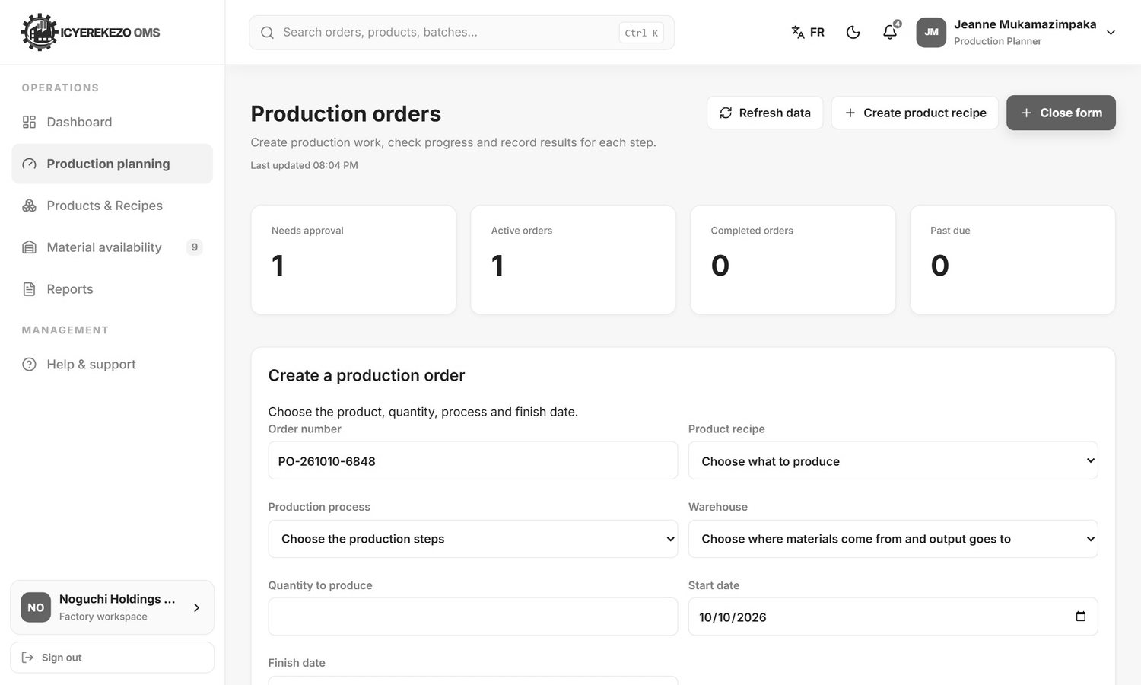
Figure 68. Create a production order
The system shows which materials are needed and which are short. The order is Draft and a notification goes to the people who approve.

8.3 Approve an order
The production manager clicks Approve on a draft order. If a material is missing, the system refuses and lists the shortages. If all is available, the materials are taken out of stock, the steps are created and the order becomes Approved.

8.4 Record the steps
Further down the page, under Production step results, each step of each approved order is listed with its input, output, waste and rejected quantity.
- Find the first step that is Ready.
- Click Start to move it to In progress.
- Type the quantities (input, output, waste, rejected), the stopped time in minutes and notes.
- Click Complete. The next step becomes Ready. Mark blocked is used when something stops the work.

Note A step cannot start before the one before it is complete. It also cannot take in more than the earlier step produced. When the last step is completed, the finished quantity is added to stock and the order is Completed.

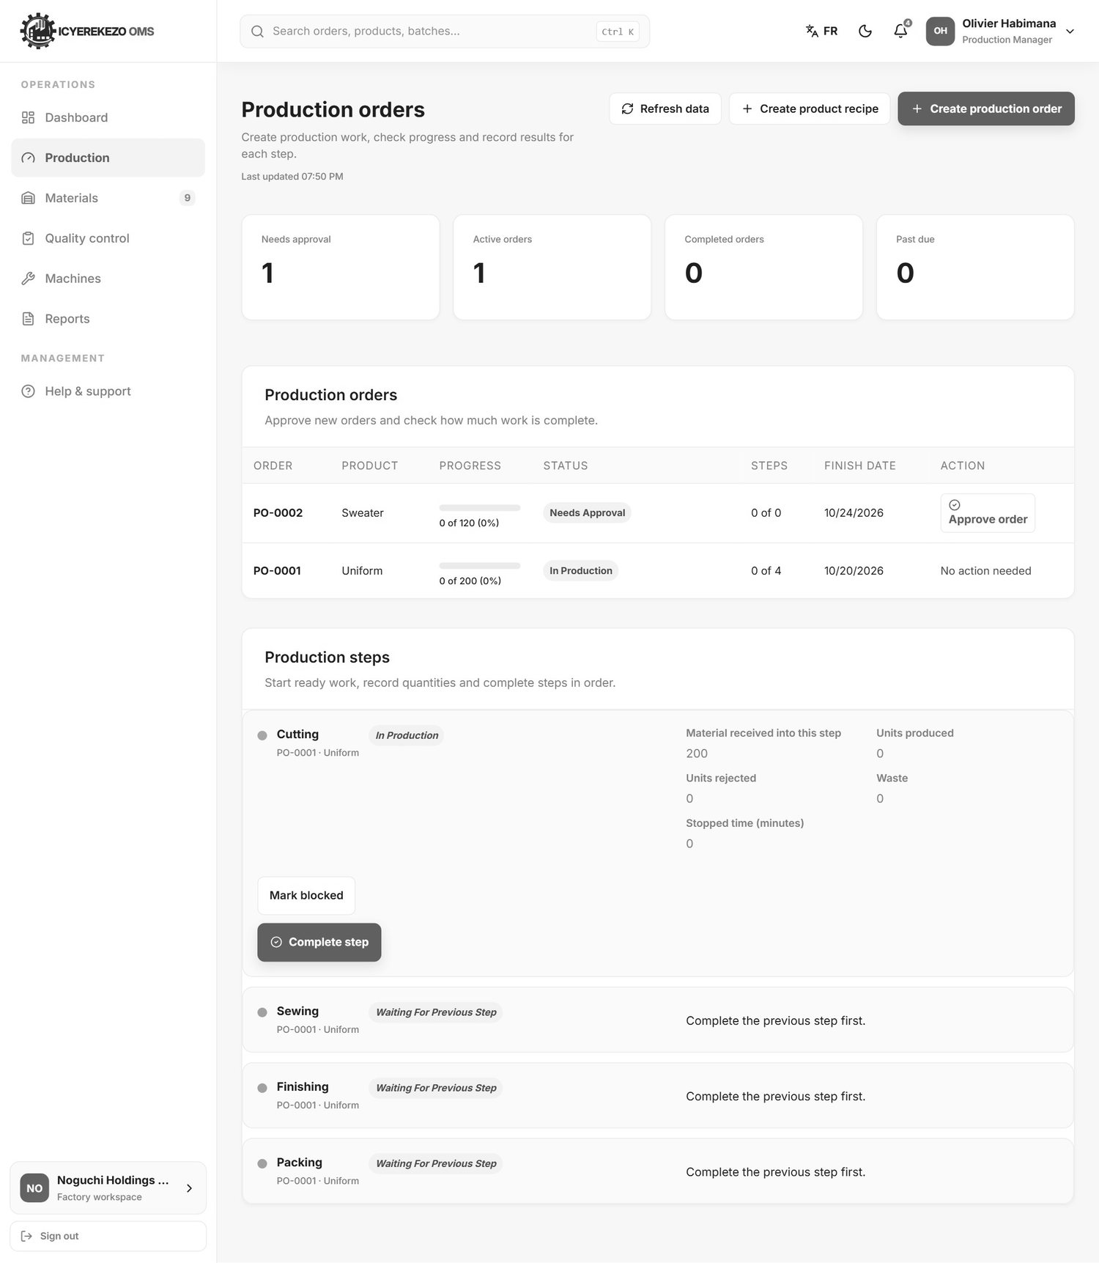
Figure 69. Production manager view
A supervisor sees only the orders that have a step assigned to them, to their workstation or to their department. If nothing is assigned yet, the list is empty, as in the picture below. The warning box "Production setup is incomplete" can also appear for a supervisor even when products exist. It is a known point and is explained in the Technical Documentation, section 12.
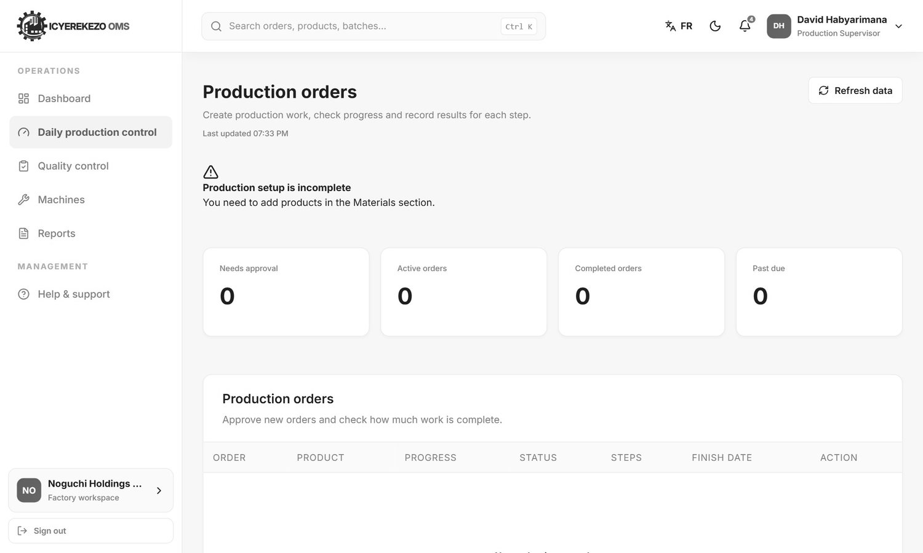
Figure 70. Daily production control (supervisor)

9. Garment floor: cutting, sewing, finishing and packing
These four roles work at Noguchi Holdings Ltd. Each has one workspace page with a few tabs. The pieces move from one team to the next: the next team must accept them before it can work on them. The Noguchi Guide explains the full flow. This section shows where to click.

9.1 Cutting operator
Menu: Dashboard, Cutting workspace, Report.
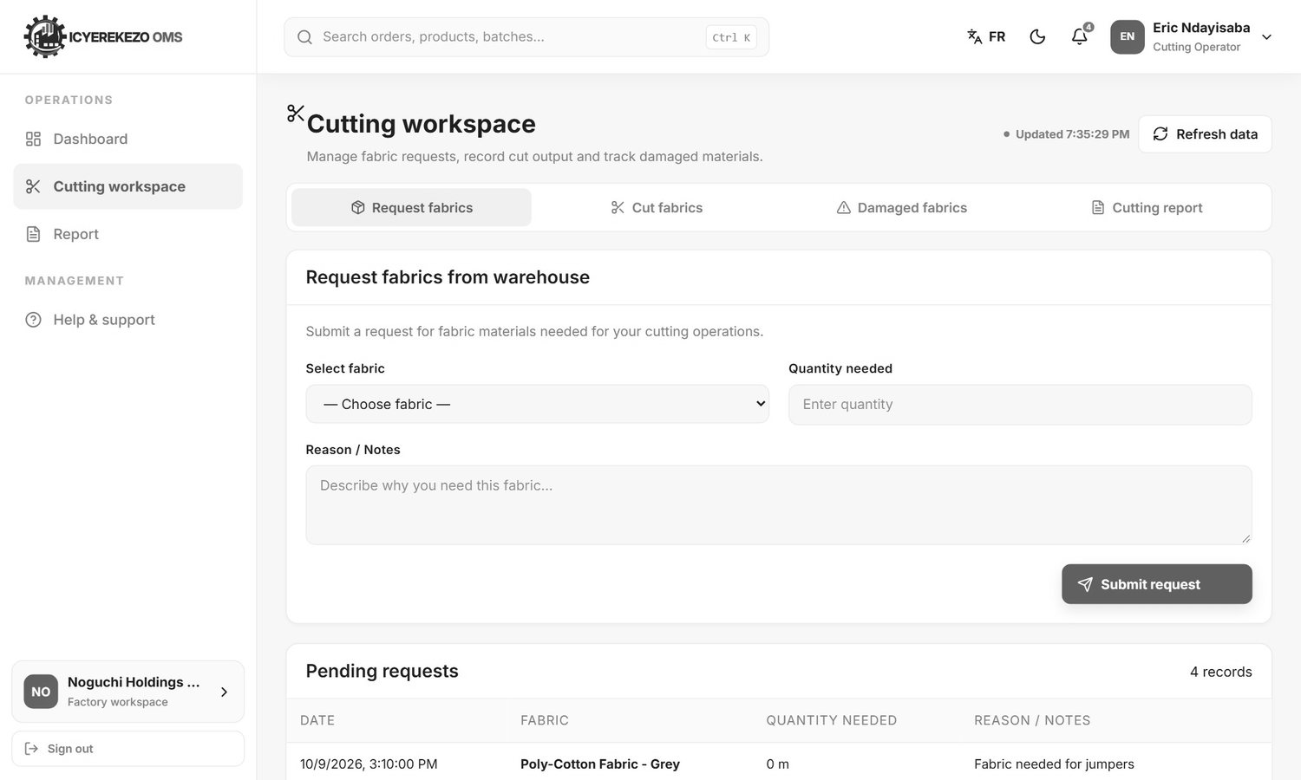
Figure 71. Cutting workspace, Request fabrics
Tab | Use it to
Request fabrics | Ask the storekeeper for fabric. Choose the fabric (the list shows what is in stock), type the quantity needed and the reason, click Submit request. The storekeeper approves it in Incoming requests.
Cut fabrics | Record what you cut. Choose the Fabric used, type the Amount of fabric cut, the Style produced (Shirt, Skirt, Short, Trousers or Dress), the Size, the Number of pieces produced and the Color produced. Click Record cut output.
Damaged fabrics | Report cut pieces that were damaged or miscut. Choose the cut pieces, the quantity damaged and what happened. Click Report damage.
Cutting report | A printable table of cutting input and output with the totals at the top: total cut, total damaged, waste rate, pending requests. Choose From date and To date, then Print filtered report.

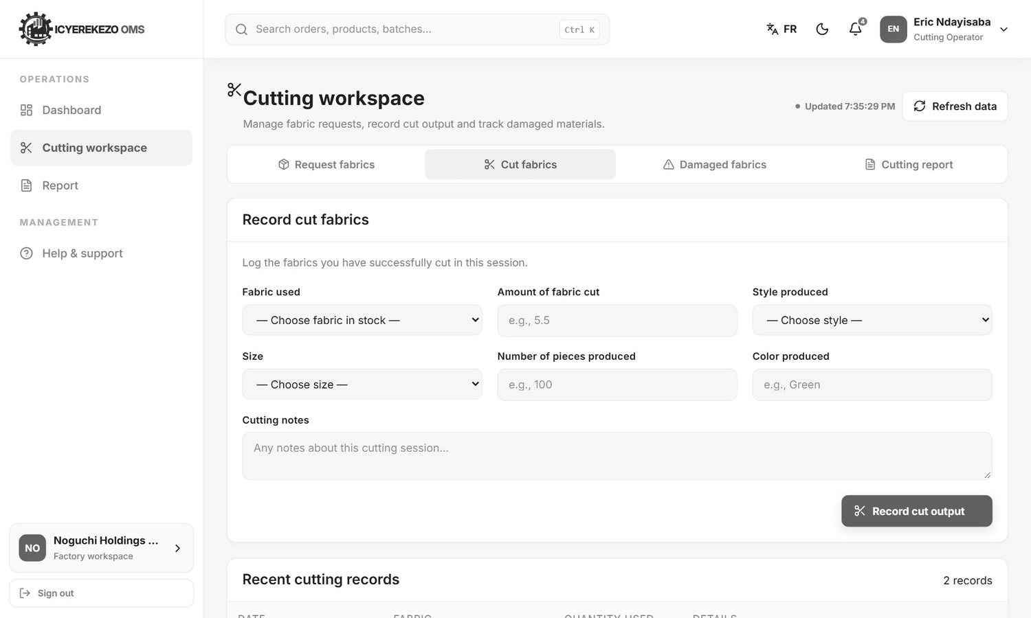
Figure 72. Cut fabrics
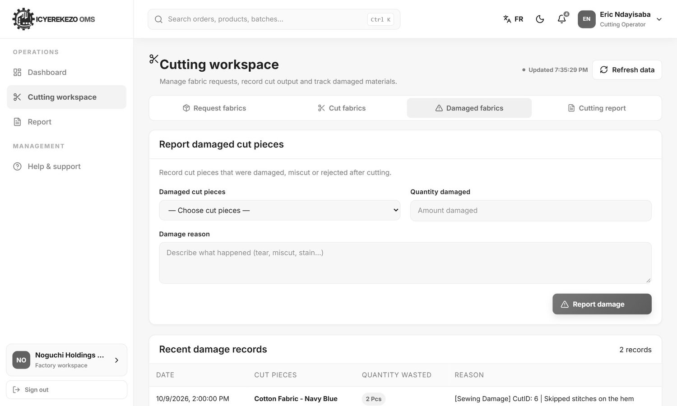
Figure 73. Damaged fabrics
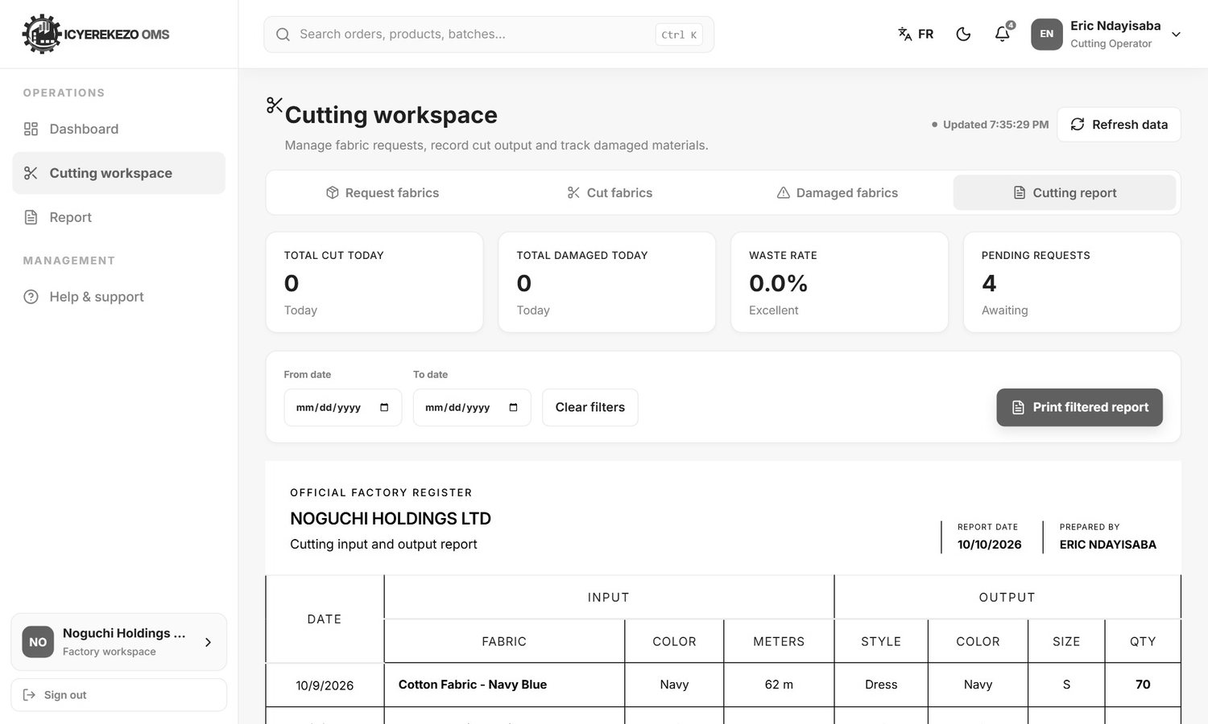
Figure 74. Cutting report
If you type more than what is on the cutting floor, a window tells you how much you have.

9.2 Sewing operator
Menu: Dashboard, Record sewing, Reports.
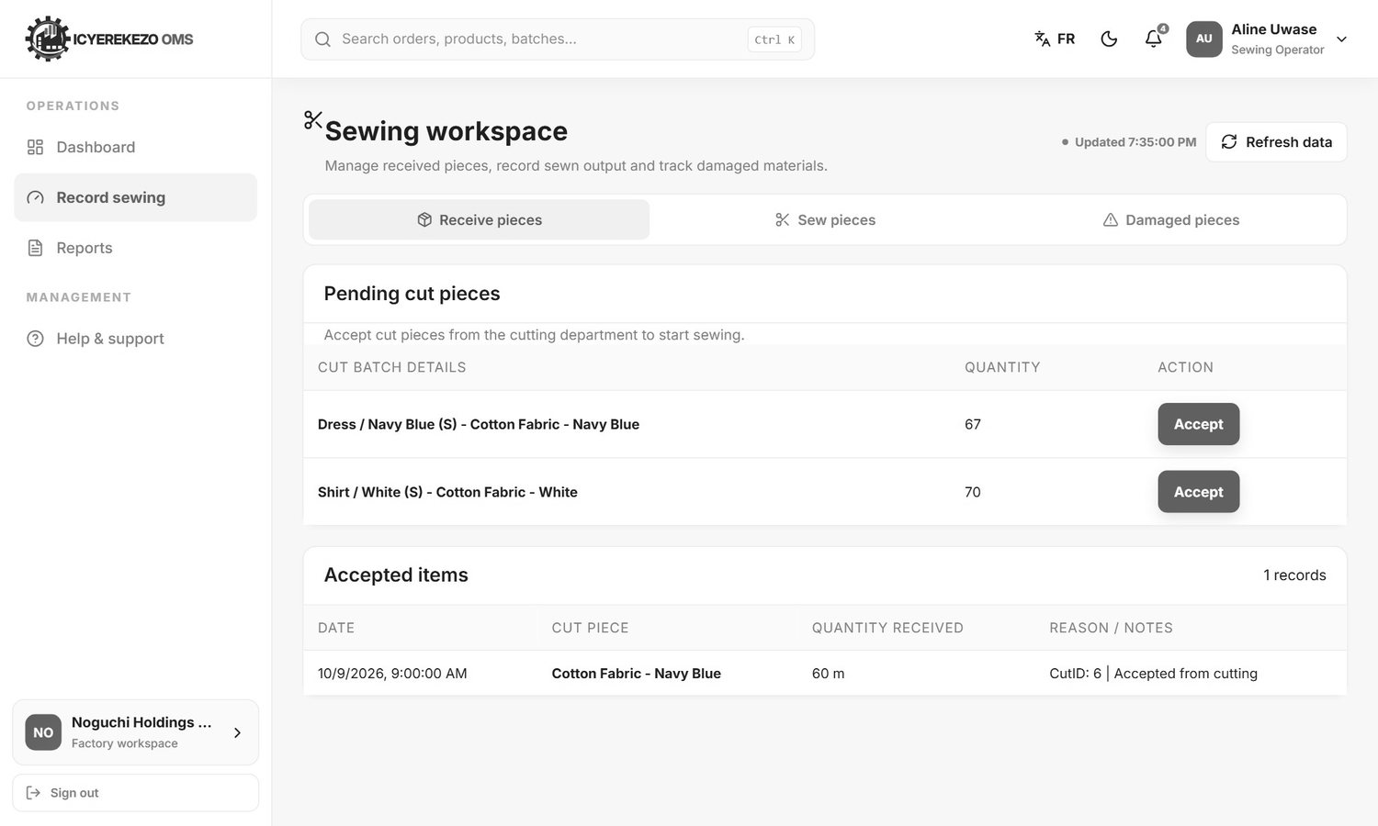
Figure 75. Sewing workspace, Receive pieces
- Receive pieces. The table Pending cut pieces lists batches that cutting has finished. Click Accept on a batch to receive it. It moves to Accepted items.
- Sew pieces. Choose an accepted batch, type how many were sewn and any notes, click Record sewing output.
- Damaged pieces. Choose the batch, type the quantity and the reason, click Report damage.

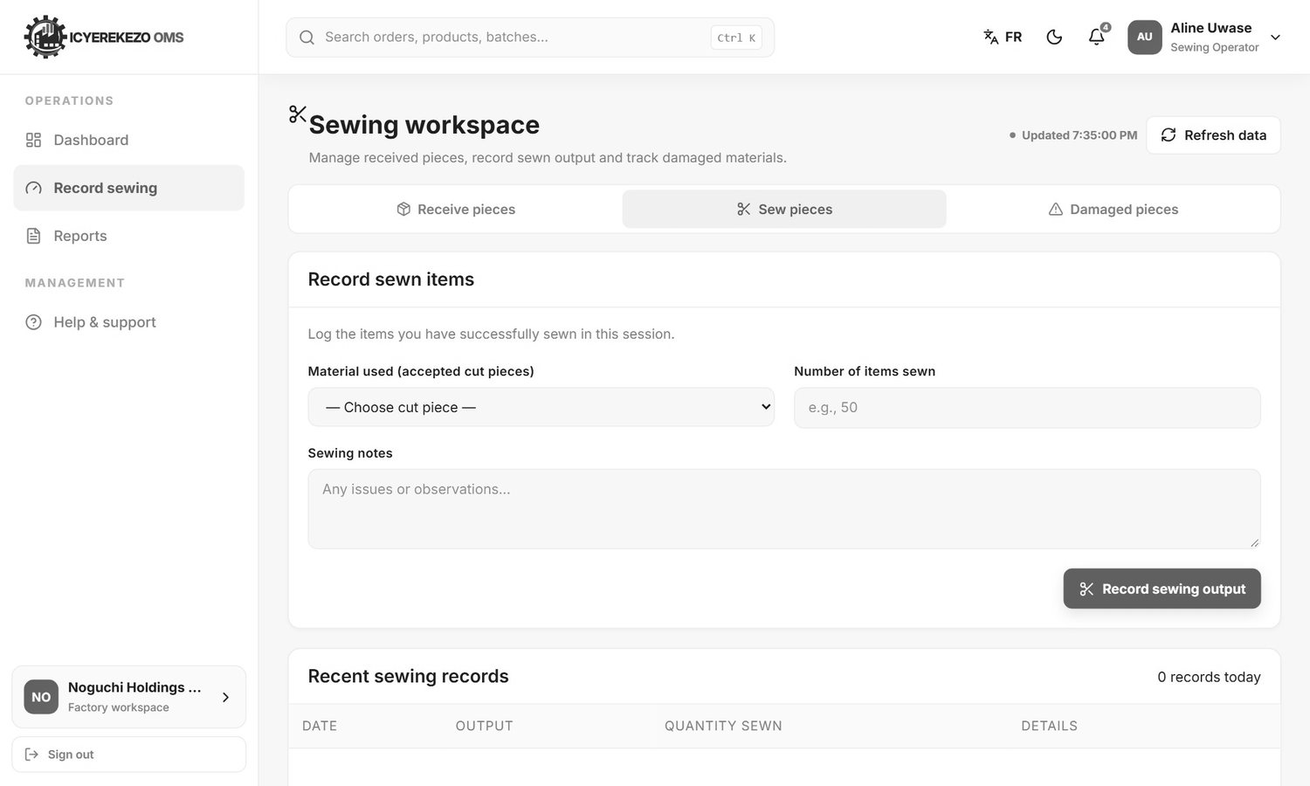
Figure 76. Sew pieces
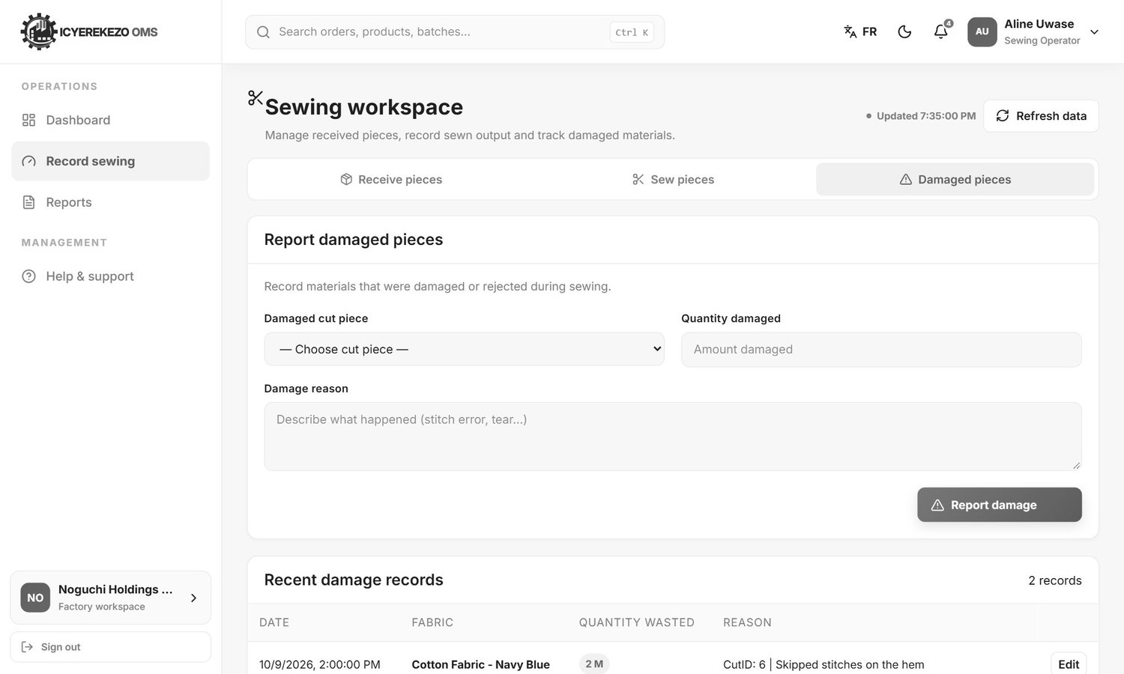
Figure 77. Damaged pieces
The Reports page shows the sewing report with the totals for each batch.
Note With the standard permissions the Sewing Operator role cannot open this page: the system answers "You do not have permission to perform this action." The administrator must ask the developer to give the role the stock permissions (inventory view and inventory issue). See the Technical Documentation, section 12.

9.3 Finishing manager
Menu: Dashboard, Record finishing, Reports.
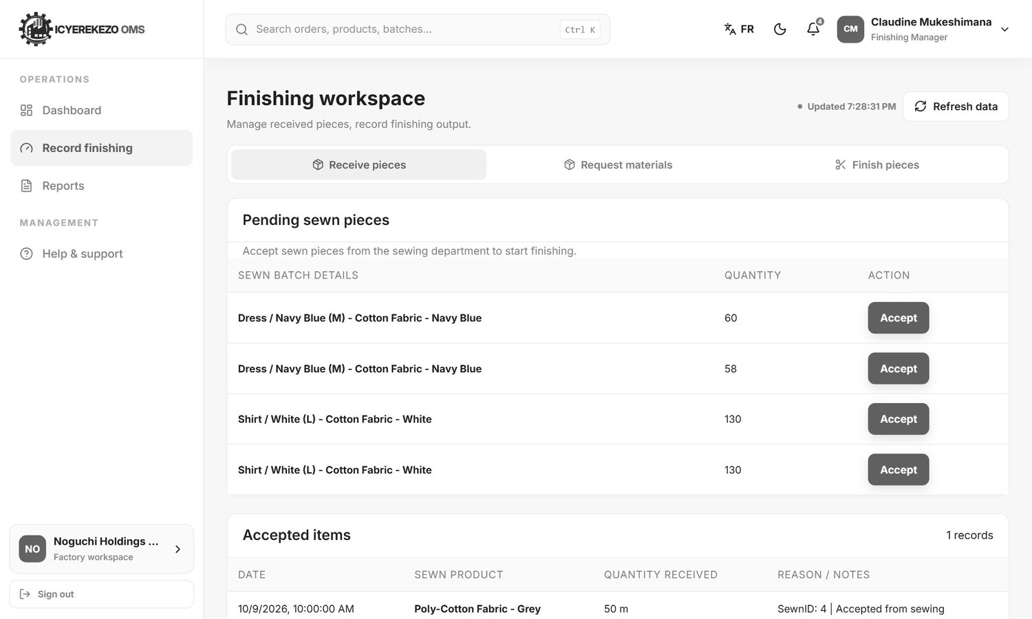
Figure 78. Finishing workspace, Receive pieces
- Receive pieces. Click Accept on the sewn batches that arrive from sewing.
- Request materials. Ask the main warehouse for buttons, thread or labels: choose the material, the quantity and the reason, click Submit request.
- Finish pieces. Choose the accepted sewn batch, type the number finished and notes, click Record finishing output.

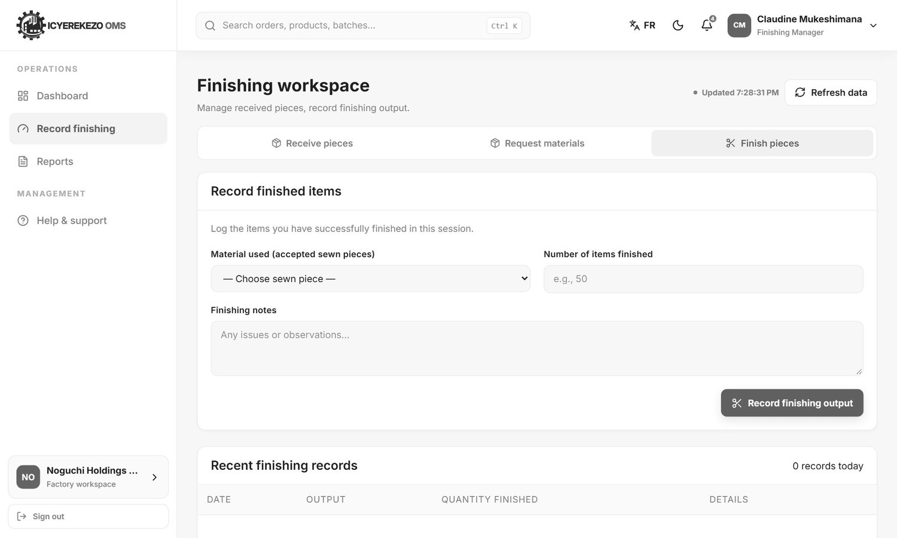
Figure 79. Finish pieces

9.4 Packing operator
Menu: Dashboard, Record packing, Reports.
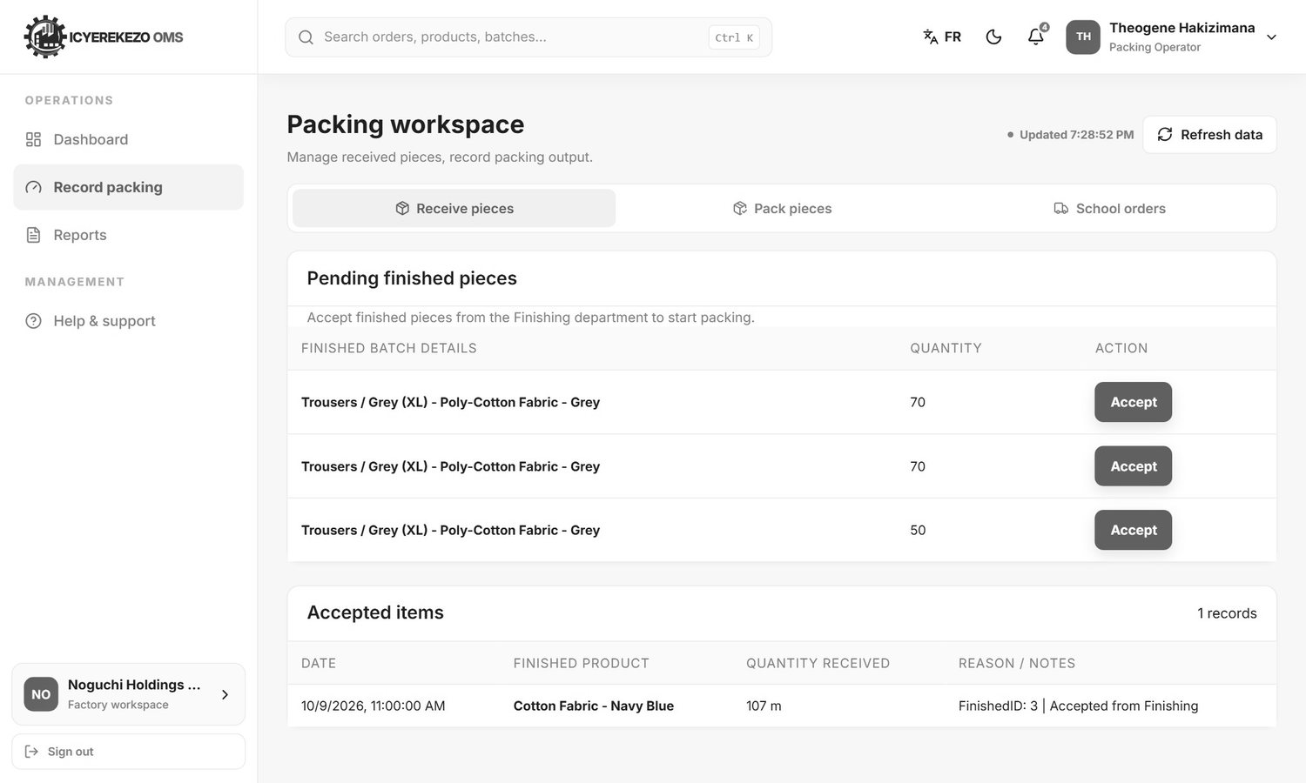
Figure 80. Packing workspace, Receive pieces
- Receive pieces. Click Accept on the finished batches from finishing.
- Pack pieces. Choose the accepted batch, choose the Finished product it is (for example Uniform or Sweater). If the product is not in the list, type its name under New product and click Add. Type the number packed and notes, click Record packing output. The batch now waits for quality control.
- School orders. Pack the garments of a school order (below).

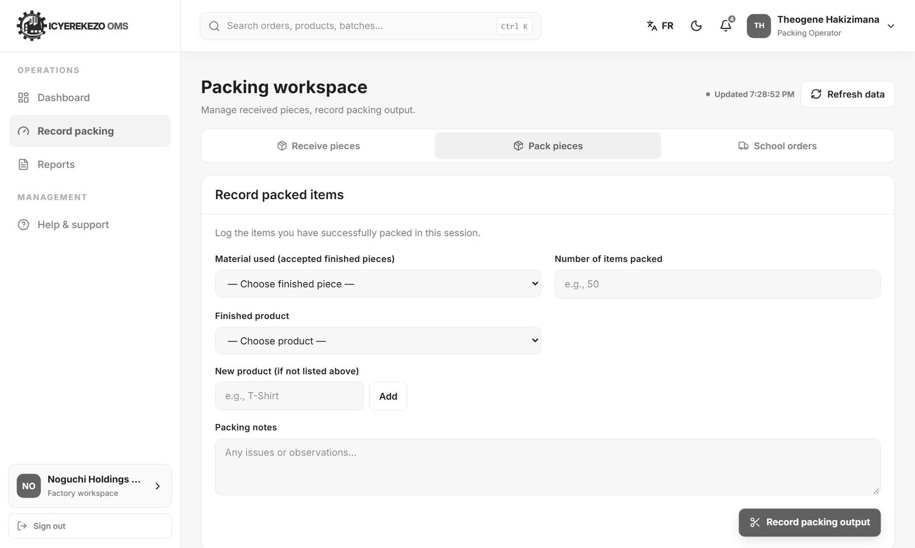
Figure 81. Pack pieces

Pack a school order
- Click the School orders tab.
- Click Pack on an order.
- In the window, type for each garment line how many are packed, then click Save on that line. You cannot enter more than was ordered.

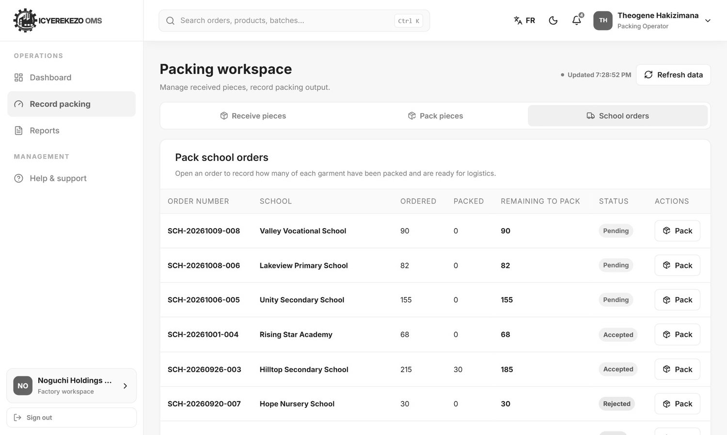
Figure 82. School orders to pack
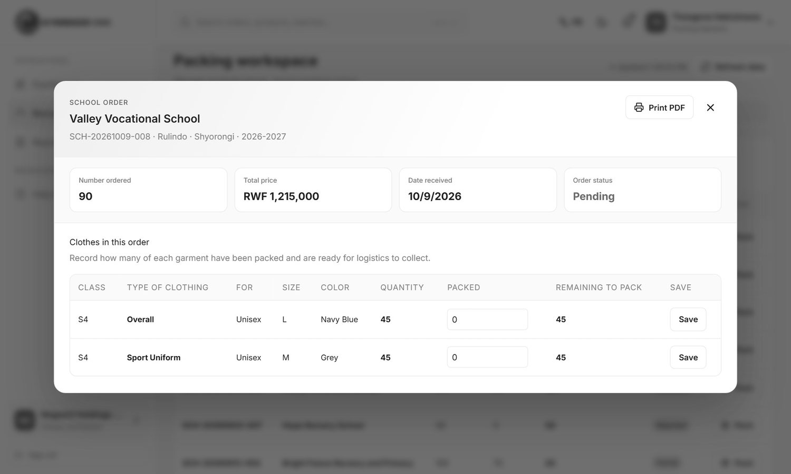
Figure 83. Order window: packed quantities

10. Quality control officer
Menu: Dashboard, Quality control, Reports.
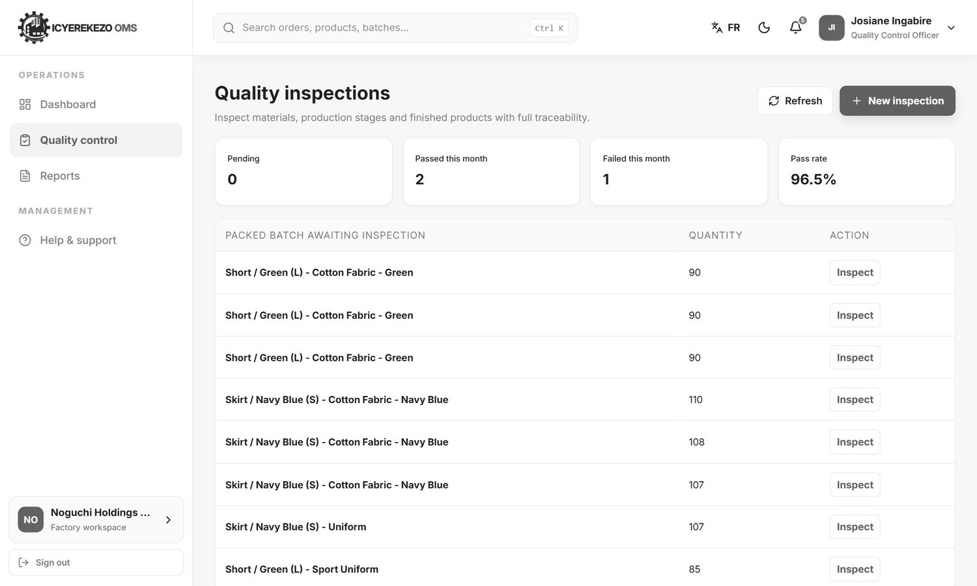
Figure 84. Quality inspections
The cards show inspections still pending, passed and failed this month, and the pass rate. The list Packed batch awaiting inspection shows batches from packing that have not been inspected. Under it is the list of inspections.

10.1 Inspect a packed batch
- Click Inspect next to the batch.
- Type the inspected, passed and rejected quantities. They must add up to no more than the inspected quantity.
- Choose the result, add notes, and save.

If the result is Passed, the batch may now leave the factory. If it is Failed, it stays blocked.
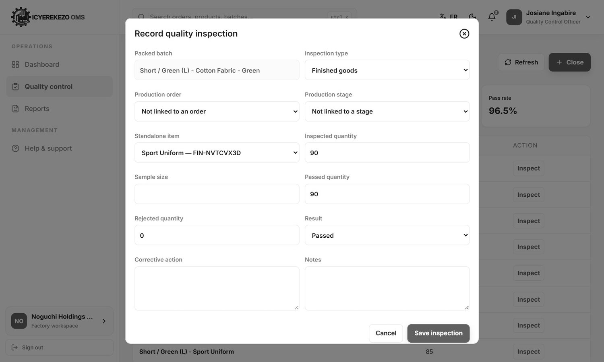
Figure 85. Inspect a batch

10.2 Record any other inspection
- Click New inspection.
- Choose the Inspection type: incoming material, in process (production stage), finished goods, random or customer return.
- Choose the Production order and Production stage if it belongs to one, or the Standalone item.
- Type the Inspected quantity, Sample size, Passed quantity and Rejected quantity.
- Choose the Result (Passed, Failed, Conditional or Pending). Describe the Corrective action and Notes.
- Save.

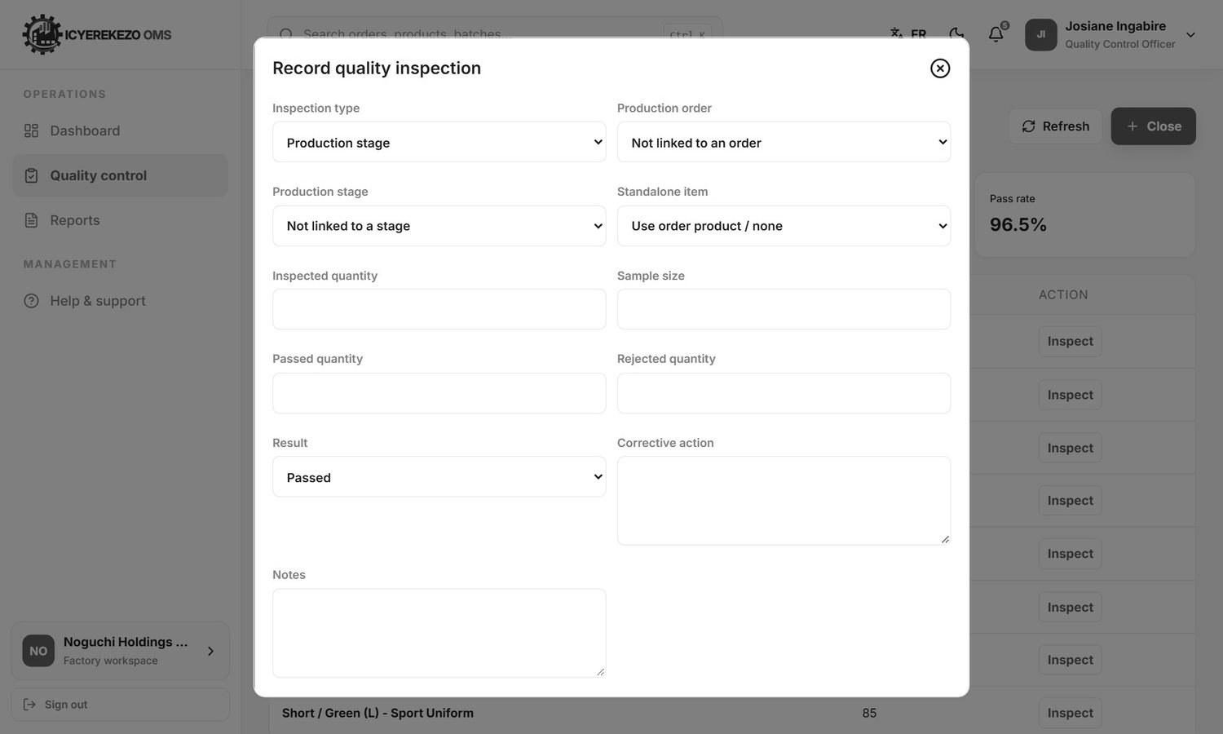
Figure 86. Record quality inspection
A failed inspection on a production step sends that step to rework and tells the people who approve. A manager clicks Approve on a finished inspection to confirm it.

11. Machines and maintenance
Menu, Machines (technician: Maintenance work orders). Spare parts are in Spare parts, which is the stock page.
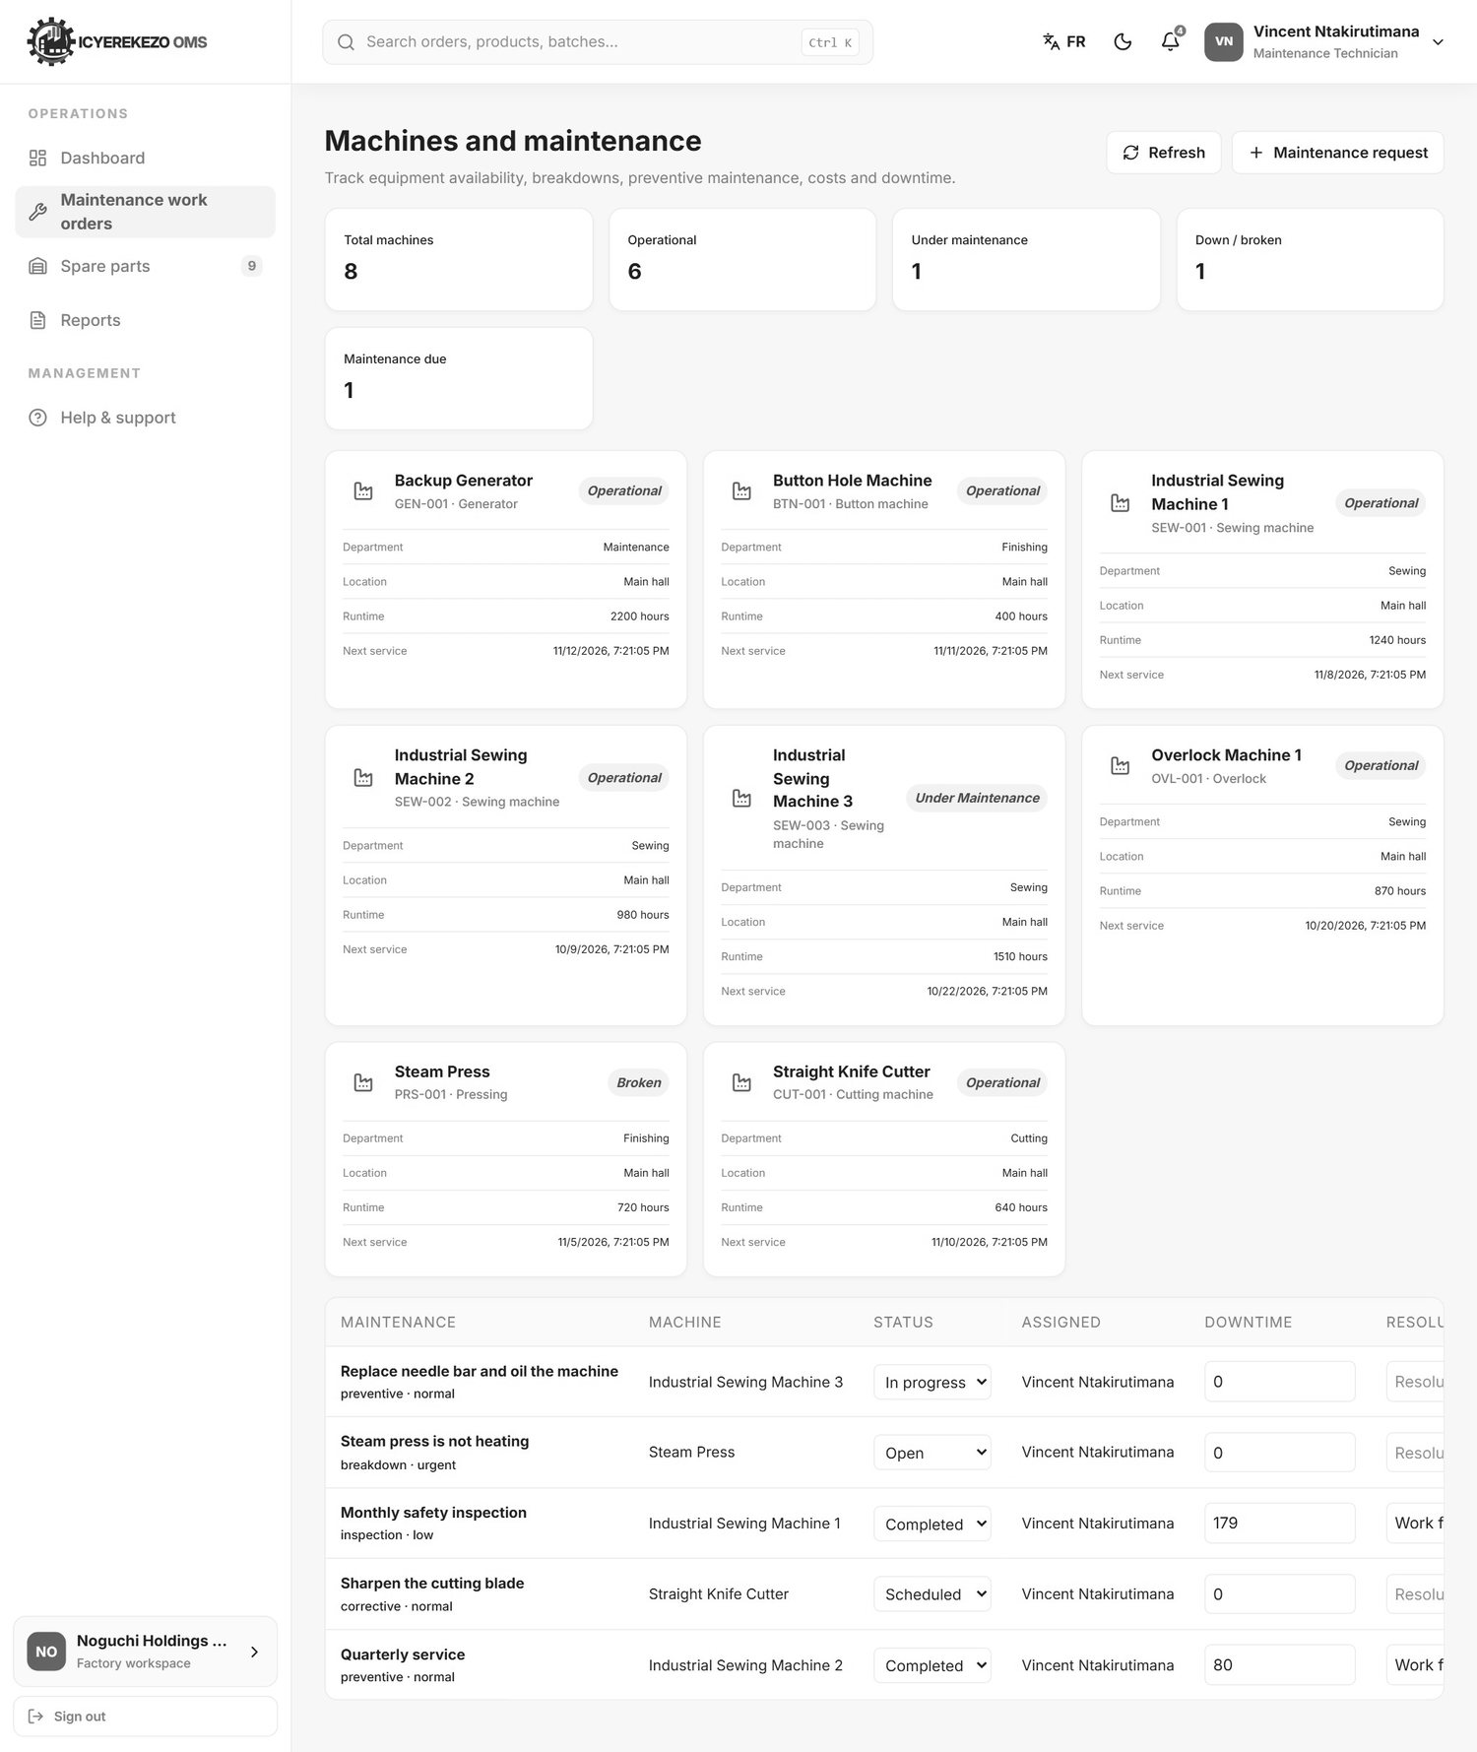
Figure 87. Machines and maintenance
The cards count the machines: total, operational, under maintenance, down or broken, and maintenance due. Each machine has a card with its code, type, status, department, location, runtime hours and next service date. Edit changes the status, runtime, location and next service date.
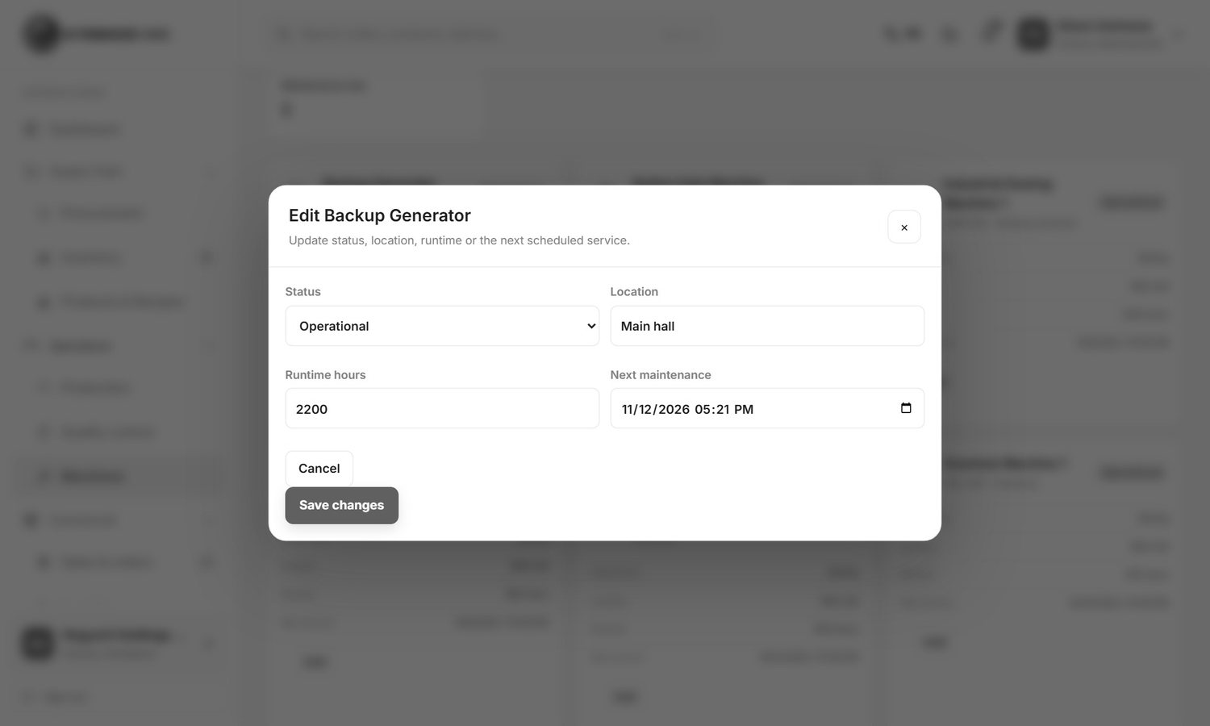
Figure 88. Edit a machine

11.1 Register a machine
- Click Register machine.
- Type the Machine name and Machine code, the type, serial number, manufacturer, model, location and department.
- Save.

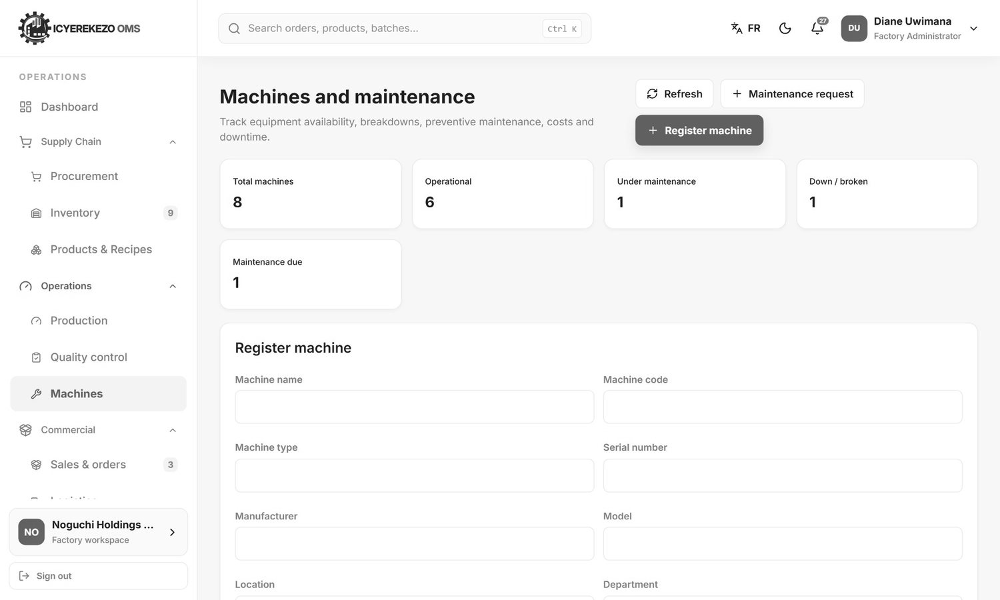
Figure 89. Register machine

11.2 Report a problem or plan maintenance
- Click Maintenance request.
- Choose the machine, the type (preventive, corrective, inspection or breakdown), the priority and the date.
- Write a title and a description and save. A breakdown request marks the machine as broken straight away.

Figure 90. Maintenance request

11.3 Finish a job
In the maintenance list change the status to Scheduled, In progress or Completed. To complete a job you must write what was done (the resolution). Add the downtime in minutes and the cost. Completing the job sets the machine back to Operational.

12. Sales officer and accountant
Menu: Dashboard, Sales & orders, Products and recipes, Stock availability, Reports. At Noguchi the Sales page is the school order desk.
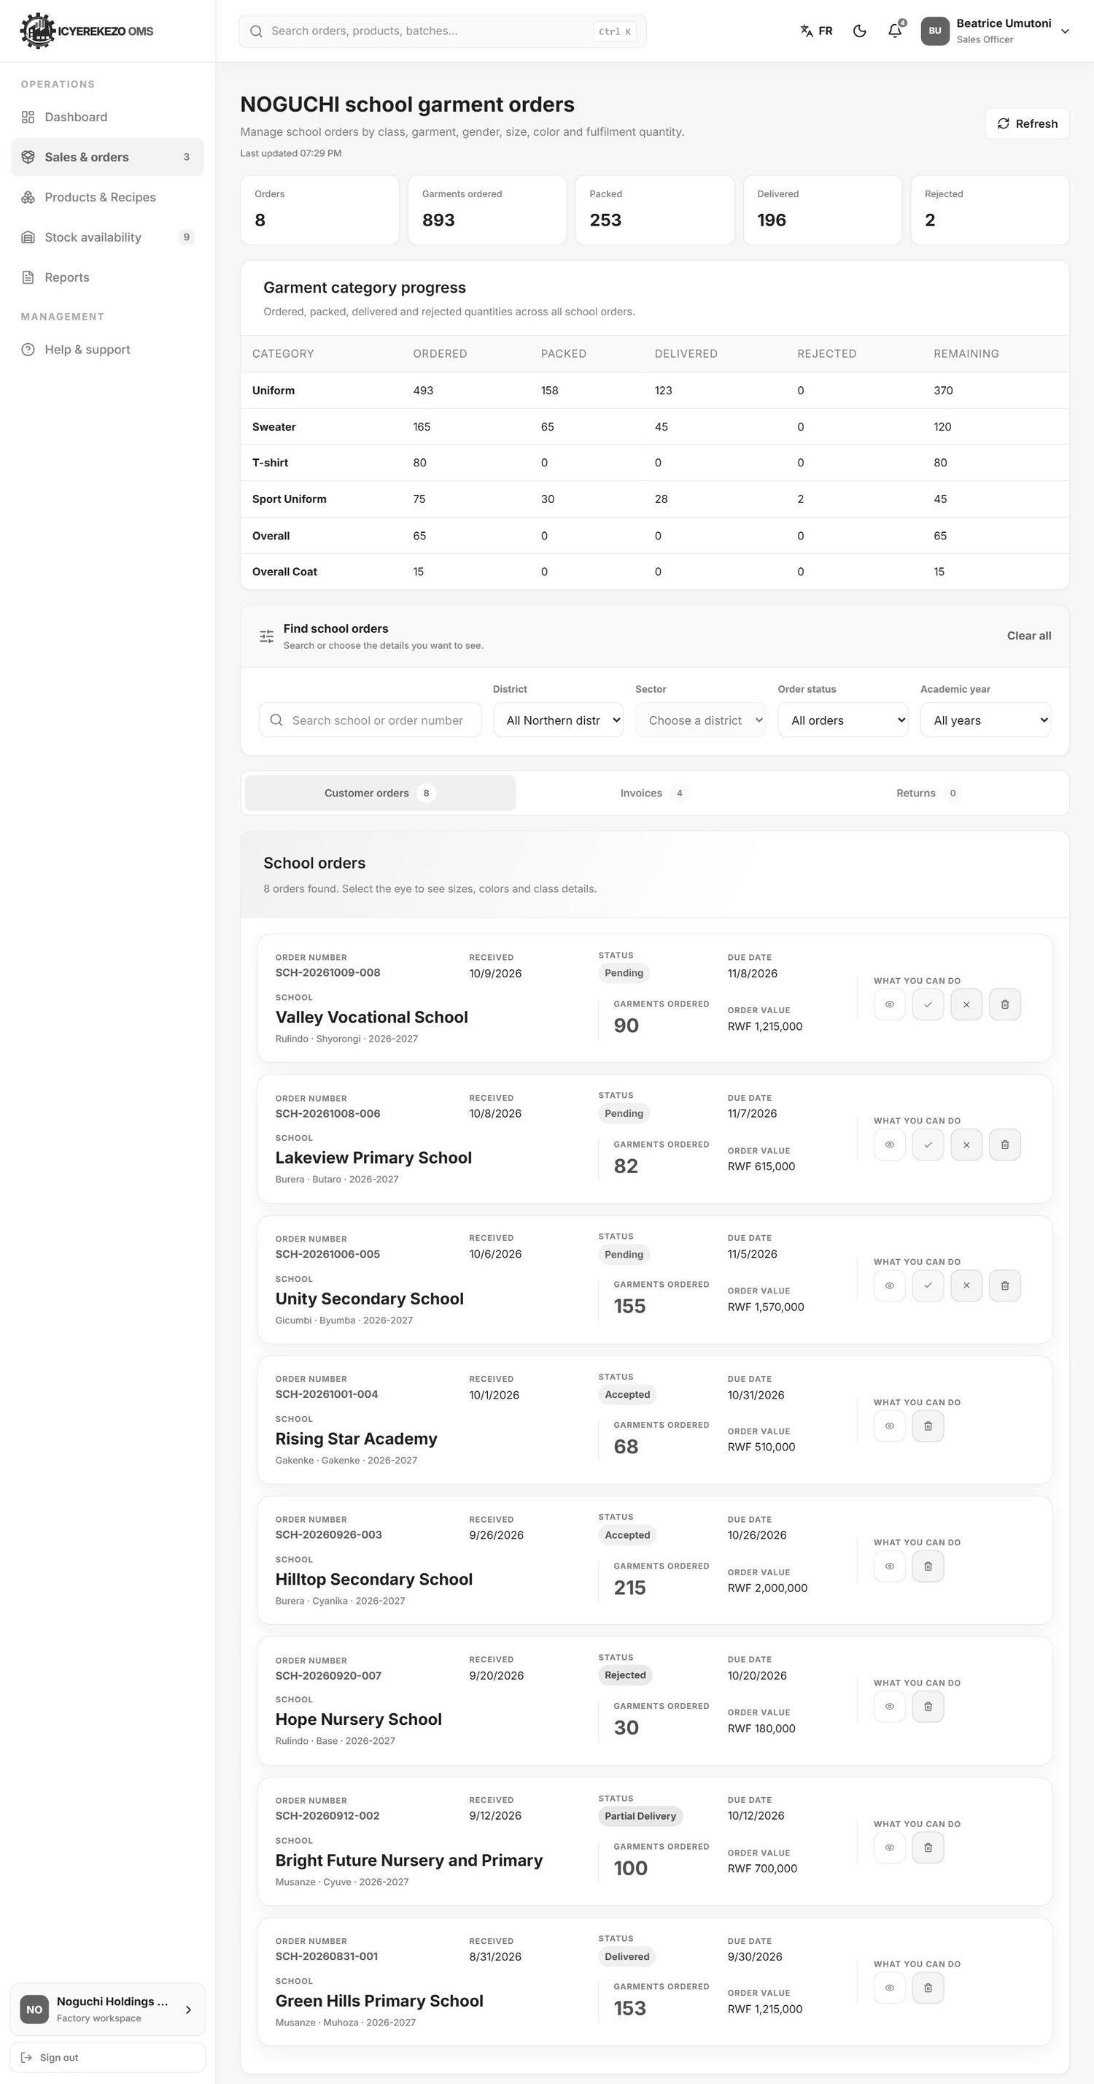
Figure 91. School garment orders
Part | Meaning
Cards | Orders, garments ordered, packed, delivered and rejected.
Garment category progress | For each garment (Uniform, Sweater, T-shirt, Sport Uniform, Overall, Overall Coat): ordered, packed, delivered, rejected and remaining.
Find school orders | Search by school name or order number. Filter by District, Sector, Order status and Academic year. Clear all removes the filters.
Tabs | Customer orders, Invoices and Returns with their counts.
Order cards | Each order shows the number, the received date, the status, the due date, the school, the garments ordered and the order value.

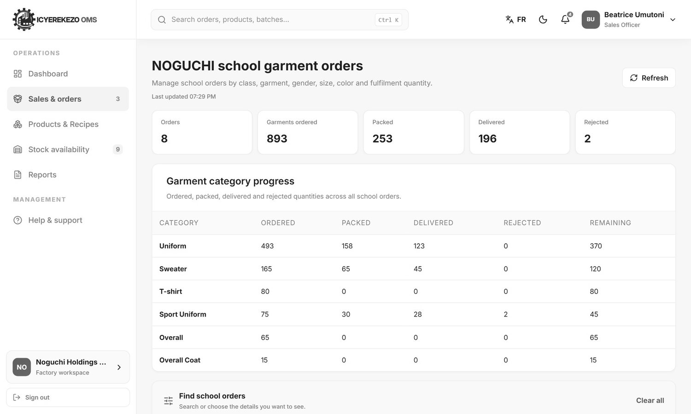
Figure 92. Orders filtered by district

12.1 What the four buttons on an order do
Button | Action
Eye | Opens the order with all its lines: class, garment, gender, size, color and quantities.
Green tick | Accepts the order. Only for pending orders.
Red cross | Rejects the order. You must write a reason.
Red bin | Deletes the order. It asks you to confirm. An order with an active shipment cannot be deleted.

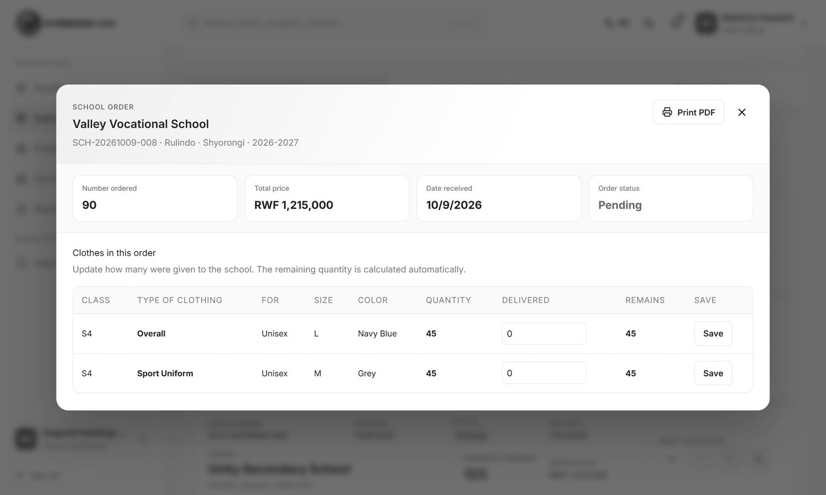
Figure 93. An order opened with the eye
Inside the order, Print PDF makes a printable page of the order. Staff with the right permission can also type how many garments were delivered to the school and click Save on a line.

12.2 Accept or reject a new order
- Open Sales & orders. New orders have the status Pending. The red number in the menu is how many wait.
- Open the order with the eye and check the lines.
- Click the green tick to accept. The school gets an email telling it the order status changed.
- Or click the red cross, write the reason and confirm. The reason is recorded on the order.

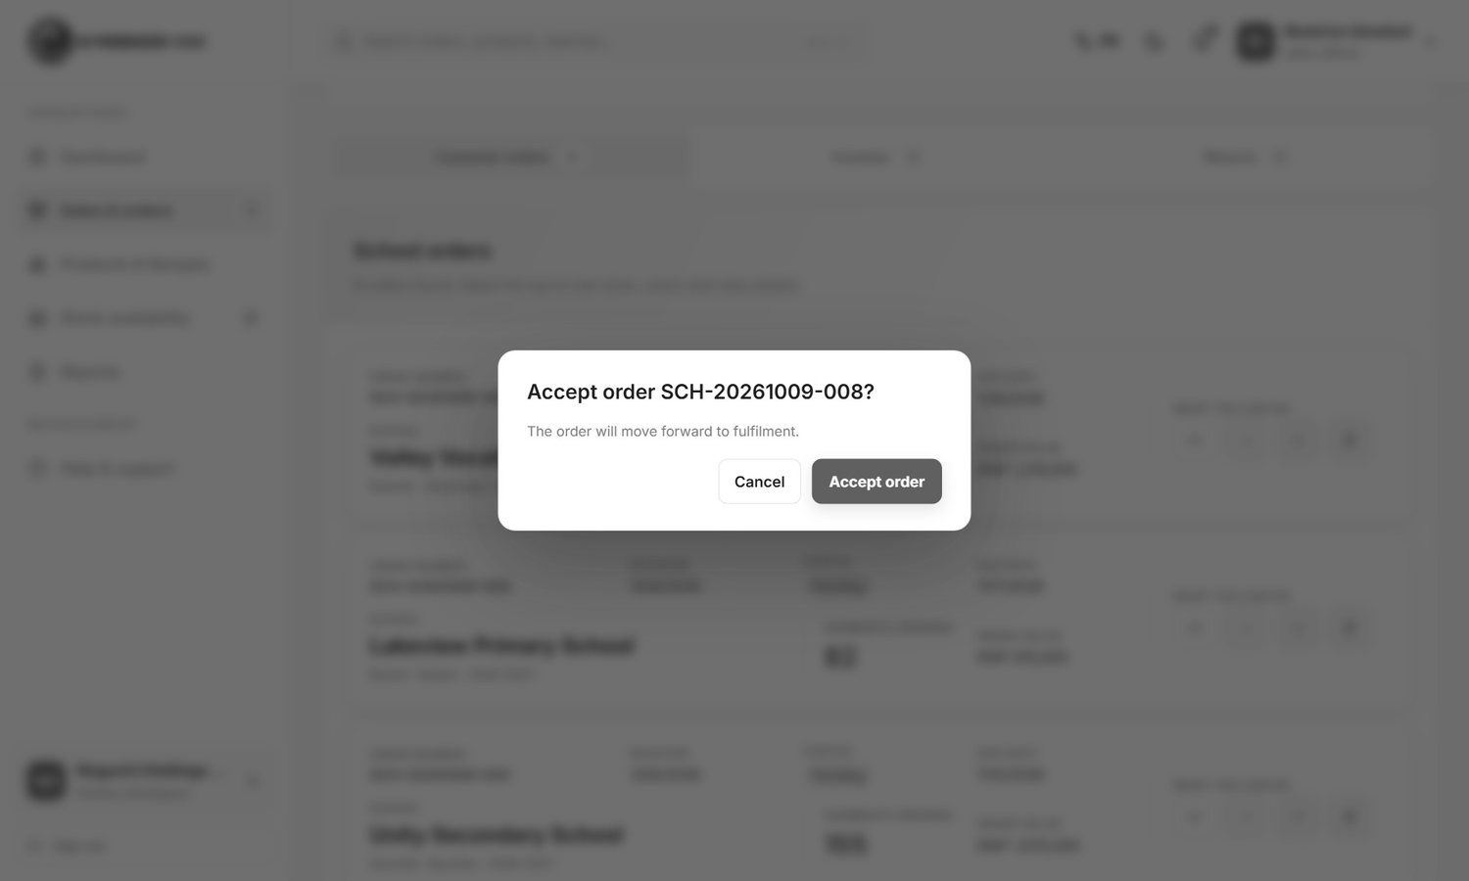
Figure 94. Accept an order
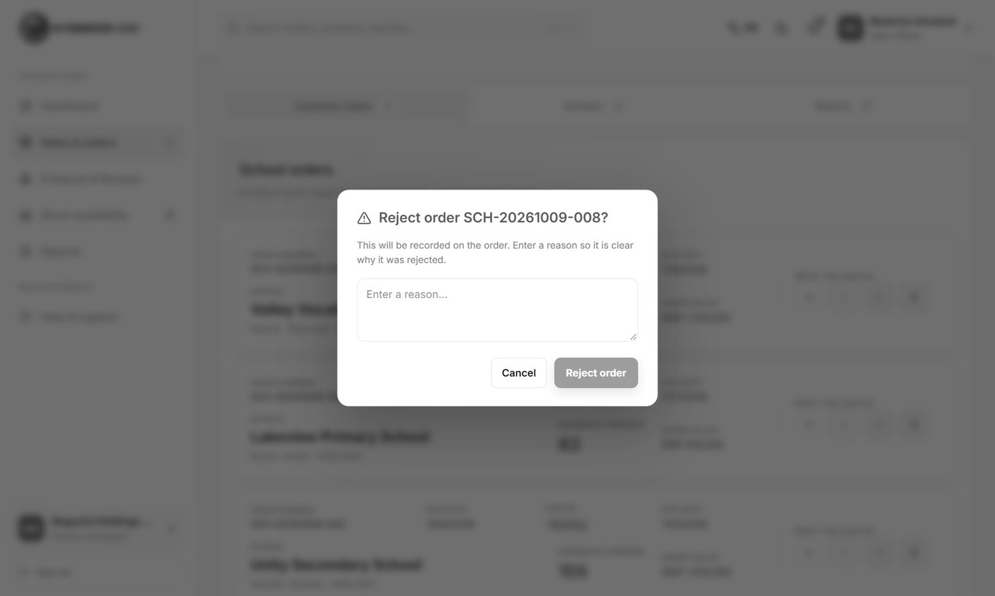
Figure 95. Reject an order

12.3 Upload an invoice
The system does not create invoices. Make the invoice in your own program and attach the file to the order.
- Click the tab Invoices.
- Find the order and click the upload button.
- Choose the PDF, JPG or PNG file (up to 15 MB) and confirm.

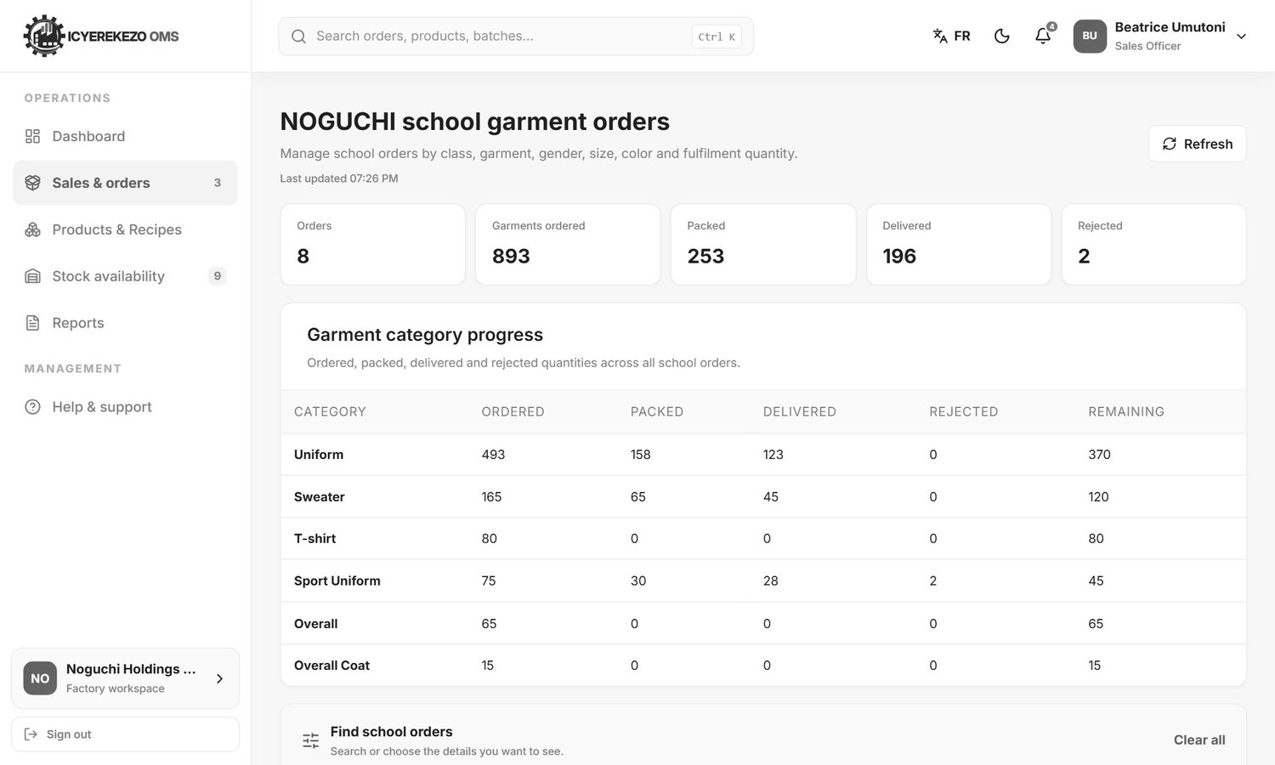
Figure 96. Invoices tab
The school can then see the invoice. The Returns tab counts return documents of the factory. Return requests that a school sends are not shown there (see the School Portal Guide).

12.4 Stock availability
The sales officer can look at the stock page to see which finished garments are available. This page is read only for this role.
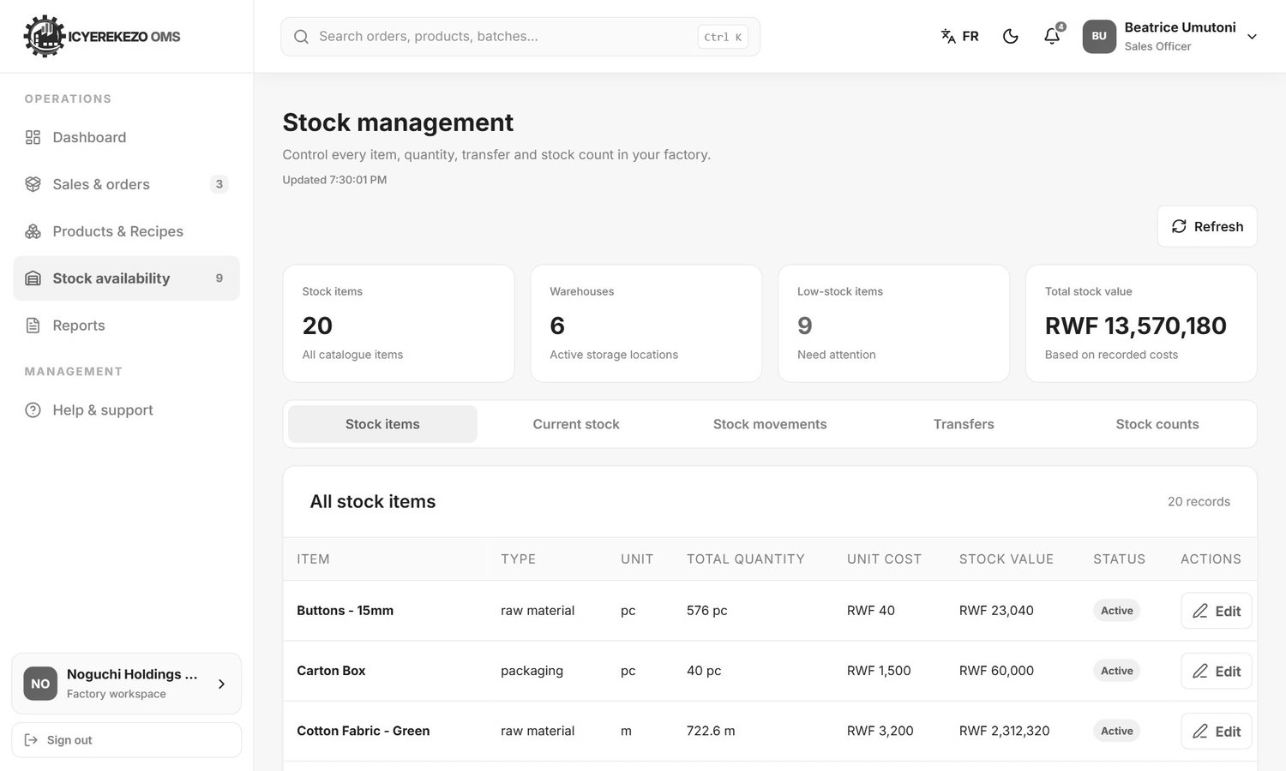
Figure 97. Stock availability
The accountant sees the same order page, plus the Procurement page, and can open reports. Payments are handled by the financial manager (section 13).

13. Financial manager
Menu: Dashboard, Finance overview, Orders & invoices, Financial reports.
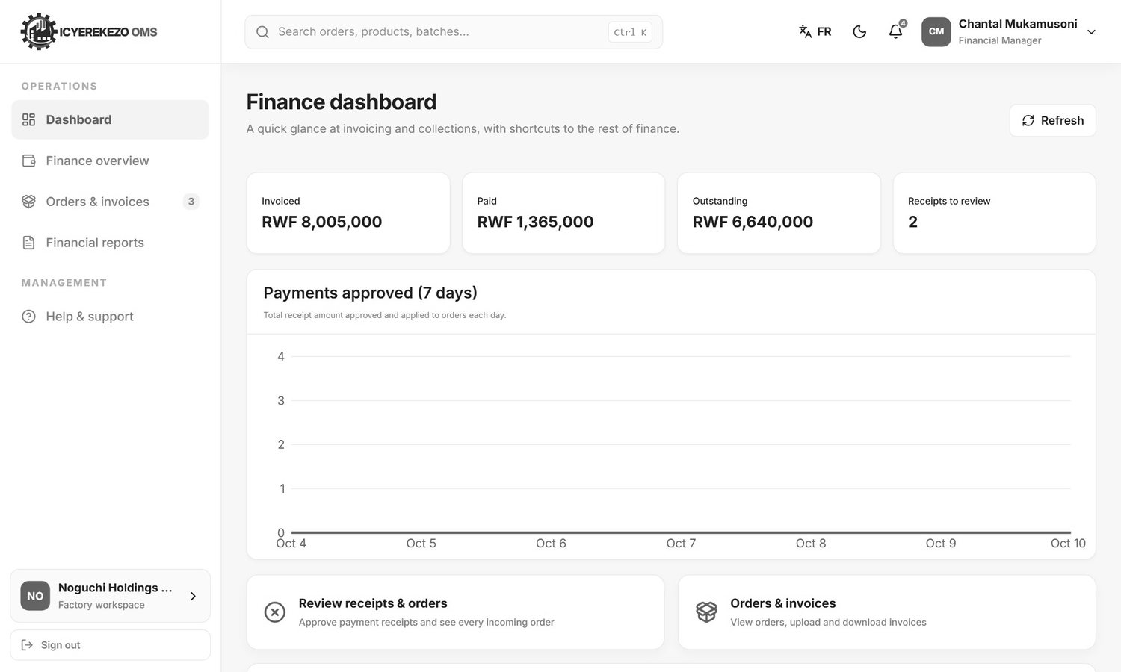
Figure 98. Finance dashboard

13.1 Approve payment receipts
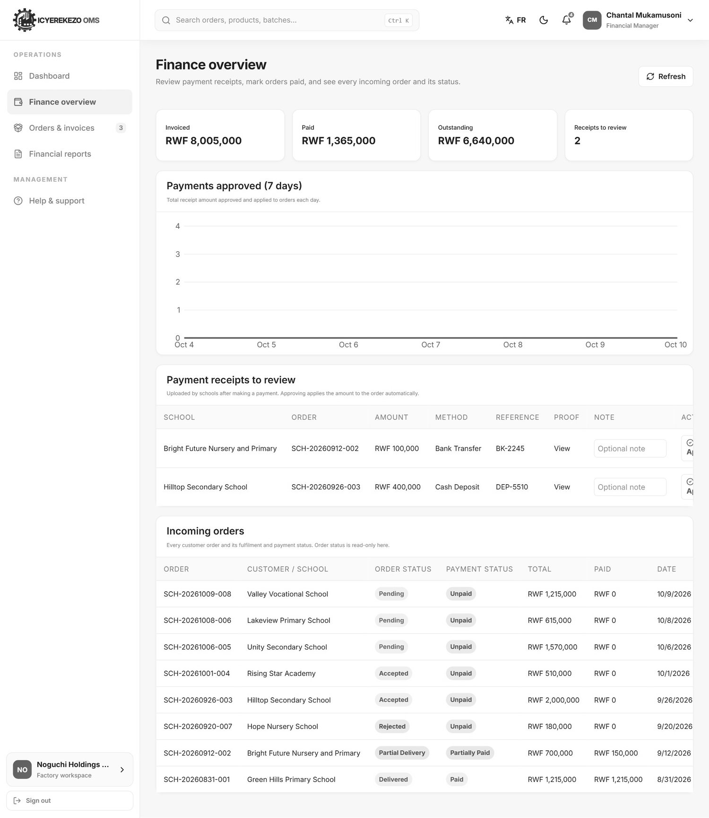
Figure 99. Finance overview
- Menu, Finance overview.
- The cards show the amount invoiced, paid, outstanding and the receipts to review.
- Under Payment receipts to review each line is a payment proof sent by a school: school, order, amount, method, reference and a link to the proof.
- Click View to open the proof (a photo or PDF). Check the amount and the reference against your bank or mobile money record.
- Type an optional note and click Approve or Reject.

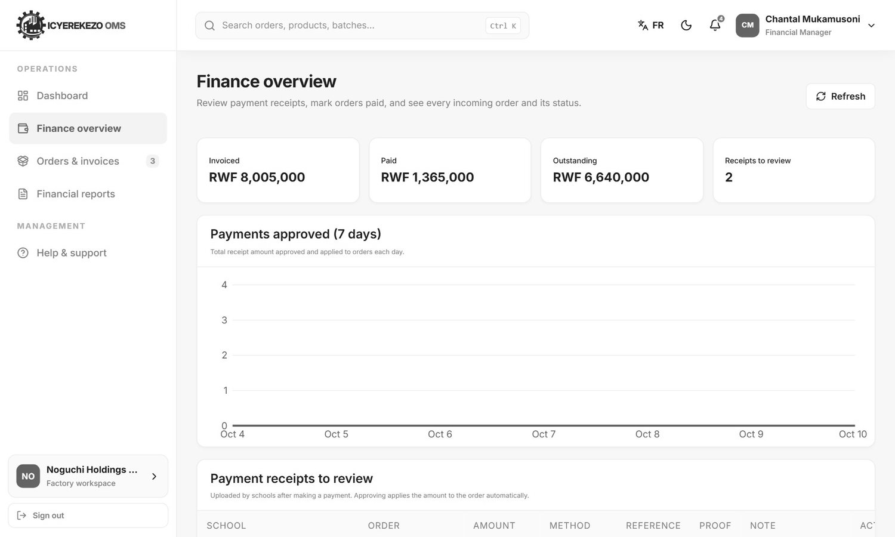
Figure 100. Payment receipts to review
Approving adds the amount to the order and changes its payment status to Partially paid or Paid. Rejecting keeps the order as it was. The school sees the result in its Financial Records. The chart Payments approved (7 days) shows the amount approved each day. The table Incoming orders at the bottom shows every order with its order status and payment status (read only).

13.2 Orders and invoices
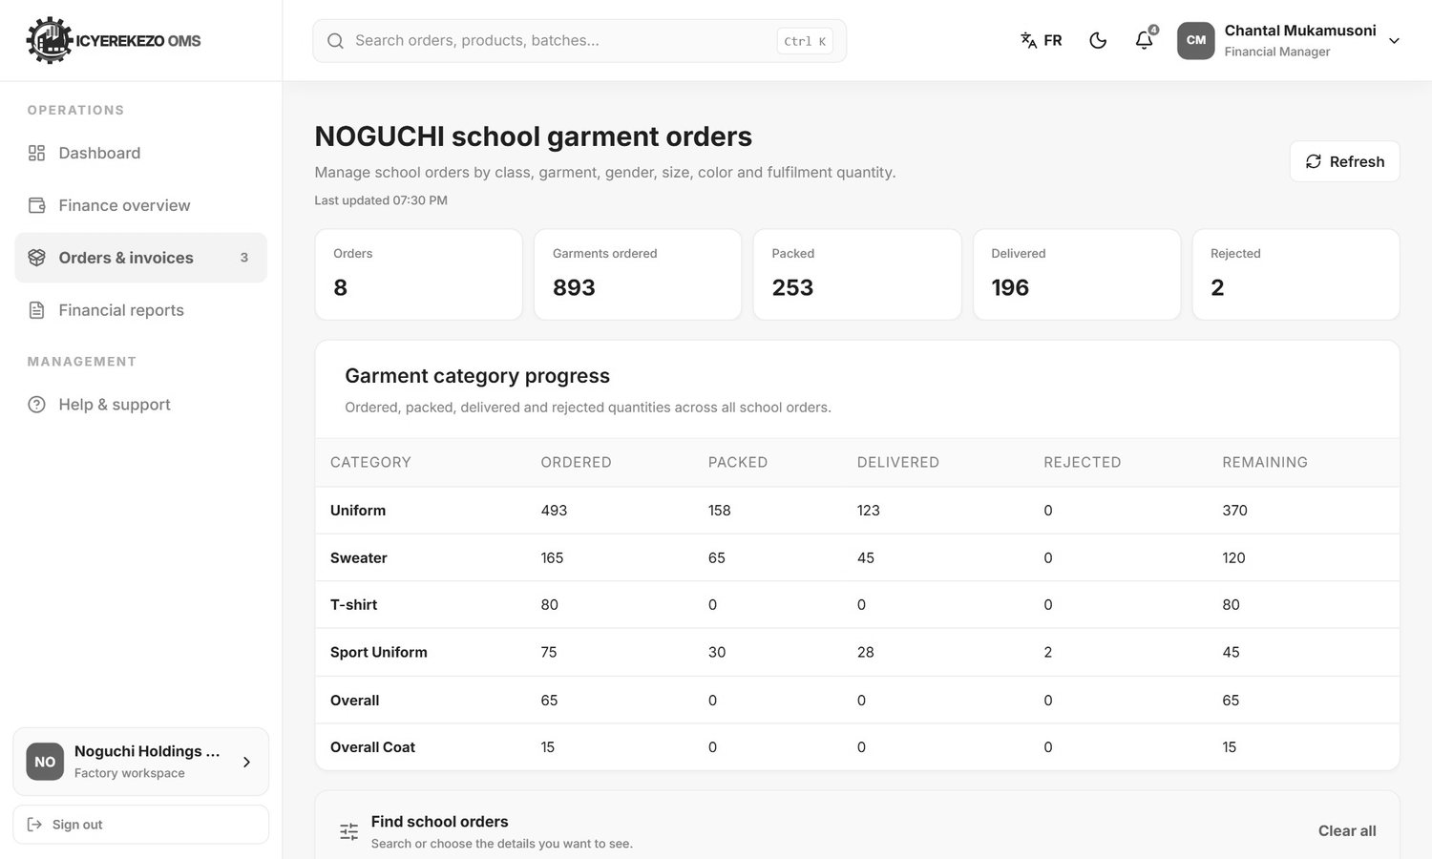
Figure 101. Orders and invoices

13.3 Financial reports
Menu, Financial reports. Choose the Report type and the Report period, read the report on the screen and click Print report.
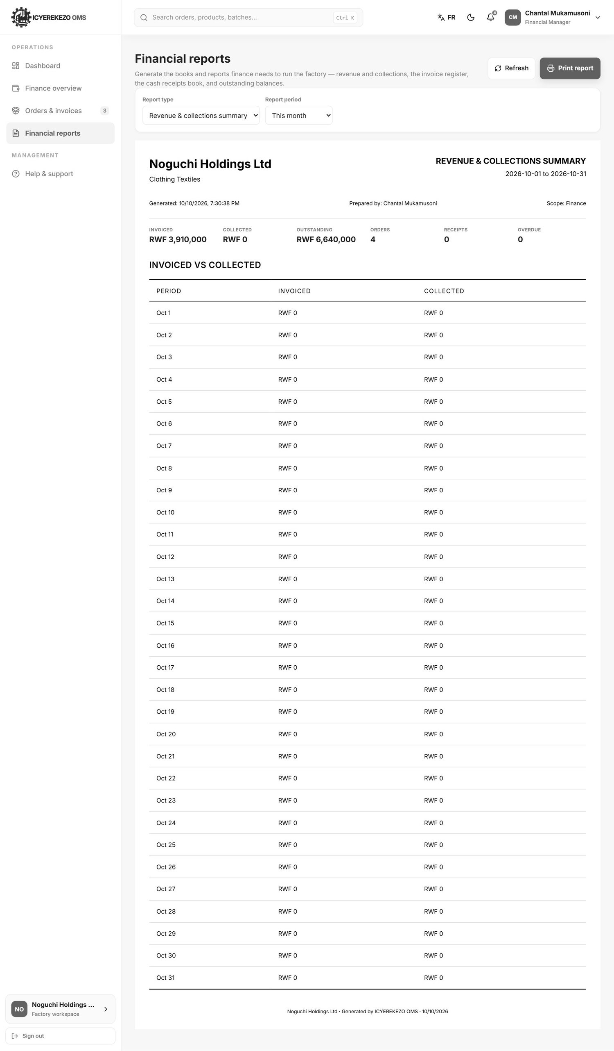
Figure 102. Financial reports
Report type | What it shows
Revenue and collections summary | Invoiced, collected, outstanding, number of orders and receipts, overdue count, and a table of invoiced against collected for each day or month.
Invoice register | Every order with its dates, status, total, paid amount and balance, and whether an invoice file was uploaded.
Cash receipts book | Every approved payment with date, school, order, method, reference, amount and who approved it.
Outstanding and aging report | Orders not fully paid, with the balance and how many days they are overdue.

Periods: today, this week, this month, this quarter, this year or custom dates (choose From and To).

14. Logistics officer

14.1 At Noguchi
Menu: Dashboard, Incoming orders, Delivery confirmation, Agreement, Reports.
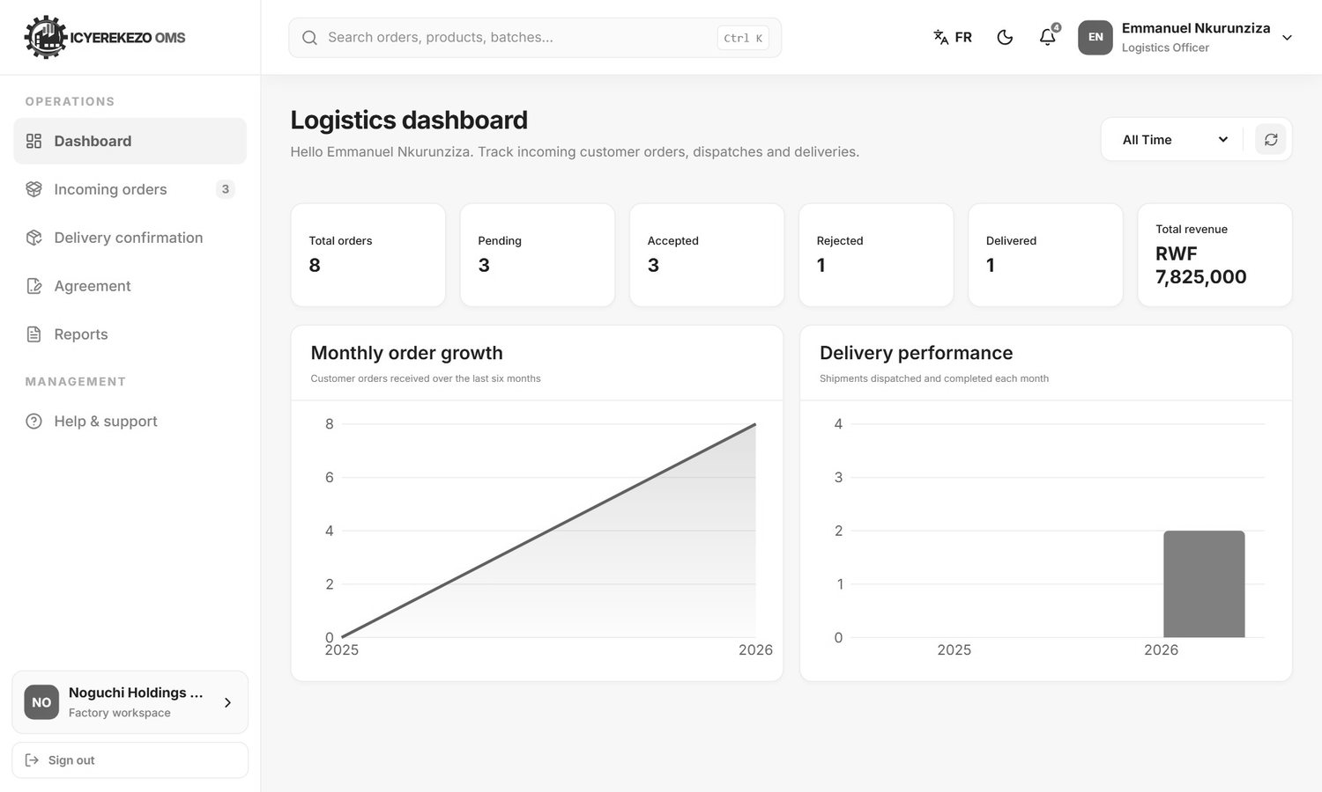
Figure 103. Logistics dashboard
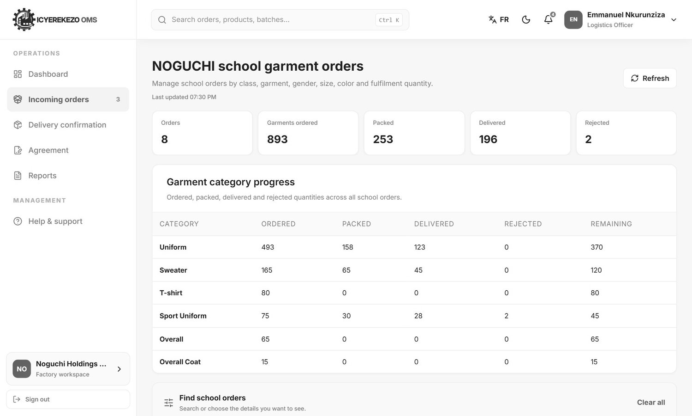
Figure 104. Incoming orders
Incoming orders is the school order page (section 12). Logistics can accept or reject orders here too.

Confirm a delivery
Logistics can only deliver what the packing team has packed.
- Menu, Delivery confirmation. The cards show orders pending, ready, partly delivered and delivered.
- Use the box at the top right to show one status.
- Click the delivery icon in the Actions column of the order.
- Check the lines. The Packed column shows what is ready. Click Deliver (the button name changes to "Nothing to deliver" when nothing is packed).
- The delivered quantity goes up to the packed quantity, the remaining quantity falls and the order status changes to Partial delivery or Delivered. The stock is reduced and the school receives an email.

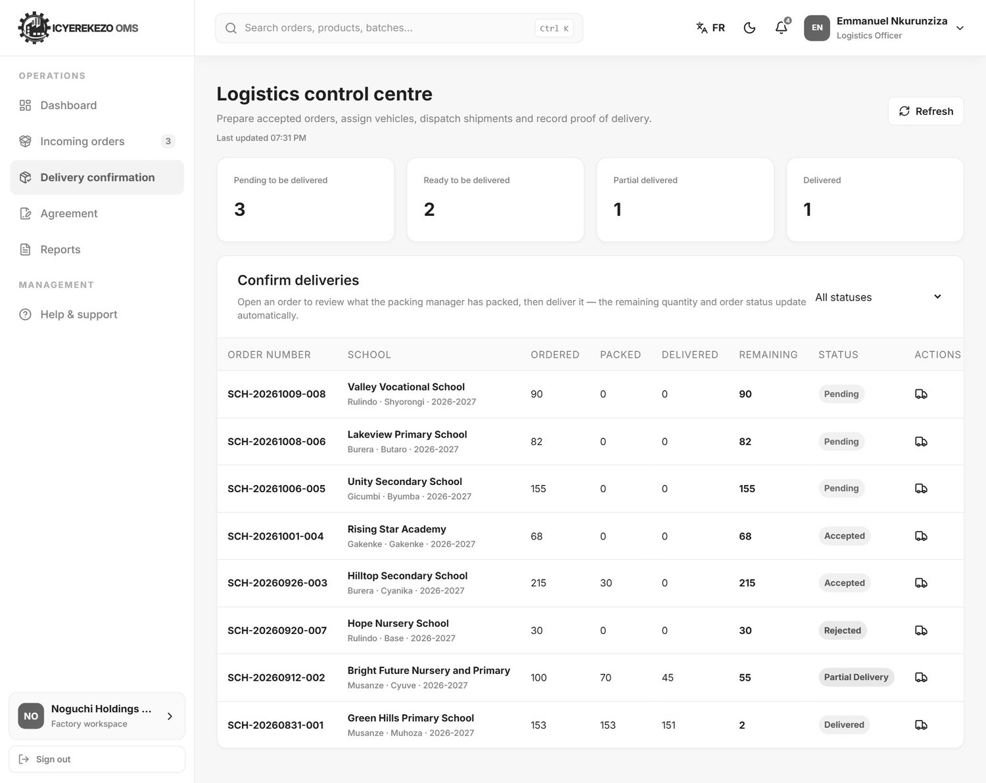
Figure 105. Delivery confirmation
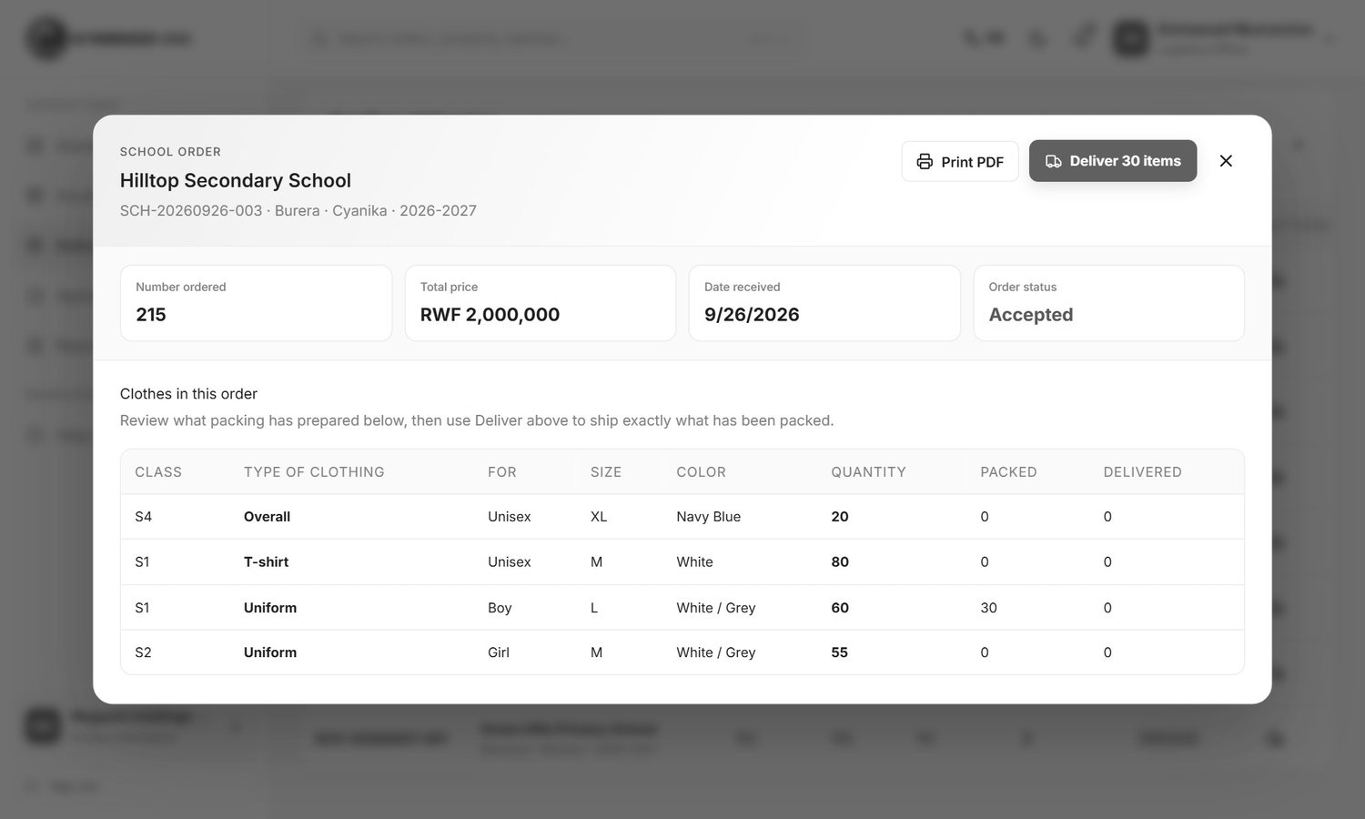
Figure 106. Deliver packed garments

School agreement
Every school should sign the supply agreement. Menu, Agreement.
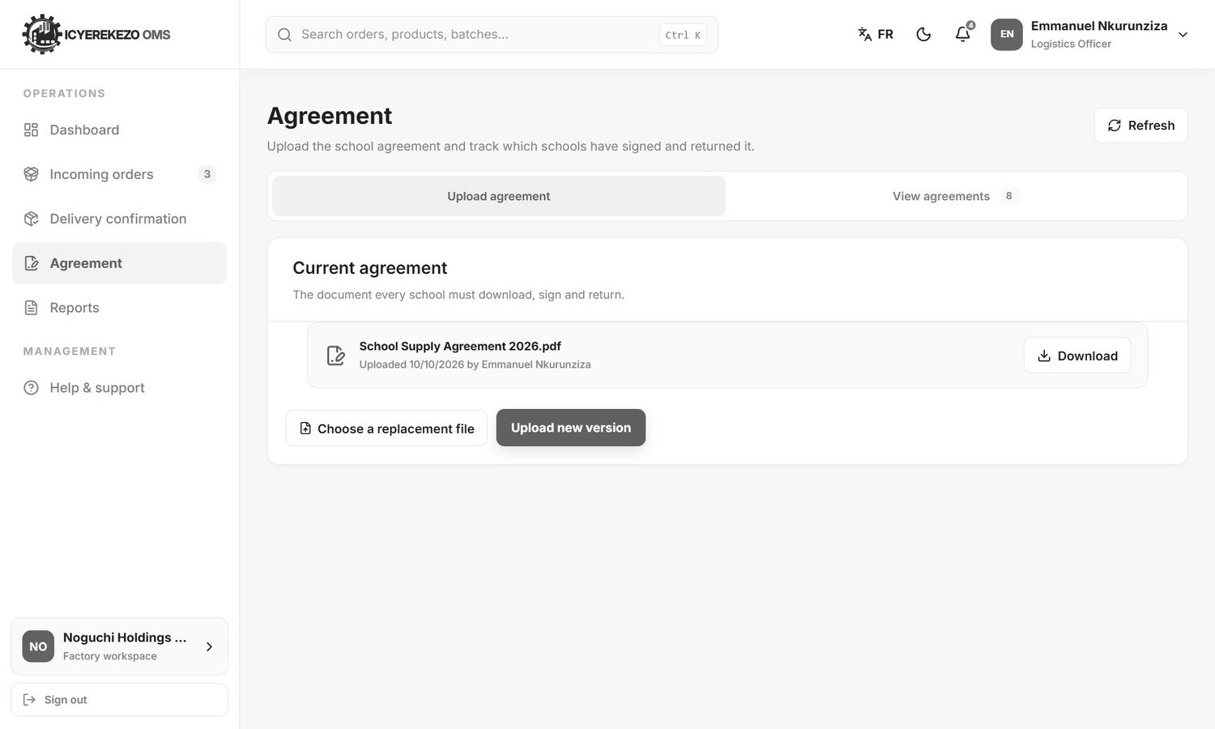
Figure 107. Agreement
- Click Choose a replacement file and pick the agreement (PDF, DOC or DOCX, up to 15 MB).
- Click Upload new version. Schools will see the new version and can sign it.
- Click the tab View agreements to see which schools signed. The cards show total schools, signed and unsigned. Filter by status, district or sector, or search by school name. View opens the signed copy.

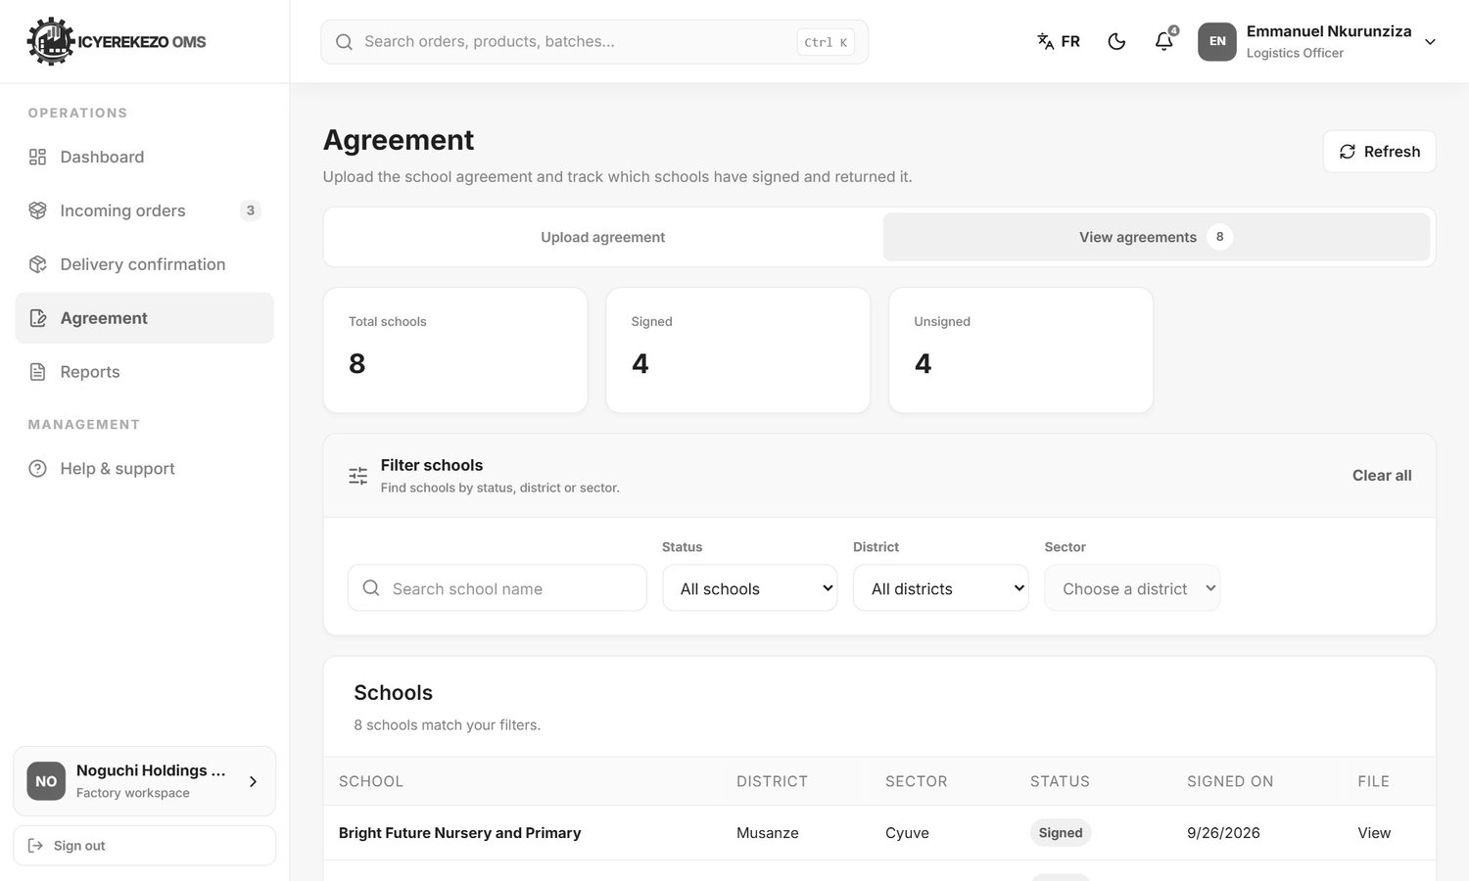
Figure 108. Which schools have signed

14.2 At other factories
Other factories use the full delivery pages. Menu: Dashboard, Incoming orders, Available goods, Shipments, Dispatch board, Vehicles & drivers, Delivery confirmation, Agreement, Reports.
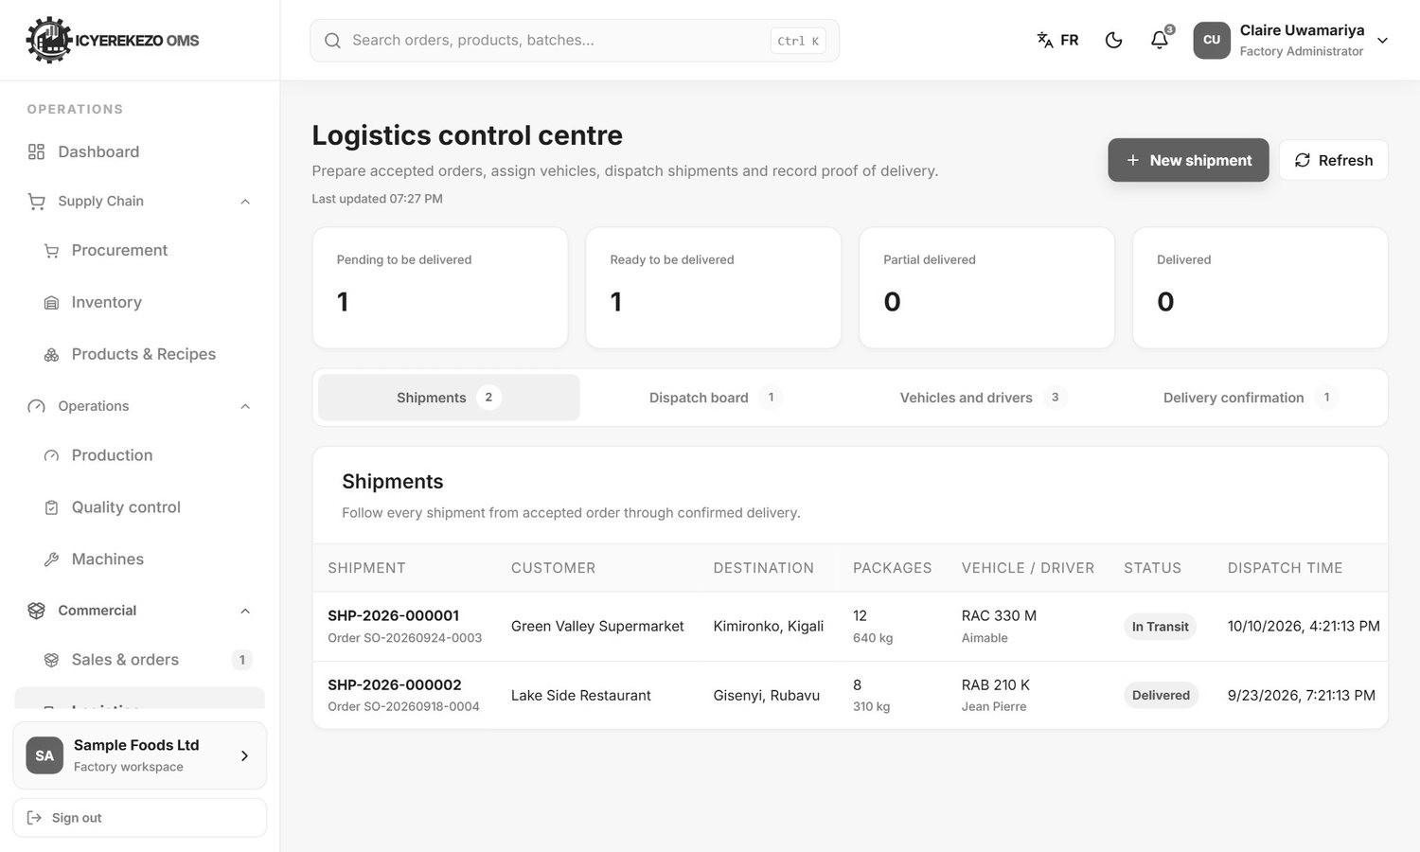
Figure 109. Logistics control centre: shipments
- Make a shipment. Click New shipment. Choose the accepted order, the vehicle (or Assign later), the destination, the number of packages, the weight and the planned dispatch time. Click Create shipment. The status is Planned, or Ready if you chose a vehicle.
- Assign a vehicle. On a planned shipment click Assign vehicle and choose one. The status becomes Ready and the vehicle becomes Assigned.
- Dispatch. When the vehicle leaves, click Dispatch on the shipment. Status: In transit.
- Confirm delivery. When the goods arrive, click Confirm delivery, type who received the goods and a proof reference (for example a delivery note number) and confirm. Status: Delivered. The order is marked completed.
- A planned or ready shipment can be cancelled with Cancel. The order goes back to Accepted.

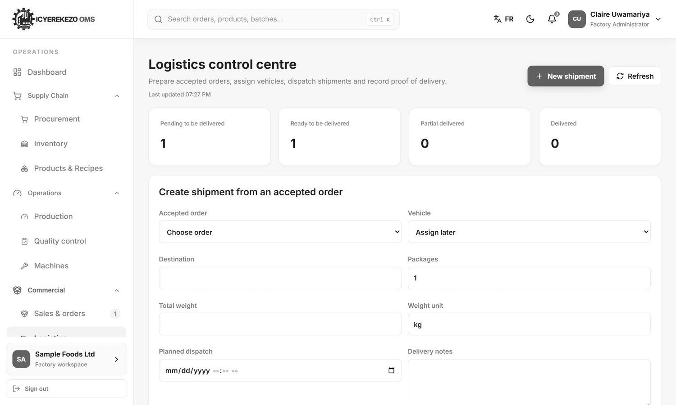
Figure 110. Create shipment from an accepted order
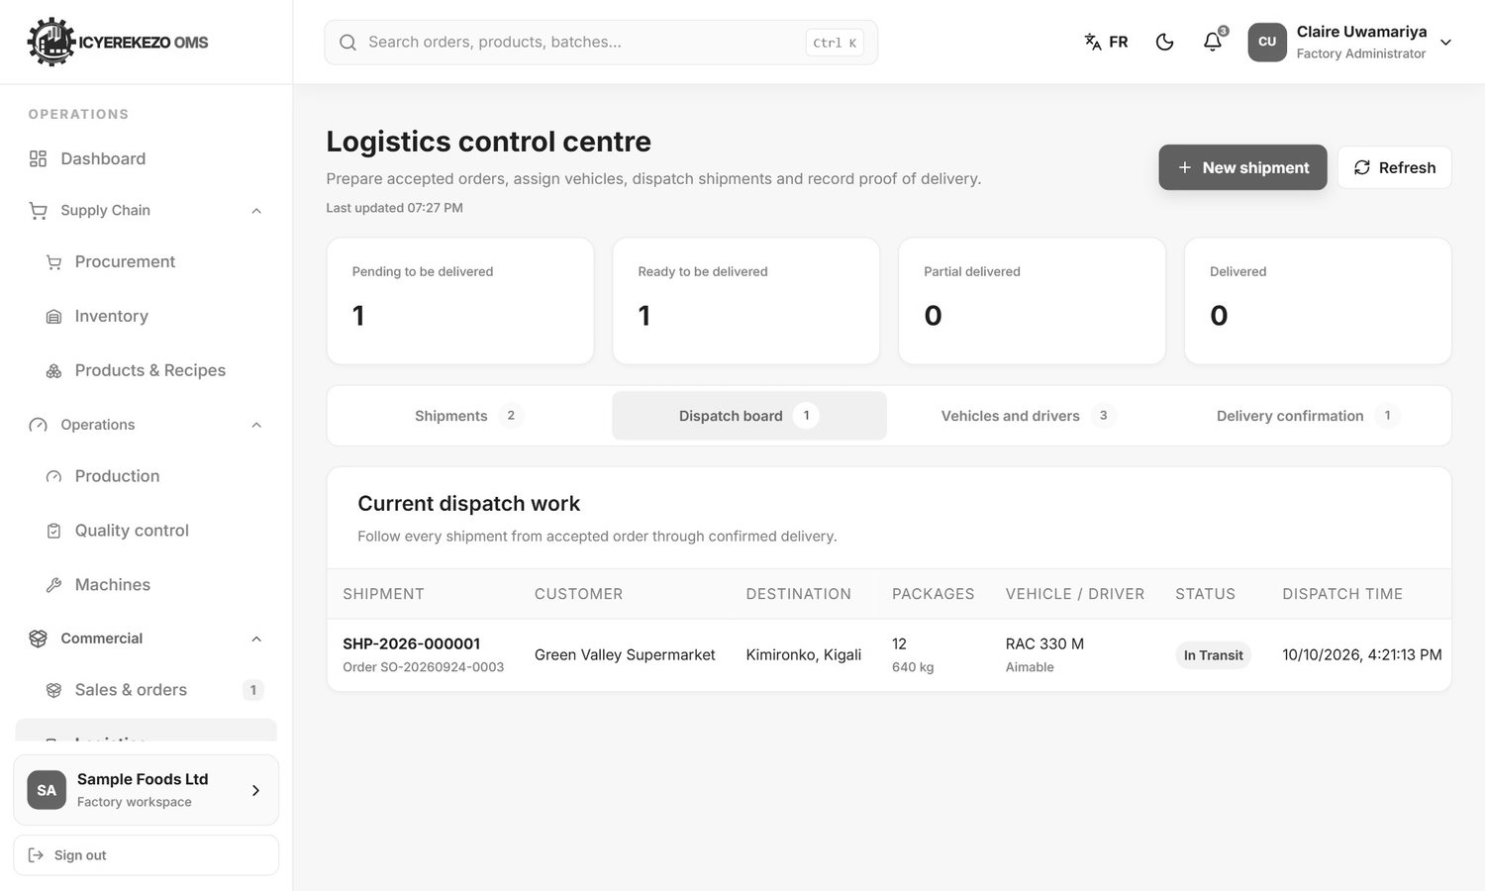
Figure 111. Dispatch board
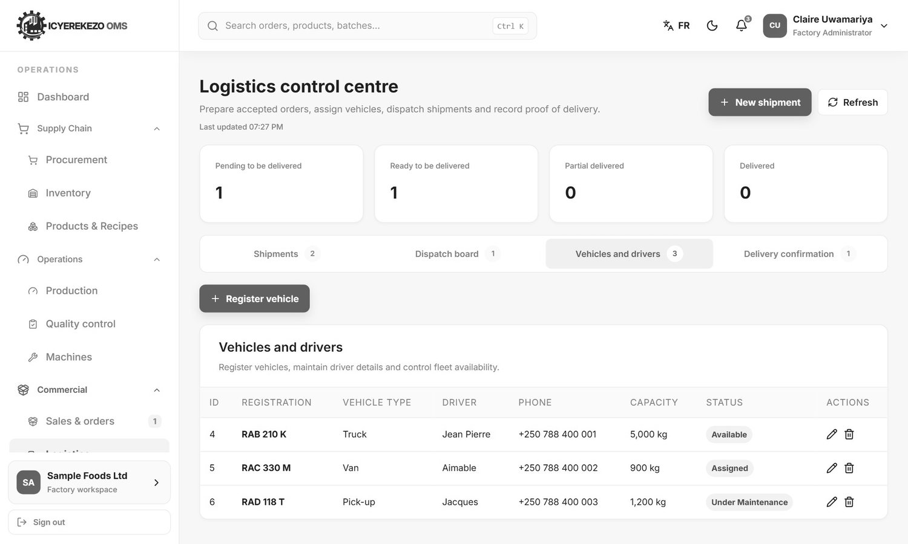
Figure 112. Vehicles and drivers
On Vehicles and drivers click Register vehicle to add a vehicle: registration number, type, driver name and phone, capacity and status. A vehicle assigned to an active shipment cannot be deleted.
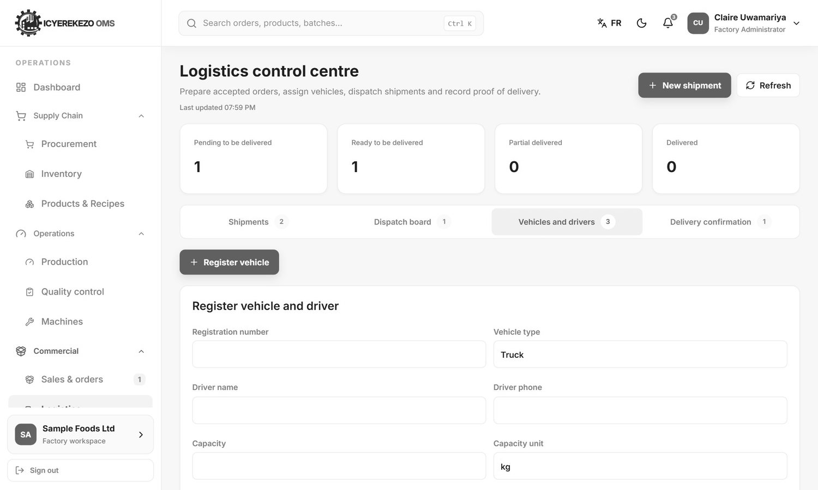
Figure 113. Register vehicle and driver
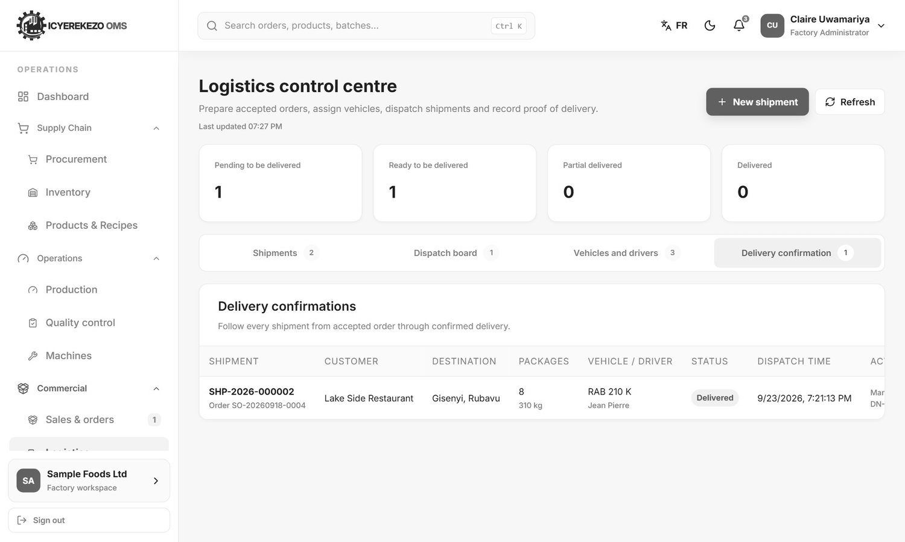
Figure 114. Delivery confirmation

15. HR officer
Menu: Dashboard, People and workforce, Attendance, leave and training, Reports.
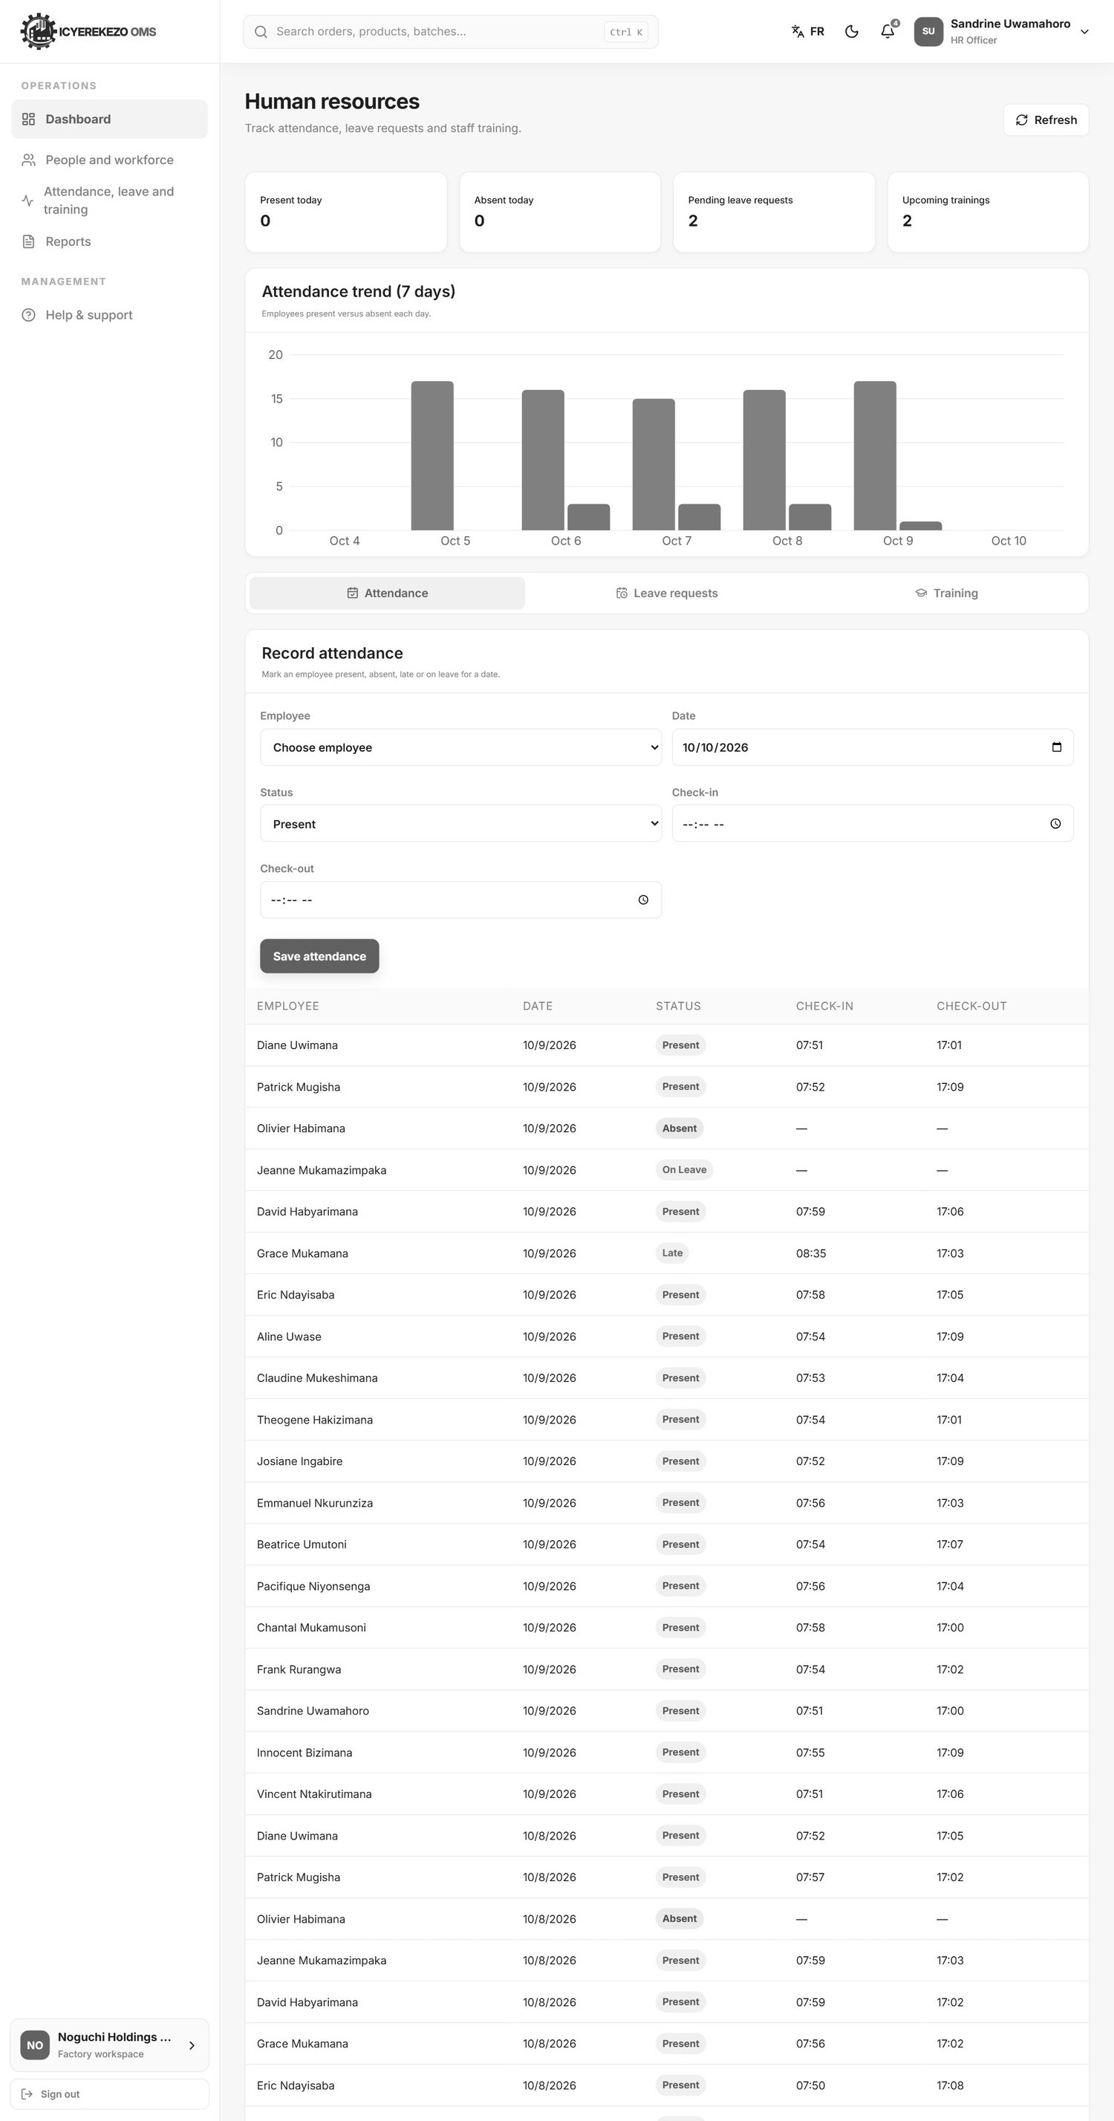
Figure 115. Human resources
The cards show who is present and absent today, pending leave requests and upcoming trainings. The chart shows present against absent for the last seven days. Three tabs sit under the chart.

15.1 Record attendance
- Click the tab Attendance.
- Choose the Employee and the Date.
- Choose the Status: present, late, absent or on leave. Type the Check-in and Check-out times if you have them, and notes.
- Click Save attendance. Recording the same person and date again replaces the earlier record.

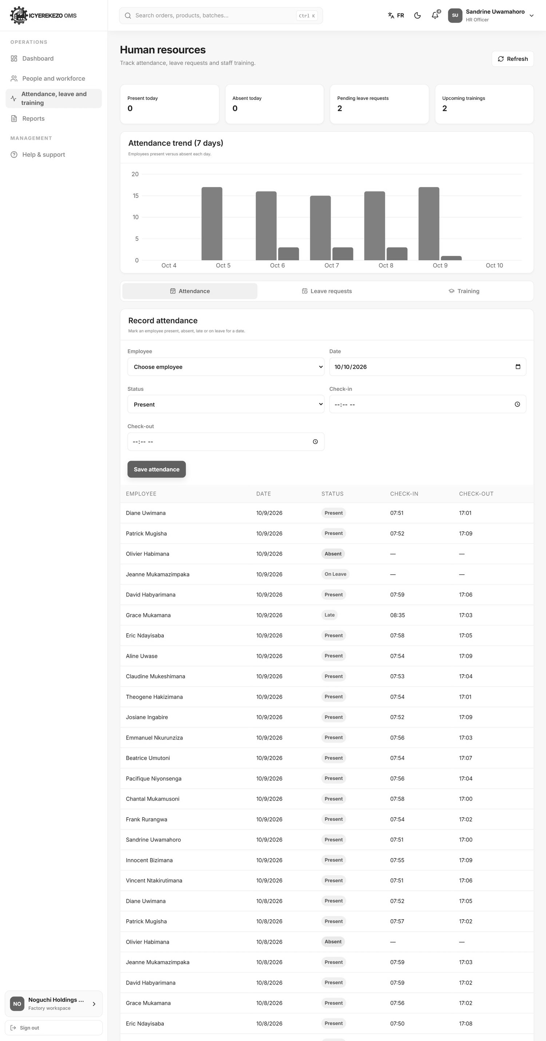
Figure 116. Attendance

15.2 Leave requests
- Click the tab Leave requests.
- To enter a request for someone: choose the employee and the Leave type (annual, sick, maternity, paternity, unpaid or other), the Starts and Ends dates and the reason. Click Submit request. The days are counted for you.
- In the list, click Approve or Reject on a pending request.

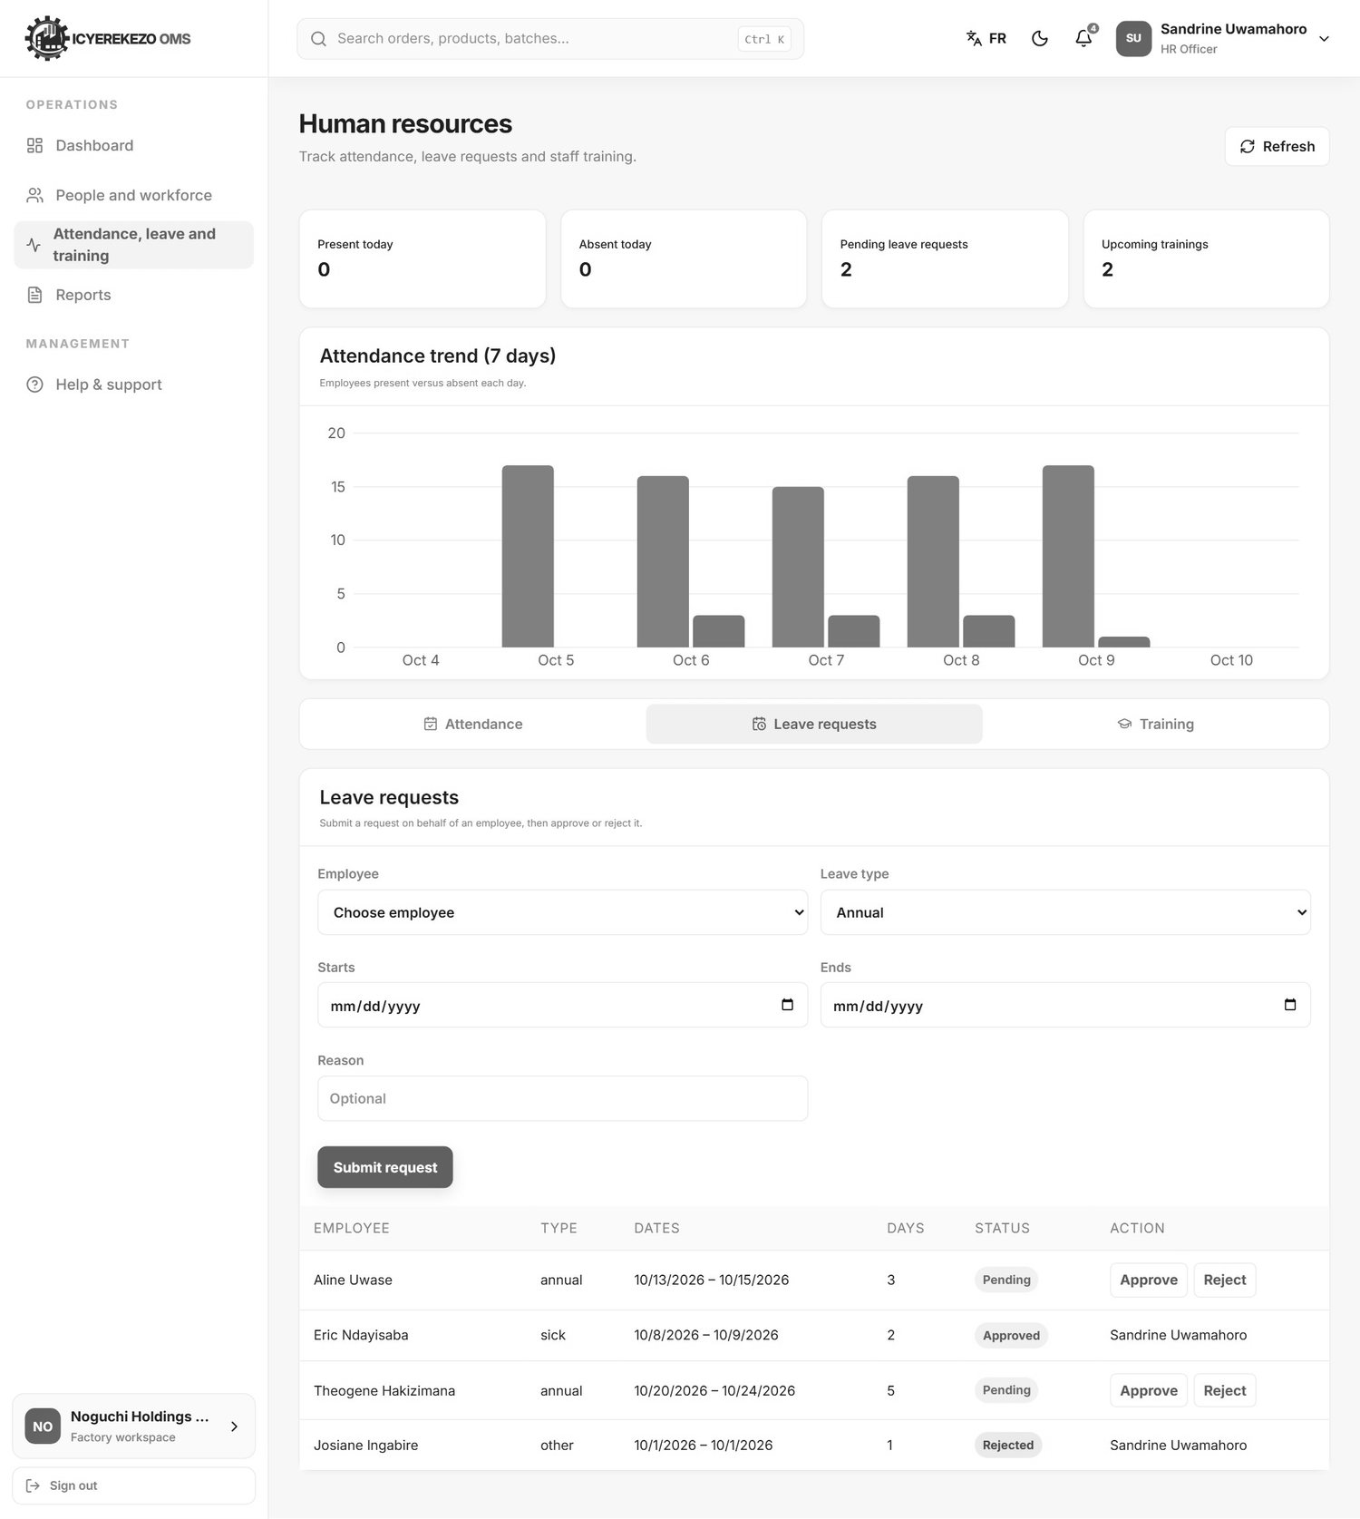
Figure 117. Leave requests

15.3 Training
- Click the tab Training.
- Click Schedule training. Type the Title, Trainer, Description, date and Duration (hours), and choose the participants.
- After the session, set each participant to Registered, Attended, Absent or Completed, and mark whether they are certified.

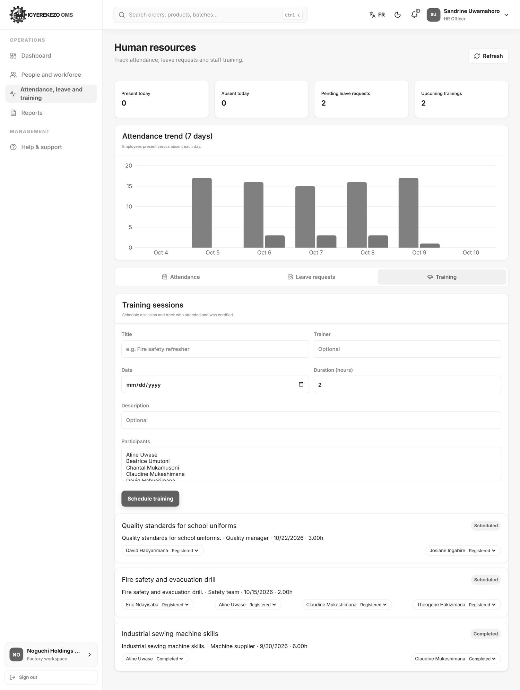
Figure 118. Training
People and workforce is the same employee list as in section 5.2.

16. Health and safety officer
Menu: Dashboard, Health and safety, Workers and training (the employee list), Equipment safety (the machines page), Compliance reports.
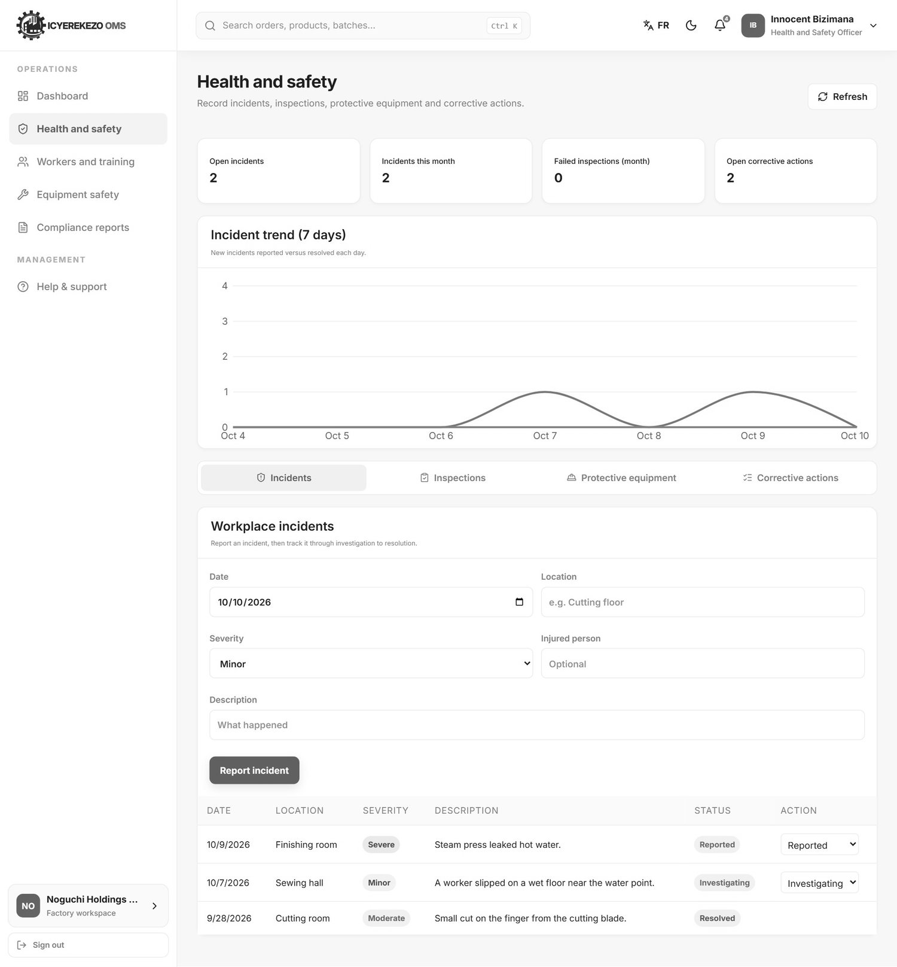
Figure 119. Health and safety
The cards show open incidents, incidents this month, failed inspections this month and open corrective actions. The chart shows new incidents against resolved ones for seven days. The four tabs are below.
Tab | How to use it
Incidents | Click Report incident. Type the date, the location, what happened, the Severity (minor, moderate, severe or critical) and the injured person. Save. Change the status to Investigating and then Resolved (write the resolution) as the case moves.
Inspections | Click Record inspection. Type the area, the date, the Result (pass, needs attention or fail) and notes.
Protective equipment | Click Issue equipment. Choose the employee, type the equipment (for example safety goggles), the date and the condition (new, good, worn or damaged). When the person gives it back click Mark returned.
Corrective actions | Click Create action. Say where it comes from (incident, inspection or general), describe what must be fixed, choose who does it and the due date. Change the status to In progress or Completed.

Figure 120. Incidents
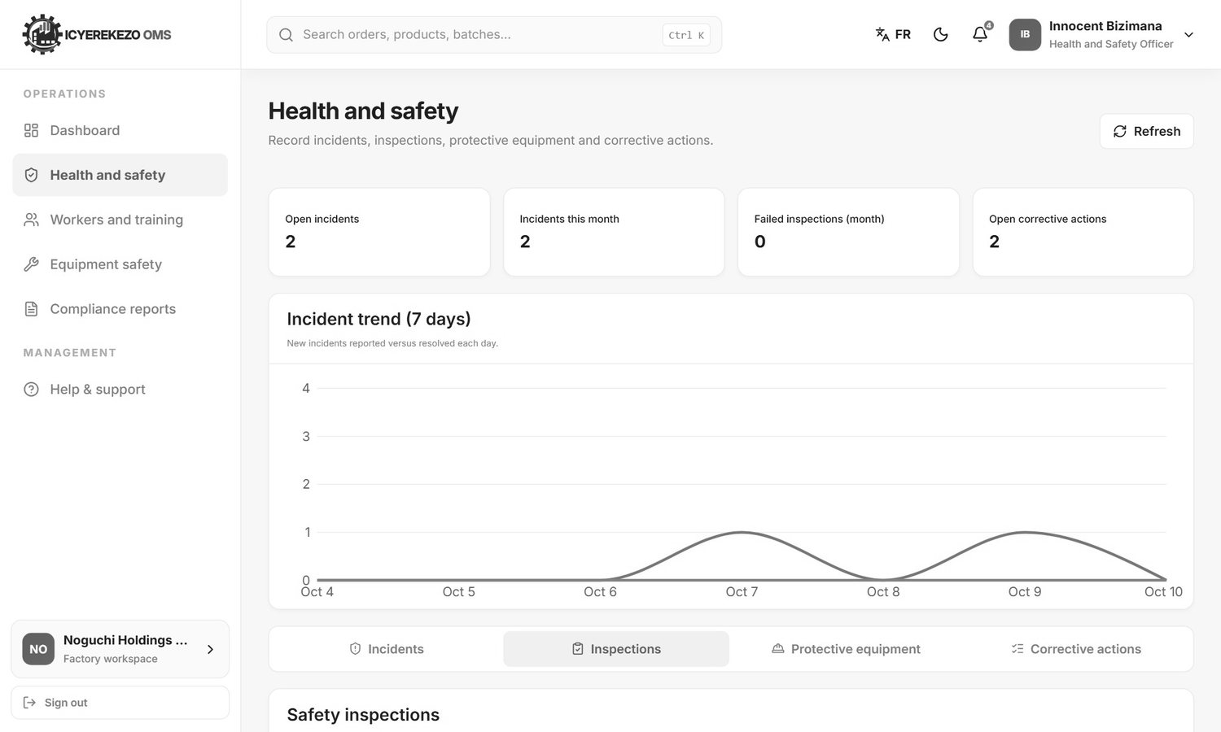
Figure 121. Inspections
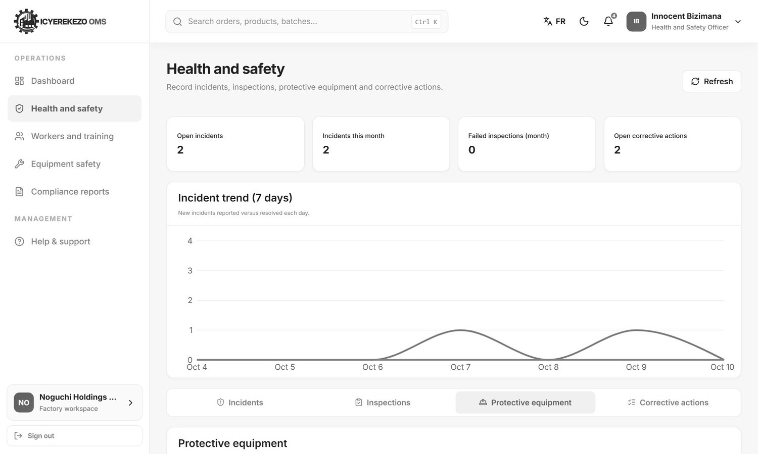
Figure 122. Protective equipment
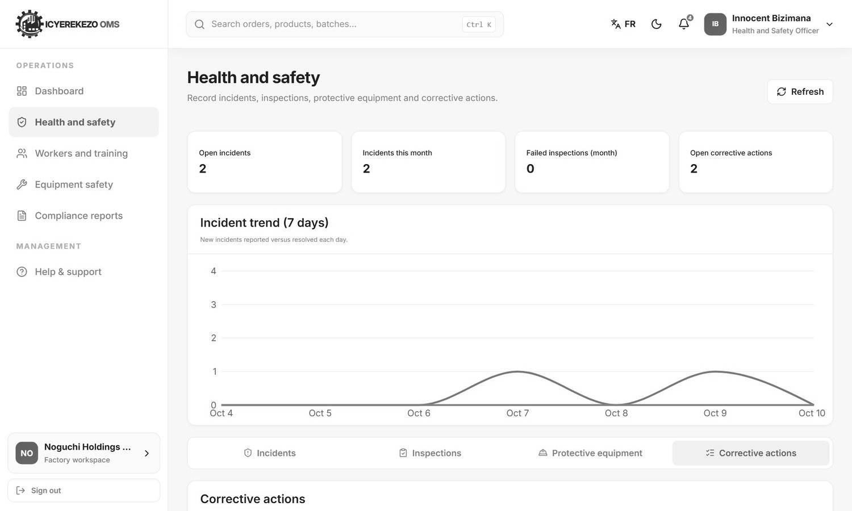
Figure 123. Corrective actions

17. Internal auditor
The auditor can only read. Menu: Dashboard, Inventory movements, Production records, Quality records, Procurement records, Financial reports.
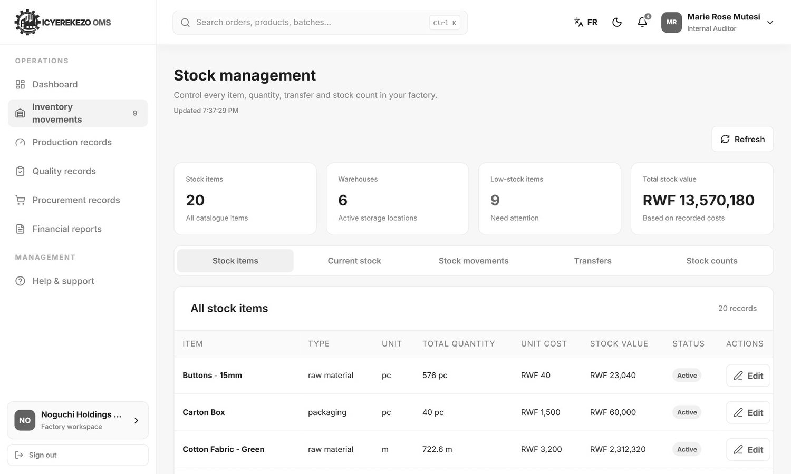
Figure 124. Inventory movements (read only)
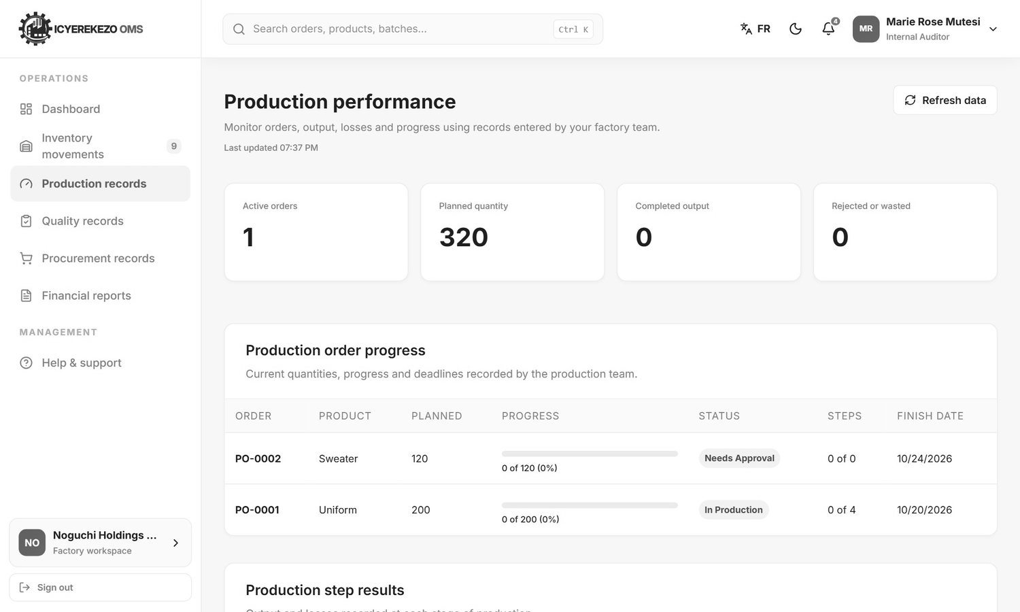
Figure 125. Production records (read only)
Use the Stock movements tab to follow where stock went and who moved it. Every movement shows the reason and the user.

18. Reports: where to click to get your data

18.1 The daily factory report
Menu, Factory reports (owner) or Reports (other roles). At Noguchi this is the Daily factory operation report, the official register with warehouse, cutting, production, finishing and closing stock.
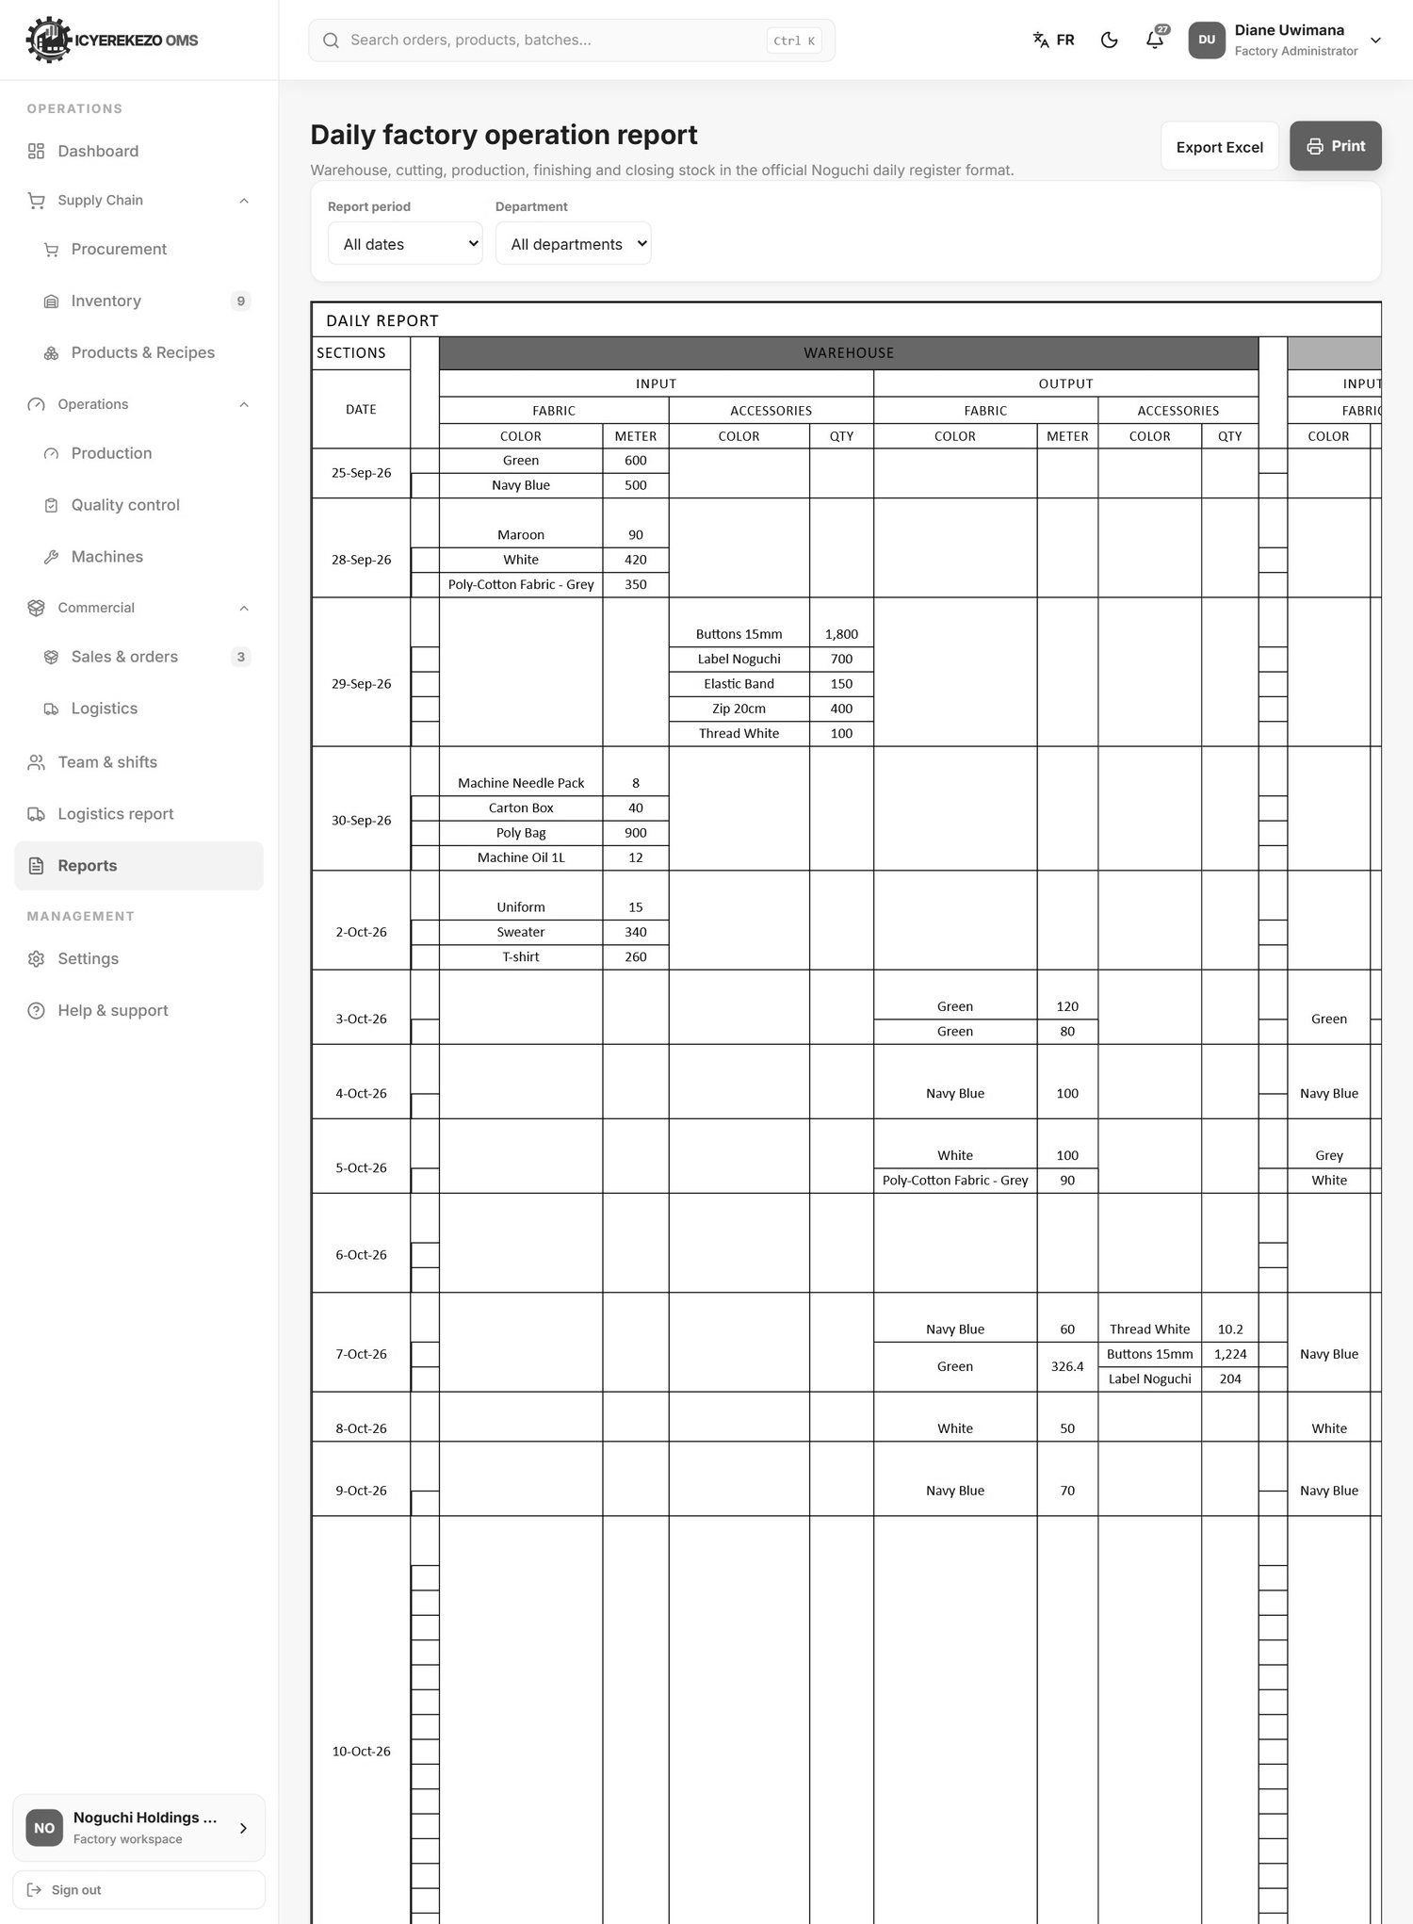
Figure 126. Daily factory operation report
Control | What it does
Report period | Today, Last 7 days, This month, Yearly, Choose dates, All dates. When you choose Choose dates, two date boxes appear.
Department | All departments, or Cutting, Finishing, Packing, Production, Sewing or Warehouse.
Export Excel | Downloads the register as an Excel file.
Print | Opens the print window. Choose Save as PDF to keep a copy.

Read the register from left to right. Each date has its own block. The Warehouse section shows fabric and accessories coming in and going out. Cutting shows the fabric used and the pieces cut by style and size. Production (sewing) and Finishing show the input and the output by style, colour and size. The last Warehouse column shows the quantity in stock on the last day. The Noguchi Guide explains the columns.

18.2 School order reports
Menu, Logistics report (administrator, manager, owner, logistics). It shows the quantities by district, sector and school.
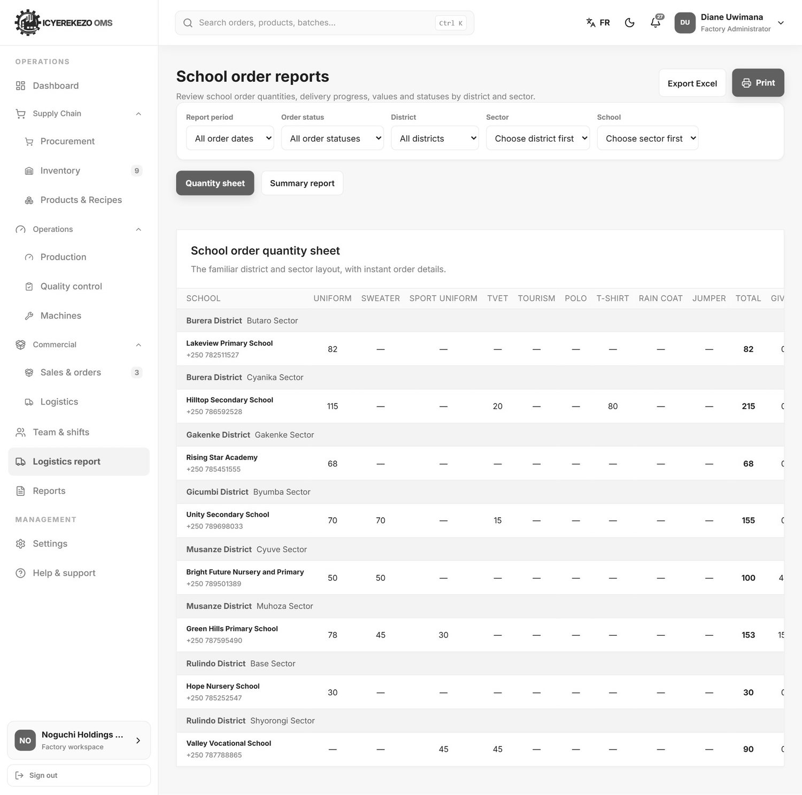
Figure 127. School order reports
- Choose the Report period (all order dates, today, last 7 days, this month, yearly or chosen dates).
- Choose the Order status, District, Sector and School to narrow the list. Choose the district before the sector, and the sector before the school.
- Choose the layout: Quantity sheet (one line per school with the columns Uniform, Sweater, Sport uniform, TVET, Tourism, Polo, T-shirt, Rain coat, Jumper, Total, Given, Remaining, Value, Status) or Summary report.
- Click Export Excel or Print.

18.3 Department reports
Operators and officers have a Reports page that shows only their department. The same period, status and department choices apply.

18.4 Quick finder: "I want to know..."
I want to know... | Go to
How many garments were ordered, packed and delivered | Sales & orders (cards and category table)
Which schools have not received their garments | Logistics report, or Delivery confirmation (status Pending / Accepted)
Which schools signed the agreement | Logistics officer: Agreement, tab View agreements
Which payments wait for approval | Financial manager: Finance overview, Payment receipts to review
How much money is still owed | Finance overview (Outstanding), or Financial reports, Outstanding and aging report
What is low in stock | Inventory (red number in menu, Low Stock label in Current stock)
How much fabric is left | Inventory, tab Current stock
Who moved stock and why | Inventory, tab Stock movements
What cutting, sewing or finishing did today | The Daily factory report (period Today), or the team's own workspace
How many pieces were damaged | Cutting workspace: Damaged fabrics, or the department report
Whether a packed batch passed quality control | Quality control
Which purchase is waiting for approval | Procurement, tab Purchase requests (status Submitted)
What we still owe a supplier | Procurement, Amount still to pay
Which machine is broken or due for service | Machines (cards at the top)
Who was absent this week | HR: Attendance, or the chart on the HR page
Open safety problems | Health and safety (cards and tab Incidents)
What a user did in the system | Platform administrator: Audit logs
Whether the factory subscription is valid | Platform administrator: Subscriptions

19. Platform administrator
The platform administrator looks after all factories. The menu has ten items.

19.1 Platform overview
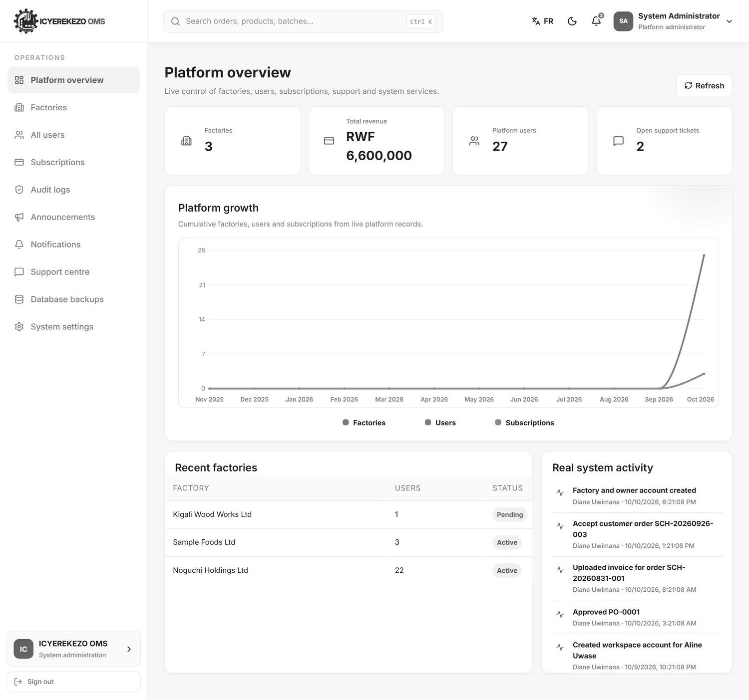
Figure 128. Platform overview
Cards show the number of factories, active factories, users, revenue and open support tickets. The chart shows growth over twelve months. Below are the latest factories, subscriptions, support tickets, backups and system activity.

19.2 Factories
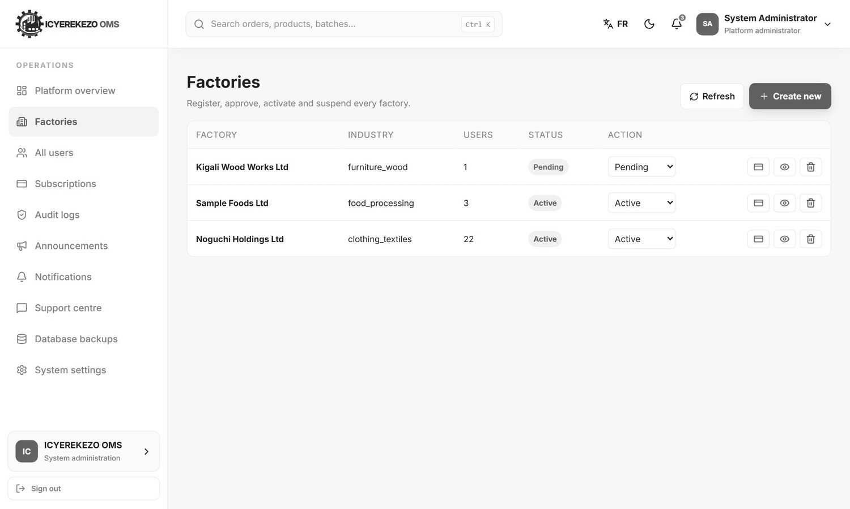
Figure 129. Factories
The list shows each factory with its industry, number of users and status. Use the drop down on a row to change the status: Pending, Active, Suspended or Rejected. A new factory stays pending until you set it to Active.
- Click Create new.
- Type the factory name and choose the industry.
- Type the owner's name, email and password. You can also add a factory manager (name, email, password).
- Click Register factory. The factory is created as pending with its roles, units and a Main Warehouse. Set it to Active and give it a subscription.

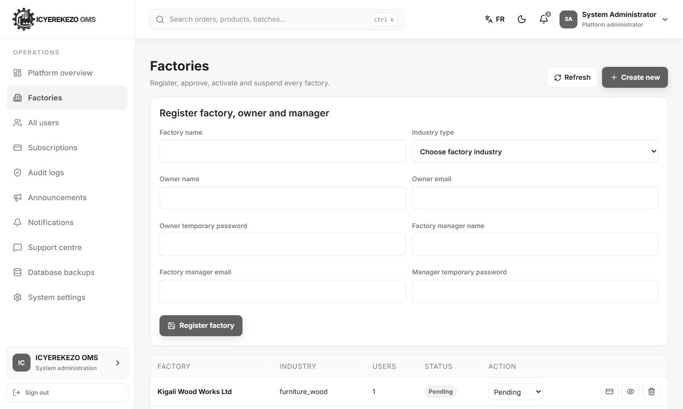
Figure 130. Create a factory

19.3 All users
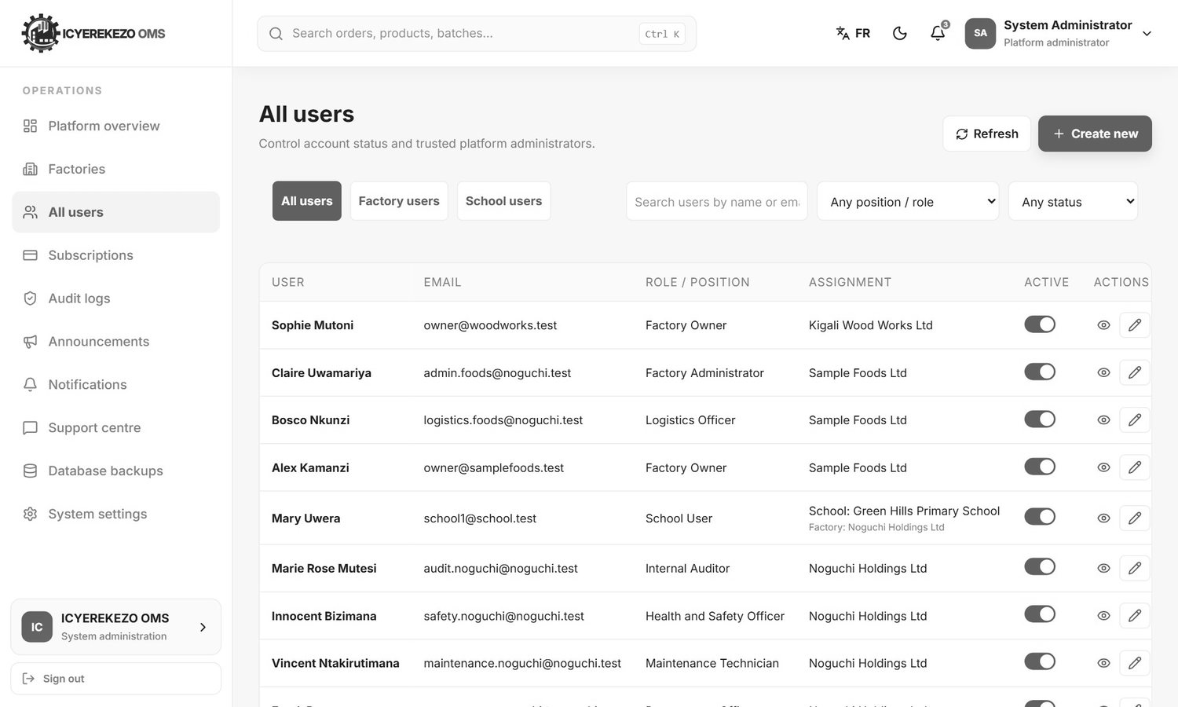
Figure 131. All users
This page lists every account. The three buttons at the top, All users, Factory users and School users, filter the list. You can search by name or email, or filter by role and status. The switch in the Active column turns an account on or off. The eye shows the details and the pencil edits the account.
- Click Create new. A form opens.
- Choose the Factory / Assignment and the Role.
- Type the Full name, the Email address, the Employee number and the Job title.
- Type a Temporary password and click Create user account.

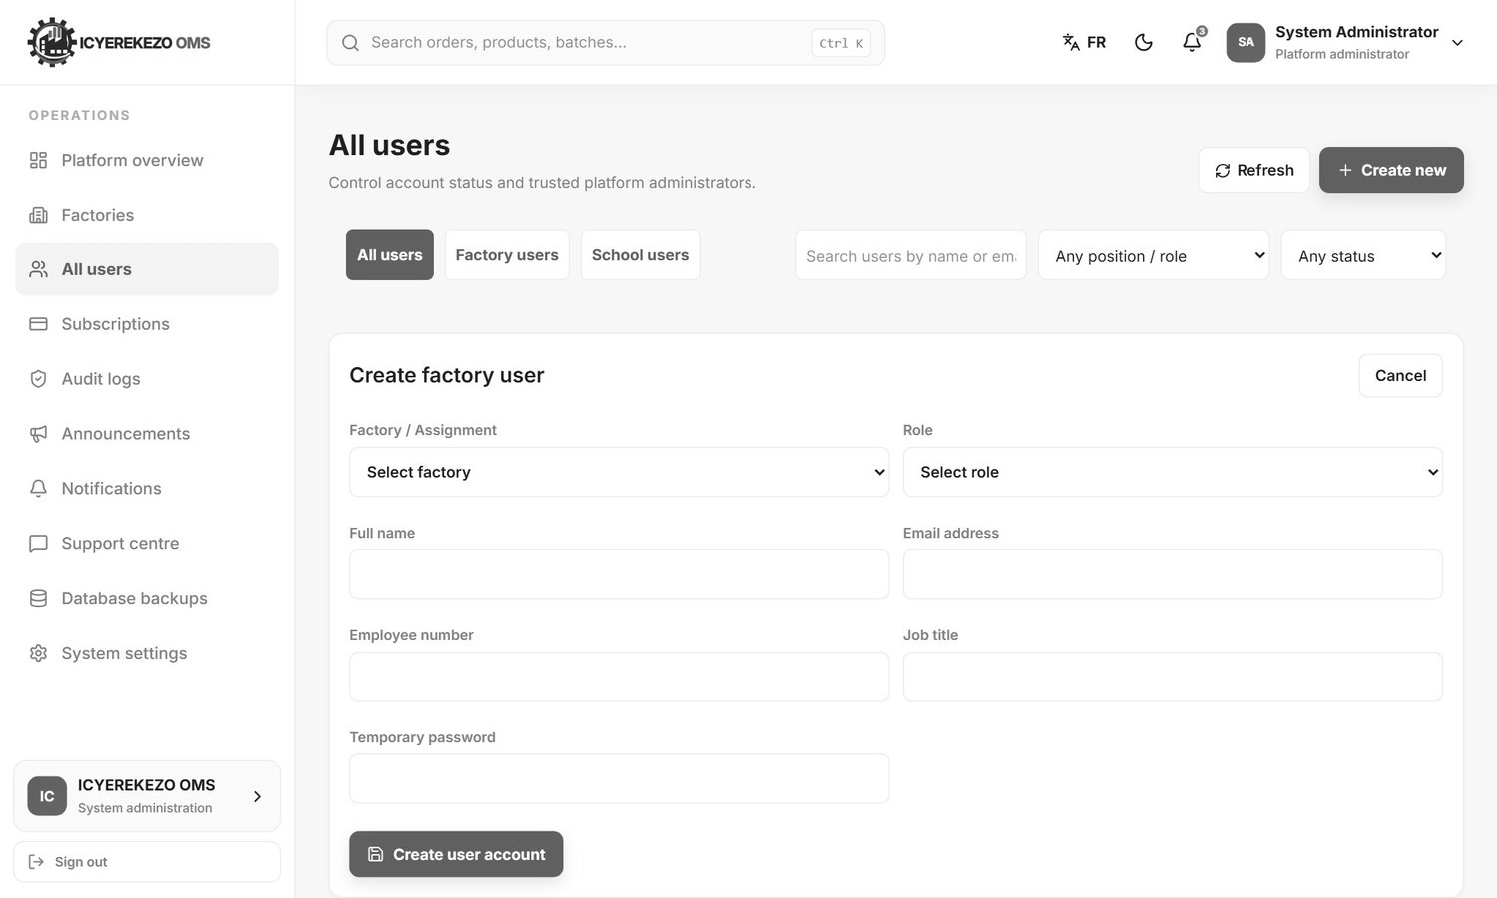
Figure 132. Create a user account

19.4 Subscriptions
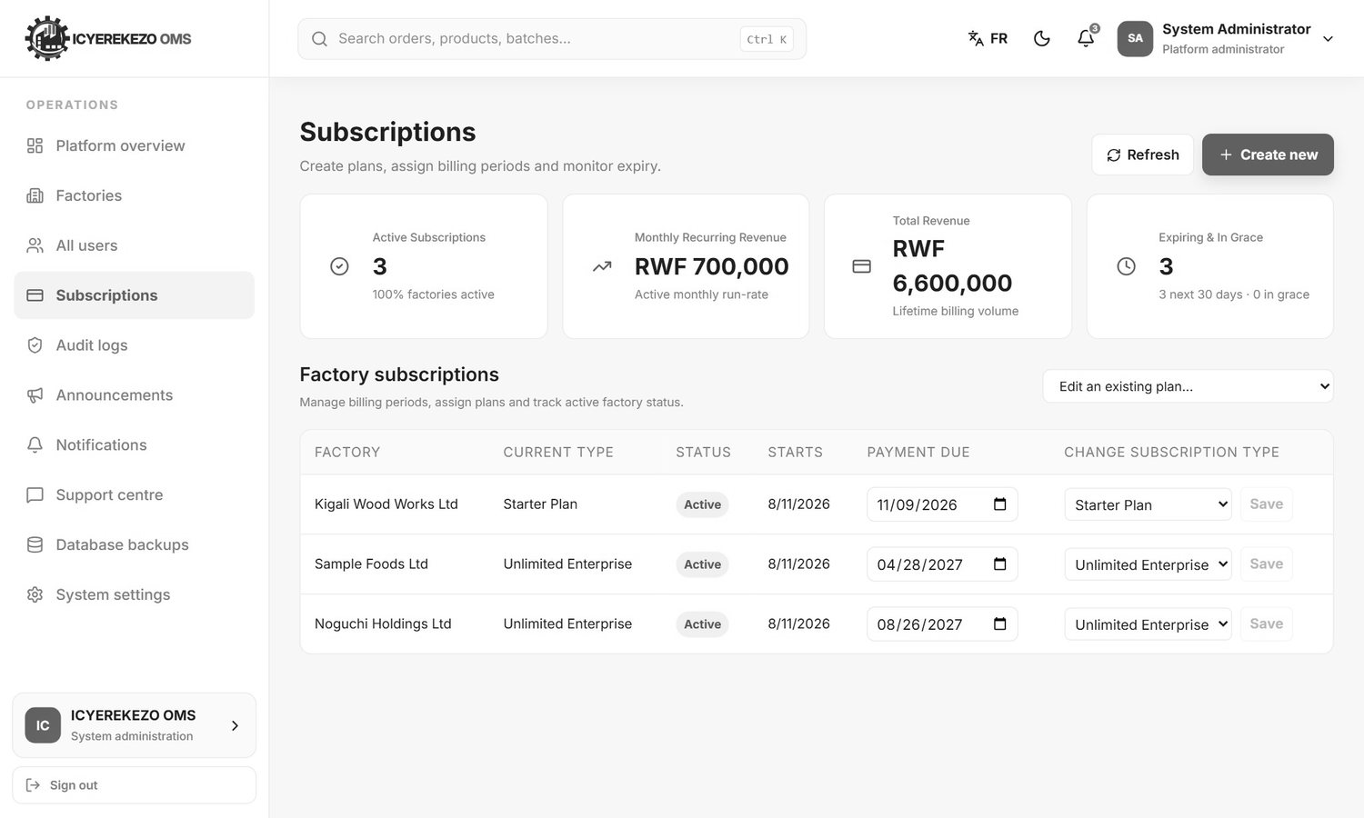
Figure 133. Subscriptions
The cards show active subscriptions, monthly recurring revenue, total revenue and subscriptions that expire soon or are in grace. In the table each factory has a plan and dates. To change a factory, choose the plan in the last column, set the dates and click Save. Extending the end date also sets the factory back to active. Create new makes a new plan (name, code, price, currency, limits and the list of features) and the drop down Edit an existing plan changes one.
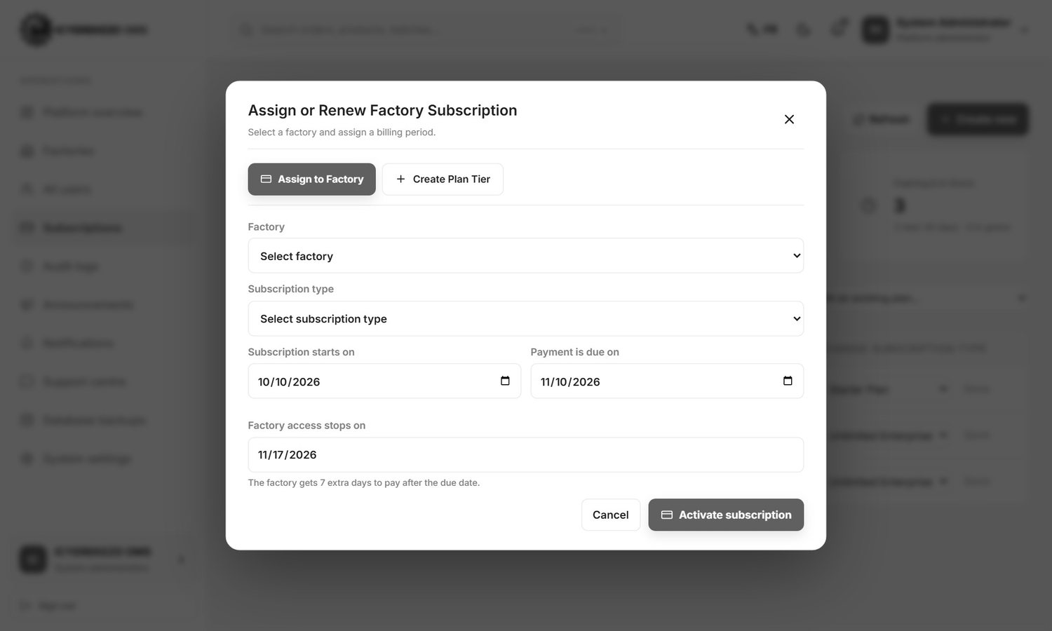
Figure 134. Create a plan

19.5 Audit logs
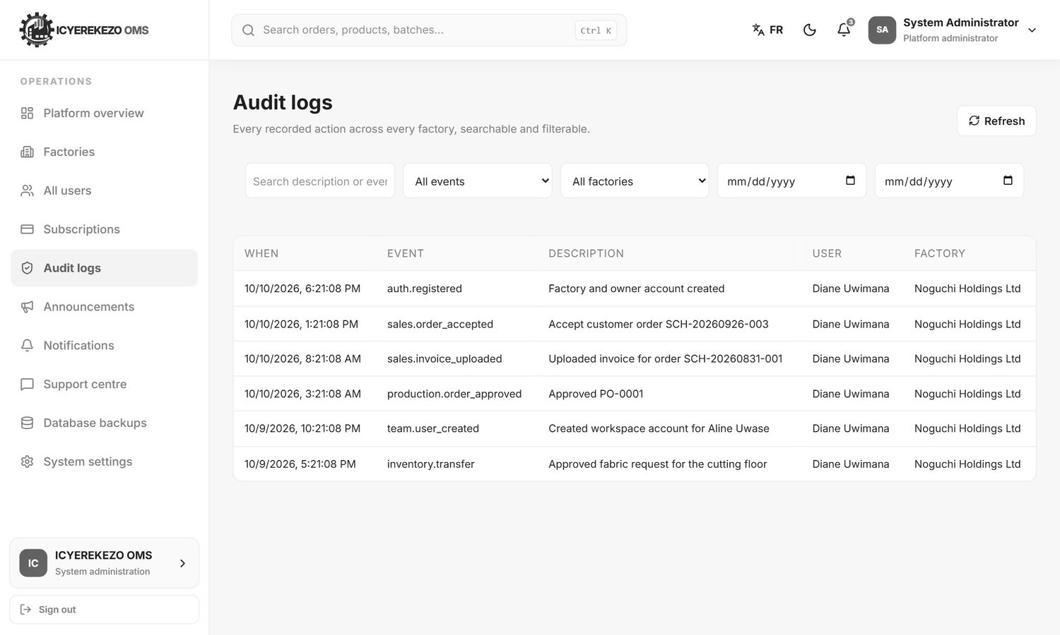
Figure 135. Audit logs
A record of important actions. Each line shows the time, the user, the factory, the event and the description. Use the filters to search by text, factory, event name and date range.

19.6 Announcements and notifications
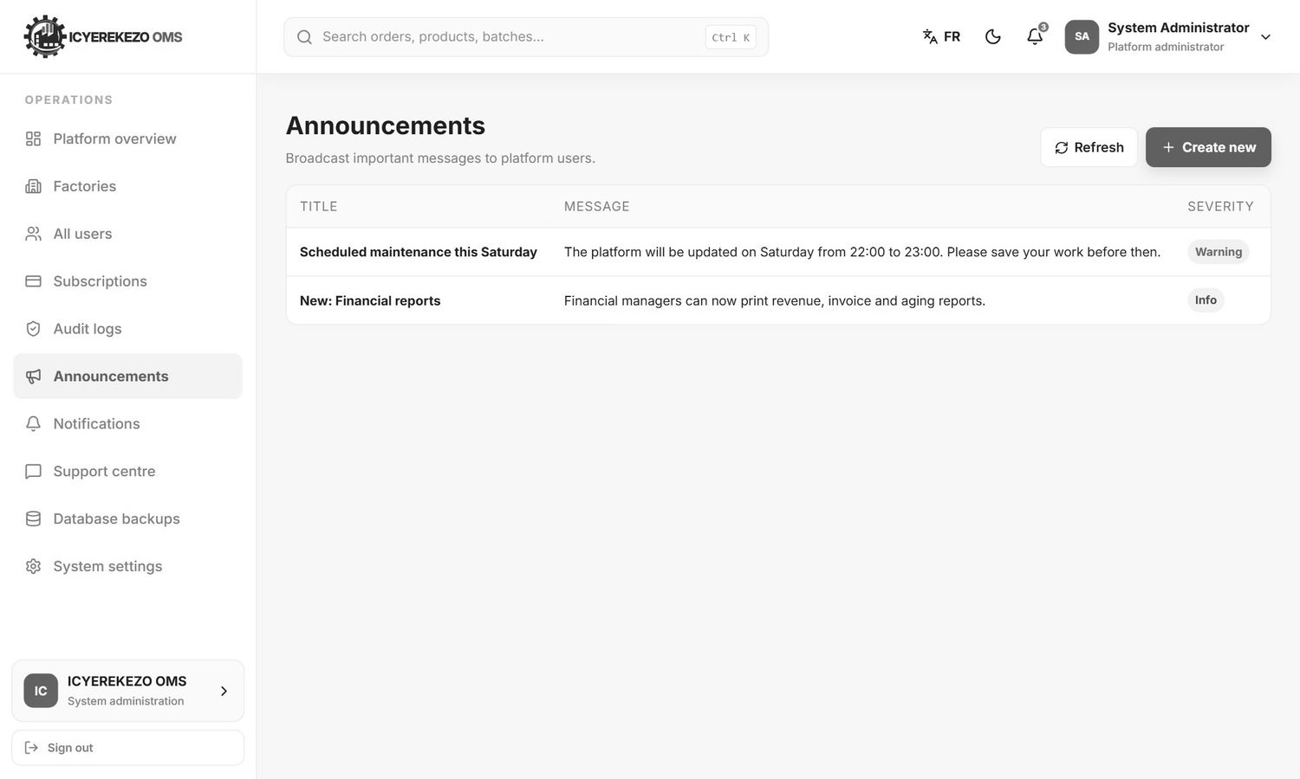
Figure 136. Announcements
- Menu, Announcements.
- Type the title and the message. Choose how serious it is (info, success, warning or critical), who sees it (everyone, factory owners or factory users) and when it expires.
- Send. It appears in the bell of every user in that group.

Notifications shows the live system notifications.

19.7 Support centre
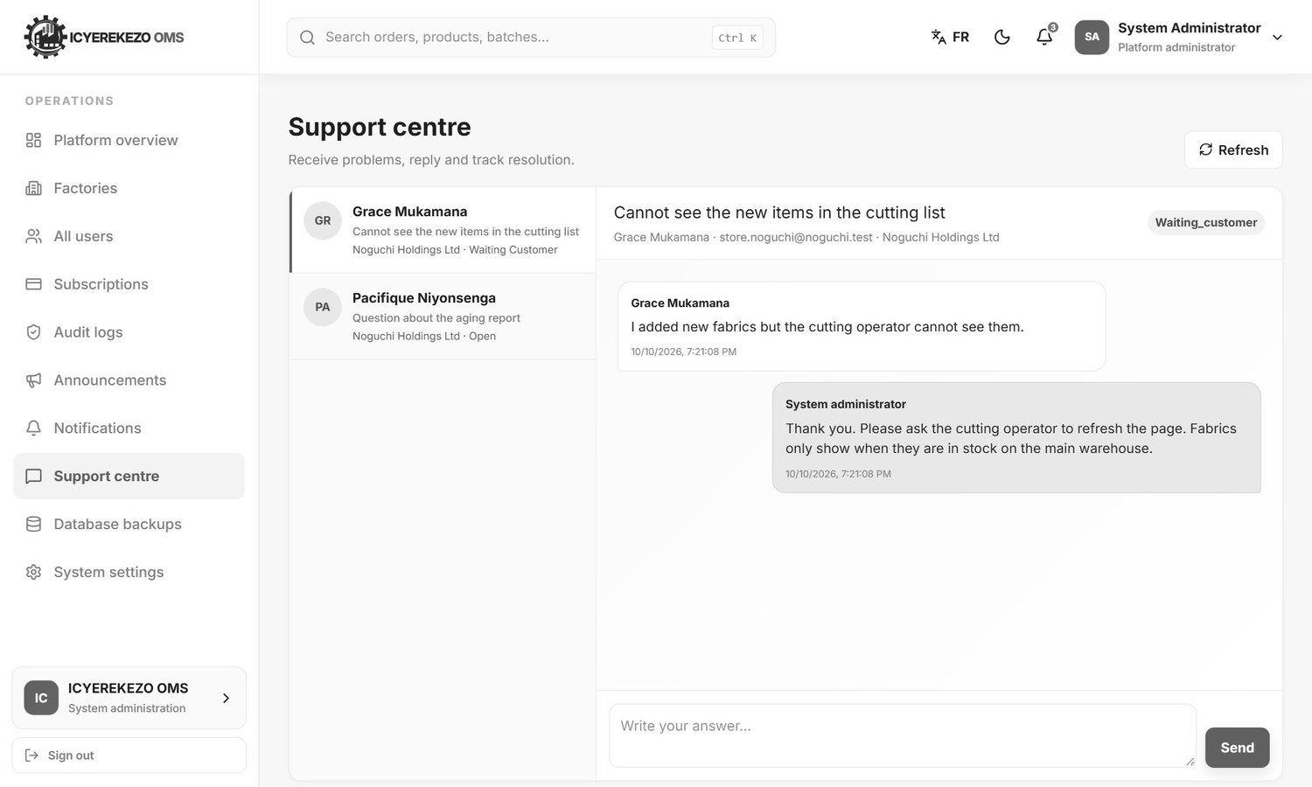
Figure 137. Support centre
All support chats of all factories are here. Open a conversation, write your answer and choose the status: open, in progress, waiting for customer, resolved or closed.
Figure 138. An open support conversation

19.8 Database backups
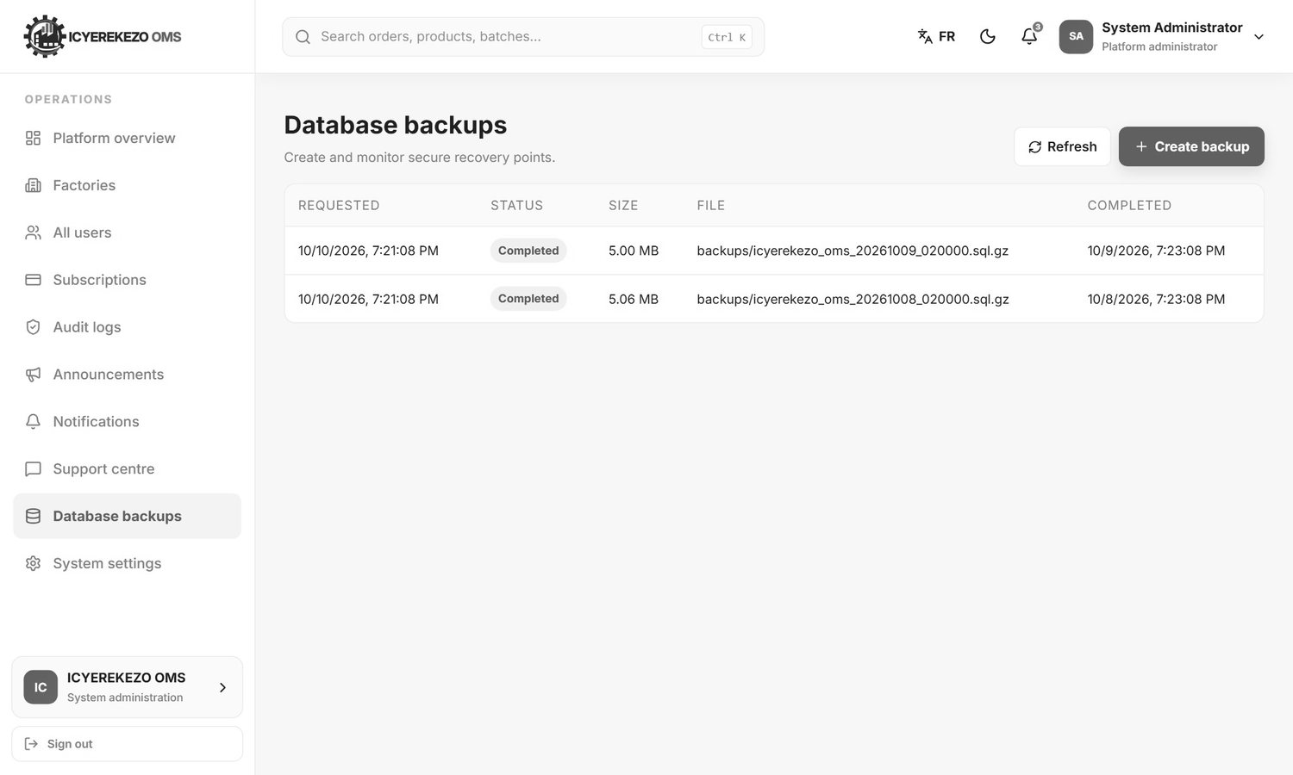
Figure 139. Database backups
The list shows each backup with its status, size and time. Click the button to make a backup now. A backup also runs automatically every night at 02:00 and old backups are removed after the retention period.

19.9 System settings
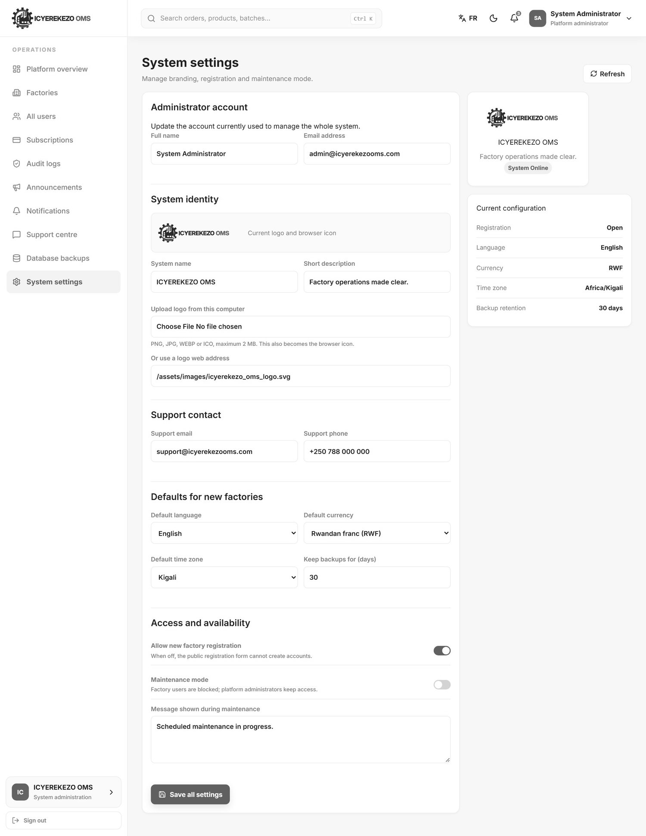
Figure 140. System settings
Section | What you can change
Administrator account | Your own name and email.
System identity | The System name, the short description, and the logo (upload a PNG, JPG, WEBP or ICO up to 2 MB, or give a web address). The logo also becomes the browser icon.
Support contact | Support email and phone number shown to users.
Defaults for new factories | Language, currency, time zone, and how many days to keep backups.
Access and availability | Allow new factory registration (when off, nobody can register), and Maintenance mode with a message. In maintenance mode only platform administrators can use the system.

Click Save all settings after you change anything.

20. School administrator
Schools use the school portal, which has its own sign in at /school/login and account page at /school/signup. The School Portal Guide explains every step. This is the short version.
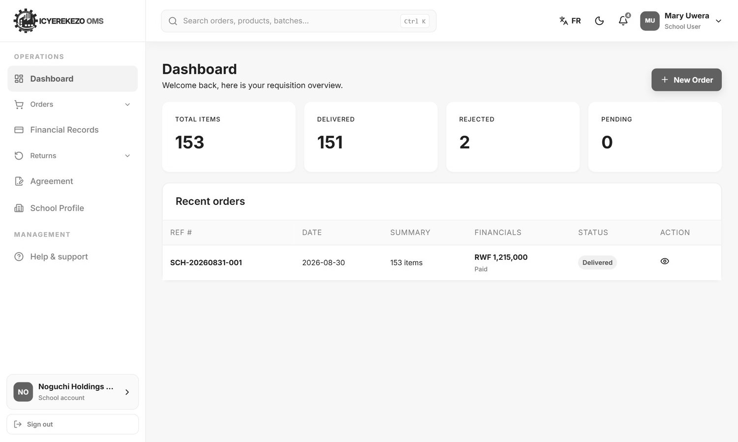
Figure 141. School dashboard
Menu item | Use it to
Dashboard | See total, delivered, rejected and pending garments and the latest orders. New Order starts an order.
Orders, Place New Order | Order garments class by class.
Orders, Order History | Find earlier orders, open them and print the order.
Financial Records | See what you owe and send a proof of payment.
Returns, Return Items | Ask to return delivered garments.
Returns, Returns History | Follow your return requests.
Agreement | Download the agreement and upload your signed copy.
School Profile | Keep the school name, contact and location correct.

21. If something does not work
What you see | What to do
A page is empty or says Connecting | Wait a few seconds. Click Refresh. If it stays, check your internet connection.
"You do not have permission to perform this action." | Your role does not allow this action. Ask your manager if you need it.
"This feature is not included in the factory subscription plan." | The factory plan does not include this module. Ask the administrator.
"Access removed due to unpaying subscription." | The factory subscription has ended. Ask the administrator to renew it.
"Insufficient stock" or "Not enough stock" | You asked for more than is available. The message says how much you can use. Check the quantity.
"Previous production stages must be completed first." | Finish the earlier step first.
You are signed out suddenly | Sessions last 2 hours without activity. Sign in again. Do not keep two people on one account.
You see old data after someone else used the computer | Press Ctrl and F5 to reload. Always sign out.
You forgot your password | Use Forgot password? (section 2.2) or ask your administrator to reset it.
The date shows "Invalid Date" in Procurement or Production | This is a known fault in the display. The data is correct. Tell the developer.
Nothing helps | Write to Help & support and describe what you did and what you saw. Say the page name and the time.

