ICYEREKEZO OMS
Noguchi Holdings Ltd Guide
How the Noguchi part of the system works
For: Noguchi managers and staff, and anyone who supports the Noguchi factory
System: ICYEREKEZO OMS
Date: October 2026
Contents
1. About this guide 3
1.1 What is special about Noguchi 3
1.2 How the system knows a factory is Noguchi 3
2. The two flows 4
2.1 Making garments 4
2.2 Selling to schools 4
3. Setting up the Noguchi factory 5
4. The people 6
5. The garment floor 7
5.1 The idea: batches and acceptance 7
5.2 The floors 7
5.3 Fabric arrives 8
5.4 Cutting 8
5.5 Sewing 10
5.6 Finishing 11
5.7 Packing 12
5.8 Quality control 13
5.9 Mistakes and corrections 14
5.10 Things to know about the numbers 14
5.11 Daily routine 14
6. The daily register 16
6.1 Controls 18
6.2 The sections and their columns 19
7. School orders at the factory 20
7.1 The order desk (Sales & orders) 20
7.2 Prices and the total 23
7.3 Packing the order 23
7.4 Delivery 25
7.5 Money 27
7.6 The agreement 28
7.7 Returns 28
7.8 School order reports 29
8. Other Noguchi screens 31
8.1 Dashboards 31
8.2 Notifications that matter 31
8.3 Importing old orders 31
9. Questions and answers 33

1. About this guide
ICYEREKEZO OMS works for many factories. Noguchi Holdings Ltd is the factory it was first built for, and Noguchi has extra parts that other factories do not have. This guide explains only those parts: how a garment is made on the production floor, how the daily register is produced, and how a school order travels from the school to delivery and payment.
The school side, as the school sees it, is in the School Portal Guide. The screens that every factory has are in the User Manual. The technical details are in the Technical Documentation.
The screenshots in this guide are black and white and were taken with sample names and numbers. On your real screen some labels have colours, and your own data will appear.

1.1 What is special about Noguchi
Part | What it is
The garment floor | Four teams (Cutting, Sewing, Finishing, Packing) each with a simple workspace page. Pieces move from one team to the next in batches.
Quality release | A packed batch cannot leave the factory until quality control has passed it.
The daily register | A report that looks like the paper register: warehouse, cutting, production, finishing and closing stock for each day. It can be printed and exported to Excel.
School orders | Schools order uniforms by class, garment, gender, size and colour. The order desk, the packing, the delivery, the invoice and the payment check are all built around this.
The school portal | A website where schools order, pay, return items and sign the agreement.
The school agreement | The factory uploads one agreement. Each school signs and returns it. The logistics officer sees who has signed.
School order reports | The quantity sheet by district, sector and school, with Excel export and print.

1.2 How the system knows a factory is Noguchi
The system decides by the name. A factory gets the Noguchi features when its industry is Clothing and textiles (clothing_textiles) and its name is Noguchi Holdings Ltd (capital letters and spaces at the ends do not matter).
Warning Never rename the Noguchi factory, not even by one letter, and do not change its industry. The school sign up, the school order desk and the daily register would stop working.

2. The two flows
Everything at Noguchi is one of two flows. They meet at the packing step.

2.1 Making garments
Step | Team | Page | What is recorded
1 | Storekeeper | Incoming goods, Inventory | Fabric and accessories bought and received into the Main Warehouse.
2 | Cutting | Cutting workspace | Request fabric. Cut it. Report damaged pieces. Each cut makes a batch with its style, colour and size.
3 | Storekeeper | Incoming requests | Approve the fabric request. The fabric moves to the cutting floor.
4 | Sewing | Record sewing | Accept the cut batch. Record how many were sewn and how many were damaged.
5 | Finishing | Record finishing | Accept the sewn batch. Record how many were finished.
6 | Packing | Record packing | Accept the finished batch. Say which product it is. Record how many were packed.
7 | Quality control | Quality control | Inspect the packed batch. Pass or fail it.
8 | Storekeeper | Inventory | Finished goods are in stock.

2.2 Selling to schools
Step | Who | Page | What happens
1 | School administrator | School portal, Place New Order | Sends the order. Status Pending. An email is sent.
2 | Sales officer | Sales & orders | Accepts or rejects. Status Accepted or Rejected. An email is sent.
3 | Sales officer | Sales & orders, Invoices tab | Uploads the invoice file.
4 | Packing | Record packing, School orders | Records how many of each line are packed.
5 | Logistics officer | Delivery confirmation | Delivers what is packed. Status Partial delivery or Delivered. Stock goes down. An email is sent.
6 | School administrator | School portal, Financial Records | Pays and sends the proof of payment.
7 | Financial manager | Finance overview | Approves or rejects the proof. The order shows Partially paid or Paid.
8 | School administrator | School portal, Return Items | May ask to return delivered garments.

Two things keep the flow honest. Packing cannot pack more than was ordered. Logistics cannot deliver more than was packed. Because of this, the number delivered can never be more than the number made ready.

3. Setting up the Noguchi factory
This is the set up that the Noguchi pages expect. If one of these is missing, a page can show an empty list or the wrong warehouse.
What | How it must look
Factory | Name Noguchi Holdings Ltd, industry Clothing and textiles, status Active, with a subscription plan that includes the features you need (Unlimited Enterprise has them all).
Warehouses | A Main Warehouse (code MAIN). A cutting floor (code CUT, or a name with the word "cutting"). A sewing floor (code SEW, or a name with "sewing"). A finishing floor (a name with "finishing"). A packing floor (a name with "packing"). A finished goods store is also useful. The pages find their warehouse by this code or word.
Departments | Cutting, Sewing, Finishing, Packing, Quality Control, Warehouse, Logistics, Sales, Finance, Human Resources, Health and Safety, Procurement, Production, Maintenance.
Items | Fabrics (raw material, unit metre). Name them with the colour at the end, for example "Cotton Fabric - Navy Blue". The register reads the colour from the name. Accessories (thread, buttons, zips, elastic, labels) are raw materials. Finished goods: Uniform, Sweater, Sport Uniform, T-shirt, Overall, Overall Coat.
Staff roles | Warehouse Keeper, Cutting Operator, Sewing Operator, Finishing Manager, Packaging Operator, Quality Control Officer, Logistics Officer, Sales Officer, Accountant or Financial Manager, and the managers.
School agreement | Uploaded by the logistics officer.

Note The standard Sewing Operator role does not include the stock permissions that the sewing page needs. Until the role is corrected in the system, the sewing page answers "You do not have permission to perform this action." See the Technical Documentation, section 12, point 16.

4. The people
Role | Menu | Does
Storekeeper (Warehouse Keeper) | Dashboard, Incoming requests, Inventory, Products and recipes, Incoming goods, Reports | Receives purchases, answers floor requests, transfers, counts, corrects.
Cutting Operator | Dashboard, Cutting workspace, Report | Requests fabric, records cutting and damaged pieces.
Sewing Operator | Dashboard, Record sewing, Reports | Accepts cut batches, records sewing and damage.
Finishing Manager | Dashboard, Record finishing, Reports | Accepts sewn batches, records finishing, requests materials.
Packaging Operator | Dashboard, Record packing, Reports | Accepts finished batches, packs, packs school orders.
Quality Control Officer | Dashboard, Quality control, Reports | Inspects packed batches.
Sales Officer | Dashboard, Sales & orders, Products, Stock availability, Reports | Accepts or rejects school orders, uploads invoices.
Logistics Officer | Dashboard, Incoming orders, Delivery confirmation, Agreement, Reports | Delivers packed garments, handles the agreement.
Financial Manager | Dashboard, Finance overview, Orders and invoices, Financial reports | Approves payment proofs, reads financial reports.
Accountant | Dashboard, Sales & orders, Procurement, Reports | Follows orders and purchases.
Procurement Officer | Dashboard, Procurement, Stock levels, Products, Reports | Buys fabric and accessories.
Factory Administrator and Manager | Almost everything | Sets up and watches the factory.
Factory Owner | Performance pages only | Looks, never changes.

5. The garment floor

5.1 The idea: batches and acceptance
A batch is a group of pieces that were cut together. Every time the cutting team records a cut, the system makes a batch with a number such as CUT-261006-4NZEJM and remembers the style, colour and size (for example Dress, Navy Blue, S).
The batch then travels. Each team must accept the batch before it can work on it. Accepting means: "these pieces are now on my floor". Only after that can the team record its output. The batch changes stage as the output is recorded:
Stage of the batch | Set when
cut | Cutting records the cut.
sewn | Sewing records the sewing output.
finished | Finishing records the finishing output.
packed | Packing records the packing output. The batch also gets the finished product (for example Uniform) and the quality status pending.

A packed batch with quality status pending cannot be issued or sent out. When quality control passes it, the status becomes passed and the garments can be used for school orders.

5.2 The floors
Each team has a warehouse (a "floor"). When a team accepts a batch, the pieces are received into that team's floor. The storekeeper moves fabric from the Main Warehouse to the cutting floor when a request is approved.
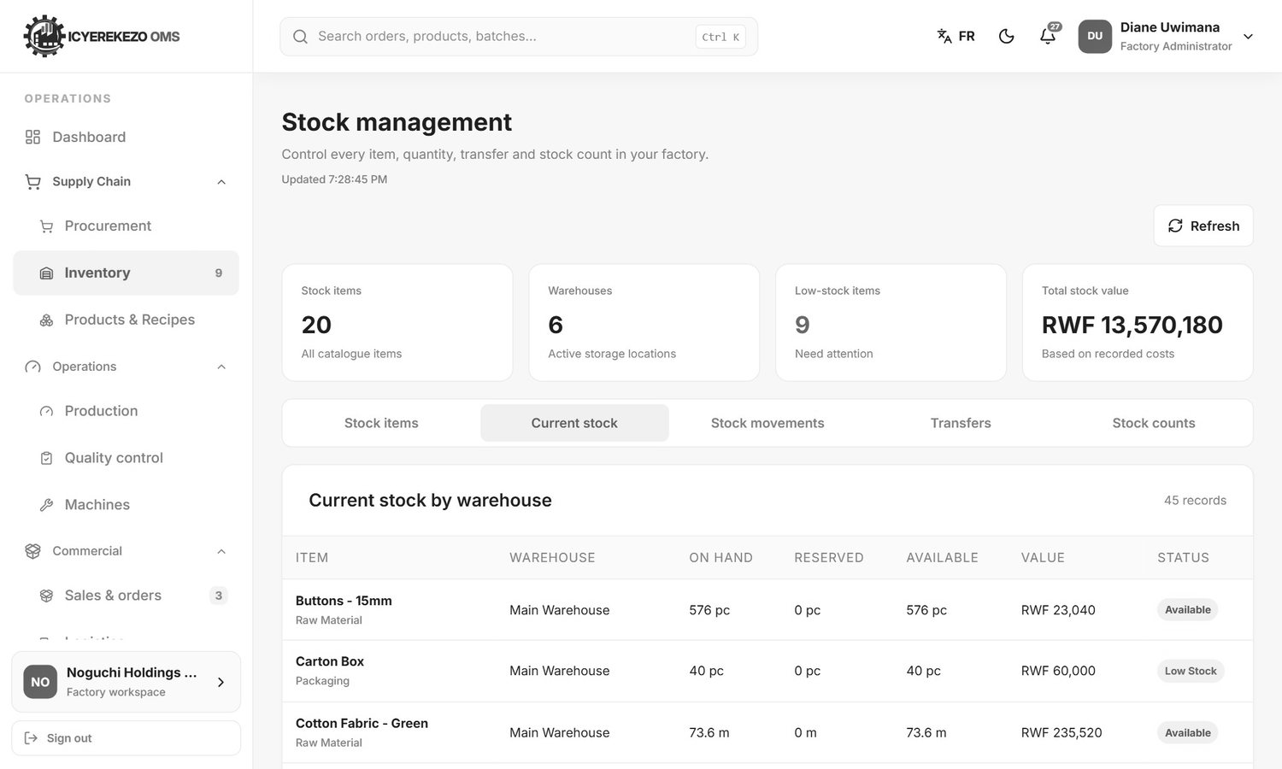
Figure 1. Current stock by warehouse: Main Warehouse, Cutting Floor, Sewing Floor and so on

5.3 Fabric arrives
Procurement buys fabric with a purchase request and a purchase order. When the delivery arrives, the storekeeper receives it into the Main Warehouse from the Incoming goods page. The fabric is now stock. The steps are in the User Manual, sections 6.4 and 7.

5.4 Cutting
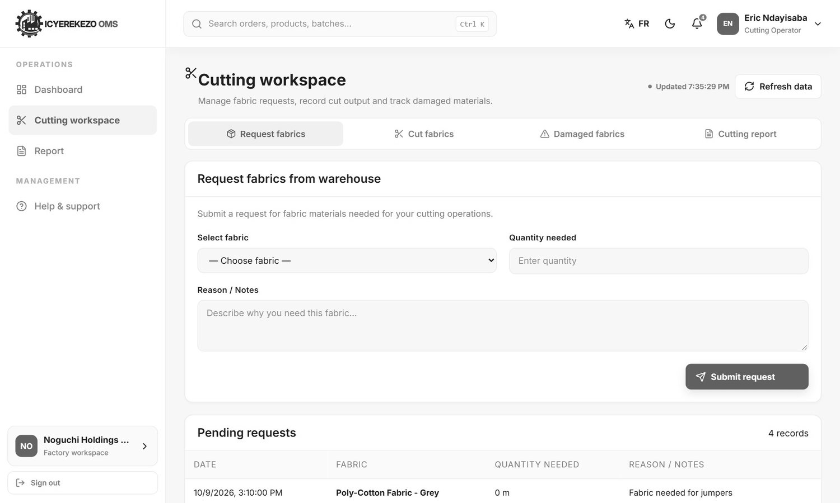
Figure 2. Cutting workspace: request fabrics
- Request fabrics. Choose the fabric (only fabrics with stock in the Main Warehouse are listed, with the quantity). Type the quantity and the reason. Click Submit request. The storekeeper sees it in Incoming requests.
- The storekeeper approves. The fabric moves to the cutting floor. The request leaves the storekeeper's Pending list.
- Cut fabrics. Choose the fabric on the cutting floor and type the metres used. Choose the Style (Shirt, Skirt, Short, Trousers or Dress), the Size (3XS to 3XL) and type the Color and the Number of pieces produced. Click Record cut output. The fabric used goes down and a new batch of pieces is created.
- Damaged fabrics. If pieces are miscut or torn, choose the batch, type the quantity and what happened, and click Report damage. The pieces are written off.
- Cutting report. Shows today's total cut, total damaged, waste rate and pending requests, and a printable table by date.

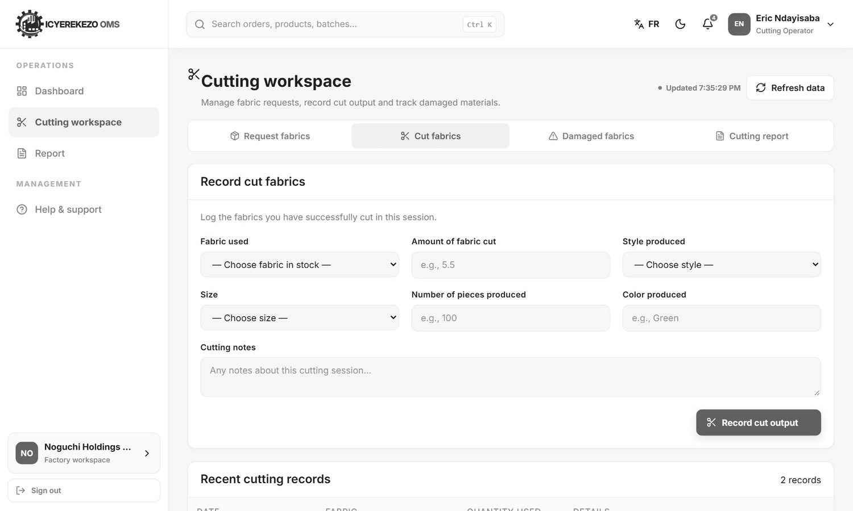
Figure 3. Cut fabrics
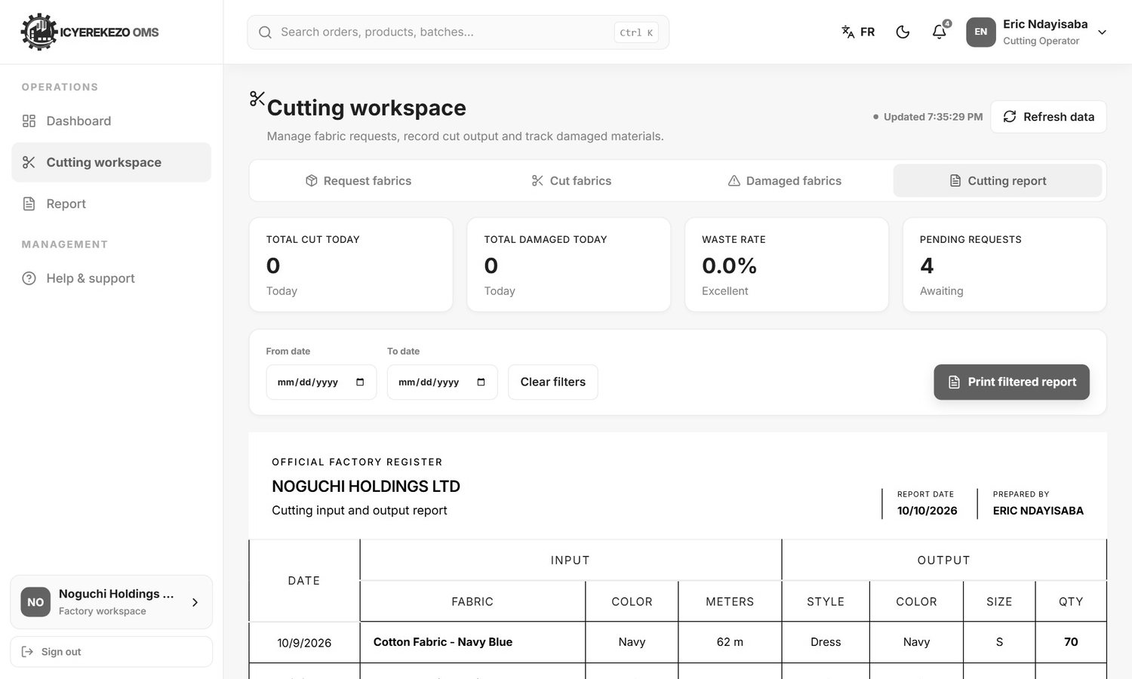
Figure 4. Cutting report
If you type more metres than the cutting floor has, a window says "Insufficient stock" and shows what you have. The waste rate shows "Excellent" below 5 percent, "Good" below 10 percent and "Needs attention" above that.

5.5 Sewing
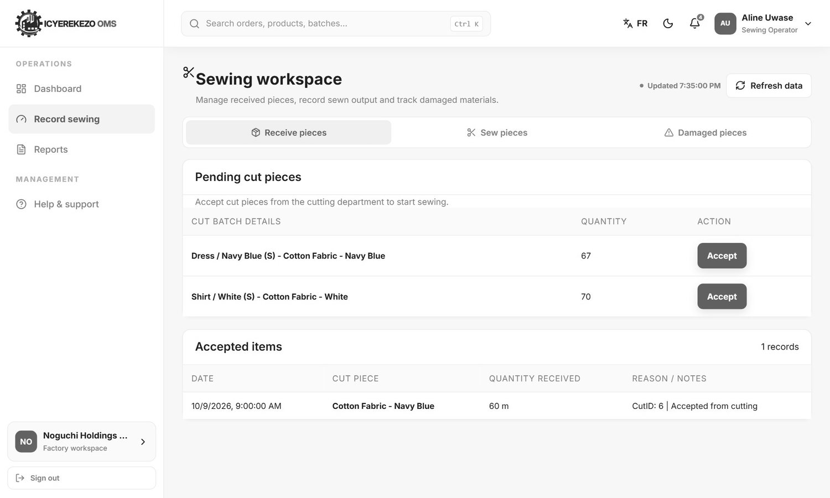
Figure 5. Sewing: pending cut pieces and accepted items
- Open Record sewing. On Receive pieces the table Pending cut pieces lists batches from cutting. Click Accept.
- On Sew pieces choose the accepted batch, type how many were sewn and notes, and click Record sewing output. You cannot type more than the batch holds.
- On Damaged pieces report any piece that was damaged or rejected while sewing.

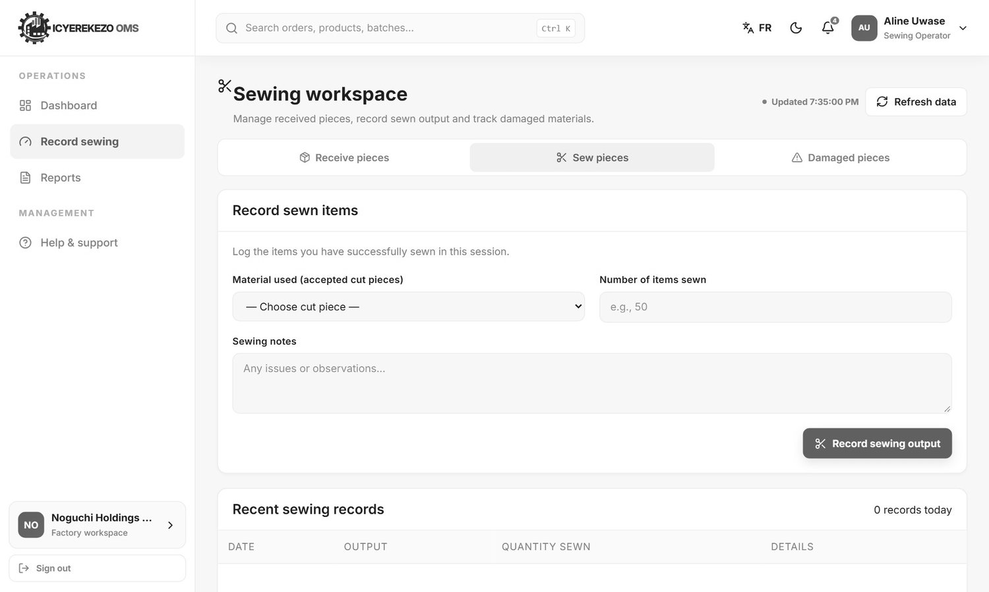
Figure 6. Sew pieces

5.6 Finishing
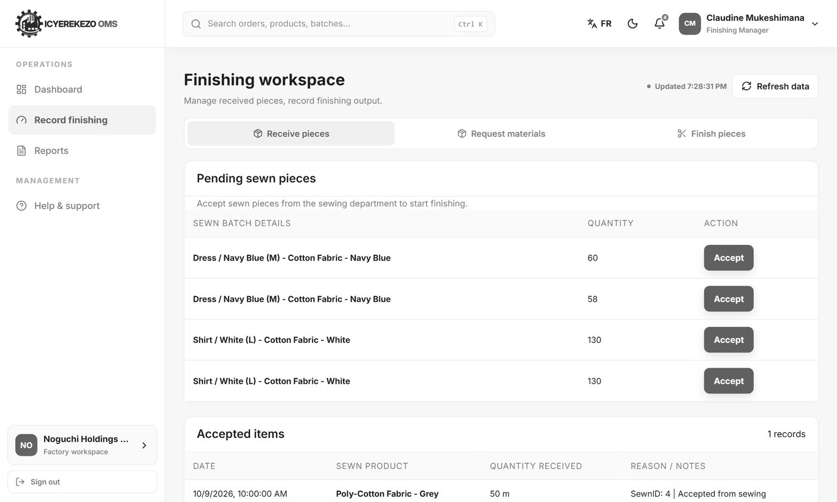
Figure 7. Finishing: pending sewn pieces
- Receive pieces. Accept sewn batches from sewing.
- Request materials. Ask the Main Warehouse for buttons, thread or labels. The storekeeper approves it like a cutting request.
- Finish pieces. Choose the accepted batch, type how many were finished and click Record finishing output.

5.7 Packing
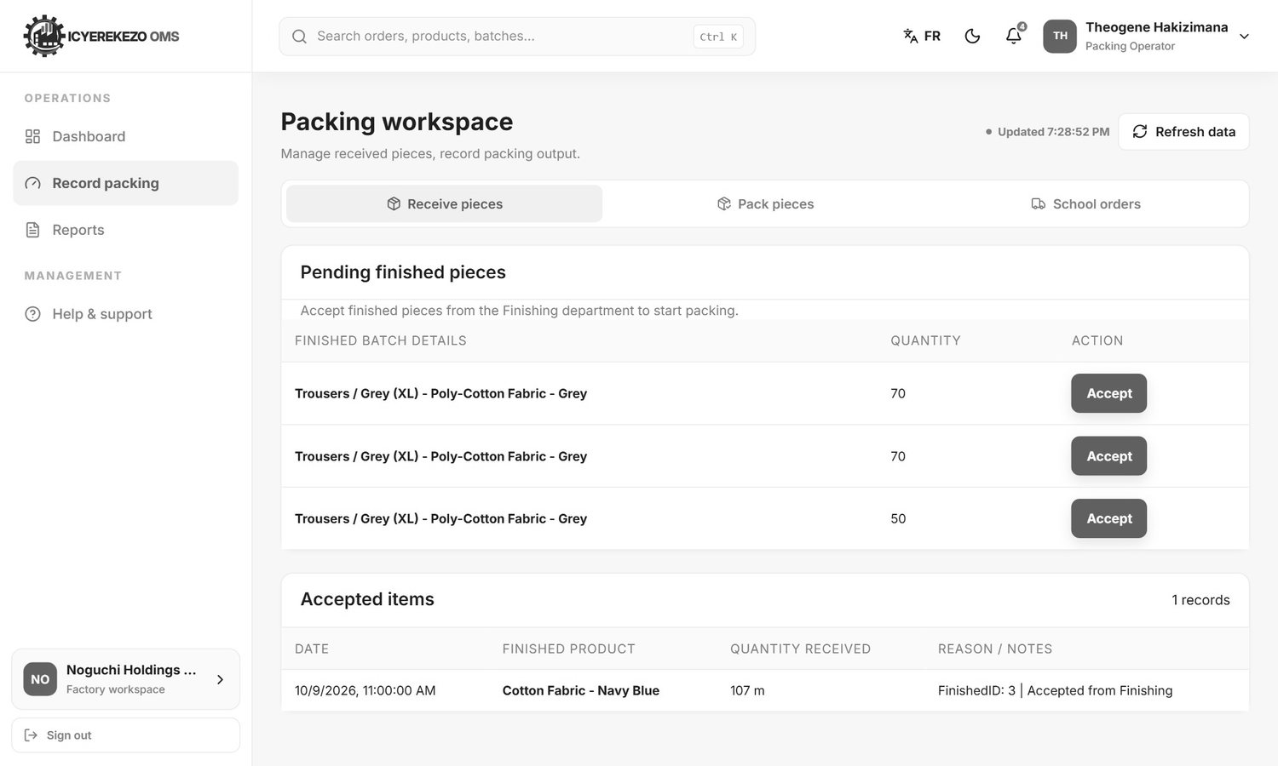
Figure 8. Packing: pending finished pieces
- Receive pieces. Accept finished batches from finishing.
- Pack pieces. Choose the batch and the Finished product it is now (Uniform, Sweater, Sport Uniform, T-shirt and so on). If the product is new, type its name under New product and click Add. Type how many were packed and click Record packing output.
- The batch now has the stage packed and waits for quality control.
- School orders. See section 7.3.

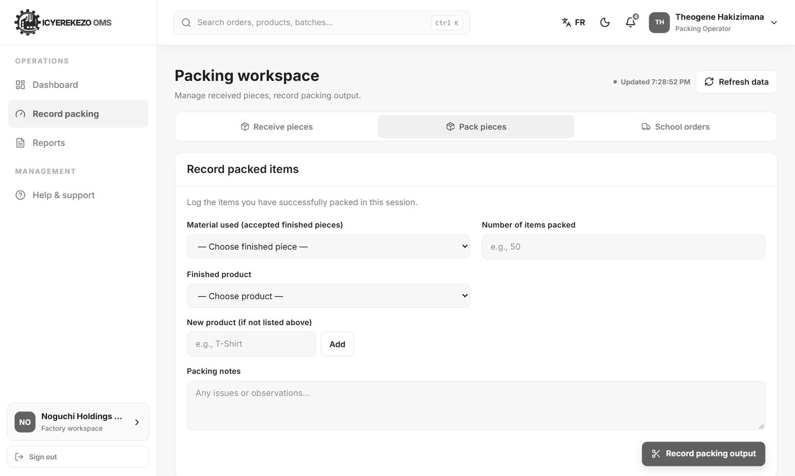
Figure 9. Pack pieces

5.8 Quality control
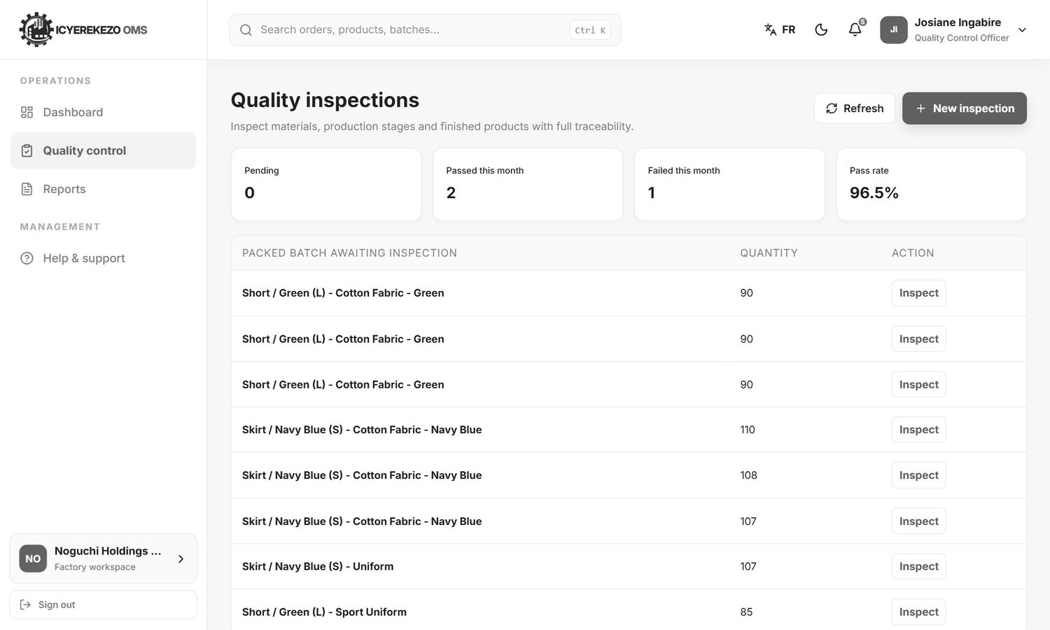
Figure 10. Packed batches awaiting inspection
The page lists every packed batch that has not been inspected. Click Inspect, type how many were inspected, passed and rejected, choose the result and save. When a packed batch is passed, it may be issued and delivered. When it is failed, it stays blocked and a notification goes to the people who approve quality.

5.9 Mistakes and corrections
- Nothing is deleted. A correction cancels the wrong record and adds the right one. Both stay visible in the history.
- Floor staff can correct a record they made within 24 hours. After that, only the storekeeper can.
- To fix a wrong number on a floor page use the Edit button on the record, type the right quantity and the reason.

5.10 Things to know about the numbers
What you see | Why
Pieces appear in the stock list of a fabric, written in metres | The system keeps cut pieces as a batch of the fabric they were cut from. A stock line such as "Cotton Fabric - Green 720.6 m" can therefore include pieces as well as metres. Use the workspace pages and the daily register for piece counts.
A batch shows on more than one floor | When a team accepts a batch, the pieces are received on its floor, but they are not taken out of the floor before. The same batch can be listed on cutting, sewing and finishing.
An accepted batch is missing from "Accepted items" after a busy day | The workspace pages read the 25 most recent stock movements of the whole factory. On a busy day older lines drop off these lists. The data is not lost. The daily register and the Inventory pages show everything.
"Pending requests" on the cutting page shows 0 m | The page reads the quantity from the movement, but a request keeps its quantity in the reserved column. Approved requests also stay in that list. The storekeeper's Incoming requests page shows the true status.

These are limits of the current version. They are listed in the Technical Documentation, section 12, so the developer can decide what to improve.

5.11 Daily routine
Role | Start of the day | During the day | End of the day
Storekeeper | Open Incoming requests. Answer the requests. | Receive deliveries. Check low stock (red number). | Make sure every request is answered. Count anything unusual.
Cutting | Request the fabric you need. | Record each cut as you finish it. | Report damaged pieces. Print the cutting report if asked.
Sewing | Accept the new cut batches. | Record sewn output. | Report damage. Check Accepted items against your count.
Finishing | Accept the new sewn batches. | Record finished output. Request materials. | Check Accepted items.
Packing | Accept the new finished batches. | Pack and record. Pack school orders. | Tell quality control which batches wait.
Quality control | Open Packed batch awaiting inspection. | Inspect and record. | Check the pass rate.
Manager | Open the daily register for yesterday. | Watch the dashboards. | Print or export the register if needed.

6. The daily register
The daily register is the report that managers know from paper: one block of rows for each date, with sections for the warehouse, cutting, production (sewing), finishing and the closing stock. The system builds it from the records the teams made. It is on the Reports page (owners see it as Factory reports).
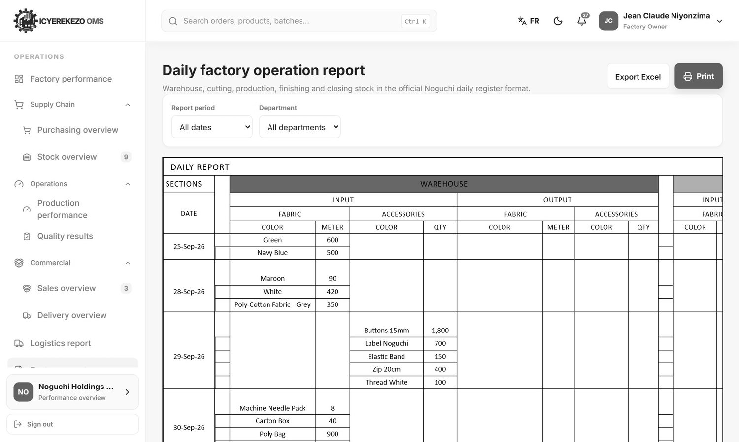
Figure 11. The Reports page with its period and department controls
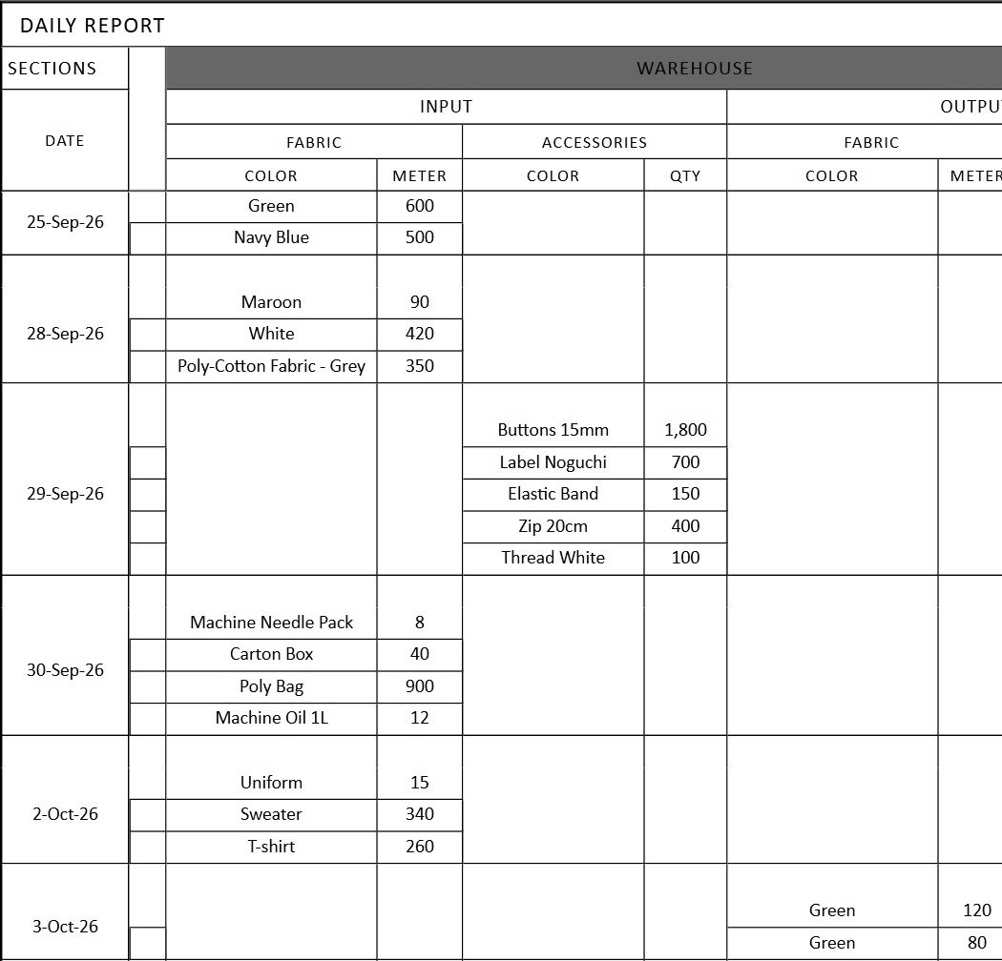
Figure 12. The daily register: left part (warehouse and cutting)
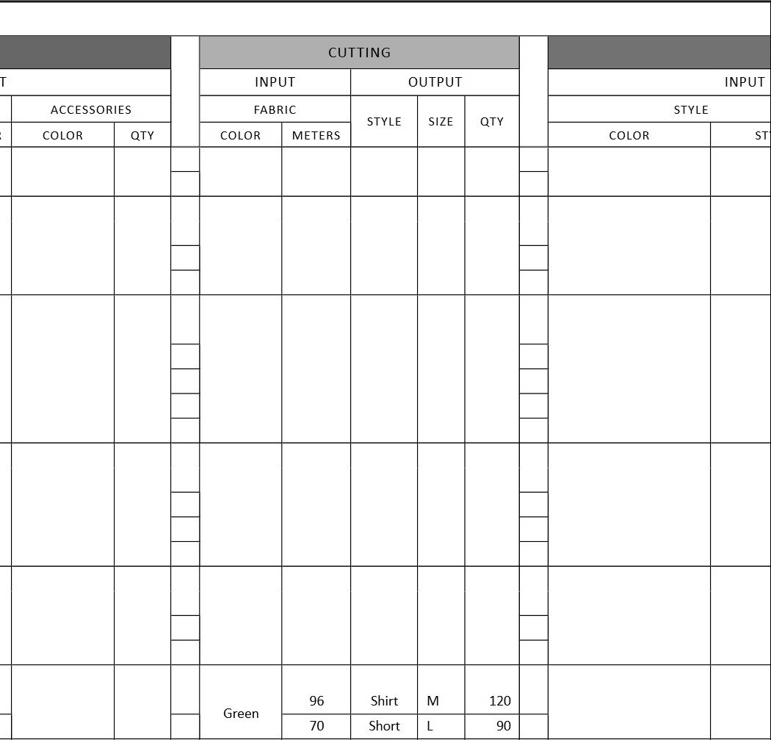
Figure 13. The daily register: right part (production, finishing and stock)

6.1 Controls
Control | What it does
Report period | Today, Last 7 days, This month, Yearly, Choose dates (two date boxes appear), All dates.
Department | All departments, or Cutting, Finishing, Packing, Production, Sewing or Warehouse. A department choice shows only its own section.
Export Excel | Downloads the register as an Excel file in the same layout. The file name starts with noguchi-daily-report.
Print | Prints the register in landscape.

6.2 The sections and their columns
Section | Columns | Where the numbers come from
Warehouse, Input | Fabric: colour and metres. Accessories: colour or name and quantity. | Receipts and other additions in the Main Warehouse and the other stores (not the floors).
Warehouse, Output | Fabric: colour and metres. Accessories: colour or name and quantity. | Issues and other removals in the same stores.
Cutting, Input | Fabric colour and metres used. | Each cut record on the cutting floor.
Cutting, Output | Style, size and quantity of pieces. | The style, size and number you typed when you recorded the cut.
Production (sewing), Input and Output | Colour, style, size, quantity. | Pieces received by sewing (input) and sewn (output), grouped by batch.
Finishing, Input and Output | Colour, style, size, quantity. | Pieces received and finished. Packing records appear in this section too.
Warehouse, Quantity in stock | Colour or name, style, size, quantity. | The closing balance on the last day of the report. Floor warehouses are left out.

Rows with the same colour (and style) on a day are merged into one cell so the register looks like the paper one. Reversed records (corrections) are left out, so the register shows the corrected figure.
Note For sewing and finishing the register tries to show the style, colour and size of the batch. In the current version it often shows the fabric name instead, because the pages now save the batch number and the report expects the older text format. The quantities are right. The Cutting section always shows style and size.

7. School orders at the factory

7.1 The order desk (Sales & orders)
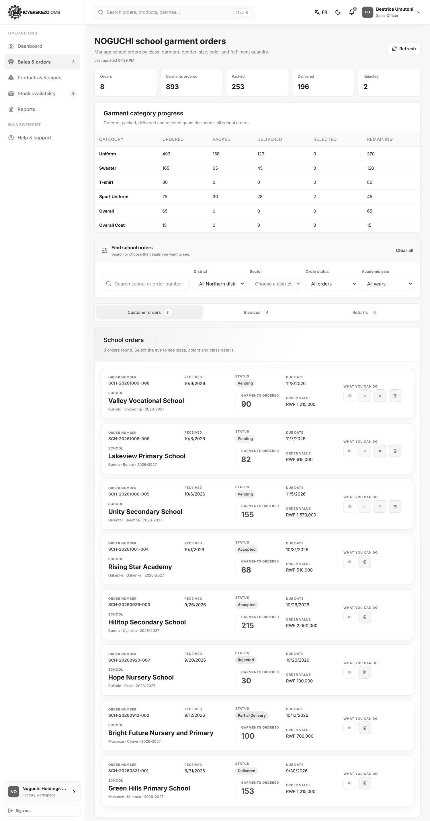
Figure 14. Sales & orders at Noguchi
The page has cards (orders, garments ordered, packed, delivered, rejected), a table Garment category progress (Uniform, Sweater, T-shirt, Sport Uniform, Overall, Overall Coat), a block Find school orders, three tabs (Customer orders, Invoices, Returns) and one card for each order.
Filter | Choices
Search | School name or order number.
District | All Northern districts, or Burera, Gakenke, Gicumbi, Musanze, Rulindo.
Sector | The sectors of the chosen district.
Order status | All orders, Pending, Accepted, Partial delivery, Delivered, Rejected.
Academic year | All years, 2025-2026 up to 2030-2031.

Order numbers look like SCH-20261009-008 (the date and a counter). Orders that were imported from the old system have the same format without the word LEGACY.

Accept, reject, delete
Each order card has four buttons: the eye (open), the green tick (accept), the red cross (reject) and the red bin (delete). Accepting and rejecting are allowed only for pending orders. Rejecting needs a reason that is recorded on the order. An order with an active shipment cannot be deleted.
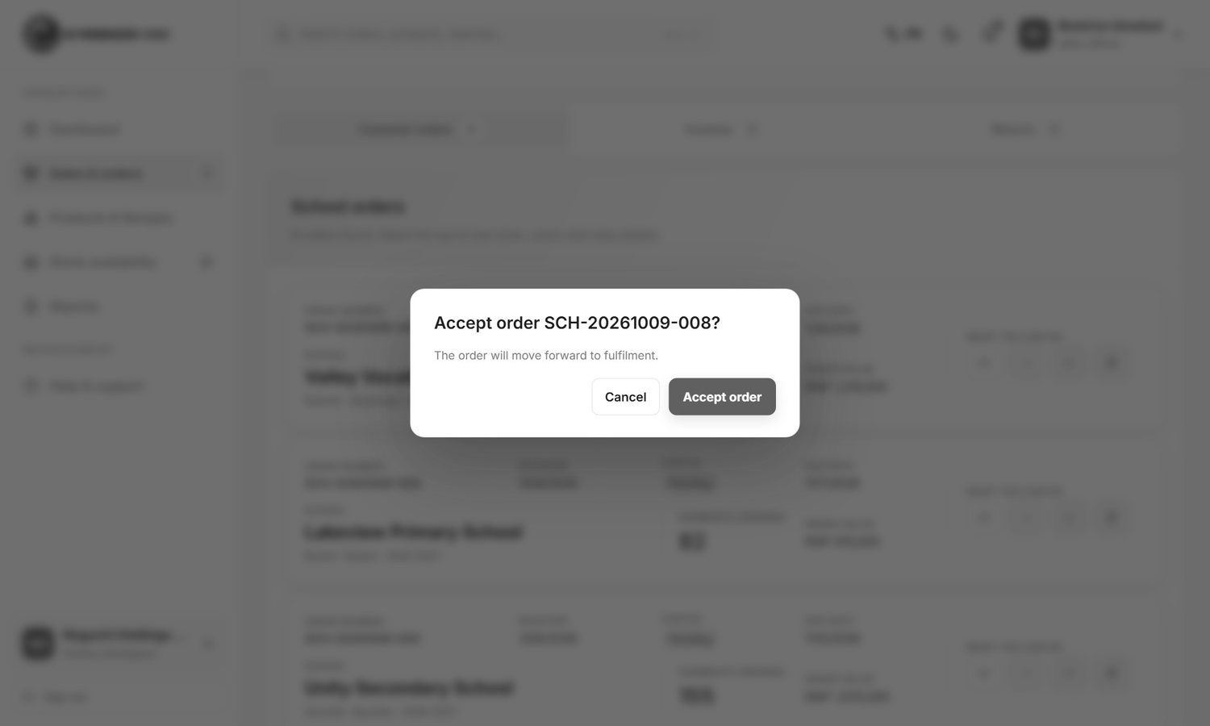
Figure 15. Accept an order
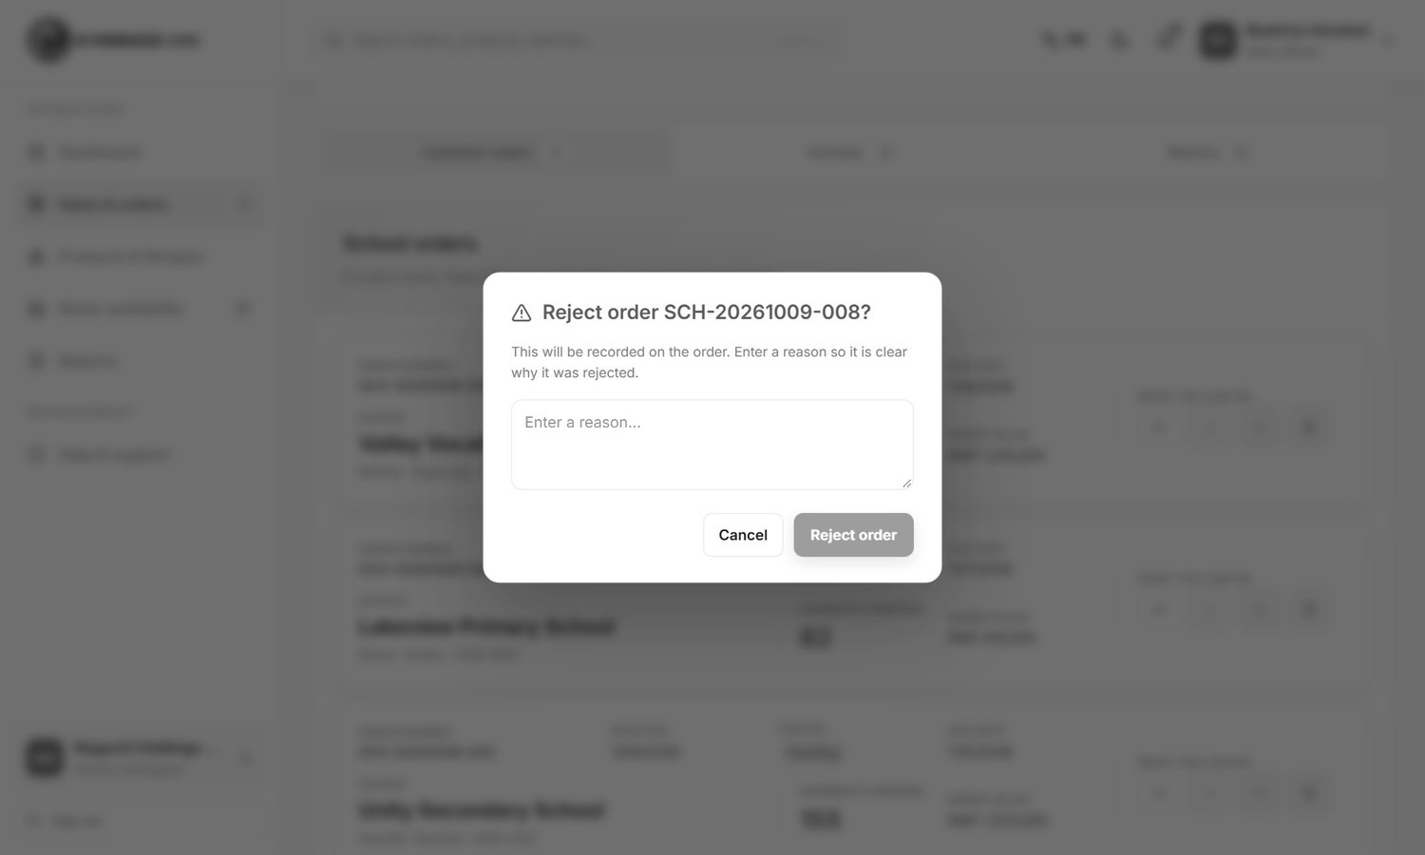
Figure 16. Reject an order

Invoices
Open the tab Invoices, find the order and upload the invoice file (PDF, JPG or PNG, up to 15 MB). The system does not make invoices. The school can see the uploaded file.
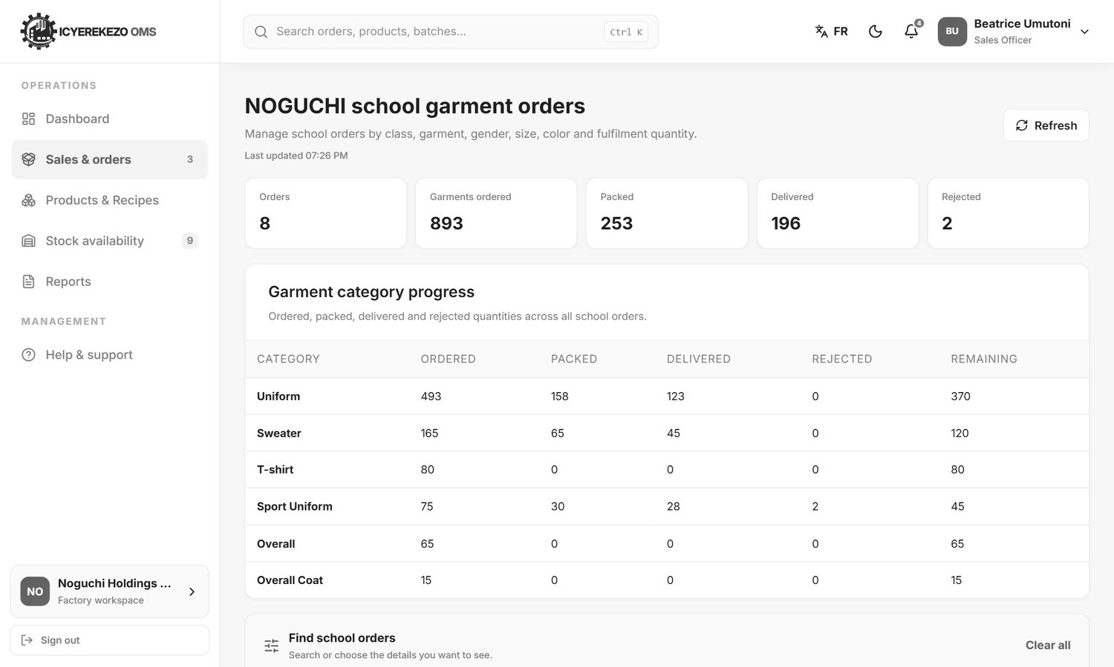
Figure 17. Invoices

7.2 Prices and the total
The total of a school order is worked out when the school sends it. The prices are written in the system:
Garment | Nursery | Primary | Secondary
Uniform | 6,000 | 7,500 | 12,000
Sweater | 6,500 | 8,000 | 8,500
Sport Uniform | no price in the portal | no price in the portal | no price in the portal
T-shirt | - | - | 4,000
Overall | - | - | 15,000
Overall Coat | - | - | 9,000

Amounts are in RWF. Sport Uniform has a price in the price list under another name, so schools see 0 for it. Orders that include sport wear therefore have a total that is too low. Check these orders before you make the invoice. This is listed for the developer in the Technical Documentation.

7.3 Packing the order
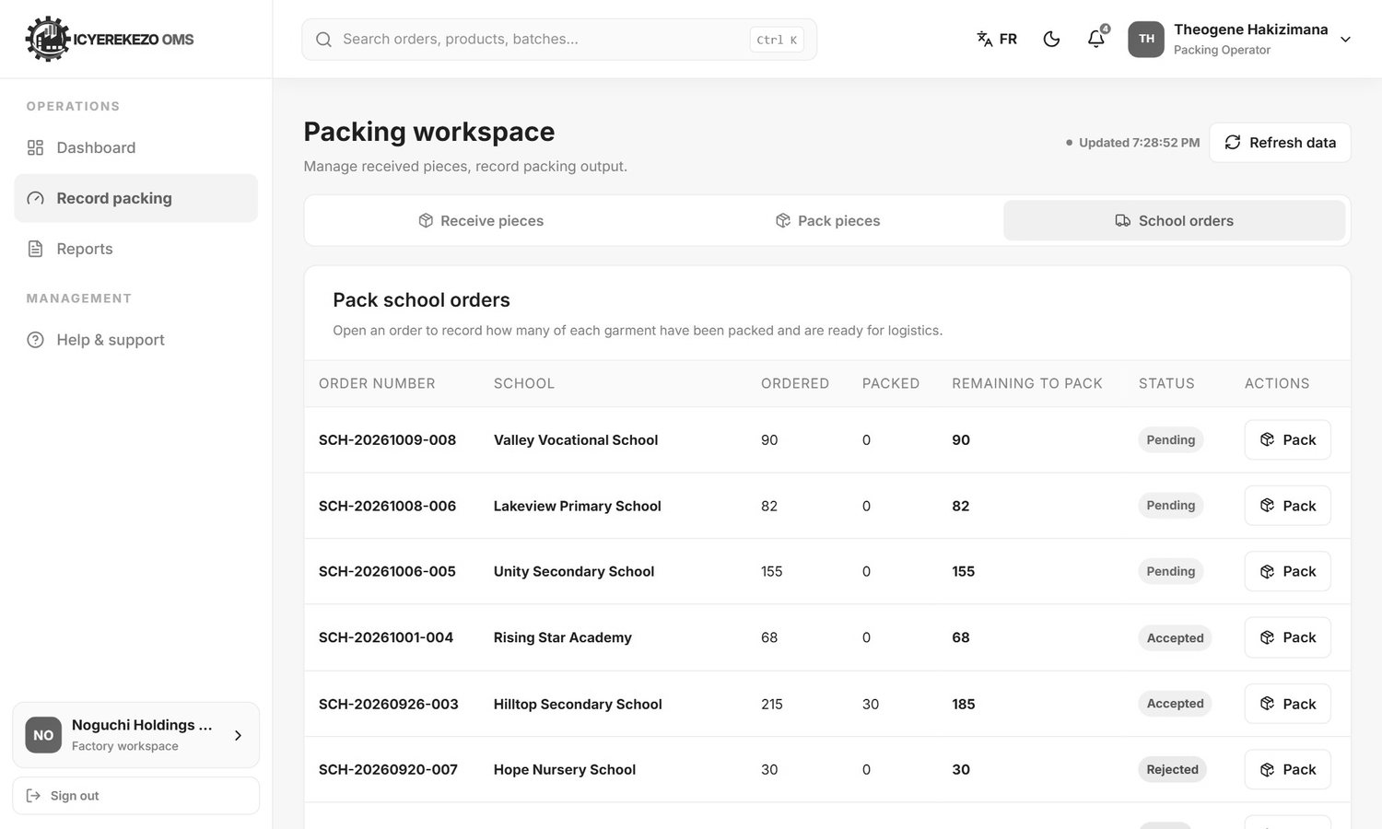
Figure 18. Packing: school orders
- Open Record packing, tab School orders.
- Click Pack on an order. A window lists its lines.
- For each line type how many are packed and click Save.

You can type any number from 0 up to the quantity ordered. Packing does not change the order status and does not touch the stock. It only tells logistics what is ready.
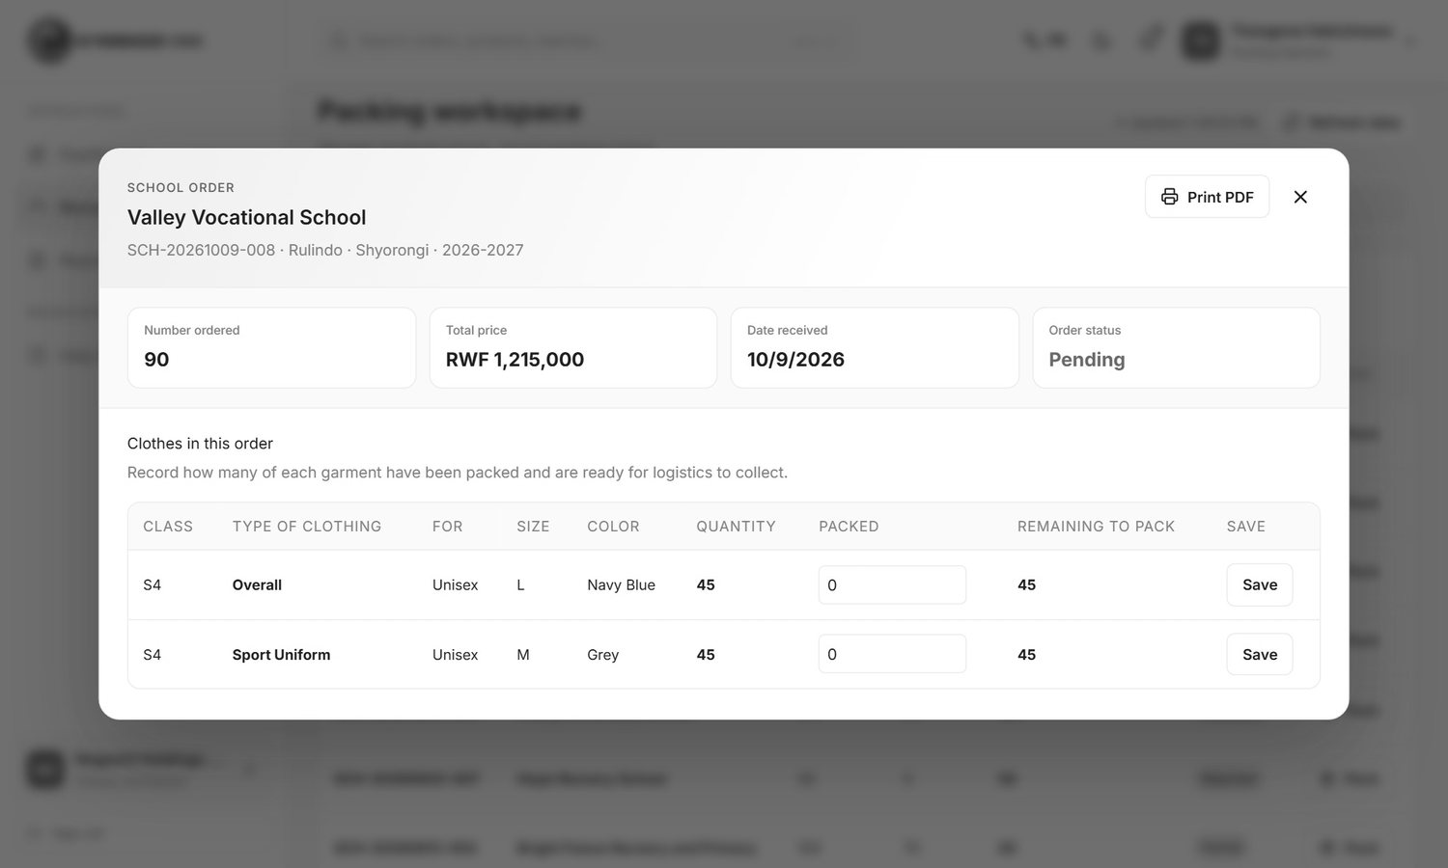
Figure 19. Pack the lines of an order

7.4 Delivery
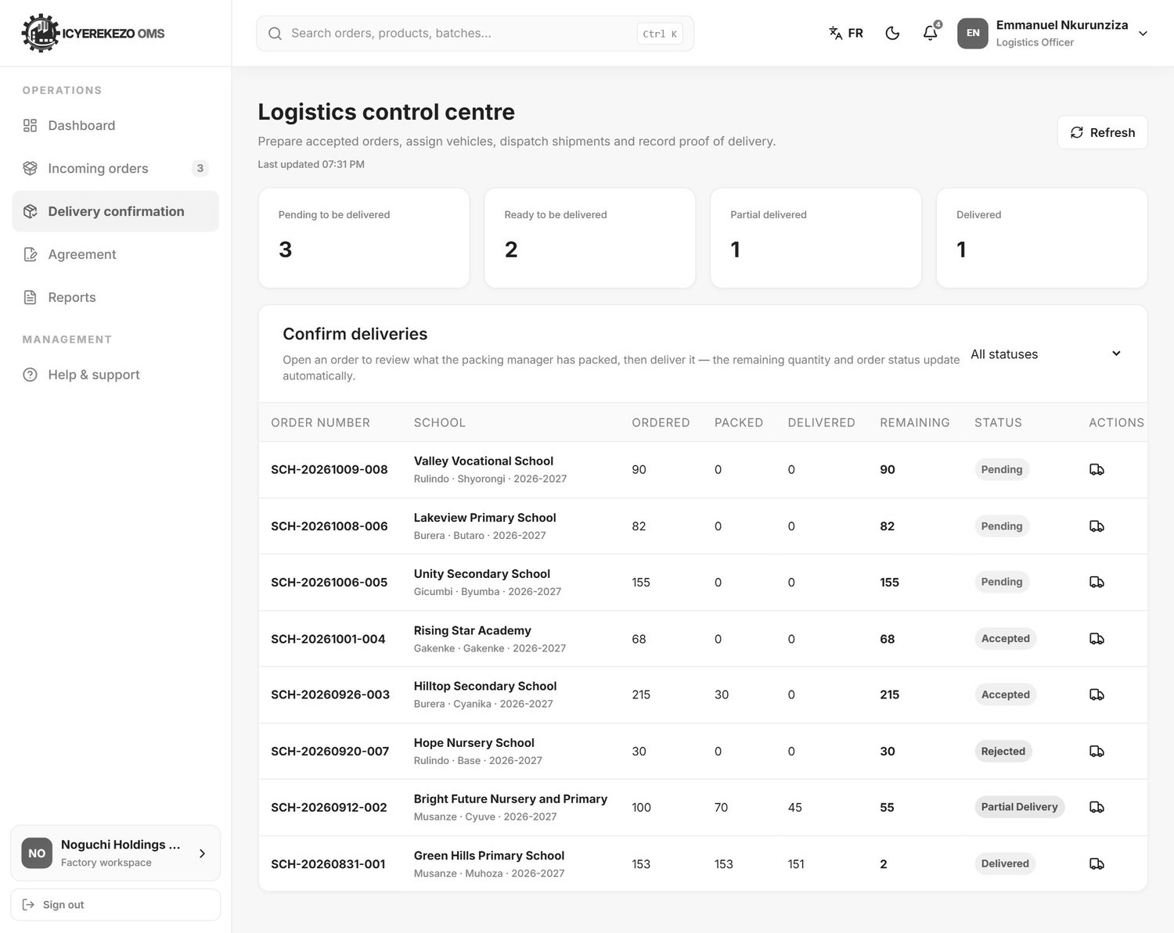
Figure 20. Delivery confirmation
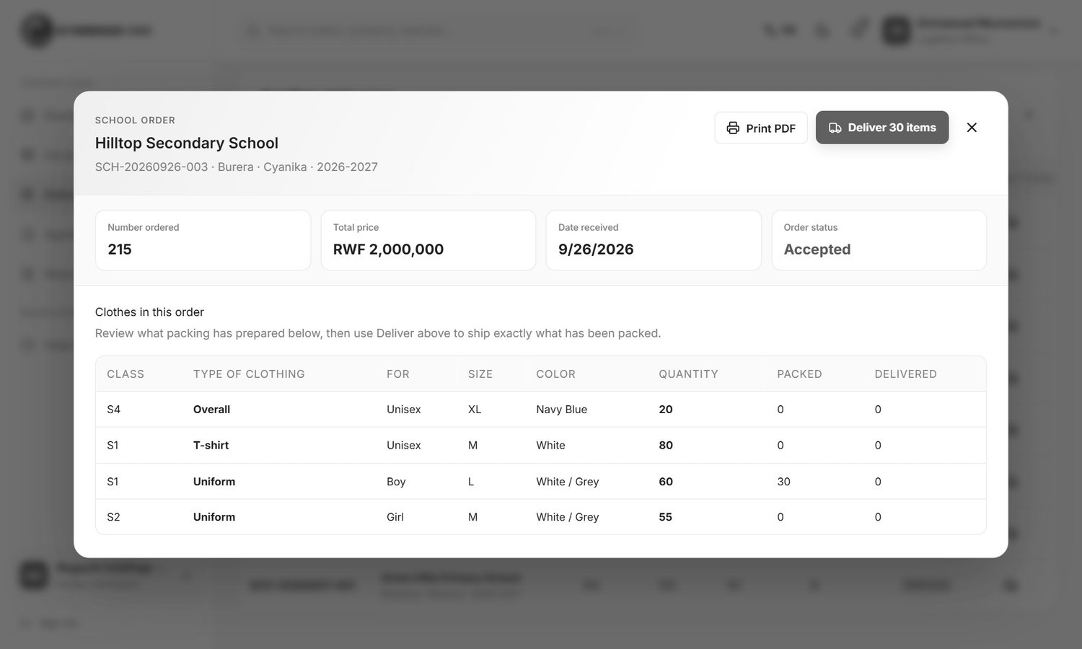
Figure 21. The delivery window
- The logistics officer opens Delivery confirmation and opens an order.
- The window shows for each line the quantity ordered, Packed and Delivered.
- The officer clicks Deliver. For every line the delivered number rises to the packed number.
- The stock of that garment goes down in the warehouse that holds enough of it. If no single warehouse holds enough, the stock is not reduced but the delivery is still recorded.
- The order becomes Partial delivery if some lines are still short, or Delivered if everything is delivered. The school gets an email each time the status changes.

7.5 Money
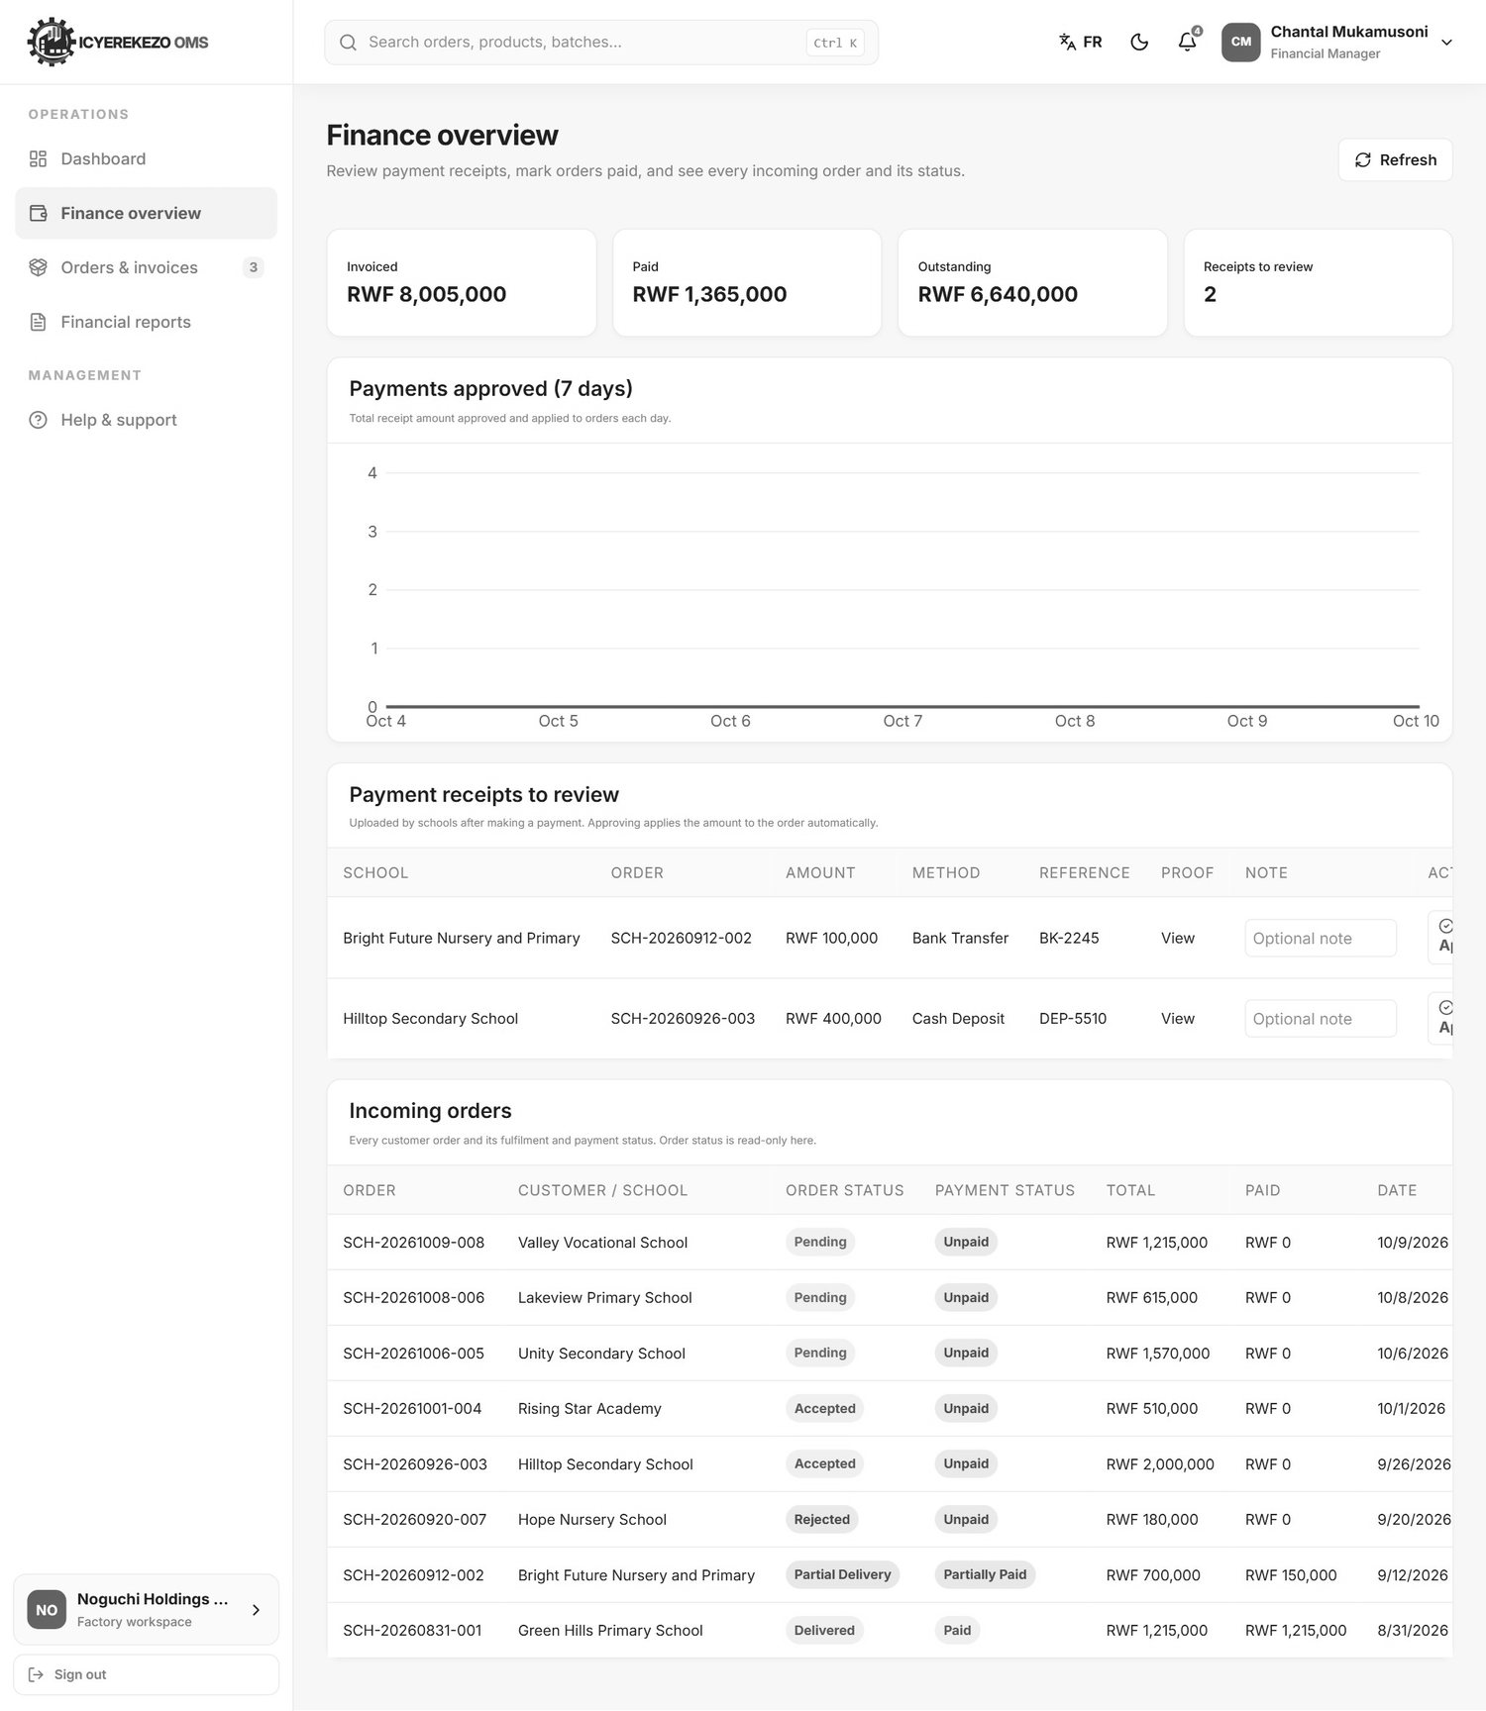
Figure 22. Finance overview
Schools pay by bank transfer, MoMo Pay, cheque or cash deposit, then send a proof from the portal. The financial manager checks it on Finance overview, in the table Payment receipts to review: open the proof, compare the amount and the reference with the bank record, write an optional note and click Approve or Reject. Approving adds the amount to the order. An order shows Unpaid, Partially paid or Paid.
The financial reports (revenue and collections, invoice register, cash receipts book, outstanding and aging) are on Financial reports.

7.6 The agreement
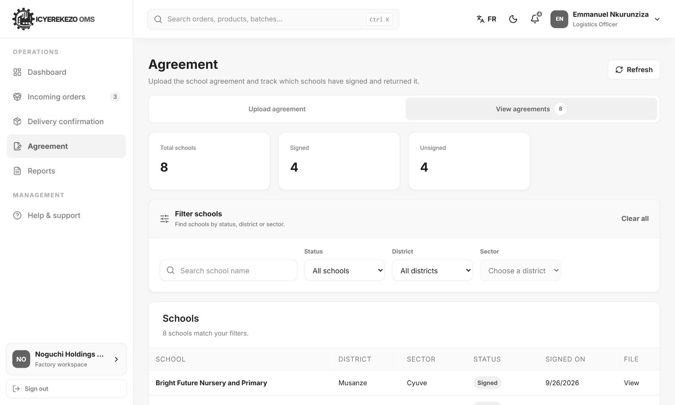
Figure 23. Which schools have signed
The logistics officer uploads the agreement on Agreement. Each new upload becomes the current version and schools see it at once. The tab View agreements shows total schools, signed and unsigned, with filters. A school that signed an older version is not counted as signed for the new one until it uploads again.

7.7 Returns
A school can send a return request from the portal: the order lines, the quantities and a reason (Too Small, Too Large, Damaged, Wrong Item, Other). The request is saved. There is no screen at the factory to read or answer it yet, so the school will keep seeing "Waiting for factory review". Until this is built, ask schools to also call the logistics officer, and handle the return outside the system.

7.8 School order reports
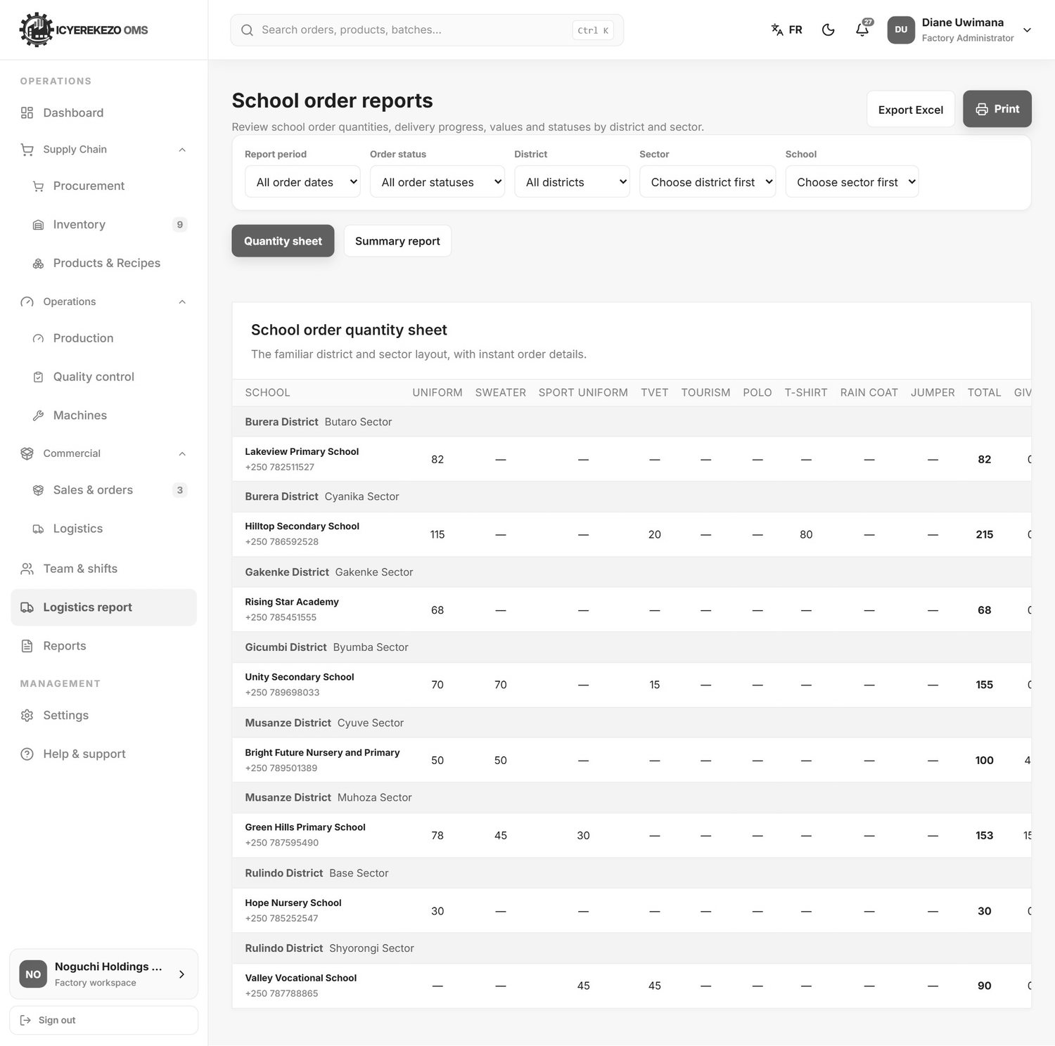
Figure 24. Logistics report: school order quantity sheet
Menu, Logistics report (administrator, manager, owner) or Reports (logistics officer). Choose the period, the order status, the district, the sector and the school. The Quantity sheet has one block for each district and sector with the schools in it and these columns:
Column | Meaning
School | Name and phone.
Uniform, Sweater, Sport Uniform, Tourism, Polo, T-shirt, Rain Coat, Jumper | Quantity ordered of each garment.
TVET | Quantity of TVET garments. Overalls and Overall Coats are added into this column.
Total | All garments ordered.
Given | Delivered quantity.
Remaining | Total minus given minus rejected.
Value | Order value in RWF.
Status | Pending, Accepted, Partial Delivery, Delivered or Rejected.
View | Opens the order.

The Summary report gives totals by district and sector. Export Excel and Print work on whatever you selected.

8. Other Noguchi screens

8.1 Dashboards
The owner, administrator and manager see the executive dashboard with school order figures: total orders, garments ordered, delivered, packed or ready, total revenue (orders that are not rejected) and delivery completion, with a chart of orders and deliveries.
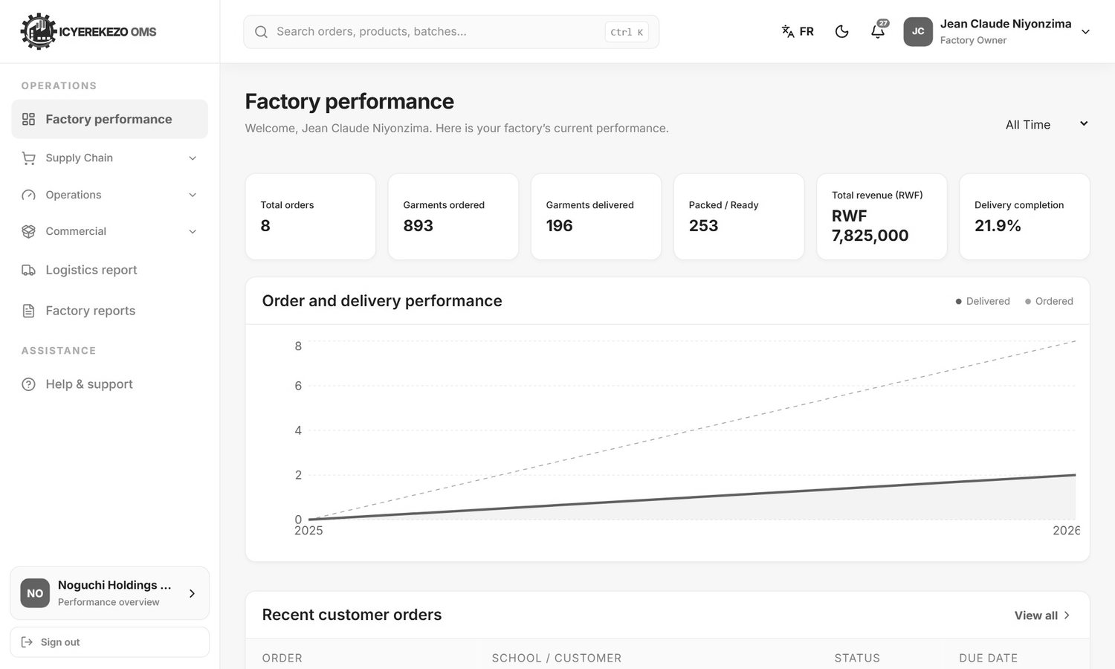
Figure 25. Factory performance (owner)
The storekeeper, cutting, sewing and the other teams have their own dashboards with cards for the work waiting and the results of the day.

8.2 Notifications that matter
- A new school order shows in the bell as "Incoming Orders" for staff, and as a red number next to Sales & orders.
- Low stock sends a notification to the storekeeper and the owner when an item falls under its reorder level.
- A failed quality inspection sends a notification to the people who approve quality.
- A new production order sends a notification to the people who approve it.

8.3 Importing old orders
Orders from the earlier system can be imported by the developer with the command php artisan noguchi:import-school-orders file.sql. Each imported order is made with the status Pending, with its lines, quantities packed, delivered and rejected. The "Rejected" quantity on the order lines can only come from such an import, because no screen records rejected garments.

9. Questions and answers
Question | Answer
A school says it cannot create an account. | Check that registration is open (platform administrator, System settings) and that the Noguchi factory exists with the exact name and industry.
The cutting page lists no fabric to request. | Fabrics are listed only if the Main Warehouse has stock of them. Receive the fabric first.
A floor page says "Insufficient stock". | You typed more than the floor holds. The message shows what is available.
Packing cannot pick the finished product. | Choose it from the list, or type a new name under New product and click Add.
Logistics sees "Nothing to deliver". | Packing has not recorded packed quantities for that order yet.
A delivery was recorded but the stock did not go down. | No single warehouse held enough of that garment. Check Inventory, Stock movements.
The register is empty. | Choose the period All dates, or choose the right department.
A payment does not show on the order. | The financial manager has not approved the proof yet.
A batch cannot be issued. | It is packed and has not passed quality control.

