ICYEREKEZO OMS
School Portal Guide
How a school orders, pays and returns uniforms with Noguchi Holdings Ltd
For: head teachers, school administrators and the Noguchi staff who help them
System: ICYEREKEZO OMS, school portal
Date: October 2026
Contents
1. About this guide 3
1.1 What you can do in the portal 3
1.2 What you need 3
2. Create your school account 4
3. Sign in 7
4. Getting around 8
4.1 The dashboard 9
5. Place a new order 11
5.1 What you fill in for each class 12
5.2 Review and submit 14
5.3 Prices 14
5.4 Rules 15
5.5 What happens next 15
6. Order history 16
7. Financial records 18
8. Send a proof of payment 19
8.1 What the factory does with it 19
9. Return items 21
9.1 Returns history 22
10. The supply agreement 24
11. School profile 25
12. Messages and help 26
13. Questions and answers 27

1. About this guide
Noguchi Holdings Ltd makes school uniforms, sweaters, sportswear and other school garments. Schools in the Northern Province order them through a website called the school portal. This guide shows a school administrator how to use the portal, from creating an account to returning a garment that does not fit.
It also explains, in simple words, what happens at the factory after you send an order, so you know what to expect.
The screenshots in this guide are black and white and were taken with sample names and numbers. On your real screen some labels have colours, and your own data will appear.

1.1 What you can do in the portal
- Create an account for your school and keep the school details up to date.
- Order garments class by class for an academic year.
- See all your orders, how many garments were delivered, and print an order.
- See how much you have paid and how much you still owe, and send a proof of payment.
- Ask to return garments that were delivered.
- Download the supply agreement and send back your signed copy.
- Write to the system support team.

1.2 What you need
- A computer, tablet or phone with internet.
- An email address that you can read. The portal uses it for your account and sends order messages to the school email.
- For payments: a photo, scan or screenshot of the payment slip (JPG, PNG or PDF, up to 5 MB).
- For the agreement: a printer or a scanner or a phone camera to make your signed copy.

Note The screenshots use sample schools and numbers. Your screen will show your own school.

2. Create your school account
Each school creates one administrator account. If your school already has an account, ask the person who made it to share the sign in details, or ask Noguchi to help.
- Open the school sign up page: the system address followed by /school/signup. Your Noguchi contact can give you the full address.
- Step 1, Account. Type your email address. Type a password and the same password again. The screen ticks each rule when it is met: at least 10 characters, a capital letter, a small letter, a number and a symbol. Click Continue.
- Step 2, Administrator. Type the administrator name and the phone number. Click Continue.
- Step 3, School. Type the school name. Choose the District and then the Sector (the sector list shows only the sectors of that district). Click Create Account.
- You are signed in at once and the portal opens on your Dashboard.

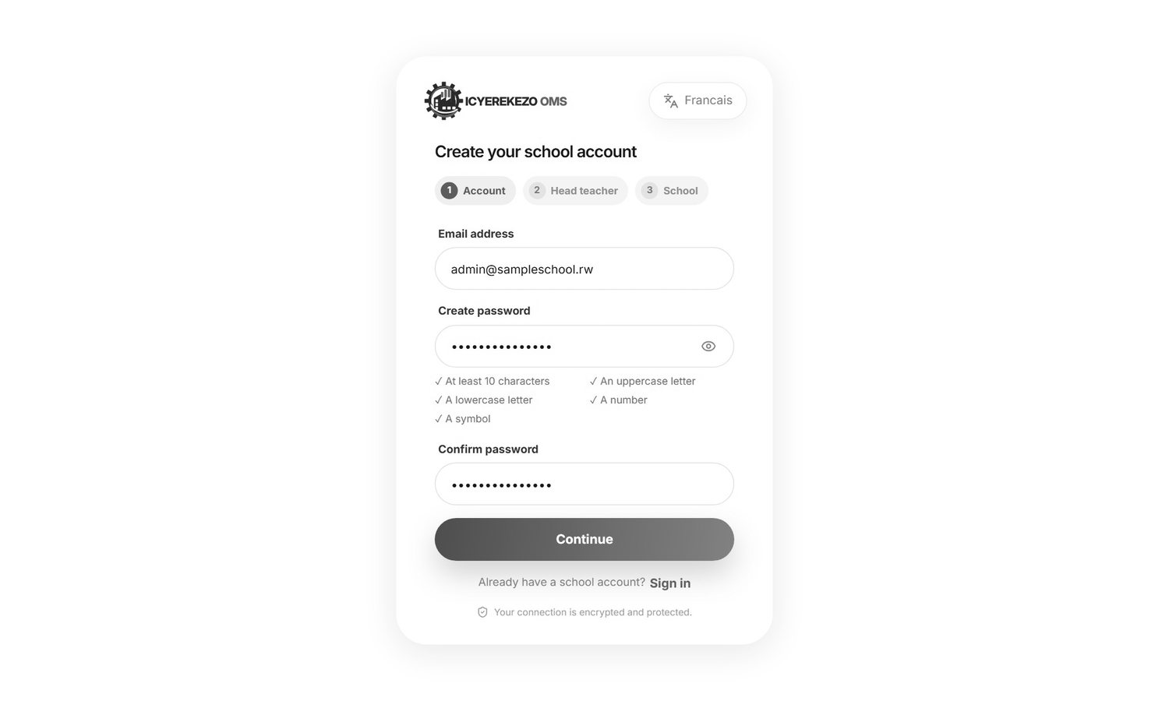
Figure 1. Step 1: email and password
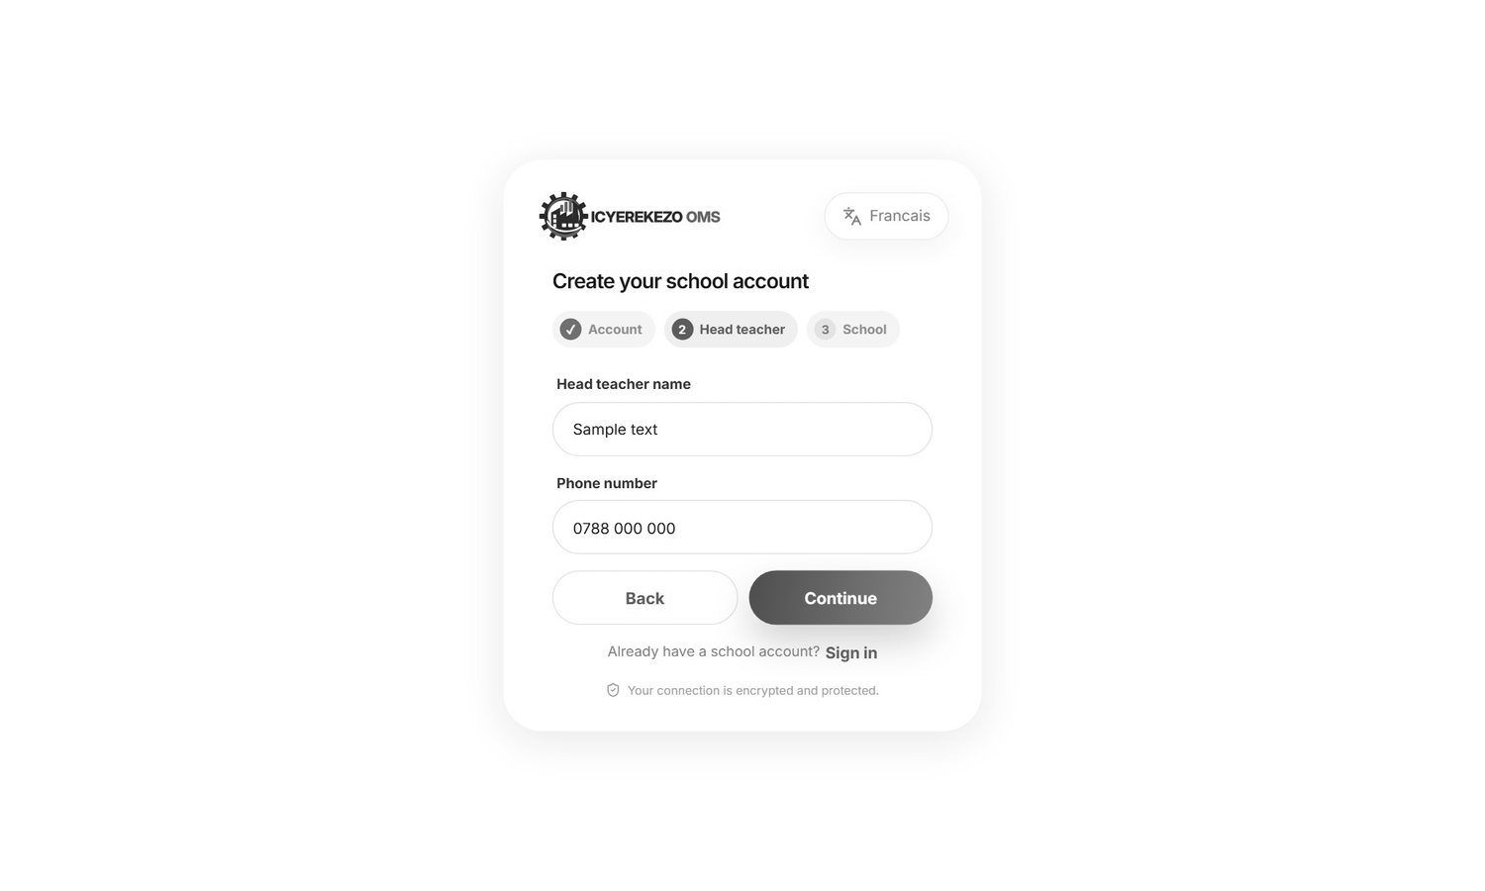
Figure 2. Step 2: administrator
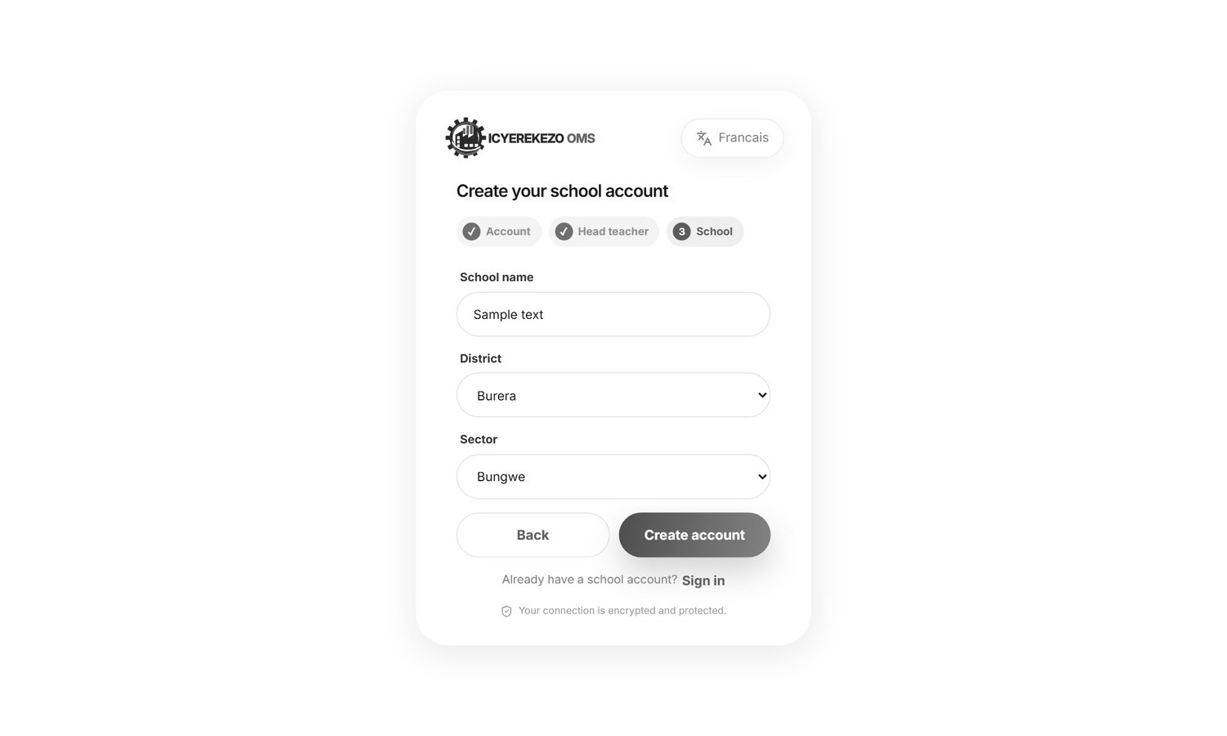
Figure 3. Step 3: school name, district and sector
Note If you register a school that is already on the list (same name, district and sector), the system uses the same school record and updates the contact details. It does not make a second school.

If you see the message "School registration is currently closed. Please contact support." new registrations are switched off for now. If you see "The school ordering factory is not available yet", ask Noguchi to check the set up.

3. Sign in
- Open the school sign in page: the system address followed by /school/login.
- Type your email (or username) and your password.
- Tick Keep me signed in only on your own computer.
- Click Sign in.

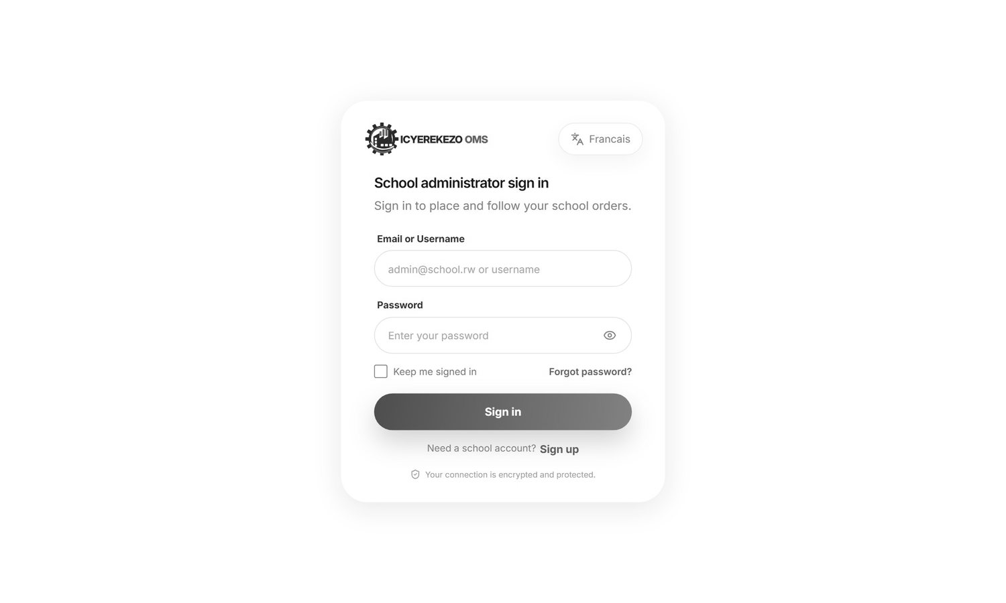
Figure 4. School sign in
- This page is only for school administrators. If you use the account of a factory employee you will see "This sign-in page is only for school administrators."
- If you forget your password click Forgot password?, type your email and open the link we send you. Check the spam folder.
- Click Sign up at the bottom if you need a new school account.
- Use Francais or English at the top of the card to change the language.

4. Getting around
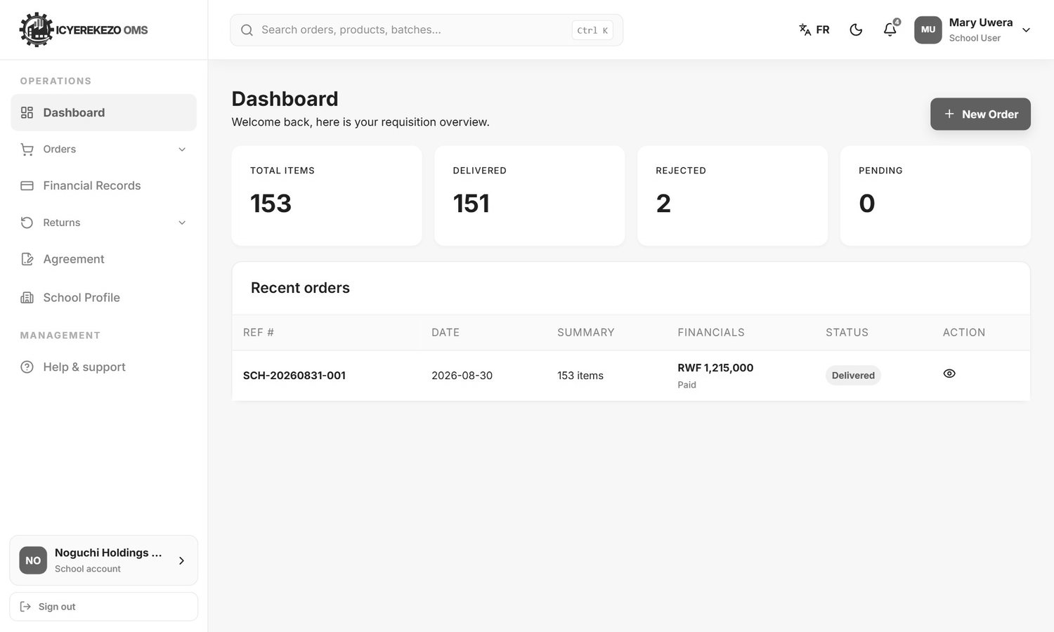
Figure 5. The school dashboard
The menu on the left has these items:
Menu item | What it is for
Dashboard | A summary of your orders.
Orders, Place New Order | Order garments.
Orders, Order History | Find, open and print earlier orders.
Financial Records | See what you owe and send proof of payment.
Returns, Return Items | Ask to return delivered garments.
Returns, Returns History | Follow your return requests.
Agreement | Download and send back the supply agreement.
School Profile | The school details.
Help & support | Write to the support team.

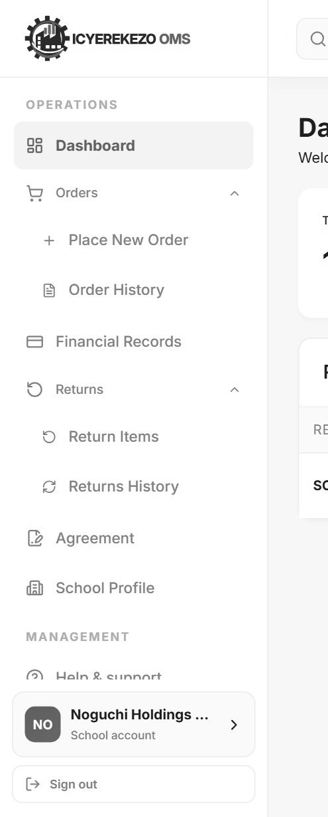
Figure 6. The school menu
At the top right you have FR (language), the moon (dark look), the bell (messages) and your name (profile menu with Sign out).

4.1 The dashboard
Part | Meaning
Total Items | All garments you have ordered.
Delivered | Garments the factory has delivered to the school.
Rejected | Garments that were rejected.
Pending | Garments ordered that are not yet delivered (ordered minus delivered minus rejected).
New Order button | Starts a new order.
Recent orders | Your latest eight orders. Columns: Ref # (order number), Date, Summary (number of items), Financials (the total and whether it is Paid, Partially paid or Unpaid), Status, and Action (the eye opens the order).

5. Place a new order
An order is built one class at a time. There are 15 classes: Nursery 1, 2 and 3, P1 to P6 and S1 to S6. You can fill only the classes that need garments and skip the others.
- Menu, Orders, Place New Order.
- Choose the Academic year at the top right of the form (for example 2026-2027).
- Click a class in the strip at the top, or use Save & Next Class. A tick appears on a class that has quantities.
- For each garment group, type a colour and then the quantity for each size, for boys and for girls.
- Go through all the classes you need.
- On the last class (S6) click Review Order. You can also click S6 in the strip at any time.
- Check the review table. If something is wrong click Edit Order.
- Click Confirm & Submit. The portal says "Your order was sent to the factory for review." and opens the Dashboard.

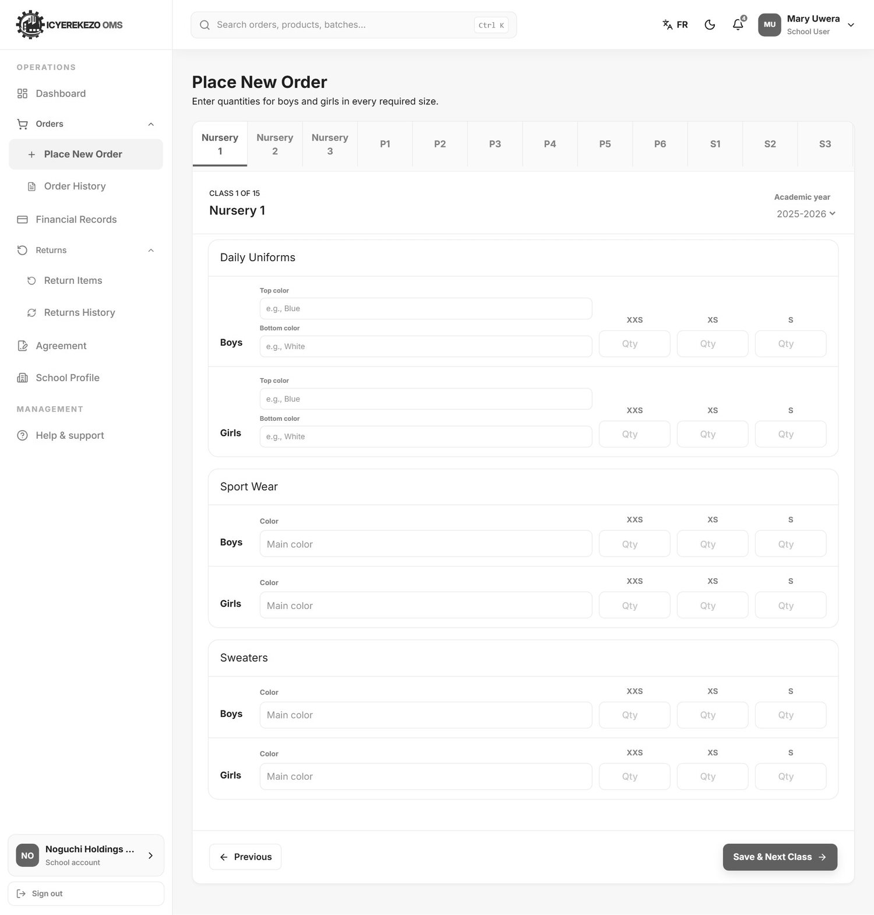
Figure 7. An empty class form (Nursery 1)

5.1 What you fill in for each class
Garment group | What to type | Sizes
Daily Uniforms | For boys and for girls: Top color and Bottom color, then the quantities. | Nursery: XXS, XS, S. P1 to P6: S, M, L, XL. S1 to S6: S, M, L, XL, XXL.
Sport Wear | For boys and girls: one Color and the quantities. | Same as above.
Sweaters | For boys and girls: one Color and the quantities. | Same as above.
T-Shirts | Only shown for S1 to S6. | S, M, L, XL, XXL.
Overalls and Overall Coats | Only shown for S4 to S6. | S, M, L, XL, XXL.

Figure 8. The class strip with a tick on the classes you filled
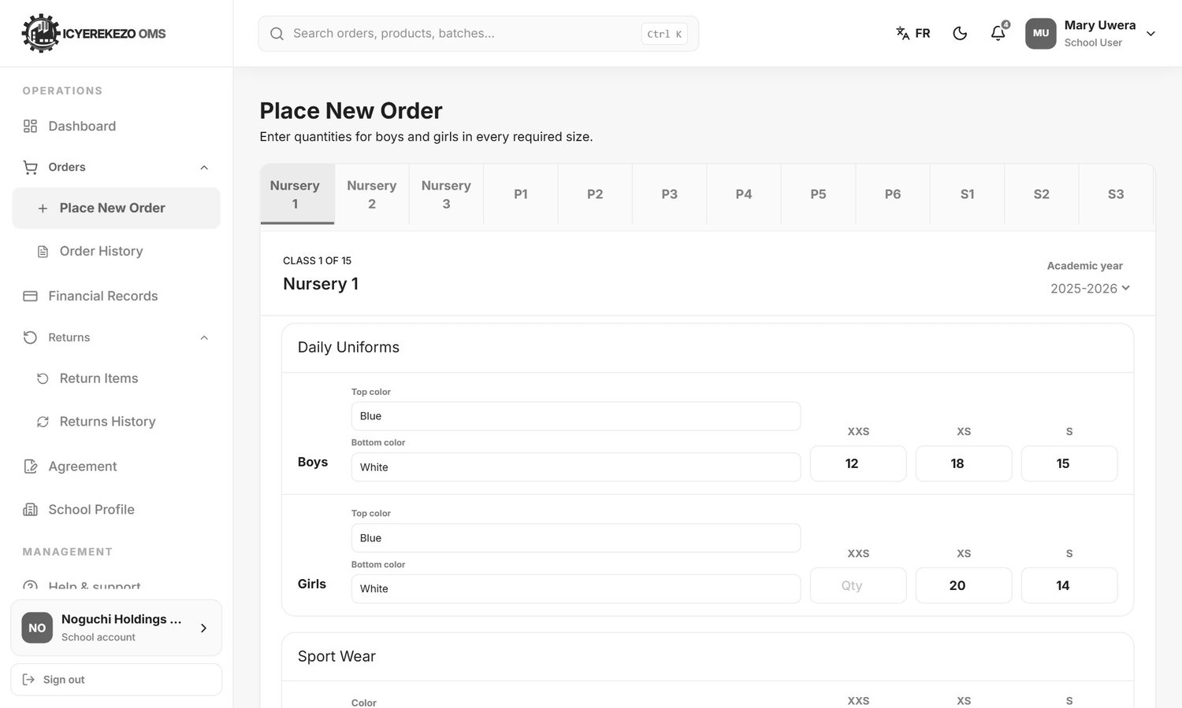
Figure 9. Nursery 1 with quantities
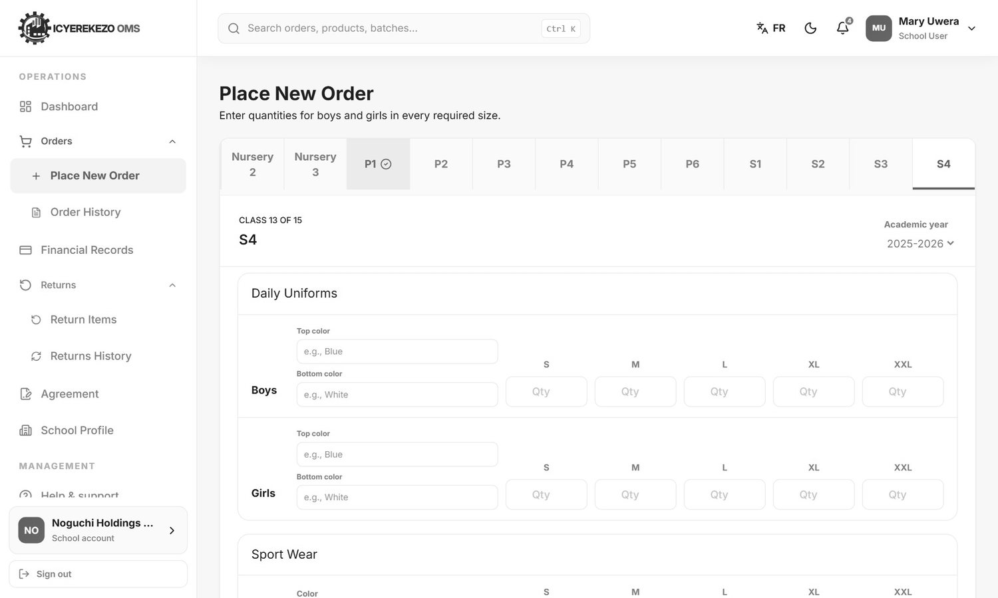
Figure 10. A secondary class (S4) also shows T-Shirts, Overalls and Overall Coats
Note Every group where you type a quantity needs a colour. If you forget one, the portal says "Complete the size and color for ..." and takes you back to that class.

5.2 Review and submit
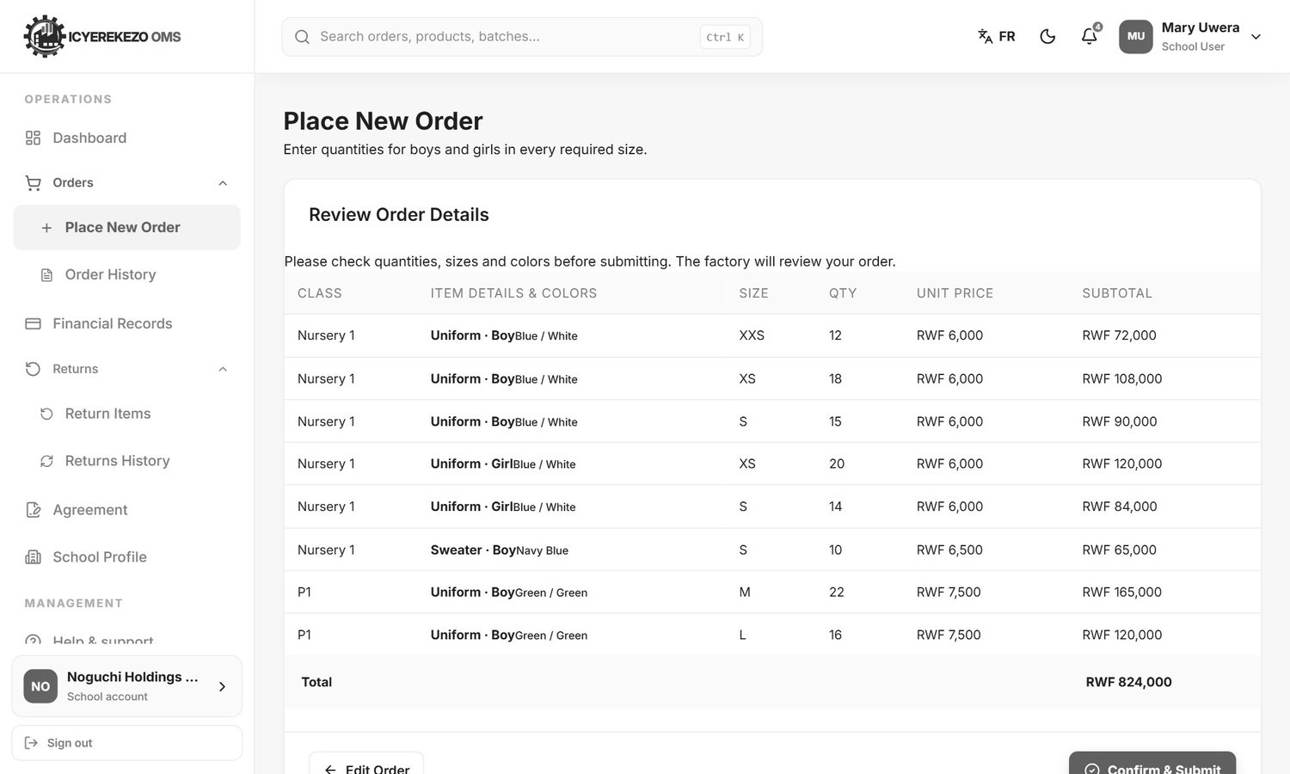
Figure 11. Review order details
The review table lists each line: class, garment and gender with the colour, size, quantity, unit price and subtotal. The Total is at the bottom. The price comes from the price list of the factory (section 5.3). The final price on the invoice is made by the factory.

5.3 Prices
The portal uses this price list (Rwandan francs per garment). It is set in the system and the factory can change it.
Garment | Nursery | Primary (P1 to P6) | Secondary (S1 to S6)
Uniform | 6,000 | 7,500 | 12,000
Sweater | 6,500 | 8,000 | 8,500
T-shirt | not sold | not sold | 4,000
Overall | not sold | not sold | 15,000
Overall Coat | not sold | not sold | 9,000

Note Sport Wear (the "Sport Uniform" garment) is not priced in the portal at the moment. Its lines show a unit price of 0 in the review table and are not included in the total. The factory will give you the price on the invoice. Ask your Noguchi contact for the sport wear price.

5.4 Rules
- A school can have only one active order for each academic year. Rejected orders do not count. If you try to place a second order for the same year you get the message "This school already has an active order for the selected academic year."
- You cannot change an order after you send it. If you made a mistake, call Noguchi. The factory can reject the old order, and then you can place a new one for the same year.
- T-shirts are for S1 to S6 only. Overalls and Overall Coats are for S4 to S6 only.
- The quantity of each line must be at least 1. Lines with no quantity are ignored.

5.5 What happens next
- The order is sent to Noguchi with the status Pending. An email tells your school: "Your order (number) has been successfully placed and is pending review by the factory."
- A sales officer reviews the order and accepts or rejects it. Each change of status sends an email: "The status of your order ... has been updated to: Accepted."
- The factory makes and packs the garments. The packing team records how many of each line are packed.
- The logistics officer delivers the packed garments. The order becomes Partial delivery and then Delivered.
- The factory uploads the invoice. You pay and send the proof (section 8).

6. Order history
Menu, Orders, Order History.
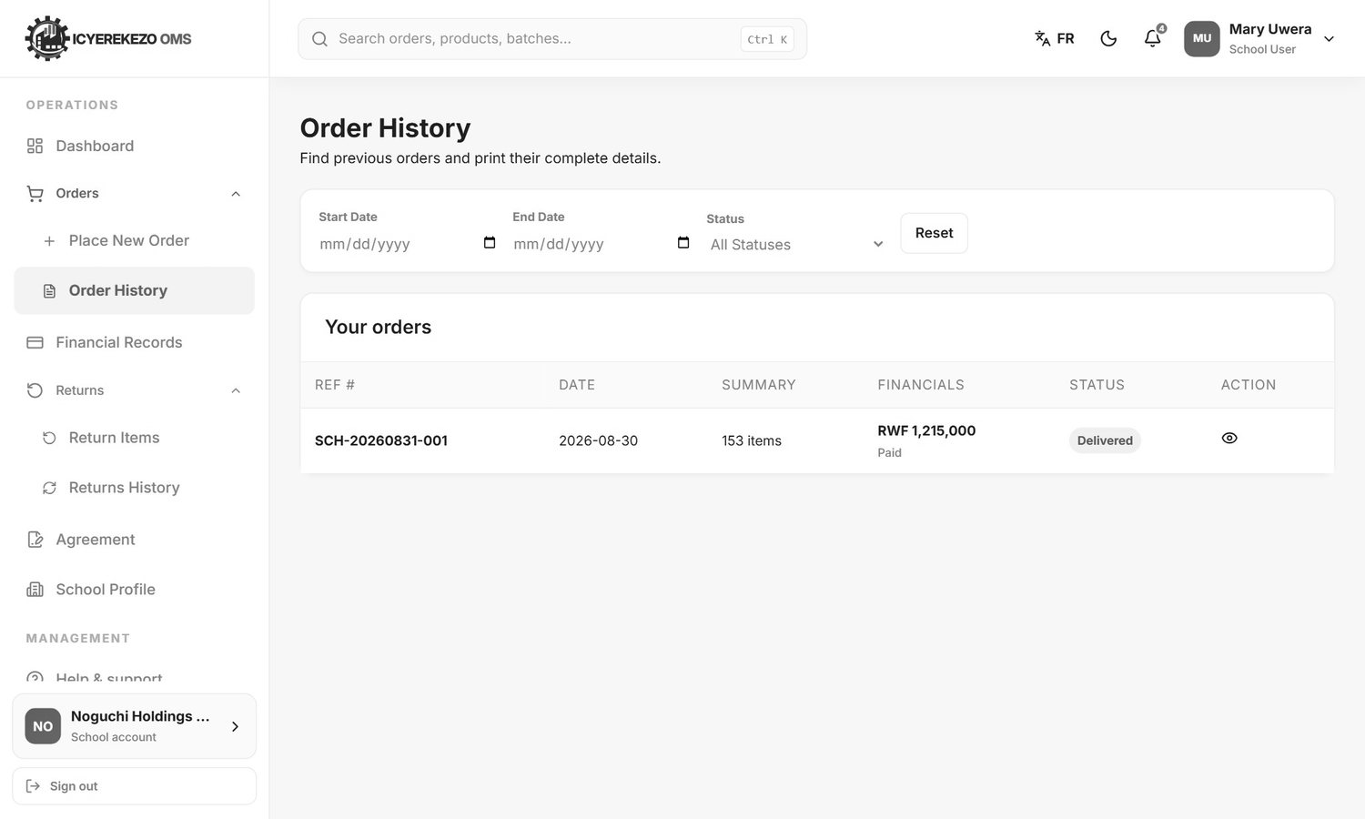
Figure 12. Order history
- To narrow the list choose a Start Date, an End Date and a Status. Click Reset to clear them.
- Click the eye on an order to open it.
- The order window shows each line with the class, garment, colour, gender, size and the quantities: Ordered, Delivered, Rejected and Remaining.
- Click Print Invoice to open a printable order page (PDF) in a new tab. Use your browser to print or save it.

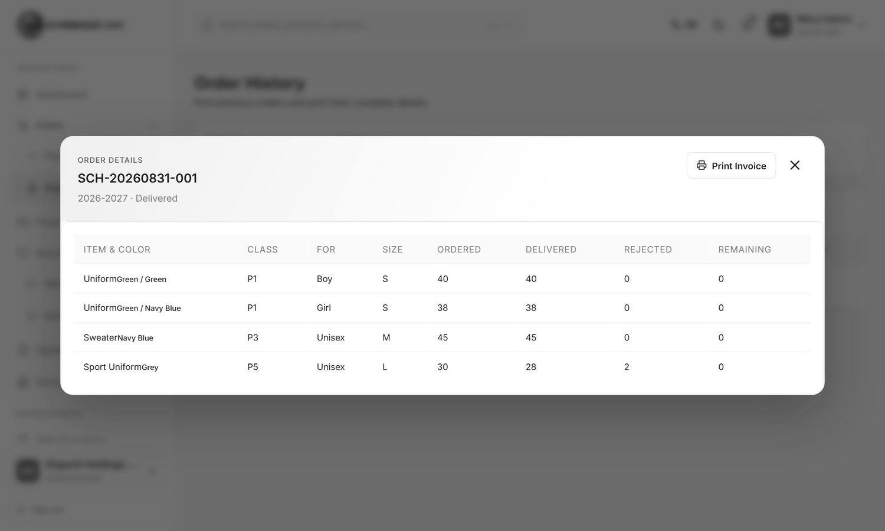
Figure 13. An order opened from the history
Status | Meaning
Pending | The factory has not reviewed the order yet.
Accepted | The factory accepted the order. It is being prepared.
Partially delivered | Some garments were delivered, some are still to come.
Delivered | Everything was delivered.
Rejected | The factory refused the order.

Note The "Print Invoice" button prints the order details with the quantities and the total price. The official invoice file, if the factory has uploaded one, is a separate document made by the finance team.

7. Financial records
Menu, Financial Records. This page shows every order and the money.
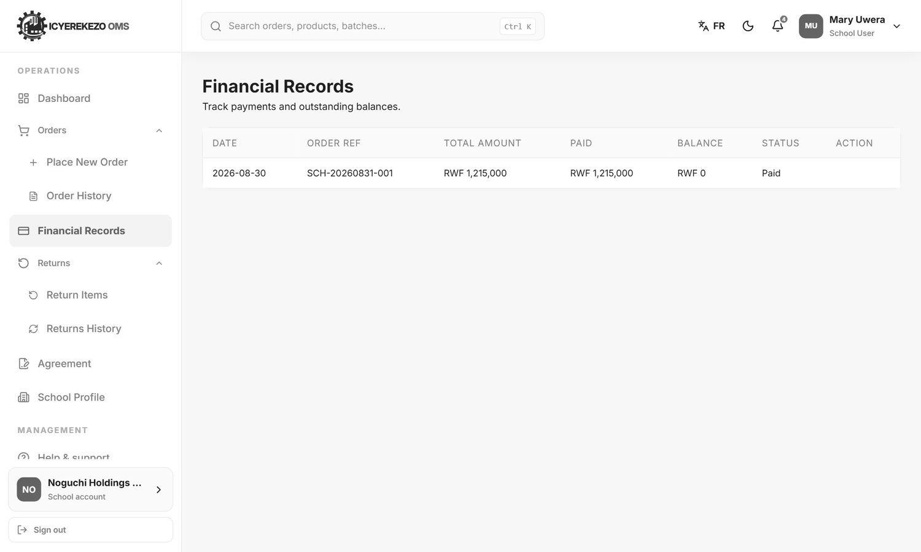
Figure 14. Financial records
Column | Meaning
Date | The order date.
Order Ref | The order number.
Total Amount | The value of the order.
Paid | The amount the factory has confirmed.
Balance | Total minus paid.
Status | Paid, Partial or Unpaid.
Action | The Submit payment button when something is still owed.

8. Send a proof of payment
The portal does not take money. You pay the factory by bank transfer, mobile money (MoMo Pay), cheque or a cash deposit, and then you send the proof so the finance team can check it.
- Pay the amount.
- Menu, Financial Records. Click Submit payment on the order you paid.
- The window shows the order total, what you have already paid and the outstanding balance.
- Type the Amount Paid (RWF). It cannot be more than the balance (including payments that are still waiting for approval).
- Choose the Payment Method: Bank Transfer, MoMo Pay, Cheque or Cash Deposit.
- Type the Transaction / Reference Number from the bank, MoMo or cheque.
- Choose the Payment Date. It cannot be in the future.
- Click the upload box and choose the payment slip or screenshot (PDF, JPG or PNG, up to 5 MB).
- Click Submit for Verification. The portal says "Payment proof submitted for verification."

Figure 15. Submit payment proof

8.1 What the factory does with it
- The financial manager at Noguchi opens your proof and checks the amount and the reference.
- If it is correct, the manager approves it. The amount is added to your order and the balance and status change.
- If it is not correct, the manager rejects it with a note.

Warning The portal does not show you whether a proof is still waiting or was rejected. It only shows the confirmed amount. If your balance has not changed after a few working days, call or write to Noguchi finance and give the reference number.

9. Return items
You can ask to return garments that were delivered, for example because they are the wrong size.
- Menu, Returns, Return Items.
- Choose the Delivered order. Only orders with delivered garments are listed.
- For each garment line the table shows the class, the item, the size, how many were Delivered, how many were Already returned and how many are Available to return.
- Type the Return Qty you want to send back (not more than Available) and choose the Reason: Too Small, Too Large, Damaged, Wrong Item or Other.
- Click Review Return Request. Check the list and click Confirm & Submit.
- The portal says "Your return request was sent to the factory." and opens Returns History.

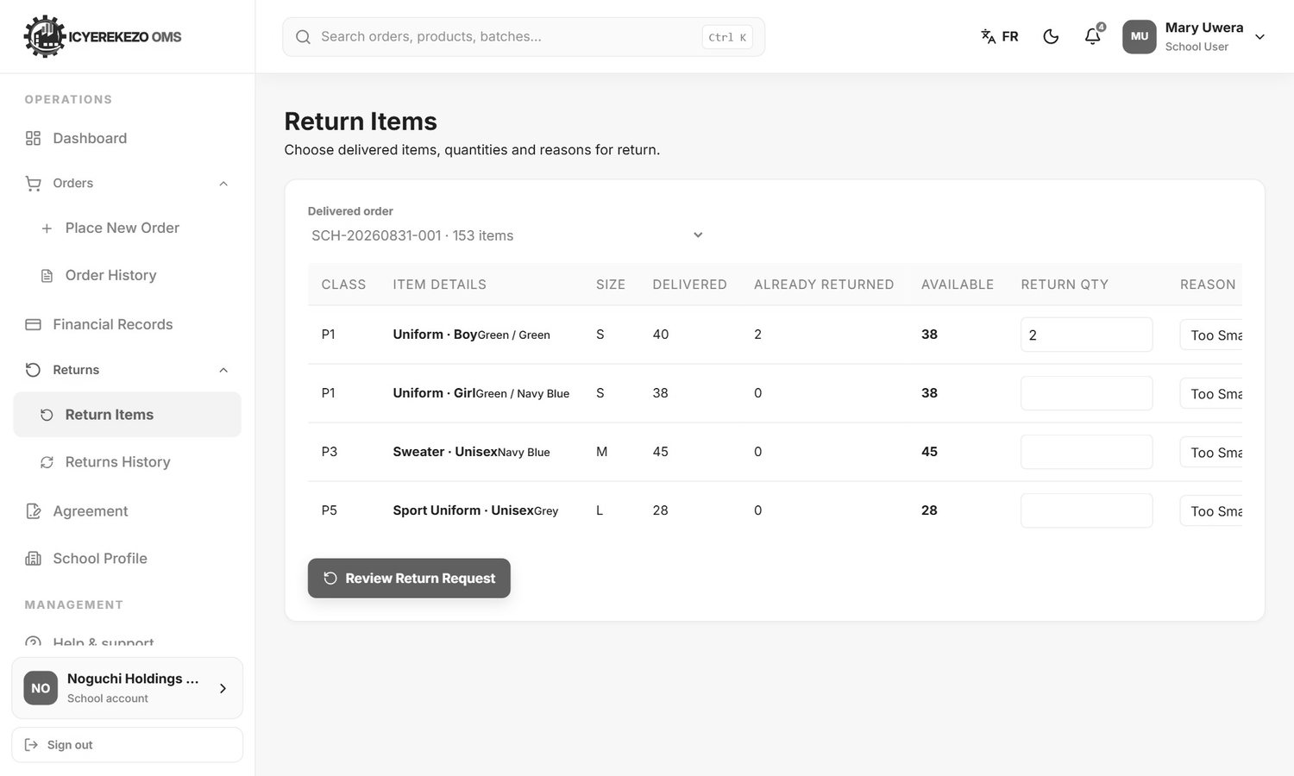
Figure 16. Choose the quantity and the reason
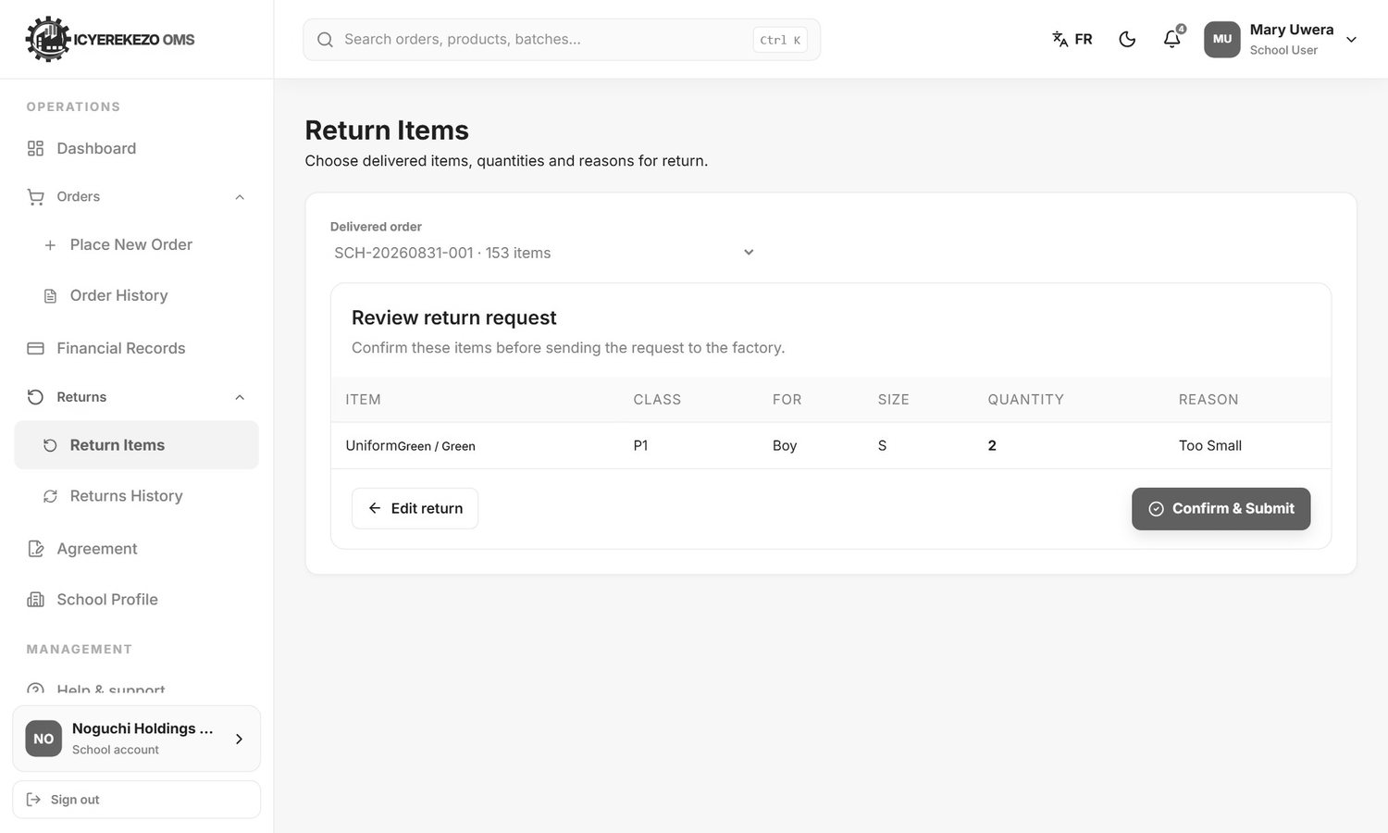
Figure 17. Review the return request

9.1 Returns history
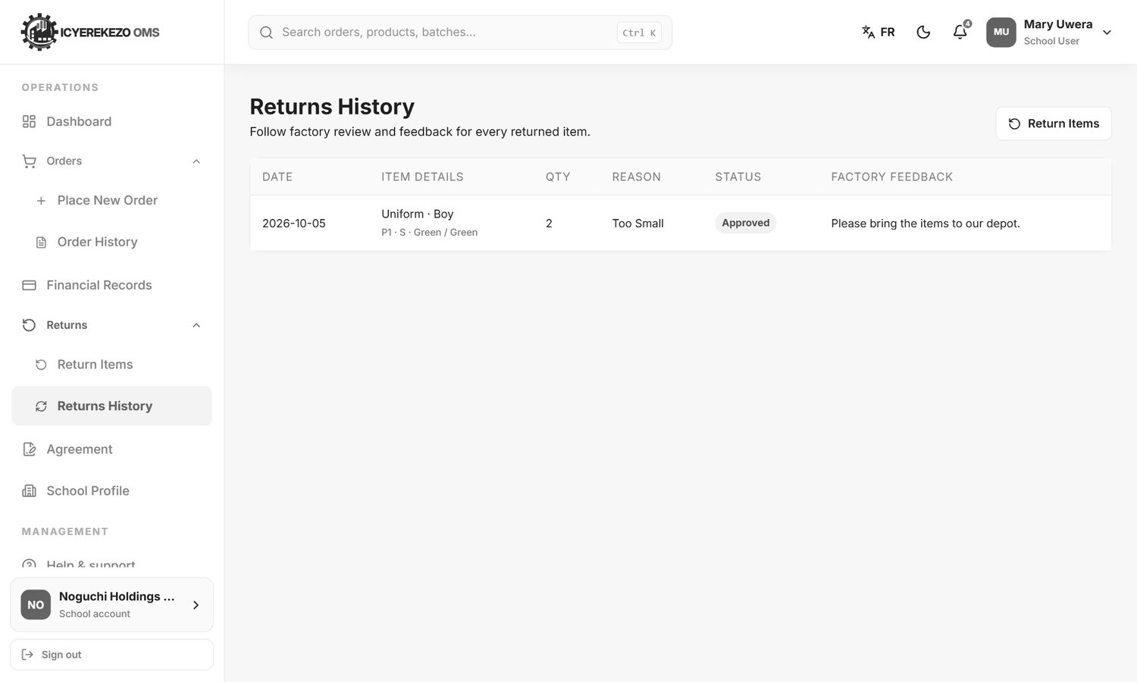
Figure 18. Returns history
The table shows the date, the item details, the quantity, the reason, the status and the Factory Feedback. A request that nobody has answered shows "Waiting for factory review".
Warning At the moment the factory side of the system has no screen to answer a return request. Your request is saved, but it will keep showing "Waiting for factory review" until the factory handles it in another way. Always also call or write to your Noguchi contact when you send a return request.

10. The supply agreement
Noguchi asks every school to sign a supply agreement. Menu, Agreement.
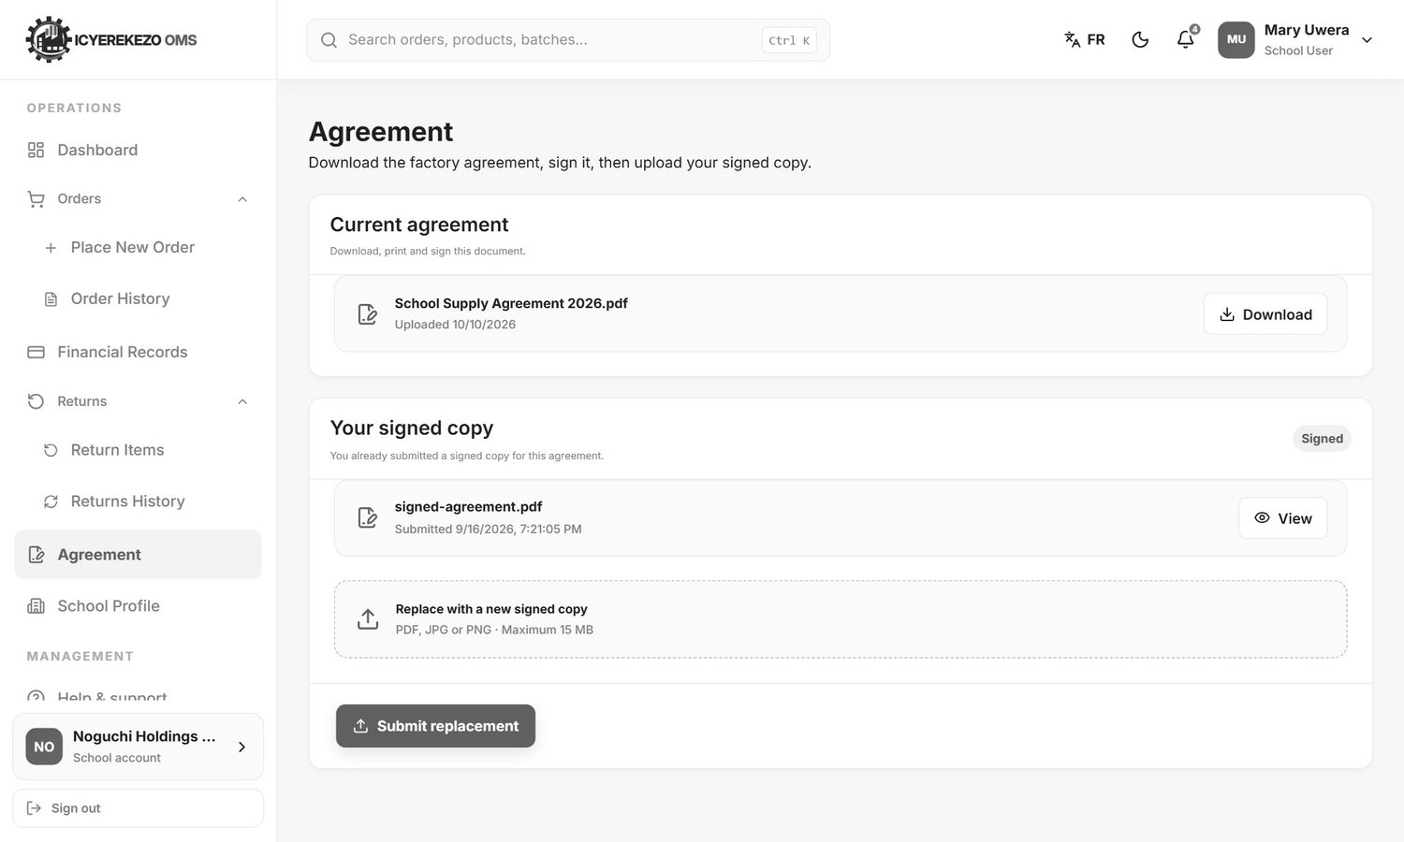
Figure 19. Agreement
- Under Current agreement click Download. Print the document.
- Sign it and stamp it as your school requires.
- Make a scan or a clear photo (PDF, JPG or PNG, up to 15 MB).
- Under Your signed copy click the upload box and choose the file.
- Click Submit signed agreement. The portal says "Signed agreement submitted." A Signed label appears.

If you need to replace the file, upload a new one with Submit replacement. If the page says "No agreement has been uploaded by the factory yet", come back later.

11. School profile
Menu, School Profile. Keep these details correct so that orders and deliveries reach your school.
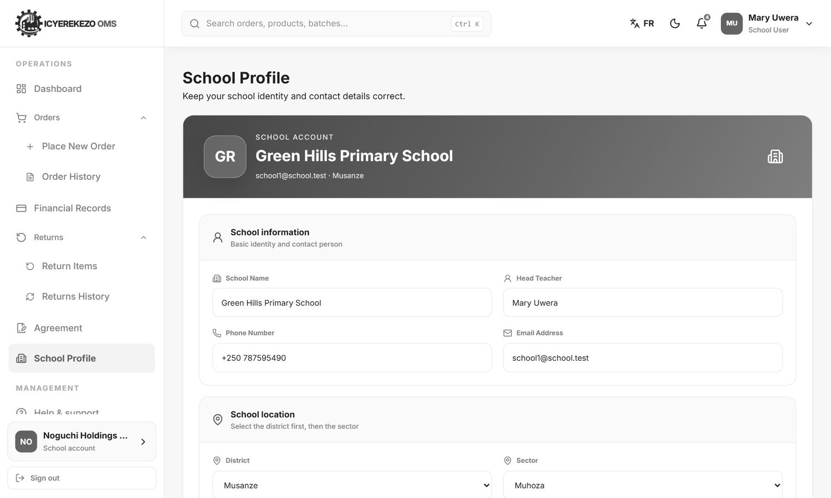
Figure 20. School profile
Field | Notes
School Name | The official school name.
Head Teacher | The contact person.
Phone Number | A number the logistics team can call.
Email Address | Order messages are sent to this address. Use an email that the school reads.
District and Sector | Choose the district first, then the sector.

Click Save Profile. The portal says "School profile updated."
Note The email on the school profile is not the same as the email you sign in with. Order messages go to the school profile email.

12. Messages and help
- Bell. Shows announcements from the system administrator.
- Email. You receive an email when an order is placed and every time its status changes.
- Help & support. Menu, Help & support opens a private chat with the support team. Write your question and press Enter. The answer appears in the same chat.
- Language and look. Use FR / EN and the moon button at the top.

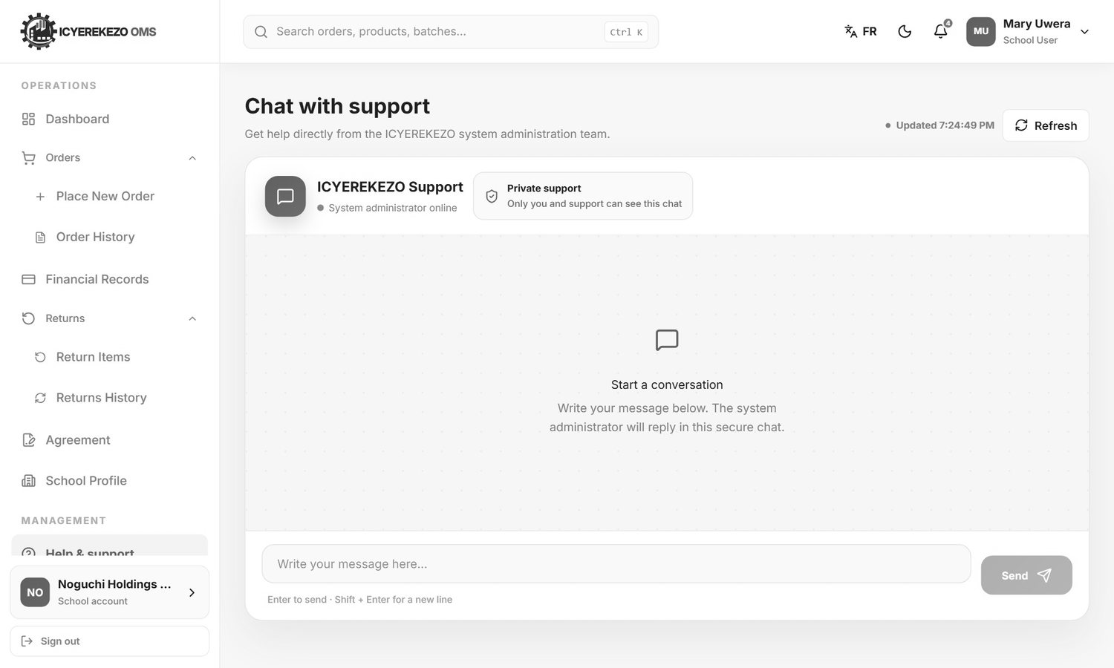
Figure 21. Help and support

13. Questions and answers
Question | Answer
I cannot find T-shirts or Overalls for my class. | T-shirts are only for S1 to S6. Overalls and Overall Coats are only for S4 to S6.
The portal says my school already has an active order. | Only one active order per academic year is allowed. Choose another year, or ask Noguchi to reject the old order.
I made a mistake in my order. | You cannot edit an order. Call Noguchi. They can reject it so you can place a corrected one.
The total does not include my sport wear. | Sport wear is not priced in the portal. The factory will price it on the invoice.
The amount I want to pay is refused. | It is more than the balance. The balance includes proofs that are still waiting for approval. Check the Financial Records page.
My payment is not shown. | The factory has not approved it yet, or it was rejected. Contact Noguchi finance with your reference number.
I do not see my delivered order in Return Items. | Only orders with delivered garments that have not all been returned are listed.
I did not get an email. | Check the spam folder and check the email on the School Profile page.
I cannot sign in on the school page with my factory login. | The school page is only for school accounts. Factory staff sign in on the main page.
I forgot my password. | Use Forgot password? on the sign in page.

