OFFSHORE WIND ENERGY
MBA Industry Primer | Energy & Infrastructure
Columbia Business School | April 2026

INDUSTRY AT A GLANCE
Offshore wind is the largest-scale renewable energy technology in the world — turbines taller than the Eiffel Tower, planted in the ocean, generating electricity with capacity factors far exceeding onshore wind or solar. For MBA candidates, offshore wind sits at the intersection of infrastructure finance, industrial policy, maritime logistics, and geopolitical competition in ways that distinguish it sharply from its onshore cousin. Understanding it means understanding why Europe has dominated for 30 years, why China added more capacity than the rest of the world combined, why the U.S. industry nearly collapsed in 2023–2024 before stabilizing, and why floating wind technology could unlock markets covering 80% of the world's coastlines.

Key Metric | Data Point (2025)
Global Offshore Installed Capacity (End 2025) | 84.5 GW operational; China 42.3 GW (50%+); Europe 36 GW (44%); rest of world ~6 GW
New Capacity Installed (2025) | 6 GW (6,019 MW) — below 2024's 11.1 GW; reflects project delays, cost resets, and U.S. policy disruption
Under Construction (End 2025) | 33.3 GW globally — strong foundation for accelerated 2026–2030 deployment
Offshore Wind Market Size (2025) | ~$64–77B (consensus range); projected $123–145B by 2033–2035 (CAGR ~12%)
Turbine Technology (2025) | Largest commercial turbines: 15–18 MW; 26 MW turbines entering prototype stage; 67% of 2025 installs were >13 MW turbines
Floating Offshore Wind | $1.7B market (2025); projected $18B by 2030 (CAGR 60%); unlocks depths >60m — 80% of world's offshore resource
Trump Executive Order (Jan 20, 2025) | Halted leasing and construction on all U.S. federal offshore wind projects; 5.8 GW of projects paused; cost to U.S. industry: billions in sunk costs
Europe: Record Auction Volumes | 56 GW awarded in competitive auctions globally in 2024 — all-time record; Europe leading with UK, Germany, Netherlands, Denmark
Installation Vessel Bottleneck | Fewer than 15 WTIV-class vessels can install 15+ MW turbines; Heerema, Van Oord, Seaway7 lead; vessel orderbook filling through 2030
Key Developers | Ørsted (#1 global), Vattenfall, RWE, Equinor, BP, Shell, Iberdrola, SSE Renewables, Ocean Winds

HISTORY & ORIGINS
Offshore wind began as an engineering experiment in Danish waters. Vindeby, installed in 1991 off the coast of Denmark, was the world's first offshore wind farm — 11 Bonus Energy turbines, each just 450 kW, in water so shallow fishermen initially opposed it as a navigational hazard. The technology looked nothing like what would follow. But the principle — that wind over water is stronger, more consistent, and less turbulent than over land — was validated immediately. The industry's entire subsequent development has been about one thing: capturing ever-more-powerful ocean winds economically.
1991–2010: The European Proving Ground. For two decades, offshore wind was an almost exclusively European enterprise. Denmark, the Netherlands, the UK, and Germany drove development through feed-in tariffs and renewable portfolio standards. Projects moved progressively into deeper water and further from shore. Turbine sizes grew from sub-1 MW to 3–5 MW. Vestas, Siemens (later Siemens Gamesa), and GE emerged as the dominant OEMs. The UK's Horns Rev projects (2002, 2009) and the London Array (2013, then the world's largest at 630 MW) established offshore wind as a serious utility-scale technology.
2010–2020: Scale-Up and Cost Reduction. The decade was defined by a 70%+ reduction in offshore wind's levelized cost of energy — from $250+/MWh to below $100/MWh — driven by larger turbines (3 MW → 12 MW), improved installation techniques, and serial project development building contractor expertise. UK Contract for Difference (CfD) auctions established competitive procurement as the standard model. The U.S. passed the Outer Continental Shelf (OCS) leasing framework; the first U.S. commercial offshore wind farm, Vineyard Wind (800 MW), received its construction permit in 2021. China quietly began building massive capacity.
2021–2023: Cost Crisis and Project Cancellations. The post-pandemic inflationary shock — steel prices up 40%, supply chain disruptions, rising interest rates — broke the economics of many offshore wind projects signed at pre-inflation prices. Ørsted cancelled Atlantis Wind and wrote down $4B. Equinor and BP cancelled their Empire Wind and Beacon Wind projects in New York. Siemens Gamesa reported billions in losses from onshore and offshore turbine quality issues. The EU and U.S. faced a brutal reckoning between ambition and economics.
2024–2026: Stabilization, Records, and the U.S. Policy Shock. Global auctions reached 56 GW in 2024 — a record — signaling renewed confidence at higher clearing prices. Europe led with the UK, Germany, Netherlands, Denmark, and France all conducting successful CfD or tender rounds. China continued its extraordinary buildout. Turbines reached 15–18 MW commercially (GE Vernova Haliade-X, Vestas V236, Siemens Gamesa SG 14-236). Then: Trump's January 20, 2025 Executive Order halted all U.S. federal offshore wind activity — stopping construction on five projects representing nearly 5.8 GW and sending developers scrambling to assess legal options and sunk costs.

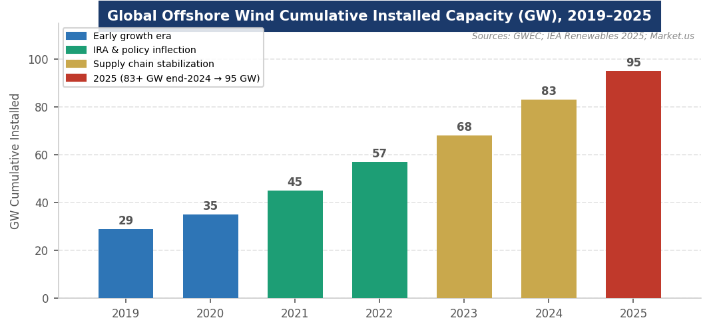
Figure 1. Global offshore wind cumulative installed capacity (GW), 2019–2025. Sources: GWEC; Westwood Global Energy; Wind Europe.
MARKET STRUCTURE & VALUE CHAIN
Offshore wind has a more concentrated and specialized value chain than onshore wind or solar, driven by the extreme technical demands of installing massive structures in corrosive marine environments. The installation vessel bottleneck is the most acute near-term constraint globally.
The Offshore Wind Value Chain (Upstream → Downstream)
1. Development & Permitting | Lease/license award, environmental impact assessment, grid connection agreement, PPA or CfD procurement. 5–10 year development timeline in most markets. BOEM (U.S.), Crown Estate (UK), and national regulators control seabed rights. Currently the primary bottleneck in U.S. under Trump EO halt.
2. Turbine Manufacturing | 3–6 MW (legacy) to 15–18 MW (current generation) turbines. OEMs: Siemens Gamesa (SGRE), Vestas, GE Vernova (Haliade-X), MHI Vestas. Chinese: Mingyang, Windey (dominant in China, expanding globally). Nacelle, blades (50–120m), and tower manufactured separately and assembled offshore.
3. Foundations & Substructures | Monopiles (steel cylinders driven into seabed, <50m water depth — dominant), jackets (lattice structures, 30–80m), and gravity-base foundations. Floating platforms for >60m: spar-buoy, semi-submersible, tension-leg. Key manufacturers: EEW, Sif, Steelwind Nordenham.
4. Array Cables | Intra-array cables connecting turbines to offshore substation. 33kV or 66kV. Prysmian (Italy), Nexans (France), NKT (Denmark), LS Cable (Korea) dominate. Cable manufacturing capacity is a secondary bottleneck behind vessels.
5. Offshore Substation & Export Cable | High-voltage offshore substation steps up voltage for transmission. HVDC (High-Voltage Direct Current) links increasingly used for distances >60 km or interconnection. ABB, Siemens, GE Vernova supply substations. Prysmian, Nexans, XLCC (UK) supply HVDC cables.
6. Installation Vessels (WTIV) | Wind Turbine Installation Vessels (WTIVs) are the single most acute global bottleneck. Fewer than 15 vessels can install 15+ MW turbines. 36+ months lead time for new WTIVs. Key operators: Heerema, Van Oord, DEME (Seaway7), Cadeler, Eneti. U.S. Jones Act limits foreign-flagged vessels in U.S. waters.
7. O&M (Operations & Maintenance) | Offshore O&M is significantly more complex and costly than onshore — crews transported by crew transfer vessels (CTVs) or helicopters; turbine access in seas up to 3m swell; remote monitoring. OEM LTSA contracts (10–15 years) and independent O&M providers. AI/drone inspection reducing costs.

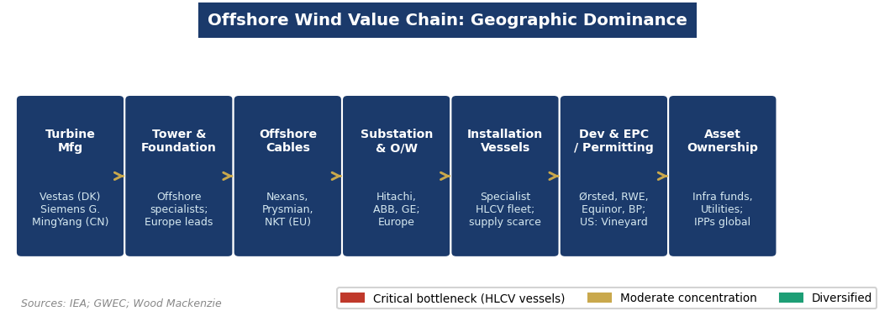
Figure 2. Offshore wind value chain geographic dominance. Sources: GWEC; BloombergNEF; Wood Mackenzie.
Three market segments define offshore wind:
- Fixed-Bottom Offshore Wind (>95% of installed capacity): Monopile and jacket foundations in water depths up to 50–60 meters. The mature, commercially proven segment. Average project size: 500 MW–1+ GW. Average cost: $80–130/MWh in Europe (post-inflation reset); $120–160/MWh in the U.S. Key markets: UK, Germany, Denmark, Netherlands, China, Taiwan, South Korea.
- Floating Offshore Wind (<5% of capacity, highest growth): Semi-submersible, spar-buoy, or tension-leg platforms for depths >60 meters. Unlocks the vast majority of the world's offshore wind resource (including U.S. West Coast, Japan, Norway, Mediterranean). First commercial-scale projects: Hywind Scotland (Equinor, 30 MW, 2017); Kincardine (BlueFloat, 50 MW, 2021). First GW-scale projects expected 2028–2030. Cost still ~$200+/MWh but learning curve rapid.
- Hybrid Wind + Hydrogen: Offshore wind co-located with electrolyzers — either on floating platforms or onshore — converting wind electricity to green hydrogen. Danish and Norwegian developers (Ørsted, Equinor, RWE) are leading concept development. The first commercial offshore wind-to-hydrogen projects are expected in the 2027–2030 timeframe, enabled by the IRA's 45V hydrogen PTC.

KEY PLAYERS & COMPETITIVE LANDSCAPE
Turbine OEMs
Company | HQ | Key Position
Siemens Gamesa (SGRE) | Spain/Germany (Siemens Energy) | SG 14-236 DD (14 MW); SG 11.0-200 DD; struggled with quality and profitability 2022–2024; restructuring under Siemens Energy ownership; still dominant European installed base
Vestas | Denmark | V236-15.0 MW (world's largest commercially available in 2025); V174-9.5 MW for U.S. market; offshore business merged with MHI Vestas (now wholly Vestas-owned); strongest track record in European markets
GE Vernova | USA | Haliade-X: 13–14+ MW, the flagship U.S. offshore turbine; installed at Vineyard Wind (U.S.), Dogger Bank (UK); NYSE: GEV; spinning off from GE 2023; key supplier for U.S. East Coast projects that survive Trump EO
Mingyang Smart Energy | China | MY 16.0-242, MY 18.X; world's largest turbines by nameplate; primarily China market; aggressive international expansion including Europe; 26 MW turbines in prototype stage — the next frontier
CSSC Haizhuang / DEC | China | Major Chinese OEM players serving China domestic market; combined with Mingyang and Goldwind serve 95%+ of China offshore installations; rapid turbine size escalation

Developers & Utilities
Company | Role / Notes
Ørsted | Danish state-backed; world's largest offshore wind developer; ~14 GW operational; cancelled U.S. projects (2023) after $4B writedown; refocused on European markets; Hornsea 1/2/3 are flagship UK projects
Vattenfall | Swedish state-owned; major European offshore developer; Norfolk Vanguard/Boreas (UK); cancelled Aberdeenshire onshore and paused some UK offshore on cost grounds 2023; active in Netherlands, Denmark
RWE | German utility; major offshore wind portfolio in UK and Germany; Dogger Bank partner; expanding in U.S. (pre-EO halt) and Asia-Pacific; €55B green investment plan through 2030
Equinor | Norwegian NOC; Hywind floating pioneer; Empire Wind (NY, halted by Trump EO); Sheringham Shoal, Dudgeon (UK); offshore wind as core Net Zero strategy alongside oil & gas
Iberdrola (Avangrid in US) | Spanish utility; Baltic Eagle (Germany); Saint Brieuc (France); Vineyard Wind partner (U.S., under construction pre-EO halt); East Anglia Hub (UK); global scale
SSE Renewables / ScottishPower | UK developer; Seagreen (Scotland, 1.1 GW); East Anglia Three; Hornsea JV partner; integral to UK CfD program
China Three Gorges / CNOOC | Chinese state-owned developers dominating China domestic market; 3.5+ GW built in China 2024 alone; limited international presence but growing

Financial Sponsors
Offshore wind attracts a distinctive capital mix. Infrastructure funds (Copenhagen Infrastructure Partners — world's largest offshore wind investor, Brookfield, Macquarie, Global Infrastructure Partners) provide equity for operating assets. Green bonds and project bonds (backed by CfD or PPA revenue) finance individual projects. The European Investment Bank (EIB), UK Green Investment Bank (now part of Macquarie), and bilateral development banks provide concessional capital for first-of-a-kind technologies (floating wind). Corporate PPAs from tech companies (Microsoft, Google) are an emerging offshore wind revenue mechanism, particularly in the UK and Ireland. Typical unlevered IRR for offshore wind (post-reset): 10–13%.

ANATOMY OF AN OFFSHORE WIND FARM
An offshore wind farm is one of the most complex engineering projects in the energy sector — combining civil marine engineering, electrical transmission, heavy-lift logistics, and precision manufacturing in one of the harshest environments on Earth.

Component | Key Specs | Strategic Significance
Monopile Foundation | Steel tubular pile; 8–12m diameter; 60–120m length; driven into seabed | Largest single-piece steel structure in most wind projects. Pile diameter increasing with turbine size. EEW, Sif, and Steelwind Nordenham are primary European manufacturers. U.S. building domestic supply (EEW Paulsboro, NJ).
Transition Piece | Connects monopile to tower; houses boat landing, cable entry | Enables installation of tower sections above water. Grouted or bolted connection. Several Siemens Gamesa blade failures 2022–2024 traced partly to transition piece interface issues.
Tower (3–5 sections) | Steel; 80–120m above waterline; 500–1,000 tonnes | Manufactured in sections for transport. Increasingly built close to installation sites to reduce logistics. Smulders, Welcon, CS Wind are key manufacturers.
Nacelle | Houses gearbox (or direct-drive generator), main shaft, cooling systems | The most technologically complex component. Direct-drive (no gearbox, fewer moving parts) vs. geared configurations. Direct-drive preferred offshore (Siemens, GE Haliade-X). Weight: 300–700 tonnes.
Rotor & Blades | Blade length 80–120m; carbon/glass fiber composite; hub includes pitch control | Longest component — requires specialized Heavy Lift Vessels. Blade failure and cracking became a major quality issue for Siemens Gamesa. LM Wind Power (GE) and SGRE self-supply blades.
Array Cable System | 33kV or 66kV inter-array cables; buried in seabed | Connects turbines to offshore substation. 66kV systems reduce cable losses and number of cables per array. Burial protects from anchors and bottom trawling.
Offshore Substation (OSS) | Transformer platform; steps up to 132–400kV; HVAC or HVDC | Topside structure installed on separate jacket foundation. Combined weight 3,000–8,000 tonnes. HVDC increasingly preferred for projects >60 km offshore due to reactive power losses of HVAC.

How it works: Wind turns the rotor blades, converting kinetic energy to mechanical rotation. The main shaft drives either a gearbox (stepping up rotation speed) or a direct-drive generator. The generator produces AC electricity, stepped up by a transformer in the nacelle and transmitted down the tower and through the monopile to the intra-array cable. Array cables collect power from multiple turbines and deliver it to the offshore substation, which steps voltage up further for efficient long-distance transmission to shore via the export cable. Capacity factors: 40–50% for fixed-bottom projects in good wind regimes (North Sea) — significantly higher than solar (~25%) or onshore wind (~35%).
GLOBAL GEOGRAPHY & COUNTRY LEADERS
China: The world's largest offshore wind market, having surpassed Europe in 2022. China added ~4–5 GW annually through 2024 and had ~42 GW operational by end-2025. China's offshore wind industry is state-driven: subsidized by provincial and national government, executed by state-owned developers (Three Gorges, CNOOC, Guodian), and supplied by Chinese OEMs (Mingyang, CSSC Haizhuang, DEC) operating at scales that drive global cost benchmarks. Chinese turbines now routinely exceed 16 MW; 18+ MW units are commercially available. The Chinese model will not be replicated elsewhere — but it sets the price reference that Western developers cannot ignore.
United Kingdom: Europe's largest offshore wind market and the global technology leader. The UK had ~16 GW installed by end-2025 and targets 50 GW by 2030. The Contract for Difference (CfD) mechanism — a reverse auction providing a guaranteed price for 15 years — is the model the world has adopted. Hornsea 1 (1.2 GW), Hornsea 2 (1.4 GW), and Hornsea 3 (under construction, 2.9 GW) are the world's largest operational and under-construction offshore wind projects. Dogger Bank (3.6 GW, GE Haliade-X turbines) will be the world's largest when complete. GB Energy (new government entity) launched its first floating wind investment in November 2025.
Germany, Netherlands, Denmark: The other European pillars. Germany targets 30 GW by 2030 (from ~9 GW in 2025), running large annual CfD auctions. The Netherlands (Hollandse Kust projects, now targeting 21 GW by 2031) has pioneered zero-subsidy offshore wind auctions. Denmark (Ørsted's home market) leads in project development expertise and turbine technology. The Baltic Sea is emerging as a major new offshore wind region — Poland, Sweden, and the Baltic states all have active development pipelines.
United States: The world's most dramatic policy reversal in offshore wind history. The Biden administration had targeted 30 GW by 2030 and approved dozens of leases and construction permits. Trump's January 20, 2025 EO halted all federal offshore wind activity — stopping construction, suspending leasing, and triggering reviews of all permits. Five projects representing 5.8 GW were directly halted. Legal challenges are ongoing. State-level commitments (NY, MA, NJ, CT, RI) remain in place, but without federal cooperation, U.S. offshore wind faces years of uncertainty.
Emerging Markets: Taiwan (target: 20 GW by 2035; Ørsted, RWE, Iberdrola active), South Korea (14.3 GW proposed under 2025 OSS Act), Japan (10 GW by 2030 target; Equinor, RWE, Marubeni active), and Vietnam are the most advanced developing offshore wind markets. Australia is emerging, as are Saudi Arabia (NEOM floating wind concept) and India (30 GW by 2030 ambition).
POLITICS, POLICY & REGULATION
Offshore wind is the energy sector most dependent on government policy for its economics — CfD contracts, seabed leasing rights, Jones Act waivers, port infrastructure investment, and grid connection agreements are all government decisions that determine whether projects are viable. This makes it uniquely sensitive to political change, as the U.S. in 2025 demonstrated catastrophically.

Key Policy Levers MBA Candidates Must Know
Policy / Lever | What It Means for Offshore Wind
Trump Executive Order (Jan 20, 2025) | Halted all federal offshore wind leasing and construction permits. Five U.S. projects totaling 5.8 GW stopped mid-construction. Legal challenges by states and developers ongoing. The most significant policy reversal in U.S. clean energy history.
UK Contract for Difference (CfD) | 15-year guaranteed price for offshore wind generation. Reverse auction (developers bid the lowest price they need). AR6 (Allocation Round 6, 2024) cleared 5 GW at strike prices of £80–95/MWh — the most successful UK CfD round. The global model for offshore wind procurement.
EU Offshore Wind Strategy | Target: 60 GW by 2030; 300 GW by 2050 (EU Wind Power Package). Key mechanisms: Contract for Difference (Germany), Tender systems (Netherlands, France, Denmark), maritime spatial planning coordination. EU Emergency Wind Regulation (2022) fast-tracked permits.
Jones Act (Vessels of the United States Act) | Requires U.S.-flagged vessels for transport between U.S. ports. No U.S.-flagged heavy-lift WTIV exists as of 2026. The Jones Act requires offshore wind projects to use complex workarounds for vessel logistics — a permanent structural cost disadvantage for U.S. offshore wind.
BOEM (Bureau of Ocean Energy Management) | U.S. federal agency controlling Outer Continental Shelf leasing. Under Trump EO, BOEM suspended all offshore wind activity. Legal jurisdiction over 85% of potential U.S. offshore wind resources.
State Procurement (U.S.) | New York (9 GW by 2035), Massachusetts (8.4 GW), New Jersey (11 GW), Connecticut, Rhode Island all have state-level offshore wind procurement programs and port investment commitments that survive the federal EO.
IRA Section 48C (Manufacturing) | Advanced Energy Project credit for domestic offshore wind manufacturing (monopiles, turbines, blades). Survives OBBBA largely intact. Key incentive for U.S. supply chain buildout — EEW Paulsboro (NJ), CS Wind (Virginia) are beneficiaries.

INDUSTRY TRENDS & TECHNOLOGY INNOVATION
Trend 1: Turbine Size Arms Race: 15 MW → 26 MW Turbine Size Arms Race: 15 MW → 26 MW
The offshore wind industry is in an unprecedented turbine size escalation. GE Vernova's Haliade-X (13–14 MW) and Vestas V236-15.0 MW are the current commercial standard. Siemens Gamesa's SG 14-236 and new 21 MW models are entering commissioning. Mingyang announced a 26 MW turbine prototype in 2025 — the scale of which would have seemed science fiction five years ago. Larger turbines reduce the number of installations required, lowering vessel time and installation cost per MWh. The tradeoff: larger turbines require specialized vessels, longer blades (harder to transport), and more robust foundations. The blade failure issues at Siemens Gamesa 2022–2024 are a cautionary note on pushing size ahead of quality.
Trend 2: Floating Wind: From Pilot to Commercial Scale Floating Wind: From Pilot to Commercial Scale
Floating offshore wind is the technology that unlocks the other 80% of the world's offshore resource — everything deeper than 60 meters, including the U.S. West Coast, Japan, Norway's deep waters, and the Mediterranean. The global floating wind market was $1.7B in 2025 and is projected at $18B by 2030 (CAGR 60%). GB Energy's first investment (Pentland Floating Wind, November 2025), Norway's Trollvind project, and South Korea's proposed floating wind arrays represent the commercial-scale pipeline. The key challenge: floating turbines cost ~$200+/MWh today vs. $80–130/MWh for fixed-bottom — learning curve investment is needed to close the gap.
Trend 3: Installation Vessel Bottleneck: The Critical Path Installation Vessel Bottleneck: The Critical Path
Fewer than 15 Wind Turbine Installation Vessels (WTIVs) in the global fleet can install 15+ MW turbines. Building a new WTIV takes 36–48 months and costs $500M–$1B. The orderbook is filling rapidly — Cadeler, Eneti, Heerema, and Van Oord have all ordered new vessels, but demand is outpacing supply through at least 2028. In the U.S., the Jones Act prohibits foreign-flagged vessels from working between U.S. ports — meaning even as global WTIV supply grows, U.S. projects must use complex logistics workarounds that add significant cost. Dominion Energy's Charybdis is the only Jones Act-compliant WTIV, commissioned 2023.
Trend 4: Offshore Grid and HVDC Supercables Offshore Grid and HVDC Supercables
As offshore wind farms move further from shore and grow larger, the case for HVDC (High-Voltage Direct Current) transmission becomes overwhelming. HVDC loses only 3% per 1,000 km vs. 5–8% for HVAC. Europe is developing an "offshore grid" concept — meshed HVDC cables connecting wind farms across the North Sea, Baltic, and beyond, enabling cross-border electricity trading and resilience. The North Sea Grid, Celtic Interconnector, and Baltic offshore grid proposals represent multi-billion-dollar infrastructure investments that will shape European electricity markets for decades. ABB and Siemens Energy (Hitachi Energy) are the primary HVDC technology suppliers.
Trend 5: Repowering and Life Extension Repowering and Life Extension
The first generation of offshore wind farms (built early 2000s–2010s) is approaching the end of their designed 20–25 year operational lives. Repowering — replacing older, smaller turbines with larger modern ones on existing seabed sites, using existing grid connections — offers a faster, lower-risk path to capacity expansion than greenfield development. Horns Rev 1 (Denmark, 80 MW, 2002) was the first major repowering candidate. Repowering economics are attractive: existing permits, foundations potentially reusable, grid connection established. The repowering wave could add 5–10 GW of European capacity through the early 2030s.
Trend 6: Wind + Hydrogen: The Co-Location Opportunity Wind + Hydrogen: The Co-Location Opportunity
Offshore wind's high capacity factors (40–50%) and falling costs make it the lowest-cost renewable input for green hydrogen production in many markets. The concept of co-locating electrolyzers with offshore wind — either on an offshore platform or onshore near the cable landing point — is attracting significant interest. Denmark's Viking Link and the North Sea Wind Power Hub concept both envision offshore wind feeding large-scale electrolyzers for hydrogen export to Germany and other industrial consumers. The IRA's Section 45V hydrogen PTC ($3/kg) makes offshore wind-to-hydrogen economically compelling in the U.S. if the political environment recovers.

CURRENT NEWS & MARKET DYNAMICS (2025–2026)
Headlines Every Candidate Should Know
- Trump Executive Order Halts U.S. Offshore Wind (January 20, 2025): Trump Executive Order Halts U.S. Offshore Wind (January 20, 2025): Trump's Day-1 EO suspended all federal offshore wind leasing and construction permits. Vineyard Wind (800 MW, under construction), New England Wind (2.1 GW), and three other projects totaling 5.8 GW were stopped. Developers (Equinor, Avangrid, SouthCoast Wind) filed legal challenges. The order was the single largest setback to U.S. offshore wind in the industry's history.
- Global Installations Slow in 2025 (6 GW vs. 11.1 GW in 2024): Global Installations Slow in 2025 (6 GW vs. 11.1 GW in 2024): Only 6 GW of offshore wind was installed globally in 2025 — significantly below 2024's record. The slowdown reflects U.S. project halts, ongoing supply chain rebalancing, and a pause in European project completions as the industry digests the 2022–2024 cost reset. However, 33.3 GW was under construction at year-end — signaling strong 2026–2030 pipeline.
- Record 56 GW in Auctions (2024): Record 56 GW in Auctions (2024): Despite project challenges, global competitive auctions awarded a record 56 GW in 2024. The UK's AR6 was the standout success: 5 GW awarded at strike prices that make projects viable at post-inflation economics. Germany, Netherlands, France, and South Korea all ran successful tenders. The auction success signals that the industry's economics are workable — at the right price.
- Floating Wind Milestones: Floating Wind Milestones: GB Energy announced its first investment in the Pentland Floating Wind project (November 2025). Norway awarded floating wind licenses under the Havvind framework. South Korea passed the OSS (Offshore Structure Support) Bill enabling EEZ floating wind development. Turbines above 13 MW now account for 67% of all installations, accelerating floating wind cost reduction.
- Siemens Gamesa Turbine Quality Crisis (2022–2025): Siemens Gamesa Turbine Quality Crisis (2022–2025): Siemens Gamesa disclosed blade cracking, nacelle component failures, and quality issues affecting multiple offshore projects — resulting in multi-billion-euro writedowns and production stoppages. The crisis cost SGRE and its parent Siemens Energy billions and set back European offshore wind expansion. Remediation is ongoing; quality processes overhauled under new leadership.
- China’s 26 MW Turbine Prototype: China's 26 MW Turbine Prototype: Mingyang Smart Energy unveiled a 26 MW offshore wind turbine prototype in 2025 — the world's largest by nameplate capacity, with 320-meter blade diameter. Intended for China domestic deep water projects. Signals China's intent to maintain OEM leadership and provides a reference point for next-generation turbine technology globally.

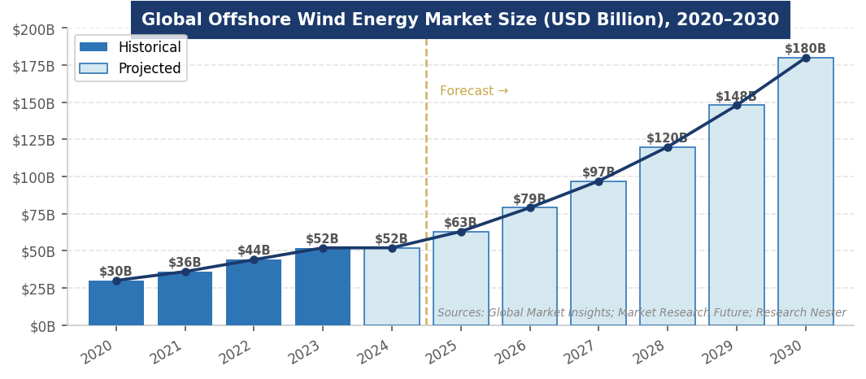
Figure 3. Global offshore wind cumulative capacity forecast (GW), 2020–2030. Sources: GWEC; Westwood Global Energy Group; GM Insights.
INVESTMENT, FINANCE & CAREER ANGLES
Offshore wind is one of the most capital-intensive and finance-intensive sectors in all of infrastructure — a single project can require $3–8 billion in project financing.

- Project Finance: Project Finance: Offshore wind uses non-recourse or limited-recourse project finance with CfD or PPA revenue anchoring the debt. Typical capital stack: 60–70% senior debt, 20–30% equity, 5–15% sub-debt or mezzanine. Lenders include EIB, KfW, Nordic Investment Bank, and major commercial banks (BNP Paribas, HSBC, Santander, DNB). Bond markets (green bonds) are increasingly used for refinancing. Key underwriting risks: construction (vessel availability, component supply), operational (turbine reliability, O&M cost), and revenue (merchant price exposure post-CfD expiry).
- Infrastructure Investing: Infrastructure Investing: Operating offshore wind assets offer long-duration, inflation-linked cash flows backed by CfD or PPA contracts. Copenhagen Infrastructure Partners, Macquarie, Brookfield, and Mirova are the most active infrastructure equity investors. Asset sales (secondary market) between developers and infrastructure funds are a primary liquidity mechanism. Typical unlevered IRR: 10–14% for operating UK/European assets (post-cost reset); 12–16% for development-stage assets.
- Corporate Strategy & Energy Procurement: Corporate Strategy & Energy Procurement: Major tech companies (Microsoft, Google) are signing offshore wind PPAs in the UK and Ireland. Offshore wind's 40–50% capacity factor makes it a more reliable source of clean energy than solar alone. Corporate offshore wind PPAs are typically structured as Virtual PPAs (VPPAs) — financial contracts that hedge electricity prices without physical delivery.
- Venture Capital & Growth Equity: Venture Capital & Growth Equity: Floating wind technology companies (Principle Power, SBM Offshore, Hexicon), offshore wind software (GIS site assessment, vessel scheduling optimization, predictive O&M), and supply chain companies (domestic monopile manufacturers, blade recycling) are active VC/PE areas. The U.S. domestic supply chain buildout under IRA Section 48C is creating investment opportunities in port infrastructure and component manufacturing.

Key financial concepts: Levelized Cost of Energy (LCOE), CfD strike price, capacity factor, capacity factor degradation (turbine aging), project finance waterfall, P50/P90 energy yield, wake effect losses, Yield Co structures, and VPPA (Virtual Power Purchase Agreement) structure.
FUTURE OUTLOOK
Offshore wind is in a genuine transition from niche technology to global utility-scale industry — but the pace of that transition is being shaped by three forces pulling in opposite directions: accelerating technology (larger turbines, floating wind), improving economics (post-inflation reset), and significant policy disruption (U.S. EO, European permitting delays). The IEA projects more than 350 GW of new capacity additions between 2025 and 2034.

- Base Case: Base Case: Global offshore wind reaches 220 GW by 2030 (from 84.5 GW in 2025). Europe adds 60+ GW; China adds 60+ GW; Asia-Pacific ex-China (Taiwan, South Korea, Japan, Vietnam) adds 15–25 GW. U.S. recovers slowly post-2026 through state-level programs and potential policy change. Floating wind reaches 2–5 GW globally by 2030.
- Bull Case: Bull Case: U.S. federal offshore wind policy reverses (post-2028 administration or court order); WTIV bottleneck relieved by new vessel deliveries; floating wind cost curve follows fixed-bottom trajectory; global capacity reaches 300+ GW by 2030. China scales to 20+ GW annual additions.
- Bear Case: Bear Case: Continued U.S. policy paralysis; turbine quality issues persist and deter institutional capital; European CfD auction prices remain too low for bankable returns; supply chain bottlenecks (vessels, cables, transformers) constrain delivery. Global capacity stuck at 150–180 GW by 2030.

The one certainty: offshore wind has more resource potential than any other renewable energy technology — the wind over the ocean is stronger, more consistent, and less contested than over land. The question is whether the supply chain, financing, and policy environment can match the ambition.
INTERVIEW CONVERSATION STARTERS
- "The U.S. offshore wind industry went from the world's most exciting growth story to a policy emergency in a single executive order — Day 1 of the Trump administration. Five projects, 5.8 GW, billions in sunk costs, all stopped. It's the single most dramatic demonstration of policy risk in clean energy, and it's why offshore wind project finance in the U.S. now requires a 50-page political risk analysis alongside the traditional technical and financial due diligence."
- "The installation vessel market is the most acute bottleneck in global offshore wind — and most people outside the industry don't know it exists. Fewer than 15 vessels in the world can install a 15 MW turbine. Building a new one takes three years and costs up to a billion dollars. The companies that own those vessels — Heerema, Van Oord, Cadeler — have more pricing power over offshore wind project economics than most of the turbine manufacturers or developers."
- "China is building half of the world's offshore wind capacity, using its own OEMs, running turbines up to 26 MW that don't exist anywhere else in the world, and doing it at costs that make European benchmarks look expensive. The Chinese market is essentially self-contained — but the technology it's developing and the cost benchmarks it's setting are rewriting the global standard. Anyone underwriting an offshore wind project anywhere in the world needs to understand the Chinese cost curve."
- "Floating offshore wind is the technology that unlocks the other 80% of the world's offshore resource — everything deeper than 60 meters. That includes the entire U.S. West Coast, most of Japan, Norway, and the Mediterranean. It's where the industry goes after 2030, and the investors who understand it now — when it's still $200+/MWh and pre-commercial at scale — will be the ones who capture the most value as it crosses the cost curve."

REFERENCES
High-Quality Sources Used in This Primer
Government & Industry Organizations
[1] Global Wind Energy Council (GWEC). "Global Offshore Wind Report 2025." Brussels: GWEC, 2025. https://gwec.net/global-offshore-wind-report-2025/
[2] Wind Europe. "Offshore Wind in Europe: Key Trends and Statistics 2025." Brussels: Wind Europe, 2026.
[3] IEA. "Offshore Wind Outlook 2025." Paris: IEA, 2025. https://www.iea.org/reports/offshore-wind-outlook-2025
[4] U.S. Bureau of Ocean Energy Management (BOEM). "Offshore Wind Energy." https://www.boem.gov/renewable-energy/offshore-wind-energy
[5] U.S. Department of Energy. "Offshore Wind Market Report: 2025 Edition." DOE, 2025. https://www.energy.gov/sites/default/files/2025-09/offshore-wind-market-report-2025-edition.pdf
Market Research & Industry News
[6] Westwood Global Energy Group. "Global Offshore Wind Build-Out: 2025 Year in Review." March 2026. https://w3.windfair.net/wind-energy/news/48660-global-offshore-wind
[7] Sea Impact / Lautec. "Offshore Wind in 2025: Key Insights, Market Trends & What to Expect in 2026." March 4, 2026. https://lautec.com/2026/02/27/report-2025/
[8] Power Magazine. "Offshore Wind Industry Posts Record Growth Amid U.S. Policy Setbacks." February 9, 2026. https://www.powermag.com/offshore-wind-industry-posts-record-growth-amid-u-s-policy-setbacks/
[9] GM Insights. "Offshore Wind Energy Market Size, Global Report 2026–2035." February 2026. https://www.gminsights.com/industry-analysis/offshore-wind-energy-market
[10] BCC Research. "Global Floating Offshore Wind Energy Market Expected to Surge with 60.1% CAGR by 2030." October 2025. https://www.globenewswire.com/news-release/2025/10/01/3159847/
News & Company Sources
[11] DataM Intelligence. "Offshore Wind Market — Q1 2026 Update." May 2026. https://www.openpr.com/news/4474319/is-offshore-wind-market-entering-a-high-growth-phase-globally
[12] Market Research Future. "Offshore Wind Market Forecast 2025–2035." February 2026. https://www.openpr.com/news/4392557/offshore-wind-market-forecast-2025-2035-cagr-12-global
[13] IMARC Group. "Offshore Wind Energy Market Size and Outlook Report, 2034." https://www.imarcgroup.com/offshore-wind-energy-market
Policy & Legislation
[14] Executive Office of the President. "Unleashing American Energy." Executive Order, January 20, 2025. (Offshore wind halt provisions.)
[15] UK Department for Energy Security and Net Zero. "Contracts for Difference Allocation Round 6 (AR6) Results." 2024. https://www.gov.uk/government/publications/contracts-for-difference
[16] European Commission. "EU Wind Power Package." Brussels: EC, 2023. https://energy.ec.europa.eu/topics/renewable-energy/wind-energy_en
[17] Jones Act (Merchant Marine Act of 1920). 46 U.S.C. § 55102. Applicable to offshore wind vessel logistics in U.S. waters.
[18] AltEnergyMag. "Why Is Offshore Wind Energy Booming — And How Big Will the Global Market Get by 2030?" February 2026. https://www.altenergymag.com/news/2026/02/18/
[19] Equinor ASA. "Annual Report 2025." Oslo: Equinor, 2026. https://www.equinor.com/investors/annual-report
[20] Ørsted A/S. "Annual Report 2025." Copenhagen: Ørsted, 2026. https://orsted.com/en/investors/reports-and-presentations/annual-report

Disclaimer: This document is prepared for educational purposes as part of an MBA classroom exercise. Market data reflects conditions as of April 2026 and is sourced from publicly available materials. It does not constitute investment advice.

