BATTERY STORAGE
MBA Industry Primer | Energy & Infrastructure
Columbia Business School | April 2026

INDUSTRY AT A GLANCE
Battery energy storage systems (BESS) are the connective tissue of the clean energy transition — the technology that transforms intermittent solar and wind power into reliable, dispatchable electricity. For MBA candidates, BESS sits at the intersection of electrochemistry, infrastructure finance, power markets, and industrial policy. The industry is experiencing explosive growth: from a niche grid-services product a decade ago to a core infrastructure asset class commanding $90B+ in annual global deployment by 2025, with no slowdown in sight as AI data centers, renewable integration, and grid modernization drive demand simultaneously from three independent directions.

Key Metric | Data Point (2025)
Global BESS Market Size (2025) | ~$50–90B (consensus range across market segments); ~$161B by 2034 (CAGR ~19%)
Global Annual Deployments (2025) | ~110+ GWh — up from ~42 GWh in 2023; doubling every 18–24 months
U.S. BESS Deployments (2025) | ~30+ GWh utility-scale; solar + storage = 79% of all new U.S. power capacity
Dominant Technology | Lithium-ion (>90% of deployments); LFP chemistry gaining rapidly vs. NMC
Battery Cell Cost Trend | ~20% price decline in 2024; China prices fell ~30%; driving rapid LCOE improvement
China Market Share (Cell Mfg) | ~69% of global battery cell manufacturing; CATL alone ~37%; BYD ~17%
IRA Incentive (Investment Tax Credit) | 30% ITC for standalone storage (Section 48E); storage phase-out starts 2034 — more favorable than solar/wind
Key U.S. Policy (OBBBA, 2025) | Storage largely preserved vs. solar/wind; FEOC rules apply from 2026; 48E survives to 2034
Key Players (Cells) | CATL, BYD, LG Energy Solution, Samsung SDI, Panasonic, SK On
Key Players (Systems/Integrators) | Tesla Megapack, Fluence (AES/Siemens), Powin, Wärtsilä, Sungrow, GE Vernova

HISTORY & ORIGINS
Energy storage is as old as the first battery — Alessandro Volta's voltaic pile in 1800. But grid-scale electricity storage spent most of the 20th century as an engineering curiosity, dominated by pumped hydropower (still the largest form of stored energy globally at ~170 GW). The modern lithium-ion BESS era traces directly to the commercialization of Li-ion batteries for consumer electronics in the 1990s (pioneered by Sony), followed by electric vehicles in the 2000s, and ultimately utility-scale grid storage in the 2010s.
2010–2018: Demonstration Projects and First Commercial Deployments. AES deployed one of the world's first utility-scale lithium-ion storage systems in Chile in 2009. Tesla's 2017 Hornsdale Power Reserve (100 MW/129 MWh) in South Australia was the landmark proof-of-concept — commissioned in 60 days on a $50M budget, it saved South Australia an estimated AUD $150M in grid costs in its first year and changed the conversation about BESS permanently. Battery costs fell from ~$1,000/kWh in 2010 to ~$250/kWh by 2018.
2019–2022: The Utility-Scale Inflection. California's CPUC mandate requiring utilities to procure storage, combined with the falling cost of lithium-ion, triggered the first wave of utility-scale procurement. Battery prices fell below $150/kWh. China's massive grid storage rollout — driven by state policy requiring renewable projects to include co-located storage — made China the largest BESS market globally. The IRA (2022) was the transformative U.S. policy moment: it created the first standalone storage investment tax credit (Section 48E), decoupling storage from solar and enabling project finance without a paired generation source.
2023–2025: Explosive Growth and the AI Catalyst. Global BESS deployments more than doubled year-over-year in 2023 and again in 2024, driven by rapidly falling costs, corporate PPAs, and AI data center power demand. Battery prices fell another 20%+ in 2024. The solar + storage combination reached 79% of all new U.S. power capacity added in 2025. Long-duration energy storage (LDES) — systems capable of 8+ hours of discharge — emerged as the next frontier, with flow batteries, iron-air batteries, and compressed air gaining investment. OBBBA (July 2025) preserved storage's more favorable ITC timeline vs. solar and wind, making BESS the most policy-protected segment of the U.S. clean energy market.

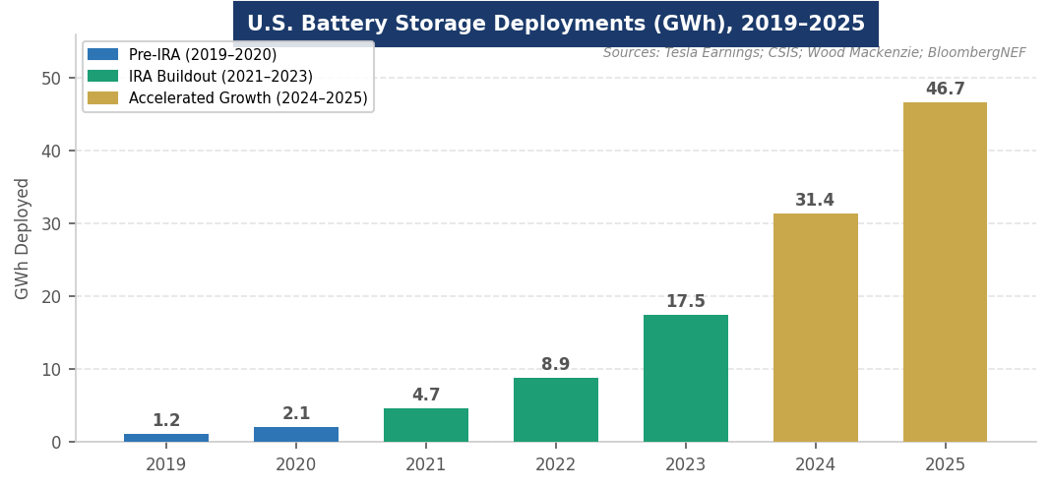
Figure 1. Global BESS annual deployments (GWh), 2015–2025. Sources: BloombergNEF; Wood Mackenzie; IEA.
MARKET STRUCTURE & VALUE CHAIN
The BESS industry spans a complex global value chain — from raw material extraction through cell manufacturing, system integration, and long-term asset operation — with China dominant in the most capital-intensive middle stages.
The BESS Value Chain (Upstream → Downstream)
1. Raw Materials | Lithium (Chile, Australia, Argentina), cobalt (DRC), nickel (Indonesia), graphite (China ~65%). Critical mineral concentration is the primary supply chain vulnerability. IRA FEOC rules are reshaping sourcing.
2. Cell Manufacturing | The highest-value-added and most China-concentrated stage. CATL (~37% global share), BYD (~17%), LG Energy Solution (~9%), Samsung SDI (~8%), SK On (~7%). Chinese producers hold ~69% combined. U.S. gigafactories (LG/GM Ultium, Samsung/Stellantis, SK/Ford) are ramping.
3. Module & Pack Assembly | Cells assembled into modules, then battery packs with thermal management, BMS (battery management system), and structural housing. More geographically distributed than cell manufacturing. Increasingly co-located with end markets.
4. Power Conversion System (PCS) | Inverters and power electronics converting DC battery output to AC grid power. SMA, ABB, GE Vernova, Delta Electronics, Sungrow, Huawei. More diversified than cell manufacturing.
5. EPC & System Integration | Engineering, procurement, and construction of complete BESS installations. Tesla Megapack, Fluence (AES/Siemens JV), Powin, Wärtsilä, BYD Energy. Turnkey integrators compete on reliability, warranty, and software.
6. Energy Management Software | SCADA, AI-driven dispatch optimization, predictive maintenance, grid services bidding. Increasingly a key competitive differentiator. AutoGrid, Stem, Fluence Digital are key players.
7. Asset Ownership & O&M | Utilities (PG&E, AES, NextEra), IPPs, infrastructure funds (Blackstone, Brookfield, KKR). Long-term service agreements (LTSAs) from OEMs cover cells and inverters. Bond-like cash flows from capacity contracts and grid services revenues.

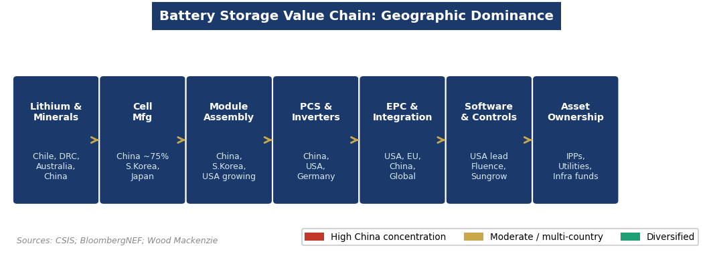
Figure 2. BESS value chain geographic concentration. Sources: BloombergNEF; Wood Mackenzie; IEA.
Three market segments define BESS deployment:
- Utility-Scale (>10 MWh): Dominant and fastest-growing segment. Projects sell capacity and energy services to utilities or grid operators under long-term contracts (10–20 years). Co-location with solar or wind is increasingly standard. CAISO (California), ERCOT (Texas), and UK capacity markets are the most active procurement regimes.
- Commercial & Industrial (C&I): Behind-the-meter storage for demand charge reduction, backup power, and on-site renewable optimization. Growing rapidly as electricity prices rise and FEOC-compliant equipment becomes available. Key verticals: data centers, hospitals, industrial facilities.
- Residential: Home battery systems (Tesla Powerwall, Enphase IQ Battery, LG RESU). Rapid growth in California, Australia, and Germany driven by high electricity prices, NEM changes, and outage resilience. Smallest segment but fastest growing by unit count.

KEY PLAYERS & COMPETITIVE LANDSCAPE
Battery Cell Manufacturers
Company | HQ | Notable Position
CATL | China | World's largest battery maker (~37% global share); dominant in China and growing in Europe (Hungary gigafactory); expanding into U.S. via LFP licensing.
BYD | China | #2 globally (~17%); vertically integrated from cells to EVs to grid storage; Blade Battery (LFP) technology sets industry benchmark for safety.
LG Energy Solution | South Korea | #3 globally (~9%); major U.S. gigafactory partnerships with GM (Ultium), Honda, Stellantis; strong NMC and cylindrical cell expertise.
Samsung SDI | South Korea | Major prismatic and cylindrical cell maker; JV with Stellantis (StarPlus Energy, Indiana); growing in European EV supply chain.
SK On | South Korea | Ford BlueOval SK JV (Kentucky, Tennessee); aggressive U.S. capacity buildout; FEOC-compliant supply chain in development.
Panasonic Energy | Japan | Tesla's primary cylindrical cell partner (Nevada Gigafactory); developing next-gen 4680 cells; Kansas gigafactory announced.

System Integrators & Project Developers
Company | Role / Notes
Tesla Energy | Megapack: dominant U.S. utility-scale BESS product; >20 GWh backlog; Lathrop Megafactory (California) producing at scale. Powerwall: leading residential product (33.4% U.S. inverter share Q4 2025).
Fluence (AES / Siemens) | Global BESS integrator and digital platform; Gridstack product family; Fluence Digital software for AI-driven dispatch. Active in U.S., Europe, and Australia.
Powin | U.S.-based BESS integrator; Stack product line; growing utility-scale presence. FEOC compliance a key selling point for U.S. ITC eligibility.
Wärtsilä Energy | Finnish; GridSolv BESS product; strong in hybrid power islands and remote microgrids; significant installed base in Pacific Islands and Caribbean.
Sungrow | China; largest global inverter maker; expanding into complete BESS solutions; competitive pricing targeting emerging markets.
NextEra Energy Storage | Largest U.S. storage developer; ~10 GWh+ contracted pipeline; co-located with NextEra wind and solar assets; NYSE: NEE.

Financial Sponsors & Investors
BESS projects are increasingly financed through infrastructure-style project finance — non-recourse debt anchored by capacity contracts or grid services revenues, plus tax equity utilizing the 48E ITC. Infrastructure funds (Blackstone, Brookfield, KKR, Macquarie) are major BESS asset acquirers. The IRA's standalone storage ITC (Section 48E, surviving to 2034 under OBBBA) provides more policy certainty than solar or wind — making BESS the most attractive renewable infrastructure segment for long-duration capital today. Typical unlevered IRR targets: 8–12% for utility-scale contracted BESS; higher for merchant or hybrid merchant/contracted structures.

ANATOMY OF A BATTERY ENERGY STORAGE SYSTEM
A utility-scale BESS is a complex electro-mechanical system converting chemical energy into electrical energy and back. Understanding each component is essential for evaluating technology risk, CapEx drivers, and O&M complexity.

Component | Key Specs | Strategic Significance
Battery Cells | LFP or NMC chemistry; cylindrical, prismatic, or pouch format | Core value driver. LFP (lithium iron phosphate): safer, longer cycle life, lower cost — dominant for stationary storage. NMC: higher energy density, preferred for EVs. Chemistry choice determines FEOC compliance risk.
Battery Management System (BMS) | Real-time cell monitoring; balancing; protection | Proprietary software IP that differentiates OEMs. Monitors temperature, voltage, and state of charge at cell level. Critical for safety and warranty performance.
Thermal Management | Liquid cooling or air cooling; HVAC | LFP runs cooler than NMC, reducing cooling cost. Thermal runaway prevention is the primary safety engineering challenge. Direct liquid cooling becoming industry standard at utility scale.
Containerized Enclosure | 20-ft or 40-ft ISO containers; weatherproof | Modular containerized design enables factory pre-assembly, rapid site deployment, and scalability. Most utility-scale BESS ships in standard containers.
Power Conversion System (PCS) | Bidirectional inverter; DC-AC conversion | Determines round-trip efficiency (typically 85–93%). SMA, Delta, GE Vernova, Sungrow lead. Increasingly integrated with BMS for holistic optimization.
Energy Management System (EMS) | AI-driven dispatch; grid services bidding; forecasting | The software brain of the asset. Determines when to charge/discharge to maximize revenue. AutoGrid, Fluence Digital, Stem lead. AI integration is the primary competitive frontier.
Grid Interconnection | Transformer; protection relay; metering | Utility-grade grid interface. FERC interconnection queue backlog (same issue as solar/wind) is a key development risk for utility-scale BESS.

How it works: During charging, grid electricity flows through the PCS into the battery cells, where electrochemical reactions store energy as chemical potential. During discharge, the reverse occurs — chemical energy converts back to electrical current, flows through the PCS (DC to AC conversion), and is exported to the grid. The EMS orchestrates this cycle in real time, responding to grid signals, price signals, and contractual obligations. Round-trip efficiency (the ratio of energy out to energy in) is the key performance metric — typically 85–93% for lithium-ion, improving as cell chemistry and PCS technology advance.
GLOBAL GEOGRAPHY & COUNTRY LEADERS
China: The world's dominant BESS market and manufacturing powerhouse. China deploys more grid storage annually than the rest of the world combined, driven by state policy requiring renewable projects to pair with storage (typically 10–20% of installed capacity). CATL and BYD together control ~54% of global cell supply, giving China structural pricing power across the entire value chain. China's 14th Five-Year Plan targets 30 GW / 60 GWh of new storage by 2025 — a target it has dramatically exceeded.
United States: The fastest-growing major BESS market outside China. The IRA's standalone 48E ITC has unlocked a wave of project finance activity — the U.S. installed 30+ GWh of utility-scale BESS in 2025. California leads with mandatory storage procurement (CPUC). Texas (ERCOT) is the most active merchant market. OBBBA preserved the 48E ITC through 2034 — making storage the most policy-protected segment of U.S. clean energy. FEOC rules from 2026 will reshape supply chain sourcing, driving U.S. gigafactory investment.
Europe: The UK is Europe's most active BESS market, driven by the Capacity Market and Balancing Mechanism grid services revenues. Germany, Italy, and the Netherlands are growing rapidly. The EU's Net-Zero Industry Act targets 90 GWh of battery manufacturing by 2030. Northvolt (Sweden) is the leading European cell manufacturer, though it faced financial difficulties in 2024–2025 and filed for bankruptcy in late 2024 — underscoring the difficulty of competing with Chinese cell costs.
Australia: One of the world's most advanced BESS markets per capita, driven by high renewable penetration and grid reliability challenges. The Hornsdale Power Reserve (Tesla, 2017) was the global proof-of-concept. Victoria's Big Battery (300 MW / 450 MWh, 2021) demonstrated large-scale grid stabilization. Australia's state governments are procuring BESS at scale to manage the "duck curve" created by 30%+ solar penetration in some grids.
POLITICS, POLICY & REGULATION
Key Policy Levers MBA Candidates Must Know
Policy / Lever | What It Means for Battery Storage
Section 48E ITC (IRA / OBBBA) | 30% standalone ITC for battery storage; phase-out starts 2034 — most favorable timeline of any clean energy technology under OBBBA. Does not require pairing with solar or wind. Transferability allows broader investor access.
FEOC Rules (OBBBA, 2025) | From 2026, BESS projects must limit Chinese-origin cells and components to claim 48E credit. Driving massive investment in U.S./Korean/Japanese supply chains. Tesla, LG, Samsung, SK are FEOC-compliant pathways.
Domestic Content Bonus | 10% additional ITC for BESS using U.S.-manufactured enclosures, cells, and modules. Rising thresholds under OBBBA accelerating U.S. manufacturing investment.
CPUC Storage Mandate (California) | California requires utilities to procure storage; NEM 3.0 changes make residential storage more valuable; California is the largest single BESS market in the U.S.
FERC Order 841 (2018) | Required ISOs/RTOs to allow storage to participate in all wholesale electricity markets (energy, capacity, ancillary services). Unlocked grid services revenue streams that make BESS project finance viable.
UK Capacity Market | Competitive auction for grid capacity — BESS competes alongside gas peakers for multi-year contracts. UK is Europe's leading BESS market driven by this revenue stream.
China 14th Five-Year Plan | Mandates storage co-location with new renewable projects; state financing for grid storage; target dramatically exceeded by 2025. Drives global cell demand and Chinese OEM scale.

INDUSTRY TRENDS & TECHNOLOGY INNOVATION
Trend 1: LFP Chemistry Displacing NMC for Stationary Storage LFP Chemistry Displacing NMC for Stationary Storage
Lithium iron phosphate (LFP) batteries have surpassed NMC (nickel manganese cobalt) as the dominant chemistry for stationary grid storage — and are rapidly gaining in EVs. LFP advantages: lower cost (~20% cheaper per kWh), longer cycle life (4,000–6,000 cycles vs. 2,000–3,000 for NMC), improved thermal stability (lower fire risk), and no cobalt or nickel dependency — addressing FEOC compliance challenges. BYD's Blade Battery and CATL's CTP (cell-to-pack) LFP designs are the industry benchmark. Tesla's Megapack uses LFP, as do most utility-scale projects globally.
Trend 2: Long-Duration Energy Storage: The Next Frontier Long-Duration Energy Storage: The Next Frontier
The grid increasingly needs storage measured in hours and days, not minutes — to balance seasonal renewable variability. Long-duration energy storage (LDES) technologies are scaling rapidly: flow batteries (vanadium redox, iron-air), compressed air, gravity storage, and green hydrogen. Form Energy's iron-air battery (100-hour discharge) raised $450M+ and is deploying in Georgia and Michigan in 2025. ESS Inc. and Invinity are scaling vanadium flow batteries. The DOE's LDES program and Grid Deployment Office are providing critical early-stage capital. LDES is the largest unmet need in the energy transition — and the largest investment opportunity in storage beyond 4-hour lithium-ion.
Trend 3: AI-Driven Dispatch and the Revenue Stack AI-Driven Dispatch and the Revenue Stack
BESS economics increasingly depend on stacking multiple revenue streams simultaneously: energy arbitrage (buy cheap, sell dear), frequency regulation, spinning reserve, capacity payments, and demand charge reduction. AI-driven Energy Management Systems (EMS) are the key differentiator — platforms from AutoGrid, Stem, and Fluence Digital optimize dispatch across these revenue streams in real time, significantly improving project IRR. As markets mature and individual revenue streams compress, the ability to capture the full revenue stack becomes the primary competitive advantage for asset managers.
Trend 4: Co-Location with Solar and Wind: The Default Model Co-Location with Solar and Wind: The Default Model
Solar + storage now accounts for 79% of new U.S. power capacity additions. Co-location enables developers to smooth intermittent generation profiles, reduce curtailment, improve PPA economics, and qualify for both solar ITC and storage ITC. The IRA's safe harbor provisions protect co-located storage projects from OBBBA's accelerated solar ITC phase-out when storage represents >50% of project cost. This structure is increasingly standard in utility-scale project design.
Trend 5: V2G (Vehicle-to-Grid): The Distributed Storage Revolution V2G (Vehicle-to-Grid): The Distributed Storage Revolution
The 20.7M EVs sold in 2025 represent a massive distributed storage resource — each vehicle's battery is large enough to power an average home for 3–5 days. Vehicle-to-grid (V2G) technology allows EVs to discharge back to the grid during peak demand periods, creating a decentralized storage network. Nissan (LEAF), Ford (F-150 Lightning), and Hyundai (Ioniq 5 and 6) have commercially deployed V2G. PG&E's V2G pilot in California demonstrated meaningful grid services revenues for EV owners. Bidirectional charging infrastructure is the key bottleneck — but the regulatory and technical groundwork is being laid.
Trend 6: Supply Chain Diversification: Post-FEOC Restructuring Supply Chain Diversification: Post-FEOC Restructuring
OBBBA's FEOC rules (effective 2026) are accelerating the restructuring of BESS supply chains away from Chinese-origin cells and components. LG, Samsung SDI, and SK On are ramping U.S. gigafactories rapidly. Panasonic's Kansas facility will add ~30 GWh of LFP capacity by 2027. Northvolt's collapse has redirected European demand toward Korean producers. The transition is painful in the near term — FEOC-compliant cells cost 15–25% more than Chinese equivalents today — but the regulatory certainty is driving the investment necessary to close the gap over the 2026–2030 period.

CURRENT NEWS & MARKET DYNAMICS (2025–2026)
Headlines Every Candidate Should Know
- OBBBA Preserves Storage ITC (July 2025): OBBBA Preserves Storage ITC (July 2025): The One Big Beautiful Bill preserved the standalone 48E ITC for battery storage through 2034 — a significantly more favorable timeline than solar (2027) or wind (2027). This has made BESS the most policy-protected segment of U.S. clean energy and is accelerating pipeline development.
- U.S. Gigafactory Surge: U.S. Gigafactory Surge: LG Energy Solution (Michigan, Ohio), Samsung SDI (Indiana), SK On (Kentucky, Tennessee), and Panasonic (Kansas) are all ramping FEOC-compliant U.S. battery manufacturing. Combined, these facilities will add 200+ GWh of annual cell capacity by 2027 — shifting the U.S. from near-total Chinese cell dependency to domestic/allied-nation supply.
- Northvolt Bankruptcy (2024): Northvolt Bankruptcy (2024): Europe's flagship battery champion filed for Chapter 11 in the U.S. in November 2024, unable to compete with Chinese cell costs despite $15B+ in raised capital. Volkswagen and BMW wrote down billions in investments. Signals the difficulty of building competitive battery manufacturing outside China at scale without equivalent government support.
- Form Energy Commercial Deployment: Form Energy Commercial Deployment: Iron-air BESS (100-hour discharge) began commercial deployment in Georgia and Michigan in 2025 — the first truly long-duration (multi-day) grid storage technology to reach commercial scale. Backed by $450M+ in funding and strategic partnerships with Georgia Power and DTE Energy.
- Battery Prices Hit New Lows: Battery Prices Hit New Lows: Global average battery pack prices fell to ~$115/kWh in 2024 (BNEF), a 20% decline year-over-year. Chinese prices fell ~30%. BloombergNEF projects sub-$80/kWh by 2030, making BESS competitive with gas peakers in almost every market globally without subsidies.
- AI Data Center Demand: AI Data Center Demand: Hyperscalers are increasingly procuring BESS alongside solar PPAs to provide 24/7 carbon-free power. Microsoft, Google, and Amazon have all included storage in recent clean energy procurement packages. Data centers' need for both firm power and grid resilience creates a premium offtake market for storage.

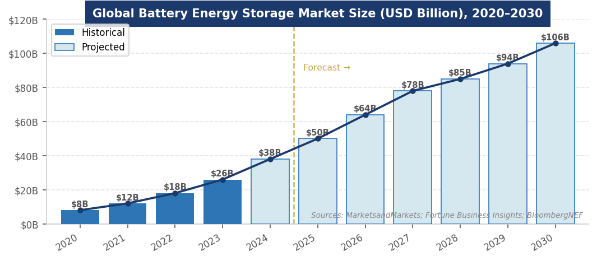
Figure 3. Global BESS market size forecast, 2020–2030 (USD Billion). Sources: MarketsandMarkets; Fortune Business Insights; BloombergNEF.
INVESTMENT, FINANCE & CAREER ANGLES
For MBA candidates, BESS intersects multiple finance and strategy functions:

- Project Finance: Project Finance: Utility-scale BESS financed through non-recourse project finance anchored by capacity contracts or grid services revenues. Capital stack: 50–65% senior debt, 25–35% tax equity (48E ITC), 10–20% sponsor equity. IRA transferability broadened the tax equity pool significantly. Revenue stacking (energy arbitrage + ancillary services + capacity) requires sophisticated financial modeling. Typical unlevered IRR: 8–12% for contracted utility-scale BESS; 12–18% for merchant/hybrid.
- Infrastructure Investing: Infrastructure Investing: Operating BESS assets exhibit stable, contracted cash flows — increasingly attractive to infrastructure funds. Blackstone, Brookfield, KKR, and Macquarie are all active BESS acquirers. The 48E ITC's survival to 2034 creates a long runway of tax-advantaged project development unavailable in most other infrastructure sectors.
- Venture Capital & Growth Equity: Venture Capital & Growth Equity: Long-duration storage (Form Energy, ESS Inc., Invinity), AI-driven EMS software (AutoGrid, Stem, Fluence Digital), battery recycling (Redwood Materials, Li-Cycle/Glencore), and solid-state battery startups (QuantumScape, Solid Power) are the most active VC segments in storage.
- Corporate Strategy: Corporate Strategy: Tech companies are structuring 24/7 clean energy procurement packages that include solar + storage. Industrial manufacturers and data center operators are deploying C&I BESS for demand charge reduction and backup power — creating corporate energy strategy roles.

Key financial concepts to know: round-trip efficiency, cycle life, C-rate, capacity factor, revenue stacking, FERC Order 841 participation, LCOE/LCOS (Levelized Cost of Storage), ITC transferability, FEOC compliance, and IRR thresholds for utility-scale vs. merchant BESS.
FUTURE OUTLOOK
The structural drivers for BESS are arguably stronger than any other energy technology: grid modernization is mandatory, renewable integration requires storage, AI data centers demand firm power, and battery costs are falling along a predictable learning curve. The primary near-term constraint is supply chain transition — moving from Chinese-dominated to FEOC-compliant supply chains takes capital and time. But the 48E ITC's 2034 sunset gives developers a long policy runway to finance that transition.

- Base Case: Base Case: Global BESS market reaches $150–200B by 2030 (CAGR ~18–20%). U.S. installs 50+ GWh annually by 2027. FEOC transition is manageable — Korean gigafactories fill the gap. LFP remains dominant; LDES (4–12 hour) grows to 20% of new U.S. utility-scale deployments by 2030.
- Bull Case: Bull Case: Battery prices reach sub-$80/kWh by 2028; V2G and vehicle integration adds 100+ GWh of virtual storage to U.S. grid by 2030; solid-state batteries achieve commercial scale in stationary applications by 2030; LDES reaches grid parity, unlocking seasonal storage markets.
- Bear Case: Bear Case: FEOC compliance costs exceed projections; Chinese cell dumping depresses prices below FEOC-compliant alternatives' breakeven; interconnection queue delays strand large-scale BESS projects; merchant revenue stacks compress as markets saturate.

The one certainty: the grid needs storage. The question is chemistry, duration, geography, and who captures the margin — not whether demand materializes.
INTERVIEW CONVERSATION STARTERS
- "Battery storage is the only energy technology that becomes more valuable as renewable penetration increases — the more solar and wind on the grid, the more you need storage to balance it. That's why BESS is growing at 25%+ CAGR even in a policy environment that's challenging for solar and wind. It's the infrastructure layer that makes the energy transition work."
- "The OBBBA actually made battery storage the most policy-protected clean energy technology in the U.S. — the 48E ITC survives to 2034 while solar and wind phase out in 2027. If you're an infrastructure fund looking for a long policy runway with stable cash flows, BESS is the most attractive segment in the market right now."
- "The FEOC rules are creating a once-in-a-generation supply chain restructuring in battery manufacturing. LG, Samsung, SK, and Panasonic are building 200+ GWh of U.S. cell capacity by 2027. That's not just an energy story — it's an industrial policy story about whether the U.S. can rebuild a domestic battery manufacturing base in 10 years that China built in 30."
- "Long-duration storage is the missing piece of the energy transition — you can integrate 30-40% renewables with 4-hour batteries, but getting to 80-90% requires days or weeks of storage. Form Energy's iron-air battery and vanadium flow batteries are the most credible commercial pathways. The DOE projects LDES costs need to fall 90% from today's levels — which is exactly the trajectory lithium-ion followed from 2010 to 2025."

REFERENCES
High-Quality Sources Used in This Primer
Government & Intergovernmental Organizations
[1] International Energy Agency (IEA). "Batteries and Secure Energy Transitions." Paris: IEA, 2024. https://www.iea.org/reports/batteries-and-secure-energy-transitions
[2] U.S. Department of Energy (DOE). "Long Duration Storage Shot." Washington, D.C.: DOE, 2024. https://www.energy.gov/eere/long-duration-storage-shot
[3] Federal Energy Regulatory Commission (FERC). "Order No. 841: Electric Storage Participation in Markets." Washington, D.C.: FERC, 2018.
[4] U.S. Energy Information Administration (EIA). "Battery Storage in the United States: An Update on Market Trends." EIA, 2025. https://www.eia.gov/analysis/studies/electricity/batterystorage/
Industry Research & Trade Associations
[5] BloombergNEF. "Energy Storage Market Outlook 2025." New York: BloombergNEF, 2025.
[6] Wood Mackenzie. "Global Energy Storage Outlook 2025." Edinburgh: Wood Mackenzie, 2025.
[7] MarketsandMarkets. "Battery Energy Storage System Market Report 2025–2030." https://www.marketsandmarkets.com/Market-Reports/battery-energy-storage-system-market-112809494.html
[8] Fortune Business Insights. "Battery Energy Storage Market Size & Trends, 2034." https://www.fortunebusinessinsights.com/industry-reports/battery-energy-storage-market-100489
News & Analysis
[9] Sidley Austin. "The One Big Beautiful Bill Act — Storage Provisions." November 2025. https://www.sidley.com/en/insights/newsupdates/2025/07/the-one-big-beautiful-bill-act-navigating-the-new-energy-landscape
[10] AltEnergyMag. "Battery Energy Storage System Market: Trends, Growth & Future Outlook 2025–2035." February 2026. https://www.altenergymag.com/news/2026/02/26/battery-energy-storage-system-market-trends-growth-future-outlook-2025-2035/46820/
[11] Straits Research. "Battery Energy Storage System Market Size, Trends & Outlook Report 2034." https://straitsresearch.com/report/battery-energy-storage-system-market
Legislation & Regulatory Texts
[12] 117th U.S. Congress. "Inflation Reduction Act of 2022" (Pub. L. 117-169). https://www.congress.gov/bill/117th-congress/house-bill/5376
[13] 119th U.S. Congress. "One Big Beautiful Bill Act" (H.R. 1). Signed July 4, 2025. §§ 48E, 45Y.
[14] Maximizemarketresearch. "Battery Energy Storage System Market: Growth Analysis 2026–2032." April 2026. https://www.maximizemarketresearch.com/market-report/battery-energy-storage-system-market/2753/

Disclaimer: This document is prepared for educational purposes as part of an MBA classroom exercise. Market data reflects conditions as of April 2026 and is sourced from publicly available materials. It does not constitute investment advice.

