DATA CENTERS
MBA Industry Primer | Infrastructure
Columbia Business School | April 2026

INDUSTRY AT A GLANCE
Data centers are the defining infrastructure investment of the AI era — the physical substrate of the digital economy, the power-hungry facilities that train large language models, serve cloud applications, and process the world's data. For MBA candidates, data centers sit at the intersection of infrastructure finance, technology strategy, energy policy, and real estate. Understanding them means understanding why top-5 hyperscalers are spending $660–690 billion on infrastructure in 2026 alone, why power availability has replaced capital as the binding constraint on AI deployment, and why the site-selection decision for a new data center is now as much about megawatts as it is about megabytes.

Key Metric | Data Point (2025–2026)
Global DC Infrastructure Market (2025) | ~$290B (IoT Analytics); AI-specific segment ~$147B (GVR); projected ~$1T total by 2030
Global IT Power Capacity (2025) | 24.4 GW globally; projected to reach 147.1 GW by 2035 (6× increase, CAGR ~27%) — ABI Research
Top-5 Hyperscaler CapEx (2026E) | $660–690B combined (Amazon ~$200B, Alphabet ~$180B, Meta ~$125B, Microsoft ~$120B, Oracle ~$50B)
U.S. Data Center Market (2026E) | >$120B; North America holds ~37–38% global market share; largest market globally by revenue
Power: The Binding Constraint | Power availability — not capital — is the #1 bottleneck for data center development in 2026
PJM Capacity Market Impact | Data centers caused a $9.3B price increase in PJM's 2025–26 capacity market — quantifying grid stress
Cooling Transition | Air → liquid cooling: CoreWeave all new facilities liquid-cooled from 2025; rack densities up to 130 kW
Goldman Sachs Power Forecast | Global data center power demand +50% by 2027 (to ~92 GW) and +165% by 2030 vs. 2023
Stargate Program | OpenAI/SoftBank/Oracle: $500B infrastructure commitment; 4.5 GW U.S. capacity addition
Three Scarcest Resources | Power, land, and talent — in that order — as the binding constraints on data center development

HISTORY & ORIGINS
The modern data center traces its origins to the mainframe era of the 1960s, when IBM's System/360 required purpose-built, climate-controlled facilities with raised floors, precision air conditioning, and uninterruptible power supplies. Early computing centers were owned and operated by individual enterprises — banks, government agencies, and large corporations — each building its own proprietary facility.
1990s–2000s: The Internet Era and Colocation. The commercial internet explosion of the 1990s created the first wave of purpose-built internet data centers (IDCs). Exodus Communications, Equinix, and Digital Realty emerged as the early colocation providers, offering shared facilities where multiple tenants could house servers in a secure, powered, and connected environment. The dot-com boom drove frenzied construction; the bust left massive overcapacity — a pattern that would repeat. The Y2K preparation cycle forced enterprises to audit and modernize their computing infrastructure, accelerating the professionalization of data center operations.
2006–2015: Cloud Computing and Hyperscale. Amazon Web Services launched in 2006 with S3 and EC2 — the first commercially viable cloud infrastructure services. The hyperscale model emerged: instead of building hundreds of small, efficient facilities, Amazon, Google, and later Microsoft built enormous, standardized campuses of 50–500 MW that could be replicated globally. Google's 2011 paper on its data center design philosophy — aggressive power usage effectiveness (PUE) optimization, custom servers, waste heat reuse — became the industry bible. Facebook (now Meta) pioneered the Open Compute Project, open-sourcing its server and data center designs.
2015–2022: Enterprise Migration and REIT Formation. Enterprise workloads migrated steadily from on-premise data centers to cloud and colocation facilities. Data center REITs (Equinix, Digital Realty, Iron Mountain) attracted institutional capital seeking stable, long-duration infrastructure cash flows. Data centers became recognized as a distinct infrastructure asset class alongside toll roads and airports. Power usage effectiveness (PUE) improved industry-wide from ~2.0 to ~1.3–1.5 as liquid cooling, free cooling, and AI-optimized power management matured.
2022–2026: The Generative AI Inflection. ChatGPT's November 2022 launch triggered the most significant infrastructure investment cycle in technology history. Training large language models requires massive GPU clusters drawing 10–100+ MW per cluster. Inference (serving AI responses at scale) requires distributed GPU capacity globally. Hyperscaler CapEx surged from ~$120B (2022) to a projected $660–690B (2026). The binding constraint shifted from capital to power: interconnection queues, utility capacity constraints, and permitting timelines became the determining factor in how quickly AI capacity could be built. Data centers moved from a backroom infrastructure discussion to a front-page geopolitical issue.

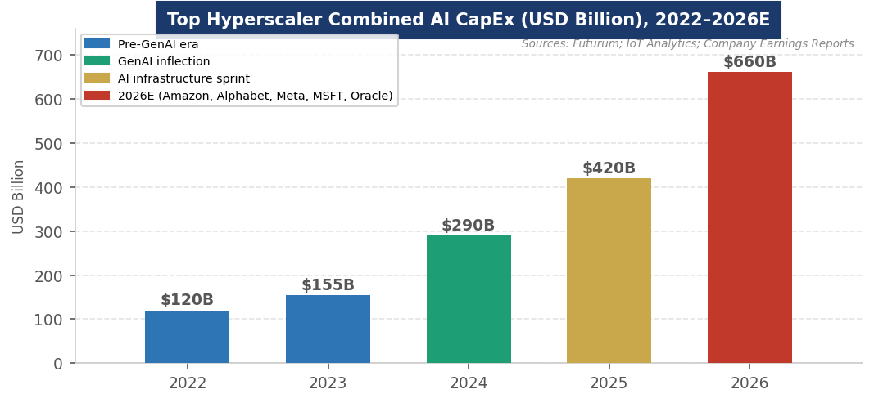
Figure 1. Top hyperscaler combined AI infrastructure CapEx (USD Billion), 2022–2026E. Sources: Futurum; IoT Analytics; Company Earnings Reports.
MARKET STRUCTURE & VALUE CHAIN
The data center industry is organized around a set of distinct but deeply interdependent participants. Understanding each layer — from power supply to the AI models that run on top — is essential for evaluating investment opportunities across the stack.
The Data Center Value Chain (Infrastructure → Application)
1. Power & Site Infrastructure | The binding constraint. Utilities, independent power producers, nuclear operators, and gas generators supply MW-scale power. Site selection driven by: power availability (primary), land cost, fiber connectivity, tax incentives, water availability, and climate for cooling. PJM, ERCOT, and CAISO are the key U.S. grid markets.
2. Compute (GPU/CPU/Accelerators) | NVIDIA controls ~80% of the AI GPU market (H100, H200, Blackwell B200). AMD MI300X is the primary alternative. Google TPUs, AWS Trainium/Inferentia, and Microsoft Maia/Cobalt are custom ASICs for internal use. NVIDIA's supply constraints have been a defining bottleneck — 12–18 month lead times at peak demand.
3. Cooling & Mechanical Systems | Rapidly transitioning from air to liquid cooling as GPU rack densities rise from 10–20 kW to 100+ kW per rack. Key players: Vertiv (market leader in cooling/power infrastructure), Schneider Electric (APC), Modine Manufacturing (liquid cooling CDUs). Liquid cooling approaches: direct-to-chip, immersion, rear-door heat exchangers.
4. Networking, Storage & Power Electronics | High-speed networking (InfiniBand for GPU clusters: NVIDIA/Mellanox; Ethernet: Arista, Cisco) interconnects GPUs within and across data centers. Storage: Seagate, Western Digital, Pure Storage, NetApp. Power electronics: Eaton, ABB, Schneider for UPS, PDUs, switchgear.
5. Data Center Software & Management | DCIM (data center infrastructure management) software: Vertiv, Schneider, Nlyte. AI-driven power management and cooling optimization platforms are reducing PUE. Hyperscalers develop proprietary OS-level tools for workload orchestration (AWS Nitro, Google Borg, Microsoft Azure Arc).
6. Data Center Operations | Hyperscalers: Amazon (AWS), Microsoft (Azure), Google (GCP), Meta, Oracle — own and operate their own campuses. Colocation providers: Equinix (global leader), Digital Realty, CyrusOne — lease space to multiple tenants. Neocloud providers: CoreWeave, Lambda Labs — GPU-as-a-Service for AI workloads; fastest-growing segment.
7. Cloud & AI Services | The revenue layer that justifies the CapEx. AWS, Azure, and GCP generate $300B+ in combined annual revenue. AI model APIs (OpenAI, Anthropic, Google Gemini), SaaS applications, and enterprise software all run on top of hyperscaler infrastructure. OpenAI ended 2025 with ~$20B ARR — a 3× increase from prior year.

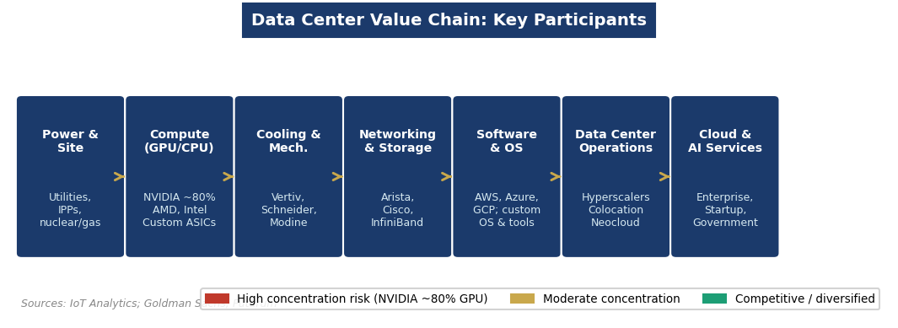
Figure 2. Data center value chain key participants and concentration risks. Sources: IoT Analytics; Goldman Sachs; Futurum.
Three market segments define data center deployment:
- Hyperscale Data Centers (>50 MW): Campuses built by or for a single hyperscaler. Largest and fastest-growing segment (49% of AI data center market in 2025). Amazon, Microsoft, Google, and Meta are building 100–500 MW campuses globally. Characterized by extreme standardization, custom hardware, and aggressive PUE optimization. The Stargate program (OpenAI/SoftBank/Oracle) is the most ambitious hyperscale commitment — $500B with 4.5 GW of planned capacity.
- Colocation Data Centers: Multi-tenant facilities where enterprises lease space (cabinets, cages, or suites) and connect to shared power, cooling, and fiber. Equinix ($8B+ revenue, 260+ facilities globally) and Digital Realty are the dominant operators. Colocation is the primary deployment model for enterprise IT and for hyperscalers seeking rapid market entry in new geographies.
- Edge Data Centers & Distributed Computing: Small, modular facilities deployed close to end users for low-latency applications (autonomous vehicles, industrial IoT, content delivery). Growing rapidly as 5G and AI inference at the edge expand. Fastest-growing data center type by count, though smallest by MW. Operators: Vapor IO, Zayo, EdgeConneX.

KEY PLAYERS & COMPETITIVE LANDSCAPE
Hyperscalers & Cloud Providers
Company | 2026E CapEx | Key Data Center Activity
Amazon (AWS) | ~$200B | 80+ availability zones; Stargate partner; $20B+ Susquehanna AI campus; largest global cloud market share (~30%)
Alphabet (Google) | ~$180B | 42 cloud regions / 127 AZs (2025); Fairwater AI campus expansion; custom TPUs; $2B Turkey commitment; cloud backlog surged 55% sequentially to $240B+
Meta | ~$125B | Prometheus AI mega campus (Ohio); 6.6 GW nuclear commitment; $14.2B CoreWeave GPU deal; 2 GW Louisiana AI campus
Microsoft (Azure) | ~$120B | Fairwater AI campuses (Atlanta Oct 2025, Wisconsin 2026): closed-loop liquid cooling, zero water; Azure Maia 100 AI accelerator; 120,000 miles dedicated fiber AI WAN; $80B Azure order backlog
Oracle | ~$50B | Stargate program lead alongside OpenAI/SoftBank; aggressive GPU cloud expansion; government cloud focus
OpenAI (Stargate) | $500B total (multi-yr) | Stargate: $500B infrastructure commitment with SoftBank and Oracle; 4.5 GW capacity addition; Texas as primary buildout location

Colocation, Neocloud & Infrastructure Providers
Company | Role / Notes
Equinix | Global colocation leader; 260+ IBX data centers in 70+ metros; $8B+ revenue; NASDAQ: EQIX; interconnection hub model; REIT structure; expanding xScale hyperscale JV campuses
Digital Realty | #2 global colocation; NYSE: DLR; REIT; 300+ data centers globally; PlatformDIGITAL interconnection fabric; JVs with hyperscalers for campus development
CoreWeave | Fastest-growing neocloud (GPU-as-a-Service); 33 data centers; all new facilities liquid-cooled from 2025; 130 kW rack densities; $14.2B Meta deal; IPO 2025; primary NVIDIA H100/Blackwell operator
NVIDIA | ~80% AI GPU market share; H100, H200, Blackwell B200/B300; DGX SuperPOD systems; NVLink for GPU interconnect; Mellanox InfiniBand for cluster networking; the most critical single supplier in AI infrastructure
Vertiv Holdings | Market-leading thermal management and power infrastructure; NYSE: VRT; $180M single-customer order (Feb 2025 — largest in company history); 60%+ data center revenue growth guide for FY2026; CDU and immersion cooling products
Modine Manufacturing | Liquid cooling CDUs; data center thermal management; $180M hyperscaler order validates market entry; significant revenue growth from AI tailwind; U.S.-based manufacturing advantage
Schneider Electric | APC power infrastructure; data center design and prefab modular solutions; reference architecture program for liquid-cooled AI DCs (expanded 2025); key competitor to Vertiv

Financial Sponsors & Real Estate Capital
Data center REITs (Equinix, Digital Realty, Iron Mountain, CyrusOne) provide investors stable, long-duration infrastructure cash flows anchored by long-term colocation leases (5–15 years) with strong credit tenants. Infrastructure funds (Brookfield, KKR, Blackstone, Global Infrastructure Partners) have aggressively acquired data center portfolios — Blackstone's $10B acquisition of QTS Realty (2021) was the landmark transaction. Sovereign wealth funds (GIC, ADIA, Mubadala) are active LP investors in data center platforms. Development financing for new campuses involves construction loans (typically 60–70% LTC) bridged to long-term CMBS or investment-grade corporate debt once stabilized. Power purchase agreements (PPAs) and utility service agreements are critical underwriting inputs.

ANATOMY OF A DATA CENTER
A data center is a highly engineered facility optimized for continuous, reliable, high-density computing. Understanding its physical layers — from the utility connection to the server rack — provides the foundation for evaluating technology evolution, capital cost drivers, and operational risk.

Component / System | Key Specs | Strategic Significance
Utility Power Feed | 33 kV–500 kV grid connection; 10–500 MW demand | The #1 bottleneck in data center development. Grid interconnection in PJM or ERCOT can take 3–7 years. On-site generation (gas, nuclear, BESS) increasingly deployed to supplement or bypass grid delays.
Uninterruptible Power Supply (UPS) | Battery or flywheel backup; 10–60 min runtime | Provides bridge power during utility outages until diesel generators start. UPS is a major CapEx item. Vertiv and Eaton dominate. Li-ion UPS replacing lead-acid for density and maintenance advantages.
Backup Generators | Diesel gensets; N+1 or 2N redundancy | Critical for Tier III/IV reliability. Diesel fuel storage (24–72 hour supply) adds real estate requirements. Some facilities converting to natural gas or hydrogen generators for sustainability compliance.
Power Distribution (PDUs) | Switchgear, busway, PDUs to rack level | Losses at each transformation step (AC→DC→AC) reduce overall efficiency. Modern designs minimize conversion steps. 480V or 415V to rack increasingly replacing 208V to improve efficiency.
Cooling Systems | PUE target: 1.1–1.3 for modern hyperscale; air vs. liquid | Air cooling: CRAC units, hot/cold aisle containment. Liquid cooling: direct-to-chip CDUs, rear-door heat exchangers, immersion tanks. AI GPU racks (100+ kW) require liquid cooling — air is physically incapable of removing the heat.
Server Racks & Cabinets | 42U standard rack; 10–130+ kW per rack in AI DCs | Rack density is the most important physical metric in AI data centers. Standard enterprise: 5–10 kW/rack. AI GPU clusters: 30–130 kW/rack. Higher density = more compute per sq ft but requires liquid cooling.
Networking Fabric | InfiniBand (NVIDIA/Mellanox) or Ethernet (Arista); 400G–1.6T | GPU clusters require ultra-low latency, high-bandwidth interconnect to avoid GPU idle time. InfiniBand dominates for training. Scale-out Ethernet gaining ground. Fiber optical transceivers: Coherent (Lumentum, II-VI).
Security & Physical Infrastructure | Biometric access; 24/7 security; seismic/fire protection | Data center physical security requirements are equivalent to financial institution vaults. SSAE 18 / SOC 2 certification required for enterprise customers. Location selection avoids flood zones, seismic risk, and flight paths.

How it works: Utility power enters the facility at high voltage, is stepped down through transformers, and distributed via UPS systems and switchgear to individual server racks. Servers generate heat in proportion to their compute load; cooling systems remove that heat via air or liquid. The ratio of total facility power consumption to IT load power consumption is the Power Usage Effectiveness (PUE) — a perfect PUE of 1.0 means all power goes to computing; best-in-class hyperscale facilities achieve 1.1–1.15. Microsoft's Fairwater AI campuses use closed-loop liquid cooling to eliminate water consumption entirely — a paradigm shift in sustainable data center design.
GLOBAL GEOGRAPHY & COUNTRY LEADERS
United States: The world's largest data center market by capacity and revenue. Northern Virginia (Loudoun County) is the global data center capital — the highest concentration of data center capacity on Earth, with more than 30% of the world's internet traffic routing through its facilities. Other major U.S. markets: Dallas/Fort Worth, Atlanta, Chicago, Phoenix (power-cheap, land-abundant), and Silicon Valley. The Stargate buildout is concentrating new capacity in Texas (Abilene). Power grid constraints in Northern Virginia have pushed development toward Georgia, Texas, and Ohio.
Europe: Frankfurt, Amsterdam, London, and Dublin (FALD) are the dominant European markets. The EU AI Act and GDPR data sovereignty requirements drive European data center demand. Ireland attracted major hyperscaler campuses (Meta, Google, Microsoft) due to favorable tax treatment; utility constraints are now limiting growth. Nordic markets (Sweden, Finland, Norway) are growing rapidly — cold climates enable free cooling, reducing energy costs and improving sustainability metrics. Microsoft's Sweden expansion and Google's Finland campuses are the flagship examples.
Asia-Pacific: Singapore is the gateway data center hub for Southeast Asia, though strict power limits (moratorium lifted partially in 2022) constrain growth. Japan (Tokyo, Osaka) serves the world's third-largest economy. Australia (Sydney, Melbourne) is a fast-growing market driven by government cloud adoption and financial services. India is a rapidly expanding market — Microsoft's $3B India commitment and Google's $2B investment reflect the country's growing digital economy and AI talent base.
Middle East: The UAE (Dubai, Abu Dhabi) and Saudi Arabia (NEOM, Vision 2030) are aggressively building data center capacity as part of sovereign AI strategies. Microsoft's $1.5B UAE AI investment and Google's $2B Turkey commitment represent the hyperscaler push into the region. Sovereign wealth funds (Mubadala, PIF) are co-investing alongside hyperscalers, creating a model that combines government-backed land, power, and capital with hyperscaler technology and demand.
POLITICS, POLICY & REGULATION
Data centers are increasingly a matter of national industrial policy — not just commercial real estate. Every major government is developing AI and data infrastructure strategies, creating a complex web of incentives, requirements, and restrictions that shapes where data centers are built.

Key Policy Levers MBA Candidates Must Know
Policy / Lever | What It Means for Data Centers
Stargate Executive Order (Jan 2025) | Trump EO establishing AI infrastructure as a national priority; Stargate designated a national security project; streamlined federal permitting; federal land for data centers. $500B private sector commitment from OpenAI, SoftBank, Oracle.
Data Center Permitting Reform | Multiple U.S. states (Virginia, Texas, Georgia) have fast-tracked data center permitting to attract CapEx. Virginia enacted data center tax exemptions worth $1B+ annually. Competing with EU where permitting for large facilities can take 2–5 years.
EU AI Act | World's first comprehensive AI regulation (effective 2024–2026). High-risk AI applications face strict requirements. Data localization and sovereignty requirements drive European data center demand. Compliance burden increases operational complexity for hyperscalers.
GDPR & Data Sovereignty | EU data protection rules restrict transfer of personal data outside the EU, requiring hyperscalers to maintain EU-based data center capacity. Similar data localization requirements emerging in India, China, Indonesia, and Brazil — each driving local data center construction.
Power Purchase Agreements (PPAs) | Hyperscalers sign long-term PPAs (10–20 years) for renewable energy to meet sustainability commitments. Google, Microsoft, and Amazon are the world's largest corporate renewable energy buyers. Nuclear PPAs (Microsoft TMI, Google Kairos) emerging as a new category for 24/7 clean power.
Grid Interconnection (FERC) | Same interconnection bottleneck as renewable energy — 3–7 year wait in many U.S. markets. PJM capacity market: data centers caused a $9.3B price increase in the 2025–26 auction. FERC Order 2023 reforms are insufficient for the scale of new demand.
Export Controls (Chips Act) | U.S. export controls on advanced AI chips (H100, A100 and successors) restrict who can build competitive AI infrastructure globally. Countries on the export control list cannot purchase NVIDIA's most advanced GPUs — a significant geopolitical tool that shapes global AI capacity distribution.

INDUSTRY TRENDS & TECHNOLOGY INNOVATION
Trend 1: The Liquid Cooling Revolution The Liquid Cooling Revolution
Air cooling is physically incapable of removing the heat generated by modern AI GPU racks drawing 100+ kW per rack. The industry is undergoing a rapid transition to liquid cooling: direct-to-chip (coolant piped directly to processor heat spreaders), rear-door heat exchangers, and single-phase or two-phase immersion cooling. CoreWeave's decision to make all new facilities liquid-cooled from 2025 signals the industry direction. Microsoft's Fairwater AI campuses deploy closed-loop liquid cooling that eliminates operational water consumption entirely. Vertiv's 60%+ data center revenue growth guidance and Modine's record $180M order validate the capital flows into this transition.
Trend 2: Power as the Strategic Moat Power as the Strategic Moat
Access to power — not capital, not technology, not talent — has become the defining competitive advantage in data center development. Data centers caused a $9.3B price increase in PJM's 2025–26 capacity market. Northern Virginia has run out of available utility capacity for new connections. The Stargate buildout is sited in Abilene, Texas, partly because ERCOT has more available power than PJM or CAISO. Forward-thinking operators are securing power rights years in advance, signing nuclear PPAs, co-locating with gas generation, and building on-site BESS. Companies that secured power capacity in 2022–2023 now have a multi-year competitive moat.
Trend 3: Nuclear and Gas as the 24/7 Power Solution Nuclear and Gas as the 24/7 Power Solution
Hyperscalers' 24/7 carbon-free power commitments cannot be met by solar and wind alone — both are intermittent. Nuclear and natural gas are the firm-power solutions. Microsoft's Three Mile Island restart (835 MW), Google's 500 MW Kairos Power deal, Meta's 6.6 GW nuclear commitment, and Amazon's X-energy investment represent the tech industry's pivot to firm zero-carbon baseload. Natural gas remains essential as a bridge fuel — Constellation Energy's gas peakers serve data center loads when solar is unavailable. The AI data center boom is creating a new category of power procurement: long-duration, firm, 24/7 clean energy PPAs.
Trend 4: Neocloud Providers: The New Infrastructure Layer Neocloud Providers: The New Infrastructure Layer
Between the hyperscalers (who build for internal use) and colocation providers (who lease space) sits a new category: neocloud providers offering GPU-as-a-Service. CoreWeave (IPO 2025, $14.2B Meta deal, $19B+ valuation) and Lambda Labs are the leaders. Neoclouds acquire massive GPU allocations directly from NVIDIA, build liquid-cooled facilities, and offer AI compute to enterprises that need GPUs at scale without building their own infrastructure. ABI Research identifies neoclouds as the fastest-growing data center segment by revenue as enterprises seek AI-first and region-specific infrastructure. This is creating a new infrastructure investment category distinct from traditional hyperscale or colocation.
Trend 5: AI-Optimized Data Center Design AI-Optimized Data Center Design
Traditional data centers were designed for CPU-based workloads with uniform power density and air cooling. AI data centers require fundamentally different design: GPU-optimized power distribution, high-density liquid cooling infrastructure from day one, ultra-low latency networking (InfiniBand or high-bandwidth Ethernet), and massive fiber capacity for GPU-to-GPU communication across facilities. Microsoft's Azure Maia 100 AI accelerator and Google's TPU v5 represent the custom silicon trend — hyperscalers designing their own chips to optimize power efficiency for specific AI workloads. The PUE metric itself is evolving: water usage effectiveness (WUE) and carbon usage effectiveness (CUE) are becoming equally important sustainability KPIs.
Trend 6: Geographic Diversification: Tier 2 Markets and Emerging Economies Geographic Diversification: Tier 2 Markets and Emerging Economies
Power scarcity in traditional Tier 1 markets (Northern Virginia, Silicon Valley, Frankfurt, Singapore) is driving data center development into Tier 2 markets with available power, land, and fiber connectivity. In the U.S.: Columbus (Ohio), Atlanta, Phoenix, Kansas City, Salt Lake City. Internationally: Poland, Spain, Malaysia, Indonesia, Saudi Arabia, and India. The IEA projects global data center electricity consumption to nearly triple from 415 TWh (2025) to ~1,100 TWh by 2034 — requiring the equivalent of Japan's entire current electricity generation to be added to global grids for data centers alone.

CURRENT NEWS & MARKET DYNAMICS (2025–2026)
Headlines Every Candidate Should Know
- $660–690B Hyperscaler CapEx (2026E): $660–690B Hyperscaler CapEx (2026E): Amazon ($200B), Alphabet ($180B), Meta ($125B), Microsoft ($120B), and Oracle ($50B) are collectively spending $660–690B on AI infrastructure in 2026 alone — more than the annual GDP of Switzerland. All five companies report supply-constrained rather than demand-constrained markets. Google's cloud backlog surged 55% sequentially to $240B+; Microsoft has an $80B Azure order backlog.
- Stargate Program ($500B): Stargate Program ($500B): The OpenAI/SoftBank/Oracle Stargate initiative — backed by a Trump executive order designating it a national security priority — is building 4.5 GW of U.S. AI data center capacity, primarily in Texas. The program represents the largest single infrastructure commitment in U.S. history since the interstate highway system.
- Microsoft Fairwater AI Campuses: Microsoft Fairwater AI Campuses: Microsoft's Fairwater facilities (Atlanta, operational Oct 2025; Wisconsin, early 2026) deploy closed-loop liquid cooling that eliminates operational water consumption. The campuses use custom Azure Maia 100 AI accelerators and are interconnected by 120,000 miles of dedicated fiber on Microsoft's AI Wide Area Network — a purpose-built global AI infrastructure layer.
- CoreWeave $14.2B Meta Deal & IPO: CoreWeave $14.2B Meta Deal & IPO: CoreWeave secured a $14.2B multi-year GPU capacity agreement with Meta and completed its IPO in 2025, validating the neocloud model as a distinct infrastructure category. CoreWeave's 33 liquid-cooled data centers — with all new facilities supporting 130 kW rack densities — represent the state of the art in AI infrastructure design.
- PJM Capacity Market Shock: PJM Capacity Market Shock: Data centers caused a $9.3B price increase in PJM's 2025–26 capacity market — the most direct quantification yet of how AI infrastructure is reshaping grid economics. Utilities in Northern Virginia have effectively run out of power capacity for new connections, driving hyperscalers to Texas, Ohio, and Georgia.
- Vertiv Record Order ($180M, Feb 2025): Vertiv Record Order ($180M, Feb 2025): Vertiv received the largest single order in company history — a $180M liquid cooling CDU contract from a single hyperscaler customer — validating hyperscaler penetration and providing forward visibility. Vertiv guides for 60%+ data center revenue growth in FY2026 and targets $2B+ data center revenue by FY2028.
- AI Chips Export Controls: AI Chips Export Controls: U.S. export restrictions on NVIDIA H100, H200, and successor chips restrict AI infrastructure buildout in China, Russia, and designated countries. China's Huawei is developing domestic alternatives (Ascend 910B), but performance and supply remain below NVIDIA levels. Export controls have become a primary tool of AI geopolitical competition.

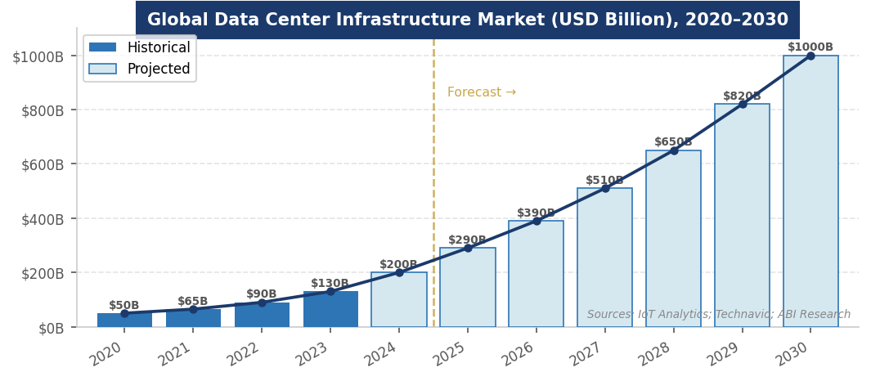
Figure 3. Global data center infrastructure market size forecast, 2020–2030 (USD Billion). Sources: IoT Analytics; Technavio; ABI Research.
INVESTMENT, FINANCE & CAREER ANGLES
Data centers offer MBA candidates exposure across infrastructure finance, real estate, private equity, venture capital, and corporate strategy — with the added dimension of technology sector overlap that distinguishes the asset class from traditional infrastructure.

- Infrastructure & Real Estate Finance: Infrastructure & Real Estate Finance: Data center REITs (Equinix EQIX, Digital Realty DLR) trade as infrastructure/real estate hybrids. Valued on FFO multiples and cap rates similar to other infrastructure REITs, but with technology obsolescence risk that traditional infrastructure lacks. Development financing: construction debt (60–70% LTC), followed by long-term CMBS or corporate bonds once stabilized. Key underwriting inputs: lease tenor (5–15 years), tenant credit quality, power contract structure, PUE, and technology obsolescence risk.
- Private Equity: Private Equity: Blackstone's $10B QTS acquisition (2021), KKR's data center platform, and Brookfield's infrastructure arm are all major data center investors. PE strategies: buy-and-build colocation platforms, develop hyperscale campuses for sale/leaseback to tech companies, and invest in power infrastructure serving data centers (gas peakers, nuclear restarts, BESS co-located with DCs). Data center PE returns: 15–25% IRR for development; 10–15% for stabilized assets.
- Venture Capital & Growth Equity: Venture Capital & Growth Equity: Neocloud providers (CoreWeave, Lambda Labs), AI infrastructure software (DCIM, power management, cooling optimization), and chip startups (Cerebras, Groq, d-Matrix for AI inference) are active VC categories. The power-tech intersection — companies helping data centers manage, procure, and reduce energy consumption — is the most compelling emerging category.
- Corporate Strategy: Corporate Strategy: Every large enterprise is making data center strategy decisions — whether to own, lease, or co-locate; how to structure cloud commitments; how to meet 24/7 clean energy targets. Corporate energy procurement and real estate strategy roles at tech companies and large enterprises now require data center infrastructure fluency. Hyperscaler partner roles (AWS, Azure, GCP enterprise) are significant hiring categories for MBAs.

Key financial concepts: PUE (Power Usage Effectiveness), Total Cost of Ownership (TCO) for compute, MW capacity vs. IT load, Cap Rate for stabilized data centers, FFO for REITs, GPU utilization rates, LTC (Loan-to-Cost) for development financing, PPA structure for power procurement, and colocation lease structures (NNN vs. gross lease).
FUTURE OUTLOOK
Data centers are the most capital-intensive infrastructure buildout of the 21st century — comparable in scale to the interstate highway system, the electric grid, or the rail network. Goldman Sachs projects global data center power demand rising 165% by 2030 vs. 2023. IoT Analytics projects the infrastructure market reaching $1 trillion annually by 2030. ABI Research forecasts global IT power capacity growing 6× from 24.4 GW to 147.1 GW by 2035.

- Base Case: Base Case: Global data center infrastructure market reaches $700–800B by 2030. Power constraints moderate growth pace in established markets; Tier 2 geographies absorb overflow. AI workload shift from training to inference reduces per-query compute intensity, moderating power demand growth. Nuclear and gas provide firm power for 24/7 AI operations.
- Bull Case: Bull Case: AI monetization exceeds expectations; AGI-scale compute requirements trigger another order-of-magnitude increase in CapEx; nuclear SMRs come online in the 2030–2032 timeframe co-located with data centers; global market reaches $1.2T+ by 2030.
- Bear Case: Bear Case: AI investment disappoints on ROI; demand-constrained markets plateau; power permitting creates multi-year delays; hyperscaler AI spending moderated. Global market growth slows to 10–12% CAGR; significant overcapacity in non-core markets.

The one certainty: digital infrastructure is as essential as physical infrastructure. Every AI model, every cloud application, every digital service runs on physical compute. The question is not whether data center investment continues — it will — but at what pace, powered by what energy sources, concentrated in what geographies, and owned by which combination of hyperscalers, REITs, and infrastructure funds.
INTERVIEW CONVERSATION STARTERS
- "Power has replaced capital as the binding constraint on AI deployment. Microsoft, Google, and Amazon have essentially unlimited capital to build data centers — the bottleneck is MW. PJM's capacity market showed data centers caused a $9.3B price increase in a single auction year. That's not an infrastructure story — that's a utility regulation and grid planning story. The most valuable skill in AI infrastructure right now isn't coding or finance; it's navigating utility interconnection processes."
- "The $660 billion that the top five hyperscalers are spending on data centers in 2026 is more than the annual GDP of Switzerland. This is the largest coordinated private infrastructure investment in human history, and it's happening in a three-year window. The companies that secured land and power rights in 2022 and 2023 now have a multi-year competitive moat that capital alone cannot replicate."
- "CoreWeave's IPO and its $14 billion Meta deal validate a new infrastructure category that didn't exist five years ago: GPU-as-a-Service neocloud providers. They sit between hyperscalers and enterprises, offering AI compute at scale without the lock-in of cloud contracts. From an investment perspective, it's the fastest-growing segment in infrastructure — but the business model depends entirely on continued GPU scarcity and NVIDIA pricing discipline."
- "Liquid cooling isn't a preference — it's a physics requirement. A modern NVIDIA Blackwell GPU rack draws 130 kilowatts. The laws of thermodynamics mean air cannot remove that heat at acceptable temperatures. Every new AI data center built today is liquid-cooled. The companies that supply cooling infrastructure — Vertiv, Schneider, Modine — are direct plays on AI infrastructure spending without the technology concentration risk of betting on a specific GPU vendor."

REFERENCES
High-Quality Sources Used in This Primer
Government & Intergovernmental Organizations
[1] International Energy Agency (IEA). "Electricity 2025: Analysis and Forecast to 2027." Paris: IEA, 2025. https://www.iea.org/reports/electricity-2025
[2] U.S. Energy Information Administration (EIA). "Data Centers and Energy." Washington, D.C.: U.S. DOE. https://www.eia.gov/todayinenergy/detail.php?id=67425
[3] ABI Research. "Forecasting Data Center Capacity Increases in the AI Era." January 28, 2026. https://www.abiresearch.com/blog/data-center-capacity-growth-forecast
Industry Research & Market Data
[4] IoT Analytics. "Data Center Equipment & Infrastructure Market Report 2025–2030." November 2025. https://iot-analytics.com/data-center-infrastructure-market/
[5] Grand View Research. "AI Data Center Market Size, Share, Growth Report, 2033." https://www.grandviewresearch.com/industry-analysis/ai-data-center-market-report
[6] MarketsandMarkets. "Hyperscale Data Center Market Report 2025–2030." https://www.marketsandmarkets.com/Market-Reports/hyperscale-data-center-market-26026183.html
[7] Precedence Research. "AI Data Centers Market Size to Lead USD 197.57 Billion by 2035." April 15, 2026. https://www.globenewswire.com/news-release/2026/04/15/3274646/
[8] Future Market Insights. "AI Datacenter Liquid Cooling Market to Reach USD 17.8 Billion by 2036." May 5, 2026. https://www.morningstar.com/news/accesswire/1163831msn/
[9] Goldman Sachs. "AI Is Poised to Drive 160% Increase in Data Center Power Demand." Goldman Sachs Equity Research, 2024.
News & Company Sources
[10] Futurum. "AI Capex 2026: The $690B Infrastructure Sprint." February 12, 2026. https://futurumgroup.com/insights/ai-capex-2026-the-690b-infrastructure-sprint/
[11] Data Center Knowledge. "AI-First Hyperscalers: 2026's Sprint Meets the Power Bottleneck." March 13, 2026. https://www.datacenterknowledge.com/hyperscalers/hyperscalers-in-2026-what-s-next-for-the-world-s-largest-data-center-operators-
[12] MLQ.AI. "AI Data Center Cooling." December 14, 2025. https://mlq.ai/research/data-center-cooling/
[13] Land Values Insider. "8 U.S. Data Center Trends for 2026." December 10, 2025. https://landvalues.acres.com/8-u.s.-data-center-trends-for-2026
[14] Avid Solutions. "13 Data Center Growth Projections That Will Shape 2026–2030." January 13, 2026. https://avidsolutionsinc.com/13-data-center-growth-projections-that-will-shape-2026-2030/
Legislation & Policy
[15] Executive Office of the President. "Removing Barriers to American Leadership in Artificial Intelligence." Executive Order, January 20, 2025.
[16] European Parliament. "EU Artificial Intelligence Act." Regulation (EU) 2024/1689. Entered into force August 1, 2024.
[17] Federal Energy Regulatory Commission (FERC). "Order No. 2023." Washington, D.C.: FERC, 2023. https://www.ferc.gov/news-events/news/ferc-takes-action-improve-electric-transmission-interconnection-process
[18] U.S. Department of Commerce. "Export Administration Regulations — Advanced Computing and Semiconductor Manufacturing Items." BIS, 2024.
[19] Brightlio. "6 Data Center Market Trends for 2025." March 29, 2026. https://brightlio.com/data-center-market-trends/
[20] GM Insights. "Data Center Market 2025: AI, Edge, and Hyperscale Expansion." 2025. https://www.gminsights.com/blogs/data-center-outlook

Disclaimer: This document is prepared for educational purposes as part of an MBA classroom exercise. Market data reflects conditions as of April 2026 and is sourced from publicly available materials. It does not constitute investment advice.

