CRITICAL MINERALS
MBA Industry Primer | Energy & Infrastructure
Columbia Business School | April 2026

INDUSTRY AT A GLANCE
Critical minerals are the defining industrial inputs of the 21st century — the physical foundation of electric vehicles, batteries, solar panels, wind turbines, semiconductors, defense systems, and AI data centers. For MBA candidates, this industry sits at the precise intersection of commodities investing, geopolitics, infrastructure finance, and industrial policy. Understanding it means understanding how the energy transition, U.S.-China strategic competition, and the AI infrastructure buildout are simultaneously creating the most significant commodity supercycle — and the most consequential supply chain vulnerability — since the oil crises of the 1970s.

Key Metric | Data Point (2025)
Global Critical Minerals Market (2025) | ~$391B (consensus); projected $586–670B by 2032–2033 (CAGR ~6–8%)
Combined Market Value by 2040 (IEA NZE) | ~$770B for Cu, Li, Ni, Co, graphite, REEs combined — equivalent to today's entire iron ore market
Lithium Demand Growth (IEA NZE, 2040) | 8× today's demand — fastest-growing critical mineral by volume
China Refining Market Share | ~70–94% for most minerals; 94% of sintered rare earth magnets; 80%+ graphite
Lithium Price Collapse (2021–2024) | Prices surged 8× in 2021–22, then fell 80%+ by 2024 — creating boom-bust investment dynamics
China Export Controls (Apr–Oct 2025) | Seven heavy REEs restricted Apr 2025; expanded Oct 2025; partial pause Nov 2025 (Busan summit)
U.S. Critical Minerals List (2025) | 50 minerals designated; silver added Nov 2025; 12 minerals with zero domestic production
Top DRC Cobalt Share | ~70% of global cobalt mined in DRC — highest single-country concentration of any key mineral
Key U.S. Policy | IRA FEOC restrictions; Trump EO Jan 2026 (processed minerals); Geothermal/Minerals EO Apr 2025
Investment Opportunity Signal | $1.5B+ raised by next-gen recycling/processing startups 2023–2025; CIF $810M in 15 countries

HISTORY & ORIGINS
Critical minerals have been extracted and traded for centuries — copper since 9000 BCE, iron since 1200 BCE, and coal since the industrial revolution. But the modern era of "critical minerals" as a strategic category distinct from ordinary commodities began in the 20th century, as advanced technology applications created dependencies on materials available only in a handful of geologically privileged locations.
Pre-2000s: Industrial Inputs, Not Strategic Assets. For most of the 20th century, minerals like cobalt, lithium, and rare earth elements were niche industrial inputs — cobalt used in superalloys for jet engines, lithium in ceramics and pharmaceuticals, and rare earths in catalysts and magnets. China began investing aggressively in rare earth mining and processing in the 1980s and 1990s, guided by Deng Xiaoping's famous 1992 observation: "The Middle East has oil; China has rare earths." By 2000, China had captured over 80% of global rare earth production.
2000–2010: China's Rare Earth Dominance and the First Wake-Up Call. China's dominance crystallized in 2010 when Beijing restricted rare earth exports — nominally for environmental reasons — sending prices of elements like dysprosium up 2,000% in 18 months. Japan, the EU, and the United States filed WTO complaints and began diversification efforts. Molycorp reopened the Mountain Pass rare earth mine in California. The episode was the first demonstration that mineral supply chains could be weaponized as geopolitical leverage — a lesson that was temporarily forgotten as prices normalized.
2010–2020: The EV Revolution and the Battery Metals Supercycle. The commercialization of lithium-ion batteries for EVs transformed lithium, cobalt, nickel, and graphite from obscure industrial minerals into headline commodities. Tesla's growth, China's massive EV subsidy program, and the Paris Agreement's clean energy commitments created the demand signal for a new supercycle. Investment in lithium and cobalt mining surged. The Democratic Republic of the Congo (DRC) — already producing 70% of global cobalt — became a focal point of supply chain concern alongside geopolitical and ESG risks.
2021–2022: Price Surge and the IRA Inflection. Post-COVID supply chain disruptions combined with surging EV demand triggered an extraordinary price spike: lithium prices rose 8× in 18 months, cobalt surged, and nickel hit circuit-breaker limits on the LME. The IRA (August 2022) responded with FEOC (Foreign Entity of Concern) restrictions — barring EVs using Chinese-processed minerals from the $7,500 EV tax credit — and the Section 45X Advanced Manufacturing Production Tax Credit, creating the first major financial incentive for domestic U.S. mineral processing.
2023–2025: Price Crash, Oversupply, and Geopolitical Escalation. Major supply increases from China (graphite, REEs), Indonesia (nickel), and the DRC (cobalt) overwhelmed demand growth, causing lithium prices to fall 80%+ by 2024 and graphite, cobalt, and nickel to fall 10–30%. This created a paradox: strategic necessity drove policy investment while price signals discouraged private capital. Simultaneously, China escalated export controls — restricting gallium, germanium, and antimony in late 2024, then seven heavy rare earth elements in April 2025, and expanding to 12 elements and processing technology by October 2025 — converting mineral dominance into active geopolitical leverage.

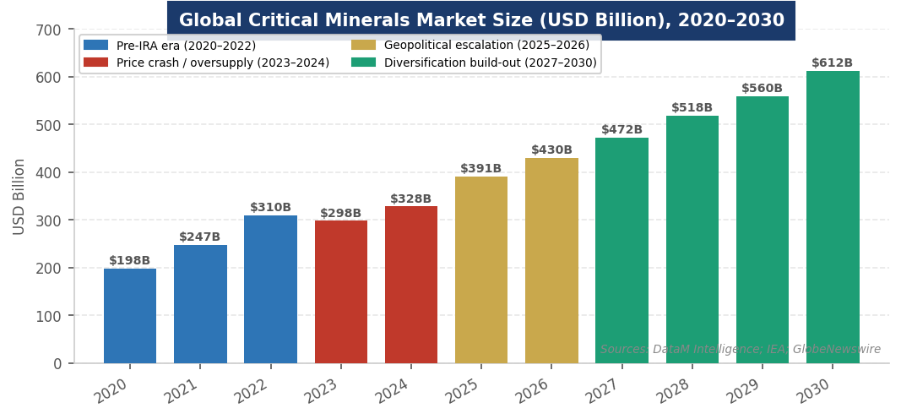
Figure 1. Global critical minerals market size (USD Billion), 2020–2030. Sources: DataM Intelligence; IEA Global Critical Minerals Outlook 2025; GlobeNewswire.
MARKET STRUCTURE & VALUE CHAIN
The critical minerals industry spans a complex, globally fragmented value chain — from geological exploration through mining, processing, refining, and manufacturing into end-use components. Each stage carries distinct risk, margin, and geopolitical exposure profiles that matter enormously for investment analysis.
The Critical Minerals Value Chain (Upstream → Downstream)
1. Exploration & Geology | Geological surveys, drilling, resource estimation. 10–20 year project lead times for new mines. Highest exploration risk. Australia, Canada, and Africa contain the most undeveloped high-quality resources.
2. Mining & Extraction | Open-pit or underground mining of ore bodies. Top producers: DRC (cobalt), Indonesia (nickel), Chile/Australia (lithium), China (REEs, graphite). Capital-intensive; 5–15 year project development timelines.
3. Processing & Refining | Converting raw ore into battery-grade or magnet-grade materials. The most China-dominated stage: China refines ~70–94% of most critical minerals. FEOC restrictions directly target this segment. Largest strategic vulnerability.
4. Cathode / Magnet Manufacturing | Lithium cathode materials (NMC, LFP), rare earth permanent magnets (NdFeB). China produces 94% of sintered NdFeB magnets. South Korea (Samsung SDI, POSCO), Japan (Sumitomo, Shin-Etsu) are key non-China players.
5. Battery & Component Manufacturing | Cell manufacturing (cylindrical, pouch, prismatic). China dominates: CATL (~37% global share), BYD, CALB. Non-China: Panasonic/Tesla, Samsung SDI, LG Energy Solution, SK On. Gigafactory buildout in US/EU accelerating.
6. OEM Assembly | EV manufacturers, wind turbine OEMs, solar panel assemblers, defense contractors. U.S., EU, Japan, China. Deepest in terms of capital and brand value; most insulated from upstream price volatility via long-term contracts.
7. Recycling & Secondary Recovery | Recovering Li, Co, Ni from end-of-life batteries. Growing at 11% CAGR; projected to supply 15–18% of battery material needs by 2032. Key players: Li-Cycle (Glencore JV), Redwood Materials, Umicore, Retriev.

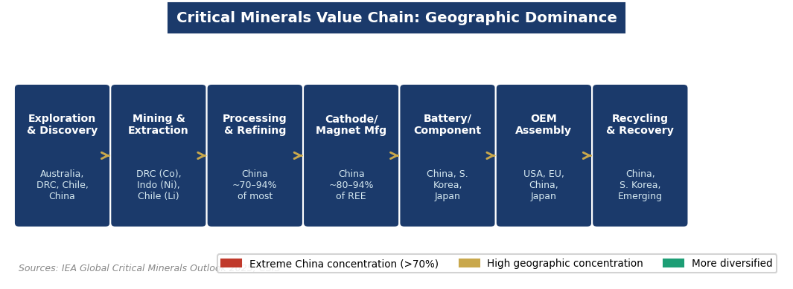
Figure 2. Geographic concentration across the critical minerals value chain. Sources: IEA Global Critical Minerals Outlook 2025; CSIS Critical Minerals Security Program.
Three market segments define critical mineral demand:
- Energy Transition Applications: The dominant and fastest-growing demand segment. EVs (lithium, cobalt, nickel, graphite, copper), battery storage (lithium, nickel, manganese), wind turbines (rare earth magnets, copper), and solar panels (silicon, silver, indium, tellurium). Energy applications account for 85%+ of total demand growth for battery metals since 2020.
- Technology & Defense Applications: Semiconductors (gallium, germanium, indium), defense systems (REEs for guidance, communication, radar), AI hardware (cobalt, tantalum for high-density storage). China's Dec 2024 export restrictions on gallium and germanium directly targeted this segment.
- Traditional Industrial Applications: Stainless steel (nickel), pigments (titanium dioxide), fertilizers (phosphate), and construction (copper for wiring). Lower growth rates but large absolute volumes — copper's grid electrification demand is the single largest absolute volume increase of any critical mineral.

KEY PLAYERS & COMPETITIVE LANDSCAPE
Mining Companies
Company | HQ / Focus | Notes
Glencore | Switzerland | Diversified miner; world's largest cobalt producer; copper, nickel, zinc. Signed recycling JV with Li-Cycle (Feb 2025).
Rio Tinto | UK/Australia | Iron ore, copper, lithium (Rincon, Argentina), aluminium. Acquired Arcadium Lithium ($6.7B, 2024) — largest recent lithium M&A.
BHP | Australia | Copper (#1 focus), nickel (exited 2024 after $3.5B writedown), potash. Jansen potash mine a major capital commitment.
Albemarle | USA | World's largest lithium producer. $1.3B hydroxide capacity expansion. Operations in Chile, Australia, U.S.
MP Materials | USA | Only integrated U.S. rare earth miner and processor; Mountain Pass, CA. DOD contracts for magnet manufacturing.
Lynas Rare Earths | Australia | Largest non-China REE producer; Mt Weld mine + Malaysia refinery. U.S. DoD funded U.S. processing plant (Texas).
Pilbara Minerals | Australia | Major spodumene lithium producer; $500M downstream JV with POSCO for lithium hydroxide (Dec 2024).
Ganfeng Lithium | China | China's largest lithium company; mining in Argentina, Australia, China; dominates Chinese battery supply chain.
CMOC Group | China | Leading cobalt producer (DRC); overtook Glencore as world's largest cobalt miner in 2023.

Processors, Battery Makers & Technology Players
Company | Role / Notes
CATL | World's largest battery manufacturer (~37% market share); Chinese; key supplier to Tesla, VW, BMW. Gigafactory in Hungary.
LG Energy Solution | South Korea; major Li-ion cell maker; JV with GM (Ultium Cells), Honda, Stellantis in U.S. gigafactories.
Panasonic Energy | Japan; Tesla's primary cell partner (Nevada gigafactory); developing next-gen 4680 cells.
Umicore | Belgium; leading battery materials and recycling company; cathode materials + precious metals recycling.
Redwood Materials | USA (founded by JB Straubel, Tesla co-founder); battery recycling and materials recovery; $5B+ raised.
MP Materials / NioCorp | U.S. rare earth processing and magnet manufacturing push; DOD-backed supply chain diversification.
Shin-Etsu Chemical | Japan's largest rare earth magnet maker; key non-China alternative for defense and EV motor applications.
Li-Cycle (Glencore JV) | Canada/global; lithium-ion battery recycler; Glencore partnership provides end-of-life battery feedstock at scale.

Financial Sponsors & Strategic Capital
Critical minerals attract a distinctive mix of capital. Infrastructure and commodities funds (Blackrock, KKR, Brookfield, Trafigura, Mercuria) provide project finance and offtake capital. Strategic investors include auto OEMs (GM's Lithium Americas investment, Toyota's rare earth supply agreements), tech companies (Apple, Tesla direct sourcing agreements), and sovereign wealth funds (Saudi Aramco, ADIA backing mineral processing). The U.S. Development Finance Corporation (DFC), Export-Import Bank, and DOE Loan Programs Office are providing concessional capital to de-risk non-China mineral projects in allied nations. The Climate Investment Funds deployed $810M for mineral projects across 15 countries in 2024.

ANATOMY OF A CRITICAL MINERAL SUPPLY CHAIN
A critical mineral supply chain converts geological resources in the ground into functional components in a product. Understanding each stage's technical requirements, cost structure, and strategic exposure is essential for evaluating investment risk and policy impact.

Stage / Mineral | Key Technical Requirements | Strategic Significance
Lithium (Brine) | Solar evaporation ponds; 12–18 months processing; high water use in Atacama | Chile and Argentina dominate; LiCl → LiCO₃ or LiOH; China refines ~65%+ of global supply; FEOC restriction key risk for U.S. EV manufacturers
Lithium (Hard Rock) | Spodumene ore; crushing, flotation, roasting, acid digestion | Australia dominates mining (Greenbushes, Pilbara); shorter lead time than brine; Albemarle and Pilbara Minerals lead
Cobalt | Co-product of copper or nickel mining; DRC hydrometallurgy; solvent extraction | 70% DRC-sourced; child labor / ESG risks drive automaker direct sourcing agreements; DRC export ban Feb 2025 pressured prices
Nickel (Class 1) | High-purity nickel sulfate for batteries; Indonesia HPAL processing dominates | Indonesia surged to lead global supply via HPAL; Chinese-owned processing plants dominate; BHP exited at $3.5B loss 2024
Rare Earth Elements | Mining → physical separation → hydrometallurgical separation → metal/alloy/magnet | China controls 60–70% mining, ~90%+ separation/refining, 94% sintered NdFeB magnet mfg; most vulnerable critical mineral segment
Graphite (Natural) | Flake graphite mining → spheronization → purification to battery-grade | China produces ~65–70% of natural graphite; restricted exports Nov 2023; synthetic graphite increasingly substituting natural
Copper | Open-pit or underground; flotation → smelting → electrorefining → wire rod | Largest absolute volume; Chile/Peru/DRC/China lead; 30% demand growth by 2040 (IEA NZE) from grid electrification alone
Battery Recycling | Hydrometallurgy (wet) or pyrometallurgy (smelting); black mass processing | Key to reducing virgin mineral dependence; Li-Cycle, Redwood, Umicore lead; expected to cover 15–18% of needs by 2032

How it works: Rock or brine containing mineral-bearing ores is extracted, concentrated, chemically processed into battery-grade or magnet-grade material, and then manufactured into functional components (cathodes, anodes, permanent magnets, wiring). Each chemical transformation step adds value but also requires specialized industrial infrastructure, proprietary chemistry, and significant energy input — which is why China's dominance of processing, not just mining, is the strategically critical bottleneck. A country can have abundant lithium in the ground and still depend entirely on China to convert it into usable battery-grade lithium hydroxide.
GLOBAL GEOGRAPHY & COUNTRY LEADERS
China: The dominant force across the entire value chain. China produces only ~10% of global lithium, cobalt, and copper at the mining stage, but controls 40–90% of processing capacity for almost all critical minerals, 94% of sintered rare earth magnets, and 65%+ of battery cell manufacturing. The IEA confirmed that for 19 of 20 important strategic minerals, China is the leading refiner, with an average 70% market share — a concentration that has increased, not decreased, since 2020. China's 2025 export controls on rare earths represent the most direct deployment of this structural leverage to date.
Democratic Republic of Congo: Home to ~70% of global cobalt production and significant copper reserves in the Copper Belt. The DRC is the single most geographically concentrated critical mineral dependency in the world. ESG risks (artisanal mining, child labor, political instability) and the DRC's February 2025 four-month cobalt export suspension underscore the vulnerability. CMOC (Chinese), Glencore, and Ivanhoe Mines are the major operators.
Chile & Argentina (Lithium Triangle): Together with Bolivia, the Lithium Triangle contains ~60% of global lithium reserves in brines beneath salt flats. Chile's Atacama (SQM, Albemarle) and Argentina's Jujuy/Salta provinces are the primary producers. Argentina's "Lithium Triangle" is experiencing rapid development from Glencore, Rio Tinto, and Allkem. Nationalization risks vary: Chile controversially moved toward state control of Codelco/lithium partnerships in 2023.
Australia: The world's most important non-China critical mineral jurisdiction. Australia leads in lithium (spodumene, 47% of global production), produces significant nickel (though BHP's exit signals project-level challenges), and hosts Lynas Rare Earths — the only large-scale non-China REE producer. Australia's Critical Minerals Strategy and the U.S.-Australia Critical Minerals Agreement are central to Western supply chain diversification.
Indonesia: The world's largest nickel producer (~50% of global supply) and a fast-growing cobalt source through its HPAL (High Pressure Acid Leaching) processing plants — almost entirely owned by Chinese companies. Indonesia's nickel reserves and processing buildout have made it the most important new entrant in critical minerals since 2018, but Chinese-owned infrastructure means Indonesia's nickel often passes through Chinese supply chains even before reaching Western OEMs.
United States: The largest consumer of critical minerals but heavily import-dependent — fully import-reliant for 12 designated minerals and >50% import-dependent for 29 others. Domestic production is concentrated in copper (Arizona, Utah), molybdenum, and lithium brine (Albemarle's Silver Peak, NV). Mountain Pass (MP Materials) is the only U.S. rare earth mine. The IRA, DFC, and DOE Loan Programs are the primary policy tools to rebuild domestic processing capacity.
Africa (Beyond DRC): Kenya, Zambia, Mozambique, Madagascar, and South Africa are emerging critical mineral jurisdictions. Africa hosts ~30% of global critical mineral reserves and is a major focus of both Chinese (Belt and Road) and Western (Lobito Corridor, DFC financing) investment. The EU's Global Gateway and the U.S. Minerals Security Partnership are competing with Chinese infrastructure financing across the continent.
POLITICS, POLICY & REGULATION
Critical minerals are perhaps the most geopolitically sensitive commodity market in the world — intersecting trade policy, national security, industrial strategy, and climate goals simultaneously. Understanding the policy landscape is essential for any finance or strategy role touching energy, defense, or advanced manufacturing.

Key Policy Levers MBA Candidates Must Know
Policy / Lever | What It Means for Critical Minerals
IRA FEOC Restrictions | Bars EVs from $7,500 tax credit if battery contains minerals processed by "foreign entities of concern" (China, Russia, North Korea, Iran). Phasing in 2024–2027. Most consequential U.S. supply chain policy ever enacted for minerals.
Section 45X (Advanced Mfg PTC) | IRA production tax credit for U.S. manufacture of battery cells, modules, electrode active materials, and critical minerals. Key driver of domestic gigafactory and processing investment.
Trump EO Jan 15, 2026 | Adjusting Imports of Processed Critical Minerals: directed Commerce to negotiate allied-country supply agreements; authorized tariffs or minimum import prices if negotiations fail. Signals shift from IRA to trade-based approach.
Trump EO Apr 2025 (Seabed) | Unleashing America's Offshore Critical Minerals: accelerated permitting for U.S. continental shelf and deep seabed mining. Reflects frustration with ISA's failure to establish global seabed mining rules.
China Export Controls | Apr 2025: 7 heavy REEs restricted. Oct 2025: expanded to 12 elements + processing tech + extraterritorial FDPR-style rule. Nov 2025 Busan pause: October measures suspended 1 year. Jan 2026: added REE compounds, silver, tungsten, antimony.
U.S. 2025 Critical Minerals List | 50 minerals designated (updated Nov 2025, adding silver); USGS-managed; triggers federal agency coordination, DFC financing eligibility, and trade remedy authority.
EU Critical Raw Materials Act | Targets 10% domestic extraction, 40% domestic processing, 25% recycling for strategic minerals by 2030. EU Strategic Projects list fast-tracks permitting. Competes with IRA for global investment.
Minerals Security Partnership (MSP) | U.S.-led coalition of 14 countries + EU; coordinates government-backed investment in non-China mineral projects. Announced $1B+ in joint investments 2023–2025.

INDUSTRY TRENDS & TECHNOLOGY INNOVATION
Trend 1: China's Export Controls as the Defining Geopolitical Weapon China's Export Controls as the Defining Geopolitical Weapon
China's 2025 export control escalation — restricting seven, then twelve rare earth elements and processing technology — is the most significant weaponization of mineral supply chains since the 1970s oil embargo. The October 2025 FDPR-style rules, which required export licenses for any foreign product containing Chinese-origin rare earths or manufactured using Chinese technology, extended Chinese regulatory authority across global supply chains. The Busan summit pause was tactical, not structural: China's underlying legal architecture remains intact and can be re-activated without legislative action. For MBA candidates, this is the single most important dynamic to understand: China's mineral processing dominance is now a live geopolitical lever, not just a theoretical risk.
Trend 2: Battery Technology Shifts Reshaping Mineral Demand Battery Technology Shifts Reshaping Mineral Demand
Lithium iron phosphate (LFP) batteries — which use no cobalt and less nickel than NMC chemistries — have surged to ~40% of global EV battery installations, dramatically reducing cobalt demand growth projections. Sodium-ion batteries (no lithium) are entering the market at the low end. Solid-state batteries (Toyota, QuantumScape) promise higher energy density with different material requirements. Each chemistry shift reshuffles the relative importance of minerals and the competitive position of producers — making battery technology tracking as important as commodity price tracking for investment analysis.
Trend 3: Recycling and the Urban Mine Recycling and the Urban Mine
Battery recycling is transitioning from niche to strategic necessity. Secondary recovery is projected to supply 15–18% of global battery mineral demand by 2032, growing at 11% CAGR. Redwood Materials (JB Straubel) has raised $5B+ and operates at gigascale in Nevada. Glencore's partnership with Li-Cycle (Feb 2025) combines mining offtake with recycled material recovery across the full loop. The IEA projects recycling could reduce new mine development needs by 40% for copper and cobalt, and 25% for lithium and nickel by 2050. For investors, recycling assets offer exposure to critical mineral demand without geological risk.
Trend 4: U.S. and Allied Processing Capacity Buildout U.S. and Allied Processing Capacity Buildout
The IRA's FEOC restrictions have created the first financially compelling business case for non-China mineral processing. Lynas's DOD-funded Texas rare earth facility, MP Materials' magnet manufacturing program, and Albemarle's $1.3B lithium hydroxide expansion are the leading U.S. examples. Australia's Arafura Rare Earths and Iluka Resources are building Australian REE processing with Western government support. The EU Critical Raw Materials Act is driving analogous investment in Europe. However, building processing capacity takes 5–10 years, requires proprietary chemistry know-how (largely Chinese-held), and demands large capital commitments during a period of suppressed mineral prices — creating a genuine valley of death for project finance.
Trend 5: Price Volatility as a Structural Investment Challenge Price Volatility as a Structural Investment Challenge
Lithium's 80% price decline since 2022 has created profound tension between policy necessity and market signals. Projects that were financially viable at $70,000/tonne LCE are underwater at $10,000/tonne. This price collapse has led to mine curtailments (Albemarle, Pilbara), project deferrals, and investor reluctance — precisely when policy goals require accelerated investment. The IEA warns that near-term oversupply masks a structural deficit emerging in the 2030s as EV adoption accelerates. Governments are exploring price floor mechanisms, strategic reserves, and long-term offtake guarantees to bridge the gap between market signals and strategic investment needs.
Trend 6: Deep Sea Mining: The Frontier Debate Deep Sea Mining: The Frontier Debate
Polymetallic nodules on the ocean floor contain vast quantities of nickel, cobalt, manganese, and copper — potentially enough to supply global battery demand for decades. The Trump Administration's April 2025 EO directed federal agencies to accelerate U.S. seabed mining permitting, while The Metals Company (TMC) and Norway's Loke Marine Minerals are the leading commercial actors. The International Seabed Authority (ISA) has failed to finalize mining regulations, creating a legal vacuum that the U.S. is now willing to step into unilaterally. Environmental groups oppose seabed mining vigorously, and the scientific community is divided on ecological impacts — making this the most contentious frontier in critical minerals and a live regulatory debate for 2026–2028.

CURRENT NEWS & MARKET DYNAMICS (2025–2026)
Headlines Every Candidate Should Know
- China's Rare Earth Export Control Escalation & Busan Pause: China's Rare Earth Export Control Escalation & Busan Pause: China restricted seven heavy REEs in April 2025; expanded to twelve elements plus processing technology and an FDPR-style extraterritorial rule in October 2025. After the Trump-Xi Busan summit (October 30), Beijing suspended the October measures for one year — but preserved the April controls, the expanded control list, and the underlying legal architecture intact. U.S. manufacturers reported production shutdowns during the summer 2025 license delays despite the official tariff truce.
- Trump Executive Order on Processed Minerals (Jan 15, 2026): Trump Executive Order on Processed Minerals (Jan 15, 2026): Directed Commerce to negotiate supply agreements with allied nations for processed critical minerals; authorized tariffs or minimum import prices if talks fail. CSIS noted the U.S. is "fully import-dependent for 12 critical minerals and reliant on imports for more than half of 29 others." Frames critical minerals as economic statecraft, not just commercial policy.
- Rio Tinto Acquires Arcadium Lithium ($6.7B): Rio Tinto Acquires Arcadium Lithium ($6.7B): The largest lithium M&A transaction in recent years, giving Rio Tinto a major integrated lithium portfolio in Argentina, Canada, and Australia. Signals that major diversified miners are doubling down on lithium despite the price collapse, betting on long-term structural demand.
- DRC Cobalt Export Suspension (Feb 2025): DRC Cobalt Export Suspension (Feb 2025): The DRC announced a four-month suspension of cobalt exports to curb falling prices — a direct intervention in global supply by the country controlling 70% of production. Highlighted how dependent Western battery supply chains remain on a single politically fragile nation.
- BHP's $3.5B Nickel Writedown and Exit: BHP's $3.5B Nickel Writedown and Exit: BHP suspended its Australian nickel operations in 2024, writing down $3.5B, as Indonesian HPAL production (largely Chinese-owned) crushed prices. Signals the difficulty of competing with Chinese-subsidized processing at current commodity prices — even for world-class miners.
- Glencore / Li-Cycle Recycling Partnership (Feb 2025): Glencore / Li-Cycle Recycling Partnership (Feb 2025): Multi-year partnership to recover lithium, cobalt, and nickel from EV batteries at scale — a landmark deal combining the world's largest cobalt miner with North America's largest battery recycler.
- China State Council Order No. 834 (Mar 2026): China State Council Order No. 834 (Mar 2026): China promulgated its first dedicated supply-chain security framework — integrating export controls, countermeasures, data security, and investment screening under a unified national security mandate. Creates whole-of-firm compliance obligations for all entities operating within Chinese jurisdiction.
- U.S. 2025 Critical Minerals List Update: U.S. 2025 Critical Minerals List Update: USGS added 10 minerals including silver (November 2025) — total now 50 designated critical minerals. Silver's addition reflects its use in solar cells, batteries, and defense electronics, and coincided with China's announcement of new silver export controls.

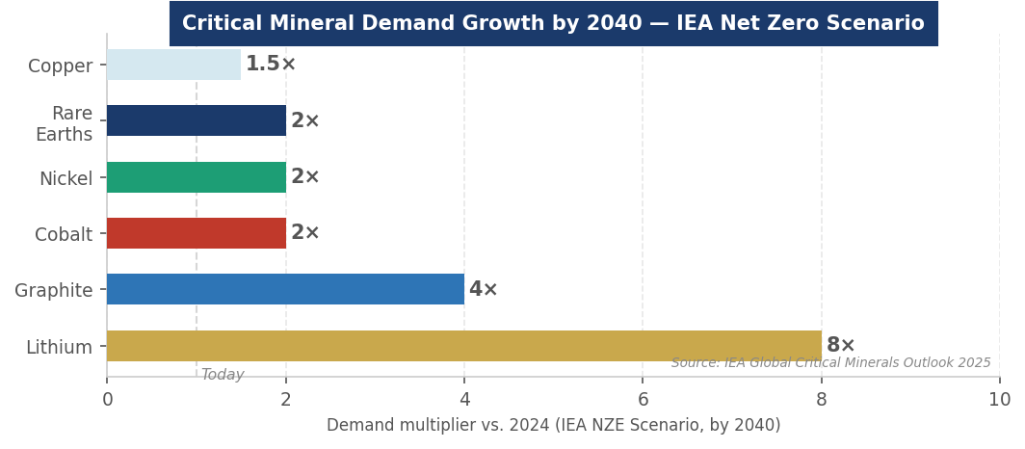
Figure 3. Critical mineral demand growth multipliers by 2040 vs. 2024 (IEA Net Zero Scenario). Source: IEA Global Critical Minerals Outlook 2025.
INVESTMENT, FINANCE & CAREER ANGLES
For MBA candidates pursuing roles in commodities, infrastructure, private equity, or energy, critical minerals sit at the nexus of every major capital allocation theme of the next decade. Understanding the investment landscape — and its unique risks — is essential.

- Commodities & Project Finance: Commodities & Project Finance: Critical mineral mining projects are financed through a combination of equity (sponsor, strategic), senior project debt, streaming agreements, and government-backed loans (DFC, DOE LPO, Export-Import Bank). The key underwriting risk is commodity price — unlike geothermal or wind, critical mineral projects have no PPA equivalent; they sell into spot or long-term offtake markets with significant price volatility. Royalty and streaming structures (Royal Gold, Wheaton Precious Metals-style) are increasingly used to provide downside protection for project developers.
- Private Equity & Growth Equity: Private Equity & Growth Equity: Battery recycling (Redwood Materials, Li-Cycle), processing technology (electrolyte specialists, cathode material makers), and critical mineral software (supply chain traceability, ESG certification platforms) are the most active PE/growth equity sub-segments. FEOC compliance software and mineral provenance tracking are niche but rapidly growing categories as automakers face regulatory deadlines.
- Infrastructure & Strategic Capital: Infrastructure & Strategic Capital: DFC (U.S. Development Finance Corporation), the DOE Loan Programs Office, Australia's Critical Minerals Facility, and the EU's EIB are providing concessional infrastructure capital to mineral projects in allied countries. These blended finance structures — where government capital absorbs first-loss risk — are essential to making non-China projects bankable at current depressed prices. Understanding how to structure and leverage these instruments is a differentiating skill in infrastructure investment roles.
- Venture Capital: Venture Capital: Next-generation mineral extraction (direct lithium extraction, heap leach improvements), battery chemistry startups (solid-state, sodium-ion), and recycling technology are all active VC segments. The DOE's Office of Manufacturing and Energy Supply Chains has funded 100+ pilot projects through 2025. Energy Impact Partners, Breakthrough Energy Ventures, and Prelude Capital are the most active climate-focused VCs in the space.
- Hedge Funds & Commodity Trading: Hedge Funds & Commodity Trading: Critical minerals are increasingly traded on organized exchanges (LME for cobalt, nickel; CME for lithium), and commodity trading firms (Trafigura, Glencore, Mercuria) play a central role in price discovery, logistics, and financing. Commodity macro funds track the battery metals supercycle thesis against price cycle timing — the 2022–2024 price collapse demonstrated the complexity of this timing risk.

Key financial concepts to know: LCOE for downstream applications, LME spot vs. forward curves, streaming and royalty structures, offtake agreements, project finance for mining, DFC and DOE blended finance, FEOC compliance, ESG/supply chain traceability, and IRR thresholds for greenfield mining (typically 15–25% to justify geological and commodity risk).
FUTURE OUTLOOK
Critical minerals face a paradox that will define the industry for the next decade: strategic necessity has never been clearer, but market signals — suppressed prices, Chinese processing dominance, and long project timelines — continue to deter the private investment required to build diversified supply chains. The geopolitical escalation of 2025 has accelerated government intervention, but structural transformation of supply chains takes 10–20 years, not policy cycles.

- Base Case: Base Case: Lithium prices recover modestly to $20,000–30,000/tonne LCE by 2027 as EV demand growth absorbs current oversupply. China retains 70%+ processing dominance but new capacity emerges in Australia, Canada, and allied African nations with government support. FEOC restrictions drive partial reshoring of cathode and magnet manufacturing to the U.S. and EU. Recycling covers 15% of demand by 2030.
- Bull Case: Bull Case: China's export control escalation triggers emergency government investment in Western processing, accelerating the build-out by 5+ years. Direct lithium extraction (DLE) technology matures, unlocking lower-grade resources globally and reducing Chile/Argentina concentration. Battery recycling achieves 25%+ supply coverage by 2032. Market values double to $700B+ by 2035 as IEA NZE pathway unfolds.
- Bear Case: Bear Case: Prolonged low prices deter private investment; U.S. permitting timelines remain 7–10 years for new mines; Chinese processing dominance intensifies. A hard export control re-imposition post-2026 pause triggers supply chain crisis in EV, defense, and semiconductor sectors. The valley of death between policy goals and market economics widens.

The one certainty: the clean energy transition, AI infrastructure buildout, and defense modernization all require critical minerals at a scale that cannot be met without transforming global supply chains. The question is not whether demand will materialize — it will — but whether the West can build the processing and refining capacity to avoid structural dependence on a single geopolitical adversary before the next supply disruption.
INTERVIEW CONVERSATION STARTERS
- "The critical minerals story is fundamentally a processing story, not a mining story. China doesn't control most of the world's lithium or cobalt in the ground — it controls the chemistry to turn raw ore into battery-grade material. That's the bottleneck that's 10 years and billions of dollars to replicate, and that's why FEOC restrictions are both essential policy and a genuine near-term supply chain risk for every EV manufacturer."
- "China's April 2025 rare earth export controls are the geopolitical equivalent of OPEC's 1973 oil embargo — it's the first time a critical input to modern technology has been deliberately restricted as a strategic weapon. The Busan pause is tactical; the underlying legal architecture is permanent. Every board and investment committee should be asking what their rare earth exposure is."
- "The lithium price collapse of 2023–2024 creates a genuine valley of death: we need $500B+ of non-China processing investment over the next decade, but market prices make most projects uneconomical today. That gap only closes with government blended finance — DFC loans, DOE grants, offtake guarantees — which is why understanding development finance instruments is as important as understanding commodity markets for anyone working in this space."
- "Battery recycling is the hidden opportunity. Li-Cycle, Redwood Materials, and Umicore are building the urban mine — recovering lithium, cobalt, and nickel from end-of-life batteries at costs that compete with virgin mining, without geological risk. By 2032, recycling could cover 15–18% of battery material demand. For infrastructure investors, it's the critical mineral exposure with the best risk-adjusted return profile."

REFERENCES
High-Quality Sources Used in This Primer
Government & Intergovernmental Organizations
[1] International Energy Agency (IEA). "Global Critical Minerals Outlook 2025." Paris: IEA, 2025. https://www.iea.org/reports/global-critical-minerals-outlook-2025
[2] International Energy Agency (IEA). "With New Export Controls on Critical Minerals, Supply Concentration Risks Become Reality." IEA Commentary, 2025. https://www.iea.org/commentaries/with-new-export-controls-on-critical-minerals-supply-concentration-risks-become-reality
[3] U.S. Geological Survey (USGS). "2025 Critical Minerals List." November 2025. https://www.usgs.gov/news/national-news-release/usgs-releases-2025-list-critical-minerals
[4] U.S. Department of Energy (DOE). "Pathways to Commercial Liftoff: Critical Materials." Washington D.C.: DOE, 2024.
[5] Climate Investment Funds (CIF). "Geothermal & Critical Minerals Investment Portfolio 2024." Washington, D.C.: CIF, 2024.
Policy Analysis & Think Tanks
[6] CSIS. "New Executive Order Ties U.S. Critical Minerals Security to Global Partnerships." March 2026. https://www.csis.org/analysis/new-executive-order-ties-us-critical-minerals-security-global-partnerships
[7] CSIS. "China's New Rare Earth and Magnet Restrictions Threaten U.S. Defense Supply Chains." October 2025. https://www.csis.org/analysis/chinas-new-rare-earth-and-magnet-restrictions-threaten-us-defense-supply-chains
[8] Wilson Center. "Critical Minerals Strategy under the Trump Administration." April 2026. https://www.wilsoncenter.org/article/critical-minerals-strategy-under-trump-administration-progress-contradictions-and-road
[9] ODI. "Critical Minerals Geopolitics in 2026: Risks, Supply Chains and Global Power Shifts." 2026. https://odi.org/en/insights/critical-minerals-geopolitics-in-2026-risks-supply-chains-and-global-power-shifts/
[10] Andersen Institute. "China's Export Control Architecture and Its Use of Critical Minerals as Strategic Pressure Points." April 2026. https://anderseninstitute.org/chinas-export-control-architecture
Industry Research & Market Data
[11] DataM Intelligence. "Critical Minerals Market Size, Outlook and Report 2026–2033." November 2025. https://www.datamintelligence.com/research-report/critical-minerals-market
[12] Supply Chain Dive. "U.S. Releases 2025 List of Critical Minerals, Featuring 10 Additions." November 2025. https://www.supplychaindive.com/news/usgs-releases-2025-list-of-us-essential-minerals/805364/
[13] Clark Hill PLC. "China Hits 'Pause' on Rare-Earth Export Controls." November 2025. https://www.clarkhill.com/news-events/news/china-hits-pause-on-rare-earth-export-controls-and-what-it-means-for-supply-chains/
[14] CNBC. "China to Restrict Silver Exports, Echoing Rare Earths Playbook." December 2025. https://www.cnbc.com/2025/12/31/china-silver-export-controls-2026-us-economy-prices-rare-earths-critical-minerals-xag-metals.html
[15] GlobeNewswire. "Critical Minerals and Rare Earth Elements Ignites Multi-Billion-Dollar Opportunity." April 2026. https://www.globenewswire.com/news-release/2026/04/29/3283758/
Legislation & Regulatory Texts
[16] 117th U.S. Congress. "Inflation Reduction Act of 2022" (Pub. L. 117-169). Signed August 16, 2022. https://www.congress.gov/bill/117th-congress/house-bill/5376
[17] Executive Office of the President. "Adjusting Imports of Processed Critical Minerals and Their Derivative Products into the United States." Executive Order, January 15, 2026.
[18] Executive Office of the President. "Unleashing America's Offshore Critical Minerals and Resources." Executive Order, April 2025.
[19] Chinese Ministry of Commerce (MOFCOM). Announcements No. 18, 46, 61, 70, 72 (2025) on Rare Earth and Critical Mineral Export Controls.
[20] State Council of the People's Republic of China. "Provisions on the Security of Industrial and Supply Chains." Order No. 834, March 31, 2026.

Disclaimer: This document is prepared for educational purposes as part of an MBA classroom exercise. Market data reflects conditions as of April 2026 and is sourced from publicly available materials. It does not constitute investment advice.

