GEOTHERMAL ENERGY
MBA Industry Primer | Energy & Infrastructure
Columbia Business School | April 2026

INDUSTRY AT A GLANCE
Geothermal energy is the original always-on renewable — tapping the Earth's internal heat to generate electricity and provide heating and cooling with no fuel cost, no weather dependency, and a carbon footprint a fraction of fossil fuels. For MBA candidates, geothermal sits at the intersection of resource extraction technology, infrastructure finance, and clean energy policy. The industry is undergoing its most significant transformation since the 1970s: Enhanced Geothermal Systems (EGS) technology, borrowed from oil and gas drilling, is unlocking geothermal resources essentially everywhere — not just near volcanoes — triggering a wave of private capital, hyperscaler procurement, and regulatory attention that may define the industry for the next two decades.

Key Metric | Data Point (2025)
Global Geothermal Power Market | ~$7.8–9.8B (2024); consensus CAGR ~5–7% to 2034; broader market incl. heat pumps ~$74B
Global Installed Capacity (2024) | ~16 GW electricity; ~107 GWth direct heat use — base-load, 24/7 output
U.S. Installed Capacity | ~3.9 GW — world's largest; California (~2.8 GW), Nevada, Utah lead
Top Countries by Power Output | USA, Indonesia (2.8 GW), Philippines (1.9 GW), Turkey (1.7 GW), Kenya, Iceland
Capacity Factor | 80–95% — highest of any renewable; surpasses wind (~35%), solar (~25%)
Next-Gen EGS Pipeline (U.S.) | 984 MWe under PPA as of June 2025; Fervo Cape Station: 500 MW by 2028
Private Capital (2021–2025) | $1.5B+ invested in next-gen geothermal companies; Fervo raised $973M
Key Technology Shift | EGS: horizontal drilling + hydraulic fracturing unlocks geothermal anywhere
Primary U.S. Federal Incentive | ITC/PTC under IRA (2022); DOE FORGE research program; Geothermal Energy Optimization Act (2024)
Key Demand Driver 2025–2026 | AI data center procurement: Google 265 MW, Meta 150 MW from EGS sources

HISTORY & ORIGINS
Geothermal energy is among humanity's oldest energy sources — hot springs have been used for bathing and cooking for millennia across Iceland, Japan, Italy, and New Zealand. The modern era of electricity generation from geothermal heat began in Larderello, Italy in 1904, where Piero Ginori Conti demonstrated that steam from naturally occurring underground reservoirs could power electric generators. That same Larderello field still operates today.
1960s–1980s: The Geysers and the First Wave. The United States pioneered large-scale geothermal power at The Geysers in California — the world's largest geothermal complex, first commissioned in 1960 and peaking at ~2,000 MW in the mid-1980s. The 1970s oil crises triggered major investment in geothermal as an alternative to imported oil. The Philippines, Indonesia, Mexico, New Zealand, and Iceland developed significant base-load geothermal capacity during this period, driven by abundant volcanic resources and energy security motivations.
1990s–2000s: Plateau and Stagnation. Growth slowed as The Geysers experienced reservoir depletion from over-extraction and low natural gas prices made other options more attractive. The industry consolidated around hydrothermal resources in a handful of geologically privileged countries. Investment was modest and the technology changed little. The key constraint was geography: conventional geothermal required specific geological conditions — volcanic hotspots, naturally permeable rock, and accessible steam — limiting deployment to Iceland, East Africa, Indonesia, and the U.S. West.
2000s–2018: Binary Cycle Expansion and Ormat’s Rise. 2000s–2018: Binary Cycle Expansion and Ormat's Rise. The commercialization of binary cycle technology — which uses lower-temperature geothermal fluid to vaporize a secondary working fluid that drives a turbine — expanded the geographic and temperature range of deployable resources. Ormat Technologies, founded in Israel and listed on NYSE, emerged as the global leader in binary cycle plant design, manufacturing, and operation. Turkey and East Africa (particularly Kenya's Olkaria complex) became major new deployment regions. Direct use of geothermal heat for district heating expanded significantly in Europe and China.
2019–2022: The EGS Breakthrough and IRA Inflection. Enhanced Geothermal Systems (EGS) — which create man-made reservoirs by hydraulically fracturing impermeable hot rock — shifted from academic concept to field demonstration. The DOE's FORGE project in Utah and Fervo Energy's Project Red in Nevada demonstrated that EGS could work at commercial scale. The Inflation Reduction Act (2022) extended the Investment Tax Credit to geothermal, treating it equivalently with solar and wind for the first time, and funded the DOE's geothermal liftoff initiative with ~$165M.
2023–2026: Commercial Liftoff. Google became the first company to receive power from a commercial EGS project (Fervo's Project Red, Nevada) in 2023 — a landmark validation. Fervo secured $973M in cumulative financing for Cape Station (Utah), targeting 100 MW online in 2026 and 500 MW by 2028. Meta signed agreements with XGS Energy and Sage Geosystems. Princeton's 2025 Joule study found EGS could supply 20% of U.S. electricity by 2050. The DOE projects EGS costs below $70/MWh by 2030. The industry has entered its most significant growth phase since the 1970s.

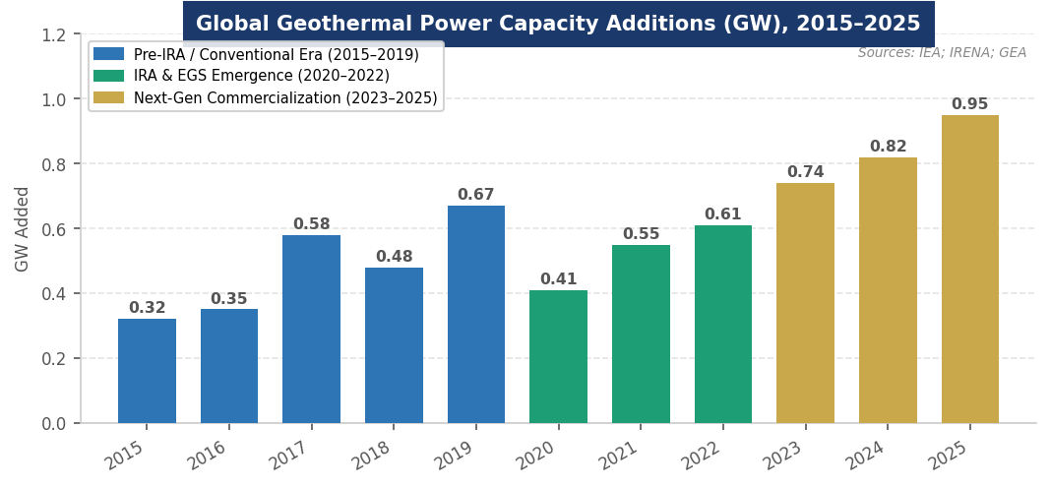
Figure 1. Global geothermal power capacity additions (GW), 2015–2025. Sources: IEA; IRENA; Geothermal Energy Association.
MARKET STRUCTURE & VALUE CHAIN
The geothermal industry has a more vertically integrated value chain than most energy sectors, driven by the resource-specific nature of each project. Understanding it is critical for any finance or infrastructure role, as cost, risk, and margin profiles differ dramatically across the chain.
The Geothermal Value Chain (Upstream → Downstream)
1. Exploration & Resource Assessment | Geological, geophysical, and geochemical surveys; temperature gradient drilling. Highest technical risk; 2–4 years; outcomes binary (viable or not). Traditional geothermal only. EGS bypasses most of this.
2. Well Development & Drilling | Production and injection wells drilled to 1.5–5 km depth. Largest single cost item (40–60% of project CapEx). EGS incorporates horizontal drilling and hydraulic fracturing from oil & gas — key cost reduction lever.
3. Surface Equipment & Turbines | Separators, heat exchangers, turbines, generators. Binary cycle OEMs: Ormat (USA), Turboden (Italy), Exergy (Italy). Flash/dry steam turbines: Mitsubishi, Toshiba, Fuji, GE. Most capital efficient part of the chain.
4. EPC & Plant Construction | Engineering, procurement, and construction. Specialized contractors with geothermal experience. Projects typically 3–5 years from resource confirmation to commissioning (EGS: potentially 18 months).
5. Power Sales & PPAs | Long-term (20–25 yr) power purchase agreements with utilities or direct corporate buyers. Geothermal's base-load profile commands premium pricing vs. intermittent sources.
6. Operations & Maintenance | Ongoing well management, fluid chemistry monitoring, turbine maintenance. Lower OpEx than fossil fuels (~$0.01–0.02/kWh). Re-injection of produced fluid sustains reservoir.
7. Asset Ownership | Utilities (Calpine, CalEnergy), IPPs (Ormat, Terra-Gen), infrastructure funds, and government utilities in developing countries. 30–40 year asset lives typical.

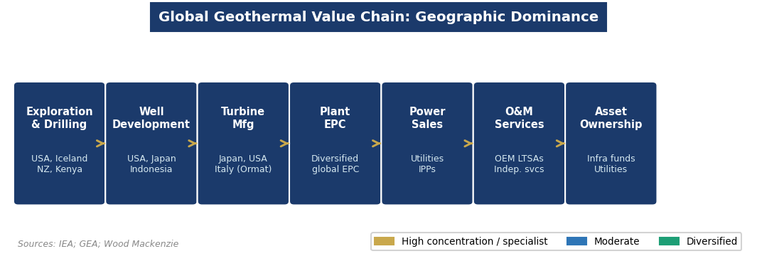
Figure 2. Geographic concentration across the geothermal value chain. Sources: IEA; GEA; Wood Mackenzie.
Three market segments define geothermal deployment:
- Geothermal Power Generation: Base-load electricity from hydrothermal and EGS resources. Dominant segment by revenue. Utility-scale projects (5–500+ MW) sell power via long-term PPAs. LCOE: $60–100/MWh for conventional hydrothermal; $70–120/MWh for early EGS, declining rapidly.
- Direct Use & District Heating: Low-temperature geothermal fluid used directly for space heating, agricultural drying, fish farming, and industrial processes. Dominant in Iceland (>90% of space heating), China, and growing in Germany and Turkey. Avoids electricity conversion losses.
- Geothermal Heat Pumps (GHPs): Ground-source heat pumps using shallow-earth temperature stability (~10–16°C). Fastest-growing segment globally; applicable nearly everywhere regardless of geothermal gradient. Residential and commercial HVAC. Largest segment by total units installed.

KEY PLAYERS & COMPETITIVE LANDSCAPE
Turbine & Equipment OEMs
Company | HQ | Notes
Ormat Technologies | USA (NYSE: ORA) | Vertically integrated: designs, manufactures, owns, and operates plants. Leader in binary ORC technology. Acquired Enel GP North America geothermal assets ($271M, 2024). ~900 MW owned/operated.
Mitsubishi Power | Japan | Dominant in flash steam turbines for large hydrothermal plants in Indonesia, Philippines, Japan. Partners with NZ on EGS technology development (2024).
Toshiba Energy Systems | Japan | Major flash steam and binary turbine supplier; key player in Philippines, Japan, Kenya. Long-term track record in large-scale plants.
Fuji Electric | Japan | High-efficiency steam turbines for geothermal; active in Philippines, Japan, and East Africa. Known for reliability in demanding geothermal environments.
Exergy International | Italy | Leader in Radial Outflow Turbine (ROT) binary technology; contracts in Turkey and Italy (2024). Innovative ORC design improving efficiency at moderate temperatures.
Turboden (Baker Hughes) | Italy/USA | ORC binary systems for low-temperature resources; acquired by Baker Hughes. Expanding globally for waste heat and geothermal applications.
GE Vernova | USA | Flash steam turbines; geothermal is a smaller part of a broader power portfolio. Active in East Africa and Central America.

Developers, IPPs & Next-Generation Players
Company | Role / Notes
Fervo Energy | Market leader in commercial EGS. $973M raised (2021–2025). Cape Station: 100 MW (2026) → 500 MW (2028) → permitted to 2 GW. PPA with Google (115 MW via NV Energy) and Southern California Edison (320 MW).
Calpine / CalEnergy | Largest U.S. geothermal operator; ~725 MW at The Geysers (CA) and Salton Sea (CA). Owned by Energy Capital Partners.
Terra-Gen Power | Operates Coso geothermal complex in California (~240 MW). Infrastructure fund-backed IPP with hydrothermal assets.
Pertamina Geothermal | Indonesia state-owned; world's largest single geothermal operator by capacity. Target: 5 GW by 2030. Partnerships with Ormat, Mitsubishi.
KenGen | Kenya's state utility; operates Olkaria complex (~870 MW) — Africa's largest geothermal installation. Target: 5 GW by 2030.
Eavor Technologies | Canadian closed-loop geothermal (no fracking needed). $387M equity raised. Pilot plants in Germany and Alberta. Backed by BP Ventures, Chevron, Temasek.
Quaise Energy | MIT spinout; millimeter-wave drilling (vaporizes rock). 250 MW agreement for AI campus (Newberry, USA). Still pre-commercial.
XGS Energy / Sage Geosystems | Next-gen EGS players. Meta signed 150 MW deal with XGS; Sage backed by Breakthrough Energy Ventures for hybrid approach.

Financial Sponsors & Strategic Investors
Geothermal's stable, base-load cash flows attract infrastructure-style capital. Breakthrough Energy Ventures (Gates) has invested in Fervo, XGS, and Quaise. Prelude Capital and Mercuria provided project finance for Cape Station alongside Breakthrough Energy Catalyst ($100M). Chevron, BP Ventures, and Temasek backed Eavor. Google, Microsoft, and Meta are strategic capital providers through long-term PPAs and direct equity — accelerating commercialization timelines. The Climate Investment Funds allocated $810M across 15 countries for geothermal in 2024, targeting 3,505 MW.

ANATOMY OF A GEOTHERMAL POWER PLANT
A geothermal power plant converts heat stored in the Earth's crust into electricity. Understanding its physical components — from the reservoir deep underground to the transmission line — provides the foundation for evaluating technology risk, capital cost drivers, and O&M complexity.

Component | Key Specs | Strategic Significance
Geothermal Reservoir | High-temp rock/fluid 1.5–5 km depth; 150–350°C+ | The fundamental resource. Hydrothermal: naturally permeable. EGS: man-made via hydraulic fracturing. Resource quality determines LCOE and project viability.
Production Wells | 1–3 km deep (conventional); 3–5 km (EGS); horizontal or vertical | Largest CapEx item (40–60% of total). EGS uses oilfield drilling techniques (rotary steerable, MWD) to reduce costs. Key innovation frontier.
Injection Wells | Returns cooled water to reservoir | Sustains reservoir pressure and longevity. Critical for avoiding depletion (The Geysers lesson). Typically 1 injection well per 2–3 production wells.
Flash Separator | Reduces pressure, flashing brine to steam | Used in high-temp (>180°C) resources. Single or double flash. Toshiba, Mitsubishi, GE supply turbines. Most efficient for high-enthalpy resources.
Binary Cycle ORC Unit | Heat exchanger + organic working fluid turbine | Enables use of 100–180°C resources — far more geographically abundant. Ormat, Exergy, Turboden lead. Sealed system — zero water/steam emissions.
Cooling System | Air-cooled or water-cooled condensers | Air-cooled preferred in water-scarce regions. Water-cooled more efficient. Key design variable affecting plant output in hot climates.
Brine Re-injection System | Surface pipes returning fluid to injection wells | Maintains reservoir productivity; prevents surface subsidence; enables closed-loop fluid management essential for EGS sustainability.
SCADA / Monitoring | Real-time reservoir pressure, temp, chemistry monitoring | AI integration increasing rapidly: predictive scaling prevention, optimal injection rates, turbine performance optimization.

How it works: Hot water and/or steam rises from a geothermal reservoir through production wells. In flash plants, pressure reduction flashes liquid to steam that directly drives turbines. In binary plants, hot fluid heats a secondary working fluid (pentane, isobutane) that vaporizes and drives a turbine. Both produce AC electricity via a generator. Cooled fluid is re-injected to sustain the reservoir. Capacity factors of 80–95% result from the constant availability of subsurface heat — independent of weather, time of day, or season.
GLOBAL GEOGRAPHY & COUNTRY LEADERS
United States: The world's largest geothermal power producer, with ~3.9 GW of installed capacity concentrated in California (The Geysers, Salton Sea), Nevada, and Utah. The U.S. is also the global leader in next-generation EGS deployment, with 58 active development prospects across nine states (mostly Nevada) and Fervo's Cape Station in Utah representing the world's most advanced commercial EGS project. DOE projects 90 GW of EGS capacity could be economically built in the U.S. by 2050.
Indonesia: The world's second-largest producer (~2.8 GW installed), with a target of 5 GW by 2030. Located along the Pacific Ring of Fire with enormous untapped resources. State utility Pertamina Geothermal Energy leads development, with international partnerships with Ormat and Mitsubishi. Government policy explicitly prioritizes domestic geothermal as a path to reducing coal dependence.
Philippines: ~1.9 GW installed — one of the world's highest geothermal shares of total electricity (~17%). First Gen Corporation and AP Renewables are the major operators. The Philippines is the fastest-growing Asia-Pacific market (projected 33% CAGR 2025–2032) as the government aggressively expands renewable capacity.
Turkey: ~1.7 GW installed and the fastest-growing geothermal market in Europe (29% CAGR). Located on the Anatolian tectonic plate with abundant high-temperature resources. A strong domestic OEM ecosystem (Exergy supplied multiple Turkish projects in 2024) and favorable government support have made Turkey one of the world's most dynamic geothermal markets.
Kenya: Africa's geothermal leader with ~870 MW at the Olkaria complex in the Rift Valley, operated by KenGen. Kenya derives over 40% of its electricity from geothermal — one of the highest shares globally. Target: 5 GW by 2030. The Rift Valley is among the world's best geothermal resources and is also drawing investment for direct-use applications.
Iceland: Though a small country (~370 MW installed for power), Iceland is the global proof-of-concept: 66% of all primary energy comes from geothermal, including ~90% of space heating. Iceland exports geothermal expertise globally and is pioneering supercritical/superhot rock research (the IDDP boreholes).
New Zealand & Japan: Both are advanced geothermal markets with strong OEM expertise. New Zealand (~1.0 GW) uses geothermal for ~17% of electricity. Japan (~600 MW) has vast untapped resources but restrictive regulations around national parks — a political debate that continues in 2025–2026.
POLITICS, POLICY & REGULATION
Geothermal's policy environment is significantly more favorable than wind or solar in most markets — it produces zero intermittency, uses minimal land, and has strong bipartisan appeal as a domestic, base-load energy source. However, it faces unique regulatory challenges around drilling permitting, national park restrictions, and seismic risk management.

Key Policy Levers MBA Candidates Must Know
Policy / Lever | What It Means for Geothermal
ITC/PTC (IRA, 2022) | 30% Investment Tax Credit and Production Tax Credit extended to geothermal under the IRA for the first time at parity with solar and wind. Key enabler of EGS project finance. Credit transferability expanded investor pool.
DOE FORGE Program | Frontier Observatory for Research in Geothermal Energy — DOE-funded R&D facility in Utah driving EGS drilling cost reductions. $165M+ committed through 2025. Direct pipeline to commercial projects.
Geothermal Energy Optimization Act (2024) | Bipartisan legislation permitting geothermal projects on public lands; streamlines federal permitting; drew significant investor interest toward U.S. federal land projects.
DOE Liftoff Report | "Pathways to Commercial Liftoff: Next-Generation Geothermal Power" (2024) — official DOE endorsement of EGS commercialization pathway. Signals policy support and de-risks institutional capital.
Japan National Park Rules | Current regulations prohibit drilling in national parks, where ~80% of Japan's best geothermal resources are located. Ongoing political debate; partial exemptions granted for small-scale projects. A major unlockable resource.
Indonesia Geothermal Law | Dedicated geothermal legislation treating it separately from mining (removing a major barrier). PLN procurement targets and government guarantees driving investment. International Development Finance Corp. active.
Kenya PIEA / KenGen Policy | Public-private partnership framework attracting climate finance (IFC, World Bank, CIF) to Rift Valley projects. KenGen target of 5 GW by 2030 anchors long-term procurement.
FERC Interconnection | Same interconnection queue bottleneck as wind and solar in the U.S. — but geothermal's firm, predictable output makes it far more valuable per MW of queue position.

INDUSTRY TRENDS & TECHNOLOGY INNOVATION
Trend 1: Enhanced Geothermal Systems: From Pilot to Commercial Enhanced Geothermal Systems: From Pilot to Commercial
EGS is the defining technological transformation in geothermal — the equivalent of shale's revolution in oil and gas. By combining horizontal drilling, multi-stage hydraulic fracturing, and precise reservoir engineering (all borrowed from the upstream O&G industry), EGS creates man-made geothermal reservoirs in hot, dry, impermeable rock that exists virtually everywhere at sufficient depth. Google's receipt of power from Fervo's EGS project in Nevada (2023) was the commercial proof point. Princeton's 2025 analysis found EGS could supply 20% of U.S. electricity by 2050 at costs competitive with nuclear. The DOE projects average EGS costs below $70/MWh by 2030, making it cost-competitive with combined-cycle gas.
Trend 2: AI Data Centers as the Anchor Tenant AI Data Centers as the Anchor Tenant
Hyperscalers need massive, 24/7, clean power — and geothermal is uniquely positioned to provide it. Unlike solar or wind, geothermal delivers base-load power with a capacity factor of 80–95%, eliminating the need for storage. Google (115 MW from Fervo via NV Energy + 150 MW from Ormat), Meta (150 MW from XGS Energy in New Mexico), and Quaise's 250 MW agreement for an AI campus demonstrate that tech companies are willing to underwrite and de-risk next-generation geothermal technology to secure their energy supply. This corporate procurement is accelerating commercialization faster than any government program.
Trend 3: Superhot Rock and Closed-Loop Systems: The Next Frontier Superhot Rock and Closed-Loop Systems: The Next Frontier
Beyond EGS, two technologies are advancing toward demonstration. Superhot rock (SHR) geothermal taps temperatures above 400°C — reaching supercritical water — which could produce 5–10x more energy per well than conventional EGS. Quaise Energy is developing millimeter-wave drilling (using modified fusion reactor technology) to reach SHR depths economically. Closed-loop geothermal systems (pioneered by Eavor Technologies) circulate a proprietary fluid through sealed underground loops without reservoir stimulation — eliminating induced seismicity concerns and enabling deployment without fracking.
Trend 4: Oilfield Technology Transfer Driving Drilling Cost Reduction Oilfield Technology Transfer Driving Drilling Cost Reduction
Drilling costs account for 40–60% of geothermal project CapEx — and they are falling rapidly due to technology transfer from oil and gas. Rotary steerable systems, measurement-while-drilling (MWD), polycrystalline diamond compact (PDC) drill bits, and cementing techniques developed for shale are being adapted for hard, hot crystalline rock. Fervo's Cape Station drilling campaigns demonstrated 2–4x improvement in rates of penetration versus early EGS pilots. The DOE projects that standardized, repeatable EGS well construction will drive costs below $5M per well by 2030, down from $10–15M today.
Trend 5: Geothermal for Heat: District Heating Renaissance Geothermal for Heat: District Heating Renaissance
Direct-use geothermal heat is experiencing a renaissance in Europe as countries seek to reduce dependence on Russian gas. Munich's Stadtwerke launched the largest European geothermal district heating project in 2024 — serving 80,000 households. The Netherlands, Denmark, France, and Germany are expanding geothermal district heating networks. This segment is less capital intensive than power plants, has lower technical risk (lower temperatures), and can achieve economics at resources inaccessible for power generation. For MBA candidates, this is an underappreciated growth market in European infrastructure investing.
Trend 6: AI and Digital Twins for Reservoir Management AI and Digital Twins for Reservoir Management
Geothermal operators are deploying machine learning and digital twin technology to optimize reservoir management — the most complex and risk-laden aspect of operations. AI platforms predict scaling (mineral precipitation) in wells before it reduces output, optimize injection rates to sustain reservoir pressure, and improve turbine dispatch efficiency. Given that reservoir degradation is the primary long-term risk to geothermal asset value (The Geysers depletion from the 1980s being the cautionary tale), AI-enabled reservoir intelligence is becoming a key differentiator in asset management and a value driver in infrastructure M&A.

CURRENT NEWS & MARKET DYNAMICS (2025–2026)
Headlines Every Candidate Should Know
- Fervo Cape Station Financing ($206M, June 2025): Fervo Cape Station Financing ($206M, June 2025): Fervo closed $206M in additional financing for Cape Station — including $100M from Breakthrough Energy Catalyst — to advance Phase I (100 MW, 2026) and Phase II (400 MW, 2028). Total Fervo fundraise reached $973M. Cape Station is permitted to expand to 2 GW — the world's largest EGS development.
- Google Signs 265 MW of Geothermal PPAs: Google Signs 265 MW of Geothermal PPAs: Google contracted 115 MW from Fervo (via NV Energy, Nevada) and 150 MW from Ormat Technologies — both to power Nevada data centers. Google is now the world's largest corporate buyer of geothermal power, validating both conventional and next-gen EGS at scale.
- Meta’s 150 MW EGS Deal: Meta's 150 MW EGS Deal: Meta signed a 150 MW power agreement with XGS Energy's closed-loop system in New Mexico to power AI infrastructure. Meta separately backed Sage Geosystems' hybrid EGS approach — the first major tech company to underwrite multiple next-generation geothermal technologies simultaneously.
- Princeton EGS Study (Joule, 2025): Princeton EGS Study (Joule, 2025): Princeton researchers published that EGS could supply 20% of U.S. electricity by 2050 and emerge as the third most significant clean energy technology behind wind and solar, if costs follow learning-curve trends observed in other energy technologies.
- U.S. Geothermal Market Report (2025): U.S. Geothermal Market Report (2025): As of June 2025, 984 MWe of next-generation geothermal capacity is under PPA in the U.S. across 11 contracts — compared to near-zero just three years ago. $1.5B+ in private capital invested in next-gen geothermal companies since 2021.
- Munich District Heating: Munich District Heating: Stadtwerke München launched the largest geothermal district heating project in Europe, serving 80,000 households in 2024. Signals that European geothermal is increasingly focused on direct heat rather than power, where economics are stronger.
- CIF $810M for Emerging Markets: CIF $810M for Emerging Markets: Climate Investment Funds allocated $810M for geothermal investments across 15 countries in 2024 — $414M in Asia (2,200 MW target), $194M in Latin America, $125M in Africa, $74M in Europe/Central Asia. DFI capital is critical for geological risk mitigation in frontier markets.
- Geothermal Energy Optimization Act (2024): Geothermal Energy Optimization Act (2024): Bipartisan U.S. legislation permitting geothermal projects on public lands, removing a key barrier to federal land development and expanding the resource base for U.S. developers.

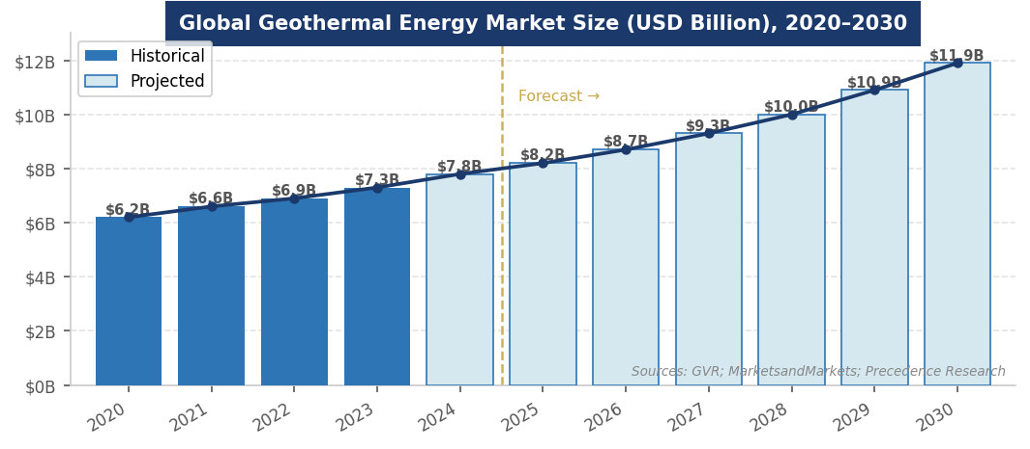
Figure 3. Global geothermal energy market size forecast, 2020–2030 (USD Billion). Sources: GVR; MarketsandMarkets; Precedence Research.
INVESTMENT, FINANCE & CAREER ANGLES
For MBA candidates pursuing energy, infrastructure, and investing roles, geothermal intersects with multiple finance functions — and is increasingly relevant as AI-driven power demand makes base-load renewables strategically critical.

- Project Finance: Project Finance: Geothermal projects are financed through non-recourse or limited-recourse project finance structures anchored by long-term PPAs. The capital stack typically includes 50–60% senior debt, ITC tax equity (30%), and 15–25% sponsor equity. The primary risk at the debt underwriting stage is resource risk — the possibility that the reservoir underperforms. Geological risk insurance (offered by Munich Re, Swiss Re) and proven pilot wells are key de-risking tools.
- Infrastructure Investing: Infrastructure Investing: Operating geothermal assets exhibit the strongest cash flow characteristics of any renewable — base-load output, 30–40 year asset life, low OpEx, and PPA-anchored revenue. Infrastructure funds (Brookfield, Macquarie, KKR) have historically underweighted geothermal due to geological risk and geographic concentration; EGS changes both constraints. Typical unlevered IRR targets: 8–12% for conventional assets; 12–18% for next-gen EGS given technology risk premium.
- Venture Capital & Growth Equity: Venture Capital & Growth Equity: EGS and next-gen geothermal represent the most active VC segment in the space. Fervo ($973M), Eavor ($387M equity), Quaise, XGS Energy, and Sage Geosystems have all raised significant rounds. Breakthrough Energy Ventures, Prelude Capital, and strategic investors (BP, Chevron, Google) are the most active. Technology risk is high but the prize — firm, clean power at any location — is enormous.
- Corporate Strategy & Energy Procurement: Corporate Strategy & Energy Procurement: Tech companies are signing geothermal PPAs as a premium, base-load complement to their solar/wind portfolios — geothermal delivers the 'firm' carbon-free power that solar and wind cannot. Corporate sustainability and energy procurement roles at hyperscalers now require deep understanding of PPA structuring, technology risk, and grid integration for geothermal.
- Development Finance: Development Finance: DFIs (World Bank, IFC, EBRD, ADB) and climate finance vehicles (GCF, CIF) are critical in frontier markets (Kenya, Ethiopia, Indonesia, Philippines) where sovereign risk and resource uncertainty require concessional capital to achieve bankability. The CIF Scaling Up Renewable Energy (SREP) program and IFC's geothermal facility are key instruments.

Key financial concepts to know: LCOE, resource risk, geological risk insurance, capacity factor, PPA tenor, ITC/PTC transferability, DSCR, unlevered IRR, concessional capital, and blended finance structures.
FUTURE OUTLOOK
Geothermal energy is at an inflection point more significant than any since The Geysers era. The combination of EGS technology maturation, AI-driven power demand, and favorable policy has created conditions for the industry's first major growth phase in four decades. The structural advantage is unique: geothermal is the only renewable that provides base-load, 24/7, zero-carbon power without storage — a capability worth a substantial premium in a grid increasingly stressed by variable renewables.

- Base Case: Base Case: Global geothermal power market grows from ~$7.8B (2024) to ~$12–14B by 2034 (CAGR ~5–6%). U.S. EGS additions reach 2–5 GW by 2030 as Cape Station and follow-on projects demonstrate commercial replicability. International expansion in Indonesia, Kenya, and Philippines continues under DFI support. Corporate PPA demand from hyperscalers sustains premium pricing for firm geothermal power.
- Bull Case: Bull Case: EGS drilling costs fall to $5M per well by 2030 (DOE target achieved); Princeton's 250 GW deployment scenario becomes plausible. Hyperscaler demand pulls forward 10+ GW of U.S. EGS capacity by 2035. DOE projects 90 GW by 2050 — geothermal emerges as the third major clean energy technology behind wind and solar.
- Bear Case: Bear Case: EGS well costs remain stubbornly high; reservoir performance disappoints at commercial scale (induced seismicity events or flow-rate declines); IRA modifications reduce ITC certainty. Market growth limited to conventional hydrothermal additions in Indonesia, Kenya, and Turkey — ~3–5% CAGR.

The one certainty: the Earth's heat is inexhaustible. The question for the next decade is not whether geothermal can grow — the resource is effectively unlimited — but whether EGS drilling and reservoir engineering can follow the cost reduction trajectory of shale, solar, and wind. All the evidence of 2023–2026 suggests it can.
INTERVIEW CONVERSATION STARTERS
- "Geothermal is the only renewable that can deliver 24/7 carbon-free base-load power without storage — that makes it structurally different from solar and wind, and worth a meaningful premium in a grid that's increasingly stressed by intermittency. The AI data center boom is the first time we've seen that premium clearly priced into corporate PPAs."
- "Enhanced Geothermal Systems are doing for geothermal what hydraulic fracturing did for natural gas — unlocking resources that were previously inaccessible. The irony is that the technology is borrowed directly from the oil and gas industry. Fervo Energy's team is essentially applying shale drilling techniques to hot rock, and it's working."
- "Google's deal to buy power from Fervo's EGS project is the geothermal equivalent of the first utility-scale solar PPA — it proves the technology is bankable and de-risks institutional capital. The 984 MWe of PPAs signed in the U.S. by mid-2025 represent the fastest commercial deployment of a new energy technology I've seen in the sector."
- "The resource risk question — 'what if the reservoir underperforms?' — is the key diligence issue in any geothermal investment. Geological risk insurance exists, proven pilot wells dramatically reduce uncertainty, and EGS essentially sidesteps the question by creating the reservoir rather than depending on finding one naturally."

REFERENCES
High-Quality Sources Used in This Primer
Government & Intergovernmental Organizations
[1] U.S. Energy Information Administration (EIA). "Enhanced Geothermal Systems: An Underground Tech Surfaces." February 2026. https://www.eia.gov/todayinenergy/detail.php?id=67204
[2] U.S. Department of Energy (DOE). "Pathways to Commercial Liftoff: Next-Generation Geothermal Power." Washington, D.C.: DOE, 2024.
[3] International Energy Agency (IEA). "Renewables 2024: Analysis and Forecast to 2030." Paris: IEA, 2024. https://www.iea.org/reports/renewables-2024
[4] International Renewable Energy Agency (IRENA). "Global Renewable Energy Statistics 2024." Abu Dhabi: IRENA, 2024.
[5] Climate Investment Funds (CIF). "Geothermal Investment Portfolio 2024." Washington, D.C.: CIF, 2024.
[6] National Laboratory of the Rockies / NREL. "2025 U.S. Geothermal Market Report." February 2026. https://www.nlr.gov/geothermal/2025-us-geothermal-market-report
Industry Research & Trade Associations
[7] Grand View Research. "Geothermal Energy Market Size and Share Report, 2030." https://www.grandviewresearch.com/industry-analysis/geothermal-energy-market-report
[8] MarketsandMarkets. "Geothermal Energy Market Report 2025–2030." https://www.marketsandmarkets.com/Market-Reports/geothermal-energy-market-205152720.html
[9] Fortune Business Insights. "Geothermal Energy Market Size & Trends, Share, Report, 2034." https://www.fortunebusinessinsights.com/geothermal-energy-market-106341
[10] Precedence Research. "Geothermal Power Market Size to Surpass USD 10.78 Billion by 2034." June 2025. https://www.precedenceresearch.com/geothermal-power-market
[11] Allied Market Research. "Geothermal Power Market Size, Share and Growth — 2034." https://www.alliedmarketresearch.com/geothermal-power-market
News, Company & Academic Sources
[12] Fervo Energy. "Fervo Energy Secures $206 Million in New Financing to Accelerate Cape Station Development." June 11, 2025. https://fervoenergy.com/fervo-secures-new-financing-to-accelerate-development/
[13] Fervo Energy. "Scaling 24/7 Power for the AI Era: The Enhanced Geothermal Data Center Corridor." July 2025. https://fervoenergy.com/fervo-uipa-the-enhanced-geothermal-data-center-corridor-july-2025/
[14] Princeton Engineering. "Enhanced Geothermal Systems: An Underground Tech Surfaces as a Serious Clean Energy Contender." July 2025. https://engineering.princeton.edu/news/2025/07/07/enhanced-geothermal-systems
[15] Schill, E. et al. "Unlocking Larger Flow and Higher Temperature with EGS Innovation in 2025." Nature Reviews Clean Technology, January 2026. https://doi.org/10.1038/s44359-025-00143-0
[16] Enkiai. "Google Geothermal 2026: 115 MW Fervo Energy Deal." April 2026. https://enkiai.com/geothermal/top-data-center-operators/
[17] Clean Air Task Force. "Superhot Rock Geothermal and Pathways to Commercial Liftoff." December 2025. https://www.catf.us/2025/02/introduction-next-clean-energy-frontier-superhot-rock-geothermal/
[18] PNAS. "Next-Gen Geothermal Could Bring Clean Power to Much More of the Planet." February 2026. https://www.pnas.org/doi/10.1073/pnas.2601712123
[19] SkyQuest. "Geothermal Energy Market Size & Share | Trends Report 2033." March 2025. https://www.skyquestt.com/report/geothermal-energy-market
[20] Research Nester. "Geothermal Energy Market Size to Surpass $15.9 Billion by 2037." September 2025. https://www.researchnester.com/reports/geothermal-energy-market/3285

Disclaimer: This document is prepared for educational purposes as part of an MBA classroom exercise. Market data reflects conditions as of April 2026 and is sourced from publicly available materials. It does not constitute investment advice.

