ONSHORE WIND ENERGY
MBA Industry Primer | Energy & Infrastructure
Columbia Business School | April 2026

INDUSTRY AT A GLANCE
Onshore wind is the backbone of the global energy transition and the lowest-cost source of new electricity generation in most markets worldwide. For MBA candidates, wind energy sits at the intersection of infrastructure finance, industrial policy, technology, and global supply chains. Understanding it means understanding how capital flows into long-duration assets, how government policy shapes project economics, and how a once-niche technology became cheaper than coal in under three decades.

Key Metric | Data Point (2025)
Global Onshore Wind Market Size | ~$112–131B (2024), growing to ~$237B by 2034 (CAGR ~6–10%)
U.S. Installed Capacity (Cumulative) | 145+ GW — second only to China globally
China Installed Capacity (Cumulative) | 310+ GW — ~50% of all global new additions in 2023
Average Turbine Size (2023) | 3.2 MW — up from 2.0 MW in 2015; 60%+ of new towers >120m tall
U.S. Onshore Wind (2024 New Builds) | ~7 GW added; interconnection queue backlog: 5–8 years in many regions
Dominant Business Model | IPP + Long-term PPA (15–25 yr) to utility or corporate offtaker
Key Players (OEMs) | Vestas, Siemens Gamesa, GE Vernova, Goldwind, Envision, Nordex
Key Players (Developers/IPPs) | NextEra, Brookfield Renewable, Iberdrola, RWE, Pattern Energy, AES
Primary U.S. Federal Incentive | Production Tax Credit (PTC): ~$28/MWh for 10 years (IRA, 2022)
Key Political Risk (2025) | Trump EO pausing federal wind approvals; courts vacated in Dec 2025

HISTORY & ORIGINS
Wind power is among the oldest energy sources known to humanity — used for grinding grain and pumping water for millennia. Modern electricity-generating wind turbines emerged in Denmark in the late 1970s and early 1980s as a response to the oil crises, with the Danish government and cooperatives pioneering the feed-in tariff model that would underpin global wind expansion for decades.
1980s–1990s: California and Denmark. The United States installed the world's first large wind farms in California's Altamont Pass, Tehachapi, and San Gorgonio in the early 1980s, driven by federal and state tax credits. When those credits expired, development stalled. Denmark continued advancing turbine technology, and companies like Vestas and Siemens (through its Bonus Energy acquisition) became the dominant global OEMs. European governments established feed-in tariff regimes guaranteeing above-market electricity prices, creating the revenue certainty needed for project financing.
2000–2010: Scale and Policy Architecture. The U.S. Production Tax Credit (PTC) became the primary federal incentive for onshore wind starting in 1992, but its periodic expiration and renewal created boom-bust cycles that plagued the industry for two decades. Europe expanded rapidly under national RPS and FiT regimes. China began investing aggressively in domestic wind manufacturing and deployment, quickly becoming the world's largest market. Germany, Spain, and the UK led European deployment while Chinese OEMs (Goldwind, Sinovel, Mingyang) emerged as formidable competitors.
2010–2020: The Cost Revolution. Wind turbine costs fell more than 70% between 2010 and 2020, driven by turbine scale-up, manufacturing efficiency, and competitive auction processes replacing guaranteed FiTs in most markets. By the mid-2010s, onshore wind was cost-competitive with new coal and gas without subsidies in most markets — a structural shift that fundamentally altered the industry's investment thesis. The U.S. experienced its first multi-year policy certainty under multi-year PTC extensions, enabling a sustained build-out.
2022–2024: The IRA Era. The Inflation Reduction Act (IRA), signed in August 2022, was the most significant clean energy legislation in U.S. history. It extended and restructured the PTC through the 2030s, introduced credit transferability (dramatically expanding the tax equity investor base), and created domestic content bonuses incentivizing U.S.-made components. The result: a surge in onshore wind project announcements and a broad expansion of the capital stack available for wind finance.
2025: Federal Headwinds and Legal Battles. The Trump Administration issued an Executive Order on January 20, 2025, directing federal agencies to pause new and renewed approvals for onshore and offshore wind projects pending a policy review. A federal district court vacated the pause in December 2025, ruling it violated the Administrative Procedure Act. A state coalition led by New York continues to challenge the broader order. The PTC remains intact, and full IRA repeal is considered unlikely given the concentration of wind investment in Republican-leaning states. Texas, Iowa, Oklahoma, Kansas, and the Midwest continue to drive the bulk of U.S. additions independent of federal permitting.

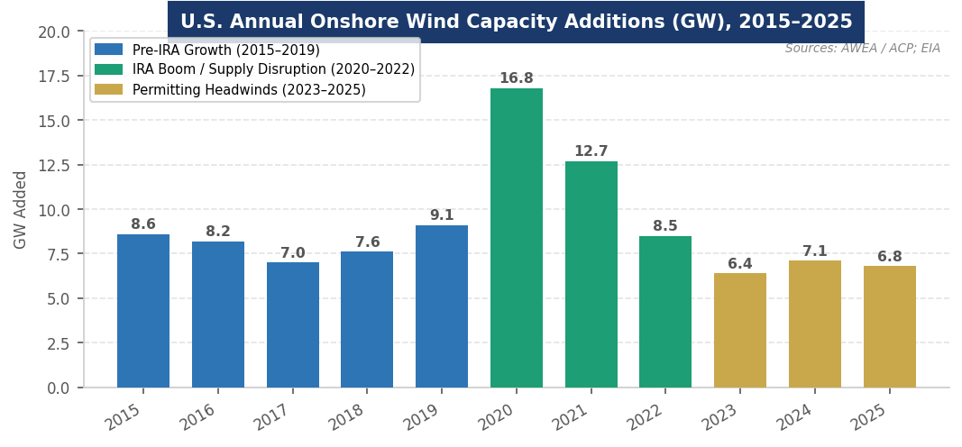
Figure 1. U.S. annual onshore wind capacity additions (GW), 2015–2025. Sources: ACP Clean Power Annual Market Report; EIA Electric Power Monthly.
MARKET STRUCTURE & VALUE CHAIN
The onshore wind industry has a complex, globally integrated value chain. Understanding it is critical for any finance or infrastructure role, since cost, margin, and risk differ dramatically at each step.
The Onshore Wind Value Chain (Upstream → Downstream)
1. Blade Manufacturing | Fiberglass/carbon composite blades, 60–100m long. China and Europe dominate. High capital intensity; Vestas, Siemens Gamesa manufacture in-house.
2. Nacelle & Drivetrain | Houses gearbox, generator, and power electronics. Germany and Denmark lead; Chinese OEMs vertically integrated. Key technology battleground (geared vs. direct drive).
3. Tower Manufacturing | Steel monopole towers, 80–160m tall. More regionalized; US, China, and India firms compete. Logistical constraints limit transport of very tall sections.
4. Turbine OEM Assembly | Integration of all components. Highly consolidated: Vestas, Siemens Gamesa, GE Vernova, Goldwind account for ~65%+ of global supply.
5. Project Development | Site acquisition, wind resource assessment, permitting (3–7 yrs), land lease negotiation, grid interconnection, PPA negotiation. Highest risk; highest returns.
6. EPC & Construction | Engineering, procurement, and construction. Heavy-lift crane operations for turbine installation. Thin margins; execution risk material.
7. Project Finance | Tax equity (PTC), senior debt, sponsor equity. IRA transferability expanded investor pool significantly. Typical project debt 50–60% of capital structure.
8. Asset Ownership & O&M | IPPs, utilities, and infrastructure funds own operating assets (25–30 yr life). O&M via OEM LTSAs or independent service providers. Stable, bond-like cash flows.

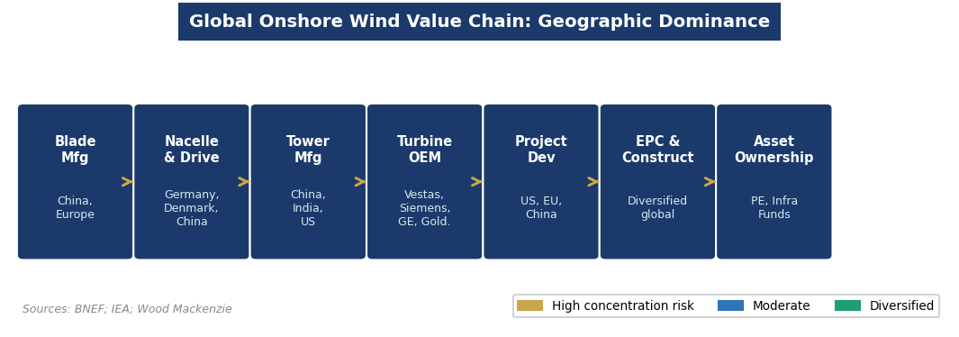
Figure 2. Geographic concentration across the onshore wind value chain. Sources: BNEF; IEA; Wood Mackenzie.
Three market segments define onshore wind deployment:
- Utility-Scale (>1 MW): The dominant segment. Projects sell power via long-term PPAs (15–25 years) to utilities or corporate offtakers. Major developers include NextEra, Brookfield, Invenergy, Iberdrola, and AES.
- Community & Distributed Wind: Smaller projects serving local communities or behind-the-meter needs. A nascent but growing segment, particularly in the Midwest and rural Europe.
- Repowering: Replacing aging turbines at existing sites with larger, more efficient models. Growing rapidly as the first generation of 1990s/2000s turbines reaches end of life, leveraging existing grid connections and land leases.

KEY PLAYERS & COMPETITIVE LANDSCAPE
Global Turbine OEMs
Company | HQ | Notes
Vestas | Denmark | #1 or #2 global market share; strong in Europe, Americas, India; 3–5 MW platform dominates outside China
Siemens Gamesa | Spain/Germany | Siemens Energy subsidiary; broad onshore and offshore portfolio; major restructuring underway 2024–2025
GE Vernova | USA | Spun off from GE in April 2024; leads U.S. onshore market with 2.x–3.x MW platform; NYSE-listed
Goldwind | China | China's largest turbine maker by installed base; direct-drive permanent magnet technology; expanding in Asia, Africa, LatAm
Envision Energy | China | Smart energy platform; launched 5 MW+ onshore turbines with 182m rotor in India and China (2024)
Nordex | Germany | Strong in Germany and Latin America; N163/5.X platform; mid-tier global position
Mingyang Smart Energy | China | Among top 5 Chinese OEMs; aggressive international expansion; MySE platform
Enercon | Germany | Direct-drive pioneer; primarily European; known for quality and longevity over volume

U.S. & Global Developers / IPPs
Company | Role / Notes
NextEra Energy | Largest U.S. renewable developer and utility (Florida Power & Light); 30+ GW wind globally; NYSE: NEE
Brookfield Renewable | Globally diversified infrastructure fund; large onshore wind + hydro portfolio; TSX/NYSE: BEP
Iberdrola / Avangrid | Spanish integrated utility; major U.S. presence through Avangrid; 326 MW Poland wind farm commissioned 2024
RWE Renewables | Europe's largest renewable generator; aggressive global expansion; onshore wind anchors portfolio
Pattern Energy | Major U.S. onshore wind developer; taken private by CDPQ (Quebec pension) in 2020; ~6 GW portfolio
Invenergy | Large private U.S. IPP; utility-scale wind, solar, and storage developer; headquartered Chicago
AES Corporation | Global integrated utility + renewables; active in U.S. onshore wind and co-located storage
Copenhagen Infra. Partners | Danish infra fund; top-10 global wind developer; invests across onshore and offshore

Financial Sponsors & Tax Equity
Infrastructure-focused private equity firms are among the most active buyers of operating onshore wind assets: Blackstone Infrastructure, KKR Infrastructure, Macquarie Asset Management, and Global Infrastructure Partners own large operating portfolios. The U.S. tax equity market — critical to project finance — is dominated by JPMorgan, Bank of America, and US Bancorp. The IRA's credit transferability provisions have substantially expanded this market, enabling a broader set of investors (insurance companies, corporates) to monetize PTCs directly.

ANATOMY OF A WIND TURBINE
A modern onshore wind turbine is a precision electromechanical system. Understanding its physical structure — from foundation to blade tip — provides the foundation for evaluating manufacturing complexity, technology differentiation, and O&M cost drivers.

Component | Key Specs (2024) | Strategic Significance
Rotor Blades (×3) | 60–100m length; fiberglass/carbon composite | Longest single components in modern manufacturing; logistical bottleneck for tall towers; proprietary aerodynamic IP
Hub & Pitch System | Connects blades; adjusts blade angle | Pitch control is primary power regulation mechanism; electronic pitch systems replacing hydraulic
Nacelle | Houses drivetrain, generator, transformer | Heart of the turbine; ~80–100 tons; direct-drive vs. geared designs create key technology differentiation
Gearbox (geared only) | Steps up RPM from ~10 to ~1,500 | Historically highest-failure component; direct-drive designs (Goldwind, Enercon, GE) eliminate gearbox risk entirely
Generator | DFIG (geared) or PMSG (direct drive) | Converts mechanical to electrical energy; permanent magnet designs more efficient but require rare earths (Chinese supply)
Tower | Steel monopole; 80–160m+ height | Taller towers access faster, more consistent winds; height is primary driver of cost-competitiveness in low-wind regions
Foundation | Reinforced concrete; site-specific | Engineered to soil conditions; ~15–25% of project civil cost; rarely discussed but critical path item
SCADA / Control System | Real-time monitoring & optimization | Increasing AI integration for predictive maintenance, yield optimization, and grid services dispatch

How it works: Wind passes over the aerodynamic blade surface, generating lift that spins the rotor. The rotor drives a generator (either directly or via a gearbox) to produce alternating current (AC) electricity. A transformer steps up voltage for grid transmission. Capacity factor — the ratio of actual energy output to theoretical maximum — is the key performance metric. Onshore wind capacity factors typically range from 25–45%, depending on site wind resources and turbine technology. Modern turbines at top-tier sites now regularly exceed 40%.
GLOBAL GEOGRAPHY & COUNTRY LEADERS
China: The dominant force in onshore wind — in both manufacturing and deployment. China controls the upstream supply chain for rare earth magnets (critical for direct-drive generators) and is home to the world's largest turbine manufacturers by volume. China installed nearly 50% of all global new onshore wind capacity in 2023 (~37 GW), and its cumulative installed base of 310+ GW exceeds the rest of the world combined. State policy, low-cost financing, and domestic demand create structural cost advantages. Chinese OEMs are now aggressively expanding into Southeast Asia, Latin America, and Africa.
United States: The world's second-largest market by cumulative installed capacity (145+ GW) and the largest by project value. Texas alone accounts for 37,000+ MW — more than any country outside China. Iowa generates over 60% of its electricity from wind. The IRA triggered a surge in manufacturing announcements and project development, though the 2025 executive order and permitting bottlenecks have constrained near-term additions. 77% of U.S. wind capacity is located in states that voted Republican in 2024 — a structural political protection for the industry.
Germany: Europe's largest onshore wind market and the birthplace of the modern wind industry. Germany's Energiewende policy framework remains the most ambitious energy transition program in Europe, though slow permitting and grid constraints have limited recent growth. REPowerEU targets 510 GW of wind by 2030, requiring a major acceleration in German onshore permitting.
India: Rapidly ascending. India has 45+ GW of installed onshore wind and is targeting 500 GW of total renewables by 2030, requiring massive wind additions. The Production Linked Incentive (PLI) scheme is driving domestic manufacturing expansion. Envision Energy's India-specific 5 MW turbine platform (2024) signals the growing importance of the market.
Brazil: The fastest-growing onshore wind market in Latin America. Brazil's northeast region hosts some of the world's strongest and most consistent wind resources. Auction-driven procurement has driven costs to some of the lowest LCOEs globally. Nordex, Vestas, and Siemens Gamesa are the leading OEMs in the market.
Europe (Other): Denmark, the UK, Spain, and the Netherlands are significant markets, though Europe's binding constraint is permitting speed rather than capital or demand. The EU has mandated streamlined permitting for renewable energy projects under the Net-Zero Industry Act, targeting 18-month permitting timelines.
POLITICS, POLICY & REGULATION
Onshore wind is significantly shaped by policy — perhaps more than any other infrastructure asset class. Policy determines financing structures, supply chain economics, project timelines, and investor return profiles in ways that few other industries experience so directly.

Key Policy Levers MBA Candidates Must Know
Policy / Lever | What It Means for Wind
Production Tax Credit (PTC) | ~$28/MWh credit for 10 years post-commissioning; primary U.S. federal incentive; extended through 2030s by IRA; technology-neutral after 2025 under 45Y.
IRA Credit Transferability | Allows PTCs to be sold directly to third-party buyers; eliminated dependence on narrow tax equity pool; dramatically expanded capital available for wind projects.
Domestic Content Bonus | IRA 10% bonus ITC/PTC for projects using U.S.-manufactured components; incentivizing tower and nacelle manufacturing domestically.
FERC Order 2023 | Reformed grid interconnection queue rules; existing 1,500+ GW backlog remains industry's primary structural bottleneck; average wait: 5–8 years in many regions.
State RPS / Clean Energy Standards | Mandatory renewable portfolio standards in 30+ states; key demand driver independent of federal policy; Texas's ERCOT market is RPS-free but market-driven.
Trump EO (Jan. 20, 2025) | Paused federal onshore wind approvals pending review; vacated by courts Dec. 2025; ongoing litigation; primarily impacts federal lands projects.
EU REPowerEU | Targets 510 GW European wind by 2030; requires 18-month permitting timelines; drives European OEM order books and financing activity.
China State Policy | Feed-in tariffs replaced by competitive auctions (2019); state-owned enterprises finance and develop the majority of Chinese capacity; SOE dominance limits private developer returns.

INDUSTRY TRENDS & TECHNOLOGY INNOVATION
Trend 1: Turbine Scale-Up Expanding the Addressable Market
Average onshore turbine capacity has grown from 2.0 MW in 2015 to 3.2+ MW in 2023, with leading-edge machines now exceeding 5–8 MW. More than 60% of new wind towers constructed in 2023 exceeded 120 meters in height. Larger rotors and taller towers capture faster, more consistent winds — enabling energy extraction from lower-wind-speed sites that were previously uneconomical. Envision Energy launched a 5 MW platform with a 182-meter rotor diameter in India in 2024, increasing annual energy generation by 40%+ vs. prior-generation turbines. This turbine scale-up is effectively expanding the geographic and economic addressable market for onshore wind.
Trend 2: AI-Driven Predictive Maintenance & Digital Operations
Wind asset operators are deploying dense sensor networks, digital twins, and machine learning models to shift from reactive/scheduled maintenance to predictive condition-based maintenance (CBM). AI-driven platforms detect gearbox, blade, and generator failure precursors before they manifest, reducing unplanned downtime (which can cost $50,000–$200,000+ per turbine per year) and extending asset life. CBM is the fastest-growing O&M segment globally and is compressing operating costs as a share of revenue — a significant margin improvement lever for large-scale asset operators and infrastructure fund managers.
Trend 3: Corporate PPAs and the AI Data Center Demand Surge
The fastest-growing offtake channel is direct corporate power purchase agreements (PPAs), driven by hyperscalers (Microsoft, Google, Amazon, Meta) and large industrials with 24/7 clean energy commitments. These buyers need massive, long-term, geographically flexible clean power — and onshore wind in the U.S. Midwest and Texas delivers the lowest-cost gigawatt-scale clean electricity available ($25–40/MWh LCOE). This demand pull is reducing developer exposure to utility procurement cycles and government policy, creating a more durable demand signal that is structurally less sensitive to federal policy shifts.
Trend 4: Repowering the First Generation
The first wave of U.S. and European onshore wind turbines installed in the 1990s and 2000s is reaching end of economic life. Repowering — replacing aging turbines with larger, more efficient models at existing sites — is a rapidly growing segment. Repowered sites benefit from existing grid connections, land leases, and permitting precedents, dramatically reducing development cost and timeline. For infrastructure investors, operating wind assets with repowering optionality represent a compelling value-add opportunity within existing portfolios.
Trend 5: Hybrid Wind + Storage Projects
Battery energy storage systems (BESS) are increasingly co-located with onshore wind projects, allowing operators to shift generation from peak production to peak demand periods, provide grid ancillary services, and improve PPA economics. Lithium-ion battery prices have fallen dramatically alongside wind costs, and regulatory markets increasingly compensate storage for frequency regulation and capacity. As wind penetration rises, grid operators face increased variability challenges that storage directly addresses — creating a structural demand pull for co-located BESS across all major onshore wind markets.
Trend 6: Grid Interconnection Reform as the Critical Bottleneck
The U.S. grid interconnection queue has grown to 1,500+ GW of projects awaiting connection — the industry's most significant structural constraint heading into 2027–2030. FERC Order 2023 reformed queue rules to reduce speculative project applications and prioritize shovel-ready developments, but implementation is slow. For MBA candidates, this is the most important structural dynamic in the industry: the economic case for wind is settled; the constraint is purely operational, regulatory, and infrastructure-based.

CURRENT NEWS & MARKET DYNAMICS (2025–2026)
Headlines Every Candidate Should Know
- Trump Executive Order (Jan. 20, 2025): Trump Executive Order (Jan. 20, 2025): Paused federal approvals for onshore and offshore wind projects pending a policy review. A federal district court vacated the pause in December 2025 as violating the APA. A coalition of 17 states led by New York continues to challenge the broader order. Primarily impacts projects on federal lands (BLM, Forest Service).
- IRA Durability: IRA Durability: Full PTC repeal is considered politically unlikely — onshore wind installations are concentrated in Republican-leaning states, and 18 Republican members of Congress urged leadership to preserve market certainty. Credit transferability remains intact.
- Interconnection Bottleneck: Interconnection Bottleneck: 1,500+ GW of projects await grid interconnection — including wind, solar, and storage. Average wait times of 5–8 years in the most congested regions (PJM, MISO, CAISO) are delaying project timelines significantly.
- AI Data Center Demand: AI Data Center Demand: Hyperscalers are executing multi-GW onshore wind PPAs to power data center buildouts. This corporate demand is pulling forward development timelines and reducing the reliance on utility offtake — particularly in ERCOT (Texas) and MISO (Midwest).
- Repowering Wave: Repowering Wave: The first wave of U.S. wind turbines (1990s–2000s vintage) is approaching end of economic life. Repowering represents a $10B+ annual market opportunity through 2030, with lower development risk than greenfield sites.
- European Permitting Reform: European Permitting Reform: EU member states are implementing the Net-Zero Industry Act's 18-month permitting mandate for renewable energy projects. Germany, historically the most permitting-constrained large EU market, is showing signs of acceleration.
- China Overcapacity Pressure: China Overcapacity Pressure: Chinese turbine OEMs are facing severe margin compression from domestic overcapacity and price competition — accelerating international expansion as a growth strategy. This is increasing competitive pressure on Western OEMs in emerging markets.

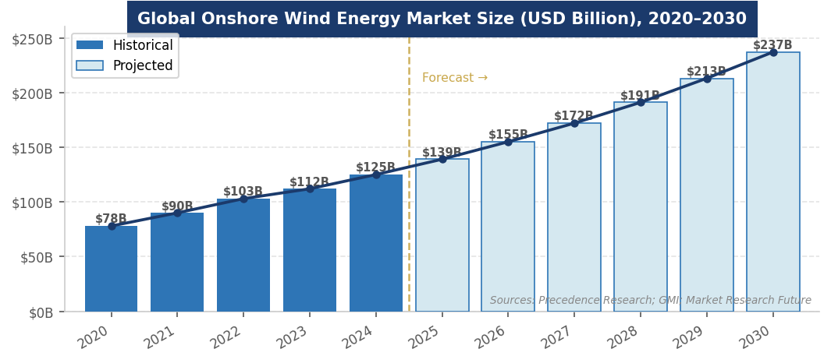
Figure 3. Global onshore wind energy market size forecast, 2020–2030 (USD Billion). Sources: Precedence Research; GMI; Market Research Future.
INVESTMENT, FINANCE & CAREER ANGLES
For MBA candidates pursuing energy, infrastructure, and investing roles, onshore wind intersects with multiple finance functions:

- Project Finance: Project Finance: Utility-scale wind is financed through non-recourse project finance structures with long-term PPAs providing revenue certainty. The capital stack typically combines 50–60% senior debt, 25–35% tax equity (utilizing the PTC), and 10–20% sponsor equity. Tax equity investors receive the PTC benefit (~$28/MWh) for 10 years in exchange for upfront capital. The IRA's credit transferability has made this market significantly more liquid.
- Infrastructure Investing: Infrastructure Investing: Operating onshore wind assets exhibit bond-like cash flow profiles — long-duration contracts (15–25 years), predictable generation, low operating costs. Infrastructure funds (Brookfield, BlackRock, KKR, Macquarie) are major acquirers of operating portfolios. Typical unlevered IRR targets: 7–10%; levered: 10–15% depending on vintage and market.
- Growth Equity & Venture Capital: Growth Equity & Venture Capital: Early-stage opportunities exist in wind software (AI-powered O&M, predictive maintenance, yield optimization), advanced turbine component materials, and grid services technology (smart inverters, storage dispatch optimization).
- Corporate Strategy: Corporate Strategy: Industrials and tech companies (Apple, Google, Amazon, Microsoft) are executing multi-GW onshore wind PPAs, creating corporate sustainability strategy, energy procurement, and real assets roles at non-energy companies.
- Policy & Development Finance: Policy & Development Finance: Development finance institutions (US EXIM Bank, IFC, ADB, OPIC) are major wind financiers in emerging markets (India, Brazil, Southeast Asia, Africa). Climate-focused investors (Breakthrough Energy Ventures, Energy Impact Partners) back frontier wind technology.

Key financial concepts to know: LCOE (Levelized Cost of Energy), capacity factor, PPA structure and tenor, tax equity, PTC transferability, domestic content bonus, DSCR (Debt Service Coverage Ratio), and IRR thresholds (typically 7–10% unlevered for U.S. utility-scale onshore wind).
FUTURE OUTLOOK
Despite near-term U.S. policy headwinds, the long-term structural trajectory for onshore wind is strong. The economic case is settled — onshore wind is now the lowest-cost source of new electricity generation in most markets globally. The structural drivers are durable: rising electricity demand from AI infrastructure, decarbonization commitments across corporate and sovereign actors, and the continuing cost improvement trajectory of turbine technology.

- Base Case: Base Case: Global onshore wind market grows from ~$125B (2025) to ~$237B by 2034 (CAGR ~6–8%). U.S. adds 8–12 GW annually from 2027–2030, weighted toward ERCOT, MISO, and SPP interconnection regions. Corporate PPA demand sustains development independent of utility procurement cycles. Repowering adds 3–5 GW/year of incremental activity.
- Bull Case: Bull Case: Grid interconnection reform accelerates (FERC Order 2023 implementation outperforms), AI data center demand pulls forward 15+ GW of additional capacity, and domestic content bonuses drive U.S. turbine manufacturing investment. Global market exceeds $300B by 2034.
- Bear Case: Bear Case: Sustained federal permitting obstruction, IRA credit modifications that reduce PTC value, and interconnection queue failures delay project pipelines. U.S. additions remain below 8 GW/year through 2028.

The one certainty: onshore wind's cost curve has made it structurally competitive without subsidies in most markets. The question for the next decade is not whether onshore wind grows — it will — but at what pace, financed by whom, built from components sourced from where, and integrated into a grid designed for a different era of energy generation.
INTERVIEW CONVERSATION STARTERS
- "Onshore wind has won the cost war — the LCOE in the best U.S. wind regions is now $25–35/MWh, cheaper than new natural gas. The constraint has shifted entirely to permitting timelines and grid interconnection. That's where the value-add opportunity lives for developers and investors."
- "The IRA's credit transferability provision is the most underappreciated structural change in U.S. renewable finance in a decade. It effectively democratized access to wind tax credits, expanding the investor base from a handful of large banks to the entire institutional investment universe."
- "The AI and data center buildout is the most important demand-side tailwind for onshore wind right now — hyperscalers are signing some of the largest PPAs ever seen, and they're agnostic to federal policy because they're contracting directly with developers. That's a structural shift in how wind gets built and financed."
- "China's dominance of the turbine supply chain — especially rare earth magnets for direct-drive generators — is onshore wind's version of the semiconductor supply chain problem. It's the geopolitical risk that doesn't get discussed enough in most investment committee presentations."

REFERENCES
High-Quality Sources Used in This Primer
Government & Intergovernmental Organizations
[1] U.S. Energy Information Administration (EIA). "Electric Power Monthly." Washington, D.C.: U.S. Department of Energy. https://www.eia.gov/electricity/monthly/
[2] U.S. Environmental Protection Agency (EPA). "Summary of Inflation Reduction Act Provisions Related to Renewable Energy." Updated 2025. https://www.epa.gov/green-power-markets/
[3] Federal Energy Regulatory Commission (FERC). "Order No. 2023: Improvements to Generator Interconnection Procedures and Agreements." Washington, D.C.: FERC, 2023. https://www.ferc.gov/media/order-no-2023
[4] Harvard Environmental and Energy Law Program. "Federal Offshore Wind Deployment Tracker." Updated March 2026. https://eelp.law.harvard.edu/tracker/federal-offshore-wind-deployment/
[5] International Energy Agency (IEA). "Renewables 2024: Analysis and Forecast to 2030." Paris: IEA, 2024. https://www.iea.org/reports/renewables-2024
[6] International Energy Agency (IEA). "World Energy Outlook 2024." Paris: IEA, 2024. https://www.iea.org/reports/world-energy-outlook-2024
[7] National Renewable Energy Laboratory (NREL). "2023 Cost of Wind Energy Review." Golden, CO: NREL, 2024. https://www.nrel.gov/wind/cost-wind-energy.html
Industry Research & Trade Associations
[8] American Clean Power Association (ACP). "Clean Power Annual Market Report 2024." Washington, D.C.: ACP, 2025. https://cleanpower.org/resources/clean-power-annual-market-report/
[9] Global Market Insights. "Onshore Wind Energy Market Size, Growth Analysis 2025–2034." March 2025. https://www.gminsights.com/industry-analysis/onshore-wind-energy-market
[10] Precedence Research. "Onshore Wind Energy Market Size 2025 to 2034." Updated September 2025. https://www.precedenceresearch.com/onshore-wind-energy-market
[11] Market Research Future. "Onshore Wind Energy Market Size, Share, Growth Report 2035." February 2026. https://www.marketresearchfuture.com/reports/onshore-wind-energy-market-5996
[12] Grand View Research. "Wind Power Market Size and Share | Industry Report, 2030." https://www.grandviewresearch.com/industry-analysis/wind-power-industry
[13] Wood Mackenzie. "U.S. Wind Power Market Outlook 2025." Edinburgh: Wood Mackenzie, 2025.
News & Policy Analysis
[14] Utility Dive. "What Trump's Reelection Could Mean for the IRA, Offshore Wind." November 6, 2024. https://www.utilitydive.com/news/trump-reelection-clean-energy-offshore-wind-inflation-reduction-act/732161/
[15] Grist. "There's Hope for the Offshore Wind Industry — Yes, Really." April 2026. https://grist.org/energy/offshore-wind-court-interior-permitting-reform-congress/
[16] Lazard. "Levelized Cost of Energy Analysis — Version 17.0." New York: Lazard, 2024. https://www.lazard.com/research-insights/lazards-lcoe-plus/
[17] U.S. Senate EPW Committee (Minority). "Trump's Assault on Wind Energy Leaves Permitting Reform Dead in the Water." December 22, 2025. https://www.epw.senate.gov/
Market Research & Financial Data
[18] Bloomberg New Energy Finance (BNEF). "New Energy Outlook 2025." New York: BloombergNEF, 2025. https://about.bnef.com/new-energy-outlook/
[19] Vind AI. "Advanced Digital Platforms for Onshore Wind Park Design." Press Release, January 2025. https://www.vind.ai
[20] Market Growth Reports. "Onshore Wind Energy Market Growth Drivers, Future 2033." 2024. https://www.marketgrowthreports.com/market-reports/onshore-wind-energy-market-101054
Legislation & Regulatory Texts
[21] 117th U.S. Congress. "Inflation Reduction Act of 2022" (Pub. L. 117-169). Signed August 16, 2022. https://www.congress.gov/bill/117th-congress/house-bill/5376
[22] Office of the United States Trade Representative (USTR). "Section 301 Tariff Actions." USTR, 2024–2025. https://ustr.gov/issue-areas/enforcement/section-301-investigations

Disclaimer: This document is prepared for educational purposes as part of an MBA classroom exercise. Market data reflects conditions as of April 2026 and is sourced from publicly available materials. It does not constitute investment advice.

