SOLAR INDUSTRY
MBA Industry Primer | Energy & Infrastructure
Columbia Business School | April 2026

INDUSTRY AT A GLANCE

Solar energy is one of the fastest-growing industries in the world — and, as of 2025, the single largest source of new electricity-generating capacity added to the U.S. grid for the fifth consecutive year. For MBA candidates, solar sits at the intersection of finance, policy, technology, and global trade. Understanding it means understanding how capital flows into infrastructure, how government policy shapes private markets, and how a technology that was once too expensive to scale became cheaper than coal in under two decades.

Key Metric | Data Point (2025)
Global Solar Market Size | ~$286B, growing to ~$522B by 2035 (CAGR ~6.2%)
U.S. Solar Market Revenue | ~$40.6B (CAGR ~28.7% from 2020–2025)
U.S. New Capacity Installed (2025) | 43.1 GWdc — #1 source of new U.S. power for 5th year running
Solar Share of U.S. New Grid Capacity | 54% of all new electricity-generating capacity in 2025
Solar Share of U.S. Electricity Generation | ~8% of total; >20% in California, Arizona, Nevada, Massachusetts
Solar + Storage Share of New U.S. Capacity | 79% combined in 2025
Key Players (Manufacturing) | Jinko Solar, LONGi, Trina, JA Solar, First Solar, Qcells
Key Players (U.S. Dev/Install) | NextEra Energy, Sunrun, Nexamp, Tesla, Invenergy

HISTORY & ORIGINS

1954–1990s: Discovery to Niche. The photovoltaic (PV) effect was discovered at Bell Labs in 1954, producing the first practical solar cell at roughly 4% efficiency. For decades, solar was expensive and reserved for satellites and remote applications. The 1970s oil crisis spiked interest but costs remained prohibitive for mass deployment.

2000–2010: Scale and Policy. Germany's feed-in tariff (Energiewende) and Japan's subsidies catalyzed early mass deployment. China began investing heavily in manufacturing, driving down panel costs dramatically. The U.S. introduced the Investment Tax Credit (ITC) in 2006, which became a cornerstone incentive. U.S. installations remained modest through this period.

2010–2018: The Cost Revolution. Solar module prices dropped over 90% between 2010 and 2020 — one of the fastest cost declines of any energy technology in history. This was driven by Chinese manufacturing scale, learning curve effects, and intense competition. Utility-scale solar became cost-competitive with natural gas in many markets. The U.S. imposed Section 201 and Section 301 tariffs on Chinese panels starting in 2012 and 2018, creating a persistent tension between cheap imports and domestic manufacturing.

2022–2024: The IRA Era. The Inflation Reduction Act (IRA), signed in 2022, was the most transformational clean energy policy in U.S. history. It extended the 30% ITC and Production Tax Credit (PTC) through 2032 and introduced domestic content bonuses and the Section 45X Advanced Manufacturing Production Tax Credit. The result: over $100B in U.S. solar and storage manufacturing investment announcements, module manufacturing capacity surging to 50+ GW by early 2025, and more than 100,000 new U.S. jobs.

2025: Policy Reversal and Turbulence. The Trump administration's 'One Big Beautiful Bill Act,' signed July 4, 2025, eliminated the residential 25D solar tax credit after December 31, 2025. Commercial and utility-scale ITC continued but with a July 2026 construction start deadline. Sweeping new tariffs — up to 175% on Chinese finished panels, 49% on Cambodia, 46% on Vietnam — reshaped global supply chains. Despite these headwinds, solar remained the #1 source of new U.S. power capacity.

U.S. Annual Solar Capacity Additions (2015–2025)

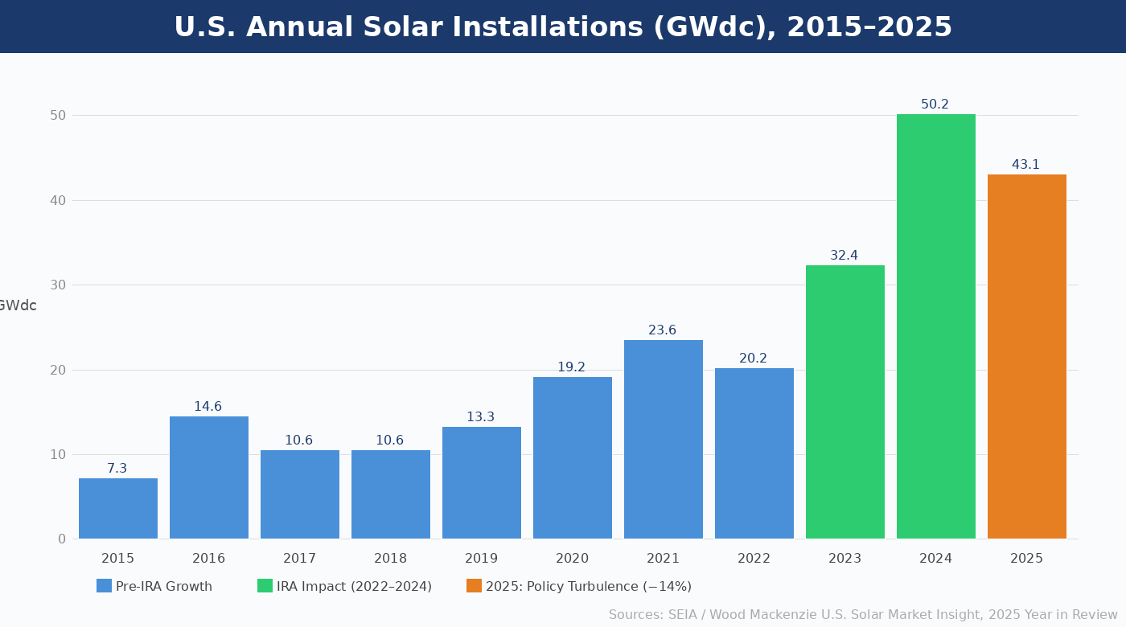
Figure 1. U.S. annual solar installations (GWdc), 2015–2025. Sources: SEIA / Wood Mackenzie U.S. Solar Market Insight, 2025 Year in Review.
MARKET STRUCTURE & VALUE CHAIN

The solar industry has a complex, globally integrated value chain. Understanding it is critical for any finance or infrastructure role, since cost, margin, and risk differ dramatically at each step.

The Solar Value Chain (Upstream → Downstream)
1. Polysilicon → Raw silicon feedstock; China controls ~95% of global supply. Highly capital-intensive.
2. Ingots & Wafers → Purified silicon shaped into wafers. China dominant; Corning opened first U.S. wafer plant (Michigan) in 2025.
3. Solar Cells → Wafers converted to PV cells via doping. China produces ~90%+. Key technology battleground (mono-Si vs. thin film).
4. Modules (Panels) → Cells assembled into modules. Most U.S. assembly here; 50+ GW U.S. capacity by 2025.
5. Racking, Inverters & Trackers → Balance of system. More diversified; U.S., Spain, and Germany firms compete.
6. Project Development → Site acquisition, permitting, PPA negotiation, financing. High returns; U.S. developers lead.
7. EPC (Engineering, Procurement & Construction) → Builds the project. Contracted or vertically integrated.
8. Asset Ownership & O&M → Utilities, IPPs, and infrastructure funds own operating assets long-term.

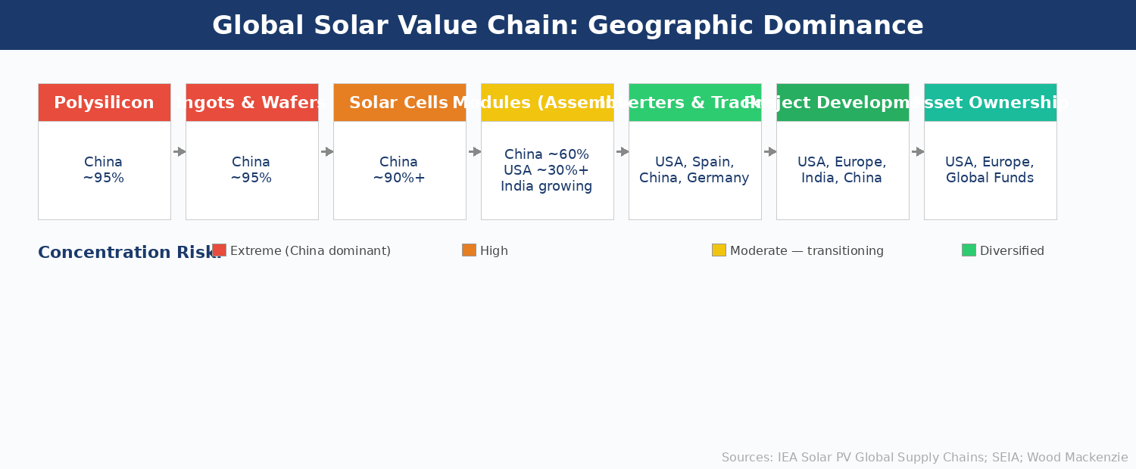
Figure 2. Geographic dominance across the solar value chain. Sources: IEA Solar PV Global Supply Chains (2022); SEIA; Wood Mackenzie.

Three market segments define solar deployment:
- Utility-Scale (>1 MW): Largest segment; ~34.7 GWdc installed in 2025. Projects sell power via long-term Power Purchase Agreements (PPAs). Major developers: AES, NextEra, Invenergy, Lightsource BP.
- Commercial & Industrial (C&I): Mid-size rooftop and ground-mount for businesses, schools, and municipalities. Grew 6% in 2025 to 2,345 MWdc. California, New York, and Illinois lead.
- Residential: Homeowner rooftop solar. Near-flat in 2025 (~5 GWdc). Faces headwinds from loss of 25D tax credit and reduced net metering in California (NEM 3.0). Sunrun, Tesla, and Qcells dominate installation.

KEY PLAYERS & COMPETITIVE LANDSCAPE

Global Module Manufacturers

Company | HQ / Notes
Jinko Solar | China — #1 globally for 4th straight year; ~130 GW annual capacity; factories in U.S. and SE Asia
LONGi Green Energy | China — Technology leader in monocrystalline silicon; R&D focus on HJT and TOPCon cells
Trina Solar | China — Top 4 global position; diversifying into trackers and storage
JA Solar | China — Rounds out dominant Chinese 'Big 4'; combined Top 4 share ~48.5% of global shipments
First Solar | USA — Only major U.S.-headquartered manufacturer; thin-film CdTe technology; strong IRA/FEOC positioning
Hanwha Qcells | South Korea / USA — Major U.S. manufacturing presence (Georgia); 38.5% residential module market share
Tongwei | China — Controls >1/3 of global polysilicon; deeply vertically integrated across supply chain
Waaree Energies | India — Among first non-Chinese firms in global top 10; signals market diversification trend

U.S. Developers, Installers & Utilities

Company | Role / Notes
NextEra Energy | Largest U.S. renewable developer and utility (Florida Power & Light); publicly traded
Invenergy | Private U.S. IPP; large utility-scale solar, wind, and storage developer
AES Corporation | Global IPP; active in U.S. utility-scale solar and co-located storage
Sunrun | Largest U.S. residential installer; heavy use of TPO (leases/PPAs) to retain federal ITC access
Nexamp | Top U.S. community solar developer; 9.4% market share in 2025
Lightsource BP | BP-backed developer; large U.S. and international utility-scale pipeline
Silicon Ranch | U.S. developer; attracted $500M from European investor AIP Management in 2025

Key Technology & Equipment Suppliers

Segment | Key Players
Inverters (Residential) | Tesla (33.4% U.S. share in Q4 2025, surging via Powerwall 3), Enphase (declining), SolarEdge
Inverters (Commercial) | Chint Power Systems (30.2% U.S. share), SMA
Trackers (Utility-Scale) | NEXTracker (global #1, 21.84 GW shipped), Array Technologies, PV Hardware
Wafers (U.S.) | Corning (Michigan facility opened 2025 — completes U.S. domestic solar supply chain)
Storage (BESS) | Tesla Powerwall, LG Energy Solution, CATL — rapidly growing co-deployment segment

ANATOMY OF A SOLAR PANEL

A photovoltaic (PV) solar panel is a layered semiconductor device. Understanding its physical structure — from glass to silicon to backsheet — provides a foundation for understanding manufacturing complexity, quality differentiation, and supply chain risk. The diagram below shows each layer and its function.

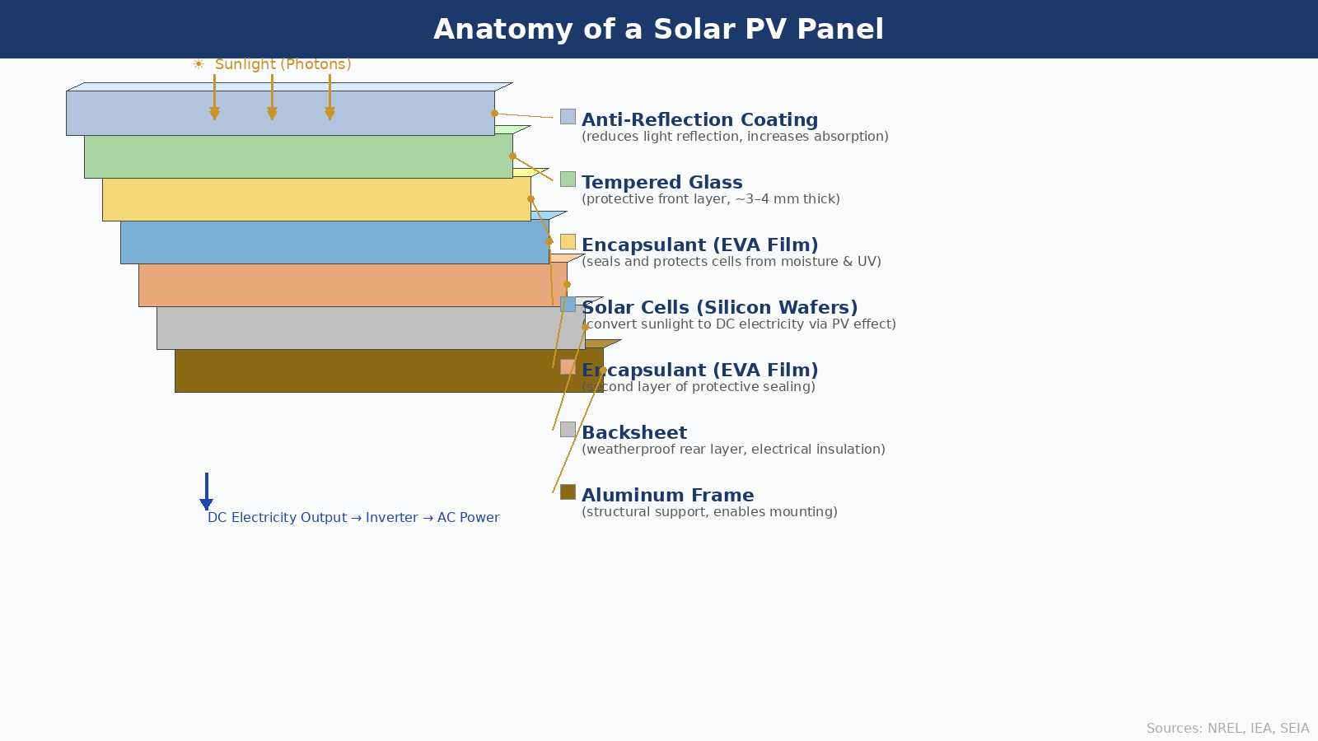
Figure 3. Cross-section of a standard crystalline silicon PV module showing all functional layers. Sources: NREL (2024); IEA; SEIA.

How it works: When photons from sunlight strike the silicon cell layer, they dislodge electrons and create an electric field (the photovoltaic effect). This generates direct current (DC) electricity, which an inverter then converts to alternating current (AC) usable by homes and the grid. Cell efficiency — the percentage of incoming solar energy converted to electricity — is the key technology metric. Standard commercial panels now achieve 20–24% efficiency; advanced HJT and TOPCon designs push toward 26–27%.

GLOBAL GEOGRAPHY & COUNTRY LEADERS

China: The dominant force in solar manufacturing. Controls ~95% of global polysilicon, ingot, and wafer production; home to 7 of the world's 10 largest module manufacturers. State-backed investment, low labor costs, and massive scale create structural cost advantages. Geopolitical tension and tariff walls are pushing global buyers to diversify sourcing.

United States: The world's largest solar deployment market by value. The IRA triggered a manufacturing renaissance, bringing U.S. module capacity to 50+ GW by 2025. Politically contested but bipartisan in practice — 77% of U.S. solar capacity in 2025 was installed in Republican-leaning states, including Texas, Indiana, Ohio, and Missouri.

India: Rapidly ascending. Achieved ~81 GW of installed capacity by 2022 and expanding aggressively through domestic manufacturing subsidies (PLI scheme) and government procurement. Waaree Energies is India's breakout global manufacturer.

Europe: Germany, Spain, and the Netherlands lead in deployment, but European manufacturing lags. The EU Solar Industry Alliance targeted 30 GW of European PV manufacturing by 2025 — largely unmet. Spain introduced innovative agrivoltaic and community solar programs in 2025.

Middle East & Southeast Asia: Saudi Arabia and the UAE are investing heavily in utility-scale solar to diversify from oil revenues. Vietnam and Cambodia were major panel-manufacturing export hubs for the U.S. market — a routing strategy largely closed by 2025 IEEPA tariff expansions.

POLITICS, POLICY & REGULATION

Solar is perhaps the most politically sensitive sector in U.S. energy. Policy shapes financing structures, supply chains, project economics, and investor return profiles in ways that few other industries experience so directly.

Key Policy Levers MBA Candidates Must Know
Investment Tax Credit (ITC): 30% credit for commercial/utility-scale solar. The most important driver of project economics. Accelerated construction start deadline now July 4, 2026, under OBBBA.
Section 25D (Residential): Ended December 31, 2025 under One Big Beautiful Bill Act. Third-party ownership (leases/PPAs) retains access to 48E credit through 2027.
Section 45X (Advanced Manufacturing PTC): Ongoing IRA credit for U.S. manufacturing of solar cells, modules, and storage. Key driver of domestic factory investment.
Section 301 / Section 201 Tariffs: Layered tariffs on Chinese solar (now 175% for finished panels), effectively requiring sourcing from SE Asia, India, or domestic producers.
IEEPA Tariffs (2025): Broad reciprocal tariffs applied to Vietnam (46%), Cambodia (49%), and other countries — closing prior routing workarounds.
Net Metering (NEM): State-level policy governing compensation for rooftop solar exports. California's NEM 3.0 (2023) cut compensation ~75%, sharply slowing residential growth.
FERC Order 2023: Reformed grid interconnection queue rules. The backlog of 1,500+ GW of projects awaiting grid connection remains the industry's primary structural bottleneck.
Domestic Content Bonus: IRA bonus adds 10% ITC for projects using U.S.-made components — major incentive for localizing manufacturing. FEOC rules penalize Chinese-sourced inputs.

INDUSTRY TRENDS & TECHNOLOGY INNOVATION

Trend 1: Solar + Storage as the Default
Battery energy storage systems (BESS) are increasingly co-located with utility-scale solar. Combined solar-and-storage represented 79% of all new U.S. power capacity in 2025. Lithium-ion batteries dominate, with longer-duration (4+ hour) systems growing rapidly in California and Arizona. BESS prices have fallen dramatically alongside solar, and regulatory markets increasingly compensate storage for grid services like frequency regulation and capacity.
Trend 2: The AI & Data Center Demand Surge
Hyperscaler demand (Google, Microsoft, Amazon, Meta) is reshaping utility-scale solar procurement. Wood Mackenzie tracks ~160 GW of new large-load requests under construction or committed — equivalent to 22% of current U.S. peak demand. Tech companies are executing large corporate PPAs directly with solar developers, often with 24/7 clean energy commitments, creating significant tailwinds for utility-scale solar through the 2030s.
Trend 3: Domestic Supply Chain Build-Out
The IRA's Section 45X manufacturing credit is incentivizing full vertical integration in the U.S. Corning's 2025 wafer plant in Michigan completed the domestic PV supply chain for the first time since 2016. First Solar's thin-film technology (which does not use Chinese polysilicon or cells) positions it favorably under FEOC restrictions. The race to domesticize supply chains is creating M&A opportunities, greenfield factory investments, and new financing structures.
Trend 4: Next-Generation Cell Technologies
The dominant technology is shifting from PERC to TOPCon (Tunnel Oxide Passivated Contact) and HJT (Heterojunction) cells, which achieve efficiencies above 25%. Perovskite cells — potentially cheaper and printable — are approaching commercialization, with tandem perovskite-silicon cells exceeding 33% efficiency in lab conditions. Technology differentiation is becoming as decisive as shipment volume in the competitive landscape.
Trend 5: AI-Powered Operations
Artificial intelligence is transforming solar asset management. AI-driven weather forecasting improves energy dispatch optimization. Predictive maintenance platforms detect panel degradation before failure. NEXTracker's AI-powered shadow avoidance increases yield at utility-scale plants. As solar penetration rises, grid operators face the 'duck curve' — midday oversupply and sharp evening demand ramps — creating value for smart inverters, storage dispatch, and demand response technology.
Trend 6: Agrivoltaics & Dual-Use Land
Agrivoltaics — co-locating solar panels with agricultural land — is emerging as a solution to land-use conflicts. Research shows certain crops benefit from panel shading, while solar operators reduce land costs. Spain and Germany are leading agrivoltaic deployment; the U.S. is piloting programs across the Midwest and Southeast. For infrastructure investors, it represents a new layer of value creation and community buy-in.

CURRENT NEWS & MARKET DYNAMICS (2025–2026)

Headlines Every Candidate Should Know
One Big Beautiful Bill Act (July 4, 2025): Eliminated residential 25D tax credit; accelerated commercial ITC deadline to July 2026. Projects ~19% market contraction in 2026.
Tariff Escalation: Chinese finished panels now face 175% tariffs; Vietnamese (46%) and Cambodian (49%) panels hit by IEEPA tariffs, closing prior routing loopholes.
U.S. Manufacturing Milestone: Corning's Michigan wafer plant (2025) completed the domestic PV supply chain for the first time since 2016.
Tesla Inverter Surge: Tesla's Powerwall 3 drove its residential inverter market share from ~17% to 33.4% in 2025, surpassing both Enphase and SolarEdge.
Data Center Solar Procurement: Utility-scale solar is being fast-tracked to meet AI/data center electricity demand. Wood Mackenzie tracks 160 GW of new large-load requests.
Interconnection Bottleneck: 1,500+ GW of projects await grid interconnection — the industry's most significant structural constraint heading into 2027–2030.
Market Contraction Then Recovery: After 14% decline in 2025 and ~19% projected in 2026, Wood Mackenzie forecasts recovery from 2027 driven by rising retail rates and falling equipment costs.
China Oversupply Crisis: Chinese manufacturers face severe financial pressure from module price crashes due to domestic overcapacity — accelerating global consolidation pressure.

INVESTMENT, FINANCE & CAREER ANGLES

For MBA candidates pursuing energy and infrastructure roles, solar intersects with multiple finance functions:

- Project Finance: Utility-scale solar is financed through non-recourse project finance structures with long-term PPAs providing revenue certainty. Tax equity (utilizing ITC/PTC) is a critical financing layer unique to U.S. renewable energy. Banks like JPMorgan, Bank of America, and Citi are major tax equity providers.
- Infrastructure Investing: Solar assets exhibit bond-like cash flow profiles — long-duration contracts, predictable generation, low operating costs. Infrastructure funds (Brookfield, BlackRock, KKR, Global Infrastructure Partners) are major acquirers of operating solar portfolios.
- Venture Capital & Growth Equity: Early-stage opportunities exist in solar software (AI-powered O&M, grid edge management), novel cell technologies (perovskites, HJT), and BESS supply chain startups.
- Corporate Strategy: Tech companies (Apple, Google, Amazon) and industrial corporates are signing multi-GW solar PPAs, creating corporate sustainability and energy procurement roles.
- Policy & Development Finance: DFIs (U.S. EXIM Bank, IFC, ADB) are major solar financiers in emerging markets. Climate-focused investors like Breakthrough Energy Ventures back frontier solar technologies.

Key financial concepts to know: LCOE (Levelized Cost of Energy), capacity factor, PPA structure, tax equity, ITC/PTC step-ups, domestic content bonus, DSCR (Debt Service Coverage Ratio), and IRR thresholds (typically 8–12% unlevered for U.S. utility-scale solar).

FUTURE OUTLOOK

Despite near-term policy headwinds, the long-term trajectory for solar is strong. The structural drivers — falling costs, rising electricity demand, decarbonization commitments, and AI-driven power demand — are durable.

- Base Case: U.S. installs ~38–40 GWdc annually from 2027–2030, with storage co-deployment rising. Solar remains the lowest-cost source of new power. Global market approaches $400–500B by 2033.
- Bull Case: Grid interconnection reform accelerates, AI demand pulls in additional capacity, domestic supply chains mature. Solar could exceed 50+ GWdc annually by the early 2030s.
- Bear Case: Sustained tariff disruption, further ITC rollbacks, and permitting failures delay projects. Wood Mackenzie's low case is ~11% below base through 2030.

The one certainty: solar's cost curve has made it structurally competitive without subsidies in most markets. The question for the next decade is not whether solar grows, but at what pace, financed by whom, built from components sourced from where, and integrated into a grid designed for a different era of power generation.

INTERVIEW CONVERSATION STARTERS
- "Solar is now the cheapest source of new electricity generation in most of the world — the question has shifted from 'can it compete?' to 'how fast can we build it and connect it to the grid?'"
- "The IRA created a manufacturing renaissance in the U.S., but the One Big Beautiful Bill has injected real uncertainty — the industry is in a bridge period between incentive regimes."
- "The AI and data center buildout is the most underappreciated tailwind for utility-scale solar right now — hyperscalers are signing some of the largest PPAs ever seen."
- "China's dominance of the supply chain is both the solar industry's greatest competitive advantage and its greatest geopolitical risk."

REFERENCES
High-Quality Sources Used in This Primer

Government & Intergovernmental Organizations

[1] U.S. Energy Information Administration (EIA). "Electric Power Monthly." Washington, D.C.: U.S. Department of Energy. Monthly publication. https://www.eia.gov/electricity/monthly/
[2] International Energy Agency (IEA). "Solar PV Global Supply Chains." Paris: IEA, 2022. https://www.iea.org/reports/solar-pv-global-supply-chains
[3] International Energy Agency (IEA). "Renewables 2024: Analysis and Forecast to 2030." Paris: IEA, 2024. https://www.iea.org/reports/renewables-2024
[4] National Renewable Energy Laboratory (NREL). "Best Research-Cell Efficiency Chart." Golden, CO: NREL, 2024. https://www.nrel.gov/pv/cell-efficiency.html
[5] National Renewable Energy Laboratory (NREL). "U.S. Solar Photovoltaic System and Energy Storage Cost Benchmarks." NREL Technical Report, 2024. https://www.nrel.gov/docs/fy24osti/87303.pdf
[6] U.S. Environmental Protection Agency (EPA). "Summary of Inflation Reduction Act Provisions Related to Renewable Energy." Updated 2025. https://www.epa.gov/green-power-markets/summary-inflation-reduction-act-provisions-related-renewable-energy
[7] Federal Energy Regulatory Commission (FERC). "Order No. 2023: Improvements to Generator Interconnection Procedures and Agreements." Washington, D.C.: FERC, 2023. https://www.ferc.gov/media/order-no-2023

Industry Research & Trade Associations

[8] Solar Energy Industries Association (SEIA) & Wood Mackenzie. "U.S. Solar Market Insight: 2025 Year in Review." Washington, D.C.: SEIA, March 2026. https://seia.org/research-resources/solar-market-insight-report-2025-year-in-review/
[9] Solar Energy Industries Association (SEIA) & Wood Mackenzie. "U.S. Solar Market Insight: Q4 2025." Washington, D.C.: SEIA, December 2025. https://seia.org/research-resources/solar-market-insight-report-q4-2025/
[10] Solar Energy Industries Association (SEIA). "Impact of the Inflation Reduction Act." Washington, D.C.: SEIA, 2024. https://seia.org/research-resources/impact-inflation-reduction-act/
[11] Solar Energy Industries Association (SEIA). "Solar Industry Research Data." Washington, D.C.: SEIA, 2025. https://seia.org/research-resources/solar-industry-research-data/
[12] Wood Mackenzie. "U.S. Distributed Solar Leaderboard: 2025 Year in Review." Edinburgh: Wood Mackenzie, March 2026. https://www.woodmac.com/news/opinion/the-us-solar-industry-navigated-unprecedented-change-in-20253/
[13] Wood Mackenzie. "U.S. Data Center Pipeline: Q3 2025." Edinburgh: Wood Mackenzie, 2025.
[14] PV Tech. "Top Ten Solar Manufacturers Shipped Over 500GW of Modules in 2025." PV Tech, March 2026. https://www.pv-tech.org/top-ten-solar-manufacturers-shipped-over-500gw-of-modules-in-2025/

Academic & Policy Research

[15] Lazard. "Levelized Cost of Energy Analysis — Version 17.0." New York: Lazard, 2024. https://www.lazard.com/research-insights/levelized-cost-of-energyplus/
[16] Center for Strategic and International Studies (CSIS). "The Impacts of Tariffs on Clean Energy Technologies." Washington, D.C.: CSIS, April 2025. https://www.csis.org/analysis/impacts-tariffs-clean-energy-technologies
[17] Novogradac & Company. "Balancing Tariffs and Incentives: How Clean Energy Tax Credits Sustain U.S. Solar in a Trade-Heavy Market." August 2025. https://www.novoco.com/notes-from-novogradac/balancing-tariffs-and-incentives
[18] Lawrence Berkeley National Laboratory. "Tracking the Sun: Pricing and Design Trends for Distributed Photovoltaic Systems in the United States." Berkeley: LBNL, 2024. https://emp.lbl.gov/tracking-the-sun

Market Research & Financial Data

[19] IBISWorld. "Solar Power in the U.S. Industry Analysis." IBISWorld, November 2025. https://www.ibisworld.com/united-states/industry/solar-power/1914/
[20] Precedence Research. "Solar Power Market Size, Share & Forecast 2026–2035." January 2026. https://www.precedenceresearch.com/solar-power-market
[21] First Solar, Inc. "Annual Report 2025 (Form 10-K)." Tempe, AZ: First Solar, 2026. Filed with U.S. Securities and Exchange Commission. https://www.sec.gov/cgi-bin/browse-edgar?action=getcompany&CIK=fslr
[22] Bloomberg New Energy Finance (BNEF). "New Energy Outlook 2025." New York: BloombergNEF, 2025. https://about.bnef.com/new-energy-outlook/

Legislation & Regulatory Texts

[23] 117th U.S. Congress. "Inflation Reduction Act of 2022" (Pub. L. 117-169). Signed August 16, 2022. https://www.congress.gov/bill/117th-congress/house-bill/5376
[24] 119th U.S. Congress. "One Big Beautiful Bill Act" (H.R. 1). Signed July 4, 2025. Modifies tax credit provisions under 26 U.S.C. §§ 25D, 48E, and 45X.
[25] Office of the United States Trade Representative (USTR). "Section 301 Tariff Actions and Exclusion Process: China." USTR, 2024–2025. https://ustr.gov/issue-areas/enforcement/section-301-investigations

Disclaimer: This document is prepared for educational purposes as part of an MBA classroom exercise. Market data reflects conditions as of April 2026 and is sourced from publicly available materials. It does not constitute investment advice.

