CHINA ENERGY & INDUSTRIAL POLICY
MBA Industry Primer | Policy & Geopolitics
Columbia Business School | May 2026

INDUSTRY AT A GLANCE
China's energy and industrial policy is simultaneously the world's most consequential climate story and the most consequential geopolitical story in modern energy. China accounts for a third of global clean energy investment, dominates the manufacturing of every critical clean energy technology (solar panels 82% market share, batteries 75%, wind turbines 60%), and has met its 2030 renewable energy targets six years early. Yet China also burns more coal than the rest of the world combined, has the world's largest annual GHG emissions, and in 2025 deployed record BRI fossil fuel investment even as it broke records on clean energy. For MBA candidates, understanding China's energy policy means understanding how Five-Year Plans translate into investment mandates, why Chinese industrial policy has made clean energy the defining geopolitical competition of the 21st century, how the Belt and Road Initiative is reshaping global energy infrastructure, and why the U.S.-China technology and trade war — from semiconductor chips to solar panels to critical minerals — is now inseparable from energy strategy.

Key Metric | Data Point (2025–2026)
Clean Energy Investment (2024) | $625B+ (IEA World Energy Investment 2025); ~$680B projected 2025; clean investment vastly exceeds coal ($54B); China accounts for ~1/3 of global clean investment
Renewable Capacity Added (2024) | 429 GW total capacity additions: 277 GW solar + 79 GW wind; met 2030 wind+solar target (1,200 GW) in 2024 — six years ahead of schedule
Solar PV Deployment (2025) | 210 GW solar added in H1 2025 alone (50 GW wind); on track for 380 GW annual solar by end 2025; solar expected to overtake coal as China's leading electricity source by 2026
15th Five-Year Plan (2026–2030) | Expected March 2026 (NDRC); targets ~900 GW solar, ~700 GW wind, ~120 GW nuclear cumulative by 2030; dual carbon goals: peak CO₂ before 2030, carbon neutrality by 2060
BRI Energy (2025) | Record $128.4B total BRI; $93.9B energy-related (highest ever, more than double 2024); $71.5B oil and gas; $18.3B green energy (22 GW wind/solar/waste-to-energy); BRI's dirtiest and greenest year simultaneously
"New Three" Export Industries | EVs, solar panels, lithium batteries — dubbed 2023 "new three" by Chinese officials; collectively drove $1T+ in exports in 2024; replace "old three" (clothing, furniture, appliances)
Solar Manufacturing Capacity | Projected 1,255 GW/year by 2030 vs. global demand ~600 GW; 80%+ global price decline over past decade; structural overcapacity driving global price deflation
Trade War Status | U.S. tariffs on Chinese EVs (100%+), solar panels (50%+); EU tariffs on EVs (17–45%); "Busan Truce" (Oct 2025) reduced general U.S.-China tariffs 20%→10% but left energy/EV tariffs intact
Export Controls | China rare earth restrictions (2024+); gallium/germanium export controls; battery EV export licensing (Jan 2026); response to U.S. chip export controls
Semiconductor Self-Sufficiency | Big Fund III (~$47B, 2024) targeting chip self-sufficiency by 2030; SMIC achieving 7nm-equivalent; Huawei Ascend 910C at ~60–70% of H100 performance

HISTORY & ORIGINS: HOW CHINA BECAME THE WORLD'S CLEAN ENERGY SUPERPOWER
China’s dominance in clean energy manufacturing is not accidental — it is the product of 25 years of deliberate industrial policy, patient state capital, and a willingness to accept losses during the learning curve phase that no purely market-driven system could have sustained.
The Industrial Policy Foundation (1995–2010): State-Led Capacity Building
China’s energy industrial policy traces its roots to the mid-1990s, when the central government identified energy technology as a strategic priority in its industrial planning. The 863 Program (1986, high-tech R&D) and 973 Program (1997, basic research) funded early solar cell and battery research at Chinese universities. The Medium- and Long-Term Plan for Science and Technology (2006–2020) explicitly identified clean energy as a strategic emerging industry, channeling state resources into solar, wind, and battery manufacturing.
The 2008 global financial crisis was the pivotal moment. China’s $586B stimulus package (proportionally the largest in the world) directed massive capital into clean energy manufacturing. State-owned banks provided loans to solar manufacturers at below-market rates; local governments offered free land and tax holidays; national development banks (CDB, Exim) funded manufacturing scale-up that private capital would never have attempted at that stage. Companies like Yingli, Suntech, and later LONGi built factories that were 10× larger than any Western competitor while the global solar market was a fraction of its current size. The losses were absorbed by state capital; the scale built the learning curves that eventually made Chinese solar panels the cheapest in the world.
The Solar Price Collapse and Western Cleantech 1.0's Destruction (2010–2014)
By 2011, Chinese solar panel prices had fallen 80% from 2008 levels — a cost reduction driven by Chinese manufacturing scale, supply chain integration, and state financing that absorbed startup losses. The consequence: virtually every Western thin-film and crystalline silicon solar manufacturer went bankrupt. Solyndra ($535M DOE loan guarantee), Evergreen Solar, SpectraWatt, Abound Solar — all closed within two years. China had successfully applied industrial policy to win global manufacturing dominance in a strategic technology, at the direct cost of the U.S. and European solar industries.
The Obama administration responded with solar panel tariffs (2012), which were maintained and expanded by subsequent administrations. The tariffs slowed Chinese solar panel imports but could not reverse the manufacturing cost gap built on 15 years of scale and learning. By 2014, China accounted for 60%+ of global solar panel production; by 2024, that share exceeds 82%.
The Dual Carbon Goals and Strategic Clean Energy Dominance (2020–2025)
President Xi Jinping’s September 2020 announcement of China’s "dual carbon goals" — peak CO₂ emissions before 2030, carbon neutrality by 2060 — marked a strategic pivot. These goals were not primarily climate commitments (though China frames them as such internationally) — they were energy security and industrial strategy objectives. By decarbonizing its energy system with domestically manufactured clean energy technology, China simultaneously reduces its dependence on imported fossil fuels (a strategic vulnerability), creates export industries for the technologies it has already mastered (solar panels, batteries, EVs), and positions itself as the indispensable supplier for the global energy transition.
The 14th Five-Year Plan (2021–2025) accelerated this strategy: renewable energy targets that were met in 2024, six years ahead of schedule; EV adoption mandates that made China the world’s largest EV market; battery manufacturing scale-up that gave CATL alone ~35% global battery market share; and the designation of EVs, solar panels, and lithium batteries as the "new three" export industries to replace the "old three" (clothing, furniture, appliances) that previously defined Chinese manufacturing exports.

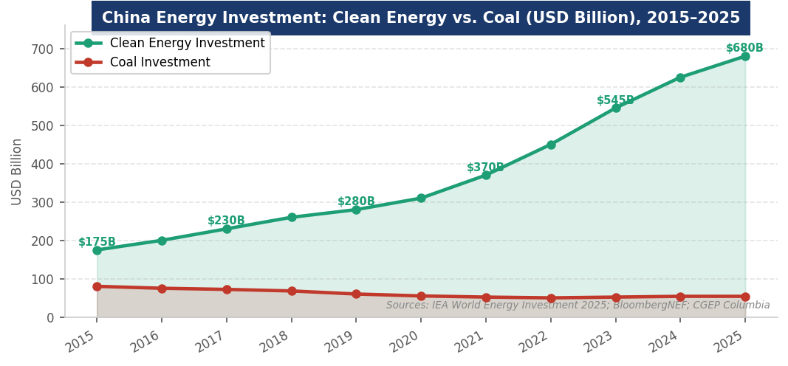
Figure 1. China energy investment: clean energy vs. coal (USD Billion), 2015–2025. Sources: IEA World Energy Investment 2025; BloombergNEF; CGEP Columbia.
THE FIVE-YEAR PLAN SYSTEM: HOW CHINA MAKES ENERGY POLICY
The Five-Year Plan (FYP) is the central mechanism of Chinese energy policy. Understanding how FYPs work — and how to read them — is essential for any investor or analyst trying to understand where Chinese state capital will flow over the next 5–10 years.

How FYPs Work
Five-Year Plans are not Soviet-style command documents — they are indicative plans that set targets, allocate priority, and signal state capital toward strategic sectors. FYPs are developed by the National Development and Reform Commission (NDRC) in consultation with ministries, state-owned enterprises, and local governments over 2–3 years, then approved by the National People’s Congress. Binding targets (mandatory, written as "must achieve") vs. aspirational targets (indicative, written as "strive to achieve") are a critical distinction: mandatory targets receive state financing and regulatory enforcement; aspirational targets are best-effort objectives. Binding targets for renewable energy capacity are backed by mandatory procurement requirements on utilities and non-compliance penalties for provincial governments.
Policy Tool | Mechanism | Energy Impact
Mandatory Capacity Targets | NDRC requires utilities to procure specified renewable percentage; provincial governments penalized for non-compliance | Direct government procurement demand independent of market economics; creates investment bankability for renewable developers even without strong power market pricing
National Development and Reform Commission (NDRC) | Approves major energy projects, sets energy pricing policy, manages industrial policy for strategic sectors | Every large-scale energy project (>50 MW power plants, major pipelines, cross-border energy infrastructure) requires NDRC approval; NDRC approval = state backing
State-Owned Enterprise (SOE) Investment Mandates | SGCC, CGN, CNNC, Datang, Huaneng, SDIC receive capital allocation directives linked to FYP targets | SOEs deploy ~60% of China's energy infrastructure investment; SOE investment is patient, long-horizon capital that moves at FYP targets regardless of short-term market conditions
National Energy Administration (NEA) | Regulatory body for energy sector; annual capacity targets, grid connection quotas, equipment standards | NEA annual targets create year-by-year investment mandates; NEA 2025 200 GW solar target was exceeded in H1 2025 alone (210 GW solar + 50 GW wind)
State Policy Banks (CDB, Exim Bank) | China Development Bank and Export-Import Bank provide below-market financing for strategic energy projects domestically and through BRI | CDB + Exim have deployed $100B+ in energy financing; their participation signals state strategic priority and enables projects that commercial banks wouldn't finance
Carbon Market (ETS) | National ETS launched 2021 (power sector only initially); expanding to other sectors under 15th FYP | China's ETS covers more GHG emissions than any other system globally; creates incremental pressure on coal plant economics but carbon price ($10-15/tonne in 2025) remains too low to drive major fuel switching
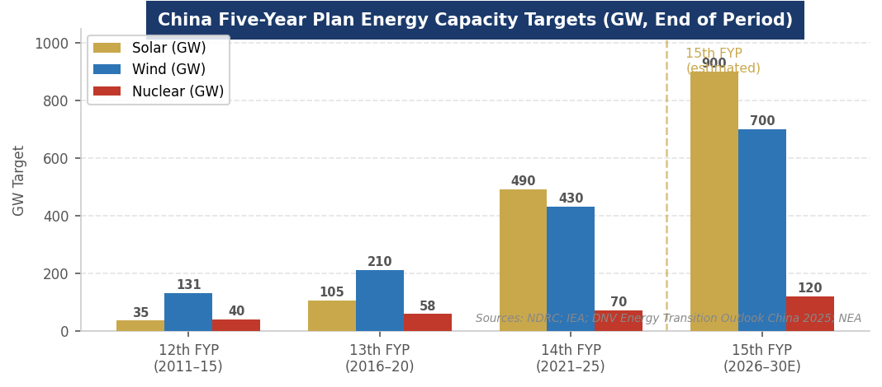
Figure 2. China Five-Year Plan energy capacity targets (GW, end of period). Sources: NDRC; IEA; DNV Energy Transition Outlook China 2025; NEA.

The 15th Five-Year Plan (2026–2030): What to Expect
The 15th FYP was expected from NDRC in March 2026 and represents the most consequential energy planning document of the decade. Based on expert analysis and pre-release signals, the key expected elements are:
- Renewable energy targets: ~900 GW cumulative solar, ~700 GW cumulative wind by 2030 (up from 490 GW and 430 GW in the 14th FYP). These targets imply 80–100 GW of solar annual additions and 50–70 GW of wind annually through 2030.
- Nuclear: ~120 GW cumulative by 2030 (up from 70 GW in 14th FYP). China is the world's largest nuclear construction market, with ~20 reactors under construction and plans to build 6–8 per year. This expansion rivals China's entire nuclear fleet being built again within a decade.
- Grid and storage: Significant investment in ultra-high voltage (UHV) transmission to move renewables from western generation centers to eastern demand centers; grid-scale battery storage targets; pumped hydro expansion.
- Dual carbon pathway: Maintaining peak emissions commitment before 2030 while managing economic growth — the central tension of Chinese climate policy. Coal consumption expected to peak in the mid-2020s but decline slowly given energy security concerns.
- Industrial policy continuation: Continued support for EV, battery, and solar manufacturing as export industries, with quality controls and consolidation expected to reduce overcapacity while maintaining scale advantages.
THE "NEW THREE": CHINA'S CLEAN ENERGY EXPORT INDUSTRIES
EVs, solar panels, and lithium batteries — China's "new three" export industries — represent the most successful application of state-led industrial policy to global market dominance since Japan’s automotive and electronics dominance in the 1970s–1980s.

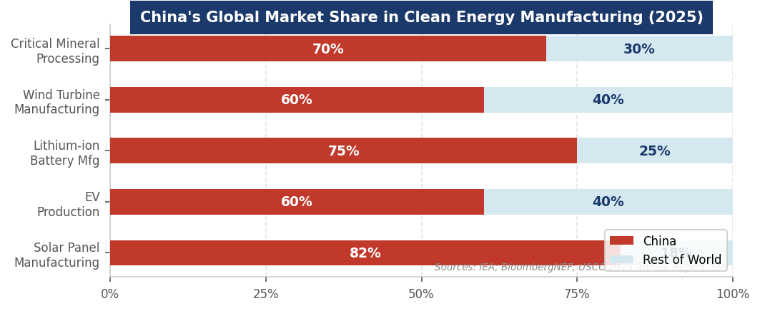
Figure 3. China's global market share in clean energy manufacturing (2025). Sources: IEA; BloombergNEF; USCC 2025 Annual Report; SIA.

Solar Panels (82% Global Market Share): Solar Panels: The Defining Industrial Policy Success
China's solar panel manufacturing dominance is the most complete industrial policy achievement of the 21st century. Chinese manufacturers (LONGi Green Energy, JA Solar, Trina Solar, Canadian Solar, Jinko Solar) account for 82% of global solar panel production. China's solar manufacturing capacity is projected to reach 1,255 GW/year by 2030 against global demand of ~600 GW — representing chronic structural overcapacity that drives global solar panel prices to near-zero and makes any Western manufacturer uncompetitive without tariff protection. The policy implication: solar energy is essentially a Chinese manufacturing product for the foreseeable future. The U.S. and EU can impose tariffs on solar panels but cannot manufacture competitively at scale without decades of industrial policy replication. This is the central tension of Western clean energy policy: wanting the energy transition but not wanting Chinese industrial dominance that enables it.
Electric Vehicles (60% Global EV Production): Electric Vehicles: BYD vs. Tesla vs. the World
China is the world's largest EV market (25%+ penetration in 2025) and the world's largest EV exporter. BYD surpassed Tesla in 2023 as the world’s largest EV seller by volume. Chinese EV manufacturers have achieved cost structures ($20–25K for a capable EV) that European and U.S. manufacturers cannot match without massive restructuring. The EU responded with tariffs of 17–45% on Chinese EV imports (2024); the U.S. with 100%+ tariffs; most emerging market countries with no tariffs, welcoming Chinese EV investment. Chinese EV exports grew 19% in H1 2025 despite Western tariffs, driven by growth in Southeast Asia, Middle East, and Latin America. China’s September 2025 EV export licensing requirement — requiring government approval for EV exports — is framed as quality control but also gives Beijing leverage over technology transfer.
Lithium Batteries (75% Global Manufacturing Share): Lithium Batteries: CATL's Global Dominance
Contemporary Amperex Technology (CATL) is the world’s largest battery manufacturer, supplying Tesla, BMW, Volkswagen, Toyota, and virtually every major automaker. CATL alone commands ~35% of the global battery market; Chinese manufacturers collectively control ~75%. The battery supply chain — from lithium and cobalt mining through cell manufacturing through battery management systems — is dominated by Chinese companies at every stage. CATL’s Condensed Matter Battery (solid-state adjacent), launched 2023, and its sodium-ion batteries represent the next frontier. The IRA's FEOC restrictions are specifically designed to exclude CATL and other Chinese battery manufacturers from U.S. EV supply chains — with limited success given the depth of Chinese supply chain integration.
THE BELT AND ROAD INITIATIVE: CHINA'S GLOBAL ENERGY STRATEGY
The Belt and Road Initiative (BRI), launched 2013, is China’s primary instrument of global economic and geopolitical influence. In 2025, BRI reached new records simultaneously in fossil fuel investment and clean energy investment — a paradox that defines China’s global energy strategy.

2025 BRI Data: The Dirty and Green Paradox
The Green Finance & Development Center’s 2025 BRI Investment Report documented record total BRI engagement: $128.4B in construction contracts and investments, with $93.9B in energy-related engagement — more than double 2024 and the highest in BRI history. The breakdown reveals the paradox: $71.5B in oil and gas engagement (more than triple the prior record year, driven by pipeline projects in Central Asia, LNG in Africa, and refinery investments in the Middle East) alongside $18.3B in green energy engagement (record high, 22 GW of wind, solar, and waste-to-energy across 40+ countries). China’s BRI energy strategy is not transitioning away from fossil fuels — it is deploying capital in both simultaneously, serving the energy needs of developing countries that cannot afford to choose between affordability (fossil fuels) and sustainability (renewables).
The Green BRI Pivot (2021–2025): The Green BRI Pivot
Xi Jinping announced at the 2021 UN General Assembly that China would stop building new coal-fired power plants overseas — a significant policy shift given that China had been the largest funder of overseas coal plants through the BRI. Since then, BRI green energy engagement has grown rapidly: H1 2025 alone saw $9.7B in green energy engagement (wind, solar, waste-to-energy), adding 11.9 GW of clean capacity. CGEP Columbia data shows China’s overseas renewable energy investments overtook fossil fuels for the first time in 2024. The green pivot is strategic as well as environmental: Chinese clean energy manufacturers need new markets as Western tariffs restrict access to U.S. and EU markets; BRI partner countries in Southeast Asia, Africa, and Latin America represent the fastest-growing clean energy markets and are receptive to Chinese technology and financing.
BRI vs. G7 Competition: Geopolitical Competition with Western Infrastructure
The G7’s Partnership for Global Infrastructure and Investment (PGII), launched 2022 with a $600B target by 2027, is explicitly designed as a BRI alternative offering transparent financing, labor and environmental standards, and non-coercive terms. The U.S. Development Finance Corporation (DFC, $60B capacity), European EFSD+, UK BII, and Japanese JBIC are the primary instruments. In practice, PGII has been slower to deploy than BRI — democratic transparency and environmental due diligence create timelines that BRI’s state-directed financing avoids. Developing countries often receive both: World Bank/PGII financing for visible flagship projects alongside Chinese BRI financing for lower-profile but commercially essential infrastructure.
U.S.-CHINA ENERGY TECHNOLOGY COMPETITION
The U.S.-China competition in energy technology — encompassing semiconductors, clean energy manufacturing, critical minerals, and AI — is the defining geopolitical contest of the 2020s. Understanding it is essential for any investor or executive in energy, technology, or industrial sectors.

Competition Domain | Current State, Stakes & 2025–2026 Developments
Solar Manufacturing | China 82% global share; U.S. attempts domestic manufacturing revival via IRA 45X credit and FEOC restrictions; Jinko Solar, LONGi, and JA Solar building U.S. factories to qualify for credits despite tariffs. OBBBA maintained 45X but accelerated phase-down. U.S. solar manufacturing remains uncompetitive without tariff protection.
Battery Manufacturing | China/CATL ~75% global share; IRA FEOC restrictions exclude Chinese manufacturers from U.S. EV supply chains; Ford Lithium Michigan factory (CATL technology license) created political controversy; Korean (LG, Samsung SDI, SK On) and Japanese (Panasonic) manufacturers are primary alternatives in U.S. market. U.S. battery manufacturing scaled from near-zero to 300+ GWh annual capacity by 2026 largely due to IRA incentives.
Critical Minerals | China controls 60–70% of critical mineral processing (cobalt, lithium, rare earths, graphite); China implemented rare earth export controls in 2024 and gallium/germanium restrictions as retaliation for U.S. chip controls; OBBBA FEOC rules restrict IRA credit eligibility for supply chains with Chinese processing; U.S. and allies (Australia, Canada, EU) building alternative processing capacity but 5–10 year development timeline.
Semiconductor / AI Chips | U.S. export controls block H100+ GPU exports to China; ASML EUV machine ban prevents China from manufacturing leading-edge chips; Huawei Ascend 910C at ~60–70% of H100 performance; SMIC achieving 7nm-equivalent without EUV; China Big Fund III ($47B) targeting chip self-sufficiency by 2030. The chip war is the highest-stakes domain of tech competition because semiconductor advantage directly translates into AI capability advantage.
Offshore Wind | China is the world’s largest offshore wind market (42 GW operational, 50%+ of global capacity); Mingyang Smart Energy and Goldwind developing 20+ MW turbines that exceed Western capabilities; Chinese offshore wind LCOE significantly below European equivalents; Trump EO halted U.S. offshore wind development in federal waters, ceding the market to China and Europe.
Nuclear Technology | China under-construction nuclear fleet (~20 reactors) is the world’s largest; Hualong One (HPR-1000) being exported to Argentina, Pakistan, UK (Bradwell B, contested); State Power Investment Corporation and China General Nuclear Group are global players; U.S. maintains technology advantage in SMRs (NuScale, TerraPower, X-energy) but commercial timelines are 5–10 years behind China's conventional reactor program.
Grid Technology | China leads in ultra-high voltage (UHV) transmission: 26 UHV lines operational, spanning 3,000+ km; ABB and Siemens supply some equipment but Chinese manufacturers (TBEA, Pinggao) dominate; SGCC (State Grid) is developing global UHV standards that embed Chinese technology. U.S. grid technology (GETs, DERMS, grid software) is a competitive strength but hardware manufacturing is largely foreign-supplied.

CHINA'S DOMESTIC ENERGY CHALLENGES
China’s clean energy dominance coexists with persistent domestic energy challenges that significantly complicate its climate commitments and energy security.

Coal Dependence: Coal Dependence and Energy Security
Coal accounted for 56% of China’s primary energy in 2024 (DNV Energy Transition Outlook). Despite record renewable additions, coal consumption has not yet peaked — new coal plants continue to be built as backup capacity for renewable intermittency and to serve industrial load growth. China commissioned more new coal capacity in 2024 than the rest of the world combined. Coal investment exceeded $54B in 2025 (IEA), even as clean energy investment reached $625B+. The political economy: coal provinces (Shanxi, Inner Mongolia, Shaanxi) are major employers and political constituencies; the central government's energy security concerns override climate commitments when electricity supply tightens.
Renewable Curtailment: Renewable Curtailment and Grid Bottlenecks
China’s renewable deployment has outpaced its grid's ability to absorb the electricity. Curtailment rates (the percentage of potentially available renewable electricity that is not used because the grid cannot absorb it) reached 8–12% in some western provinces in 2024 — meaning 8–12% of China’s solar and wind capacity produced electricity that was simply wasted. $88B in transmission and distribution investment in 2025 (IEA) is attempting to address this through ultra-high voltage lines moving power from western generation regions to eastern demand centers. Until grid infrastructure catches up with generation capacity, China’s renewable dominance on paper exceeds its functional clean energy utilization.
Economic Pressures: Economic Pressures and the Clean Energy Investment Cycle
China’s economy in 2024–2025 faces the most severe deflationary and demand pressures since the 2008 financial crisis: weak domestic consumption, real estate sector collapse (Evergrande, Country Garden), deflationary risk, and youth unemployment above 20%. Against this backdrop, clean energy investment serves as economic stimulus as much as energy policy — solar panel factories create manufacturing jobs, EV subsidies stimulate consumer spending, and infrastructure investment absorbs excess steel and cement capacity. The risk: if China’s economic slowdown deepens, clean energy investment may slow faster than global demand growth — exacerbating the overcapacity dynamic and driving further export-led price deflation.

CURRENT NEWS & MARKET DYNAMICS (2025–2026)
Headlines Every Candidate Should Know
- Record BRI Energy Engagement (2025): Record BRI Energy Engagement (2025): BRI reached $93.9B in energy engagement — the highest ever, more than double 2024. Paradoxically both the dirtiest year (oil and gas $71.5B, triple prior record) and the greenest year (renewable energy $18.3B, 22 GW capacity) simultaneously. The data reflects China's strategic calculation: serve developing market energy needs across all technologies while maintaining geopolitical relationships through energy finance.
- China Met 2030 Wind+Solar Target in 2024: China Met 2030 Wind+Solar Target in 2024: China installed 277 GW solar + 79 GW wind in 2024 alone, reaching its 2030 combined 1,200 GW wind+solar target six years early. The 15th FYP (2026–2030) will set new targets significantly above prior ambition. Solar alone is on track for 380 GW annual deployment in 2025 — more than the entire global solar market as recently as 2022.
- 15th Five-Year Plan (Expected March 2026): 15th Five-Year Plan (Expected March 2026): The 15th FYP is the most consequential energy policy document for global markets in the decade. It will set binding renewable capacity targets, EV adoption mandates, nuclear construction schedules, and critical minerals supply chain policies. Early signals: ~900 GW solar, ~700 GW wind, ~120 GW nuclear cumulative by 2030; continued EV and battery manufacturing support with quality controls to reduce overcapacity; expanded carbon market coverage.
- Busan Truce and Tariff Status (October 2025): Busan Truce and Tariff Status (October 2025): The U.S.-China Busan Trade Truce reduced general tariffs from 20% to 10% but explicitly exempted energy-related products: EV tariffs (100%), solar panel tariffs (50%), battery tariffs remained intact. China's rare earth and gallium/germanium export controls, implemented in 2024 as retaliation for U.S. chip controls, remain in place. The partial trade de-escalation has not resolved the core energy technology competition.
- Huawei Ascend 910C Launch (2025): Huawei Ascend 910C Launch (2025): Huawei's Ascend 910C AI chip — manufactured by SMIC using a 7nm-equivalent process without EUV lithography — delivers approximately 60–70% of NVIDIA H100 performance at a fraction of the cost for Chinese buyers who cannot access H100s due to export controls. This validates China’s ability to partially work around chip export controls through indigenous manufacturing. The Ascend 920 (next generation) is reportedly targeting performance parity with NVIDIA Blackwell.
- EV Export Licensing (January 2026): EV Export Licensing (January 2026): China's Ministry of Commerce implemented export licensing requirements for battery EVs beginning January 2026, ostensibly as quality control measures. Analysts interpret this as dual-purpose: improving Chinese EV brand reputation in export markets while giving Beijing leverage over EV technology transfer negotiations. The licensing requirement adds regulatory complexity for Chinese EV exporters but has not significantly slowed export growth to tariff-free markets.
- Solar Overcapacity Crisis: Solar Overcapacity Crisis: China's solar panel manufacturing capacity now exceeds 1,000 GW/year against global demand of ~500–600 GW, creating chronic overcapacity. Panel prices fell to near the cost of raw materials in 2024–2025, driving consolidation: several smaller Chinese manufacturers filed for bankruptcy; LONGi, JA Solar, and Trina Solar are investing in higher-efficiency next-generation cells (TOPCon, perovskite-silicon tandem) to maintain margin while commodity panel prices approach zero.
INVESTMENT, FINANCE & CAREER ANGLES
China’s energy and industrial policy creates investment implications that touch every sector of the global economy. MBA candidates need a framework for analyzing how Chinese policy affects investment decisions across energy, technology, and industrial sectors.

- Supply Chain Risk Analysis: Supply Chain Risk Analysis: Any investment in EV, battery, solar, or wind manufacturing requires a China supply chain risk assessment. FEOC compliance (for U.S. IRA credits), tariff exposure, and critical mineral sourcing from Chinese-controlled supply chains are material risks. ESG frameworks increasingly require China supply chain transparency (forced labor in Xinjiang in solar supply chains is a documented issue). Investment thesis: which non-Chinese alternatives exist at competitive cost?
- BRI as Investment Signal: BRI as Investment Signal: When China commits BRI capital to a country or sector, it is a leading indicator of future energy market development in that geography. BRI financing de-risks early infrastructure investment; Chinese equipment suppliers follow BRI financing. For emerging market infrastructure investors, BRI engagement patterns are a valuable tool for identifying next-cycle investment opportunities before market prices reflect them.
- Technology Competition as Investment Thesis: Technology Competition as Investment Thesis: The U.S.-China technology war creates investment opportunities in alternative supply chain development: U.S. and Australian critical mineral processing, Korean battery manufacturers, European solar manufacturing (with subsidy support), and Japanese materials suppliers. Every Chinese supply chain restriction creates a corresponding opportunity for non-Chinese alternatives. Investors who understand where China dominates vs. where alternatives are viable can identify mispriced opportunities.
- Chinese Market Access: Chinese Market Access: For companies selling into China (not just competing with Chinese manufacturers), understanding NDRC approval processes, SOE procurement dynamics, and FYP alignment is essential. Companies whose products align with FYP priorities (grid software, battery management systems, offshore wind components) can access Chinese state procurement channels that are the largest energy procurement markets in the world.

Key concepts: Dual carbon goals and their investment implications; Five-Year Plan mandatory vs. aspirational targets; NDRC project approval process; FEOC restrictions and CATL/BYD supply chain implications; BRI energy financing flows and geographic patterns; "new three" export industry dynamics and overcapacity; U.S.-China chip war and semiconductor self-sufficiency strategy; Chinese ETS carbon price and its gap from European ETS; ultra-high voltage transmission as a model for grid investment; and the paradox of China as simultaneously the world’s largest clean energy investor and largest coal consumer.
FUTURE OUTLOOK
China’s energy trajectory will determine whether the world meets its climate goals, who dominates the global clean energy technology industry, and how U.S.-China geopolitical competition evolves over the next decade. The fundamental tension: China wants to decarbonize its economy using technologies it manufactures, export those technologies to the world, and maintain economic growth and energy security throughout — all simultaneously.

- Base Case: Base Case: China meets its 2060 carbon neutrality commitment with a 20–30 year coal phase-down; solar overtakes coal as primary electricity source by 2030; Chinese manufacturers maintain 70–80% global market share in solar, batteries, and wind despite Western tariffs by dominating emerging market growth; BRI green energy engagement doubles by 2030; EV penetration exceeds 50% of new car sales in China by 2027; Big Fund III advances but China remains 3–5 years behind leading-edge semiconductor frontier.
- Bull Case: Bull Case: 15th FYP exceeds expectations; Chinese nuclear SMR commercializes at $50/MWh LCOE by 2033; perovskite-silicon tandem solar cells achieve 35%+ efficiency at commercial scale by 2030; CATL solid-state battery commercializes 2027; China becomes net energy exporter via electricity interconnection with Southeast Asia by 2035.
- Bear Case: Bear Case: Economic slowdown triggers sharp reduction in clean energy investment; Xi succession uncertainty destabilizes FYP implementation; Taiwan Strait military conflict disrupts global trade including Chinese clean energy exports; overcapacity drives mass bankruptcy of Chinese clean energy manufacturers, similar to 2012–2014 solar crisis but at 10× the scale; coal consumption fails to peak before 2030, missing dual carbon commitment.
INTERVIEW CONVERSATION STARTERS
- "China’s clean energy dominance is the most successful application of industrial policy to a strategic technology since America’s semiconductor program in the Cold War. The difference is China did it for a technology that the entire world needs for the energy transition. Solar panels are 82% Chinese. Batteries are 75% Chinese. EVs are 60% Chinese. The U.S. can impose tariffs, but it cannot close a 25-year manufacturing head start in a five-year policy cycle. The IRA was the most serious attempt to do so — and OBBBA walked part of it back."
- "The BRI paradox in 2025 is that China had its dirtiest and greenest BRI year simultaneously. $71.5B in oil and gas — triple the prior record. $18.3B in renewable energy — also a record. This isn’t hypocrisy; it’s strategy. Developing countries need energy, and China is willing to supply whatever they need — coal, gas, solar, wind — with Chinese financing, Chinese equipment, and Chinese relationships. Western development banks have environmental requirements that take years. China moves in months. That’s why BRI continues to win in the Global South."
- "China met its 2030 wind and solar target in 2024 — six years early. The 15th Five-Year Plan will likely double those targets. Solar is on track for 380 GW in a single year — that’s more than the entire global solar market was in 2022. The manufacturing capacity is now 1,255 GW/year by 2030 against global demand of 600 GW. The overcapacity drives prices to near-zero, which means the world gets cheap solar panels but at the cost of every non-Chinese solar manufacturer becoming uncompetitive without tariff protection."
- "The chip war and the energy war are the same war. China restricted rare earth exports as retaliation for U.S. chip controls. The U.S. imposed FEOC restrictions that exclude Chinese battery manufacturers from the IRA. ASML blocked EUV machine exports to Chinese chipmakers. And underneath all of this is the question of who controls the physical supply chains — the minerals, the materials, the manufacturing know-how — for both AI compute and clean energy. The country that controls those supply chains controls the infrastructure of the 21st century economy."

REFERENCES
High-Quality Sources Used in This Primer
Primary Data Sources
[1] IEA. "World Energy Investment 2025 — China." https://www.iea.org/reports/world-energy-investment-2025/china
[2] Green Finance & Development Center. "China Belt and Road Initiative (BRI) Investment Report 2025." https://greenfdc.org/china-belt-and-road-initiative-bri-investment-report-2025/
[3] DNV. "Greater China Energy Transition Outlook 2025." October 30, 2025. https://www.dnv.com/energy-transition-outlook/2025/greater-china/
[4] Columbia University CGEP. "US-China Trade Tensions and Clean Energy Investment in Third Countries." October 30, 2025. https://www.energypolicy.columbia.edu/publications/us-china-trade-tensions-and-clean-energy-investment-in-third-countries-implications-for-us-policymakers/
[5] Columbia University CGEP. "China's Energy Powerhouse Ambitions." May 2026. https://www.energypolicy.columbia.edu/chinas-energy-powerhouse-ambitions/
Industry & Government Reports
[6] U.S.-China Economic and Security Review Commission (USCC). "Power Surge: China's Electrification Drive and Push for Global Energy Dominance." Chapter 10, 2025 Annual Report. November 2025. https://www.uscc.gov/
[7] BloombergNEF. "China Clean Energy Outlook 2025." 2025.
[8] Inside Climate News. "For the First Time, China Invests More in Wind and Solar Than Coal Overseas." August 15, 2025. https://insideclimatenews.org/news/26052025/china-belt-and-road-initiative-wind-solar-investments/
[9] TIME Magazine. "World's Biggest Polluter, China, Is Ramping Up Renewables." March 10, 2026. https://time.com/7265783/how-china-is-boosting-renewable-energy-goals/
[10] Renewable Energy Industry. "H1 2025 China Solar and Wind Capacity Additions." 2025.
Academic & Policy Analysis
[11] Buzan, B. and Lawson, G. "China's Rise and the Transformation of the World Order." 2024.
[12] Helveston, J. and Nahm, J. "China's Key Role in Scaling Clean Energy Technologies." Science, 2019.
[13] Kennedy, S. "Made in China 2025." CSIS, 2015 (updated through 2026).
[14] Peters, M. et al. "Carbon Dioxide Emissions from China’s Power Sector: A Historical Perspective." Energy Policy, 2025.
[15] Steinfeld, E. "Playing Our Game: Why China's Rise Doesn't Threaten the West." Oxford, 2010.
News & Current Sources
[16] Semiconductor Industry Association (SIA). "Chipmakers in China: Big Fund III and Self-Sufficiency Strategy." 2024.
[17] Financial Times. "CATL and the Global Battery Supply Chain." 2025.
[18] Reuters. "BYD Surpasses Tesla: China’s EV Champions." 2025.
[19] Wood Mackenzie. "China Solar Overcapacity and Global Price Impact." March 2026.
[20] National Development and Reform Commission (NDRC). "14th Five-Year Plan for Renewable Energy Development." June 2021. (15th FYP expected March 2026.) https://www.ndrc.gov.cn/

Disclaimer: This document is prepared for educational purposes as part of an MBA classroom exercise. Market data reflects conditions as of May 2026 and is sourced from publicly available materials. It does not constitute investment advice.

