U.S. ENERGY POLICY
MBA Industry Primer | Policy & Regulation
Columbia Business School | May 2026

INDUSTRY AT A GLANCE
U.S. energy policy is the most consequential and most rapidly shifting policy environment in the American economy. Within three years (2022–2025), the United States enacted the largest clean energy investment in its history ($369B, the Inflation Reduction Act) and then partially repealed it (the One Big Beautiful Bill Act, July 2025), generating $496 billion in ten-year savings and simultaneously creating one of the most complex investment environments energy markets have ever navigated. For MBA candidates, understanding U.S. energy policy means understanding the institutional framework (FERC, DOE, EPA, state PUCs, ISO/RTOs) that governs how electricity is generated, transmitted, and priced; the legislative history from the Public Utility Regulatory Policies Act (1978) through the IRA and OBBBA; and how policy shifts create and destroy investment opportunities across every energy sub-sector from nuclear to natural gas to grid software.

Key Metric | Data Point (2025–2026)
IRA (Aug 2022) | $369B in clean energy tax credits and spending — the largest energy investment in U.S. history; established 45Y/48E technology-neutral credits, 45V clean hydrogen, 45Q CCS expansion, transferable credits (Sec. 6418)
OBBBA (Jul 4, 2025) | Partially repealed IRA: eliminated 30D EV, 25D residential solar, 25C home efficiency; curtailed 45Y/48E solar/wind (begin construction by Jul 4, 2026, in service by Dec 31, 2027); $496B in 10-year savings
Preserved Credits | 45Q (CCS/DAC), 45V (clean H₂ with additionality), 48E storage (through 2032), 45U nuclear (through 2034), 45Z clean fuels, transferability and direct pay maintained
Interconnection Queue | 2,600+ GW awaiting grid connection; average wait 5–7 years in PJM and MISO; FERC Orders 2023 and 1920 attempting reform
AI Power Demand | NERC revised 10-year U.S. load growth forecast from 6.1% to 11.6% in 2025 reliability assessment; data centers creating unprecedented new load; PJM capacity prices hit $329/MW-day cap
DOE Speed to Power | Initiative promoting co-location of compute and generation on federal lands to cut permitting delays; part of broader pivot from decarbonization metrics toward implementation speed
Foreign Investment | $90B+ in foreign investment in U.S. clean and digital infrastructure in 2025 (Global Legal Insights); Middle Eastern and European sovereign capital seeking dollar-denominated energy assets
State Policy Role | California, New York, Illinois state RPS and storage mandates independent of federal IRA; state PUCs and IRP processes now primary policy environment for many energy technologies
FERC Jurisdiction | Federal Power Act gives FERC authority over wholesale electricity markets, interstate transmission, and gas pipelines; state PUCs regulate retail rates and distribution; tension defines U.S. energy governance
Coal Comeback | Trump administration embraced coal as reliability asset; DOE narrowed GHG accounting requirements; administration signaled coal as baseload backup amid renewable intermittency concerns

HISTORY & ORIGINS: THE ARCHITECTURE OF U.S. ENERGY POLICY
U.S. energy policy is not a single coherent system — it is a layered accumulation of federal statutes, regulatory orders, state laws, and market structures built over 80 years in response to successive crises. Understanding this architecture is prerequisite to understanding any specific policy debate.
The Regulatory Foundation (1935–1978)
The Federal Power Act (1935) established FERC's predecessor (the Federal Power Commission) and gave the federal government authority over interstate electricity transmission and wholesale power markets. For decades, the U.S. electricity system was dominated by vertically integrated monopoly utilities — companies that owned generation, transmission, and distribution within defined service territories, with rates set by state public utility commissions to provide a regulated return. This system prioritized stability and reliability over competition or innovation.
The energy crises of the 1970s — the 1973 OPEC oil embargo and the 1979 Iranian Revolution — forced the first major federal energy policy response. The Energy Policy and Conservation Act (1975), the Department of Energy Organization Act (1977, creating DOE), and the landmark Public Utility Regulatory Policies Act (PURPA, 1978) collectively established the modern federal energy apparatus. PURPA was transformative: it required utilities to purchase power from qualifying small generators at avoided cost, opening the first crack in the utility monopoly and creating the legal basis for independent power producers.
Deregulation and Market Competition (1992–2005)
The Energy Policy Act of 1992 further opened transmission access and enabled competitive wholesale electricity markets. FERC Orders 888 and 889 (1996) required utilities to provide open, non-discriminatory access to transmission and created the modern wholesale market architecture. Independent System Operators (ISOs) and Regional Transmission Organizations (RTOs) — PJM, MISO, CAISO, ERCOT, SPP, ISO-NE, NYISO — emerged as the institutions that manage wholesale electricity markets across roughly two-thirds of the U.S. The Energy Policy Act of 2005 strengthened FERC’s transmission authority, established electricity reliability standards (NERC became the mandatory reliability organization), and provided the first significant federal support for nuclear power and coal.
The Clean Energy Era: ARRA Through IRA (2009–2022)
The American Recovery and Reinvestment Act (2009) deployed $90B in clean energy spending and loan guarantees — the largest federal clean energy investment before the IRA. ARRA funded the DOE Loan Programs Office (LPO), which backed Tesla, Solyndra, and dozens of early-stage clean energy projects. The political fallout from Solyndra’s bankruptcy ($535M loan guarantee) became the defining obstacle to clean energy policy for a decade, poisoning the term "government clean energy investment" in Republican politics.
The Production Tax Credit (PTC) and Investment Tax Credit (ITC) — first established in the Energy Policy Act of 1992 — became the primary federal clean energy incentives through the 2010s, subject to repeated near-expiration and extension cycles that created boom-bust dynamics in wind and solar investment. The failure of Waxman-Markey cap-and-trade (2010) ended carbon pricing as a near-term U.S. policy option. The Obama administration’s Clean Power Plan (2015) used EPA Clean Air Act authority to regulate power sector emissions but was stayed by the Supreme Court and later repealed. The Paris Agreement (2015) created international climate commitments that the Trump administration withdrew from in 2017 and the Biden administration rejoined in 2021.
The Infrastructure Investment and Jobs Act (Bipartisan Infrastructure Law, November 2021) committed $1.2T total ($550B in new spending), including $65B for grid modernization, $7.5B for EV charging, and significant broadband and water infrastructure. The Inflation Reduction Act (August 2022) was the defining domestic clean energy legislation: $369B in tax incentives and spending, technology-neutral credits (45Y production, 48E investment), transferability (Section 6418) enabling direct credit sales to any U.S. taxpayer, direct pay for non-profits and governments, and the first major U.S. policy to address the full clean energy value chain from generation through storage through manufacturing (45X advanced manufacturing).
The OBBBA Reversal (July 2025) and the Current Landscape
The One Big Beautiful Bill Act, signed July 4, 2025, is the most consequential energy policy reversal since the repeal of the Carter-era windfall profits tax. Structured as a budget reconciliation bill to pass with simple Senate majority, OBBBA terminated or curtailed most IRA clean energy tax credits, generating $496B in 10-year budget savings. The political logic: Republican concerns about the IRA’s cost and its perceived benefits to Democratic-leaning states and industries, combined with the Trump administration’s preference for fossil fuel energy dominance over climate-driven transition.
The investment landscape post-OBBBA is defined by a bifurcation: technologies with bipartisan support (nuclear, CCS, storage for grid reliability, clean hydrogen for industrial use) retained policy backing; technologies seen as primarily climate-motivated and Democratic-associated (residential solar, consumer EVs, onshore wind) lost most federal support. The $30B+ annual transferable credit market (Crux, 2024) was preserved — a significant structural element that continues to direct private capital toward remaining clean energy opportunities.

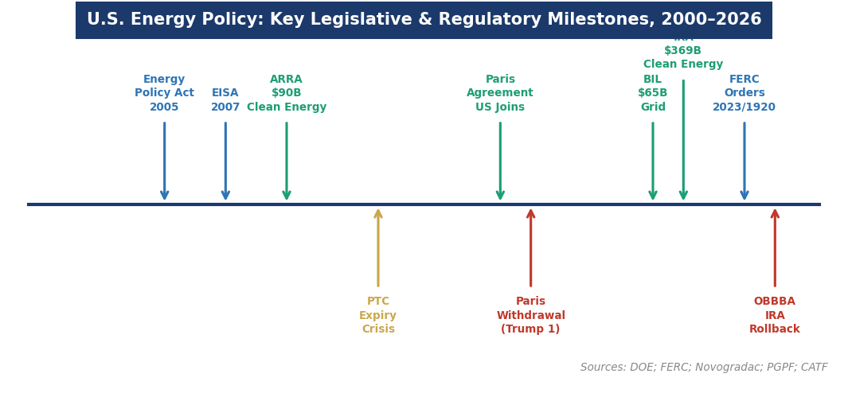
Figure 1. U.S. energy policy: key legislative and regulatory milestones, 2000–2026. Sources: DOE; FERC; Novogradac; PGPF; CATF.
THE INSTITUTIONAL FRAMEWORK: WHO GOVERNS U.S. ENERGY
Understanding U.S. energy policy requires understanding the institutions that make it — and the jurisdictional divisions between them that create both policy opportunities and gridlock.

Institution | Role, Authority & Key 2025–2026 Activity
Federal Energy Regulatory Commission (FERC) | Independent agency (5 commissioners, Senate-confirmed, bipartisan balance required). Jurisdiction: interstate electricity transmission and wholesale power markets (Federal Power Act), natural gas pipelines and LNG export terminals (Natural Gas Act), hydroelectric licensing. Key recent orders: FERC Order 2023 (interconnection queue reform, cluster study approach), FERC Order 1920 (long-range transmission planning), FERC December 2025 co-location order (requiring PJM to create rules for data centers connecting behind substations). FERC cannot be overridden by executive order — its independence is a structural feature of U.S. energy governance.
Department of Energy (DOE) | Cabinet-level department. Key responsibilities: energy R&D (national laboratories, ARPA-E), loan guarantees (LPO, $400B+ authority post-IRA, now partially curtailed), strategic petroleum reserve, nuclear weapons complex, energy data (EIA). DOE Speed to Power initiative (2025): co-locating compute and generation on federal lands to bypass interconnection queue. LPO portfolio: Rivian, Ford BlueOval, TerraPower, Heirloom Carbon; $1B commitment for Three Mile Island restart.
Environmental Protection Agency (EPA) | Regulates air emissions from power plants under Clean Air Act. GHG rule for power sector (2024) set limits on coal and new gas plants; legal status uncertain post-OBBBA. Section 111 authority is the primary federal lever for power sector emissions regulation in absence of cap-and-trade. Obama Clean Power Plan (2015) stayed by SCOTUS; West Virginia v. EPA (2022) limited EPA’s ability to set system-wide GHG standards without explicit congressional authorization (Major Questions Doctrine).
State Public Utility Commissions (PUCs) | Regulate retail electricity rates, utility resource planning (Integrated Resource Plans, IRPs), and distribution infrastructure. States have primary authority over where new generation is sited and how utilities plan their portfolios. California (CPUC), New York (PSC), Illinois (ICC), and Texas (PUC of Texas/ERCOT) are the most influential state regulators. OBBBA does not preempt state RPS mandates or state clean energy programs — California and New York clean energy requirements remain in force regardless of federal credit changes.
ISO/RTOs (PJM, MISO, CAISO, ERCOT, SPP, ISO-NE, NYISO) | Operate wholesale electricity markets for roughly 65-70% of U.S. electricity consumption. Set capacity prices, energy prices, and ancillary service prices through market mechanisms. PJM’s capacity market price surged to $329/MW-day cap in 2025–26 auction due to data center load growth — the most dramatic single market signal of AI’s power demand impact. FERC Order 2023 directed ISOs to reform interconnection queues; implementation varies by ISO.
North American Electric Reliability Corporation (NERC) | Sets and enforces mandatory reliability standards for the bulk power system. NERC’s 2025 Long-Term Reliability Assessment revised 10-year U.S. load growth forecast from 6.1% to 11.6% — the most significant upward revision in NERC history, driven by AI data center and EV demand. NERC reliability standards govern how much reserve margin utilities must maintain and how generators must perform.
Treasury Department / IRS | Administers clean energy tax credits post-IRA. Key rulings: final 45V clean hydrogen additionality rules (January 2024), 45Q direct pay mechanics, transferability marketplace guidance (Notice 2024-XX). IRS Notice 2025-XX addressed OBBBA transition rules for projects under construction. Treasury’s guidance on what qualifies for remaining credits is often as consequential as the statutory language itself.

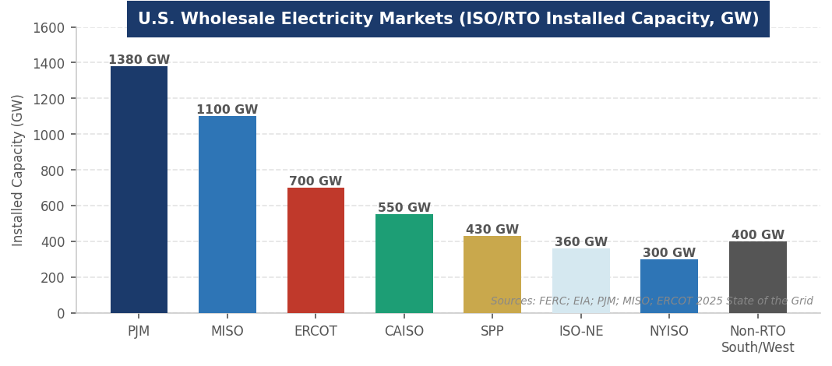
Figure 2. U.S. wholesale electricity markets: ISO/RTO installed capacity (GW). Sources: FERC; EIA; PJM; MISO; ERCOT 2025.
THE IRA AND OBBBA: THE DEFINING POLICY SHIFT
The IRA-to-OBBBA sequence is the most important policy story in U.S. energy markets since deregulation. MBA candidates must be able to articulate both the IRA’s architecture and the OBBBA’s specific changes with precision.

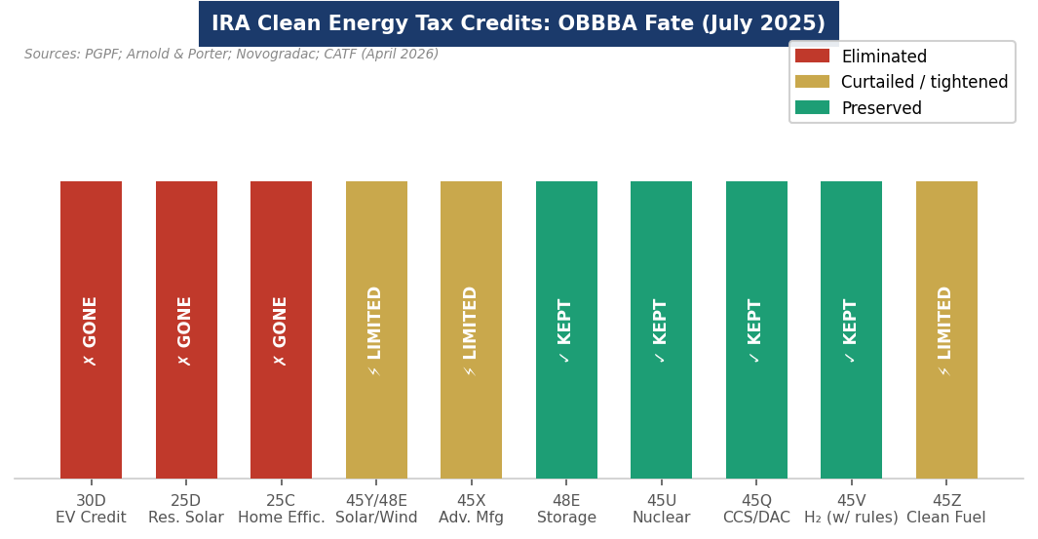
Figure 3. IRA clean energy tax credits: OBBBA fate (July 2025). Sources: PGPF; Arnold & Porter; Novogradac; CATF.

What the IRA Built (2022–2025)
The IRA’s core innovation was not its scale but its structure. Prior clean energy incentives (PTC, ITC) required annual Congressional reauthorization and created boom-bust cycles. The IRA established technology-neutral, long-dated credits (45Y production credit, 48E investment credit) that were supposed to run through 2032 or until the power sector’s GHG emissions fell below 20% of 2022 levels — giving developers a decade-long policy runway for the first time. Three structural innovations made IRA fundamentally different from prior policy: (1) Transferability (Section 6418): credits could be sold to any U.S. taxpayer, creating a $30B+ annual market and dramatically broadening the pool of clean energy investors beyond the 20 tax equity banks that previously dominated the market. (2) Direct Pay: non-profit hospitals, universities, municipalities, and rural electric cooperatives could receive credits as cash refunds, enabling clean energy investment by entities with no tax liability. (3) Domestic content bonuses: additional 10% credit for using domestically manufactured components, triggering massive investment in U.S. solar, battery, and wind manufacturing.
What the OBBBA Changed (July 2025)
Credit / Provision | OBBBA Outcome & Investment Implication
30D New Clean Vehicle Credit | Terminated September 30, 2025. Immediate demand shock: EV sales fell sharply in Q4 2025. Eliminated the $7,500 consumer incentive that had been the primary driver of EV market penetration for non-luxury buyers. Kia EV6 sales fell 71% month-over-month post-termination.
25D Residential Clean Energy Credit | Terminated December 31, 2025. Eliminated 30% credit for residential solar, small wind, geothermal heat pumps, fuel cells, and home battery storage. Immediate impact on residential solar installers (Sunrun, SunPower) and home battery companies (Tesla Powerwall). SunPower bankruptcy accelerated.
25C Energy Efficient Home Improvement | Terminated December 31, 2025. Eliminated credits for heat pumps, insulation, windows, and other home efficiency upgrades. Removed the primary federal incentive for residential electrification.
45Y/48E Solar & Wind (Generation) | Curtailed: begin construction by July 4, 2026; in service by December 31, 2027, to retain eligibility. Other technologies (hydro, nuclear, geothermal) face graduated phase-outs through 2036. Approximately 43 GW of clean energy has interconnection agreements and could feasibly meet deadlines (EVA analysis); additional 187 GW has possible path but faces tariff and FEOC risks.
45X Advanced Manufacturing Credit | Accelerated phase-down. Credits for solar panels, wind components, and battery cells now phase down faster than original IRA schedule. Negative for U.S. solar and battery manufacturing buildout; positive for federal budget.
48E Storage ITC (PRESERVED) | Retained through 2032. Battery storage is the most favorably treated clean energy technology in OBBBA — retained full ITC while solar/wind generation faces phase-out. Reflects bipartisan recognition of grid reliability need for storage.
45U Nuclear PTC (PRESERVED) | Existing nuclear plants retain $15/MWh production tax credit through 2034. New nuclear and SMRs qualify for 48E ITC. Bipartisan support for nuclear as firm, zero-carbon power for both climate and reliability reasons.
45Q CCS / DAC Credit (PRESERVED) | $85/tonne for geological CCS; $180/tonne for direct air capture. Preserved intact. Bipartisan support driven by oil and gas industry interest in CCS and the alignment of carbon capture with fossil fuel operations.
45V Clean Hydrogen (PRESERVED w/ rules) | Preserved but with strict additionality, temporal matching, and deliverability rules that significantly limit eligible projects. 45V qualification ends for projects not in service by December 31, 2027 (significantly accelerated from IRA’s original timeline).
Transferability & Direct Pay (PRESERVED) | Section 6418 transferability and direct pay both survived OBBBA. The $30B+ annual transferred credit market continues. This is the most important structural element of IRA that OBBBA did not touch — it preserves the ability of a broad range of investors to participate in clean energy finance.
Section 163(j) EBITDA Reversion | OBBBA reverted interest deductibility cap from EBIT back to EBITDA standard. For capital-intensive energy borrowers with large non-cash depreciation, this materially increases tax-efficient debt capacity — directly improving LBO and project finance economics for gas plants, pipelines, and other capital-heavy assets.

THE INTERCONNECTION CRISIS & GRID MODERNIZATION
The single largest bottleneck in U.S. energy policy is not a tax credit or a regulatory rule — it is the interconnection queue. As of 2025, 2,600+ GW of generation and storage projects are waiting 5–7 years for grid connection approval in PJM and MISO. This backlog means that even if a developer has financing, permits, and a willing offtaker, they may wait years simply to get their project connected to the grid. Understanding the interconnection crisis is essential for any energy policy or infrastructure investing conversation.

Why the Queue Exists
The interconnection queue bottleneck is structural. Under the prior "first-come, first-served" (serial) study process, each new project triggered a full restudy of all preceding projects in the queue. A single late entrant could delay hundreds of projects. Studies took 3–5 years. Withdrawal rates exceeded 70–80% of queued capacity (projects that entered but never reached interconnection agreements). FERC Order 2023 (2023) attempted to fix this by replacing serial studies with "cluster studies" — studying groups of projects simultaneously — and requiring firm financial commitments from developers before entering the queue. FERC Order 1920 (2024) required ISOs to conduct long-range transmission planning that accounts for 20 years of future needs, not just interconnecting specific projects.
The Data Center Complication
AI data centers have created an entirely new category of interconnection demand: large load requests (50–500 MW each) from hyperscalers who want to connect directly to the bulk transmission system, bypassing distribution infrastructure. ERCOT saw new large load requests quadruple in 2025. PJM capacity prices hit the $329/MW-day regulatory cap in 2025–26, directly attributable to data center load growth. FERC’s December 2025 order directed PJM to create specific rules for co-located load (data centers connecting behind existing substations, sharing interconnection with generation) — validating Blackstone’s Bring Your Own Power model as a legitimate grid architecture.
Grid-Enhancing Technologies
The fastest and cheapest path to unlocking transmission capacity is deploying grid-enhancing technologies (GETs) on existing infrastructure: advanced power flow control (FACTS devices), topology optimization software, dynamic line ratings (DLR), and high-temperature low-sag conductors (HTLS). The American Council on Renewable Energy estimates GETs could unlock 100+ GW of additional transmission capacity on existing lines at $1–2/MWh cost — a fraction of new line construction. DOE’s Grid Deployment Office has prioritized GETs as a near-term reliability tool while new long-range transmission lines (SunZia HVDC, Cardinal-Hickory Creek, SOO Green) await construction.

THE AI DEMAND SURGE & ENERGY SECURITY AGENDA
Two developments are reshaping U.S. energy policy priorities in 2025–2026 in ways that cross partisan lines: the AI data center power demand surge and the energy security agenda.

AI Power Demand: The Most Important Policy Driver of the Cycle
NERC’s upward revision of U.S. load growth from 6.1% to 11.6% in its 2025 Long-Term Reliability Assessment is the most consequential number in U.S. energy policy. It means that the U.S. power system — which had been in structural electricity demand decline since 2007 (driven by efficiency gains) — is now entering the fastest demand growth period since post-WWII industrial electrification. This demand growth is concentrated in specific geographies: Virginia (largest data center market globally), Texas (ERCOT), Georgia, and the Pacific Northwest. Utilities in these markets are planning for 20–40% load growth over 10 years from data centers alone. Every policy discussion about new generation, transmission, permitting, and grid reliability is now filtered through the AI demand lens.
Energy Dominance as Policy Framework
The Trump administration has organized its energy policy around "energy dominance" — maximizing U.S. fossil fuel production and export while eliminating regulatory constraints on oil, gas, and coal development. Executive orders in January 2025 declared a national energy emergency, withdrew from the Paris Agreement (second time), paused LNG export permit reviews, and directed agencies to maximize oil and gas leasing on federal lands. DOE narrowed its authority to condition grants on GHG accounting. The "energy dominance" framework is not simply anti-clean energy — it is pro-domestic production of all fuels, which creates bipartisan overlap on nuclear (domestic energy, jobs) and CCS (enables continued fossil fuel use with reduced emissions) even as it opposes wind and solar as the primary energy transition technologies.
Permitting Reform: The Permitting Reform Bipartisan Opportunity
NEPA (National Environmental Policy Act) review timelines — often 3–7 years for major energy projects — are a genuine bipartisan constraint. Clean energy developers, fossil fuel producers, and grid operators all need faster permitting. The DOE/FERC/CEQ coordination on shortened NEPA timelines for strategic projects is one of the few areas of genuine cross-partisan alignment. State "fast-lane" siting programs (Virginia, Texas, Montana) integrating data center development with utility resource planning are the most effective current models.
STATE ENERGY POLICY: THE PARALLEL SYSTEM
State energy policy is not subordinate to federal policy — it operates in parallel and often fills the gap when federal policy changes. For any energy investment analysis, state policy is frequently as important as federal policy.

State / Policy | Key Energy Policy and Investment Implication
California (CPUC) | 100% clean electricity by 2045 (SB 100); aggressive storage procurement mandate (1,000+ MW annual); carbon cap-and-trade system (AB 32/SB 32); CPUC regulates PG&E, SCE, SDG&E as the primary investor-owned utilities. California clean energy policy survived OBBBA entirely. California Clean Energy Fund (CalCEF) deploys state capital into energy innovation.
New York (PSC) | Climate Leadership and Community Protection Act (CLCPA): 70% renewable electricity by 2030, 100% zero-carbon by 2040; 6 GW offshore wind target; NY-Sun solar program; NYC Local Law 97 requires building emissions reductions. New York is the most aggressive state clean energy jurisdiction in the U.S.
Texas (ERCOT) | Unique: ERCOT is the only major U.S. grid not subject to FERC jurisdiction (intrastate only). Texas relies on energy-only wholesale market (no capacity market) for resource adequacy. Post-Winter Storm Uri (2021), Texas made significant investments in weatherization and emergency reserves. Texas has more wind capacity than any other state (40+ GW); AI data center boom centered in northern Texas. Texas PUC less prescriptive than California or New York on clean energy mandates.
PJM States (PA, OH, IL, MD, NJ, DE, VA, WV, DC) | PJM capacity market is the most important wholesale market in the U.S. for generation investment decisions. Illinois Future Energy Jobs Act; New Jersey clean energy requirements; Virginia Clean Economy Act (100% clean by 2050 for Dominion, Appalachian Power). Virginia is the data center capital of the world — Northern Virginia alone accounts for 25%+ of global hyperscale data center capacity.
Gulf Coast States (TX, LA, MS, AL) | Primary LNG export region: Sabine Pass (Cheniere), Corpus Christi (Cheniere), Calcasieu Pass (Venture Global), Lake Charles, Golden Pass. Conservative energy policy priorities; pro-fossil fuel, anti-renewable mandate. However, offshore wind potential in Gulf of Mexico now being explored post-federal pause.
Mountain West / SPP | Western Energy Imbalance Market (EIM) expanding to full Western Organized Market (WEIS). High renewable resource potential (solar in Southwest, wind in Great Plains). SunZia HVDC line (1,200 MW, New Mexico to Arizona, Brookfield) is the largest U.S. transmission project under construction.

INDUSTRY TRENDS & CURRENT ISSUES
Trend 1: The Coal Reliability Debate The Coal Reliability Debate
The Trump administration’s embrace of coal as a reliability asset — directing FERC and DOE to support coal plant retention and even expansion — is the most significant break from prior bipartisan energy policy. The administration’s argument: retiring coal plants too quickly creates reliability risk, especially as AI demand surges and new clean energy faces interconnection delays. The counterargument: coal plants are expensive to maintain, face fuel supply challenges, and are uncompetitive with gas and renewables on a market basis. PJM’s capacity market is the primary venue where this debate plays out — coal plants that receive capacity payments can remain economical even when they rarely run on energy markets.
Trend 2: FEOC Restrictions and Supply Chain Nationalism FEOC Restrictions and Supply Chain Nationalism
OBBBA tightened Foreign Entity of Concern (FEOC) restrictions on clean energy tax credits. Companies with significant Chinese ownership or control cannot receive most clean energy credits. This is directly aimed at Chinese solar panel manufacturers, battery producers, and EV companies — but it also affects U.S. companies using Chinese supply chains. The practical implication: U.S. clean energy manufacturers must certify supply chain compliance, creating significant compliance costs and supply chain restructuring. The FEOC rules are the intersection of energy policy and geopolitics in its most concrete form.
Trend 3: Offshore Wind: Federal Pause, State Continuation Offshore Wind: Federal Pause, State Continuation
Trump executive order (January 20, 2025) halted all federal offshore wind leasing and paused construction permits for projects in federal waters. 5.8 GW of projects were immediately paused. The executive order cannot override existing leases (legally binding contracts) but creates regulatory uncertainty that has caused several developers to write down projects or exit the U.S. market. State-level offshore wind mandates (New York, New Jersey, Massachusetts, Connecticut, Maryland) continue independently. The tension between federal pause and state mandates is creating legal disputes that will likely reach federal courts.
Trend 4: Nuclear Renaissance: Bipartisan and AI-Driven Nuclear Renaissance: Bipartisan and AI-Driven
Nuclear energy is the only large-scale clean energy technology with strong bipartisan support in 2025–2026. The combination of preserved 45U and 48E tax credits, DOE LPO financing authority, Big Tech PPAs (Microsoft TMI, Meta 6.6 GW commitment, Google Kairos, Amazon X-energy), and the Trump administration’s pro-nuclear stance (energy security, jobs, no intermittency) has created the strongest nuclear investment environment in 40 years. The Palisades restart (Holtec, Michigan, $1B+ DOE LPO commitment) is the first U.S. nuclear restart in history. TerraPower’s Natrium reactor (Wyoming, Bill Gates’ company) broke ground in 2024.

CURRENT NEWS & MARKET DYNAMICS (2025–2026)
Headlines Every Candidate Should Know
- OBBBA Signed July 4, 2025: OBBBA Signed July 4, 2025: The most significant U.S. energy policy reversal in recent history. $496B in 10-year savings primarily from eliminating 30D EV credit ($190B), curtailing 45Y/48E solar/wind ($166B), and terminating 25D residential solar ($77B). Bipartisan provisions preserved: 48E storage, 45U nuclear, 45Q CCS. Transferability maintained. Market response: EV stocks fell sharply, residential solar installers faced bankruptcy risk, nuclear and storage stocks rallied.
- NERC Load Growth Revision (2025): NERC Load Growth Revision (2025): NERC revised its 10-year U.S. load growth forecast from 6.1% to 11.6% in its 2025 Long-Term Reliability Assessment — the most dramatic upward revision in NERC history. Primary driver: AI data center demand. PJM alone estimated 40 GW of new load requests in 2025. The revision triggered emergency capacity procurement processes and accelerated gas plant retentions across multiple ISOs.
- PJM Capacity Market Crisis: PJM Capacity Market Crisis: PJM's 2025/26 capacity auction cleared at $329/MW-day — the regulatory price cap — representing a 10× increase from recent auctions. The surge was caused by retirement of old coal and gas plants, delays in new generation interconnection, and the sudden surge in data center load requests. The $9.3B total capacity payment is the largest in PJM history and created immediate political pressure to reverse coal retirements.
- FERC Order 1920 Implementation: FERC Order 1920 Implementation: FERC’s long-range transmission planning order (May 2024) is being implemented by ISOs. PJM’s Regional Transmission Expansion Plan (RTEP) includes $2.6B in near-term transmission projects. The order requires ISOs to plan for 20-year scenarios including high renewables penetration, extreme weather, and load growth — creating new investment opportunities for transmission developers and GETs companies.
- Three Mile Island Restart: Three Mile Island Restart (2024–2025): Microsoft signed a 20-year PPA with Constellation Energy to restart Unit 1 at Three Mile Island — the first nuclear restart in U.S. history. DOE provided $1B+ in loan commitments. The plant came back online in late 2024. The TMI restart is the template for nuclear restarts: investment-grade tech company PPA + DOE LPO financing + preserved 45U credits + state regulatory support.
- DOE Speed to Power Initiative: DOE Speed to Power Initiative: DOE announced the Speed to Power initiative in 2025, promoting co-location of data center compute and clean energy generation on federal lands to bypass the interconnection queue. First projects involve co-locating solar and storage directly adjacent to hyperscale data centers on DOE national laboratory sites, enabling grid connection without waiting in the 5–7 year interconnection queue.
INVESTMENT, FINANCE & CAREER ANGLES
U.S. energy policy literacy is a prerequisite for any finance role touching energy, infrastructure, or climate. Here is how policy knowledge translates into investment decisions and career positioning.

- Infrastructure PE and Project Finance: Infrastructure PE and Project Finance: Every energy infrastructure investment thesis starts with a policy question — what credits apply, what regulatory framework governs revenues, what state IRP process creates offtake demand. Understanding FERC market rules, ISO/RTO capacity market mechanics, and IRA/OBBBA credit eligibility is the core technical competency for any infrastructure PE associate working on energy deals.
- ClimateTech VC: ClimateTech VC: Policy literacy separates credible ClimateTech investors from those who confuse the policy environment with the investment thesis. The OBBBA demonstrated that investors who had built theses around subsidy-independence (grid software, nuclear, geothermal, CCS) were far more resilient than those who depended on IRA credits (residential solar, EV-adjacent). Understanding which technologies need policy vs. which are commercially self-sustaining is the core VC judgment call.
- Energy Corporate Strategy: Energy Corporate Strategy: Utilities, energy developers, oil majors, and industrials all maintain government affairs and regulatory strategy functions staffed partly by MBA graduates. Policy analysis — modeling the investment implications of specific credit changes, regulatory orders, or state RPS mandates — is a core corporate strategy skill in the energy sector.
- Policy Advisory and Consulting: Policy Advisory and Consulting: DOE, FERC, EPA, and state PUCs hire MBA-level policy analysts. Management consultants (McKinsey, BCG, Bain energy practices) and specialized energy advisors (Lazard Energy, Wood Mackenzie, ICF) advise energy companies and governments on policy implications. The DOE LPO has a significant analytical staff evaluating loan applications across every clean energy technology.

Key concepts every candidate must know: FERC vs. state PUC jurisdiction; ISO/RTO market structure (energy, capacity, ancillary services markets); IRA credit taxonomy (45Y, 48E, 45Q, 45V, 45U, 45X, 48E) and OBBBA changes to each; transferability mechanics (Section 6418); FERC Order 2023 interconnection reform; NERC reliability standards and the 2025 load growth revision; the "energy dominance" policy framework; and the state-federal policy interplay in offshore wind, storage, and nuclear.
FUTURE OUTLOOK
U.S. energy policy is at its most uncertain and most consequential inflection point since the 1970s energy crises. The convergence of AI-driven demand growth, climate commitments, geopolitical energy security concerns, and the OBBBA policy reversal has created a complex investment landscape where sector expertise is more valuable than ever.

- Base Case: Base Case: OBBBA provisions remain largely intact through 2028. Nuclear, storage, and CCS receive continued policy support. AI data center demand drives 15–20% U.S. load growth by 2030. FERC Order 2023 reduces interconnection wait times to 2–3 years by 2028. Natural gas remains the primary balancing fuel for grid reliability. State clean energy mandates (CA, NY, IL) drive renewable development independent of federal policy. U.S. maintains world’s largest LNG export capacity.
- Bull Case: Bull Case: Permitting reform passes with bipartisan support, reducing NEPA timelines from 5+ years to 2 years; nuclear SMR commercial deployment begins 2030; fusion achieves commercial milestone; OBBBA reversed or modified in 2027 mid-term policy window; U.S. becomes global leader in grid modernization technology exports.
- Bear Case: Bear Case: Grid reliability emergency (major blackout driven by AI load growth + insufficient new generation) forces emergency policy response; further OBBBA-style rollbacks eliminate remaining clean energy credits; FEOC supply chain restrictions increase clean energy costs dramatically; U.S. falls behind China and Europe in next-generation energy technology development.
INTERVIEW CONVERSATION STARTERS
- "The OBBBA didn't kill the U.S. clean energy transition — it stress-tested it. The technologies that survived — storage, nuclear, CCS — have commercial economics and bipartisan support. The technologies that got hit hardest — residential solar, consumer EVs, onshore wind — were the ones most dependent on subsidies to compete. The $30B+ transferable credit market survived intact, which means private capital can still find its way to the best clean energy opportunities without ITC/PTC eligibility."
- "The most important number in U.S. energy policy right now is 11.6% — NERC's revised 10-year load growth forecast. For 20 years, U.S. electricity demand was flat or declining. AI data centers have reversed that completely. Every grid planning assumption, every resource adequacy calculation, every capacity market price is being recalibrated around that number. It’s why PJM cleared capacity at the $329/MW-day regulatory cap. It’s why nuclear plants that were scheduled for retirement are being restarted. It’s why the interconnection queue has 2,600 GW waiting and the line isn’t getting shorter."
- "The energy dominance agenda and the clean energy transition are more compatible than they appear. The administration wants maximum domestic energy production of all types — oil, gas, coal, and nuclear. Nuclear fits perfectly: domestic fuel, no imports, reliable baseload, and zero emissions. That’s why 45U and 45U nuclear PTC survived OBBBA untouched while solar and wind credits were cut. The administration's energy policy is less anti-clean and more anti-intermittent and anti-import-dependent."
- "FERC Order 2023 is the most important energy regulatory action since deregulation in the 1990s, and most people haven’t heard of it. 2,600 GW of generation is stuck in interconnection queues — that’s more than the entire current U.S. generating fleet. Fixing the interconnection process is more valuable to the clean energy transition than any tax credit, because you can have a fully financed, fully permitted solar farm and still wait 7 years to sell a single electron."

REFERENCES
High-Quality Sources Used in This Primer
Legislation & Regulatory
[1] 117th U.S. Congress. "Inflation Reduction Act of 2022" (Pub. L. 117-169). Signed August 16, 2022. https://www.congress.gov/bill/117th-congress/house-bill/5376
[2] 119th U.S. Congress. "One Big Beautiful Bill Act" (H.R. 1). Signed July 4, 2025.
[3] Peter G. Peterson Foundation (PGPF). "Energy Tax Policy Under the OBBBA." March 3, 2026. https://www.pgpf.org/article/energy-tax-policy-under-the-obbba/
[4] Arnold & Porter. "From IRA to OBBBA: A New Era for Clean Energy Tax Credits." July 22, 2025. https://www.arnoldporter.com/en/perspectives/advisories/2025/07/from-ira-to-obbba-a-new-era-for-clean-energy-tax-credits
[5] Novogradac. "Key Energy Policy Developments of 2025 that are Reshaping the Industry." February 18, 2026. https://www.novoco.com/notes-from-novogradac/key-energy-policy-developments-of-2025-that-are-reshaping-the-industry
Regulatory & Market Data
[6] Federal Energy Regulatory Commission (FERC). "Order No. 2023 — Improvements to Generator Interconnection Procedures and Agreements." 2023. https://www.ferc.gov/
[7] Federal Energy Regulatory Commission (FERC). "Order No. 1920 — Building for the Future Through Electric Regional Transmission Planning and Cost Allocation." May 2024. https://www.ferc.gov/
[8] NERC. "2025 Long-Term Reliability Assessment." December 2025. https://www.nerc.com/
[9] ICLG. "Energy Laws and Regulations 2026: USA." Global Legal Insights. December 22, 2025. https://www.globallegalinsights.com/practice-areas/energy-laws-and-regulations/usa/
[10] ICLG. "Renewable Energy Laws and Regulations Report 2026: USA." September 22, 2025. https://iclg.com/practice-areas/renewable-energy-laws-and-regulations/usa
Analysis & News
[11] Clean Air Task Force (CATF). "Taking Stock of Energy and Climate Policy Since 2020." April 16, 2026. https://www.catf.us/resource/taking-stock-us-energy-climate-policy-since-2020/
[12] Energy Ventures Analysis (EVA). "The One Big Beautiful Repeal: How OBBBA Resets Clean Energy Policy." June 2, 2025. https://www.evainc.com/energy-blog/the-one-big-beautiful-repeal-obbba-resets-clean-energy-policy/
[13] Thomson Reuters Institute. "The One Big Beautiful Bill Act: Changing the Landscape for US Clean Energy." August 11, 2025. https://www.thomsonreuters.com/en-us/posts/sustainability/one-big-beautiful-bill-act-clean-energy/
[14] Lexology. "Renewable Energy and Carbon Capture in USA." September 30, 2025. https://www.lexology.com/library/detail.aspx?g=b44c63de-9c5b-4c67-90dc-b1ed3cccefe9
[15] Build with Basis. "One Big Beautiful Bill: Final Impact Analysis on IRA Clean Energy Tax Credits." July 9, 2025. https://www.buildwithbasis.com/insights/one-big-beautiful-bill-final-impact-analysis-on-ira-clean-energy-tax-credits
Institutional Sources
[16] U.S. Energy Information Administration (EIA). "Annual Energy Outlook 2025." https://www.eia.gov/outlooks/aeo/
[17] U.S. Department of Energy (DOE). "Speed to Power Initiative." 2025. https://www.energy.gov/
[18] PJM Interconnection. "2025/2026 RPM Base Residual Auction Results." 2025. https://www.pjm.com/
[19] BloombergNEF. "U.S. Clean Energy Investment Monitor 2025." 2025.
[20] McKinsey Global Institute. "The Energy Transition: A Region-by-Region Agenda for Near-Term Action." 2025.

Disclaimer: This document is prepared for educational purposes as part of an MBA classroom exercise. Market data reflects conditions as of May 2026 and is sourced from publicly available materials. It does not constitute investment advice.

